Loqate, A GBG Solution
Release Notes – Verify API

2024Q2.0 Major Release

Local API Notice
This is to inform our customers that in 2024Q2.0 release we have made a couple of improvements to the Verify API please see details below.
The latest API version reference included in this release is 2.51.0.17470-ab0b8b0

Case Resolutions
Details of the one customer case resolution and an internal performance improvement are detailed below. If you would like more details on these cases, please contact LoqateSupport@gbgplc.com for further information.

Local API Improvement
Case Number | Change Description | Country
CAS-111034-Y5Y2Y9 | Match Score Calculation Update | Singapore
Internal | Fixed crash with EnhancedCountryTool. | ALL

Case Number | Change Description | Category | Country | Example Address
CAS-111034-Y5Y2Y9 | Match Score Calculation Update | API | Singapore | 1A A Lady Hill Road  #10-01 Shangri-La Residences  Singapore 258685
Before Image |  |  | After Image
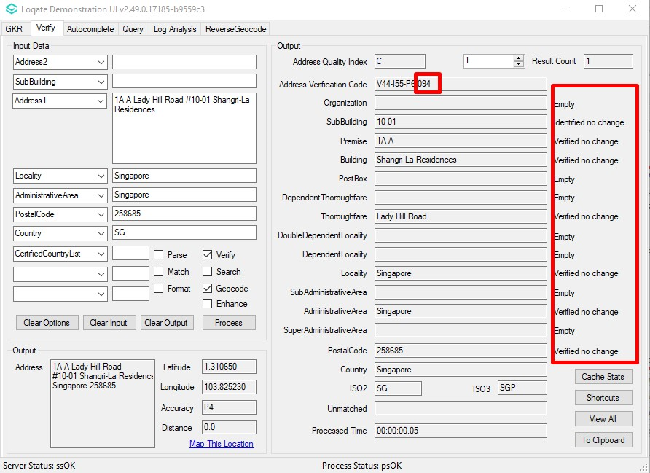 |  |  | 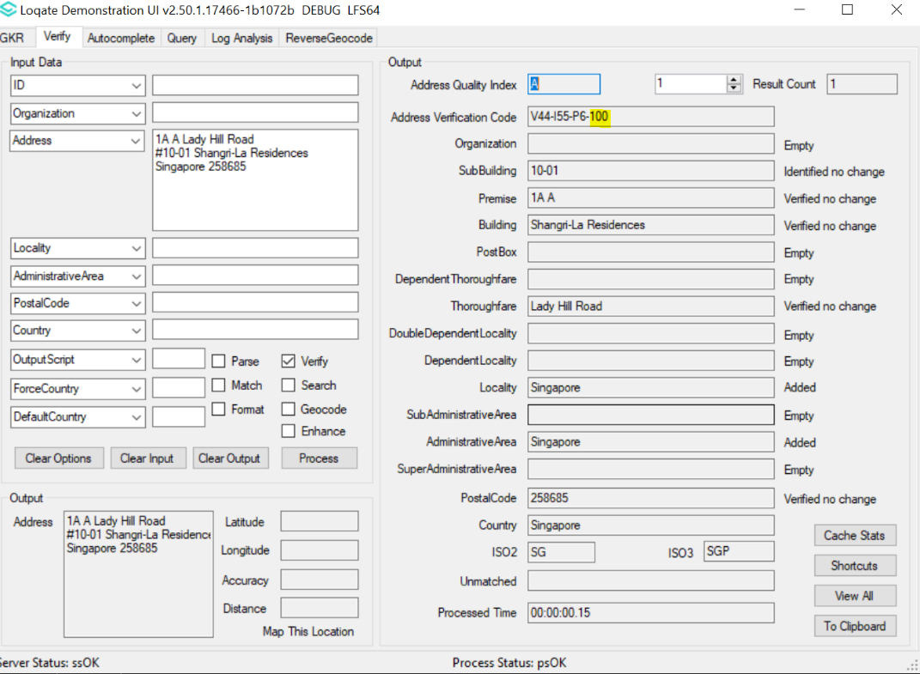

Installation Instructions
Please remember to update both the program files and the reference data and please install these to a new fresh folder location. The improvements are tied to the data in the Global Knowledge Repository and the Local API. When updating the data, it is recommended to use a new data folder each time to ensure the latest dataset is installed properly.

If you need any assistance with the upgrade of the Local API or the data update process, please contact GBG Loqate Support.

The setup wizard for the Local API can be obtained from our SFTP server. Please contact your account manager to retrieve the SFTP information. If you do not know who your account manager is, please contact the support team at LoqateSupport@gbgplc.com.

