Loqate, A GBG Solution

Release Notes – Verify API - 2024Q1.1 Minor Release

Case Resolutions
Please visit the resolved cases page for a list of all cases resolved in this release. If you would like more details on any of the solved cases listed, please contact LoqateSupport@gbgplc.com for further information.

Local API Notices
This is to inform our customers that in this 2024Q1.1 release there is a new API version - 2.50.1.17434-5fa37a5 - that contains the following case fixes below.

Case Number | Change Description | Country
Internal | Changed SERP/CASS to use AddressLineSeparator server option. | US & CA
CAS-113127-D7Z2T7 | Add new format exception for an empty format field | All

Local API Improvements

Case Number | Change Description |  | Category | Country | Example Address
Internal | Changed SERP/CASS to use AddressLineSeparator server option. |  | API | CAN/USA | address1: "4005 Vial RD 90909090",  address2: "Park Dr 2110",  locality: "Richmond",  administrativeArea: "VA",  postalCode: "23234-2460",  country: "CAN"
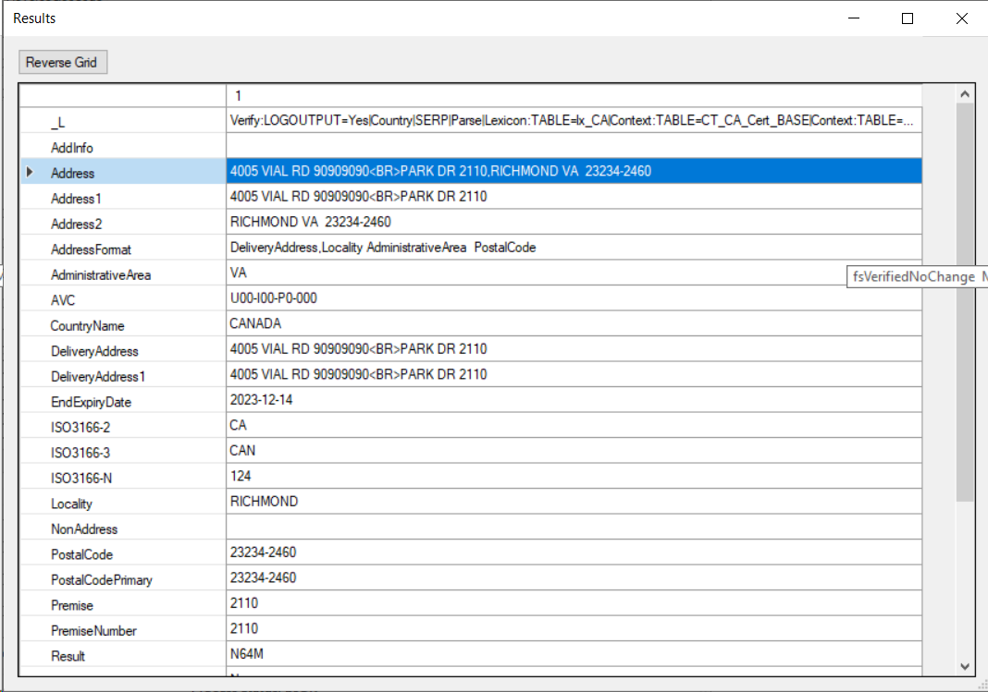 |  | 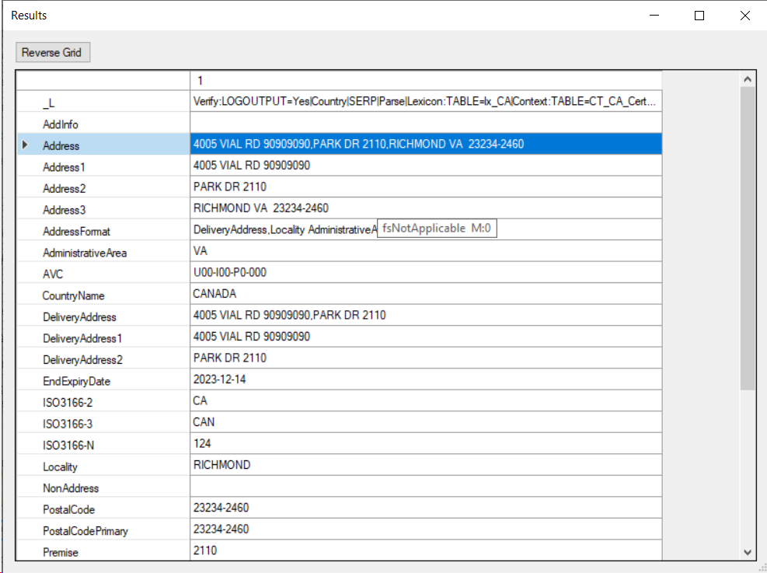

Case Number | Change Description | Category | Country | Example Address
CAS-113127-D7Z2T7 | API side added new format exception for empty format field, after set up of new format exception into country.txt, the format field is able to set based on rule set in empty format exception | API | All | address: 5 Church Lawn Blennerville  postalcode: V92XPT4  country: IE
Before Image |  |  | After Image
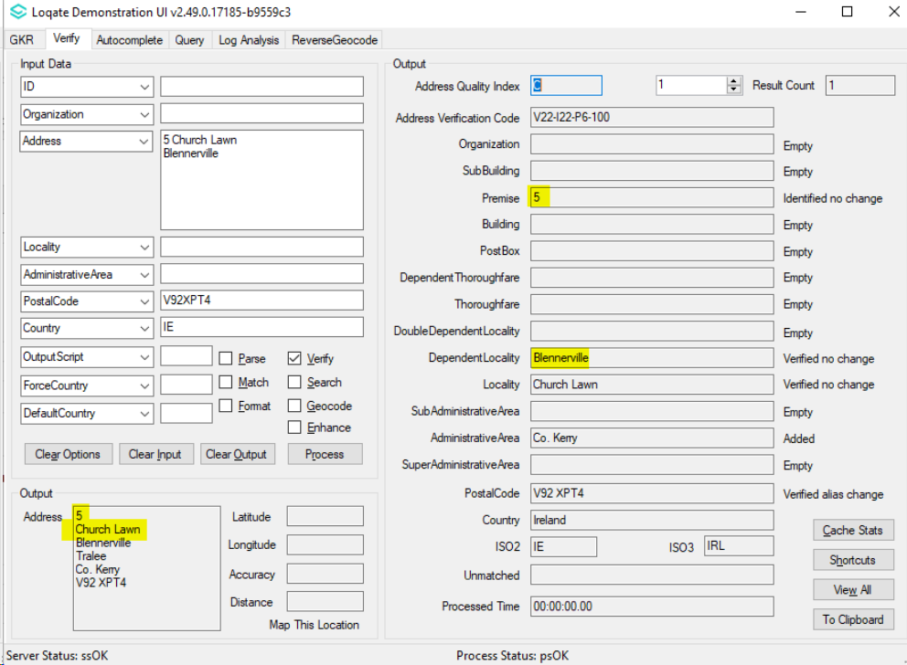 |  |  | 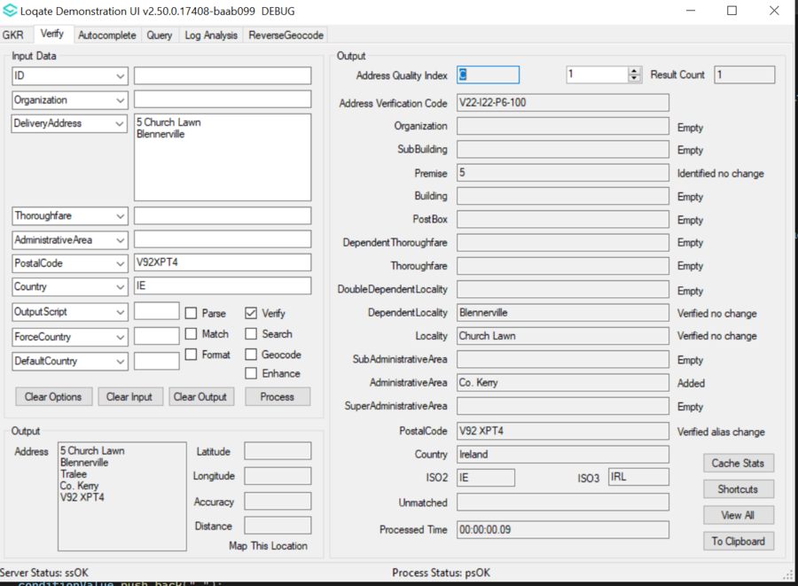

Installation Instructions
If you need any assistance with the upgrade of the Local API or the data update process, please contact GBG Loqate Support.

The setup wizard for the Local API can be obtained from our SFTP server. Please contact your account manager to retrieve the SFTP information. If you do not know who your account manager is, please contact the support team at LoqateSupport@gbgplc.com.

