Data Release Notes

Reference Data & Knowledge Base – 202403
March 2024
Contents
Data Release Notes 1
Country Rebuild / Major Highlights 3
Summary 3
Country Refreshes 3
Case resolutions 4
Summary 4
Details of Case fixes 5

Country Rebuild / Major Highlights
Countries below have notable changes that go beyond just a normal refresh. Details are provided below.

Summary
Country | ISO2 | Description
Germany | DE | Country Rebuild (source replacement)

Country Refreshes
Data in these countries has been updated with the latest available address data.
Country | ISO2 | Remarks
Australia | AU | Country Refresh
Austria | AT | Country Refresh
Belgium | BE | Country Refresh
Canada | CA | Country Refresh
Denmark | DK | Country Refresh
Estonia | EE | Country Refresh
France | FR | Country Refresh
Germany | DE | Country Refresh
Guernsey | GG | Country Refresh
India | IN | Country Rebuild
Indonesia | ID | Country Refresh
Isle of Man | IM | Country Refresh
Jersey | JE | Country Refresh
Norway | NO | Country Refresh
Singapore | SG | Country Refresh
South Korea | KR | Country Refresh
Spain | ES | Country Refresh
Sweden | SE | Country Refresh
Switzerland | CH | Country Refresh
Ukraine | UK | Case Resolution
United Kingdom | GB | Country Refresh
United States | US | Country Refresh
Vietnam | VN | Country Refresh

Case resolutions
These are the case fixes that have been resolved in this release.

Summary
Country | Case Number | Remarks
Norway | CAS-112323-L4Y6L7 | Fixed incorrect DependentLocality
Spain | CAS-113135-X5M1G1 | Fixed incorrect parsing between premise and subbuilding field
Spain | CAS-113135-X5M1G1 | Fixed incorrect parsing of Premise
Estonia | CAS-101848-F3Y2L9 | Fixed incorrect AdministrativeArea
Estonia | CAS-101847-T9F0K7 | Fixed incorrect AdministrativeArea
Ukraine | CAS-110721-C1K2H0 | Fixed Cyrillic parsing for ThoroughfareType
Czech Republic | CAS-111397-Y3Q1F7 | Incorrect capitalisation within addresses
Slovakia | CAS-111397-Y3Q1F7 | Fixed incorrect capitalisation within addresses
United Kingdom | CAS-113321-K8J1T8 | Fixed parsing of subbuilding without input premise
India | CAS-103024-L1R5S6 | Fixed incorrect Locality
Germany | CAS-112455-M2G0N6 | Missing addresses are now present in reference data
Germany | CAS-108338-F0H6X8 | Aligned Capture and Verify locality output
Germany | CAS-112453-P3L9G5 | The premises parse and verify correctly
Germany | Internal | Missing addresses are now present in reference data
Australia | CAS-119345-Z4Q4T5 | Fixed incorrect geocodes

Details of Case fixes
Case Number: CAS-112323-L4Y6L7 - Fixed incorrect DependentLocality
Issue 1 - Input Address:
Address1: Pløens Gate 4
City: Oslo
State: Oslo
PostalCode: 0181
Country: NO
Before
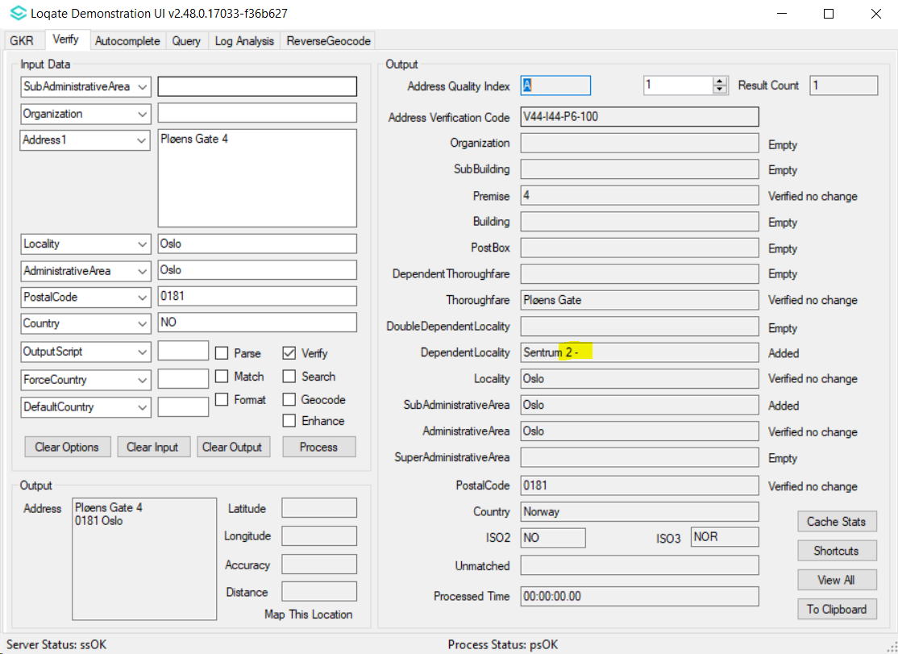
After
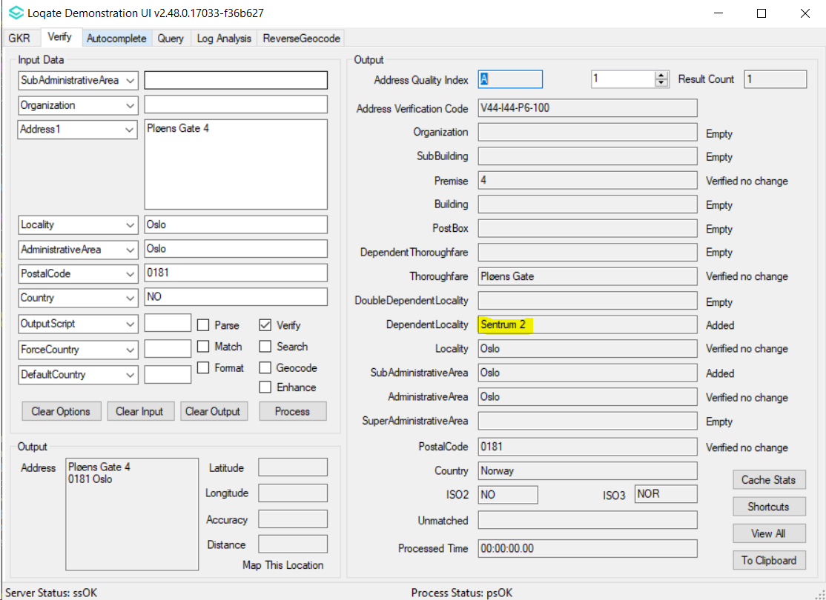
Case Number: CAS-113135-X5M1G1 - Fixed incorrect parsing between premise and SubBuilding
Input Address:
Address1: Avenida Concentración Harley Davidson 4 F 1
Locality: El/Grao, El Grau de Castello
PostalCode: 12100

Before
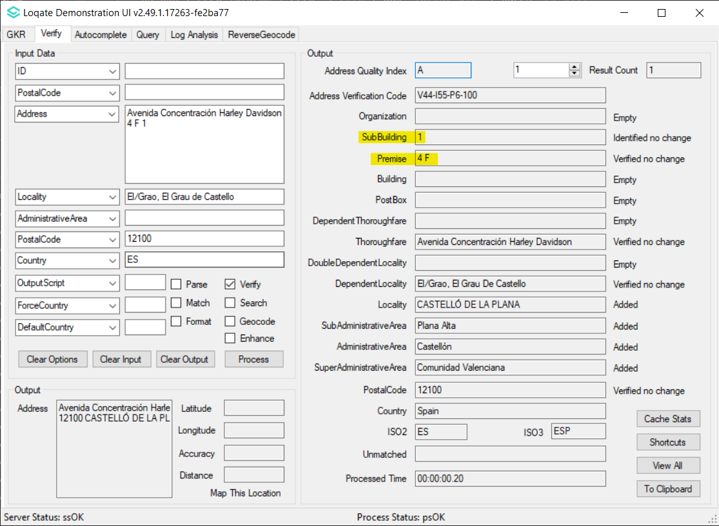
After
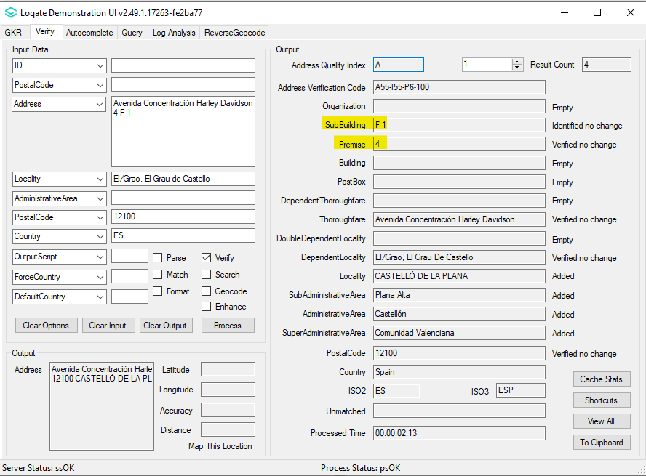

Case Number: CAS-113135-X5M1G1 - Fixed incorrect parsing of Premise
Input Address:

Address1: Calle Profesor Tierno Galván S/N 13
Locality: Granada
PostalCode: 18006
Country: ES

Before
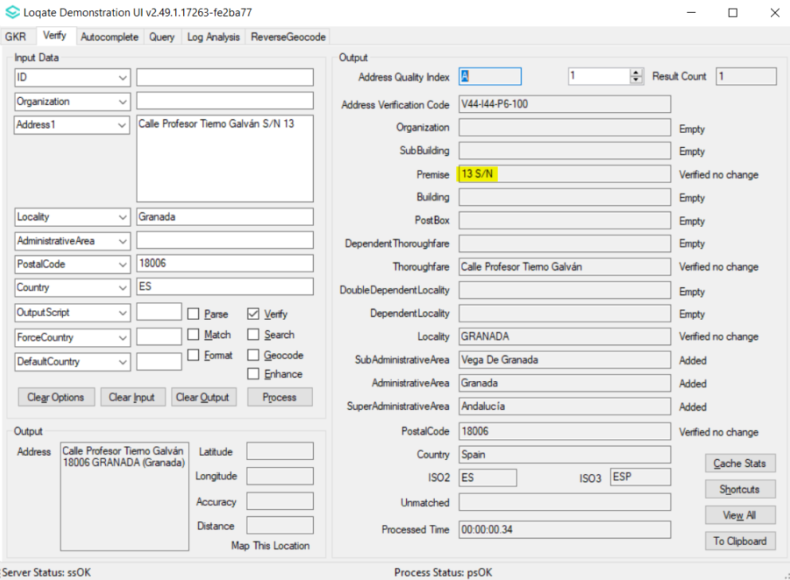

After
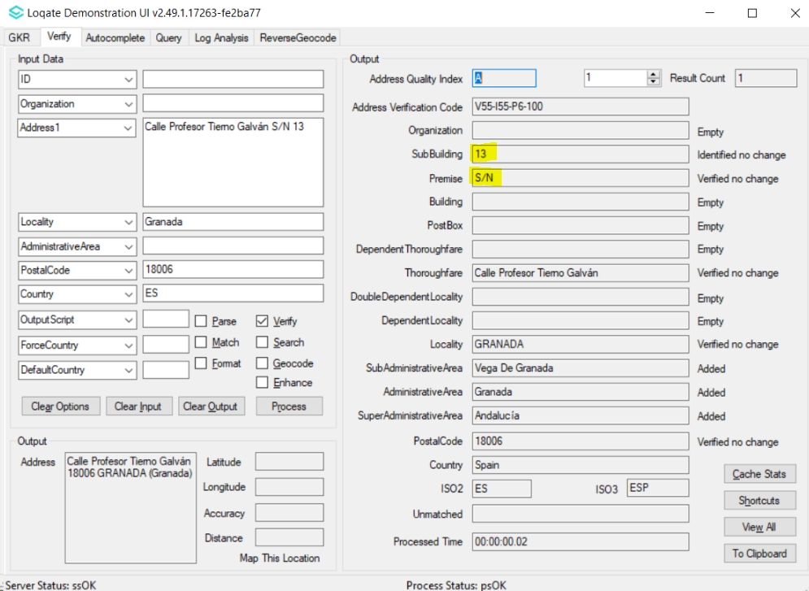
Case Number: CAS-101848-F3Y2L9 - Fixed incorrect AdministrativeArea
Input Address:
Address1: Piiri 2
Locality: Jögeva
AdministrativeArea: EE-49
PostalCode: 48307
Country: EE

Before
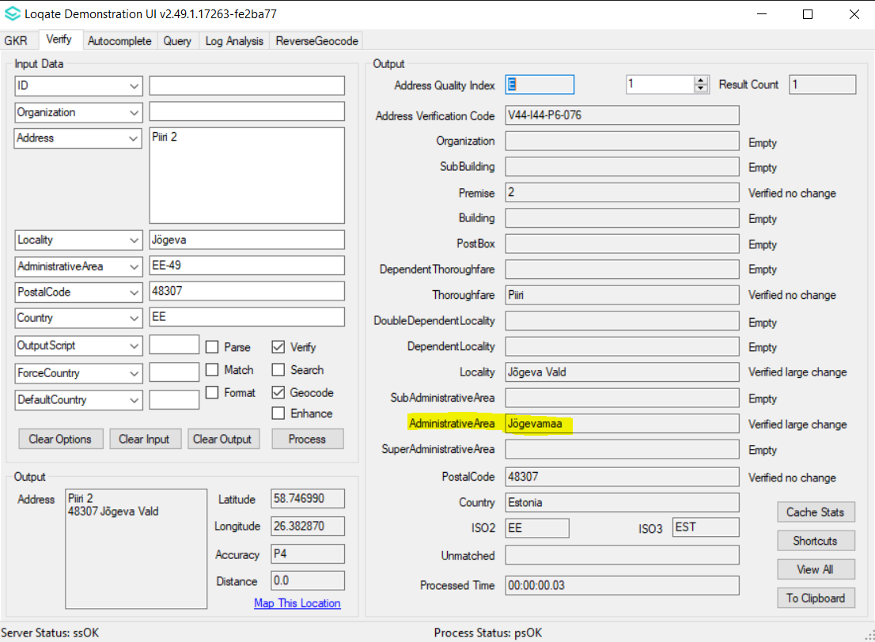
After
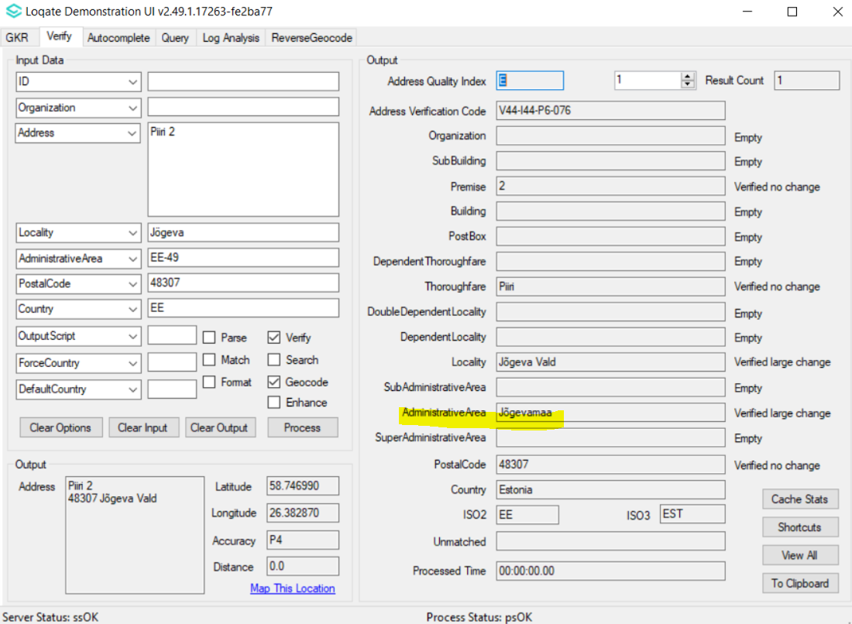
Case Number: CAS-101847-T9F0K7 - Fixed incorrect AdministrativeArea
Input Address:
Address1: Aia 25
Locality: Kuressaare linn
AdministrativeArea: EE-74
PostalCode: 93815
Country: EE

Before
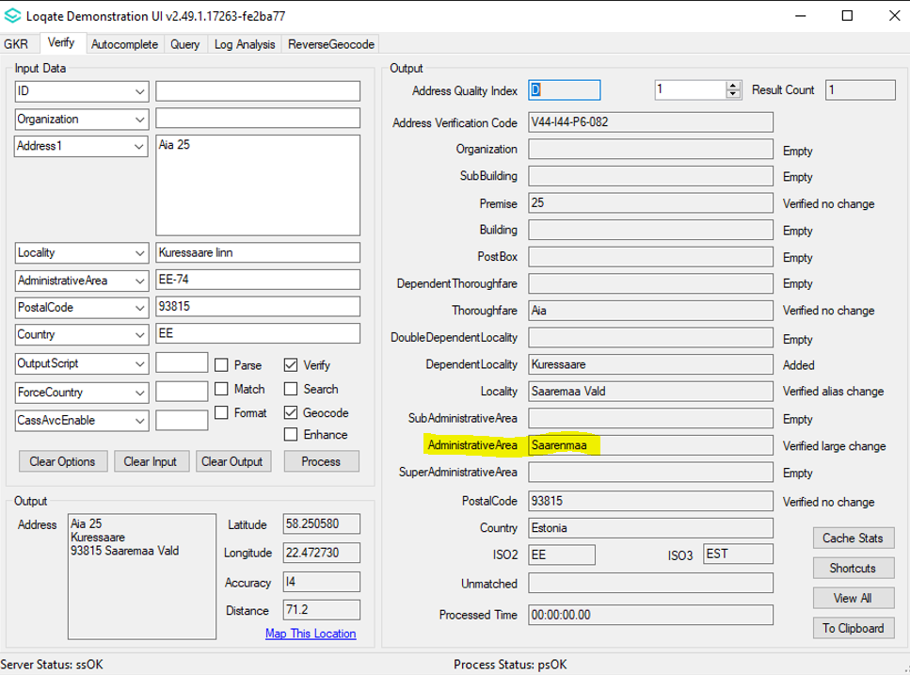
After
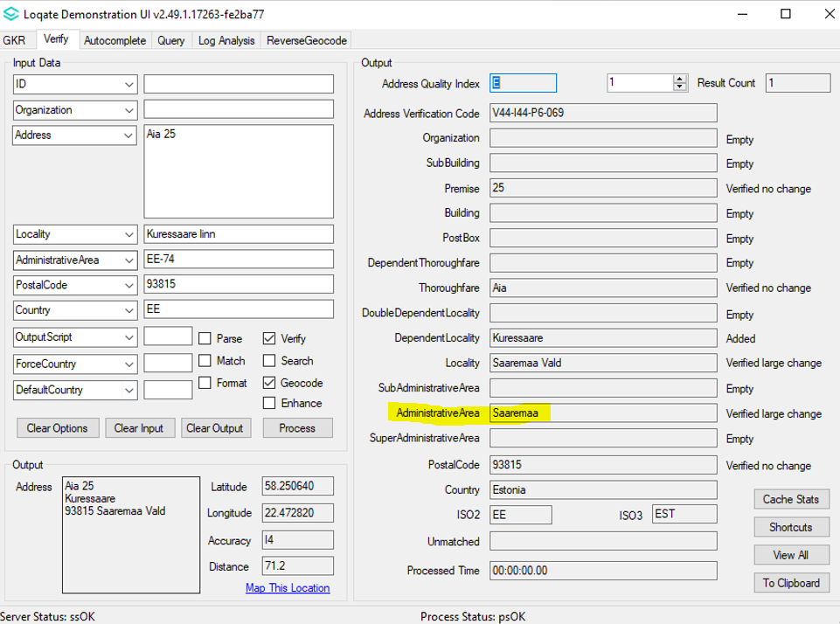
Case Number: CAS-110721-C1K2H0 - Fixed Cyrillic parsing for ThoroughfareType
Input Address:
Address1: вул.Короленко 3
Locality: ДНІПРО
PostalCode: 49000
Country: Україна

Before
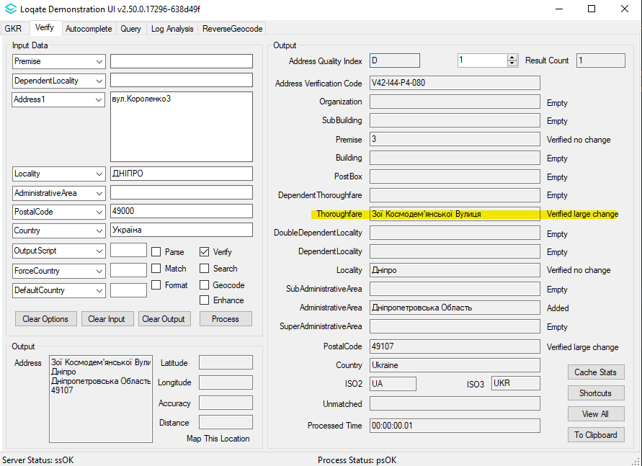
After
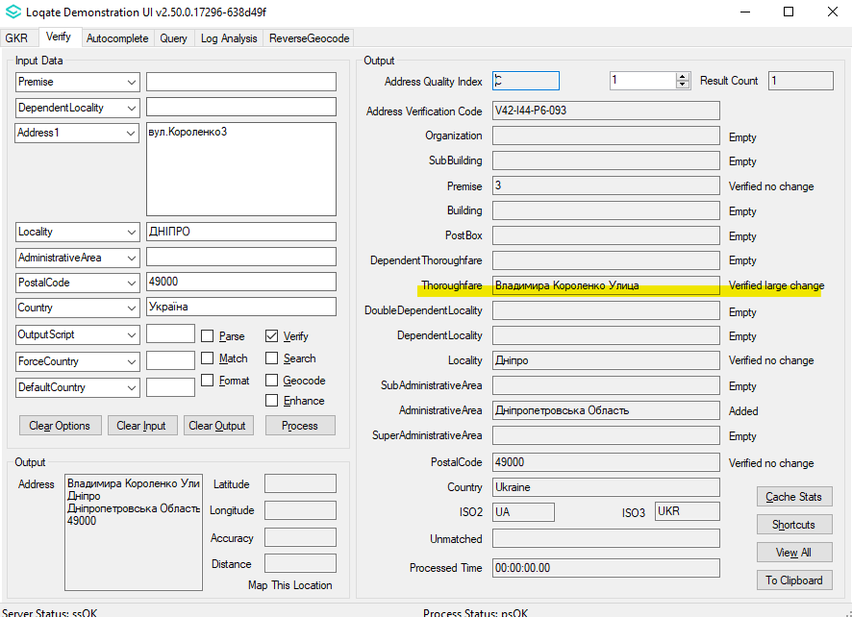

Case Number: CAS-111397-Y3Q1F7 - Fixed incorrect AdministrativeArea
Input Address:
Address: Karlovo náměstí
Locality: Praha
PostalCode: 12000
Country: CZ

Before
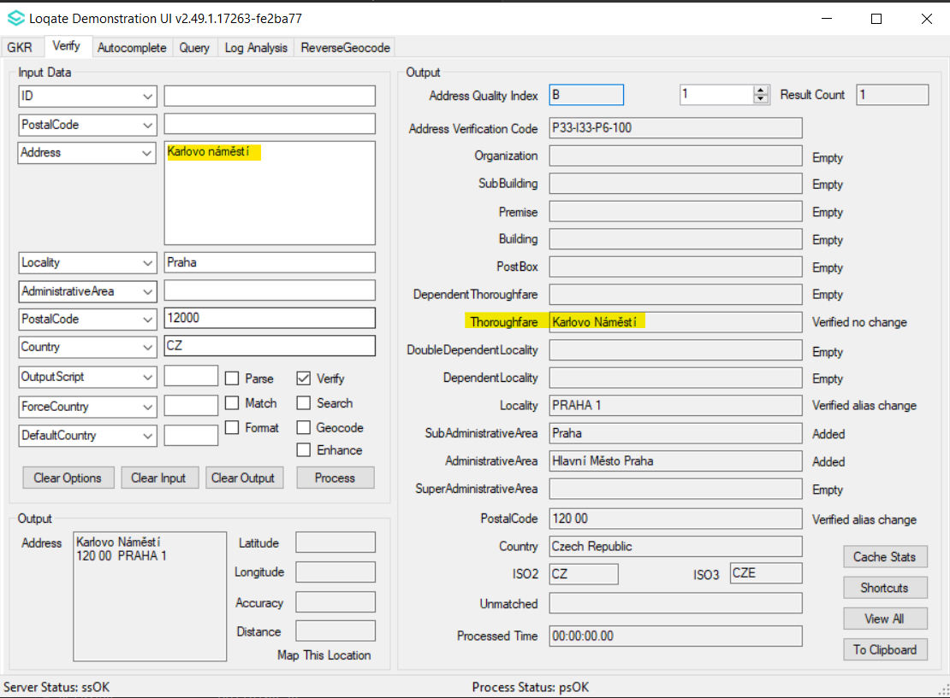
After
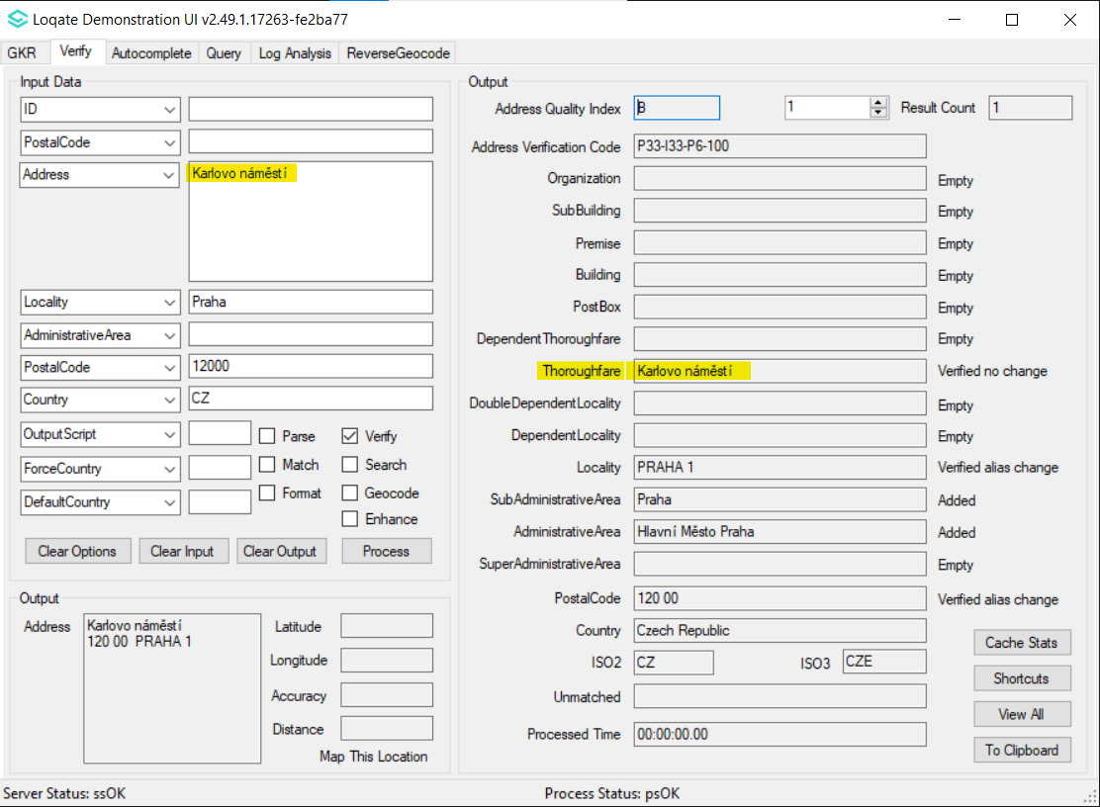
Case Number: CAS-111397-Y3Q1F7 - Fixed incorrect capitalisation within addresses
Input Address:
Address1: Železničná 320, Hliník nad Hronom, 966 01
Country: SK

Before
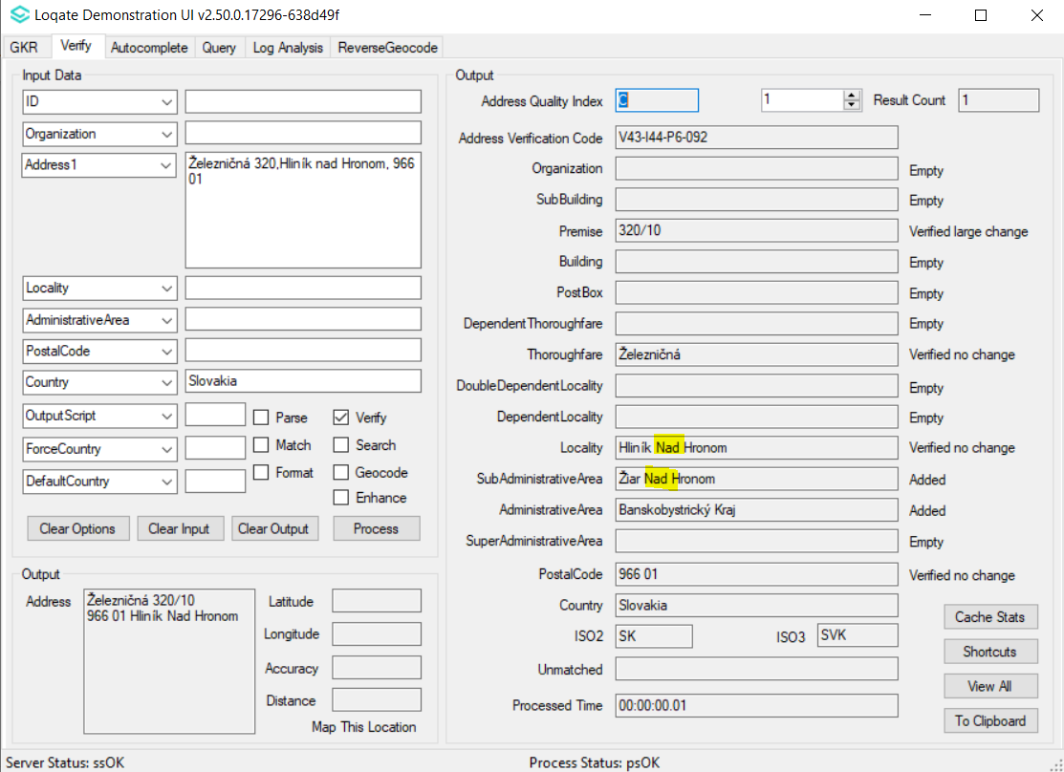
After
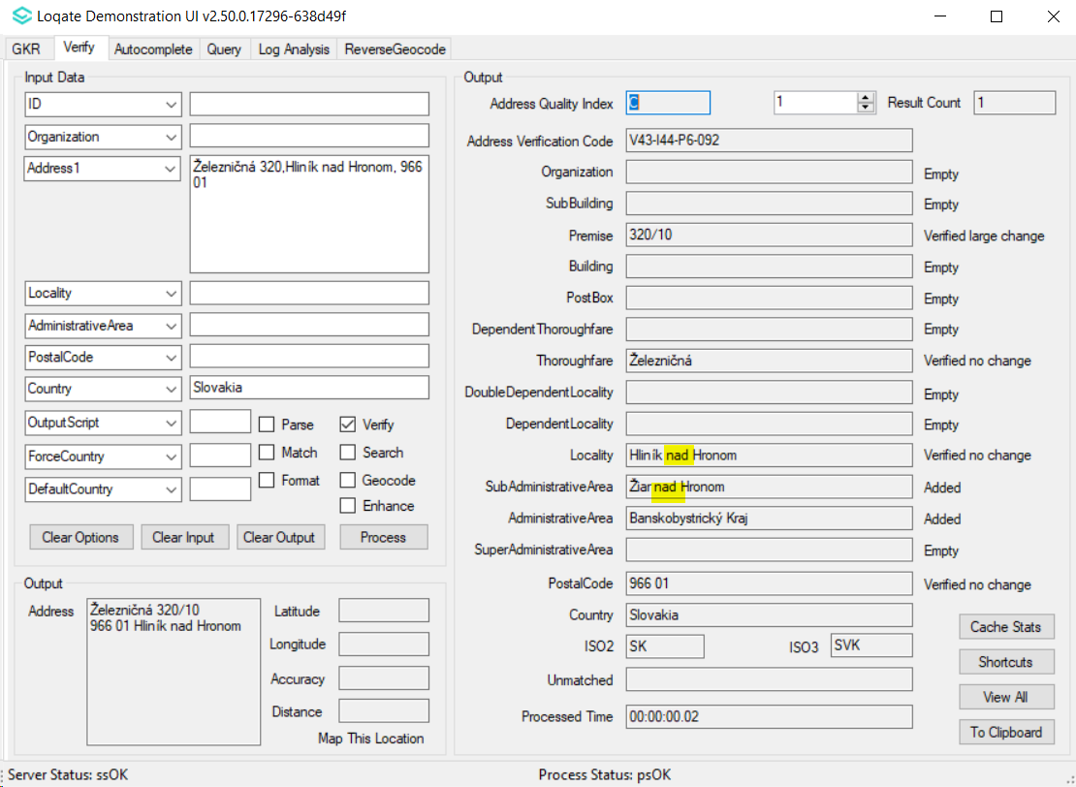

Case Number: CAS-113321-K8J1T8 - Fixed parsing of subbuilding without input premise
Input Address:
Address1: Unit 8-9 Westmoreland Road, London, NW9 9RL
Country: GB

Before
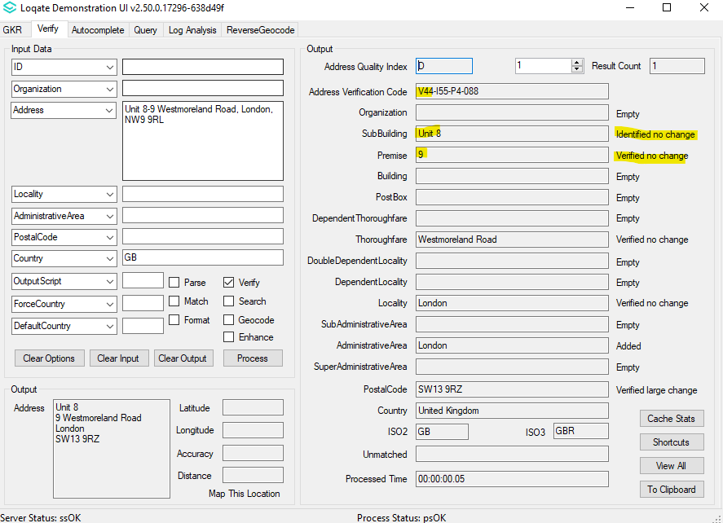
After
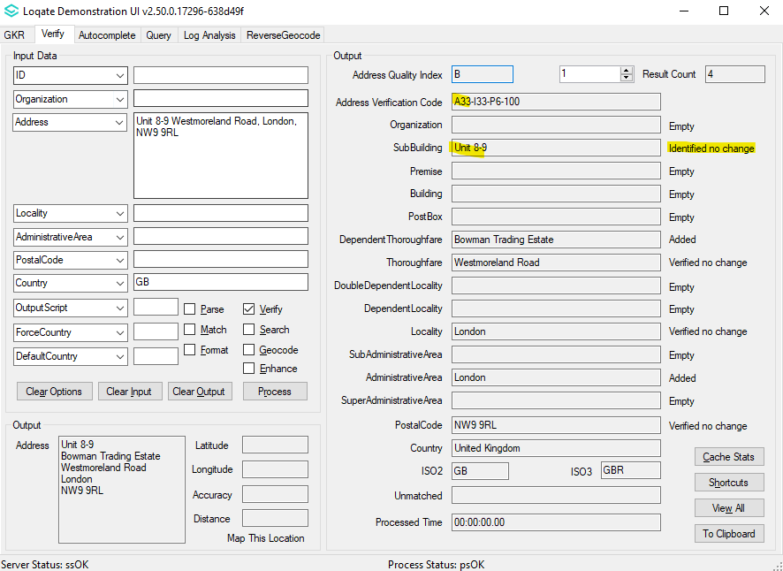

Case Number: CAS-103024-L1R5S6 - Fixed incorrect Locality
Input Address:
Address1: 9, Kaiserbagh, Lucknow
Locality: Lucknow
AdministrativeArea: IN-UP
Postal Code: 226001
Country: IN

Before
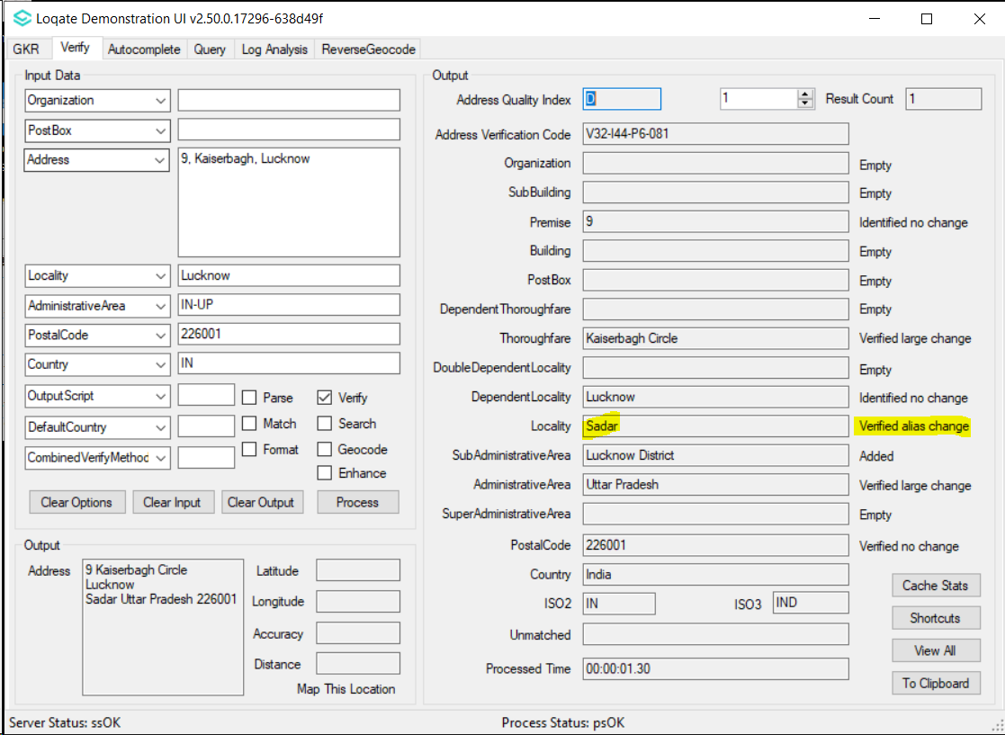
After
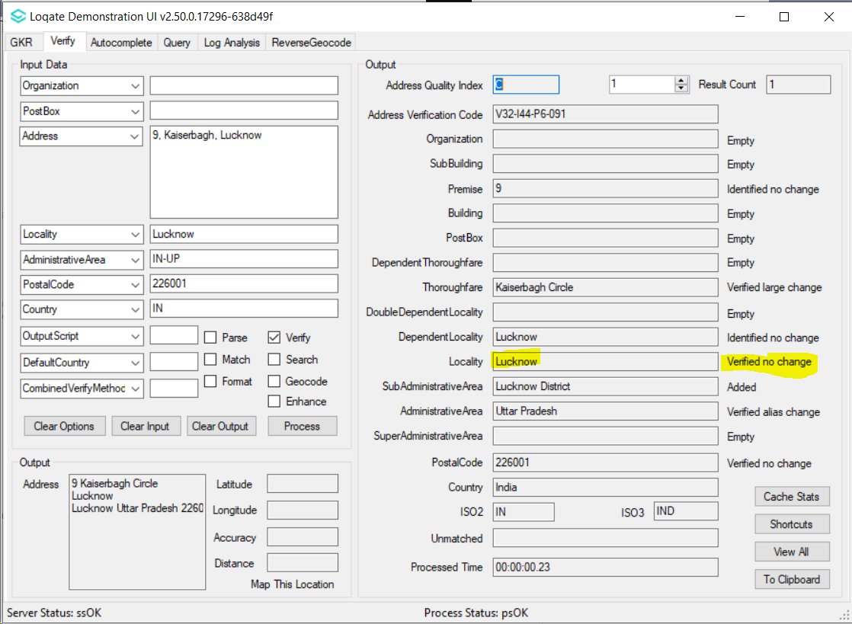
Case Number: CAS-119345-Z4Q4T5- Fixed incorrect geocodes
Input Address:
Address1: Shop 1/69 Dunmore St
Address2: Wentworthville NSW 2145
Country: AU

Before
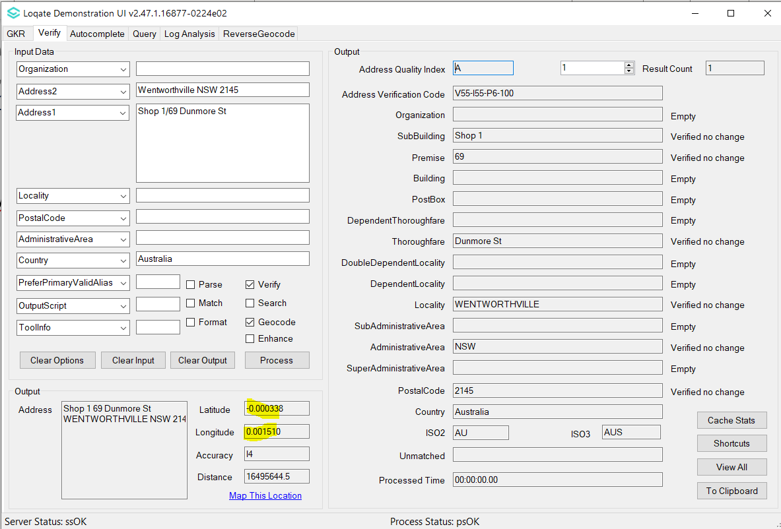

After
