Loqate, A GBG Solution
Release Notes – Verify API

2024Q1.0 Major Release

Case Resolutions
Details of the one customer case resolution and an internal performance improvement are detailed below. If you would like more details on these cases, please contact LoqateSupport@gbgplc.com for further information.

Local API Notice
This is to inform our customers that in 2024Q1.0 release we have made a couple of improvements to the Verify API and our SERP Certify solutions – please see details below.
The latest API version reference included in this release is 2.50.0.17296-638d49f

SERP
There is a new version of SERP libraries for all supported platforms. Please download and install via Install Manger to ensure you get the new SERP module as well as the new runtime dependency vcruntime140_1.dll for Windows 64bit installs.

Local API Improvement
Case Number | Change Description | Country
CAS-102591-V8N7H0 | Changed Country detection to priorities Default Country when specified at the end of the address. | All
Internal | Implement Start/End condition in format fields and improved speed when the field range has very big value ({1*999}). | All

Case Number | Change Description | Category | Country | Example Address
CAS-102591-V8N7H0 | Changed Country detection to prioritize DefaultCountry when specified at the end of the address. | API | ALL | 228 Bushwick ave Brooklyn Kings County, New York 11206 United States
Before Image |  |  | After Image
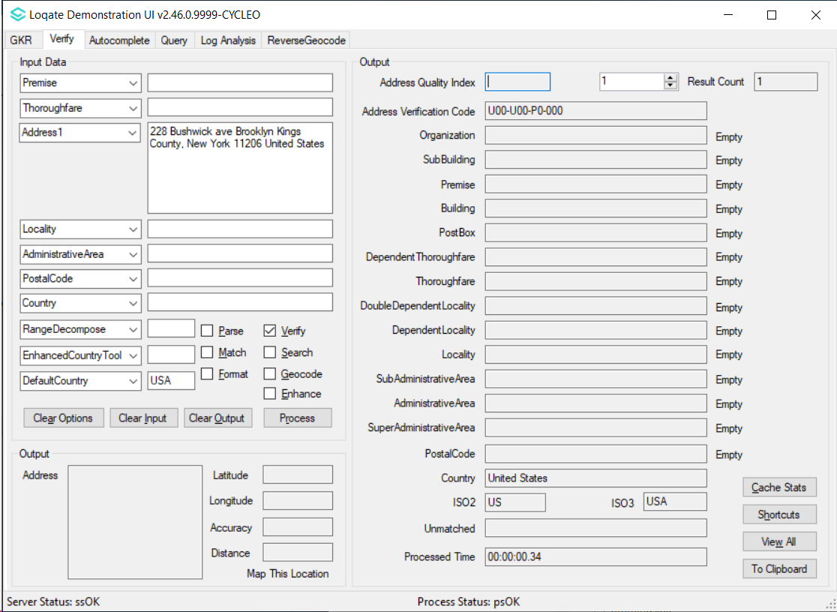 |  |  | 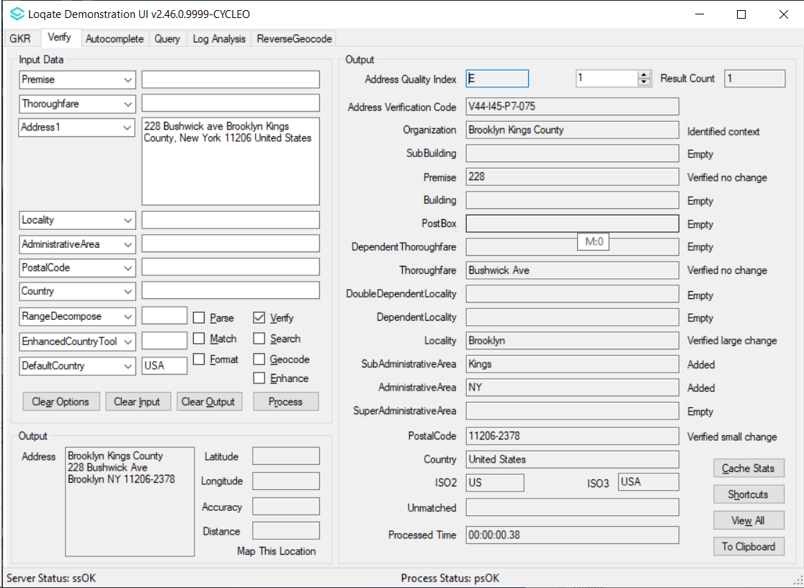

Case Number | Change Description | Category | Country | Example Address
n/a | Implement Start/End condition in format fields and improved speed when the field range has very big value ({1*999}). | API | All | Address =1/45 Narcissus Ave Boronia VIC 3155, AU  FormatExceptions=DeliveryAddress[SubBuilding(Start)-U \{1*999}]:,PostBox;<BR>,Building;<BR>,SubBuildingExtra; ,SubBuildingFloor;<BR>,SubBuilding; ,Premise; ,Thoroughfare;<BR>,DependentThoroughfare;<BR>,DoubleDependentLocality;<BR>,DependentLocality
Before Image |  |  | After Image
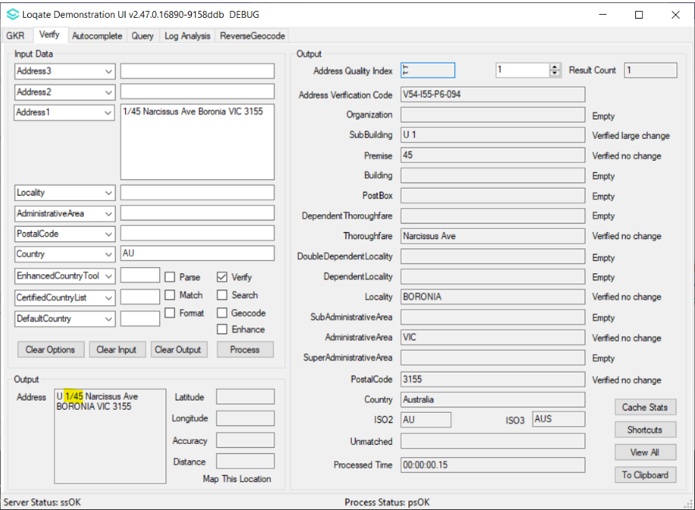 |  |  | 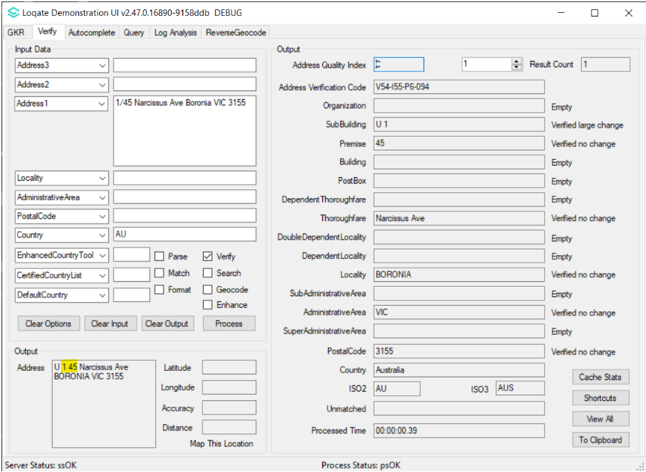

Installation Instructions
Please remember to update both the program files and the reference data and please install these to a new fresh folder location. The improvements are tied to the data in the Global Knowledge Repository and the Local API. When updating the data, it is recommended to use a new data folder each time to ensure the latest dataset is installed properly.

If you need any assistance with the upgrade of the Local API or the data update process, please contact GBG Loqate Support.

The setup wizard for the Local API can be obtained from our SFTP server. Please contact your account manager to retrieve the SFTP information. If you do not know who your account manager is, please contact the support team at LoqateSupport@gbgplc.com.

