Loqate, A GBG Solution
Release Notes – Verify API - 2023Q4.1 Minor Release

Case Resolutions
Please visit https://support.loqate.com/2023q4-1-resolved-cases/ for a list of all cases resolved in this release. If you would like more details on any of the solved cases listed, please contact LoqateSupport@gbgplc.com for further information.

Local API Notices
This is to inform our customers that in this 2023Q4.1 release there is a new API version - 2.49.1.17263-fe2ba77 that contains the following case fixes below.

Case Number | Change Description | Country
CAS-97741-R3S9T1 | Fixed incorrect behavior "S Limestone" vs "South Limestone" | USA
CAS-107909-Z4Z2Y7 | Fixed issue with Geocoding and OutputCasing | GBR/USA
CAS-100414-X1Z0C4 | Fixed parsing fault with "Virginia Beach Blvd" | USA
CASS2 Engine Improvement | Our CASS2 Engine interface with the CASSTM data has been updated in this release to support the fixing of some CASS2 issues. | CASS USA

Local API Improvements

Case Number | Change Description |  | Category | Country | Example Address
CAS-97741-R3S9T1 | The engine should produce the same result for "S Limestone" vs "South Limestone." |  | API | USA | Address1: "740 S Limestone"  Locality: "Lexington"  AdministrativeArea: "KY"  PostalCode: "40536"  Country: "US"
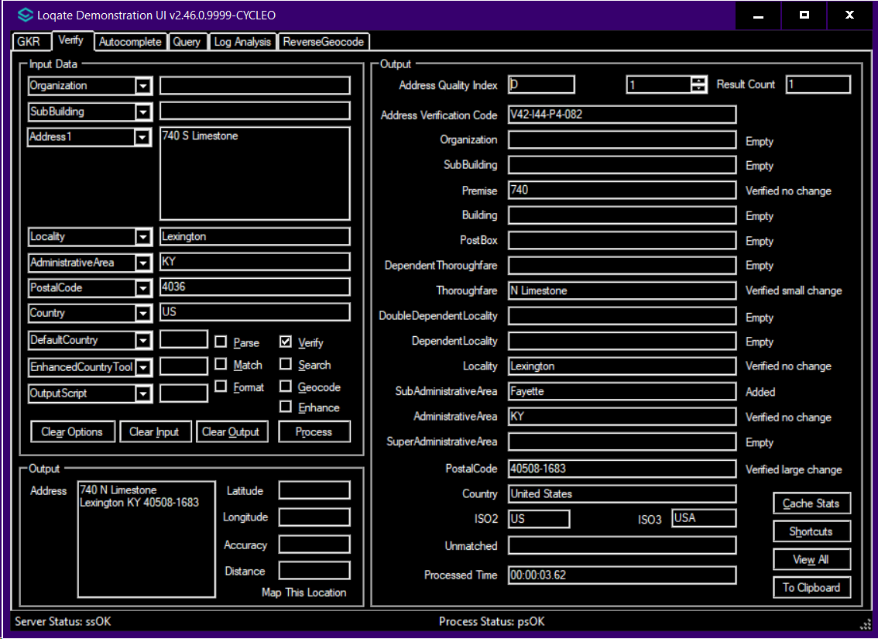 |  | 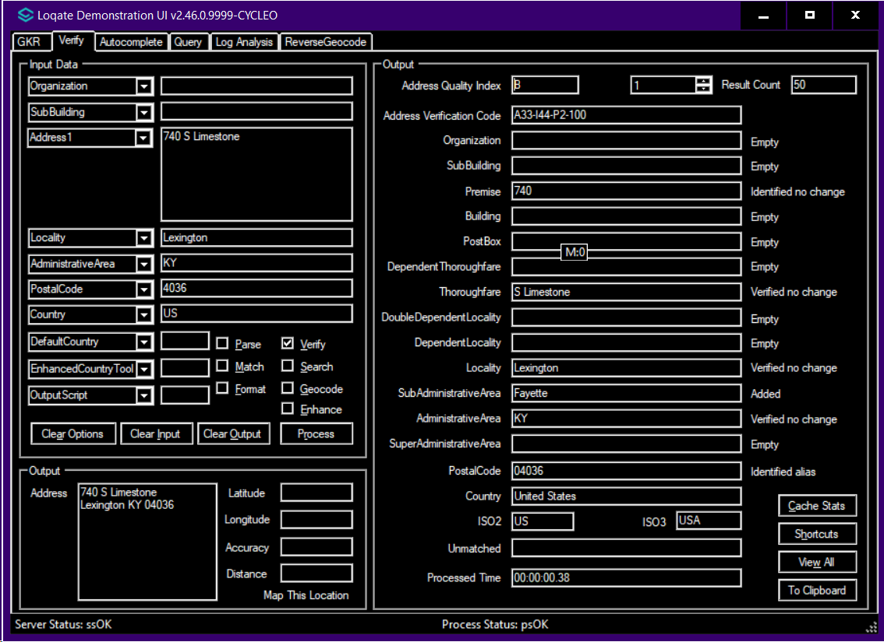

Case Number | Change Description | Category | Country | Example Address
CAS-107909-Z4Z2Y7 | Fixed issue with Geocoding and OutputCasing. | API | GBR/USA | Address1: "FLAT 5"  Address2: "13"  Address3: "DOUGLAS"  Address4: "CIRCULAR ROAD"  Address5: "DOUGLAS"  Country: "GBR"  PostalCode: "IM1 1AF"
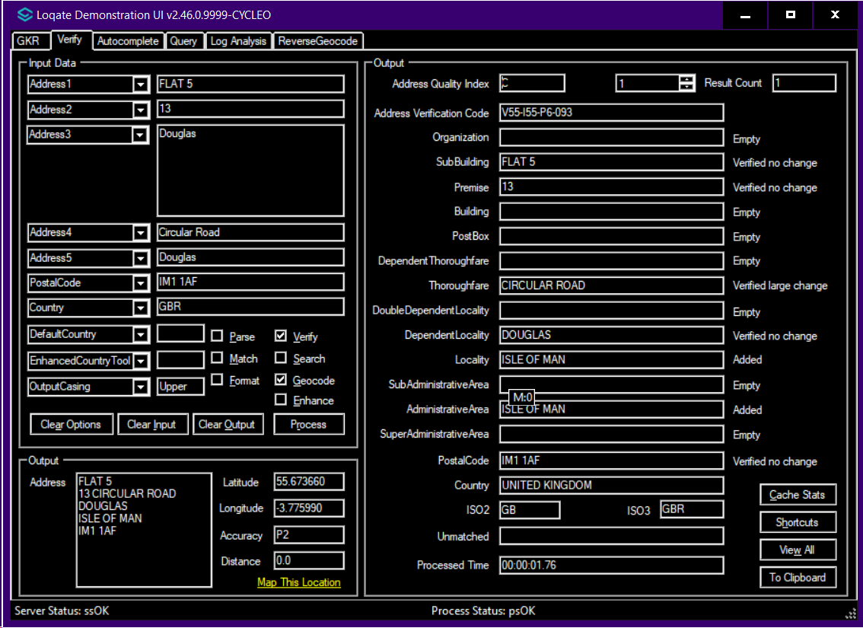 |  |  | 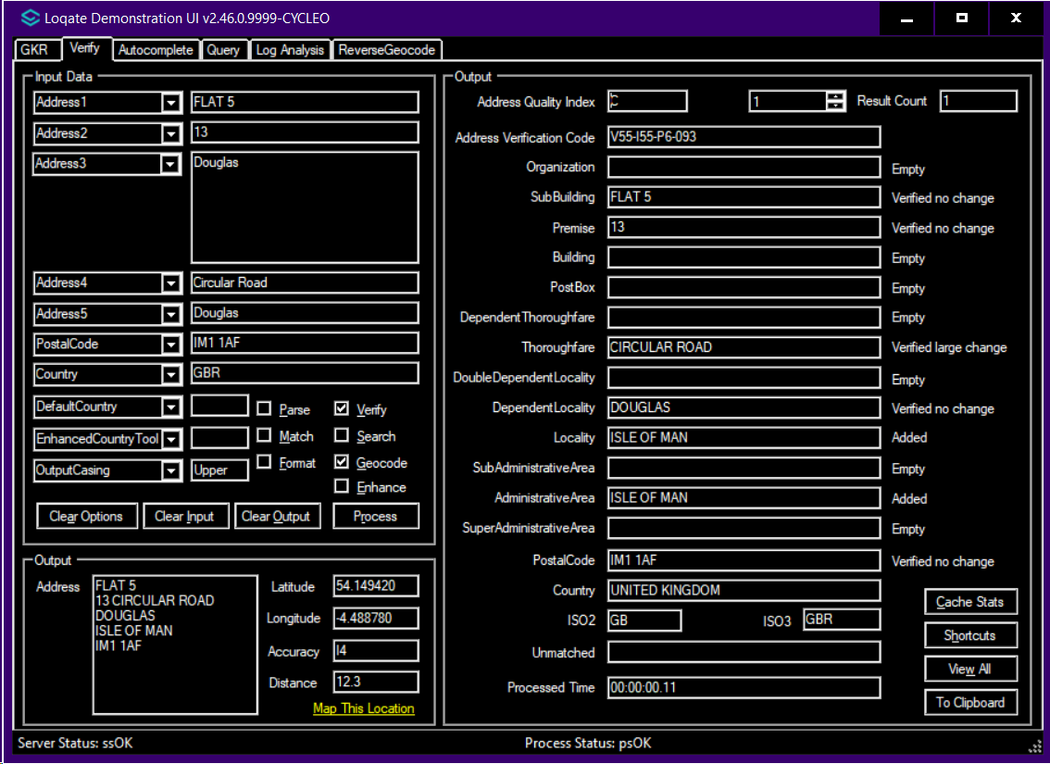

Case Number | Change Description | Category | Country | Example Address
CAS-100414-X1Z0C4 | parsing fault with "Virginia Beach Blvd" | API | USA | 4421 Virginia Beach Blvd Ste 101  Virginia Beach  VA 23462 USA
Before Image |  |  | After Image
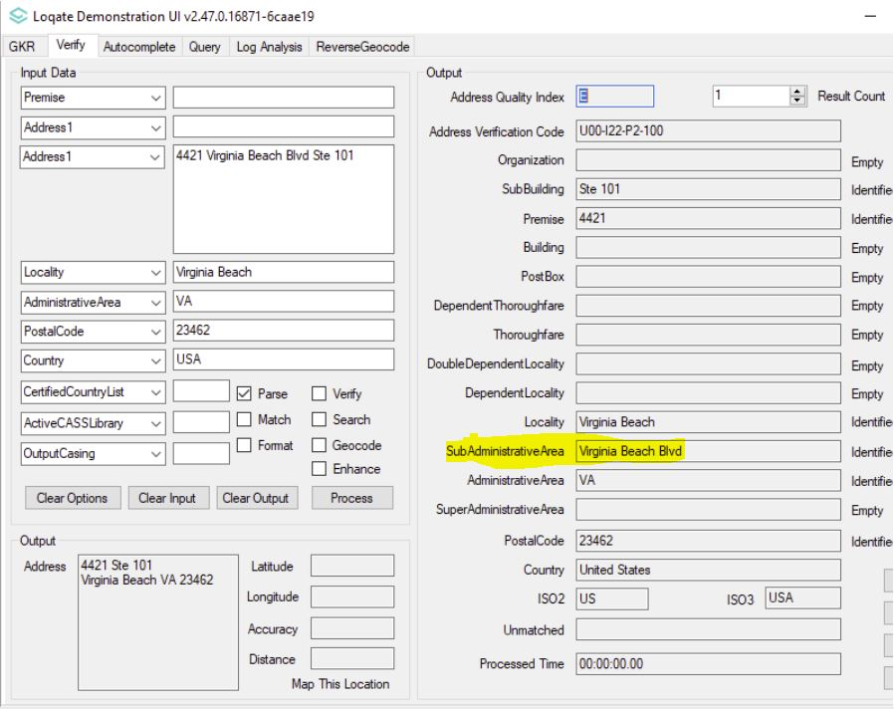 |  |  | 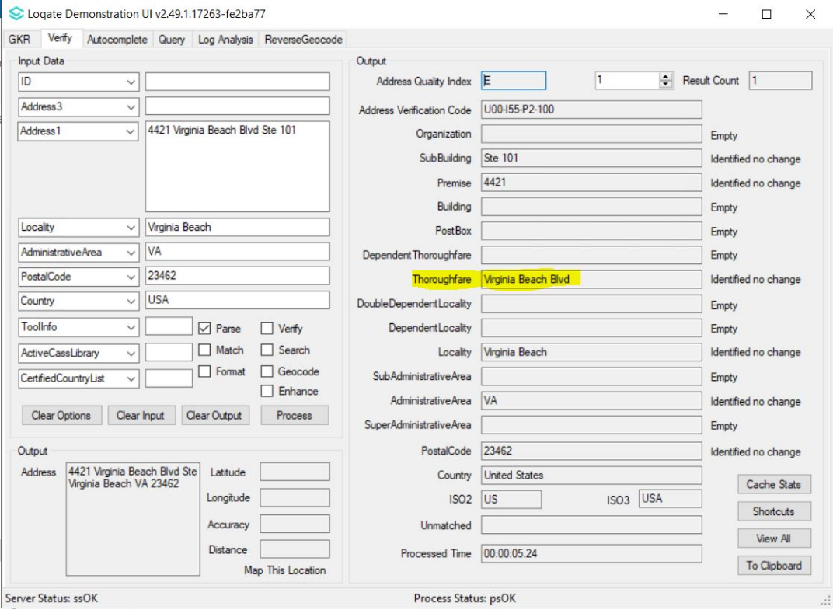

Case Number | Change Description | Category | Country | Example Address
CASS2 Engine Improvement | Our CASS2 Engine interface with the CASSTM data has been updated in this release to support the fixing of some CASS2 issues. | API | USA | 512 Stonewall Dr, Apt 420 D, Jacksonville, AR 72076-3360
Test Address |  |  | After Image
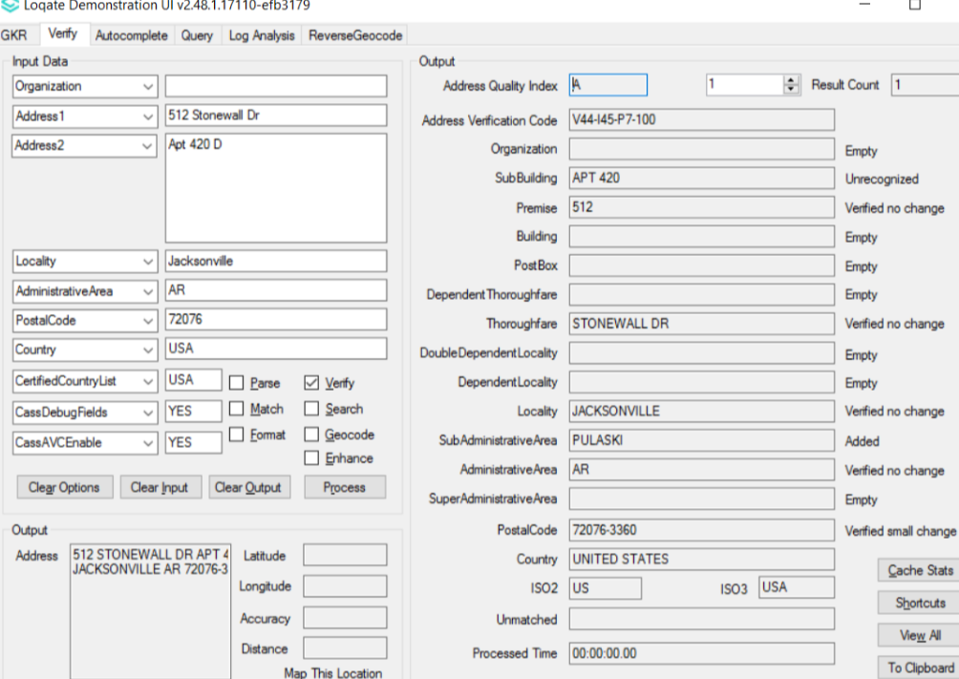 |  |  | Previously did not return AE08 in footnotes – now it is included –  AC10,AC11,AE08,AS02,AS17

Installation Instructions

If you need any assistance with the upgrade of the Local API or the data update process, please contact GBG Loqate Support.

The setup wizard for the Local API can be obtained from our SFTP server. Please contact your account manager to retrieve the SFTP information. If you do not know who your account manager is, please contact the support team at LoqateSupport@gbgplc.com.

