Data Release Notes
Reference Data & Knowledge Base - 202312

Contents
Contents 2
Country Rebuild / Major Highlights 3
Summary 3
Country Refreshes 3
Case resolutions 4
Summary 5
Details 6
Download Instructions 17
Getting new data only. 17
Getting all country data. 17

Country Rebuild / Major Highlights
Countries below have notable changes that go beyond just a normal refresh. Details are provided below.

Summary
Country | ISO2 | Description
Macao | MO | Country Rebuild due to change in data source.
Hong Kong | HK | Country Rebuild due to change in data source.

Country Refreshes
Data in these countries have been updated with latest available address data.
Country | ISO2 | Notes
Argentina | AR
Australia | AU
Austria | AT
Brazil | BR
Bulgaria | BG | Country Refresh | Case Resolution
Canada | CA
Chile | CL
Dominican Republic | DO
Finland | FI
France | FR
Germany | DE
Greece | GR
Italy | IT
Japan | JP
Korea, Republic of | KR | Country Refresh | Case Resolution
Lithuania | LT
Luxembourg | LU
Mexico | MX
Netherlands | NL
Norway | NO
Saudi Arabia | SA
Singapore | SG
South Africa | ZA
Spain | ES
Sweden | SE
Switzerland | CH
Turkey | TR
United Arab Emirates | AE
United Kingdom | GB | Country Refresh | Case Resolution
Belgium | BE | Case Resolution
Hong Kong | HK | Case Resolution
Ireland (Premium) | IE | Case Resolution

Certification Data Expiration Dates
If you have purchased a certification product, please be aware that some of the datasets have expiration dates set by the respective postal authorities. Please ensure that you have the latest library and data installed to avoid loss of service through these products.
Please check Install Manager for the latest versions of our certification data | Loqate Release Date | Certification Expiry Date*
AMAS Data | 2023-09-19 | 2023-12-31
CASS2 Data | 2023-11-01 | 2024-01-31
SERP | 2023-10-03 | No Expiry

For more information on expiry date checking for CASS and AMAS, please refer “Usage expiration” section in https://support.loqate.com/documentation/local-apis/cass-overview-2/ and https://support.loqate.com/address-matching-approval-system-amas/
For SERP there is no forced expiry in the data it just becomes less current the longer you leave it between updates.
Please check using Install Manager to get the latest versions of our certification data.

Case resolutions
These are the case fixes that have been resolved in this release.

Summary
Country | Case Number | Change Description
GB | CAS-109853-G2C6L3 | Improvement in DPS codes return from Verify enhance
IE | CAS-110119-N4J3Q6 | Improvement of PostalCode/EIRCode verification
IE | CAS-110116-B9L7W0 | Improvement of output address format
IE | CAS-110375-G6H5R8 | Improvement of output address format
IE | CAS-110744-M7P1V5 | Improvement of Building and Premise parsing
BE | CAS-111268-W9Z1W9 | Improvement of “Boite” SubBuilding parsing and output address format
HK | CAS-87626-J0V8C6 | Improvement of Building parsing
BG | CAS-107481-F1K1T1 | Improvement of output PostalCode
BE | CAS-112519-C0Y8T3 | Improvement of Throughfare parsing
KR | CAS-98586-N5B0N5 | Improvement of address parsing

Details

Case Number: CAS-109853-G2C6L3
Input Address:
#1 Address1: 46 Chapel Street, Aberdeen, PostalCode: AB10 1SN Country: GB
Before
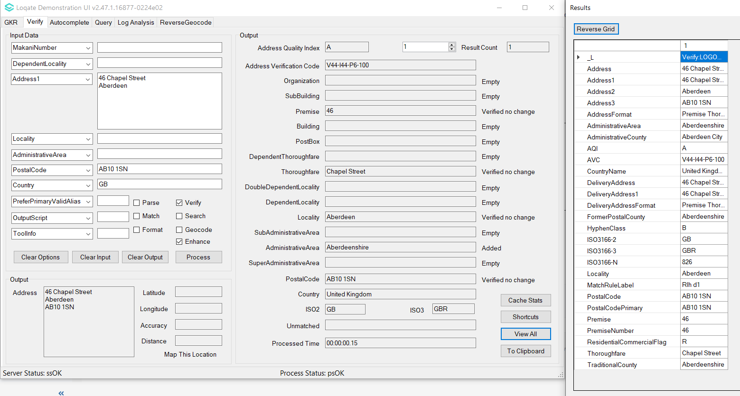
After
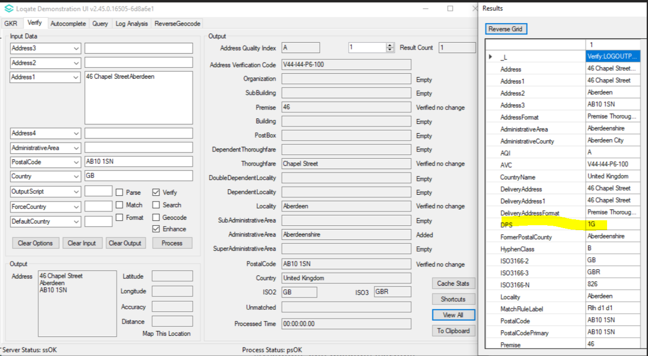

Case Number: CAS-110119-N4J3Q6
Input Address:
#1 Address1: 8 Trafalgar Court, Greystones , PostalCode: A63FY53 Country: IE
Before:
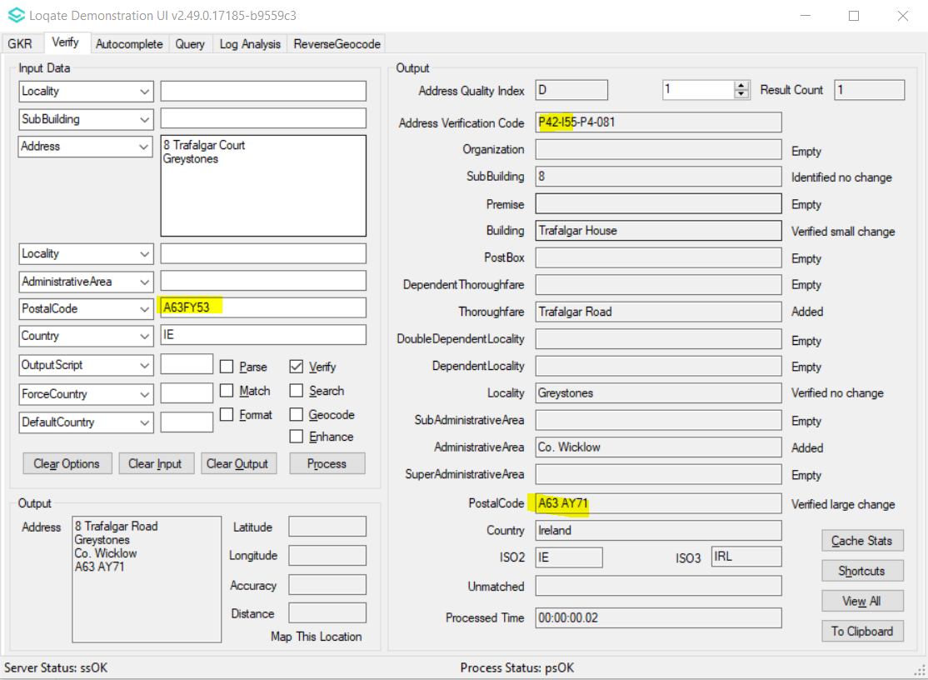
After:
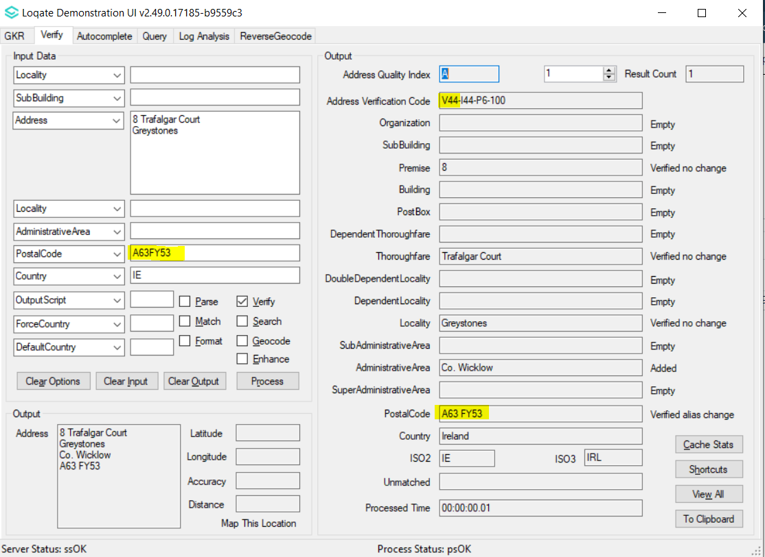

Case Number: CAS-110116-B9L7W0
Input Address:
#1 Address1: Apartment 3, 3 New Row, Portlaoise, PostalCode: R32 XP82 Country: IE
Before:
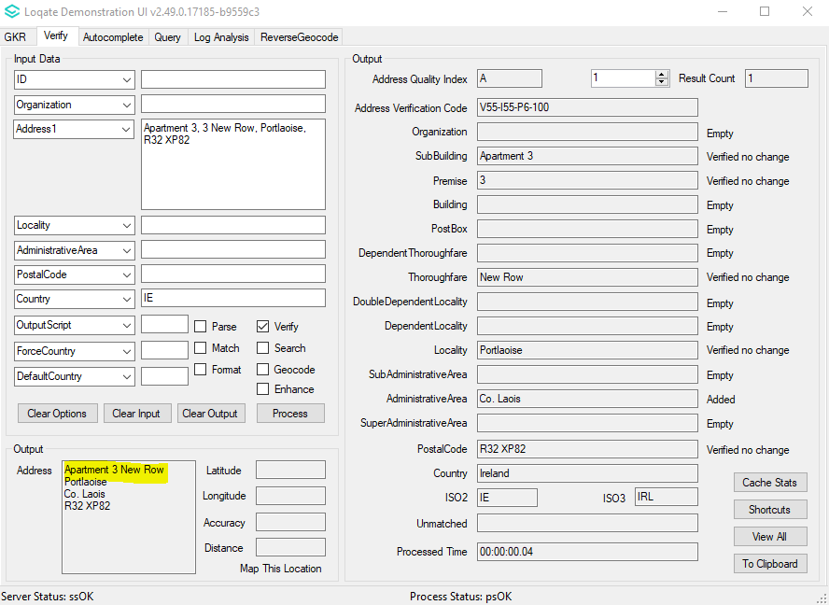
After:
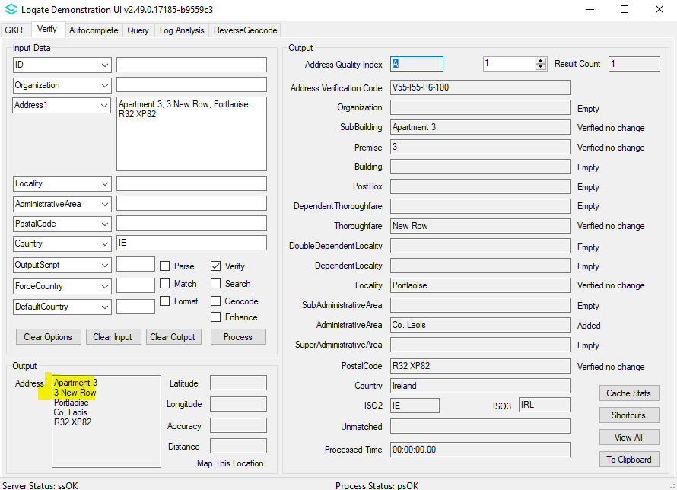

Case Number: CAS-110375-G6H5R8
Input Address:
#1 Address1: LIOS NA GCRANN, GARDINERS HILL, CORK PostalCode: T23 HP6K Country: IE
Before:
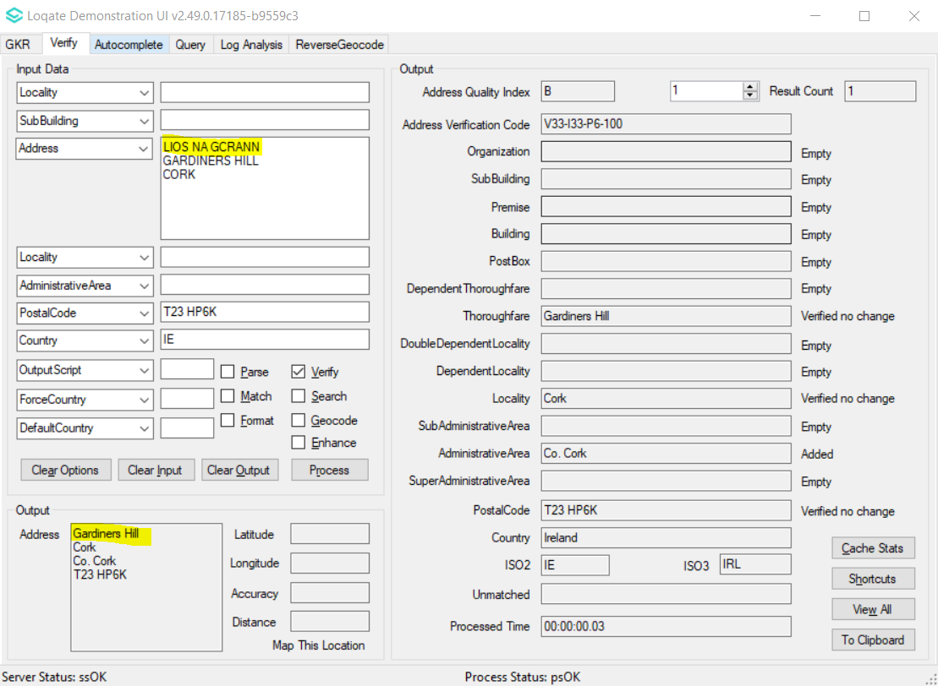
After:
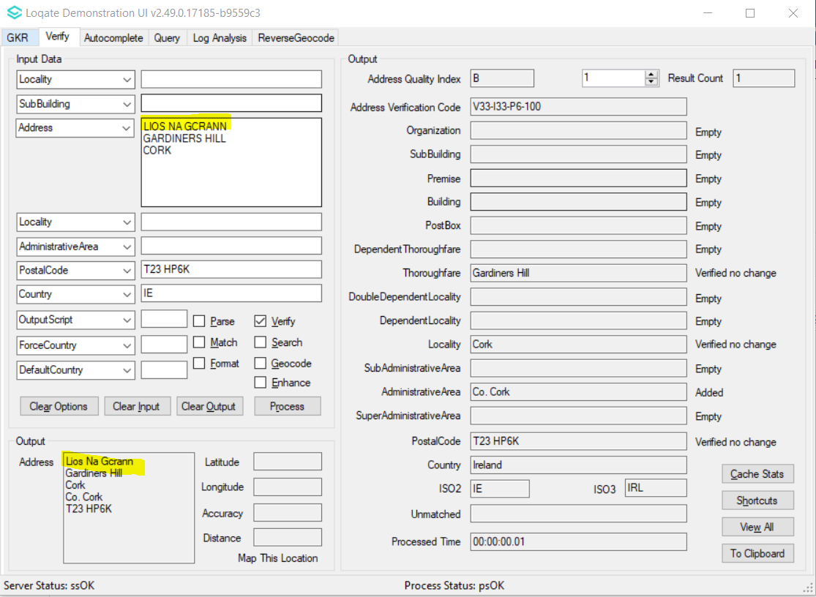
Input Address:
#2 Address1: 3 SAINT PETER’S TERRACE, ATHLONE, CO. WESTMEATH PostalCode: N37 N9C4 Country: IE
Before:
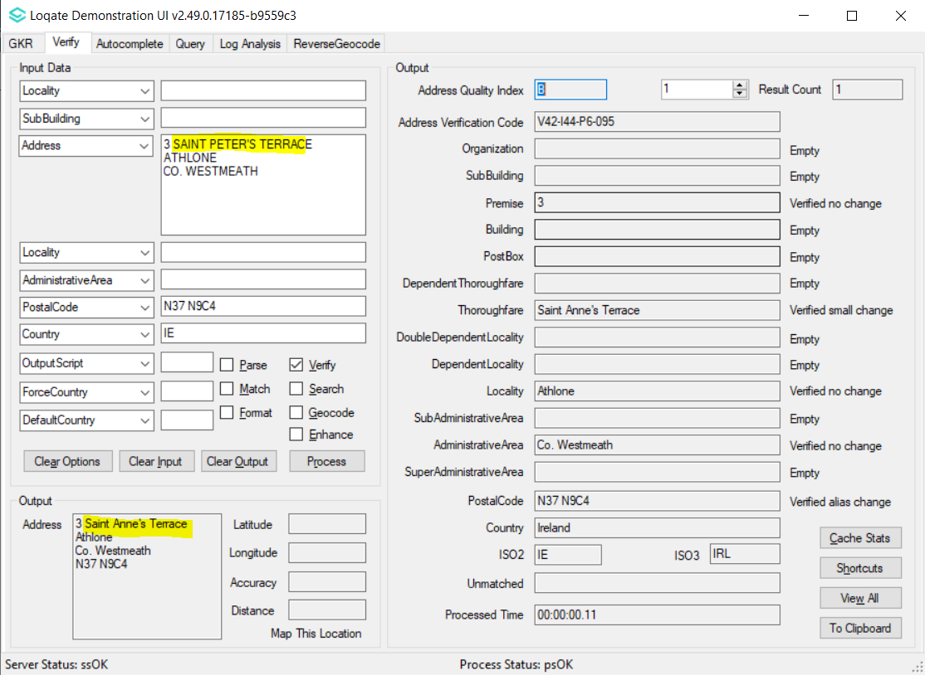
After:
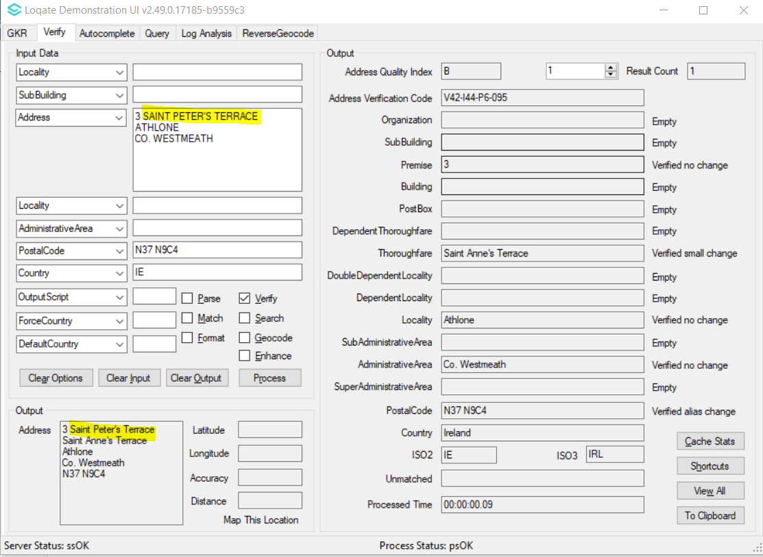

Case Number: CAS-110744-M7P1V5
Input Address:
#1 Address1: Unit2, 57 JKL Street, Edenderry Country: IE
Before:
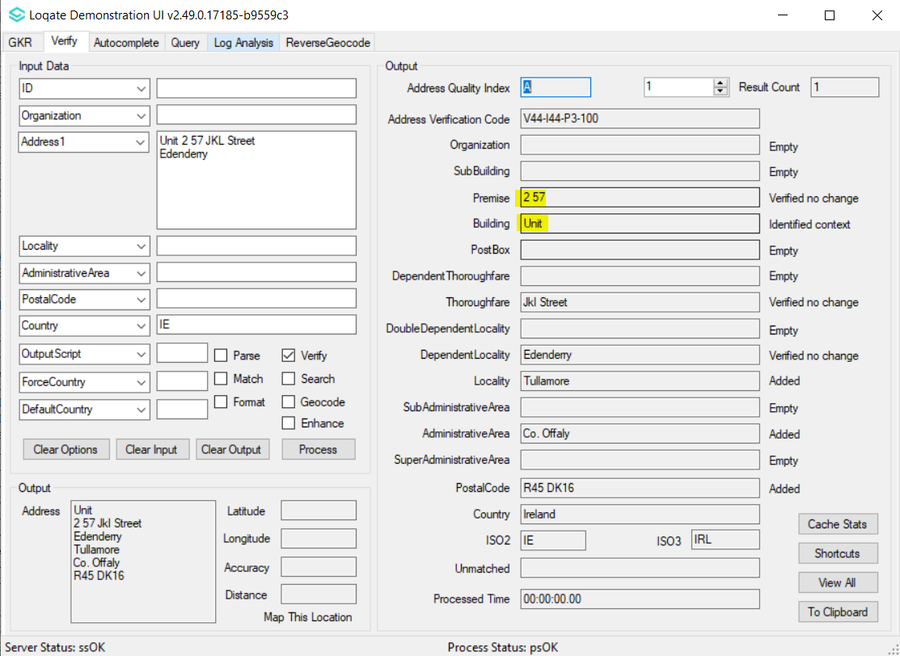
After:
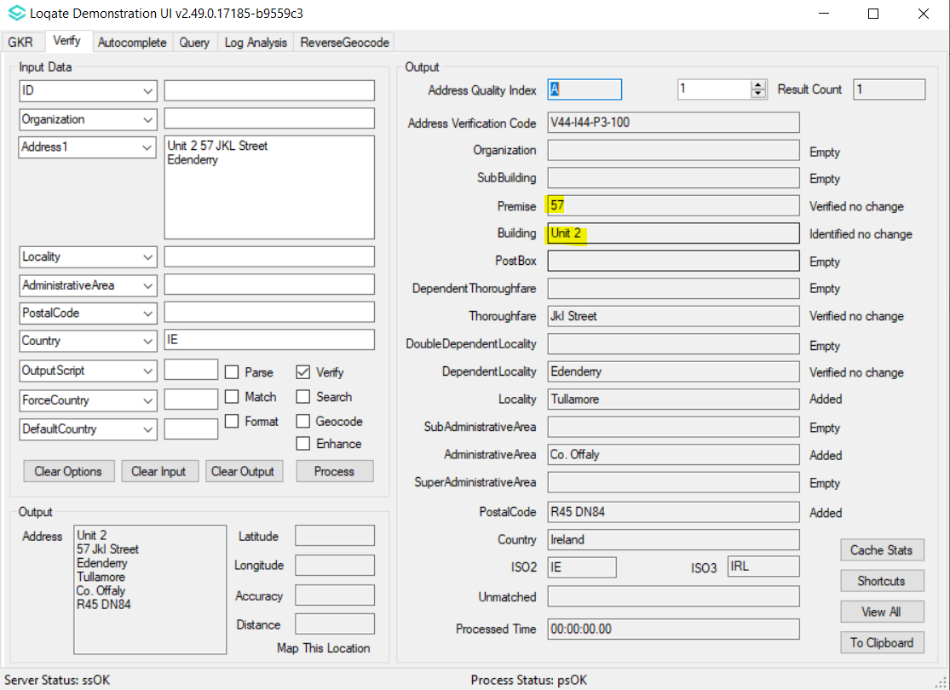

Case Number: CAS-111268-W9Z1W9
Input Address:
#1 Address1: rue de stalle 105 boite 6 Locality: uccle PostalCode: 1180 Country: BE
Before
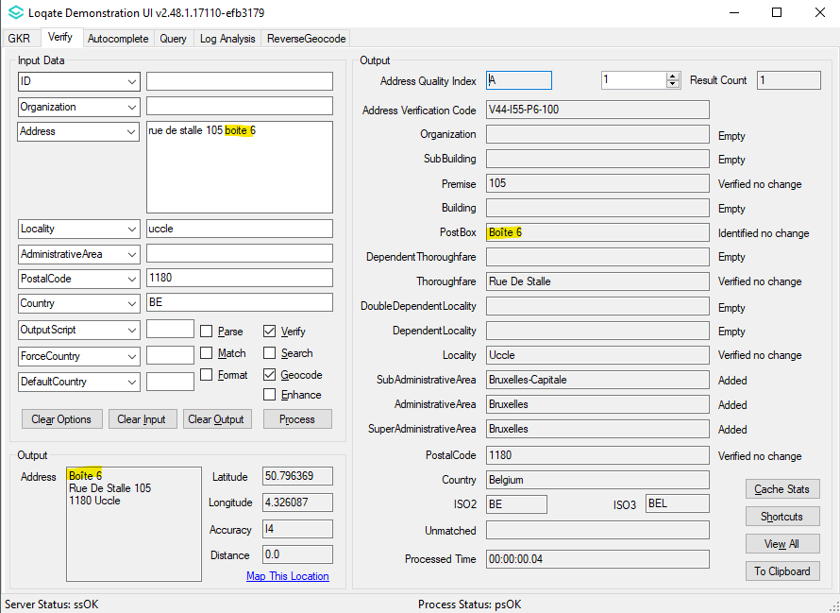
After
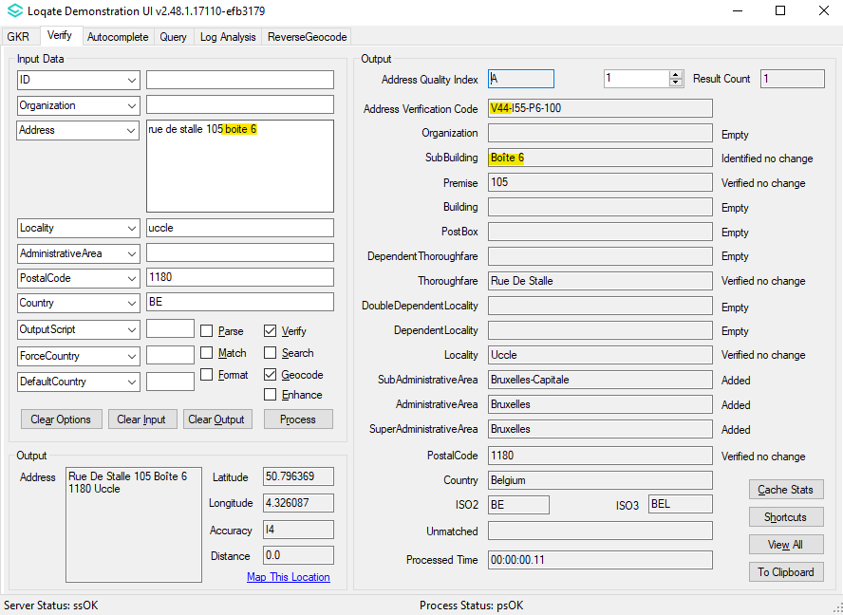

Case Number: CAS-87626-J0V8C6
Input Address:
#1 Address1: Flat 3, 3/F, Block A, 90 Kennedy Road HONG KONG. Country: HK
Before
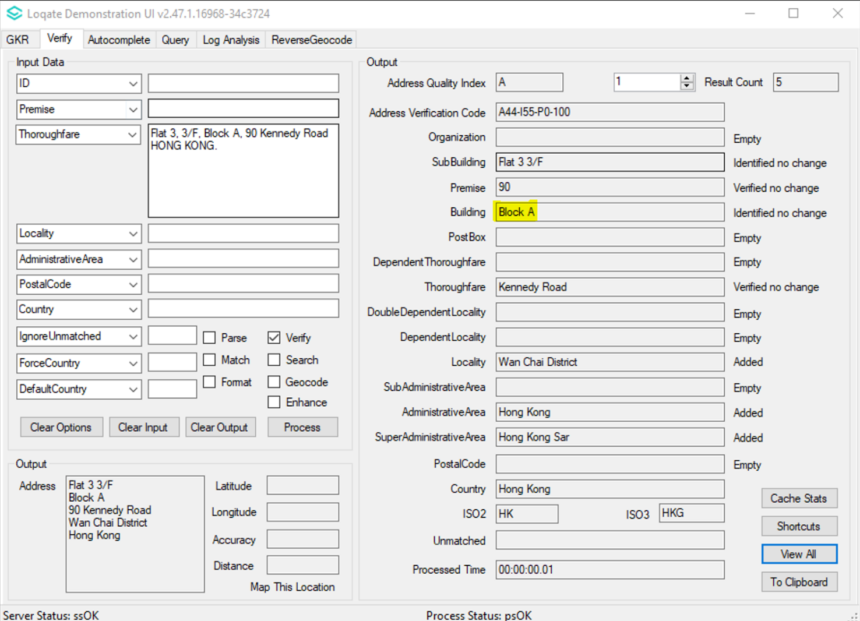
After
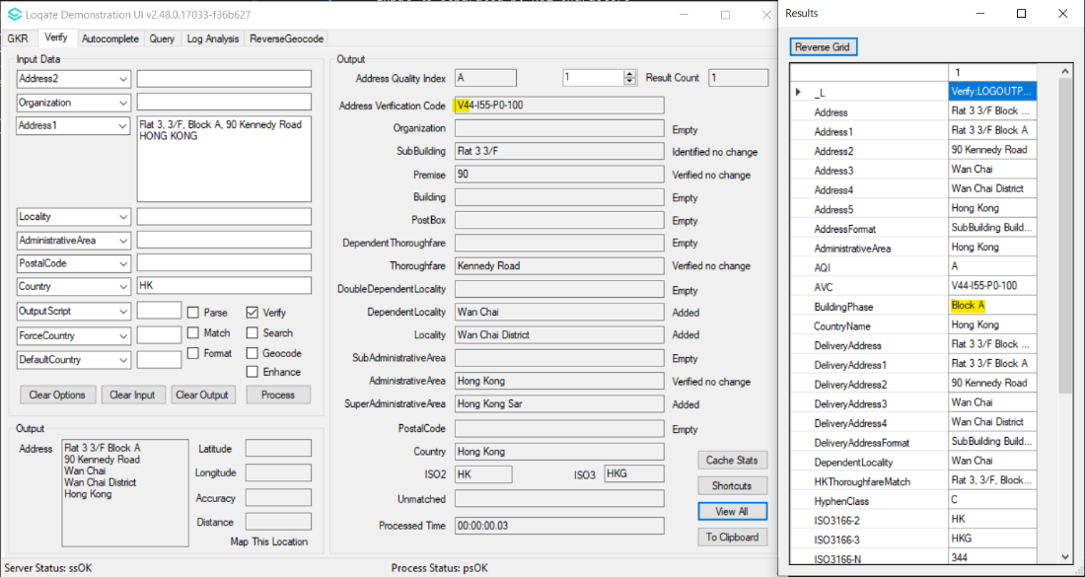

Case Number: CAS-107481-F1K1T1
Input Address:
#1 Address1: бул.Пещерско шосе 66, 4001, Пловдив Locality: Пловдив AdministrativeArea: Plovdiv
PostalCode: 4001 Country: Bulgaria
Before:
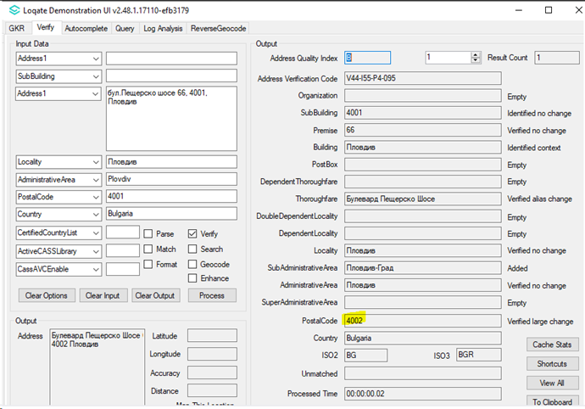
After:
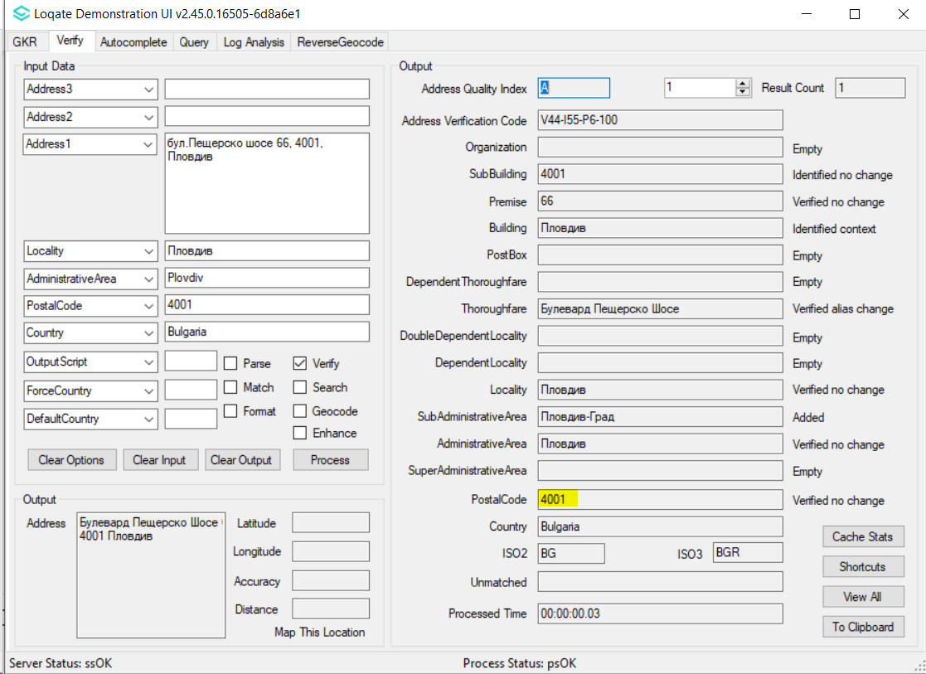

Case Number: CAS-112519-C0Y8T3
Input Address:
#1 Address1: Domaine des Écureuils 4 Postalcode: 5660 Locality: Namur Country: BEL
Before
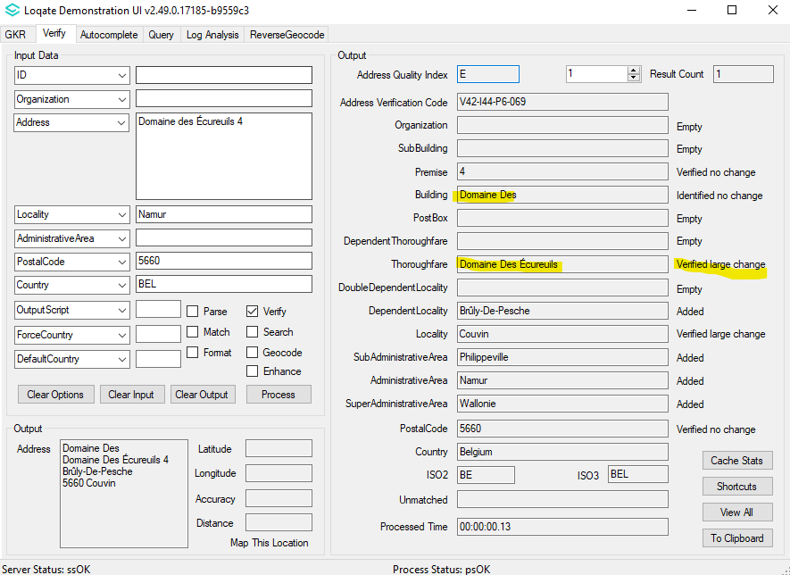
After
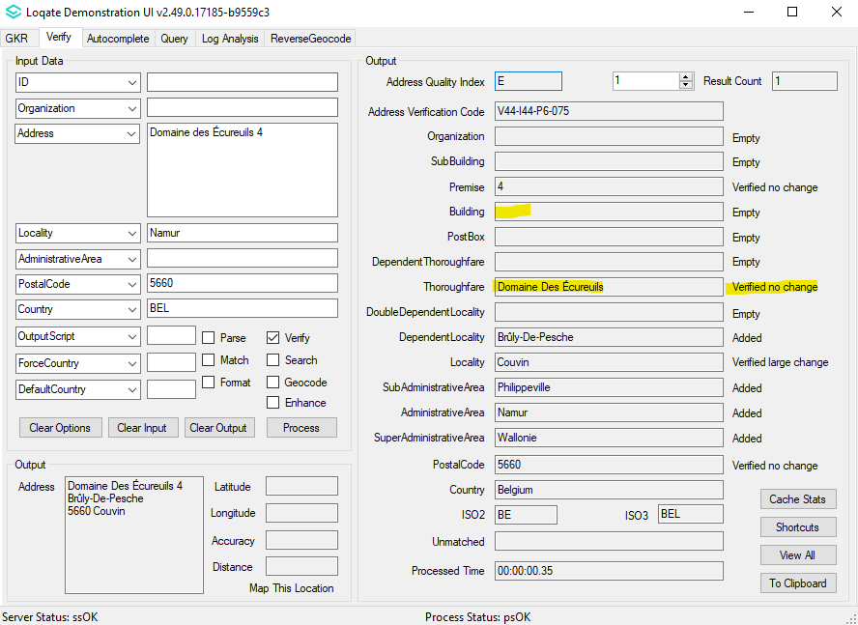

Case Number: CAS-98586-N5B0N5
Input Address:
#1 Address1: 101동 한라아파트 강변로 내곡동 강릉시 Postalcode: 25603 Country: KR
Before
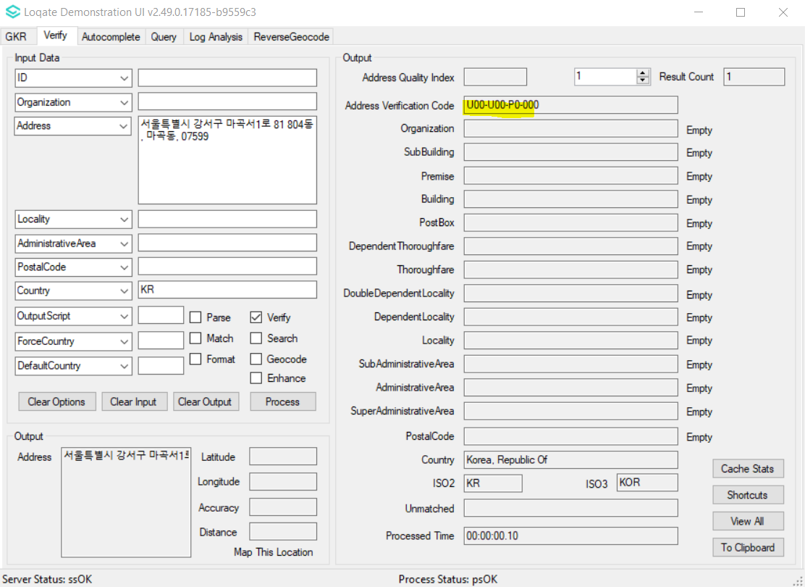

After:
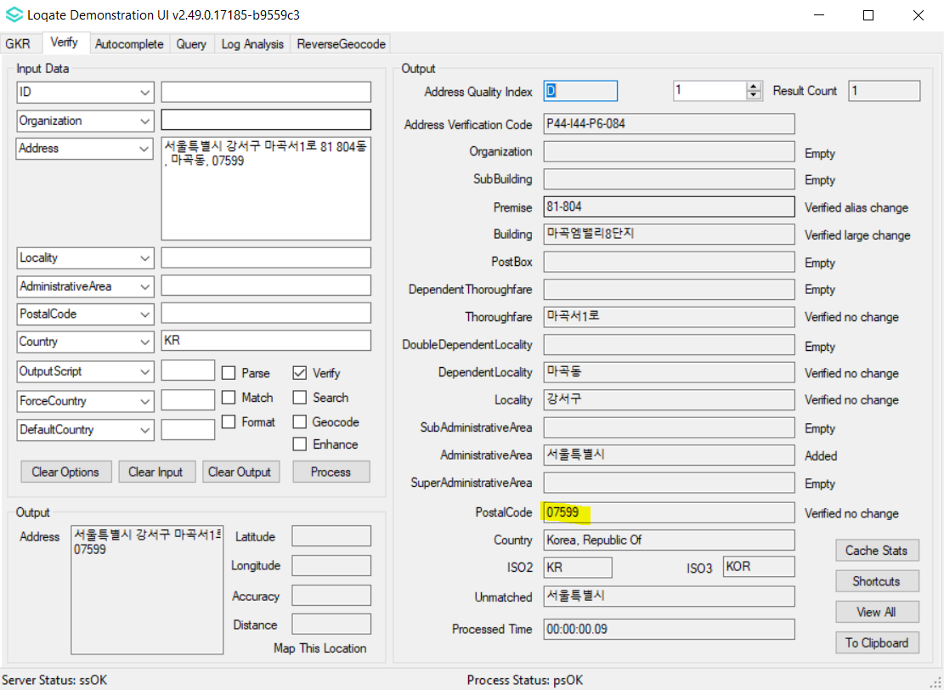

Download Instructions

Getting new data only.
- Run InstallManager.bat / InstallManager.sh in current API folder.
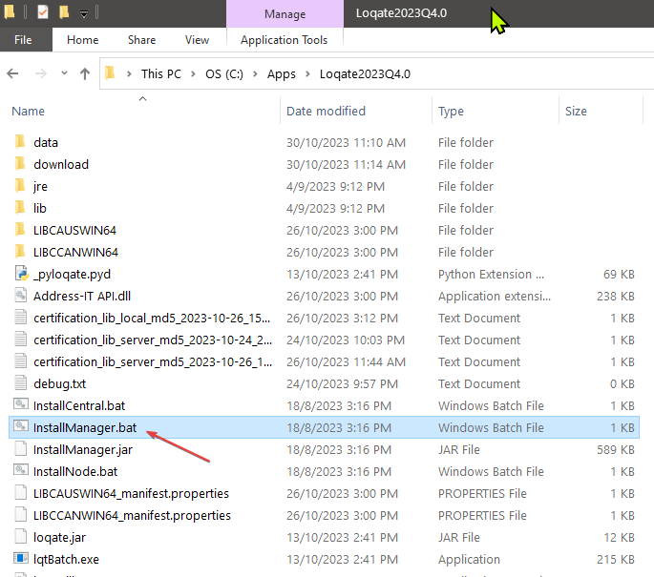
- If the Install Manager is set to point to existing /data directory, it will detect and download only newer versions of country data allowed by your license key.
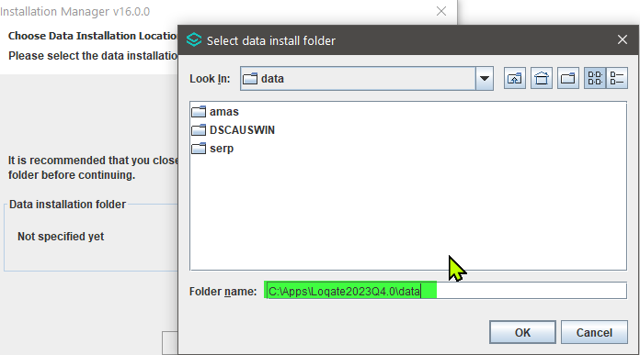
  - This can work across multiple data releases, for example if you have not updated data for two data releases, Install Manager will download all data updated in both releases.
  - Important: When pointing to an existing install, Install Manager will overwrite existing data files with new ones. We strongly recommend backing up existing data by selecting 'Y' when Install Manager prompts 'Backup existing data packs'.
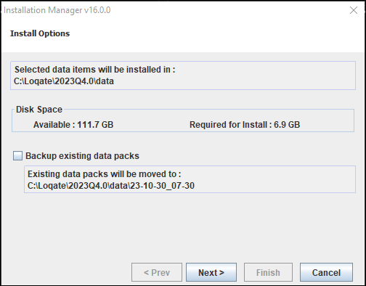

Getting all country data.
- Run InstallManager.bat / InstallManager.sh in current API folder.
- Point the Install Manager to a new and empty /data folder. This will force Install Manager to download all latest available data for all countries allowed by your license key.
- Ensure to configure your API to point to the new /data folder to ensure it is using latest reference data.

