Loqate, A GBG Solution

Release Notes – Reference Data & Knowledge Base

2023Q4.0 Major Release

Case Resolutions
Please visit https://support.loqate.com/2023q4-0-resolved-cases/ for a list of cases resolved in this release.
If you would like more details on any of the solved cases listed, please contact LoqateSupport@gbgplc.com for further information.

Certification Expiration Dates
If you have purchased a certification product, please be aware that the datasets have expiration dates set by the respective postal authorities. Please ensure that you have the latest library and data installed to avoid loss of service through these products.

Please check Install Manager for the latest versions of our certification data

 | Loqate Release Date | Certification Expiry Date*
AMAS Data | 2023-09-19 | 2023-12-31
CASS2 Data | 2023-10-04 | 2023-12-31
SERP | 2023-10-03 | No Expiry

For more information on expiry date checking for CASS and AMAS, please refer “Usage expiration” section in https://support.loqate.com/documentation/local-apis/cass-overview-2/ and https://support.loqate.com/address-matching-approval-system-amas/
For SERP there is no forced expiry in the data it just becomes less current the longer you leave it between updates.

Country Data Refreshes

The below is a list of the 25 countries refreshed as part of this major release.
Country | ISO2
United Arab Emirates | AE
Argentina | AR
Austria | AT
Australia | AU
Brazil | BR
Canada | CA
China | CN
Germany | DE
Spain | ES
Finland | FI
United Kingdom | GB
Guernsey | GG
Hungary | HU
Croatia | HR
Ireland | IE
Isle of Man | IM
India | IN
Jersey | JE
Japan | JP
Norway | NO
Romania | RO
Sweden | SE
Singapore | SG
Turkey | TR
United States | US

Country Rebuild

The below is a summary of the Countries where we have updated the reference data / structure.
Country | Description
Mexico | Addition of new data source to PDH build

Mexico
Country Information | Description
ISO2 | MX
ISO3 | MEX
Address Format | No changes
PDH | YES
New Source | YES
 |  | Pre-PDH | Post-PDH
Reference Data |  | rd_MX_vfy.lfs  rd_MX_vfy_ai.lfs  rd_MX_ggg.lfs  rd_MX_ggg_rg.lfs  rd_MX_ggg_r1.lfs  rd_MX_ggg_r.lfs | rd_MX_vfy.lfs  rd_MX_vfy_ai.lfs  rd_MX_ggg.lfs  rd_MX_ggg_rg.lfs rd_MX_ggg_r3.lfs  rd_MX_ggg_r2.lfs  rd_MX_ggg_r1.lfs  rd_MX_ggg_r.lfs

- Improvement of Address verification.
- New field addition (DoubleDependentLocality) in Verify.
2023Q3.1 | 2023Q4.0
Premise is not verified.  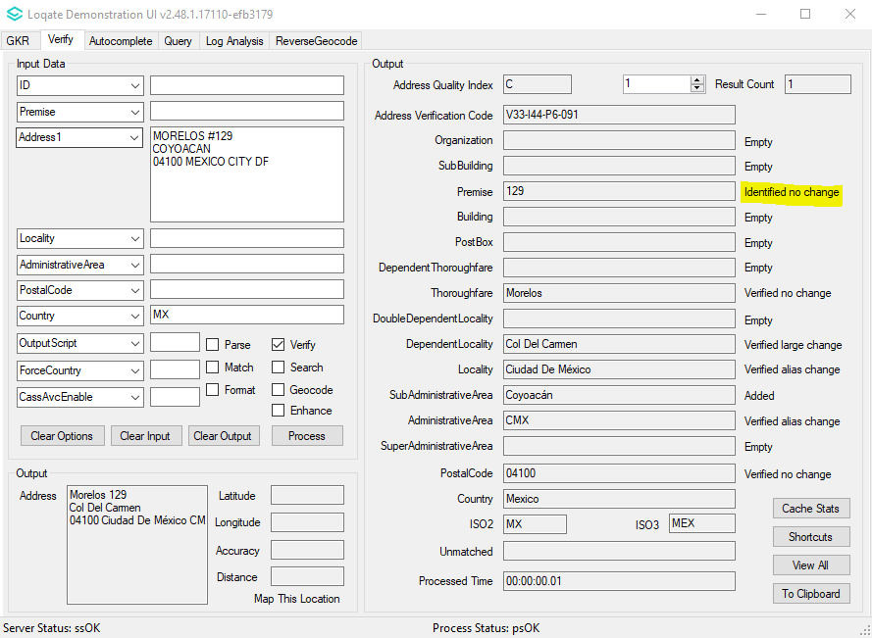 | Premise are now verified.  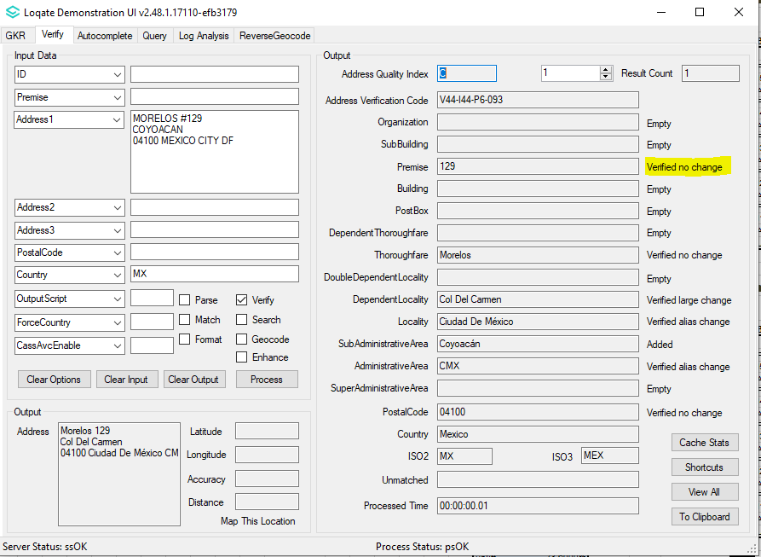

DoubleDependentLocality is not present in the Verify field.  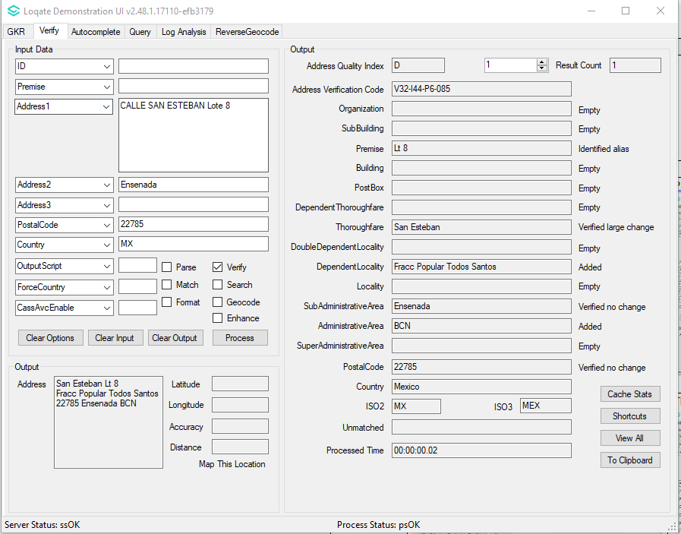 | DoubleDependentLocality is now present in the Verify field.  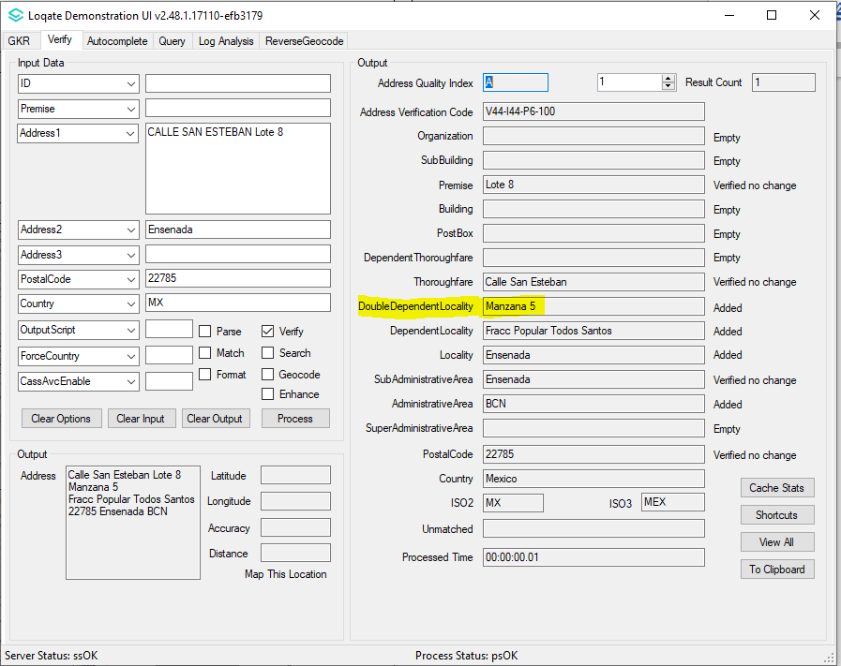

Country Rebuild Highlights
Country | Description
Saudi Arabia | Casing adjustment for ShortAddressCode
South Korea | Renaming of a native AdministrativeArea name

Saudi Arabia
Casing adjustment for ShortAddressCode.
2023Q3.1 | 2023Q4.0
ShortAddressCode is wrongly output in lowercase.  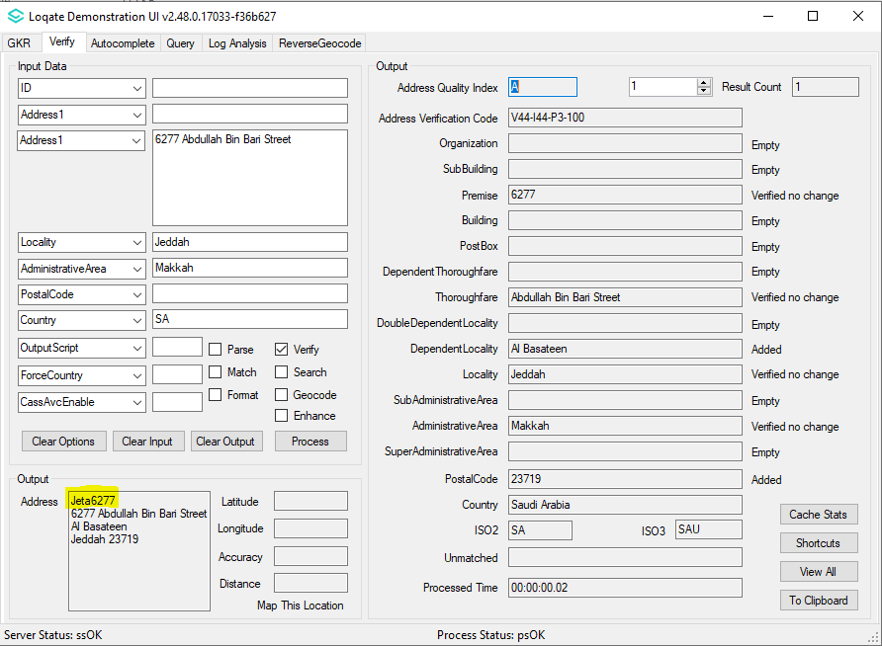 | ShortAddressCode is correctly output in uppercase.  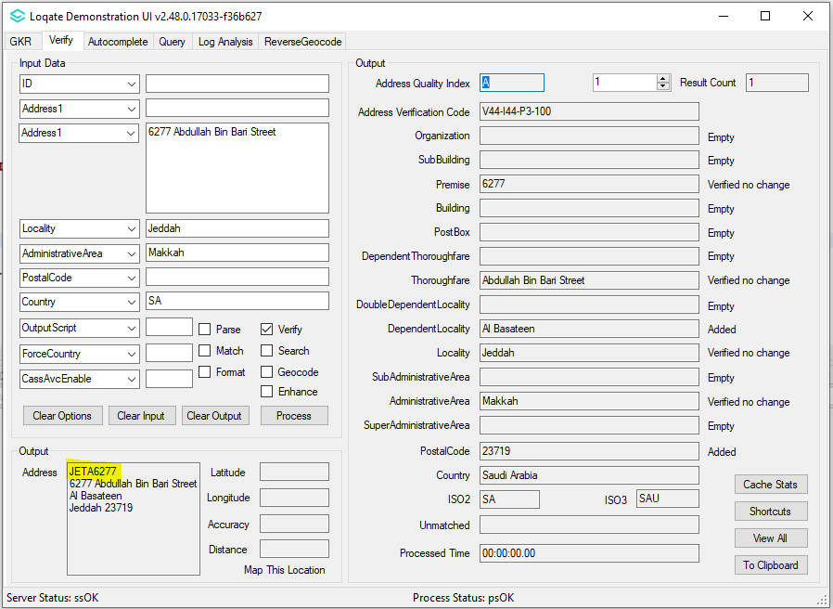

South Korea
Renaming of a native AdministrativeArea name
2023Q3.1 | 2023Q4.0
Former AdministrativeArea name returned.  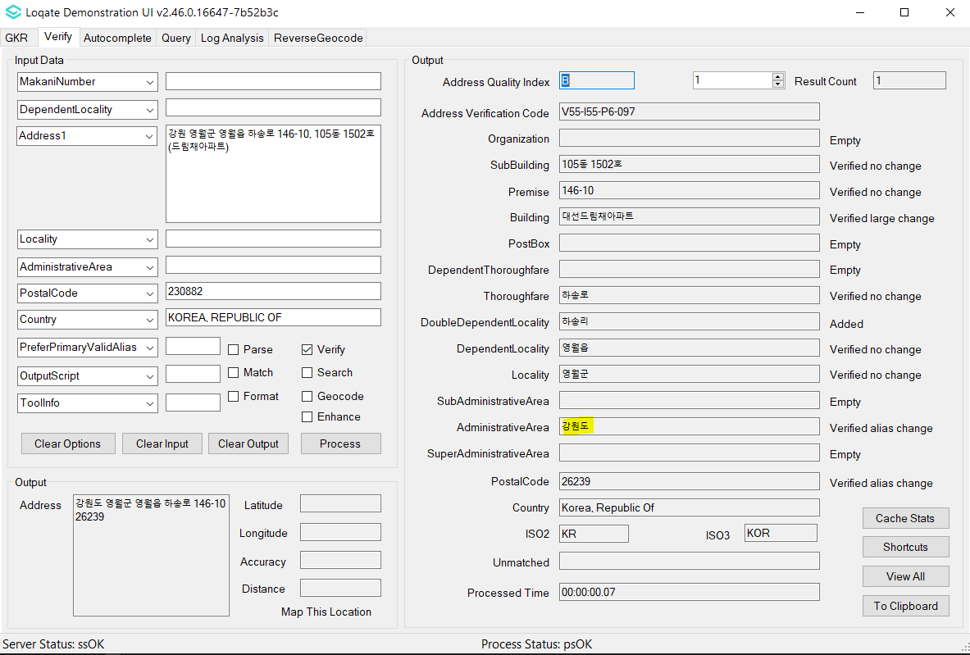 | New AdministrativeArea name returned.  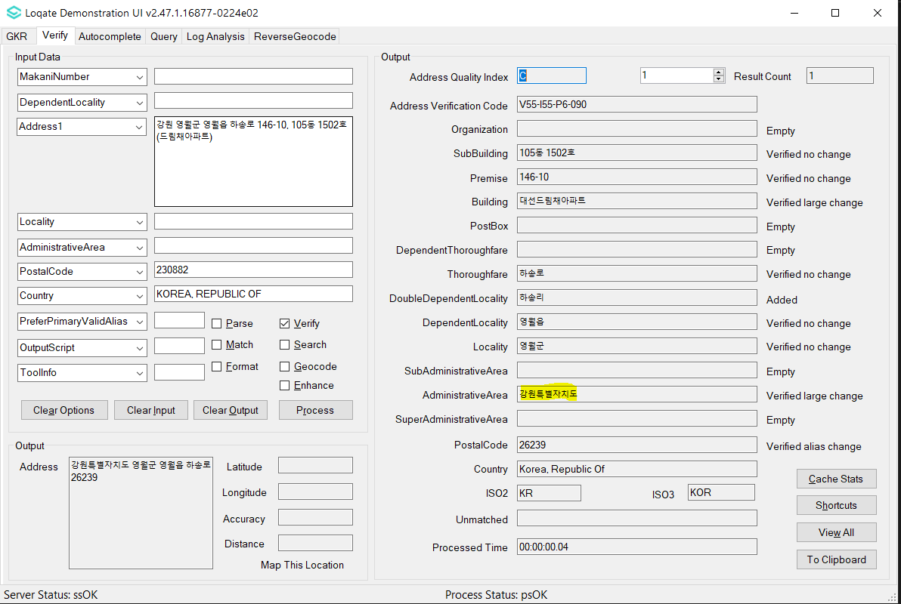

Case Resolutions

2023Q4.0 Data related Case Fixes
Case Number | Change Description | Country
CAS-103020-V1W8P2 | Improvement of SubBuilding parsing | South Korea
CAS-103013-P7L0N6 | Improvement of Thoroughfare parsing | South Korea
CAS-103010-N9Y9M6 | Improvement of Thoroughfare parsing | South Korea
CAS-NOTPROVIDED | Correction of output DependentLocality | China
CAS-93981-K2H0K0 | Removal of bad character in output | China
CAS-104705-D3Z3G7 | Improvement of Thoroughfare parsing | Bulgaria
CAS-106950-G2C5N7 | Improvement of Thoroughfare parsing | Thailand
General Parsing Fix | Improvement of Thoroughfare parsing | Ireland
CAS-105709-Y7Q2P5 | Correction of Building verification for Latin input language | Japan
General Parsing Fix | Improvement of Thoroughfare parsing | Romania
CAS-104680-X4B1T1 | Correction of Betina Locality | Croatia
CAS-103743-Q4V7C1 | Correction of Slough AdministrativeArea | Great Britan

Case Number | Change Description | Category | Country | Example Address
CAS-103020-V1W8P2 | Improvement of SubBuilding parsing | Data | South Korea | Address1: 화랑로 376, B1~5층 (고잔동)  Locality: 안산시 단원구  AdministrativeArea: KR-41  PostalCode: 15353  Country: KR
Before Image |  |  | After Image
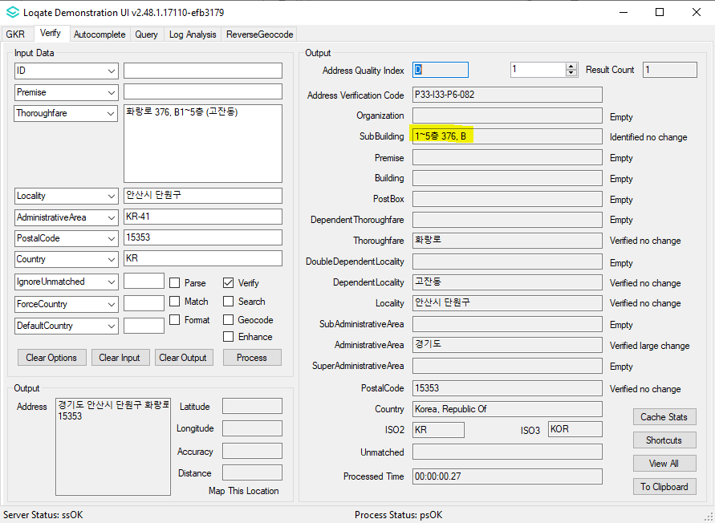 |  |  | 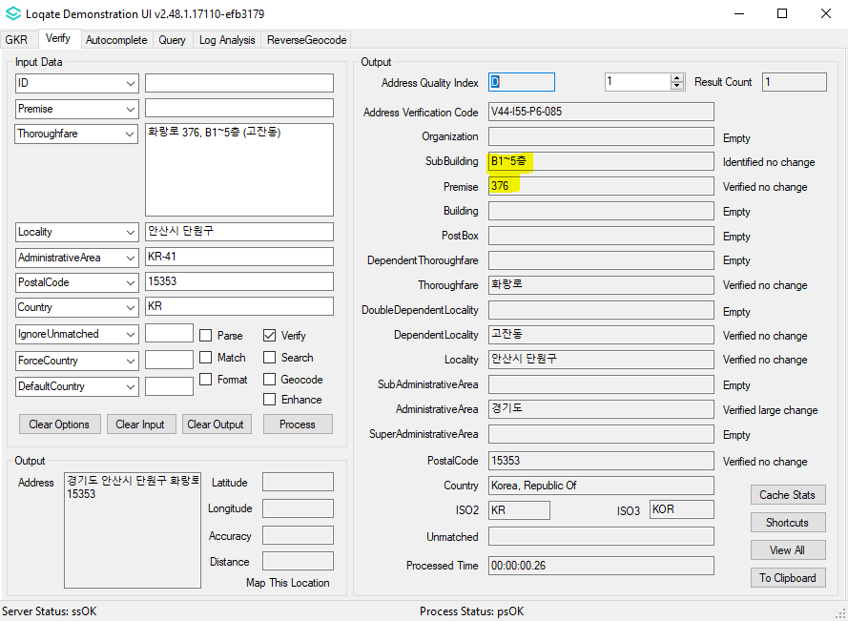

Case Number | Change Description | Category | Country | Example Address
CAS-103013-P7L0N6 | Improvement of Thoroughfare parsing | Data | South Korea | Address1: 외동반림로126번길 56 (중앙동)  Locality: 창원시 성산구  AdministrativeArea: KR-48  PostalCode: 51516  Country: KR
Before Image |  |  | After Image
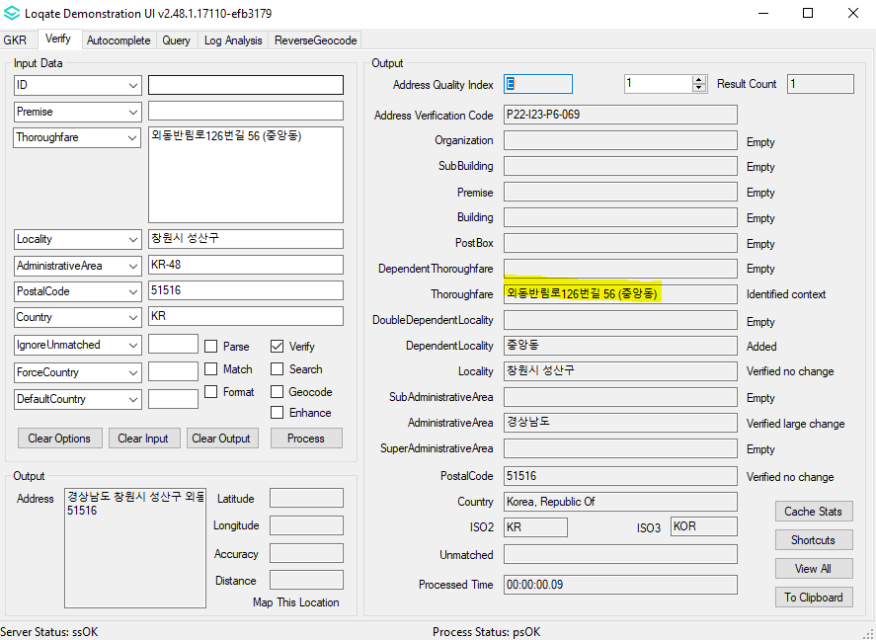 |  |  | 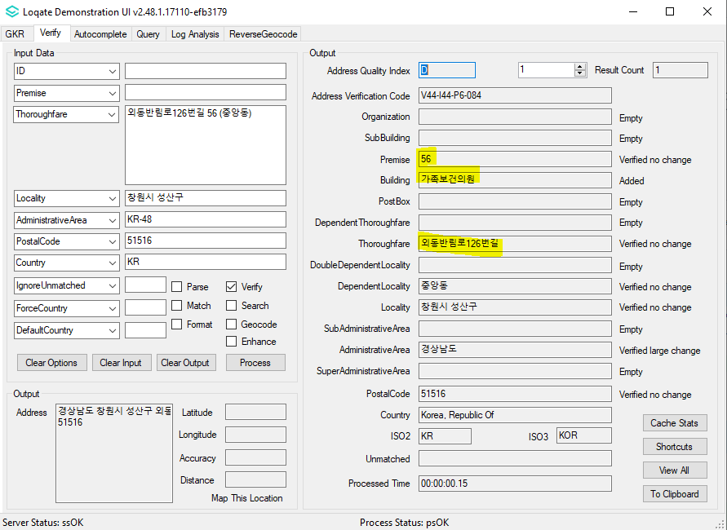

Case Number | Change Description | Category | Country | Example Address
CAS-103010-N9Y9M6 | Improvement of Thoroughfare parsing | Data | South Korea | Address1: 안성맞춤대로 1043, 2층 (서인동)  Locality: 안성시  AdministrativeArea: KR-41  PostalCode: 17581  Country: KR
Before Image |  |  | After Image
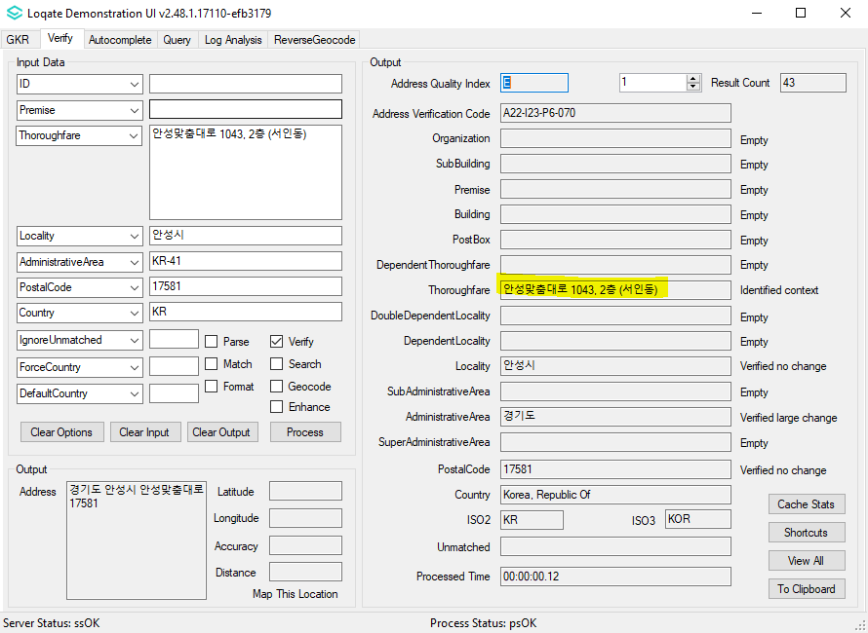 |  |  | 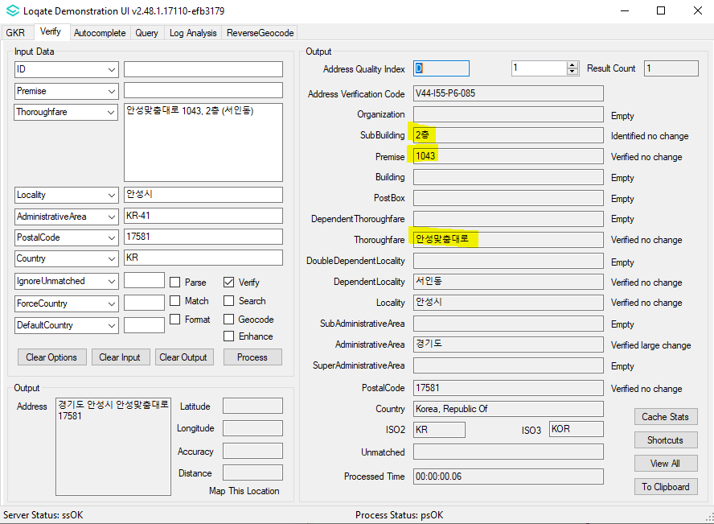

Case Number | Change Description | Category | Country | Example Address
Country Improvement | Correction of output DependentLocality | Data | China | Address : 北京北京西城区宣武门外大街甲1号环球财讯中心a座15层  Country : China  OutputScript : Native
Before Image |  |  | After Image
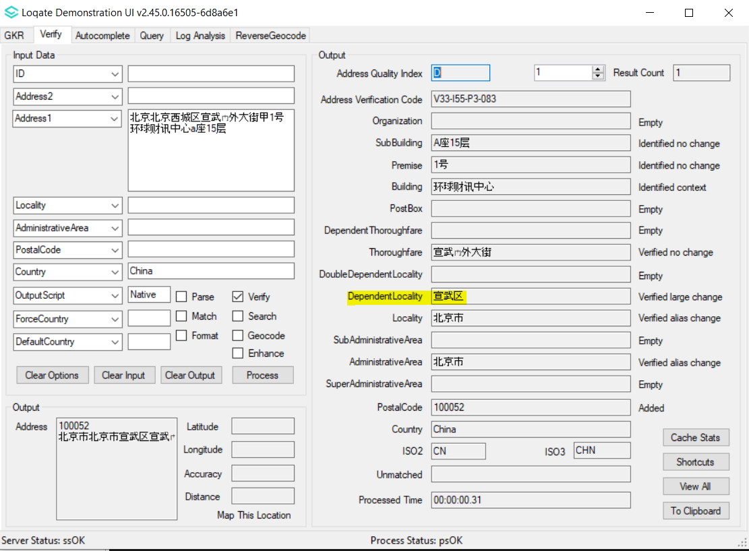 |  |  | 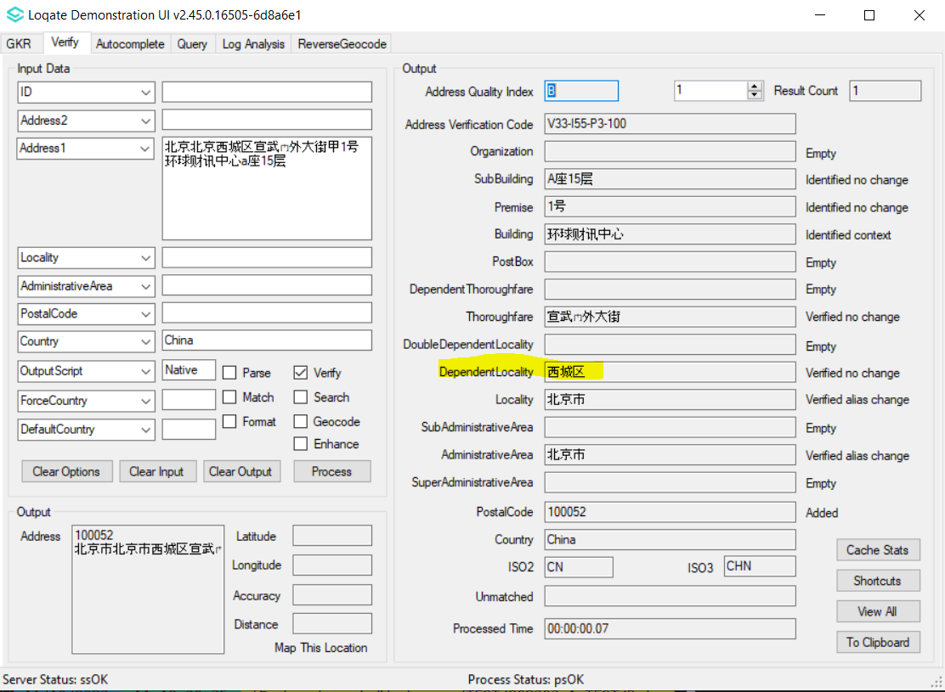

Case Number | Change Description | Category | Country | Example Address
CAS-93981-K2H0K0 | Removal of bad character in output | Data | China | Address1: FUSHUN WANGHUA DISTRICT FAKU STREET 15TH, BUILDING 1 UNIT 101-103  Locality: FUSHUN  AdminArea: LiaoNing  PostalCode: 113200  Country: CHN
Before Image |  |  | After Image
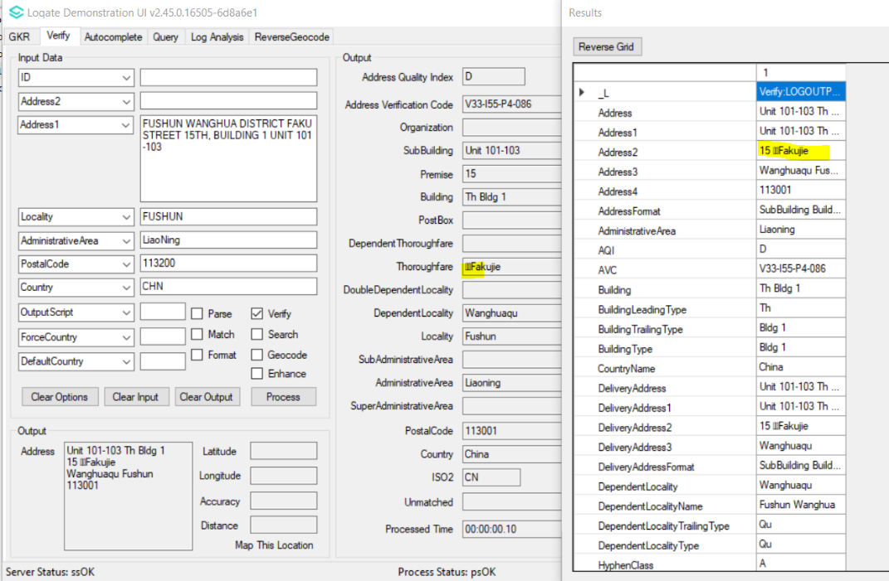 |  |  | 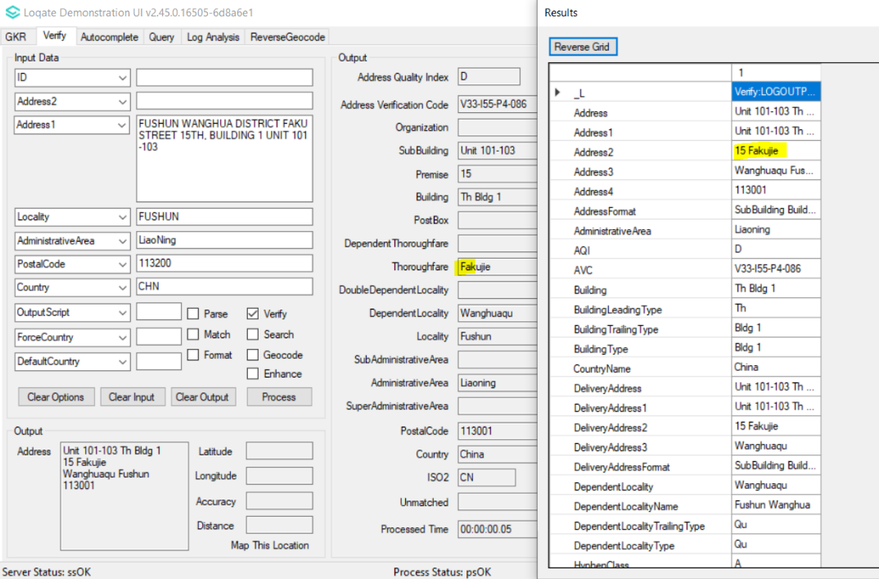

Case Number | Change Description | Category | Country | Example Address
CAS-104705-D3Z3G7 | Improvement of Thoroughfare parsing | Data | Bulgaria | Address1: Akad. Konstantint Pashev 32  Locality: Sofia  AdministrativeArea: 1635  Country: BG
Before Image |  |  | After Image
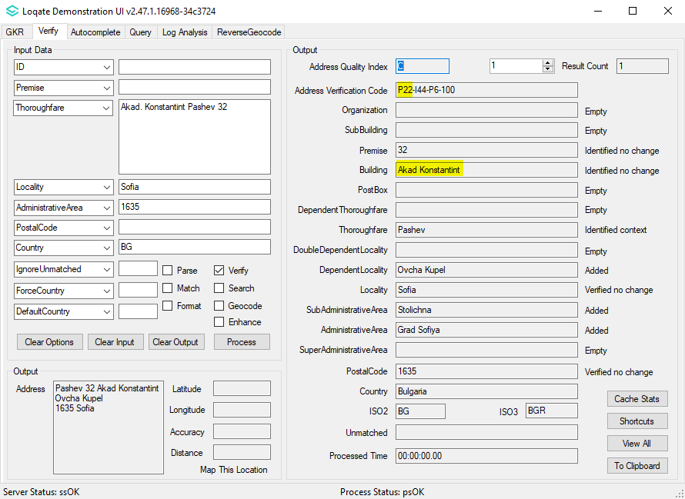 |  |  | 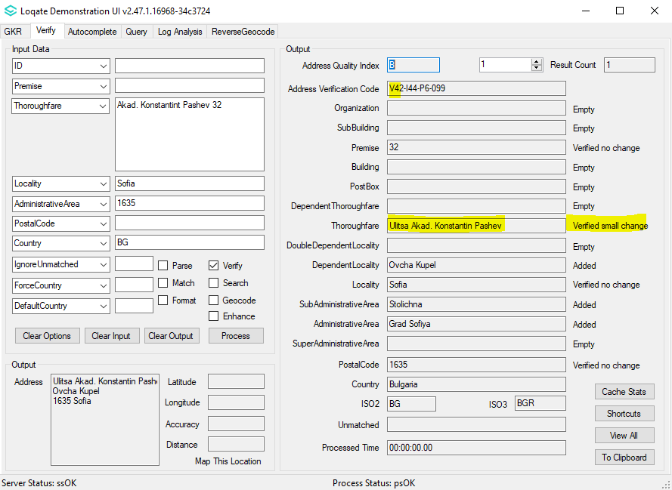

Case Number | Change Description | Category | Country | Example Address
CAS-106950-G2C5N7 | Improvement of Thoroughfare parsing | Data | Thailand | Address1: 1411 Sukumvit Road  Address2: Khwaeng Prakanong Nuea  Address3: Khet Wattana  Locality: Bangkok  AdministrativeArea: TH-10  PostalCode: 10110  Country: TH
Before Image |  |  | After Image
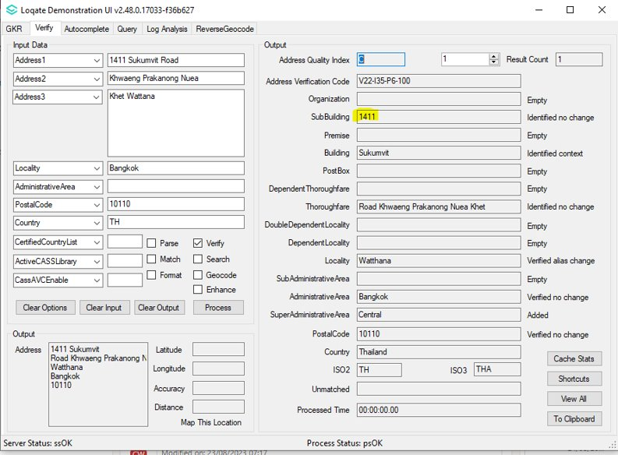 |  |  | 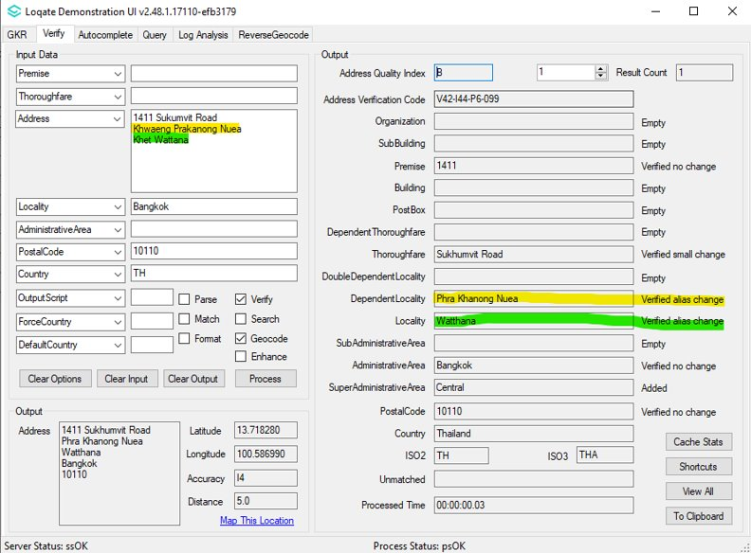

Case Number | Change Description | Category | Country | Example Address
Parsing Improvement | Improvement of Thoroughfare parsing | Data | Ireland | Address1: 59 parklands court  Locality: dublin  PostalCode: d24 ca39  Country: ie
Before Image |  |  | After Image
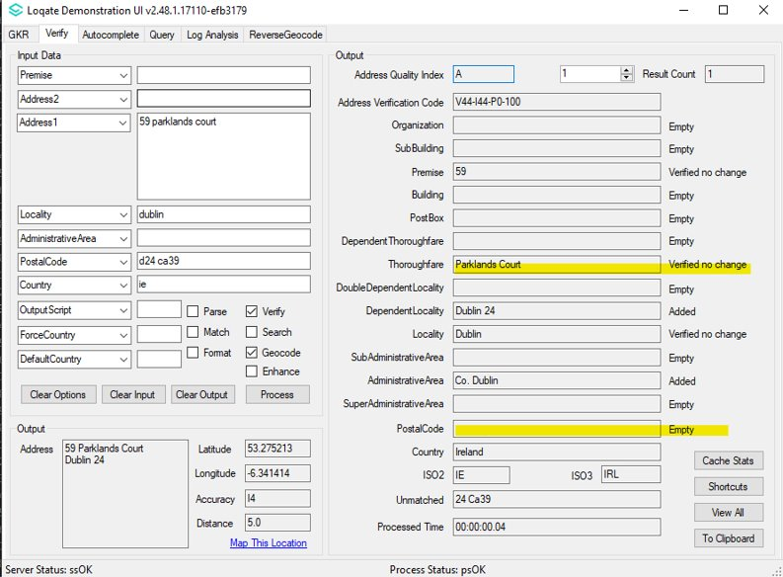 |  |  | 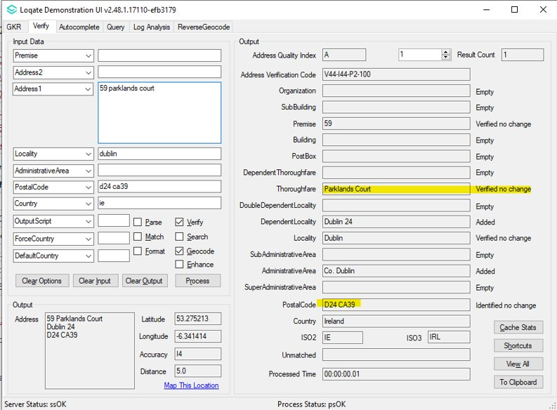

Case Number | Change Description | Category | Country | Example Address
CAS-105709-Y7Q2P5 | Correction of Building verification for Latin input language | Data | Japan | Address1: 4-1-1 Kuba  Locality: Otake City,Hiroshima  AdministrativeArea: 34,Hiroshima  PostalCode: 739-0696  Country: Japan
Before Image |  |  | After Image
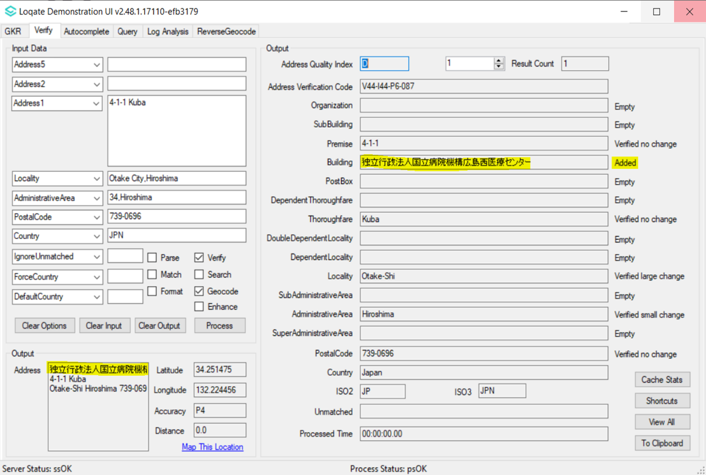 |  |  | 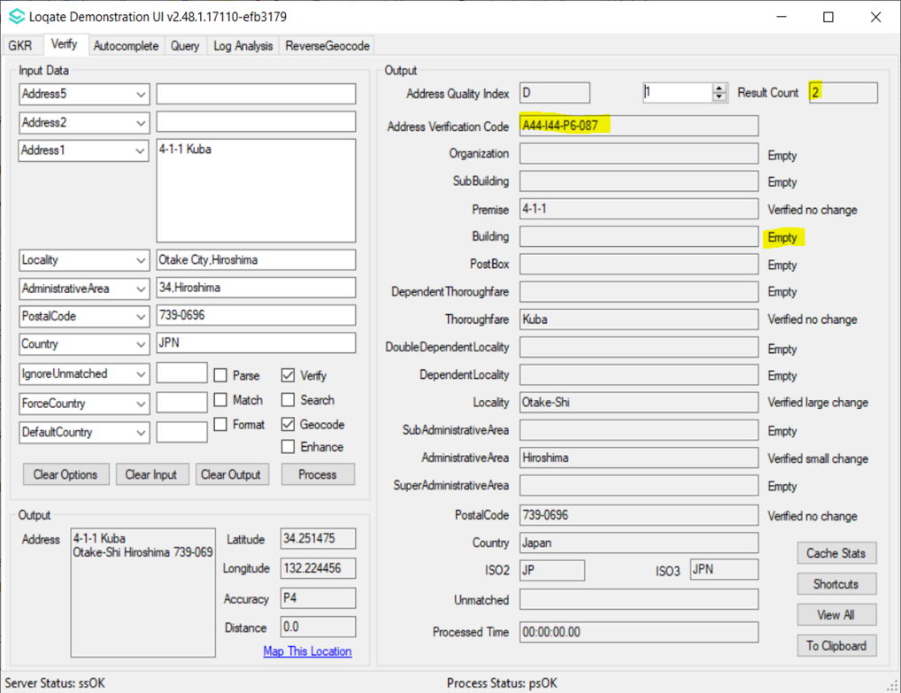

Case Number | Change Description | Category | Country | Example Address
Parsing Improvement | Improvement of Thoroughfare parsing | Data | Romania | Address1: Strada Luceafarului  Locality: Baciu  Country: RO
Before Image |  |  | After Image
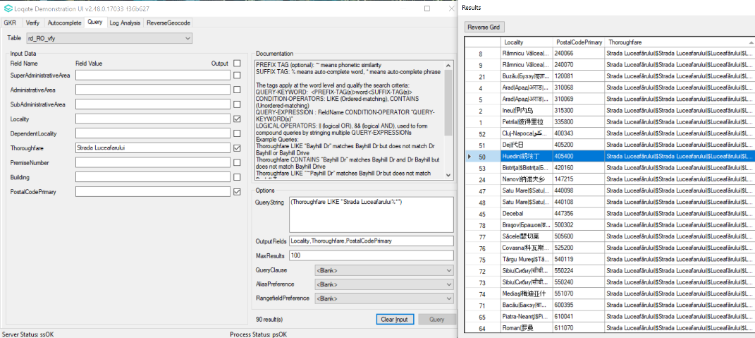 |  |  | 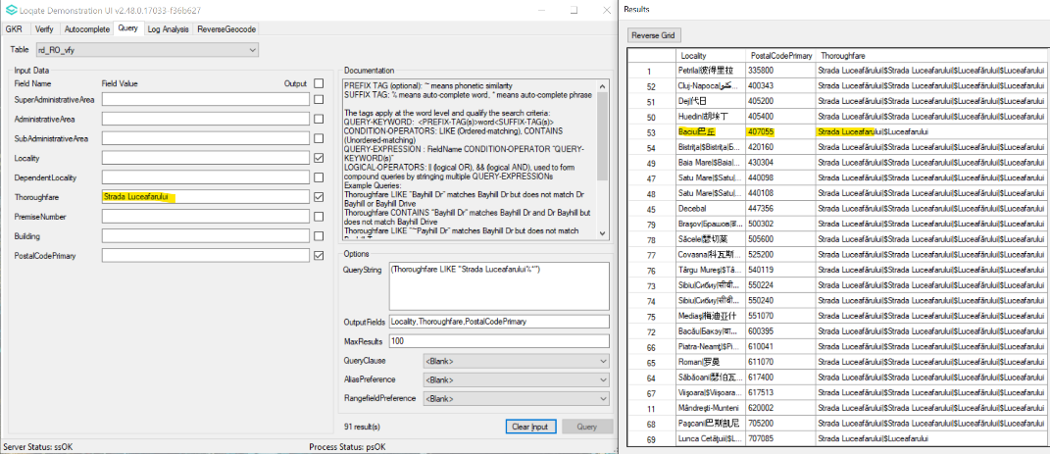

Case Number | Change Description | Category | Country | Example Address
CAS-104680-X4B1T1 | Correction of Betina Locality | Data | Croatia | Address = Ljudevita Gaja 3  Locality = Betina  PostalCode = 22244  Country = HR
Before Image |  |  | After Image
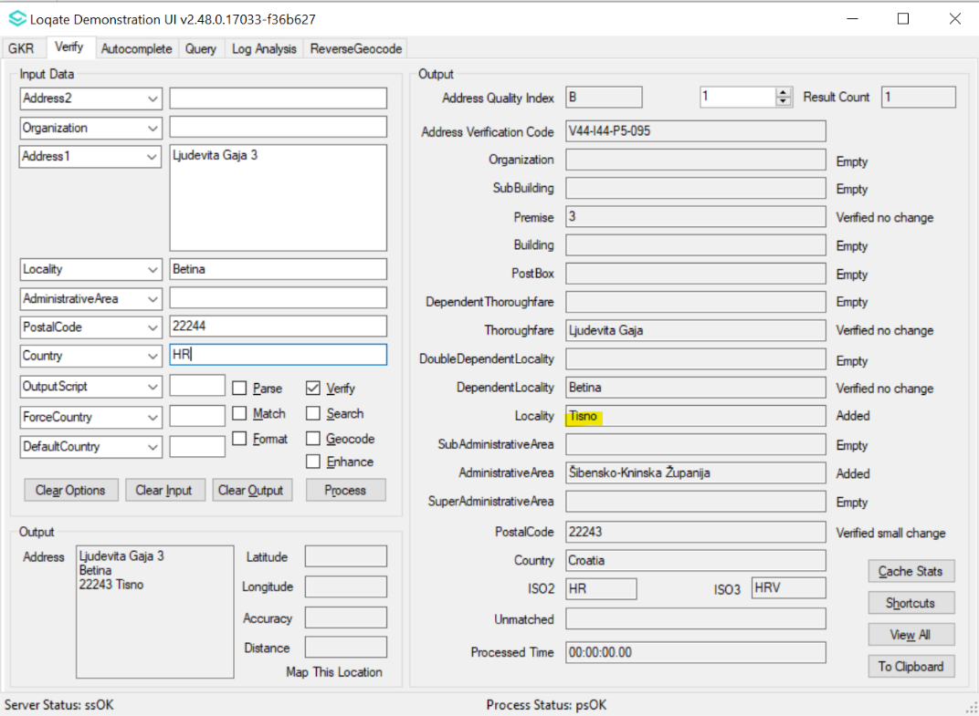 |  |  | 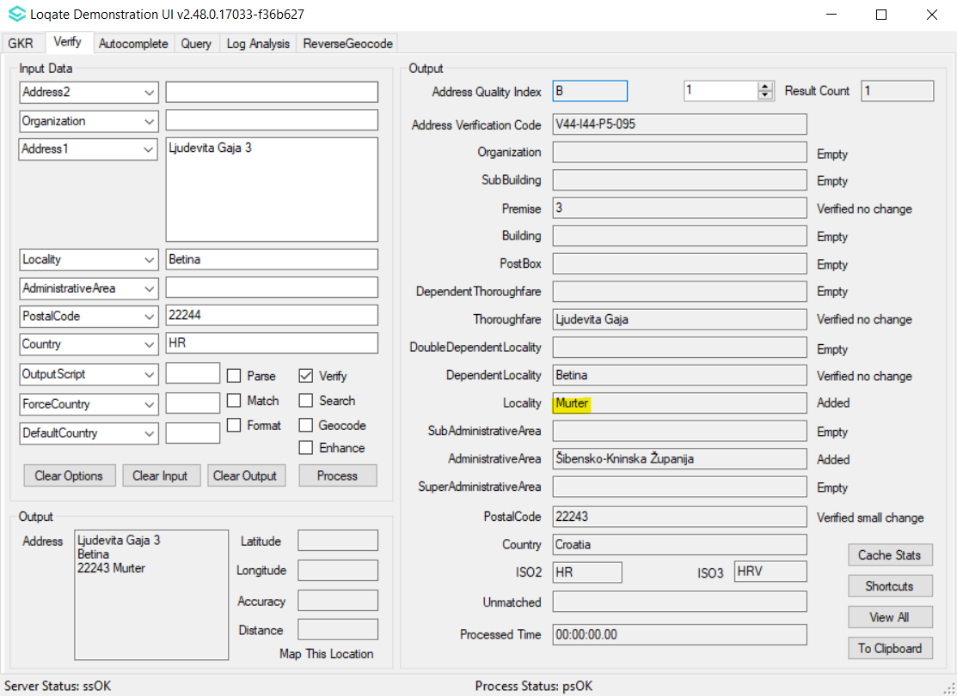

Case Number | Change Description | Category | Country | Example Address
CAS-103743-Q4V7C1 | Correction of Slough AdministrativeArea | Data | Great Britian | Address1: 672 Galvin Road  Locality: Slough  Postal Code: SL1 4AN  Country: GB
Before Image |  |  | After Image
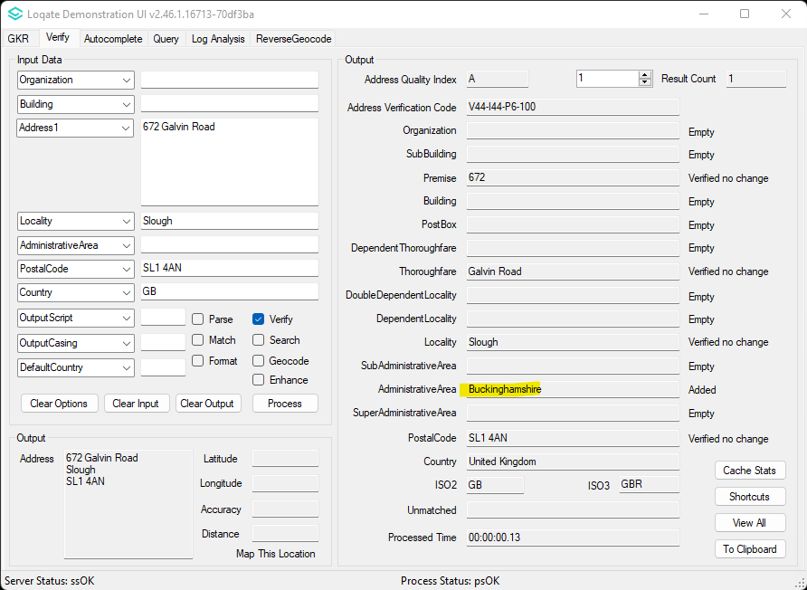 |  |  | 



