Loqate, A GBG Solution
Release Notes – Verify API

2023Q4.0 Major Release

Case Resolutions
Please visit https://support.loqate.com/2023q4-0-resolved-cases/ for a list of all cases resolved in this release. If you would like more details on any of the solved cases listed, please contact LoqateSupport@gbgplc.com for further information.

Local API Notice
This is to inform our customers that in 2023Q4.0 release we have made a couple of improvement to the Verify API and our CASS and SERP Certify solutions – please see details below.
The latest API version reference included in this release is 2.49.0.17185-b9559c3

Local API Improvement
Case Number | Change Description | Country
CAS-106780-C4D7K9 | Fix to prevent crash in AIX version of Verify on premise solution when using EnhancedCountryTool | US & Canada
CAS-107873-N4B8F1 | Fix to Verify Certify products to not apply casing to HTML tag results | US CASS & Canada SERP
General Country Improvement | Enhancement to handle longer Argentina Postalcodes | Argentina
CAS-108556-W0X3Q8 | Improvement in urbanization handling. | Puerto Rico

Case Number | Change Description | Category | Country | Example Address
CAS-107873-N4B8F1 | Don't apply casing to HTML tags | API | US CASS & CA SERP | Address1="476 Murray St"  Address2="301"  Locality="Pelham"  AdministrativeArea="NY"  PostalCode="10803"  Country="USA"
Before Image |  |  | After Image
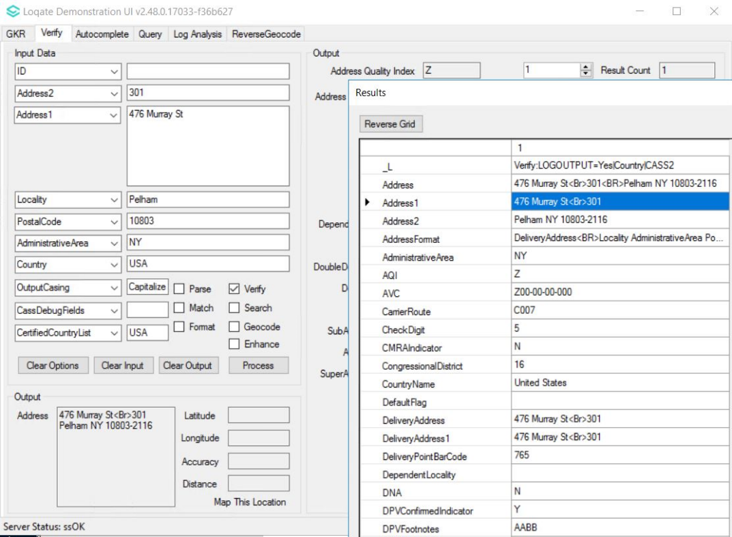 |  |  | 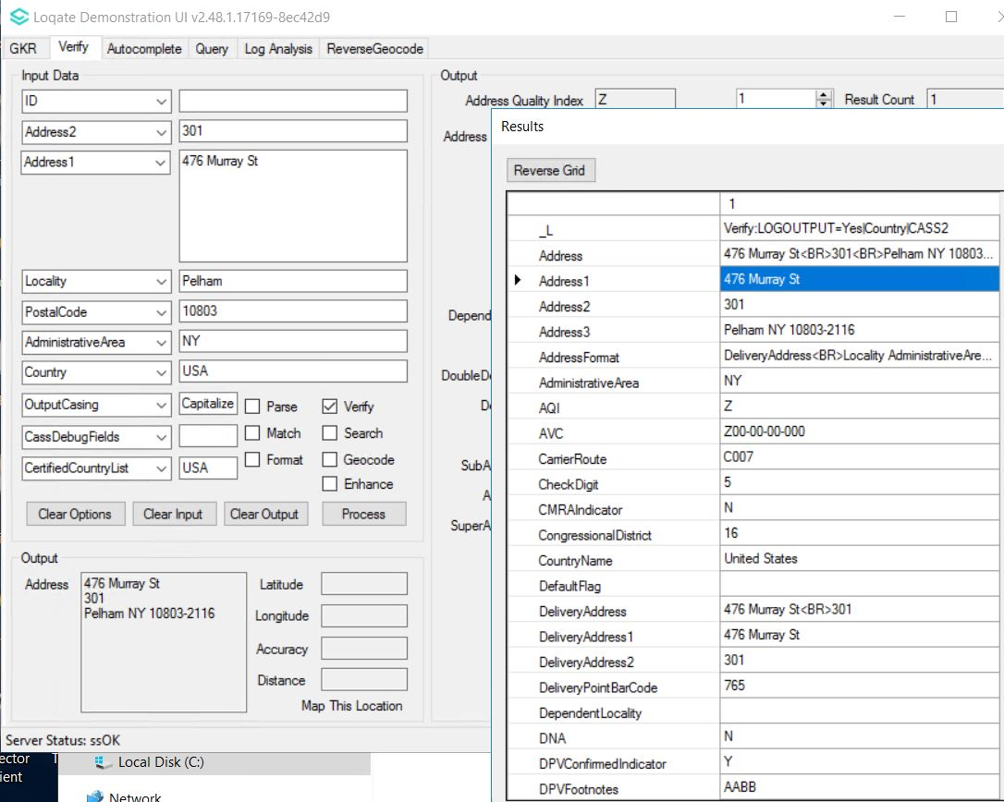
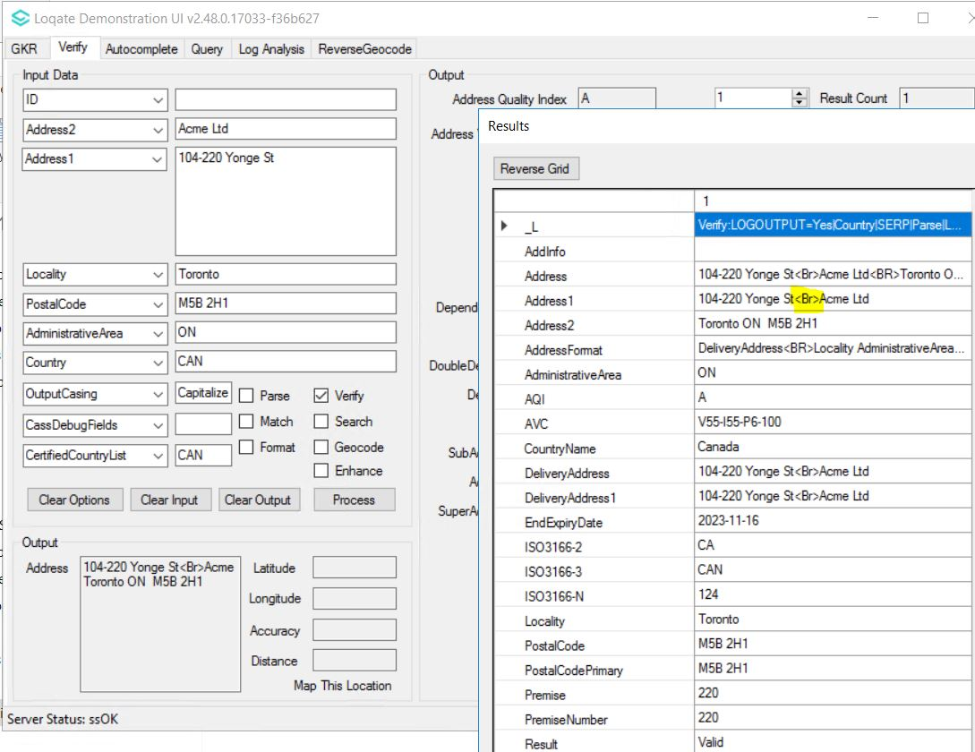 |  |  | 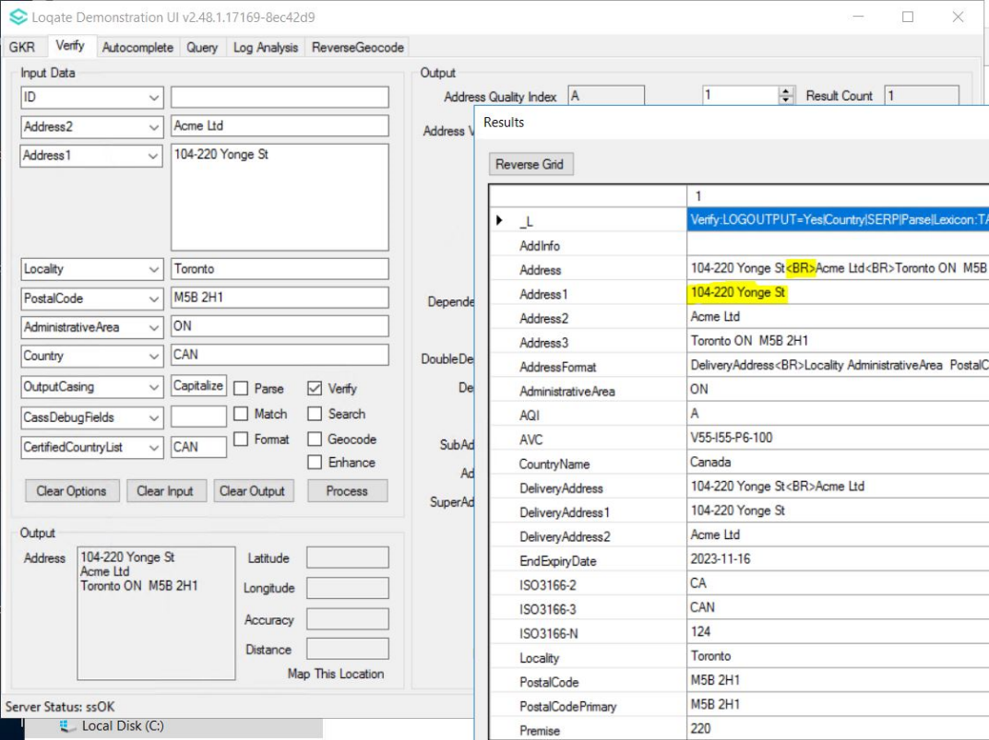

Case Number | Change Description | Category | Country | Example Address
NA | Enhancement to handle Argentina postal code update. | API | Argentina | Avenida Nazca 4 438, Buenos Aires, C1406ABC, ARG
Before Image |  |  | After Image
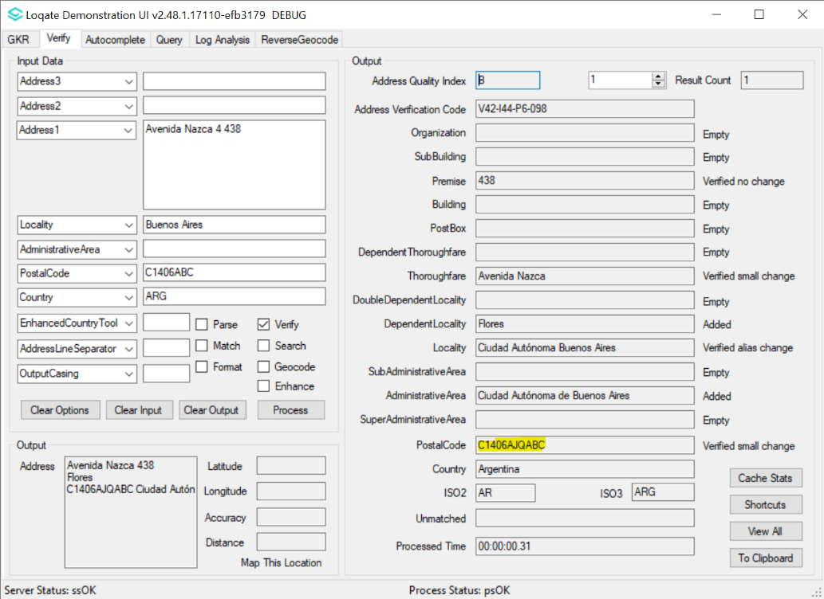 |  |  | 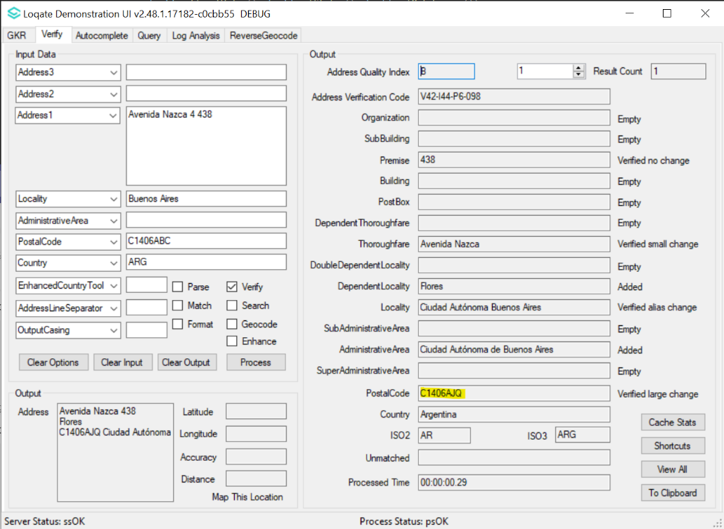

Case Number | Change Description | Category | Country | Example Address
CAS-108556-W0X3Q8 | Verify Improvement in urbanization handling. | API | Puerto Rico | 1895 CALLE GUARA, URB LOS CAOBOS, PONCE, PUERTO RICO
Before Image |  |  | After Image
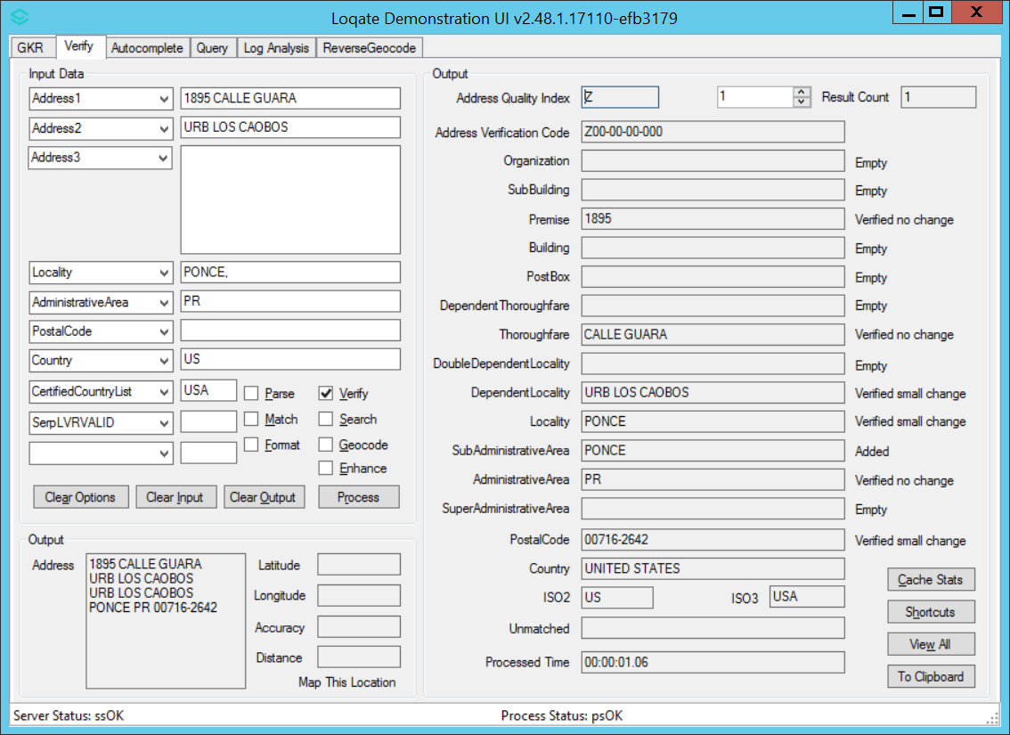 |  |  | 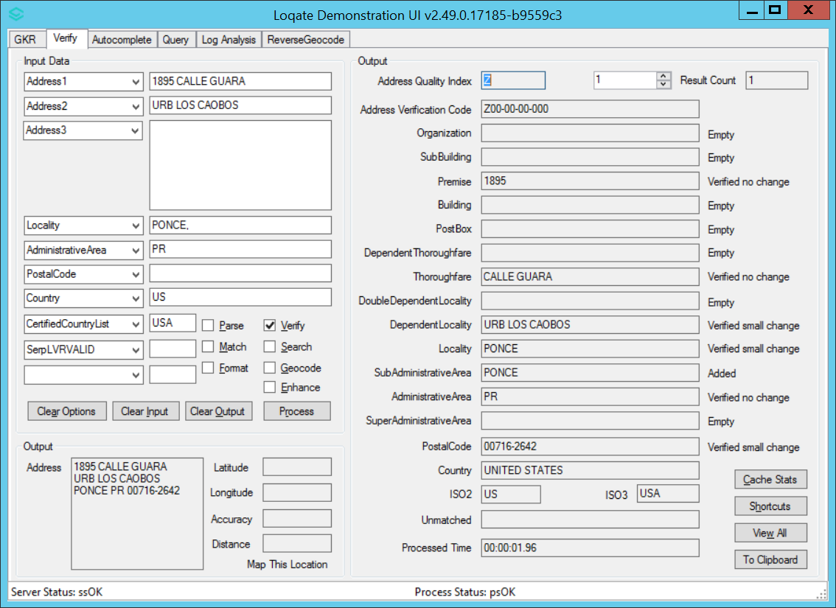
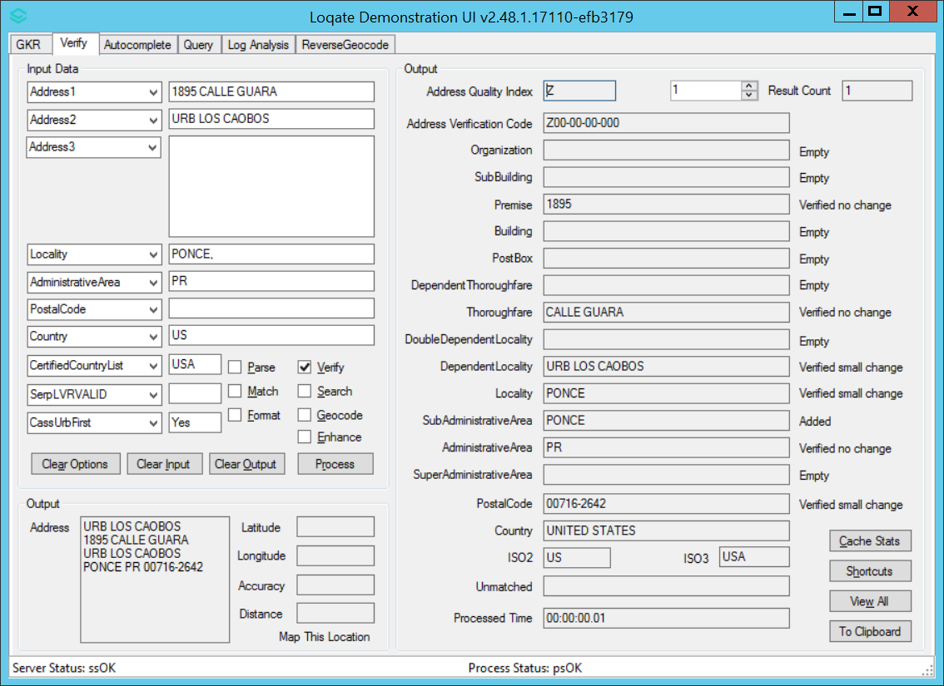 |  |  | 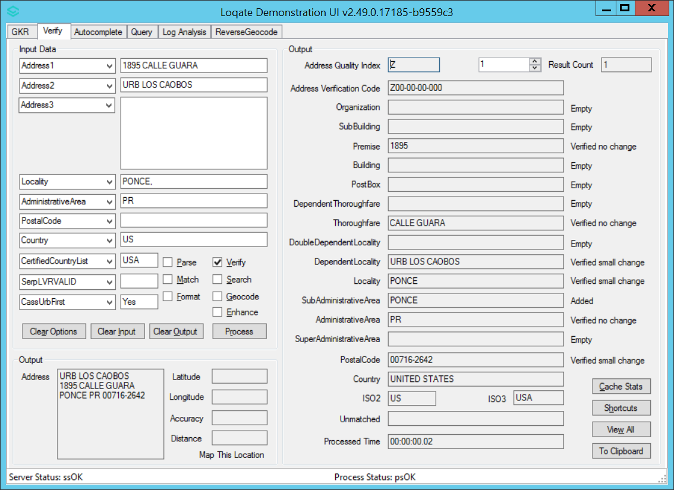

Installation Instructions
Please remember to update both the program files and the reference data and please install these to a new fresh folder location. The improvements are tied to the data in the Global Knowledge Repository and the Local API. When updating the data, it is recommended to use a new data folder each time to ensure the latest dataset is installed properly.

If you need any assistance with the upgrade of the Local API or the data update process, please contact GBG Loqate Support.

The setup wizard for the Local API can be obtained from our SFTP server. Please contact your account manager to retrieve the SFTP information. If you do not know who your account manager is, please contact the support team at LoqateSupport@gbgplc.com.

