Loqate, A GBG Solution
Release Notes – Reference Data & Knowledge Base - 2023Q3.1 Minor Release

Case Resolutions
Please visit https://support.loqate.com/2023q3-1-resolved-cases/ for a list of cases resolved in this release.
If you would like more details on any of the solved cases listed, please contact LoqateSupport@gbgplc.com for further information.

Certification Expiration Dates
If you have purchased a certification product, please be aware that the datasets have expiration dates set by the respective postal authorities. Please ensure that you have the latest library and data installed to avoid loss of service through these products.
Please check Install Manager for the latest versions of our certification data

 | Loqate Release Date | Certification Expiry Date*
AMAS Data | 2023-06-02 | 2023-09-30
CASS2 Data | 2023-07-31 | 2023-10-31
SERP Data | 2023-08-23 | No Expiry

For more information on expiry date checking for CASS2 and AMAS, please refer “Usage expiration” section in https://support.loqate.com/documentation/local-apis/cass-overview-2/ and https://support.loqate.com/address-matching-approval-system-amas/

Country Rebuild / Refresh
Country | ISO2 | Description
Austria | AT | Country Rebuild
Australia | AU | Country Rebuild
New Zealand | NZ | Country Rebuild

Other Country changes to highlight:
Country | Description
Saudi Arabia | New field addition (ShortAddressCode) in Verify

Country Refresh List – All in this release
Country | ISO2
Argentina | AR
Belgium | BE
Canada | CA
Colombia | CO
Finland | FI
France | FR
France (Premium) | FR
Guernsey | GG
Hong Kong | HK
Ireland (Premium) | IE
Isle of Man | IM
Jersey | JE
Korea, Republic Of | KR
Netherlands | NL
Norway | NO
Poland | PL
Portugal | PT
Saudi Arabia | SA
Spain | ES
Sweden | SE
Switzerland | CH
United Kingdom | GB
United States | US
Vietnam | VN

Country Rebuild/Refresh Highlights
Austria
Country Information | Description
ISO2 | AT
ISO3 | AUT
Address Format | No changes
PDH | YES
New Source | YES
Reason | Improvement of Address Verification and data parity
2023Q3.0 |  | 2023Q3.1
Premise is not verified.  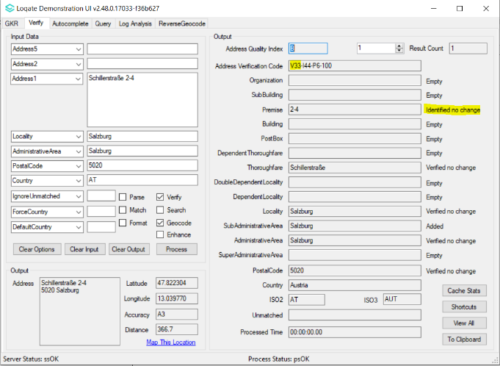 |  | Premise is now verified.  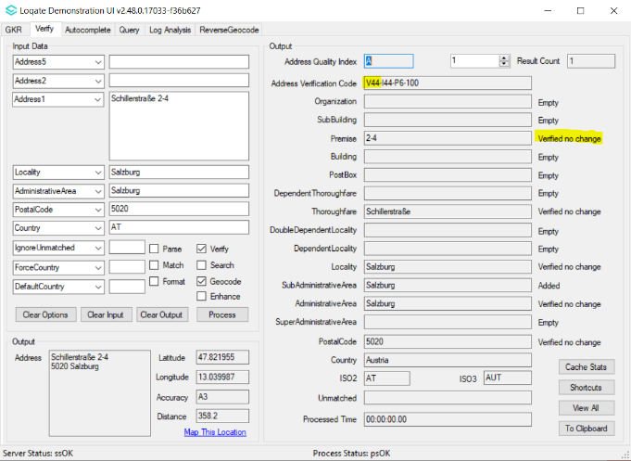

Thoroughfare is incorrectly verified.  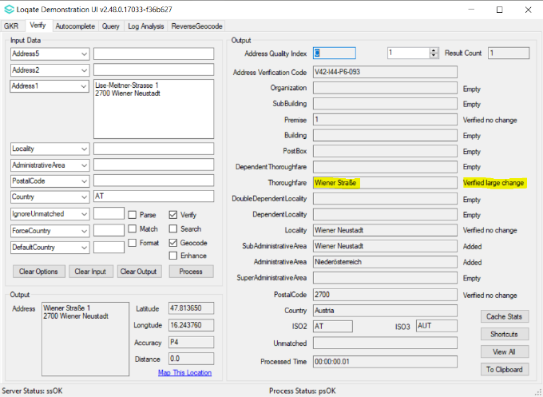 | Thoroughfare is correctly verified.  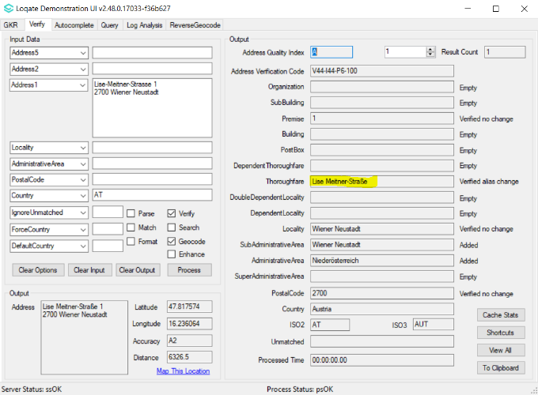

Australia
Country Information | Description
ISO2 | AU
ISO3 | AUS
Address Format | No changes
PDH | Yes
New Source | Yes (GNAF geocodes)
Reason | Geocode accuracy improvement for premise level geos

2023Q3.0 | 2023Q3.1
GeoAccuracy was A3.  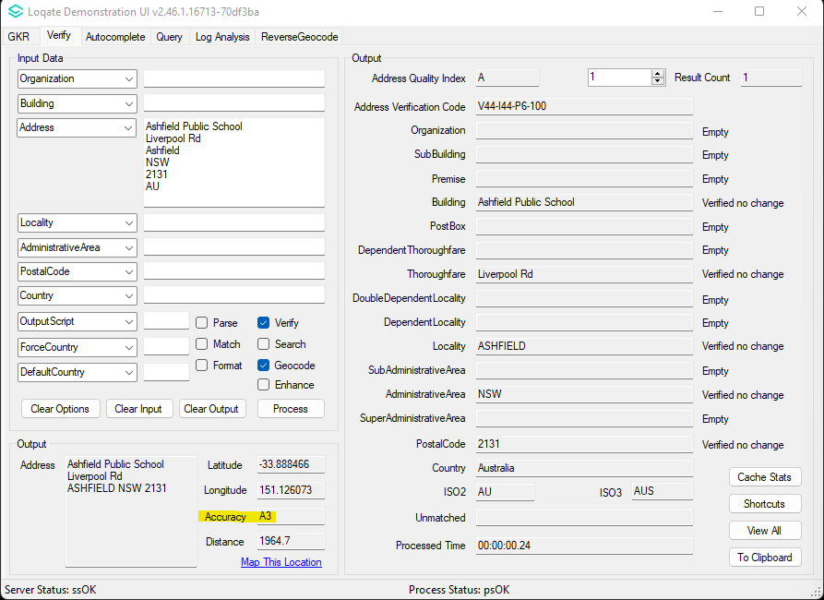 | GeoAccuracy is now P4.  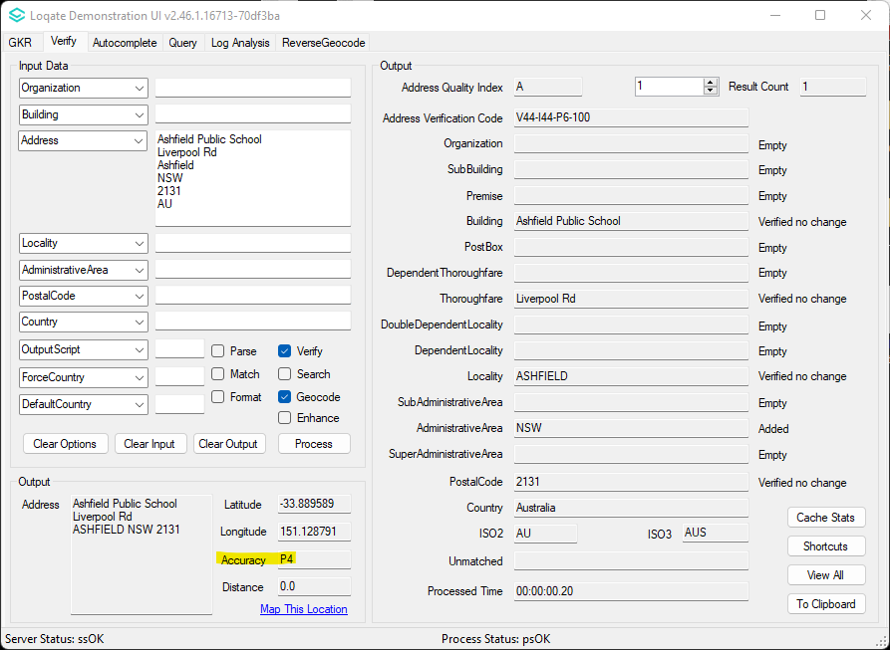

New Zealand
Country Information | Description
ISO2 | NZ
ISO3 | NZL
Address Format | No changes
PDH | YES
New Source | YES
Reason | Premise level geocode improvments

2023Q3.0 | 2023Q3.1
GeoAccuracy is A3 for V4 address.  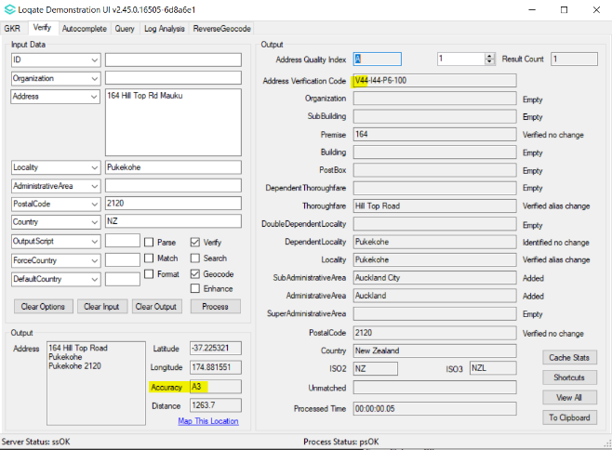 | GeoAccuracy is now P4 for V4 address.  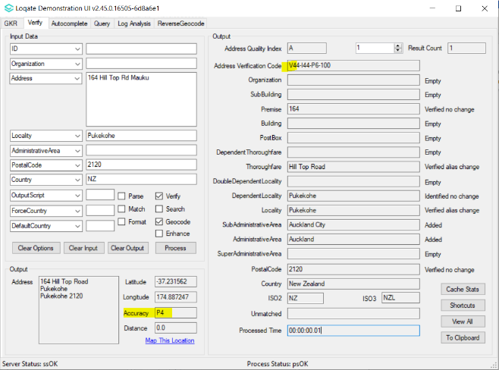

MAJOR HIGHLIGHT
Saudi Arabia
New field addition (ShortAddressCode) in Verify.
2023Q3.0 | 2023Q3.1
ShortAddressCode is not in Verify output.  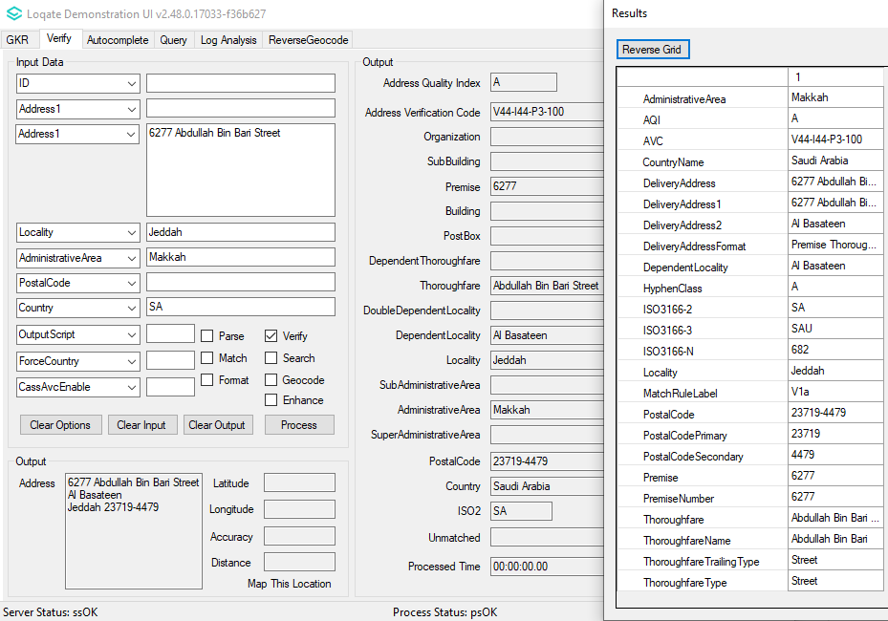 | ShortAddressCode is added in Verify output.  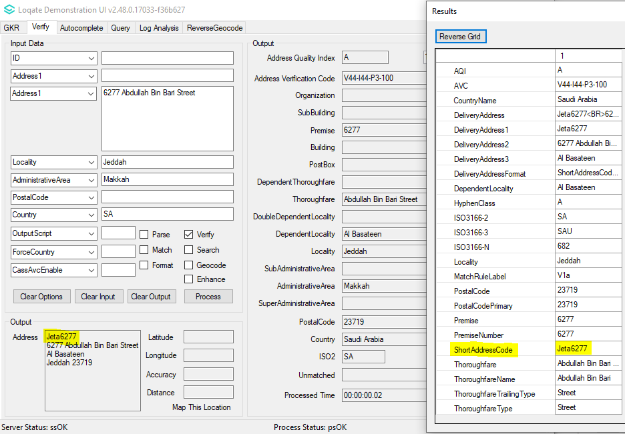

2023Q3.0 | 2023Q3.1
Previous Format of Output Address:  Line 1 | Organization  Line 2 | PostBox  Line 3 | SubBuilding Building  Line 4 | PremiseExtra Premise Thoroughfare  Line 5 | DependentThoroughfare  Line 6 | DoubleDependentLocality  Line 7 | DependentLocality  Line 8 | Locality PostalCode | NEW Output Address Format:  Line 1 | Organization  Line 2 | ShortAddressCode  Line 3 | PostBox  Line 4 | SubBuilding Building  Line 5 | PremiseExtra Premise Thoroughfare  Line 6 | DependentThoroughfare  Line 7 | DoubleDependentLocality  Line 8 | DependentLocality  Line 9 | Locality PostalCode

2023Q3.1 Data related Case Fixes

Case Number | Change Description | Category | Country | Example Address
- | Improvement of Building, AdministrativeArea and parsing removal of junk words | Data | GB | 1st Address  Address1: Miss K Riley  Address2: 662 Bury Rd  PostalCode: OL11 4AY  Country: UK  2nd Address  Address1: Mr Andrew Dawson  Address2: 129 Abbey Foregate  PostalCode: SY2 6AX  Country: GB  3rd Address  Address1: Unrecognized Property  Address2: 129 Abbey Foregate  PostalCode: SY2 6AX  Country: GB  4th Address  Address1: 1 rosemary close  Address2: crundale  Address3: Haverfordwest  Address4: Pembrokeshire  PostalCode: SA62 4EF  Country: GB

Before Image | After Image
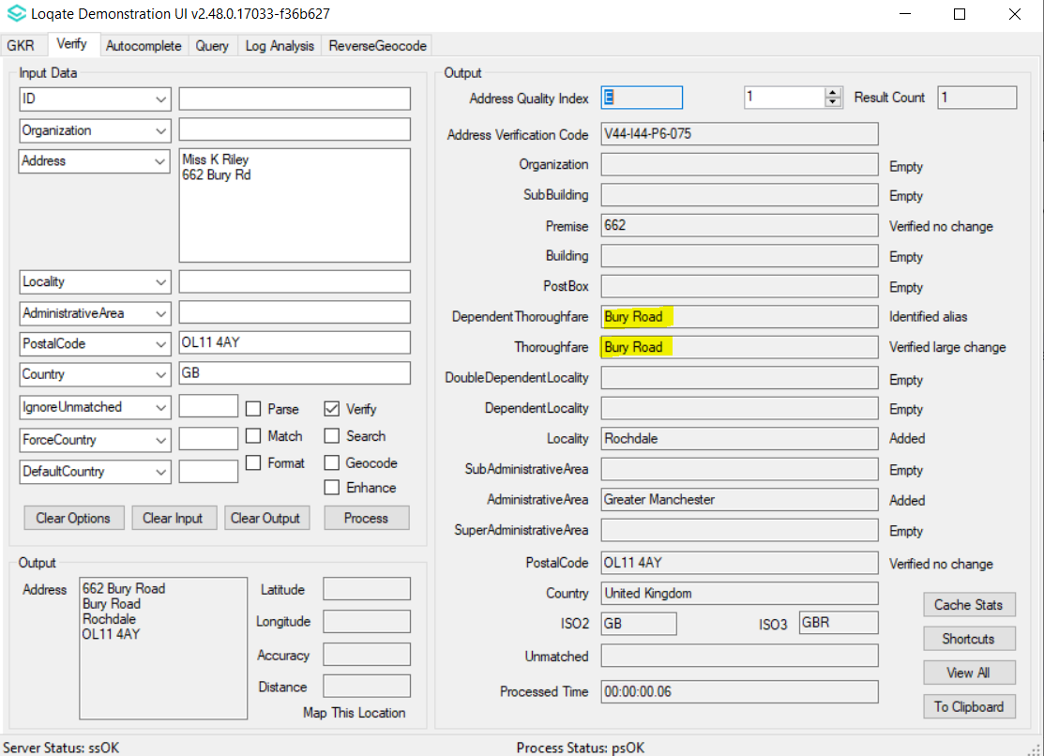 | 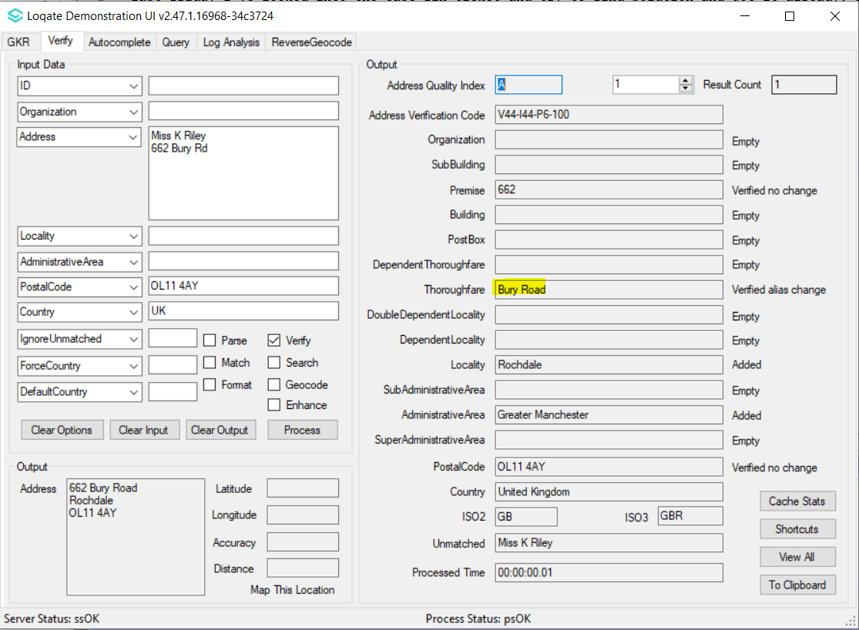
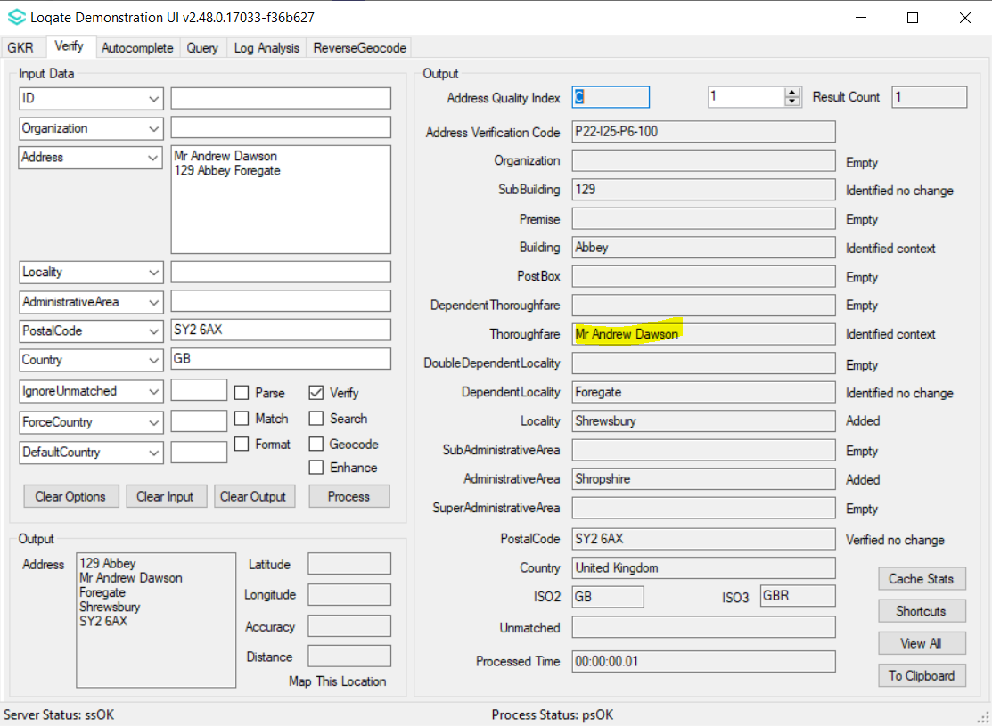 | 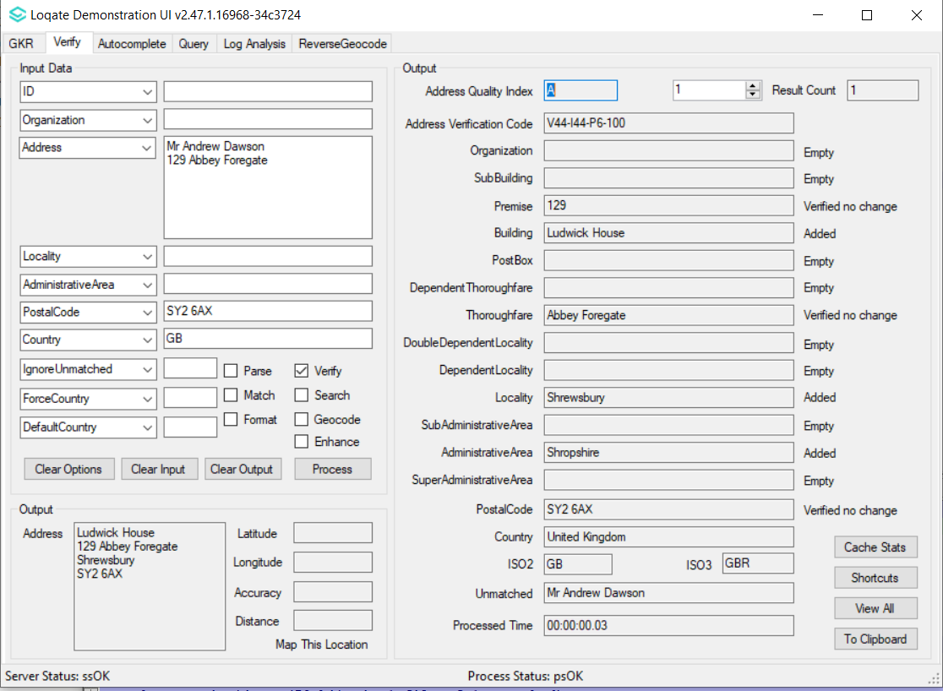
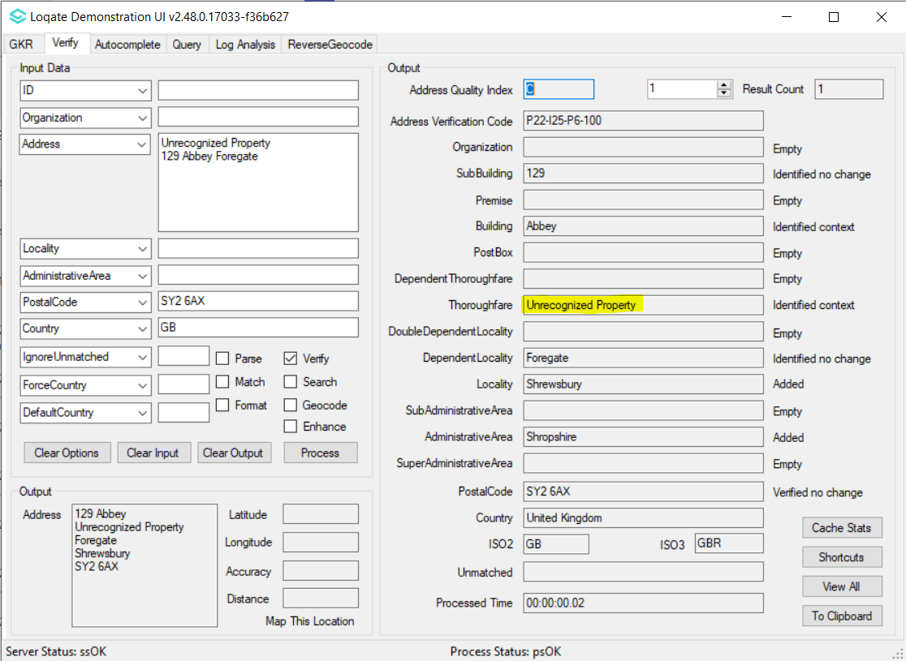 | 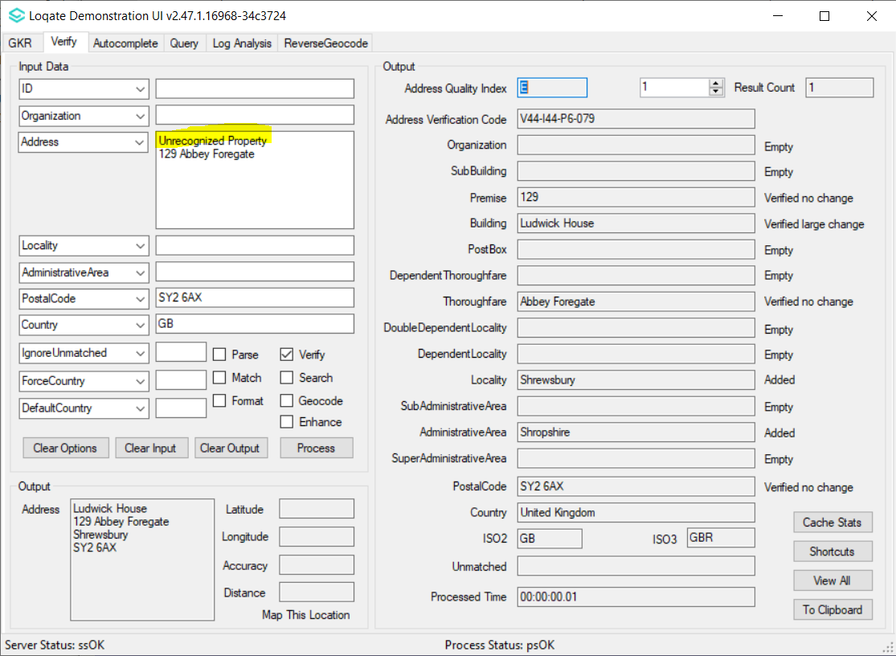
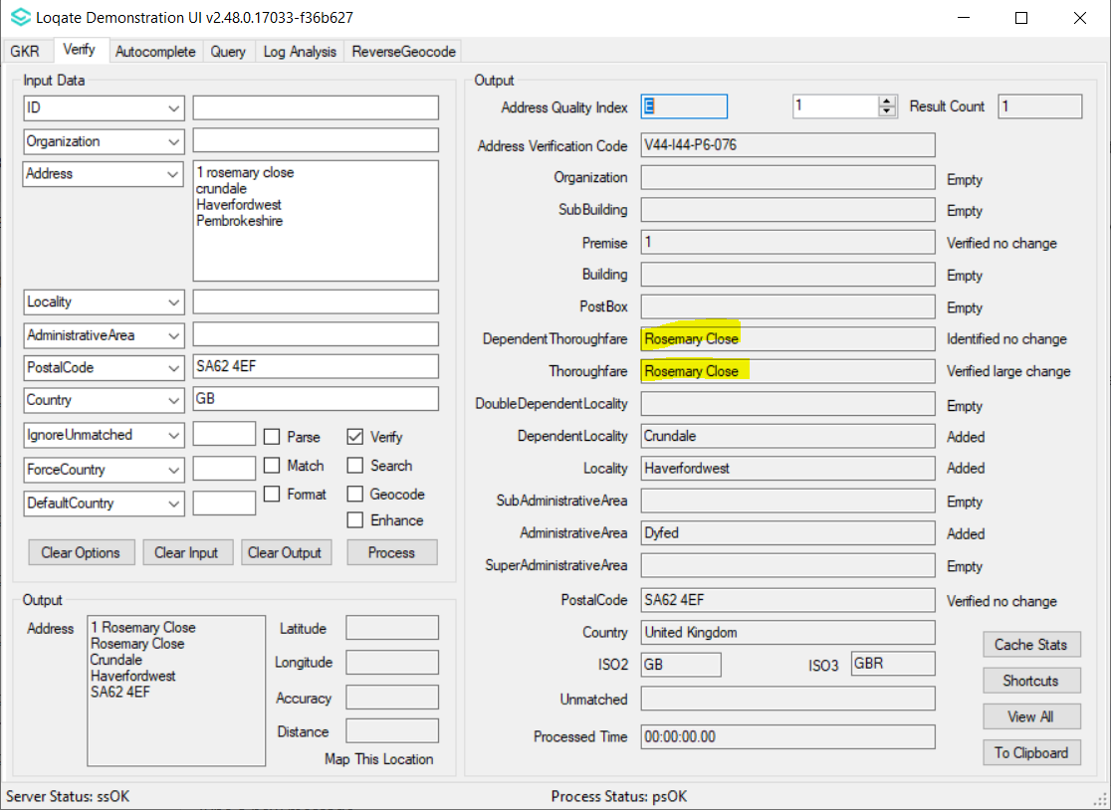 | 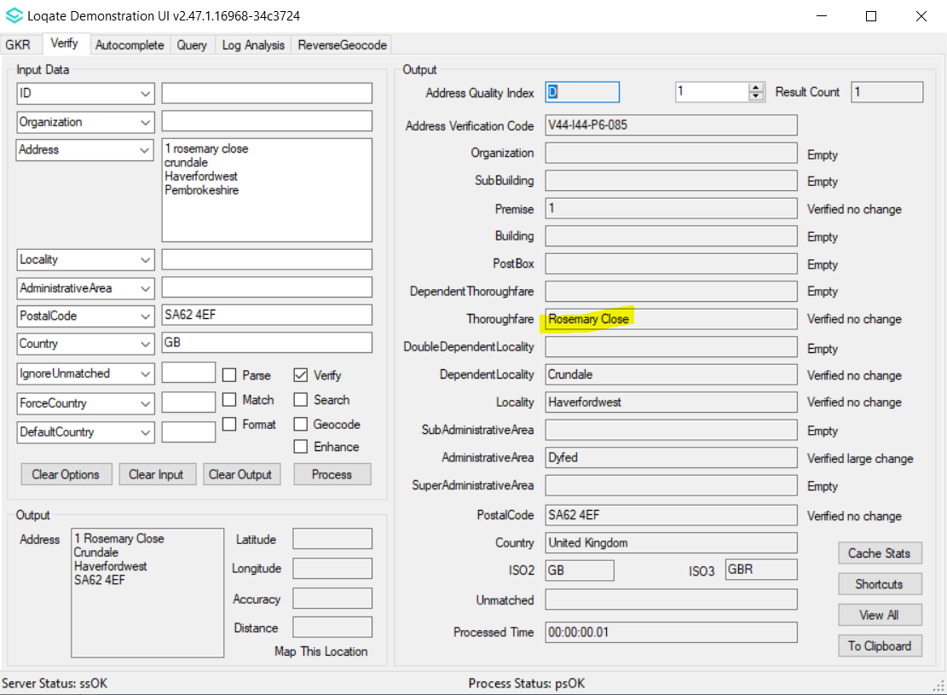

Case Number | Change Description | Category | Country | Example Address
CAS-97794-G3R0N0 | Improvement of Geocode accuracy for Thoroughfare with 'Route' types | Data | US | 1st Address  Address1: 1719 State Route 10, Parsippany, NJ 07054  2nd Address  Address1: 1515 State Route 10, Parsippany, NJ 07054  3rd Address  Address1: 2200 State Route 10, Ste 105, Parsippany, NJ 07054
Before Image |  |  | After Image
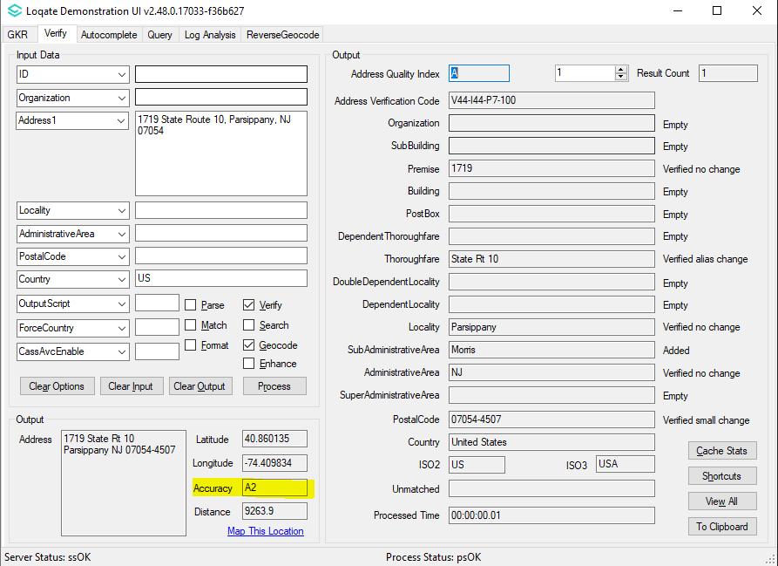 |  |  | 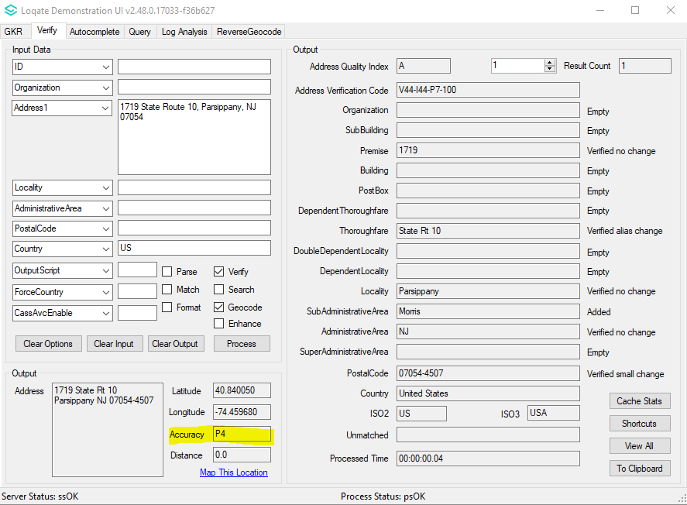
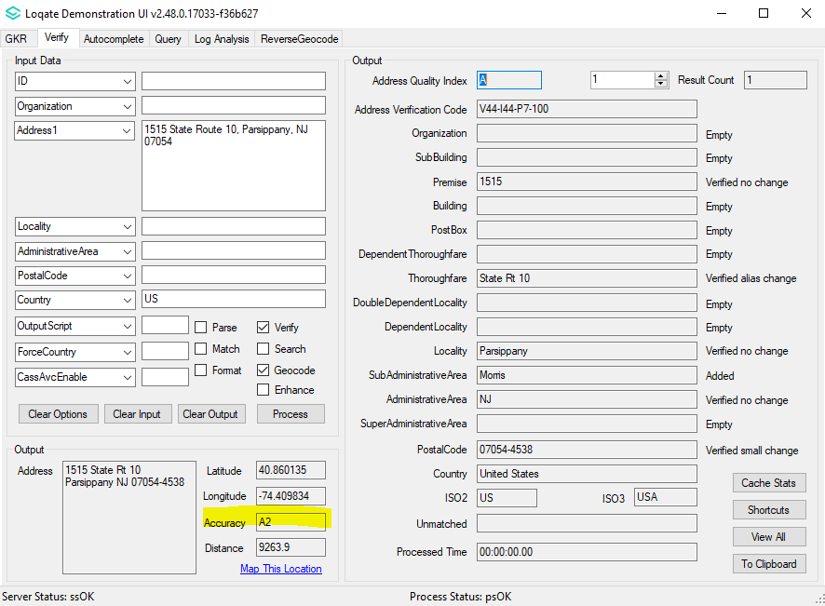 |  |  | 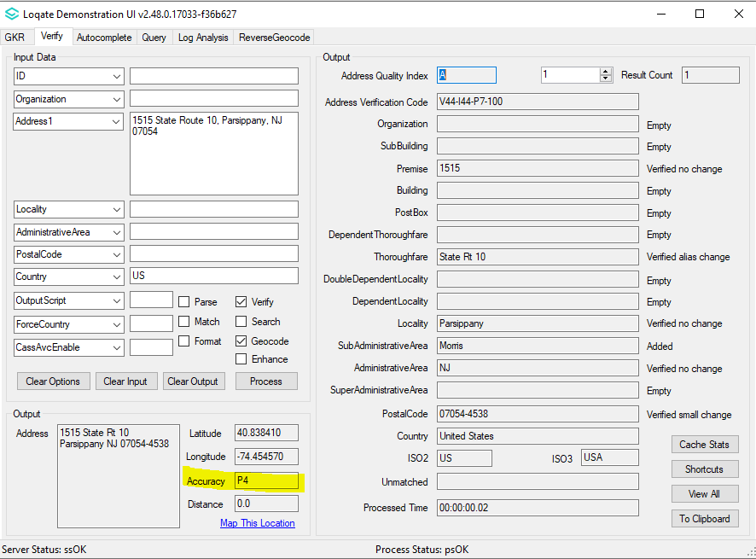
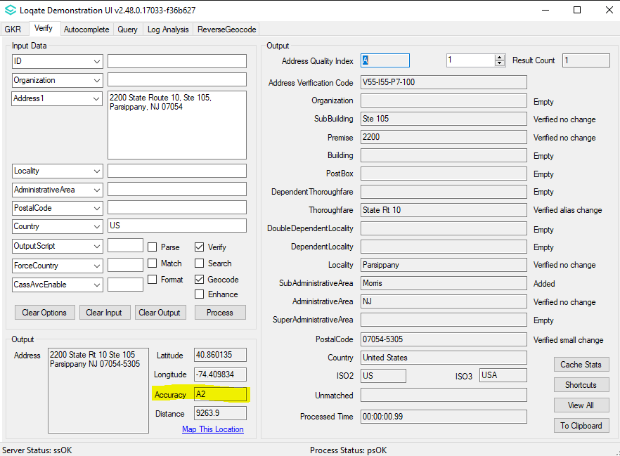 |  |  | 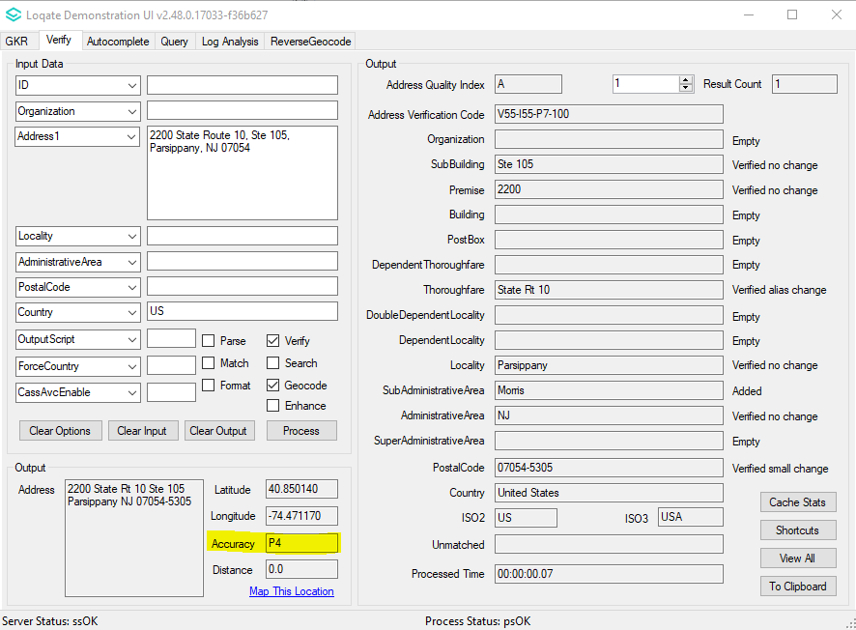

Case Number | Change Description | Category | Country | Example Address
- | Improvement of Address verification | Data | AT | 1st Address  Address1: Hauptstraße 20, 3376 St. Martin-Karlsbach  Country: AT  2nd Address  Address1: Lise-Meitner-Strasse 1, 2700 Wiener Neustadt  Country: AT
Before Image |  |  | After Image
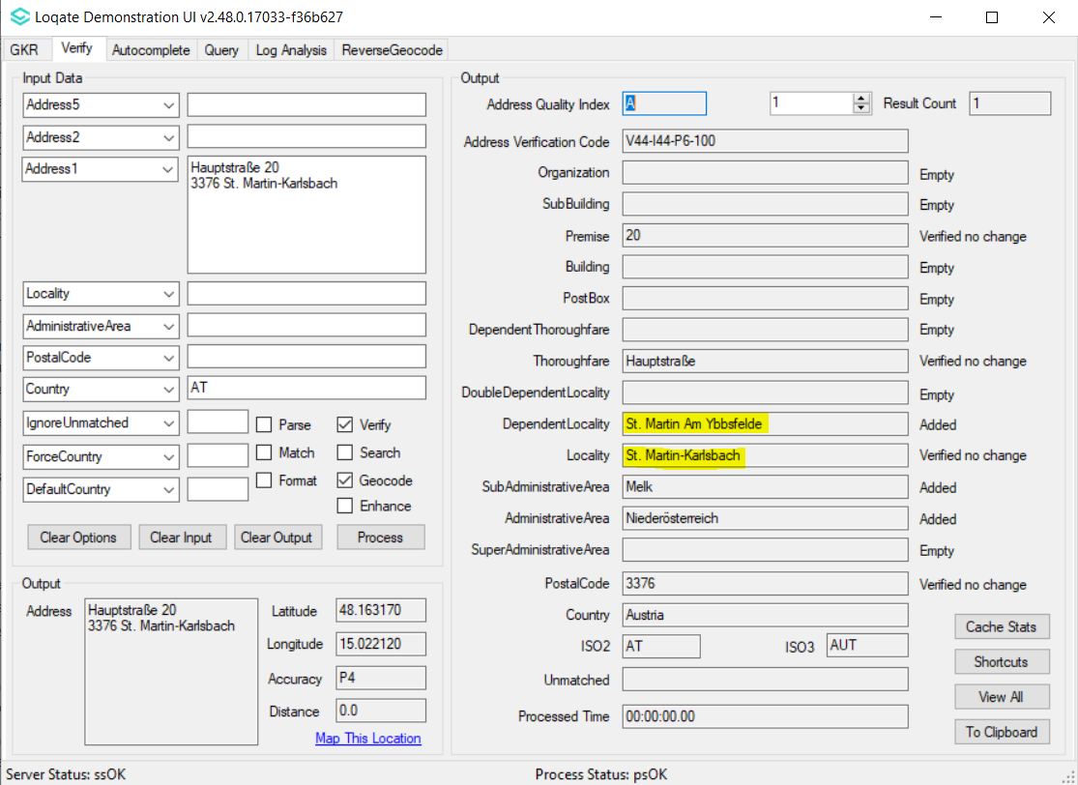 |  |  | 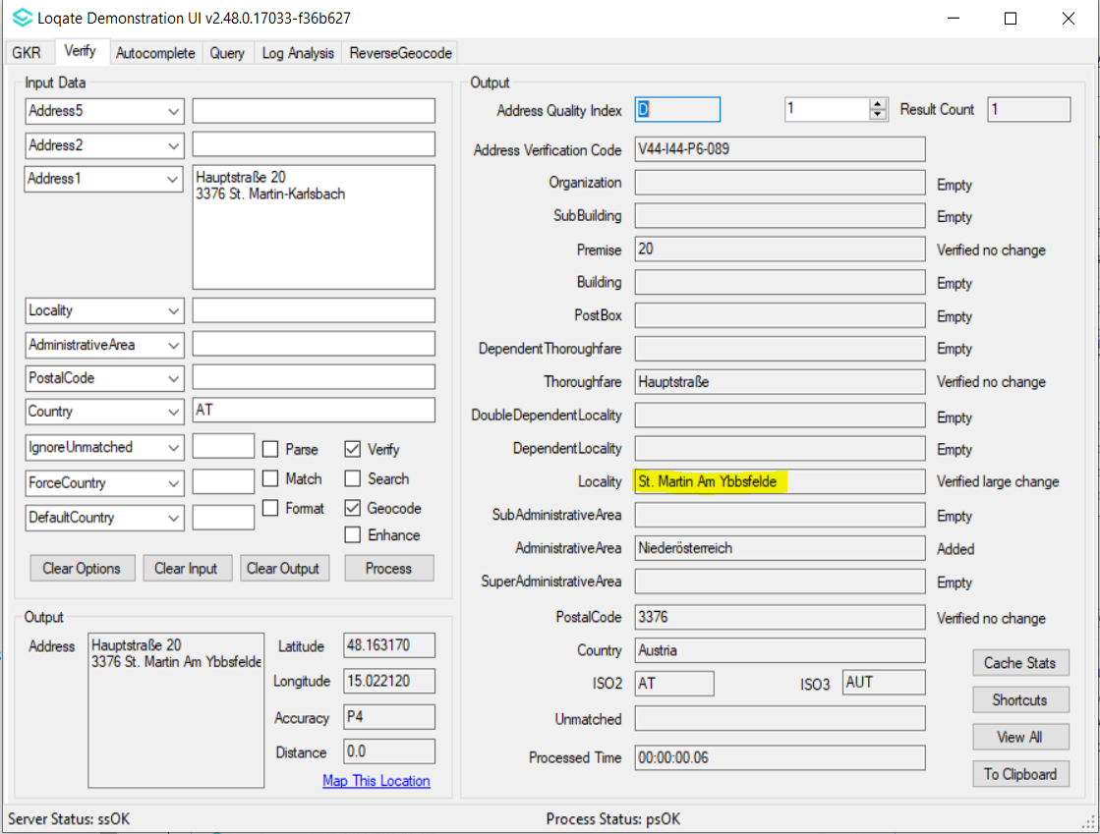
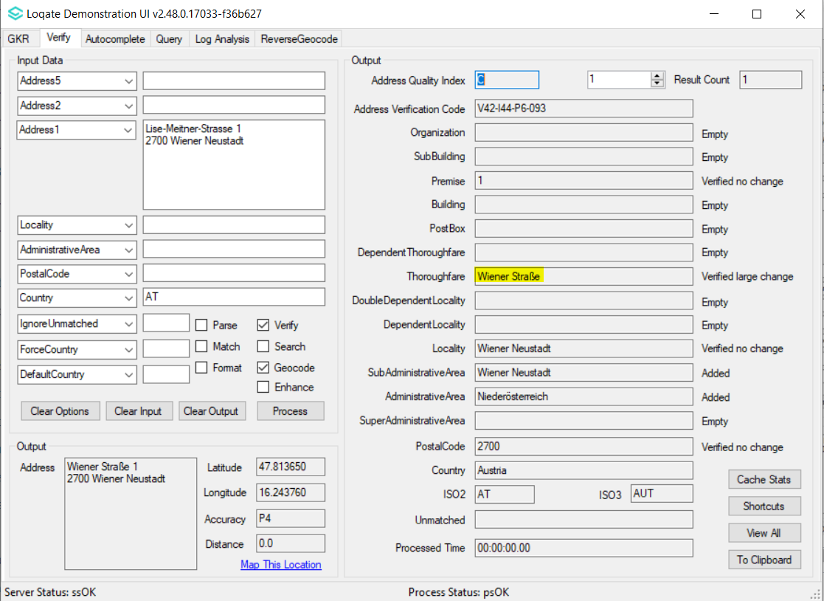 |  |  | 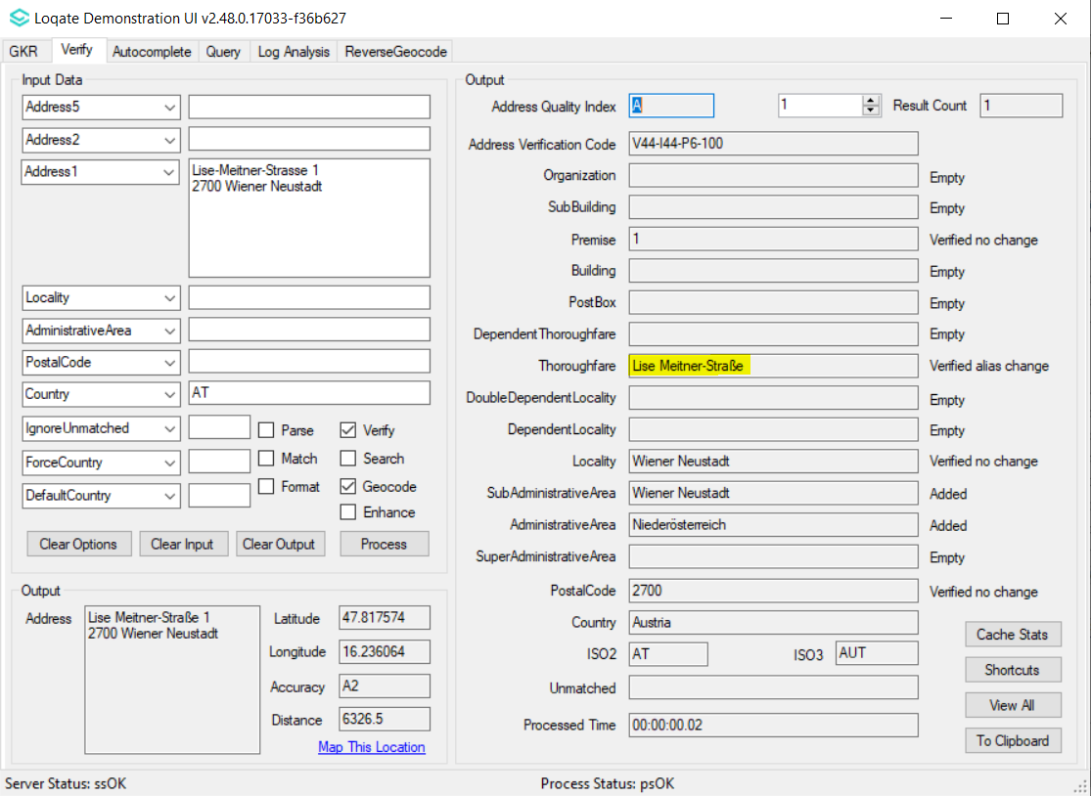

Case Number | Change Description | Category | Country | Example Address
CAS-90569-W0J0Z2 | Improvement of Address verification | Data | PT | Address1 : Rua José Pinheiro Gonçalves 299 loja 11  Locality: Monção  PostalCode: 4950-495  Country: Portugal
Before Image |  |  | After Image
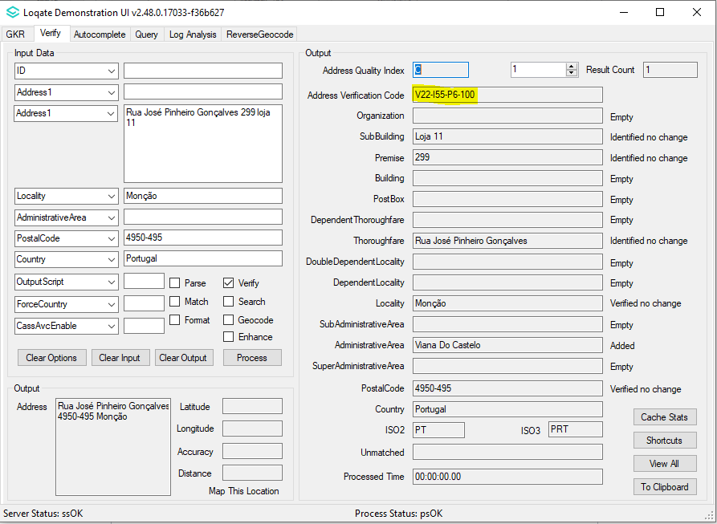 |  |  | 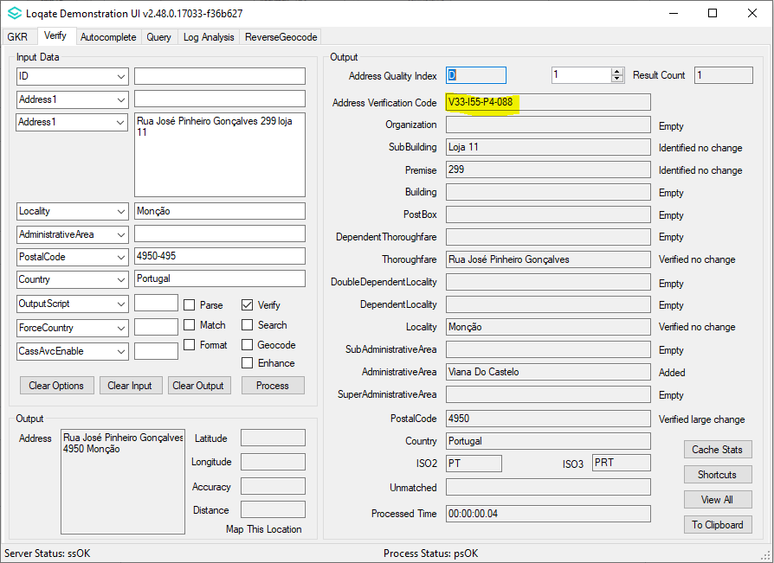

Case Number | Change Description | Category | Country | Example Address
CAS-48760-C4R0B6 | When EnhancedCountryTool=true, token would not be removed from address if that token does not represent the end result country | API | All | Address1="Verlengde Duinvalleiweg 102", Locality="Almere", PostalCode="1361 BR"
Before Image |  |  | After Image
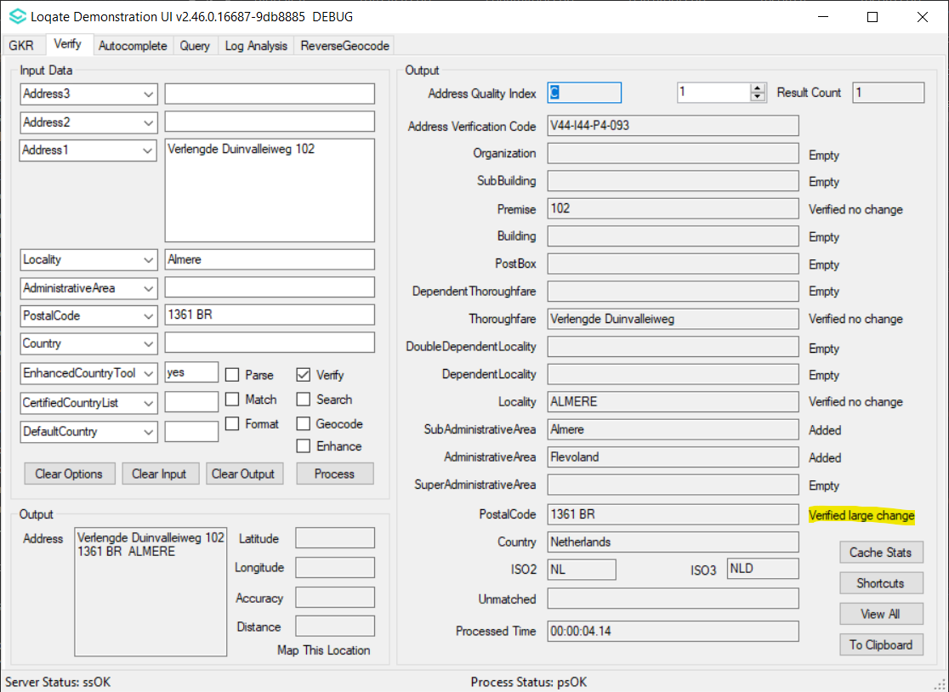 |  |  | 