Loqate, A GBG Solution
Release Notes – Verify API

2023Q3.1 Minor Release

Any customers using CASS2 must download the Q3.1 Loqate API and CASS2 together using the latest install manager. This is to ensure continuity of the CASS2 service due to a combined bug fix.

Case Resolutions
Please visit https://support.loqate.com/2023q3-1-resolved-cases/ for a list of all cases resolved in this release. If you would like more details on any of the solved cases listed, please contact LoqateSupport@gbgplc.com for further information.

Local API Notices
This is to inform our customers that in this 2023Q3.1 release there is a new API version - 2.48.1.17110-efb3179 that contains the following case fixes below.

Case Number | Change Description | Country
CAS-48760-C4R0B6 | When EnhancedCountryTool=true, token would not be removed from address if that token does not represent the end result country | All Countries with enhanced data
CAS-100414-X1Z0C4 | Hong Kong addresses are taking a long time to process. | Hong Kong
CASS2 Engine Improvement | Our CASS2 Engine interface with the CASSTM data has been updated in this release to support the fixing of some CASS2 issues. | United States

Local API Improvements
Case Number | Change Description | Category | Country | Example Address
CAS-48760-C4R0B6 | When EnhancedCountryTool=true, token would not be removed from address if that token does not represent the end result country | API | All | Address1="Verlengde Duinvalleiweg 102", Locality="Almere", PostalCode="1361 BR"
Before Image |  |  | After Image
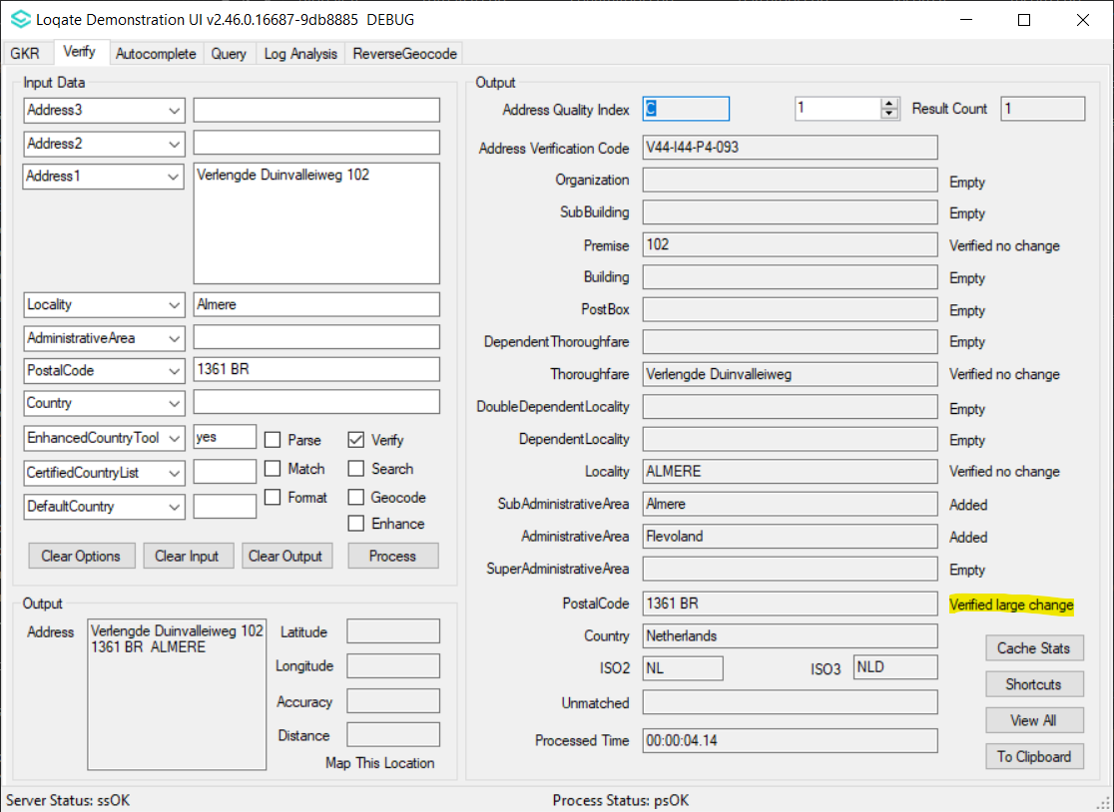 |  |  | 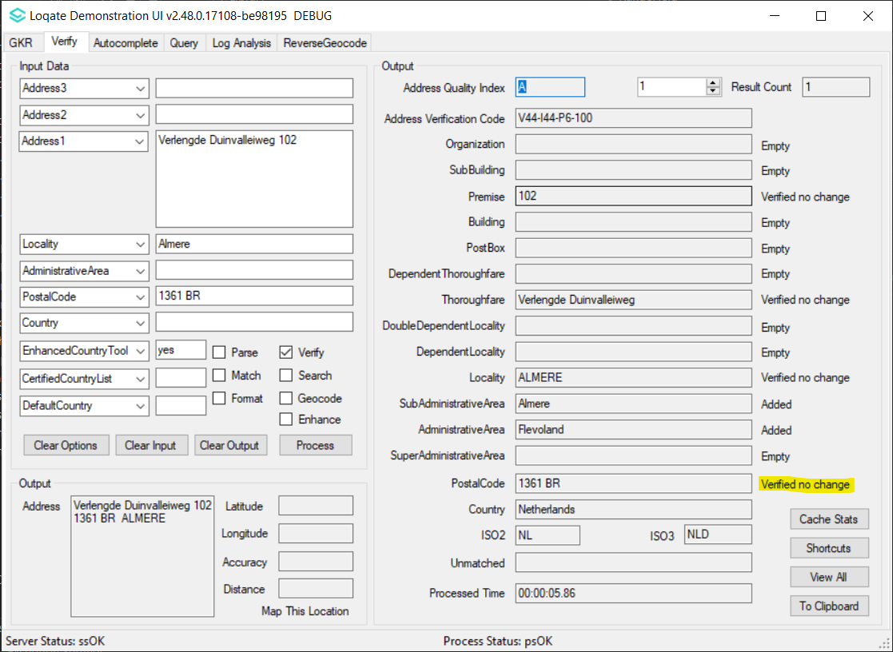

Case Number | Change Description | Category | Country | Example Address
CAS-100414-X1Z0C4 | Hong Kong addresses are taking a long time to process. | API | HK | Address1="UNIT C,18/F,TUNG CHIU COMM CTR.,193 LOCKHART RD., WANCHAI, HK"  Locality="HK"  AdministrativeArea="HK_HK"  PostalCode="1361 BR"
Before Image |  |  | After Image
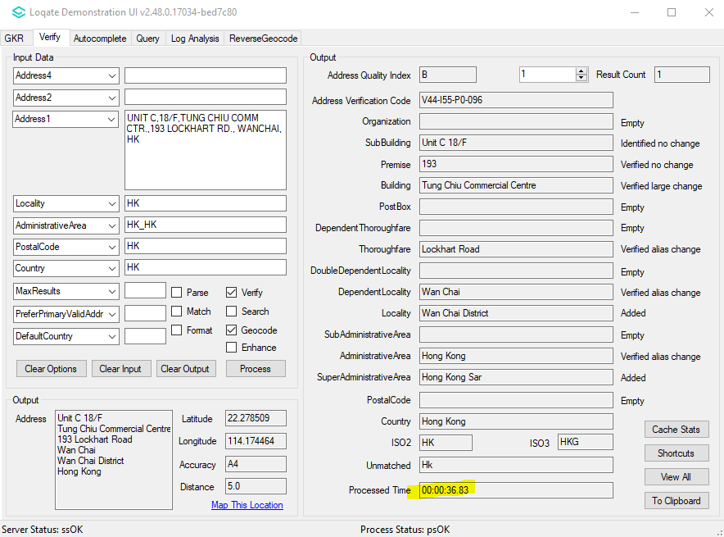 |  |  | 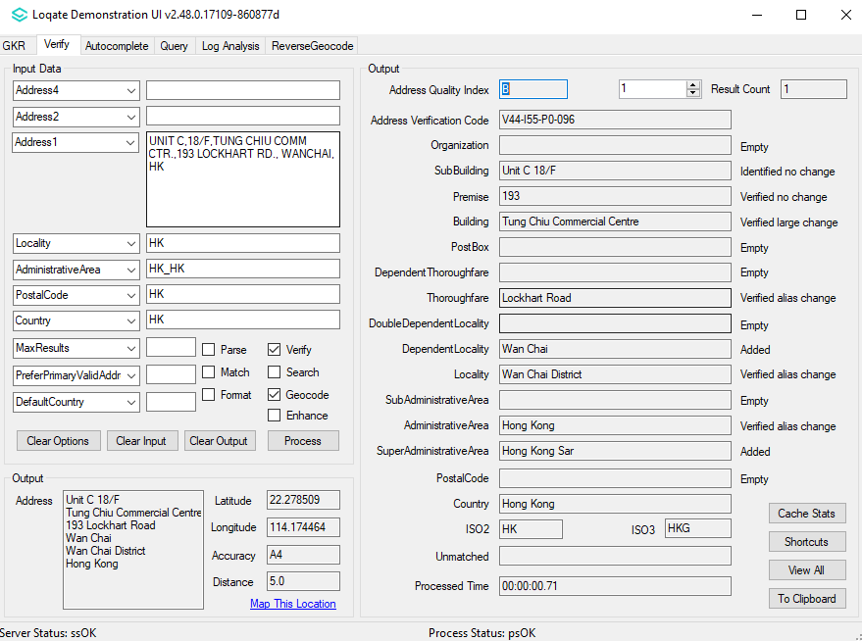

Case Number | Change Description | Category | Country | Example Address
CASS2 Engine Improvement | Our CASS2 Engine interface with the CASSTM data has been updated in this release to support the fixing of some CASS2 issues. | API | USA | 512 Stonewall Dr, Apt 420 D, Jacksonville, AR 72076-3360
Test Address |  |  | After Image
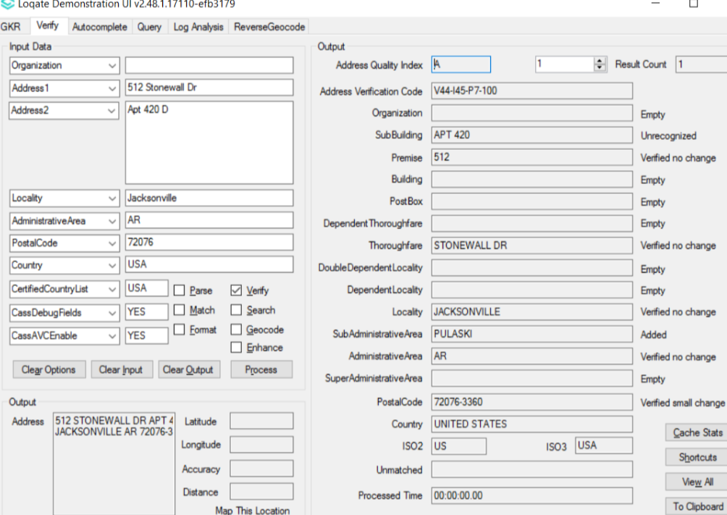 |  |  | Previously did not return AE08 in footnotes – now it is included –  AC10,AC11,AE08,AS02,AS17

Installation Instructions

If you need any assistance with the upgrade of the Local API or the data update process, please contact GBG Loqate Support.

The setup wizard for the Local API can be obtained from our SFTP server. Please contact your account manager to retrieve the SFTP information. If you do not know who your account manager is, please contact the support team at LoqateSupport@gbgplc.com.

