Loqate, A GBG Solution

Release Notes – Reference Data & Knowledge Base

2023Q3.0 Major Release

Case Resolutions
Please visit https://support.loqate.com/2023q3-0-resolved-cases/ for a list of cases resolved in this release.
If you would like more details on any of the solved cases listed, please contact LoqateSupport@gbgplc.com for further information.

Certification Expiration Dates
If you have purchased a certification product, please be aware that the datasets have expiration dates set by the respective postal authorities. Please ensure that you have the latest library and data installed to avoid loss of service through these products.

Please check Install Manager for the latest versions of our certification data

 | Loqate Release Date | Certification Expiry Date*
AMAS Data | 2023-06-02 | 2023-09-30
CASS2 Data | 2023-07-09 | 2023-09-30
SERP | 2023-07-14 | No Expiry

For more information on expiry date checking for CASS and AMAS, please refer “Usage expiration” section in https://support.loqate.com/documentation/local-apis/cass-overview-2/ and https://support.loqate.com/address-matching-approval-system-amas/
For SERP there is no forced expiry in the data it just becomes less current the longer you leave it between updates.

Country Data Refreshes

The below is a list of the 25 countries refreshed as part of this major release.
Country | ISO2
Australia | AU
Austria | AT
Canada (rebuild see below) | CA
Denmark | DK
Finland | FI
France | FR
Guernsey | GG
Hungary | HU
India | IN
Italy | IT
Isle of Man | IM
Japan (restructure see below) | JP
Jersey | JE
Korea, Republic Of | KR
Luxembourg | LU
Mexico | MX
Norway | NO
Singapore | SG
Sweden | SE
Switzerland | CH
Turkey | TR
South Africa | ZA
United Arab Emirates | AE
United Kingdom | GB
United States | US

Country Rebuild

The below is a summary of the Countries where we have updated the reference data / structure.
Country | Description
Canada | Addition of data source to provide premise level data
Japan | Improvement of Building, Premise, and PostalCode verifications using new data

Country Rebuild Highlights

Canada
Country Information | Description
ISO2 | CA
ISO3 | CAN
Address Format | No changes
PDH | YES
New Source | YES
 | Pre-PDH | Post-PDH
Reference Data | rd_CA_vfy.lfs  rd_CA_vfy_ai.lfs  rd_CA_ggg_rg.lfs  rd_CA_ggg_r3.lfs  rd_CA_ggg_r2.lfs  rd_CA_ggg_r1.lfs  rd_CA_ggg_r.lfs  rd_CA_ggg.lfs | rd_CA_vfy.lfs  rd_CA_vfy_ai.lfs  rd_CA_ggg.lfs  rd_CA_ggg_r.lfs  rd_CA_ggg_rg.lfs
Release Notes | Range Premises, SubBuilding, and PostBox data are removed - only valid and point data are provided in the new dataset. | Improvement of SubBuilding data coverage

2023Q2.1 | 2023Q3.0
SubBuilding was not verified.  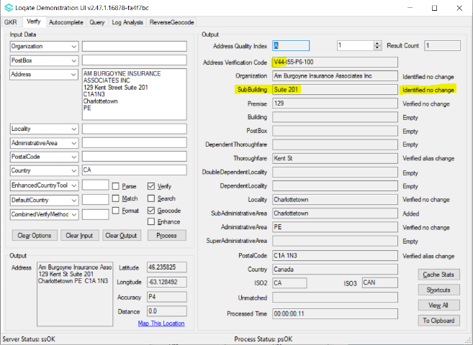 | SubBuilding is now verified.  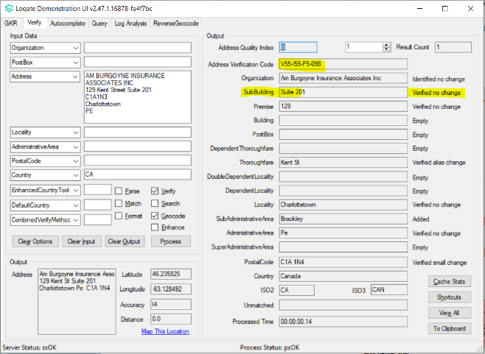

GeoAccuracy returned I4.  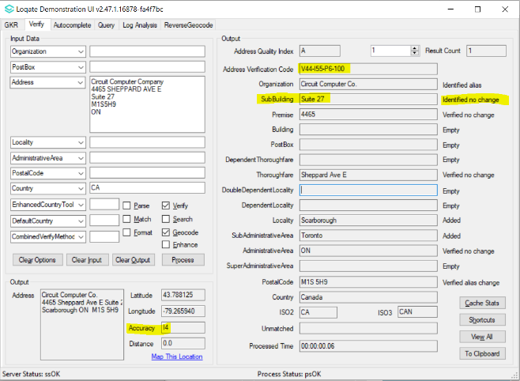 | GeoAccuracy now returned P4.  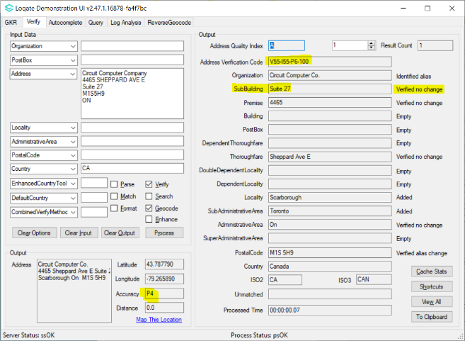

Invalid input Premise verified.  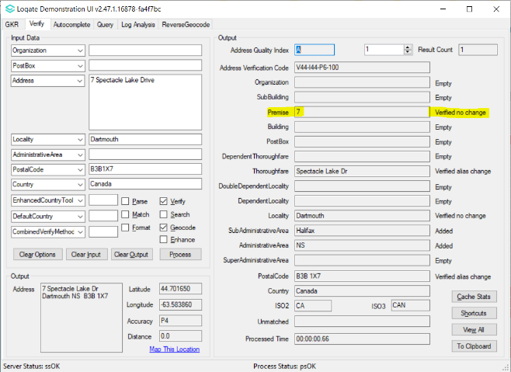 | Invalid input Premise no longer verified.  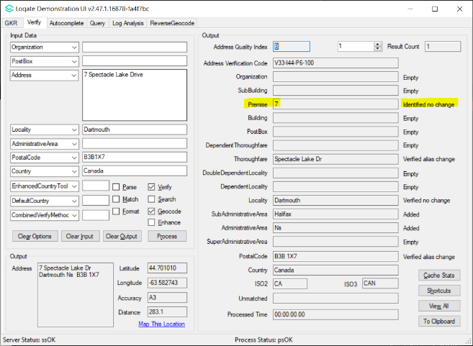

Japan
- New addition – business addresses
- Improvement on Premise and PostalCode verification.
2023Q2.1 | 2023Q3.0
No Building value added in output.  PostalCode verified large change.  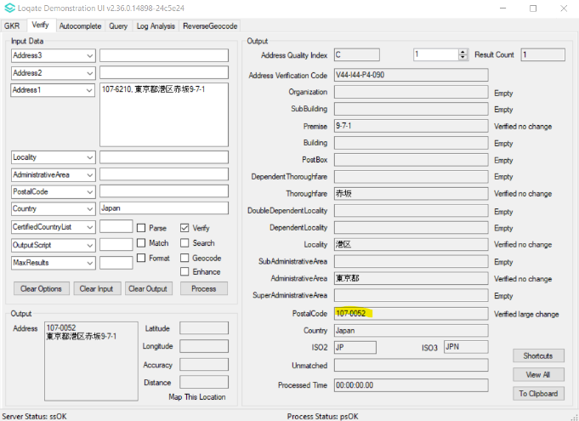 | Added Building value in output.  PostalCode now verified no change.  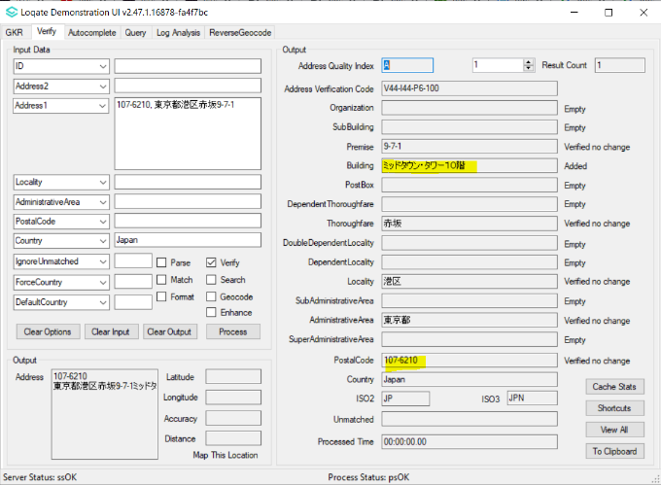

No Building value added in output.  Premise not verified.  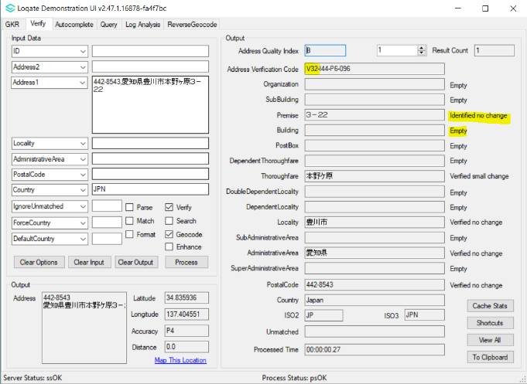 | Added Building value in output.  Premise now verified.  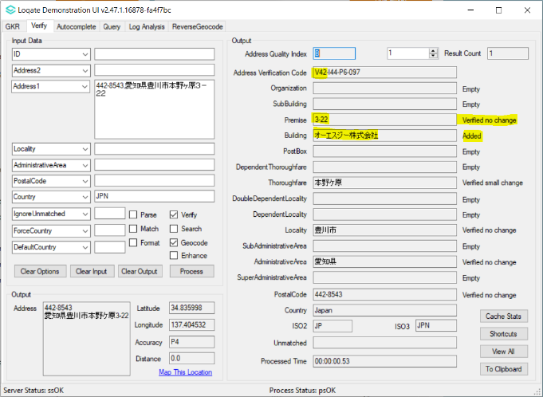

PostalCode not verified.  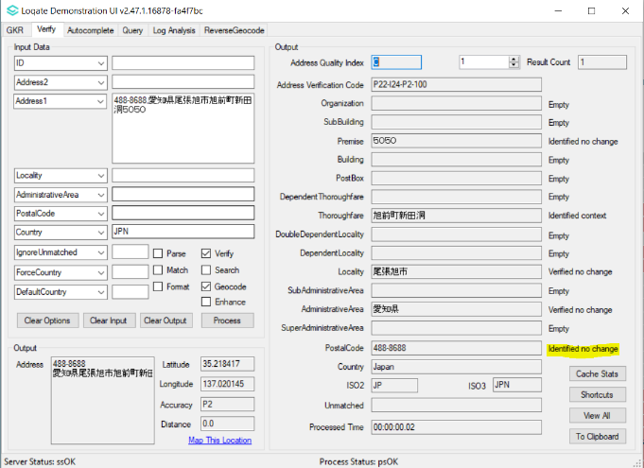 | PostalCode now verified.  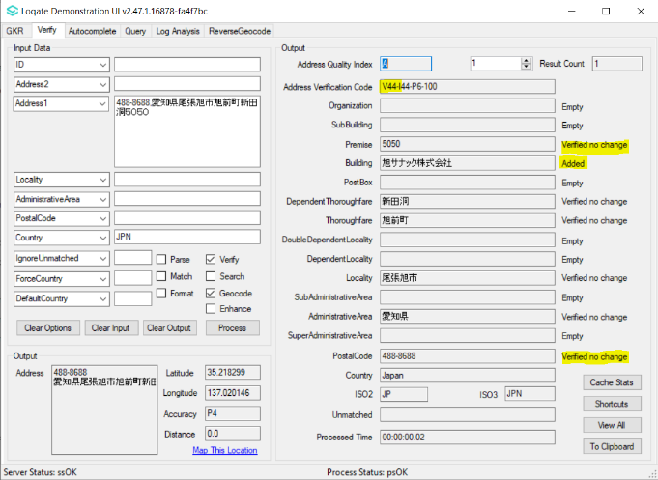

Case Resolutions

2023Q3.0 Data related Case Fixes
Case Number | Change Description | Category | Country | Example Address
CAS-94184-G5Y7F8 | Correction of address that has missing Timezone data | Data | US | Address1: 457 Highway 46 South  Locality: Dickson  AdministrativeArea: TN  PostalCode: 37055  Country: USA
Before Image |  |  | After Image
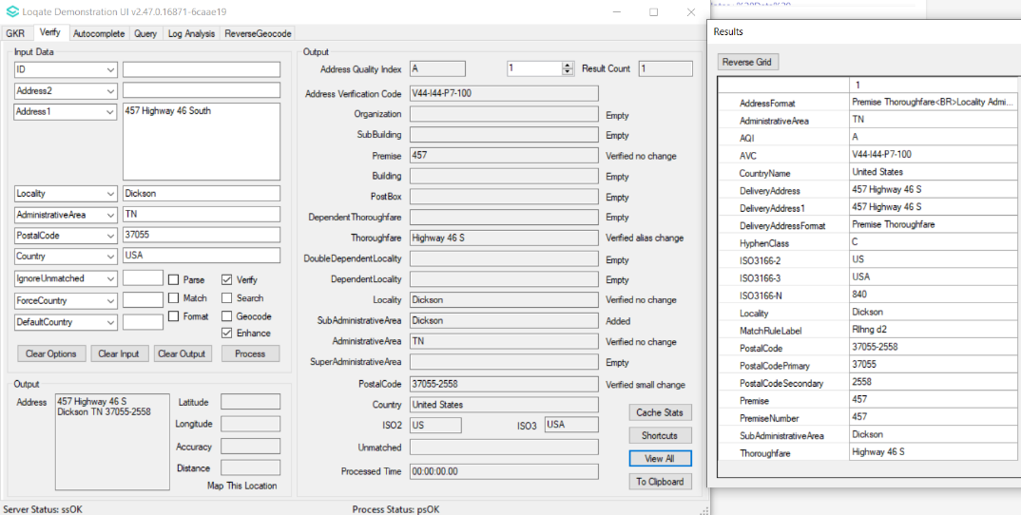 |  |  | 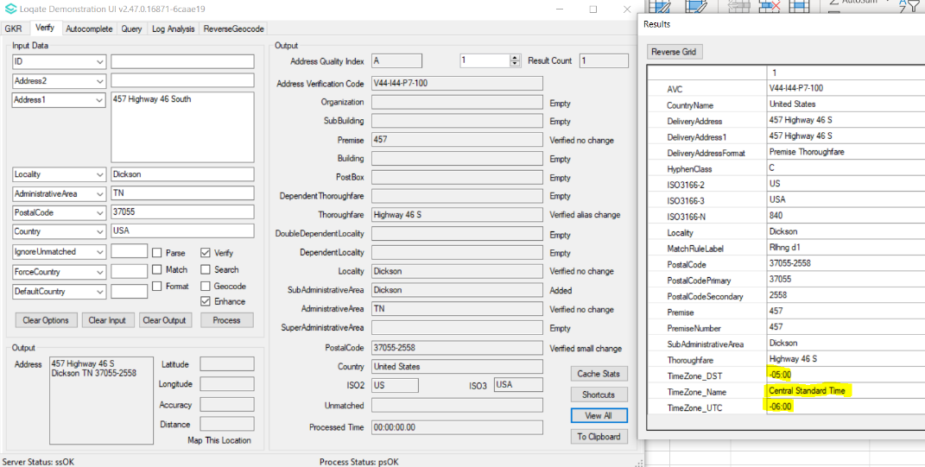

Case Number | Change Description | Category | Country | Example Address
CAS-96960-T6M8Z9 | Correction of Timezone output | Data | US | Address1: 6824 Michael Ln, Hayes, VA 23072-3204, USA
Before Image |  |  | After Image
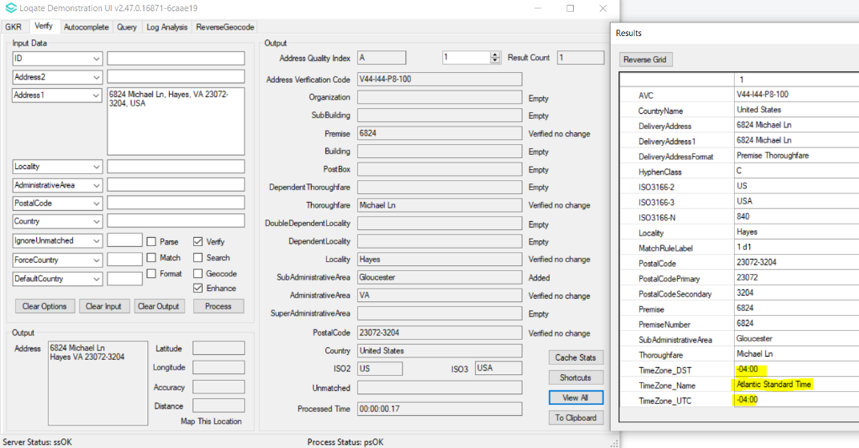 |  |  | 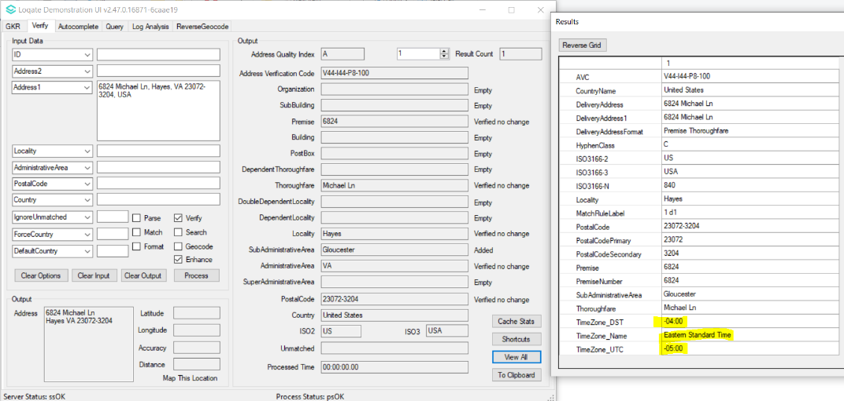

Case Number | Change Description | Category | Country | Example Address
CAS-99790-D7X0L7 | Improvement of SubBuilding parsing | Data | GB | 1st Address  Address1: 7 Garden Flat  Address2: 5 Massie Road  Postal Code: E8 1BY  Country: GB  2nd Address  Address1: Garden Flat 7  Address2: 5 Massie Road  Postal Code: E8 1BY  Country: GB
Before Image |  |  | After Image
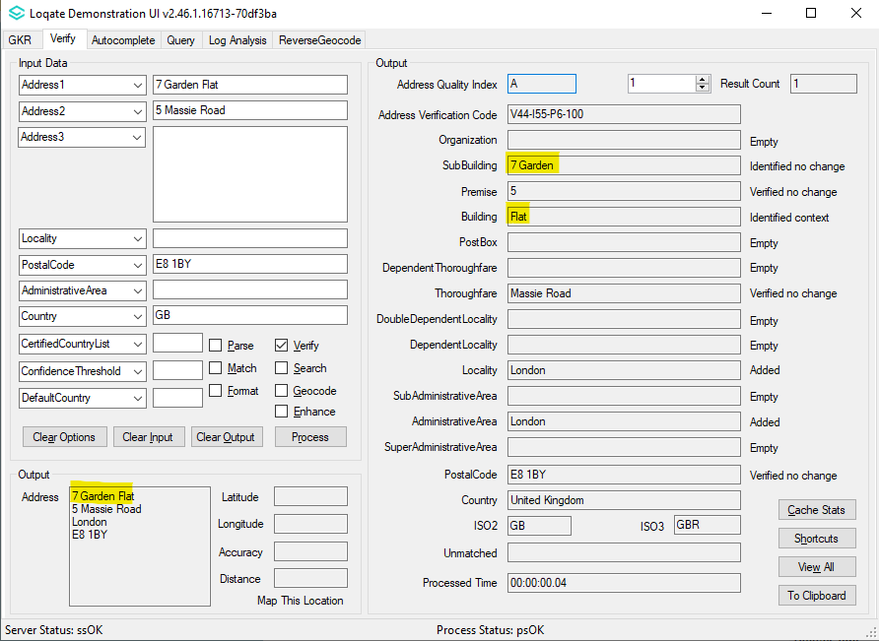 |  |  | 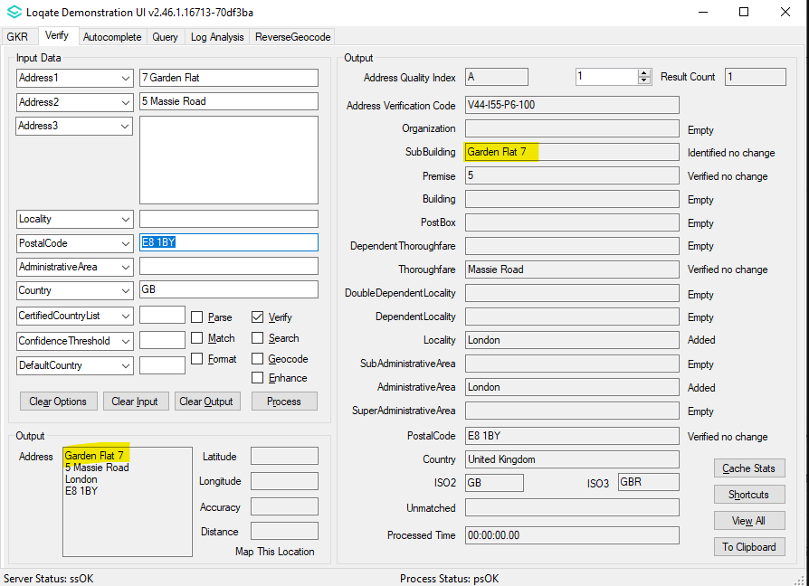
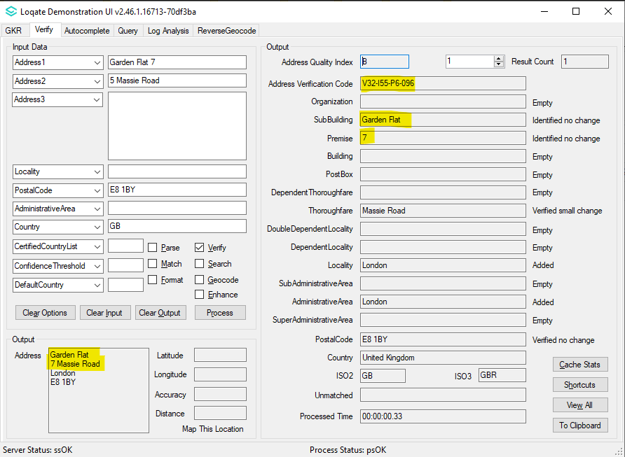

Case Number | Change Description | Category | Country | Example Address
CAS-94255-Q1V0R7 | Improvement of Building and SubBuilding parsing | Data | KR | 1st Address  Address1: 경기도 성남시 분당구 금곡동  Address2: 210 코오롱트리폴리스1 A-3402  PostalCode: [13616]  Country: KOR  2nd Address  Address1: 경기도 성남시 분당구 금곡동  Address2: 210 코오롱트리폴리스1 A동 3402  PostalCode: [13616]  Country: KOR
Before Image |  |  | After Image
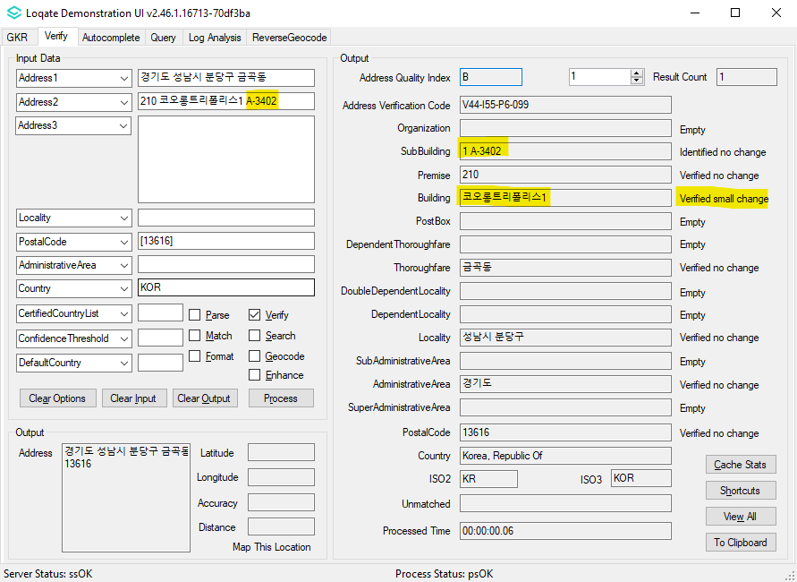 |  |  | 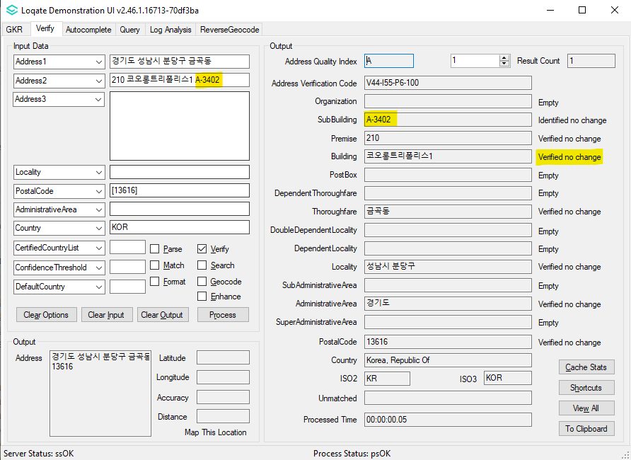
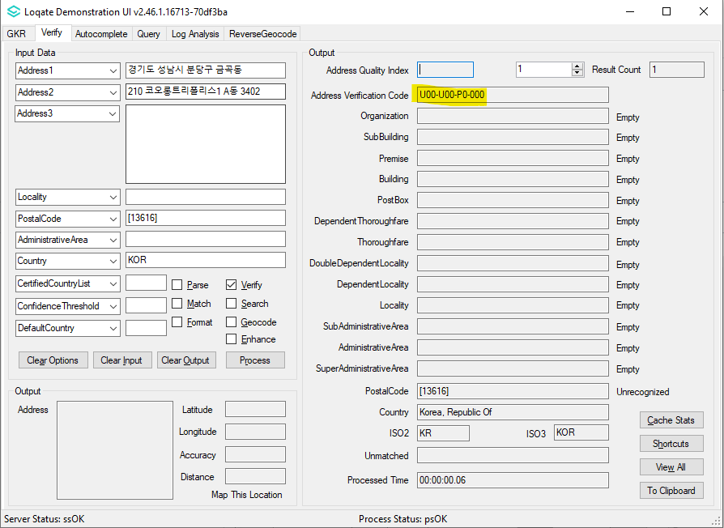 |  |  | 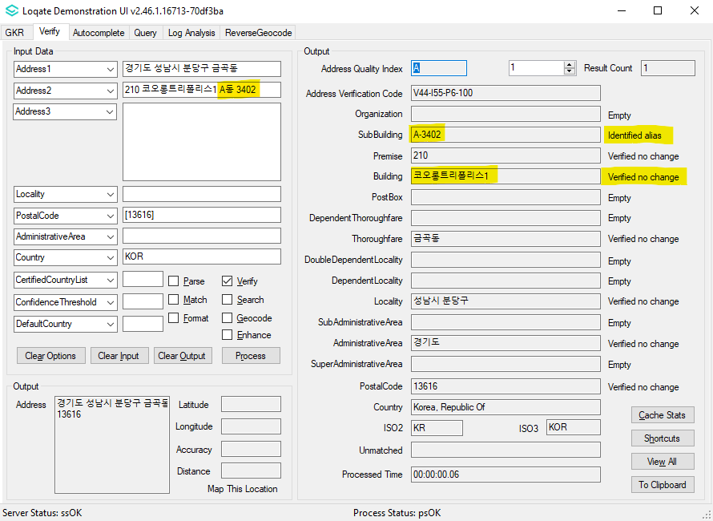

Case Number | Change Description | Category | Country | Example Address
CAS-54610-T8R3W7 | Improvement of Building and Postal Code verifications | Data | JP | Address1: 107-6210, 東京都港区赤坂9-7-1  Country: Japan
Before Image |  |  | After Image
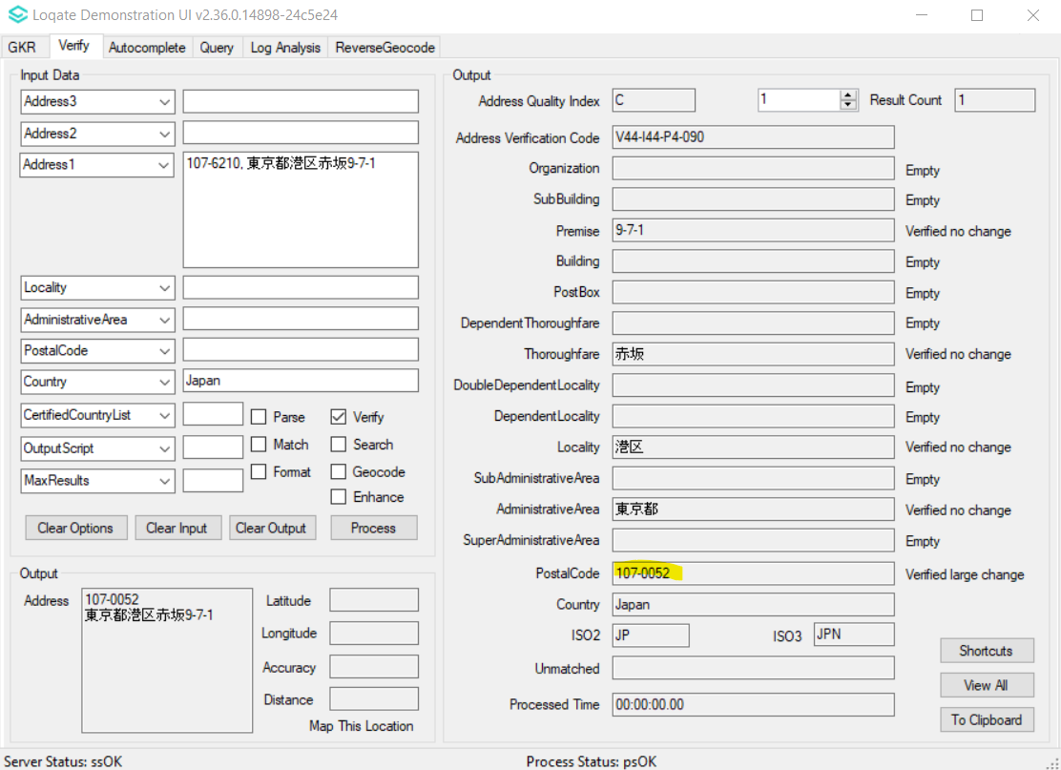 |  |  | 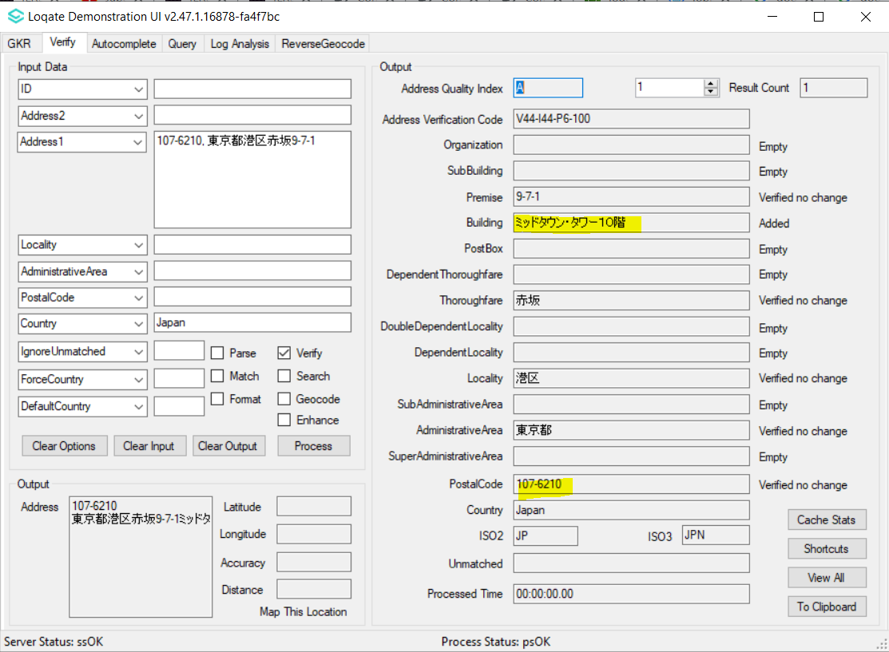

Case Number | Change Description | Category | Country | Example Address
CAS-92344-Z2S3Q4 | Improvement of the PremiseType output format | Data | ID | Address1: Jl. Jawa No.2  Address2: Kec. Medan Timur  Locality: Medan  AdministrativeArea: ID-SU  PostalCode: 20231  Country: ID
Before Image |  |  | After Image
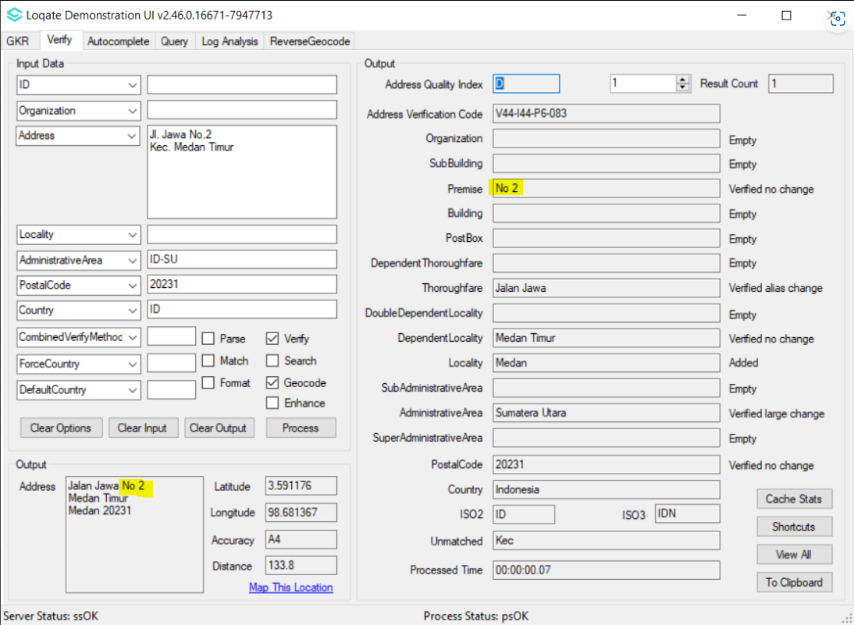 |  |  | 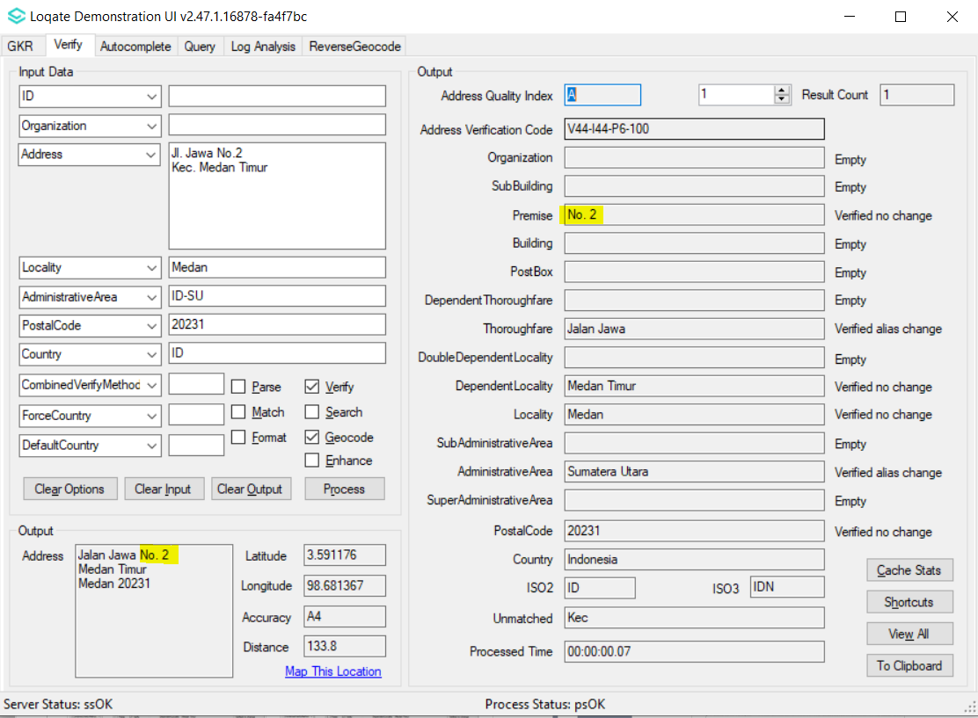

Case Number | Change Description | Category | Country | Example Address
CAS-97003-C3P1G9 | Improvement of SubBuilding verification | Data | CA | Address1: 4512 Boul Saint-Joseph, Drummondville QC J2A 1B1
Before Image |  |  | After Image
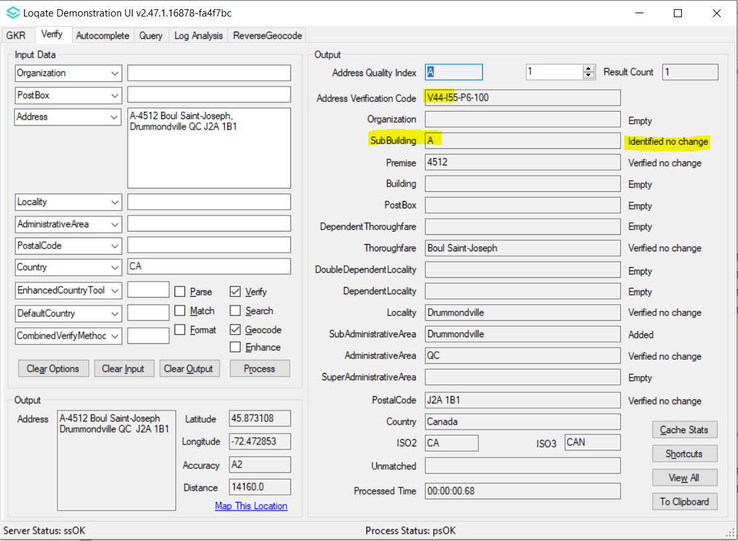 |  |  | 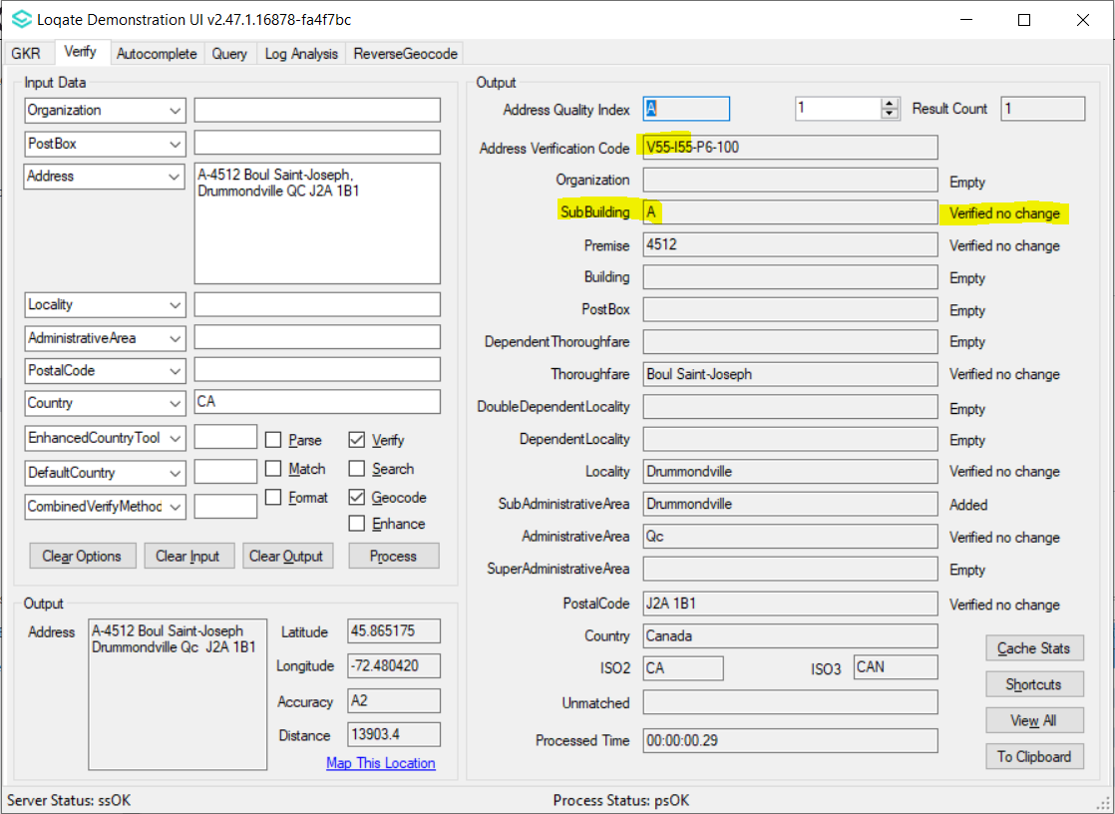

Case Number | Change Description | Category | Country | Example Address
CAS-93613-B4N0C7 | Improvement of Geocode accuracy | Data | SG | 1st Address  Address1: 15 BEACH ROAD  Locality: SINGAPORE  Postal Code: 189677  2nd Address  Address1: 33 OXFORD ROAD  Locality: SINGAPORE  Postal Code: 218816
Before Image |  |  | After Image
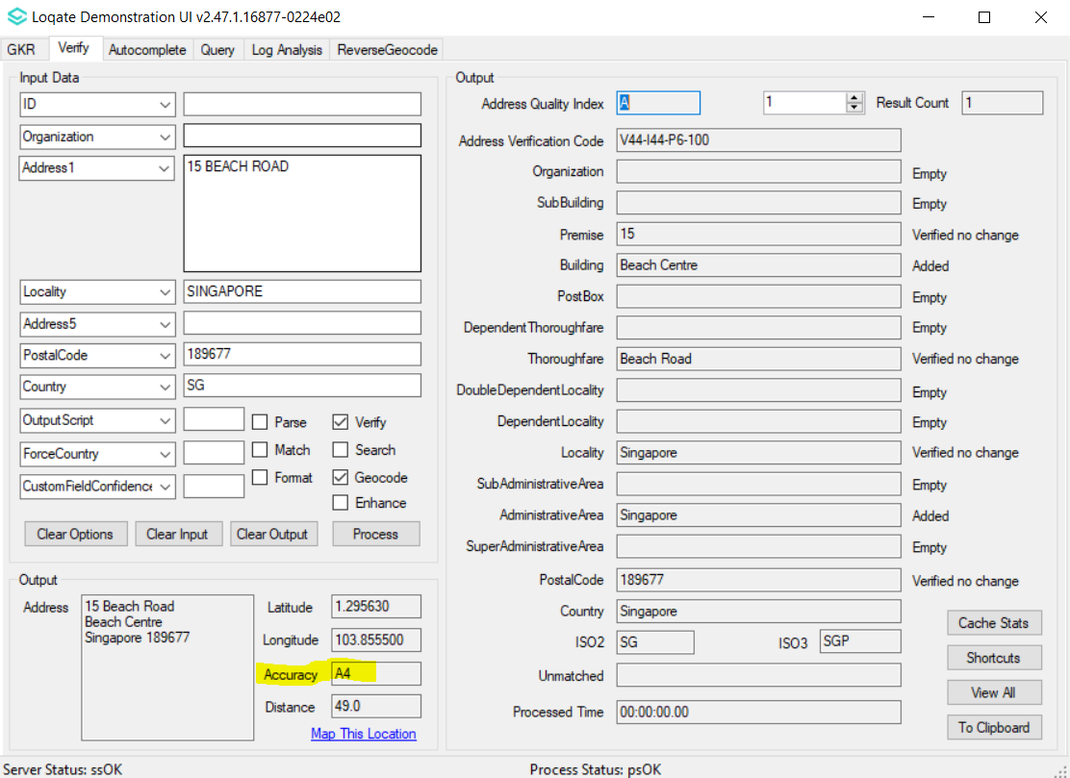 |  |  | 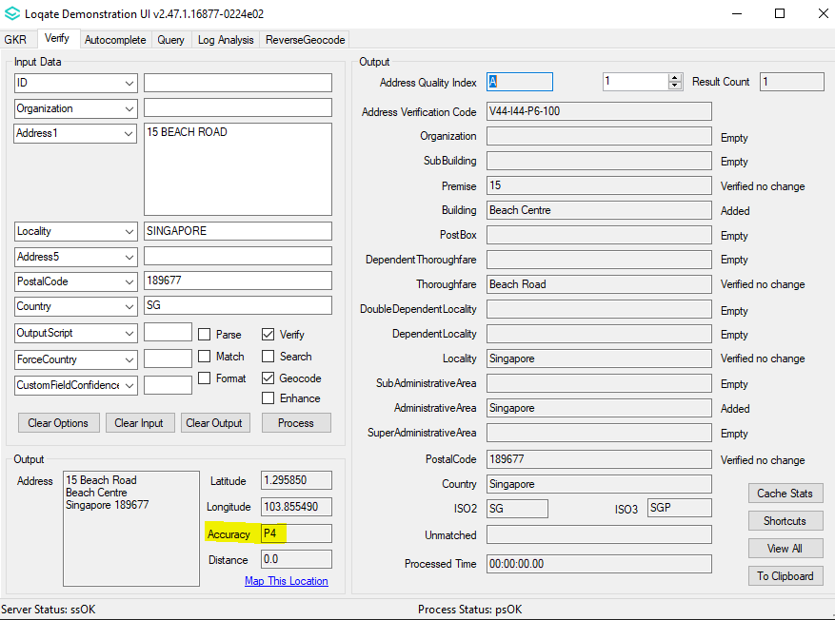
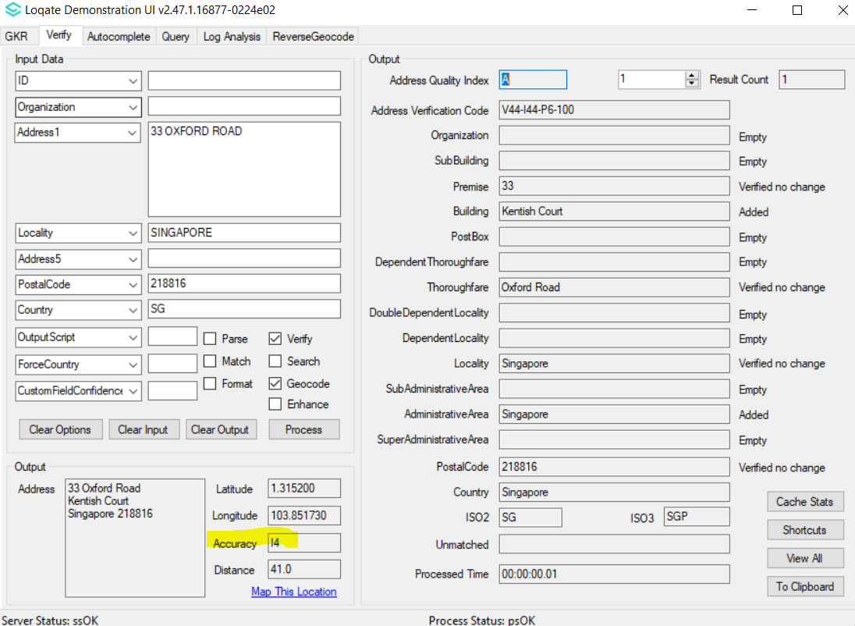 |  |  | 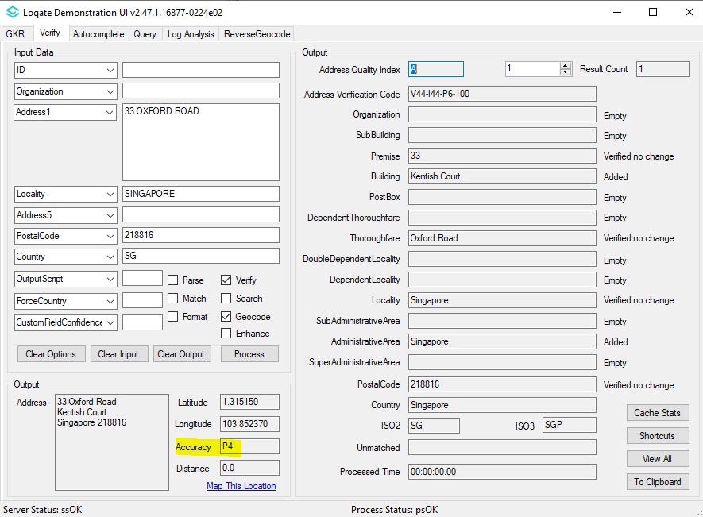

Case Number | Change Description | Category | Country | Example Address
CAS-98671-G6H3Q3 | The engine would now skip checking the candidates if the filtering process is not able to narrow down the regions where the address could be from. | API | All | Address1=RES CAMP ROBERT BTH1PTE125, AdministrativeArea=FREJUS,  PostalCode=83600, Country=France
Before Image |  |  | After Image
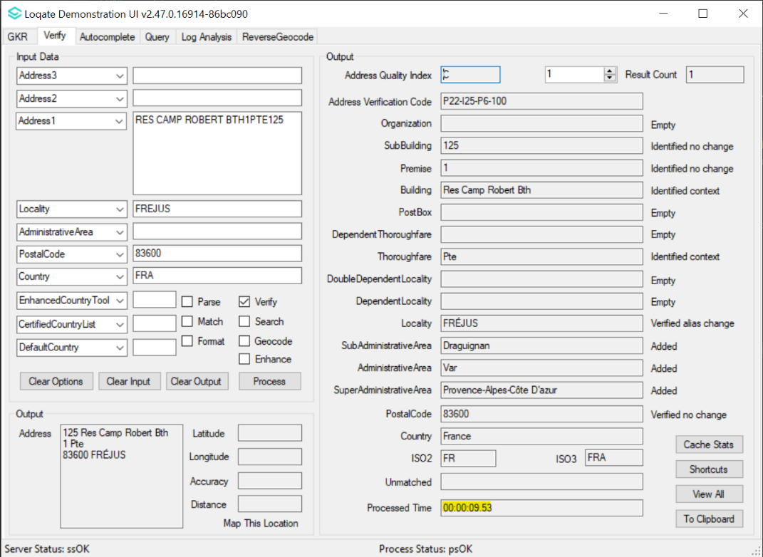 |  |  | 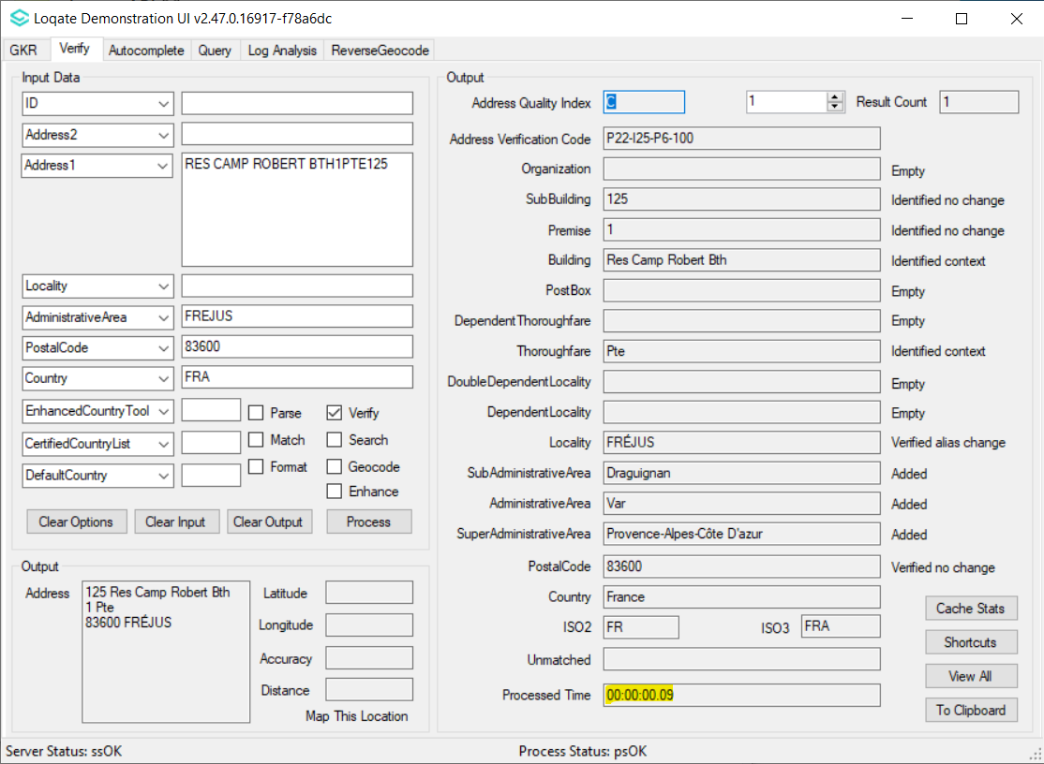

Case Number | Change Description | Category | Country | Example Address
CAS-95188-P1R7G1 | Improvement of Address verification | Data | IT | 1st Address  Address1: Via Giuseppe Borsani 3  Locality: Abbiategrasso PostalCode: 20081  2nd Address  Address1: Via dei Pioppi 20  Locality: Piedimonte Matese PostalCode: 81016  3rd Address  Address1: traversa san marco  Locality: Afragola PostalCode: 80011
Before Image |  |  | After Image
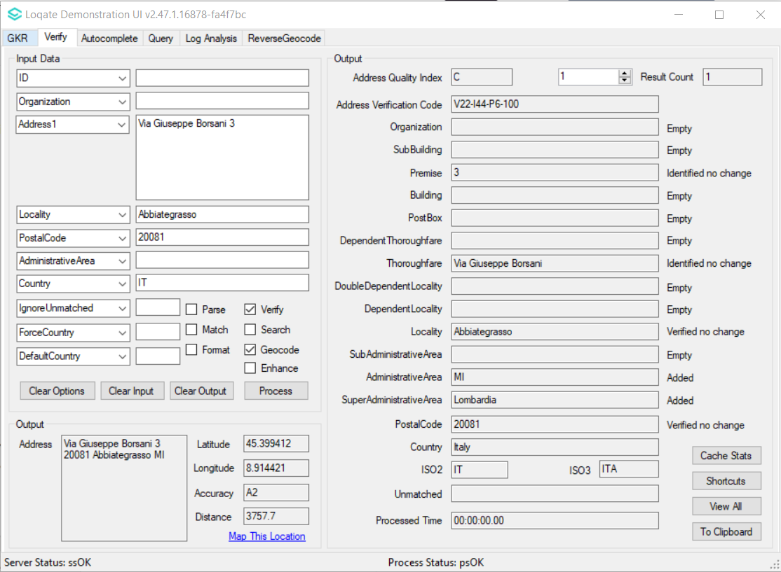 |  |  | 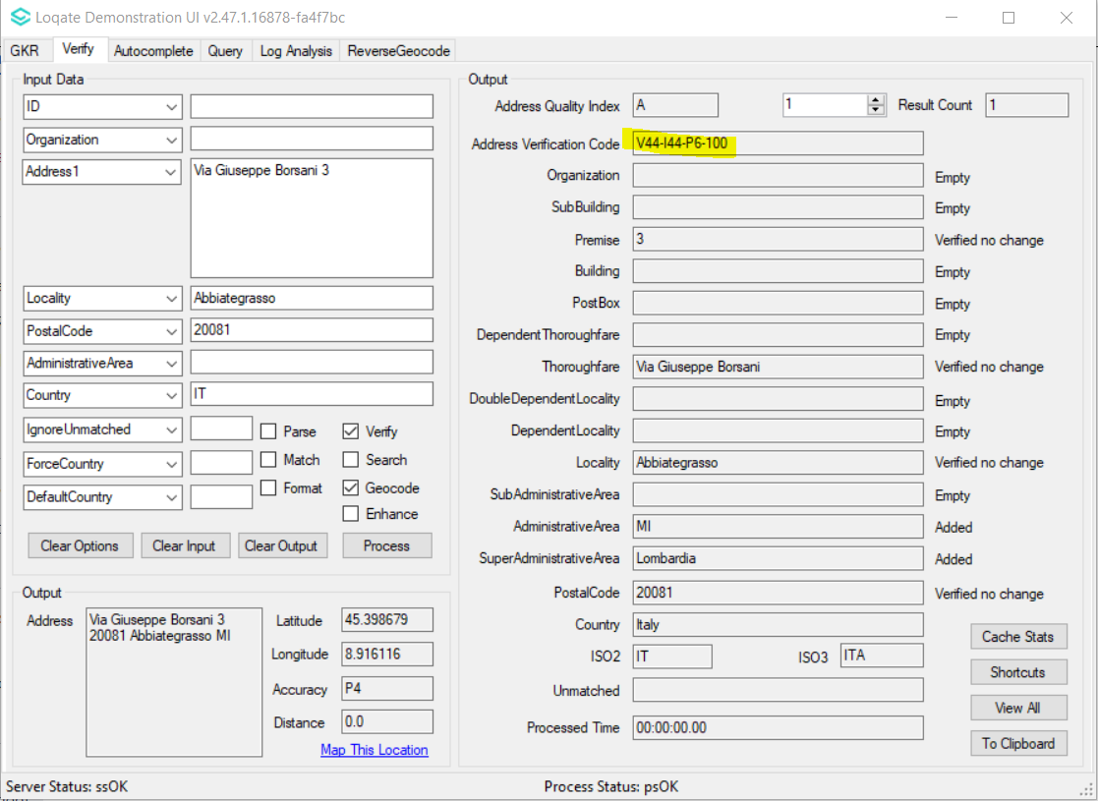
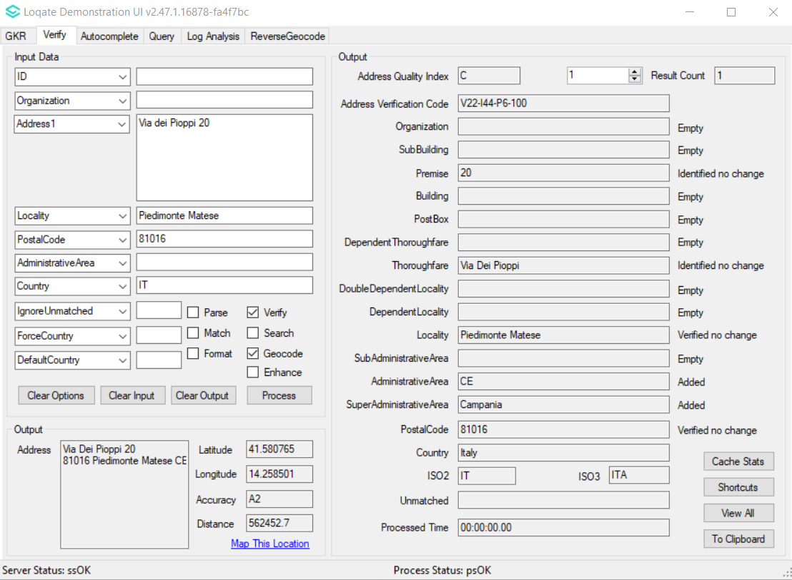 |  |  | 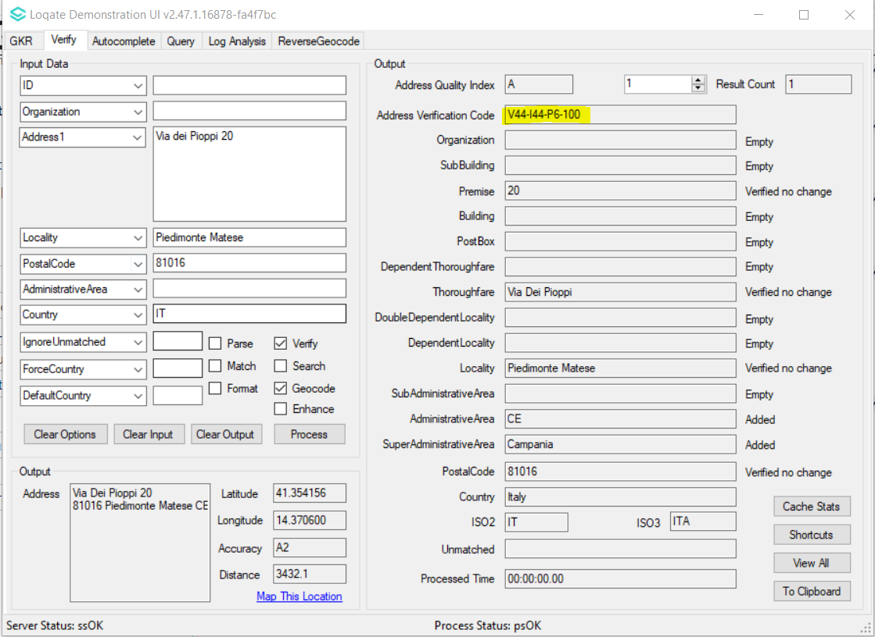
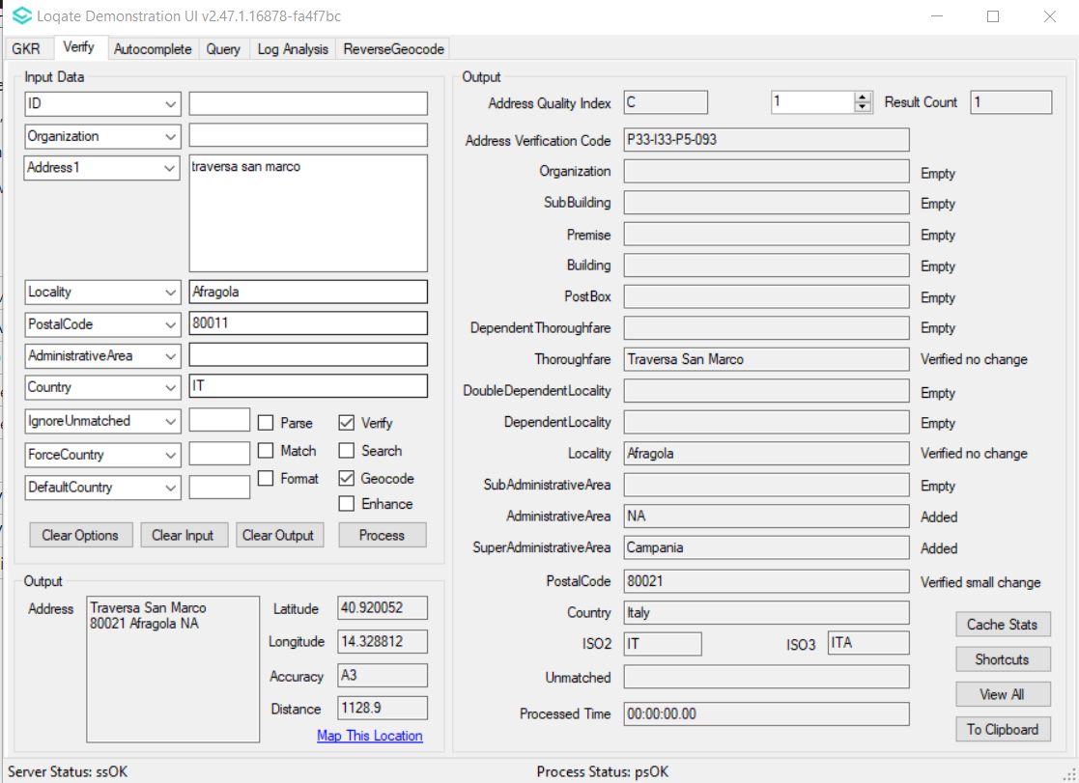 |  |  | 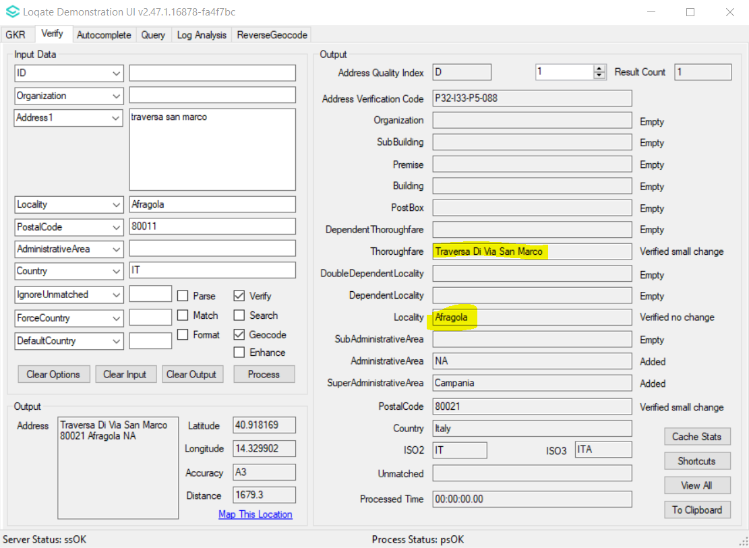

Case Number | Change Description | Category | Country | Example Address
CAS-89309-J4H1D7 | Improvement of DoubleDependentLocality and DependentLocality verifications | Data | IN | Address: Vijay Nagar, Dighi  DependentLocality: Pune  Locality: Pune  PostalCode: 411015  Country: IN
Before Image |  |  | After Image
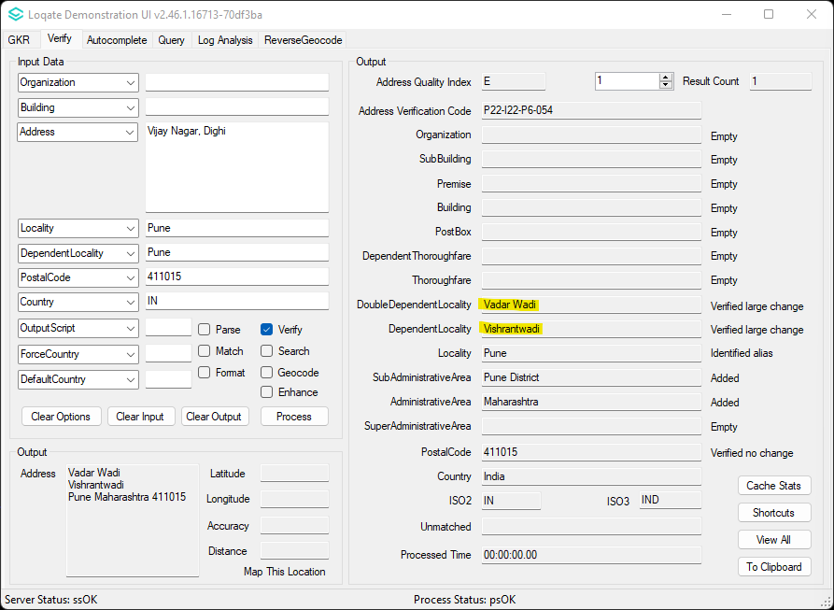 |  |  | 