Loqate, A GBG Solution
Release Notes – Verify API

2023Q3.0 Major Release

Case Resolutions
Please visit https://support.loqate.com/2023q3-0-resolved-cases/ for a list of all cases resolved in this release. If you would like more details on any of the solved cases listed, please contact LoqateSupport@gbgplc.com for further information.

Local API Notice
This is to inform our customers that in 2023Q3.0 release we have made an improvement to the API to improve the performance on France which will have some benefits on other countries as well.
The latest API version reference included in this release is 2.48.0.17033-f36b627

Local API Improvement
Case Number | Change Description | Category | Country | Example Address
CAS-98671-G6H3Q3 | The engine would now skip checking the candidates if the filtering process is not able to narrow down the regions where the address could be from which has improved performance. | API | All | Address1=RES CAMP ROBERT BTH1PTE125, AdministrativeArea=FREJUS,  PostalCode=83600, Country=France

Before Image | After Image
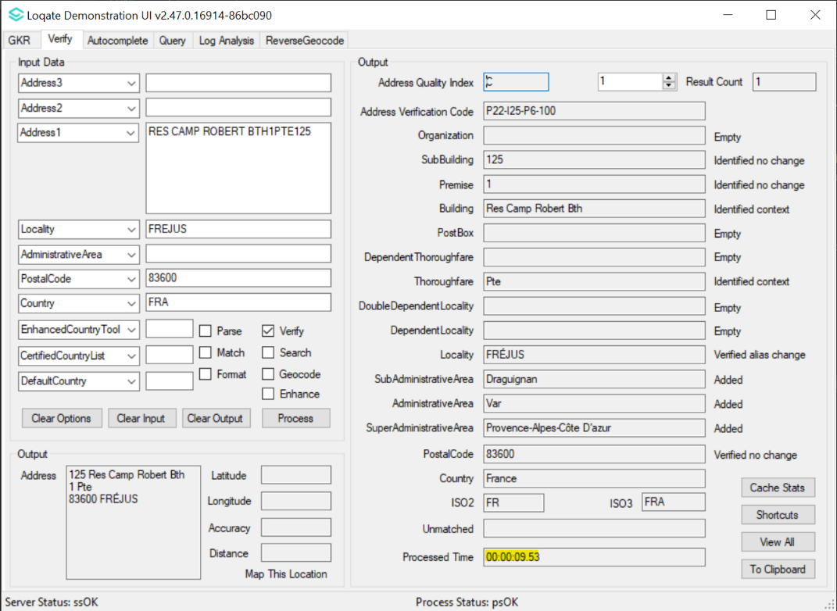 | 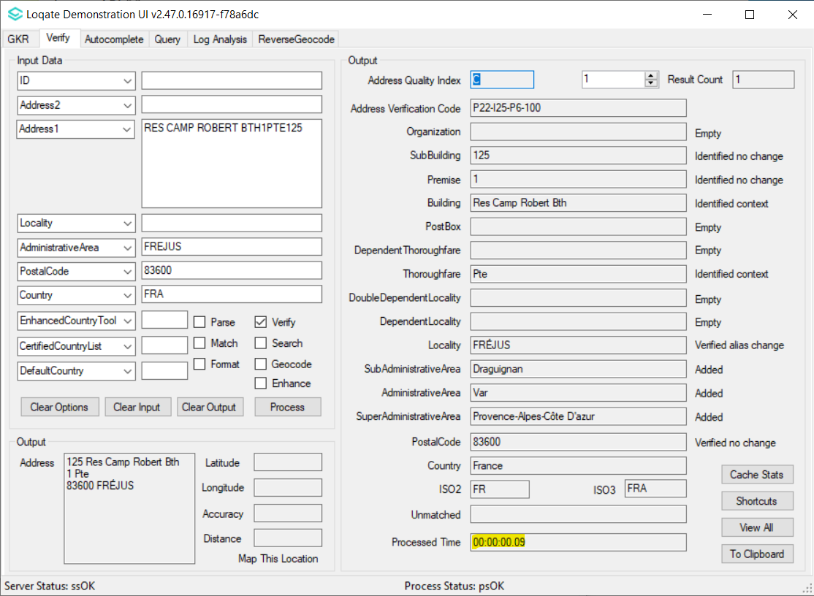

Installation Instructions
Please remember to update both the program files and the reference data and please install these to a new fresh folder location. The improvements are tied to the data in the Global Knowledge Repository and the Local API. When updating the data, it is recommended to use a new data folder each time to ensure the latest dataset is installed properly.

If you need any assistance with the upgrade of the Local API or the data update process, please contact GBG Loqate Support.

The setup wizard for the Local API can be obtained from our SFTP server. Please contact your account manager to retrieve the SFTP information. If you do not know who your account manager is, please contact the support team at LoqateSupport@gbgplc.com.

