Loqate, A GBG Solution
Release Notes – Reference Data & Knowledge Base - 2023Q2.1 Minor Release

Case Resolutions
Please visit https://support.loqate.com/2023q2-1-resolved-cases/ for a list of cases resolved in this release.
If you would like more details on any of the solved cases listed, please contact LoqateSupport@gbgplc.com for further information.

Certification Expiration Dates
If you have purchased a certification product, please be aware that the datasets have expiration dates set by the respective postal authorities. Please ensure that you have the latest library and data installed to avoid loss of service through these products.

Please check Install Manager for the latest versions of our certification data

Certification Product | Loqate Release Date | Certification Expiry Date*
AMAS Data | 2023-05-19 | 2023-09-30
CASS Data (Retirement of service 31st July 2023) | 2023-05-01 | 2023-07-31
CASS (2) Data | 2023-05-02 | 2023-07-31
SERP | 2023-05-09 | No Expiry

For more information on expiry date checking for CASS2 and AMAS, please refer “Usage expiration” section in https://support.loqate.com/documentation/local-apis/cass-overview-2/ and https://support.loqate.com/address-matching-approval-system-amas/

Data Structure Changes

The below is a summary of the Countries where we have updated the reference data / structure.

Country Rebuild / Refresh
Country | ISO2 | Description
Hong Kong | HK | Country Rebuild
Serbia | RS | Country Rebuild

Other major changes to highlight:
Country | Description
US | Census+ premium enhanced data case fix

Country Rebuild/Refresh Highlights
Country Information |  | Description
ISO2 |  | HK
ISO3 |  | HKG
Address Format |  | Organization  PostBox  SubBuilding BuildingPhase  Building BuildingPhaseExtra  Thoroughfare Premise SubBuilding  Premise Thoroughfare  DependentThoroughfare  Locality  AdministrativeArea
Address Format (Native) |  | AdministrativeArea  Locality DependentLocality  DependentThoroughfare Thoroughfare Premise  Building BuildingPhase  Organization SubBuilding Postbox
PDH |  | YES
New Source |  | YES
 | Pre-PDH |  | Post-PDH
Reference Data | rd_HK_ggg.lfs  rd_HK_ggg_rg.lfs  rd_HK_vfy.lfs  rd_HK_vfy_ai.lfs |  | rd_HK_ggg.lfs  rd_HK_ggg_rg.lfs  rd_HK_vfy.lfs  rd_HK_vfy_ai.lfs

2023Q2.0 | 2023Q2.1
Building was not verified.  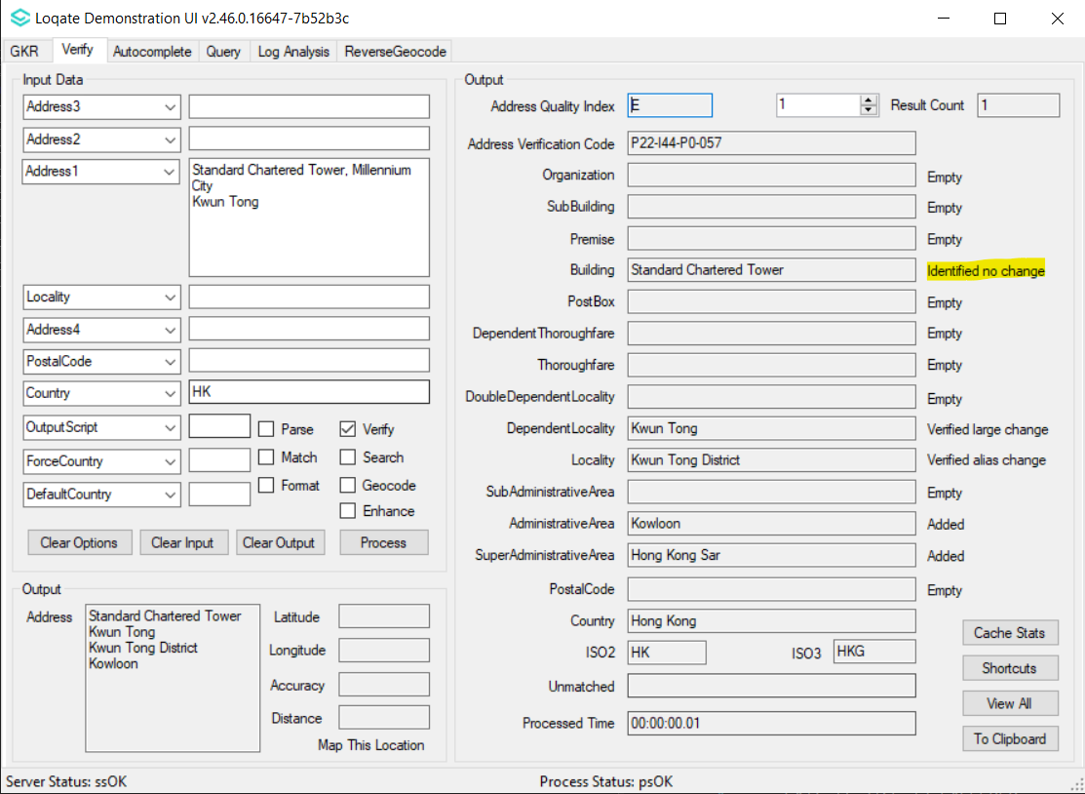 | Building is now verified.  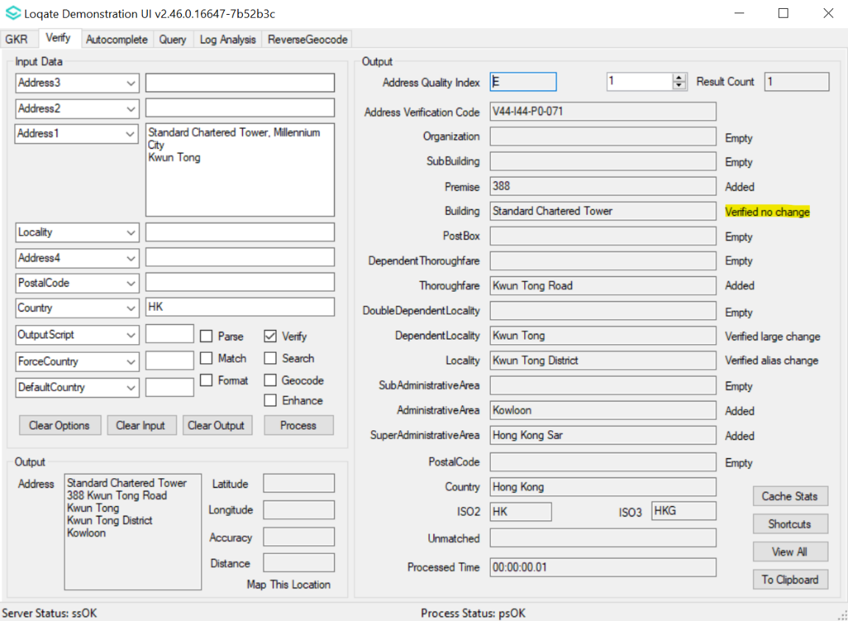

Subbuilding was not verified.  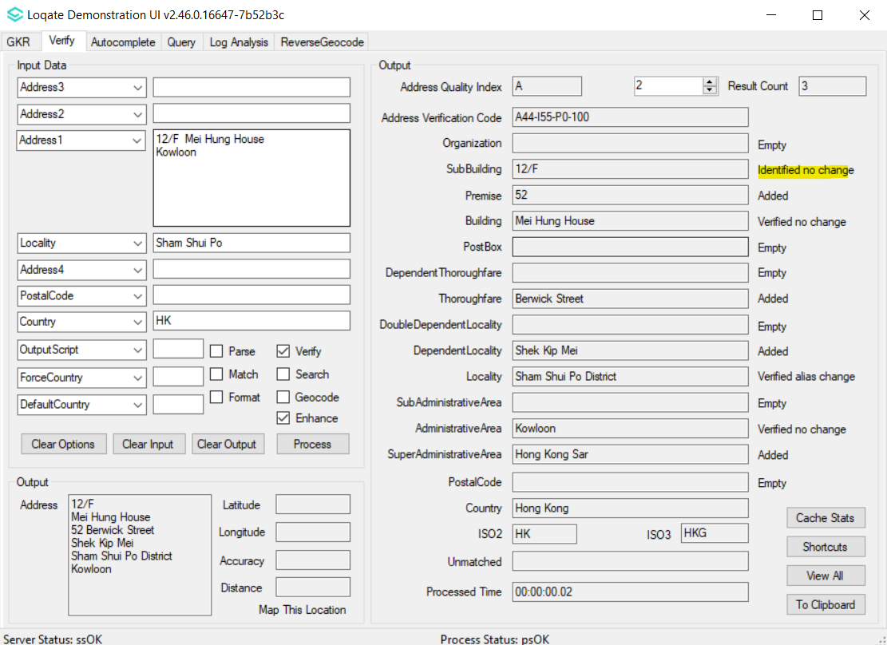 | SubBuilding is now verified.  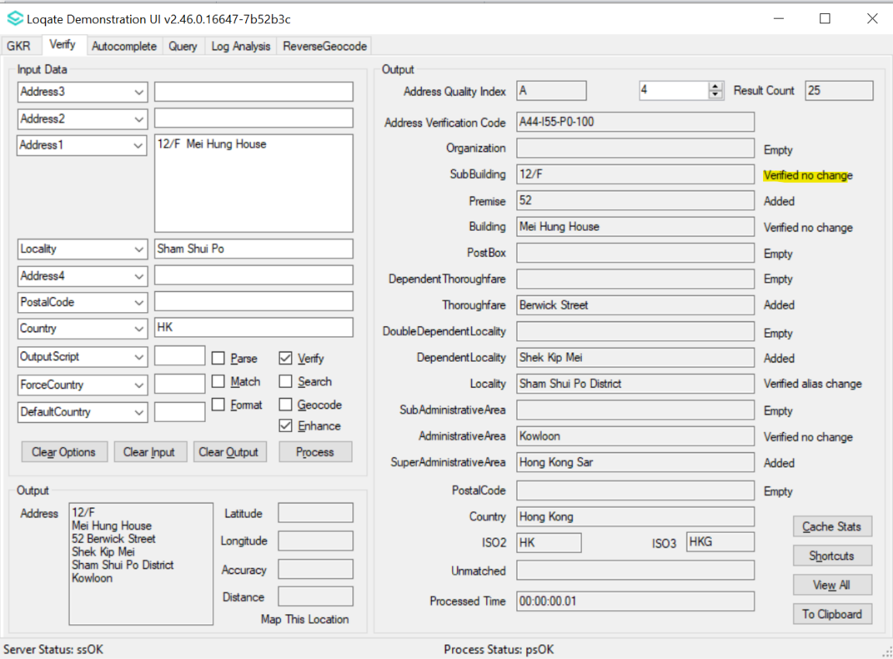

Serbia
Country Information |  | Description
ISO2 |  | RS
ISO3 |  | SRB
Address Format |  | Organization  PostBox  Thoroughfare Premise SubBuilding  DependentLocality  PostalCode Locality
PDH |  | YES
PDH completed date |  | 2020Q4.0
New Source |  | NO
 | Pre-PDH |  | Post-PDH
Reference Data | rd_RS_ggg_rg.lfs  rd_RS_ggg.lfs  rd_RS_vfy_ai.lfs  rd_RS_vfy.lfs |  | rd_RS_ggg_rg.lfs  rd_RS_ggg.lfs  rd_RS_vfy_ai.lfs  rd_RS_vfy.lfs

2023Q2.0 | 2023Q2.1
Locality was incorrectly verified. Thoroughfare and Premise were not verified.  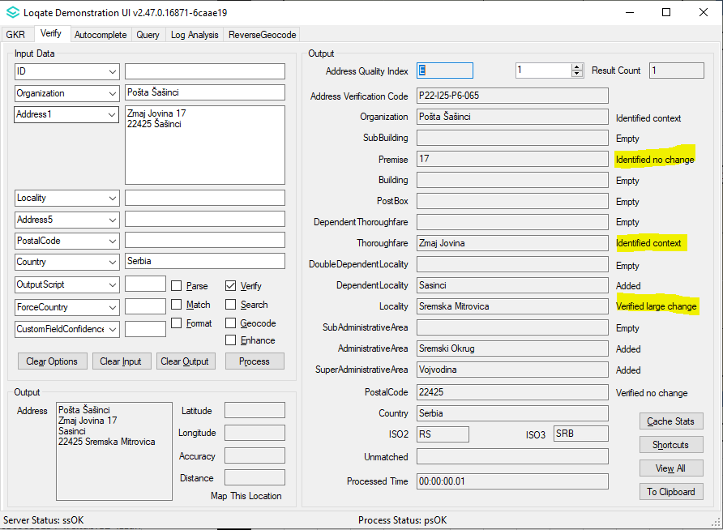 | Locality, Thoroughfare and Premise are now correctly verified.  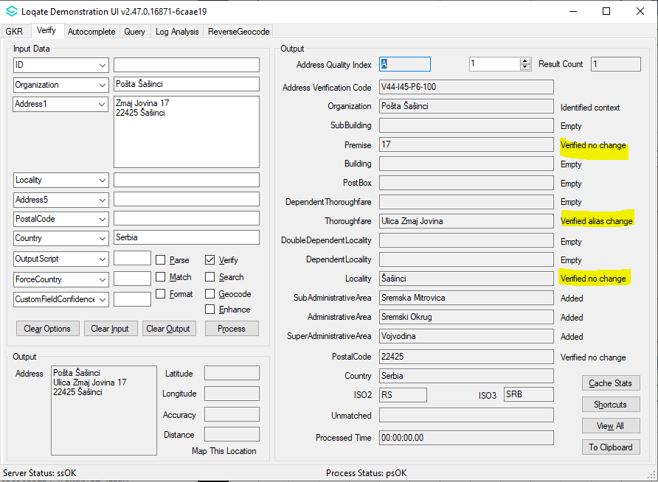

USA
Country Information | Description
ISO2 | US
ISO3 | USA
Address Format | N/A for Census data.
PDH | YES
PDH completed date | N/A
New Source | No
Reference Data | rd_US_enh_CENSUS_PartA.lfs  rd_US_enh_CENSUS_PartA_f.lfs  rd_US_enh_CENSUS_PartA_m.lfs  rd_US_enh_CENSUS_PartA_pr.lfs  rd_US_enh_CENSUS_PartA_r.lfs  rd_US_enh_CENSUS_PartA_r1.lfs  rd_US_enh_CENSUS_PartA_r2.lfs  rd_US_enh_CENSUS_PartB.lfs  rd_US_enh_CENSUS_PartB_f.lfs  rd_US_enh_CENSUS_PartB_m.lfs  rd_US_enh_CENSUS_PartB_pr.lfs  rd_US_enh_CENSUS_PartB_r.lfs  rd_US_enh_CENSUS_PartB_r1.lfs  rd_US_enh_CENSUS_PartB_r2.lfs

CensusPlusHotfix1.0 | 2023Q2.1
Number of data files: 13  Part A (7 files)  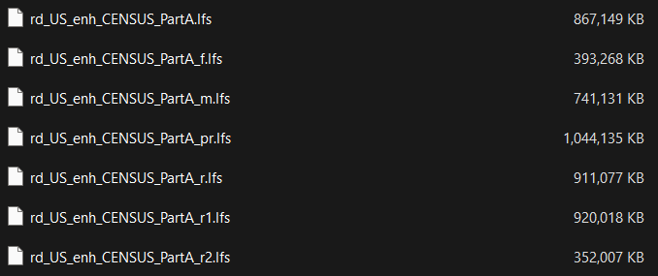  Part B (6 files)  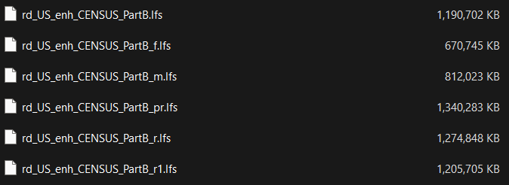 | Number of data files: 14  Part A (7 files)  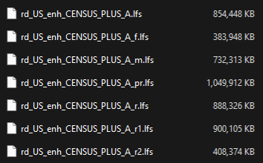  Part B (7 files)  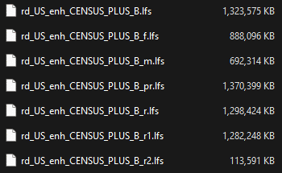  Recommended data cache size: 18  Recommended memory size: 16 GB

Case Resolutions

2023Q2.1 Data related Case Fixes
Case Number | Change Description | Category | Country | Example Address
CAS-97003-C3P1G9 | Improvement of SubBuilding parsing | Data | CA | 1st Address  Address1: A-38 Stafford St Woodstock ON N4S 3Z6  Country: CA  2nd Address  Address1: A 4512 Boul Saint-Joseph Drummondville, QC J2A 1B1  Country: CA
Before Image |  |  | After Image
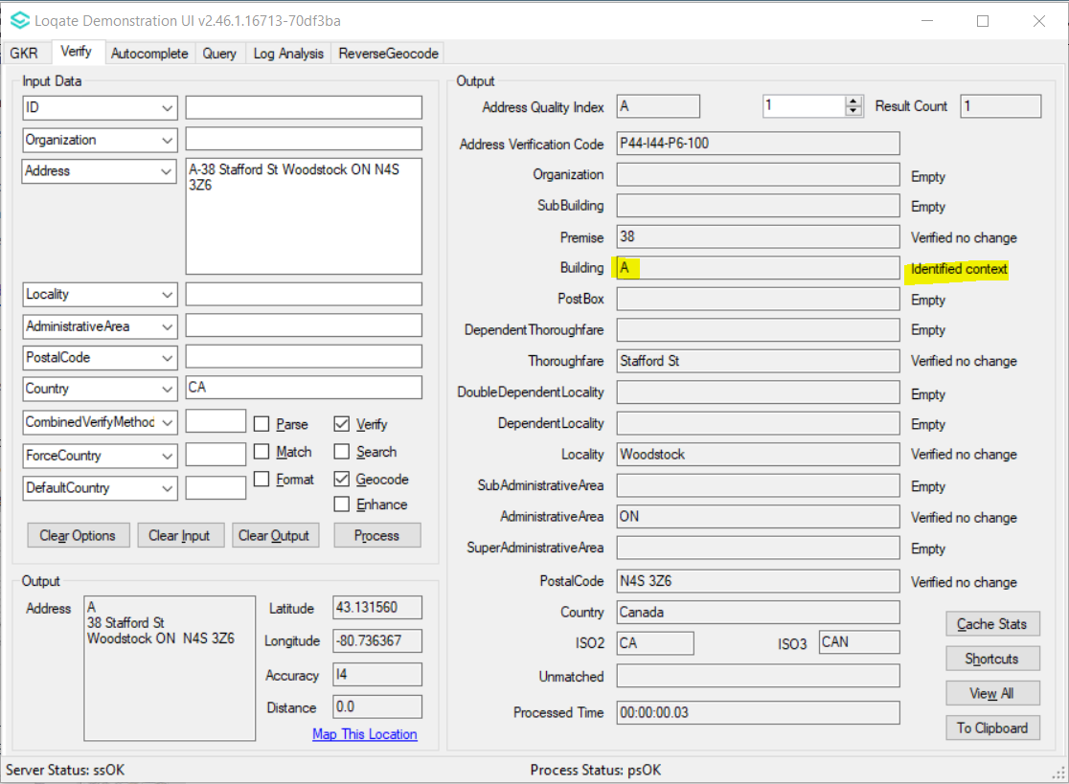 |  |  | 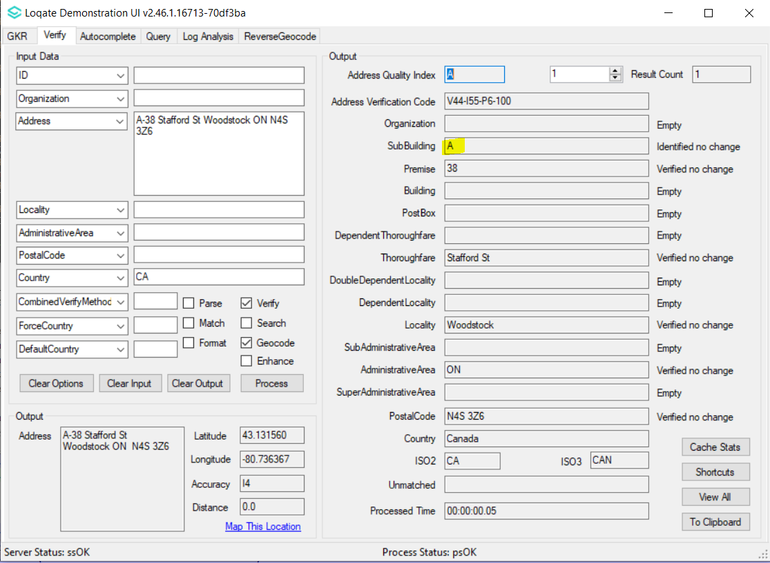
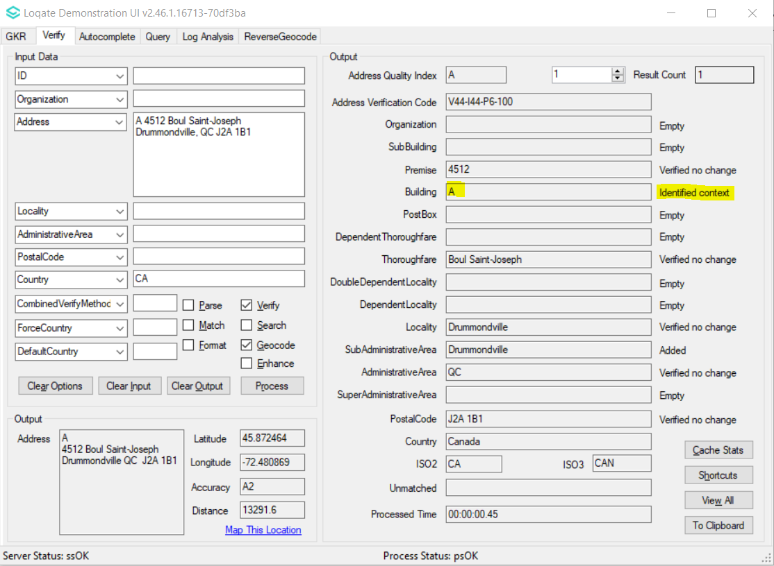 |  |  | 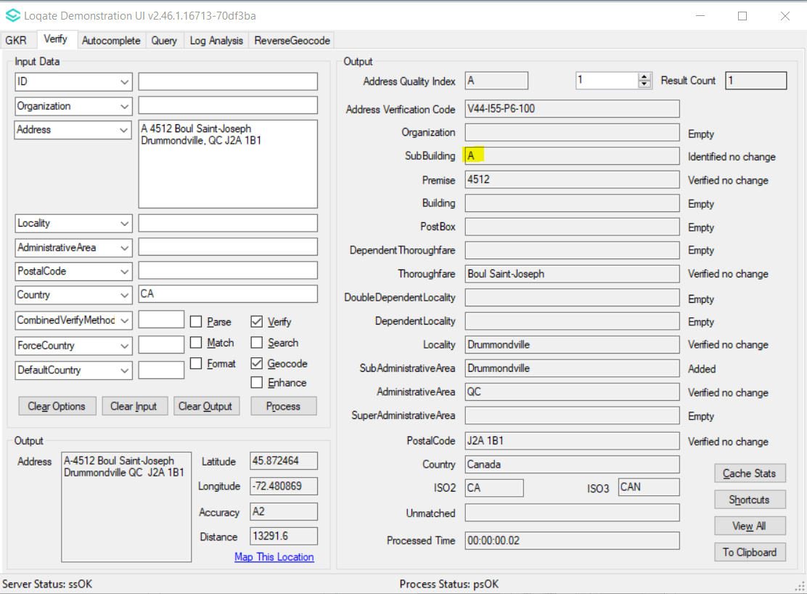

Case Number | Change Description | Category | Country | Example Address
CAS-92344-Z2S3Q4 | Correction of output Premise format | Data | ID | Address1: Jl. Jawa No.2  Address2: Kec. Medan Timur  Locality: Medan  AdministrativeArea: ID-SU  PostalCode: 20231  Country: ID
Before Image |  |  | After Image
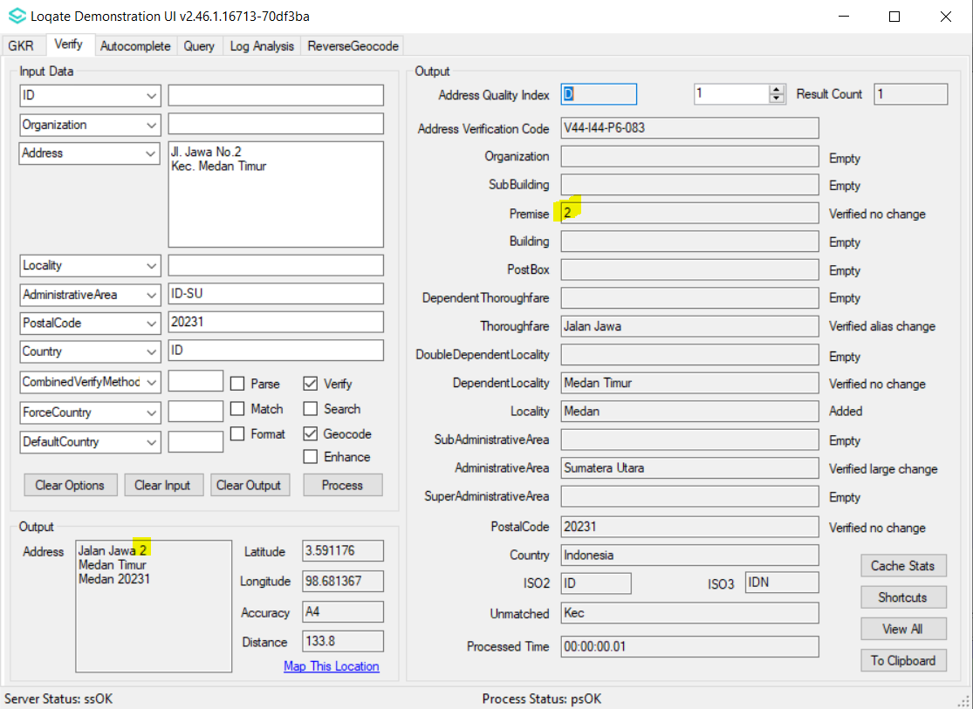 |  |  | 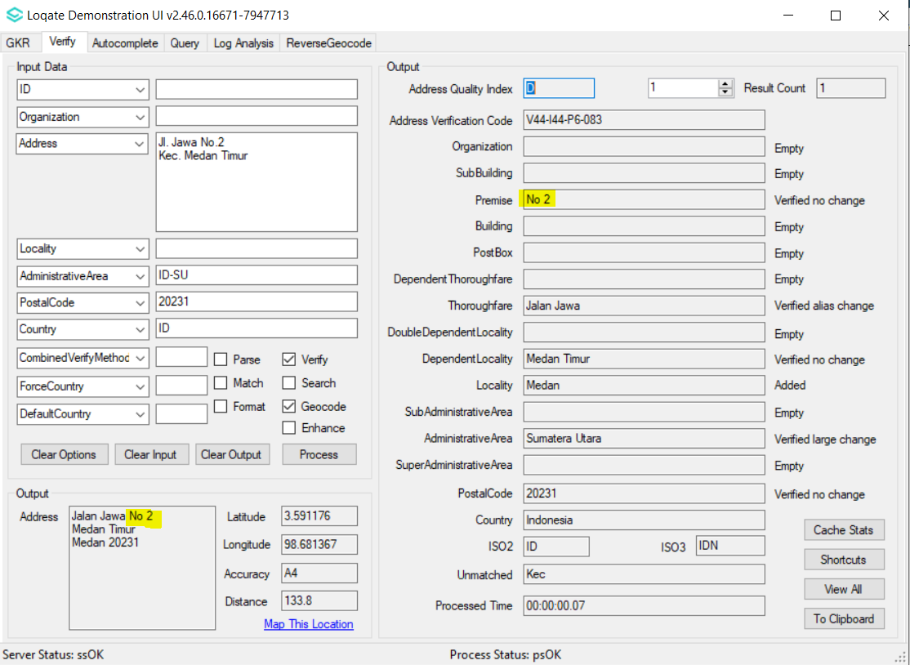

Case Number | Change Description | Category | Country | Example Address
CAS-89533-H4F5T4 | Improvement of Thoroughfare parsing and verification | Data | IN | Address1: 10 Bannerghatta Main Road  Locality: Bangalore  AdministrativeArea: Karnataka  PostalCode: 560076  Country: India
Before Image |  |  | After Image
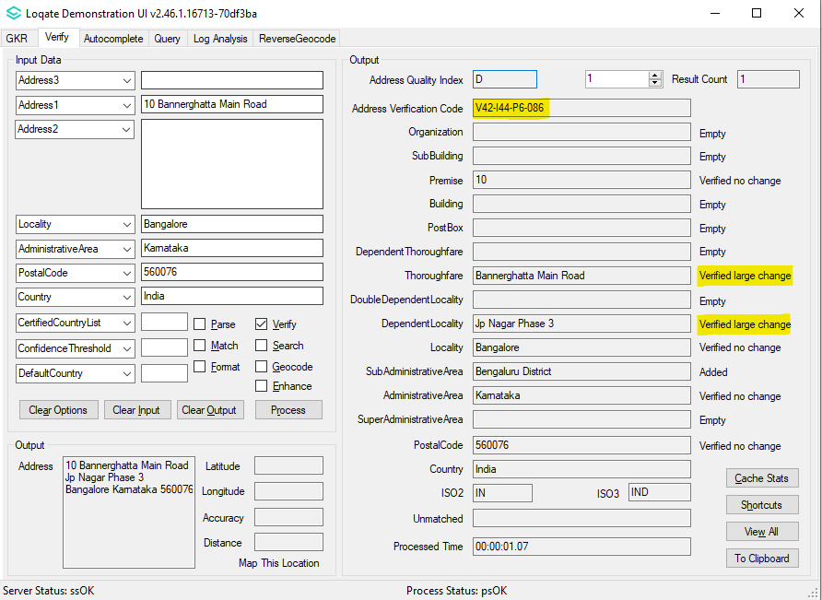 |  |  | 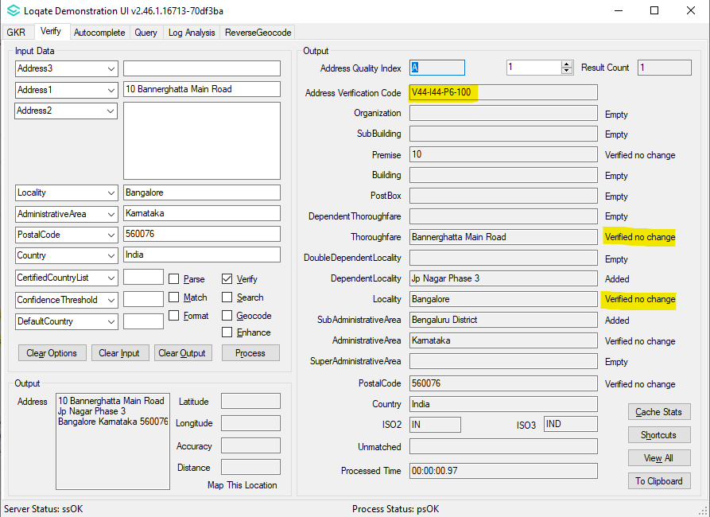

Case Number | Change Description | Category | Country | Example Address
CAS-97468-M4X3K2 | Improvement of SubBuilding parsing | Data | GB | Address1: 1st Floor Bishopsgate Court, 4-12 Norton Folgate  AdministrativeArea: London  PostalCode: E1 6DB  Country: GBR
Before Image |  |  | After Image
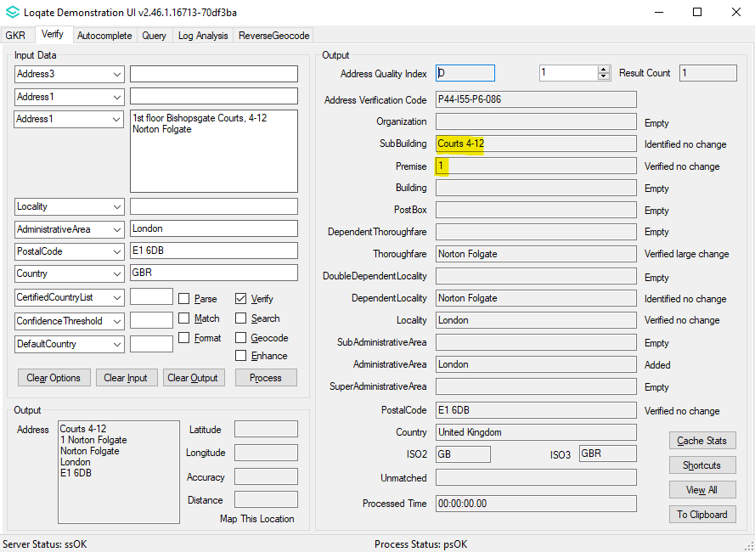 |  |  | 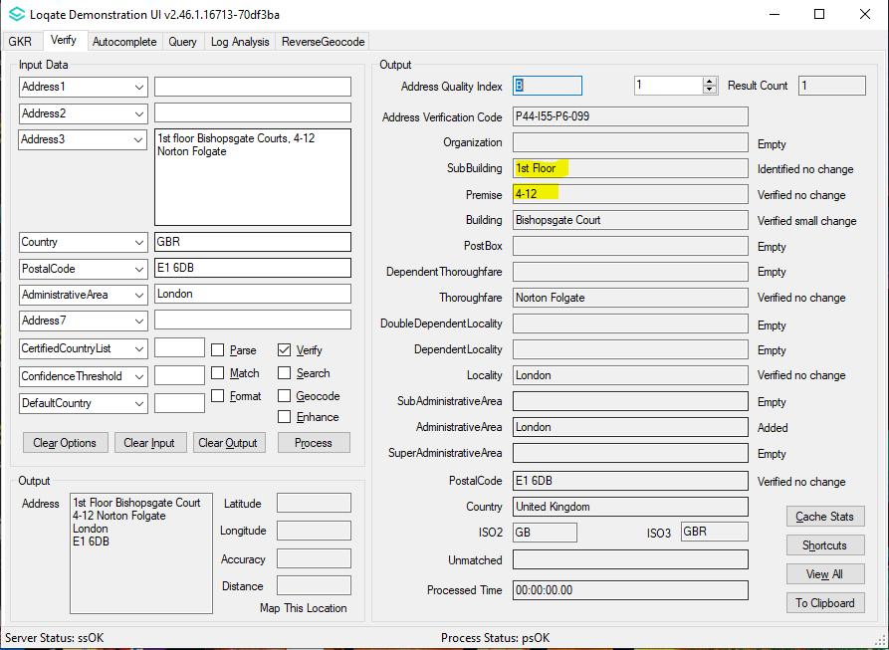

Case Number | Change Description | Category | Country | Example Address
CAS-96613-P0L5X4 | Improvement of SubBuilding parsing | Data | BG | Address1: ул. Славянска 1, вход Б, апт. 1  Locality: Варна  PostalCode: 9000  Country: BG
Before Image |  |  | After Image
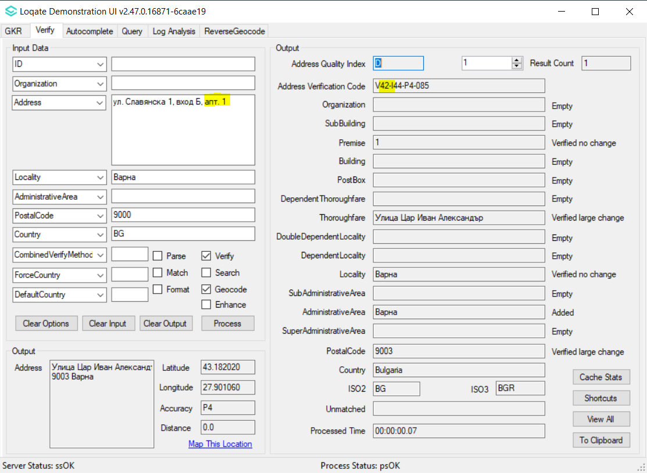 |  |  | 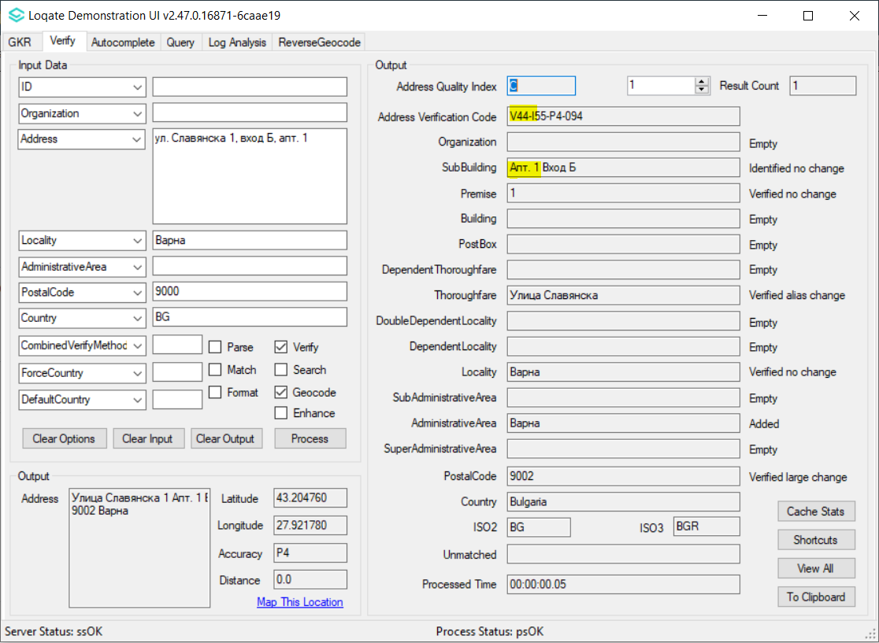

Case Number | Change Description | Category | Country | Example Address
CAS-98628-X8Q8H1 | Improvement of Thoroughfare parsing | Data | MC | Address1: 2 AVENUE DE MONTE CARLO  Locality: MONACO CEDEX  AdministrativeArea: Monaco  PostalCode: 98014  Country: Monaco
Before Image |  |  | After Image
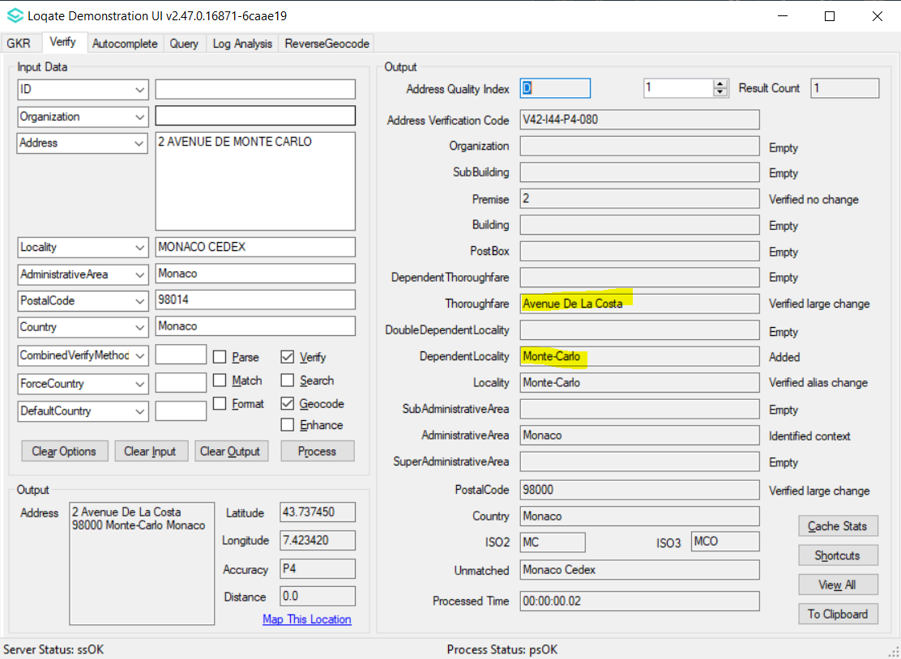 |  |  | 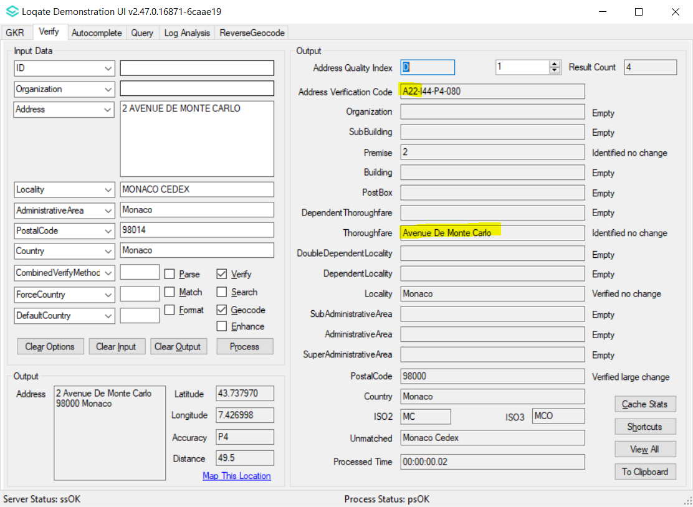

Case Number | Change Description | Category | Country | Example Address
CAS-94184-G5Y7F8 | Improvement of address parsing and verification | Data | US | Address1: HIGHWAY 27 AND SUNRISE LK  Locality: CLEARMONT  AdministrativeArea: FL  Country: US
Before Image |  |  | After Image
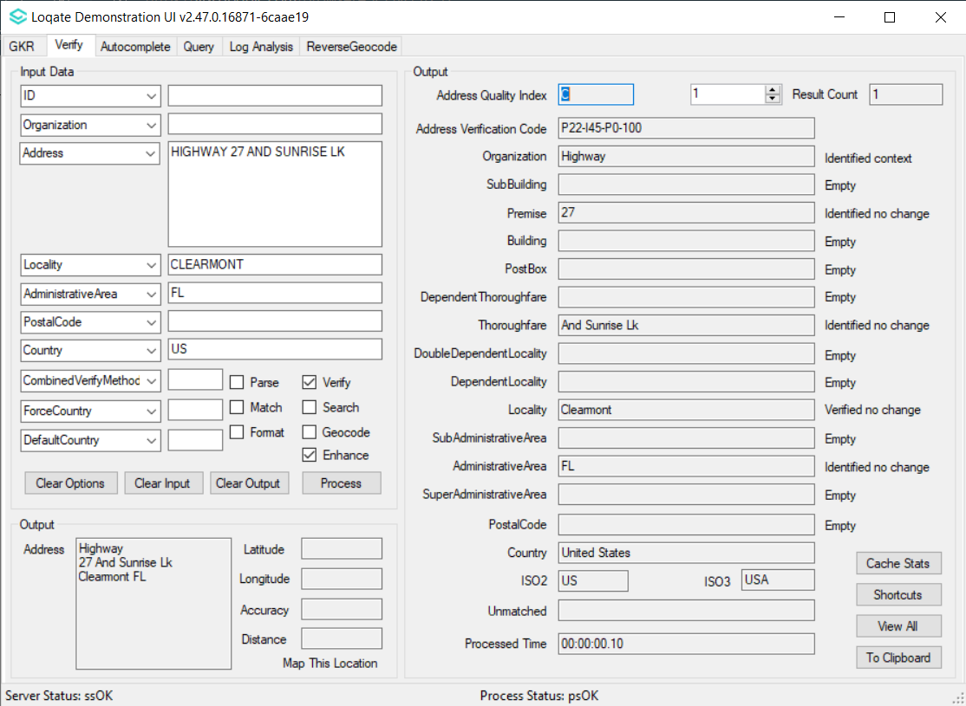 |  |  | 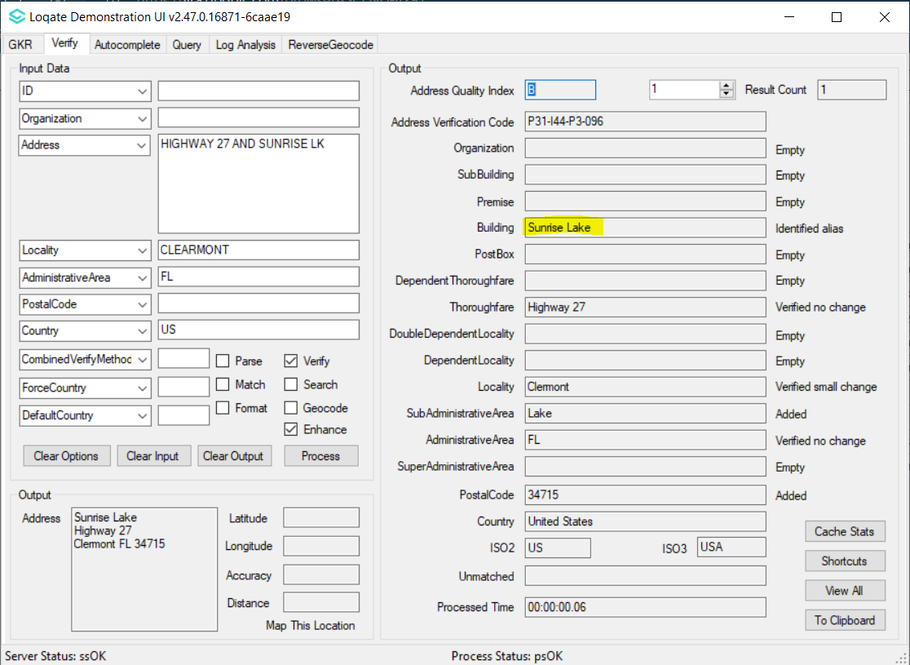

Case Number | Change Description | Category | Country | Example Address
CAS-50196-P8Q8K3 | Improvement of Locality added | Data | RS | PostalCode: 22320  Country: SRB
Before Image |  |  | After Image
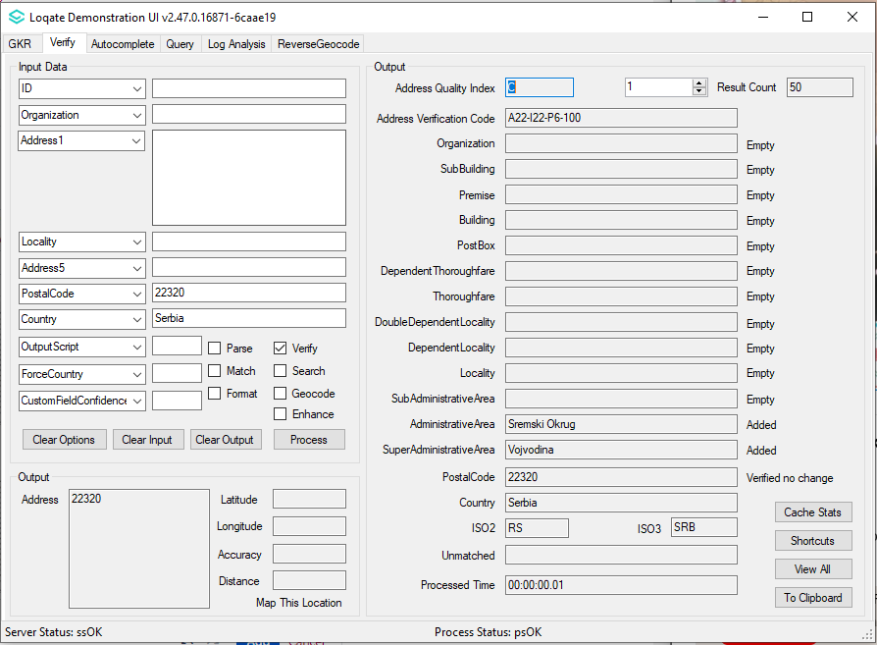 |  |  | 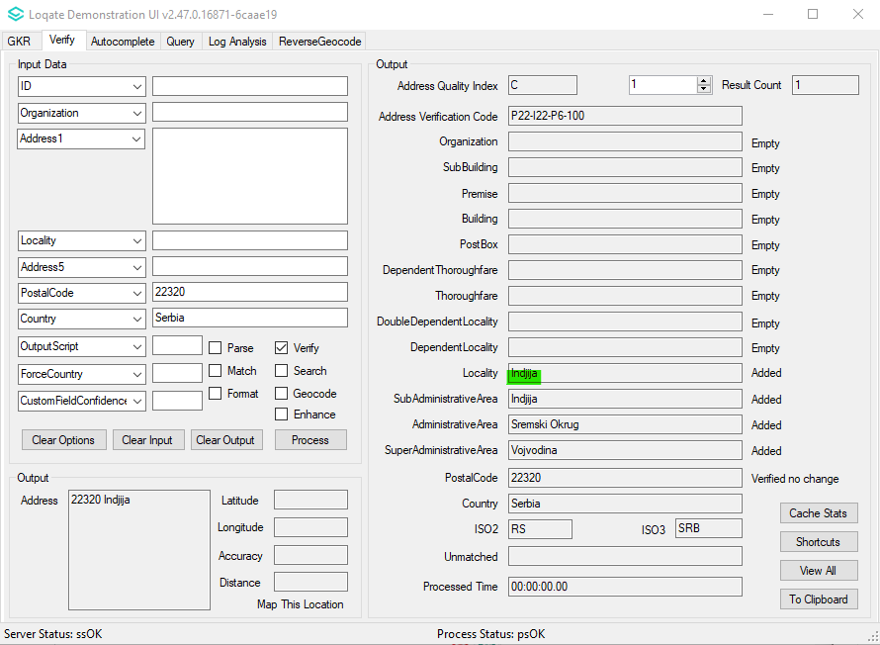

Case Number | Change Description | Category | Country | Example Address
CAS-10792-C2K9T1 | Correction of Locality added | Data | RS | PostalCode: 19220  Country: SRB
Before Image |  |  | After Image
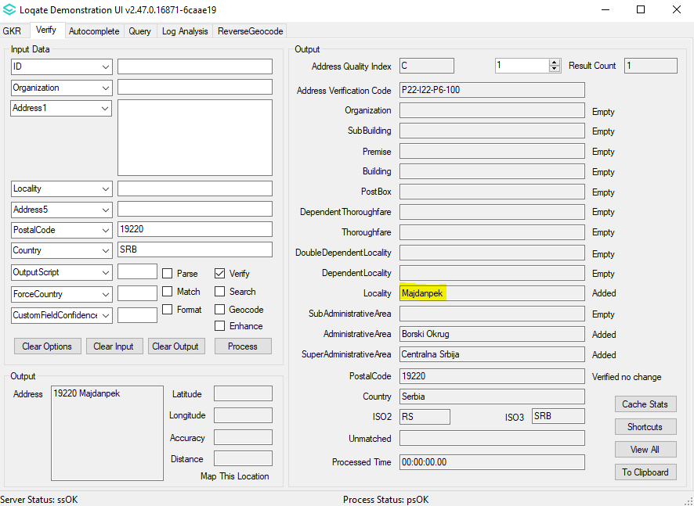 |  |  | 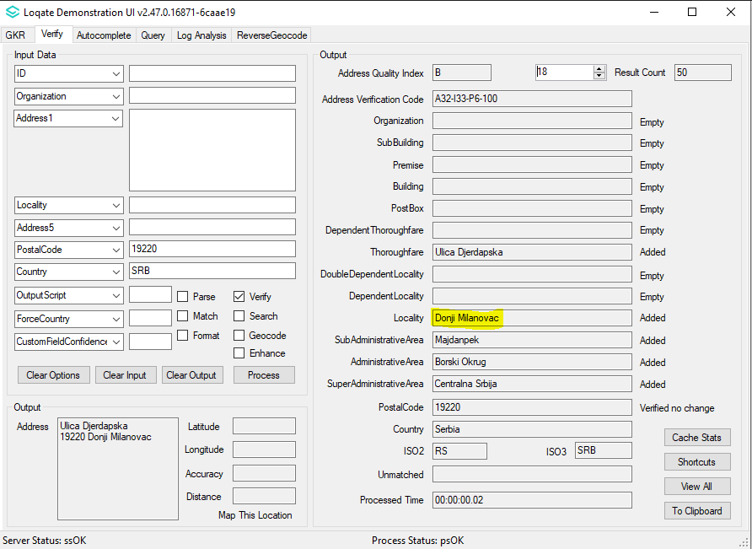

Case Number | Change Description | Category | Country | Example Address
CAS-92391-G2Q3W6 | Improvement of Premise verification | Data | BE | 67F Rue Fond des Chansons 5621  Florennes
Before Image |  |  | After Image
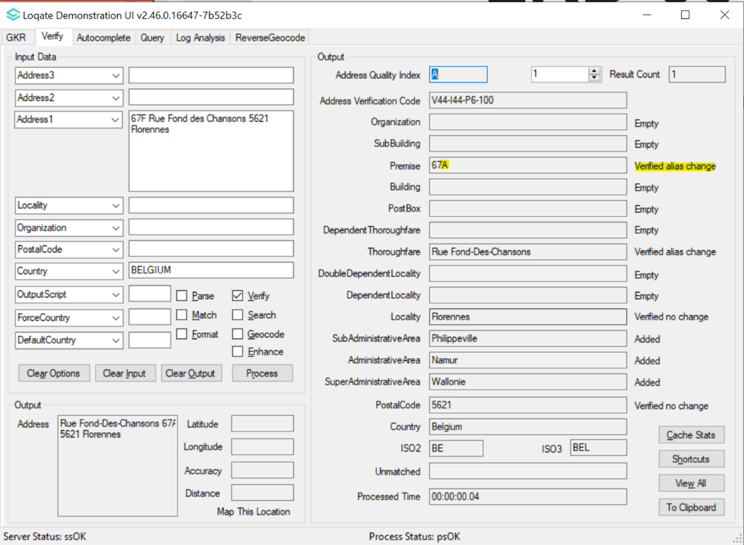 |  |  | 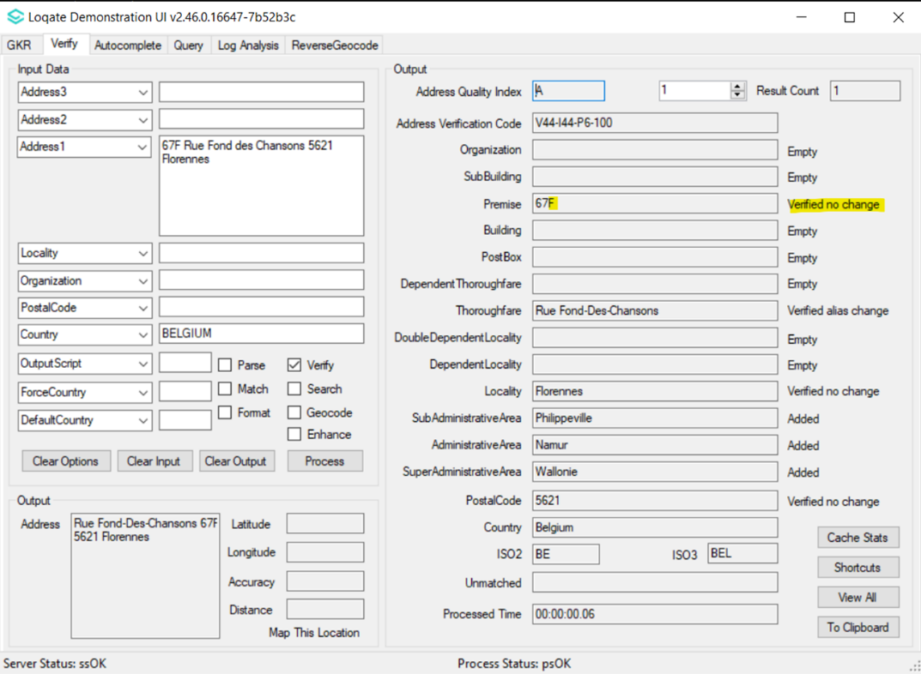

Case Number | Change Description | Category | Country | Example Address
CAS-99215-N1P6Z3 | Improve Census+ data to return BlockCode, BlockGroupCode and TractCode to the reported address | Data | US | Address1: 20573 GLEN BROOK TER  Locality: POTOMAC FALLS  AdministrativeArea: VA  PostalCode: 20165  Country: USA
Before Image |  |  | After Image
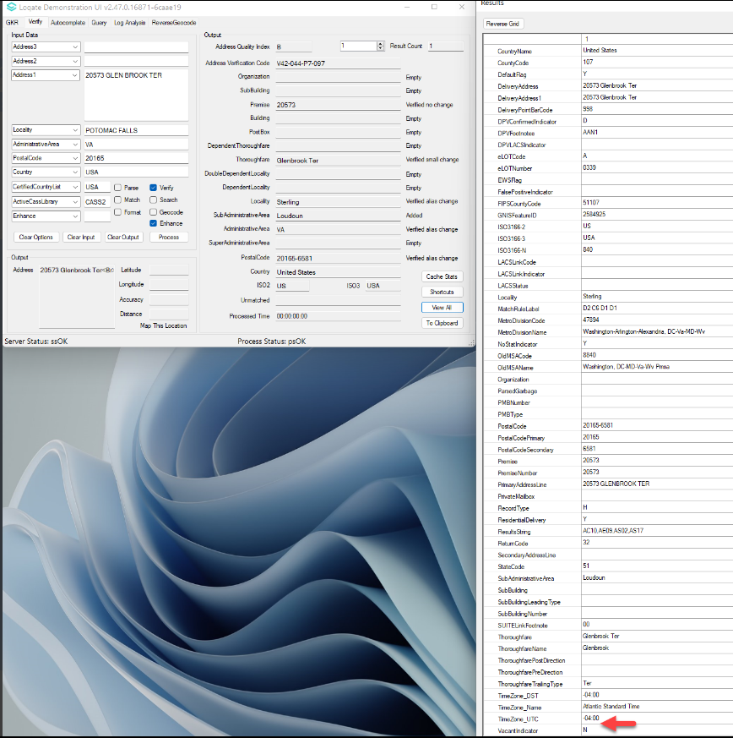 |  |  | 