Loqate, A GBG Solution
Release Notes – Verify API

2023Q2.1 Minor Release

Case Resolutions
Please visit https://support.loqate.com/2023q2-1-resolved-cases/ for a list of all cases resolved in this release. If you would like more details on any of the solved cases listed, please contact LoqateSupport@gbgplc.com for further information.

Local API Notices
This is to inform our customers that in this 2023Q2.1 release there is a new API version - 2023Q2.1 branch 2.47.1.16878-fa4f7bc that contains the following case fixes below.

Case Number | Change Description | Country
CAS-84286-C5H1F3 | Improve matching logic for multi-tokens address fields. | All
ASCEND-4155 | ReferenceImport Issue - brackets not handled | KR
CAS-97545-C6J2B8 | Issue with subbuilding field being used for unrecognized address info. Improve CASS2 AVC generation | USA (CASS2)
ASCEND-1763 | CASS2 Cycle-O certification update from Cycle-N | USA (CASS2)

Local API Improvements
Case Number | Change Description | Category | Country | Example Address
CAS-84286-C5H1F3 | Improve matching logic of multi-tokens address fields. | API | All | Address1: "245 Private Road 7103", Locality: "Buna"  AdministrativeArea: "TX", PostalCode: "77612", country: "US"
Before Image |  |  | After Image
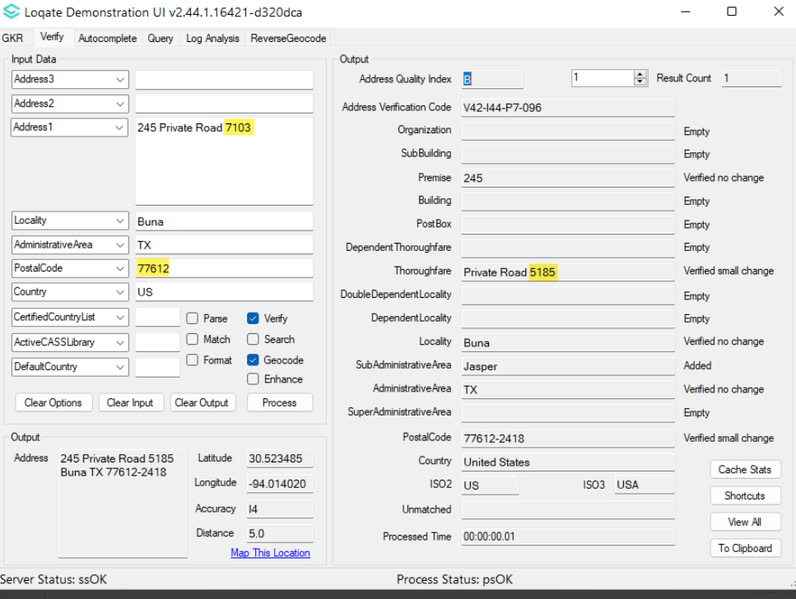 |  |  | 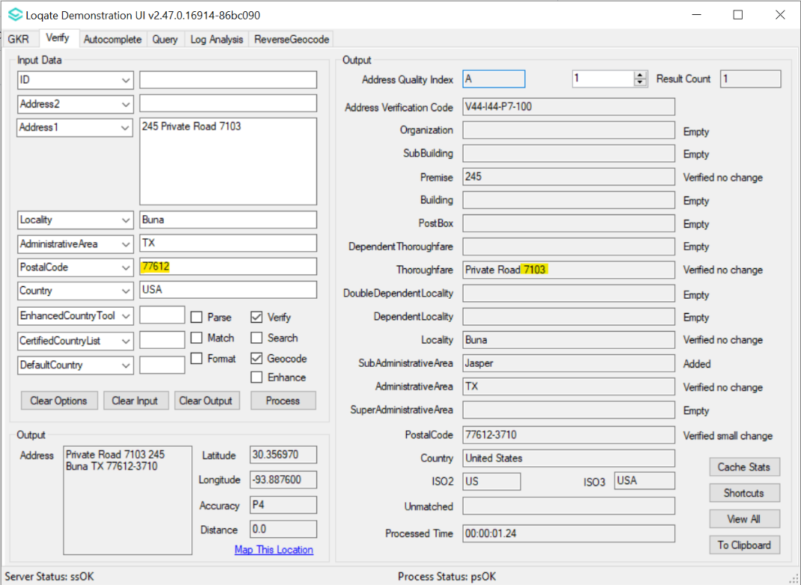

Case Number | Change Description | Category | Country | Example Address
ASCEND-4155 | ReferenceImport Issue - brackets not handled | API | KR | Address1: "Hanil Group Building 191"  Address2: "Hangangro 2ga Yongsan gu"  PostalCode: "140-702"  Country: "KR"
Before Image |  |  | After Image
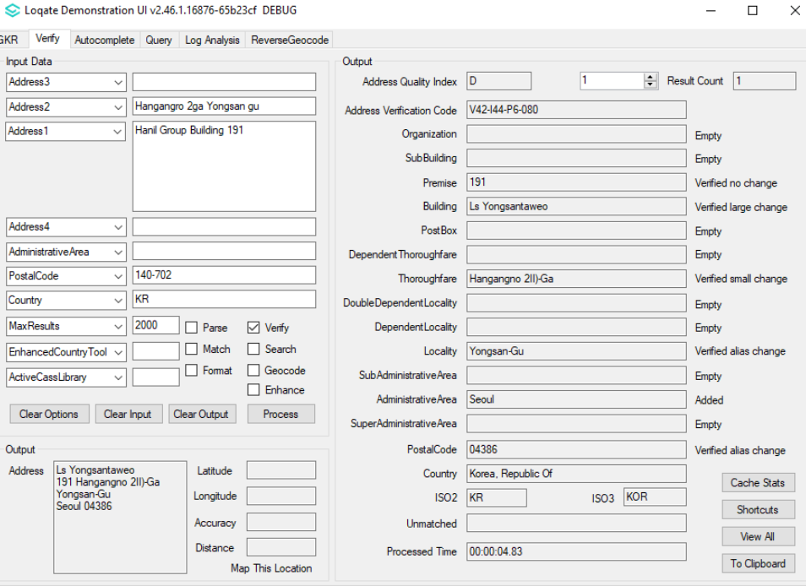 |  |  | 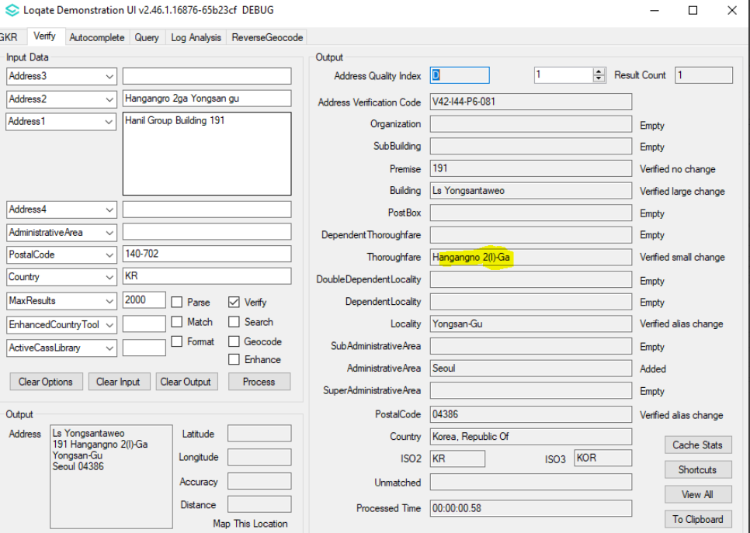

Case Number | Change Description | Category | Country | Example Address
CAS-97545-C6J2B8 | Improve CASS2 AVC generation | CASS2 (API) | USA | Address1: 395 shelds dr  Address2: other stuff  Locality: Bennington  AdministrativeArea: VT  PostalCode: 05201
Before Image |  | After Image
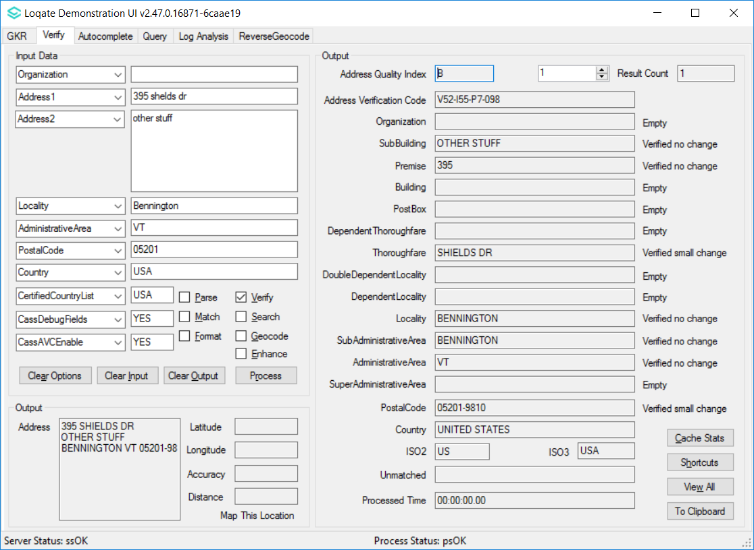 |  | 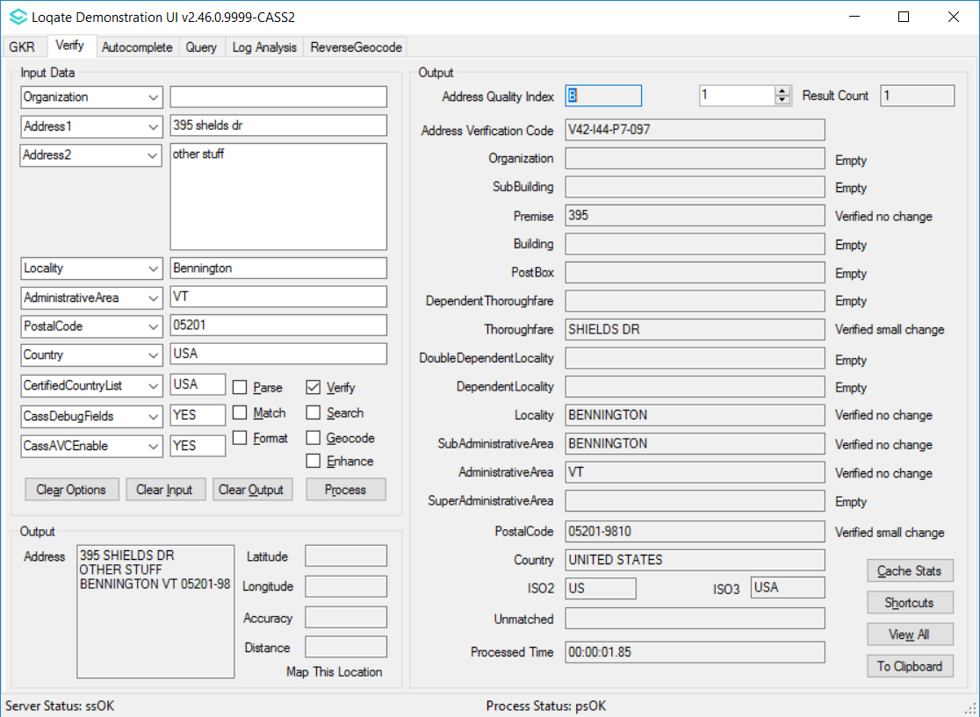

Case Number | Change Description | Category | Country | Example Address
ASCEND-1763 | CASS2 Cycle-O certification. | CASS2 (API) | USA | Address1: 395 shelds dr  Address2: other stuff  Locality: Bennington  AdministrativeArea: VT  PostalCode: 05201
Before |  | After
_L | Verify:LOGOUTPUT=Yes|Country|CASS2 | _L | Verify:LOGOUTPUT=Yes|Country|CASS2
Address | 395 SHIELDS DR<BR>OTHER STUFF<BR>BENNINGTON VT 05201-9810 | Address | 395 SHIELDS DR<BR>OTHER STUFF<BR>BENNINGTON VT 05201-9810
Address1 | 395 SHIELDS DR | Address1 | 395 SHIELDS DR
Address2 | OTHER STUFF | Address2 | OTHER STUFF
Address3 | BENNINGTON VT 05201-9810 | Address3 | BENNINGTON VT 05201-9810
AddressFormat | DeliveryAddress<BR>Locality AdministrativeArea PostalCode | AddressFormat | DeliveryAddress<BR>Locality AdministrativeArea PostalCode
AdministrativeArea | VT | AdministrativeArea | VT
AQI | B | AQI | B
AVC | V52-I55-P7-098 | AVC | V42-I44-P7-097
CarrierRoute | R002 | CarrierRoute | R002
CheckDigit | 0 | CheckDigit | 0
CMRAIndicator | N | CMRAIndicator | N
CongressionalDistrict | 01 | CongressionalDistrict | 01
CountryName | UNITED STATES | CountryName | UNITED STATES
DefaultFlag |  | DefaultFlag
DeliveryAddress | 395 SHIELDS DR<BR>OTHER STUFF | DeliveryAddress | 395 SHIELDS DR<BR>OTHER STUFF
DeliveryAddress1 | 395 SHIELDS DR | DeliveryAddress1 | 395 SHIELDS DR
DeliveryAddress2 | OTHER STUFF | DeliveryAddress2 | OTHER STUFF
DeliveryPointBarCode | 950 | DeliveryPointBarCode | 950
DependentLocality |  | DependentLocality
DPVConfirmedIndicator | Y | DNA | N
DPVFootnotes | AABB | DPVConfirmedIndicator | Y
DPVLACSIndicator |  | DPVFootnotes | AABB
eLOTCode | A | DPVLACSIndicator
eLOTNumber | 0012 | DropSiteIndicator | N
EWSFlag |  | eLOTCode | A
FalsePositiveIndicator |  | eLOTNumber | 0012
FIPSCountyCode | 50003 | EnhancedReturnCode | Y
ISO3166-2 | US | EWSFlag
ISO3166-3 | USA | FalsePositiveIndicator
ISO3166-N | 840 | FIPSCountyCode | 50003
LACSLinkCode |  | ISO3166-2 | US
LACSLinkIndicator |  | ISO3166-3 | USA
LACSStatus |  | ISO3166-N | 840
Locality | BENNINGTON | LACSLinkCode
NoStatIndicator | Y | LACSLinkIndicator
Organization |  | LACSStatus
ParsedGarbage |  | Locality | BENNINGTON
PMBNumber |  | NDDFlag | N
PMBType |  | NoStatIndicator | Y
PostalCode | 05201-9810 | NoStatReason | 02
PostalCodePrimary | 05201 | NSL | N
PostalCodeSecondary | 9810 | Organization
Premise | 395 | ParsedGarbage
PremiseNumber | 395 | PBSAIndicator | N
PrimaryAddressLine | 395 SHIELDS DR | PMBNumber
PrivateMailbox |  | PMBType
RecordType | S | POBoxOnly | N
ResidentialDelivery | N | PostalCode | 05201-9810
ResultsString | AC10,AS01,AS17 | PostalCodePrimary | 05201
ReturnCode | 31 | PostalCodeSecondary | 9810
SecondaryAddressLine | OTHER STUFF | Premise | 395
SubAdministrativeArea | BENNINGTON | PremiseNumber | 395
SubBuilding | OTHER STUFF | PrimaryAddressLine | 395 SHIELDS DR
SubBuildingLeadingType |  | PrivateMailbox
SubBuildingNumber |  | RecordType | S
SUITELinkFootnote |  | ResidentialDelivery | N
Thoroughfare | SHIELDS DR | ResultsString | AC10,AS01,AS17
ThoroughfareName | SHIELDS | ReturnCode | 31
ThoroughfarePostDirection |  | SecondaryAddressLine | OTHER STUFF
ThoroughfarePreDirection |  | SubAdministrativeArea | BENNINGTON
ThoroughfareTrailingType | DR | SubBuilding
VacantIndicator | N | SubBuildingLeadingType
 |  | SubBuildingNumber
 |  | SUITELinkFootnote
 |  | Thoroughfare | SHIELDS DR
 |  | ThoroughfareName | SHIELDS
 |  | ThoroughfarePostDirection
 |  | ThoroughfarePreDirection
 |  | ThoroughfareTrailingType | DR
 |  | ThrowBackIndicator | Y
 |  | VacantIndicator | N
 |  | Zip5Valid | Y

Installation Instructions
With this release the install manager program has been updated to work with the 1.8 version of Java support.
Details of this update are below. Please remember to update both the program files and the reference data and install these to a new fresh folder location.

The improvements are tied to the data in the Global Knowledge Repository and the Local API. When updating the data, it is recommended to use a new data folder each time to ensure the latest dataset is installed properly.

Case Number | Change Description | Category
CAS-76283-B5W4W5 &  CAS-90636-L6W9D8 | Upgraded Install Manager's dependency libraries due to CVEs.  Jar Name with Java 1.7 CVEs with Java 1.7 Jar Name with Java 1.8 (Upgraded version)  jre/lib/jfr.jar CVE-2013-2380 /CVE-2011-3545 / CVE-2009-1006 CVE-2013-5782 / CVE-2013-5830 / CVE-2011-3551 CVE-2013-5802 / CVE-2011-3556 /CVE-2011-3557 CVE-2013-5804 /CVE-2013-5823 / CVE-2013-5825 CVE-2013-5780 / CVE-2011-3553 / CVE-2013-5797 CVE-2013-5803 jre/lib/jfr.jar  jersey-core-1.8.jar CVE-2014-3643 jersey-core-1.13.jar | Install Manager

If you need any assistance with the upgrade of the Local API or the data update process, please contact GBG Loqate Support.

The setup wizard for the Local API can be obtained from our SFTP server. Please contact your account manager to retrieve the SFTP information. If you do not know who your account manager is, please contact the support team at LoqateSupport@gbgplc.com.

