Loqate, A GBG Solution

Release Notes – Reference Data & Knowledge Base

2023Q1.0 Major Release

Case Resolutions
Please visit https://support.loqate.com/2023q1-0-resolved-cases/ for a list of cases resolved in this release.
If you would like more details on any of the solved cases listed, please contact LoqateSupport@gbgplc.com for further information.

Certification Expiration Dates
If you have purchased a certification product, please be aware that the datasets have expiration dates set by the respective postal authorities. Please ensure that you have the latest library and data installed to avoid loss of service through these products.

Please check Install Manager for the latest versions of our certification data

 | Loqate Release Date | Certification Expiry Date*
AMAS Data | 2022-11-28 | 2023-03-31
CASS Data | 2023-01-01 | 2023-03-31
CASS (2) Data | 2023-01-05 | 2023-04-01
SERP | 2022-12-15 | No Expiry

For more information on expiry date checking for CASS and AMAS, please refer “Usage expiration” section in https://support.loqate.com/documentation/local-apis/cass-overview-2/ and https://support.loqate.com/address-matching-approval-system-amas/

Data Structure Changes

The below is a summary of the Countries where we have updated the reference data / structure.

Country Rebuild / Refresh
Country | Description
Belgium | Improvement in geocodes accuracy.
Canada | Improvement in geocodes accuracy and correction of reverse geocoding Premise.
Israel | Improvement in postal code data.
South Korea | Native address formatting changed

Country Refresh Highlights
Belgium
Improvement in geocodes accuracy.
2022Q4.1 | 2023Q1.0
Accuracy and Distance were A4 and 5.0.  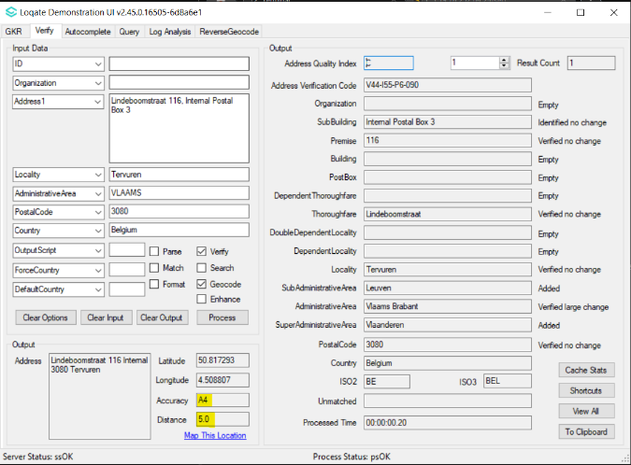 | Accuracy and Distance are now P4 and 0.0.  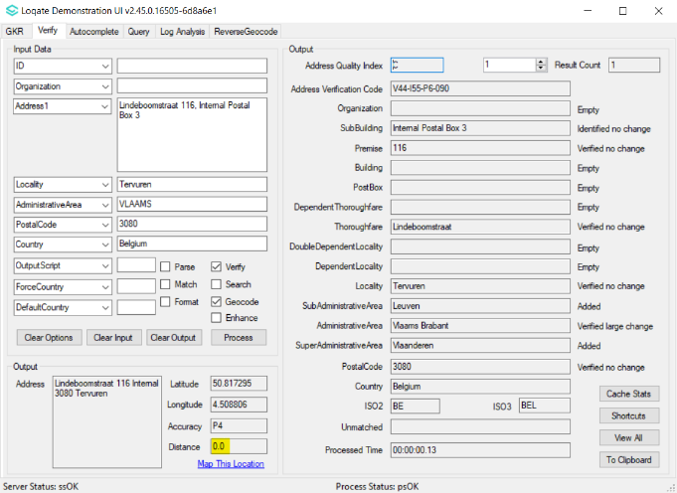

Canada
- Improvement in geocodes accuracy.
- Correction of reverse geocoding Premise.
2022Q4.1 | 2023Q1.0
Accuracy was I4.  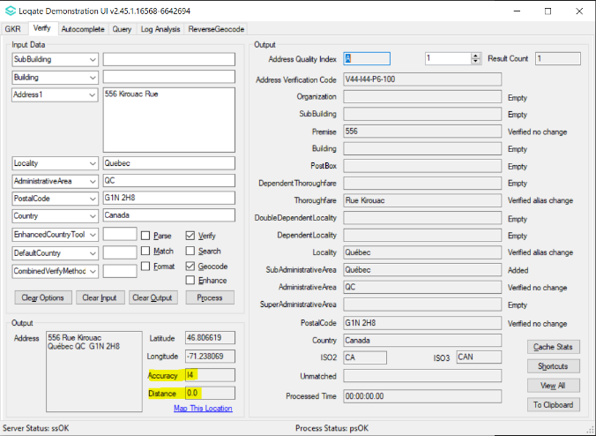 | Accuracy is now P4.  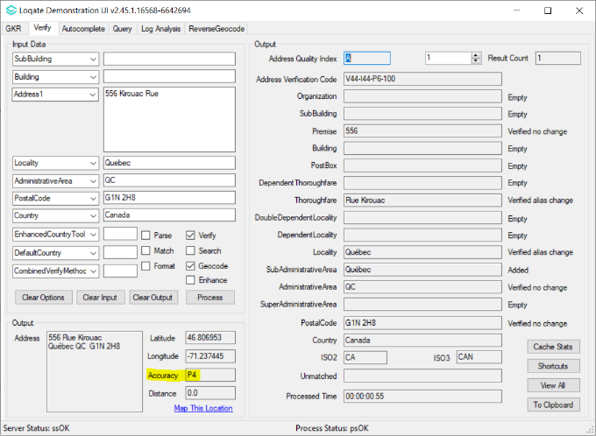

Incorrect range Premise was returned.  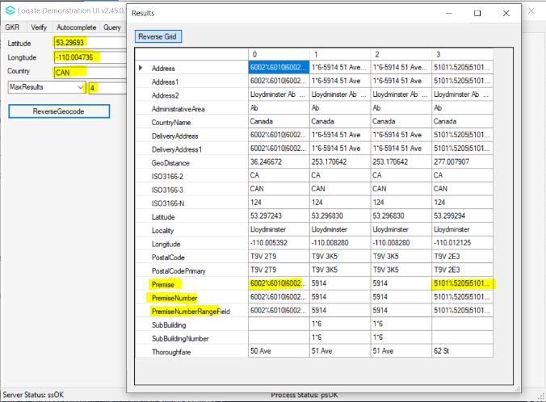 | Premise is now returned correctly.  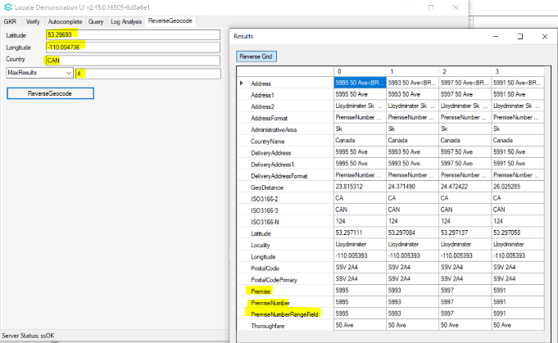

Israel
- Israel has a 7 digits postcode system, which currently supported by Loqate reference data. However, not all records contain 7-digits postcode coverage, for one that is not covered, the postcode field is currently blank.
- Enhancement in Israel reference data to include 5 digits postcode for records that do not contain 7-digits postcode coverage.
- In new verify outcome, we expect the 7-digits verified postcode remains verified, whereas unidentified/blank postcode will be verified to 5-digits postcode (refer example below).

2022Q4.1 | 2023Q1.0
PostalCode was not verified.  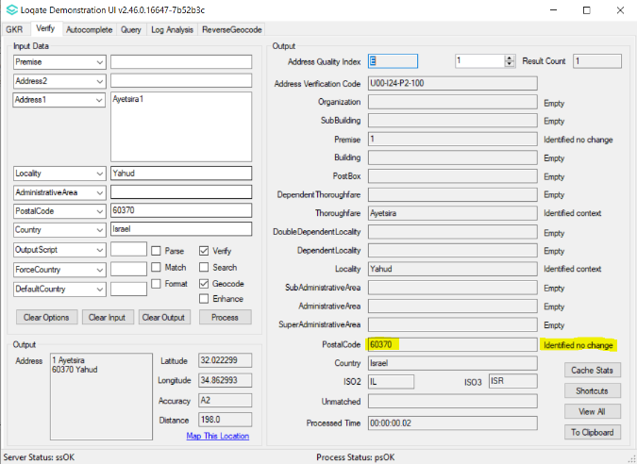 | PostalCode is now verified.  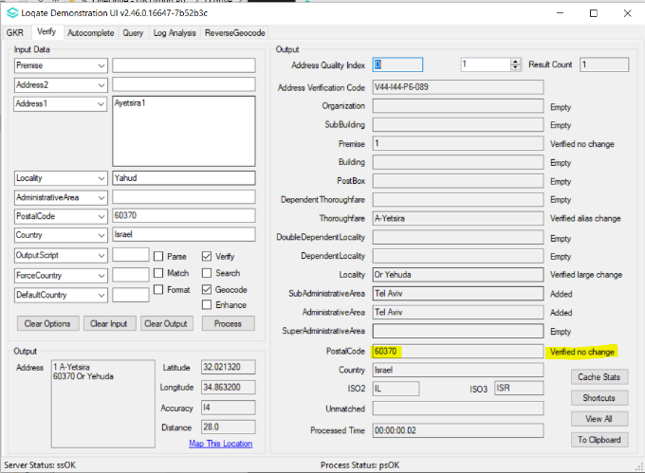

PostalCode was empty.  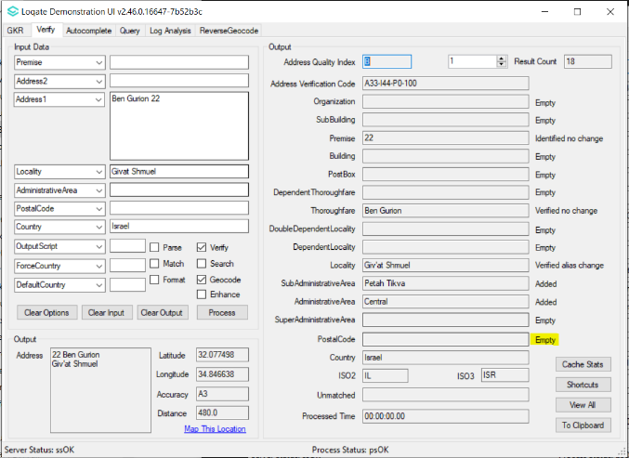 | PostalCode is now added.  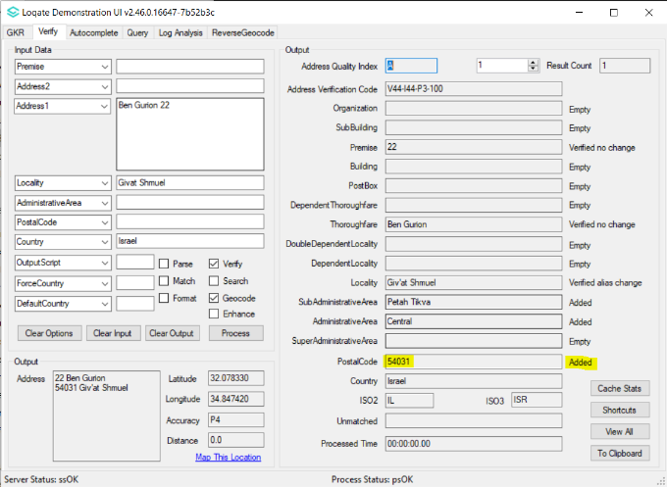

Korea, Republic of
Address formatting changed
Address Format (Native)  Default address | Line1: AdministrativeArea Locality DependentLocality Thoroughfare DependentThoroughfare Premise SubBuilding PostBox  Line2: Organization  Line3: PostalCode
Address Format (Native)  When DependentLocality ends with ‘동’ or ‘가’  (Indicator for residential address:  Building ends with ‘아파트’ or ‘빌라’, or ‘힐하이츠’, or ‘아트빌’, or ‘빌’, or ‘주택’, or ‘맨션’, ‘하우스’, or ‘팔레스타운’ or ‘팔레스’) | Residential address  Line1: AdministrativeArea Locality DependentLocality Thoroughfare DependentThoroughfare Premise SubBuilding  Line2: (DependentLocality, Building) PostBox  Line3: Organization  Line4: PostalCode  Business address:  Line1: AdministrativeArea Locality DependentLocality Thoroughfare DependentThoroughfare Premise SubBuilding  Line2: (DependentLocality) PostBox  Line3: Organization  Line4: PostalCode

2022Q4.1 | 2023Q1.0
AdministrativeArea is placed in a separate line from delivery address.  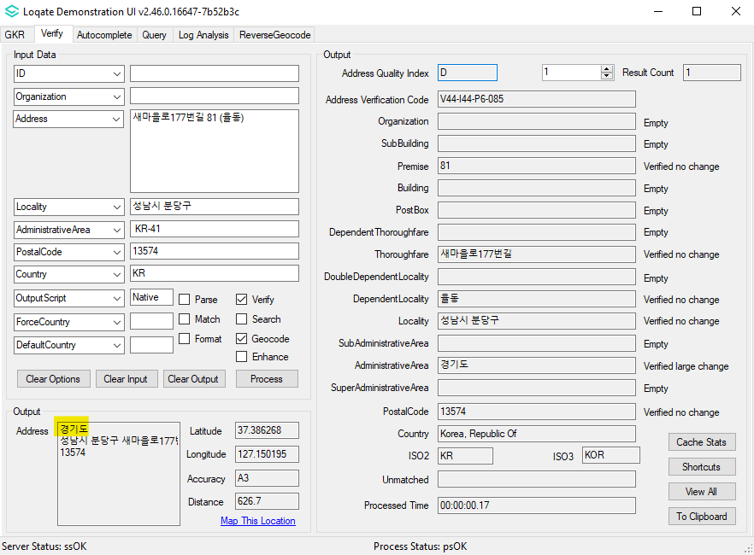 | AdministrativeArea is placed in the same line as delivery address.  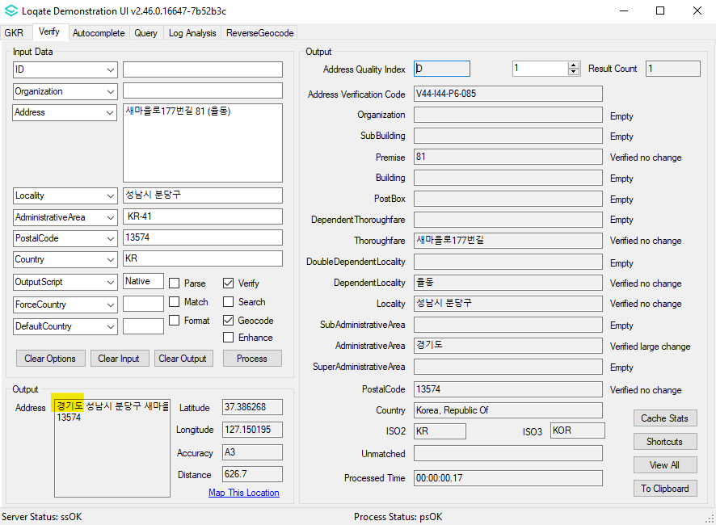

DoubleDependentLocality is included in the output address.  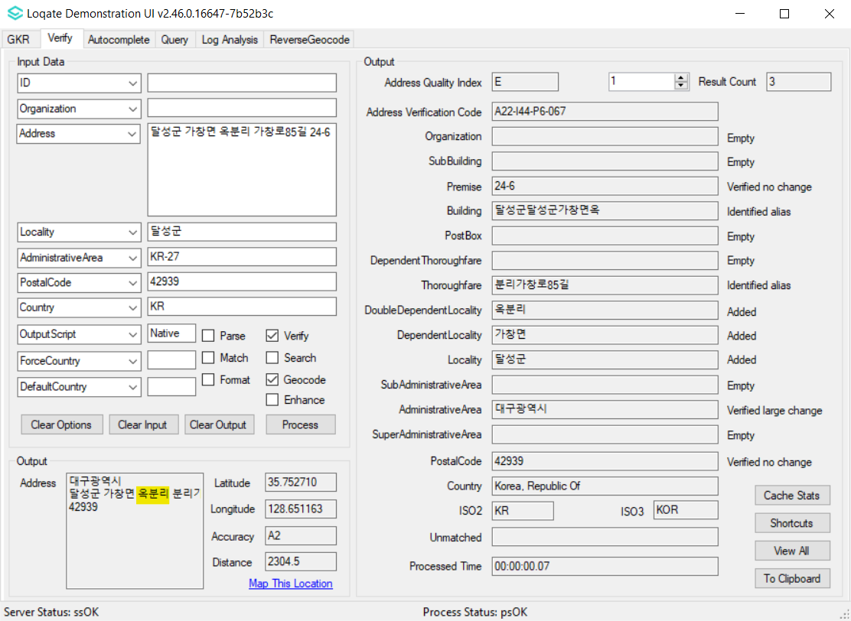 | DoubleDependentLocality is removed from output address.  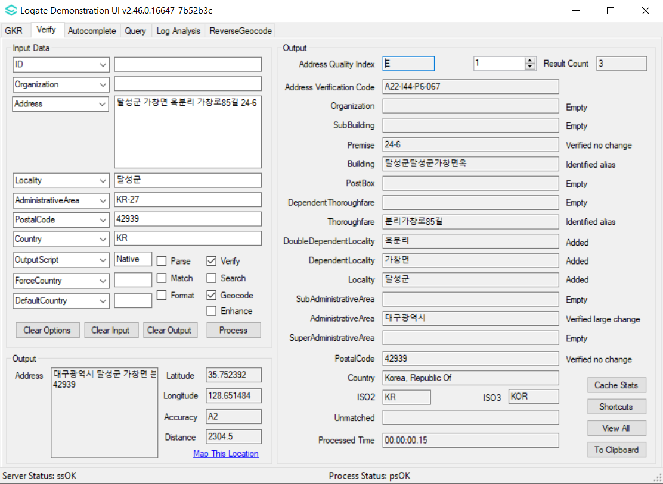

DependentLocality ends with ‘동’ and building are written inside parentheses.  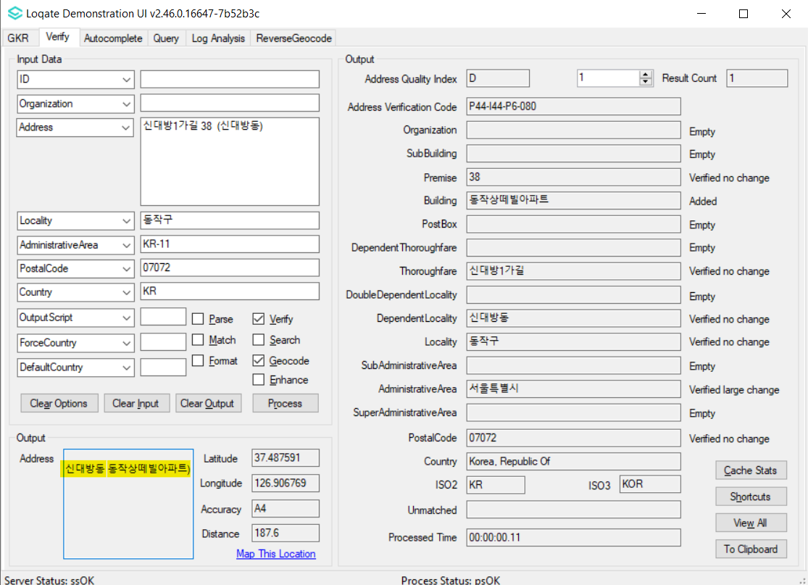 | DependentLocality ends with ‘동’ and residential building are written inside parentheses and separated with a comma.  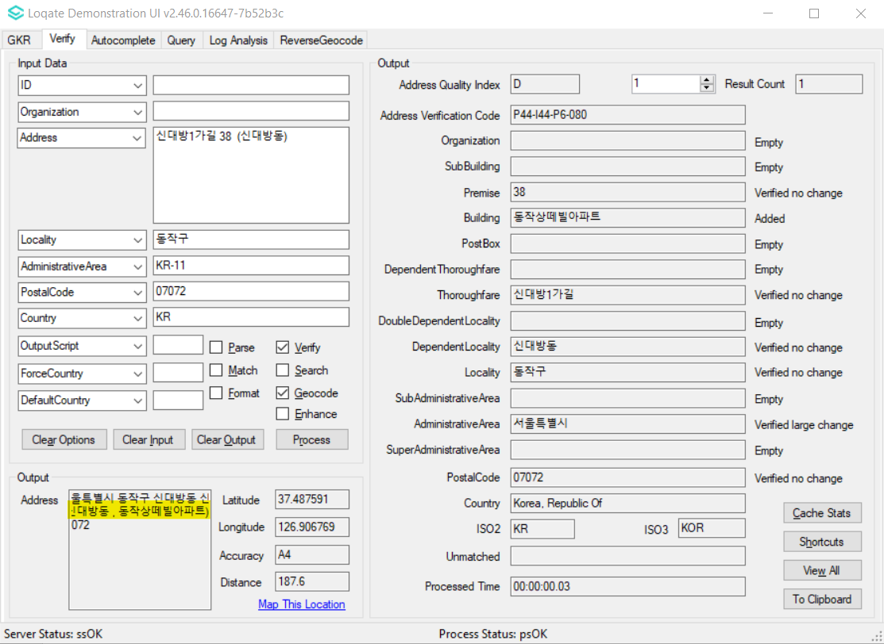

DependentLocality ends with ‘동’ and Building are written inside parentheses  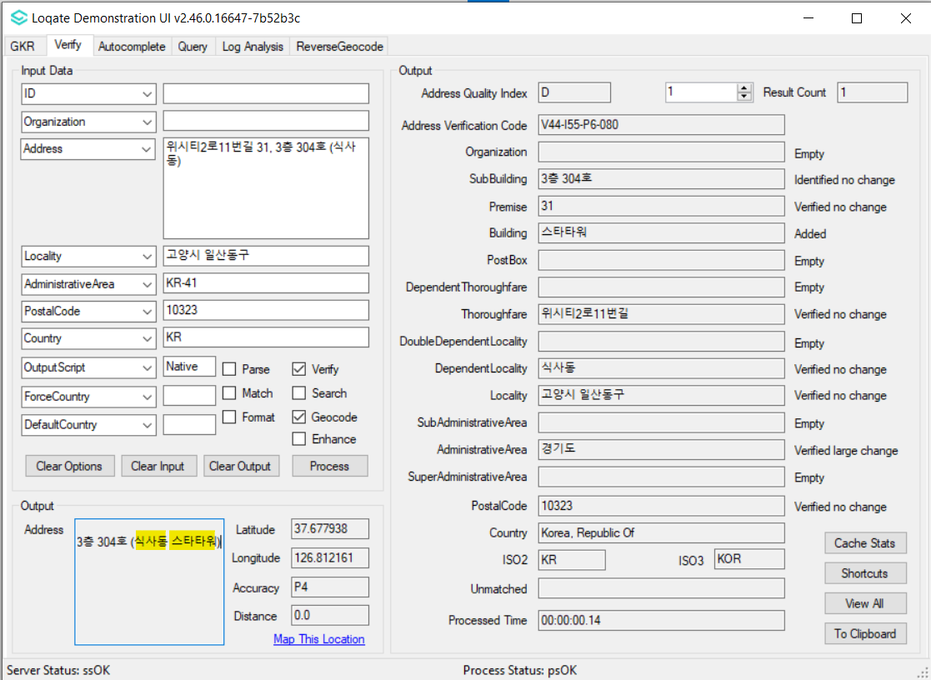 | DependentLocality ends with ‘동’ is written inside parentheses and business building is removed from output address  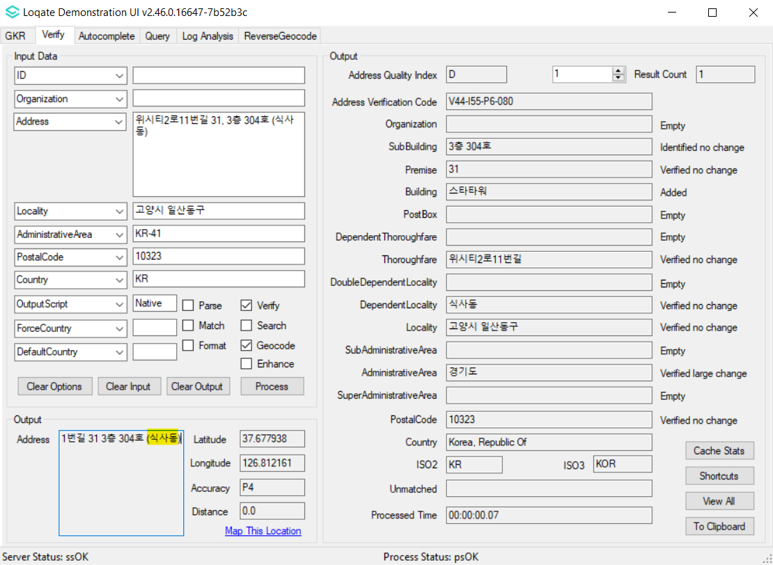

Case Resolutions

2023Q1.0 Data related Case Fixes
Case Number | Change Description | Category | Country | Example Address
Internal | Retain leading zeros in UDPRN Key (Verify Enhance) | Data | GB | Address: GB Group, Chester  Country: GB  PostalCode: CH4 9GB
Before Image |  |  | After Image
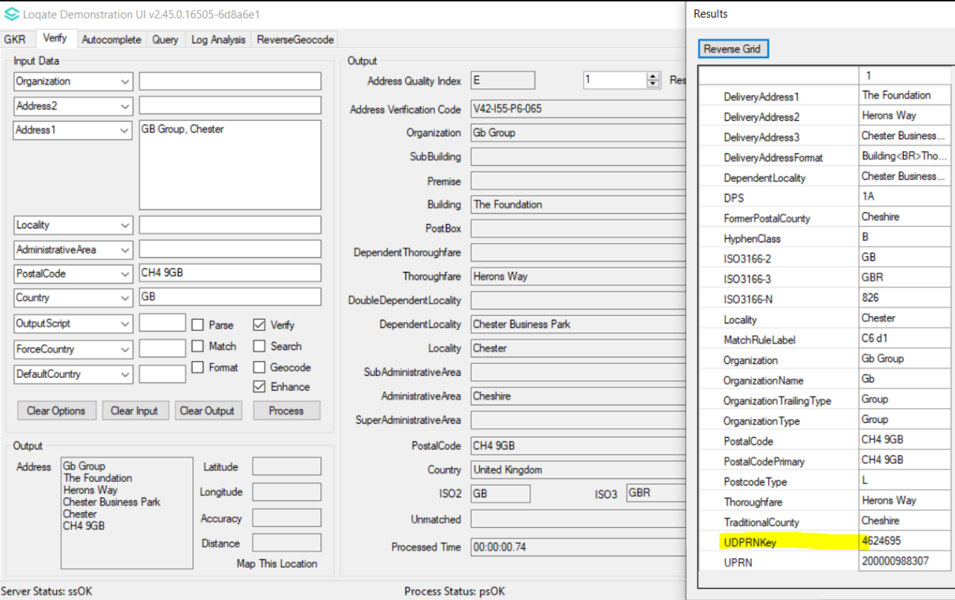 |  |  | 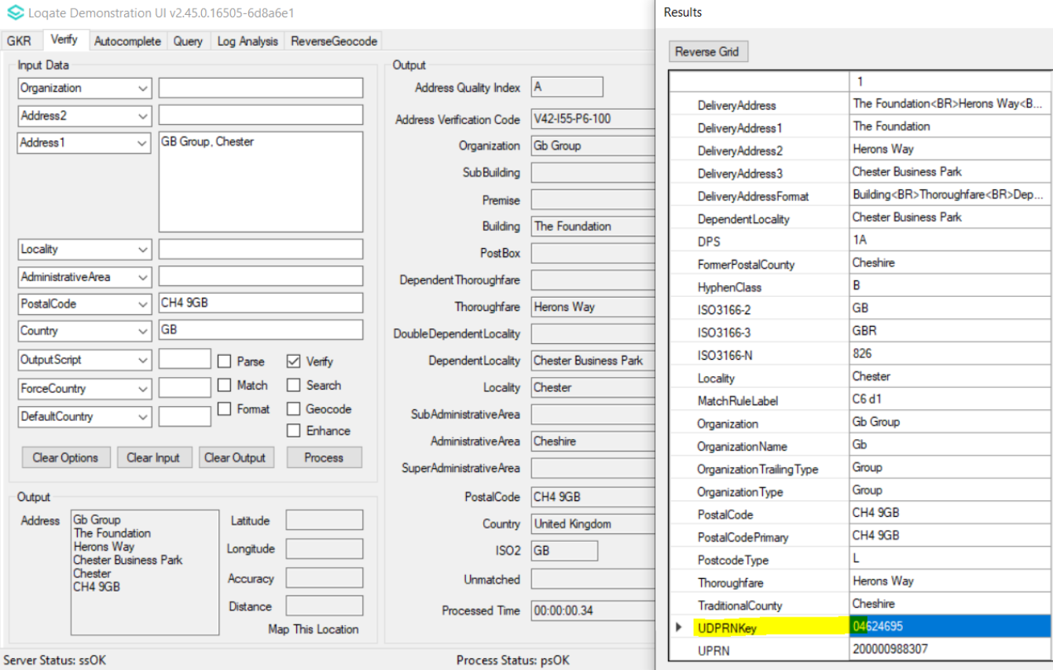

Case Number | Change Description | Category | Country | Example Address
CAS-83437-B4T8K0 | Improvement of DependentLocality verification. | Data | LT | Address1: Vilties g. 2  Locality: Naujieji Valkininkai  AdministrativeArea: LT-AL  Country: LT
Before Image |  |  | After Image
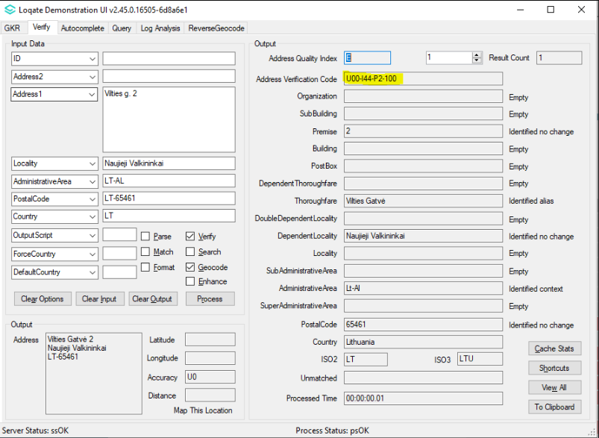 |  |  | 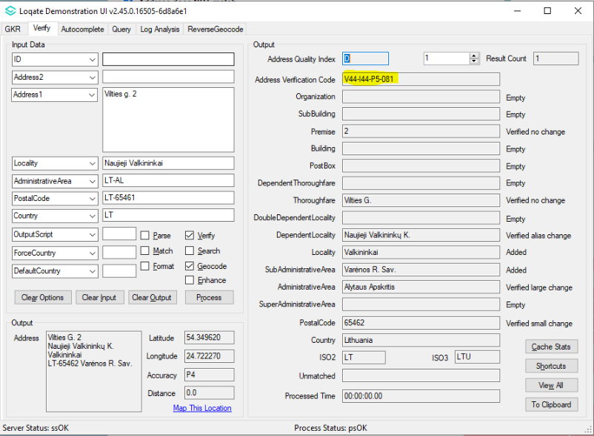

Case Number | Change Description | Category | Country | Example Address
CAS-10685-P4Q3Y9 | Improvement of DependentLocality parsing and address verification. | Data | TH | Address 1: 1/238 Soi Vibhavadi 25  Vibhavadi-Rangsit Road  Tailat Bang Khen, Laksi Thailand
Before Image |  |  | After Image
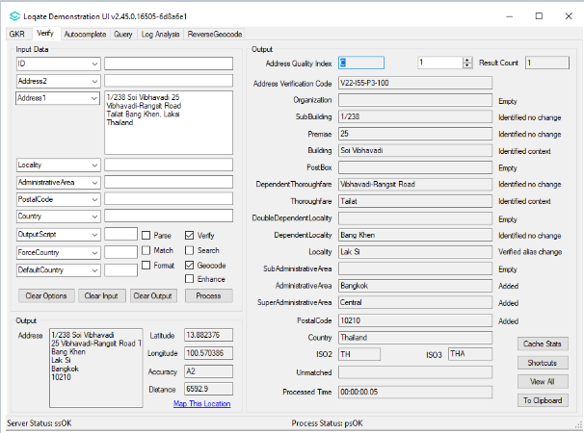 |  |  | 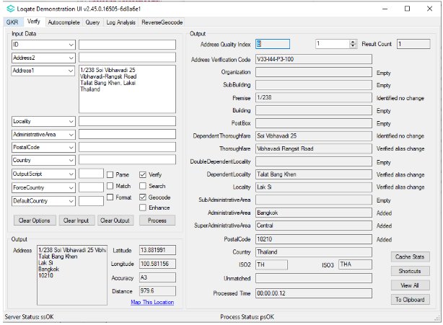

Case Number | Change Description | Category | Country | Example Address
CAS-78850-G1J1S4 | Improvement of address parsing and verification. | Data | HK | 1st address: Address1: Wing F, 1/F, Main Block, 102 Pokfulam Road Country: HK  2nd address: Address1: Room A9, 7th Floor, Block A, Hong Kong Industrial Centre, 489-491 Castle Peak Ro Hong Kong Cheung Sha Wan 00000 Country: HK
Before Image |  |  | After Image
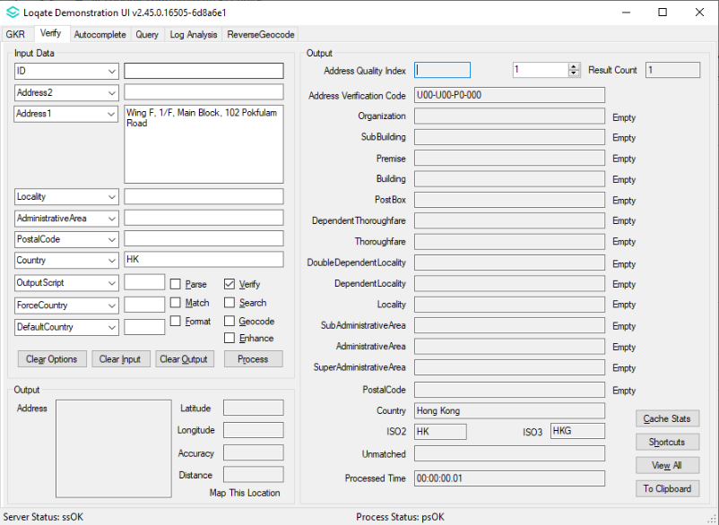 |  |  | 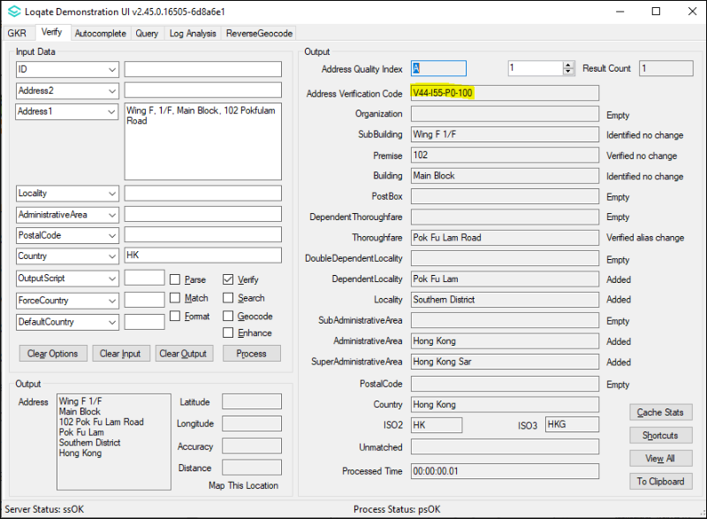
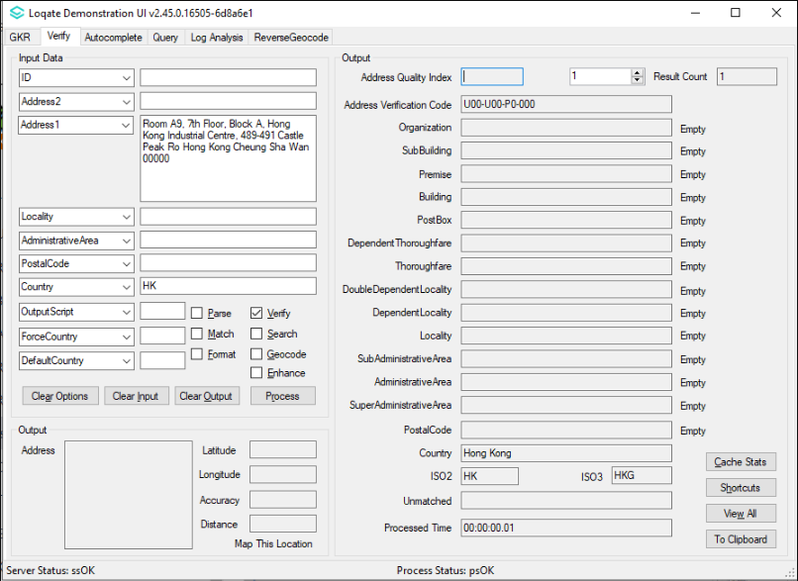 |  |  | 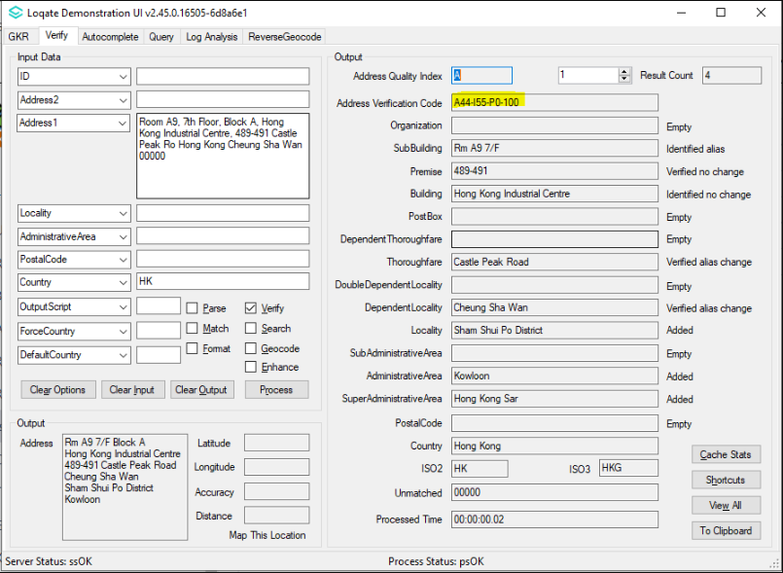

Case Number | Change Description | Category | Country | Example Address
CAS-85000-Z2Z7L9 | Correction of output address format for native addresses | Data | KR | 1st address: Address1: 신대방1가길 38, 105동 3층 311호 (신대방동)  Locality: 동작구  AdministrativeArea: KR-11  PostalCode: 07072  Country: KR  2nd address:Address1: 청량면 덕하장터길 3  Locality: 울주군  AdministrativeArea: KR-31  PostalCode: 44984  Country: KR
Before Image |  |  | After Image
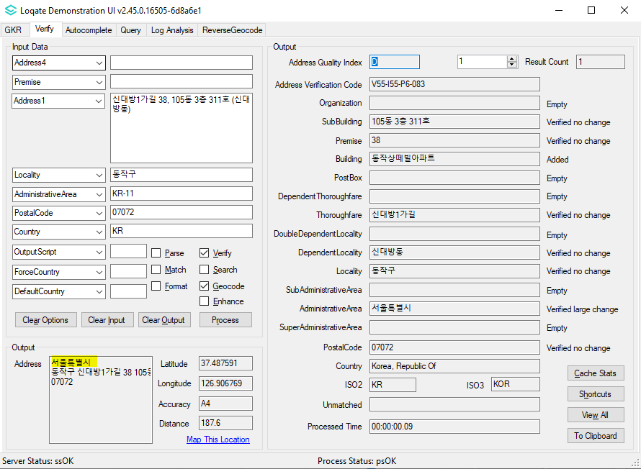 |  |  | 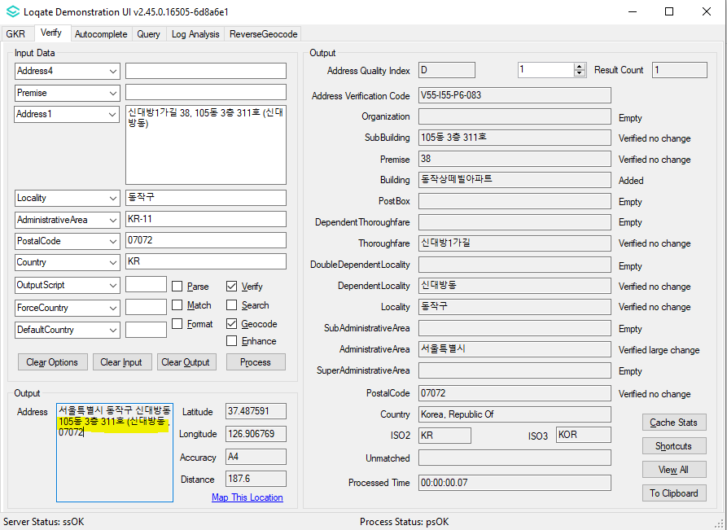
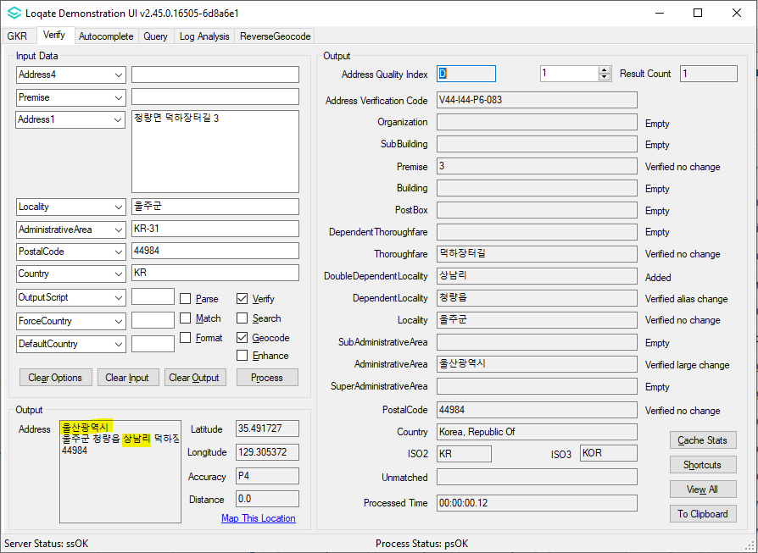 |  |  | 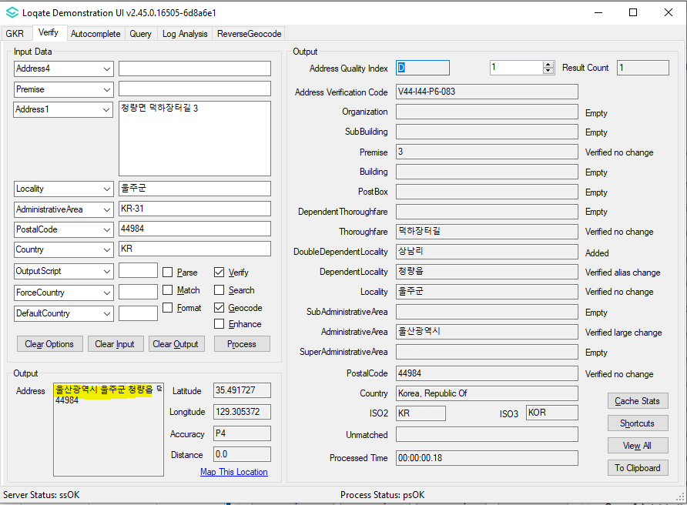

Case Number | Change Description | Category | Country | Example Address
CAS-87177-F0L9L6 | Improvement of Thoroughfare parsing and verification. | Data | US | Address1: 98 DALLAS 115  Locality: FORDYCE  AdministrativeArea: Arkansas  Country: United States
Before Image |  |  | After Image
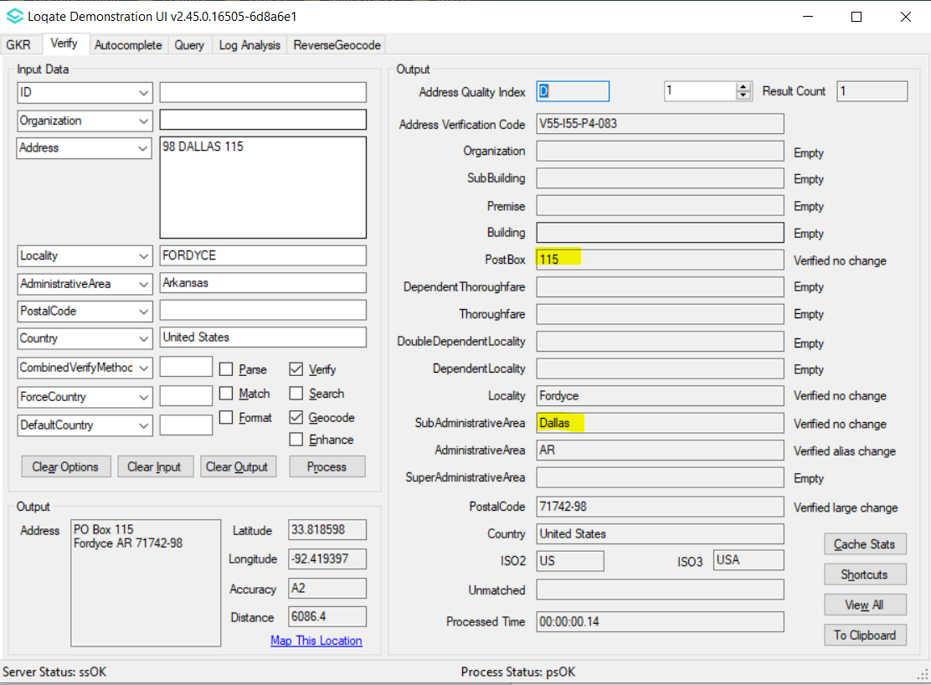 |  |  | 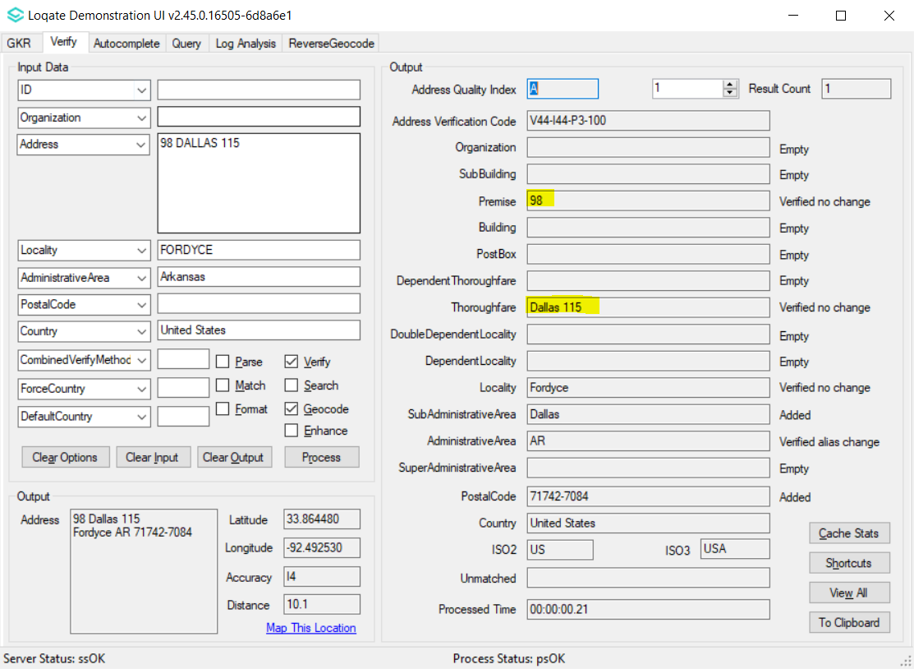

Case Number | Change Description | Category | Country | Example Address
CAS-81237-B3G4N6 | Improvement of SubBuilding parsing and address verification. | Data | BG | Address1: Улица Деян Белишки 46, Вход B, етаж 6, апартамент 14  Address2: Триаде  Address3: 2400 София  Country: BG
Before Image |  |  | After Image
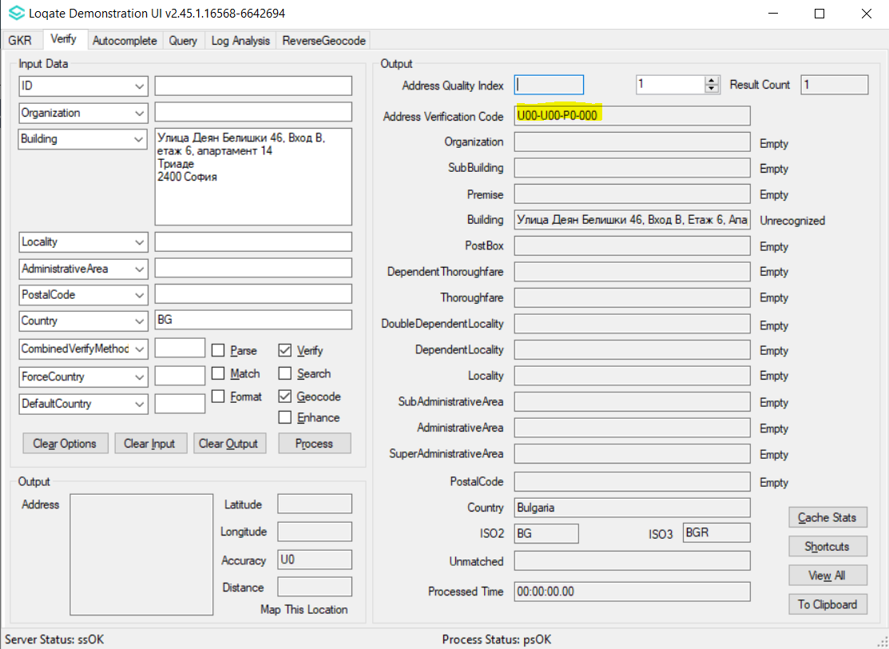 |  |  | 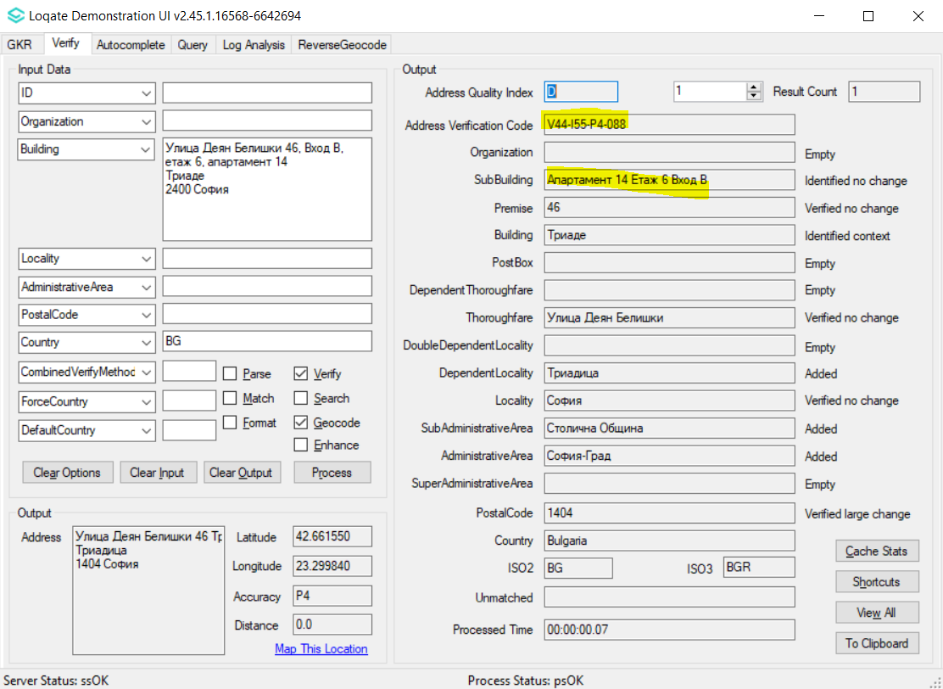

Case Number | Change Description | Category | Country | Example Address
CAS-90191-X9J2K9 | Improvement of SubBuilding and Premise parsing. | Data | SE | 1st Address Address1: Väsby Ängsväg 28C, lght 1102,  Locality: Vagnhärad,  PostalCode: 619 72  Country: SE  2nd Address Address1: Styrbordsgången 1HA,  Locality: Ystad,  PostalCode: 271 52  Country: SE
Before Image |  |  | After Image
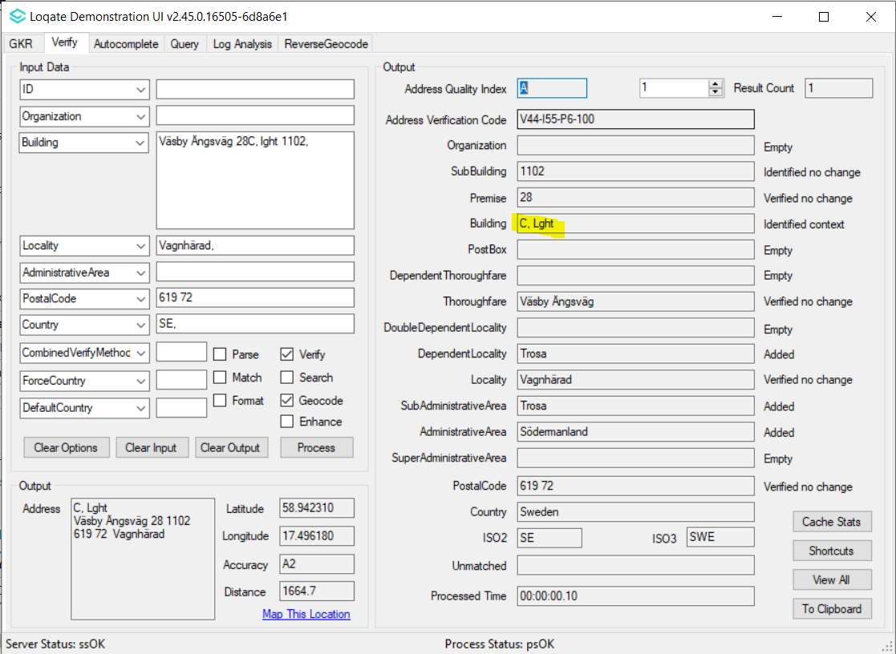 |  |  | 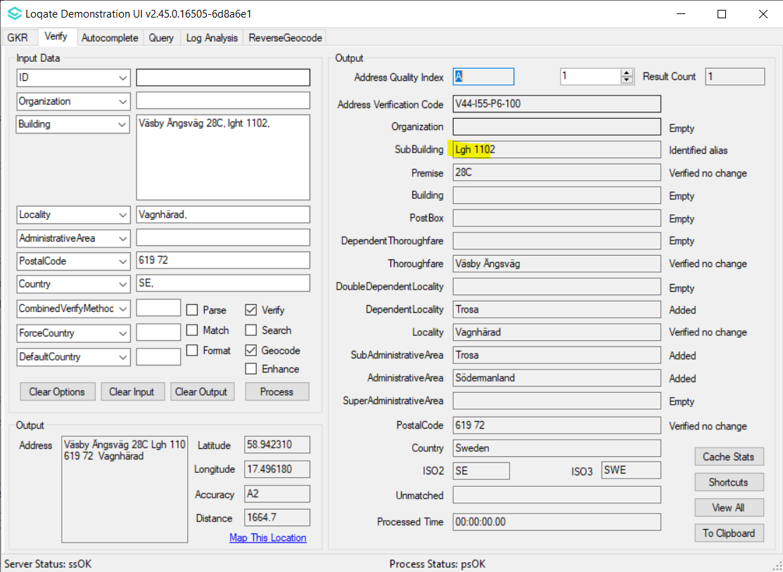
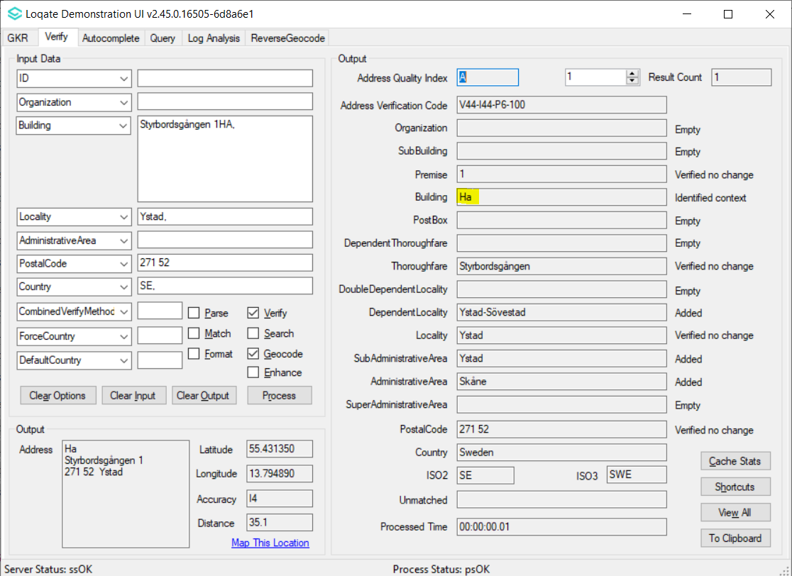 |  |  | 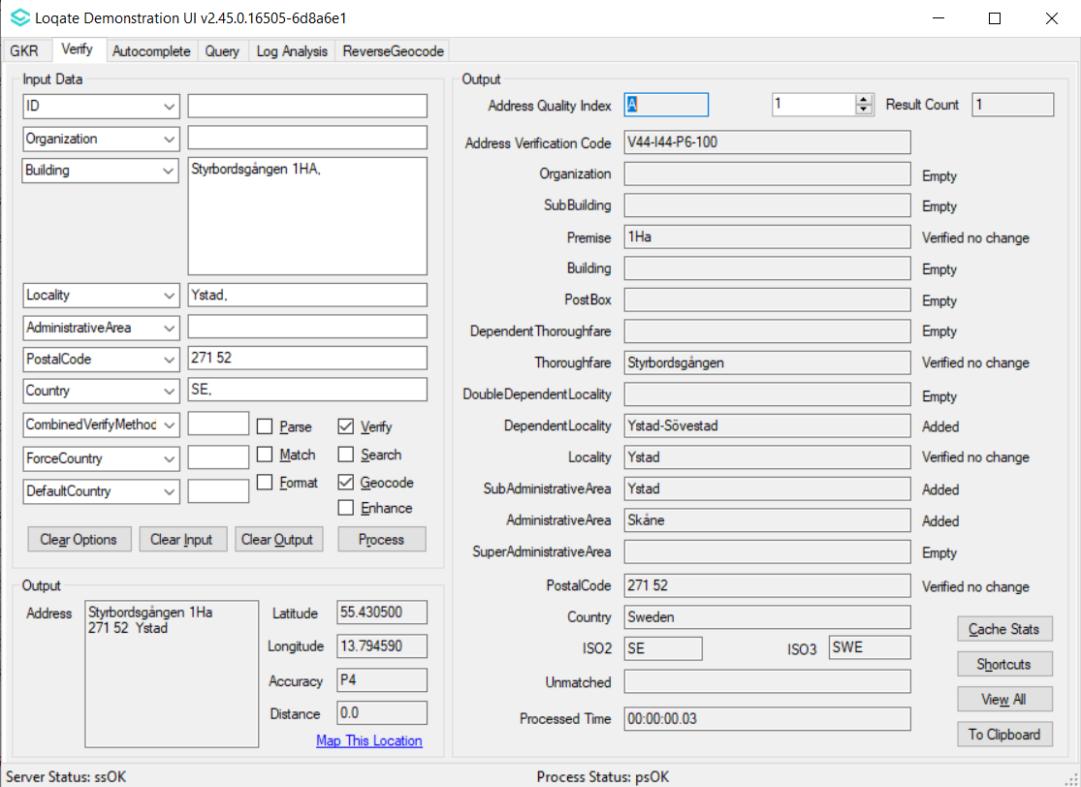

Case Number | Change Description | Category | Country | Example Address
CAS-84689-R8J5G6 | Improvement of PostalCode parsing. | Data | IE | Address1: 22 Stonewell  Locality: Garristown  PostalCode: A42YE37  Country: IE
Before Image |  |  | After Image
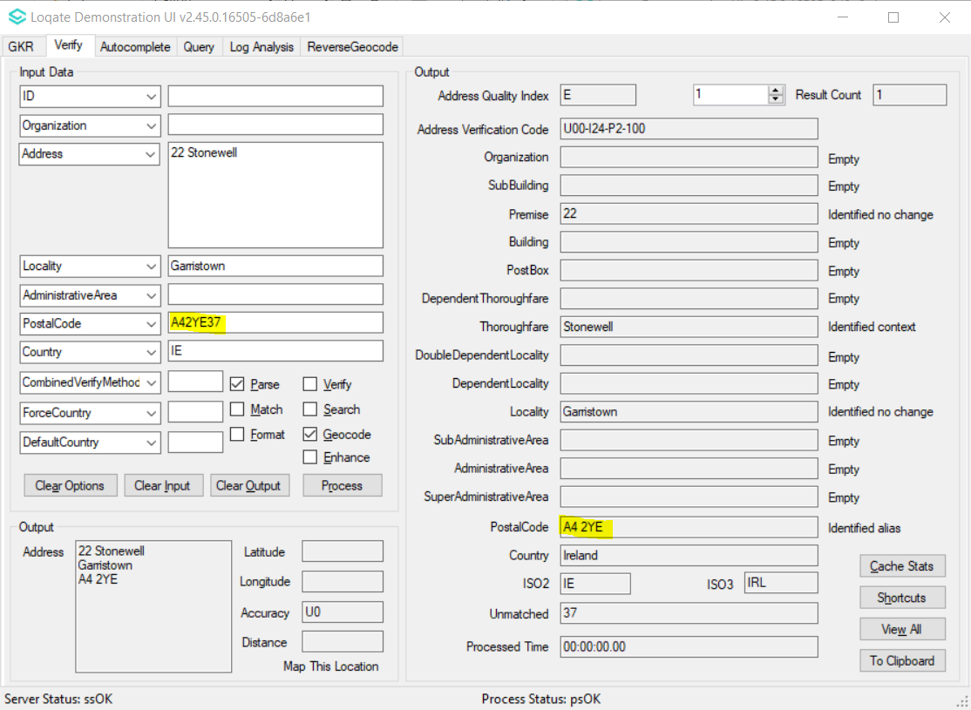 |  |  | 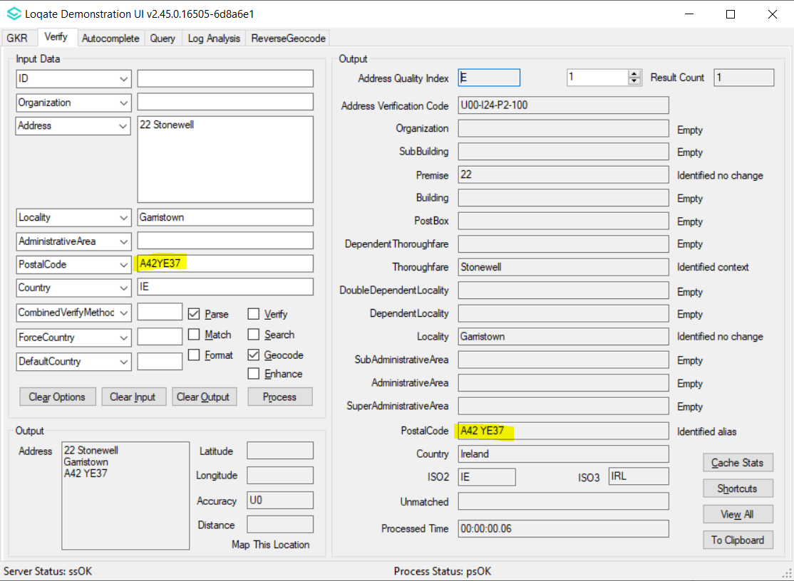

Case Number | Change Description | Category | Country | Example Address
RMG-122 | Correction of addresses that have missing DPS values | Data | GB | Address1: FLAT A 320 322  Address2: BARKING ROAD  Locality: LONDON  PostalCode: E6 3BA  Country: GBR
Before Image |  | After Image
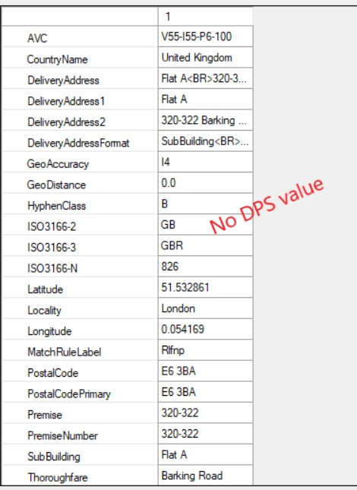 |  | 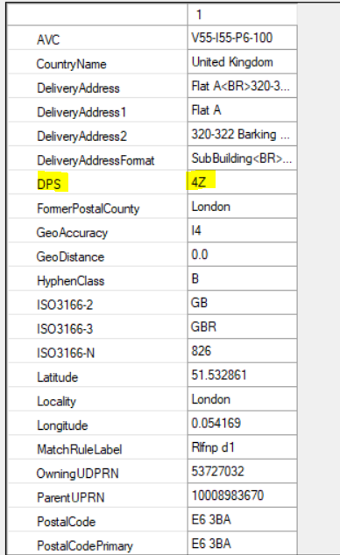

Case Number | Change Description | Category | Country | Example Address
CAS-999-NOTPROVIDED | Correction of the Locality being verified | Data | ES | 1st Address  Address1: Passatge Xiprers 2 Portal 6 Piso 1B  Locality: Sant Andreu de Llavaneres  PostalCode: 08392  Country: ES  2nd Address  Address1: Calle diputació 37, 3r B  Locality: sant sadurni d'anoia  PostalCode: 08770  Country: ES
Before Image |  |  | After Image
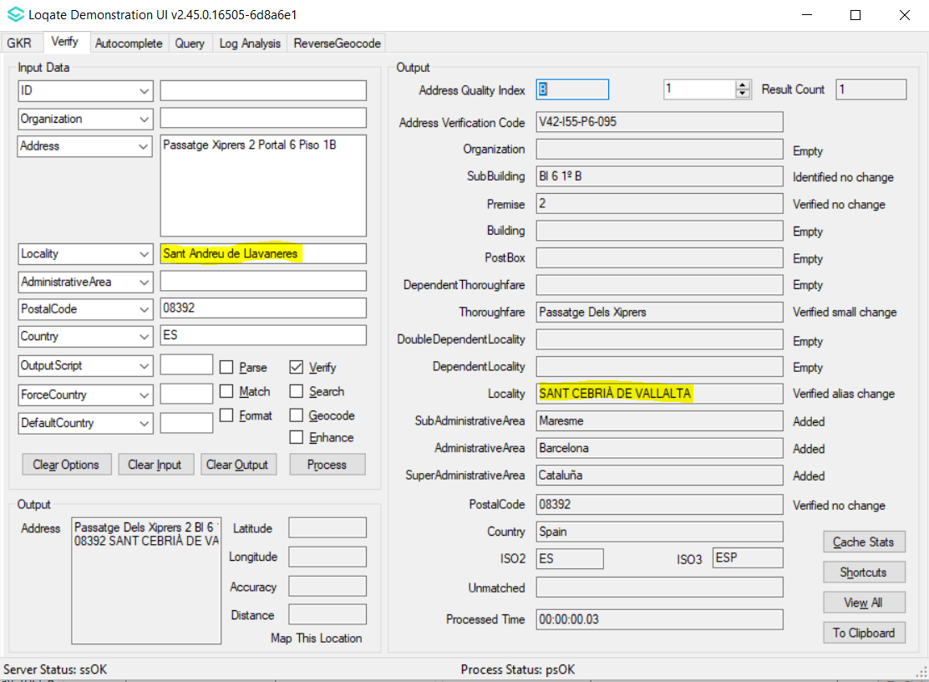 |  |  | 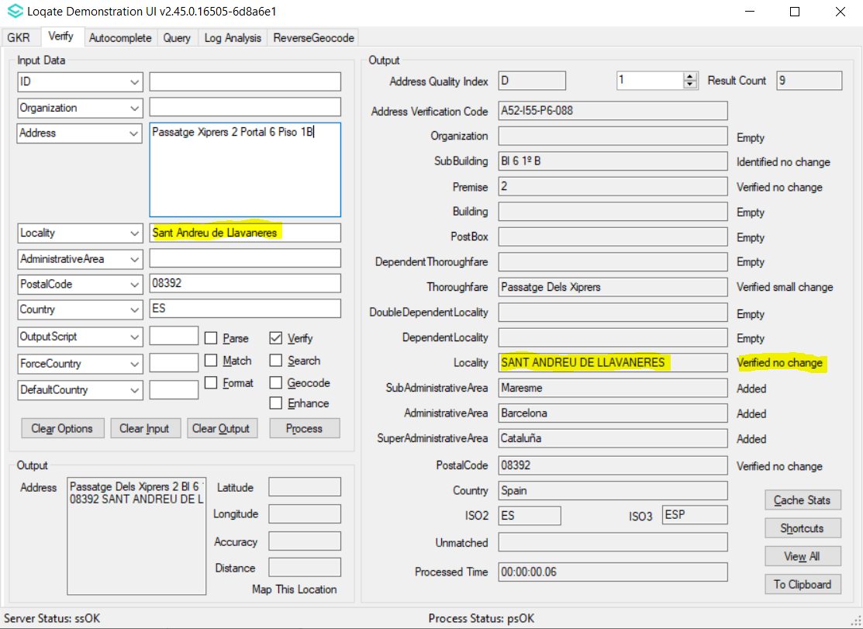
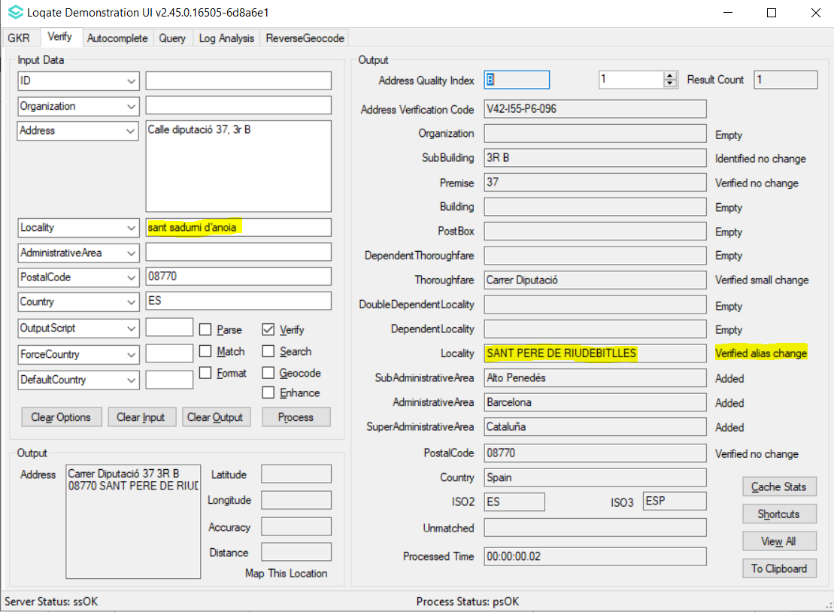 |  |  | 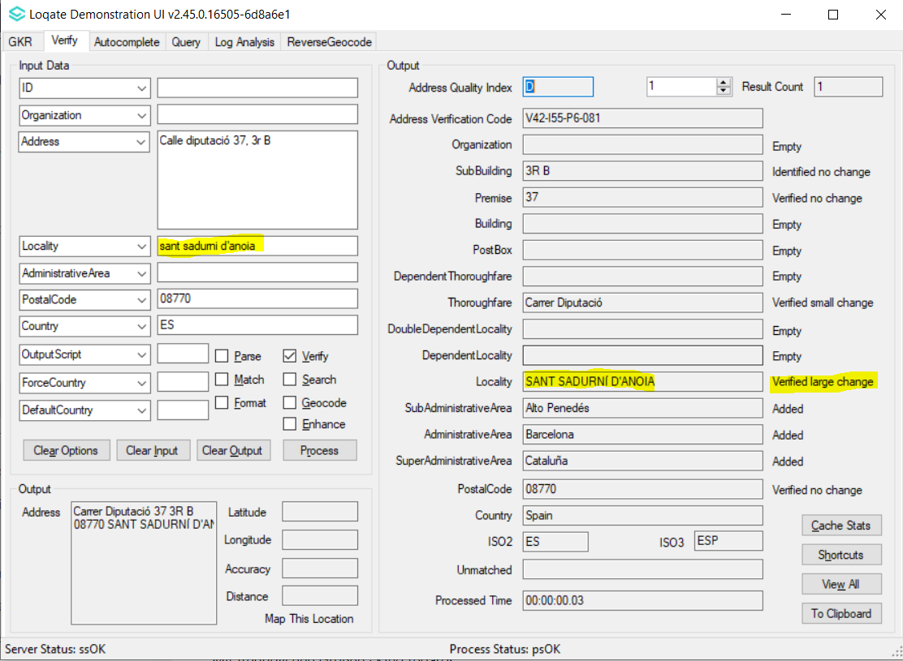

Case Number | Change Description | Category | Country | Example Address
CAS-86994-F0Y4C3 | Improvement of Premise verification | Data | KR | Address1: 서면로 10  Locality: 부산진구  AdministrativeArea: 부산광역시  PostalCode: 47289  Country: KR
Before Image |  |  | After Image
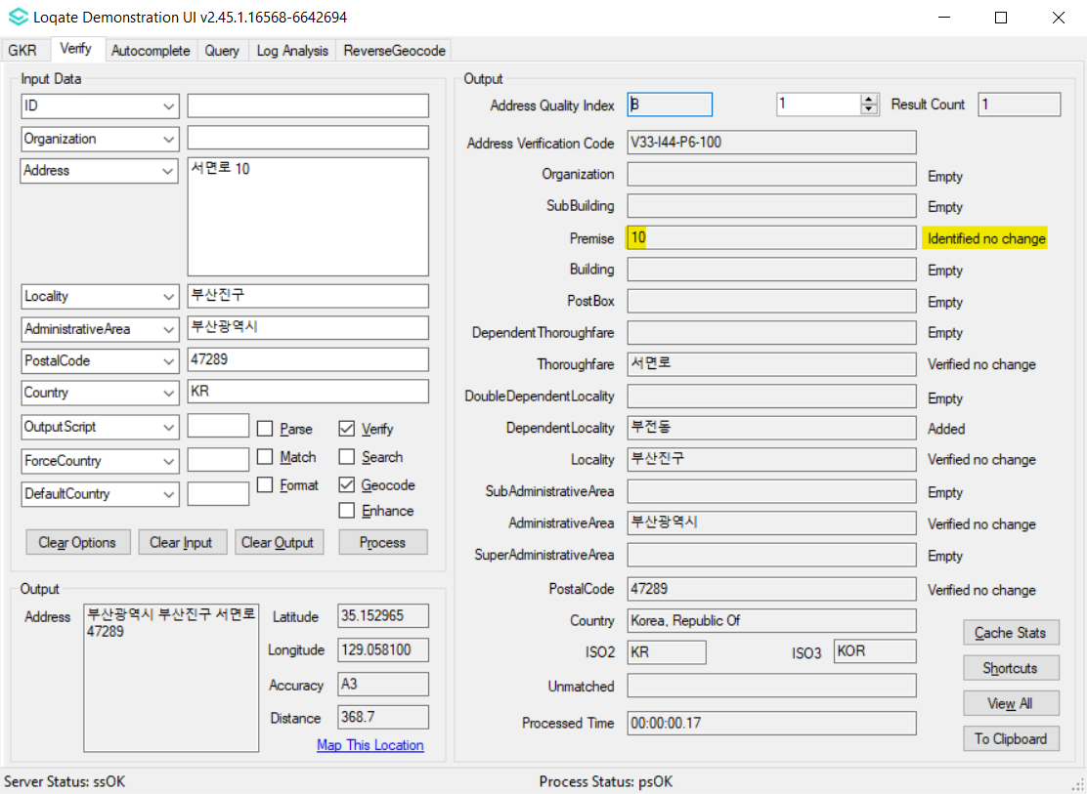 |  |  | 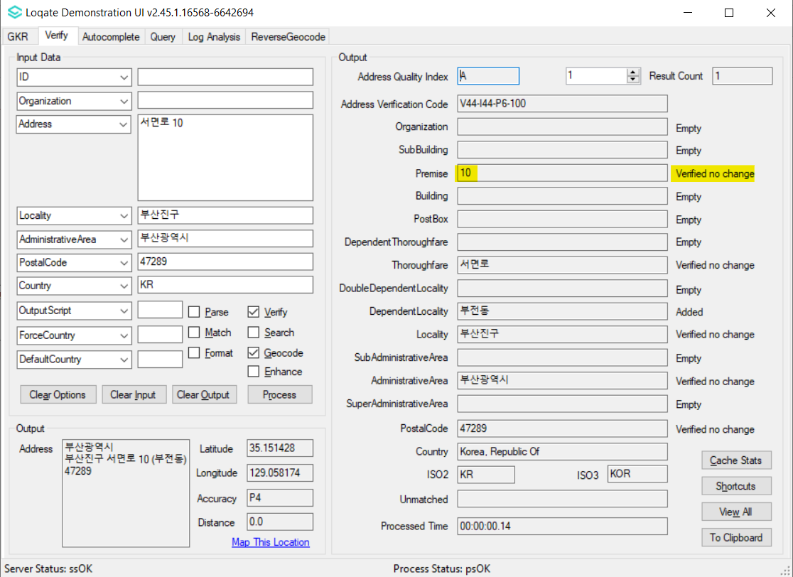

Case Number | Change Description | Category | Country | Example Address
CAS-85206-N0W1L9 | Improvement of address parsing and verification | Data | KR | Address1: 탕정면 한들물빛도시로 85, 2~4층  Locality: 아산시  AdministrativeArea: KR-44  PostalCode: 31465  Country: KR
Before Image |  |  | After Image
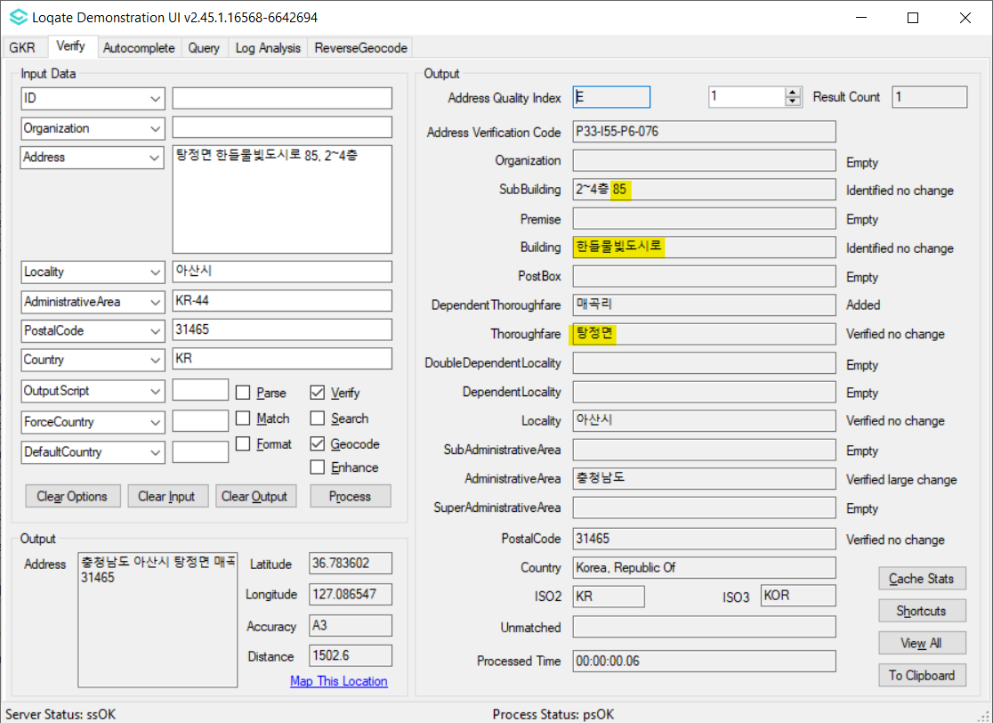 |  |  | 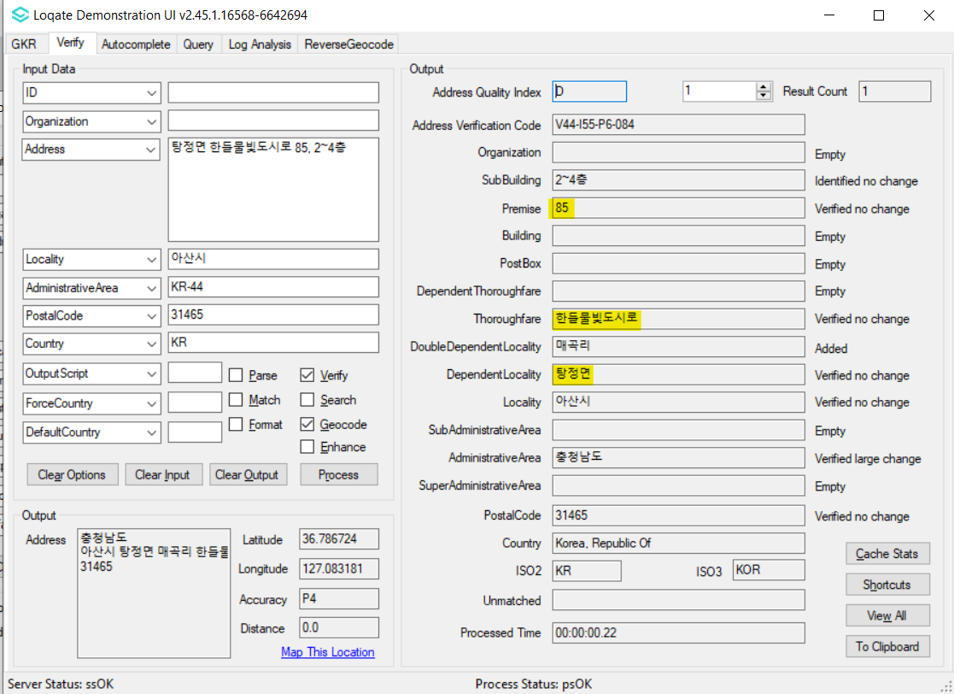

Case Number | Change Description | Category | Country | Example Address
CAS-85003-W3R3M6 | Improvement of address parsing and verification | Data | KR | Address1: 연신로 52 (이도2동)  Locality: 제주시  AdministrativeArea: KR-49  PostalCode: 63227  Country: KR
Before Image |  |  | After Image
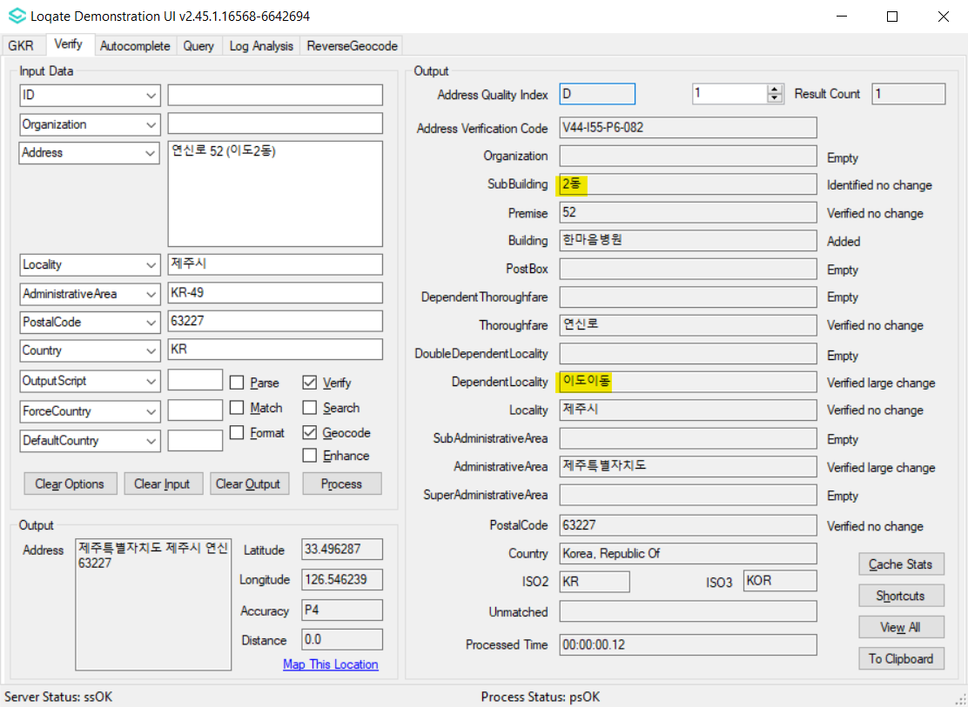 |  |  | 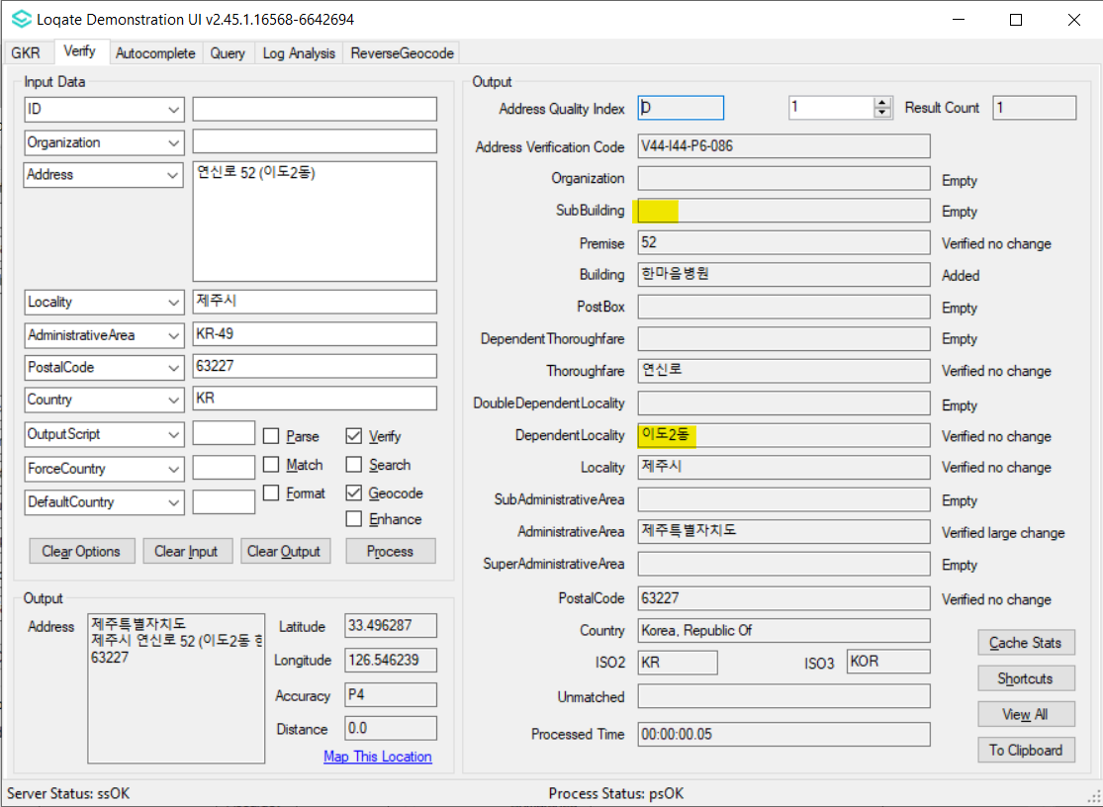

Case Number | Change Description | Category | Country | Example Address
CAS-78030-C1C1J1 | Improvement of Building parsing and verification | DATA | IN | Address1: Berach Dale  Address2: Arakkakadavu Road  Address3: Vennala  Locality: Ernakulam  PostalCode: 682028  Country: IN
Before Image |  |  | After Image
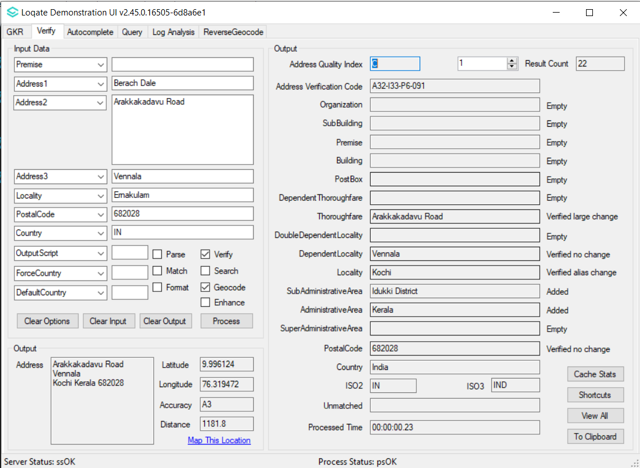 |  |  | 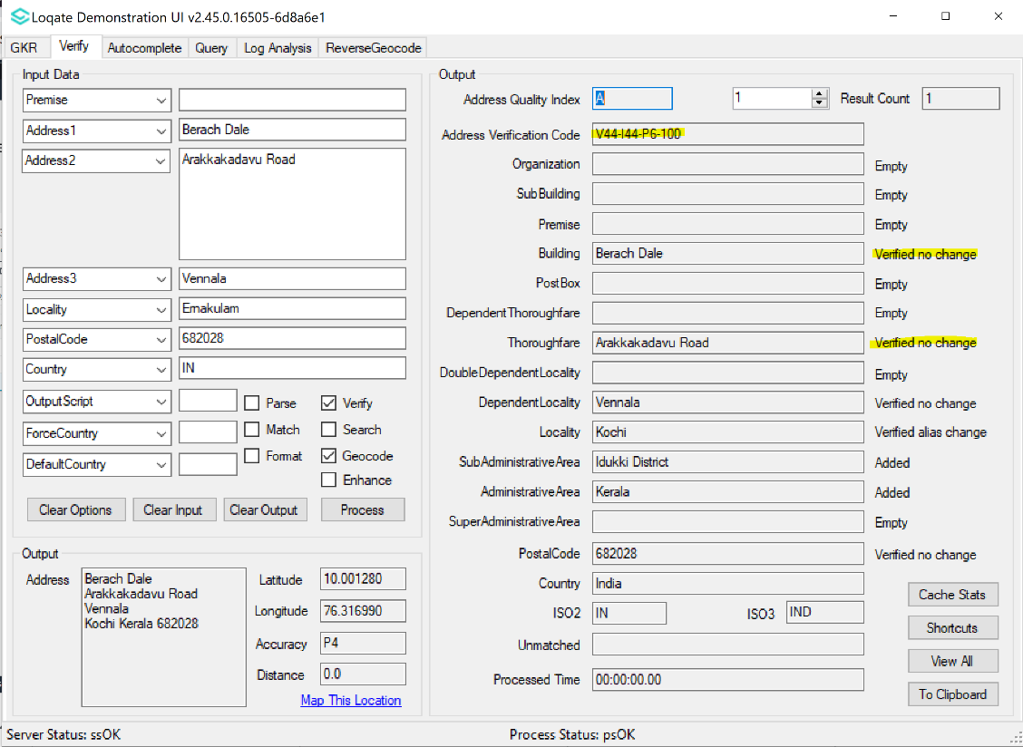

Case Number | Change Description | Category | Country | Example Address
CAS-79995-J4J0H0 | Improvement of geocodes accuracy | Data | CA | Address1: 15 BONDAR WAY  Locality: OTTAWA  Admin: ON  Postal Code: K1T4A9  Address1: 105 ROSEMARY LANE  Locality: ANCASTER  Admin: ON  Postal Code: L9G2K4  Address1: 120 W LAKEVIEW DR  Locality: CHESTERMERE  Admin: AB  Postal Code: T1X1J1
Before Image |  |  | After Image
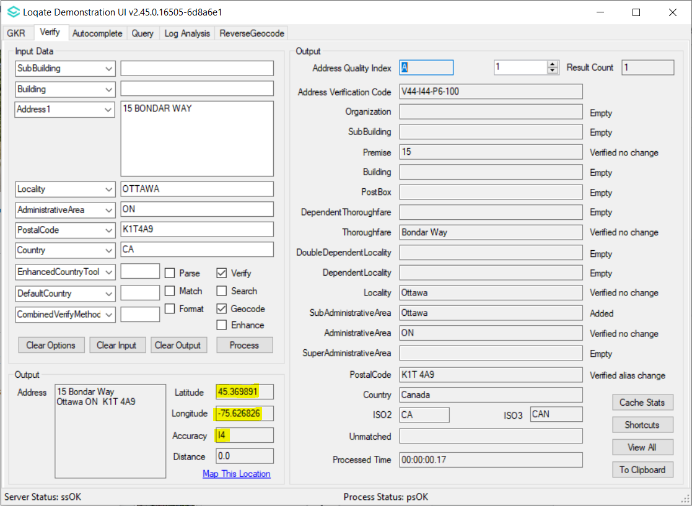 |  |  | 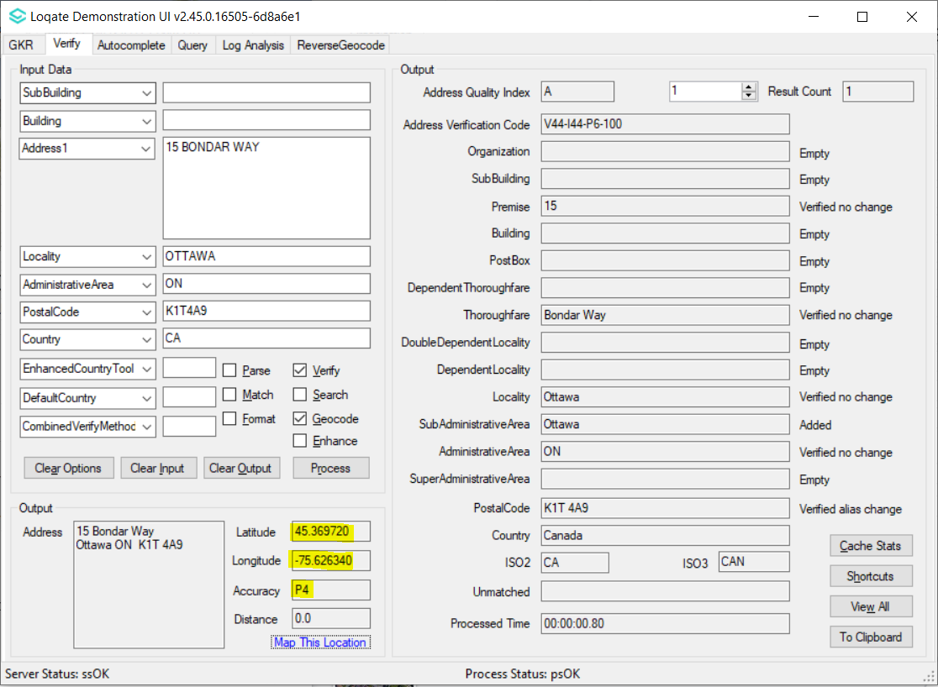
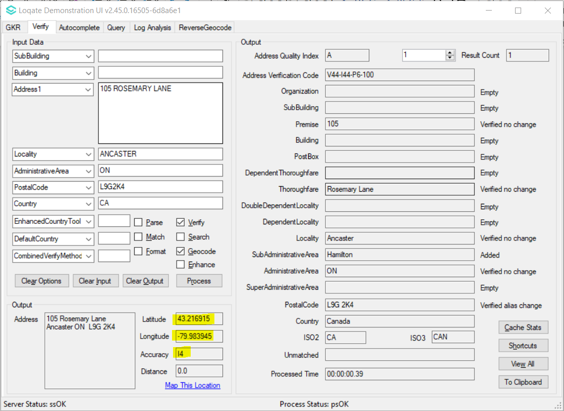 |  |  | 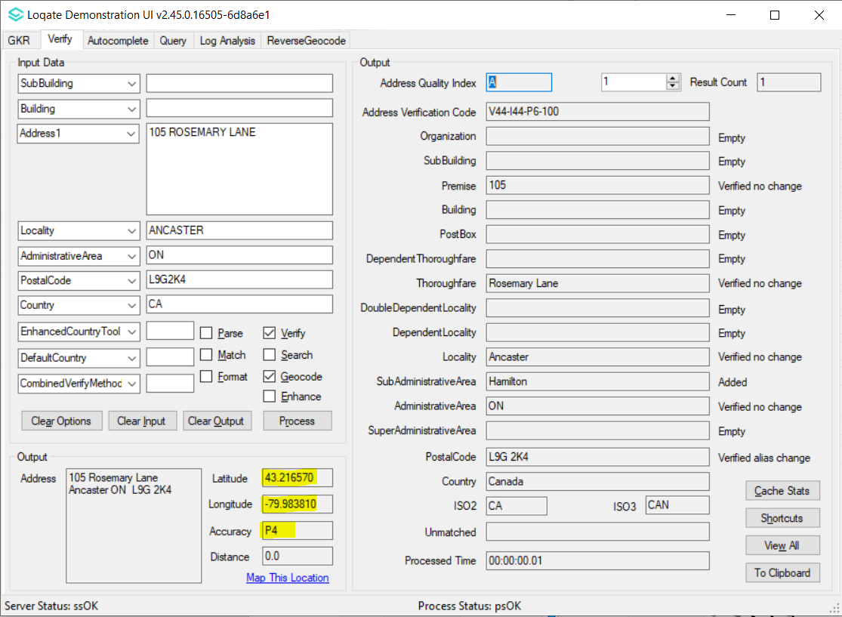
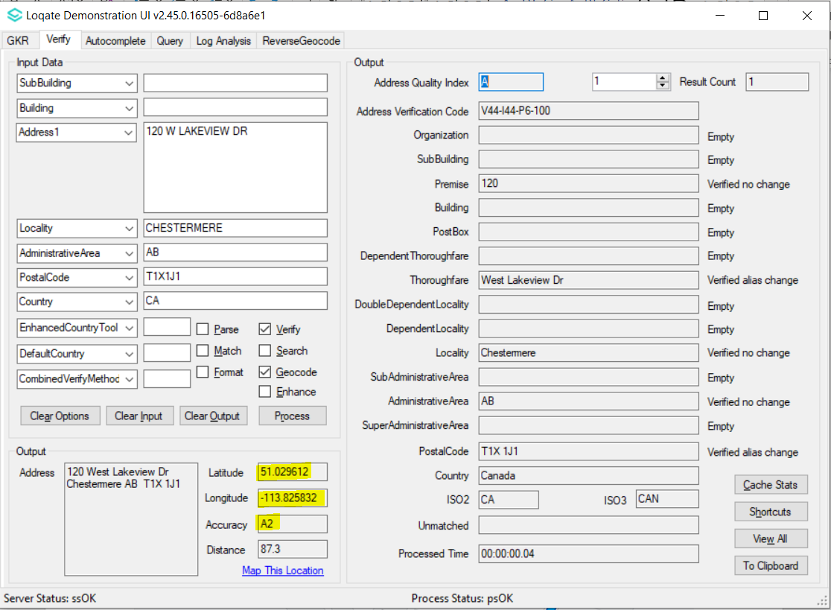 |  |  | 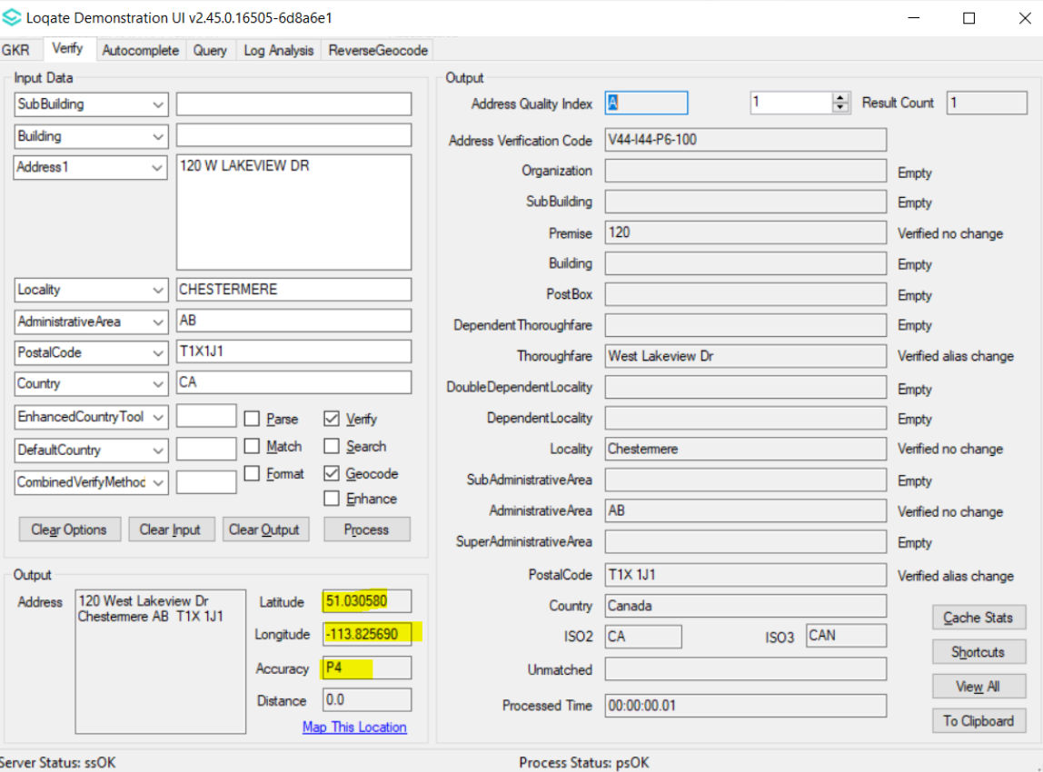

Case Number | Change Description | Category | Country | Example Address
CAS-67892-Q1R1X2 | Correction of reverse geocoding Premise | Data | CA | Latitude=53.29693  Longitude=-110.004736  Country=CAN  MaxResults=4
Before Image |  |  | After Image
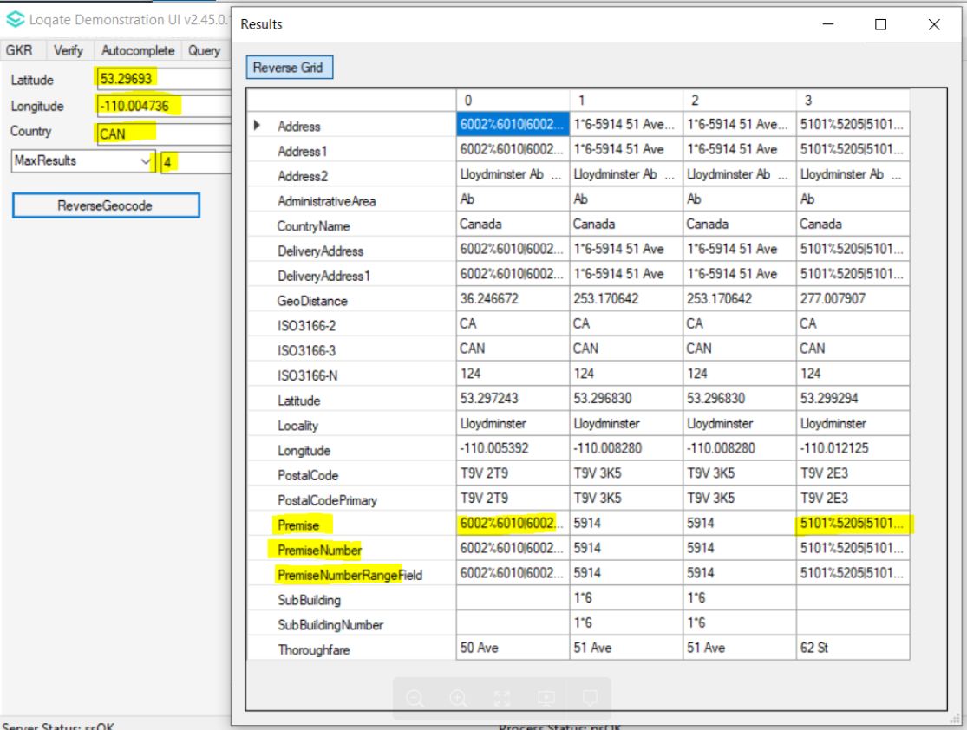 |  |  | 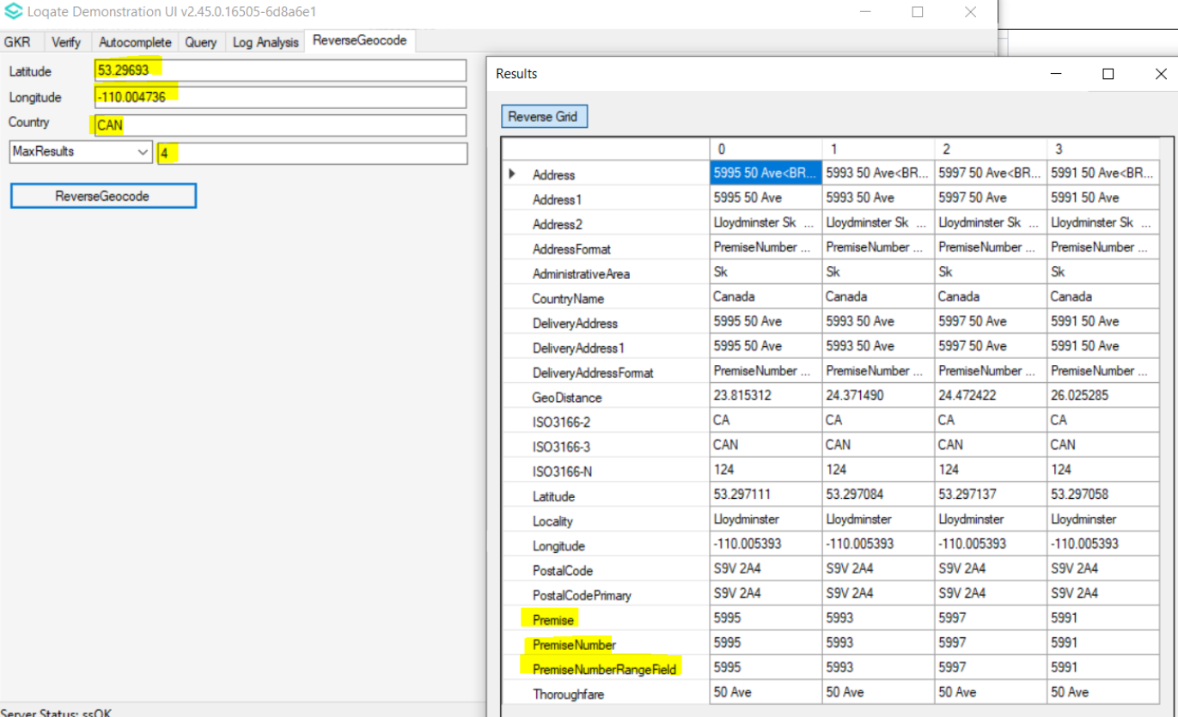

Case Number | Change Description | Category | Country | Example Address
CAS-82263-G7X1J7 | Improvement of geocodes accuracy | Data | BE | Address1: Lindeboomstraat 116, Internal Postal Box 3  Locality: Tervuren  Admin: VLAAMS BRABANT  Postal Code: 3080
Before Image |  |  | After Image
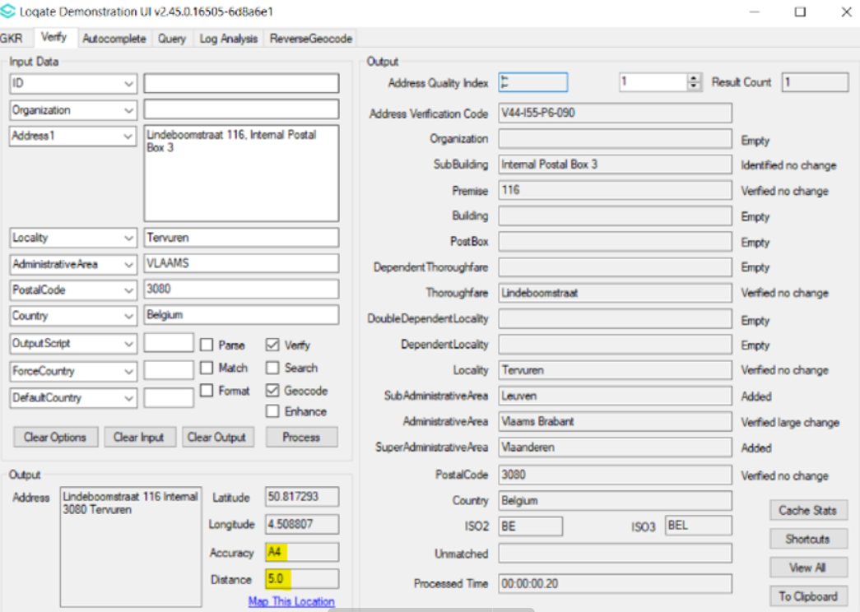 |  |  | 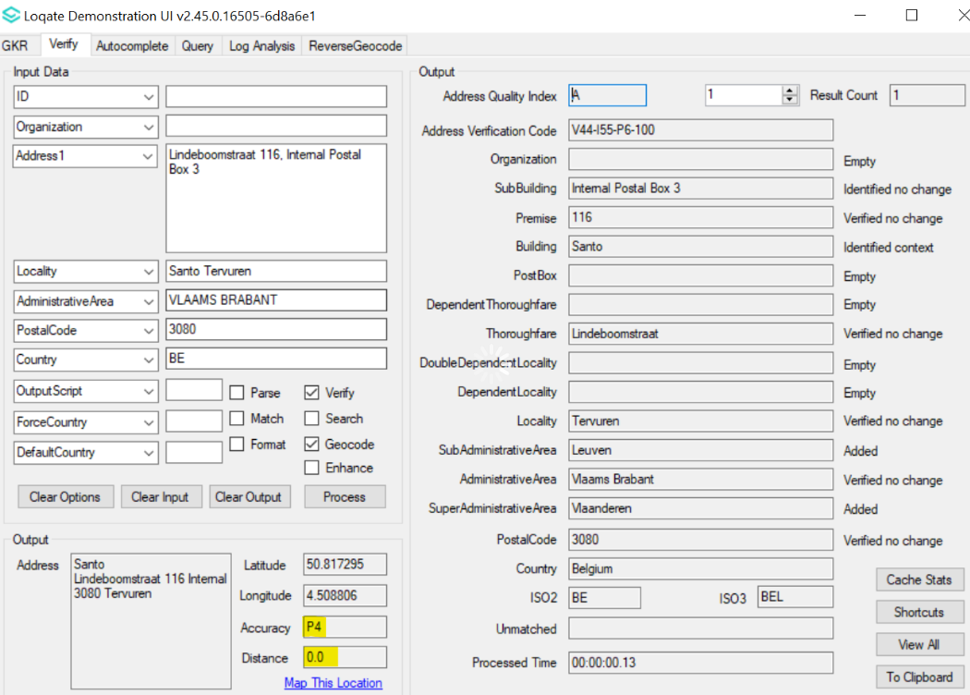

Case Number | Change Description | Category | Country | Example Address
CAS-89251-J3M8W9 | Improvement of address verification | Data | US | Address1: N49W17791 Christopher Ct  Locality: Menomonee Falls  AdministrativeArea: WI  PostalCode: 53051-6504  Country : USA
Before Image |  |  | After Image
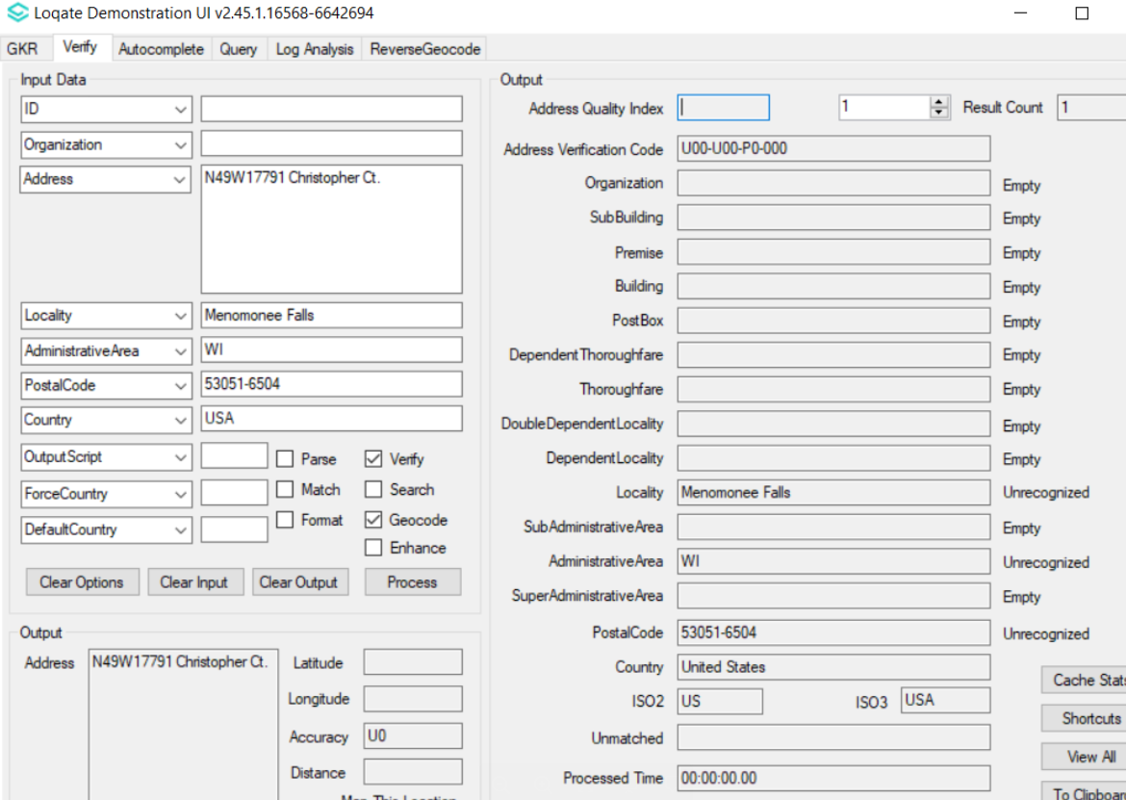 |  |  | 