Loqate, A GBG Solution
Release Notes – Verify API

2023Q1.0 Major Release

Case Resolutions
Please visit https://support.loqate.com/2023q1-0-resolved-cases/ for a list of all cases resolved in this release. If you would like more details on any of the solved cases listed, please contact LoqateSupport@gbgplc.com for further information.

Local API Notices
This is to inform our customers that in 2023Q1.0 release we have made one change to the API in relation to use of hyphens in premises that has resolved 2 customer cases.

Case Number | Change Description | Country
CAS-83302-Q5W0N5 | All numbers in hyphened range would be used for address matching. Prioritize records with prefix and postfix matched if the matched records exceed the engine's predefined limit. | All
CAS-03293-X6M4B0 | All numbers in hyphened range would be used for address matching. Prioritize records with prefix and postfix matched if the matched records exceed the engine's predefined limit. | All

Local API Improvements
Case Number | Change Description | Category | Country | Example Address
CAS-83302-Q5W0N5 | All numbers in hyphened range would be used for address matching. | API | All | 4-831 Kuhio Hwy Ste 438 #204 Kapaa HI, USA  5-1105 Kuhio Hwy #B&C Kilauea HI, USA
Before Image |  |  | After Image
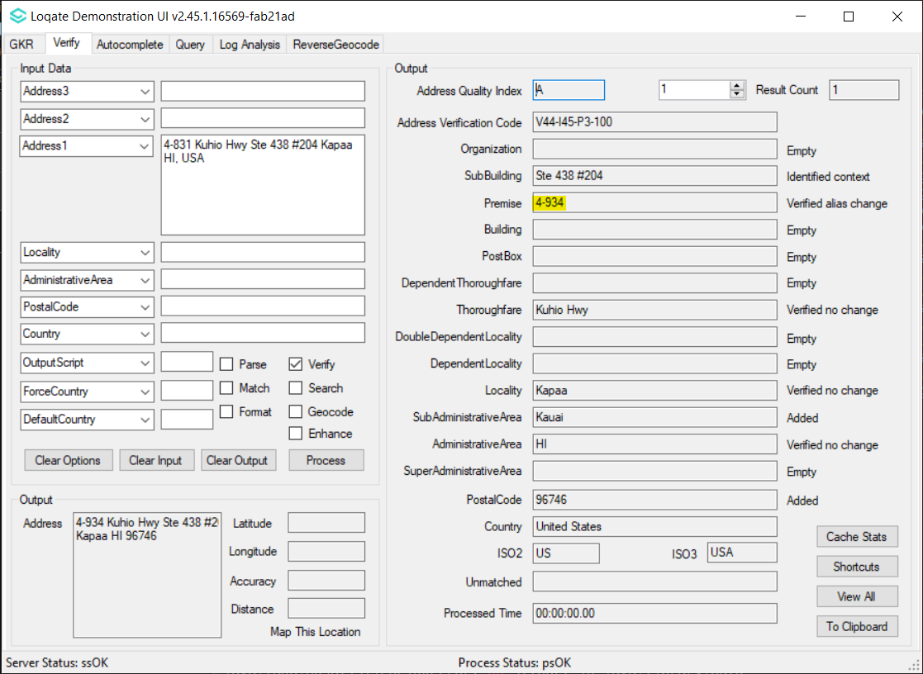 |  |  | 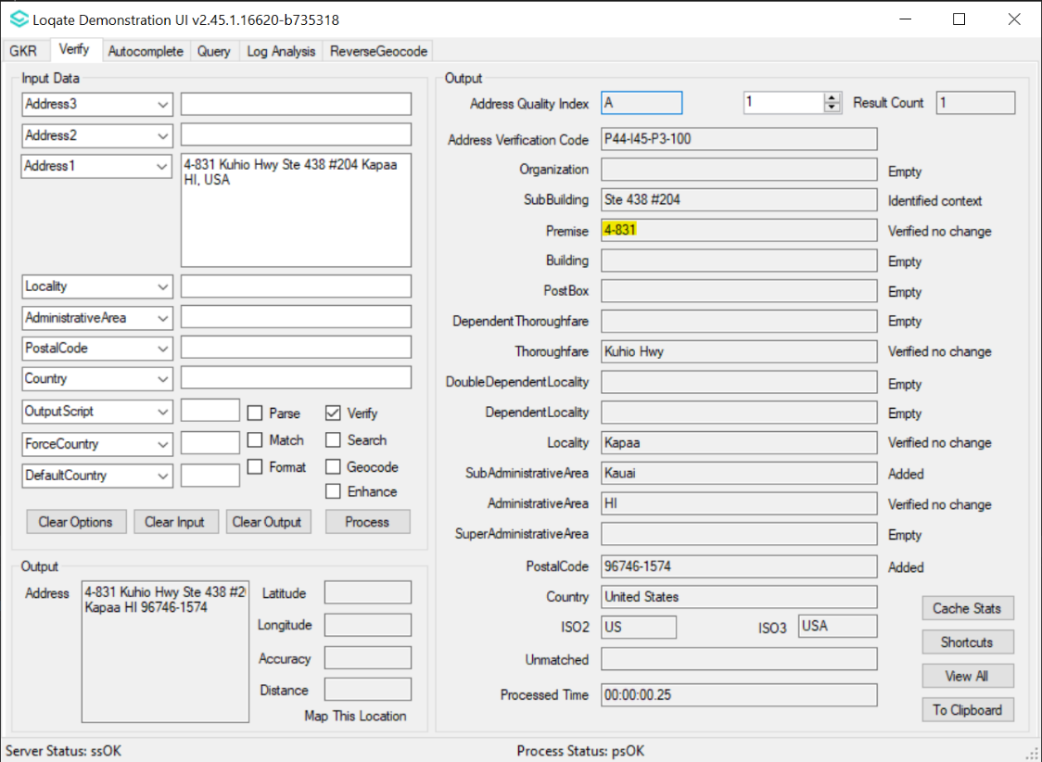
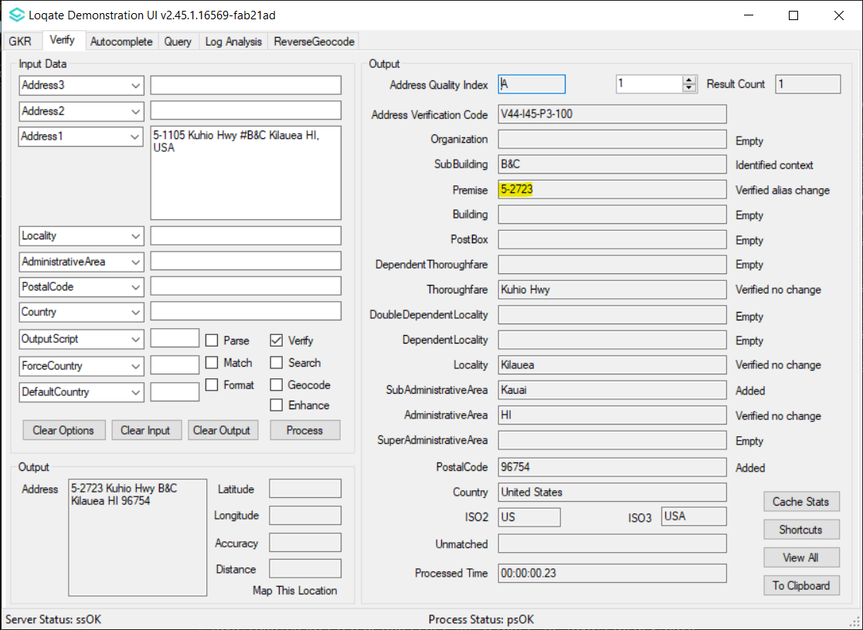 |  |  | 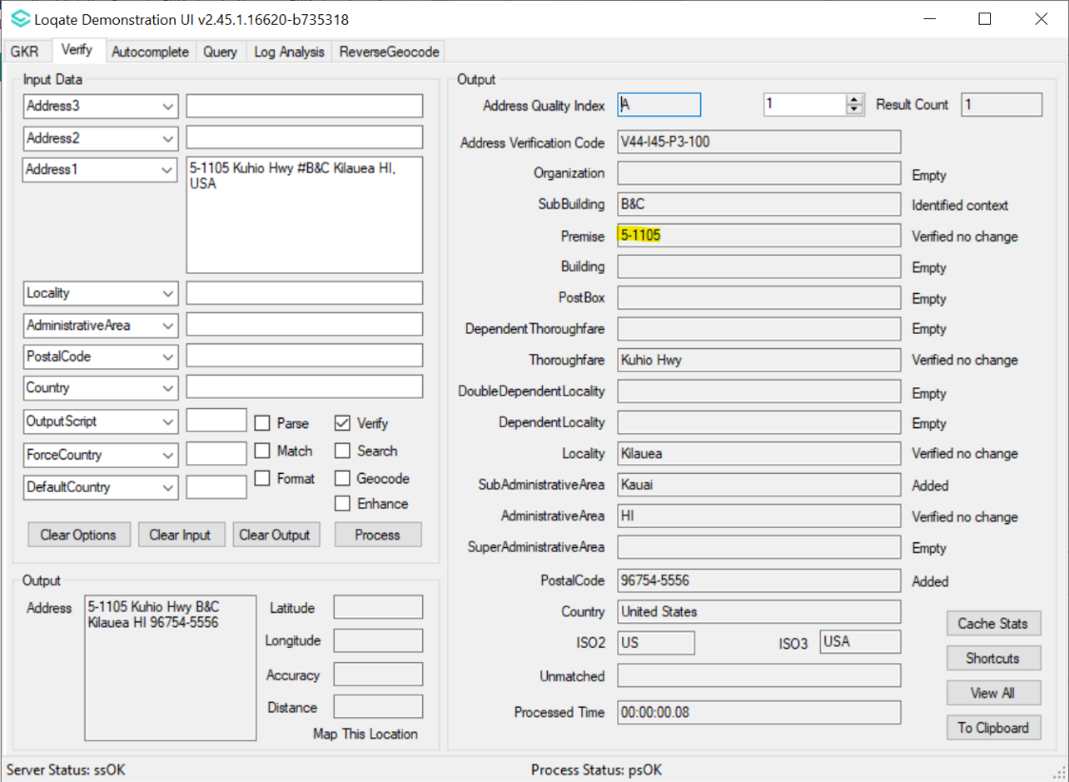

Case Number | Change Description | Category | Country | Example Address
CAS-03293-X6M4B0 | All numbers in hyphened range would be used for address matching. | API | All | 75-5687 ALII DR, 96740, USA
Before Image |  |  | After Image
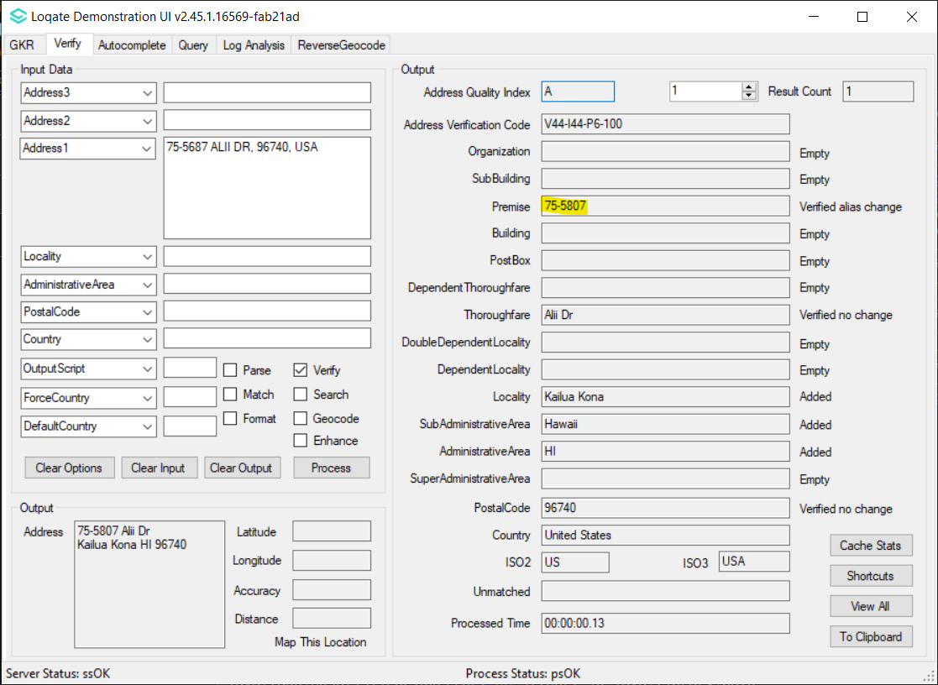 |  |  | 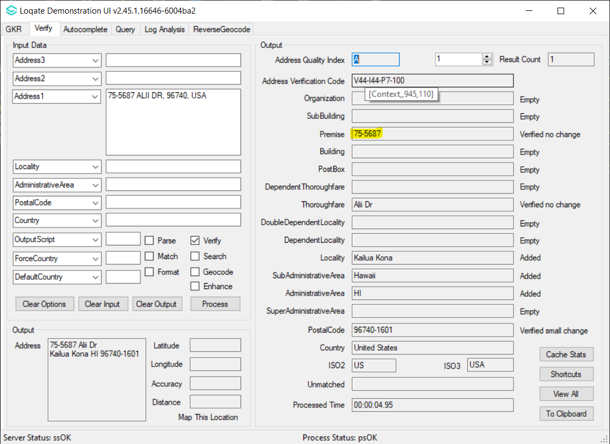

Installation Instructions
Please remember to update both the program files and the reference data and please install these to a new fresh folder location. The improvements are tied to the data in the Global Knowledge Repository and the Local API. When updating the data, it is recommended to use a new data folder each time to ensure the latest dataset is installed properly.

If you need any assistance with the upgrade of the Local API or the data update process, please contact GBG Loqate Support.

The setup wizard for the Local API can be obtained from our SFTP server. Please contact your account manager to retrieve the SFTP information. If you do not know who your account manager is, please contact the support team at LoqateSupport@gbgplc.com.

