Loqate | A GBG Solution
Release Notes – Geographic Hierarchy (Seed) Data
2023Q1.0 Major Release

Overview
The following document identifies all improvements and changes made to the Seed data files for the Loqate 2023Q1.0 Major Release

Case Resolutions
The below section includes a summary of resolved cases in this release.
External issue ID | Country | Description
CAS-87005-T3L1C0 | US | Fix incorrect alias name for New York locality.  Wall Street is no longer an alias name for New York locality.
CAS-89808-L1L6N7 | BR | Fix the missing 8908* postcode in Indaial Locality.  8908* postcode are now returned in the dependentlocality of Indaial Locality.  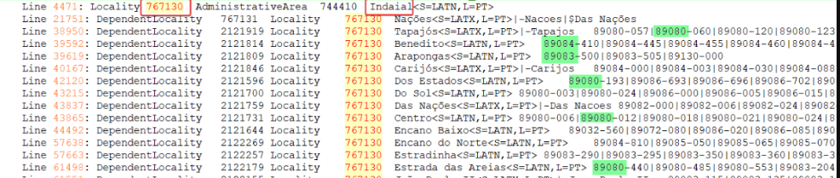

File Changes
The table below indicates the count of changed rows between the previous
and current release. There are no or nominal changes for all other country files.
Country | Count | Description
AT | 800 | Country Refresh | PostalCode and entries added
AU | 2 | Country Refresh | Slight re-ordering of invalid aliases
BE | 60 | Country Refresh | PostalCode and entries added
BR | 87850 | Country Refresh | Case Resolution(s) | PostalCode and entries added | PostalCode clean up
CA | 151 | Country Refresh | PostalCode and entries added
CH | 2968 | Country Refresh | PostalCode and entries added
CZ | 252 | Country Refresh | PostalCode and entries added
DE | 9 | Country Refresh | PostalCode added
DK | 2 | Country Refresh | Entries added
ES | 6329 | Country Refresh | PostalCode and entries added
FR | 4186 | Country Refresh | PostalCode and entries added
GB | 623 | Country Refresh | PostalCode and entries added
IL | 42 | Country Refresh | PostalCode added
IM | 1 | Country Refresh | PostalCode added
KR | 856 | Country Refresh | PostalCode and entries added
NL | 3286 | Country Refresh | PostalCode and entries added
RO | 306 | Country Refresh | PostalCode and entries added
US | 32 | Country Refresh | Case Resolution(s) | Entries added

Geographic Structure Changes
The following table describe changes to the country structures document.
Dataset | Description
 | No changes in Geo-Structure document.

