Loqate, A GBG Solution

Release Notes – Reference Data & Knowledge Base

2022Q4.1 Minor Release

Case Resolutions
Please visit https://support.loqate.com/2022q4-1-resolved-cases/ for a list of cases resolved in this release.
If you would like more details on any of the solved cases listed, please contact LoqateSupport@gbgplc.com for further information.

Certification Expiration Dates
If you have purchased a certification product, please be aware that the datasets have expiration dates set by the respective postal authorities. Please ensure that you have the latest library and data installed to avoid loss of service through these products.

Please check Install Manager for the latest versions of our certification data

 | Loqate Release Date | Certification Expiry Date*
AMAS Data | 2022-11-28 | 2023-03-31
CASS Data | 2022-11-15 | 2023-02-28
CASS (2) Data | 2022-10-28 | 2023-01-31
SERP | 2022-11-15 | No Expiry

For more information on expiry date checking for CASS and AMAS, please refer “Usage expiration” section in https://support.loqate.com/documentation/local-apis/cass-overview-2/ and https://support.loqate.com/address-matching-approval-system-amas/

Data Structure Changes

The below is a summary of the Countries where we have updated the reference data / structure.

Country Rebuild / Refresh
Country | Description
Belgium | Improvement in address verification
Norway | Improvement in Premise parsing and verification.  Added a new field ‘Bolignummer’ (residential number) and changed address format to include the new field.
Portugal | Improvement in address verification
Slovenia | Improvement in address parsing and verification
Spain | Improvement in address parsing and verification

Country Refresh Highlights
Belgium
Improvement in address verification.

2022Q4.0 | 2022Q4.1
Premise and Thoroughfare were not verified.  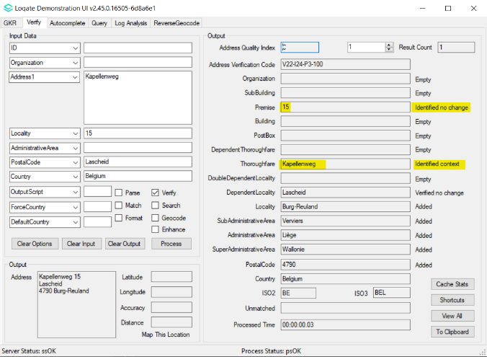 | Premise and Thoroughfare are now verified.  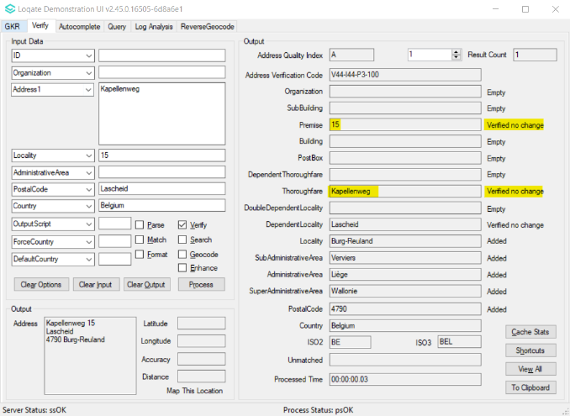

Norway
- Improvements in Premise parsing and verification.
- Added a new field ‘Bolignummer’ (residential number) and changed address format to include the new field.
2022Q4.0 | 2022Q4.1
Premise suffix was incorrectly parsed to SubBuilding and Premise was incorrectly verified.  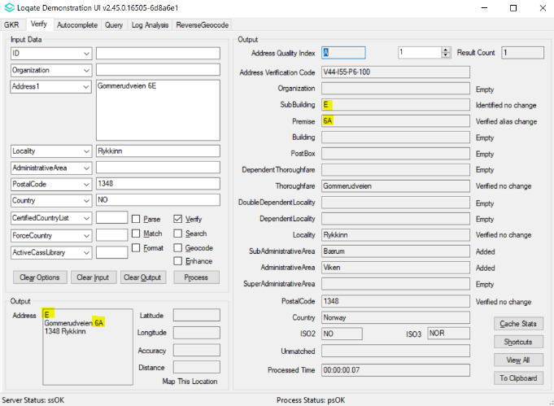 | Premise with suffix is now correctly parsed and verified.  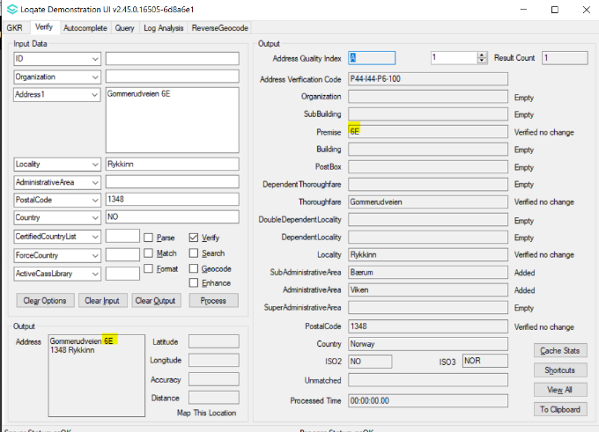

Bolignummer, Premise, and SubBuilding were incorrectly parsed and displayed in Address field.  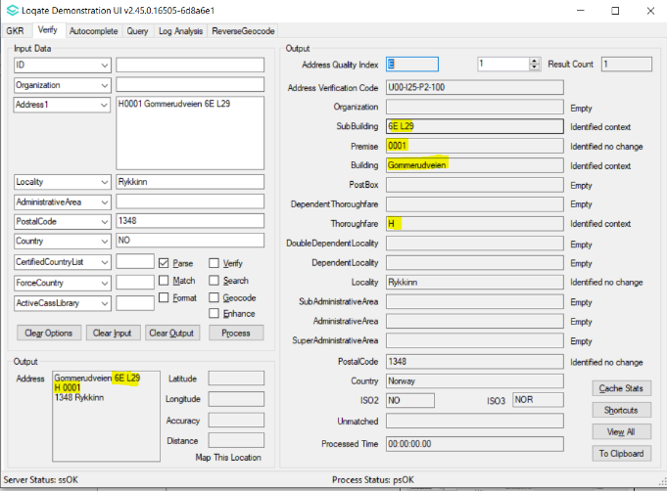  Bolignummer field not added thus incorrectly parsed to other field(s). 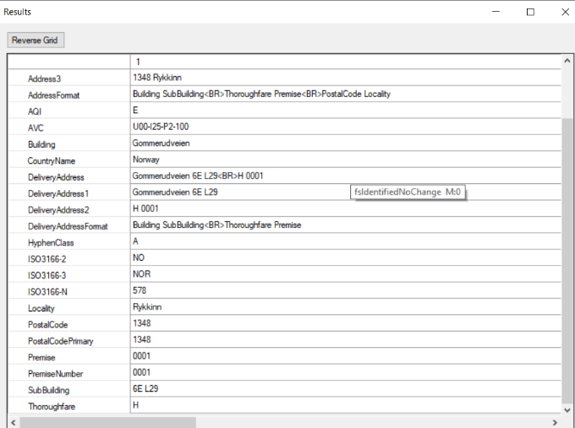 | Bolignummer, Premise, and SubBuilding now correctly parsed and displayed in Address field.  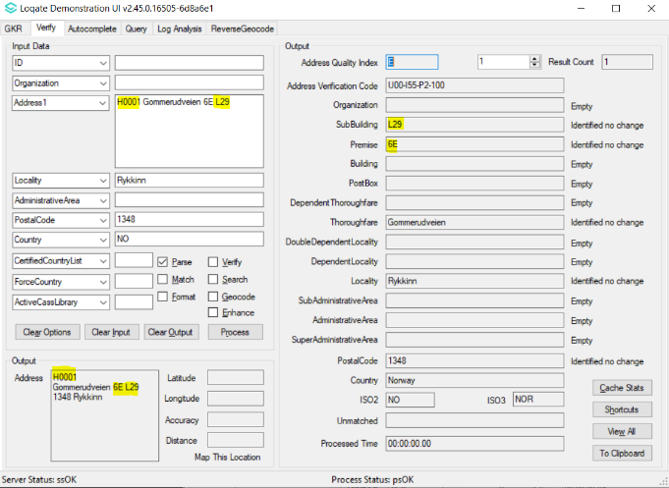  Bolignummer field now added thus parsed correctly.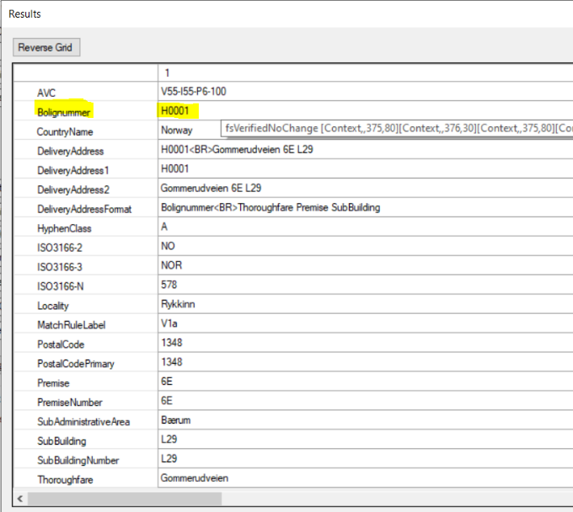

Portugal
Improvement in address verification.

2022Q4.0 | 2022Q4.1
Premise and Thoroughfare were not verified.  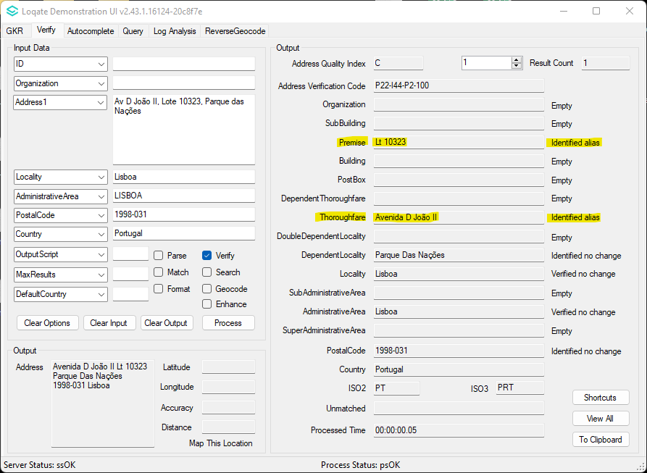 | Premise and Thoroughfare are now verified.  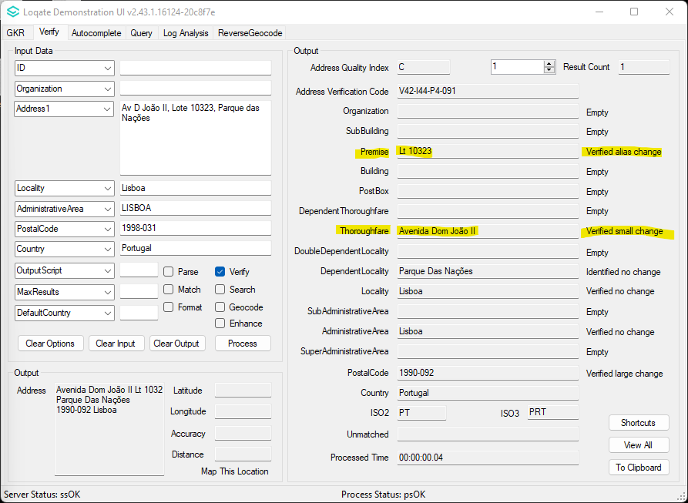

Slovenia
Improvement in address parsing and verification.

2022Q4.0 | 2022Q4.1
Organization, Premise and Thoroughfare were not parsed into their respective fields.  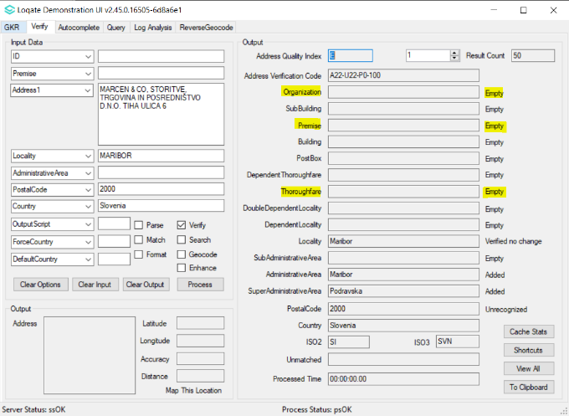 | Organization, Premise and Thoroughfare are now parsed into their respective fields. Premise and Thoroughfare are now verified.  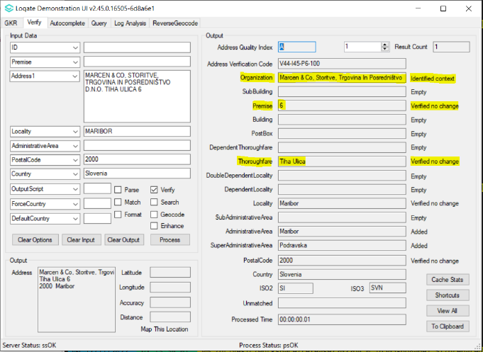

Spain
Improvement in address parsing and verification.

2022Q4.0 | 2022Q4.1
Premise was not verified.  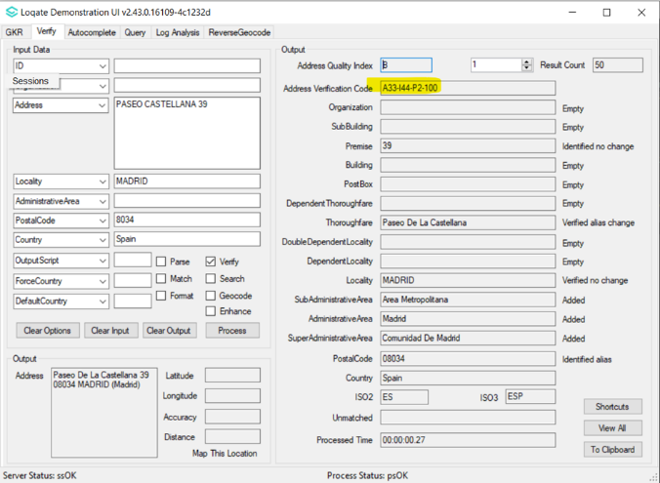 | Premise now verified.  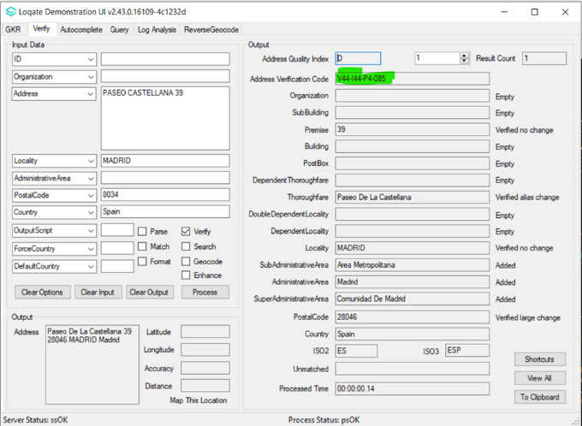

Thoroughfare was incorrectly verified.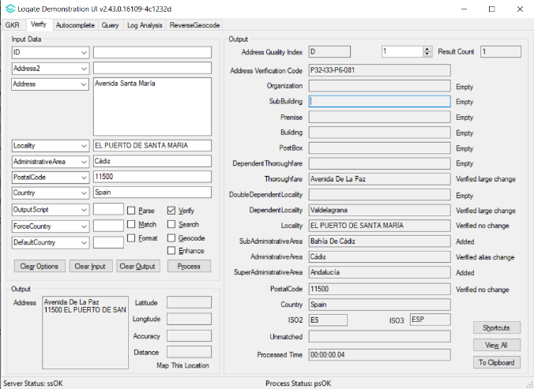 | Thoroughfare is now correctly verified.  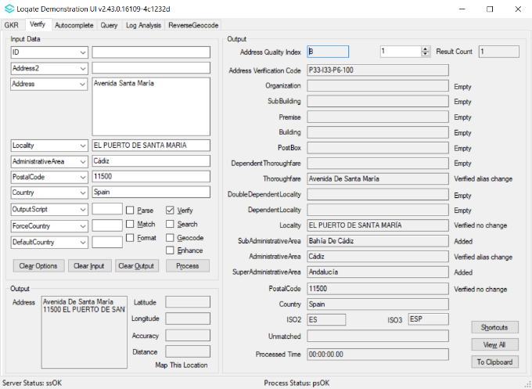

Case Resolutions

2022Q4.1 Data related Case Fixes
Case Number | Change Description | Category | Country | Example Address
CAS-84097-P2B5D4 | AdministrativeArea code is now parsed into the correct field. | Data | KR | Address 1: 탑동로 26 (삼도이동)  Locality: 제주시  AdministrativeArea: KR-49  PostalCode: 63166  Country: KR
Before Image |  |  | After Image
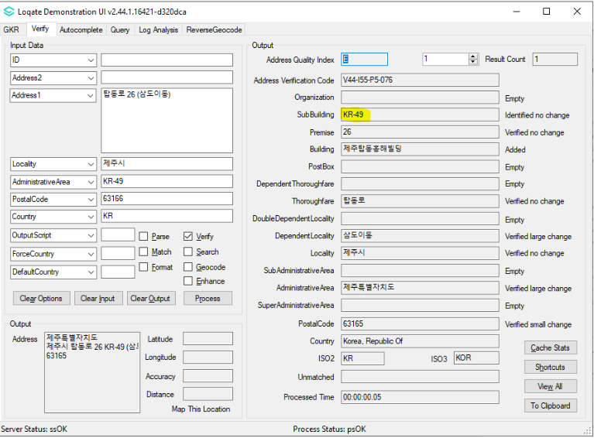 |  |  | 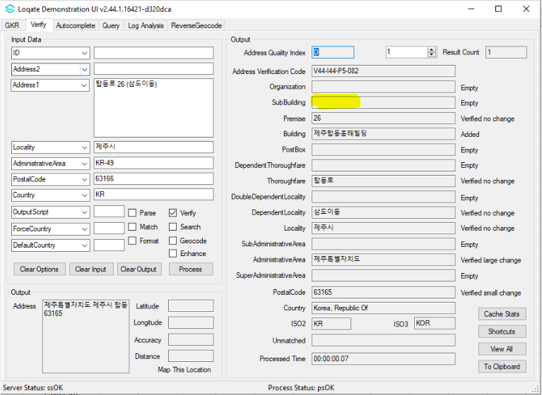

Case Number | Change Description | Category | Country | Example Address
CAS-85207-P5Y6Q0 | Improvement of thoroughfare parsing | Data | KR | Address1: 1100로 3213-27 (노형동)  Locality: 제주시  AdministrativeArea: KR-49  PostalCode: 63092  Country: KR
Before Image |  |  | After Image
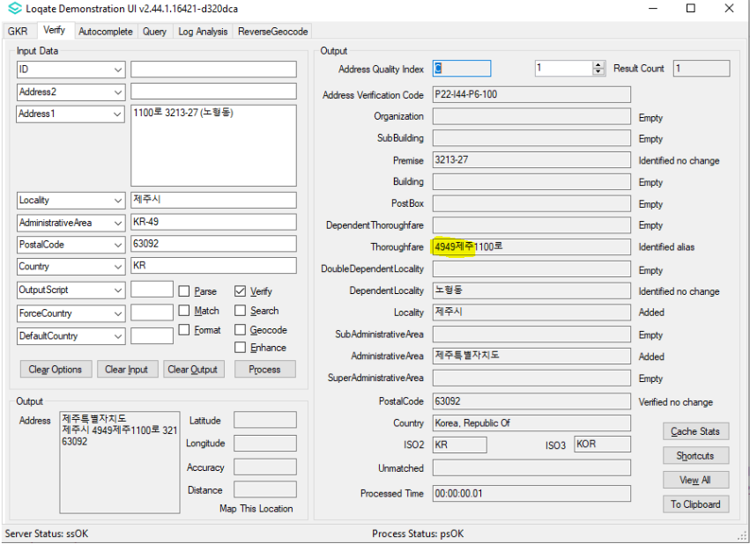 |  |  | 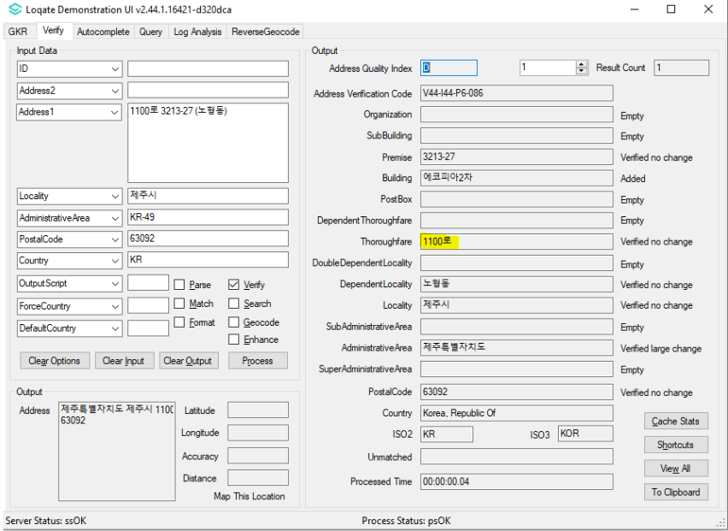

Case Number | Change Description | Category | Country | Example Address
CAS-79875-S5Z5L3 | Improvement of geocode accuracy | Data | US | Address1: 6490 MOUNT MORIAH ROAD EXT, MEMPHIS, Tennessee, 38115 Country: US
Before Image |  |  | After Image
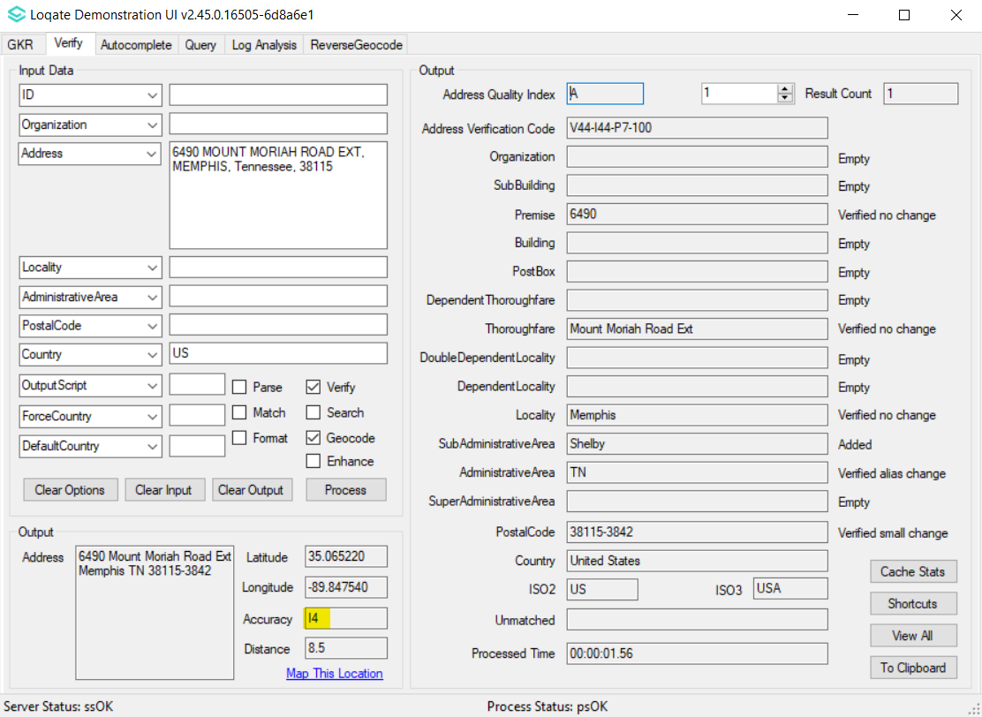 |  |  | 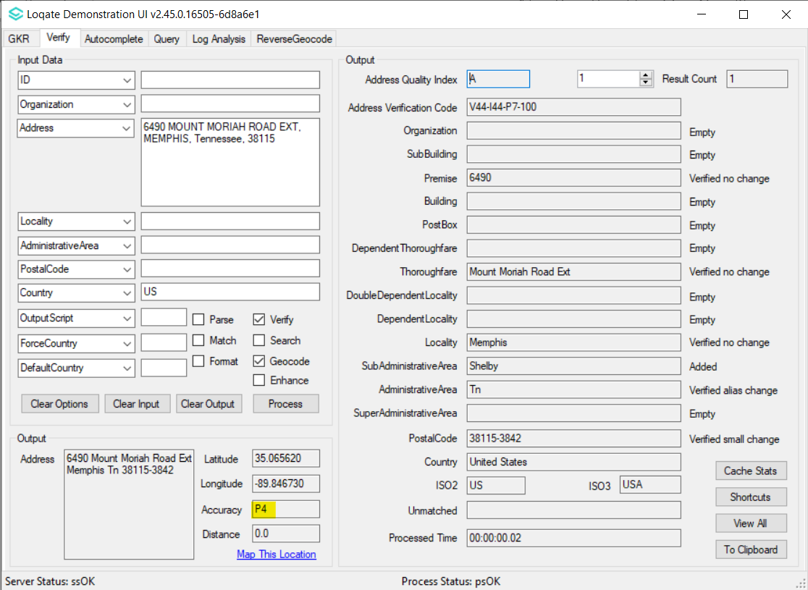

Case Number | Change Description | Category | Country | Example Address
CAS-84795-X8R2W3 | Improvement in address parsing and correction of output address format | Data | NO | 1st address: Address1: Gommerudveien 6E,  Locality: Rykkinn,  PostalCode: 1348  Country: NO  2nd address: Address1: Dyre Halses gate 14 L29,  Locality: Trondheim,  PostalCode: 7042  Country: NO  3rd address: Address1: Ã†rfuglveien 45 2b,  Locality: Kristiansand S,  PostalCode: 4623  Country: NO
Before Image |  |  | After Image
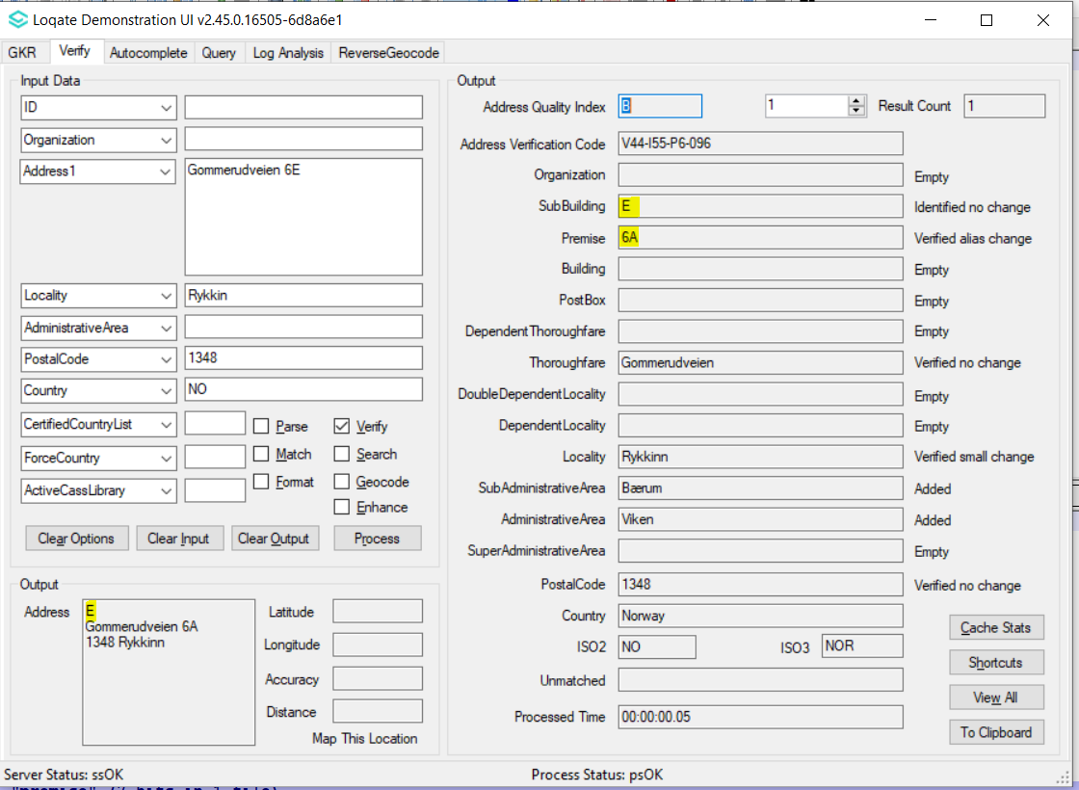 |  |  | 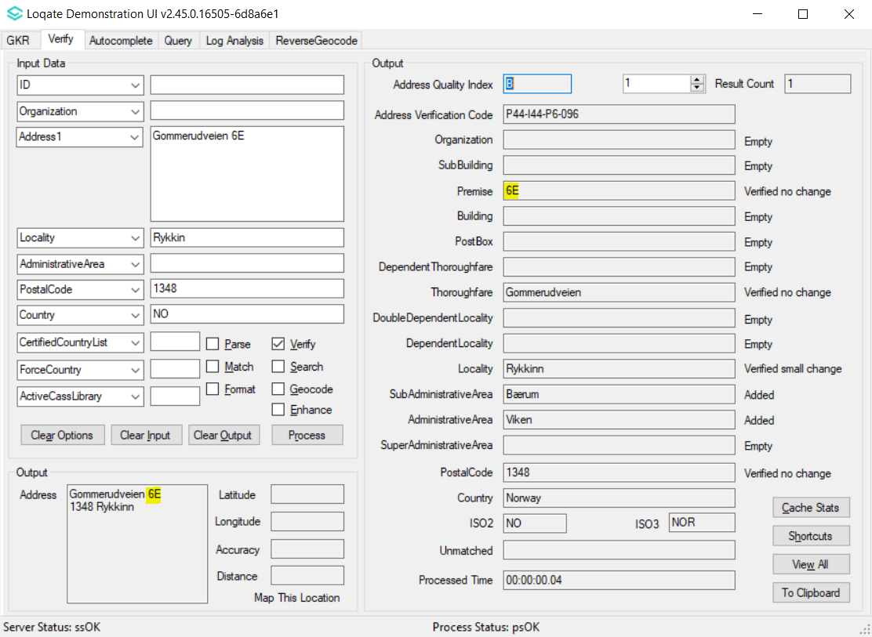
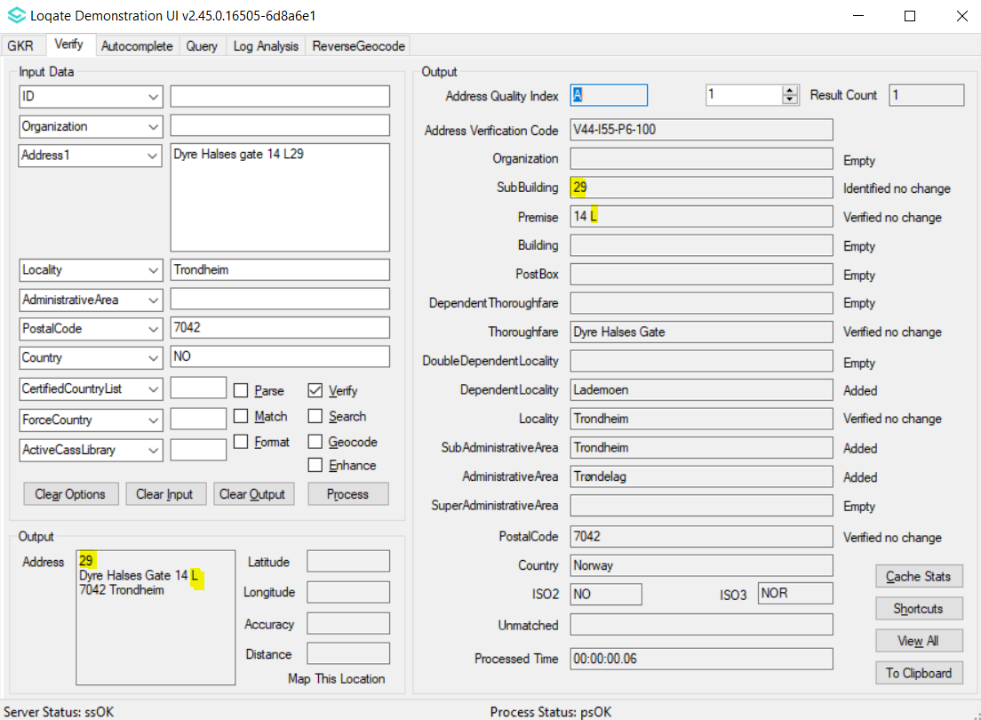 |  |  | 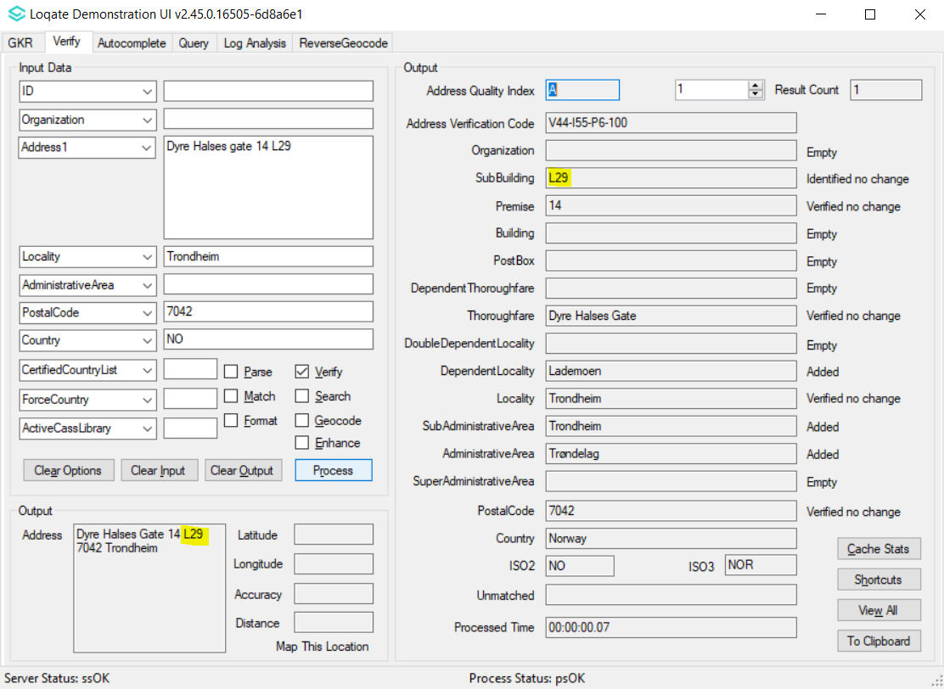
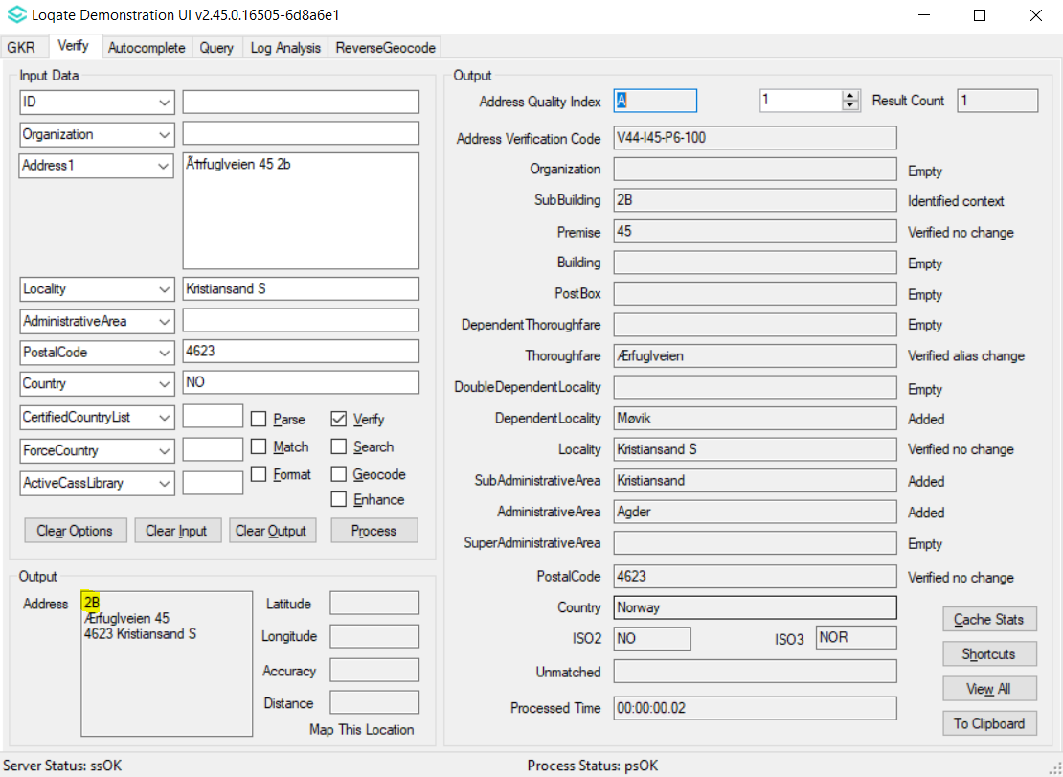 |  |  | 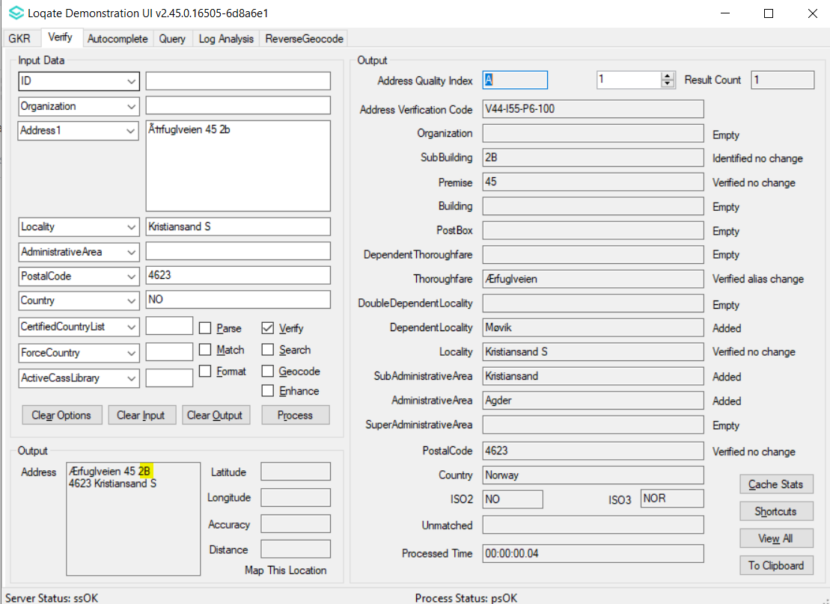

Case Number | Change Description | Category | Country | Example Address
CAS-78188-V4B1T9 | Addition of AdministrativeAreaISO2 code "BE-BRU" for Brussels | Data | BE | Address1: Rue Paul Gauguin 24  Address2: 1140  Locality: Evere  AdministrativeArea: Région De Bruxelles-Capitale  Country: Belgium
Before Image |  |  | After Image
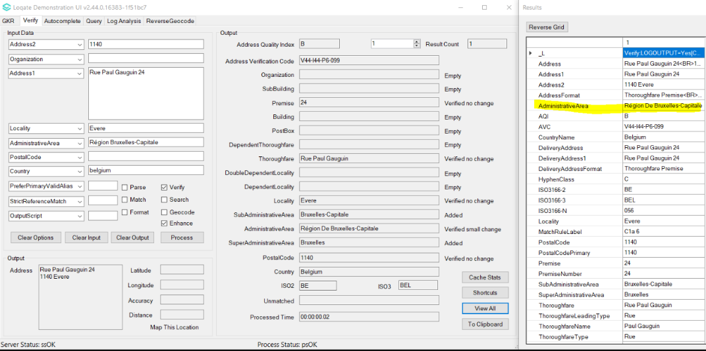 |  |  | 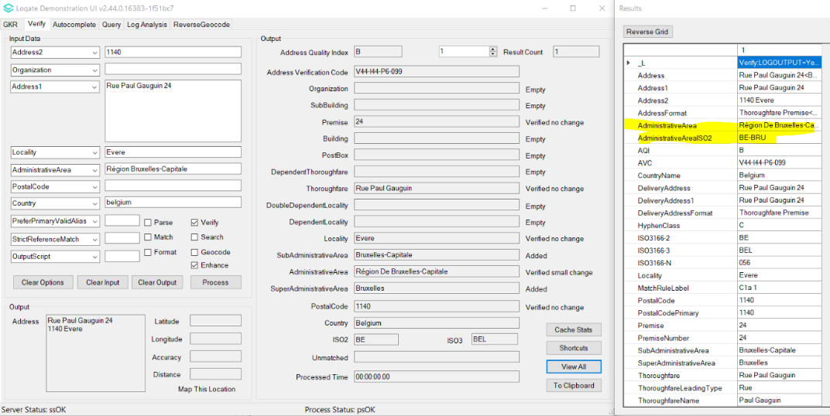

Case Number | Change Description | Category | Country | Example Address
CAS-79725-W3B4G8 | Output capitalised AdministrativeArea when OutputScript=Latn | Data | MX | Address1: Av Costera Miguel Alemán 3128, Acapulco 39850  Country: MX
Before Image |  |  | After Image
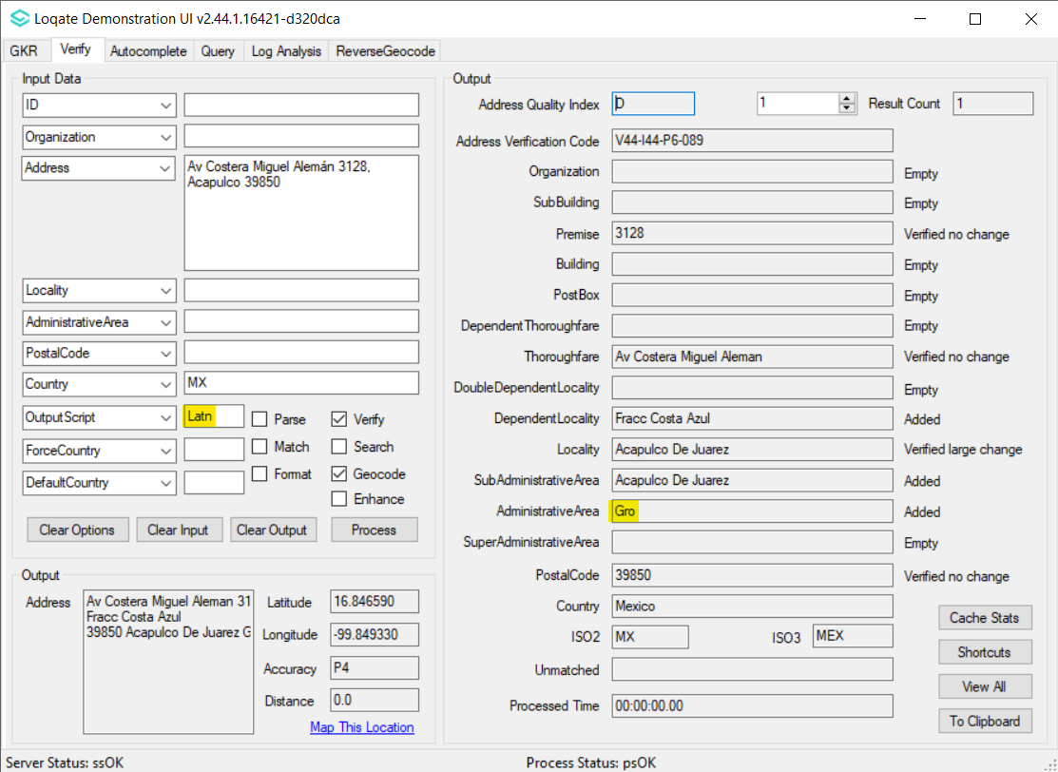 |  |  | 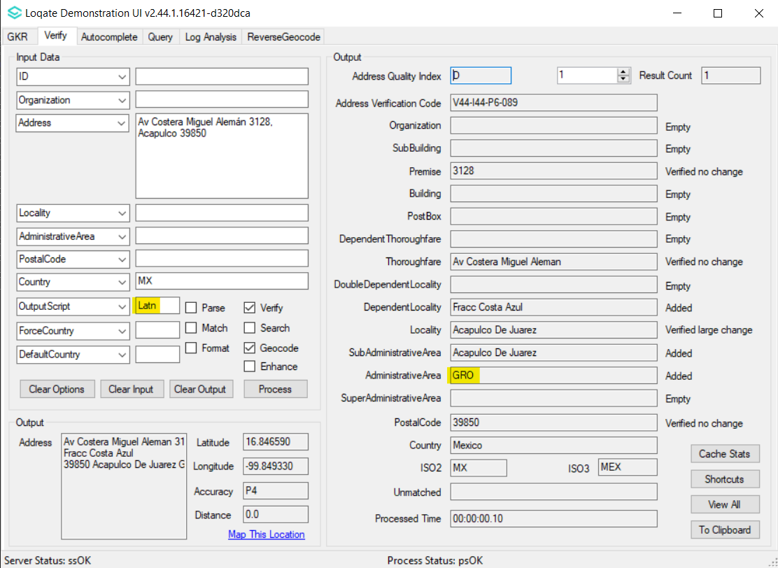

Case Number | Change Description | Category | Country | Example Address
CAS-81836-G2C3J1 | Improvement of Thoroughfare parsing | Data | CA | 1st Address Address1: 9832 Rue Saint-Hubert  Locality: MONTREAL  AdministrativeArea: QC  PostalCode: H2C 2H3  Country: CA  2nd Address Address1: 1-1545 Rue Saint-Dominique  Locality: MONTREAL  AdministrativeArea: QC  PostalCode: H2X 2W7  Country: CA
Before Image |  |  | After Image
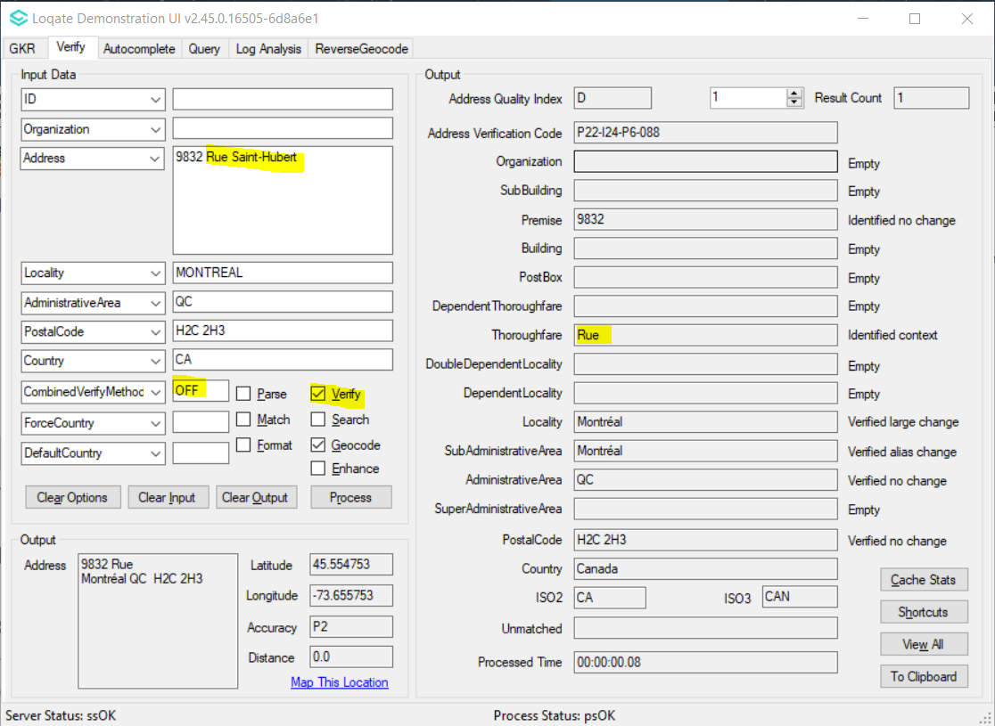 |  |  | 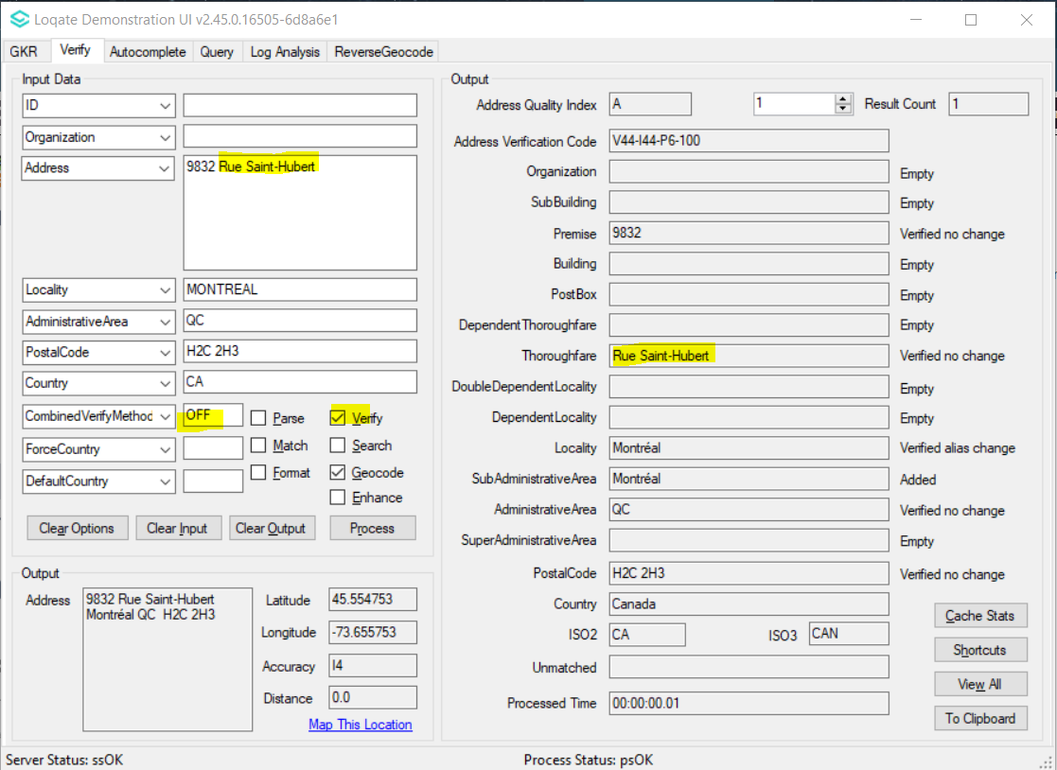
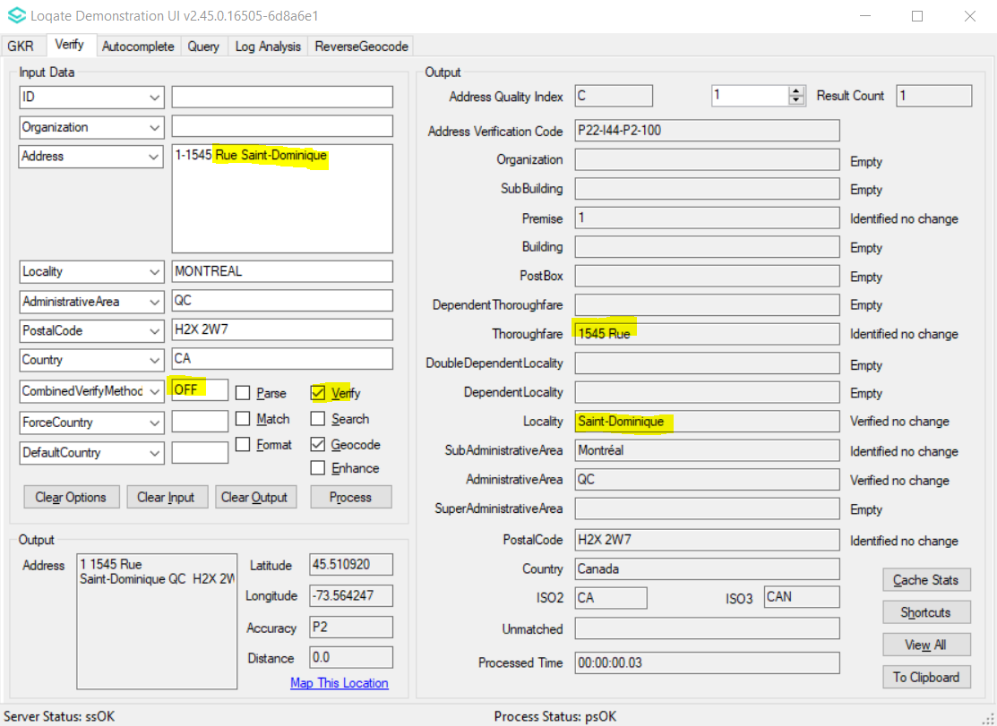 |  |  | 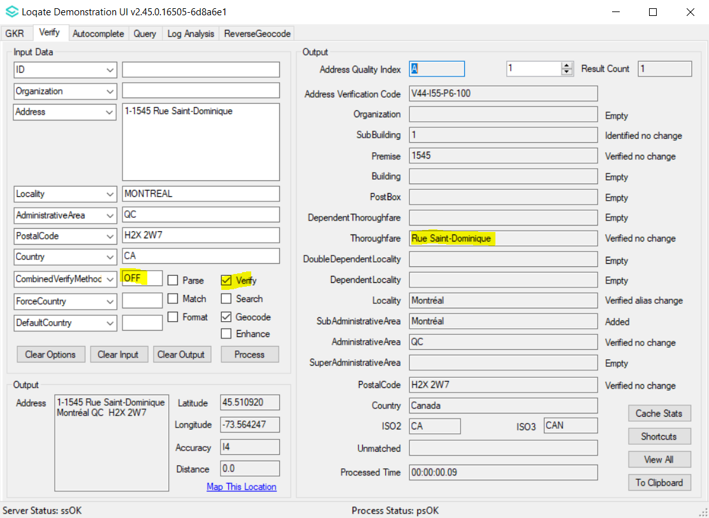

Case Number | Change Description | Category | Country | Example Address
CAS-73501-G6Y6R2 | Improvement of Thoroughfare parsing | Data | DE | Address1: Hinter dem Schloß 13, 55234 Bechtolsheim  Country: DE
Before Image |  |  | After Image
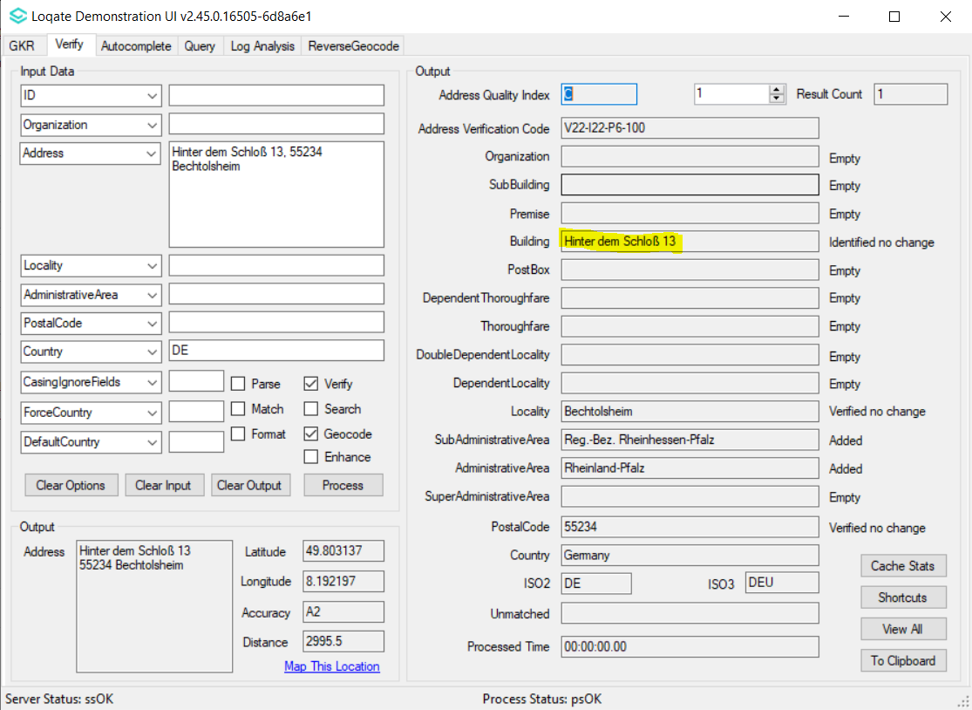 |  |  | 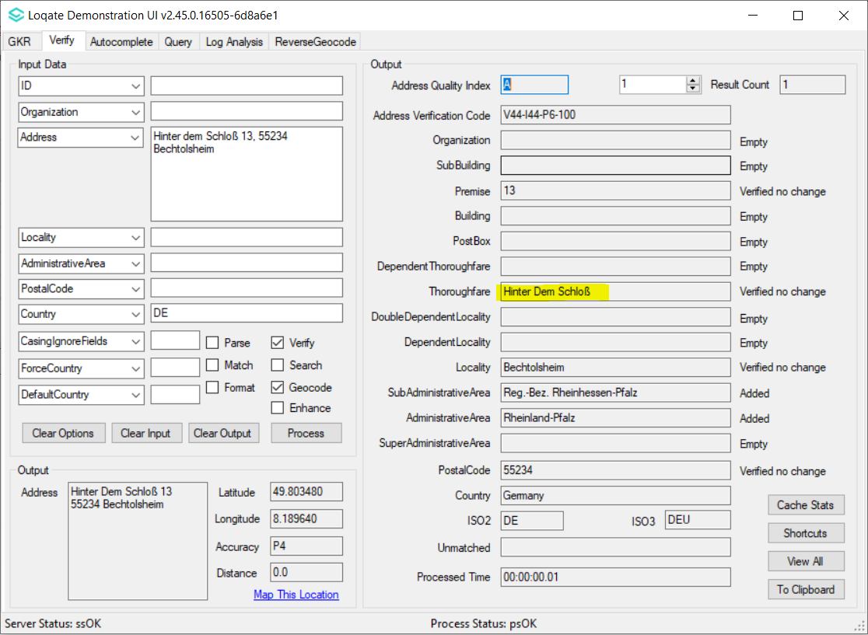

Case Number | Change Description | Category | Country | Example Address
CAS-73746-S6R3J3 | Improvement of Thoroughfare parsing | Data | ES | 1st Address Address1: Avenida Santa Maria  Locality: El Puerto De Santa Maria  AdministrativeArea: Cadiz  PostalCode: 11500  Country: ES  2nd Address Address1: Avenida Santa Maria De La Cabeza  Locality: El Puerto De Santa Maria  AdministrativeArea: Cadiz  PostalCode: 11500  Country: ES
Before Image |  |  | After Image
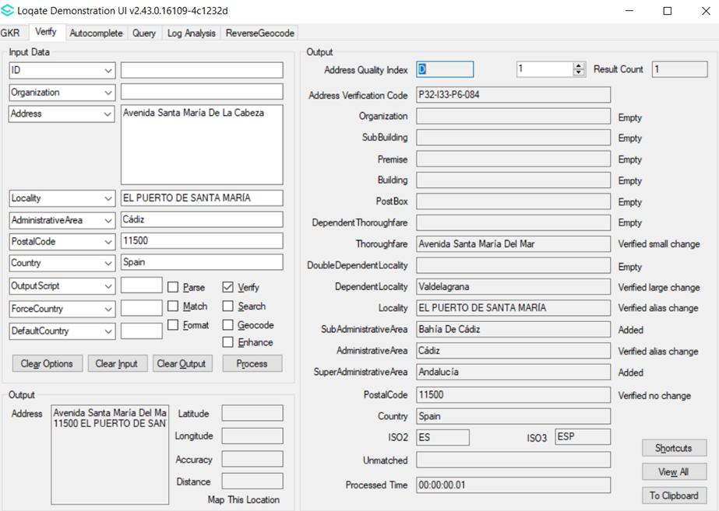 |  |  | 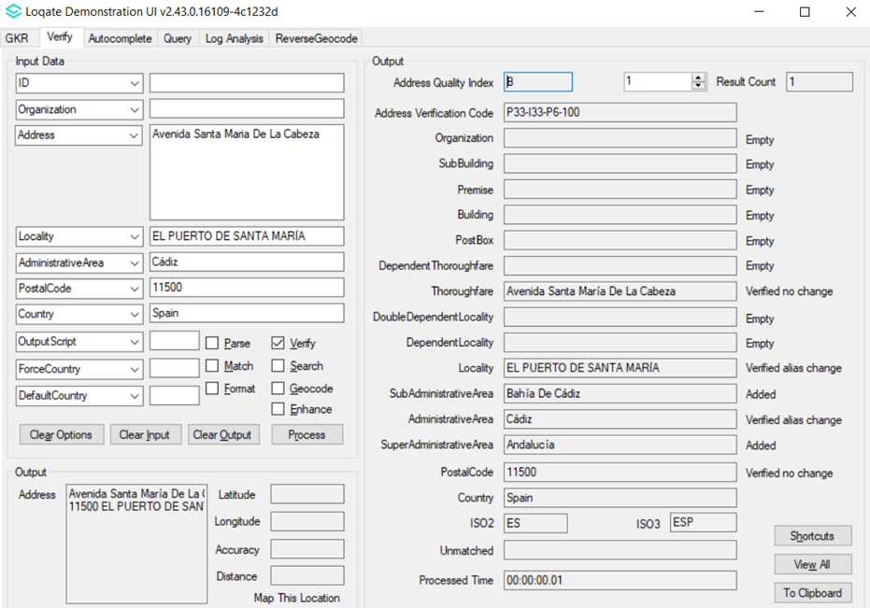
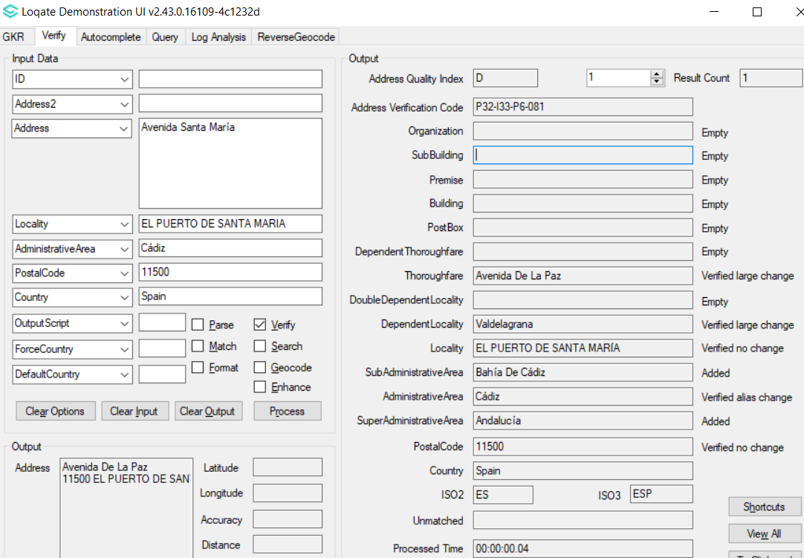 |  |  | 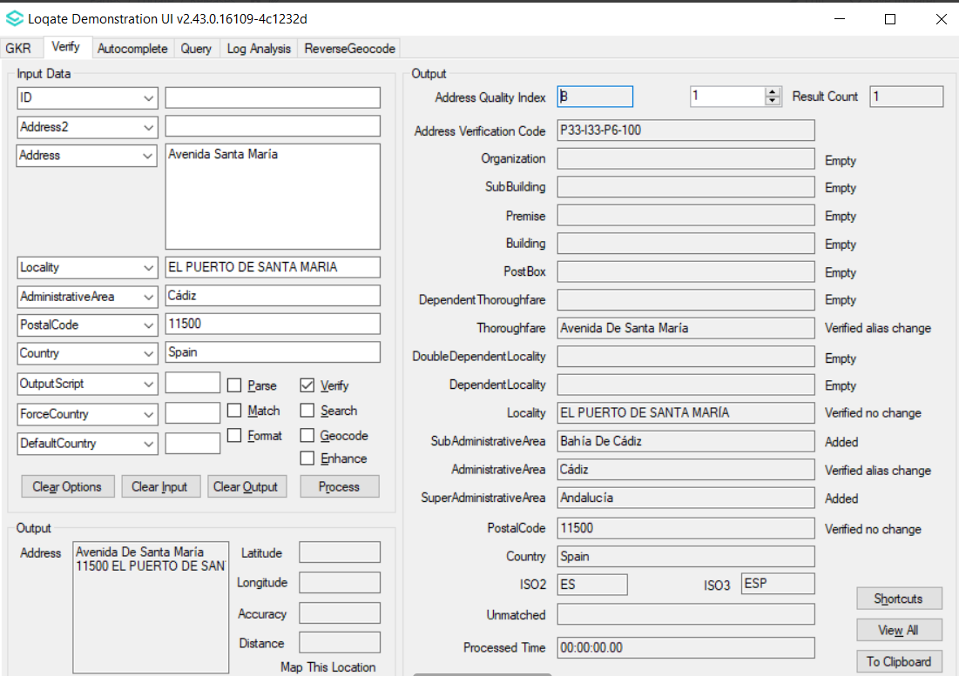

Case Number | Change Description | Category | Country | Example Address
CAS-74312-H9G3S3 | Correction of the PostalCode being verified | Data | HU | Address1: Szépvölgyi Út 6 /1025 Budapest  Country: Hungary
Before Image |  |  | After Image
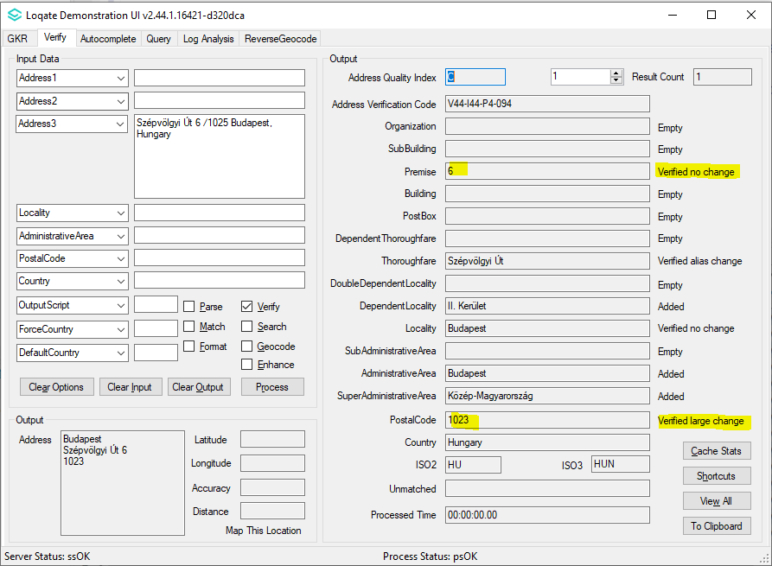 |  |  | 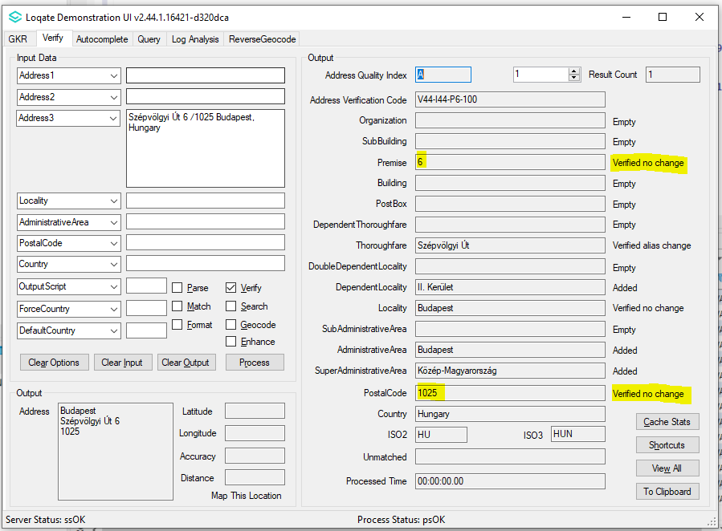

Case Number | Change Description | Category | Country | Example Address
CAS-84099-C4D0D4 | Correction of Locality added based on input PostalCode. | Data | GR | Address1: Solomou Dionysiou 34, 152 33  Country: GR
Before Image |  |  | After Image
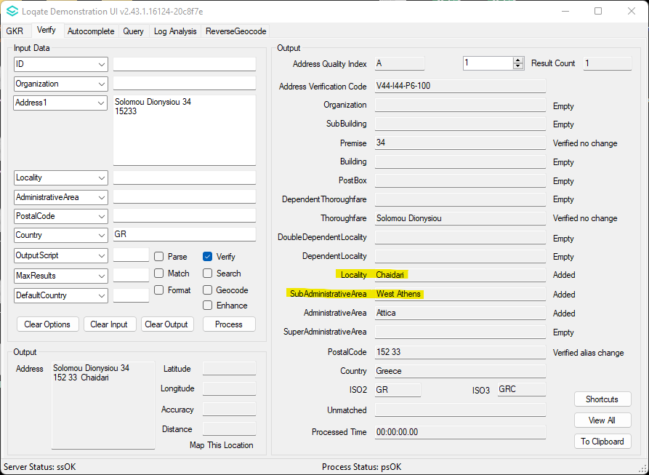 |  |  | 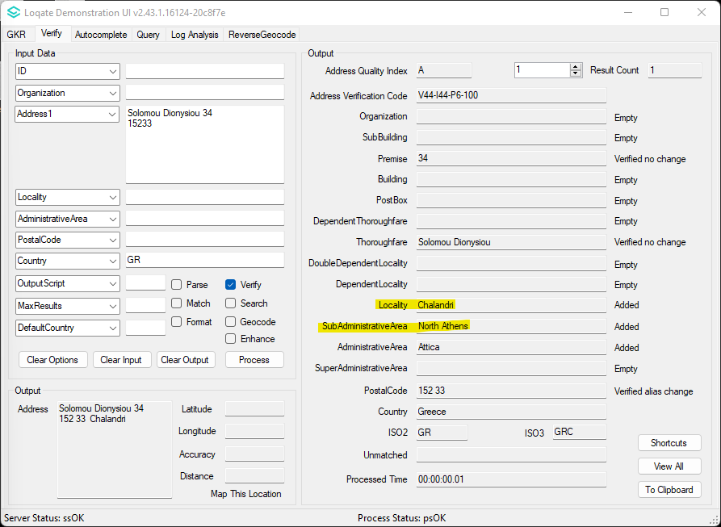

Case Number | Change Description | Category | Country | Example Address
CAS-83793-G8N6S3 | Improvement of Thoroughfare and Premise verification | Data | US | Address1: 111 Abersham Dr  Locality: Mooresville  AdministrativeArea: NC  PostalCode: 28115-0169  Country: US
Before Image |  |  | After Image
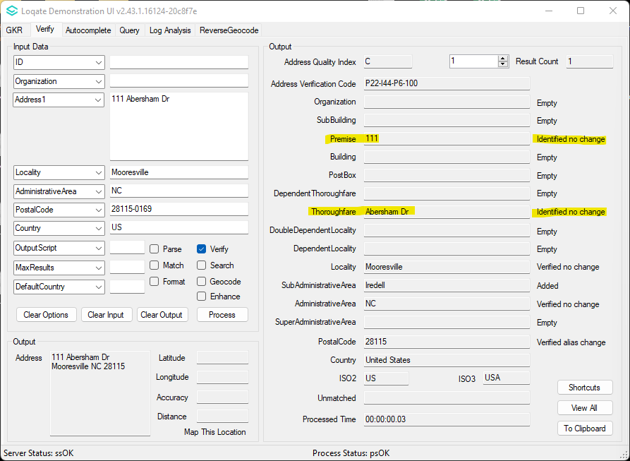 |  |  | 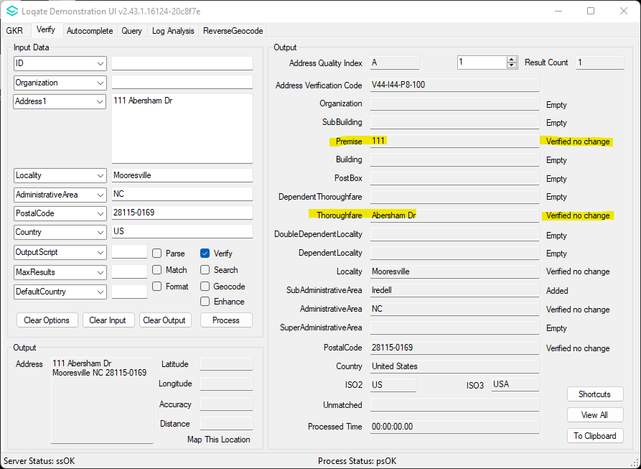

Case Number | Change Description | Category | Country | Example Address
CAS-88005-M8K9W6 | Improvement of Thoroughfare and Premise verification | Data | US | Address1: 1615 Vista Del Lago, Fallbrook, CA 92028-1752  Country: US
Before Image |  |  | After Image
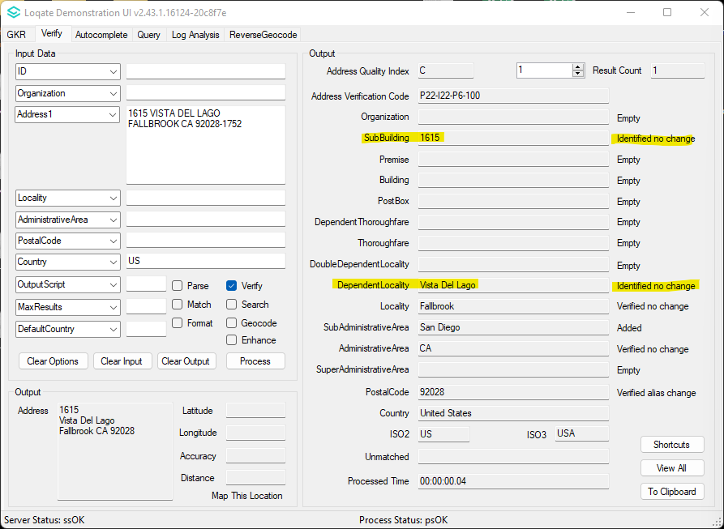 |  |  | 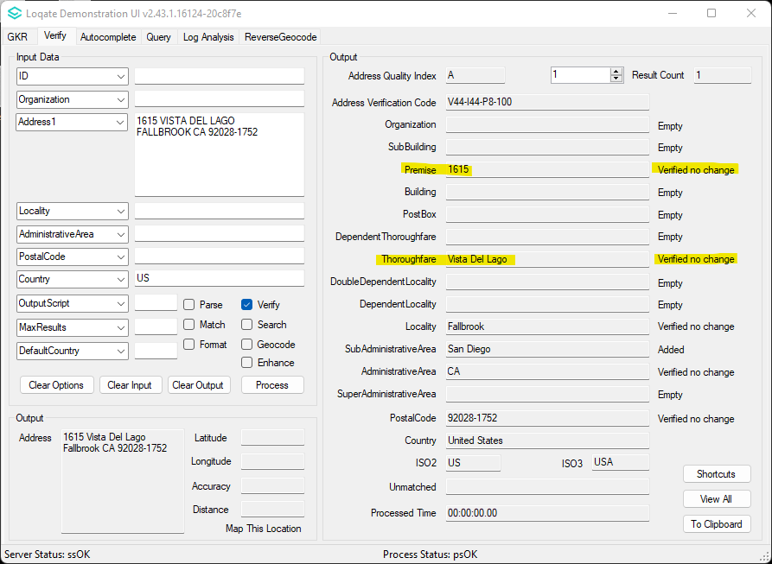

Case Number | Change Description | Category | Country | Example Address
CAS-60646-C3G4L9 | Correction of the PostalCode being verified | Data | SK | Address1: Ružová dolina 8  Locality: Bratislava  PostalCode: 821 09  Country: Slovakia
Before Image |  |  | After Image
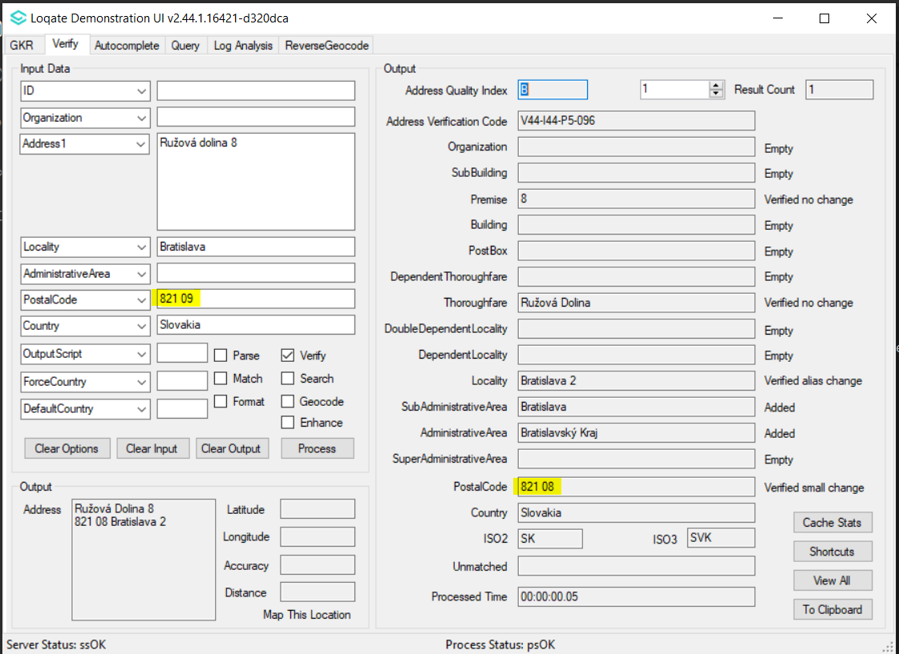 |  |  | 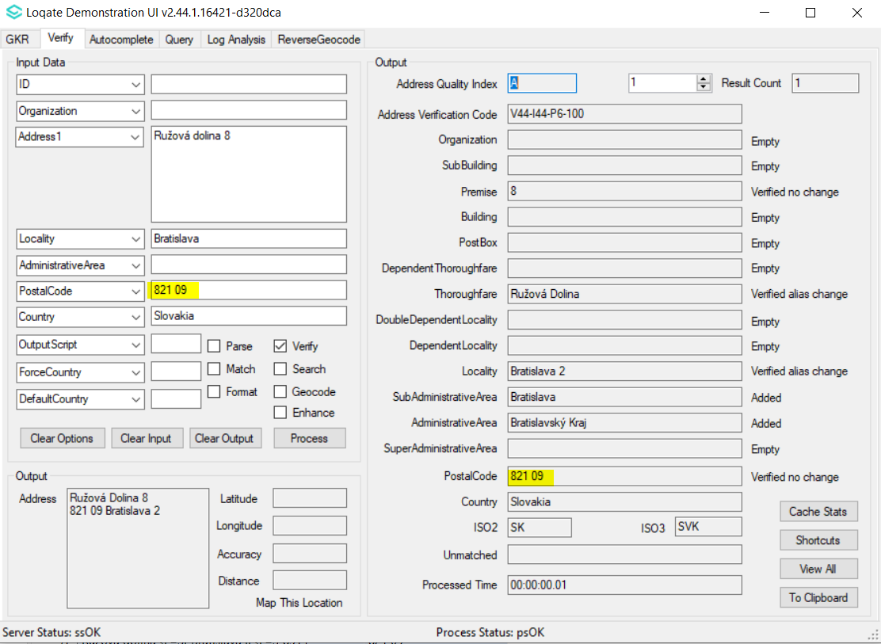

Case Number | Change Description | Category | Country | Example Address
CAS-78651-N2F6F4 | Correction of the Locality being verified | Data | SI | Address1: Ptujska Cesta 343  Locality: Maribor  PostalCode: 2000  Country: SI
Before Image |  |  | After Image
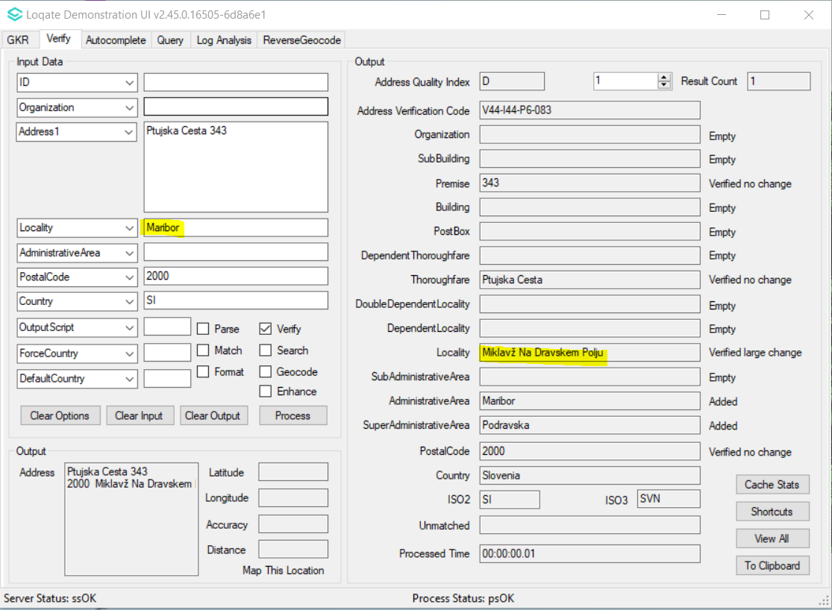 |  |  | 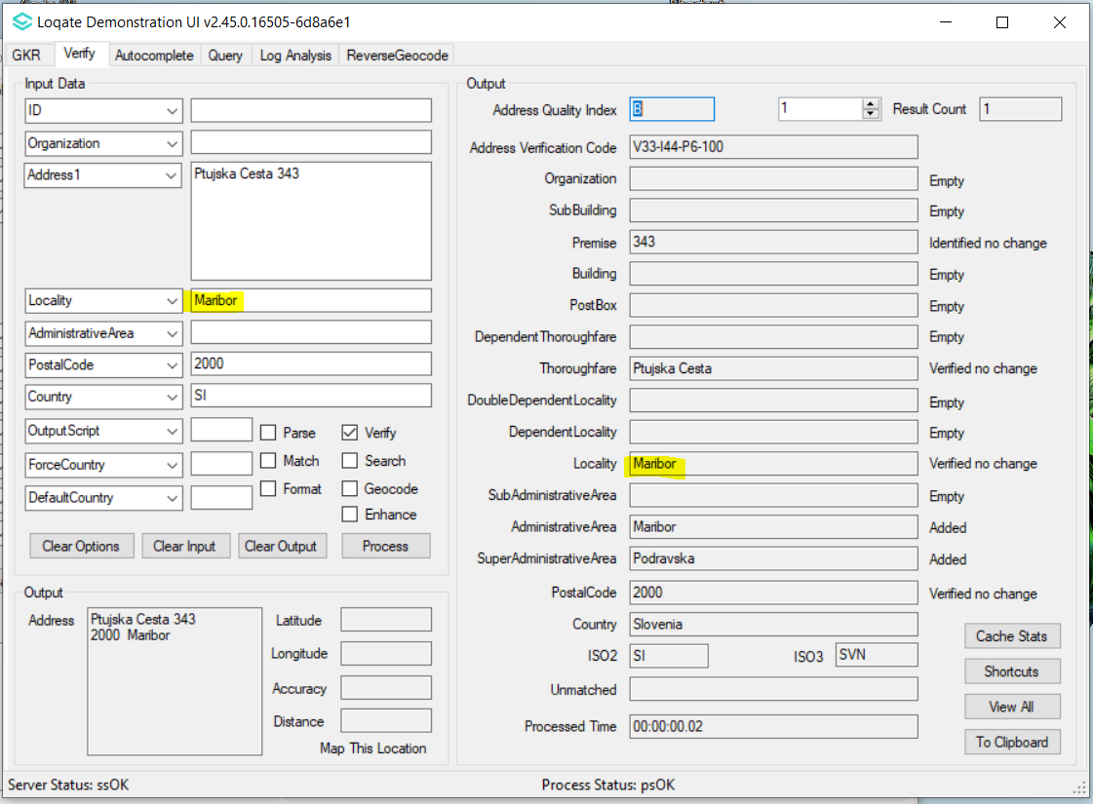

Case Number | Change Description | Category | Country | Example Address
CAS-83403-B7M0R3 | Improvement of PostalCode verification | Data | NZ | Address1: 124 Shakespeare Road  Locality: Takapuna  AdministrativeArea: Auckland  PostalCode: 0622  Country: NZ
Before Image |  |  | After Image
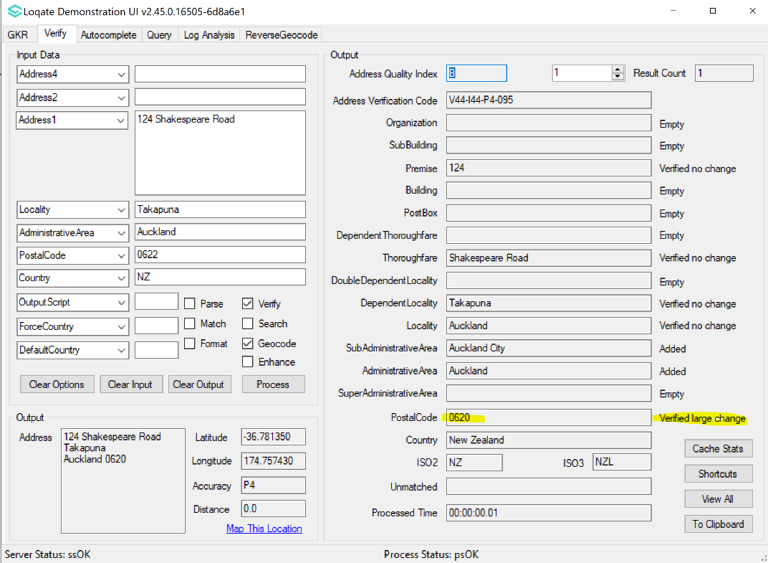 |  |  | 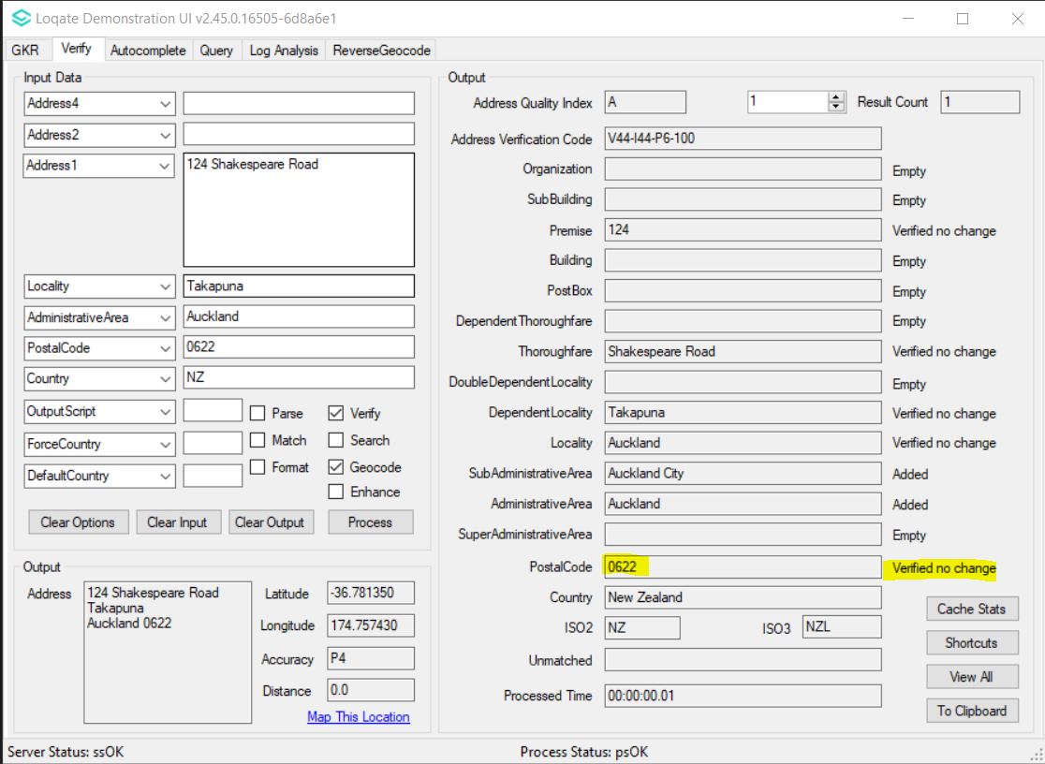

Case Number | Change Description | Category | Country | Example Address
CAS-83391-J3G9B1 | Correction of added DependentLocality | Data | NZ | Address: 3 Umu Place Auckland Country: NZ
Before Image |  |  | After Image
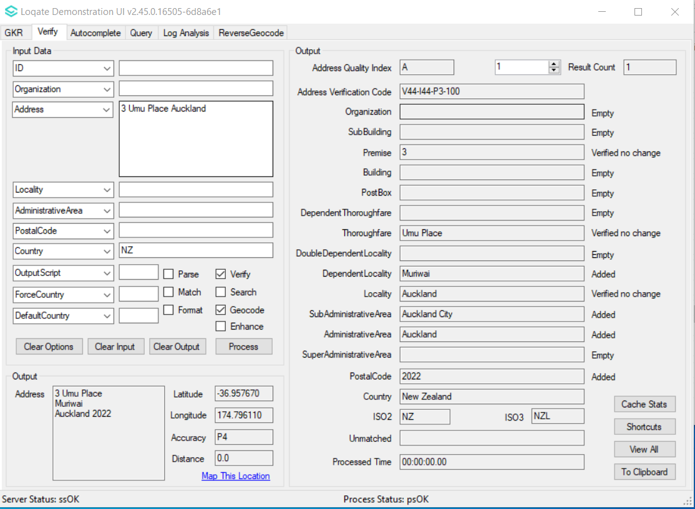 |  |  | 