Loqate, A GBG Solution
Release Notes – Verify API

2022Q4.1 Minor Release

Case Resolutions
Please visit https://support.loqate.com/2022q4-1-resolved-cases/ for a list of all cases resolved in this release. If you would like more details on any of the solved cases listed, please contact LoqateSupport@gbgplc.com for further information.

Local API Notices
This is to inform our customers that in this 2022Q4.1 release we have made one minor change to the API in relation to use of a virtual postcode in Hong Kong Addresses

Case Number | Change Description | Country
CAS-85019-Z9S9W4 | All occurrence of 999077 in Hong Kong addresses would be removed before address verification. | Hong Kong

Local API Improvements
Case Number | Change Description | Category |  | Country | Example Address
CAS-85019-Z9S9W4 | All occurrence of 999077 in Hong Kong addresses will be removed before address verification to prevent speed degredation | API |  | HK | Rm. 19c, lockhart ctr., 201-207 lockhart rd, wan chai, hong kong  Hong Kong, 999077 HK
Before Image |  |  | After Image
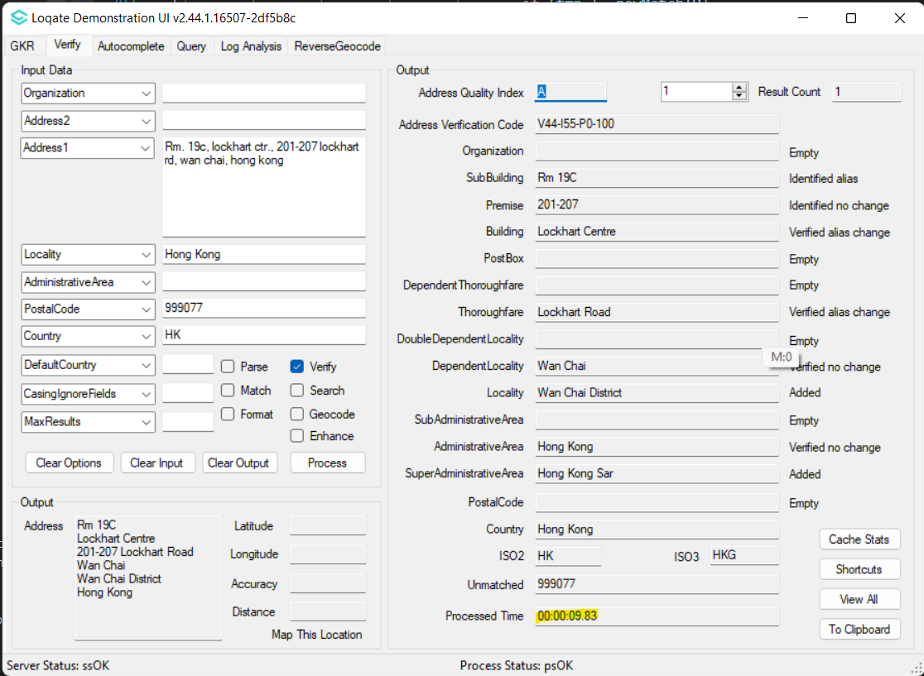 |  |  | 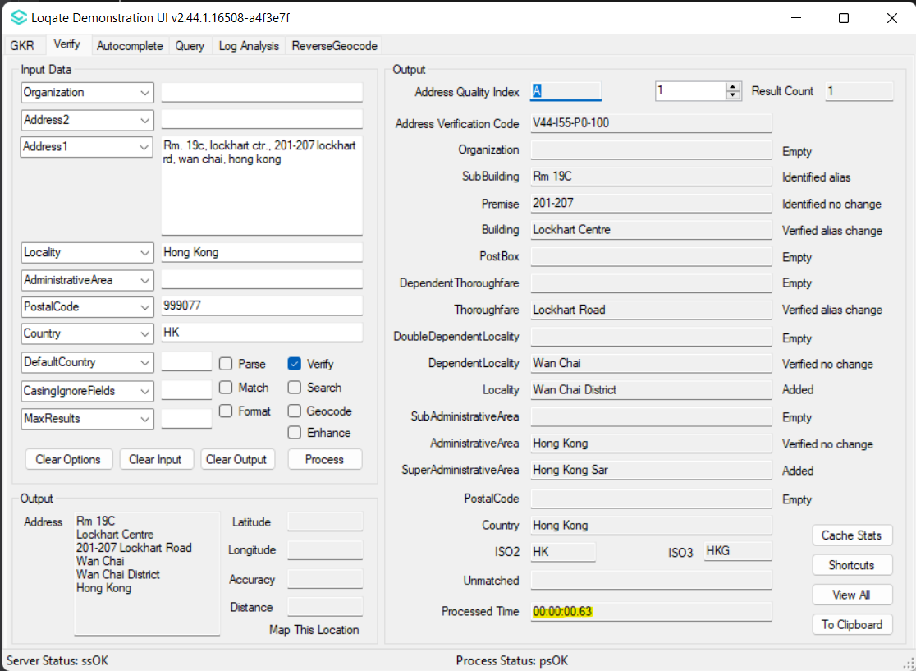

Installation Instructions
Please remember to update both the program files and the reference data and please install these to a new fresh folder location. The improvements are tied to the data in the Global Knowledge Repository and the Local API. When updating the data, it is recommended to use a new data folder each time to ensure the latest dataset is installed properly.

If you need any assistance with the upgrade of the Local API or the data update process, please contact GBG Loqate Support.

The setup wizard for the Local API can be obtained from our SFTP server. Please contact your account manager to retrieve the SFTP information. If you do not know who your account manager is, please contact the support team at LoqateSupport@gbgplc.com.

