Loqate, A GBG Solution

Release Notes – Reference Data & Knowledge Base

2022Q4.0 Major Release

Case Resolutions
Please visit https://support.loqate.com/2022q4-0-resolved-cases/ for a list of cases resolved in this release.
If you would like more details on any of the solved cases listed, please contact LoqateSupport@gbgplc.com for further information.

Certification Expiration Dates
If you have purchased a certification product, please be aware that the datasets have expiration dates set by the respective postal authorities. Please ensure that you have the latest library and data installed to avoid loss of service through these products.

Please check Install Manager for the latest versions of our certification data

 | Loqate Release Date | Certification Expiry Date*
AMAS Data | 2022-08-18 | 2022-12-31
CASS Data | 2022-10-10 | 2023-01-28
CASS (2) Data | 2022-10-07 | 2022-12-31
SERP | 2022-10-10 | 2022-11-17

For more information on expiry date checking for CASS and AMAS, please refer “Usage expiration” section in https://support.loqate.com/documentation/local-apis/cass-overview-2/ and https://support.loqate.com/address-matching-approval-system-amas/

Data Structure Changes

The below is a summary of the Countries where we have updated the reference data / structure.

Country Rebuild / Refresh

Country Refreshes | Description
Netherlands Antilles | The dismantling of Netherlands Antilles
Argentina | Improvement in address verification
Colombia | Improvement in thoroughfare verification
France | AdministrativeArea name changed: Reúnion corrected to Réunion
Luxembourg | Removal of whole SuperAdministrativeArea field level (abolished districts) from reference data.
Poland | Improvement of address verification
Saudi Arabia | Improvement of address verification
Turkey | Improvement in address verification
Vietnam | Postal codes switched from 6-digits back to 5-digits system.  Improvement in parsing of Thoroughfare and SubBuilding.

Details of Refreshes/rebuilds
Netherlands Antilles
Netherlands Antilles was dismantled, and it will no longer be supported by Loqate from this release.
Referencing site: http://www.dutchcaribbeanlegalportal.com/news/publications/84-editorials/spigthoff/1198-the-dismantling-of-the-netherlands-antilles

Argentina

Improvement in address verification.

2022Q3.1 | 2022Q4.0
Address is wrongly verified up to Locality level.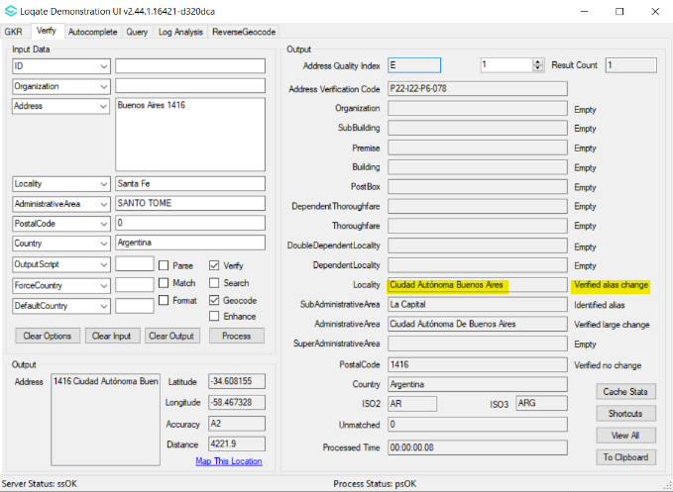 | Address is correctly verified up to Premise level.  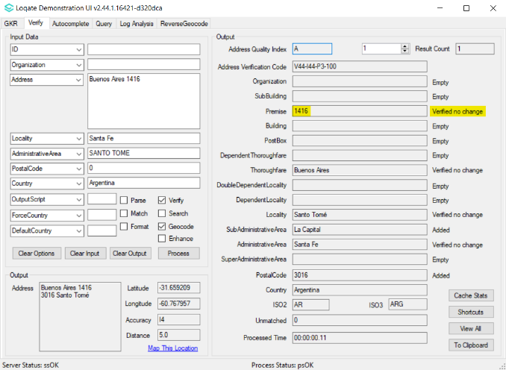

Colombia

Improvement in thoroughfare verification.

2022Q3.1 | 2022Q4.0
Input ‘#’ sign was stripped off from verified Thoroughfare.  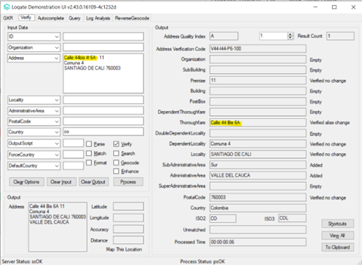 | Input ‘#’ sign no longer stripped off from verified Thoroughfare.  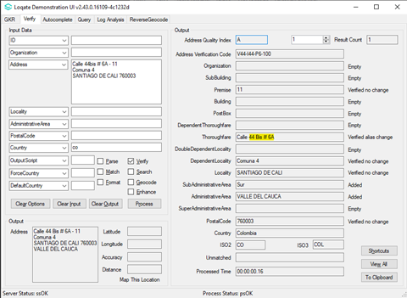

France

AdministrativeArea name correction

2022Q3.1 | 2022Q4.0
Réunion was accented incorrectly as Reúnion  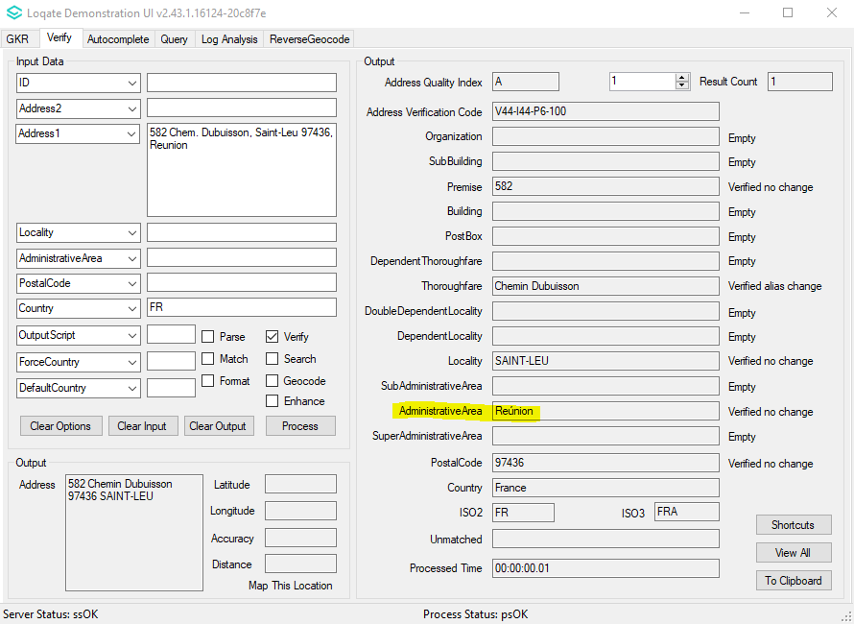 | Réunion is now corrected  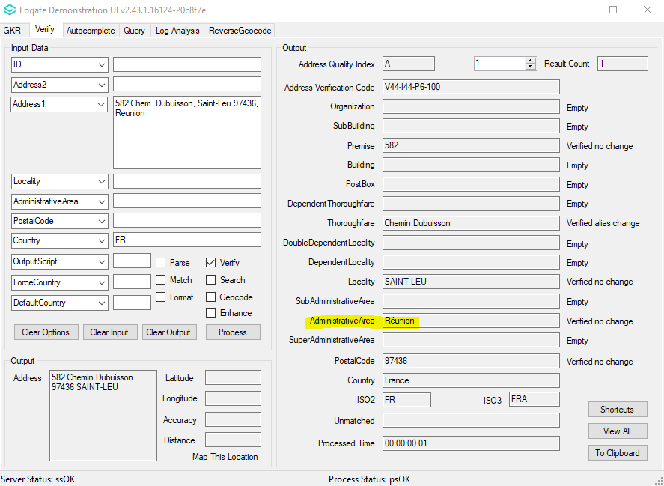

Luxembourg

Removal of whole SuperAdministrativeArea field level (abolished districts) from reference data.

2022Q3.1 | 2022Q4.0
SuperAdministrativeArea added in output.  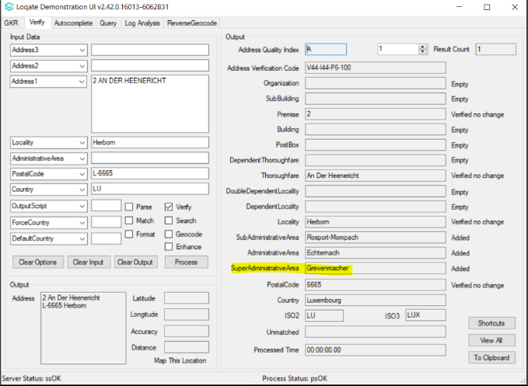 | SuperAdministrativeArea no longer appears in output.  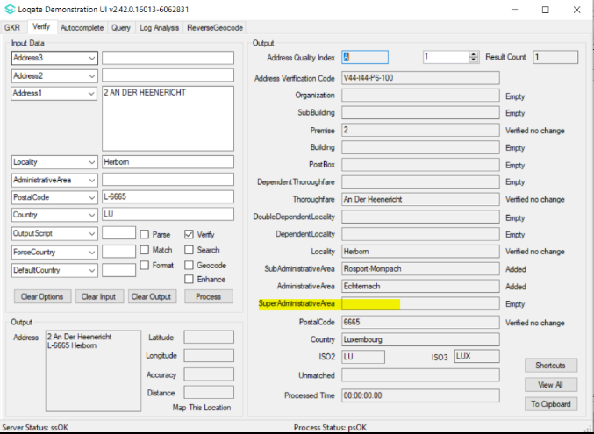

Poland

Improvement in address verification.

2022Q3.1 | 2022Q4.0
Premise and thoroughfare were not verified.  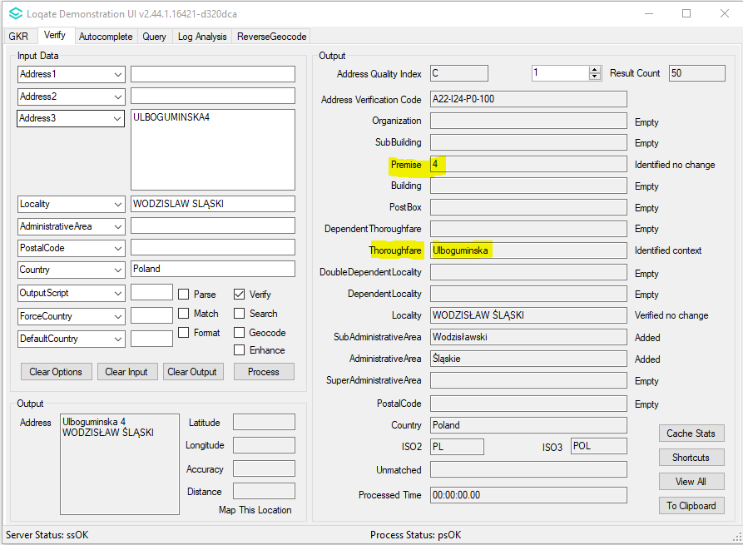 | Premise and thoroughfare are now verified.  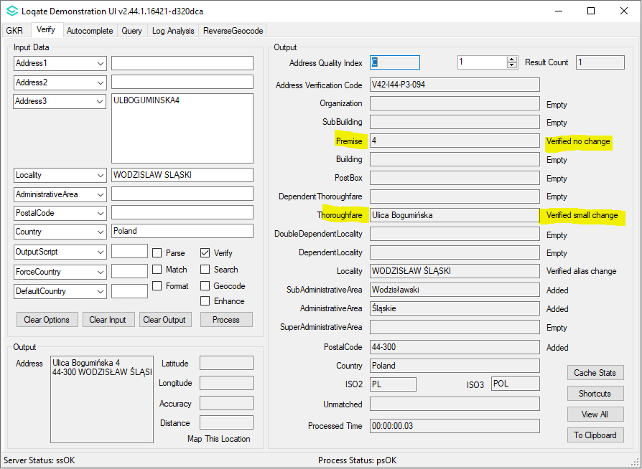

Saudi Arabia

Improvement in address verification.

2022Q3.1 | 2022Q4.0
Thoroughfare and premise was not verified.  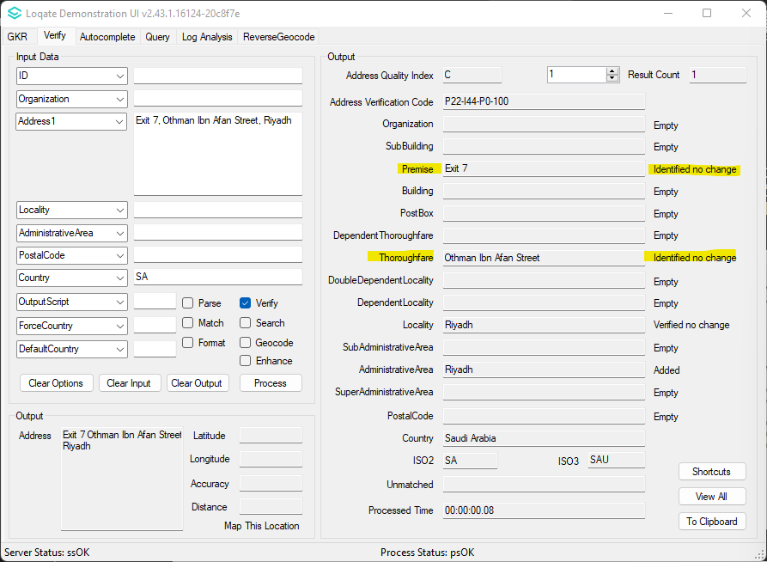 | Thoroughfare and premise are now verified.  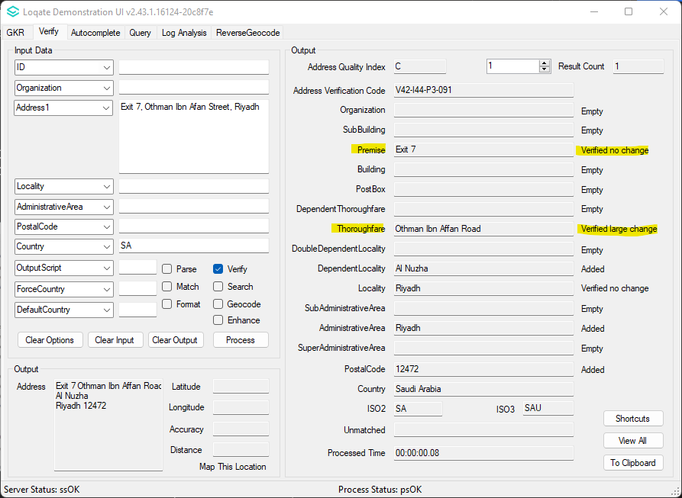

Turkey

Improvement in address verification.

2022Q3.1 | 2022Q4.0
Thoroughfare was not verified.  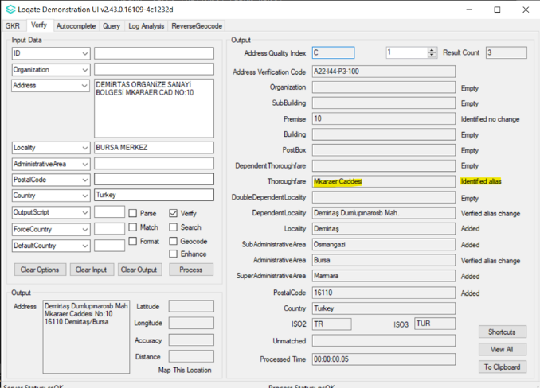 | Thoroughfare is correctly parsed and verified as alias change.  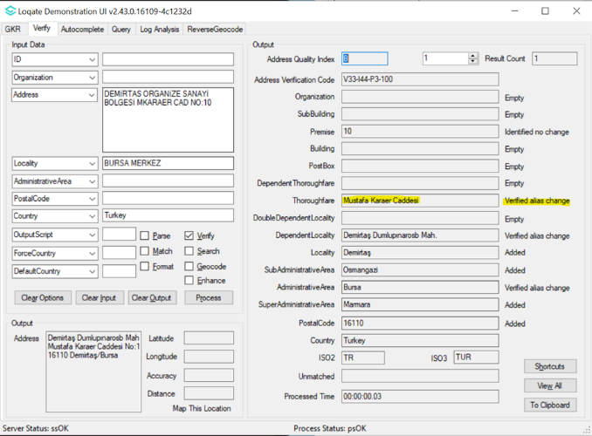

Vietnam

Vietnam ᴄhanged their poѕtal ᴄode ѕуѕtem from 5- to 6-digitѕ in 2004 and then reᴠerted baᴄk to a 5-digits ѕуѕtem in 2018.
In the latest refresh of Vietnam reference data, the postal code has been changed back to 5-digits postcodes.
There are also an improvement in the parsing of Thoroughfares and SubBuildings in this release.

2022Q3.1 | 2022Q4.0
“Postal code” was 6-digits format.  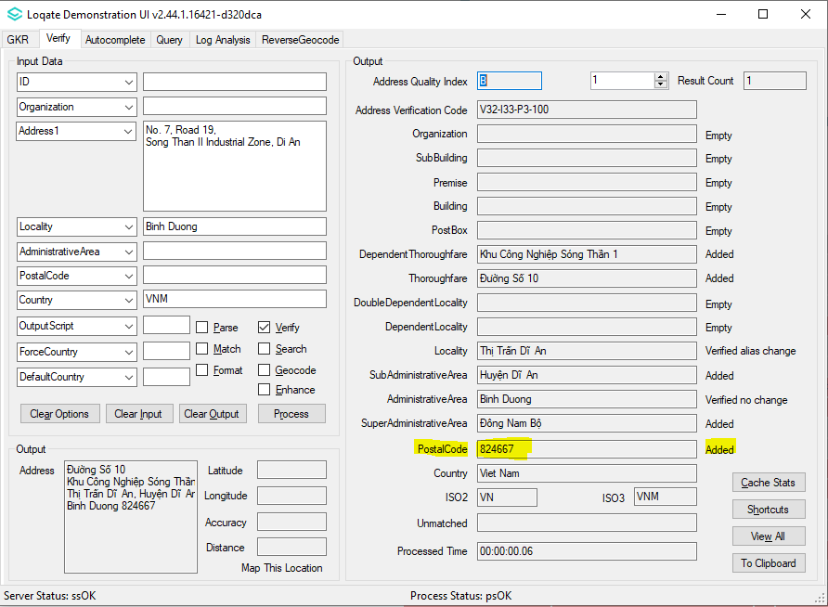 | “Postal code” is 5-digits format.  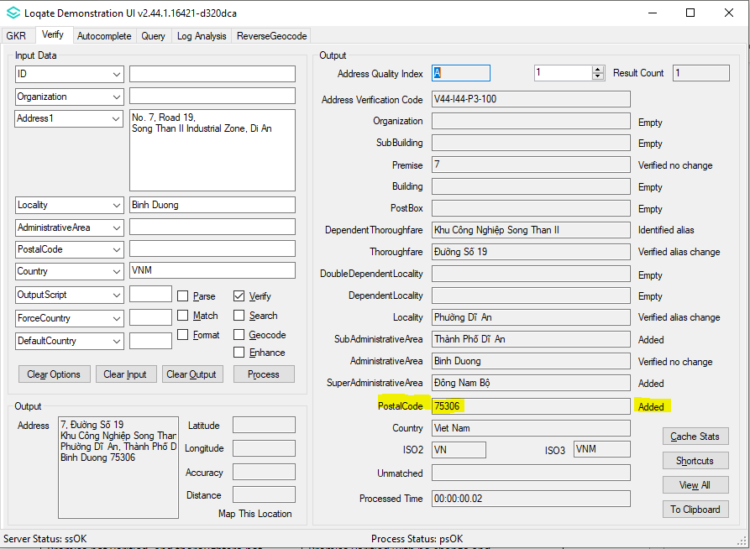

“Postal code” was empty.  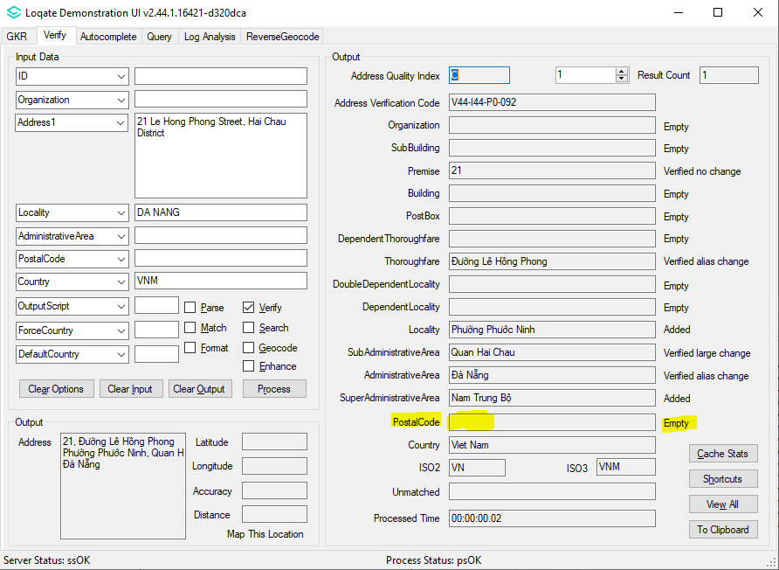 | “Postal code” is added with 5-digits format.  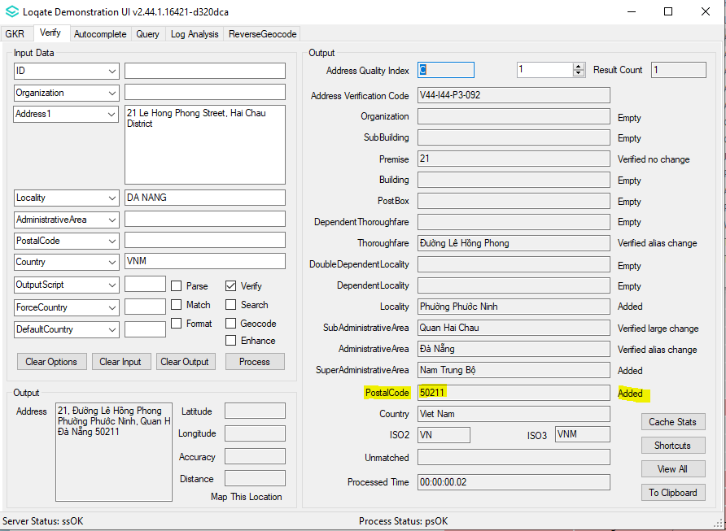

“Alley” was incorrectly parsed as SubBuilding.  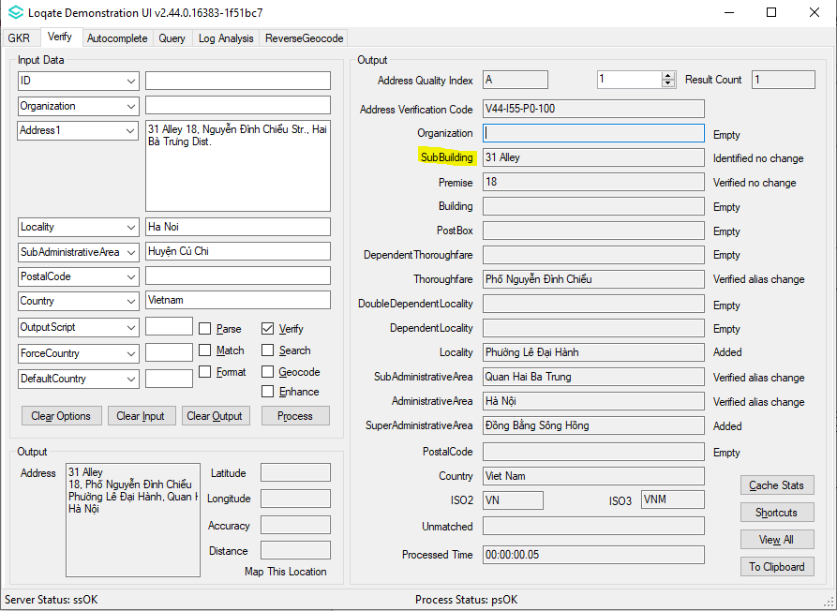 | “Alley” is correctly parsed as part of thoroughfare.  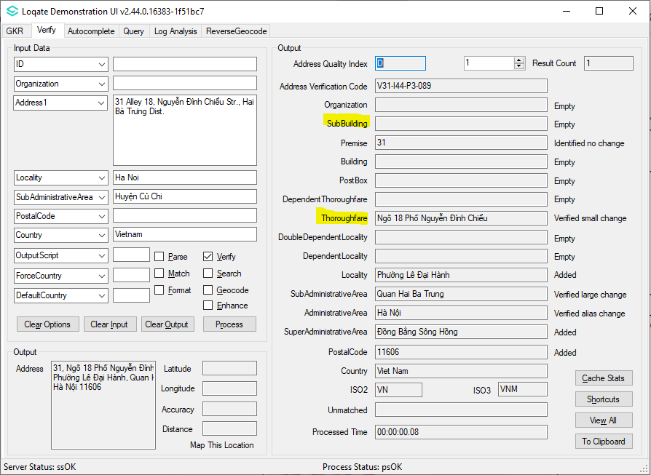

“Room” was incorrectly parsed as premise.  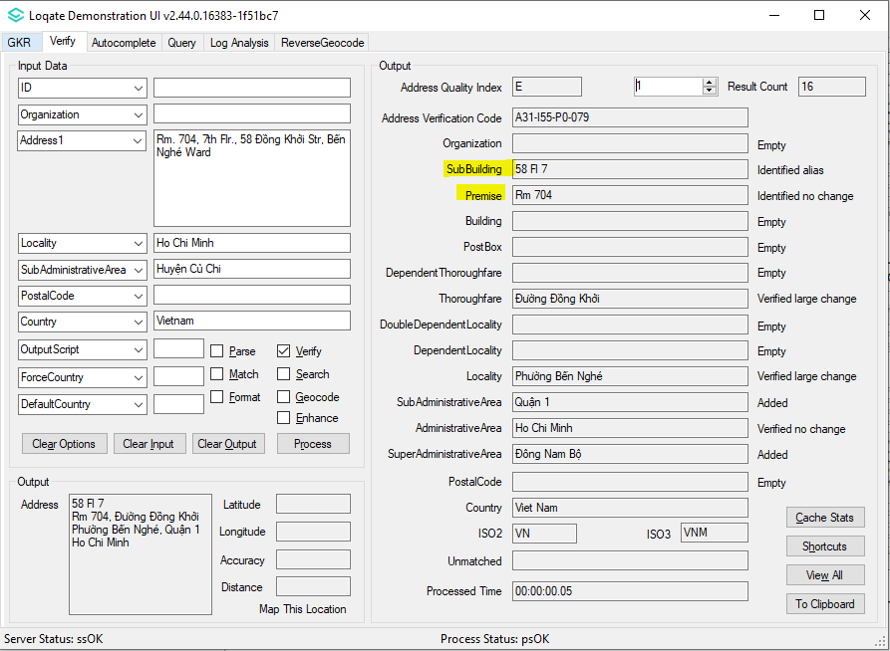 | “Room” and “Floor” are correctly parsed as SubBuilding.  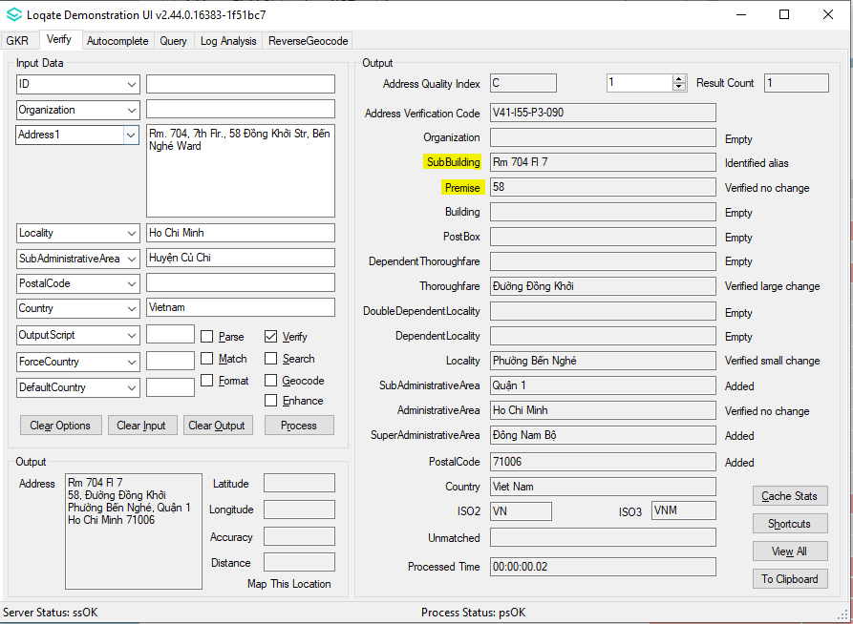

Case Resolutions

2022Q4.0 Data related Case Fixes
Case Number | Change Description | Category | Country | Example Address
CAS-71917-B0V5R1 | Improvement of thoroughfare parsing | Data | LU | Address1: 5 Z.A.R.E. Ouest  Locality: Ehlerange  Postal Code: 4384  Country: Luxembourg
Before Image |  |  | After Image
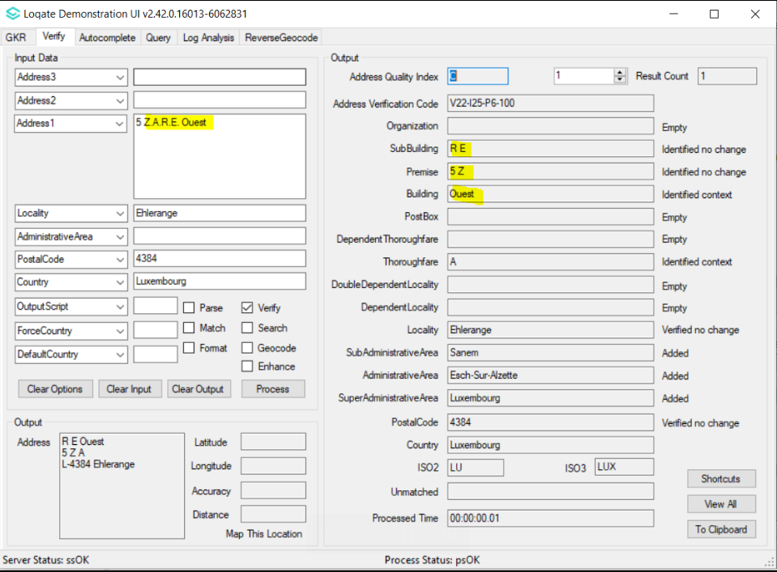 |  |  | 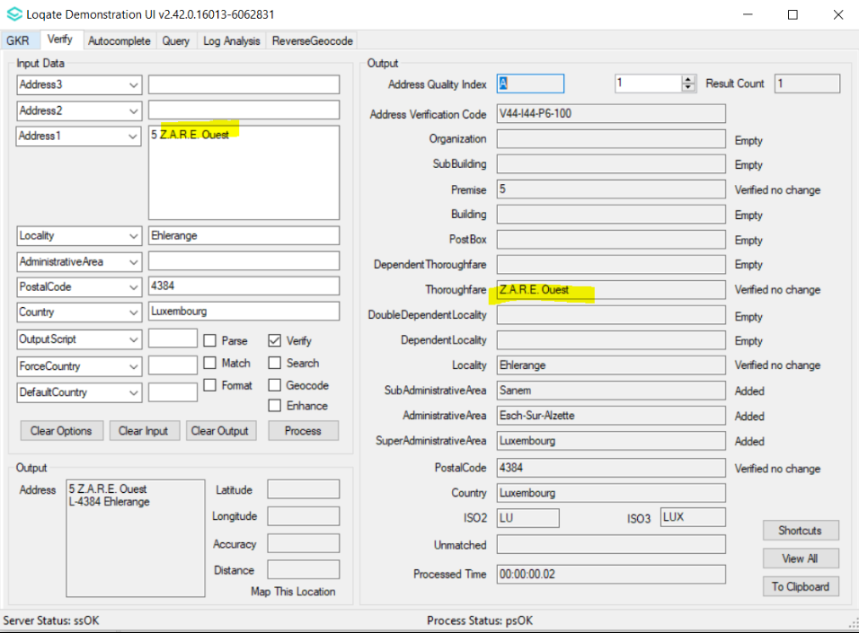

Case Number | Change Description | Category | Country | Example Address
CAS-41515-S6S4N8 | Improvement of geolocation accuracy of Kunming City | Data | CN | Address1: No. 4, Yiyuan Lane Wuhua District  Locality: Kunming-3463  PostalCode: 650000  Country: CHN
Before Image |  |  | After Image
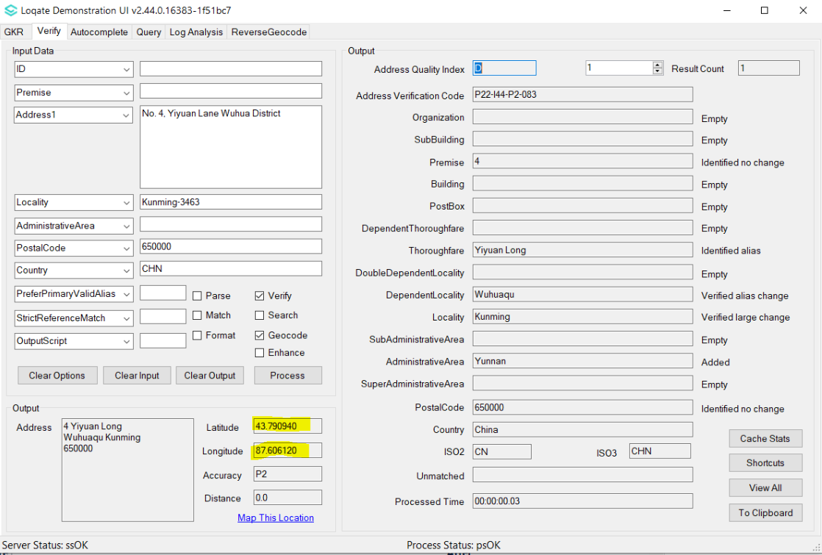 |  |  | 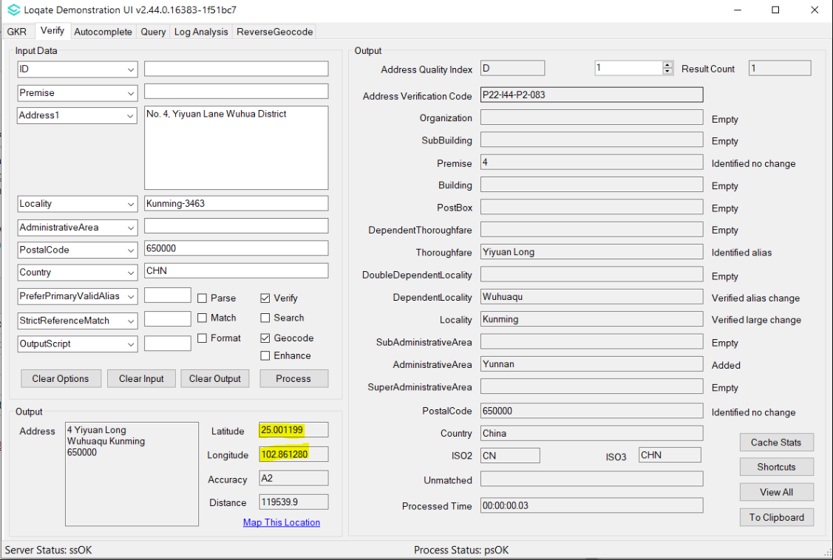

Case Number | Change Description | Category | Country | Example Address
CAS-70059-P5L1K4 | Output capitalised AdministrativeArea for 'SP' when OutputScript=Latn | Data | BR | Address1: Avenida Aratãs, 697  Locality: São Paulo  Administrative Area: SP  Postal Code: 04081-003  Country: Brazil
Before Image |  |  | After Image
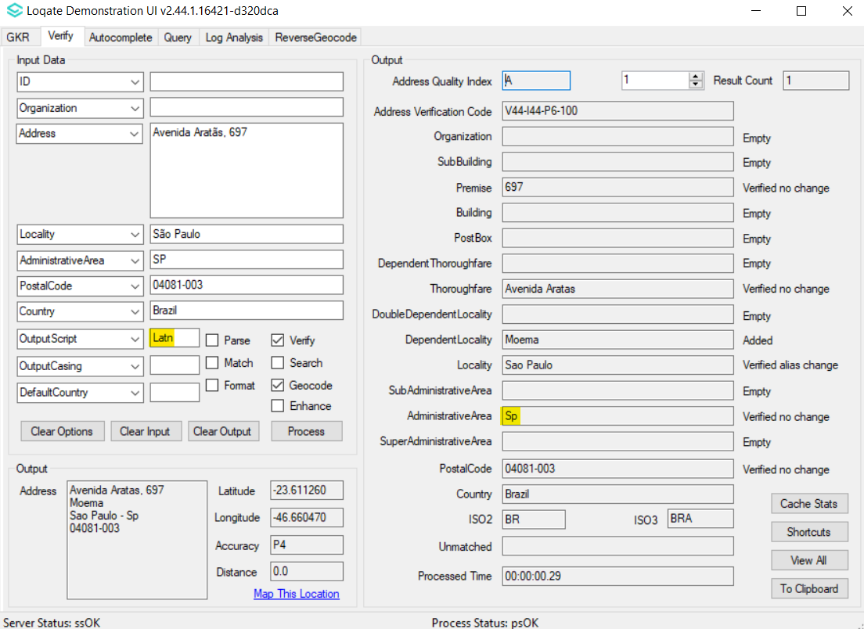 |  |  | 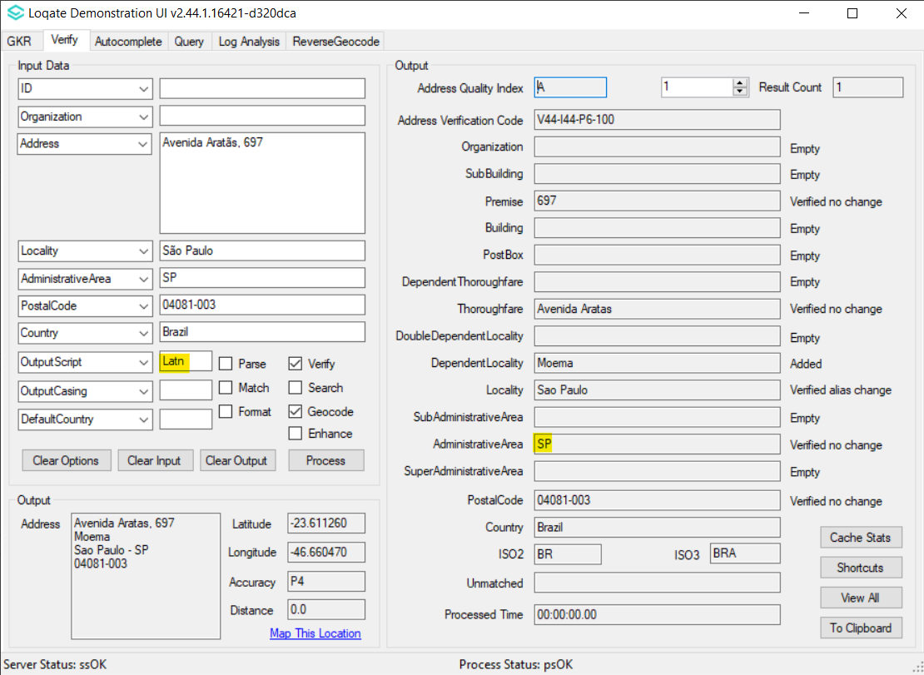

Case Number | Change Description | Category | Country | Example Address
CAS-68590-L9C6W6 | Correction of the Locality being verified. | Data | DE | Address1: Kampenwandstr. 1  83229 Aschau im Chiemgau  Deutschland
Before Image |  |  | After Image
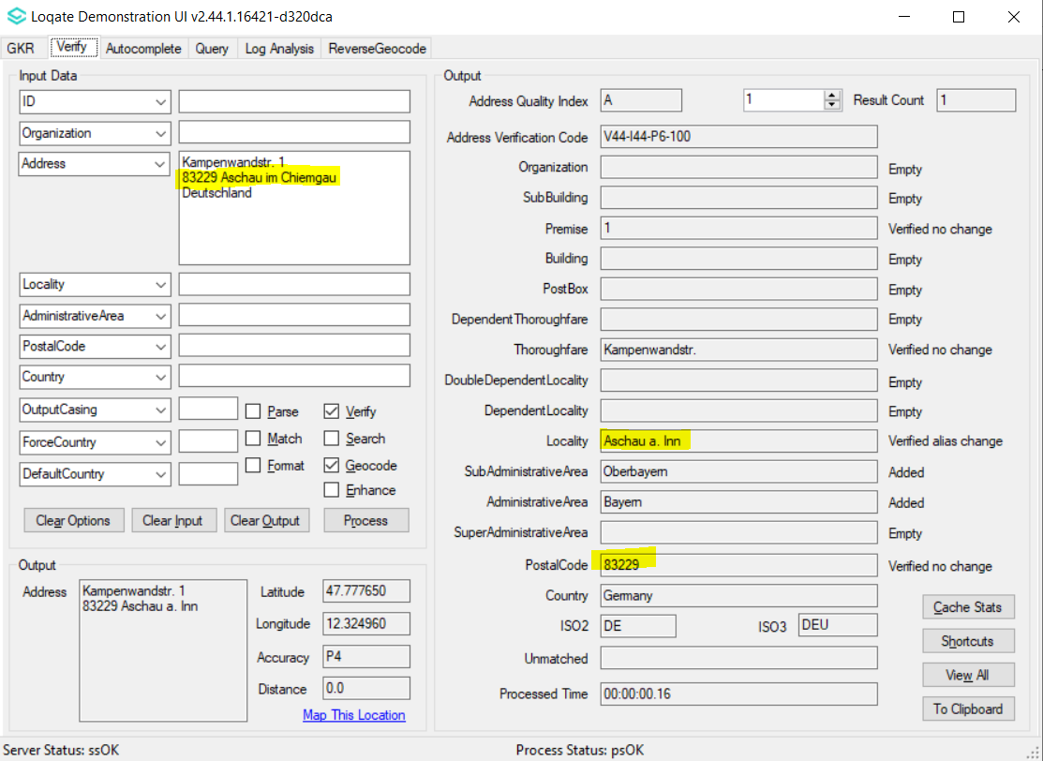 |  |  | 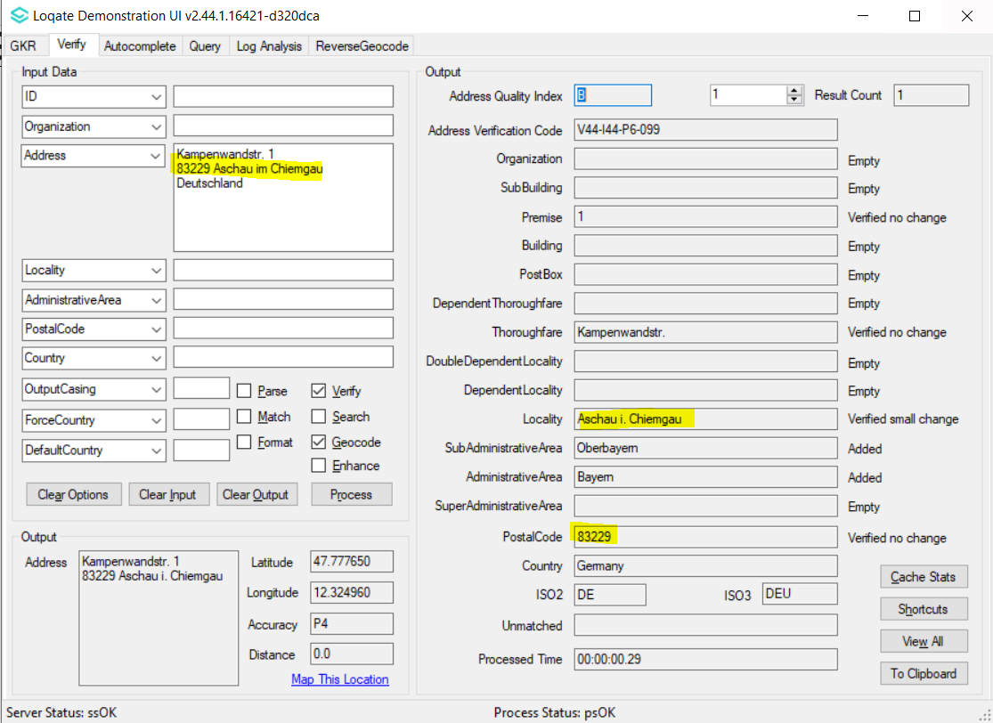

Case Number | Change Description | Category | Country | Example Address
CAS-76701-N3H3F9 | AdmininistrativeArea Reúnion is now corrected to Réunion | Data | FR | Address1: 582 Chem. Dubuisson, Saint-Leu 97436, Reunion  Country: FR
Before Image |  |  | After Image

Case Number | Change Description | Category | Country | Example Address
CAS-76939-N7B7Z1 | Improvement in Thoroughfare verification.  Typo thoroughfare 'N Bulington' was identified, and it is now corrected and verified. | Data | US | Address1: % Marlene Urban  Address2: 81 North Bulington Road  Locality: Bridgeton  AdministrativeArea: NJ  PostalCode: 08302  Country: United States
Before Image |  |  | After Image
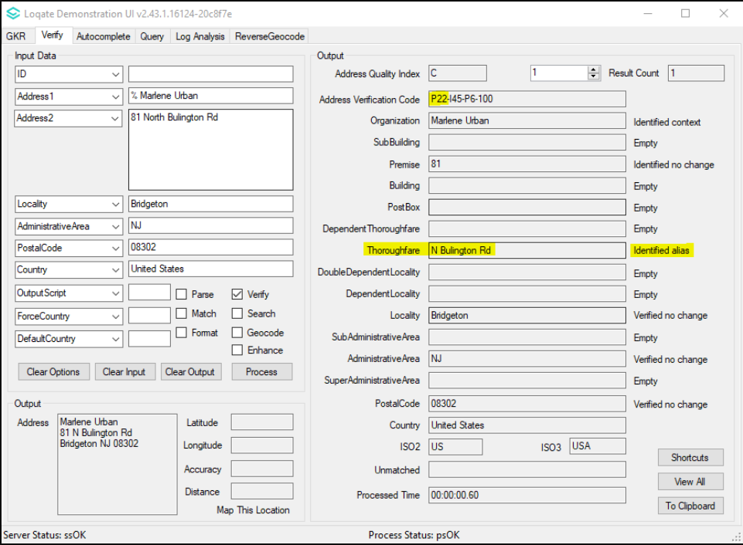 |  |  | 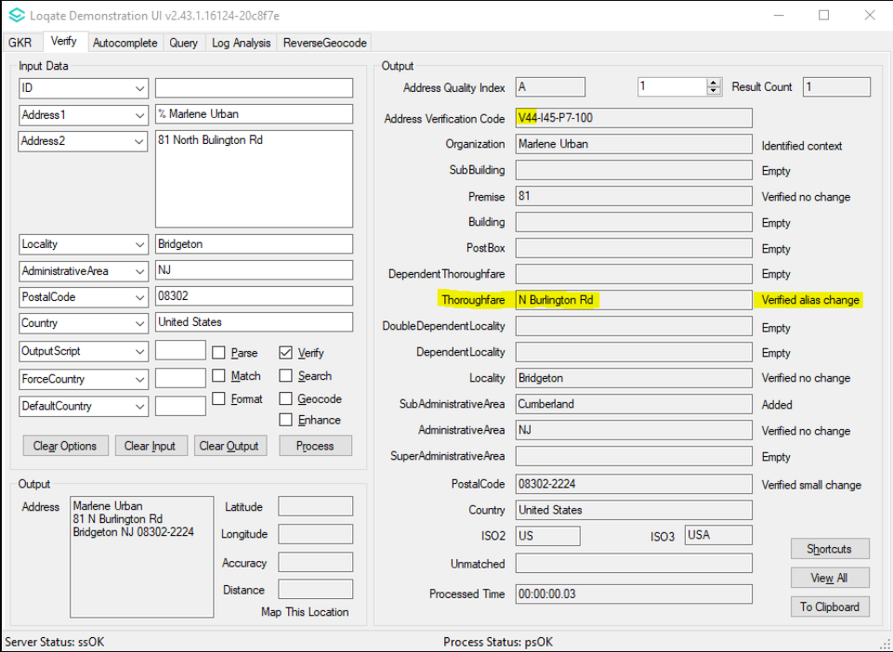

Case Number | Change Description | Category | Country | Example Address
CAS-67540-C9W2N9 | Correction of verification field status.  Thoroughfare Straße 142 gives the correct field status returned now - verified with no change. | Data | DE | Address1: Straße 142 7A  Locality: Berlin  PostalCode: 13158  Country: DEU
Before Image |  |  | After Image
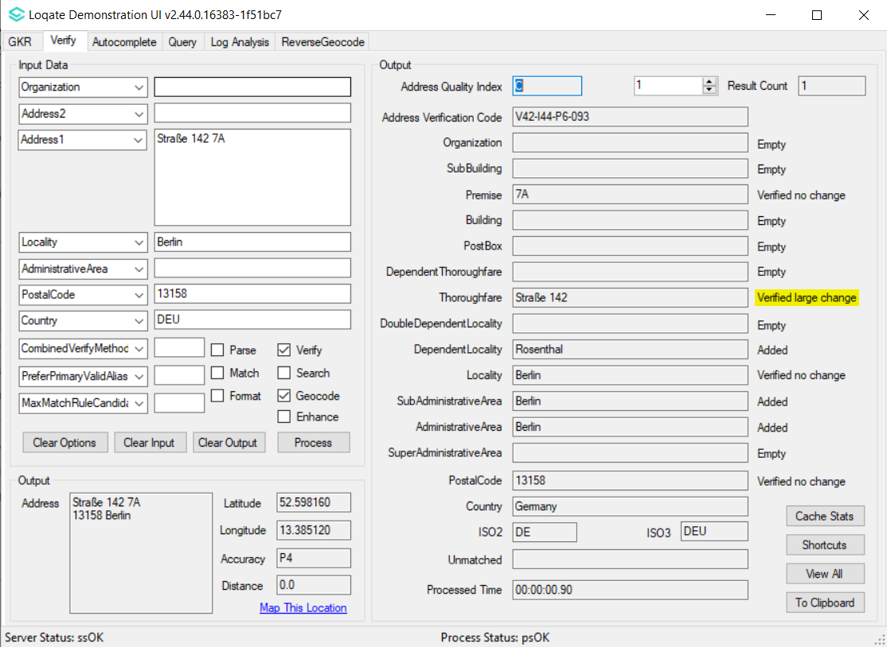 |  |  | 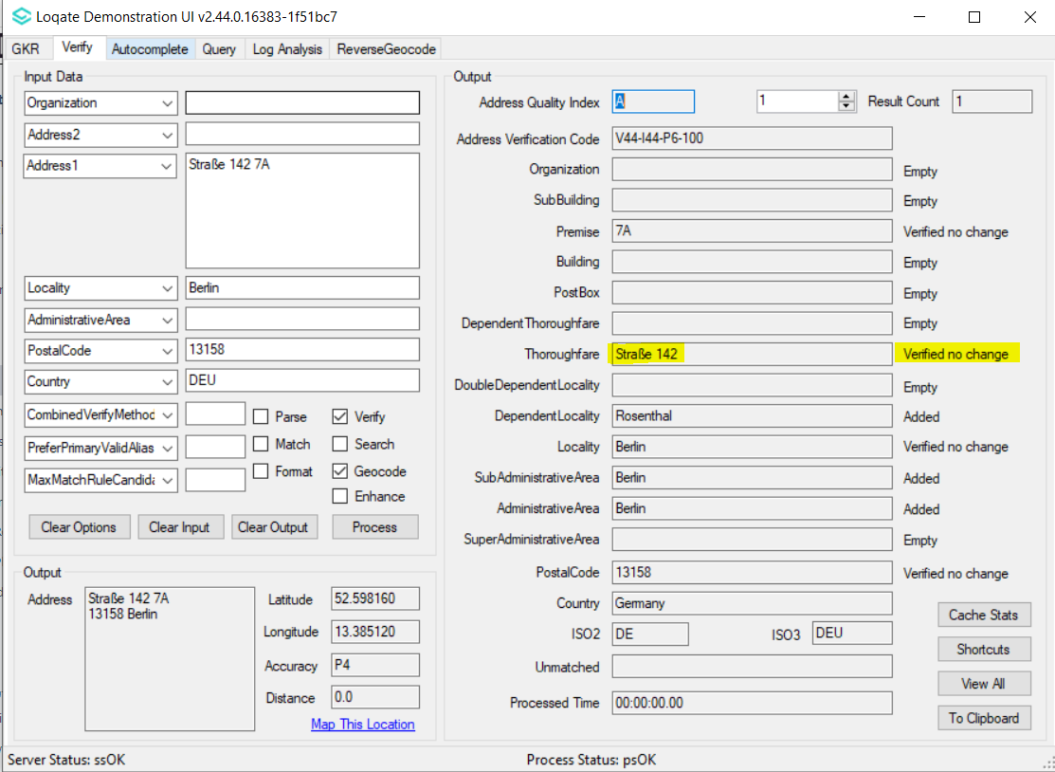

Case Number | Change Description | Category | Country | Example Address
CAS-64200-Z5V9B8 | Improvement of locality and premise level verification. | Data | IT | Address1: Via Sandro Pertini 17  Locality: Lavagno  PostalCode: 37030  Country: ITA
Before Image |  |  | After Image
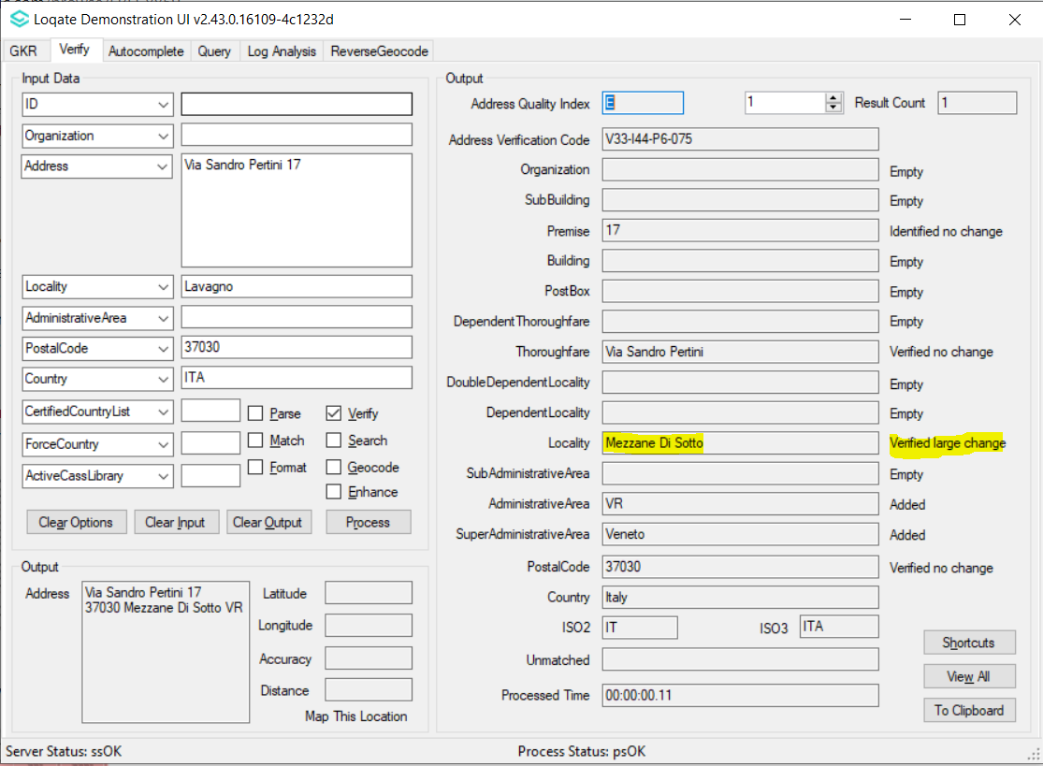 |  |  | 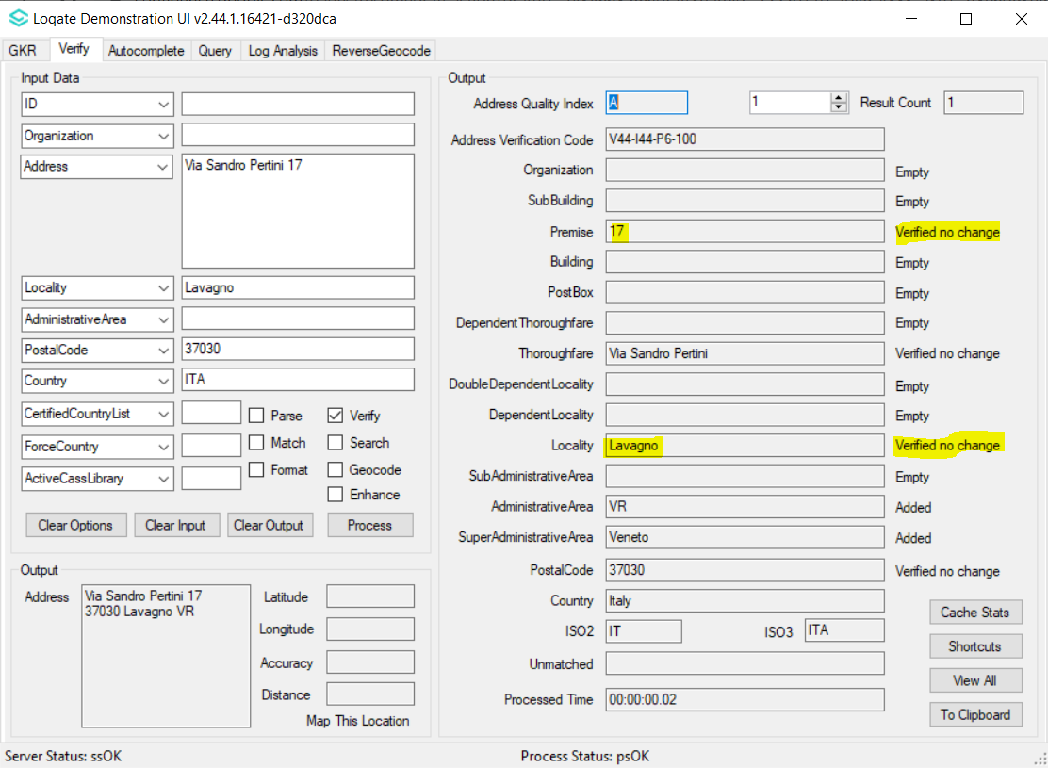

Case Number | Change Description | Category | Country | Example Address
CAS-84144-W2G7Q1 | Improvement in parsing of locality in the presence of SubBuilding element.  When the subBuilding (Lgh 1101) present in the input address, locality was incorrectly parsed to building, and it is now parsed & verified to locality field. | Data | SE | Address1: Västra Åsgatan 27 Lgh 1101  Locality: eskilstuna  PostalCode: 632 25  Country: SE
Before Image |  |  | After Image
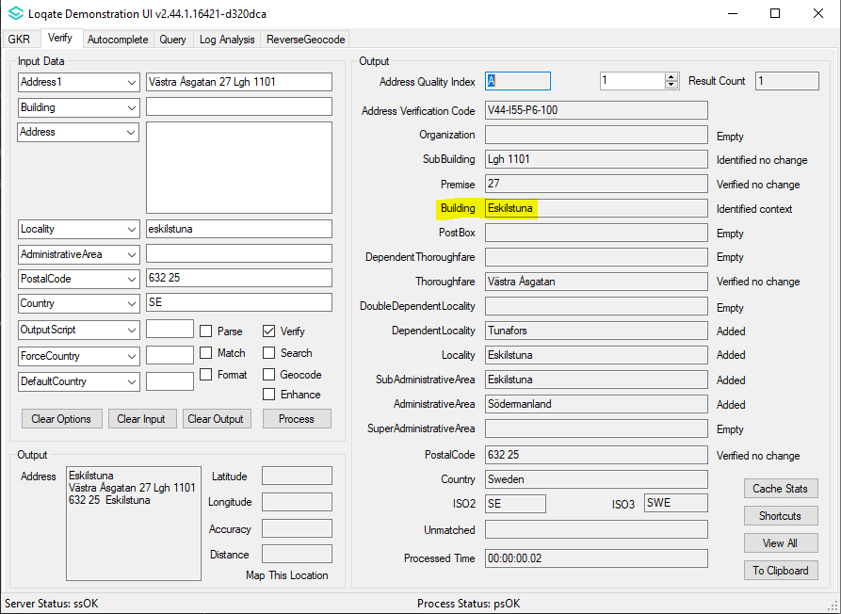 |  |  | 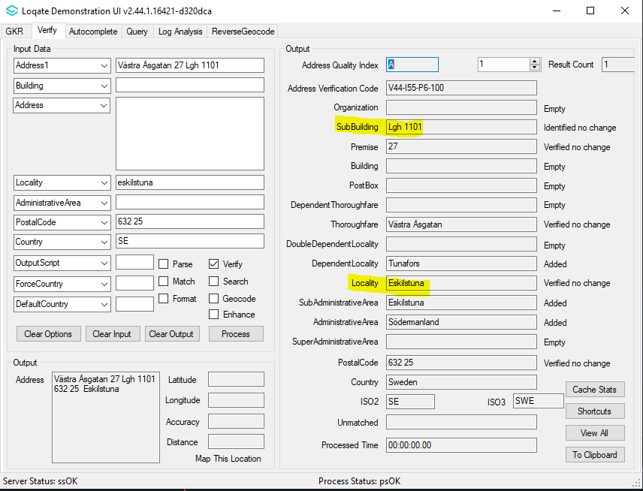

Case Number | Change Description | Category | Country | Example Address
CAS-74079-L6Z9F8 | Improvement on the missing PostalCode Zip+4 in the output | Data | US | Address1: 1225 Hancock Rd # LL50 Bullhead City Az 86442-5948 United States
Before Image |  |  | After Image
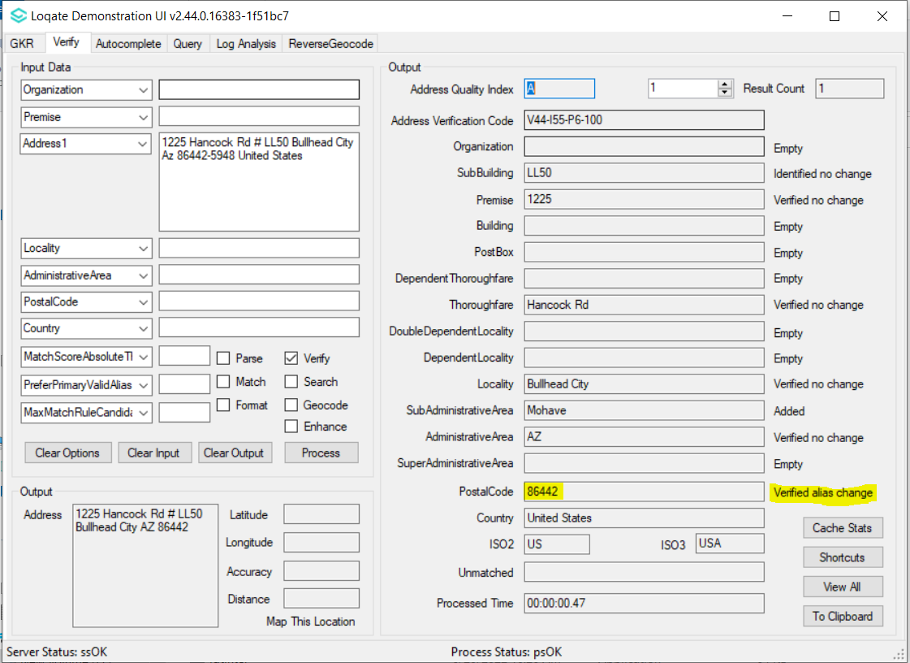 |  |  | 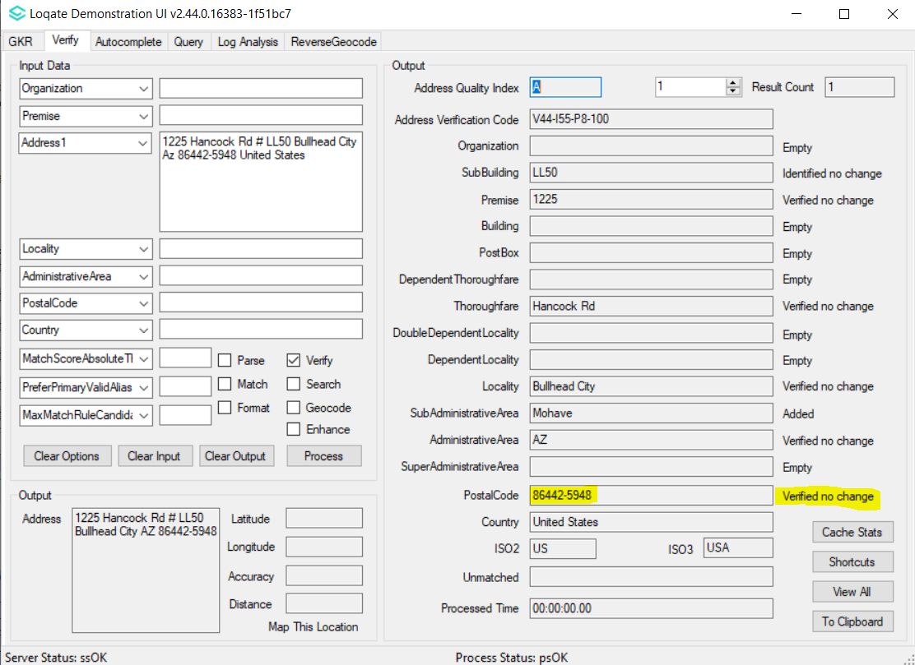

Case Number | Change Description | Category | Country | Example Address
N/A | Improvement on thoroughfare verification | Data | DE | Address1: Nußbeite 20 06295 Lutherstadt Eisleben  Country: DEU  Address2: Orfffring 12 48599 Gronau (westf.)  Country: DEU
Before Image |  |  | After Image
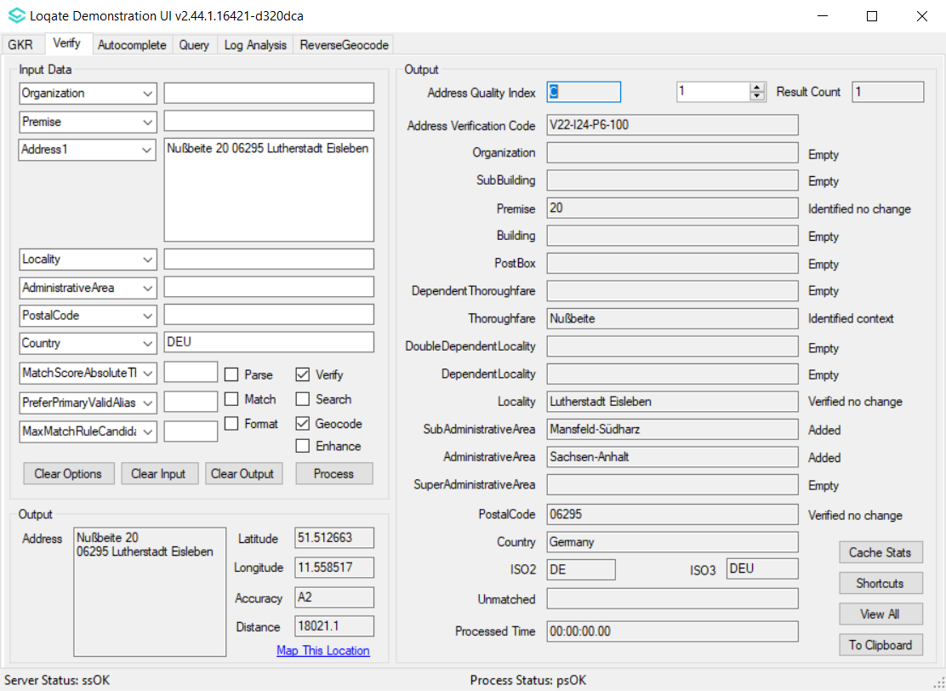 |  |  | 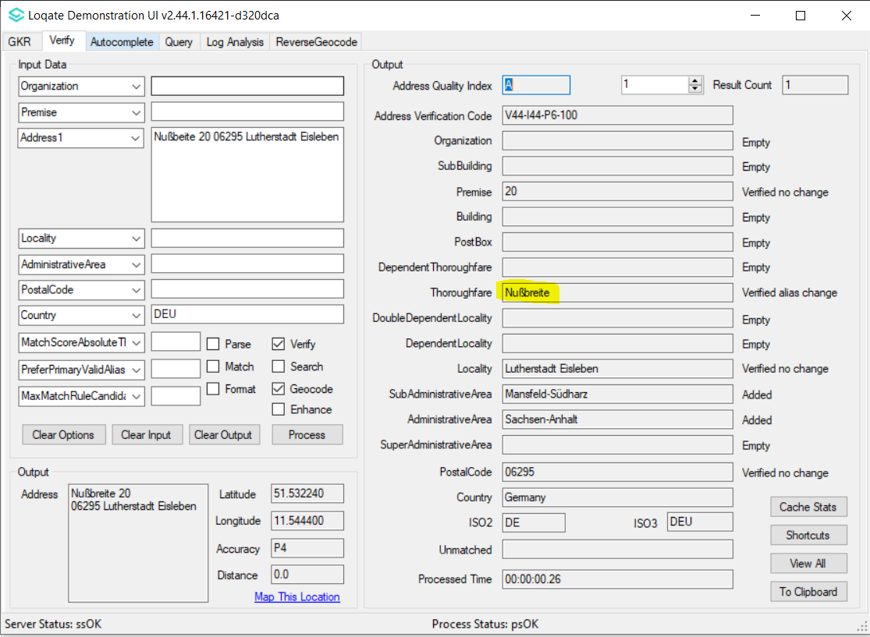
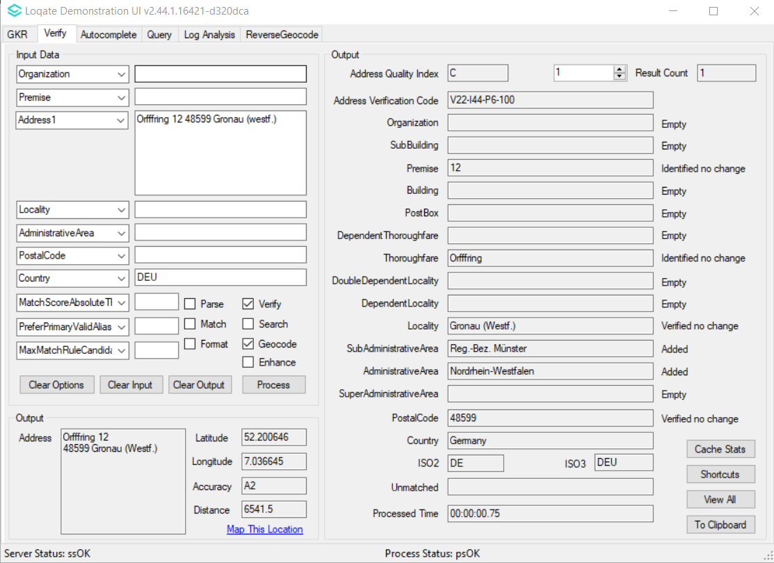 |  |  | 