Loqate, A GBG Solution
Release Notes – Verify API

2022Q4.0 Major Release

Case Resolutions
Please visit https://support.loqate.com/2022q4-0-resolved-cases/ for a list of all cases resolved in this release. If you would like more details on any of the solved cases listed, please contact LoqateSupport@gbgplc.com for further information.

Local API Notices
This is to inform our customers that in this 2022Q4.0 release we have made a major change to the API in relation to preposition handling for Germany along with 2 minor enhancements for Colombia and New Zealand.

Case Number | Change Description | Country
CAS-73536-H9N2M4 | Added "an der schule" to German lexicon file as thoroughfare | DE
CAS-76184-K0V4W5 | Treat premise number postfix with format -<digits> as potential invalid range node instead of just postfix.GB/AU | GB/AU
CAS-41610-W6J3N2 | Differences between input and reference data's symbols, spaces and diacritics now matter and would cause result to be alias changed instead of no change | ALL
CAS-79524-F2K5K0 | CountryDataImporter bugfix to import data from country.txt to country.lfs correctly | ALL
Internal | Changed the way Loqate detects when a result is CASS related and therefore does not change the casing of CASS fields. This means the casing should work more reliably. | CASS

Local API Improvements
Case Number | Change Description | Category | Country | Example Address
CAS-73536-H9N2M4 | Added "an der schule" to German lexicon file as thoroughfare. | API | DE | an der schule 6, hesel, de
Before Image |  |  | After Image
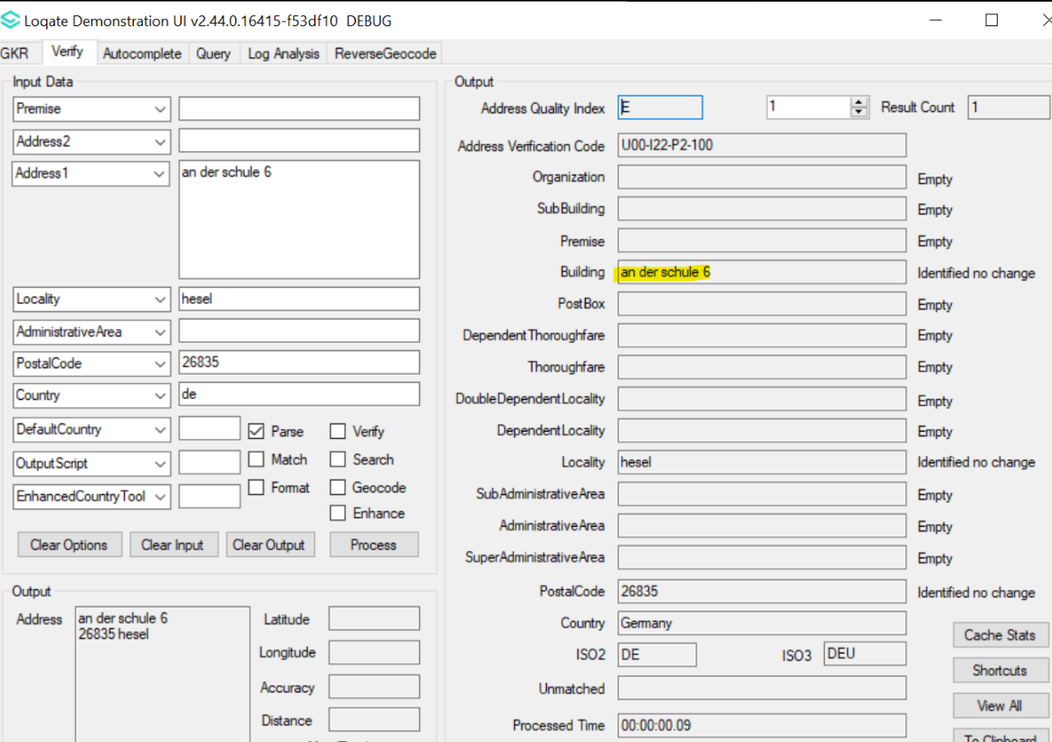 |  |  | 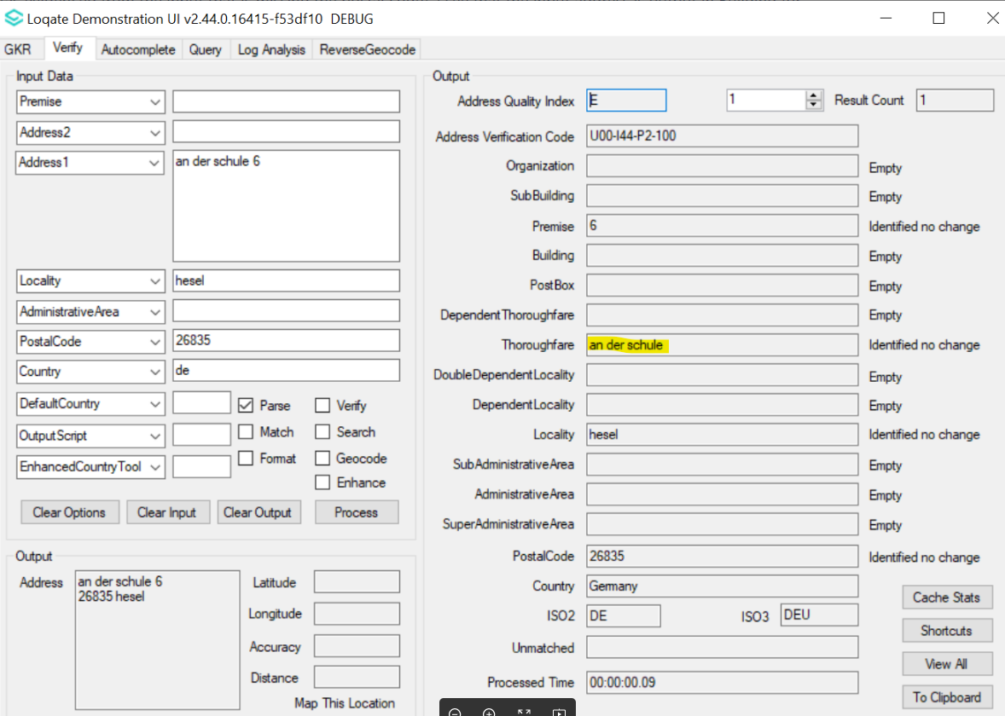

Case Number | Change Description | Category | Country | Example Address
CAS-76184-K0V4W5 | Treat premise number postfix with format -<digits> as potential invalid range node instead of just postfix. | API | GB/AU | - 154-15 HIGH STREET, BRIERLEY HILL, DY5 2AF, GB  - 143-14 Stanwell Road, Ashford, TW15 3QN, GB
Before Image |  |  | After Image
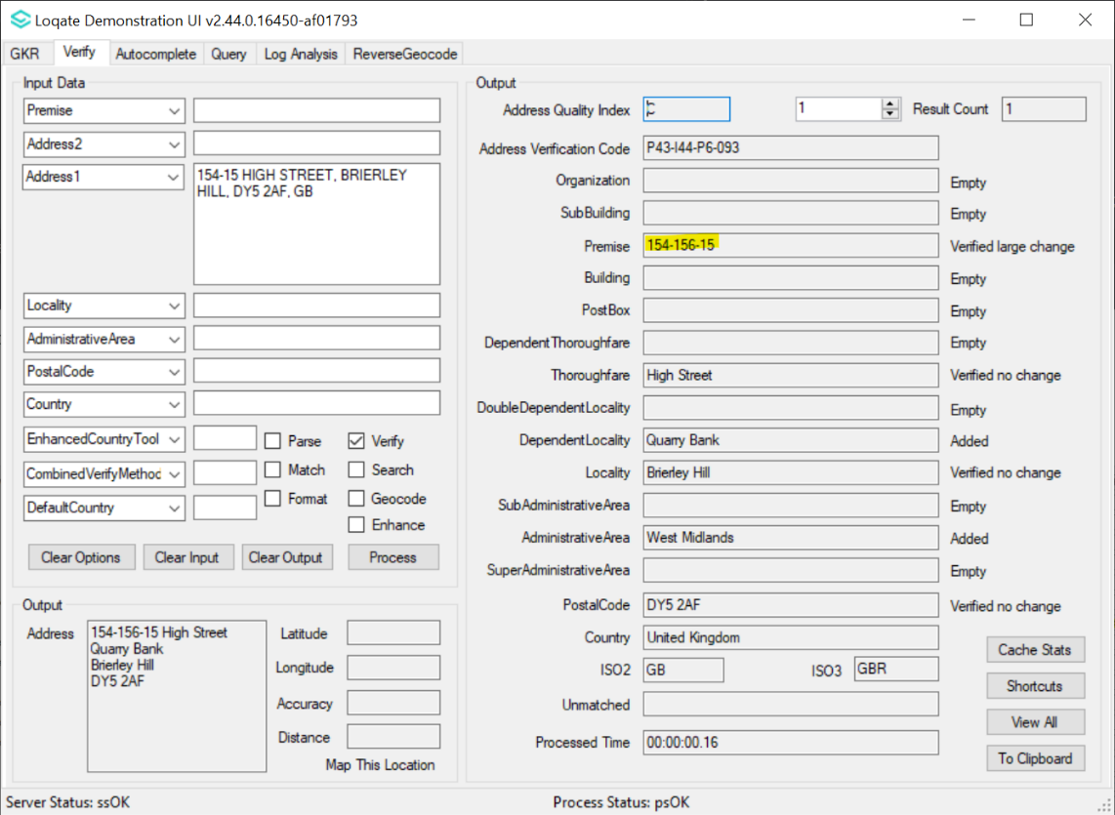 |  |  | 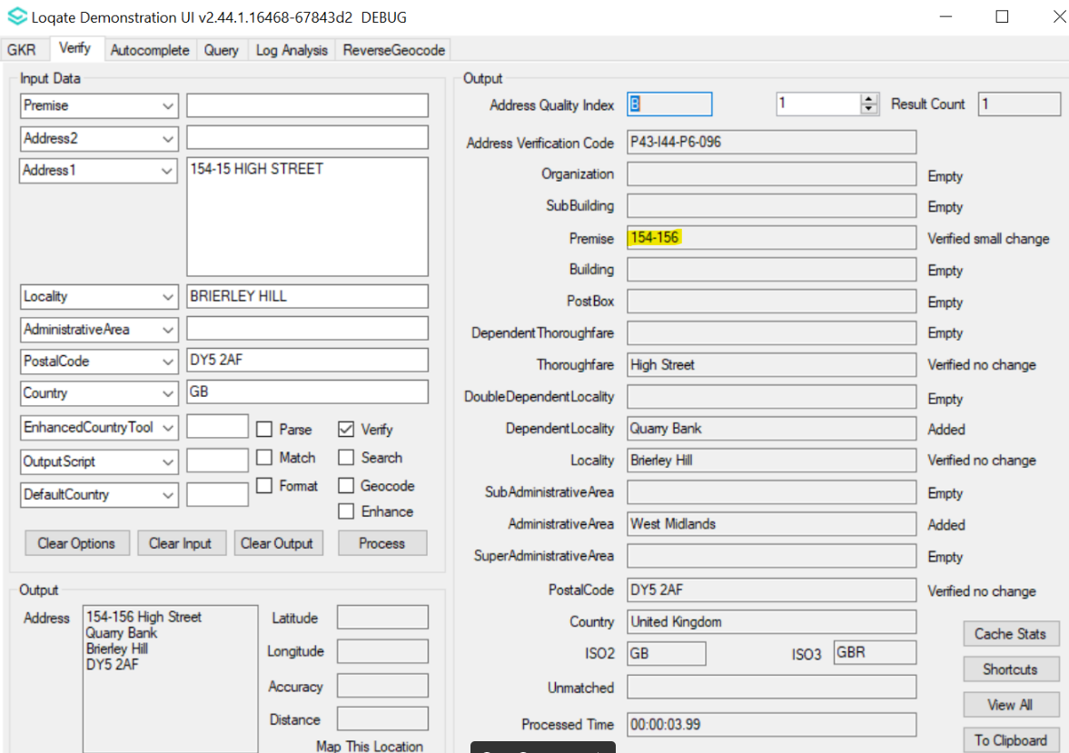
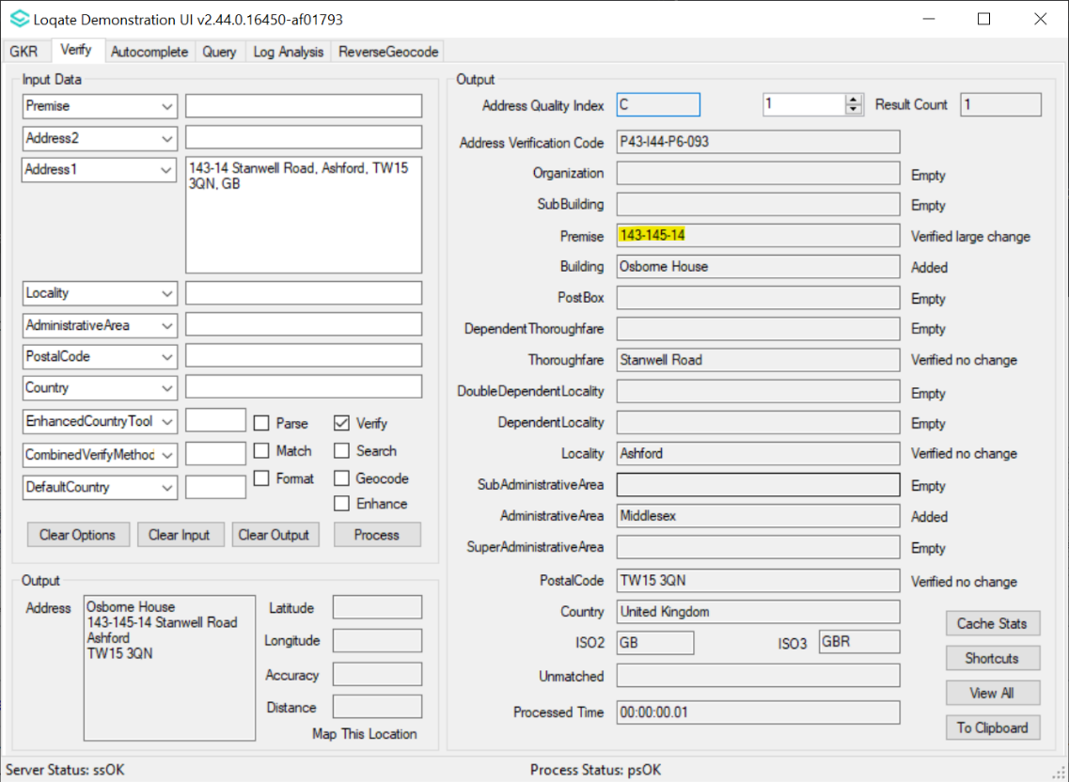 |  |  | 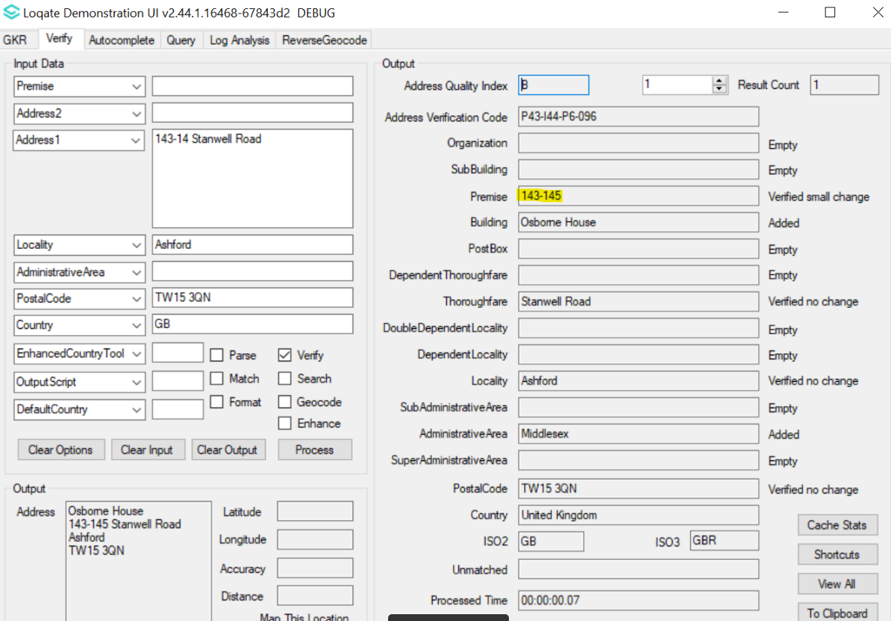

Case Number | Change Description | Category | Country | Example Address
CAS-41610-W6J3N2 | Differences between input and reference data's symbols, spaces and diacritics now matter and would cause result to be alias changed instead of no change. | API | All | Address1: Beruti 2602, Recoleta  Locality: Ciudad Autonoma Buenos Aires  Administrative Area: Cuidad Autonoma de Buenos Aires  Postal Code: 1425  Country: Argentina
Before Image |  |  | After Image
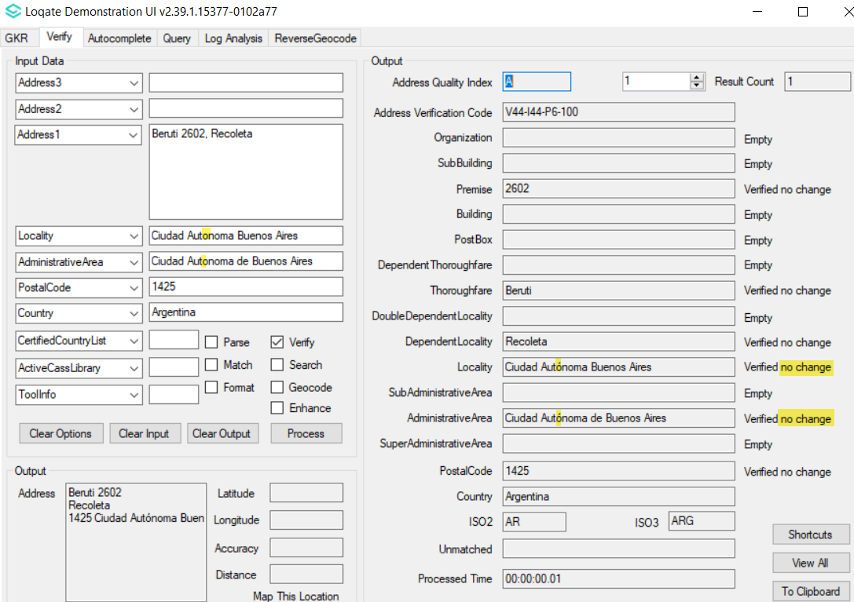 |  |  | 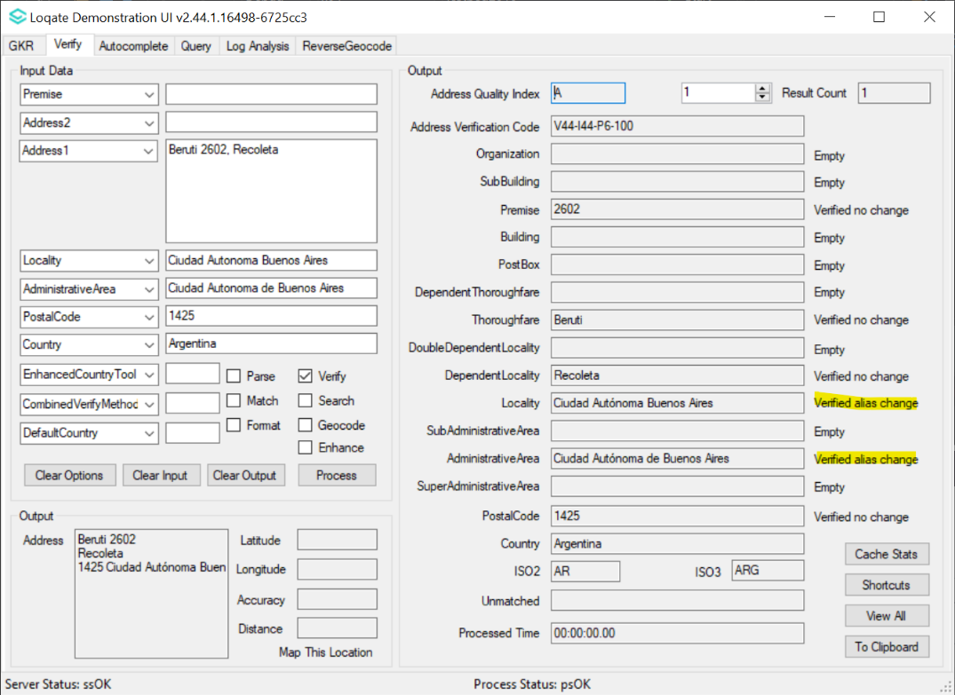

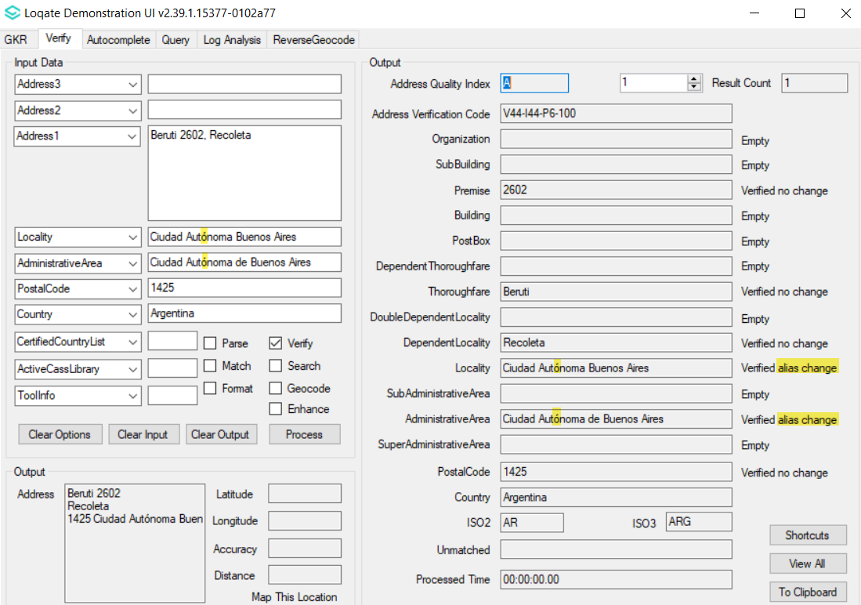 | 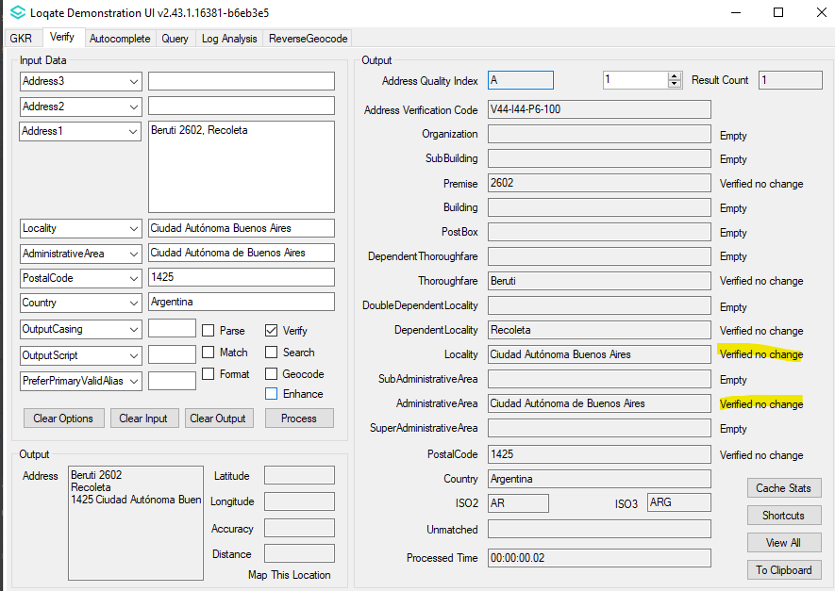

Case Number | Change Description | Category | Country | Example Address
CAS-79524-F2K5K0 | CountryDataImporter bugfix to import data from country.txt to country.lfs correctly | API | All | N/A
Before Image |  |  | After Image
N/A |  |  | N/A

Installation Instructions

Please remember to update both the program files and the reference data and please install these to a new fresh folder location. The improvements are tied to the data in the Global Knowledge Repository and the Local API. When updating the data, it is recommended to use a new data folder each time to ensure the latest dataset is installed properly.

If you need any assistance with the upgrade of the Local API or the data update process, please contact GBG Loqate Support.

The setup wizard for the Local API can be obtained from our SFTP server. Please contact your account manager to retrieve the SFTP information. If you do not know who your account manager is, please contact the support team at LoqateSupport@gbgplc.com.

