Loqate, A GBG Solution
Release Notes – Reference Data & Knowledge Base

2022Q3.0 Major Release

Case Resolutions
Please visit https://support.loqate.com/2022q3-0-resolved-cases/ for a list of cases resolved in this release.
If you would like more details on any of the solved cases listed, please contact LoqateSupport@gbgplc.com for further information.

Certification Expiration Dates
If you have purchased either the CASS (USA) or AMAS (Australia) certified products, please be aware that the datasets have expiration dates set by the respective postal authorities. Please ensure that you have the latest library and data installed to avoid loss of service through these products.

Please check Install Manager for the latest versions of AMAS & CASS
 | Loqate Release Date | Certification Expiry Date*
AMAS Data | 2022-05-28 | 2022-09-30
CASS Data | 2022-06-15 | 2022-09-28
CASS (2) Data | 2022-06-24 | 2022-10-28
*Certification Expiry Date is different from Loqate license key expiry date. The earliest expiry date will apply.

For more information on expiry date checking for CASS and AMAS, please refer “Usage expiration” section in https://support.loqate.com/documentation/local-apis/cass-overview-2/ and https://support.loqate.com/address-matching-approval-system-amas/

Data Structure Changes

The below is a summary of the Countries where we have updated the reference data structure.

BPDH/PDH Countries/Country Rebuild

Country | ISO2 | Description
Hong Kong | HK | Country Rebuild- New data source included

Other major changes to highlight:

Country | Description
India | Improvement in parsing and verification, and data coverage.
New Zealand | Improvement in New Zealand dependent locality field verification.
Netherlands | Improvement in parsing and verification.
Peru | Improvement in parsing and verification.
Singapore | Address formatting changed

BPDH/PDH Countries
Hong Kong
Country Information | Description
ISO2 | HK
ISO3 | HKG
Address Format | Organization  PostBox  SubBuilding BuildingPhase  Building BuildingPhaseExtra  Premise Thoroughfare  DependentThoroughfare  DependentLocality  Locality  AdministrativeArea
Address Format (Native) | AdministrativeArea  Locality DependentLocality  DependentThoroughfare Thoroughfare Premise  Building BuildingPhase  Organization SubBuilding PostBox
PDH | YES
PDH completed date
New Source | YES

 | Pre-PDH | Post-PDH
Reference Data | rd_HK_ggg.lfs  rd_HK_ggg_rg.lfs  rd_HK_vfy_ai.lfs  rd_HK_vfy.lfs | rd_HK_ggg.lfs  rd_HK_ggg_rg.lfs  rd_HK_vfy_ai.lfs  rd_HK_vfy.lfs

2022Q2.1 | 2022Q3.0
The building is not verified. | The building is verified.
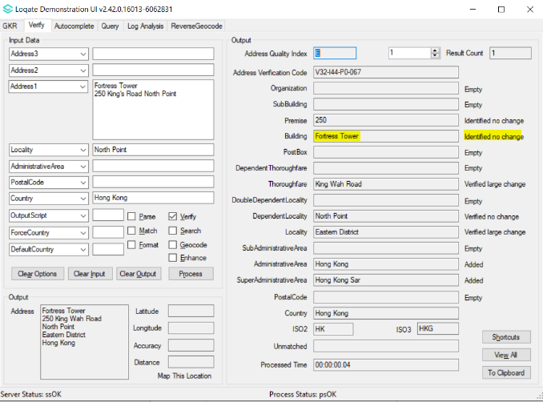 | 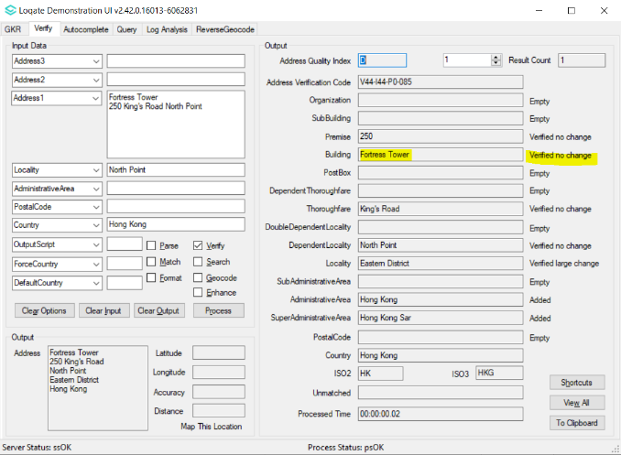

2022Q2.1 | 2022Q3.0
Building group (xx Estate) is separated from building name (xx House) and parsed to thoroughfare field | Building group (xx Estate) is parsed to building field along with building name (xx House) and verified as building.
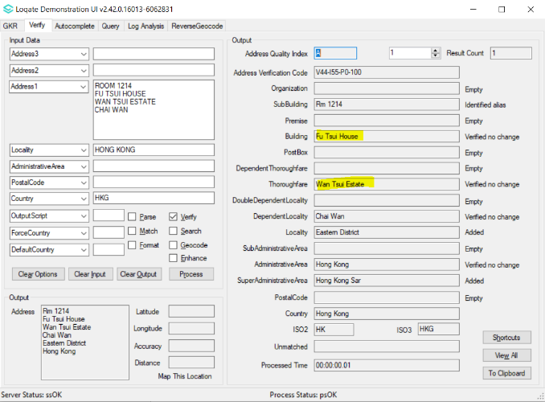 | 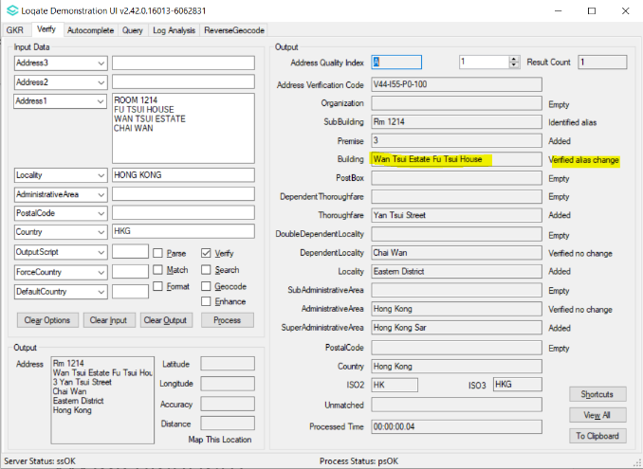

2022Q2.1 | 2022Q3.0
GeoAVC A3 is returned for V4 verification. | GeoAVC P4 is returned for V4 verification.
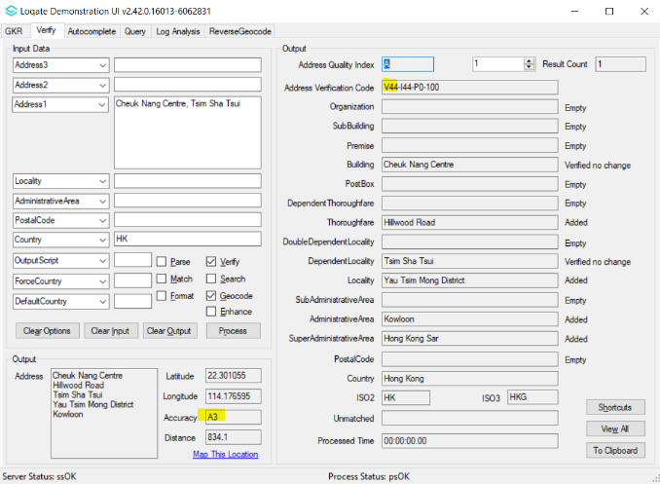 | 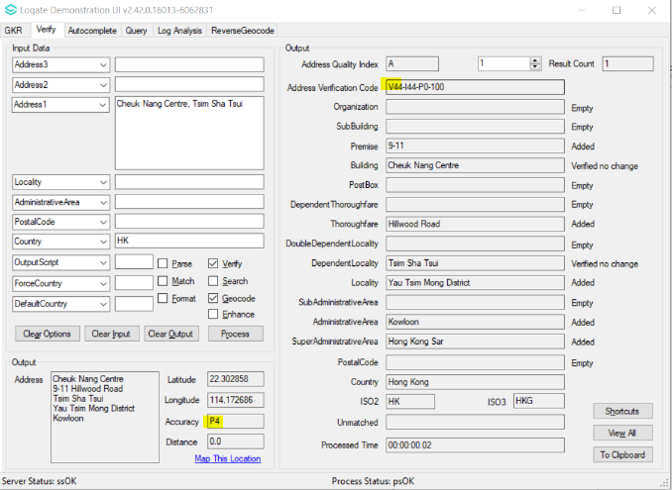

OTHER MAJOR HIGHLIGHTS
India

Improvement in parsing and verification, and data coverage.
2022Q2.1 | 2022Q3.0
Incorrect parsing which results in incorrect verification  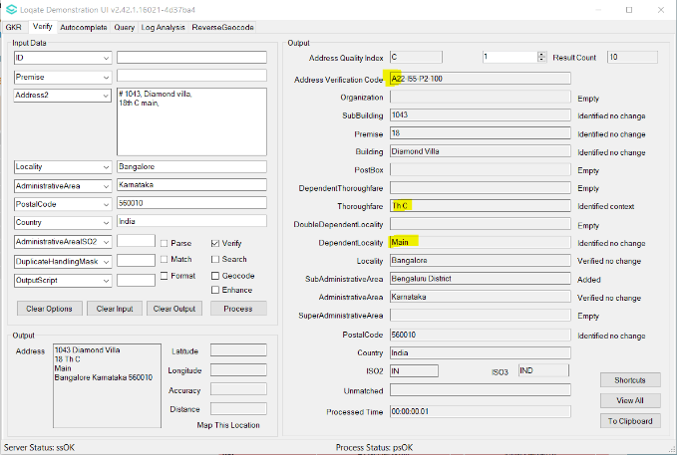 | Parsing has now improved and yields good verification output  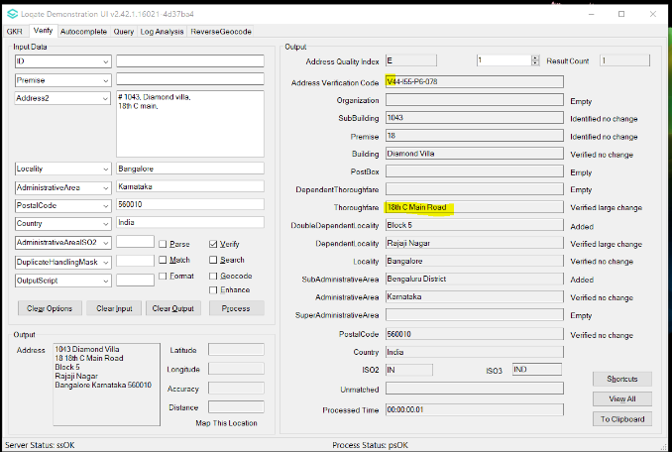
Thoroughfare, Premise and Building are not able to verify.  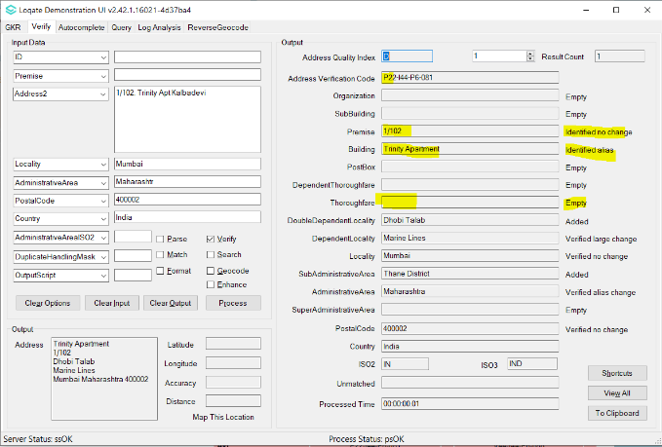 | Thoroughfare, Premise and Building can be verified.  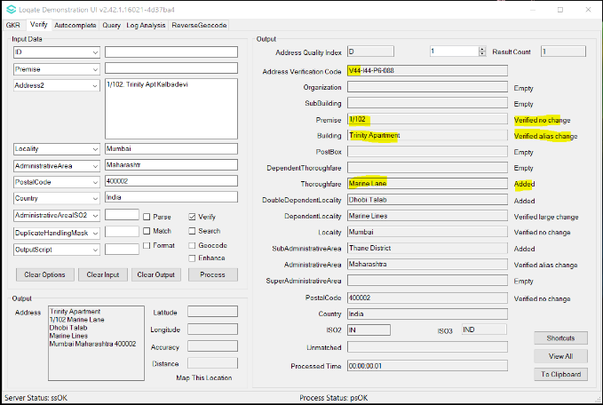

New Zealand

There’s improvement in New Zealand dependent locality verification.
2022Q2.1 | 2022Q3.0
Dependent Locality is incorrectly changed.  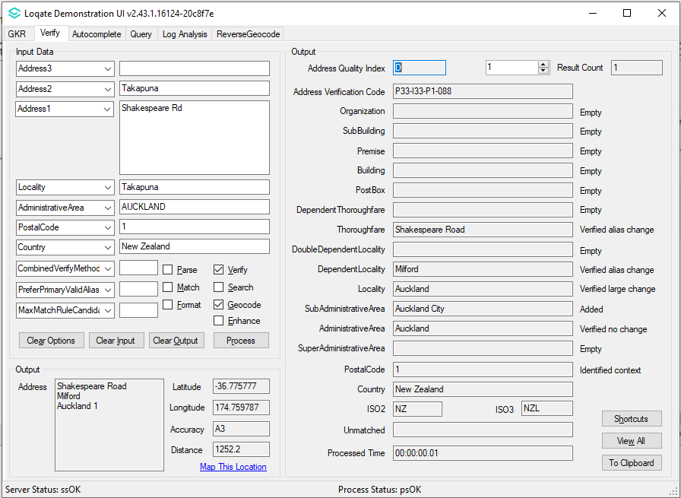 | Dependent Locality correctly returned now.  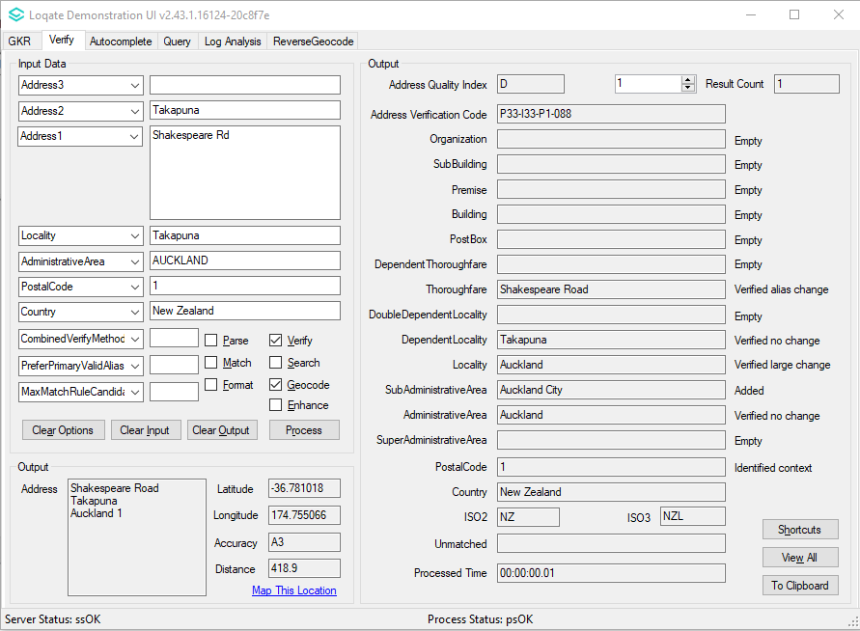
Dependent Locality is verified with alias change.  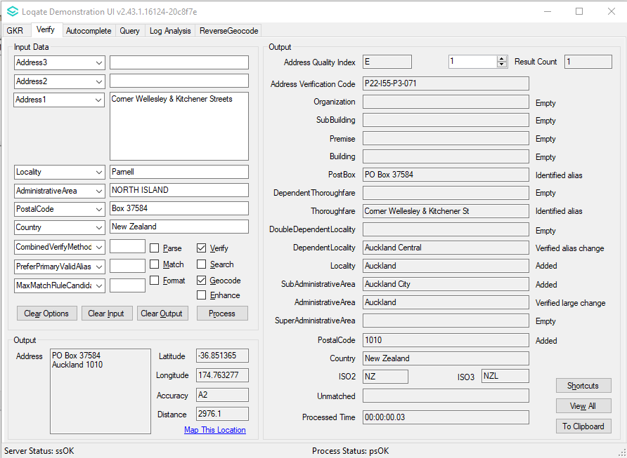 | Dependent Locality now verified with no change.  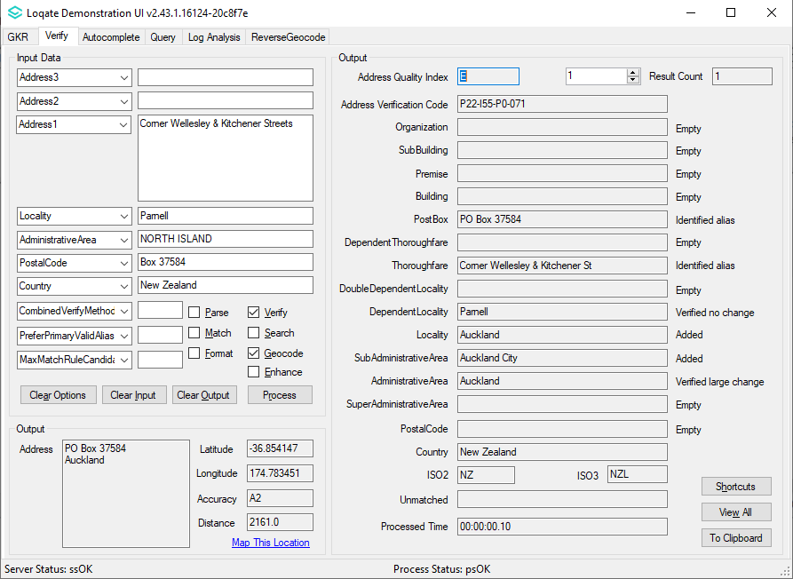

Netherlands

Improvement in parsing and verification.
2022Q2.1 | 2022Q3.0
Thoroughfare and premise are not verified.  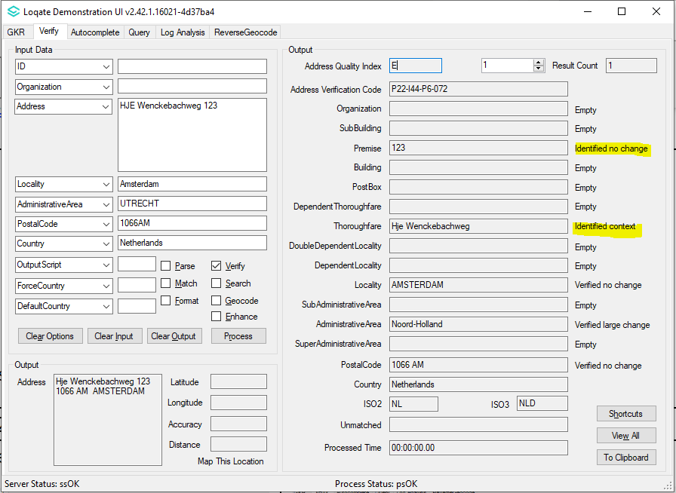 | Thoroughfare and premise can be verified.  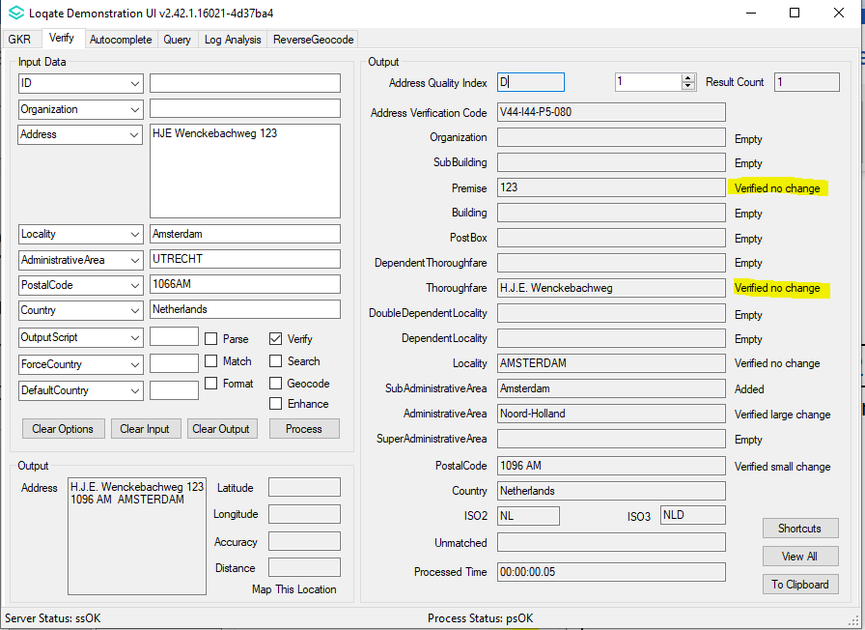

Peru

Improvement in parsing and verification.
2022Q2.1 | 2022Q3.0
Thoroughfare not verified.  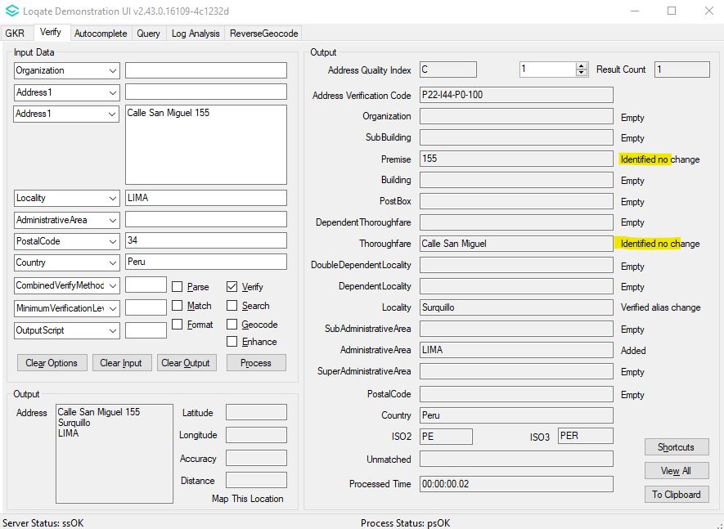 | Thoroughfare and premise can be verified.  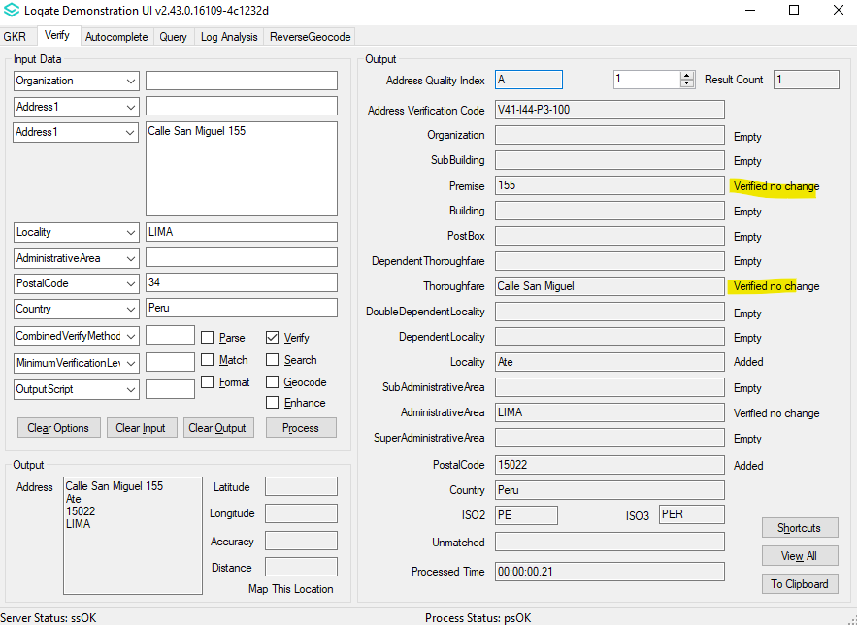

Singapore

Address formatting changed.
2022Q2.1 | 2022Q3.0
SubBuilding prefix have ‘#’ in output address field  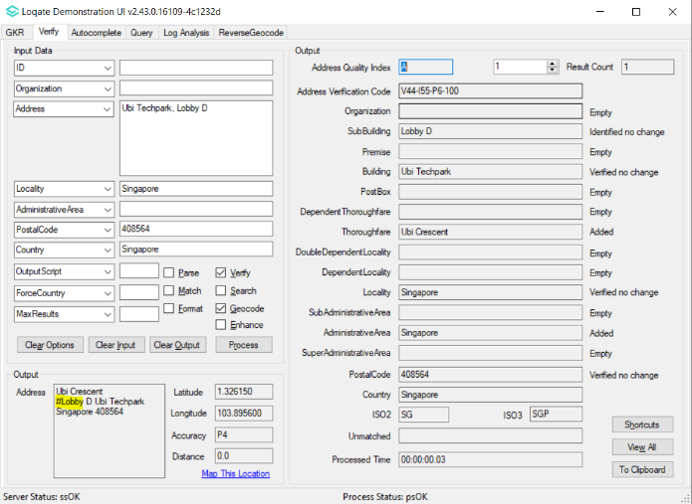 | SubBuilding prefix does not have any symbols in output address field  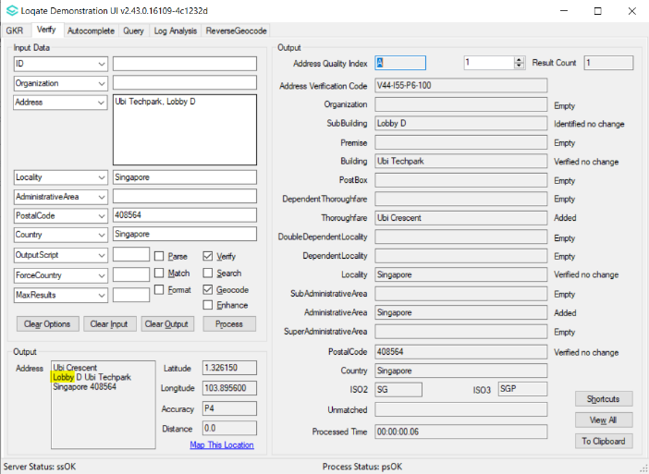

Case Resolutions

2022Q3.0 Data related Case Fixes
Case Number | Change Description | Category | Country | Example Address
CAS-71502-V9G8W2 | Output transliterated values when OutputScript=Native | Data | HK | Address1 = 10 Henderson Road  Locality = Wan Chai District  Country = HKG  Output script = native
Before Image |  |  | After Image
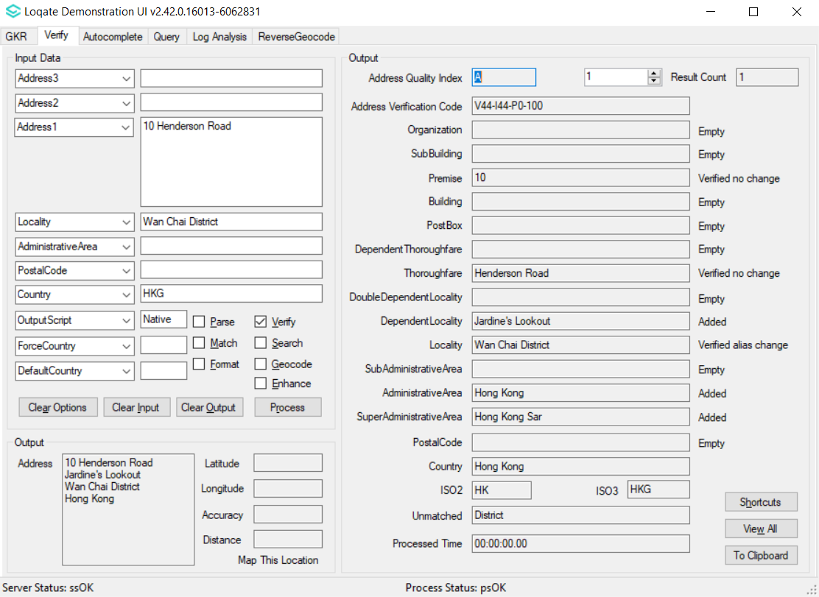 |  |  | 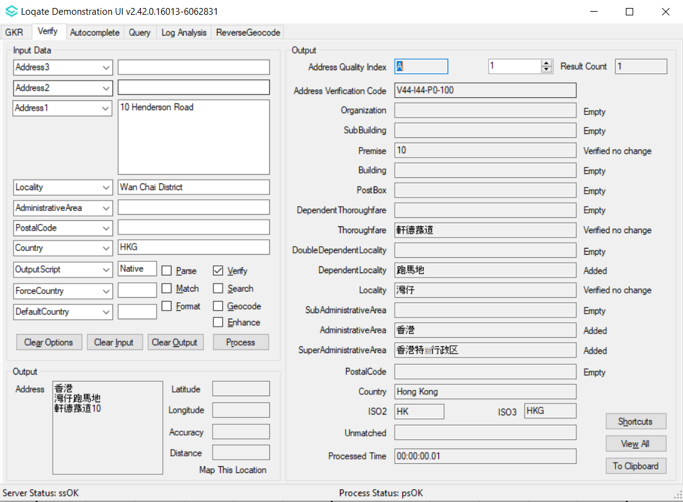

Case Number | Change Description | Category | Country | Example Address
CAS-68916-Z5H7S4 | Unmerged localities and corrected postcodes | Data | DE | Locality = Winsen  PostalCode = 29308  Country = Germany  Locality = Winsen  PostalCode = 21423  Country = Germany
Before Image |  |  | After Image
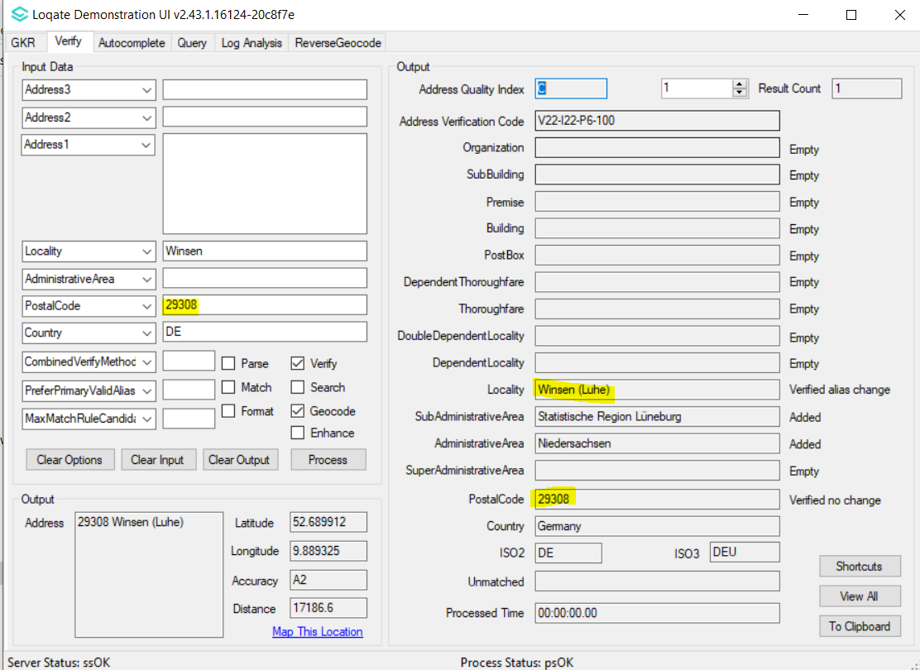 |  |  | 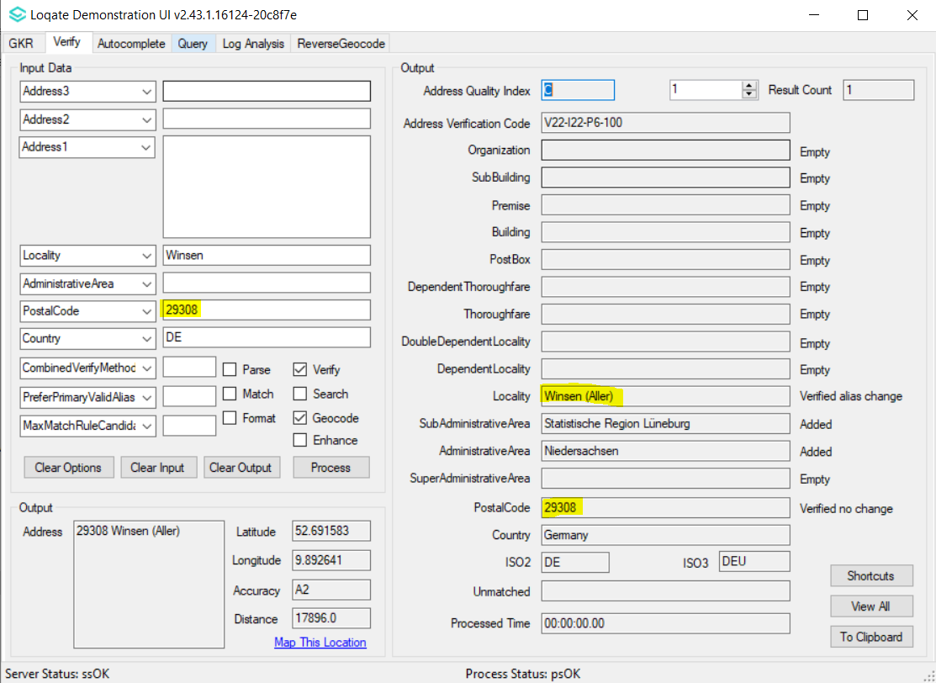
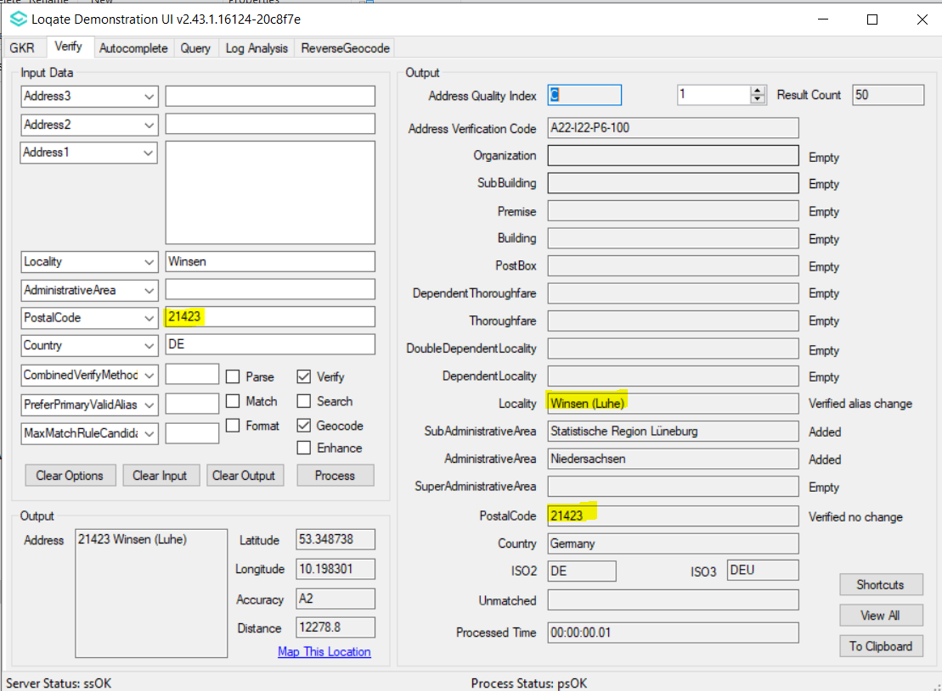 |  |  | 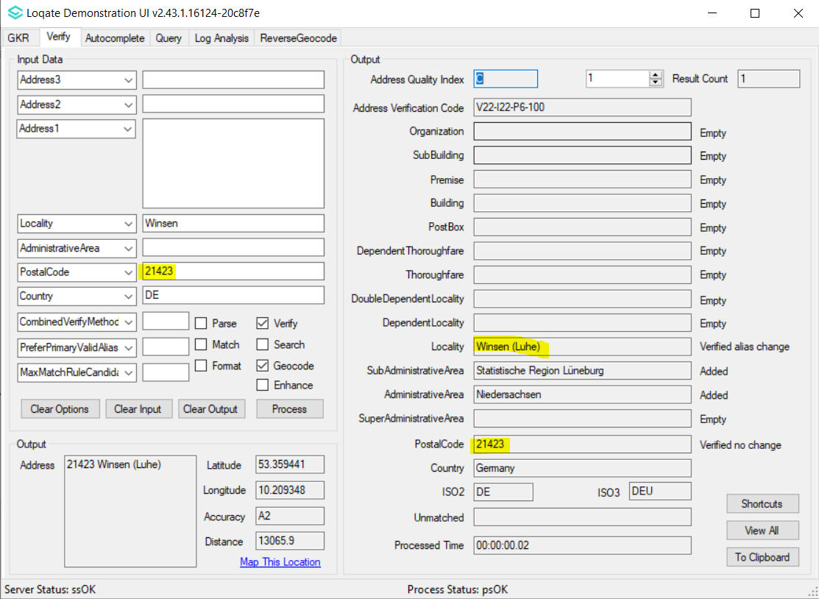

Case Number | Change Description | Category | Country | Example Address
CAS-65340-H7X8T2 | Verification of missing premise number | Data | DE | Address1 = Brauerstr 17 87484 Nesselwang  Address1 = Heinz-Zurmühlen-Straße 14 27211 Bassum  Address1 = Haeverfeld 35 47647 Kerken  Address1 = Mühlstrasse 7 Stahltreppe hoch 69198 Schriesheim
Before Image |  |  | After Image
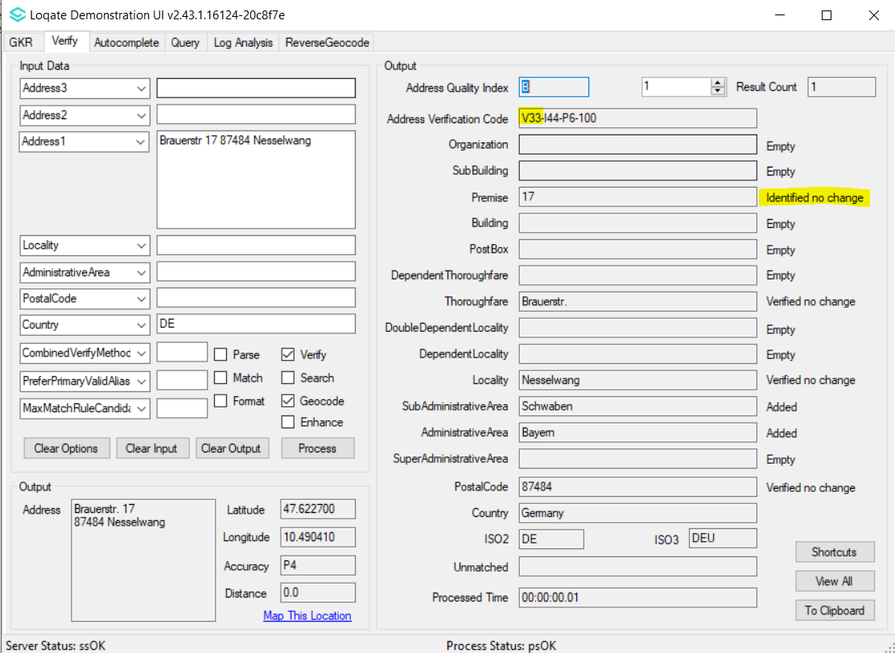 |  |  | 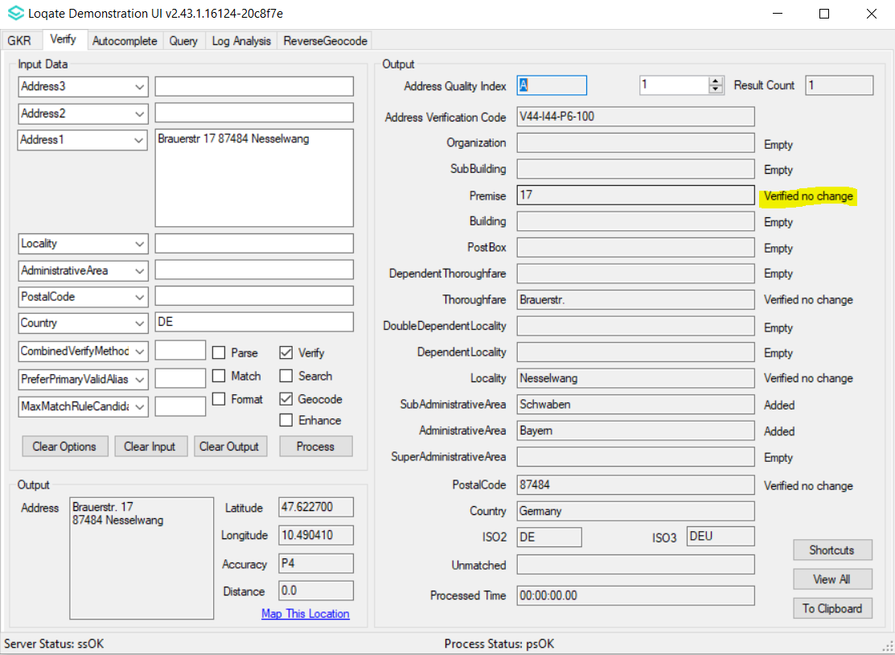
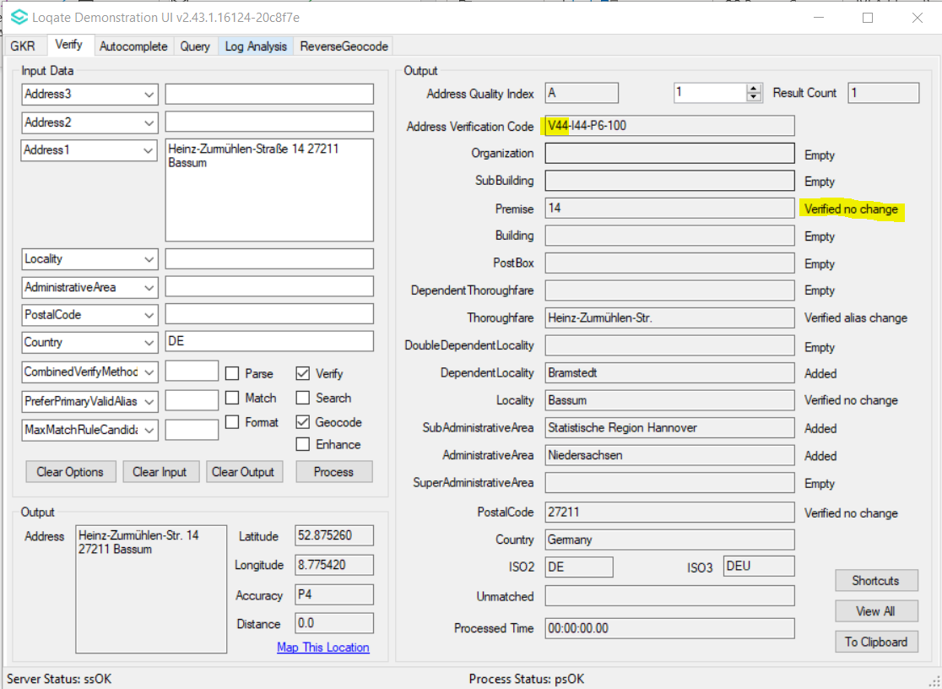 |  |  | 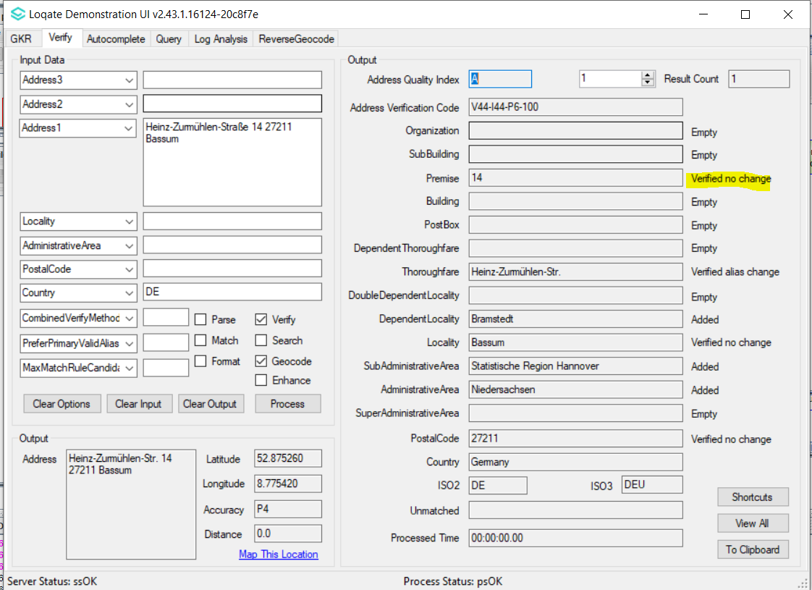
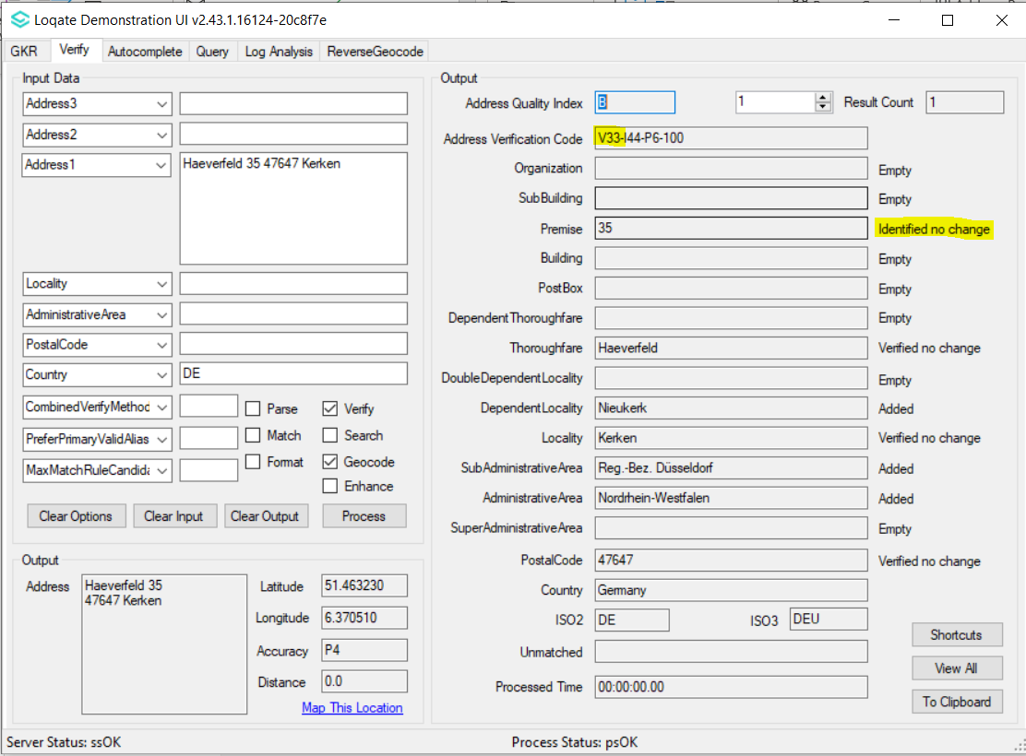 |  |  | 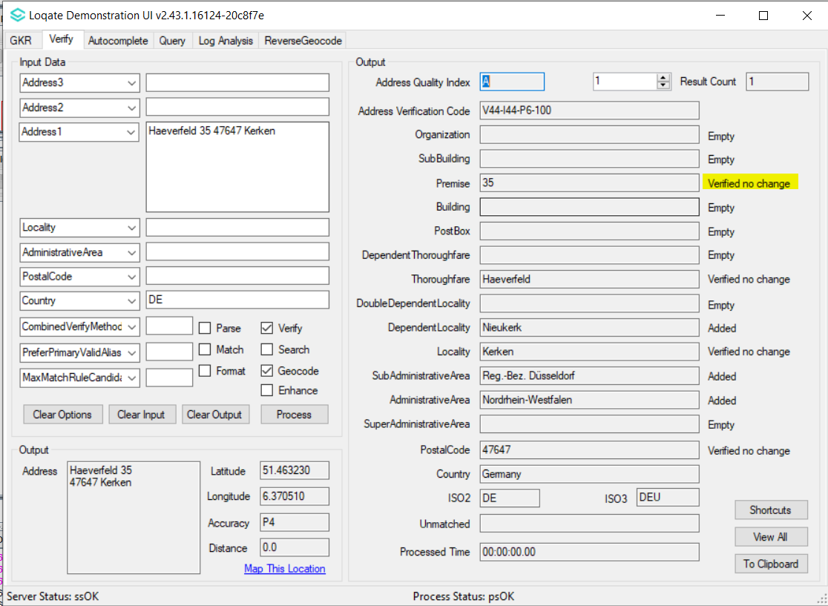
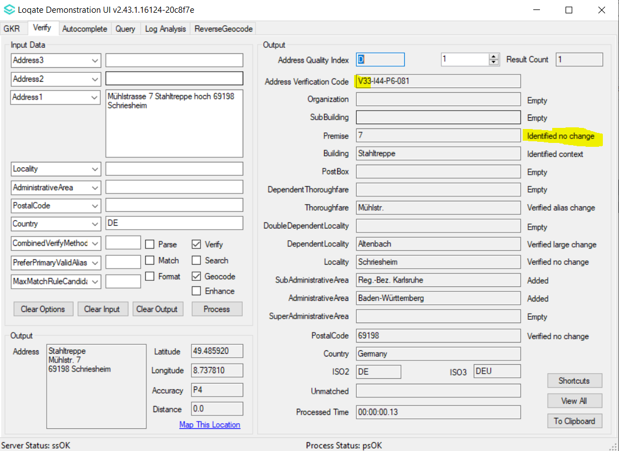 |  |  | 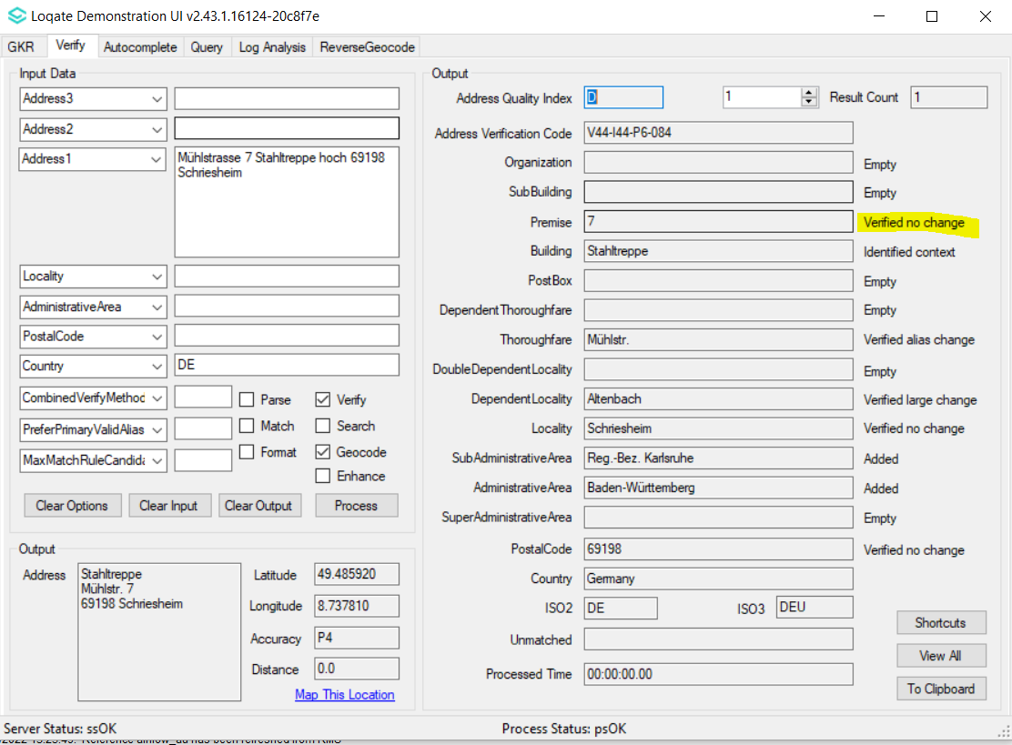

Case Number | Change Description | Category | Country | Example Address
CAS-66130-T7V6C2 | AVC level improvement from 3 to 4 | Data | India | Address: No. 26, 2nd floor, Bunder Street, Chennai - 600001, Tamil Nadu, India.
Before Image |  |  | After Image
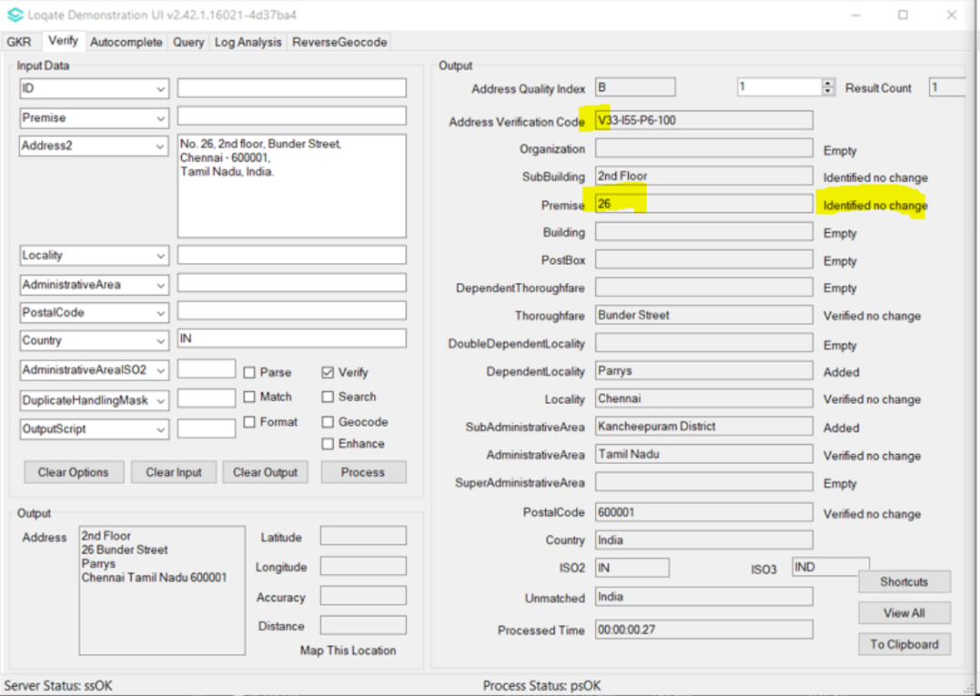 |  |  | 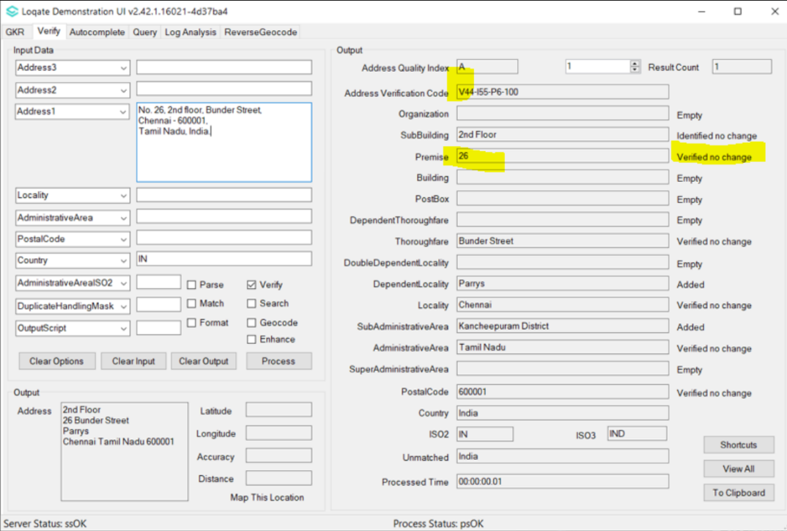

Case Number | Change Description | Category | Country | Example Address
CAS-01728-S8C8Q9 | Improvement in postal code data | Data | IN | -
Before |  |  | After
Claim: Missing 174 postcode. |  |  | In accordance with our supplier out of the 174 postcodes given, 11 are validated postcodes, the remaining 163 postcode do not exist as per Indian government official listing.  The 11 validated postcodes are now present in seed file, which includes:  121013, 500103, 500104, 500107, 516361, 517646, 560111, 560113, 560114, 560115, 700161

Case Number | Change Description | Category | Country | Example Address
CAS-65405-Y6L4J3 | Improvement in parsing input address | Data | US | Address1: Naval Submarine Base New London  Address2: bldg 484  Locality: Groton  AdministrativeArea: CT  PostalCode: 06349  Country: USA
Before Image |  |  | After Image
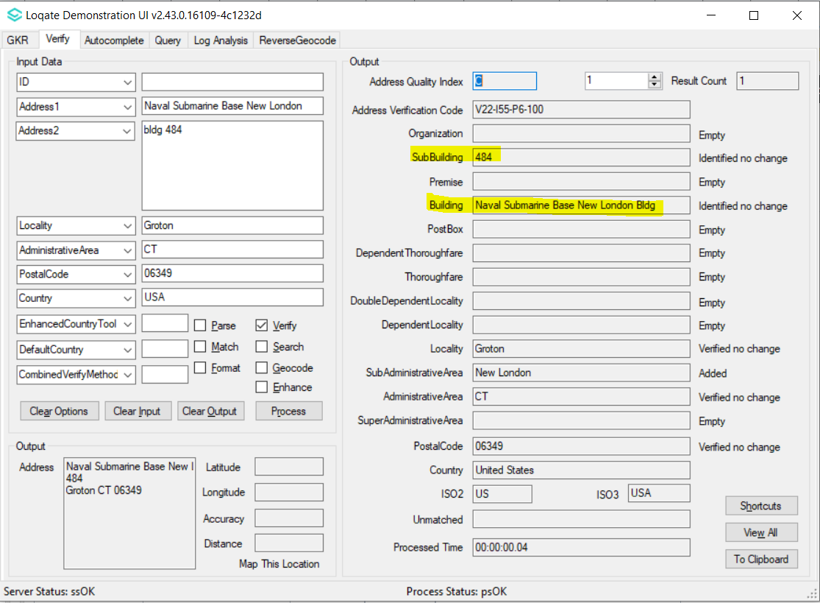 |  |  | 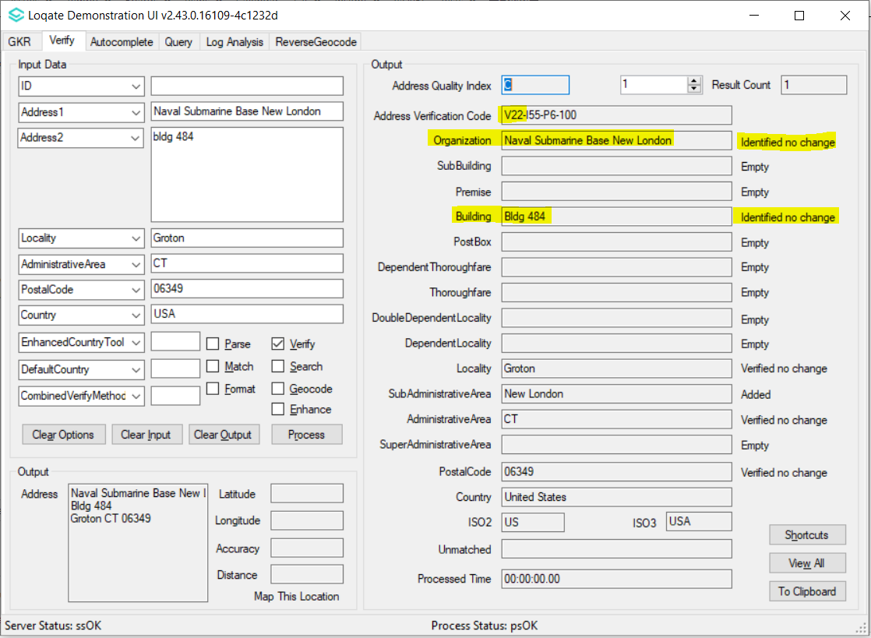

Case Number | Change Description | Category | Country | Example Address
CAS-70511-H9N1Y5 | Verification of corrected Thoroughfare data | Data | CA | 206 Pingwi Place Gloucester ON K1X 0G1  Canada
Before Image |  |  | After Image
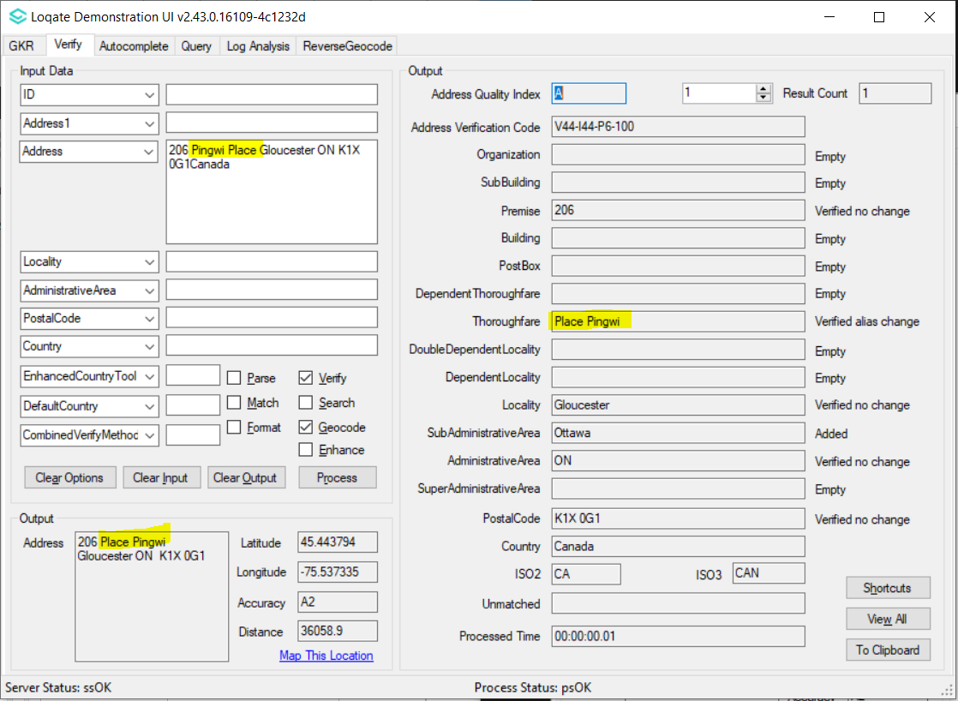 |  |  | 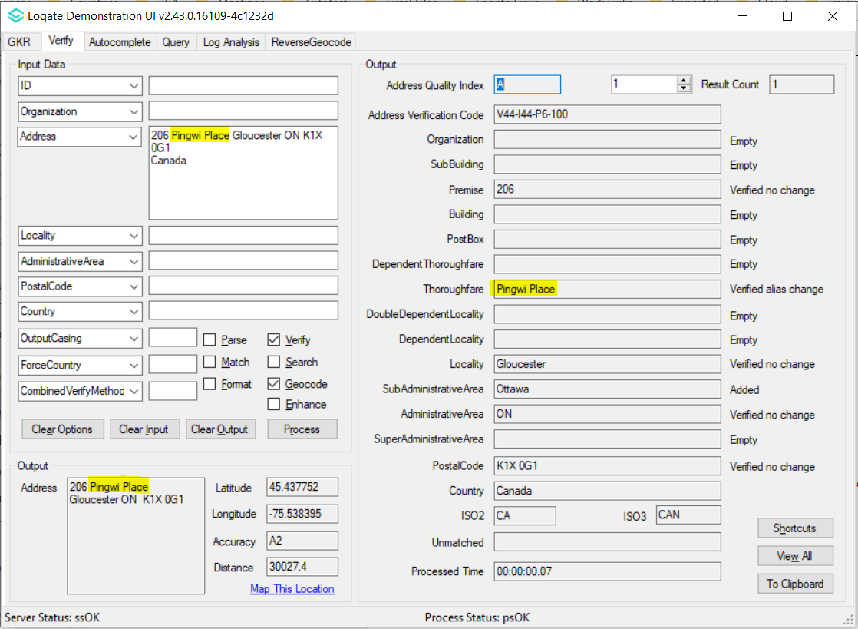

Case Number | Change Description | Category | Country | Example Address
CAS-73124-X9Y0D2 | Verification of removed invalid Thoroughfare from reference data | Data | US | Address: 1 New  Address1: Apt  Country: US  Locality: Winamac  PostalCode: 46996
Before Image |  |  | After Image
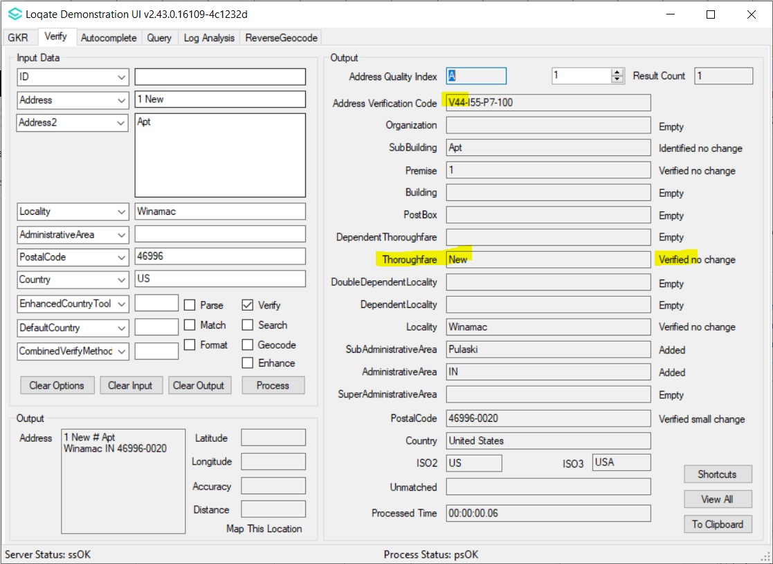 |  |  | 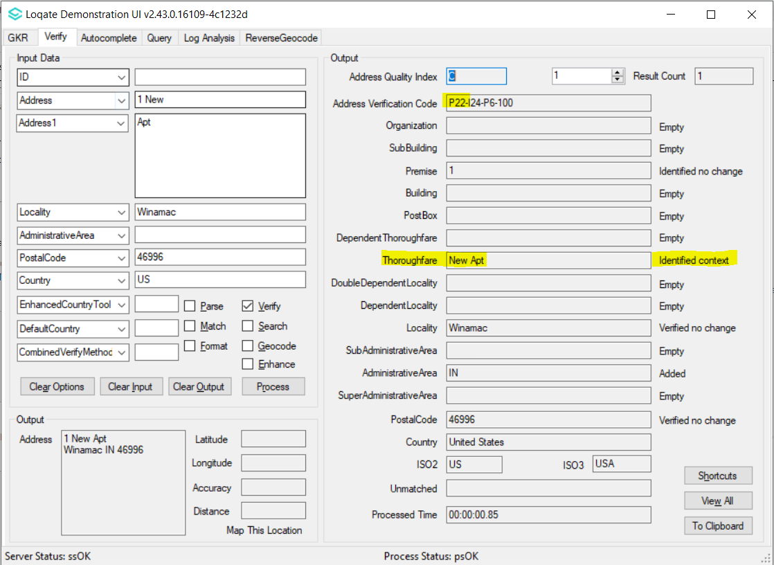

Case Number | Change Description | Category | Country | Example Address
CAS-66268-H0M2J7 | Improvement in parsing SubBuilding and output address format | Data | SG | Address1: 7 ONE-NORTH GATEWAY  Address2: #05-28 LOBBY G  Address3: ONE-NORTH RESIDENCES  PostalCode: 138642  Address1: Regent Grove Condo, 50 Choa Chu Kang North 7  Address2: #09-01, Tower A  Locality: SINGAPORE  PostalCode: 689527  Address1: 32 TANAH MERAH KECHIL ROAD  Address2: #08-20 TOWER 1B EAST MEADOWS  Locality: SINGAPORE  PostalCode: 465559  Country: SGP
Before Image |  |  | After Image
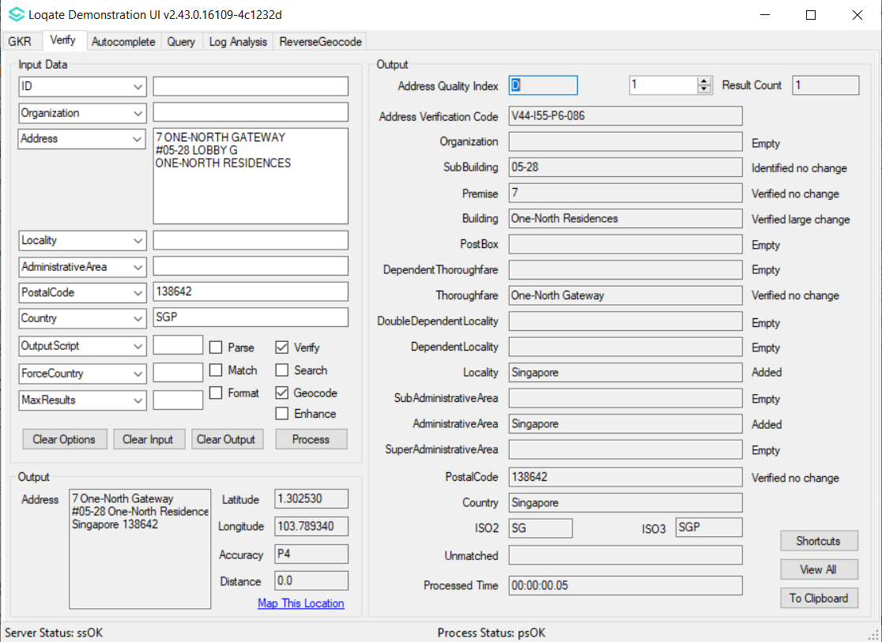 |  |  | 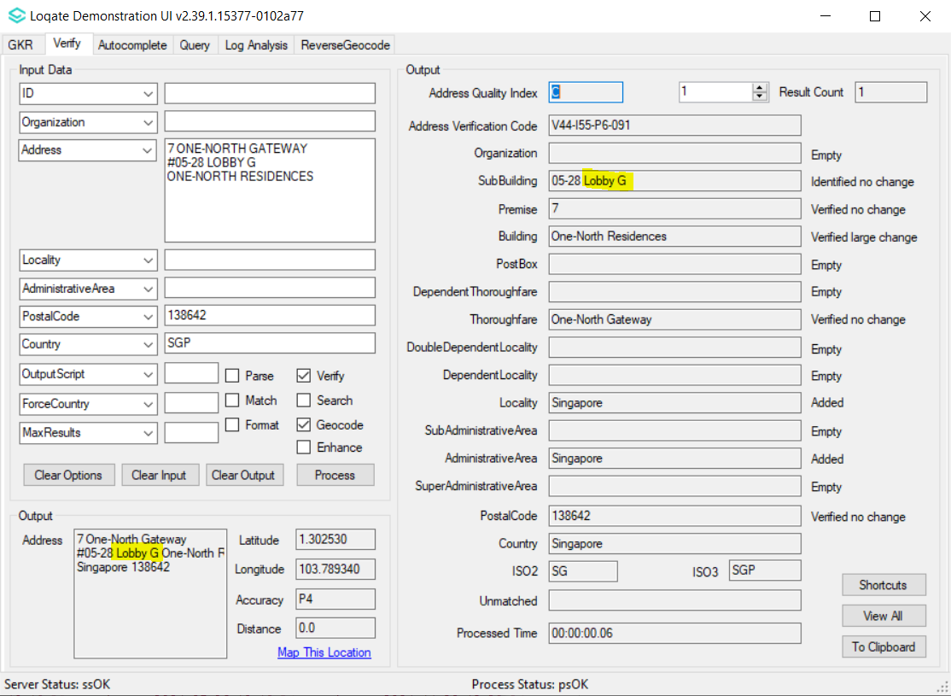
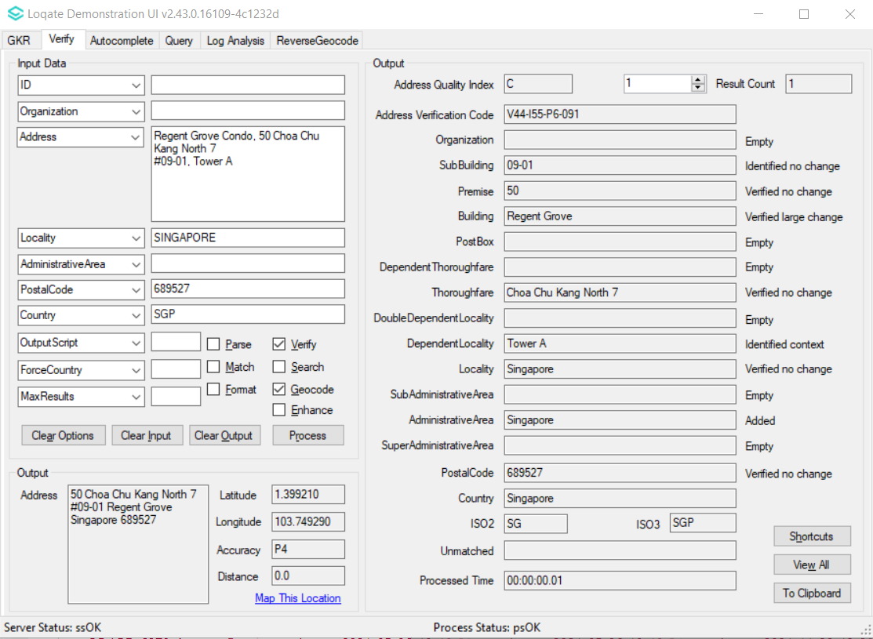 |  |  | 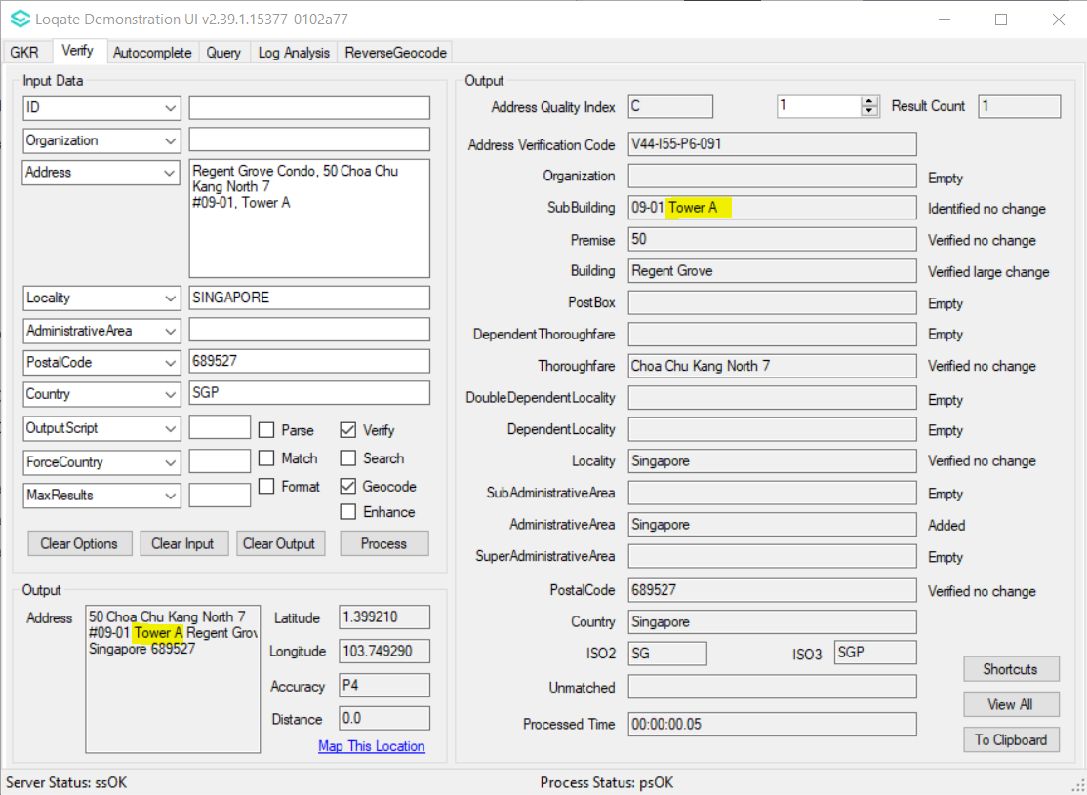
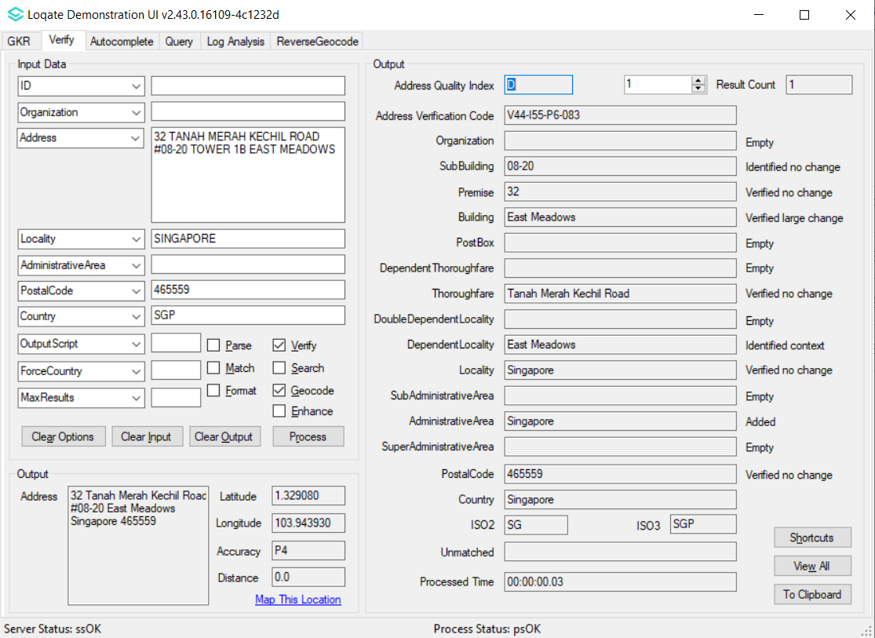 |  |  | 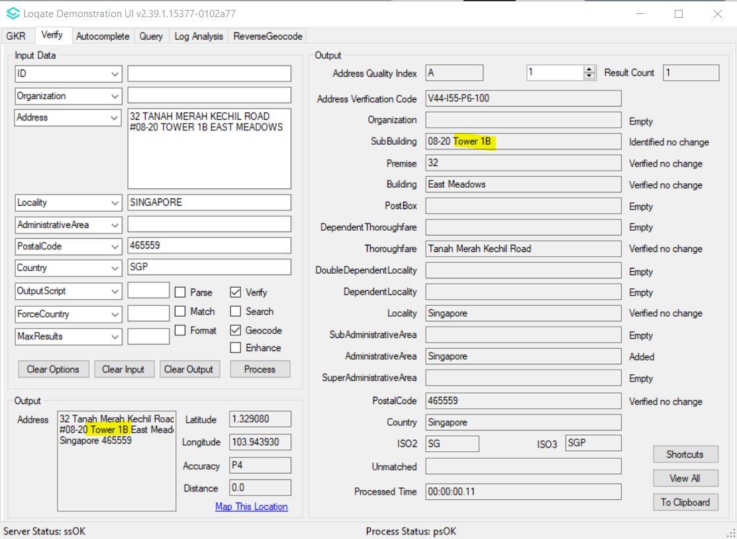

Case Number | Change Description | Category | Country | Example Address
CAS-66268-H0M2J7 | Improvement in parsing of ThoroughfareType | Data | FR | Address1: RIE DU HOUX 4-55  Locality: METZ MAGNY  PostalCode: 57000  Country: FR
Before Image |  |  | After Image
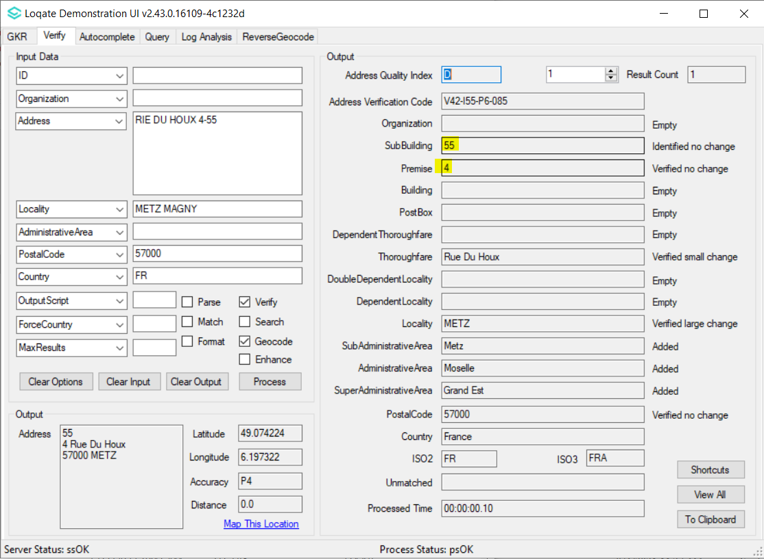 |  |  | 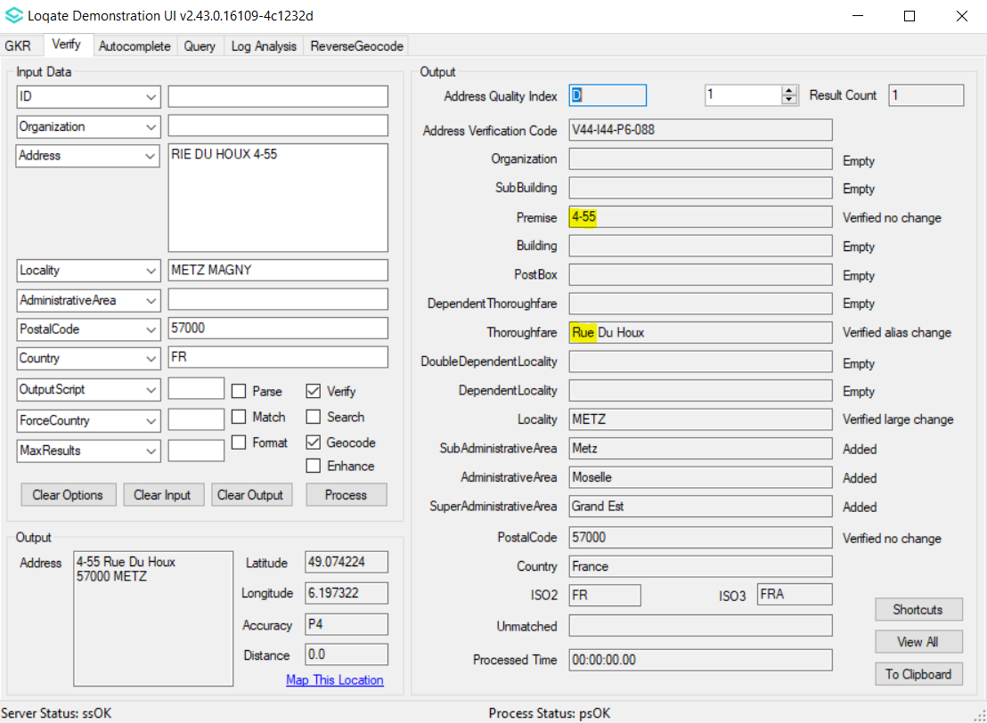

Case Number | Change Description | Category | Country | Example Address
CAS-73742-Z5S3M4 | Improvement on verification of Locality and DependentLocality | Data | NZ | Address1: 124 Shakespeare Road, Takapuna, Auckland 0622  Country: NZ
Before Image |  |  | After Image
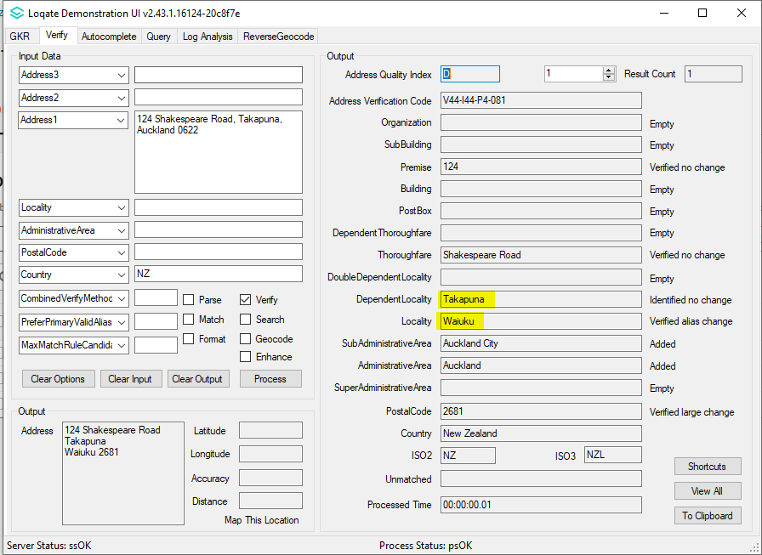 |  |  | 