Loqate, A GBG Solution
Release Notes – Verify API

2022Q3.0 Major Release

Case Resolutions
Please visit https://support.loqate.com/2022q3-0-resolved-cases/ for a list of all cases resolved in this release. If you would like more details on any of the solved cases listed, please contact LoqateSupport@gbgplc.com for further information.

Local API Notices
This is to inform our customers that in this 2022Q3.0 release we have made a major change to the API in relation to preposition handling for Germany along with 2 minor enhancements for Colombia and New Zealand.

Case Number | Change Description | Country
CAS-49891-X4J8D4 | This is a new feature converting preposition words appears in German Locality to lowercase when OutputCasing=<Empty>/Default or OutputCasing=Title. | DE
CAS-60702-Z5Q3X6 | Colombia cross-street addressing causes performance issue, even slower if multithread | CO
CAS-62552-Z7G8Z2 | New Zealand SEED enhance process returns incorrect city now fixed. | NZ

Local API Improvements

Case Number | Change Description | Category | Country | Example Address
CAS-49891-X4J8D4 | This is a new feature converting preposition words appears in German Locality to lowercase when OutputCasing=<Empty>/Default or OutputCasing=Title. | API | DE | - Taunusanlage 12  60325 Frankfurt Am Main, DE  - Marktpl. 1  91541 Rothenburg ob der Tauber, DE
Before Image |  | After Image
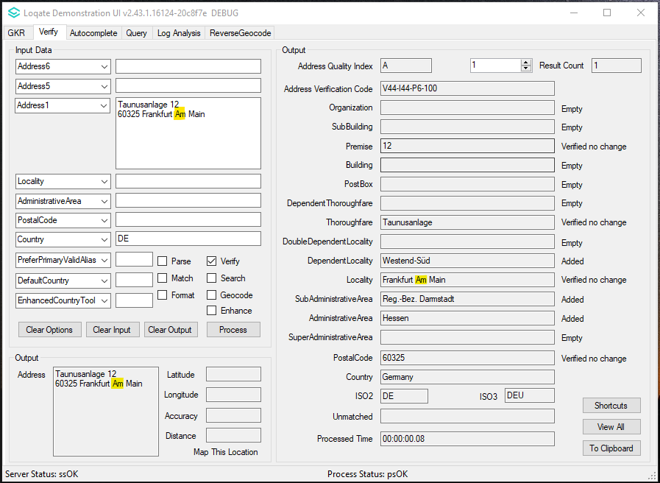 |  | 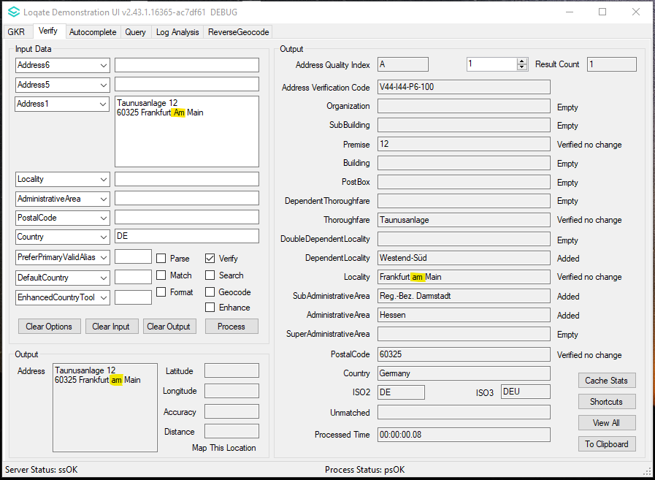
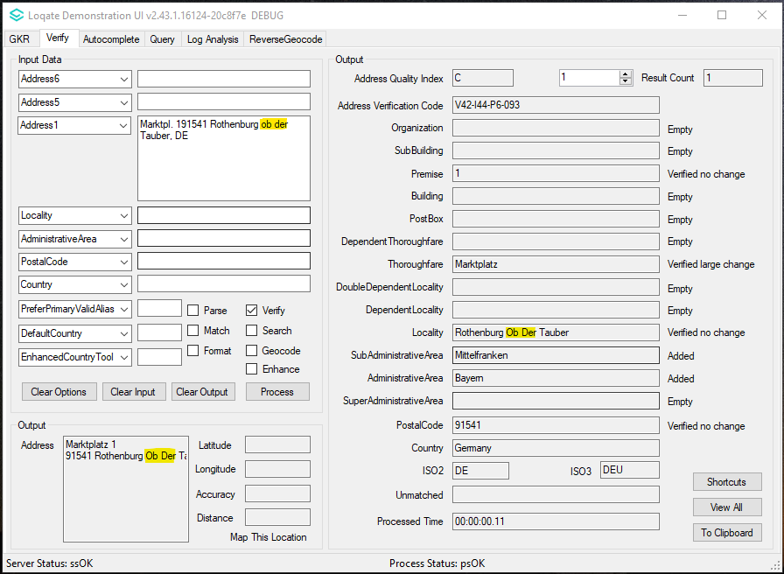 |  | 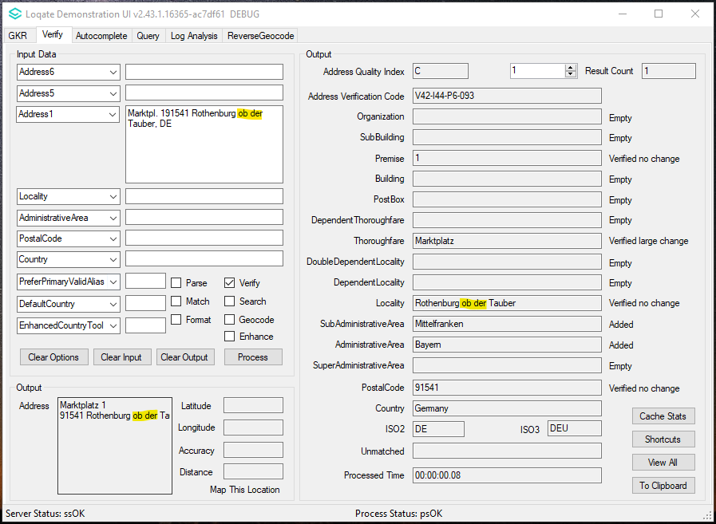

Case Number | Change Description | Category | Country | Example Address
CAS-62552-Z7G8Z2 | New Zealand SEED enhance process returns incorrect city now fixed. | API | NZ | Address1: 8 Antares PI  Locality: Auckland  DefaultCountry: NZ
Before Image |  |  | After Image
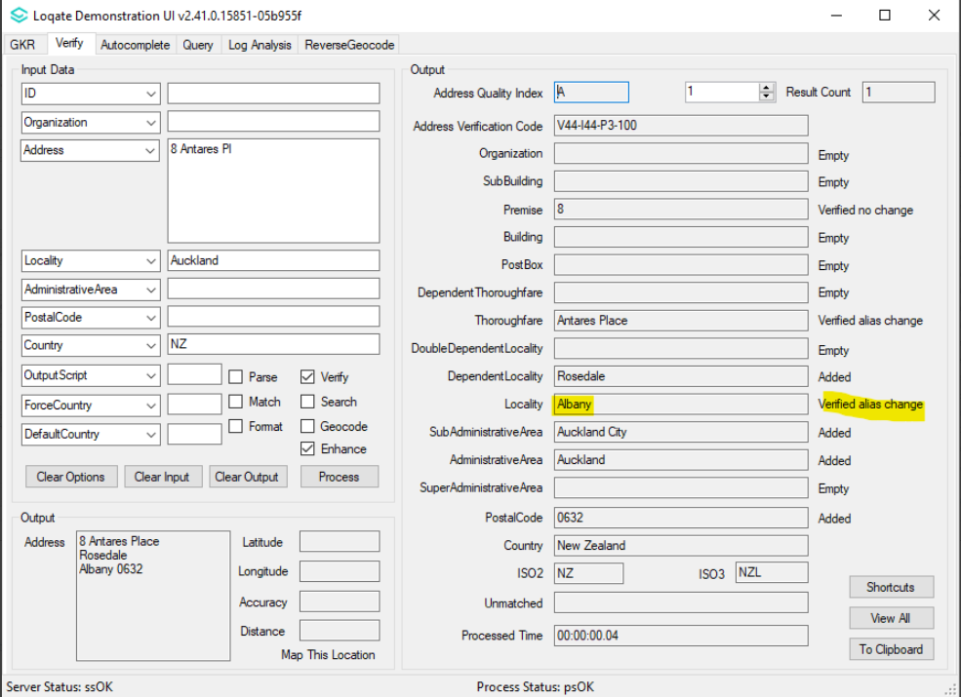 |  |  | 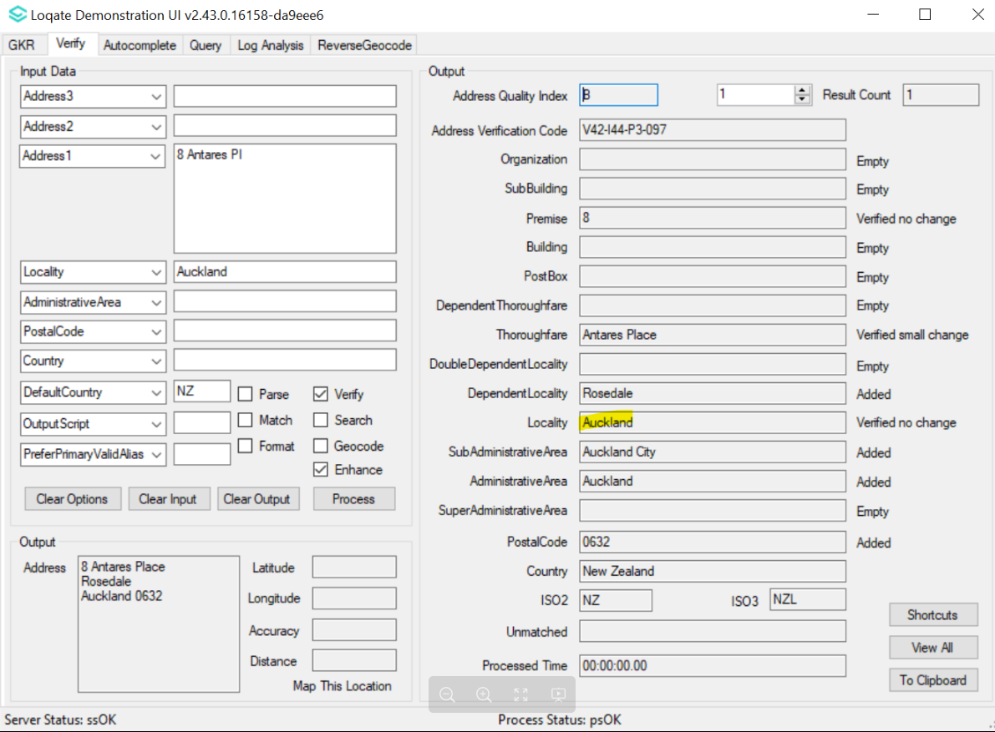

Case Number | Change Description | Category | Country | Example Address
CAS-60702-Z5Q3X6 | Engine related fix discovered when processing Colombia cross-street addressing where it caused performance issue, even slower if multithread – fix included in Q3.0 | API | CO | CL. 2 SUR Nro. 1A-09  BOGOTA  CUNDINAMARCA  CO

Installation Instructions

Please remember to update both the program files and the reference data and please install these to a new fresh folder location. The improvements are tied to the data in the Global Knowledge Repository and the Local API. When updating the data, it is recommended to use a new data folder each time in order to ensure the latest dataset is installed properly.

If you need any assistance with the upgrade of the Local API or the data update process, please contact GBG Loqate Support.

The setup wizard for the Local API can be obtained from our SFTP server. Please contact your account manager to retrieve the SFTP information. If you do not know who your account manager is, please contact the support team at LoqateSupport@gbgplc.com.

