Loqate, A GBG Solution
Release Notes – Reference Data & Knowledge Base

2022Q3.1 Minor Release

Case Resolutions
Please visit https://support.loqate.com/2022q3-1-resolved-cases/ for a list of cases resolved in this release.
If you would like more details on any of the solved cases listed, please contact LoqateSupport@gbgplc.com for further information.

Certification Expiration Dates
If you have purchased either the CASS (USA) or AMAS (Australia) certified products, please be aware that the datasets have expiration dates set by the respective postal authorities. Please ensure that you have the latest library and data installed to avoid loss of service through these products.

Please check Install Manager for the latest versions of our certification data
 | Loqate Release Date | Certification Expiry Date*
AMAS Data | 2022-08-18 | 2022-12-31
CASS Data | 2022-08-17 | 2022-11-28
CASS (2) Data | 2022-07-26 | 2022-11-28
SERP | 2022-08-17 | 2022-12-31

For more information on expiry date checking for CASS and AMAS, please refer “Usage expiration” section in https://support.loqate.com/documentation/local-apis/cass-overview-2/ and https://support.loqate.com/address-matching-approval-system-amas/

Data Structure Changes

The below is a summary of the Countries where we have updated the reference data structure.

Countries Refreshed or Rebuilt

Country | ISO2 | Description
Japan | JP | Country refresh and rebuild – Addition of Company and Building PostalCode
Spain | ES | Country Refresh and rebuild – Addition of new SubBuilding fields

Other major changes to highlight:

Country | Description
Denmark | Addition of Major Recipient Postcode
Finland | Improvement in address verification
Hungary | Improvement in thoroughfare and premise coverage
Greece | Improvement in parsing of thoroughfare and verification
Korea, Republic of | Address formatting changed
Switzerland | Improvement in address verification

Details of Country Data Changes
Country Information | Description
ISO2 | JP
ISO3 | JPN
Address Format | Organization  PostBox  SubBuilding Building  Premise Thoroughfare  DependentThoroughfare  DoubleDependentLocality  DependentLocality  Locality AdministrativeArea PostalCode
PDH | No
PDH completed date | 2022Q3.1
New Source | No

 | Pre-PDH | Post-PDH
Reference Data | rd_JP.lfs  rd_JP_ai.lfs  rd_JP_enh_S.lfs  rd_JP_r.lfs  rd_JP_r1.lfs  rd_JP_rg.lfs | rd_JP_ggg_f.lfs  rd_JP_ggg.lfs  rd_JP_ggg_r1.lfs  rd_JP_ggg_r2.lfs  rd_JP_ggg_rg.lfs  rd_JP_ggg_r.lfs  rd_JP_vfy_ai.lfs  rd_JP_vfy_f.lfs  rd_JP_vfy.lfs  rd_JP_vfy_r1.lfs  rd_JP_vfy_r.lfs

2022Q3.0 | 2022Q3.1
Premise is unverified | Premise is verified now.  General improvement in data coverage.
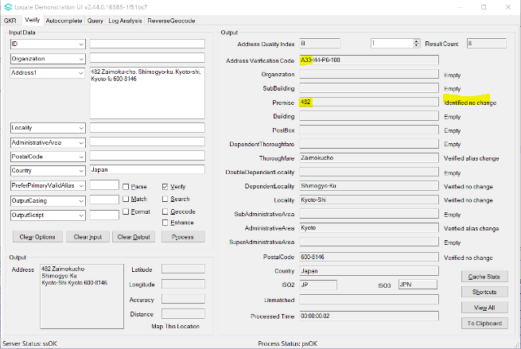 | 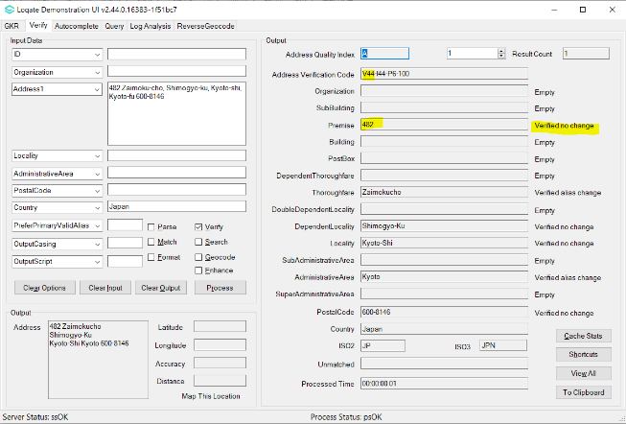

PostalCode is unverified | PostalCode is verified now.  General Improvement in PostalCode coverage.
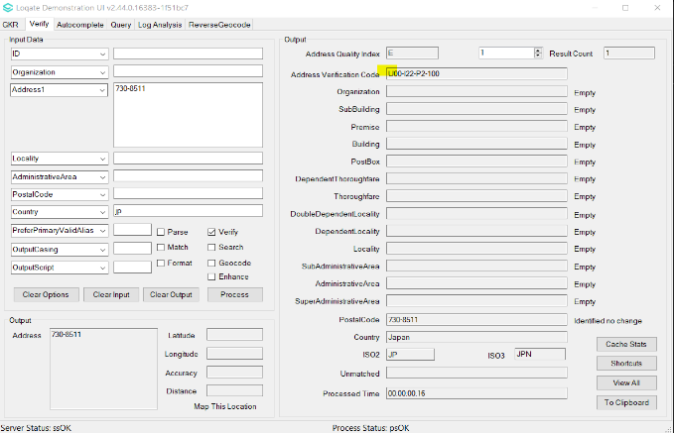 | 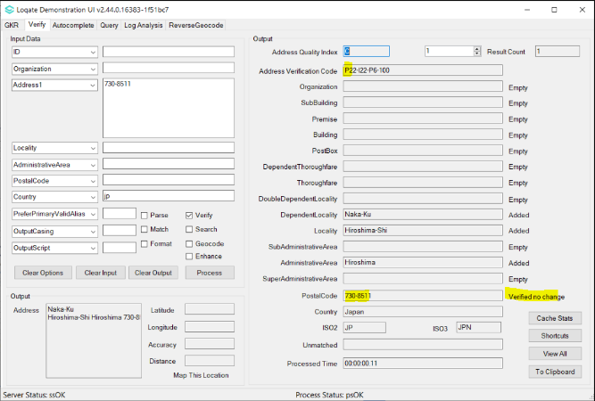

Note: Loqate introduces Company and Building postal code in the 2022Q3.1 release.

Spain
Country Information |  | Description
ISO2 |  | ES
ISO3 |  | ESP
Address Format |  | Organization  Thoroughfare Premise Building SubBuilding  DependentThoroughfare  PostBox  DependentLocality  PostalCode Locality AdministrativeArea
PDH |  | YES
PDH completed date |  | 2022Q3.1
New Source |  | YES (DataCentric SubBuilding)
 | Pre-PDH |  | Post-PDH
Reference Data | rd_ES_ggg.lfs  rd_ES_ggg_r1.lfs  rd_ES_ggg_r2.lfs  rd_ES_ggg_rg.lfs  rd_ES_ggg_r.lfs  rd_ES_vfy_ai.lfs  rd_ES_vfy.lfs  rd_ES_vfy_r.lfs |  | rd_ES_ggg.lfs  rd_ES_ggg_r.lfs  rd_ES_ggg_r1.lfs  rd_ES_ggg_r2.lfs  rd_ES_ggg_rg.lfs  rd_ES_vfy_ai.lfs  rd_ES_vfy.lfs  rd_ES_vfy_r.lfs  rd_ES_vfy_r1.lfs

Note: Loqate introduces new additional SubBuilding information in the 2022Q3.1 release. The SubBuilding field format now is constructed from the combination of SubBuildingBlock + SubBuildingStaircase + SubBuildingFloor + SubBuildingDoor
SubBuilding elements that are available in new Spain reference data.
- SubBuildingBlock
- SubBuildingStaircase
- SubBuildingFloor
- SubBuildingDoor

Example:
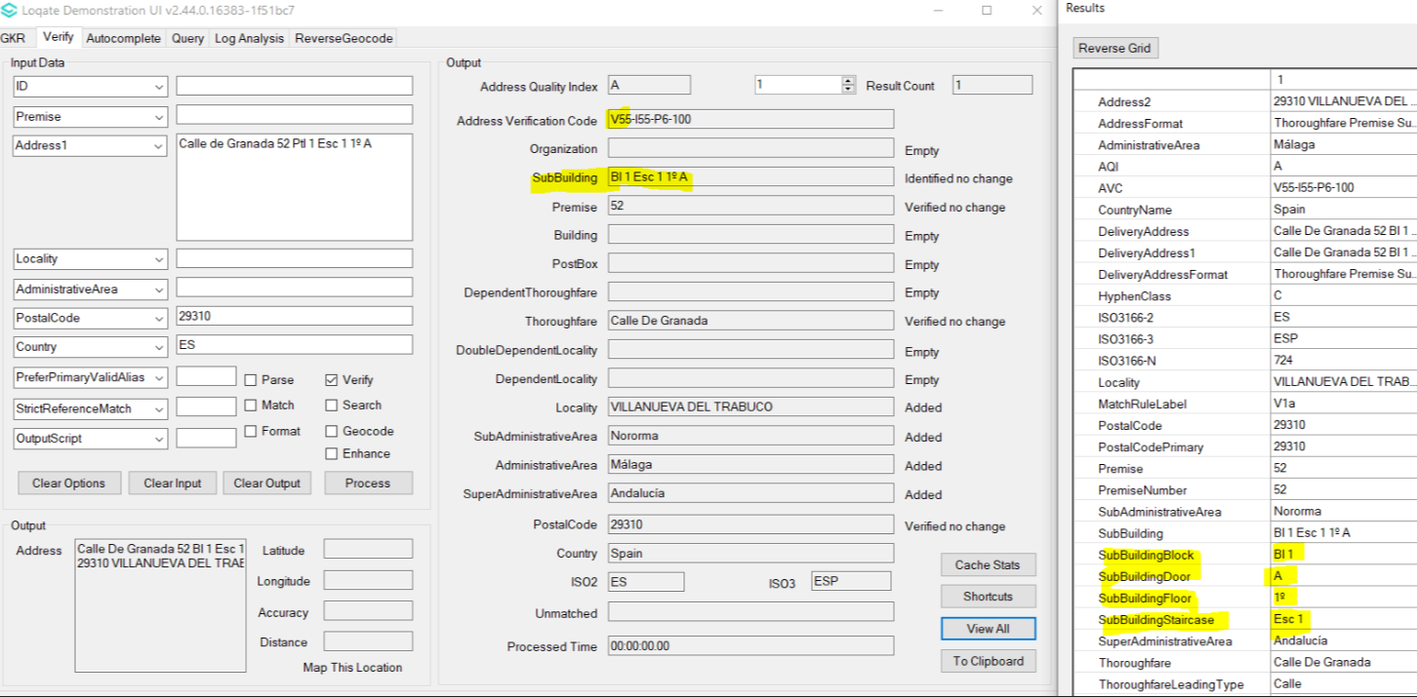

2022Q3.0 | 2022Q3.1
SubBuilding fields cannot be verified | SubBuilding fields can be verified now
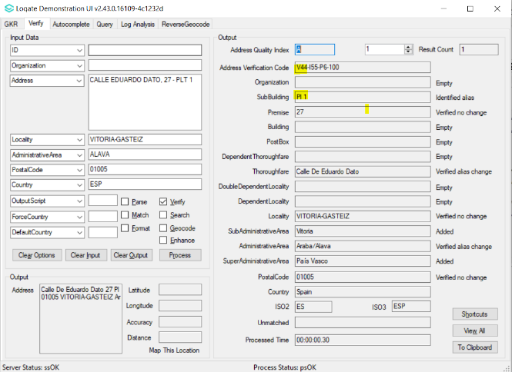 | 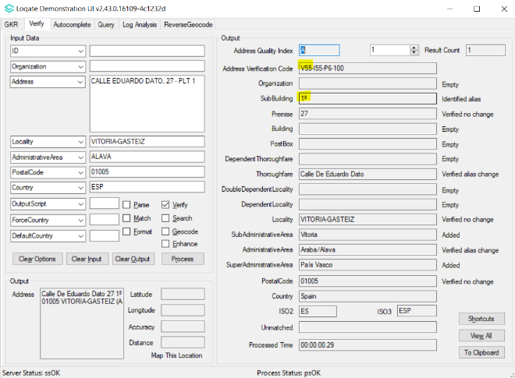

Other Major Country Changes
Denmark
Addition of 18 Major Recipient Postcode as valid alias to the current postcode.
2022Q3.0 | 2022Q3.1
Major Recipient Postcode status is identified with no change.  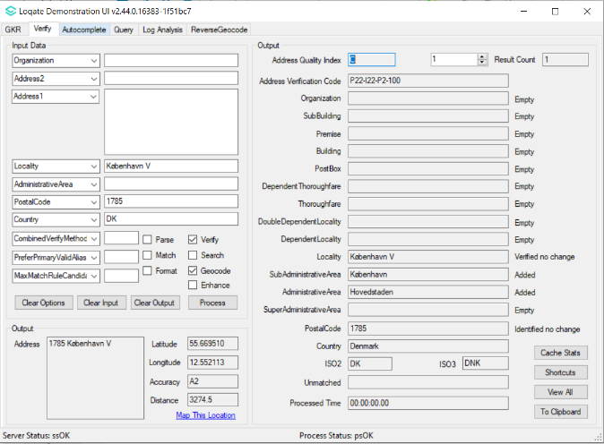 | Major Recipient Postcode can be verified with no change.  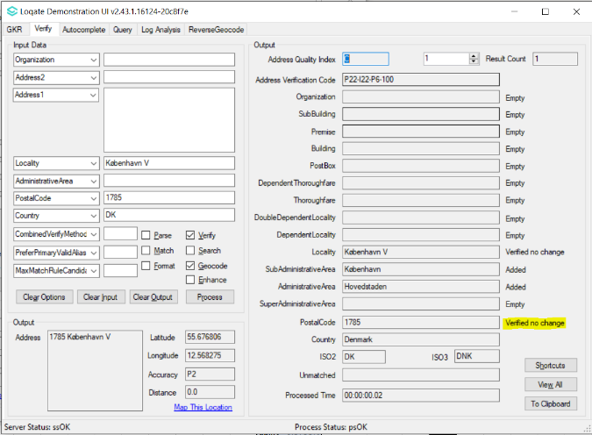

Major Recipient Postcode status is identified with no change.  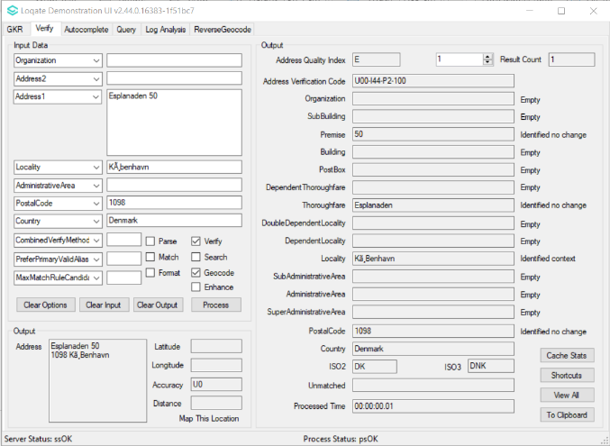 | Major Recipient Postcode can be verified with no change.  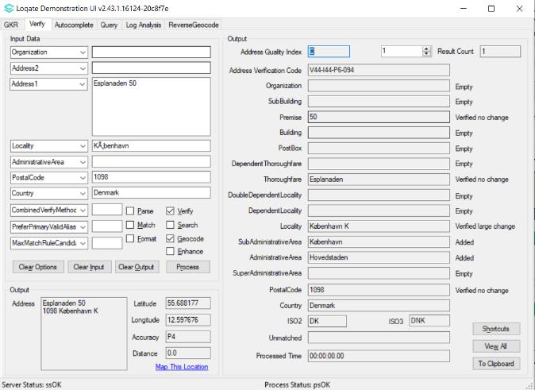

Finland
Improvement in address verification.
2022Q3.0 | 2022Q3.1
Premise not verified, and thoroughfare verified large change to other thoroughfare name.  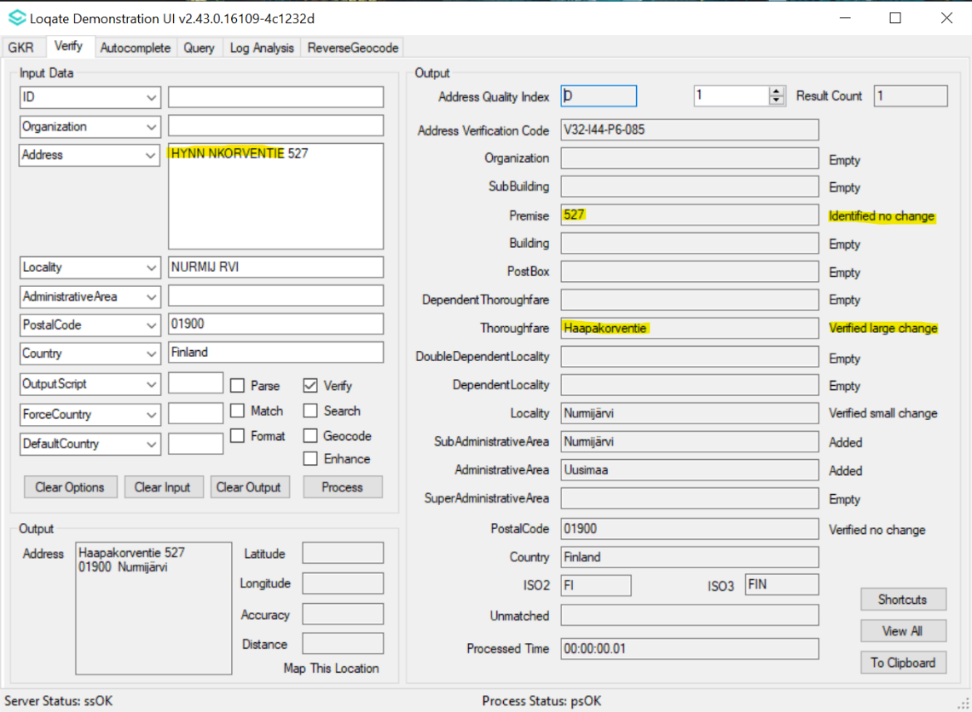 | Premise is verified, thoroughfare verified alias change to correct thoroughfare.  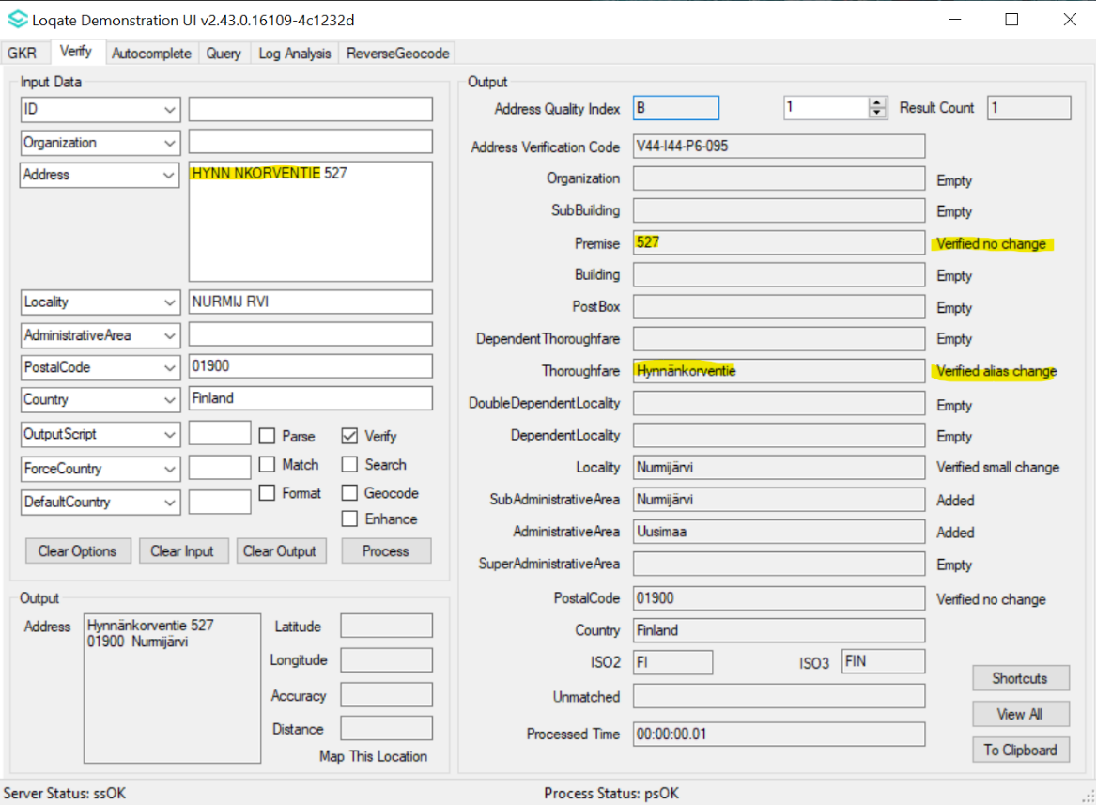

Hungary
Improvement in thoroughfare and premise coverage.
2022Q3.0 | 2022Q3.1
Thoroughfare and Premise are not verified  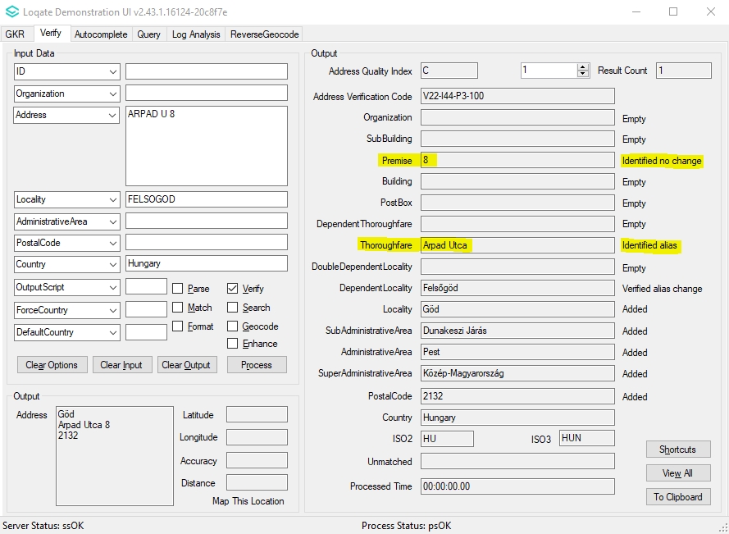 | Thoroughfare and Premise are verified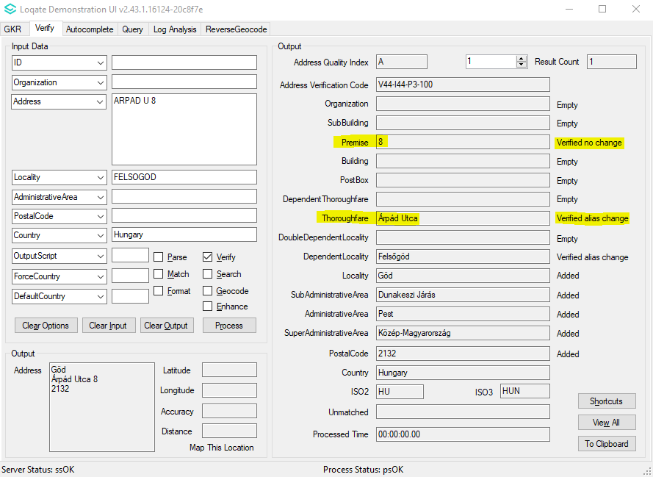

Greece
Improvement in parsing of thoroughfare and verification.
2022Q3.0 | 2022Q3.1
"Fon Karagianni” is incorrectly parsed.  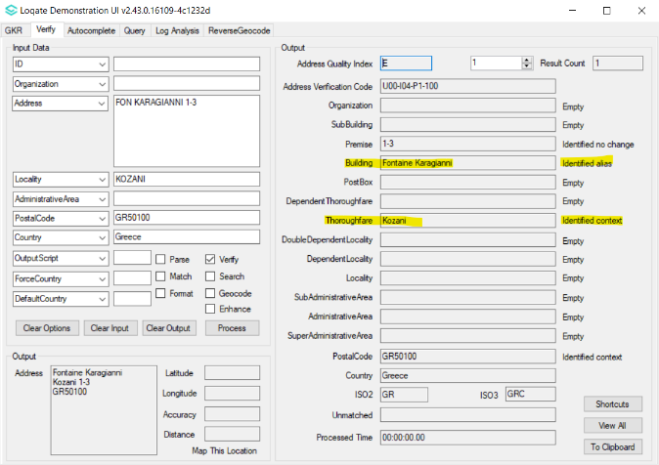 | "Fon Karagianni” is correctly parsed to thoroughfare and verified.  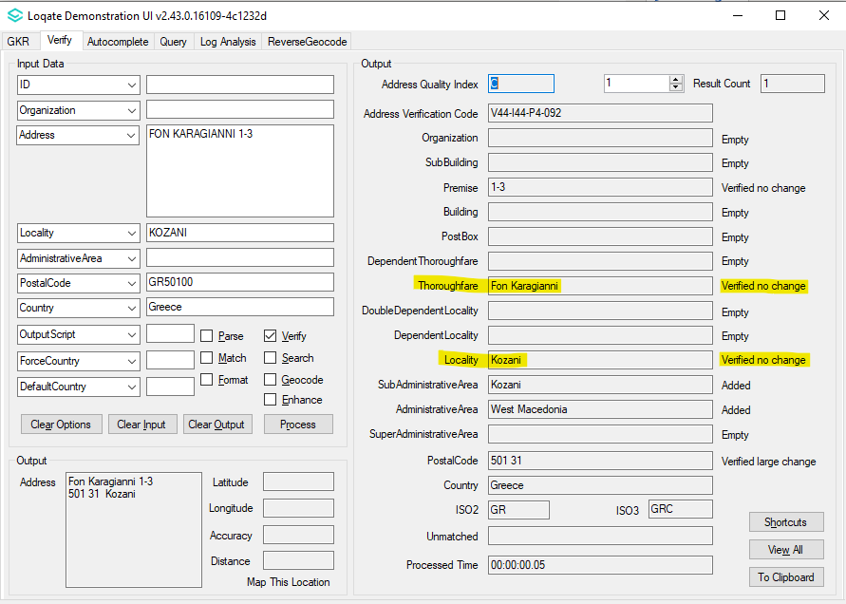

Korea, Republic of
Address output formatting changed see next page for an example.
Address Format | Organization PostBox  Building SubBuildingExtra SubBuildingFloor  SubBuildingLeadingType SubBuildingNumber  SubBuildingTrailingType  Premise DependentThoroughfare Thoroughfare  DoubleDependentLocality  Locality  AdministrativeArea PostalCode
Address Format (native) | AdministrativeArea  Locality Thoroughfare DependentThoroughfare  Premise SubBuildingExtra SubBuildingFloor  SubBuildingLeadingType SubBuildingNumber  SubBuildingTrailingType (DependentLocality  Building) PostBox  Organization  PostalCode

2022Q3.0 | 2022Q3.1
In SubBuilding output field, SubBuildingNumber located before SubBuildingFloor  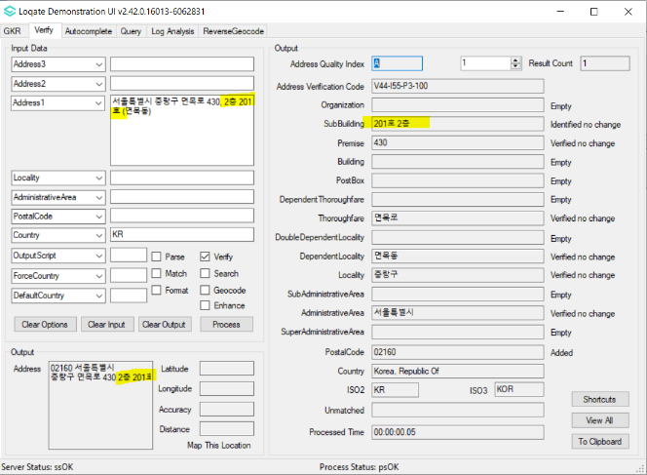 | In SubBuilding output field, SubBuildingNumber located after SubBuildingFloor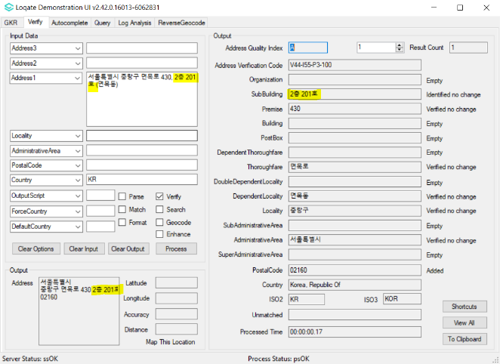

Postalcode is at the beginning of output address  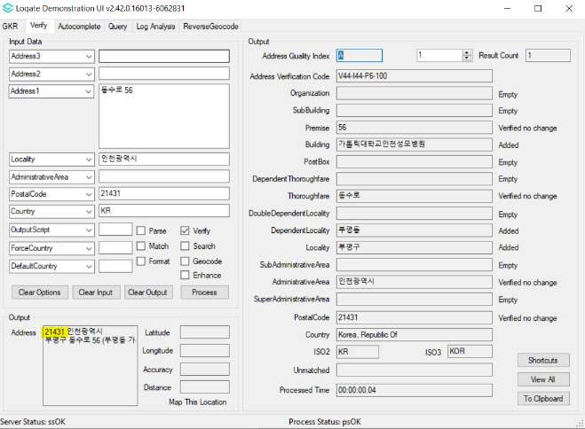 | Postalcode is at the end of output address  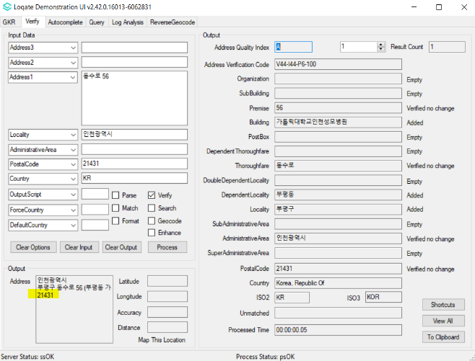

Switzerland
Improvement in address verification.
2022Q3.0 | 2022Q3.1
Thoroughfare and Premise not verified.  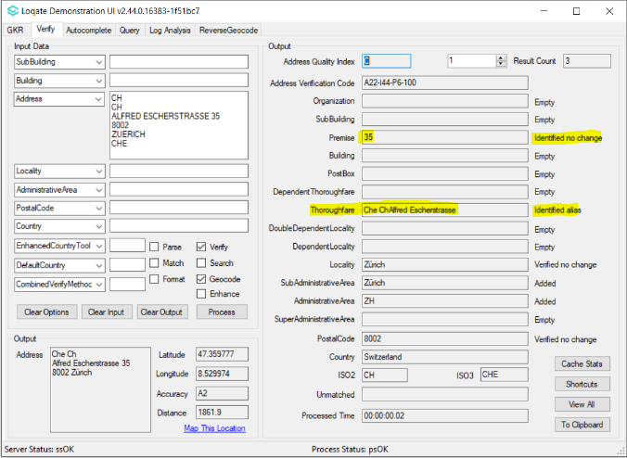 | Thoroughfare and Premise verified.  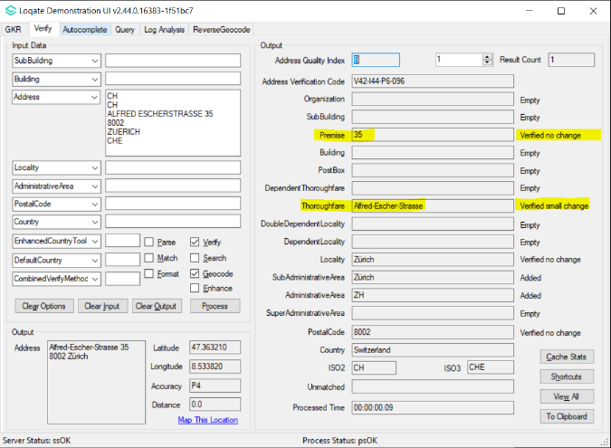

Premise incorrectly verified large change.  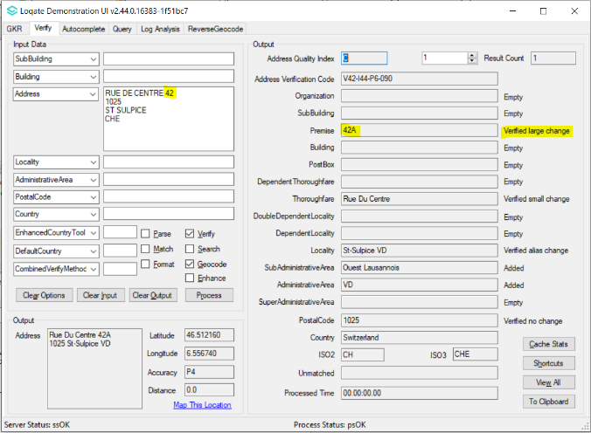 | Premise correctly verified following input.  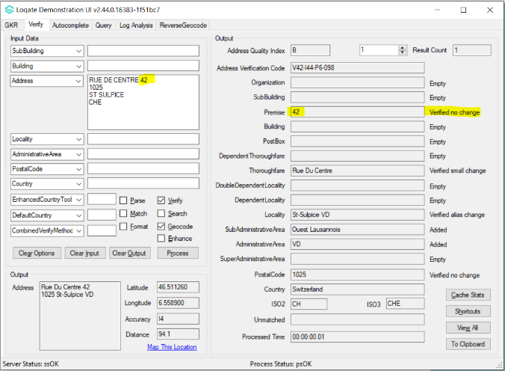

Case Resolutions

2022Q3.1 Data related Case Fixes
Case Number | Change Description | Category | Country | Example Address
CAS-05112-X0B2Q7 | Improvement of geocodes | Data | US | Address: 350 5th Ave  Building: Empire State Building,  SubBuilding: 57th Floor  Locality: New York,  PostalCode: 10118  Country: US
Before Image |  |  | After Image
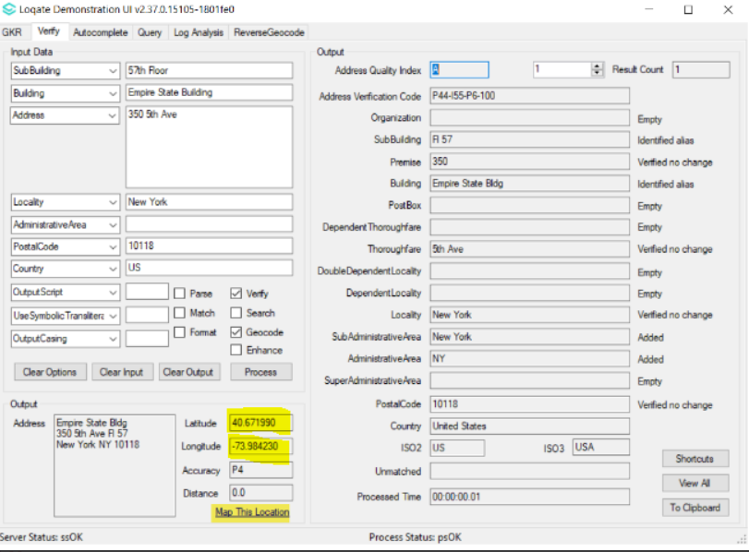 |  |  | 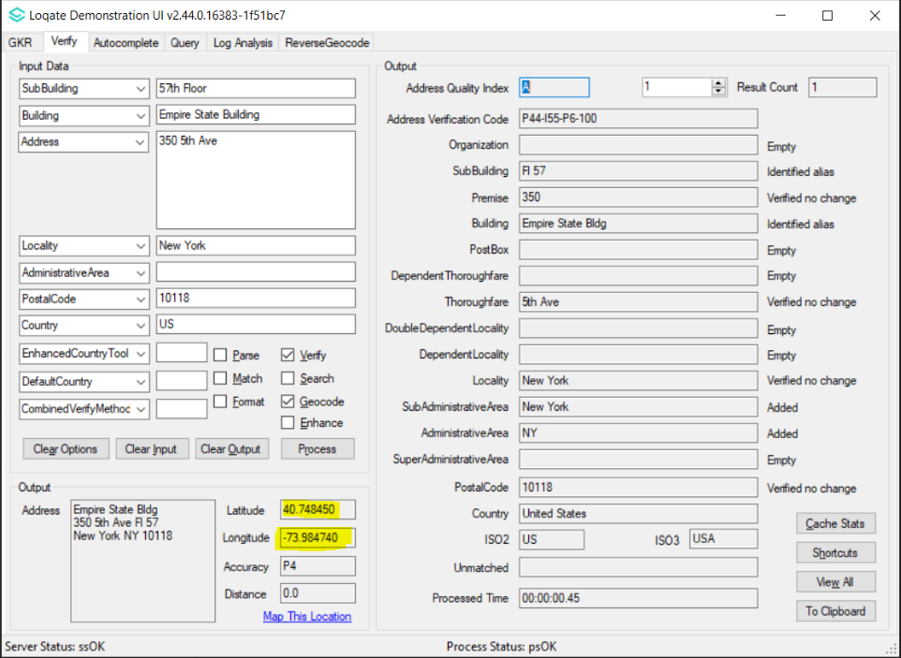

Case Number | Change Description | Category | Country | Example Address
CAS-73329-B1B6Y5 | Improvement of SubBuilding parsing | Data | KR | Address1: 경기도 부천시 길주로 80, 6층 603~604호 (상동)Country: KR
Before Image |  |  | After Image
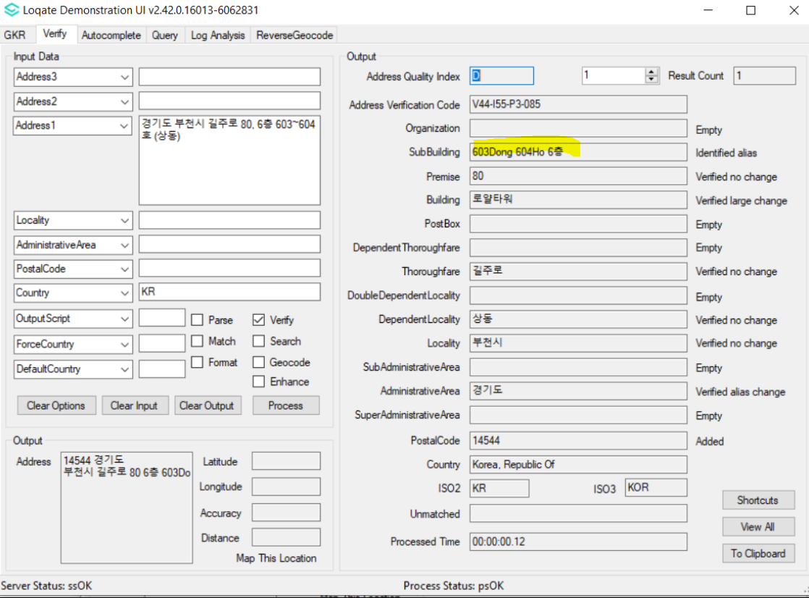 |  |  | 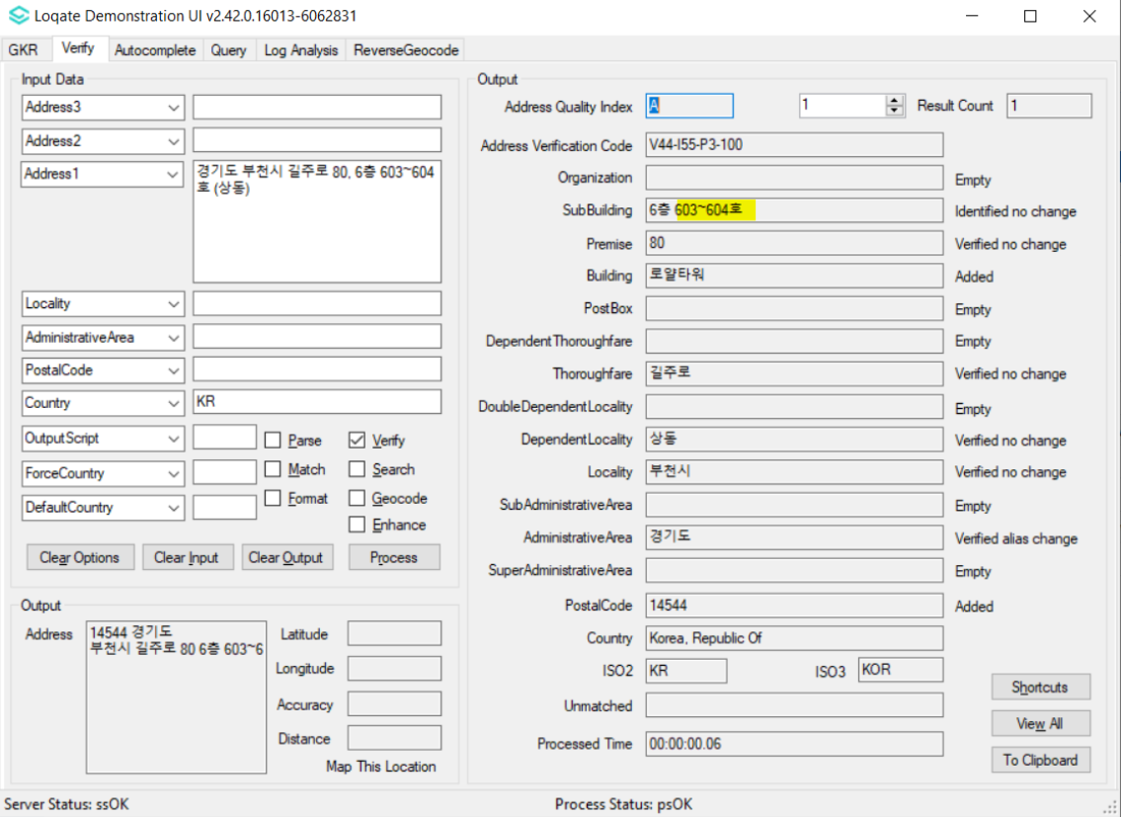

Case Number | Change Description | Category | Country | Example Address
CAS-71803-S1M6X1 | Reorder output SubBuilding components | Data | KR | Address: 서울특별시 중랑구 면목로 430, 2층 201호 (면목동)  Country: KR
Before Image |  |  | After Image
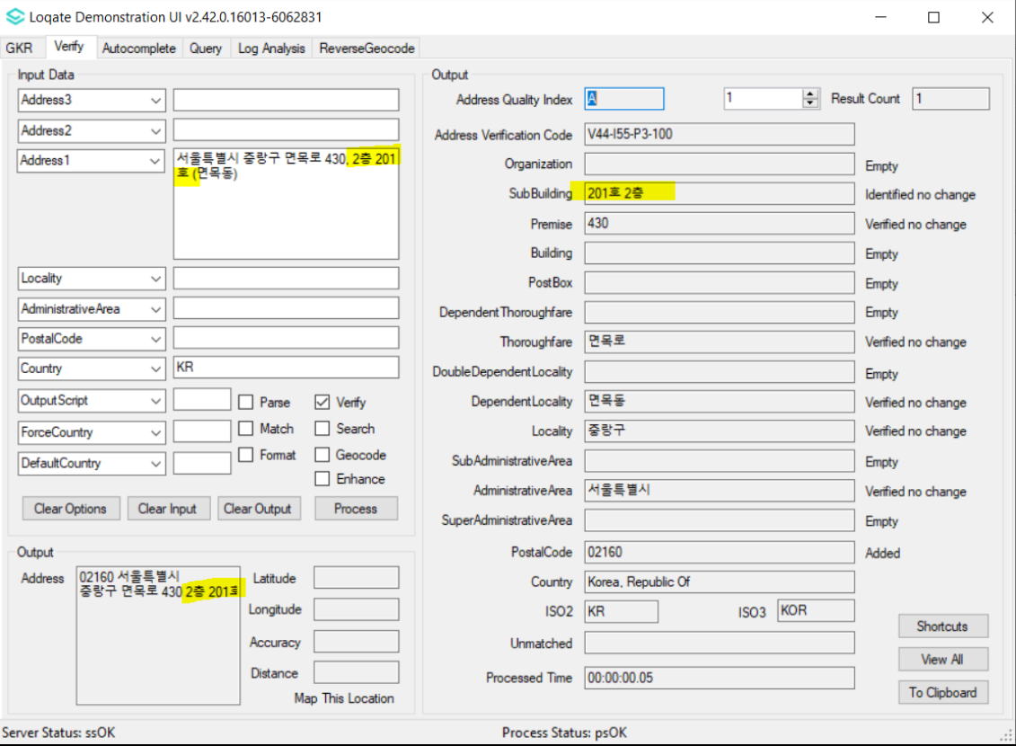 |  |  | 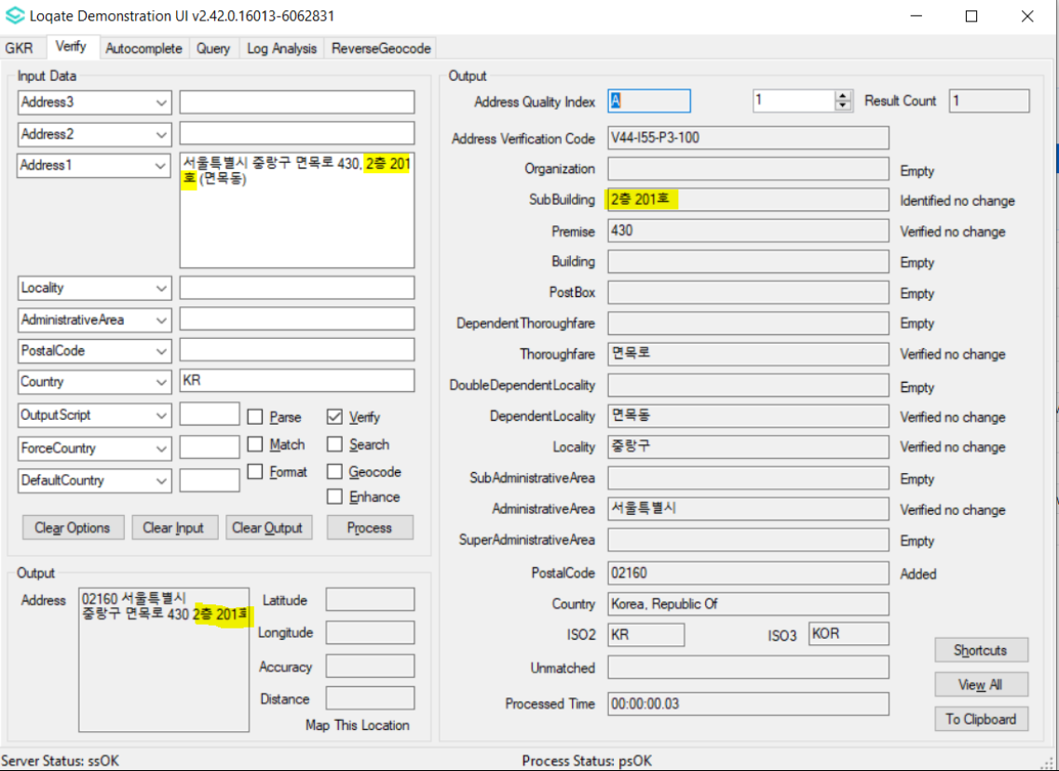

Case Number | Change Description | Category | Country | Example Address
CAS-69953-S9G9M7 | CAS-69953-S9G9M7 | Data | KR | Address: 서울특별시 용산구 서빙고로 137  Country: KR
Before Image |  |  | After Image
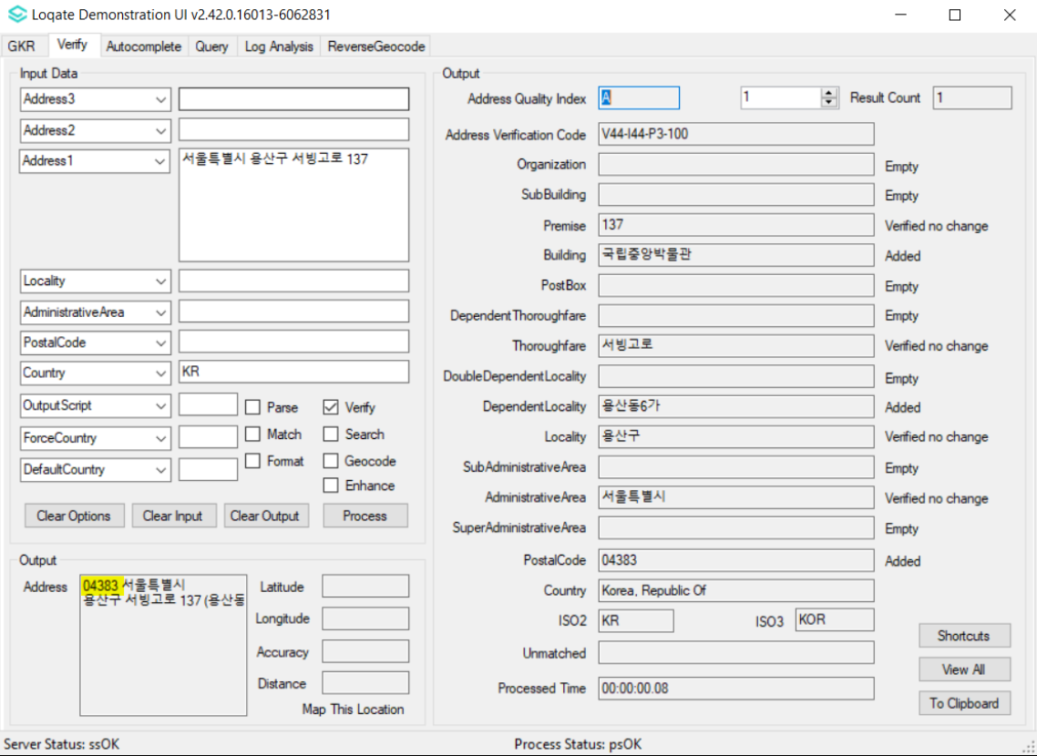 |  |  | 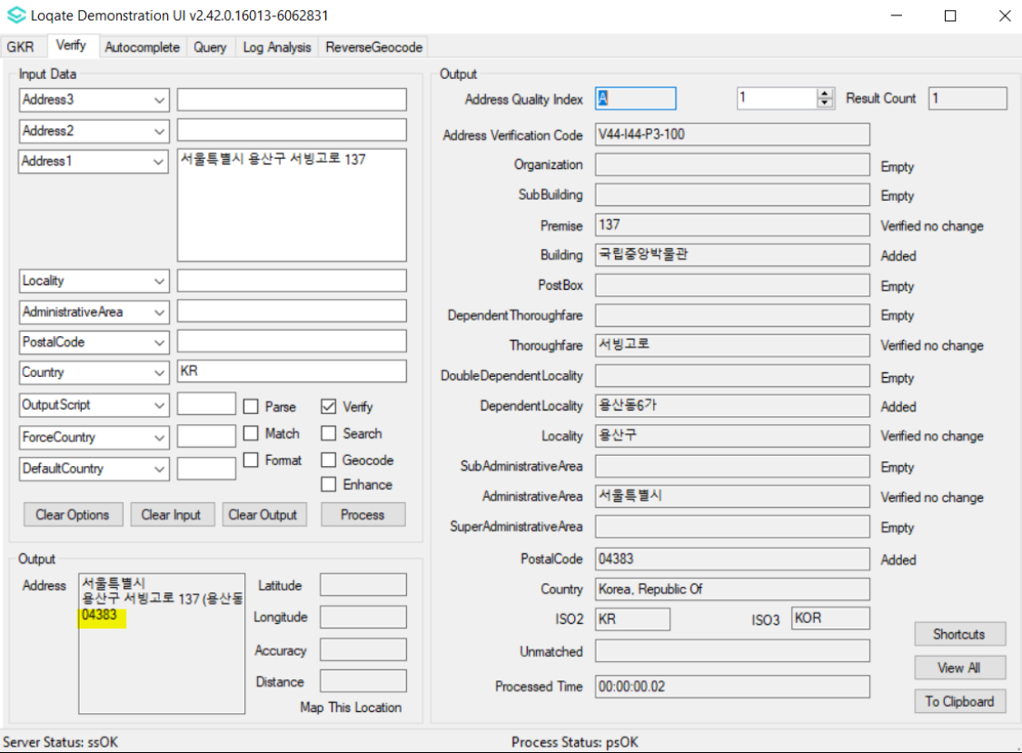

Case Number | Change Description | Category | Country | Example Address
CAS-71809-J6V8Q6 | Improvement of premise and SubBuilding parsing | Data | KR | Address: 서울특별시 강남구 일원로 81, 1~8층 (일원동)  Country: KR
Before Image |  |  | After Image
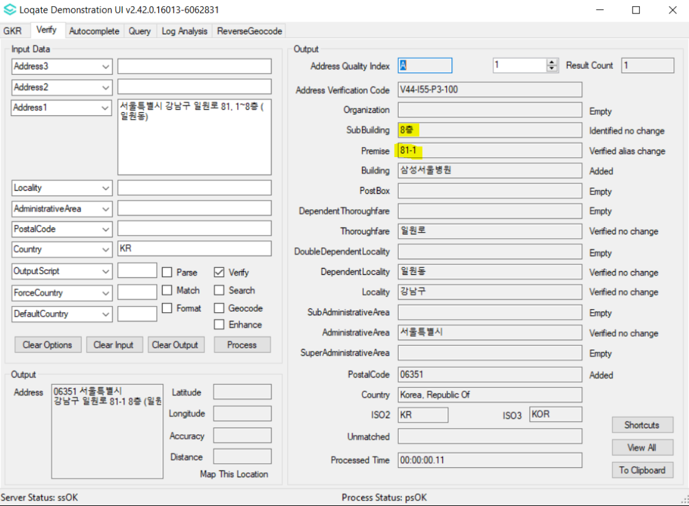 |  |  | 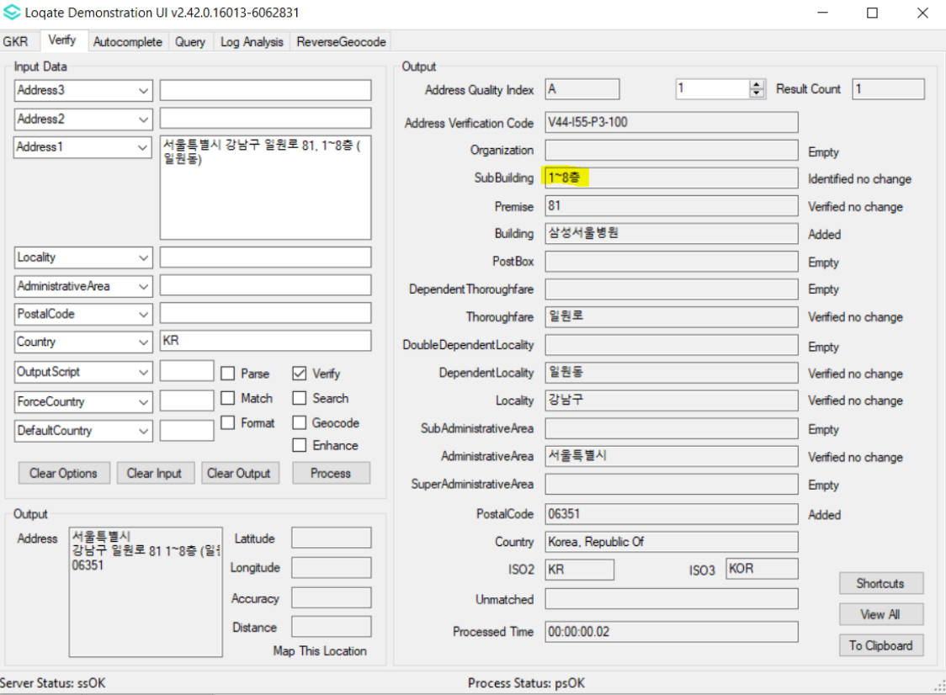

Case Number | Change Description | Category | Country | Example Address
CAS-72630-P2B3L2 | Improvement of SubBuilding parsing | Data | US | Address1: 160 Dental Cir # Cb#7064 Fl 1  Locality: Chapel Hill  AdministrativeArea: NC  Country: USA
Before Image |  |  | After Image
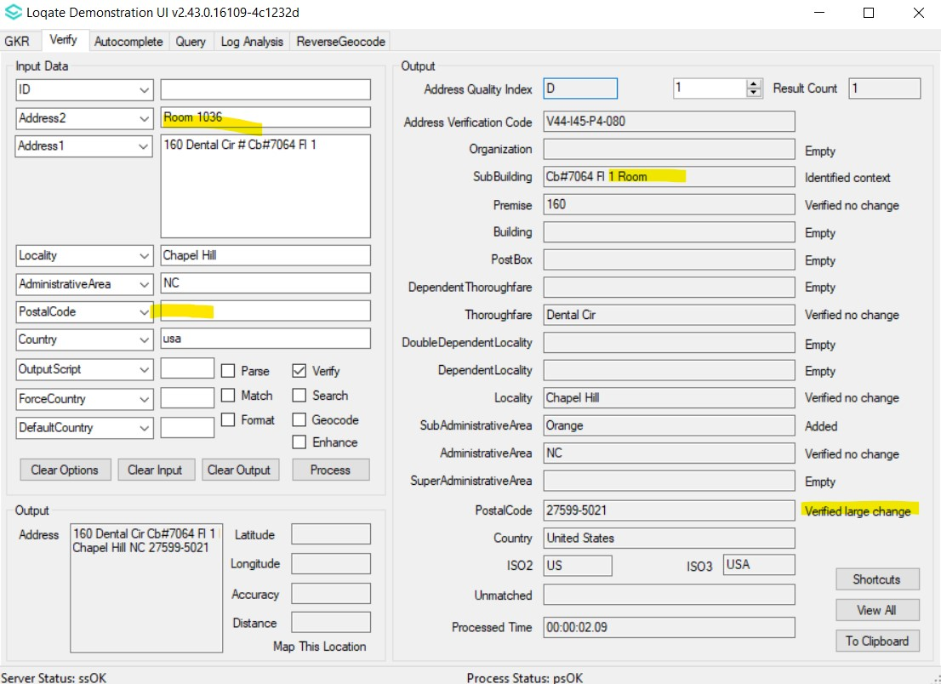 |  |  | 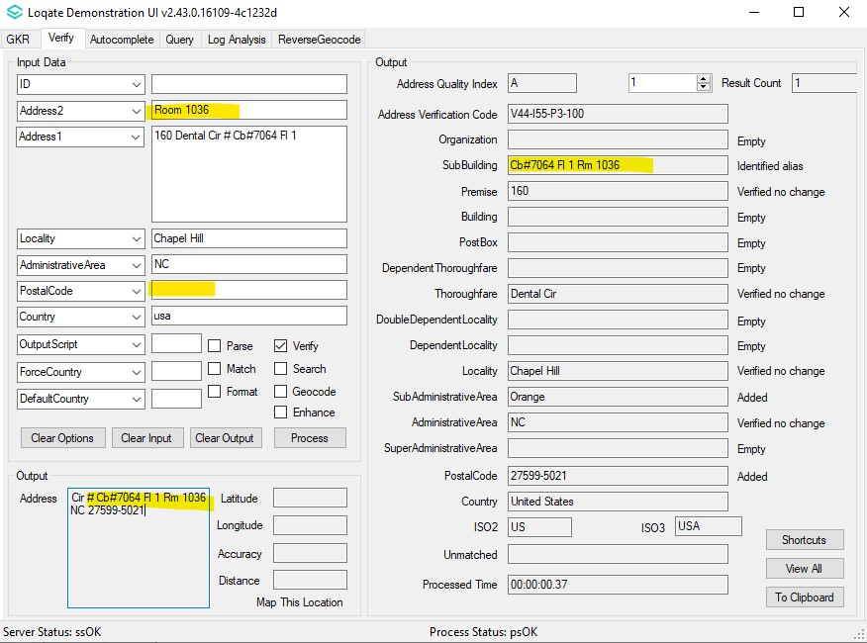

Case Number | Change Description | Category | Country | Example Address
CAS-60797-T7Y0G2 | Change AdministrativeArea primary name | Data | BY | -
Before Image |  |  | After Image
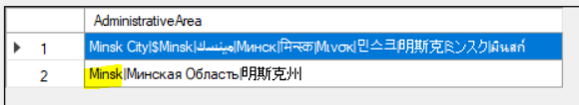 |  |  | 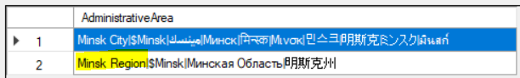
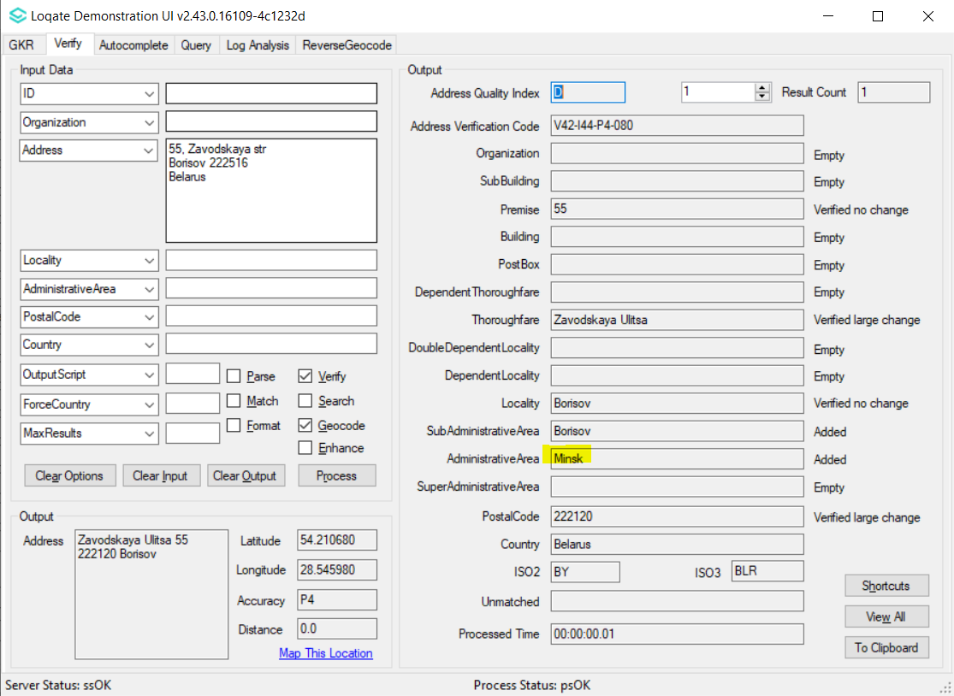 |  |  | 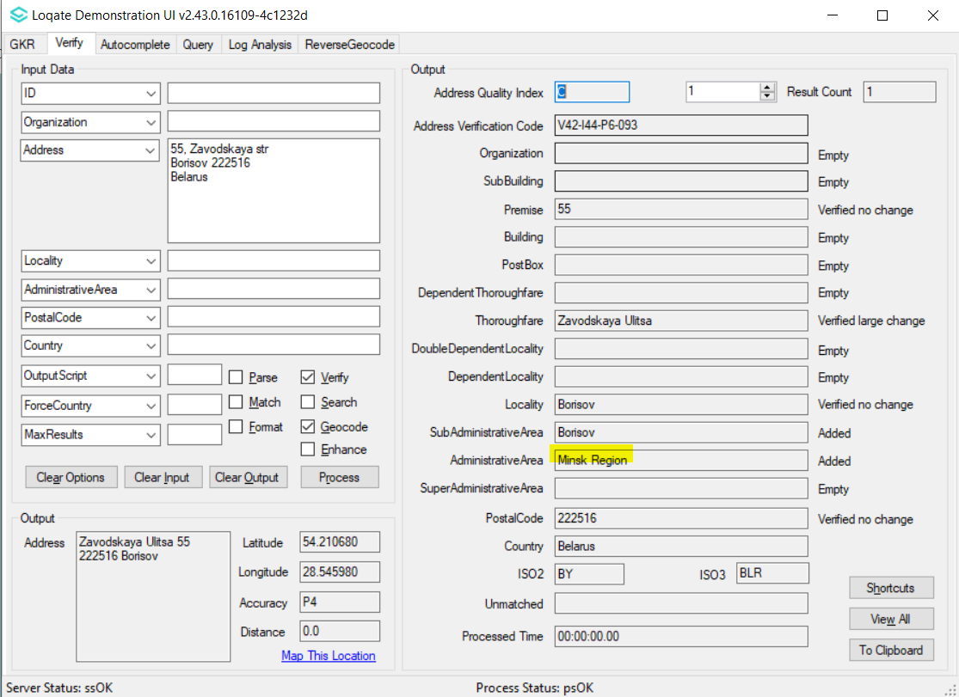

Case Number | Change Description | Category | Country | Example Address
CAS-65141-B6W7Y6 | Improvement of DependentLocality parsing | Data | HR | Address1: ANTUNA MIHANOVIĆA 6, BIJELA GOR  Locality: DUBRAVICA  PostalCode: 10293
Before Image |  |  | After Image
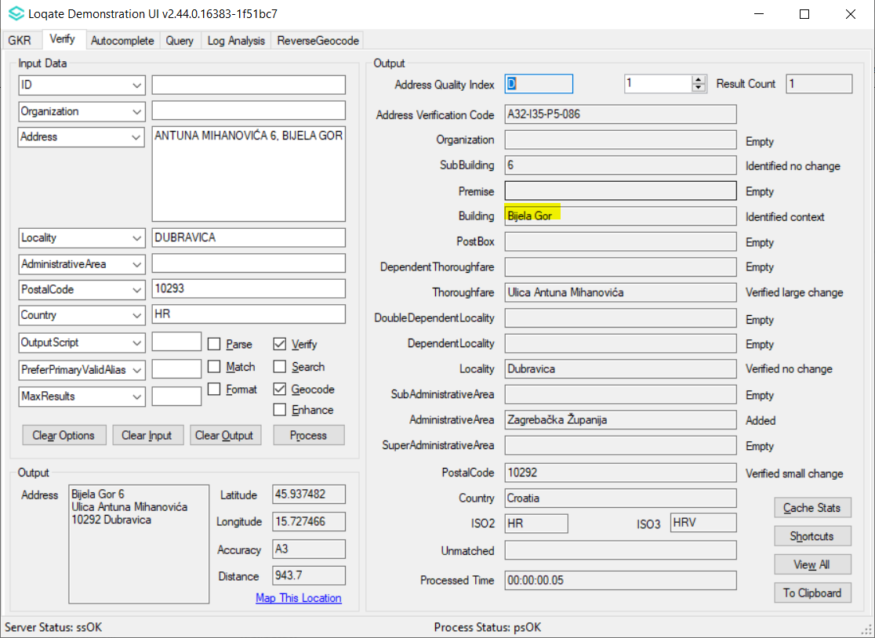 |  |  | 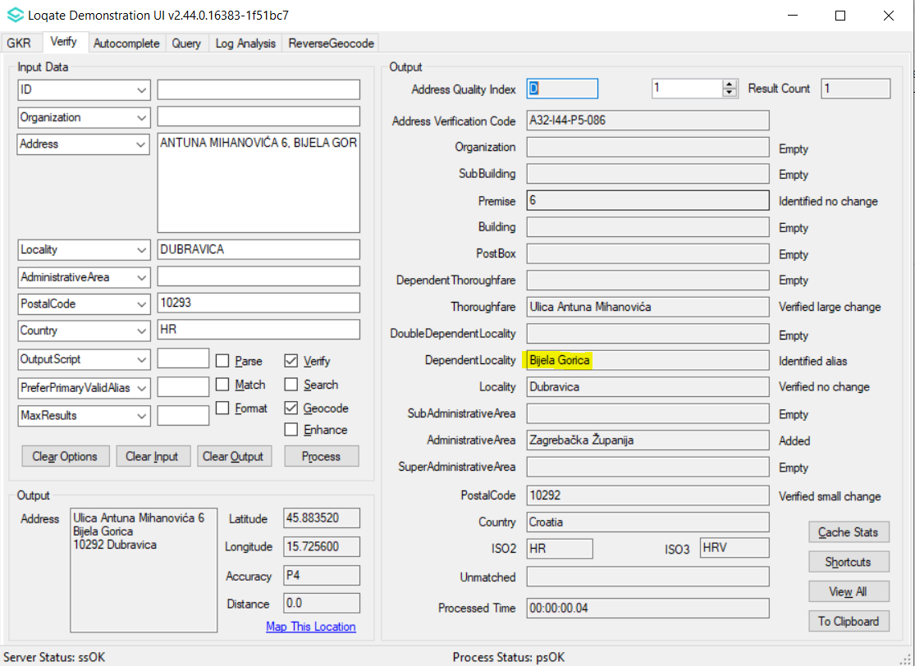

Case Number | Change Description | Category | Country | Example Address
CAS-77713-H3F0J3 | Removal of an unexpected valid alias from an entry | Data | CA | Address1: 6767 RTE DE L'AÉROPORT  SAINT-HUBERT QC J3Y 8Y9
Before Image |  |  | After Image
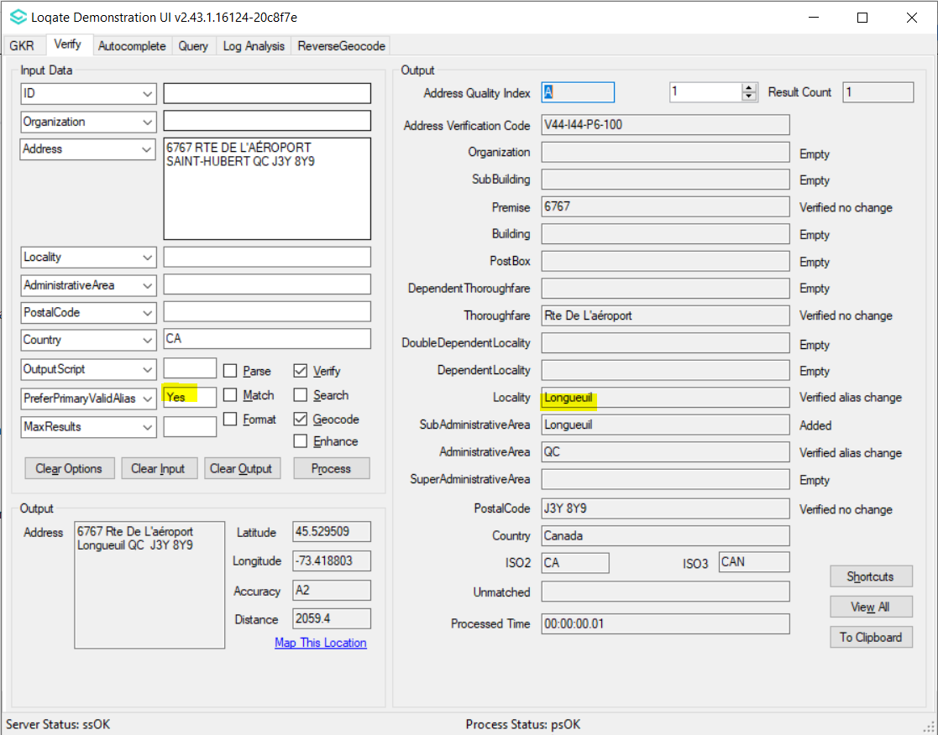 |  |  | 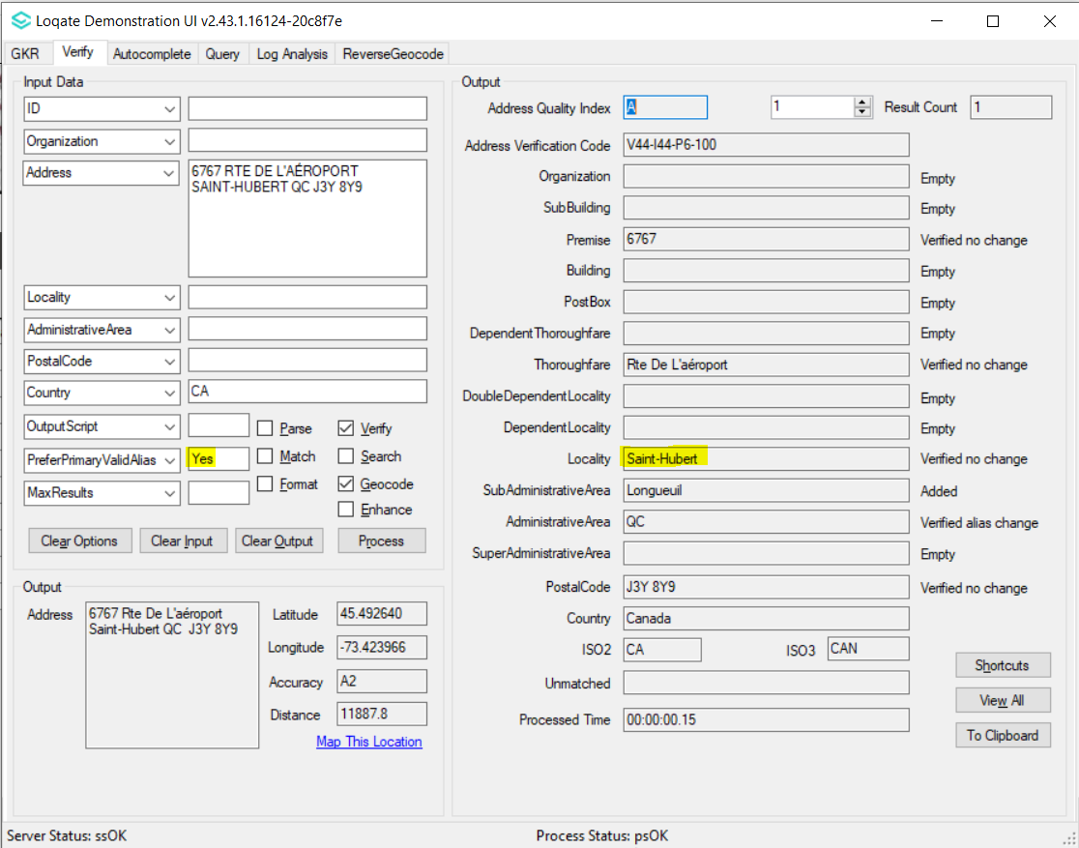
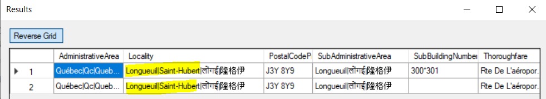 |  |  | 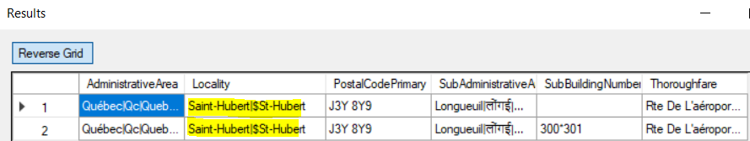

Case Number | Change Description | Category | Country | Example Address
CAS-70593-Q3D3X2 | Addition of major recipient postcode as valid alias to current postcode | Data | DK | -
Before Image |  |  | After Image
Missing major recipient postcode |  |  | The major recipient postcode are now present.  0800 Høje Taastrup<S=LATX,L=DA>  0999 København S<S=LATX,L=DA>  1092 København K<S=LATX,L=DA>  1093 København K<S=LATX,L=DA>  1095 København K<S=LATX,L=DA>  1098 København K<S=LATX,L=DA>  1140 København K<S=LATX,L=DA>  1147 København K<S=LATX,L=DA>  1148 København K<S=LATX,L=DA>  1217 København K<S=LATX,L=DA>  1448 København K<S=LATX,L=DA>  1566 København V<S=LATX,L=DA>  1592 København V<S=LATX,L=DA>  1599 København V<S=LATX,L=DA>  1630 København V<S=LATX,L=DA>  1780 København SV<S=LATX,L=DA>  1785 København V<S=LATX,L=DA>  1786 København V<S=LATX,L=DA>

Case Number | Change Description | Category | Country | Example Address
CAS-68882-M3H2P7 | Improvement of AdministrativeArea name in Seed | Data | SV/IS/SE | - AdministrativeArea: La Libertad, Country: El Salvador  - (IS and SE already have similar AdministrativeArea names in both Seed and Verify files.
Before Image |  |  | After Image
AdministrativeArea 7960 Departamento de La Libertad<S=LATN,L=ES>|$La Libertad|$La Li Bei Ta De|拉利贝塔德<S=HANS,L=ZH> |  |  | AdministrativeArea 7960 La Libertad<S=LATN><L=ES>|$La Li Bei Ta De|$Departamento de La Libertad|拉利贝塔德<S=HANS><L=ZH>

Case Number | Change Description | Category | Country | Example Address
CAS-04685-H3Q6Y2 | Improvement of Postalcode | Data | JP | -
Before Image |  |  | After Image
Missing 4 postcodes |  |  | The missing 4 postcodes are now present.  458-8530, Midori-Ku, Nagoya, Aichi, Japan  460-8625, Naka-Ku, Nagoya, Aichi, Japan  108-6216, Minato City, Tokyo, Japan  100-8019, Chiyoda-Ku, Tokyo, Japan

Case Number | Change Description | Category | Country | Example Address
CAS-53589-B5Q8N8 | Improvement of Premise coverage | Data | JP | Address1: 482 Zaimoku-cho, Shimogyo-ku, Kyoto-shi, Kyoto-fu 600-8146  Country: Japan
Before Image |  |  | After Image
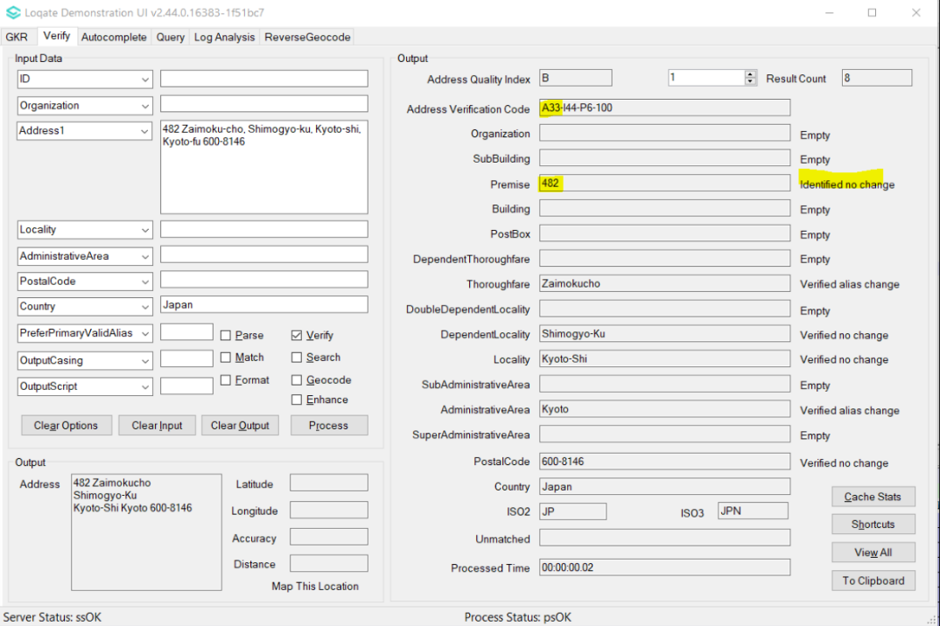 |  |  | 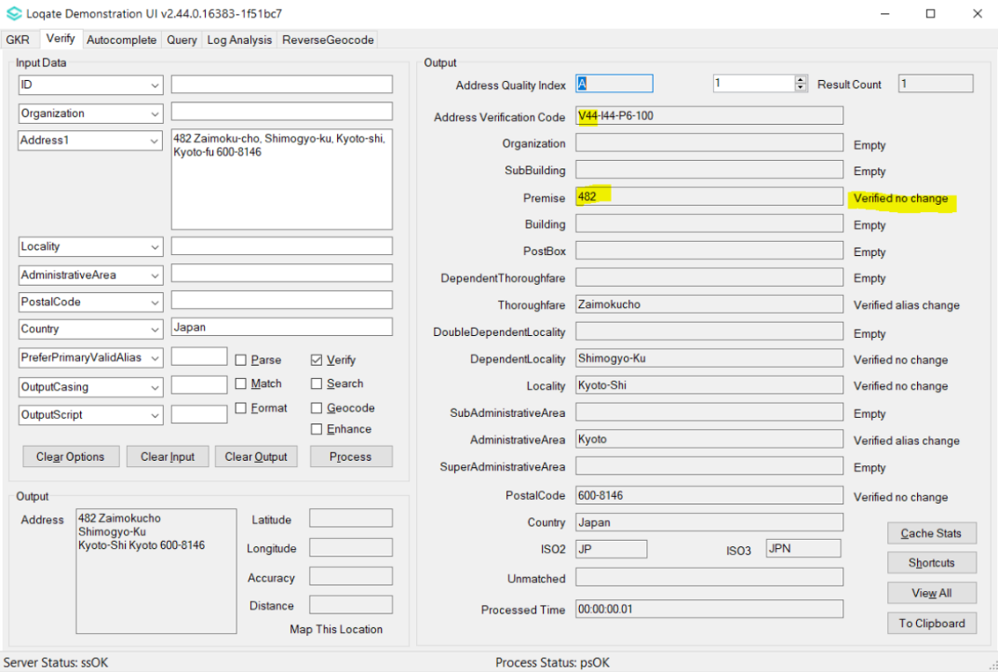

Case Number | Change Description | Category | Country | Example Address
CAS-43130-N7M8F3, CAS-30532-H5M6V9 | Correction of premise verification | Data | JP | Address1: 東京都大田区平和島1-2-3  Country: Japan
Before Image |  |  | After Image
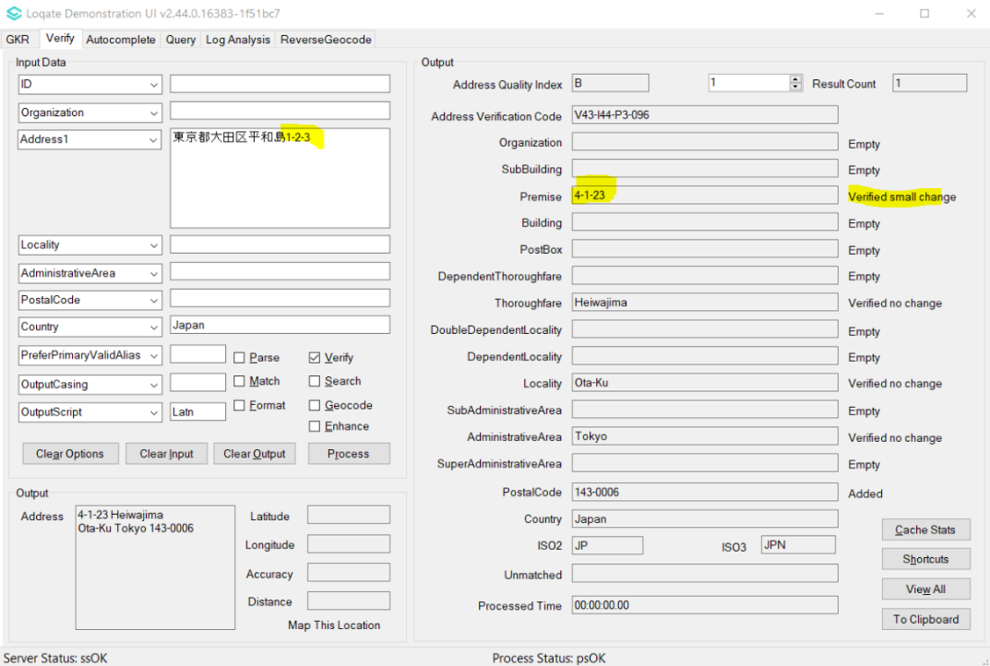 |  |  | 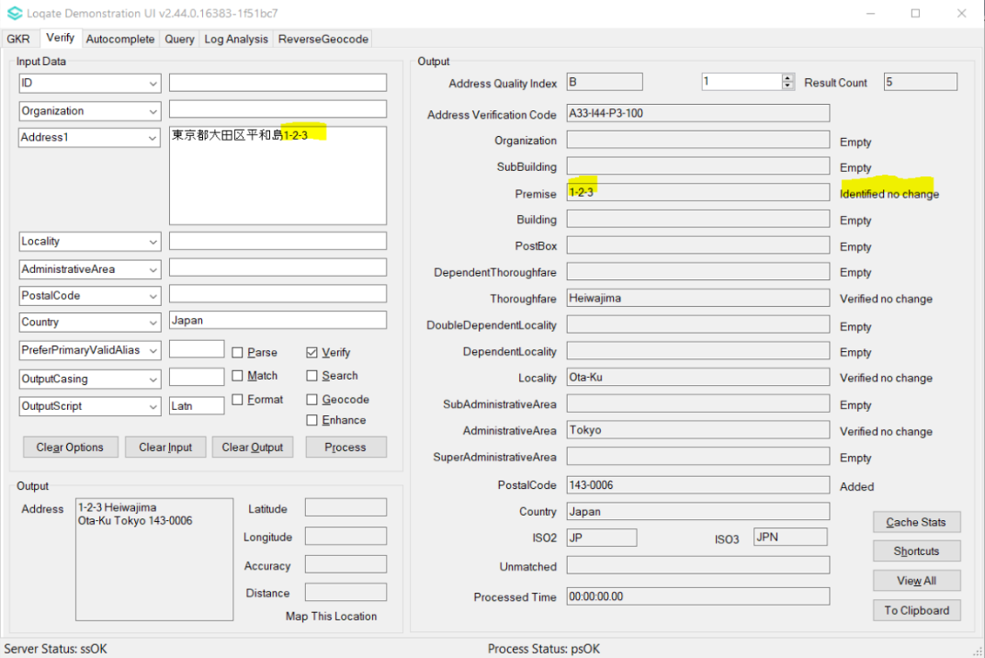

Case Number | Change Description | Category | Country | Example Address
CAS-48036-D0V7V7 | Improvement of Thoroughfare parsing | Data | JP | Address1: 98-8  Locality: 名張市つつじが丘北８番町  AdministrativeArea: 三重県  PostalCode: 5180438  Country: Japan
Before Image |  |  | After Image
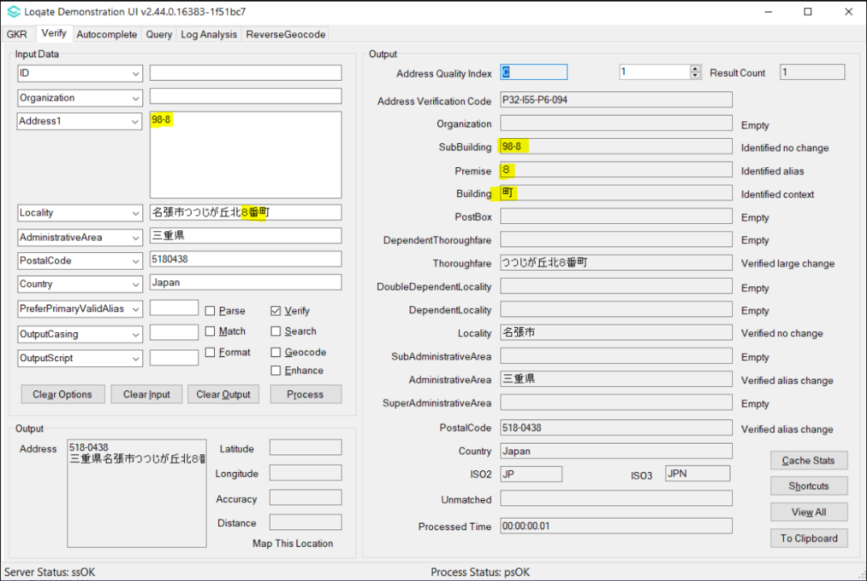 |  |  | 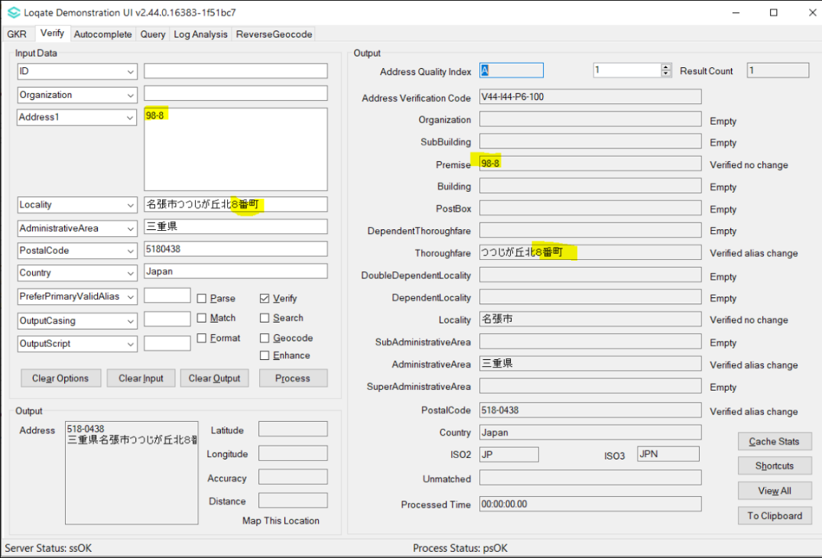

Case Number | Change Description | Category | Country | Example Address
CAS-54184-Y1M4Z6 | The input "hyphenated" SubBuilding no longer stripped off | Data | JP | Address1: 神奈川県藤沢市石川4-14-3  Address2: ペルメレック電極湘南寮Ａ-205  Country: Japan
Before Image |  |  | After Image
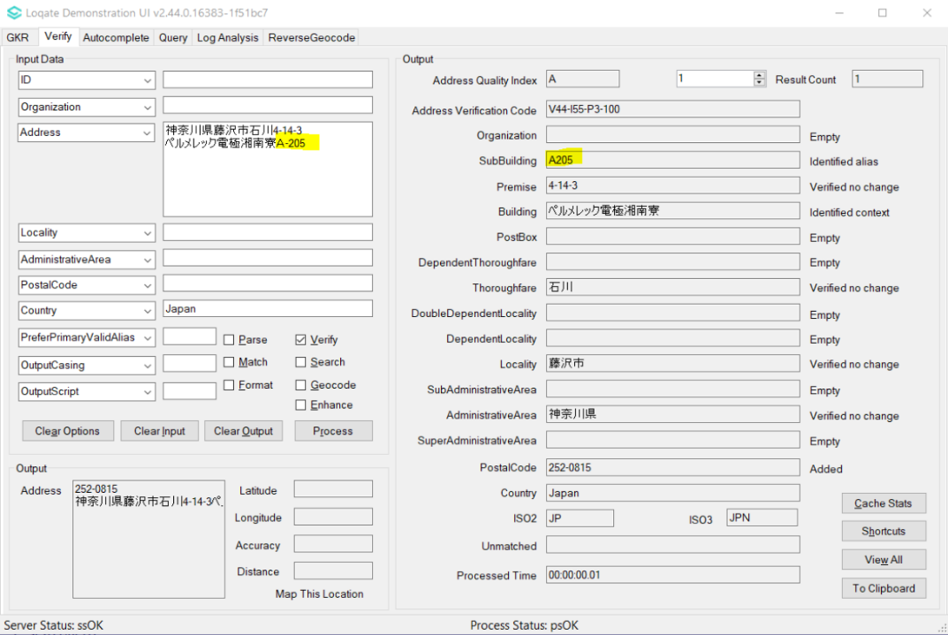 |  |  | 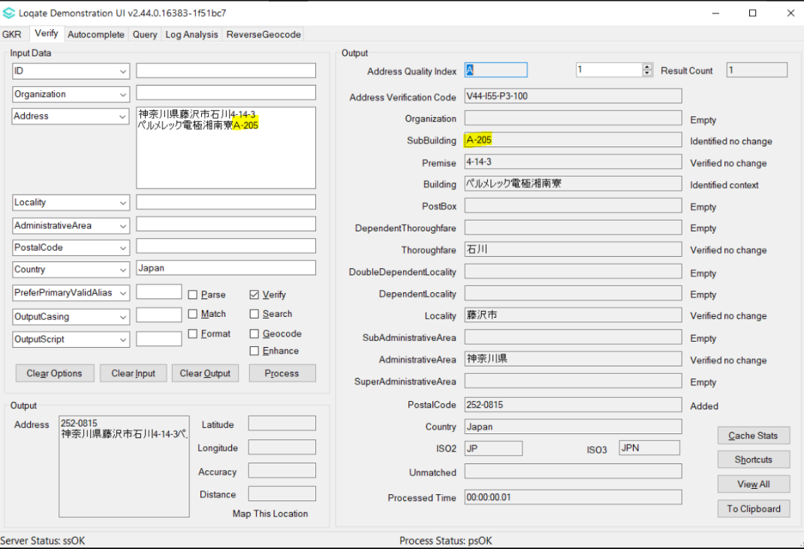

Case Number | Change Description | Category | Country | Example Address
CAS-77605-H8J2D5 | Improvement of Premise coverage | Data | JP | Address1: 東京都大田区田園調布  Address2: 2-24-11  PostalCode: 145-0071  Country: Japan
Before Image |  |  | After Image
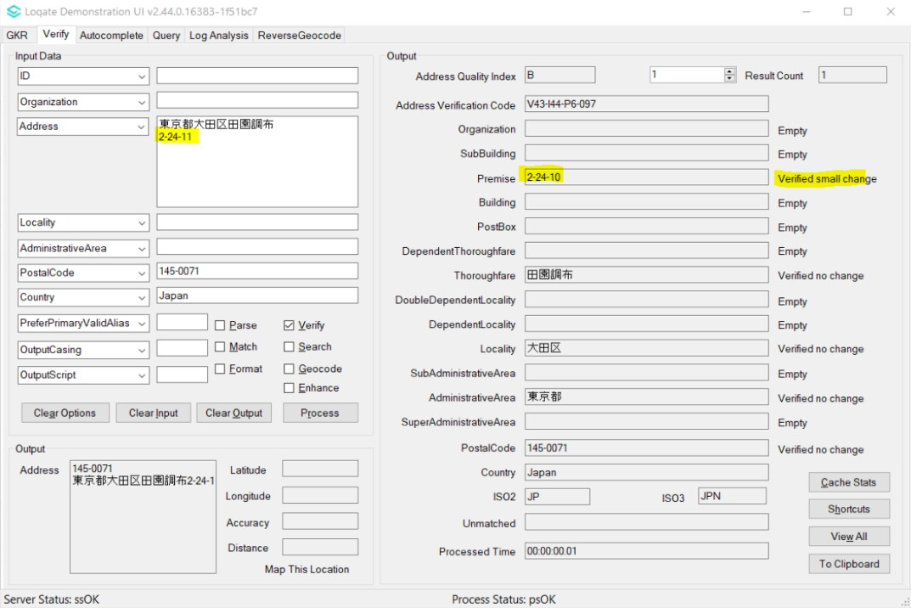 |  |  | 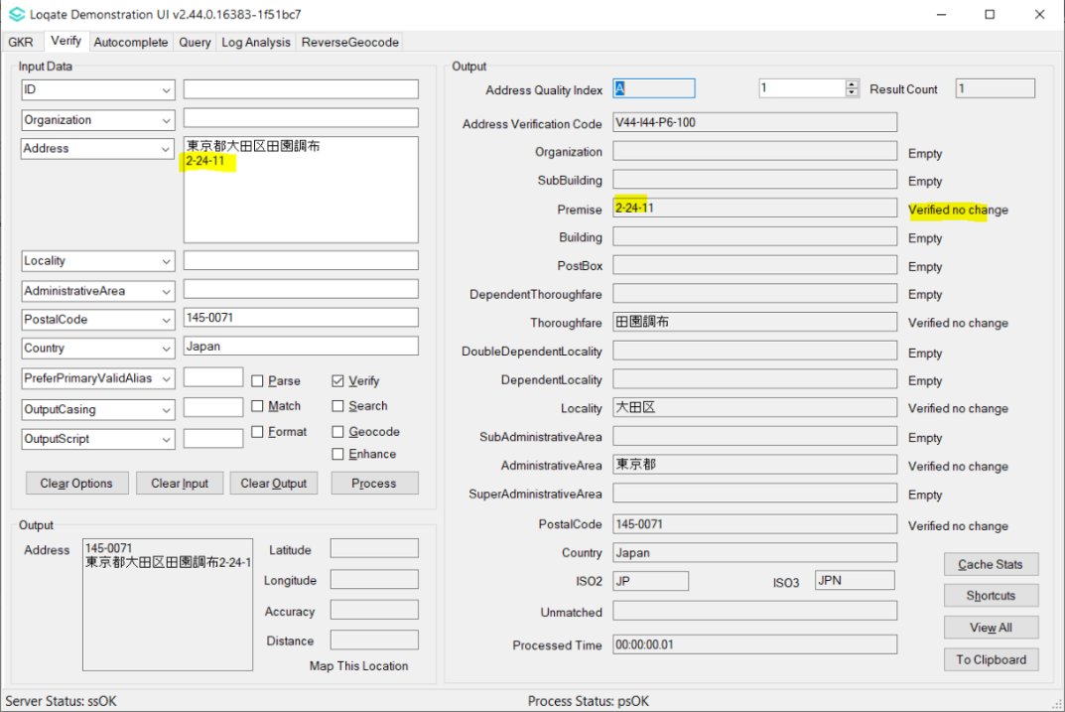

Case Number | Change Description | Category | Country | Example Address
Internal Support | Improvement of Postalcode | Data | JP | -
Before Image |  |  | After Image
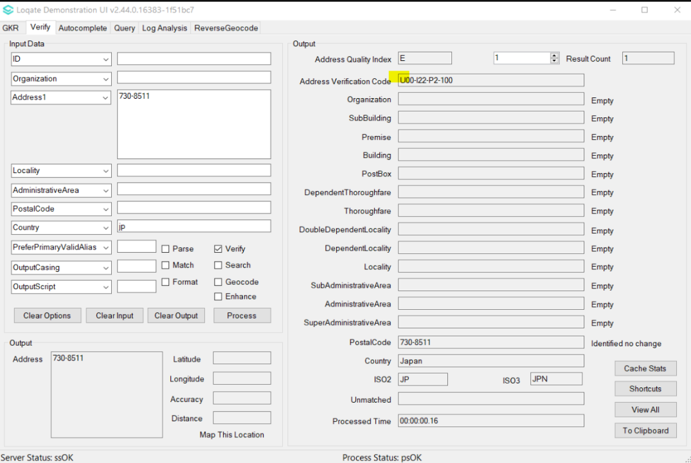 |  |  | 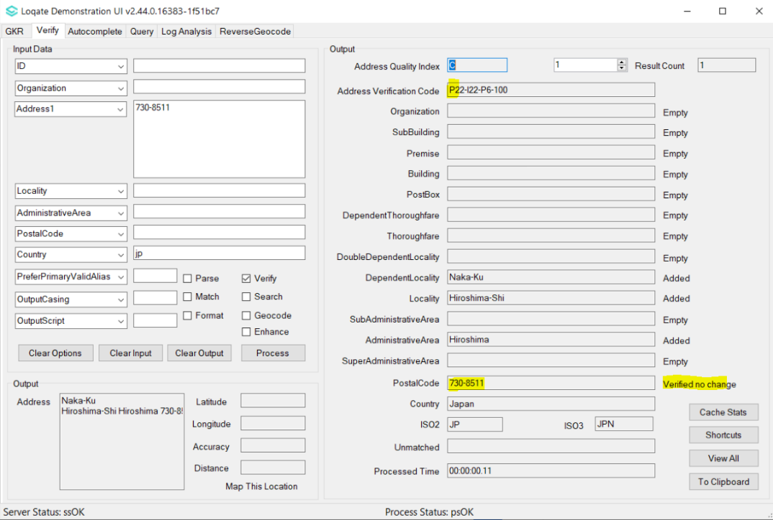  Remark: Similarly to 471-8571, the postcode used to be identified, and is now verified.

Case Number | Change Description | Category | Country | Example Address
CAS-79794-F0H3W7 | Improvement of Premise coverage | Data | US | 4734 Wolf Creek Drive, San Angelo, TX 76904
Before Image |  |  | After Image
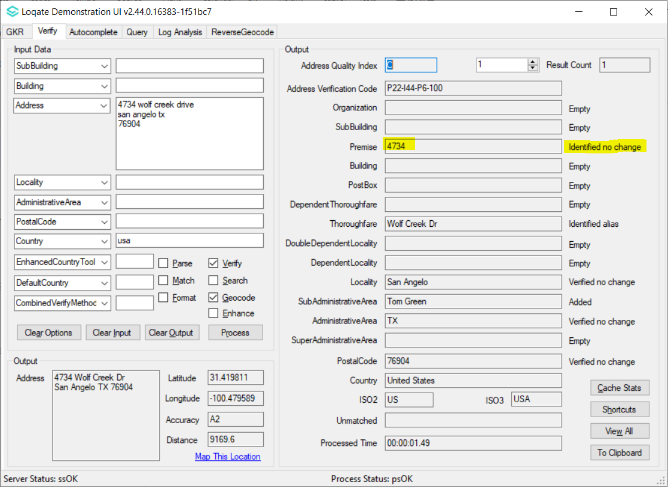 |  |  | 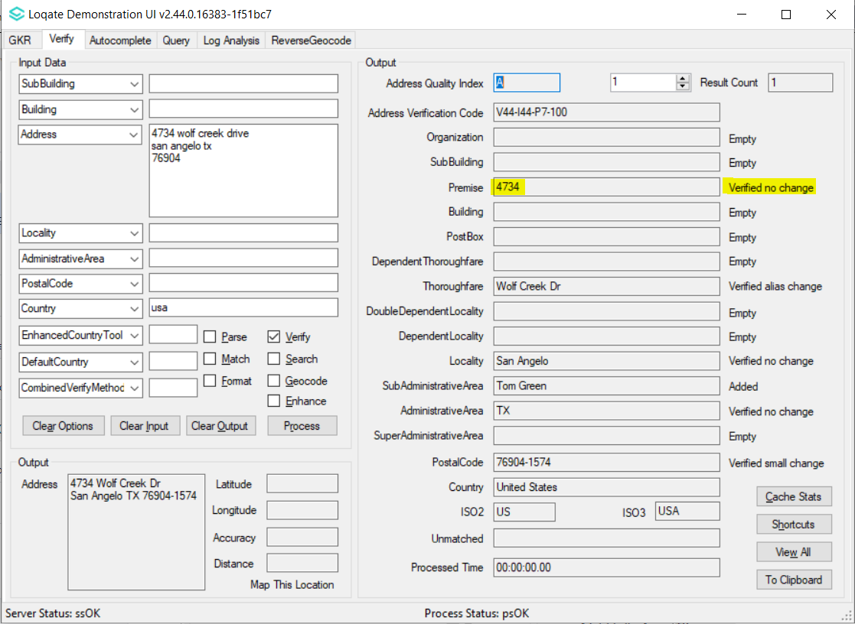

Case Number | Change Description | Category | Country | Example Address
CAS-73803-W4Q6L3 | Improvement of geocodes | Data | US | 5710 108th Street Ct SW, Lakewood WA 98499 USA
Before Image |  |  | After Image
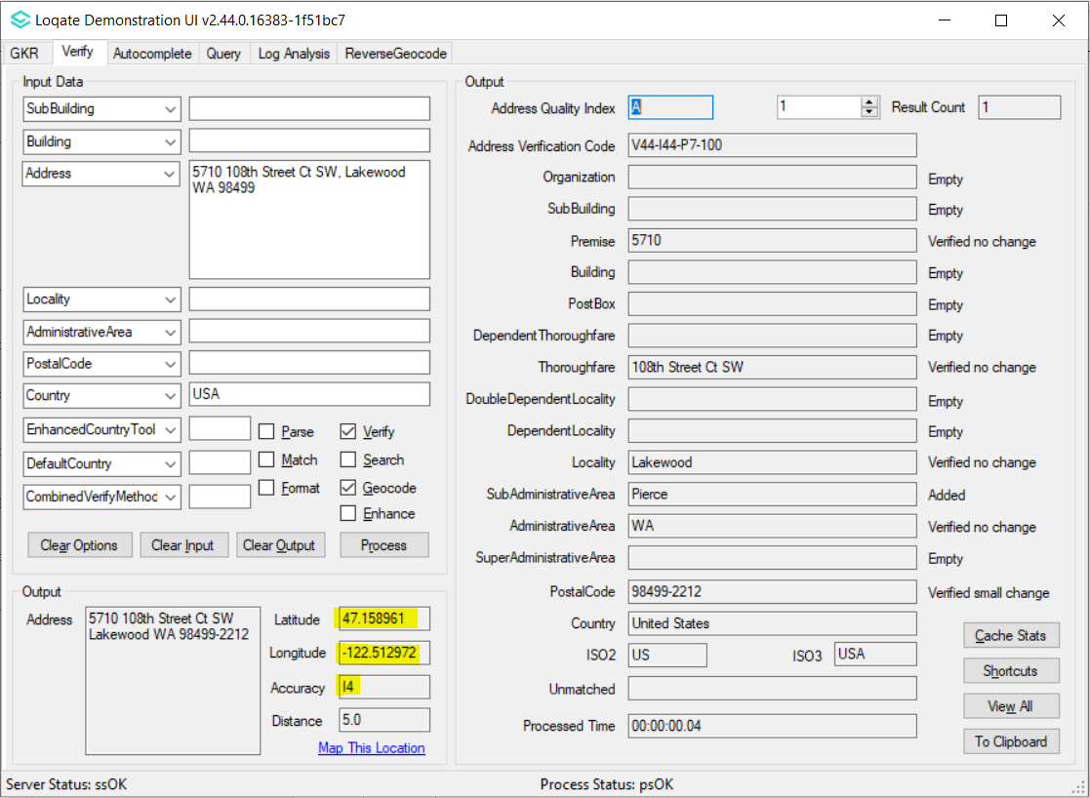 |  |  | 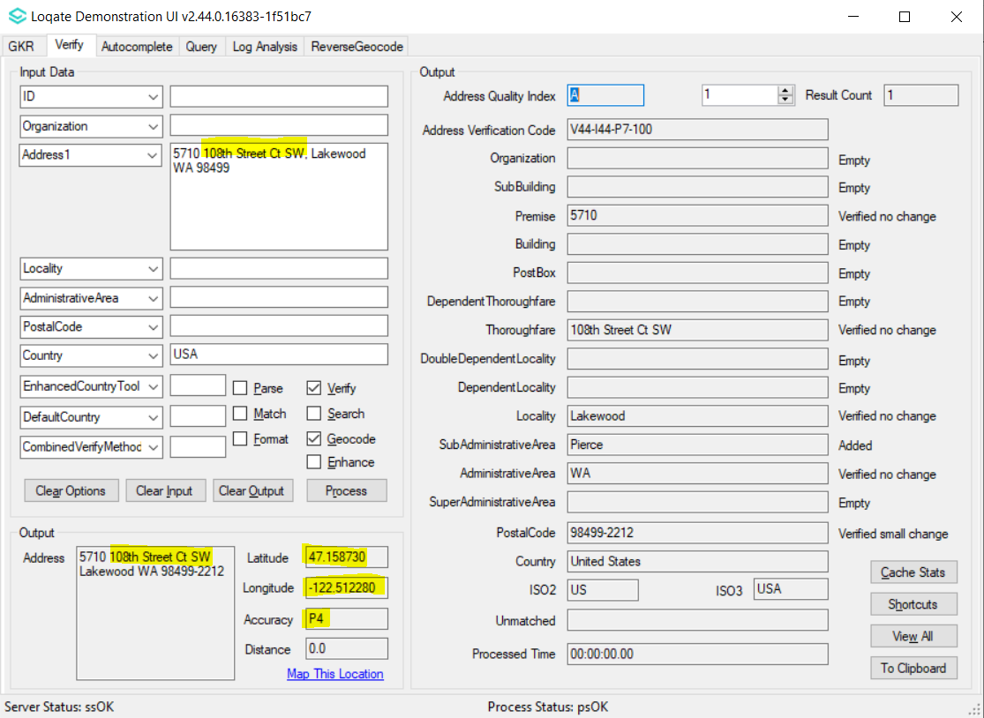

Case Number | Change Description | Category | Country | Example Address
CAS-65846-Q5Y9Y5 | Improvement of geocodes | Data | US | 12715 LBJ FWY, GARLAND, TX 75041 USA
Before Image |  |  | After Image
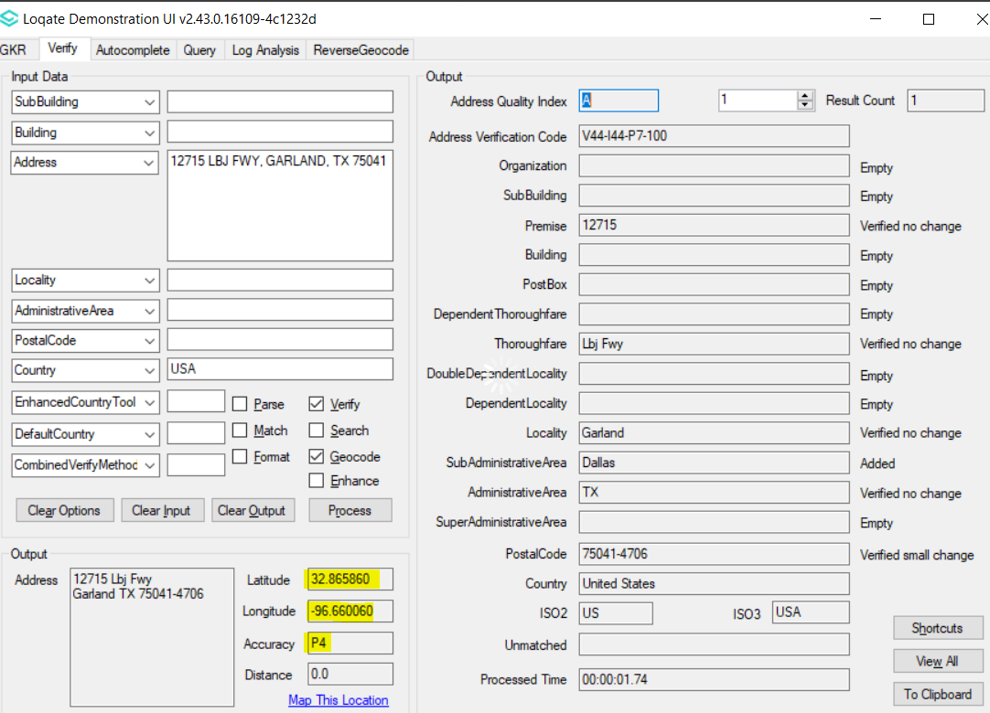 |  |  | 