Loqate, A GBG Solution
Release Notes – Verify API
2022Q2.1 Minor Release

Case Resolutions
Please visit https://support.loqate.com/2022q2-1-resolved-cases/ for a list of all cases resolved in this release. If you would like more details on any of the solved cases listed, please contact LoqateSupport@gbgplc.com for further information.

Local API Notices
This is to inform our customers that in this 2022Q2.1 release we have made no major changes to the API there are 3 minor improvements.

Local API Improvements

Verify Improvements
Case Number | Change Description |  | Category | Country | Example Address
CAS-68047-W1K4B8 | When server option EnhancedCountryTool=ON and DefaultCountry=US for certain US addresses without country value, input AdministrativeArea was changed to incorrect AdministrativeArea as output, This has been fixed and input AdministrativeArea is verified. |  | API | US | Address1: 621 MAIN ST  Locality: MAYSVILLE  AdministrativeArea: OKLAHOMA  Address1: 813 MAIN ST  Locality: CHARLESTON  AdministrativeArea: SOUTH CAROLINA  Address1: 329 6TH ST  Locality: WEST POINT  AdministrativeArea: VIRGINIA  Address1: 204-4th Avenue East  Locality: NEWTON  AdministrativeArea: IOWA
Before Image |  | After Image
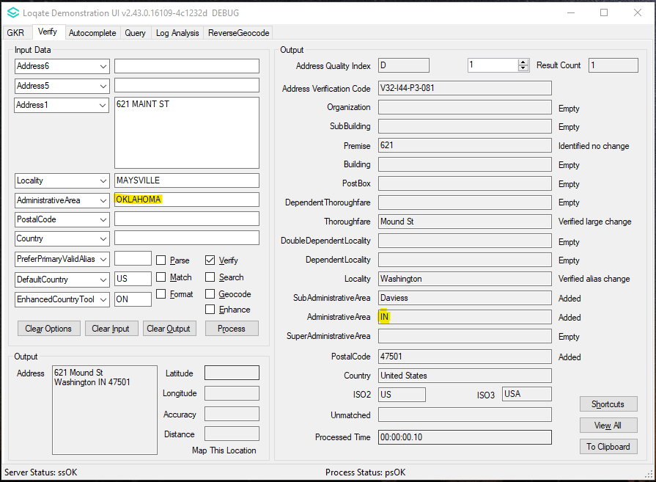 |  | 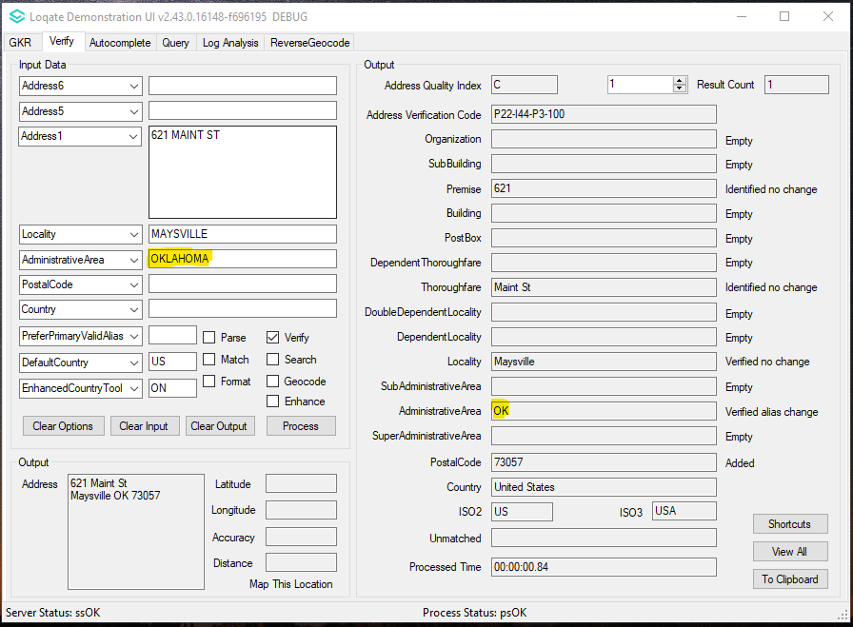
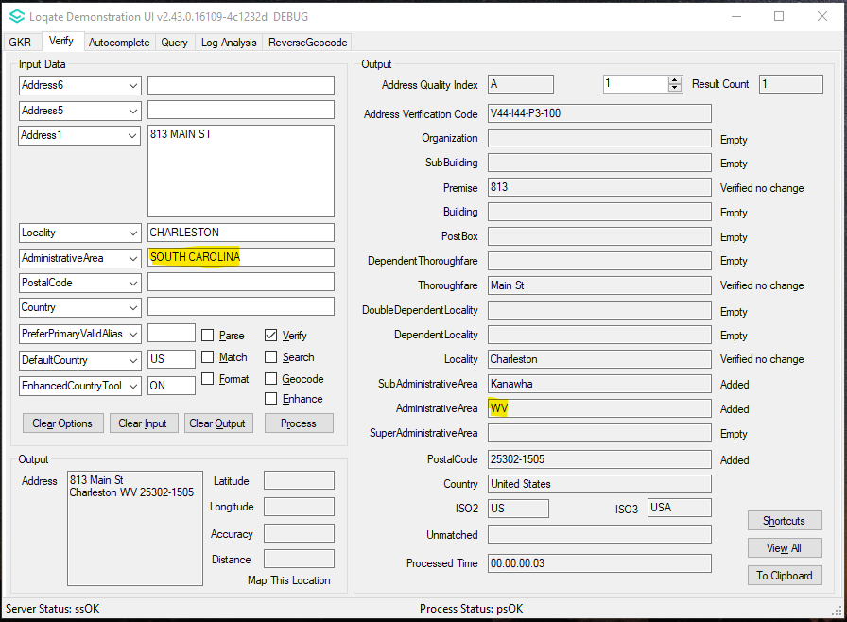  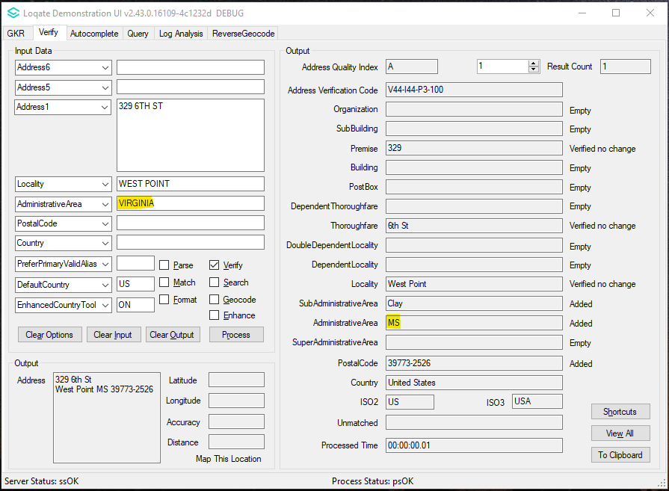  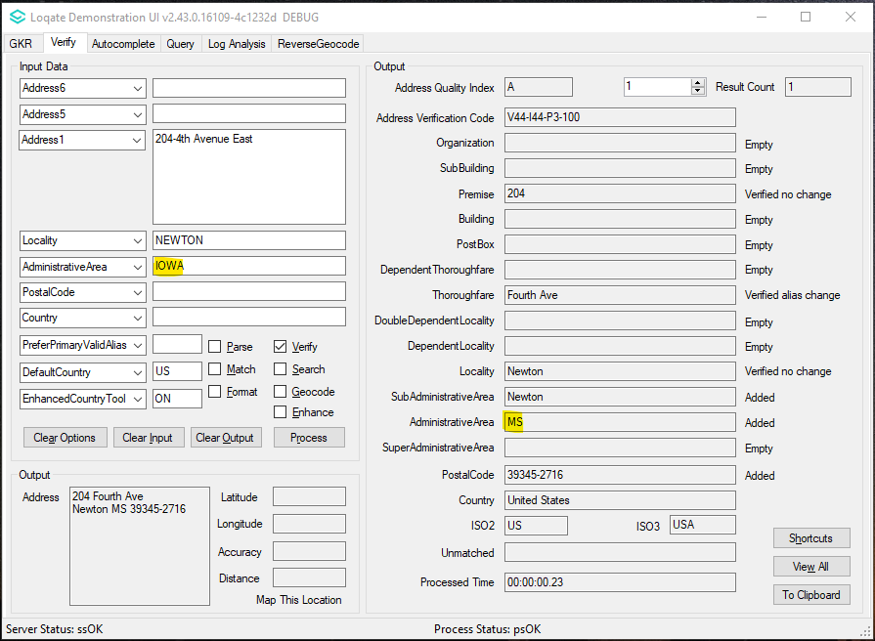 |  | 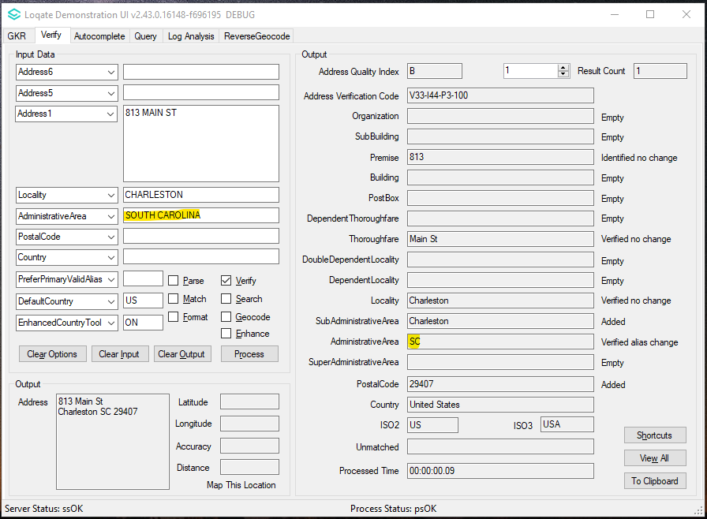  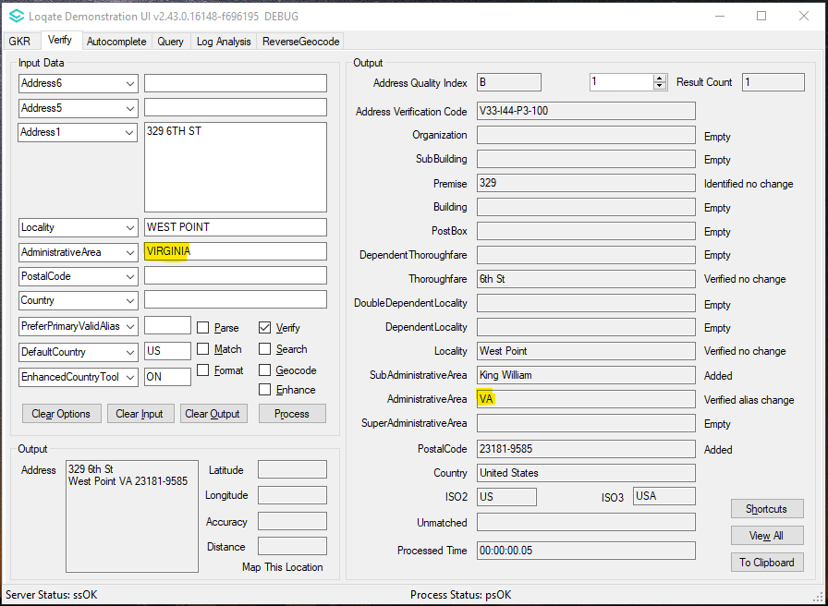  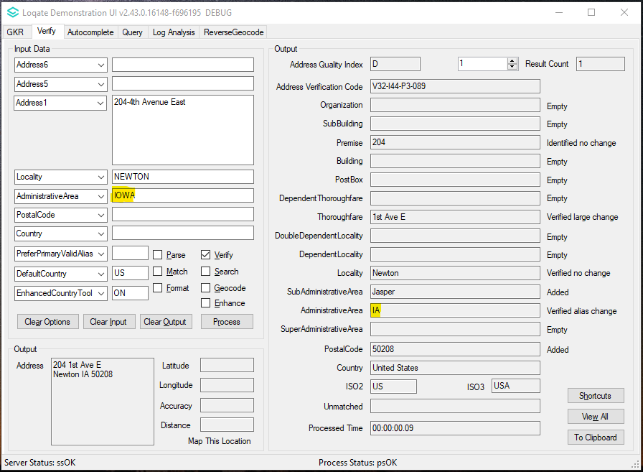

Case Number | Change Description | Category | Country | Example Address
CAS-68779-P6S7F0 | SEED Enhance would now apply postcode matching for candidates’ selection for Brazil. | API | BR | Address1: Rua Aprígio Veloso, 882 Campina Grande - PB 58429-140 Country: BR
Before Image |  |  | After Image
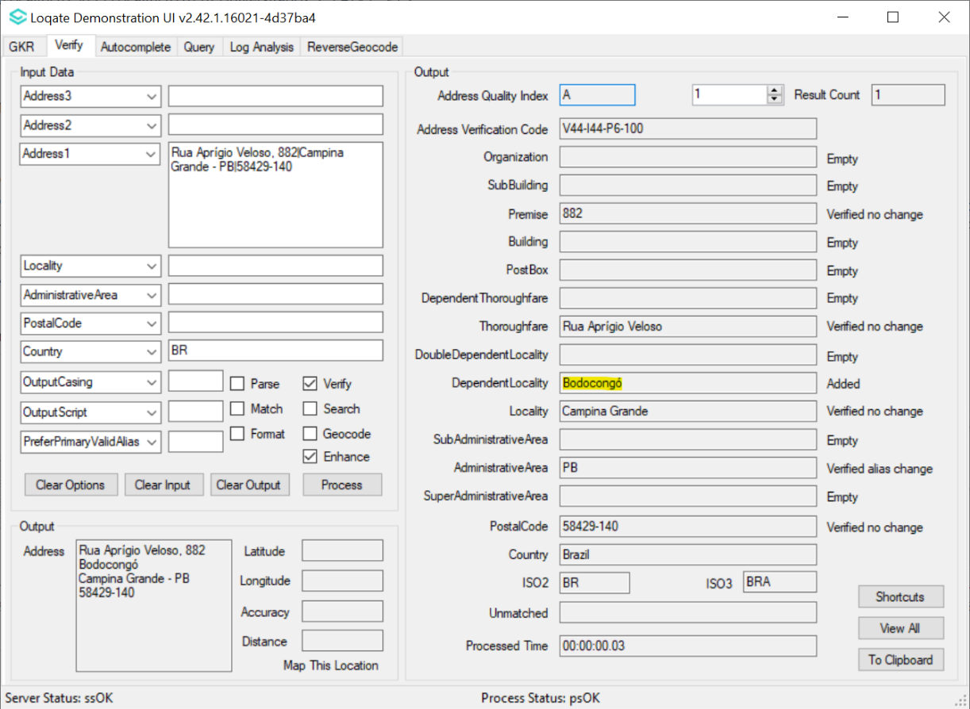 |  |  | 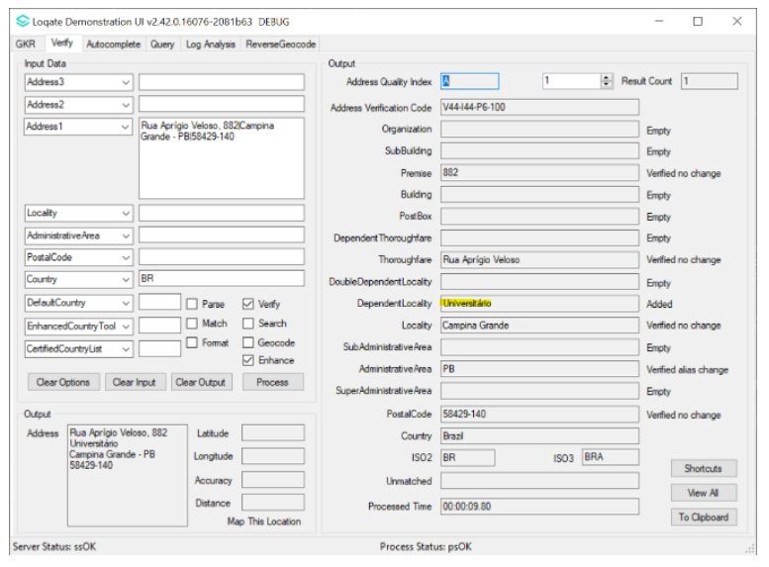

Case Number | Change Description | Category | Country | Example Address
CAS-66819-Y9B1Y3 | Server Option PreferPrimaryValidAlias=Yes and OutputScript=Native would now give the correct field status. Previously there were cases where the fields status was Identified and not Verified even though it matches our reference data. | API | All | Address1: 3-5-1, Kibuki-cho  Locality: KASUGAI-SHI  Country: JP
Before Image |  |  | After Image
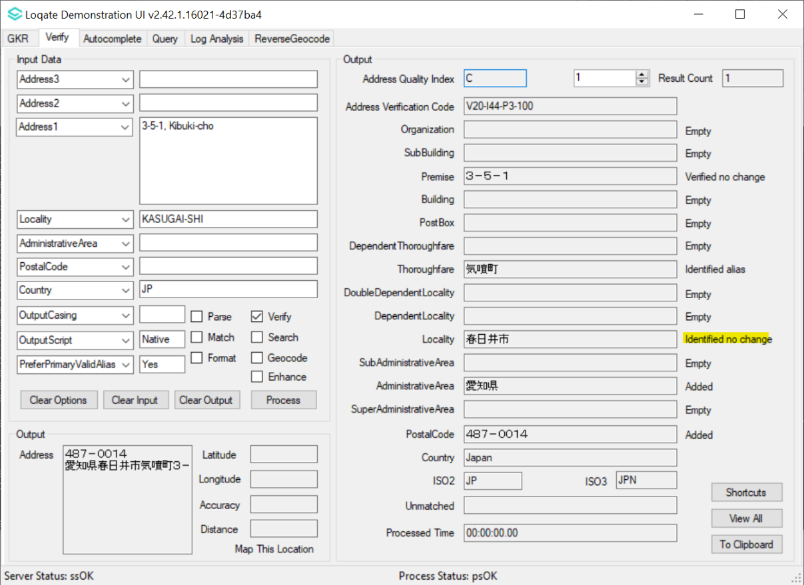 |  |  | 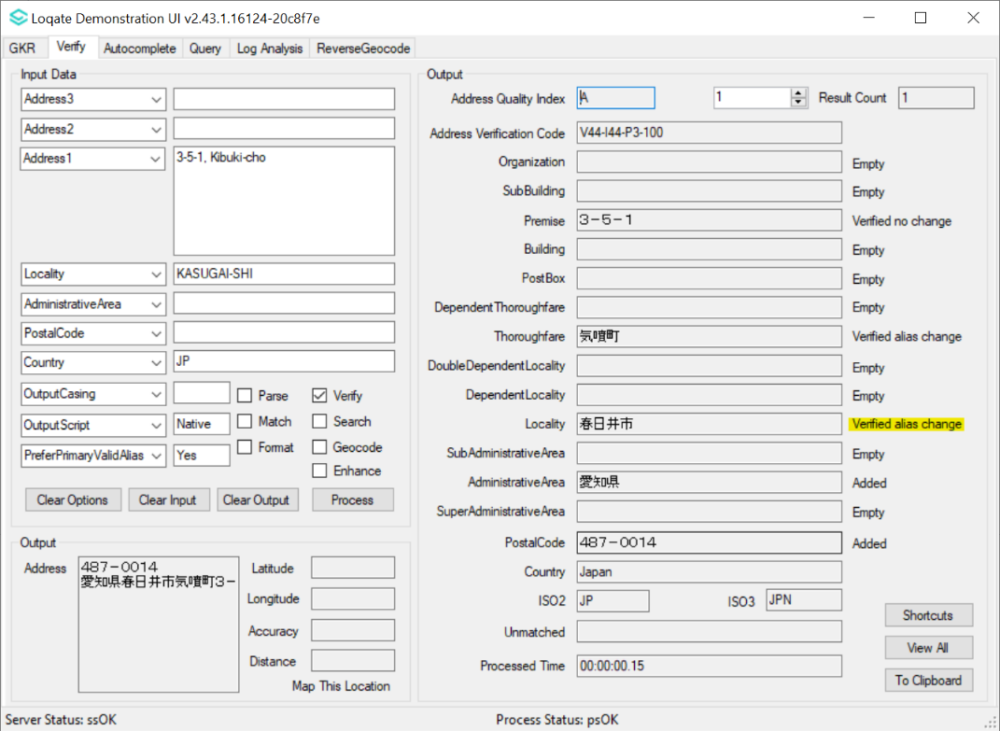

Installation Instructions

Please remember to update both the program files and the reference data and please install these to a new fresh folder location. The improvements are tied to the data in the Global Knowledge Repository and the Local API. When updating the data, it is recommended to use a new data folder each time in order to ensure the latest dataset is installed properly.

If you need any assistance with the upgrade of the Local API or the data update process, please contact GBG Loqate Support.

The setup wizard for the Local API can be obtained from our SFTP server. Please contact your account manager to retrieve the SFTP information. If you do not know who your account manager is, please contact the support team at LoqateSupport@gbgplc.com.

