Loqate, A GBG Solution
Release Notes – Reference Data & Knowledge Base

2022Q2.0 Major Release

Case Resolutions
Please visit https://support.loqate.com/2022q2-0-resolved-cases/ for a list of cases resolved in this release.
If you would like more details on any of the solved cases listed, please contact LoqateSupport@gbgplc.com for further information.

Certification Expiration Dates
If you have purchased either the CASS (USA) or AMAS (Australia) certified products, please be aware that the datasets have expiration dates set by the respective postal authorities. Please ensure that you have the latest library and data installed to avoid loss of service through these products.

Please check Install Manager for the latest versions of AMAS & CASS
 | Loqate Release Date | Certification Expiry Date*
AMAS Data | 2022-02-10 | 2022-06-30
CASS Data | 2022-04-15 | 2022-07-29
*Certification Expiry Date is different from Loqate license key expiry date. The earliest expiry date will apply.

For more information on expiry date checking for CASS and AMAS, please refer “Usage expiration” section in https://support.loqate.com/documentation/local-apis/cass-overview-2/ and https://support.loqate.com/address-matching-approval-system-amas/

Data Structure Changes

The below is a summary of the Countries where we have updated the reference data structure.
BPDH/PDH Countries

Country | ISO2 | Description
France | FR | Country rebuild (Removal of DependentLocality field)

Other major changes to highlight:

Country | Description
Canada | General improvement in parsing of Thoroughfare and Locality.
Poland | Removal of "M." suffix from the city in Locality field.  Note: M. stand for Miesto
United States | Improvement is made within the USA geocode reference data to improve geocoding level

BPDH/PDH Countries Details

France
Country Information | Description
ISO2 | FR
ISO3 | FRA
Address Format | Organization  SubBuilding Building  Premise Thoroughfare  DependentThoroughfare  PostBox Town  DoubleDependentLocality  DependentLocality  PostalCode Locality LocalityExtra LocalityExtra_Others
PDH | YES
PDH completed date | 2017Q3.0
New Source | No but updated structure

 | Pre-PDH | Post-PDH
Reference Data | rd_FR_ggg.lfs  rd_FR_ggg_r1.lfs  rd_FR_ggg_rg.lfs  rd_FR_ggg_r.lfs  rd_FR_vfy_ai.lfs  rd_FR_vfy.lfs | rd_FR_ggg.lfs  rd_FR_ggg_r1.lfs  rd_FR_ggg_rg.lfs  rd_FR_ggg_r.lfs  rd_FR_vfy_ai.lfs  rd_FR_vfy.lfs

DependentLocality field has been removed from reference data from this release onwards due to it has no longer being provided by data supplier. Investigation has shown that the dependant locality has little use and has been phased out of use by La Poste over several years.

2022Q1.1 | 2022Q2.0
DependentLocality is added. | DependentLocality is no longer added.
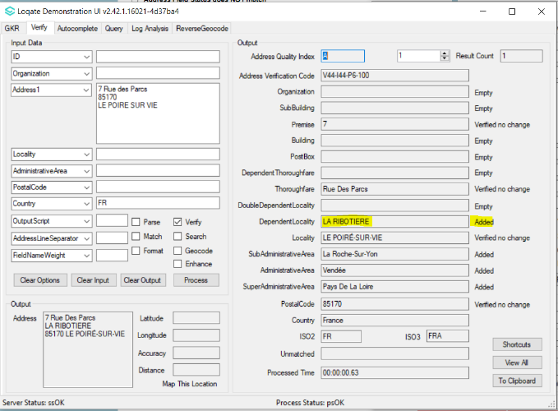 | 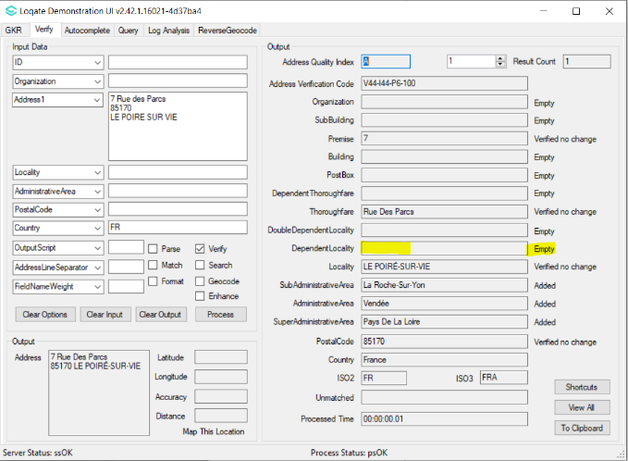

2022Q1.1 | 2022Q2.0
Le Chesnay (former commune) is returned in locality field | Le Chesnay (new commune) is returned in locality field. General improvement in locality field – Changing former commune to new commune.
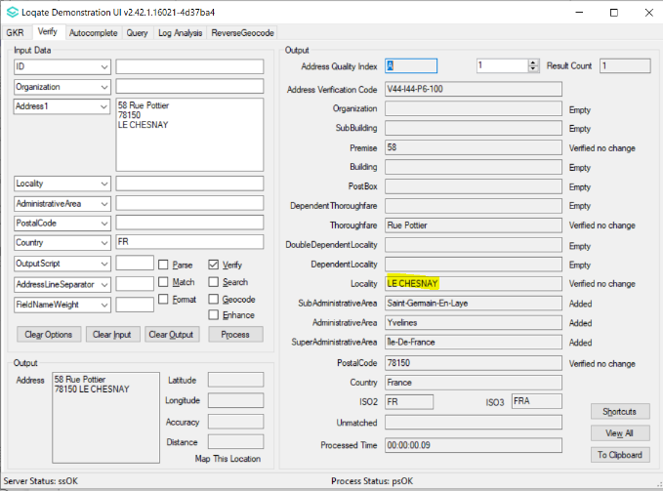 | 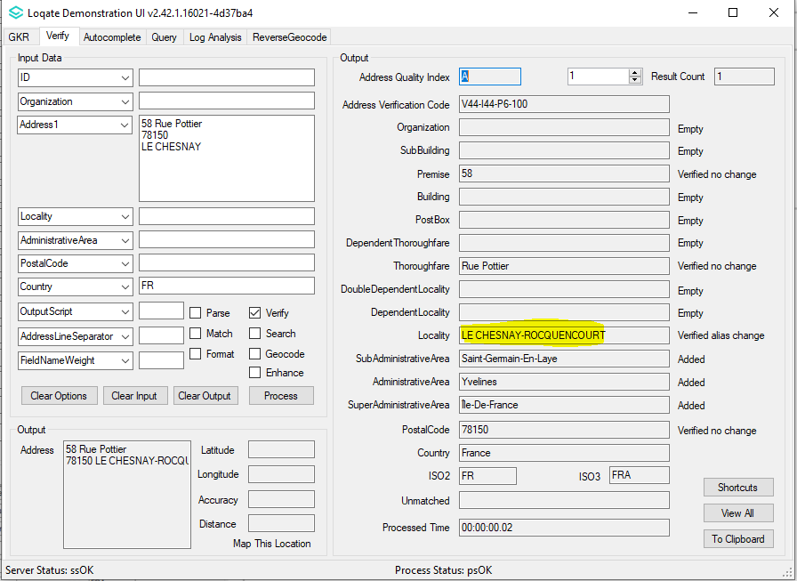

2022Q1.1 | 2022Q2.0
Previously it took 24 seconds to process a complex input address. | It now takes 7 seconds to process the same complex input address. General speed improvement.
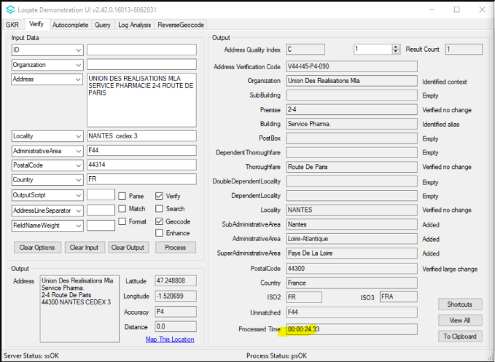 | 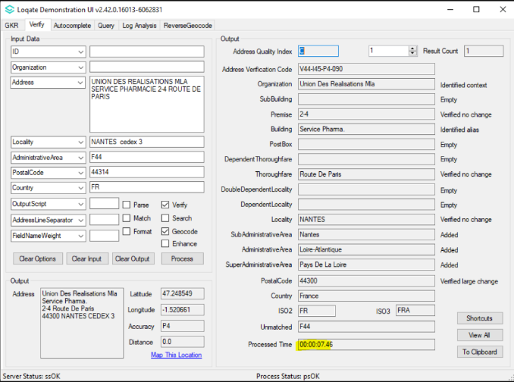

MAJOR HIGHLIGHTS
Canada
General improvement in parsing of Thoroughfare and Locality.

2022Q1.1 | 2022Q2.0
ThoroughfareName and Locality incorrectly parsed to Locality and SubAdministrativeArea fields respectively.  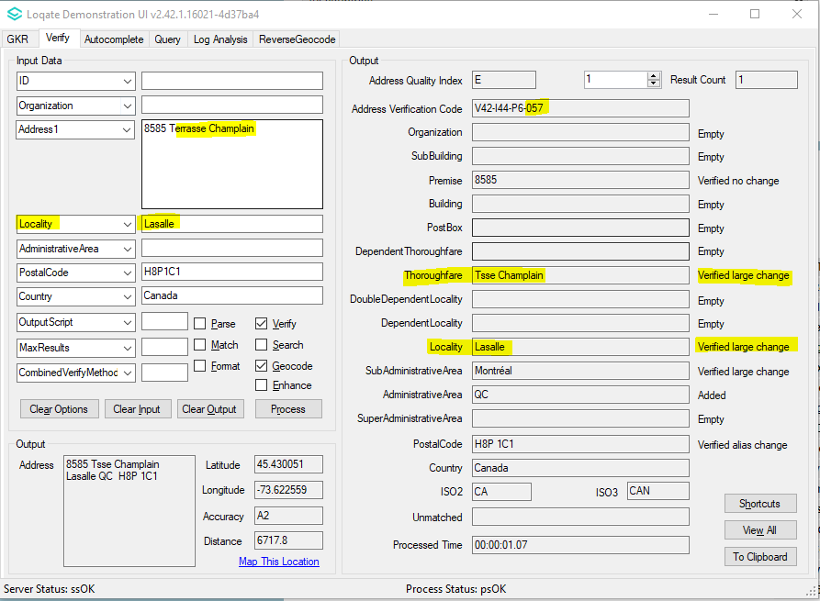 | Thoroughfare and Locality correctly parsed and verified.  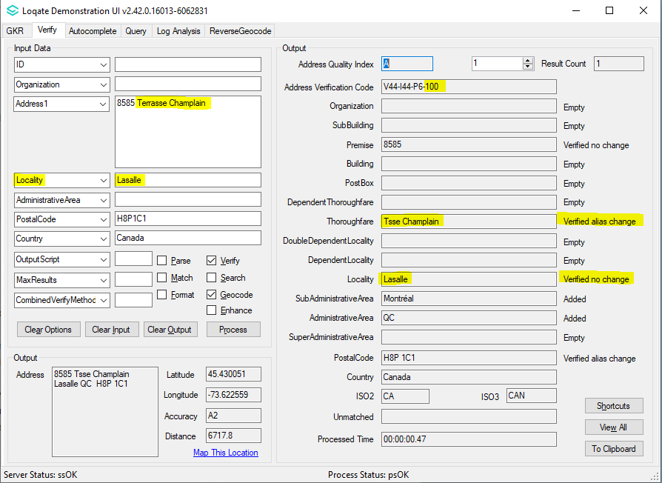

ThoroughfareName incorrectly parsed to SubAdministrativeArea field.  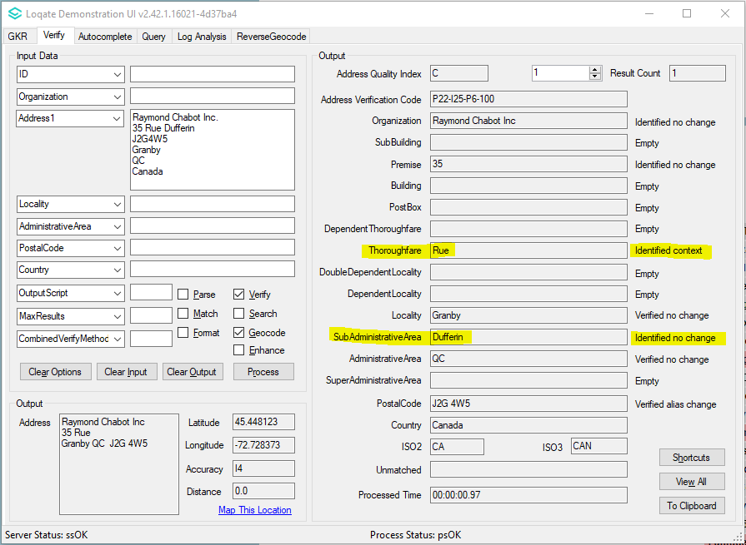 | Thoroughfare correctly parsed and verified.  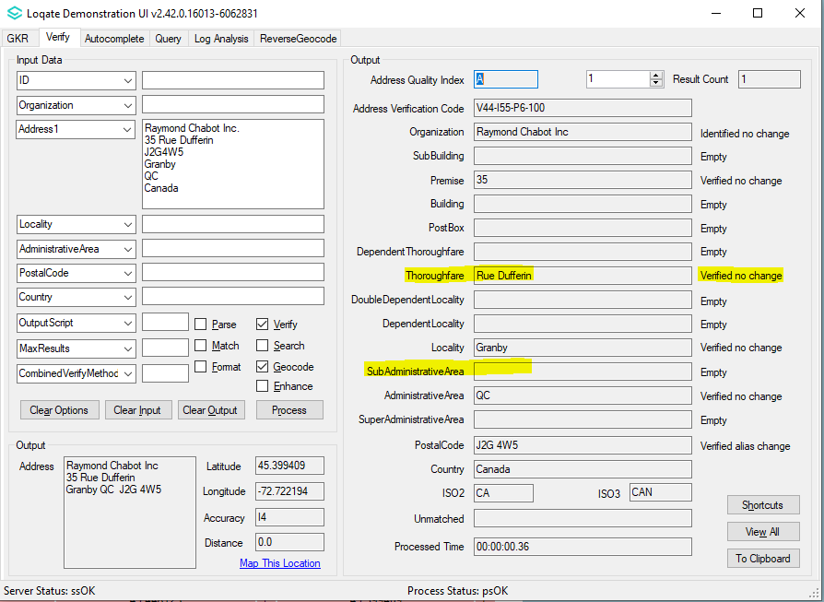

Poland
Removal of "M." suffix from the city in Locality field.
Note: M. stand for Miesto (english translation: city). Research has shown that “M.” suffix is uncommon in Poland addressing.

2022Q1.1 | 2022Q2.0
“M” suffix city name returned in the Locality field  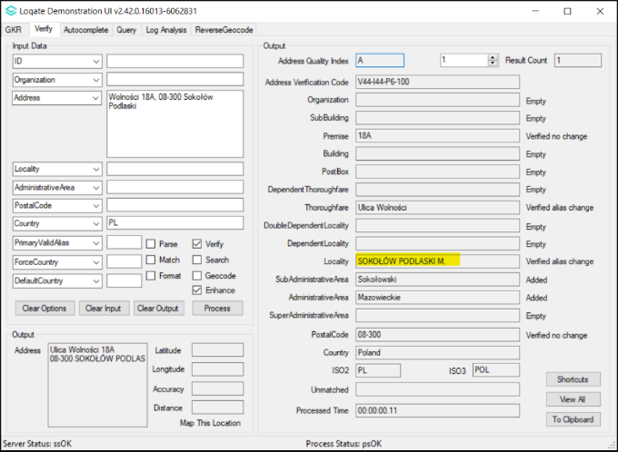 | “M” suffix no longer returned in Locality field  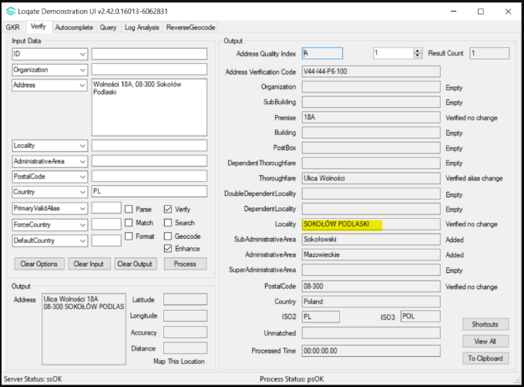

United States
Improvement is made within the USA geocode reference data to improve geocoding level.

2022Q1.1 | 2022Q2.0
GeoAccuracy of “A2” returned  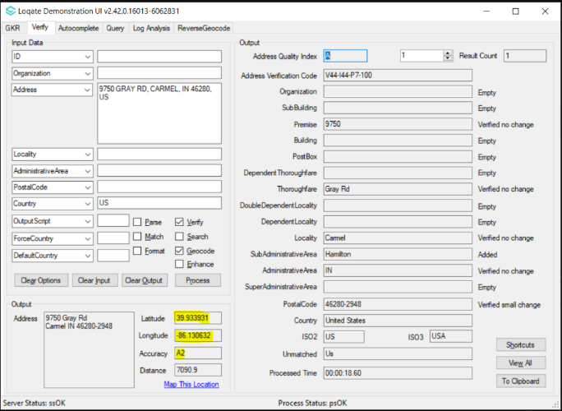 | Improvement in GeoAccuracy from A2 to P4.  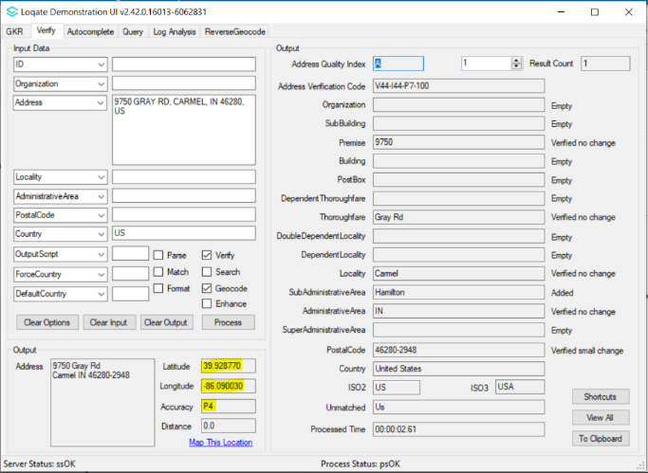

Case Resolutions

2022Q2.0 Data related Case Fixes
Case Number | Change Description | Category | Country | Example Address
CAS-53448-Z0G0C7 | Improvement of France address matching and verification. | Data | FRA | Address1: 7 Allee du Chateau  Locality: Pouilly  PostalCode: 60790  Country: FRA
Before Image |  |  | After Image
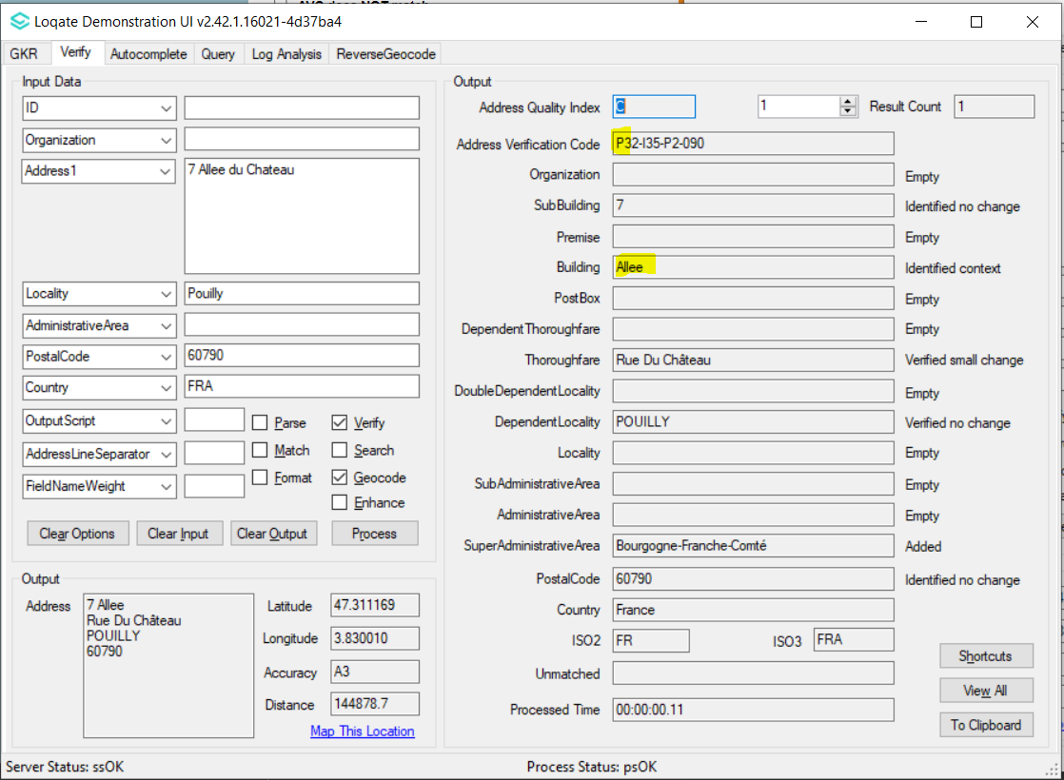 |  |  | 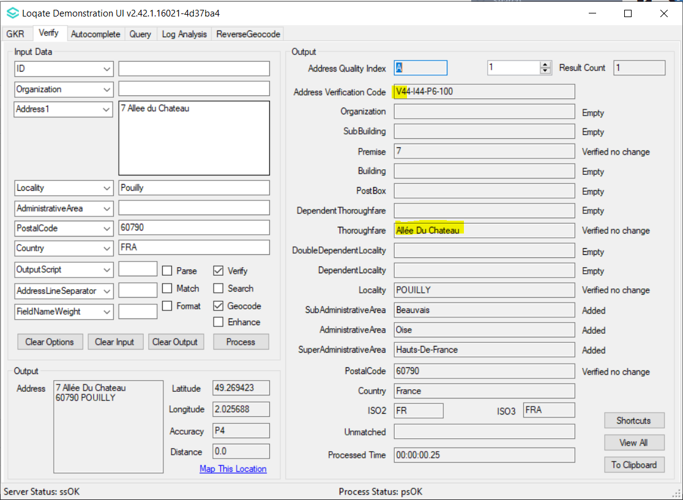

Case Number | Change Description | Category | Country | Example Address
CAS-70334-G3F0J7 | Improvement in locality field - former commune turns invalid. | Data | FRA | -
Before Image |  | After Image
The three entries are former commune.  Locality 2347897 SubAdministrativeArea 2657841 Château-Gontier<S=LATX,L=FR>|-Chateau-Gontier|$Chateau Gontier  Locality 1292188 SubAdministrativeArea 2661158 Rocquencourt  Locality 1291933 SubAdministrativeArea 2661158 Le Chesnay |  | The former commune when merged - turns invalid. Primary name is the new commune name  Locality 2347897 SubAdministrativeArea 2657841 Château-Gontier-Sur-Mayenne<S=LATX><L=FR>|-Chateau-Gontier-Sur-Mayenne|$Château-Gontier|$Chateau Gontier  Locality 1291933 SubAdministrativeArea 2661158 Le Chesnay-Rocquencourt<S=LATN><L=FR>|$Le Chesnay|$Rocquencourt

Case Number | Change Description | Category | Country | Example Address
CAS-64581-F1Y8L5 | Improvement in Locality return and AVC level.  ANCENIS-SAINT-GÉRÉON is a commune resulting from amalgamation of the communes of ANCENIS and SAINT-GÉRÉON. | Data | FRA | Address: Espace 23-Bd de la Prairie, 44150 Ancenis-Saint-Géréon, France
Before Image |  |  | After Image
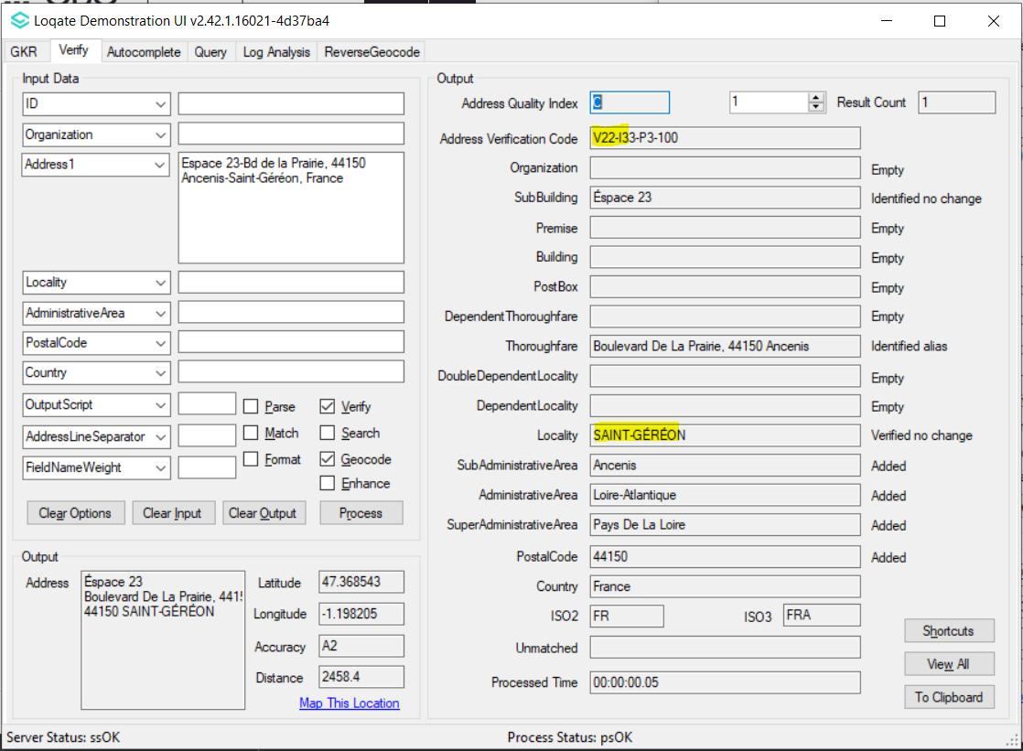 |  |  | 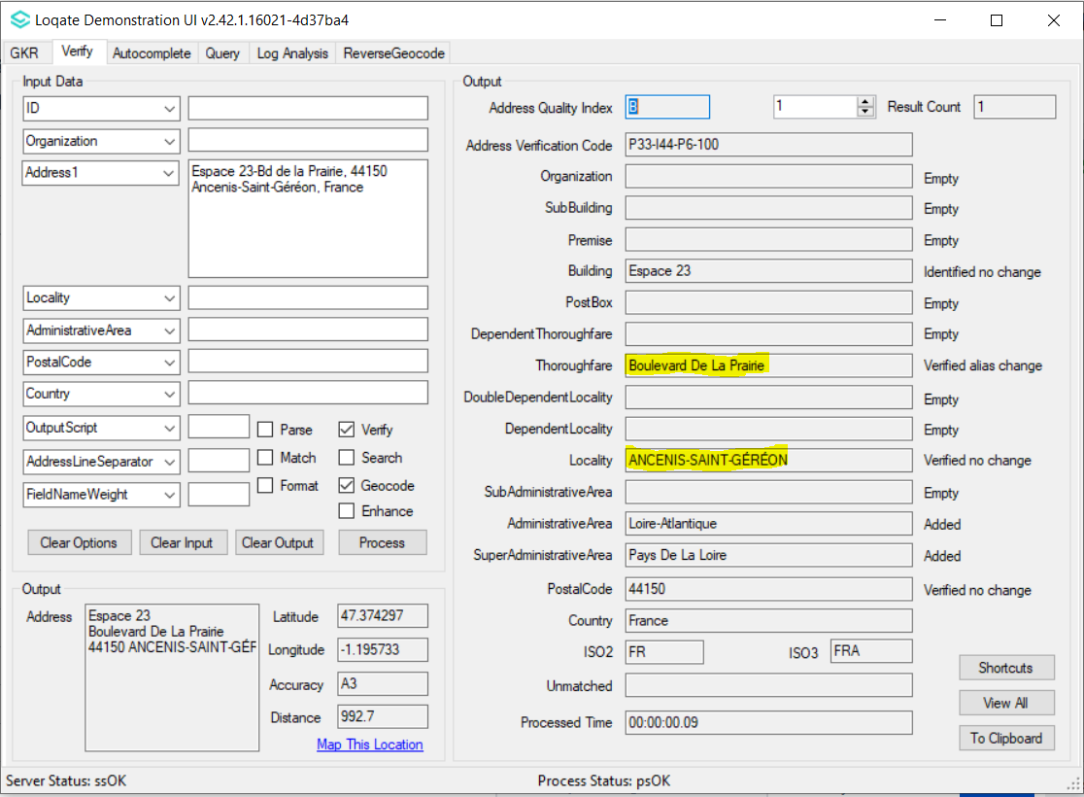

Case Number | Change Description | Category | Country | Example Address
CAS-10592-F0C2W9 | Removal of Incorrect Building | Data | AUS | Address1: 19 Byron Court, Narre Warren South, VIC, 3805, AUS
Before Image |  |  | After Image
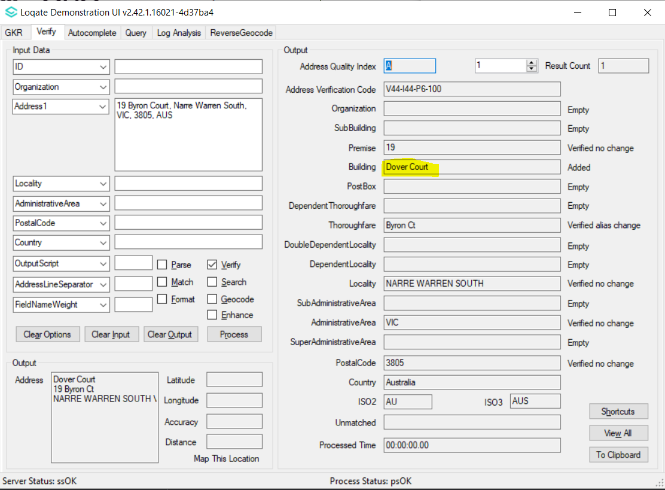 |  |  | 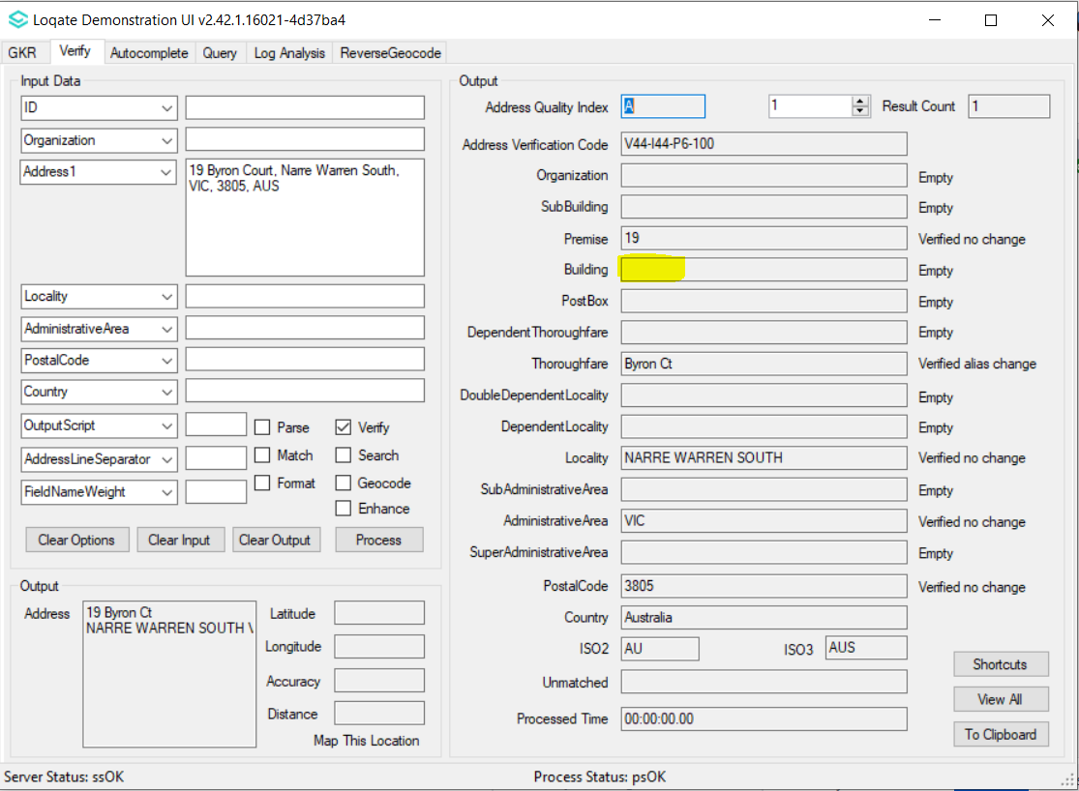

Case Number | Change Description | Category | Country | Example Address
CAS-49550-F5T0M4 | Locality is no longer missing in the output field | Data | ZAF | Address1: 94 NEW CROSS ROAD  Locality: NYANGA  PostalCode: 7750  Country: ZAF
Before Image |  |  | After Image
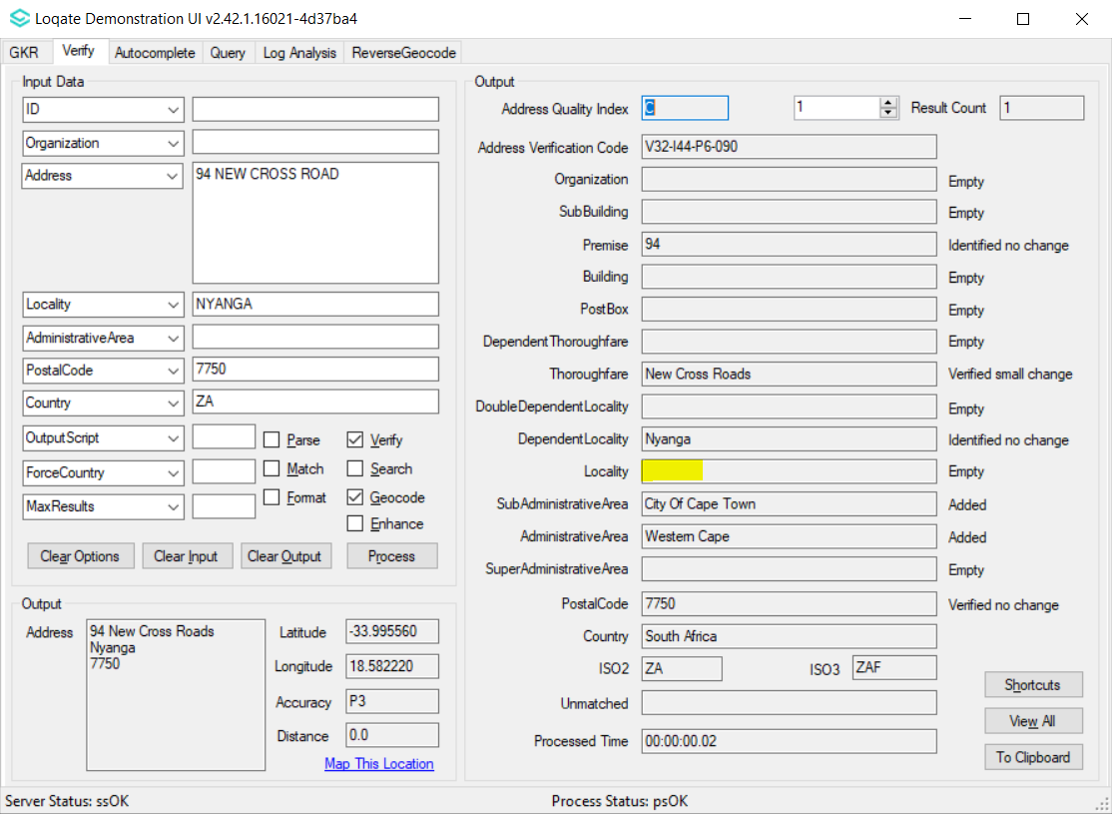 |  |  | 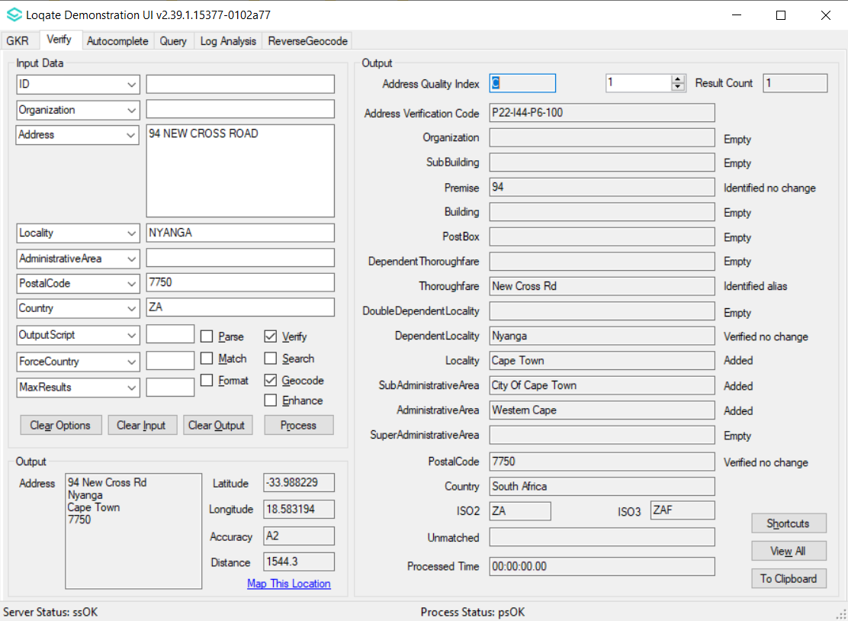

Case Number | Change Description | Category | Country | Example Address
CAS-66488-W5N3G9 | Removal of SubAdministrativeArea because it's no longer available/valid under respective AdminisitrativeArea  (Leh District should only be under Ladakh) | Data | IND | -
Before Image |  |  | After Image
Leh District is incorrectly under Jammu & Kashmir state  SubAdministrativeArea 3115557 AdministrativeArea 3072962 Leh District<S=LATN><L=EN>  AdministrativeArea 3072962 Jammu & Kashmir<S=LATN><L=EN> |  |  | Leh District is no longer under Jammu & Kashmir state. The relevant district is only under Ladakh state.  SubAdministrativeArea 4857999 AdministrativeArea 4857944 Leh Ladakh District<S=LATN><L=EN>  AdministrativeArea 4857944 Ladakh<S=LATN><L=EN>

Case Number | Change Description | Category | Country | Example Address
CAS-56740-Z2R7R4 | Improvement on Premise level verification | Data | Mexico | Address1: Emiliano Zapata 51 El Colorado 76246  Country: Mexico  Address1: Lazaro Cardenas 36, Francisco I. Madero, 27908  Country: Mexico
Before Image |  |  | After Image
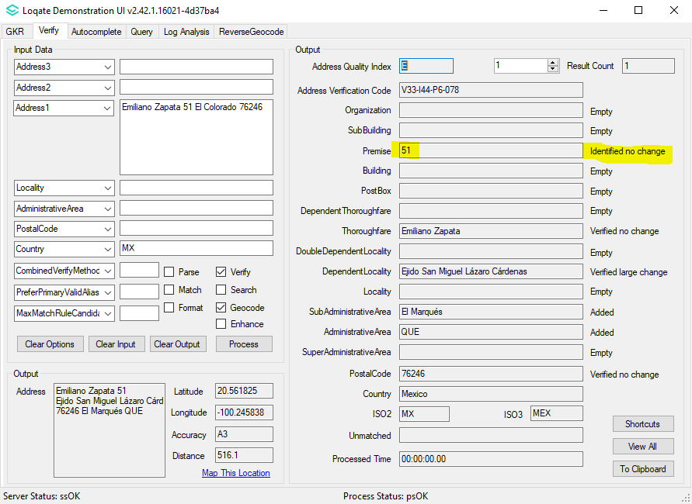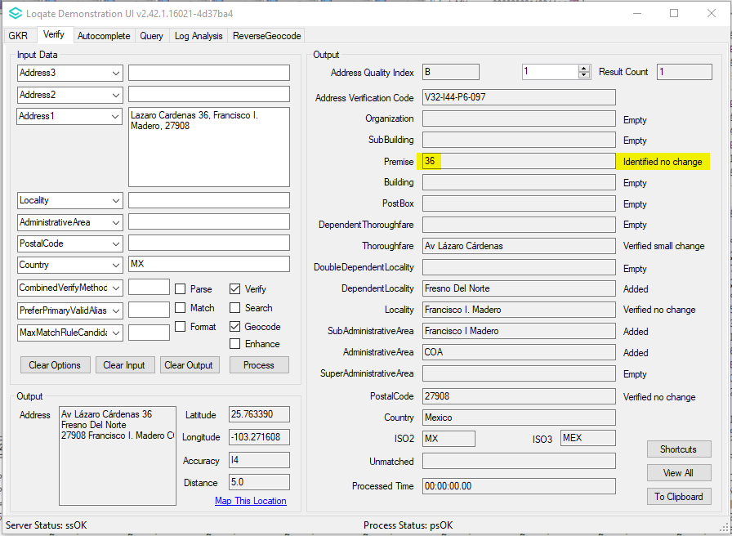 |  |  | 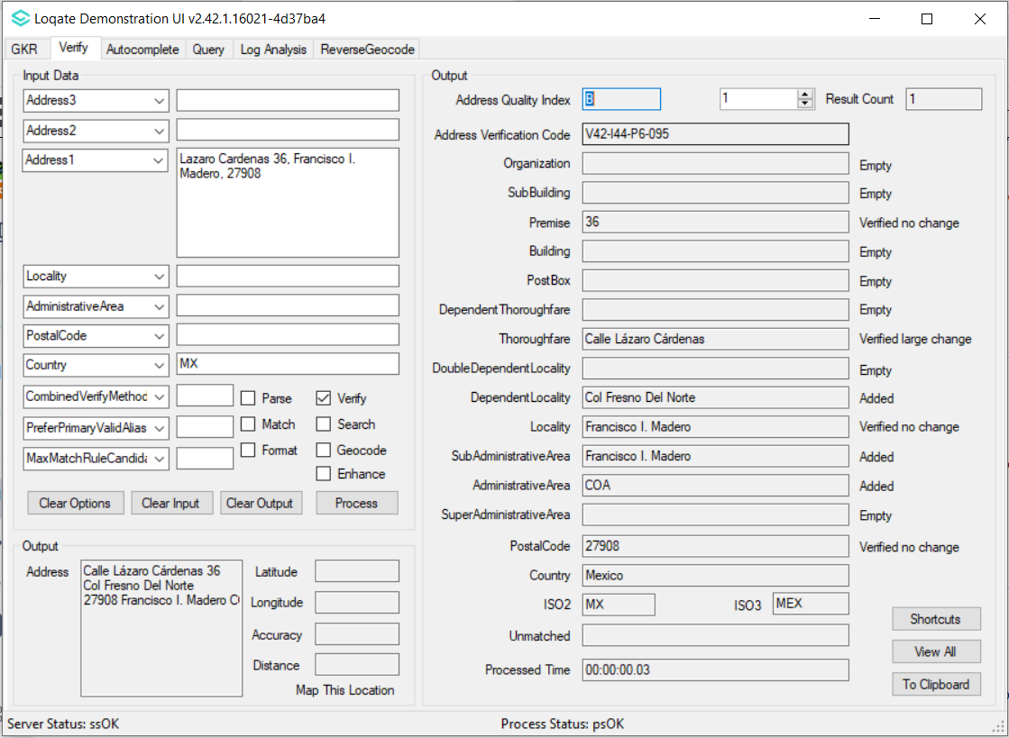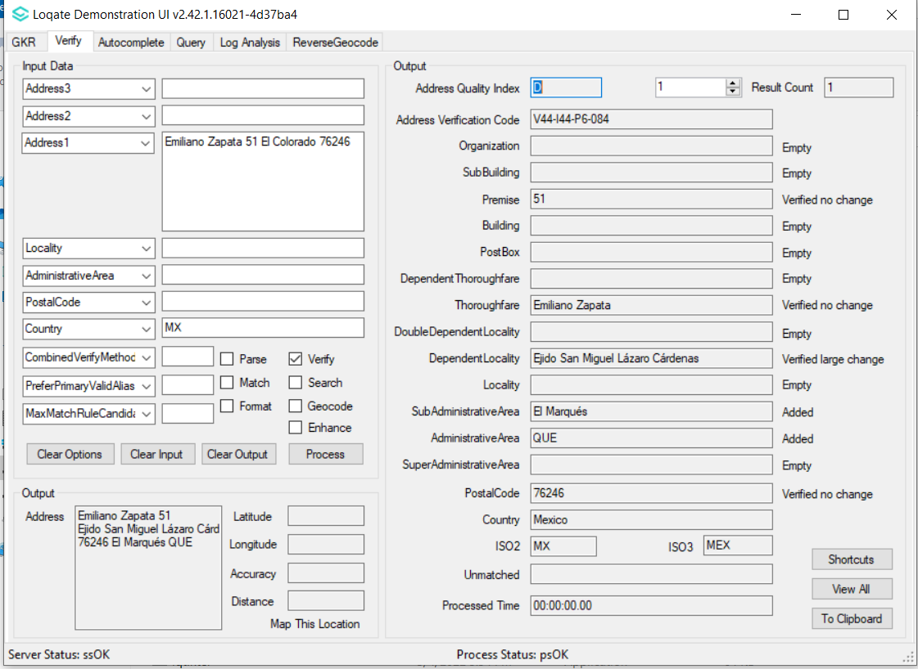

Case Number | Change Description | Category | Country | Example Address
CAS-65497-Z5P0D6 | Improvement of the Primary Name for the Canada Locality | Data | Canada | Address 1: 2130 BOUL LEMIRE  DRUMMONDVILLE QC J2B 7E9  Country: Canada
Before Image |  |  | After Image
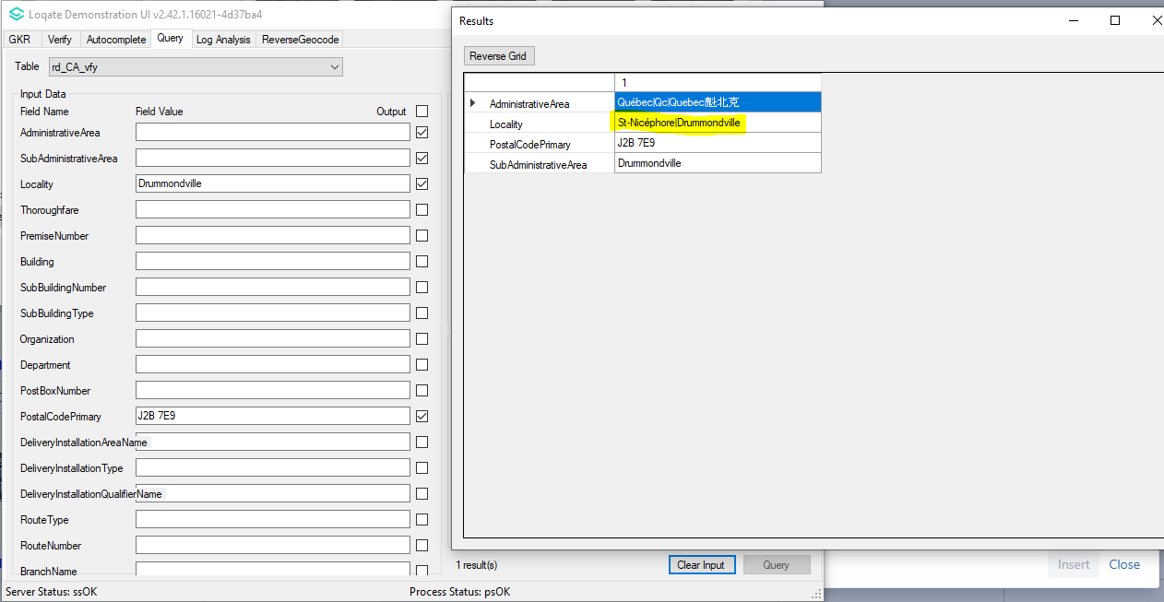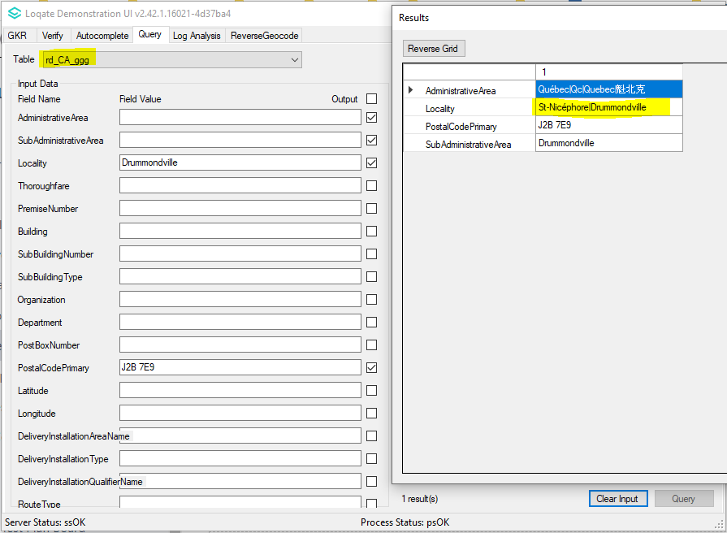  St-Nicéphore are former primary name  Locality 616880 SubAdministrativeArea 616879 St-Nicéphore<S=LATX,L=FR>|-St-Nicephore|Drummondville<S=LATN,L=EN>|$Saint-Charles-de-Drummond|$Saint-Joachim-de-Courval|$Saint-Nicephore|$St-Joachim-de-Courval|$St-Charles-de-Drummond |  |  | 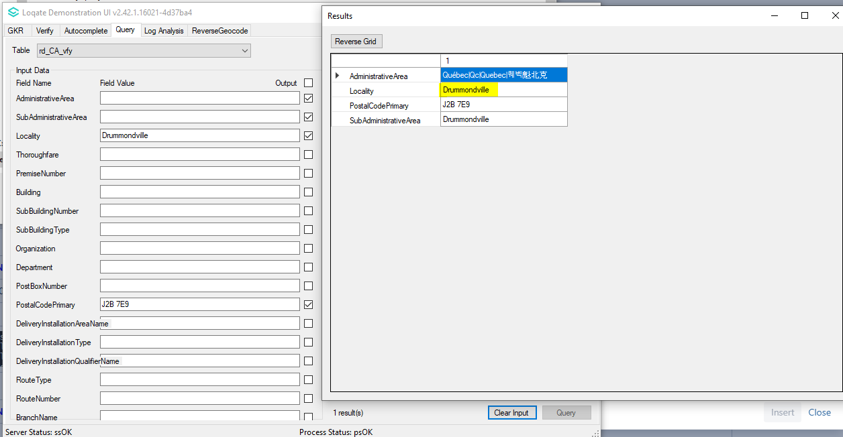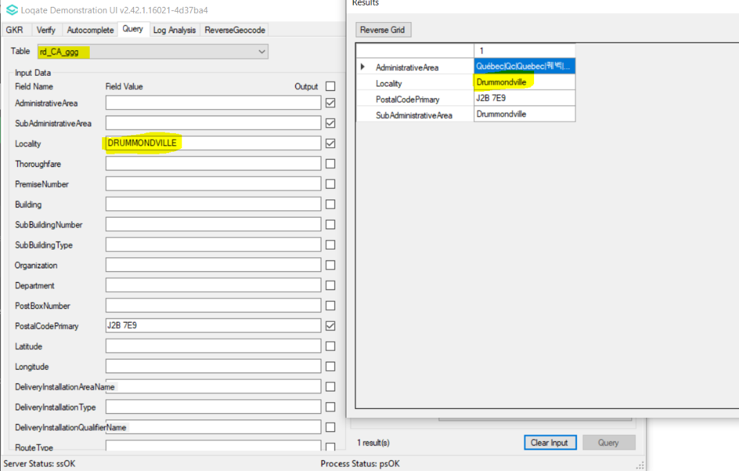  Drummondville is the new primary name and St-Nicéphore is set as invalid alias  Locality 616880 SubAdministrativeArea 616879 Drummondville<S=LATN><L=FR>|$Saint-Charles-de-Drummond|$Saint-Joachim-de-Courval|$Saint-Nicephore|$St-Nicéphore|$St-Joachim-de-Courval|$St-Charles-de-Drummond

Case Number | Change Description | Category | Country | Example Address
CAS-68445-R0V3Z0 | Corrected the missing Locality for Argentina | Data | Argentina | -
Before Image |  |  | After Image
Previously, Locality Paraná does not exist. Paraná only exists as SubAdministrativeArea  SubAdministrativeArea 51682 AdministrativeArea 51681 Paraná<S=LATX,L=ES>|-Parana|$Ba La Na|파라나<S=HANG,L=KO>|巴拉那<S=HANS,L=ZH> |  |  | Locality Paraná is now exist  SubAdministrativeArea 51682 AdministrativeArea 51681 Paraná<S=LATN><L=ES>|-Parana|$Ba La Na|파라나<S=HANG><L=KO>|巴拉那<S=HANS><L=ZH>  Locality 52223 SubAdministrativeArea 51682 Paraná<S=LATN><L=ES>|-Parana|$Ba La Na|파라나<S=HANG><L=KO>|巴拉那<S=HANS><L=ZH> $3100|$3114|$3116|$3118|$3132|$3134|E3100|E3114|E3116|E3118|E3132|E3134

Case Number | Change Description | Category | Country | Example Address
CAS-70950-H2D8V9 | Corrected the primary valid alias of Localities to original native names in diacritic for Seed file. | Data | PRI | N/A
Before Image |  |  | After Image
The alias with diacritic is not set as the primary valid alias.  Locality 13866 SubAdministrativeArea 13865 Anasco<S=LATN,L=ES>|$Añasco|$A Ni Ya Si Ke|阿尼亚斯科<S=HANS,L=ZH>  Locality 24438 SubAdministrativeArea 24431 Comerio<S=LATN,L=ES>|$Comerío|$Ke Mei Li Ao|科梅里奥<S=HANS,L=ZH> |  |  | The alias with diacritic is set as the primary valid alias.  Locality 13866 SubAdministrativeArea 13865 Añasco<S=LATX,L=ES>|-Anasco|$A Ni Ya Si Ke|阿尼亚斯科<S=HANS,L=ZH>  Locality 24438 SubAdministrativeArea 24431 Comerío<S=LATX,L=ES>|-Comerio|$Ke Mei Li Ao|科梅里奥<S=HANS,L=ZH>

Case Number | Change Description | Category | Country | Example Address
CAS-65049-G1D6J1 | Improvement on Locality and Thoroughfare parsing and verification with option CombinedVerifyMethods=OFF. | Data | CAN | A total of 25 addresses provided. Three are shown below.  Address1: 557 RUE HUBERDEAU  Locality: LAVAL  AdministrativeArea: QC  PostalCode: H7X1P6  Country: CAN  Address1: 3207 RUE VERRET  Locality: QUÉBEC  AdministrativeArea: QC  PostalCode: G2B1G6  Country: CAN  Address1: 3532 RUE LA SALLE  Locality: LAC-MEGANTIC  AdministrativeArea: QC  PostalCode: G6B1T3  Country: CAN
Before Image |  |  | After Image
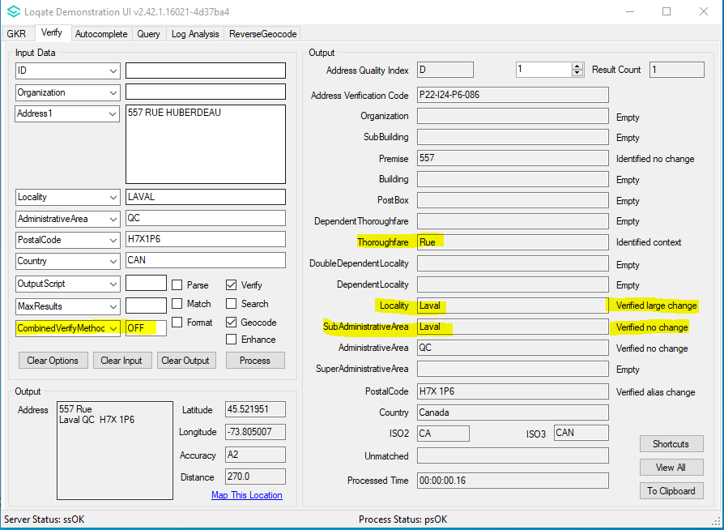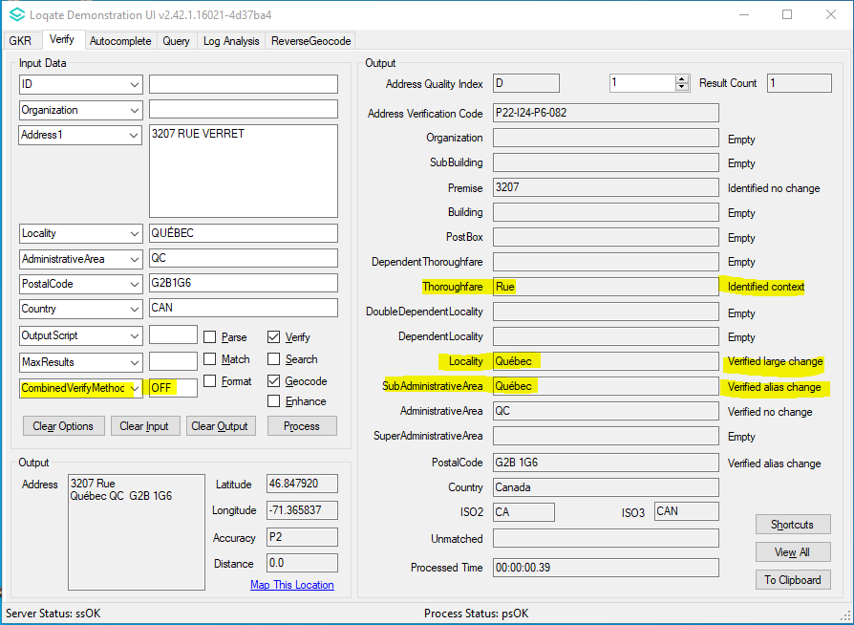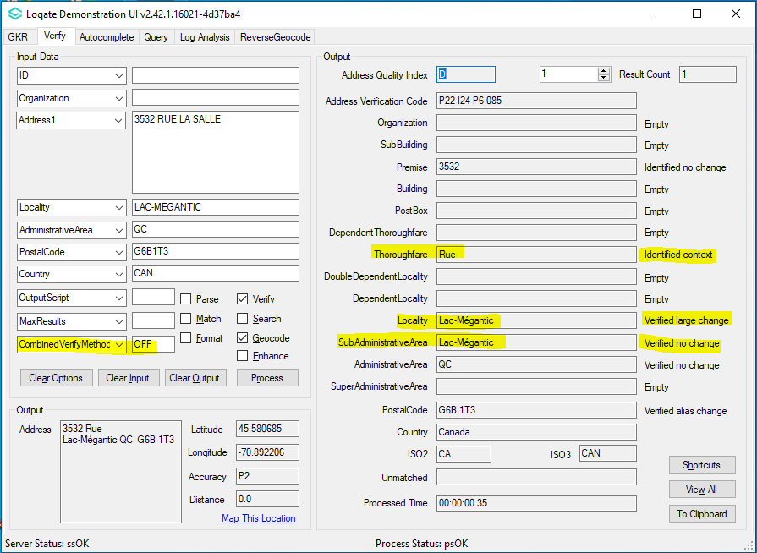 |  |  | 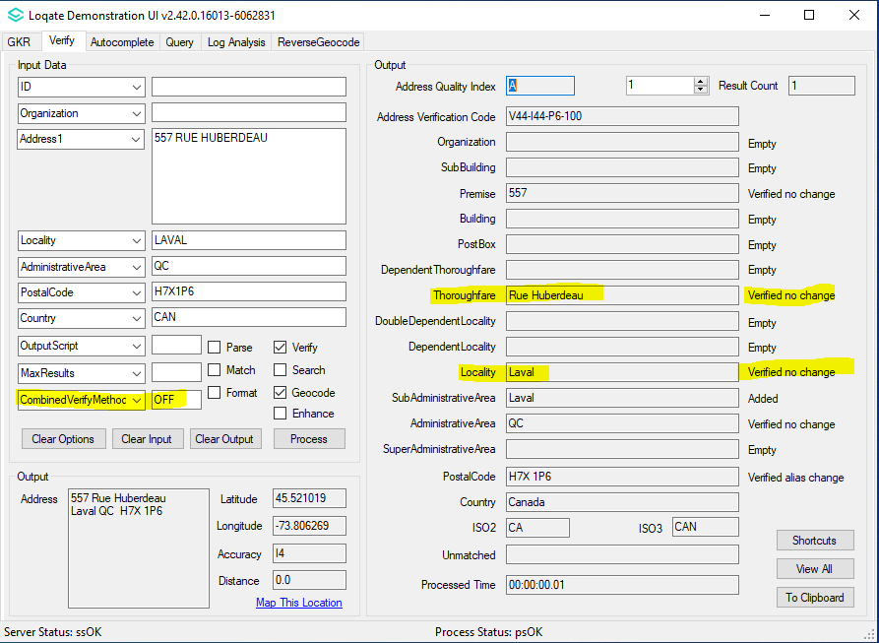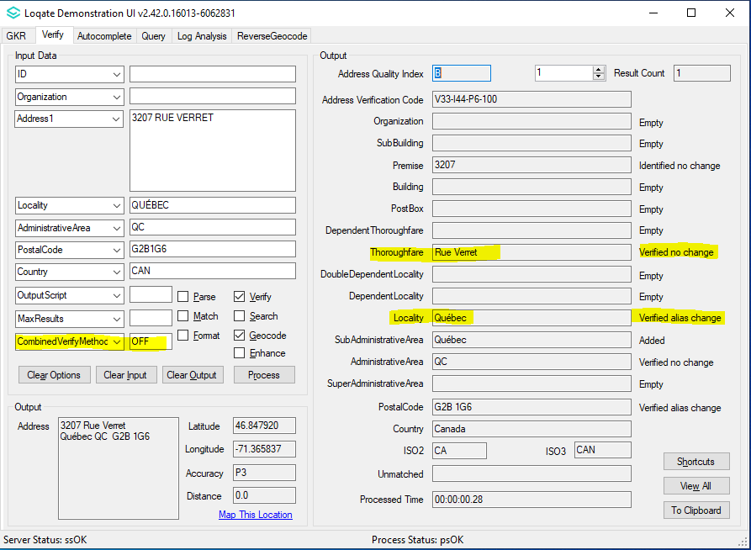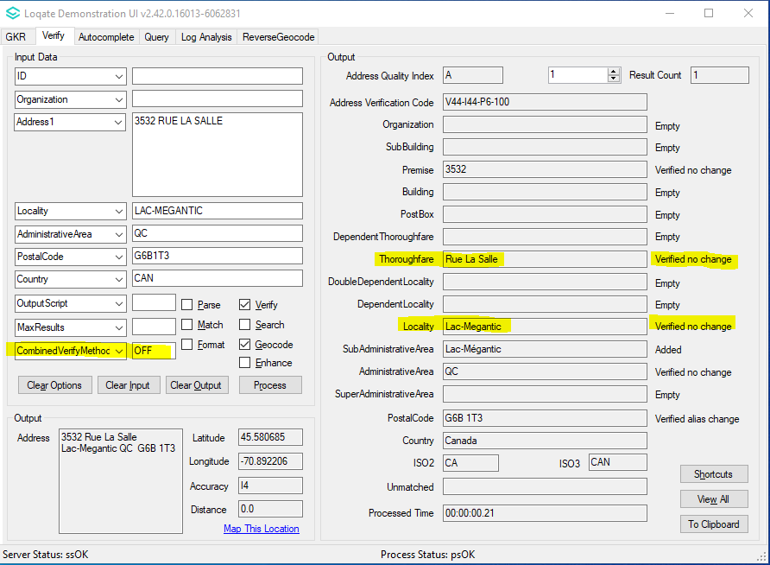

Case Number | Change Description | Category | Country | Example Address
CAS-68051-T3B2P6 | Improvement on Locality and Thoroughfare parsing with higher AVC match score. | Data | CAN | Address1: 24 Glen Ames  Locality: Toronto  AdministrativeArea: ON  PostalCode: M4E 1M4  Country: CAN  Address1: 3399 The Credit Woodlands  Locality: Mississauga  AdministrativeArea: ON  PostalCode: L5C 2K2  Country: CAN  Address1: 258 Indian Road Crescent  Locality: Toronto  AdministrativeArea: ON  PostalCode: M6P 2G7  Country: CAN  Address1: 20 Port Union Road  Locality: Toronto  AdministrativeArea: ON  PostalCode: M1C 5K5  Country: CAN
Before Image |  |  | After Image
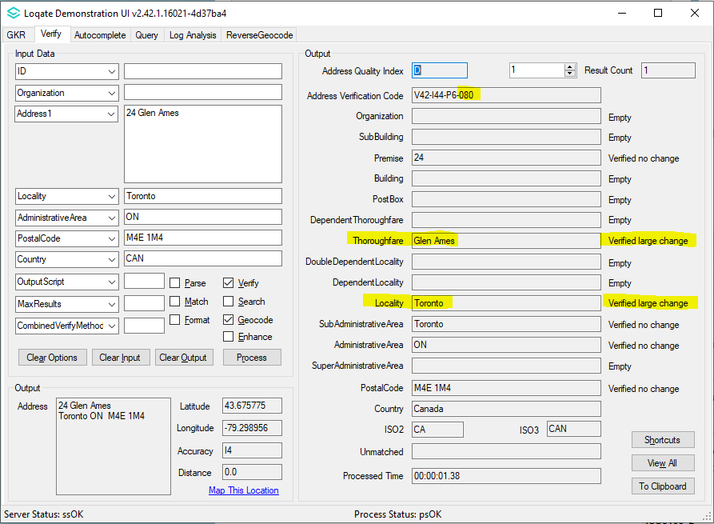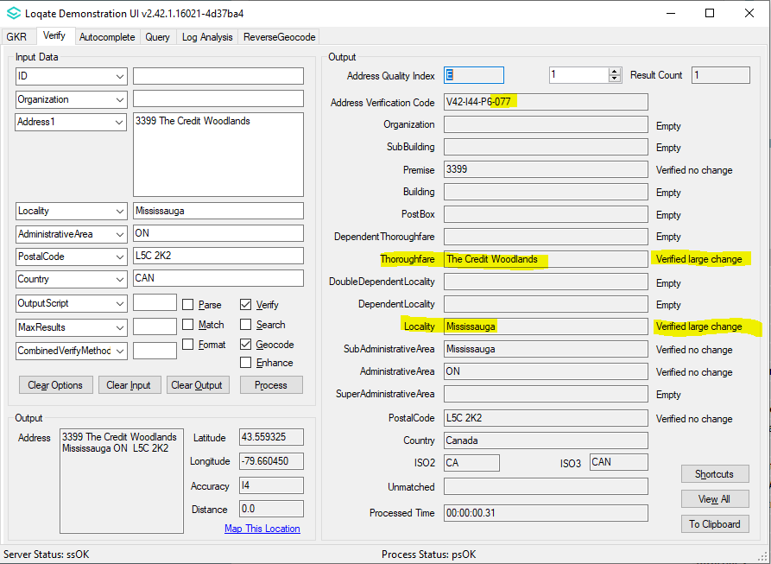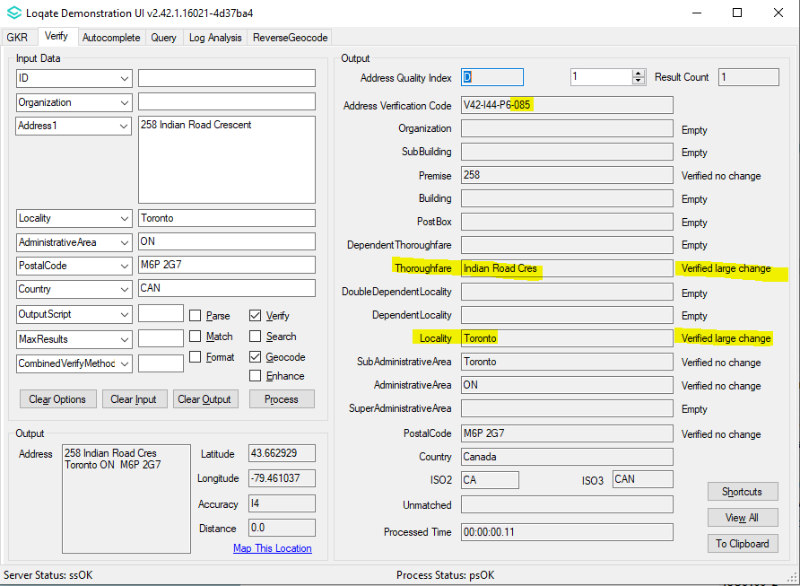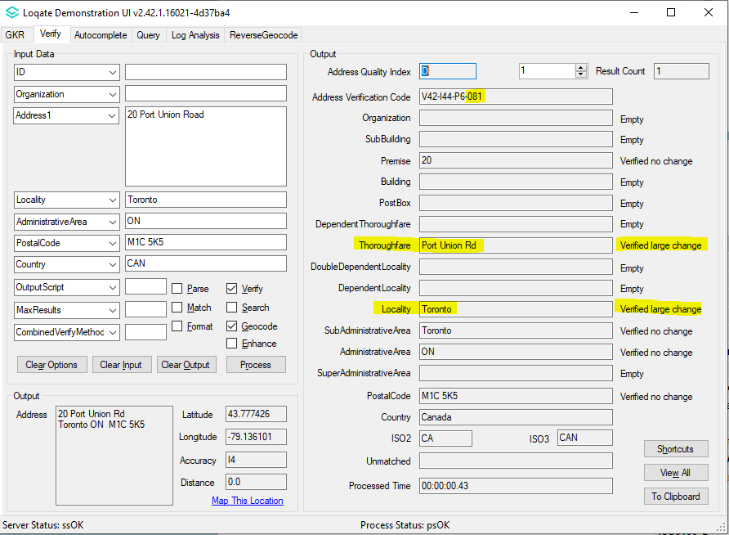 |  |  | 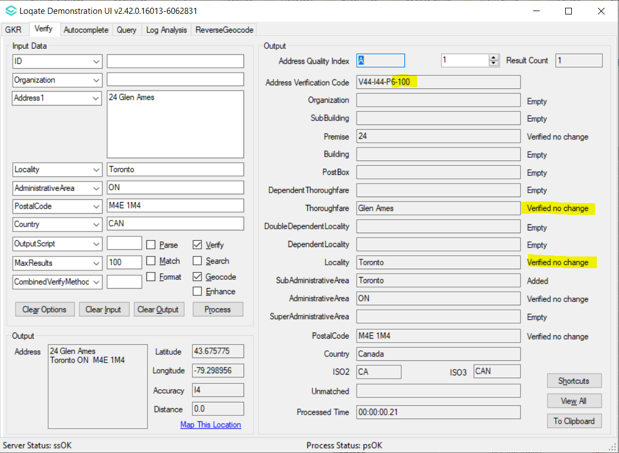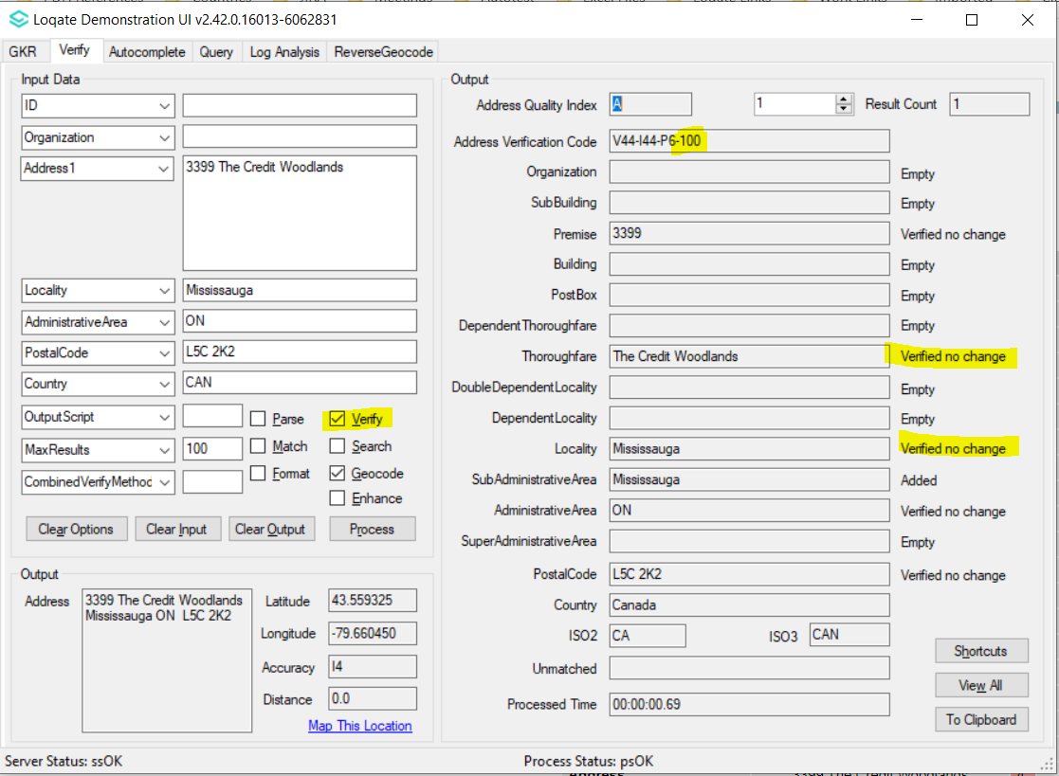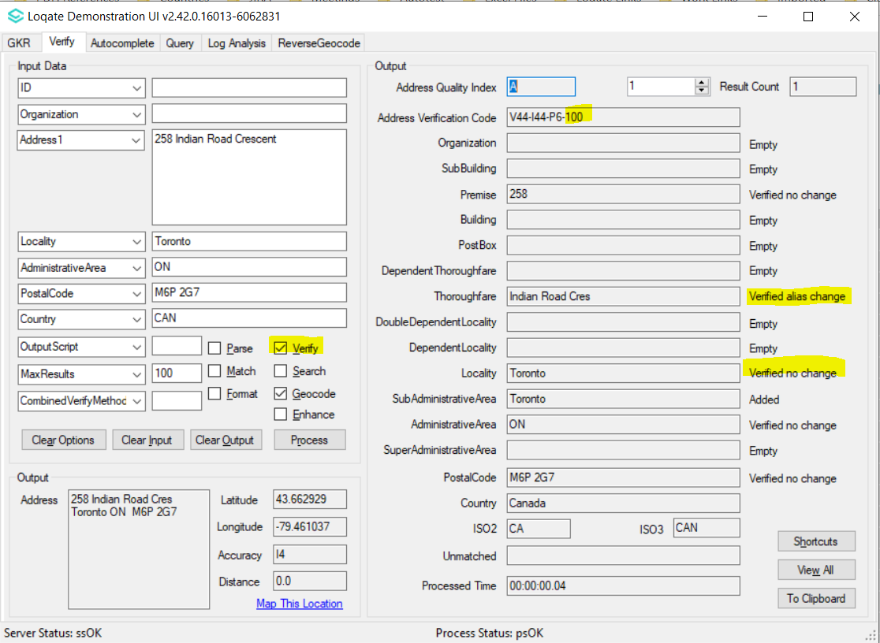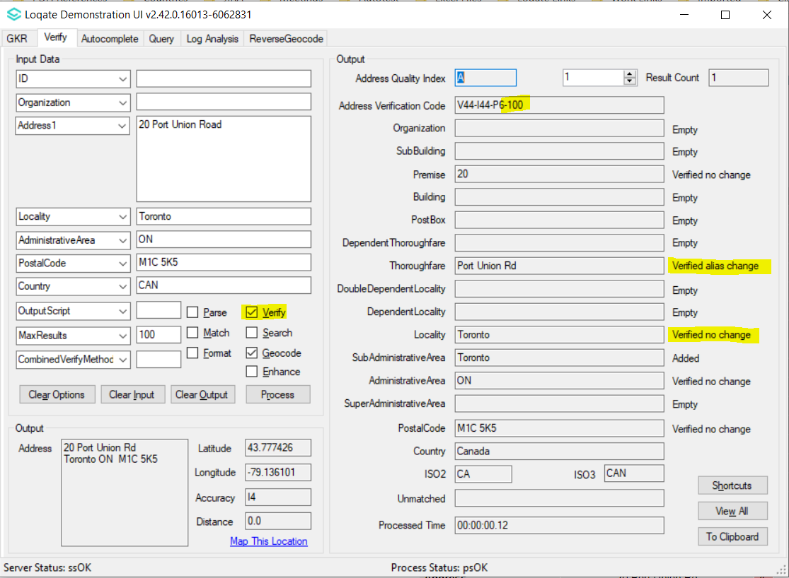

Case Number | Change Description | Category | Country | Example Address
CAS-58833-X8Q9W5 | Improvement on Building parsing and Thoroughfare verification. | Data | ESP | Address: hotel asturias , calle de sevilla 2, madrid, 28014  Country: ESP
Before Image |  |  | After Image
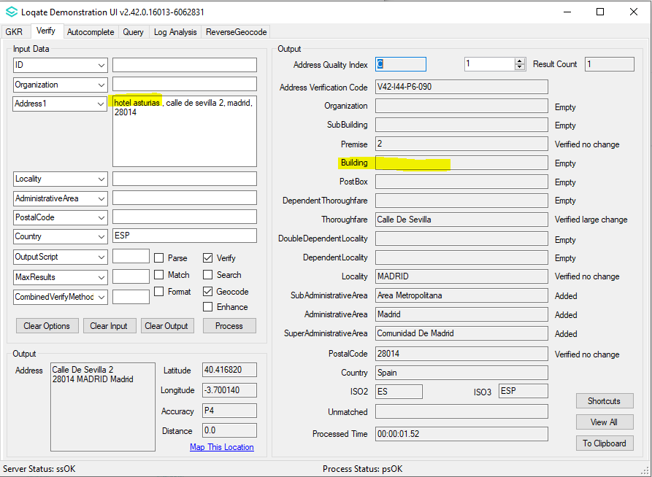 |  |  | 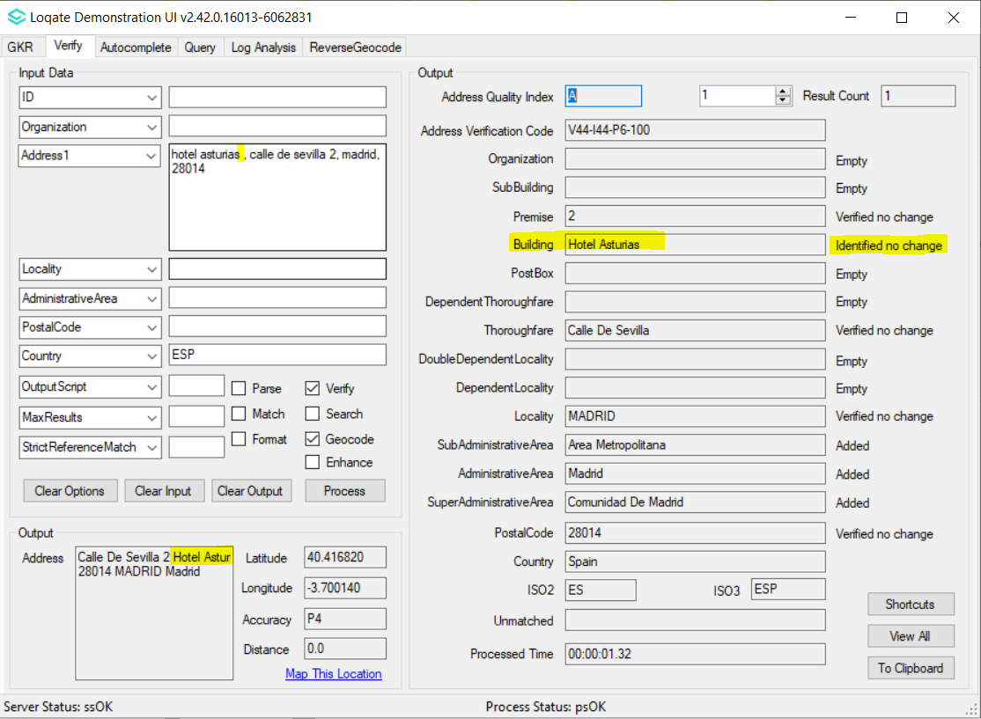

Case Number | Change Description | Category | Country | Example Address
CAS-04783-J3G0W9 | Improvement on address parsing and verification when input have a mix of Native and Latin input. | Data | RUS | Address1: Ул Stachki pr-k 25  Locality: Rostov-na-Donu  Country: Russia  Address1: Ул Gruzinskaya 7  Locality: Perm  Country: Russia  Address1: Ул Lyambirskoe sh. 15  Locality: Saransk  Country: Russia
Before Image |  |  | After Image
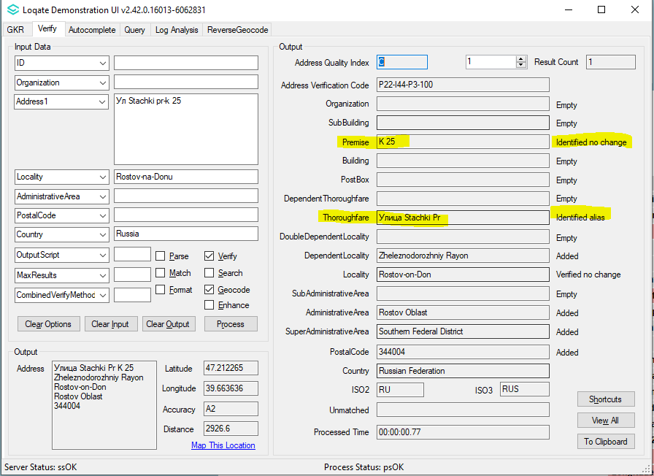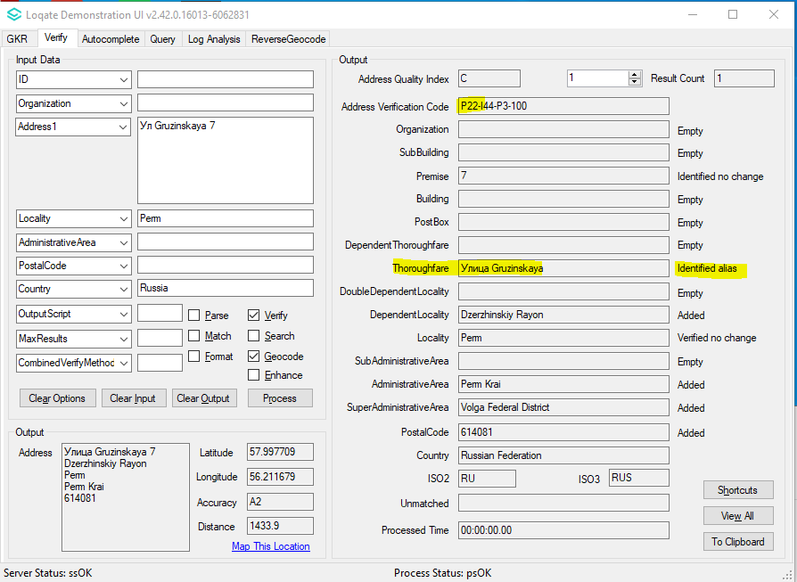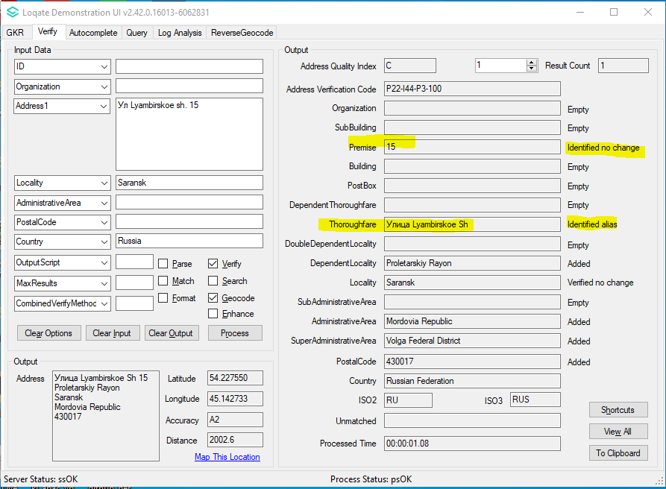 |  |  | 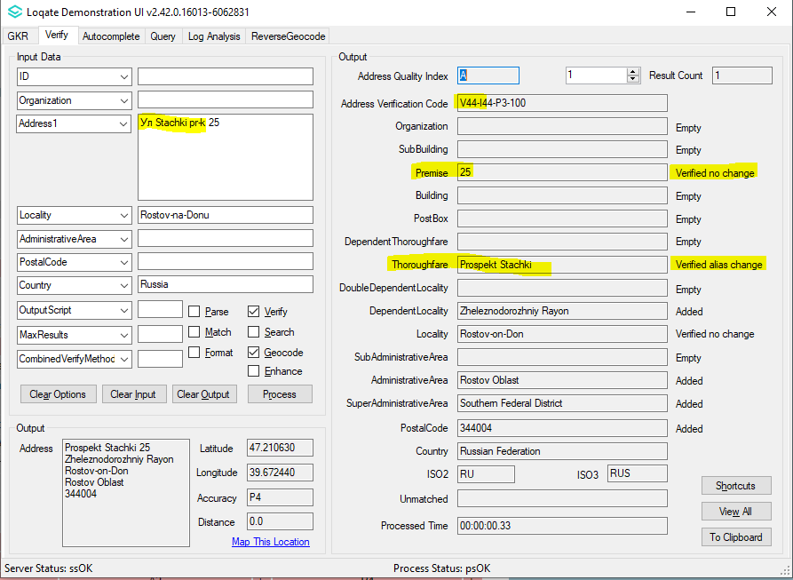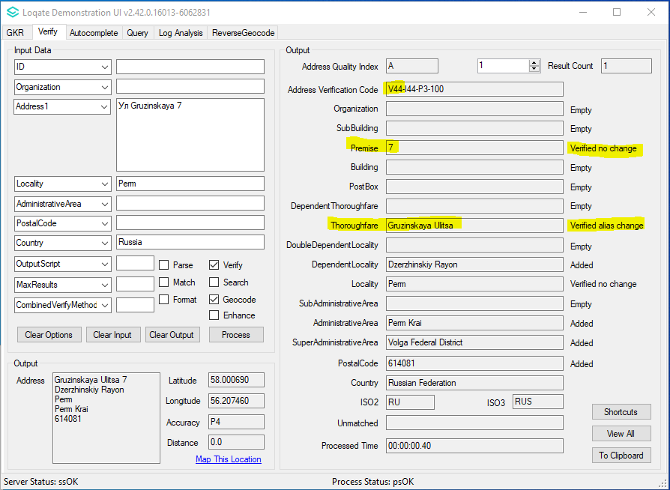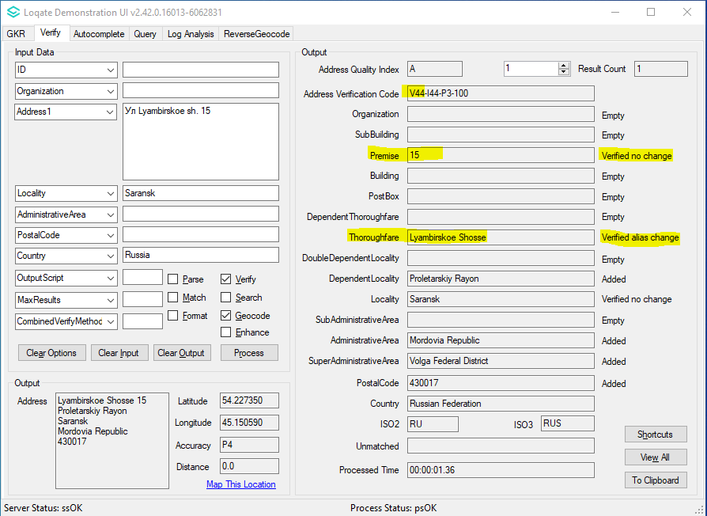

Case Number | Change Description | Category | Country | Example Address
CAS-41802-G2M8S6 | Included a list of missing PostalCode into Seed file. | Data | RUS | Some of the PostalCodes that are missing now added into Seed file.
Before Image |  |  | After Image
PostalCodes not found in Seed file. |  |  | PostalCodes found in newer Seed file.  Locality 786462 SubAdministrativeArea 575758 Kalinovka<S=LATN,L=EN>|Калиновка<S=CYRL,L=RU> 423800|423871  Locality 575901 SubAdministrativeArea 575758 Kuperle<S=LATN,L=EN>|Куперле<S=CYRL,L=RU> 423800|423871  Locality 575977 SubAdministrativeArea 575758 Shukrale<S=LATN,L=EN>|Шукрале<S=CYRL,L=RU> 423800|423871  Locality 759997 SubAdministrativeArea 189233 Izbishchi<S=LATN,L=EN>|Избищи<S=CYRL,L=RU> 399844|399845|399850  Locality 576595 SubAdministrativeArea 576323 Danaurovka<S=LATN,L=EN>|Данауровка<S=CYRL,L=RU> 422951|422953  Locality 760537 SubAdministrativeArea 190947 Darenovka<S=LATN,L=EN>|$Daryonovka|Дареновка<S=CYRL,L=RU>|$Дарёновка  398502|398506  Locality 760538 SubAdministrativeArea 190947 Davydovka<S=LATN,L=EN>|Давыдовка<S=CYRL,L=RU> 398502|398506  Locality 191129 SubAdministrativeArea 190947 Tyushevka<S=LATN,L=EN>|Тюшевка<S=CYRL,L=RU> 398502|398506  Locality 573693 SubAdministrativeArea 573660 Nizhnekamsk<S=LATN,L=EN>|$Nijnekamsk|$Nischnekamsk|$Nizjnekamsk|$Nižněkamsk|$Niznekamsk|$Nižnekamsk|$Niżniekamsk|  $Nyizsnyekamszk|$Nizniekamsk|Нижнекамск<S=CYRL,L=RU>|Νιζνεκάμσκ<S=GREK,L=EL> 422582|423551|423556|423570|423571|423572|423574|423575|423576|423577|423578|423579|423580|423582|423584|423585|423586|423587|423599  Locality 190231 SubAdministrativeArea 190182 Eletsky<S=LATN,L=EN>|$Eletskiy|Елецкий<S=CYRL,L=RU> 399741|399750|399762|399774

Case Number | Change Description | Category | Country | Example Address
CAS-37251-G7B9D2 | Removed "office" from thoroughfare names | Data | HKG | Address1: ROOM 402 4/F  Address2: CHUN YU HOUSE  Address3: SAM SHING ESTATE  Address4: TUEN MUN  Locality: NEW TERRITORIES  Country: HKG
Before Image |  |  | After Image
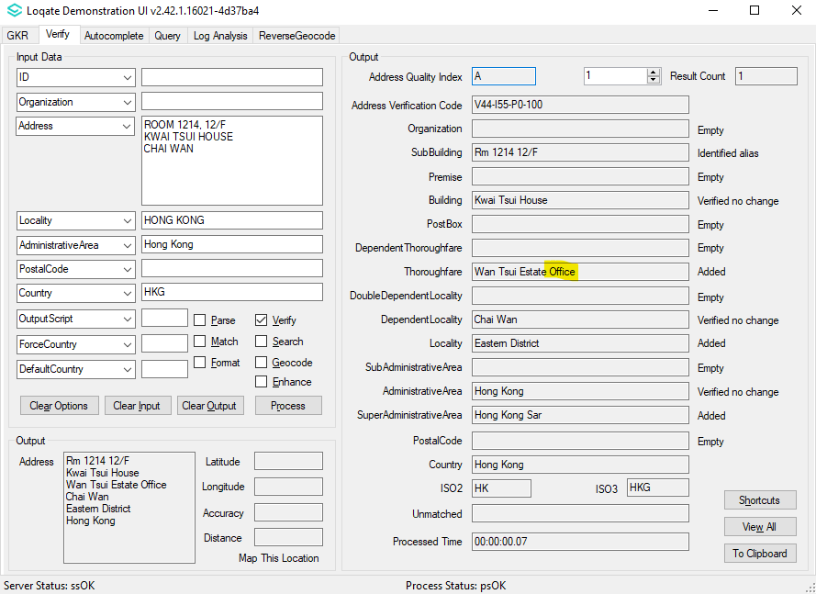 |  |  | 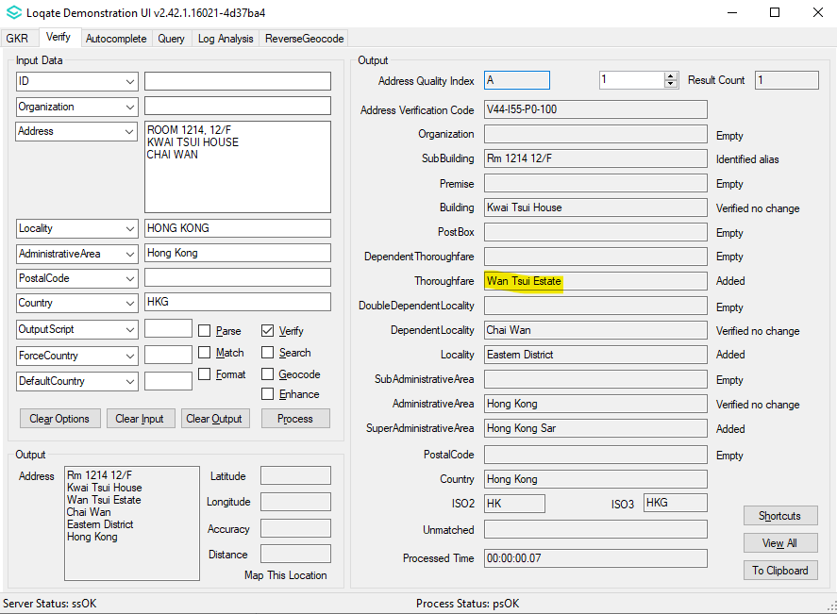

Case Number | Change Description | Category | Country | Example Address
CAS-63818-R6K3Q0 | Improved the parsing of "IE-D" as an AdministrativeArea  to match Regular IE data | Data Premium | IRL | Address1: St James Gate  Locality: Dublin  AdministrativeArea: IE-D  PostalCode: 8  Country: IE
Before Image |  |  | After Image
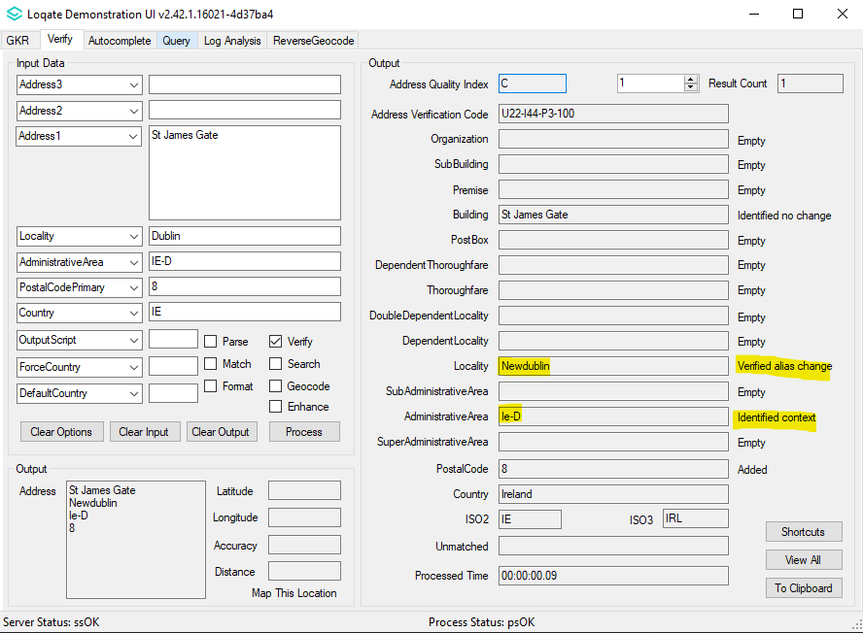 |  |  | 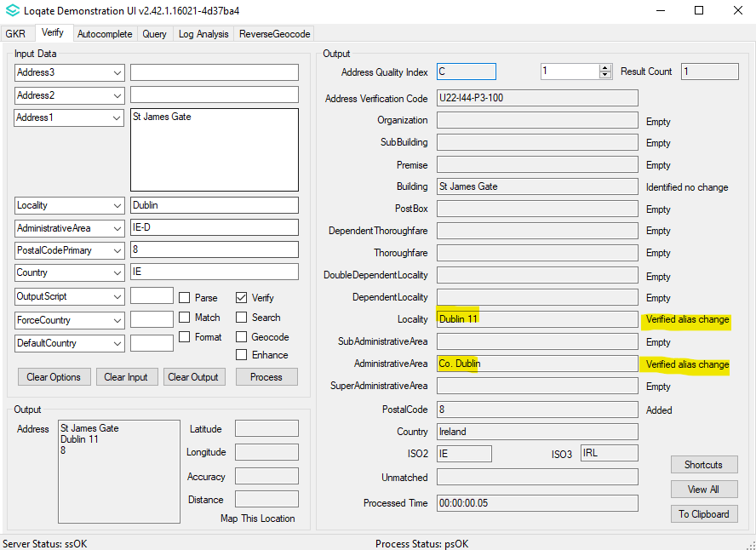

Case Number | Change Description | Category | Country | Example Address
CAS-69120-V3R1W2 | Improved the parsing of 藥庫 as OrganizationType | Data | TWN | Address1: 軍校路５５３號Ｂ１藥庫  Locality: 左營區  AdministrativeArea: 左營區  PostalCode: 81342  Country: TW
Before Image |  |  | After Image
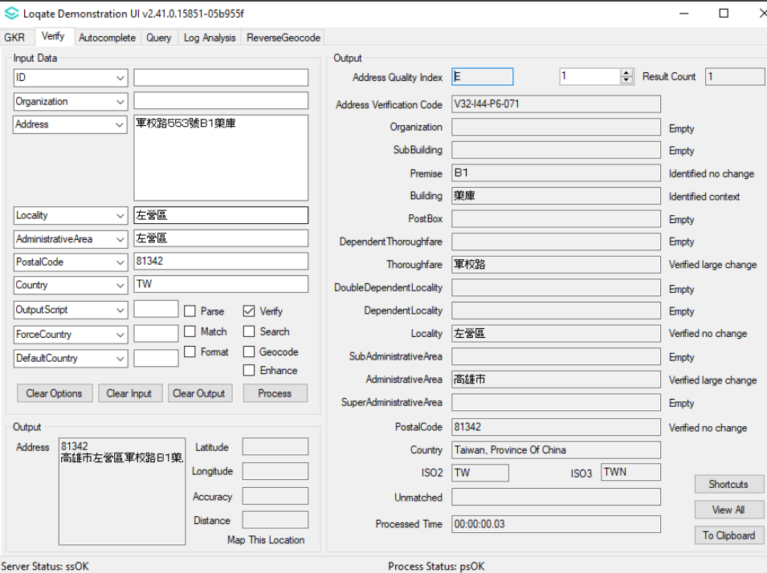 |  |  | 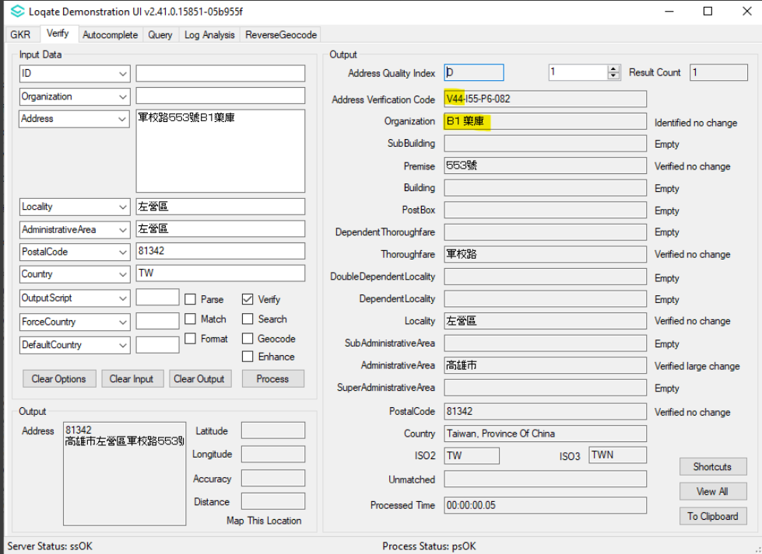

Case Number | Change Description | Category | Country | Example Address
CAS-65846-Q5Y9Y5 | Improvement is made within the USA geocode reference data to improve geocoding level | Data | USA | Address1: 9750 GRAY RD, CARMEL, IN 46280, US
Before Image |  |  | After Image
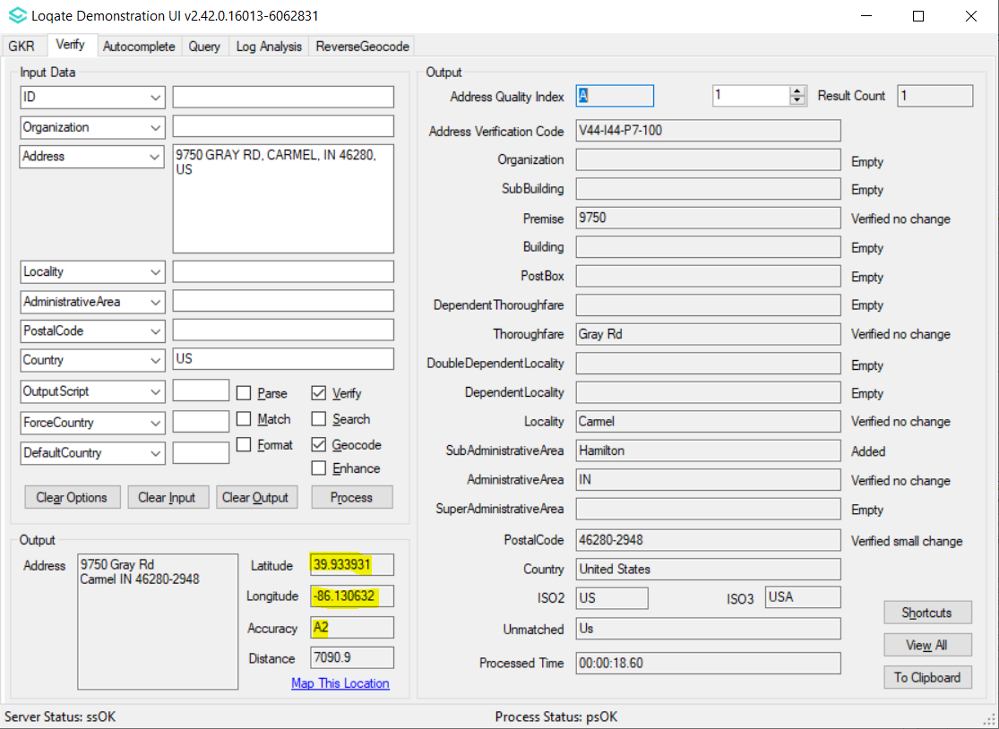 |  |  | 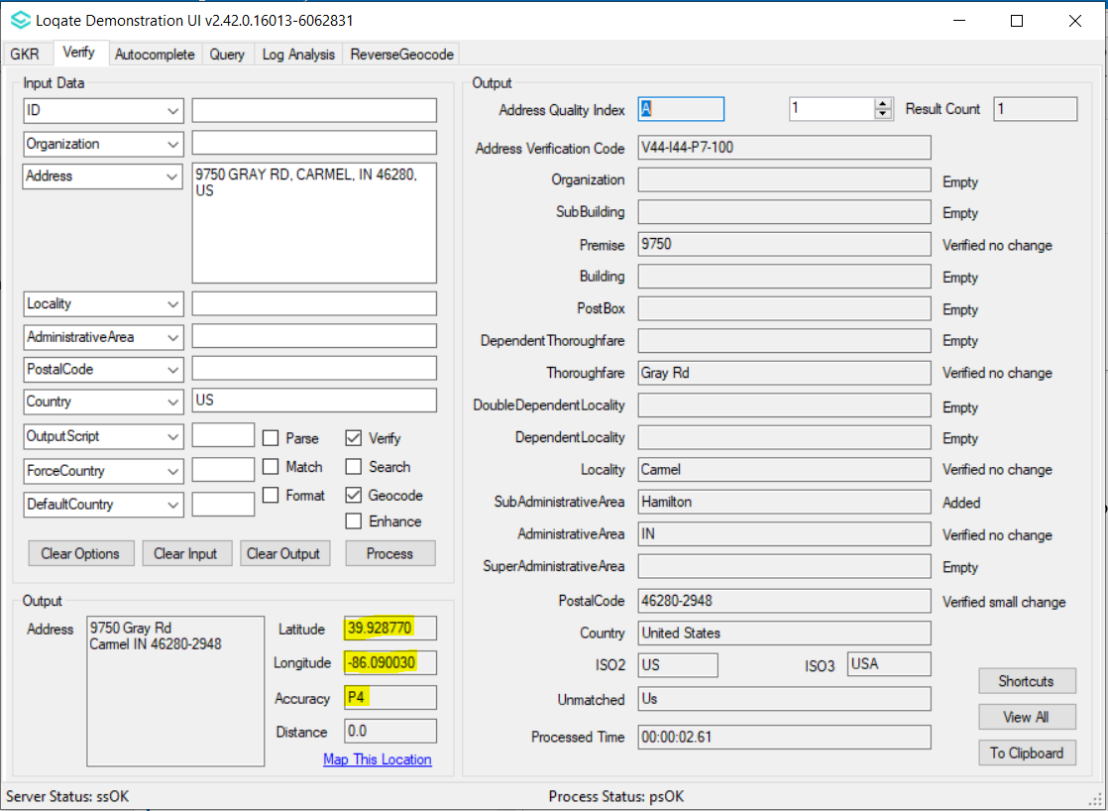

Case Number | Change Description | Category | Country | Example Address
CAS-68777-G3W7N9 | Removal of "M." suffix from Miesto name (under Locality field) | Data | POL | Address1: Wolności 18A, 08-300 Sokołów Podlaski  Country: PL
Before Image |  |  | After Image
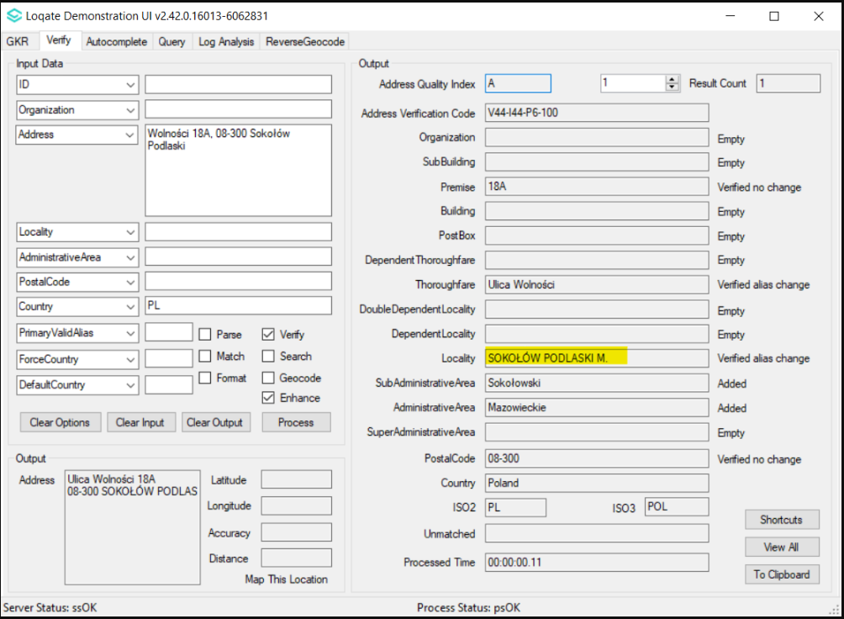 |  |  | 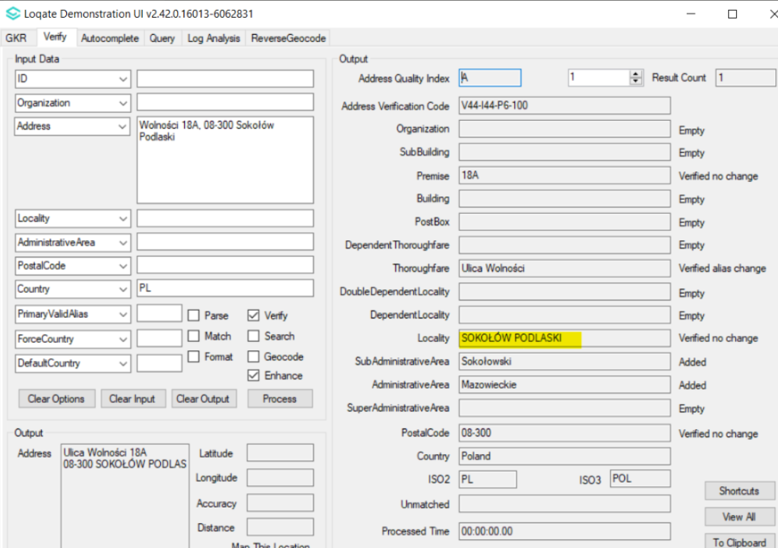

Case Number | Change Description | Category | Country | Example Address
CAS-53731-X3C5L8 | Added list of missing postal code. | Data | NOR | -
Before Image |  |  | After Image
PostalCodes not found in Seed file. |  |  | PostalCodes found in newer Seed file.  Locality 809399 SubAdministrativeArea 626258 Hopen<S=LATN,L=NB> 9174  Locality 809401 SubAdministrativeArea 626258 Sveagruva<S=LATN,L=NB> 9175  Locality 809398 SubAdministrativeArea 626258 Bjørnøya<S=LATX,L=NB>|-Bjornoya 9176  Locality 809397 SubAdministrativeArea 626258 Barentsburg<S=LATN,L=NB> 9178  Locality 89051 SubAdministrativeArea 89047 Oslo<S=LATN,L=NB>  0001|0018|0021|0024|0028|0030|0031|0032|0033|0034|0040|0045|0046|0047|0048|0055|0060|0081|0101|0102|0103|0104|0105|0106|0107|0109|0110|0111|0112|0113|0114|0115  |0116|0117|0118|0119| 0120|0121|0122|0123|0124|0125|0128|0129|0130|0131|0132|0133|0134|0135|0136|0138|0140|0201|0202|0203|0204|0207|0208|0211|0212|0213|0214|0215  |0216|0217|0218|0230|0240|0244|0247|0301|0302|0303|0304|0305|0306|0307|0308|0309|0311|0313|0314|0315|0316|0317|0318|0319|0323|0330|0401|0402|0403|0404|0405|0406  |0408|0409|0410|0411|0412|0413|0415|0421|0422|0423|0424|0440|0441|0442|0501|0502|0503|0504|0505|0506|0507|0508|0509|0510|0511|0512|0513|0515|0516|0517|0518|0520  |0540|0601|0602|0603|0604|0605|0606|0607|0608|0609|0611|0612|0613|0614|0615|0616|0617|0618|0619|0620|0621|0622|0623|0624|0626|0701|0702|0705|0710|0712|0801|0805  |0806|0807|0840|0901|0902|0903|0904|0905|0907|0908|0913|0914|0915|1001|1003|1005|1006|1007|1008|1009|1011|1101|1102|1108|1109|1112|1201|1203|1204|1205|1207|1214|1215  Locality 782253 SubAdministrativeArea 782203 Jan Mayen<S=LATN,L=NB> 8099

