Loqate, A GBG Solution
Release Notes – Verify API
2022Q2.0 Major Release

Case Resolutions
Please visit https://support.loqate.com/2022q2-0-resolved-cases/ for a list of all cases resolved in this release. If you would like more details on any of the solved cases listed, please contact LoqateSupport@gbgplc.com for further information.

Local API Notices
This is to inform our customers that in this 2022Q2.0 release we have made no major changes to the API there are two minor improvement.

Local API Improvements

Case Number | Change Description | Category | Country | Example Address
CAS-70258-M0H2Q7 | Fixed SERP crash when Canada postal code has less than 3 characters. | API | CAN | Address1: 10|3021 Birds Hill Road  Locality: East St. Paul  AdministattiveArea: Manitoba  Postalcode: MB  Country: CA
Before Image |  |  | After Image
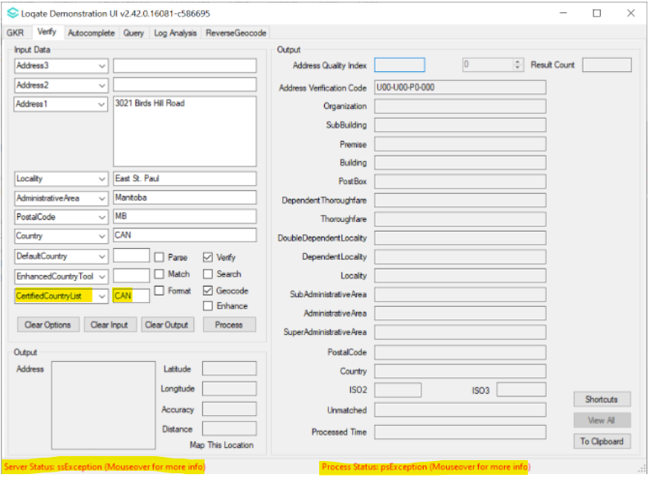 |  |  | 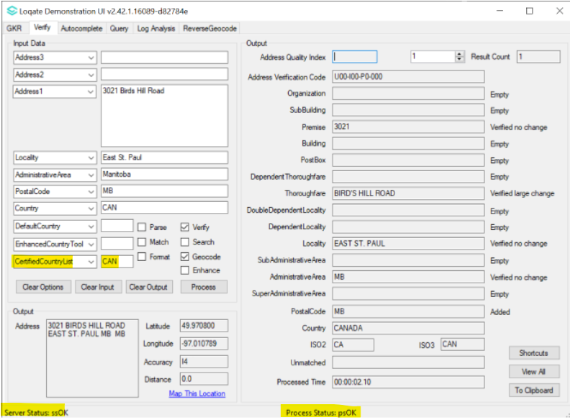

Case Number | Change Description | Category | Country | Example Address
CAS-68244-P9D9W4 | Improvement of processing speed for address containing "~" in the input address. | API | JPN | Address1: 1CHOUME2BAN  Address2: RUSUKUU~EAA2102  Locality: TAKATSUKISHIAKUTAGAWACHOU  PostalCode: 5691123  Country: JPN
Before Image |  |  | After Image
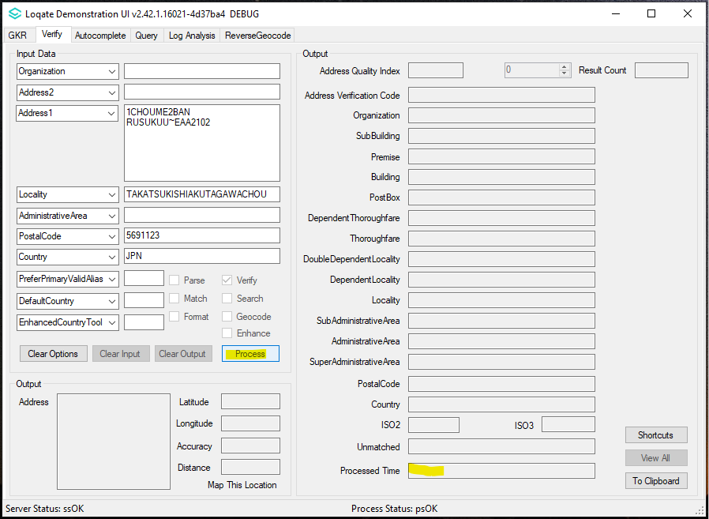  2022Q1.1: This is running more than 30 minutes that it is unable to complete the verification process |  |  | 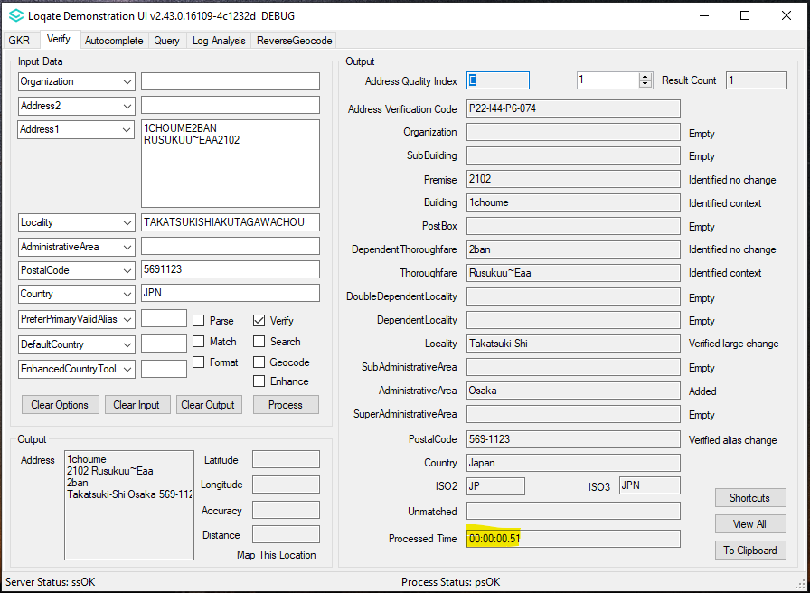  2022Q2.0: The engine processes the address around 51ms to complete the verification

Installation Instructions

Please remember to update both the program files and the reference data and please install these to a new fresh folder location. The improvements are tied to the data in the Global Knowledge Repository and the Local API. When updating the data, it is recommended to use a new data folder each time in order to ensure the latest dataset is installed properly.

If you need any assistance with the upgrade of the Local API or the data update process, please contact GBG Loqate Support.

The setup wizard for the Local API can be obtained from our SFTP server. Please contact your account manager to retrieve the SFTP information. If you do not know who your account manager is, please contact the support team at LoqateSupport@gbgplc.com.

