Loqate, A GBG Solution
Release Notes – Reference Data & Knowledge Base

2022Q1.1 Minor Release

Case Resolutions
Please visit https://support.loqate.com/2022q1-1-resolved-cases/ for a list of cases resolved in this release.
If you would like more details on any of the solved cases listed, please contact LoqateSupport@gbgplc.com for further information.

Certification Expiration Dates
If you have purchased either the CASS (USA) or AMAS (Australia) certified products, please be aware that the datasets have expiration dates set by the respective postal authorities. Please ensure that you have the latest library and data installed to avoid loss of service through these products.

Please check Install Manager for the latest versions of AMAS and CASS.
 | Loqate Release Date | Certification Expiry Date*
AMAS Data | 2022-02-10 | 2022-06-30
CASS Data | 2022-03-15 | 2022-06-28
*Certification Expiry Date is different from Loqate license key expiry date. The earliest expiry date will apply.

For more information on expiry date checking for CASS and AMAS, please refer “Usage expiration” section in https://support.loqate.com/documentation/local-apis/cass-overview-2/ and https://support.loqate.com/address-matching-approval-system-amas/

Data Structure Changes

The below is a summary of the Countries where we have updated the reference data structure.

Country Rebuilds

Country | ISO2 | Description
Kosovo | XK | Country Rebuild (New country introduced into Loqate)
Belgium | BE | Country Rebuild (New Source Addition)

Other major changes to highlight:

Country | Description
Mexico | Standardize Administrative Area to ISO 3166-2 three-letter acronym
ADMIN_ISO | Re-order displayed fields. Updated Germany and France Admin ISO.
Timezone | New Time zone Name

BPDH/PDH Countries
Kosovo
Country Information | Description
ISO2 | XK
ISO3 | XKV
Address Format | Organization  PostBox  Building SubBuilding  Thoroughfare Premise  DependentThoroughfare  DoubleDependentLocality  DependentLocality  PostalCode Locality
PDH | YES
PDH completed date | 2022Q1.1
New Source | YES
 |  | Pre-PDH | Post-PDH
Reference Data |  | - | rd_XK_ggg.lfs  rd_XK_ggg_rg.lfs  rd_XK_vfy_ai.lfs  rd_XK_vfy.lfs

Belgium
Country Information | Description
ISO2 | BE
ISO3 | BEL
Address Format | Organization  PostBox  Building  Thoroughfare Premise SubBuilding  DependentThoroughfare  DoubleDependentLocality  DependentLocality  PostalCode Locality
PDH | YES
PDH completed date | 2019Q4.0
New Source | YES
 |  | Prior to New Data Source | Post New Data Source
Reference Data |  | rd_BE_vfy.lfs  rd_BE_vfy_ai.lfs  rd_BE_ggg.lfs  rd_BE_ggg_r.lfs  rd_BE_ggg_rg.lfs | rd_BE_vfy.lfs  rd_BE_vfy_ai.lfs  rd_BE_ggg.lfs  rd_BE_ggg_r.lfs  rd_BE_ggg_r1.lfs  rd_BE_ggg_rg.lfs

In the 2022Q1.1 release, we added a new data source to the existing ones for Belgium, which provides PostBox and has a better Premise coverage.

Example of previous and new Belgium data handling PostBox input.

2022Q1.0 | 2022Q1.1
The PostBox was parsed incorrectly before adding the new data source. | The PostBox can be verified after new data source being added.
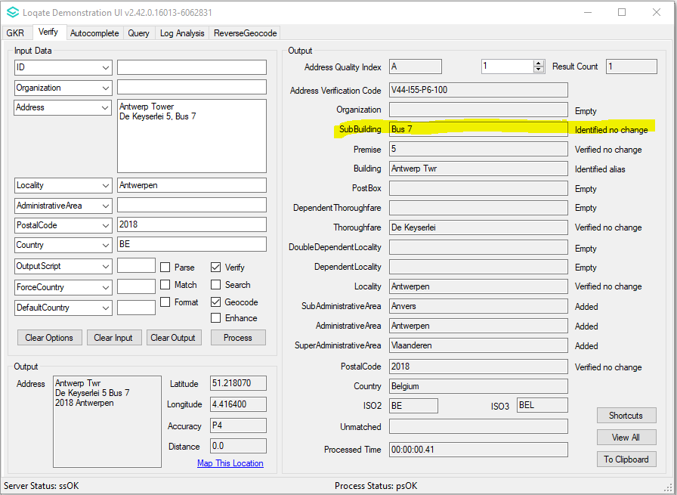 | 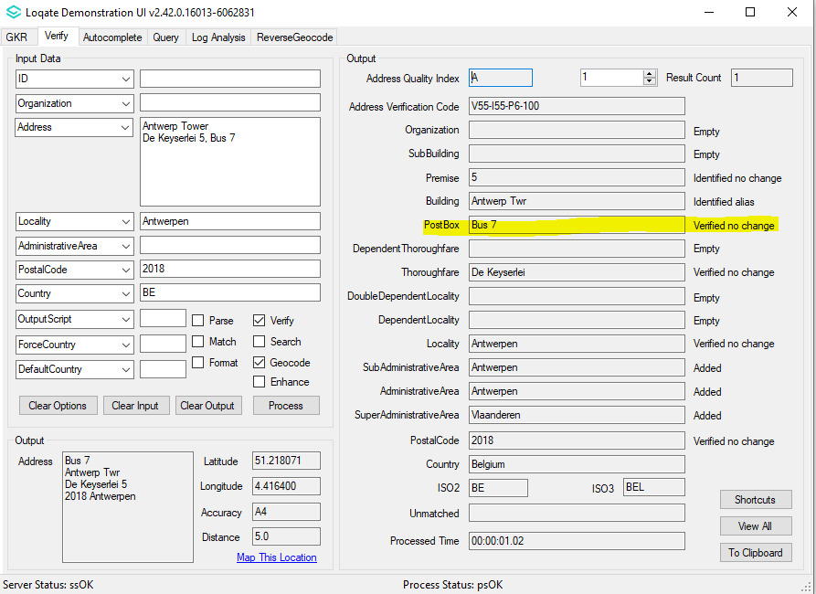
Some Premise were identified in the previous releases. | More premise now are verified after introducing the new data source.
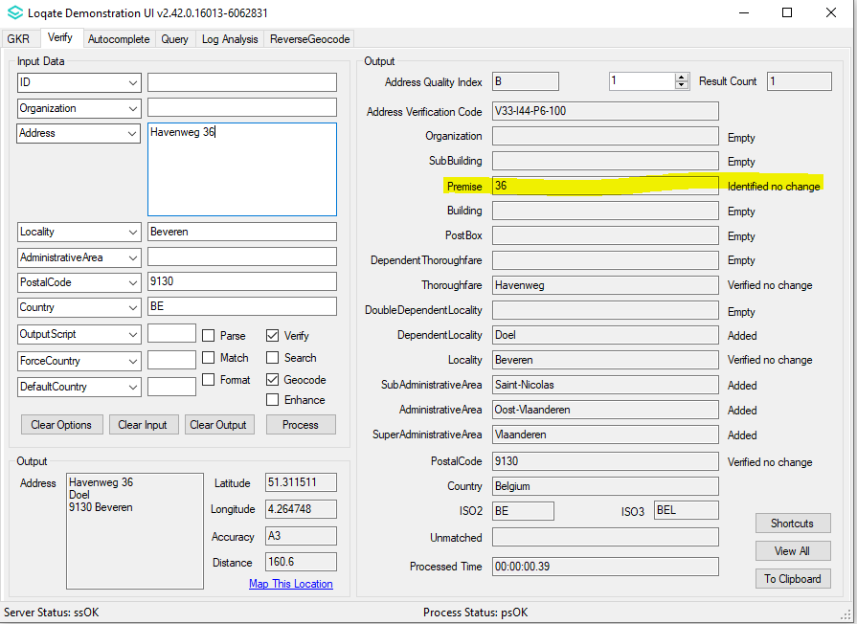 | 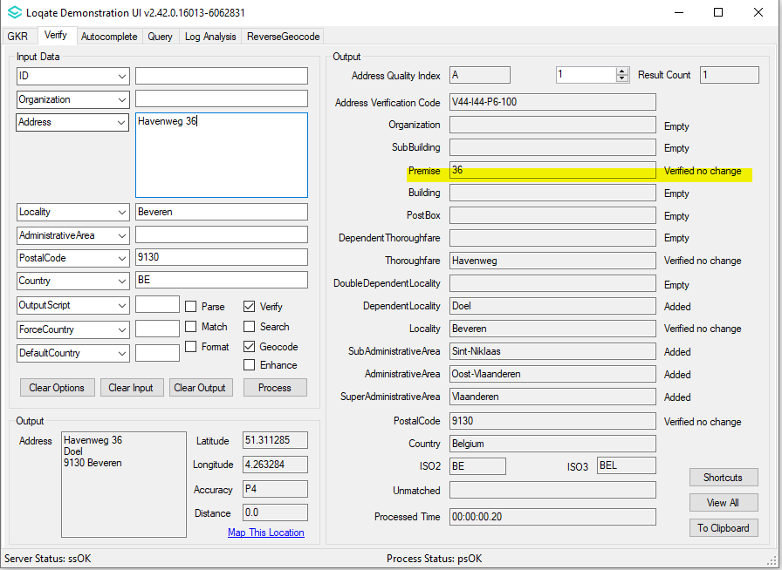

MAJOR HIGHLIGHTS

Mexico
The Administrative Area is standardized to ISO 3166-2 three-letter acronym.

2022Q1.0 | 2022Q1.1
Output Administrative Area is CDMX.  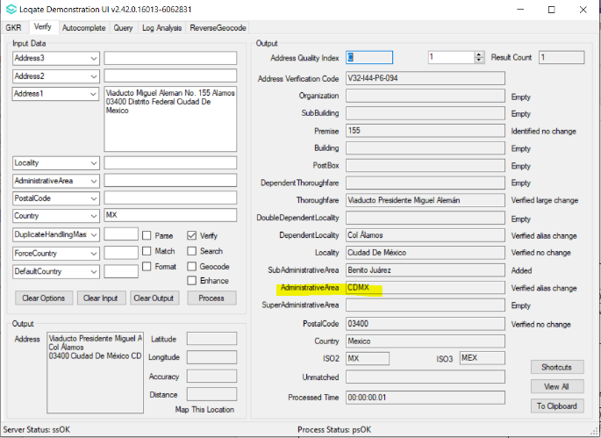 | Output Administrative Area is CMX.  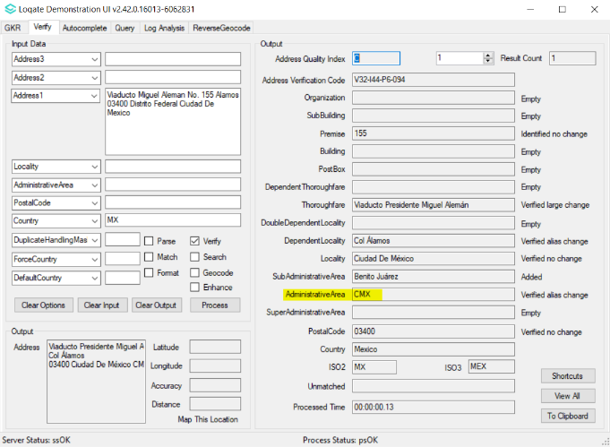

Output Administrative Area is NL.  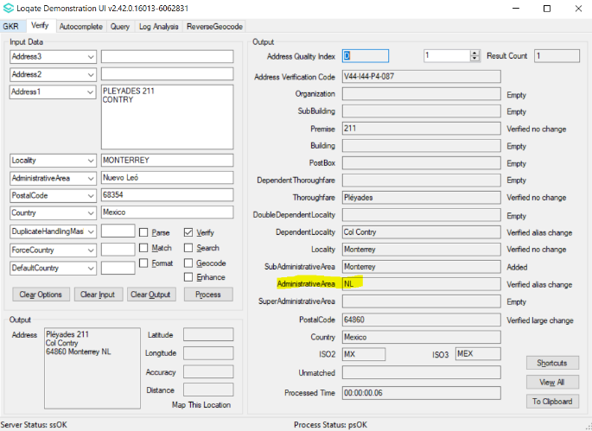 | Output Administrative Area is NLE.  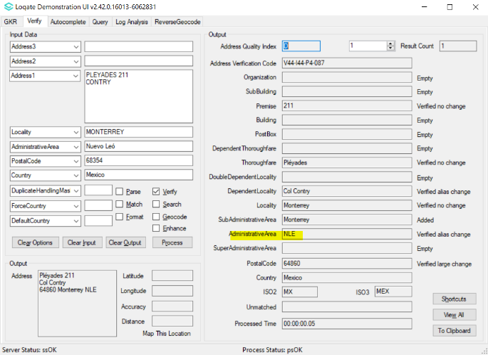

Enhance Administrative ISO2 Dataset

Germany and France have had an Admin ISO updated in this release.

Example of the German ISO update below

2022Q1.0 | 2022Q1.1
Baden-Württemberg has no AdministrativeArea ISO returned.  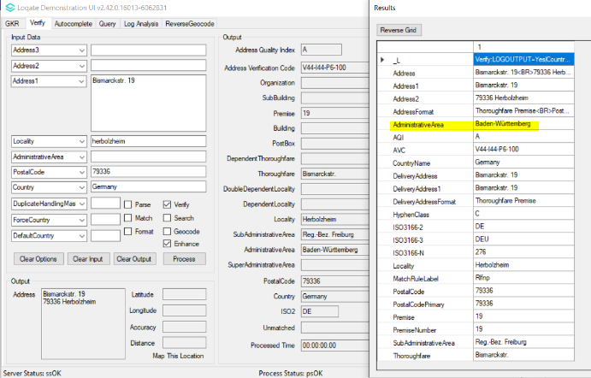 | Baden-Württemberg has AdministrativeArea ISO returned.  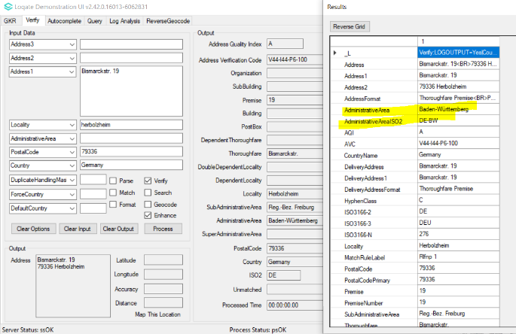

Enhance Time Zone Dataset

Previously support TimeZone_DTC & TimeZone_UTC only.
NEW field - TimeZone_Name is supported and displayed from 2022Q1.1 onwards.
2022Q1.0 | 2022Q1.1
Support TimeZone_DTC & TimeZone_UTC only  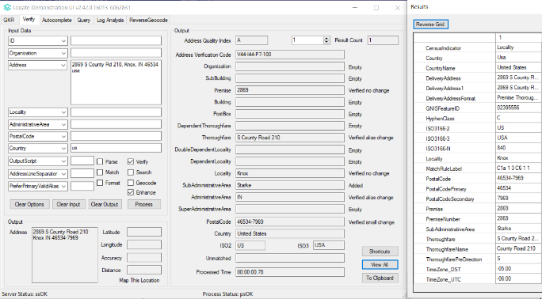 | Support new field – TimeZone_Name  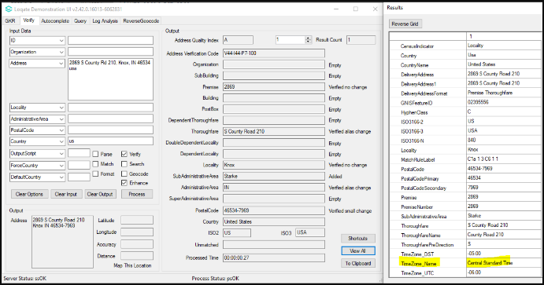

2022Q1.1 Data related Case Fixes

Case Number | Change Description | Category | Country | Example Address
CAS-61061-W3R6K4 | Administrative Area acronym standardized to ISO3166-2 in seed | Data | MEX | N/A
Before Behaviour |  |  | After Behaviour
AdministrativeArea 2334664 Chiapas<S=LATN,L=ES>|@CHIS|$CHA  AdministrativeArea 1915201 México<S=LATX,L=ES>|-Mexico|@MÉX|$Meksiko|$Edomex  AdministrativeArea 2153184 Nuevo León<S=LATX,L=ES>|-Nuevo Leon|@NL |  |  | AdministrativeArea 2334664 Chiapas<S=LATN><L=ES>|@CHP|$CHA|$CHIS  AdministrativeArea 1915201 México<S=LATN><L=ES>|-Mexico|@MEX|$MÉX|$Meksiko|$Edomex  AdministrativeArea 2153184 Nuevo León<S=LATN><L=ES>|-Nuevo Leon|@NLE|$NL

Case Number | Change Description | Category | Country | Example Address
CAS-09261-C3C3F6 | Verify Dependent Locality | Data | USA | Address1: 150 Ave Pedro Albizu Campos  Address1: Repto Lopez  Locality: Aguadilla  AdministrativeArea: PR  Postalcode: 603  Country: USA
Before Image/Behaviour |  |  | After Image/Behaviour
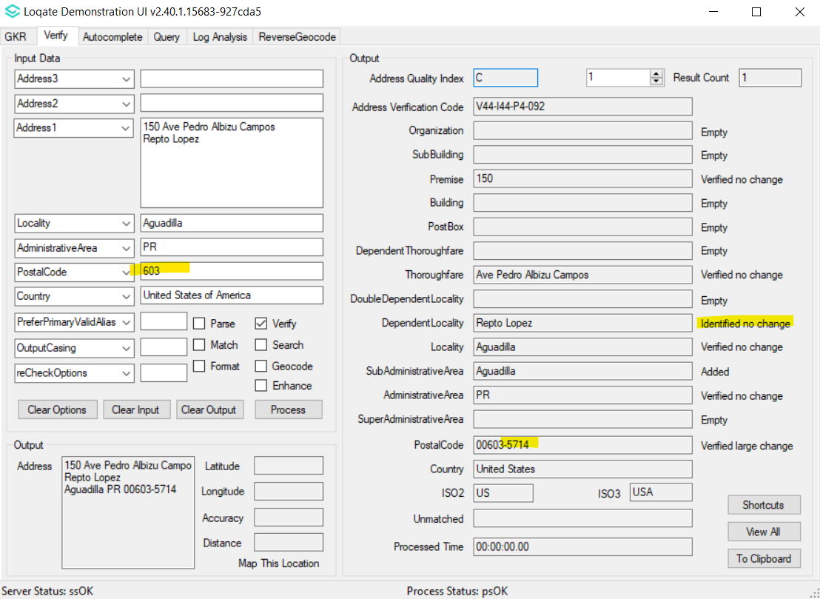 |  |  | 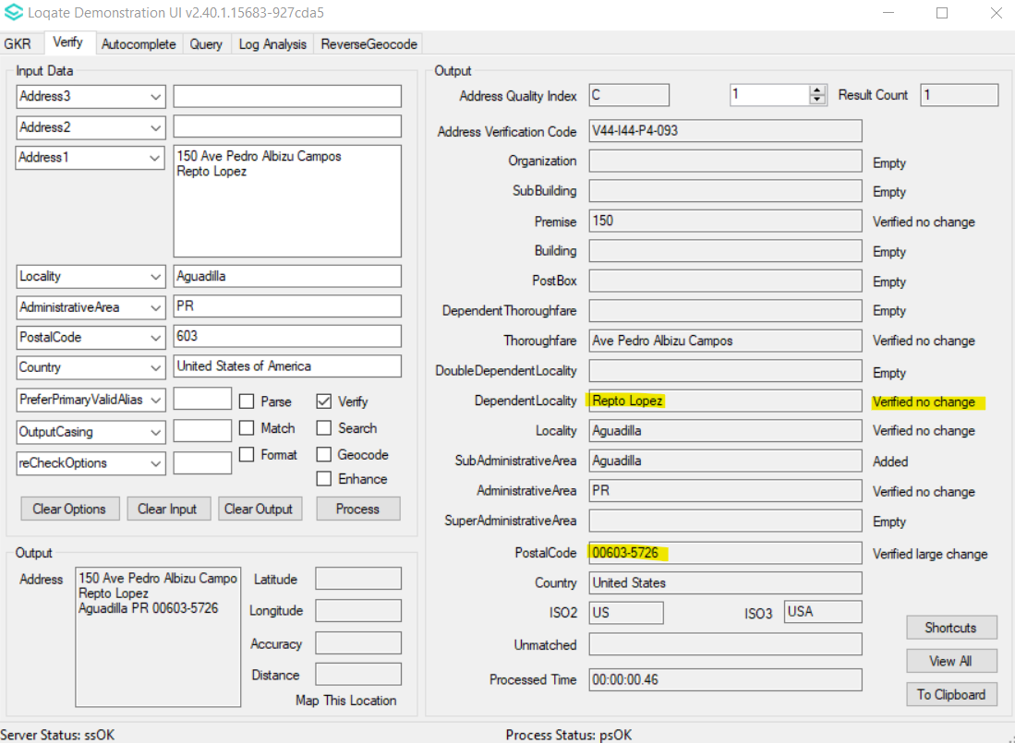

Case Number | Change Description | Category | Country | Example Address
CAS-38495-P6V6W6 | Improve Geo accuracy and thoroughfare output | Data | Ireland | Address1: 8 Glengariff Parade  Locality: Dublin  AdministrativeArea: Co Dublin  PostalCode: 7  Country: IE  Address1: 10 Lower Abbey Street  Locality: Dublin  AdministrativeArea: Co Dublin  PostalCode: 1  Country: IE  Address1: 98 Lower Baggot Street  Locality: Dublin  AdministrativeArea: Co Dublin  PostalCode: 2  Country: IE  Address1: 12 Lr Ormond Quay  Locality: Dublin  AdministrativeArea: Co Dublin  PostalCode: 1  Country: IE

Before Image/Behaviour | After Image/Behaviour
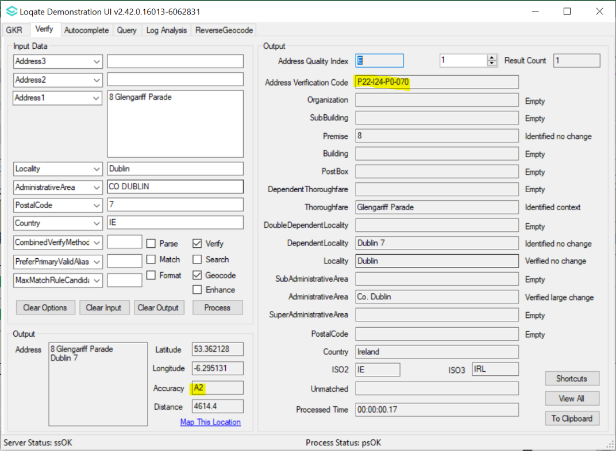 | 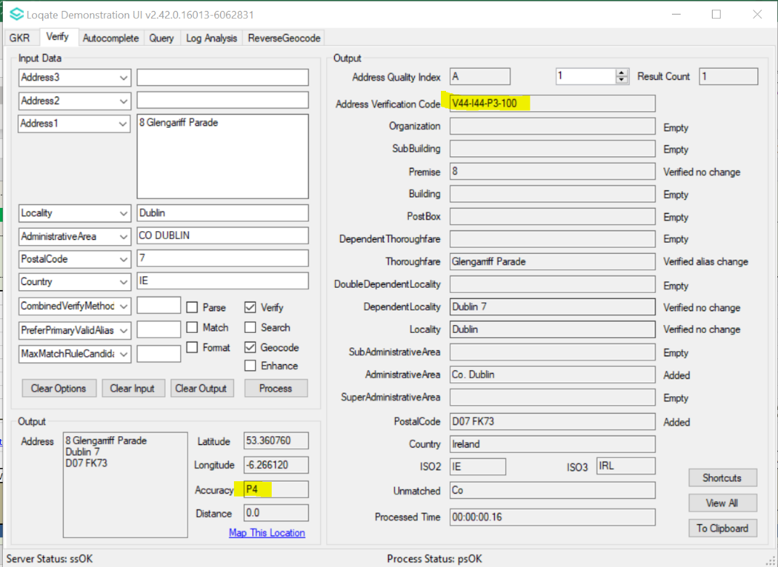
Before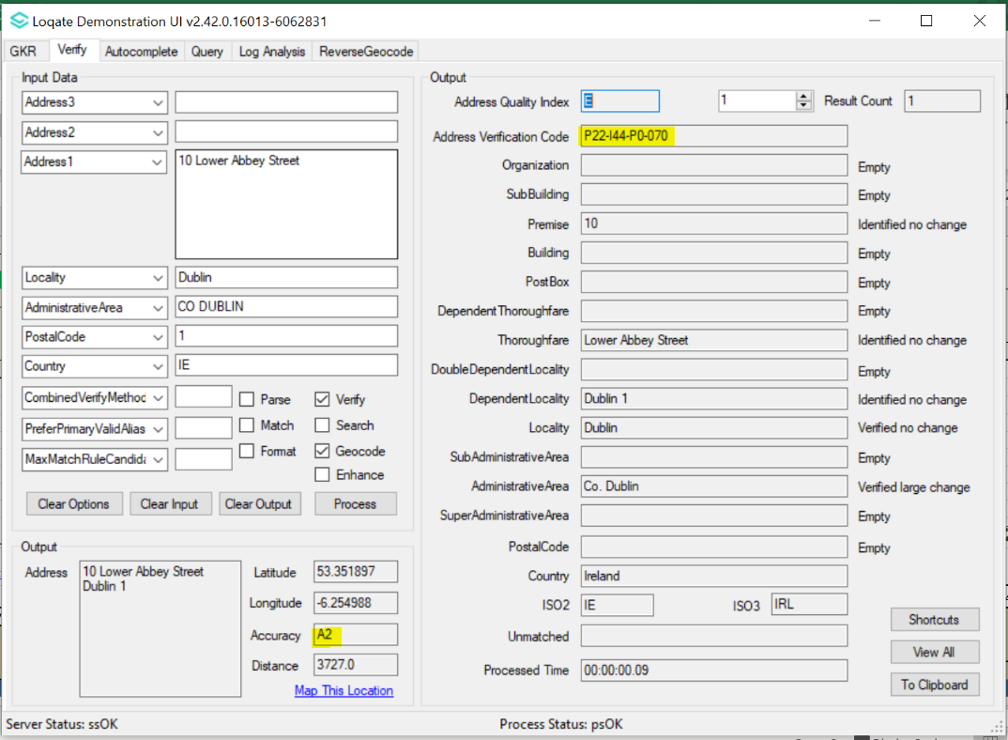 | After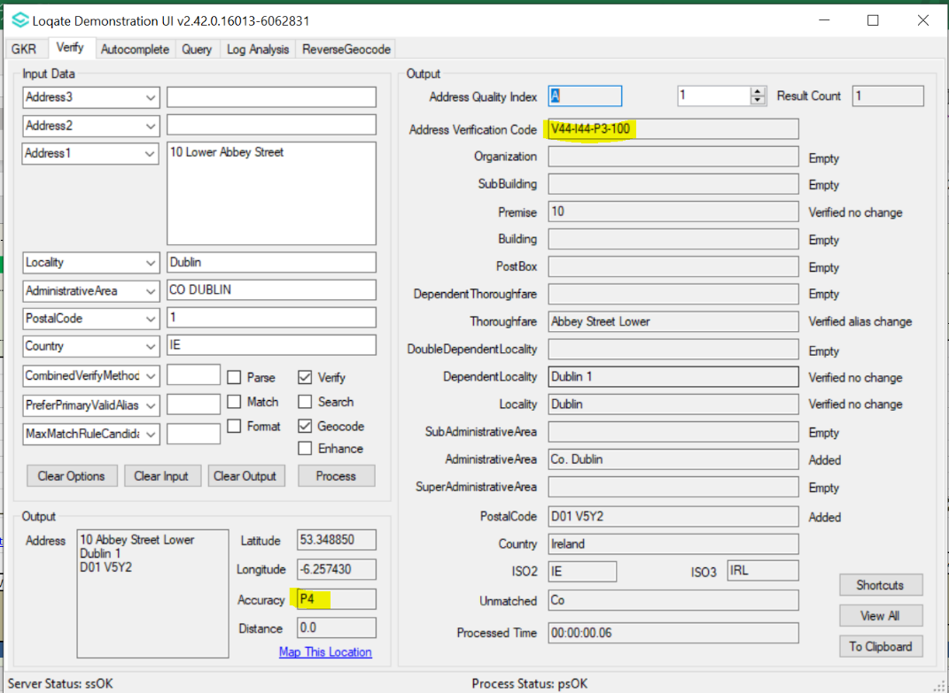
Before 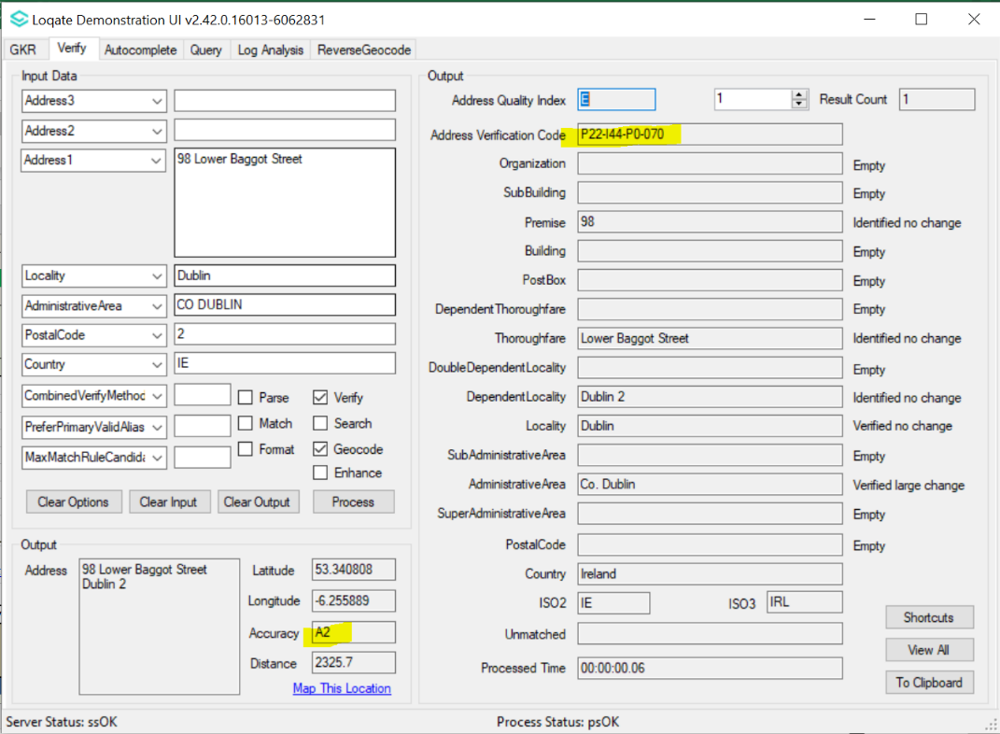 | After 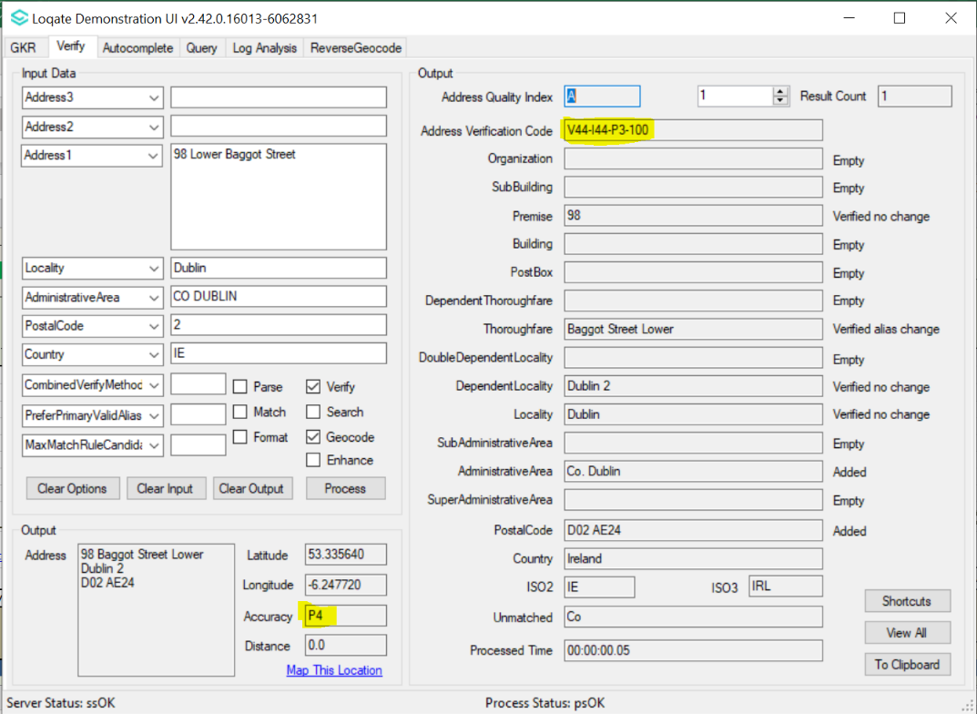
Before 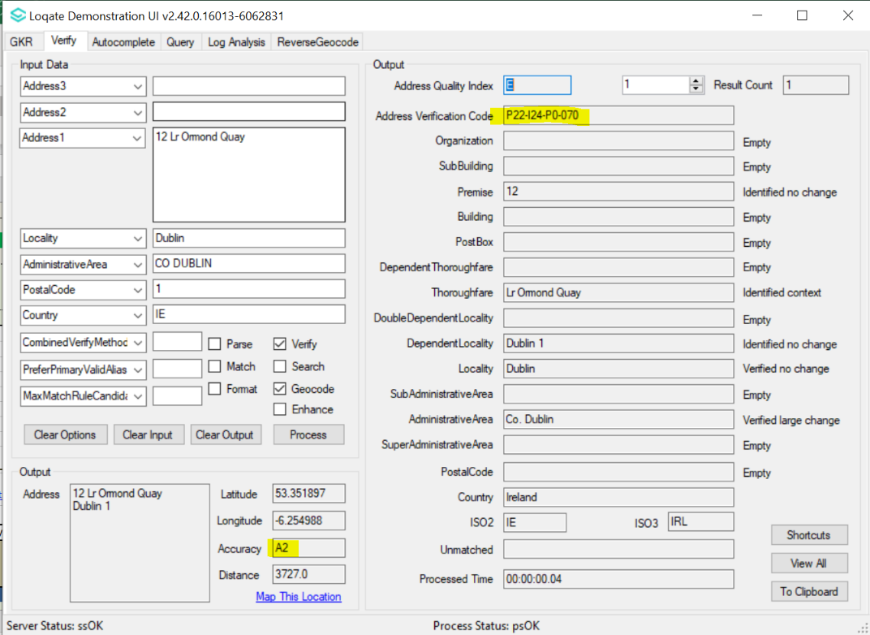 | After 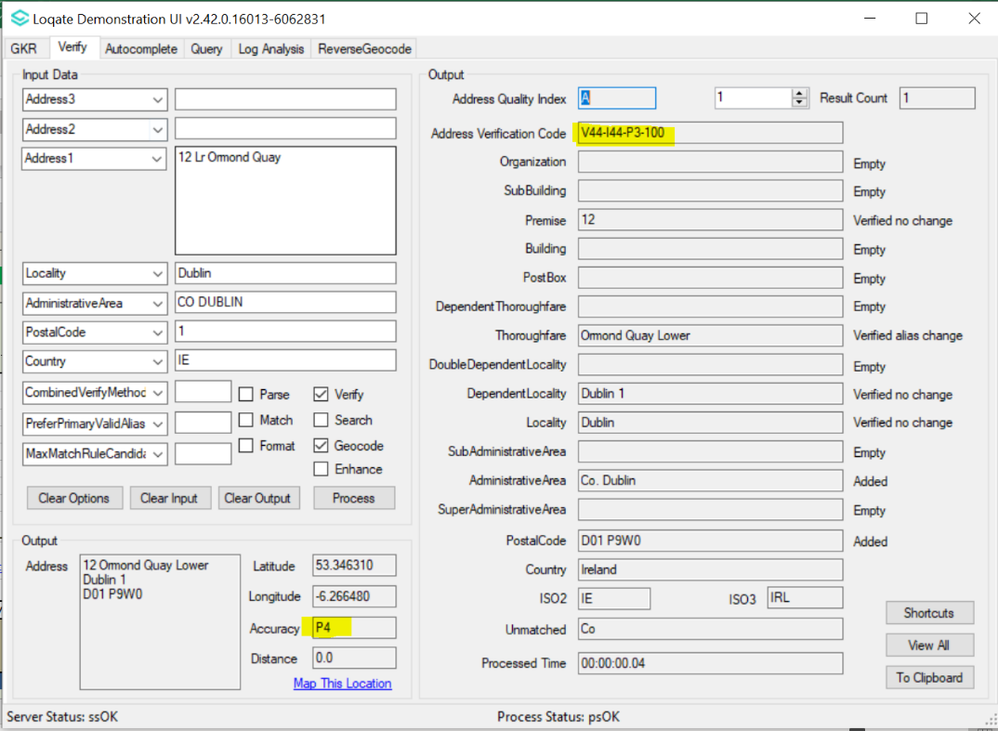

Case Number | Change Description | Category | Country | Example Address
CAS-63288-V6Z5R8 | PostalCode corrected in new Reference Data | Data | RUS | Address1: 3-1-265 Sayanskaya  Locality: Moscow  PostalCode: 111531  Country: RU
Before Image/Behaviour |  |  | After Image/Behaviour
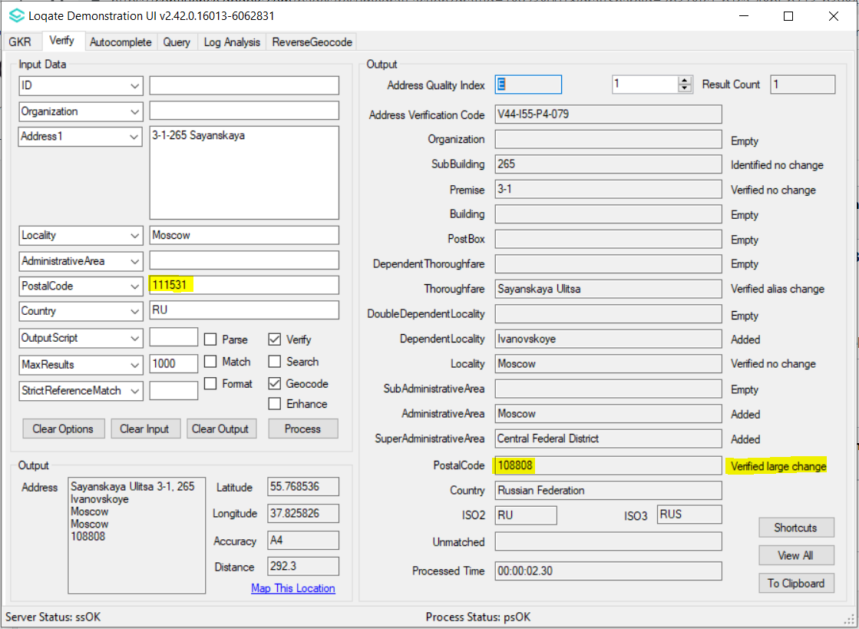 |  |  | 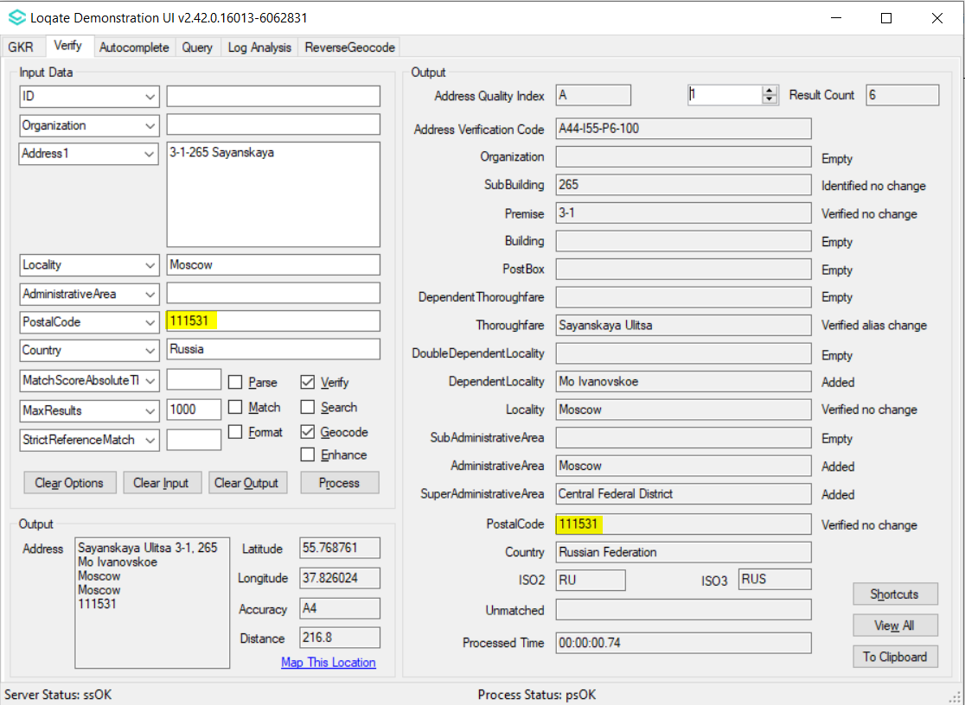

Case Number | Change Description | Category | Country | Example Address
CAS-09746-K5L6Q0 | The BE address was not verified to Premise level | Data | BE | Rue des Noctuelles 55  4020 Liège  BE
Before Country Rebuild |  |  | After Country Rebuild
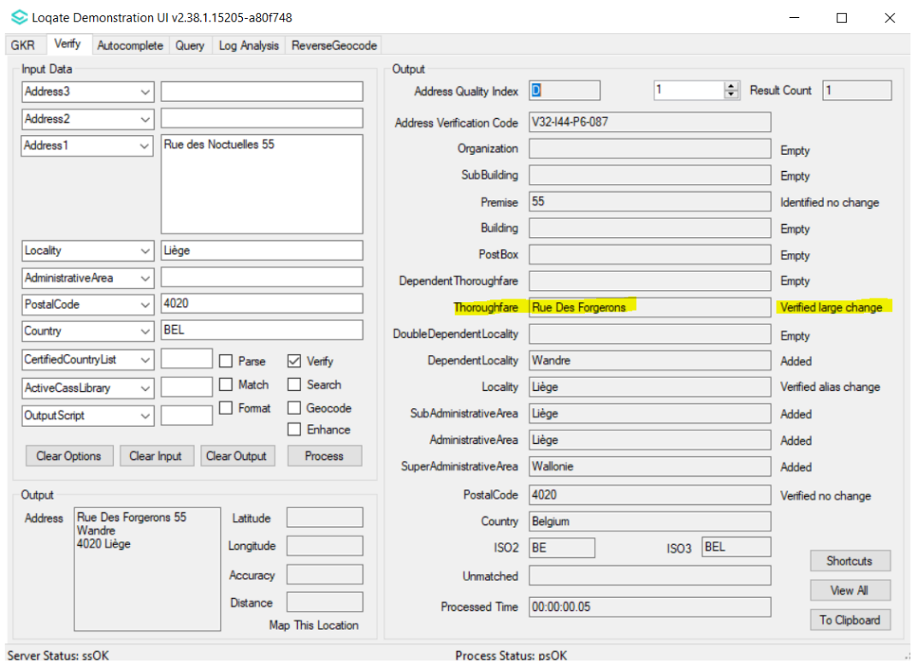 |  |  | 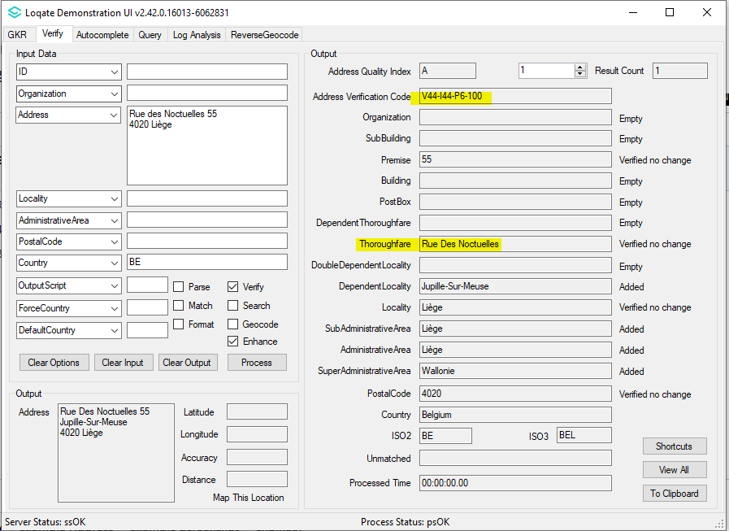

Case Number | Change Description | Category | Country | Example Address
CAS-10929-W8Y7G3 | The output town and postal code do not follow BE Postal | Data | BE | Tweekronenstraat 7  2180 Ekeren  BE
Before Country Rebuild |  |  | After Country Rebuild
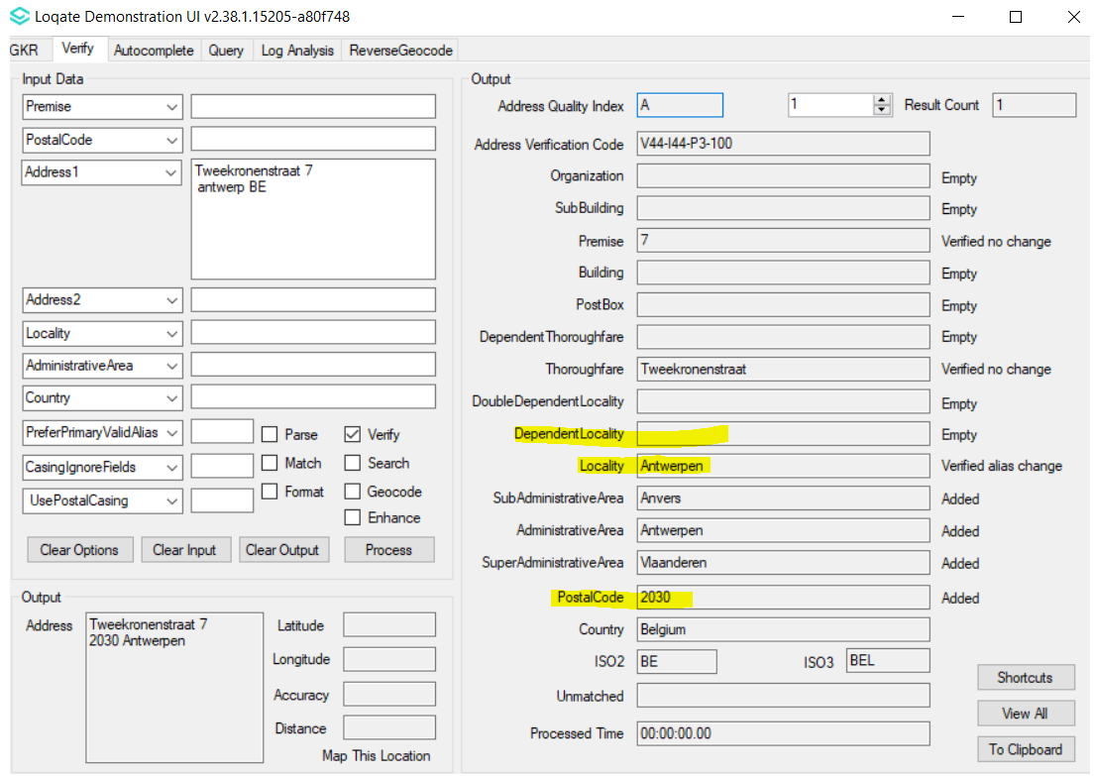 |  |  | 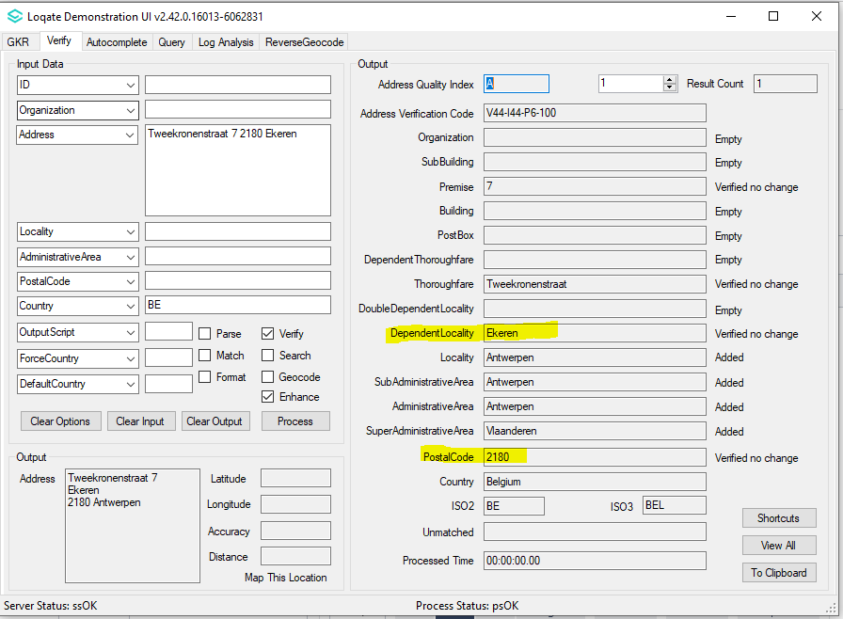

Case Number | Change Description | Category | Country | Example Address
CAS-10679-C3B7P7 | The Locality entries are expected to have multiple languages, e.g., NL and FR | Data | BE | Locality: Liège
Before Country Rebuild |  |  | After Country Rebuild

Case Number | Change Description | Category | Country | Example Address
CAS-11800-C6J8Y6 | Input dependent localities are no longer parse to building field | Data | Malaysia | Address1: 2, JALAN AUSTIN HEIGHTS 1/5  Address2: MOUNT AUSTIN  Address3: JOHOR BAHRU  Locality: JOHOR.  PostalCode: 81100  Country: Malaysia  Address1: NO 9 JALAN DAGANG B/6  Address2: SRI AMPANG MAS  Address3: TAMAN DAGANG  Address4: AMPANG  Country: Malaysia
Before Image |  |  | After Image
Address 1  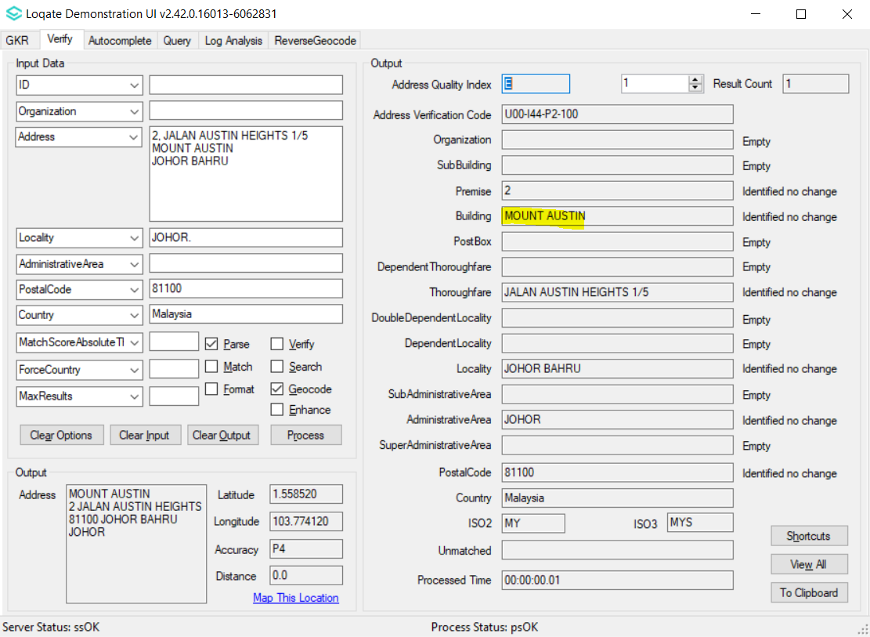 |  |  | Address 1 After  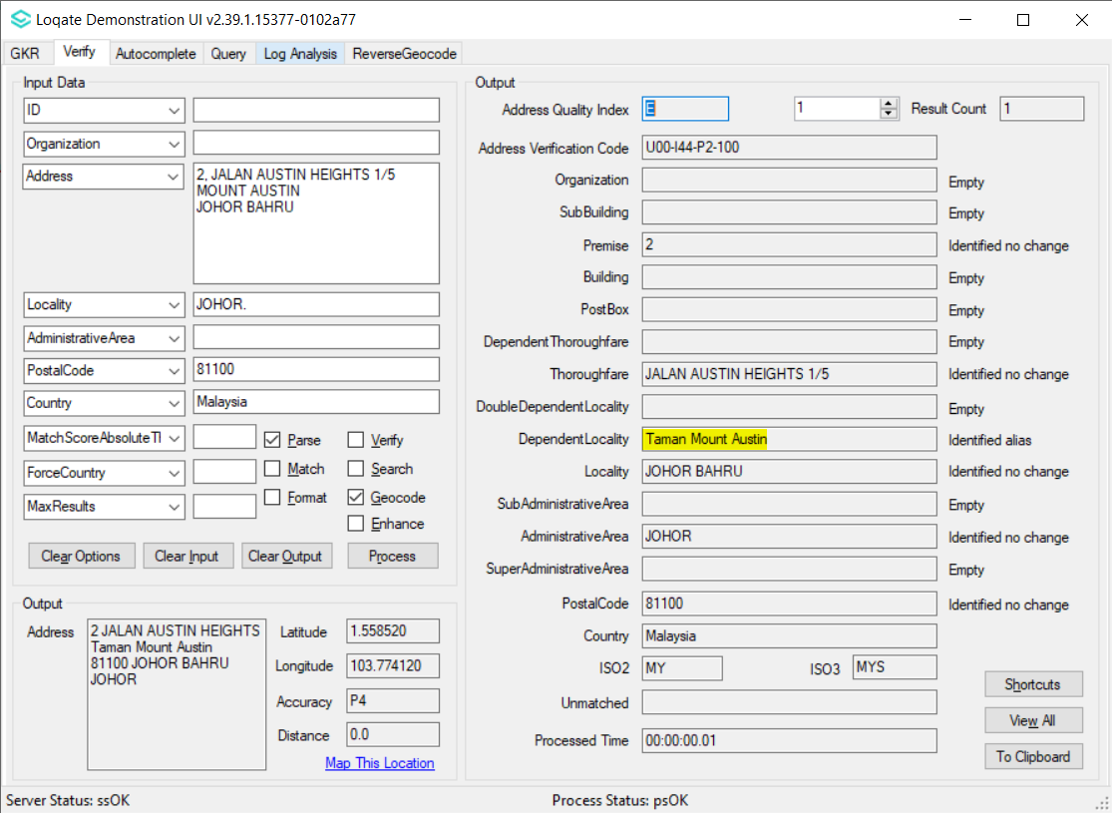
Address 2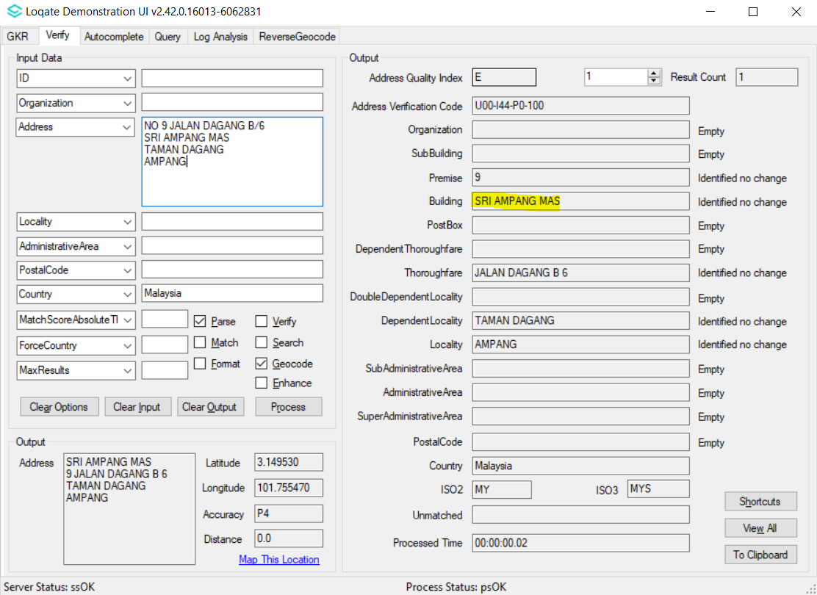 |  |  | Address 2 After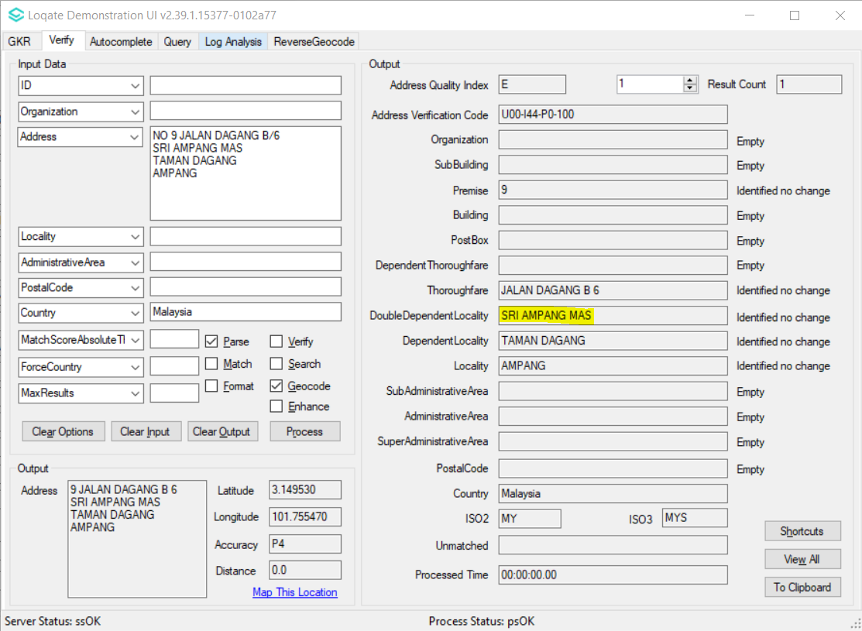

Case Number | Change Description | Category | Country | Example Address
CAS-62991-M4F7T7 | 'N' a thoroughfare pre-direction is now parsed to thoroughfare field. Previously parsed to premise field. | Data | USA | Address1: 309 N Gertrude St,Morrisonville IL 62546  Country: USA
Before Image |  |  | After Image
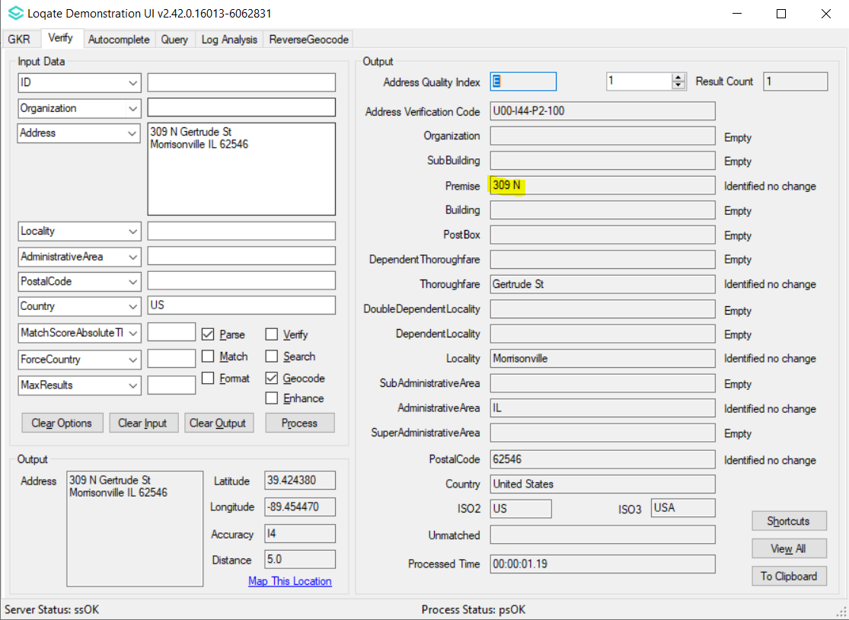 |  |  | 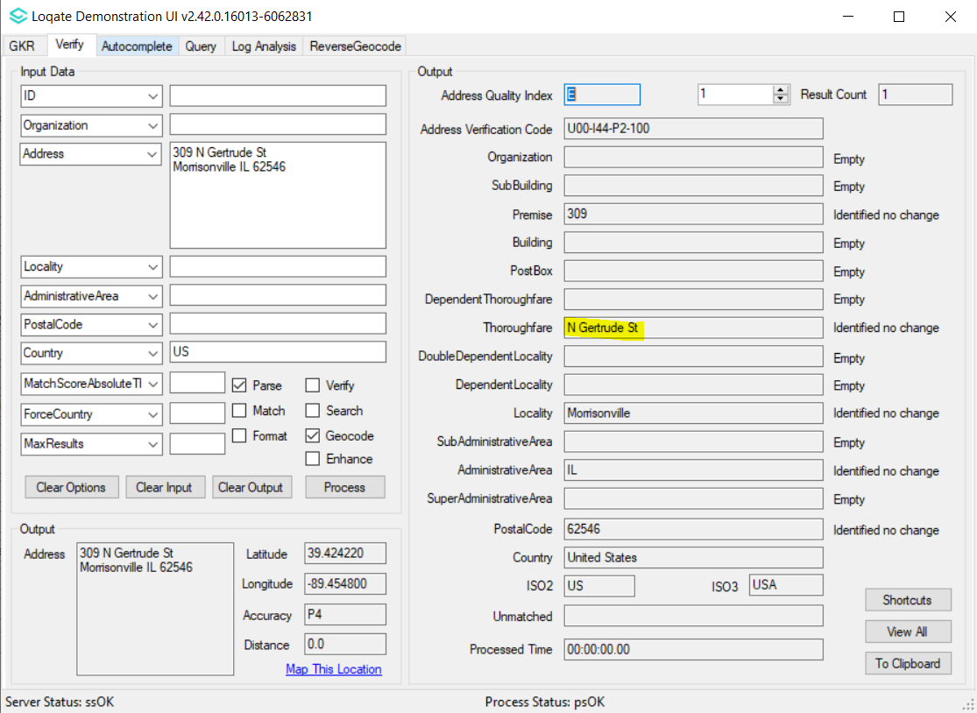

Case Number | Change Description | Category | Country | Example Address
CAS-63559-R1L0F2 | GD is no longer parsed to thoroughfare field | Data | Canada | Address1: 631 Rue Brassard, GD, Saint-Michel-Des-Saints, CA J0k Country: Canada
Before Image |  |  | After Image
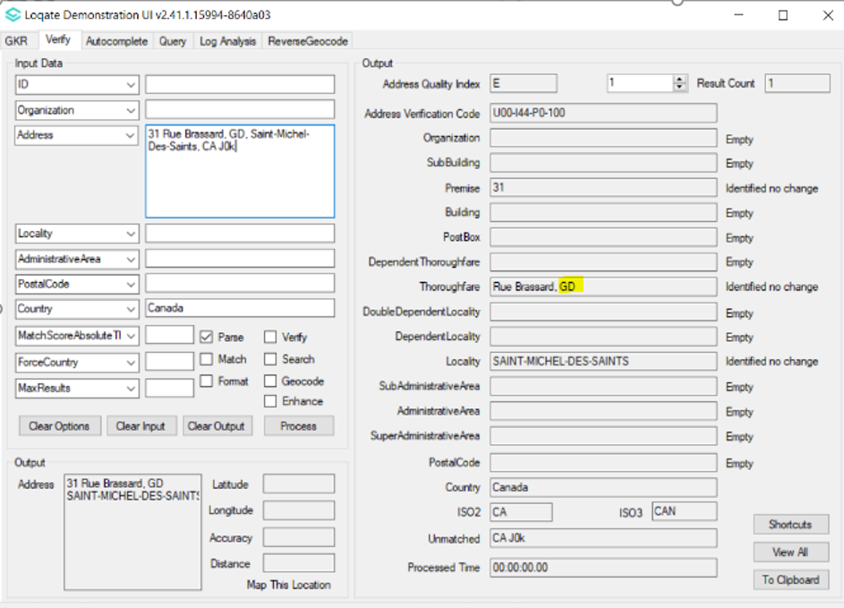 |  |  | 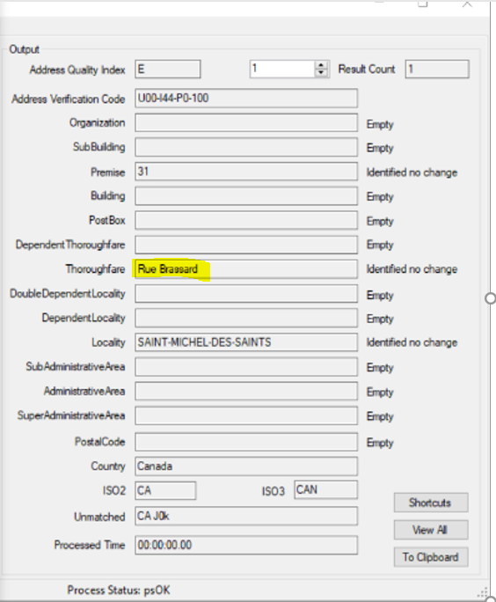

Case Number | Change Description | Category | Country | Example Address
CAS-66748-M9D2D3 | Fix the mapping and the expected locality 'San Lazzaro di Savena' is returned correctly. | Data | Italy | Address1: Via Viviana Bugamelli 7  40068 San Lazzaro di Savena  Bologna  Italy
Before Image |  |  | After Image
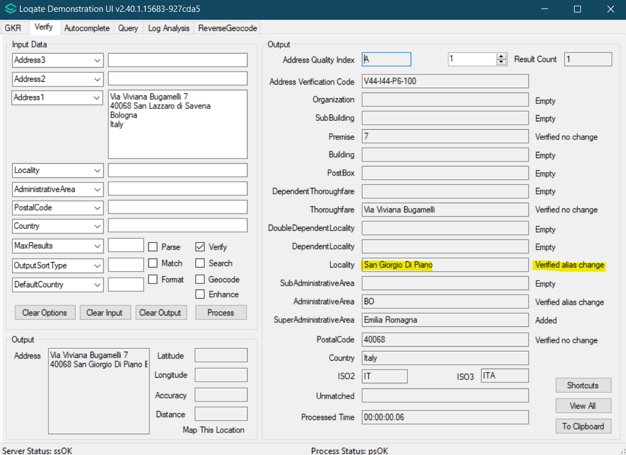 |  |  | 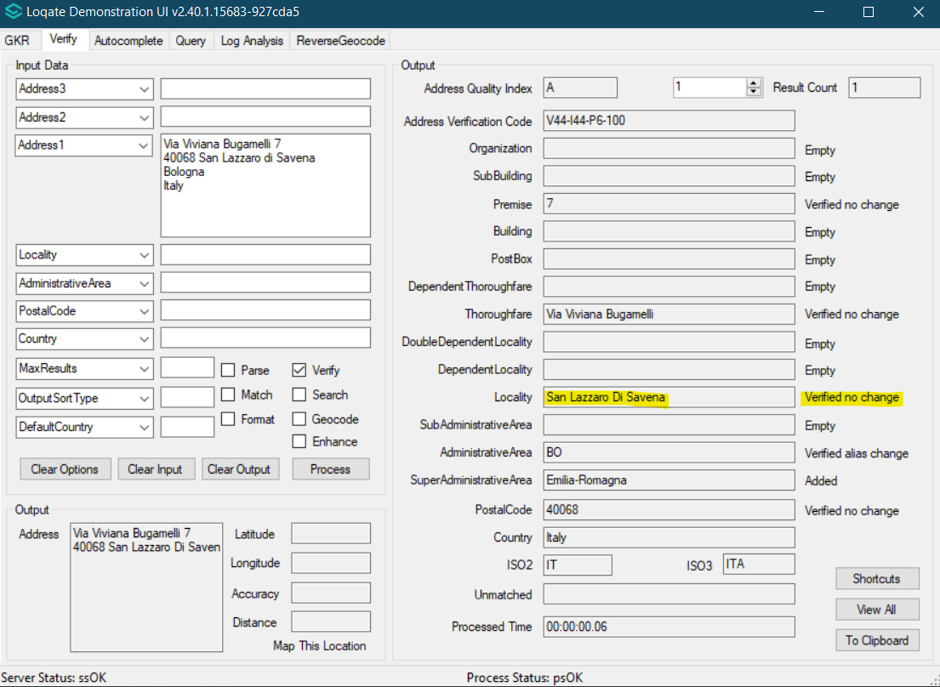

Case Number | Change Description | Category | Country | Example Address
CAS-50122-D7N0Z0 | SubBuilding able to be parsed correctly and overall address parsing is improved | Data | Italy | AddressLine1=Via Giuseppe Felici, 1, Scala E, Piano 4, Interno 7  City=Roma  PostalCode=00144  Country=IT
Before Image |  |  | After Image
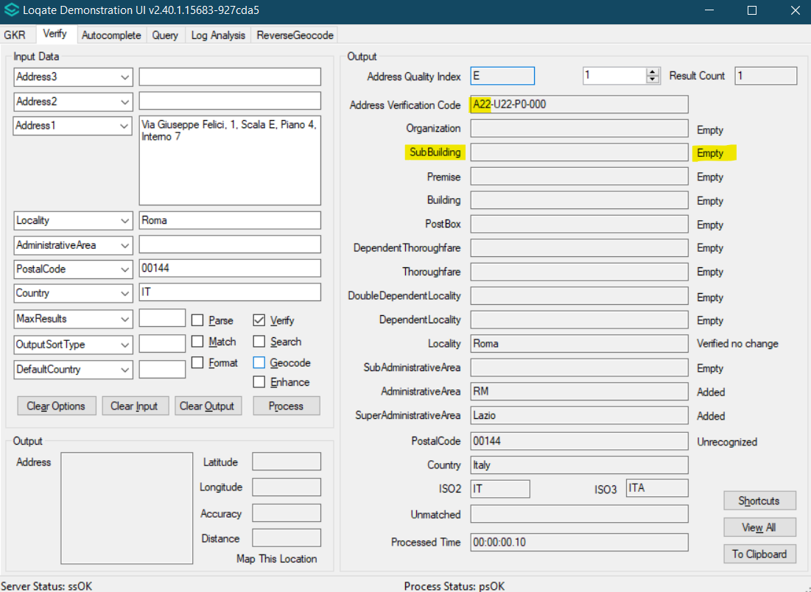 |  |  | 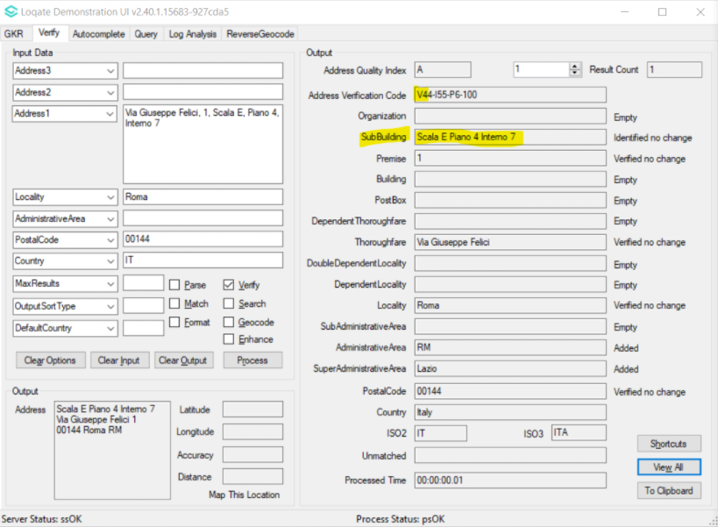

Case Number | Change Description | Category | Country | Example Address
CAS-10603-M0W0C5 | Improvement in address verification | Data | Belgium | Address= Rue Simone Veil 10  5101 Erpent (BE)
Before Image |  |  | After Image
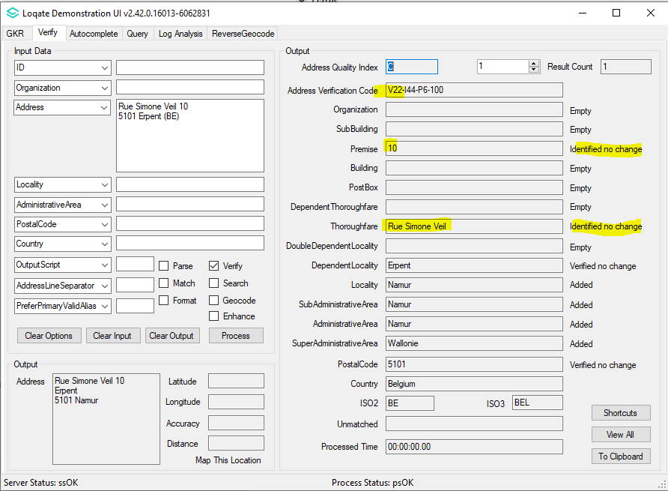 |  |  | 