Loqate, A GBG Solution
Release Notes – Verify API
2022Q1.1 Minor Release

Case Resolutions
Please visit https://support.loqate.com/2022q1-1-resolved-cases/ for a list of all cases resolved in this release. If you would like more details on any of the solved cases listed, please contact LoqateSupport@gbgplc.com for further information.

Local API Notices
This is to inform our customers that in this 2022Q1.1 release we have made no major changes to the API there are 3 minor improvements.

Local API Improvements

Verify Improvements
Parsing Fix to a parsing error when the input premise number is the same as the PostalCode in US addresses. Issue was the postcode was dropped if the same number was entered as the premise.
2022Q1.0 (Before Change)
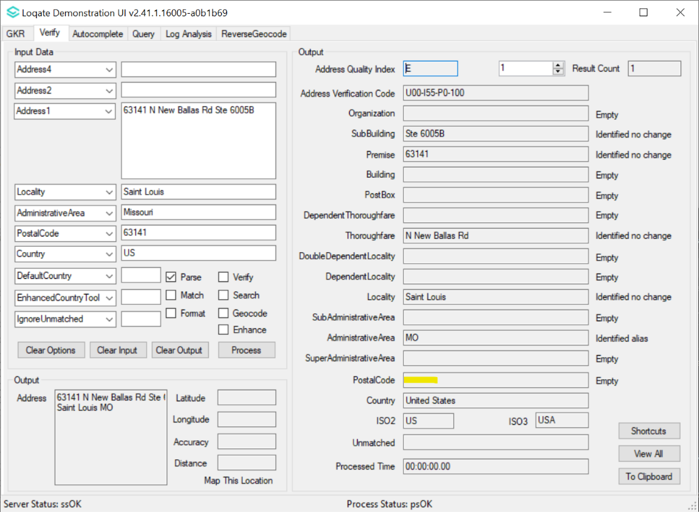
2022Q1.0: The output postal code is empty even though the input is not.

2022Q1.1 (After Change)
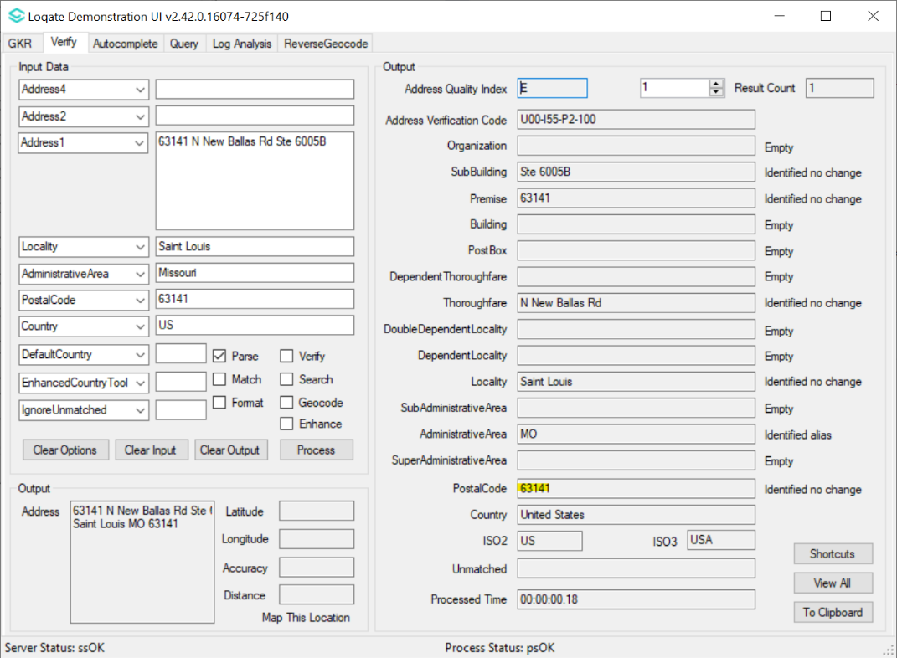
2022Q1.1: The output postal code is the same as input postal code.

New Thoroughfare Typo Handling feature for USA and Germany
- This feature adds capability into the engine to correct Thoroughfare input with minimal typo mistakes. It relies on correct input of both Locality and PostalCode to correct typo in input Thoroughfare.
USA Example 2022Q1.0 (Before Change)
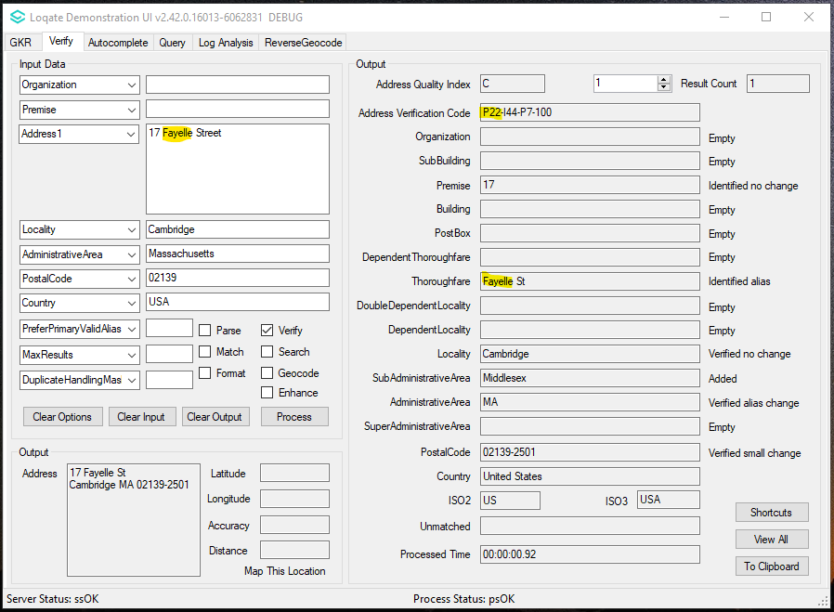
2022Q1.0: The engine was unable to verify Input Thoroughfare "Fayelle", thus returned
the input as output with field status "identified"
2022Q1.1 (After Change)
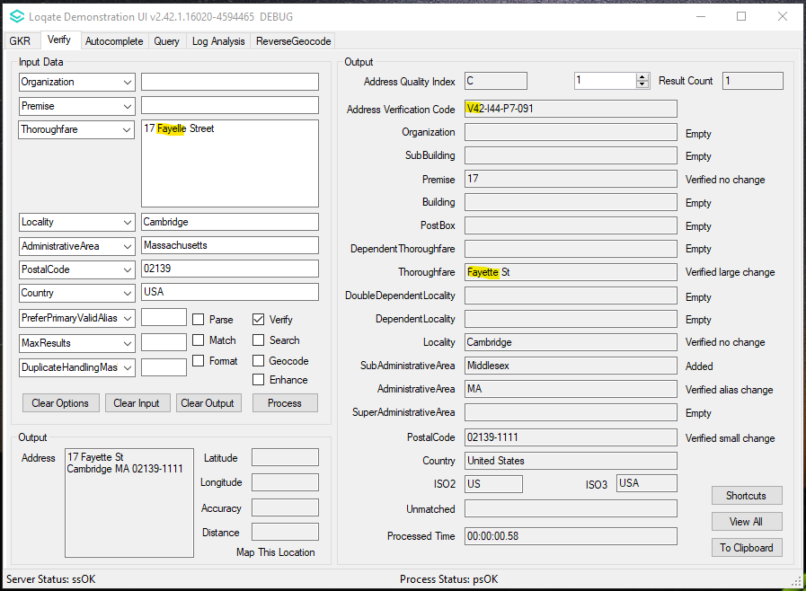
2022Q1.1: The engine corrects Input Thoroughfare "Fayelle" as "Fayette", and verifies
with field status "verified"

German example 2022Q1.0 (Before Change)
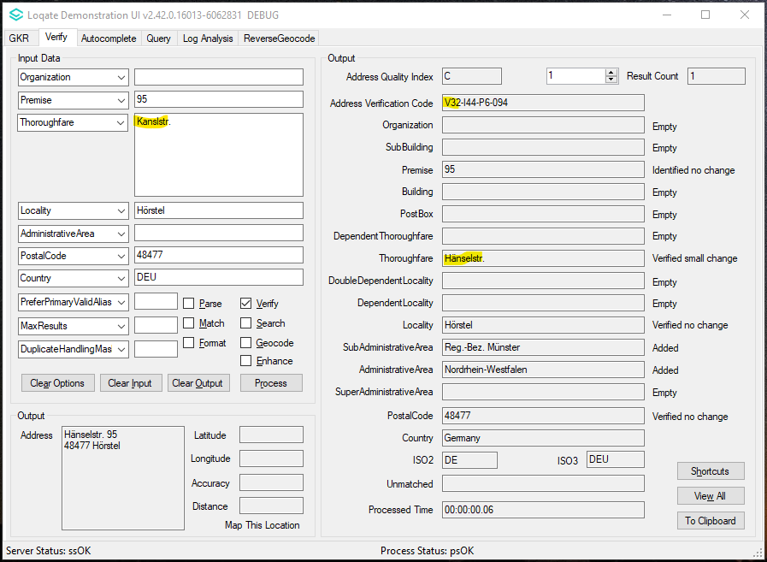
2022Q1.0: Input Thoroughfare "Kanslstr.", the engine produces
Output Thoroughfare as "Hänselstr." which is a false positive result

2022Q1.1 (After Change)
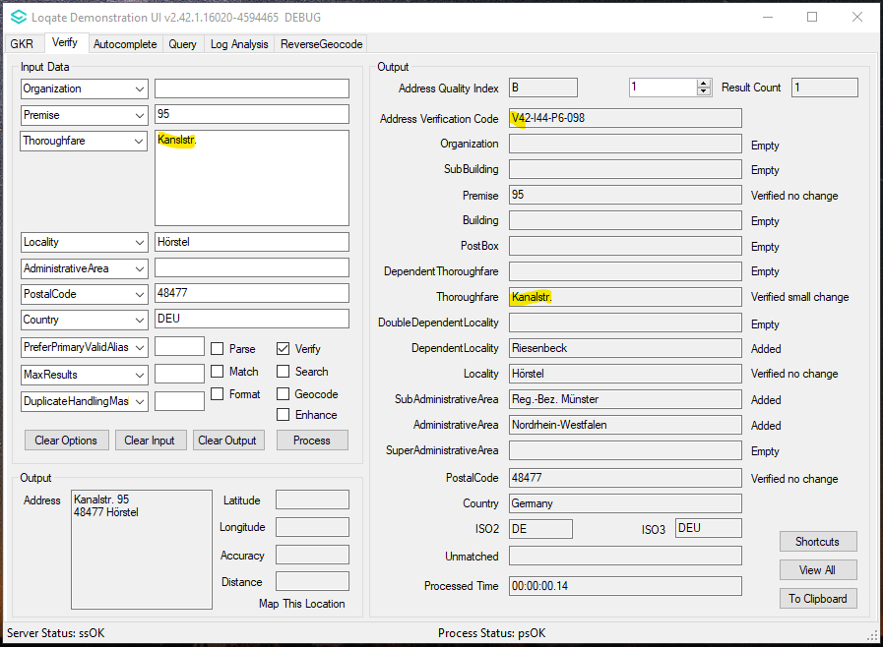
2022Q1.1: Input Thoroughfare "Kanslstr.", the engine corrects the typo and produces
Output Thoroughfare as "Kanalstr." then it is able to verify the premise number

Improvement on premise level Geocode accuracy for UK addresses
From this release the geocode option now uses the PostalCode as well to distinguish between duplicate roads within the same locality to return the correct premise level geocodes.
2022Q1.0 (Before Change)
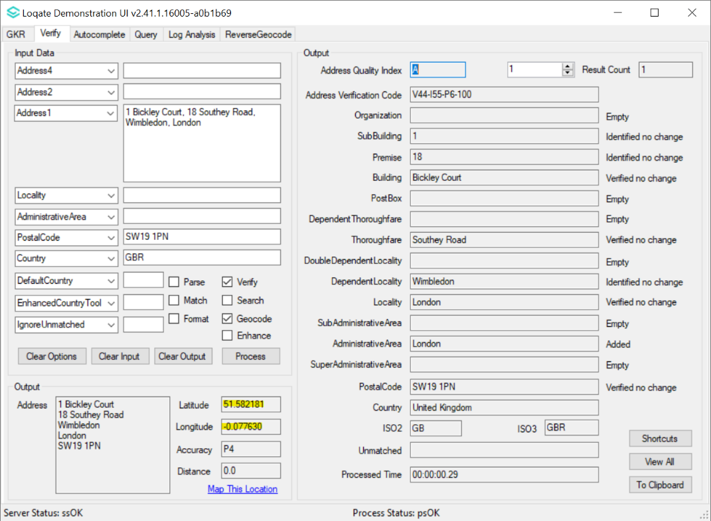
2022Q1.0: The Geolocation returned is very far from the actual location.
2022Q1.1 (After Change)
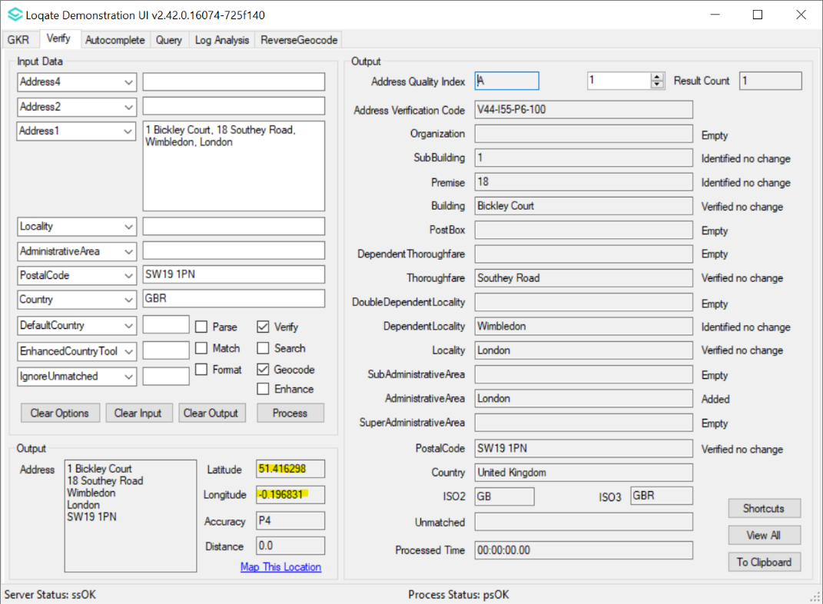
2022Q1.1: The Geolocation returned is much closer to the actual location.

Installation Instructions

Please remember to update both the program files and the reference data and please install these to a new fresh folder location. The improvements are tied to the data in the Global Knowledge Repository and the Local API. When updating the data, it is recommended to use a new data folder each time in order to ensure the latest dataset is installed properly.

If you need any assistance with the upgrade of the Local API or the data update process, please contact GBG Loqate Support.

The setup wizard for the Local API can be obtained from our SFTP server. Please contact your account manager to retrieve the SFTP information. If you do not know who your account manager is, please contact the support team at LoqateSupport@gbgplc.com.

