Loqate, A GBG Solution
Release Notes – Verify API
2022Q1.0 Major Release

Case Resolutions
Please visit https://support.loqate.com/2022q1-0-resolved-cases/ for a list of all cases resolved in this release. If you would like more details on any of the solved cases listed, please contact LoqateSupport@gbgplc.com for further information.

Local API Notices
This is to inform our customers that in this 2022Q1.0 release we have made no major changes to the API there is one minor improvement.

Local API Improvements

Verify Improvements

- This fix adds an enhancement to the RefLex tool by adding a feature allowing mismatch of thoroughfare for a condition aaccepting a mismatch with at least 80% match score for fault tolerance.

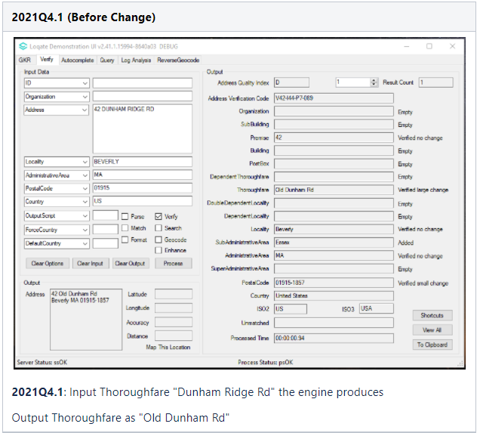
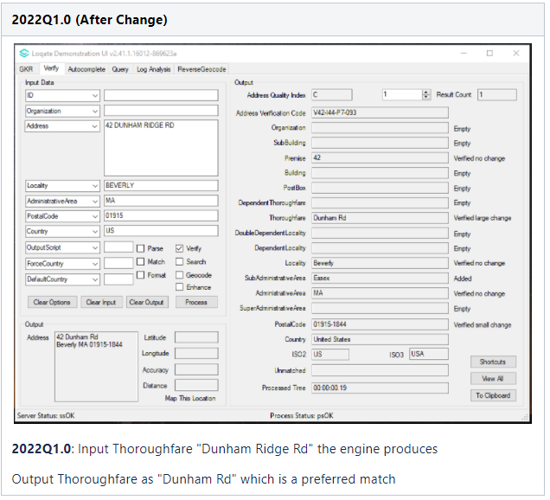

Installation Instructions

Please remember to update both the program files and the reference data and please install these to a new fresh folder location. The improvements are tied to the data in the Global Knowledge Repository and the Local API. When updating the data, it is recommended to use a new data folder each time in order to ensure the latest dataset is installed properly.

If you need any assistance with the upgrade of the Local API or the data update process, please contact GBG Loqate Support.

The setup wizard for the Local API can be obtained from our SFTP server. Please contact your account manager to retrieve the SFTP information. If you do not know who your account manager is, please contact the support team at LoqateSupport@gbgplc.com.

