Loqate, A GBG Solution
Release Notes – Reference Data & Knowledge Base
2021Q4.1 Minor Release

Case Resolutions
Please visit https://support.loqate.com/release-information/2021q4-1-resolved-cases/ for a list of cases resolved in this release.
If you would like more details on any of the solved cases listed, please contact LoqateSupport@gbgplc.com for further information.

Certification Expiration Dates
If you have purchased either the CASS (USA) or AMAS (Australia) certified products, please be aware that the datasets have expiration dates set by the respective postal authorities. Please ensure that you have the latest library and data installed to avoid loss of service through these products.

Please check Install Manager for the latest versions of AMAS and CASS.
 | Loqate Release Date | Certification Expiry Date*
AMAS Data | 2021-10-14 | 2022-03-31
CASS Data | 2021-11-15 | 2022-02-28
*Certification Expiry Date is different from Loqate license key expiry date. The earliest expiry date will apply.

For more information on expiry date checking for CASS and AMAS, please refer “Usage expiration” section in https://support.loqate.com/documentation/local-apis/cass-overview-2/ and https://support.loqate.com/address-matching-approval-system-amas/

Loqate, A GBG Solution
Release Notes – Data - 2021Q4.1 Minor Release

Data Structure Changes
BPDH/PDH Countries Details
Bolivia
Country Information |  | Description
ISO2 |  | BO
ISO3 |  | BOL
Address Format |  | Organization  PostBox  Building SubBuilding  Thoroughfare Premise  DependentThoroughfare  DoubleDependentLocality  DependentLocality  Locality
PDH |  | Yes
PDH Completed Date |  | 2021Q4.1
New Source |  | No
 | Pre-PDH |  | Post-PDH
Reference Data | rd_BO_ggg.lfs  rd_BO_ggg_rg.lfs  rd_BO_vfy_ai.lfs  rd_BO_vfy.lfs |  | rd_BO_ggg.lfs  rd_BO_ggg_rg.lfs  rd_BO_vfy_ai.lfs  rd_BO_vfy.lfs
2021Q4.0 |  | 2021Q4.1
Thoroughfare could not be verified.  Poor parsing. |  | Thoroughfare parsed correctly and verified.  Overall Improvement in parsing and verification.  SuperAdministrativeArea, AdministrativeArea, SubAdministrativeArea are added.
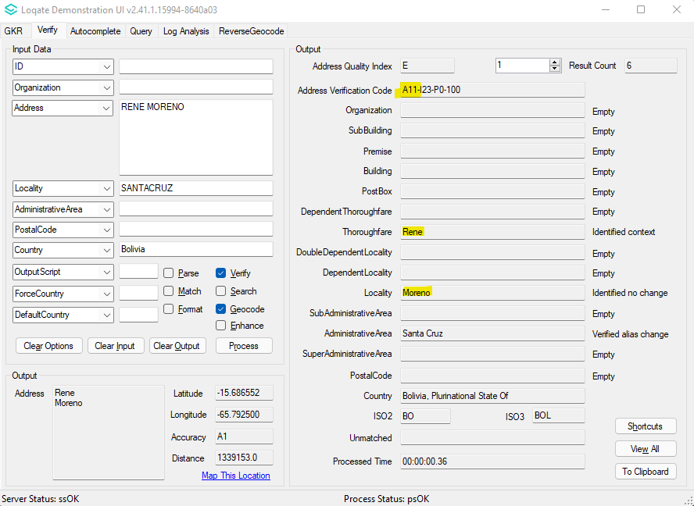 |  | 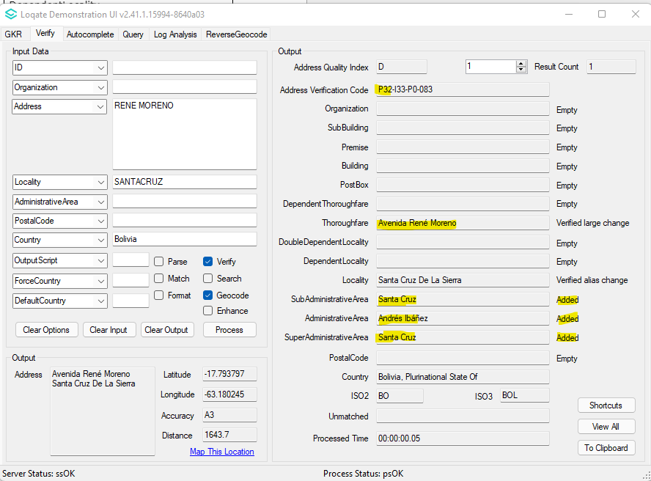

Cayman Island
Country Information |  | Description
ISO2 |  | KY
ISO3 |  | CYM
Address Format |  | Organization  PostBox  SubBuilding Building  Premise Thoroughfare  DependentThoroughfare  DoubleDependentLocality  DependentLocality  Locality PostalCode
PDH |  | Yes
PDH Completed Date |  | 2021Q4.1
New Source |  | No
 | Pre-PDH |  | Post-PDH
Reference Data | rd_KY_ggg.lfs  rd_KY_ggg_rg.lfs  rd_KY_vfy_ai.lfs  rd_KY_vfy.lfs |  | rd_KY_ggg.lfs  rd_KY_ggg_rg.lfs  rd_KY_vfy_ai.lfs  rd_KY_vfy.lfs

2021Q4.0 | 2021Q4.1
Premise and Thoroughfare could not be verified. | Premise and Thoroughfare is now able to be verified.
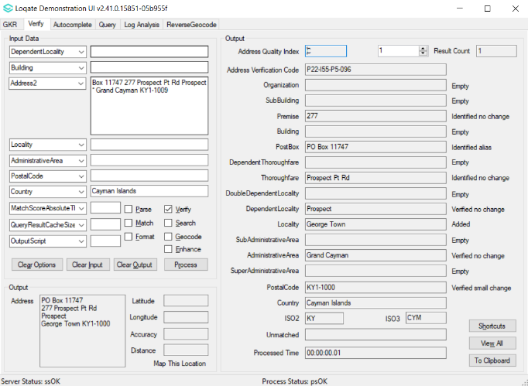 | 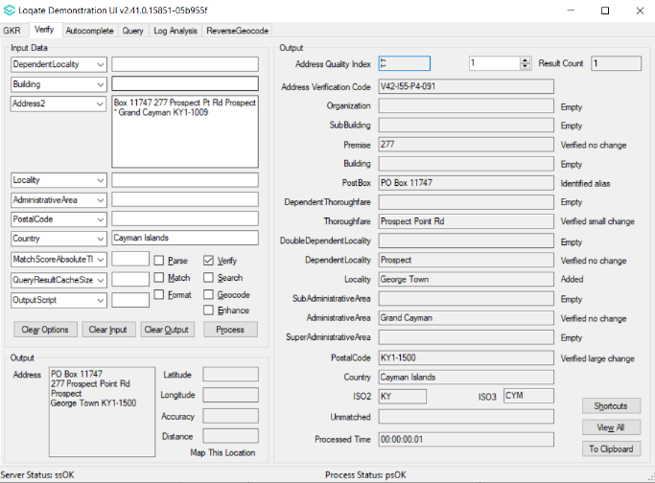

Cyprus
Country Information |  | Description
ISO2 |  | CY
ISO3 |  | CYP
Address Format |  | Organization  PostBox  SubBuilding Building  Premise Thoroughfare  DependentThoroughfare  DoubleDependentLocality  DependentLocality  PostalCode Locality
PDH |  | Yes
PDH Completed Date |  | 2021Q4.1
New Source |  | No
 | Pre-PDH |  | Post-PDH
Reference Data | rd_CY_geo.lfs  rd_CY_geo_rg.lfs  rd_CY_vfy_ai.lfs  rd_CY_vfy.lfs |  | rd_CY_ggg.lfs  rd_CY_ggg_rg.lfs  rd_CY_vfy_ai.lfs  rd_CY_vfy.lfs

2021Q4.0 | 2021Q4.1
Premise and Thoroughfare could not be verified. | Premise and Thoroughfare is now able to be verified.
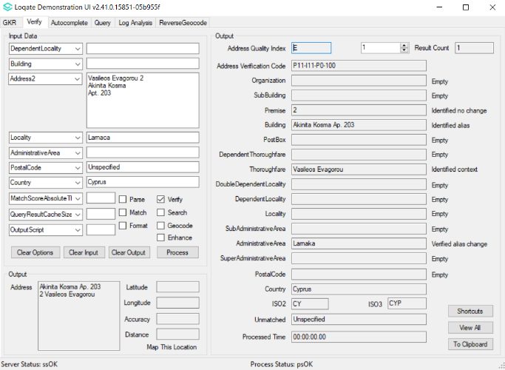 | 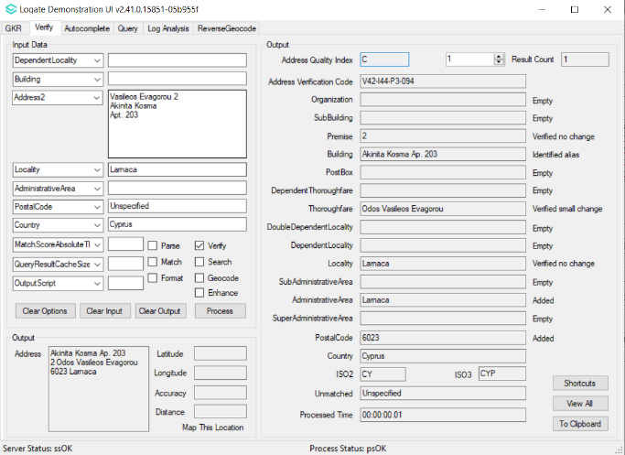

Guam
Country Information |  | Description
ISO2 |  | GU
ISO3 |  | GUM
Address Format |  | Organization  Postbox  SubBuilding Building  Premise Thoroughfare  DependentThoroughfare  DoubleDependentLocality  DependentLocality  Locality AdministrativeArea PostalCode
PDH |  | Yes
PDH Completed Date |  | 2021Q4.1
New Source |  | No
 | Pre-PDH |  | Post-PDH
Reference Data | rd_GU_geo.lfs  rd_GU_geo_rg.lfs  rd_GU_vfy_ai.lfs  rd_GU_vfy.lfs |  | rd_GU_ggg.lfs  rd_GU_ggg_rg.lfs  rd_GU_vfy_ai.lfs  rd_GU_vfy.lfs

2021Q4.0 | 2021Q4.1
Premise and Thoroughfare could not be verified. | Premise and Thoroughfare is now able to be verified.
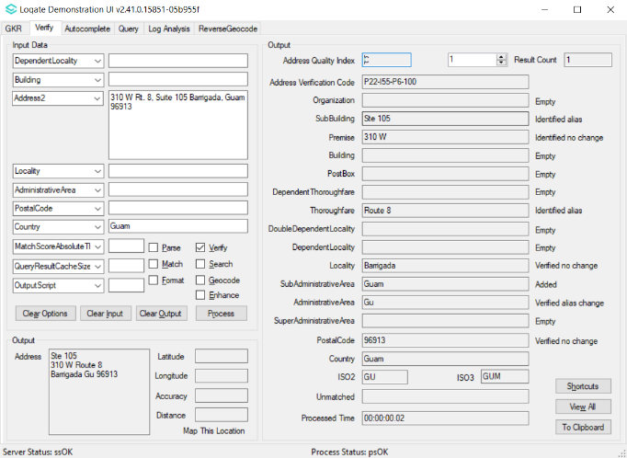 | 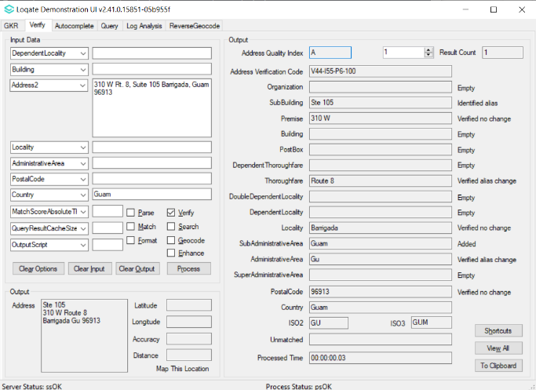

REFERENCE DATA NOTICES

Macao
Address format change
2021Q4.0 | 2021Q4.1
Organization  Postbox  Building SubBuilding  Thoroughfare Premise  DependentThoroughfare  DoubleDependentLocality  DependentLocality  Locality | Organization  PostBox  Thoroughfare Premise  DependentThoroughfare  Building  DoubleDependentLocality  DependentLocality  Locality

Slovakia
Bratislava (Locality) and its corresponding sub-division of Bratislava 1 to Bratislava 5 (SubAdministrativeArea) are replaced with each other to follow Slovakia postal authority site. The same changes applied to Kosice and its corresponding sub-division of Kosice 1 to Kosice 4.
2021Q3.1 | 2021Q4.1
Bratislava II and Bratislava incorrectly parsed and verified as SubAdministrativeArea and Locality respectively. | Bratislava II and Bratislava correctly parsed and verified as Locality and SubAdministrativeArea respectively.
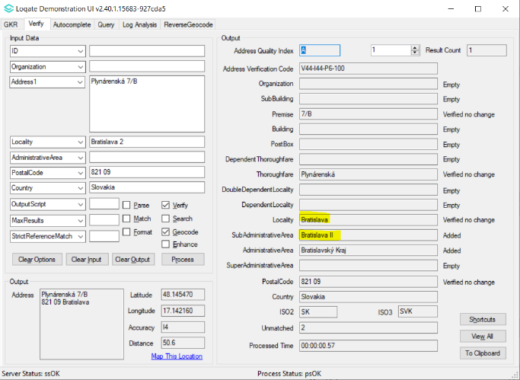 | 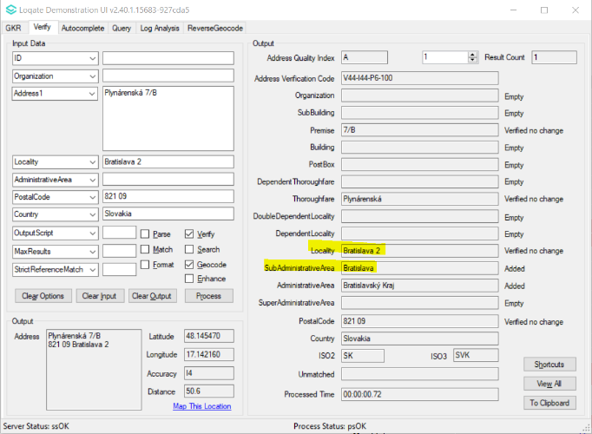
Kosice I incorrectly parsed to Building field and Kosice incorrectly parsed and verified as Locality. | Both Kosice I and Kosice correctly parsed and verified as Locality and SubAdministrativeArea.
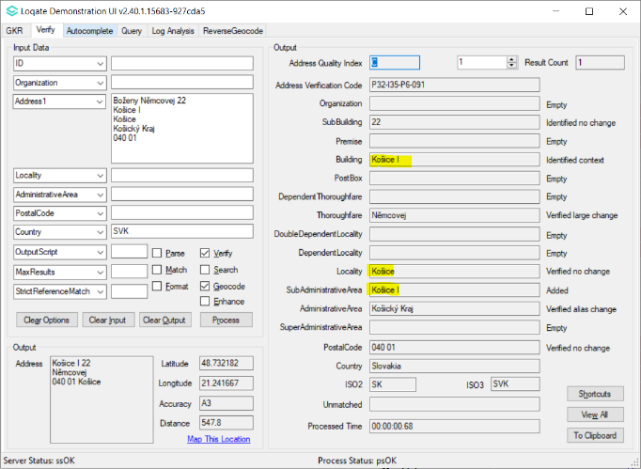 | 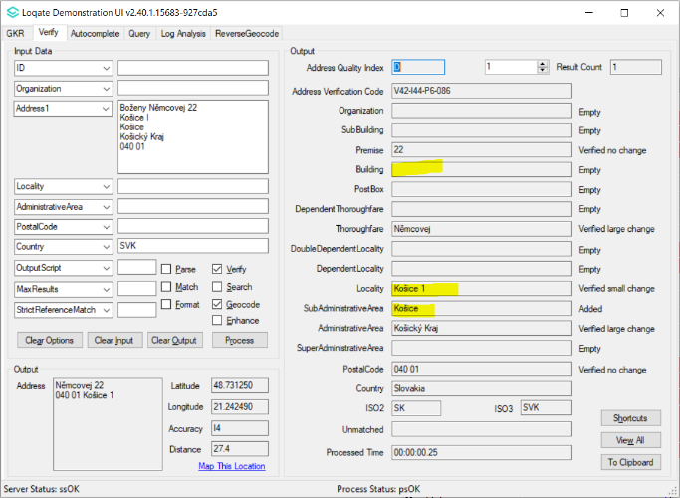

United Arab Emirates
Makani number is a unique 10-digit number that is assigned to each property, and since the UAE does not have a postal code system, they rely on these Makani number instead as a form of geo-addressing. Makani number helps to navigate to the correct entrance/building. A building can have multiple Makani number as some building has multiple entrance (i.e., Burj Khalifa).

2021Q4.0 | 2021Q4.1
When using Verify, the Building field was verified with 10-digit number as an output.  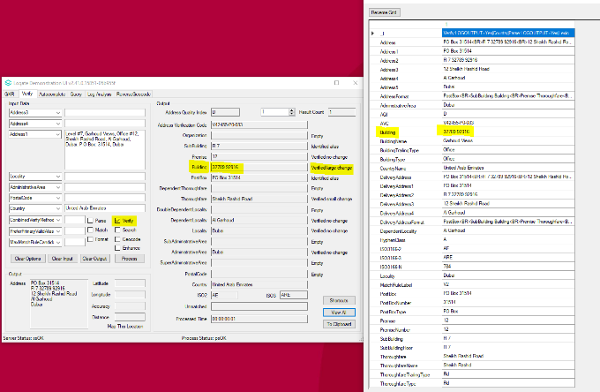 | When using Verify, the Building field are now parsed correctly, and the 10-digit number are now in MakaniNumber field.  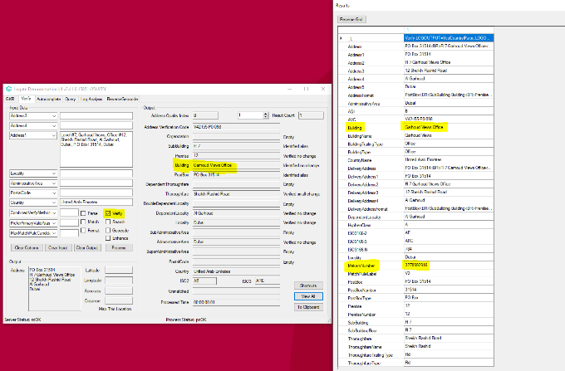
When input the 10-digit MakaniNumber in Search function, it was parsed to the Building field.  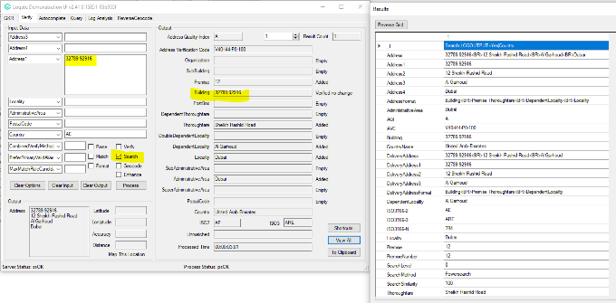 | When input the 10-digit MakaniNumber in Search function, it was parsed correctly to the MakaniNumber field.  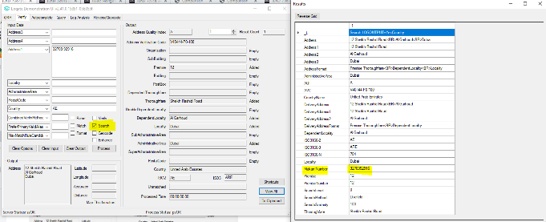

United Kingdom (GBR)

Country Information | Description
ISO2 | GB
ISO3 | GBR
Address Format  Default Format: | Organization  Department  PostBox  SubBuilding Building  Premise Thoroughfare DoubleDependentLocality DependentLocality  Locality  PostalCode
Address Format  Conditional Address Format:  (I) If a DependentThoroughfare is present then the format will be: | Organization  Department  PostBox  SubBuilding Building  Premise DependentThoroughfare Thoroughfare  DoubleDependentLocality DependentLocality  Locality  PostalCode
Address Format Conditional Address Format:  (II) If the Thoroughfare is absent, whereas Premise & Building are present then the format will be: | Organization  Department  Premise Building  DoubleDependentLocality DependentLocality  Locality  PostalCode
PDH | YES
PDH completed date | 2021Q4.1
New Source | YES

 | Pre-PDH | Post-PDH
Reference Data | rd_GB_ggg.lfs  rd_GB_ggg_rg.lfs  rd_GB_ggg_r.lfs  rd_GB_vfy_ai.lfs  rd_GB_vfy.lfs | rd_GB_ggg.lfs  rd_GB_ggg_rg.lfs  rd_GB_ggg_r.lfs  rd_GB_vfy_ai.lfs  rd_GB_vfy.lfs
Enhanced Files | rd_GB_enh_DPS.lfs  rd_GB_enh_DPS_r1.lfs  rd_GB_enh_DPS_r.lfs | rd_GB_enh_DPS_f.lfs  rd_GB_enh_DPS.lfs  rd_GB_enh_DPS_m.lfs  rd_GB_enh_DPS_pr.lfs  rd_GB_enh_DPS_r1.lfs  rd_GB_enh_DPS_r.lfs

2021Q4.0 | 2021Q4.1
Building verified alias change to other building name when ‘PreferPrimaryValidAlias’ option is on  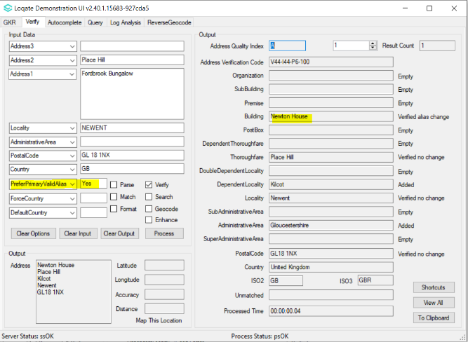 | Building verified no change when ‘PreferPrimaryValidAlias’ option is on  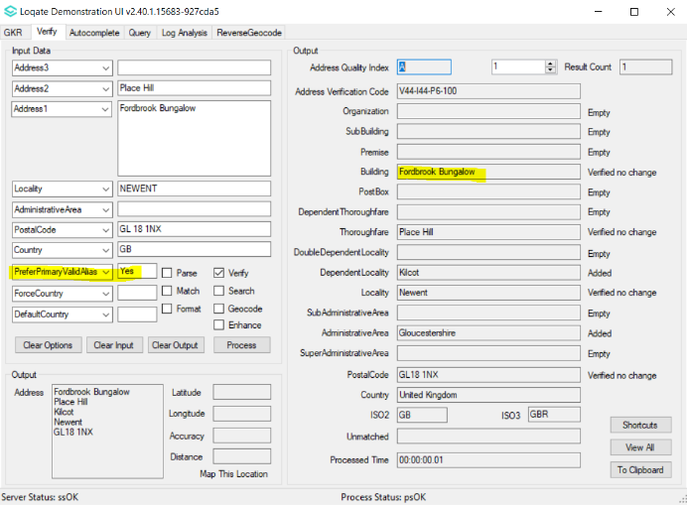
P3 geocodes returned for AVC V4 address.  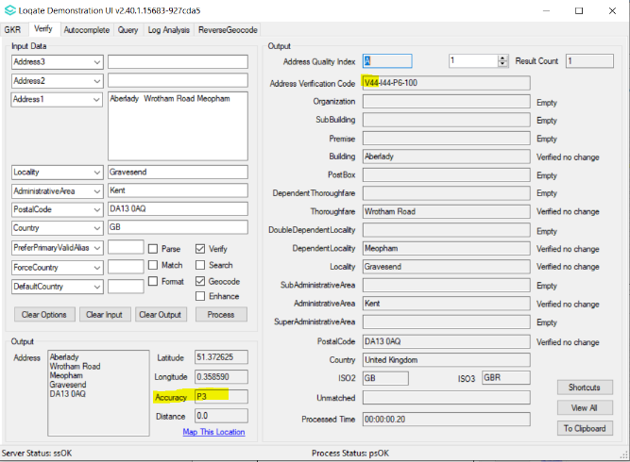 | P4 geocodes returned for AVC V4 address – geocodes improvement.  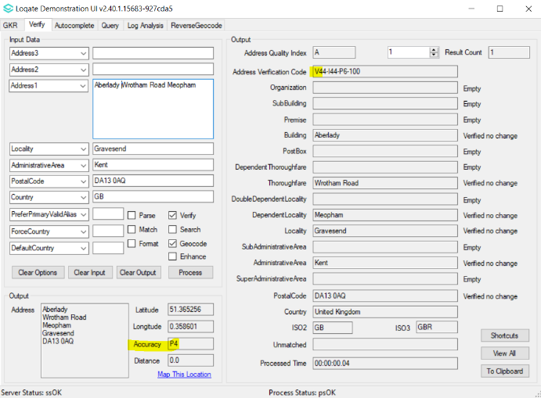

2021Q4.1
Improvement in verify enhanced result:
There’re four additional key fields returned for the address.
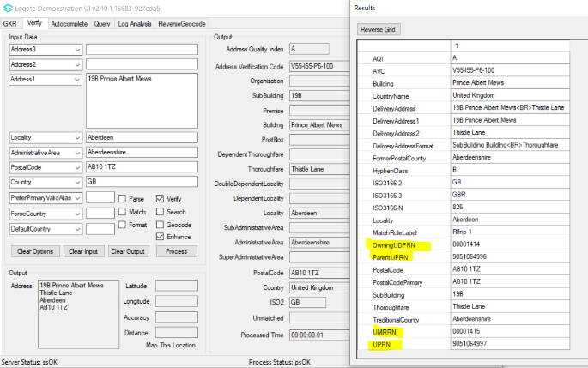

GBR four new enhanced fields (Link: https://support.loqate.com/gb-enhancement-data-fields/)

New GBR additional enhanced data fields.

UPRN
The Unique Property Reference Number (UPRN) is a twelve-digit Ornance Survey's unique record ID.

ParentUPRN
The Parent UPRN is a twelve-digit UPRN of the 'shell' or 'owning' building of a Multiple Residence (flat, unit or apartment).
Note that this is inferred from the relationships of an MR with a PAF parent record.

OwningUDPRN
The Owning UDPRN is an eight-digit UDPRN key of the 'shell' or 'owning' PAF building record of a Multiple Residence (flat, unit or apartment).
For example, if Ground Floor Flat, Princes House is a Multiple Residence record, then Princes House would be its owning building.

UMRRN
The Unique Multiple Residence Reference Number (UMRRN) is an eight-digit numeric key that is unique to every Multiple Residences (MRs).

United States

According to the: https://www.cia.gov/the-world-factbook/field/independence: Micronesia, Federated States of (ISO2: FM), Marshall Islands (ISO2: MH), and Palau (ISO2: PW) are considered independent from the USA. As these nations are considered independent countries, beginning in the 2021Q4.1 major release, the following countries will be removed from the USA data set; these countries will become individual data sets.
FM – Federated States of Micronesia
MH – Marshall Islands
PW – Palau
2021Q4.0 | 2021Q4.1
Palau’s address is verified in USA dataset  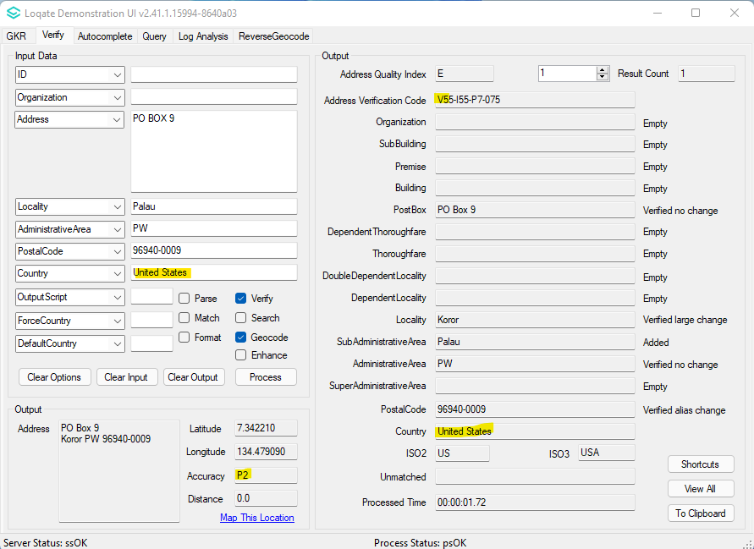 | Palau’s address no longer verified in United States country dataset  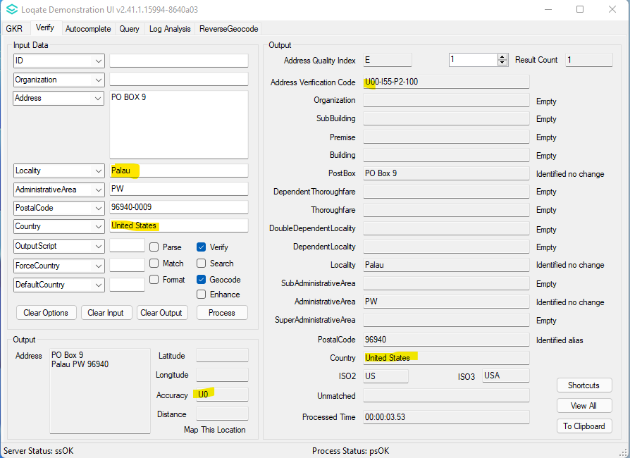  Palau address will only be verified in Palau country dataset.  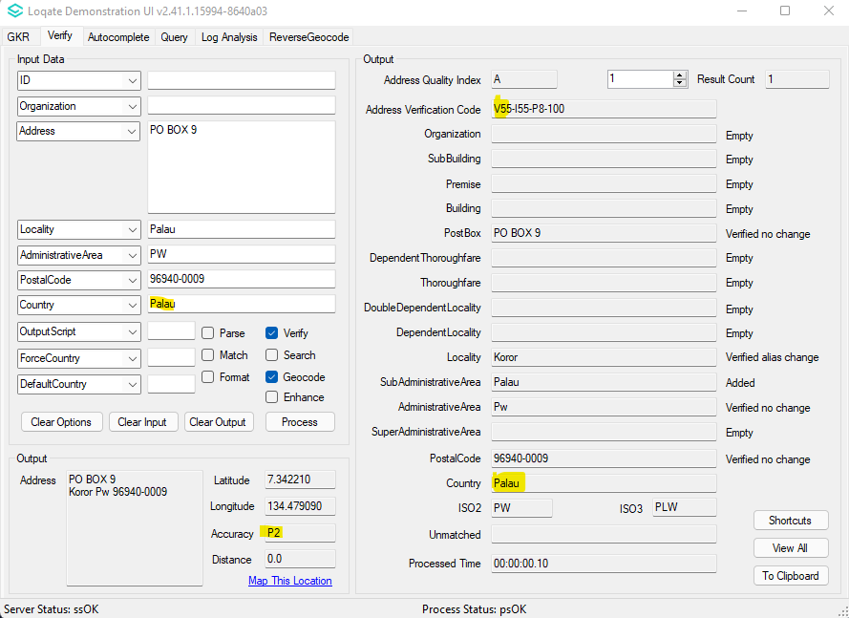
Time Zone
Loqate provide new enhancement dataset – covering world’s time zone information.

Most countries have a single time zone, there are 23 countries with at least two time zones, including Antarctica, Australia, Brazil, Canada, The Democratic Republic of the Congo, Ecuador, French Polynesia, Greenland, Indonesia, Kazakhstan, Kiribati, Mexico, Federated States of Micronesia, Mongolia, New Zealand, Papua New Guinea, Portugal, Russian Federation, Spain, Ukraine, United States Minor Outlying Islands, and United States.

2021Q4.1
New enhancement dataset, which provide world’s time zone information, including Coordinated Universal Time (UTC) & Daylight Saving Time (DST).
File name: rd_WW_enh_TIMEZONE.lfs

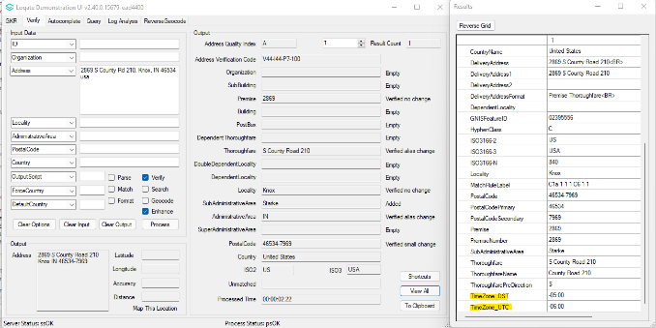

Timezone fields (NEW)

What are Time Zones?
Time Zone refers to the local time of a region or a country. The local time within a time zone is defined by its offset (difference) from Coordinated Universal Time (UTC), the world's time standard, ranging from UTC-12:00 to UTC +14:00.
Some countries or regions use Daylight Savings Time (DST) for part of the year during spring and summer. During DST, our clocks are forwarded an hour, so daylight ends at later time of the day.

Coverage and Data
Loqate provide time zone information for world-wide countries. Most countries have a single time zone, there are 23 countries with at least two time zones, including Antarctica, Australia, Brazil, Canada, The Democratic Republic of the Congo, Ecuador, French Polynesia, Greenland, Indonesia, Kazakhstan, Kiribati, Mexico, Federated States of Micronesia, Mongolia, New Zealand, Papua New Guinea, Portugal, Russian Federation, Spain, Ukraine, United States Minor Outlying Islands, and United States.
For countries with single time zone, Loqate engine will add the time zone fields using CountryName field. Whereas for countries with multiple time zones, Loqate will add the time zone fields using a combination of CountryName and Geographical fields (SuperAdministrativeArea/AdministrativeArea/SubAdministrativeArea/Locality/or the combination of them).

Value Fields
TimeZone_UTC
UTC defines the Coordinated Universal Time.
Example: 2869 S County Road 210, Knox IN 46534-7969, USA
Returned UTC values: -05:00

TimeZone_DST
DST defines the Daylight Saving Time.
Example: 2869 S County Road 210, Knox IN 46534-7969, USA
Returned DST values: -06:00

TimeZone_Name (Unavailable yet, enhancement in near future)

Case Resolutions

2021Q4.1 Data related Case Fixes

Case Number | Change Description |  | Category | Country | Example Address
CAS-49068-Y6F2L8 | Building and SubBuilding parsing improvement |  | Data | MAC | Address1: FLAT B, 21/F, TOWER 5, NOVA CITY, RUA DE NAM KENG  Address2: TAIPA, MACAU  Country: Macao
Before Image/Behaviour 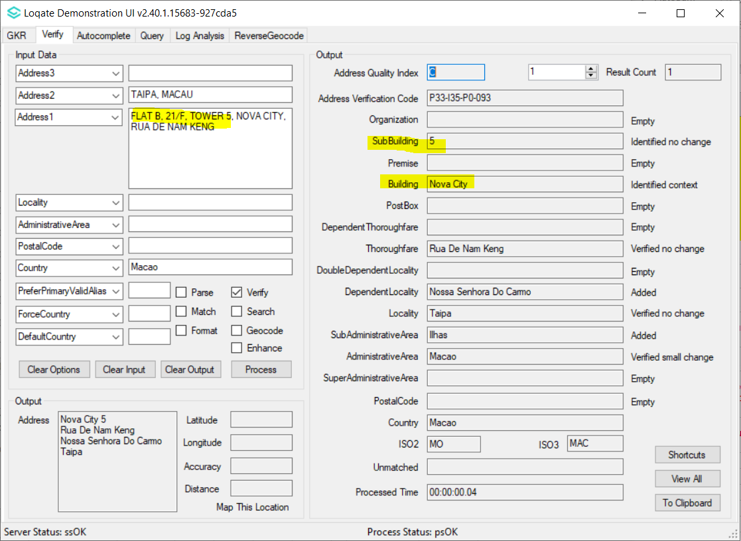 |  | After Image/Behaviour 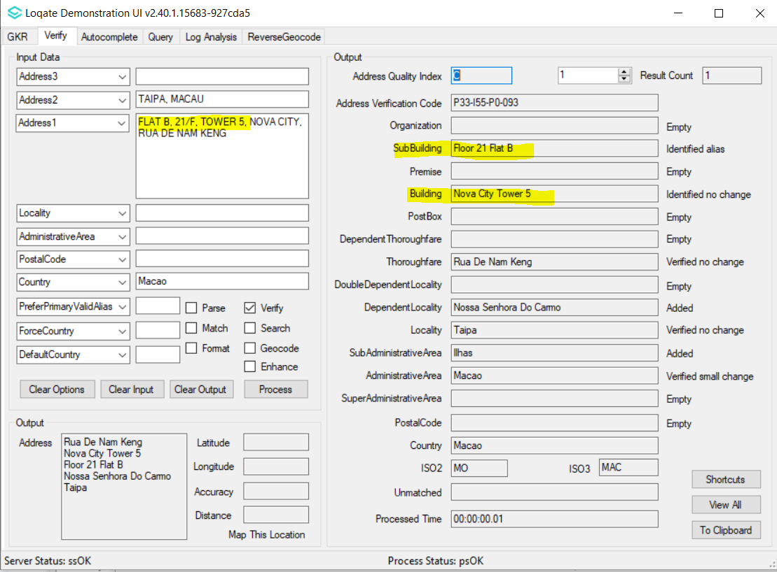

Case Number | Change Description |  | Category | Country | Example Address
CAS-58754-X5Q0D4 | Building, Organization and Department records grouping change in reference data |  | Data | GBR | Address1: Hartlip Place  Address2: Hartlip  Locality: SITTINGBOURNE  PostalCode: ME9 7TR  Country: GB
Before Image/Behaviour 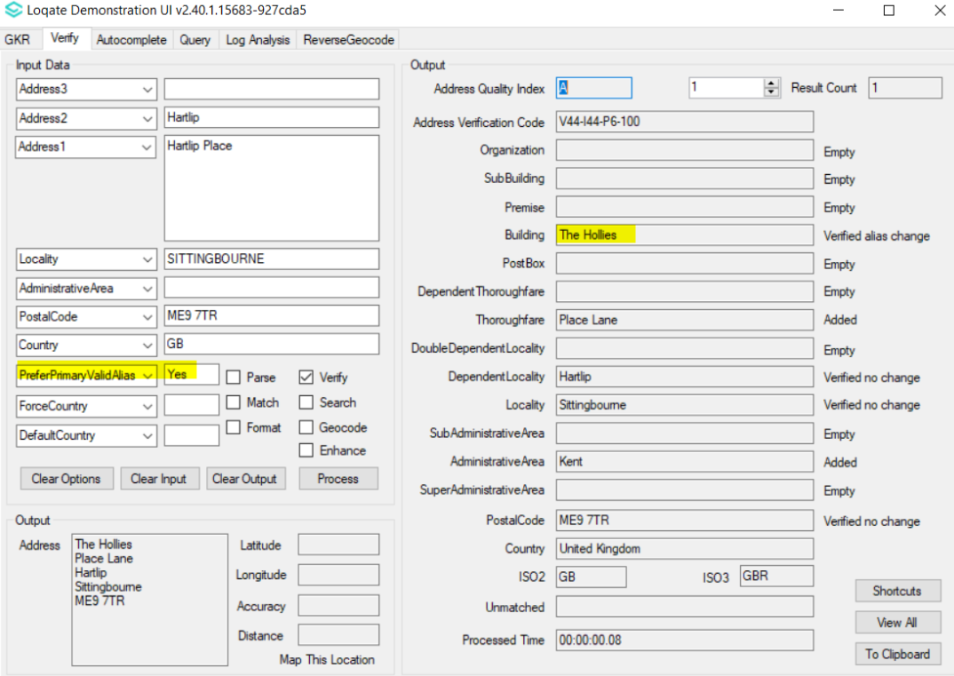 |  | After Image/Behaviour 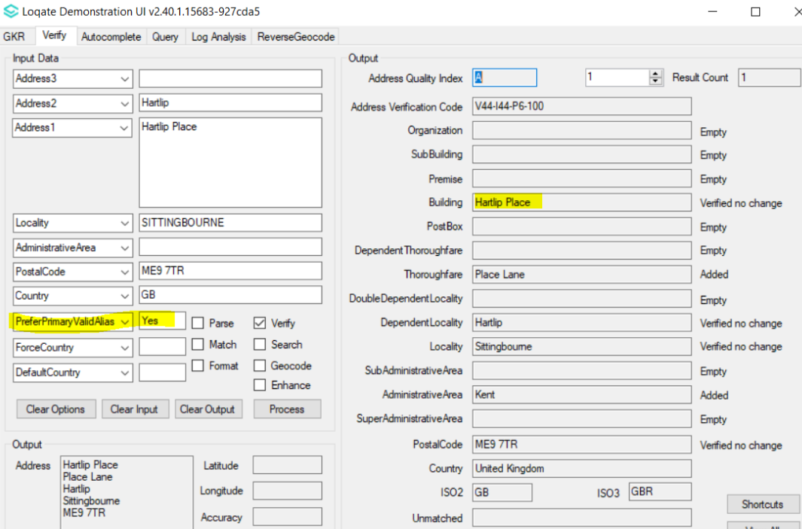

Case Number | Change Description | Category | Country | Example Address
CAS-50655-D3K6F3 | Improved geocodes from new data source | Data | GBR | Address1: Gosh sight and sound centre, 40-41 Queens Square, London, WC1N 3AJ  Country: GB
Before Image/Behaviour 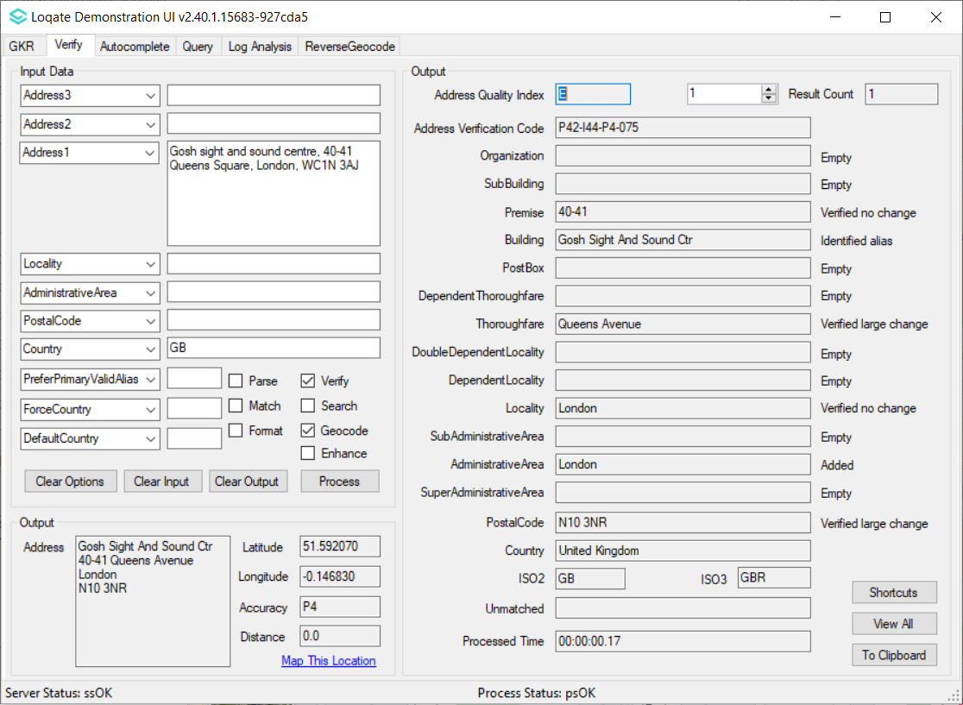 |  |  |  | 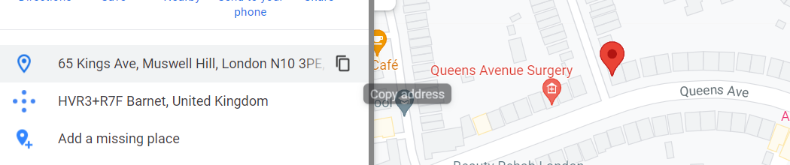

After Image/Behavior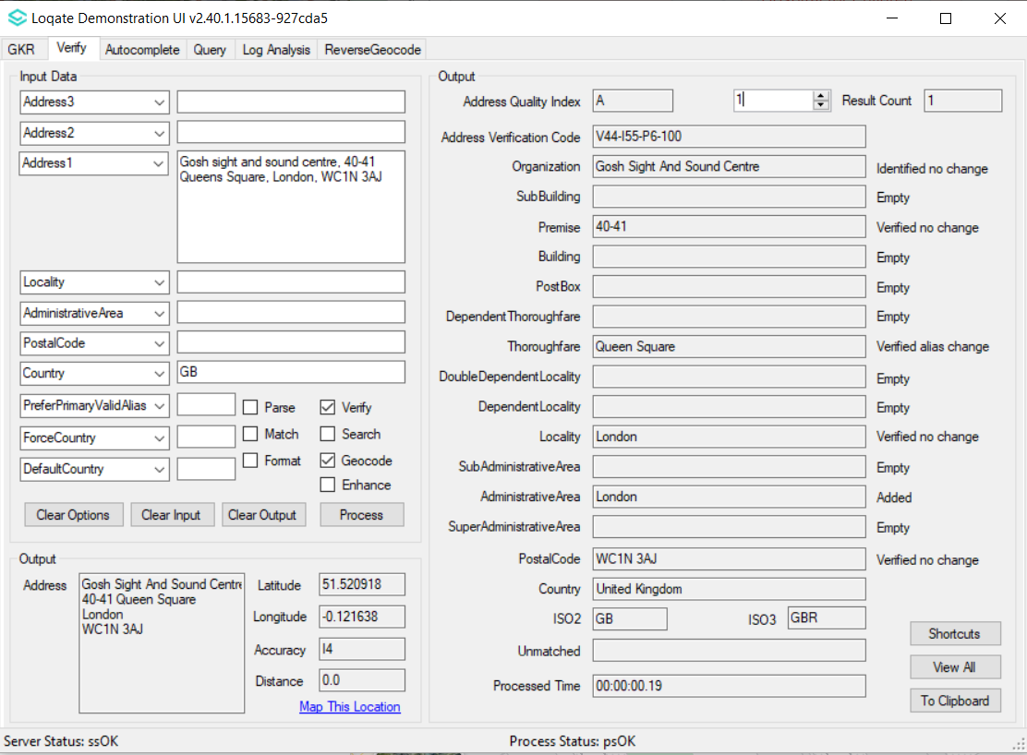 | 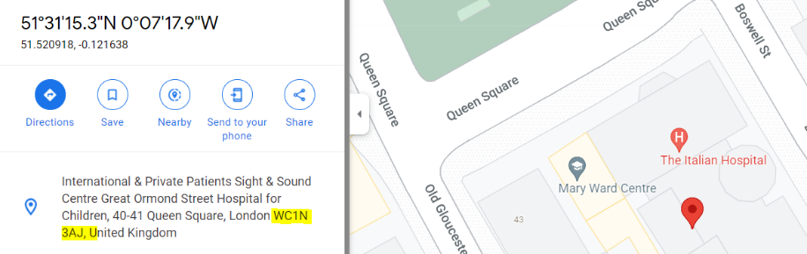

Case Number | Change Description | Category | Country | Example Address
CAS-10723-V3P6J0 | Fix duplicate 'Box' issue in Premise field | Data | USA | Address1: box 386 RR 1  Locality: Ironton  AdministrativeArea: MO  Country: USA

Before Image/Behaviour | After Image/Behaviour
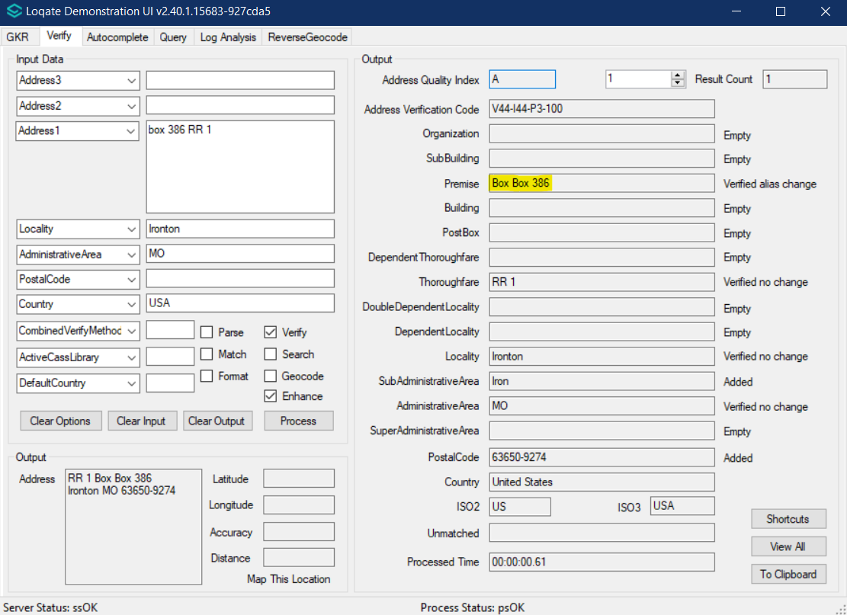 | 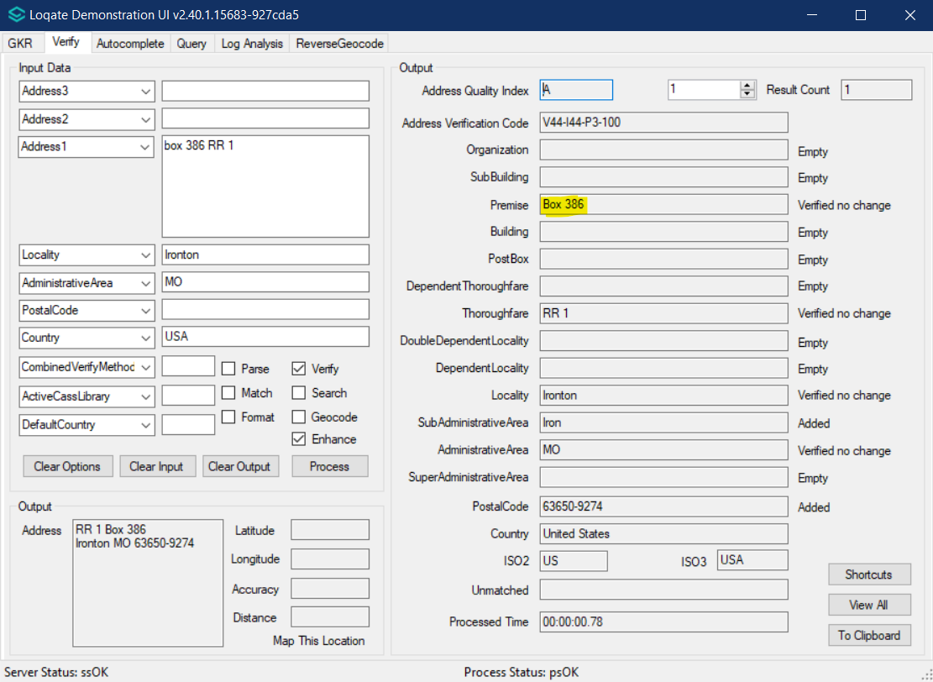

Case Number | Change Description | Category | Country | Example Address
CAS-49509-H4R6H4 | Fix blank locality value | Data | KHM | Address1: Str 1003  Locality: Phnom Penh  Country: KH

Before Image/Behaviour | After Image/Behaviour
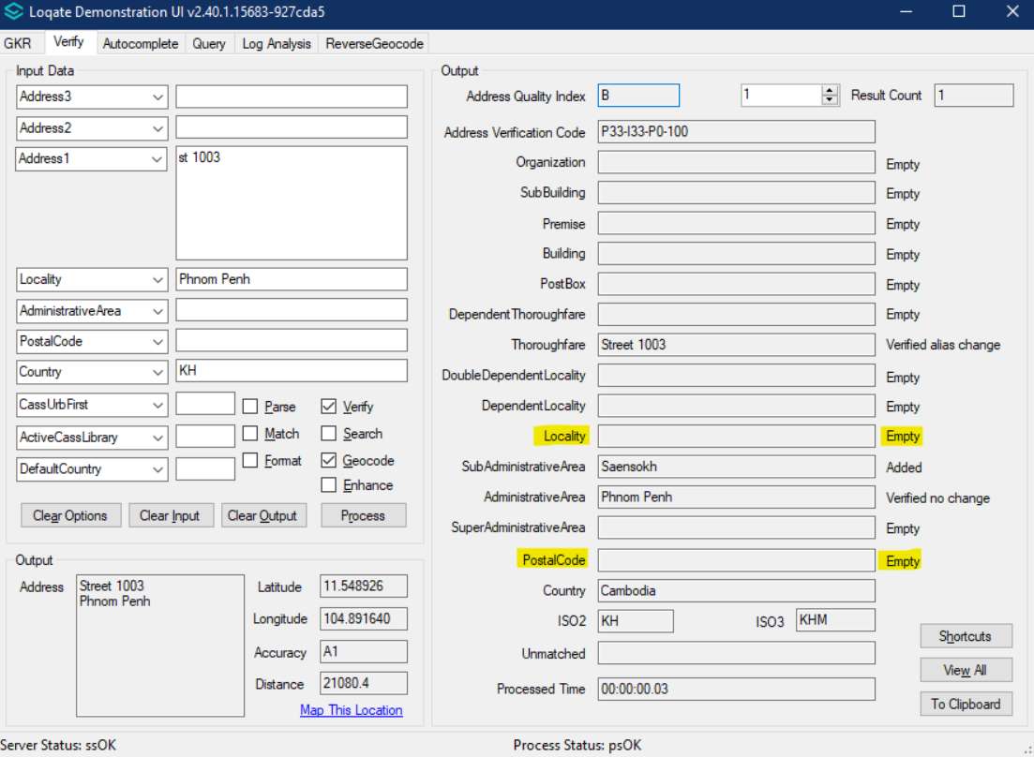 | 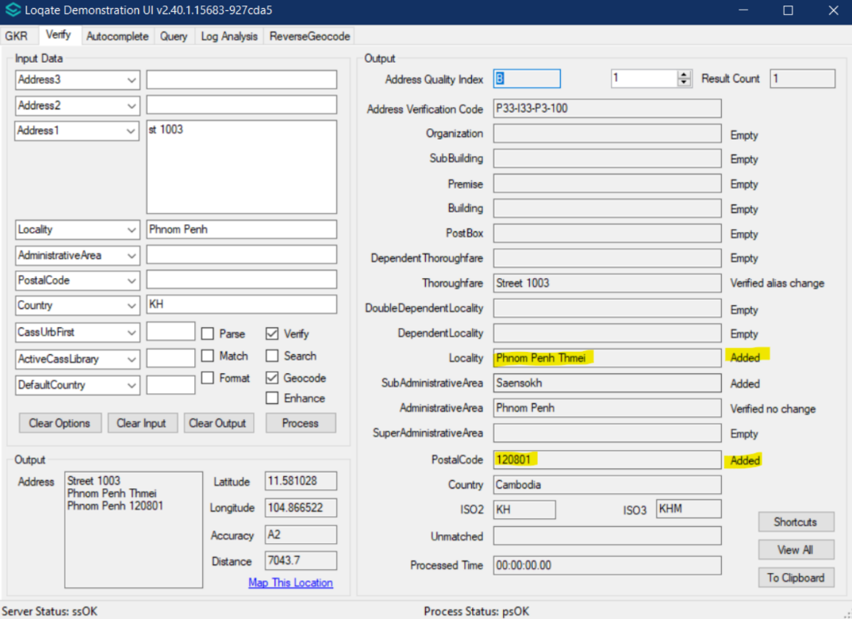

Case Number | Change Description | Category | Country | Example Address
CAS-09226-F9R3H2 | Thoroughfares and dependent locality are able to be verified correctly | Data | MYS | Address 1: 26 Lorong PJU 1/46E, Aman Suria Damansara PJ, 47301, Selangor, Malaysia

Before Image/Behaviour | After Image/Behaviour
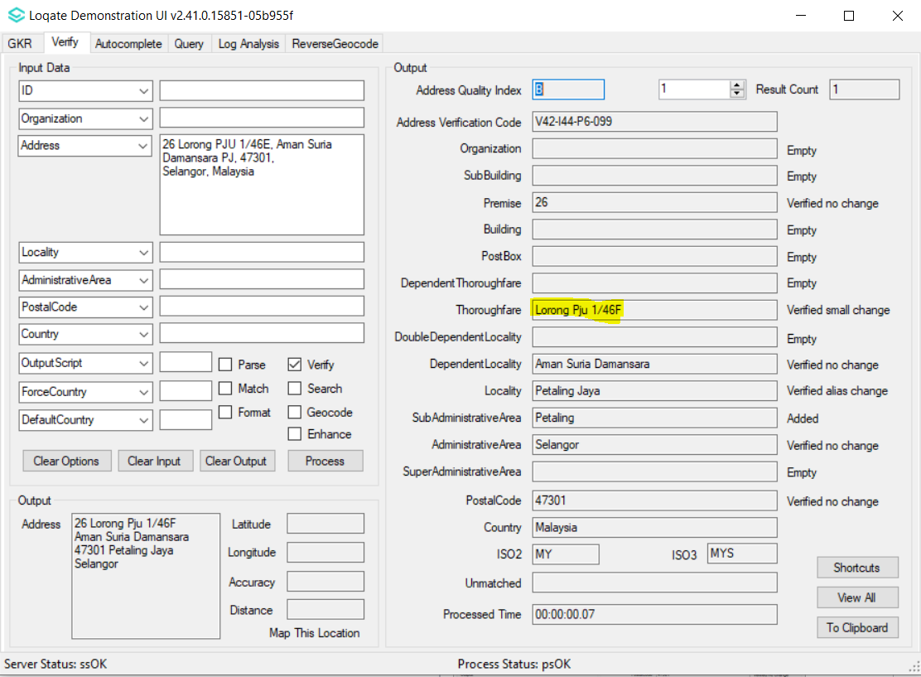 | 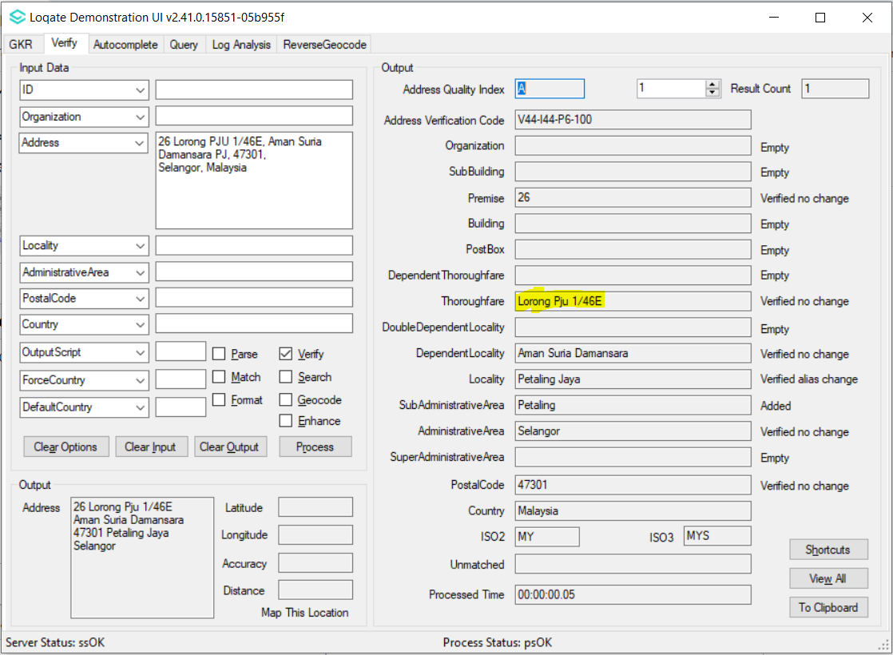

Case Number | Change Description | Category | Country | Example Address
CAS-39020-K9C3H8 | DependentLocality able to be verified correctly | Data | MYS | Address 1: No 15, Jalan Magnesium 7/106c, Putramas Shah Alam, 40000 Selangor, Malaysia

Before Image/Behaviour | After Image/Behaviour
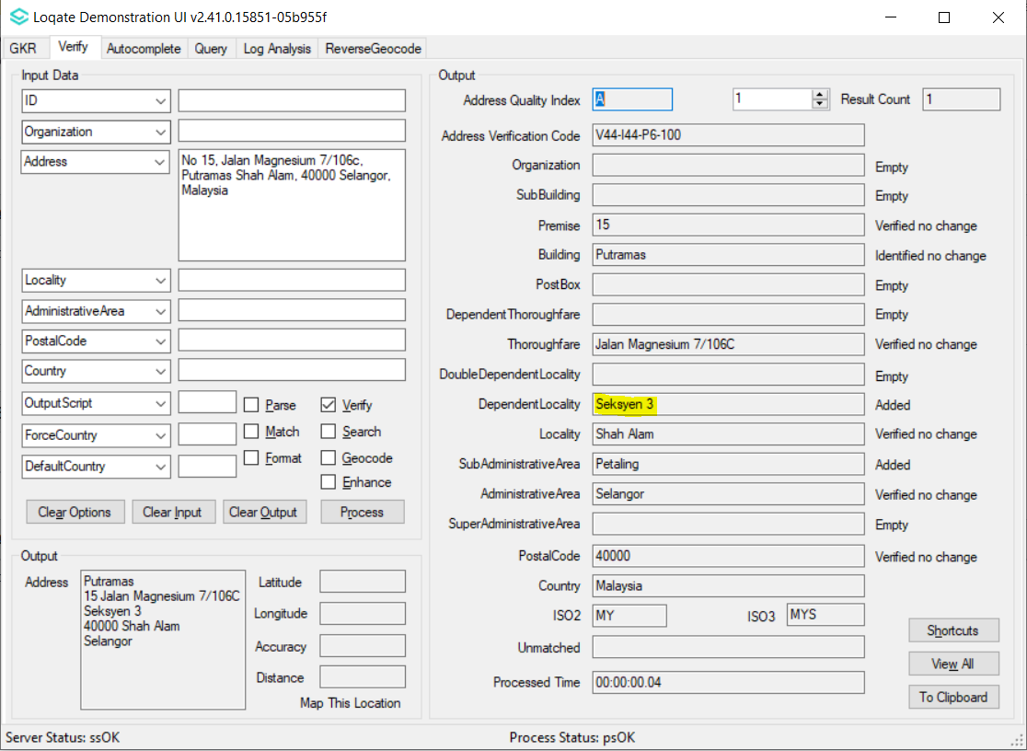 | 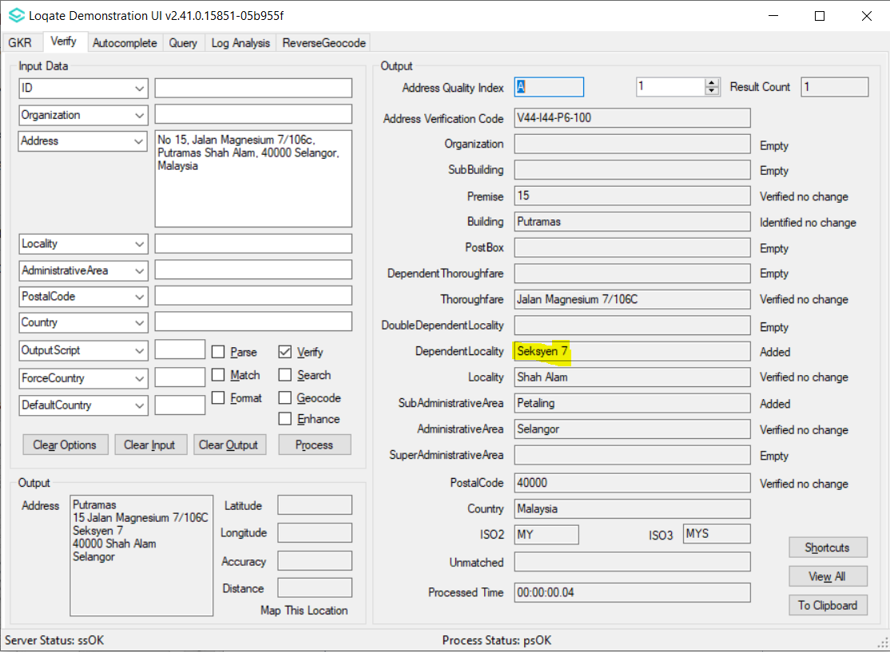

Case Number | Change Description | Category | Country | Example Address
CAS-39283-R1Q4X8 | Correct format of premise number in the output result | Data | SGP | Address 1: 624B Punggol Central, Punggol Spectra #18-316  Locality: Singapore  Postalcode:822624  Country:SGP

Before Image/Behaviour | After Image/Behaviour
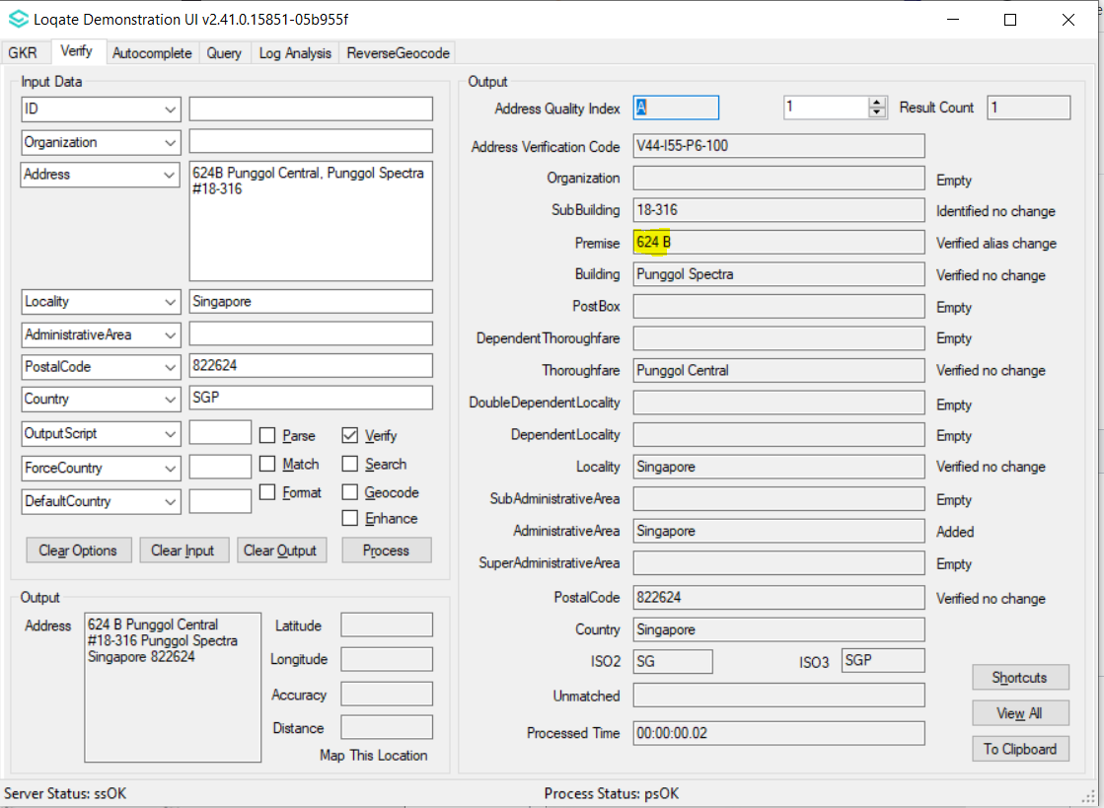 | 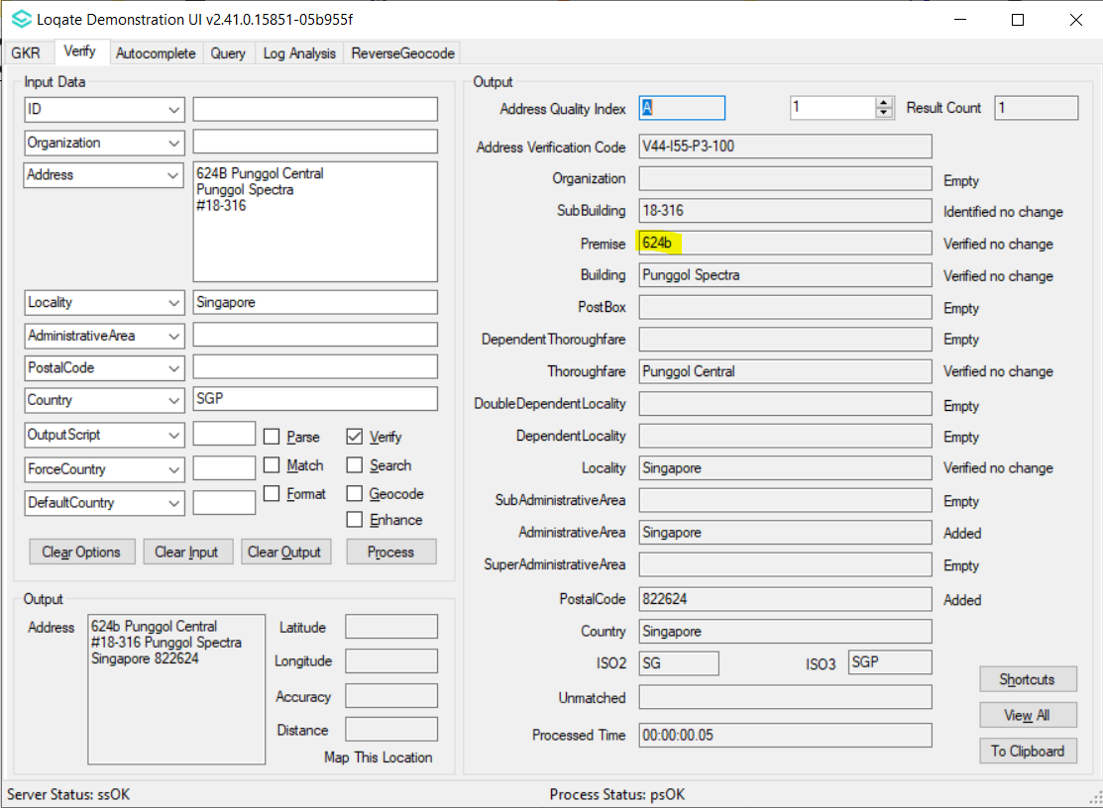

Case Number | Change Description | Category | Country | Example Address
CAS-60713-V7Z2G3 | Localities are realigned and restructured as dependentlocality so that the correct locality are displayed in output result. | Data | BRA | Address 1: Rua Treze De Maio  Abaeté Dos Mendes  Country: BRA  Address: Rua Principal  Açude Dos Pinheiros  Country: BRA

Before Image/Behaviour | After Image/Behaviour
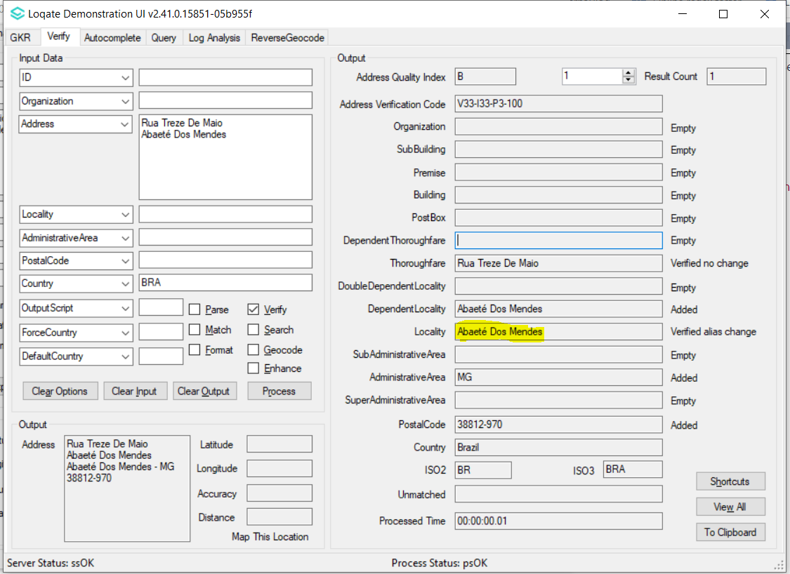 | 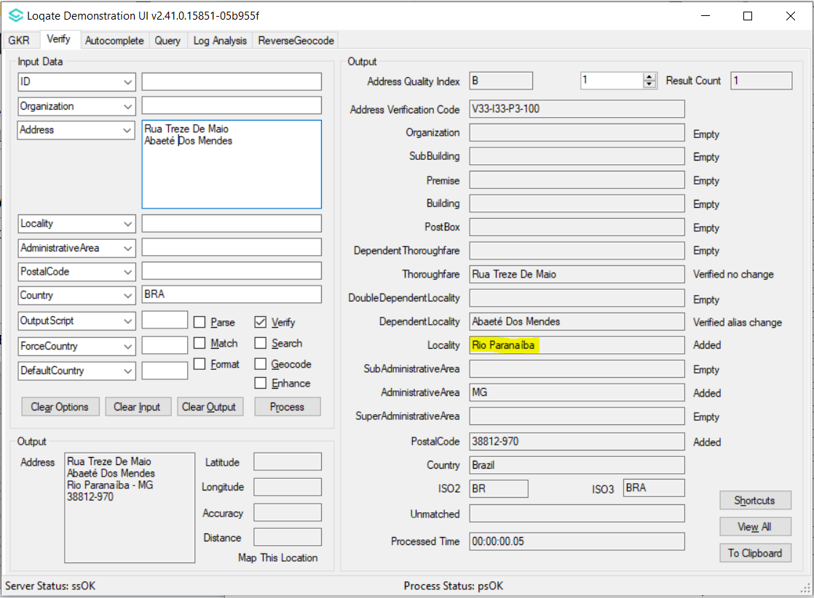
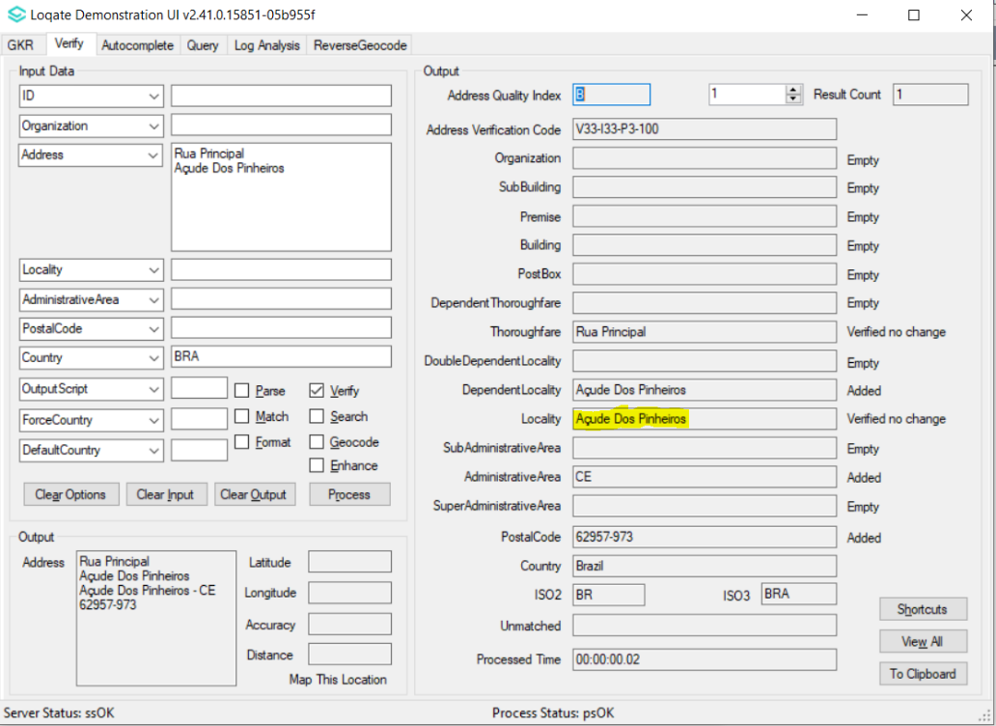 | 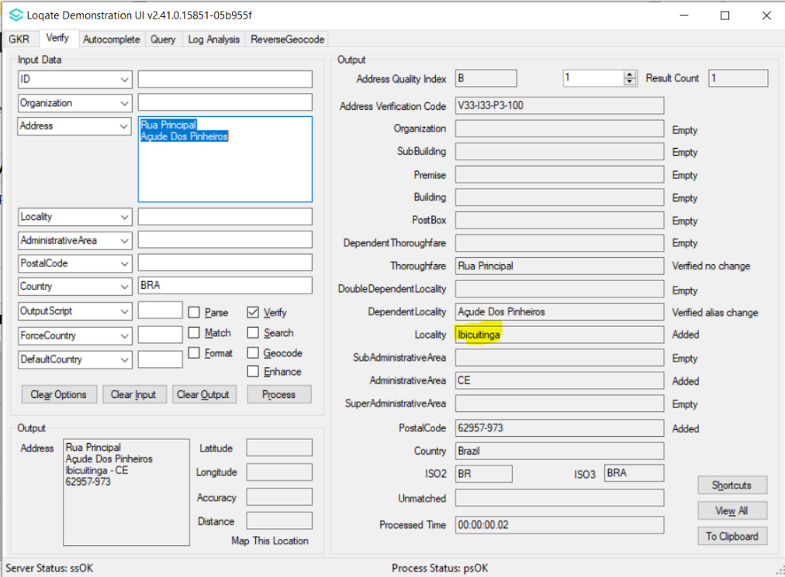

Case Number | Change Description | Category | Country | Example Address
CAS-03323-L0X0Y4 | Locality changed from Melawati to Ampang | Data | MYS | Address 1: 1 Jalan UP 3/5A, Ukay Perdana  Locality: Ampang  AdministrativeArea: Selangor  Postalcode:68000  Country: MYS

Before Image/Behaviour | After Image/Behaviour
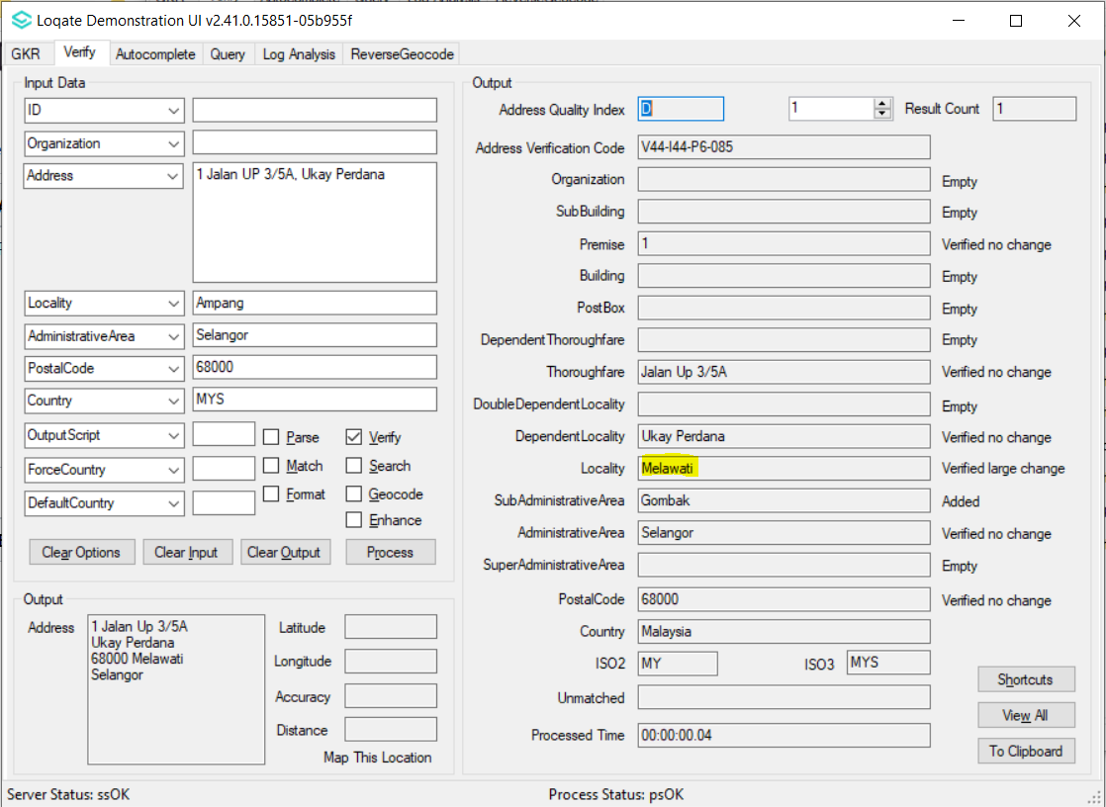 | 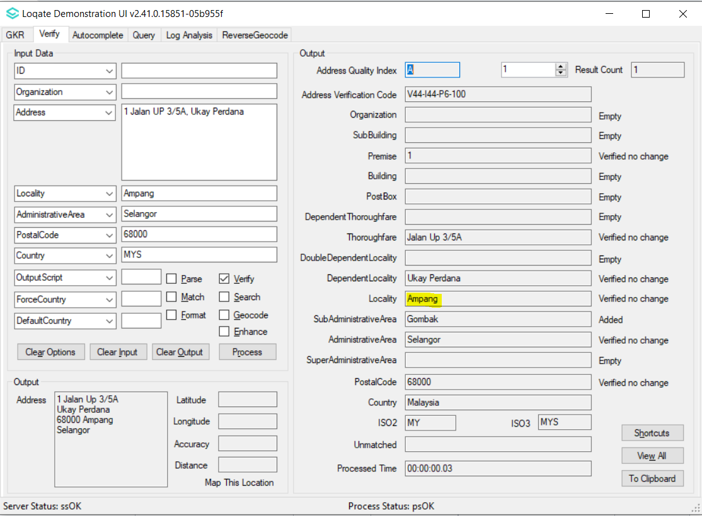

Case Number | Change Description | Category | Country | Example Address
CAS-41326-R3K6S7 | Changing hierarchy structure for Bratislava. | Data | CAN | -
Before Image/Behavior
Five instances of 'Bratislava' as Locality under five different 'Bratislava 1' to 'Bratislava 5' as SubAdministrativeArea.
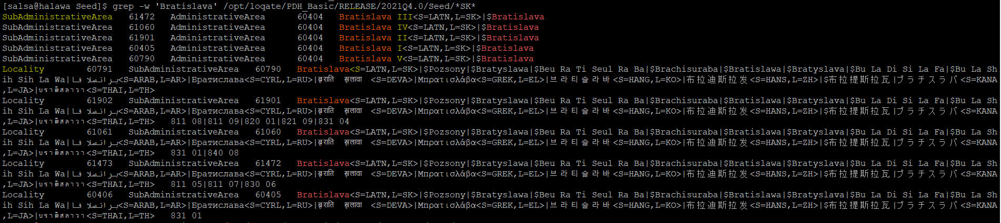
After Image/Behavior
'Bratislava' re-align to SubAdministrativeArea and 'Bratislava 1' to 'Bratislava 5' re-align to Locality.

Case Number | Change Description | Category | Country | Example Address
CAS-58610-G7N0R1 | Add subbuilding pattern in lexicon to parse '4g65k' to subbuilding. | Data | USA | Address 1:  4g65k 113 Coolidge Dr  Brick 08724  Country: USA
Before Image/Behaviour |  | After Image/Behaviour
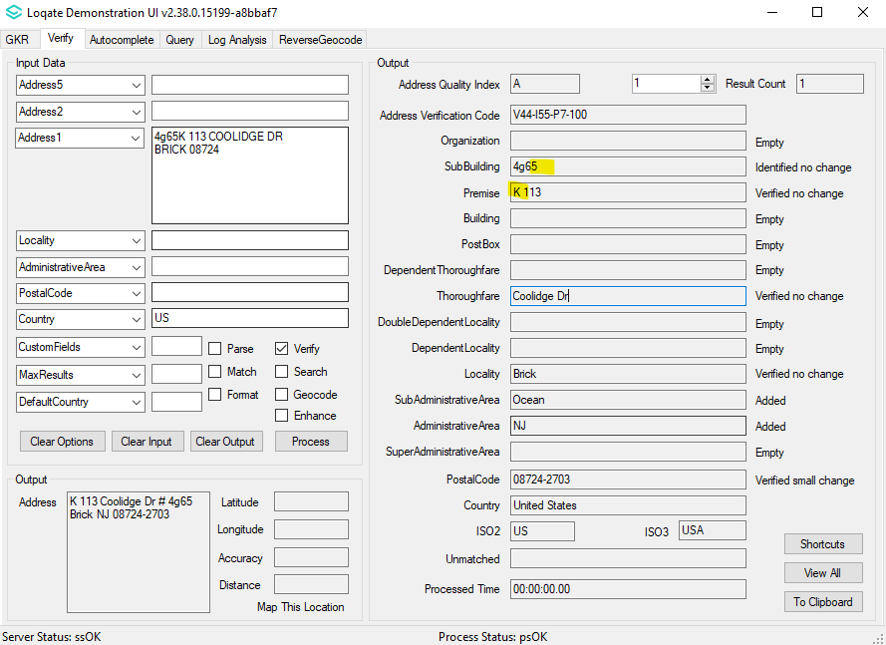 |  | 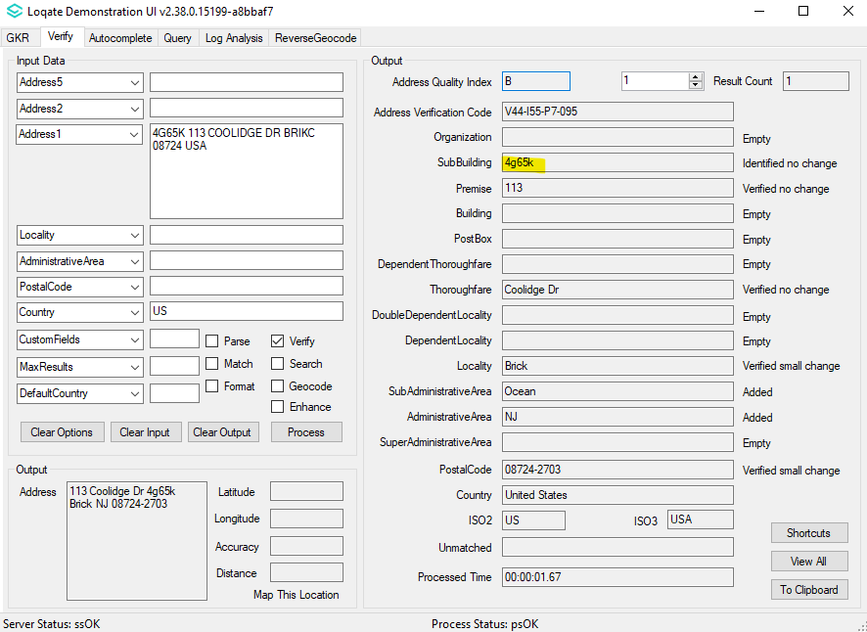

Case Number | Change Description | Category | Country | Example Address
CAS-10086-L4Z6M1 | Improve the accuracy of the geocodes by using Geo+ reference data source | Data | GBR | Address 1:  Macclesfield Road, Tower 1 Ability, Flat 13 London EC1V 8AE  Country: GB
Before Image/Behaviour |  |  | After Image/Behaviour
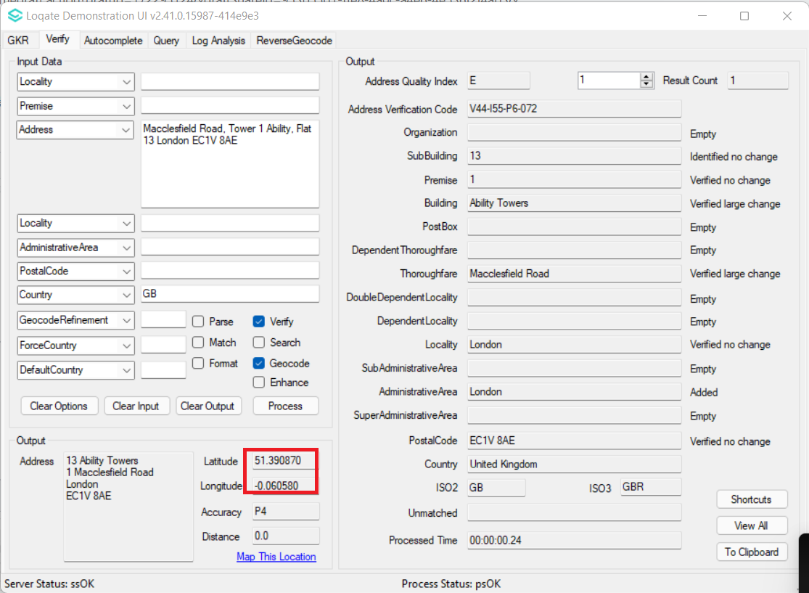 |  |  | 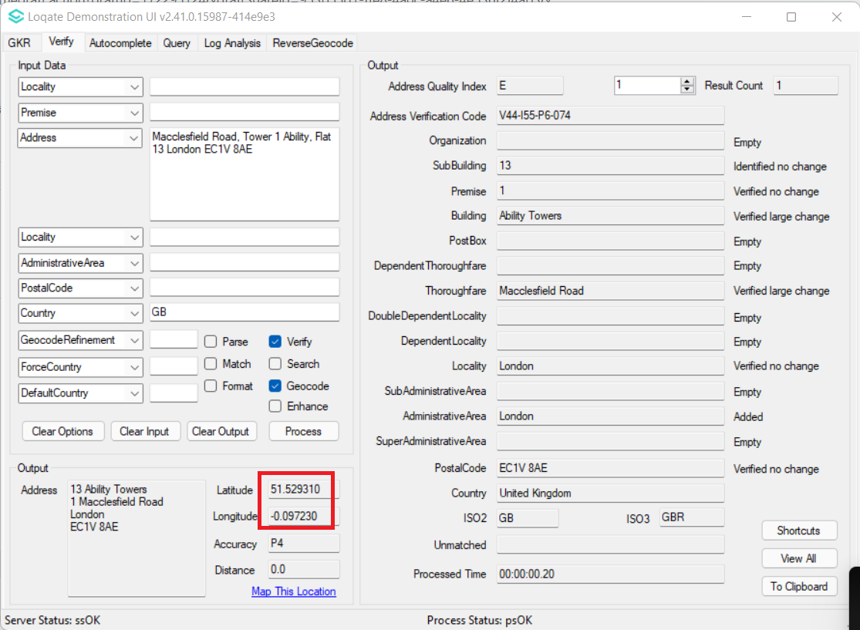

Case Number | Change Description | Category | Country | Example Address
CAS-09825-T9V8Z5 | Improve the accuracy of the geocodes by using Geo+ reference data source | Data | GBR | Address1: 447 Great West Road  Locality: Hounslow  Postal Code: TW5 0BY  Administrative Area: MIDDLESEX  Country: GB
Before Image/Behaviour |  | After Image/Behaviour
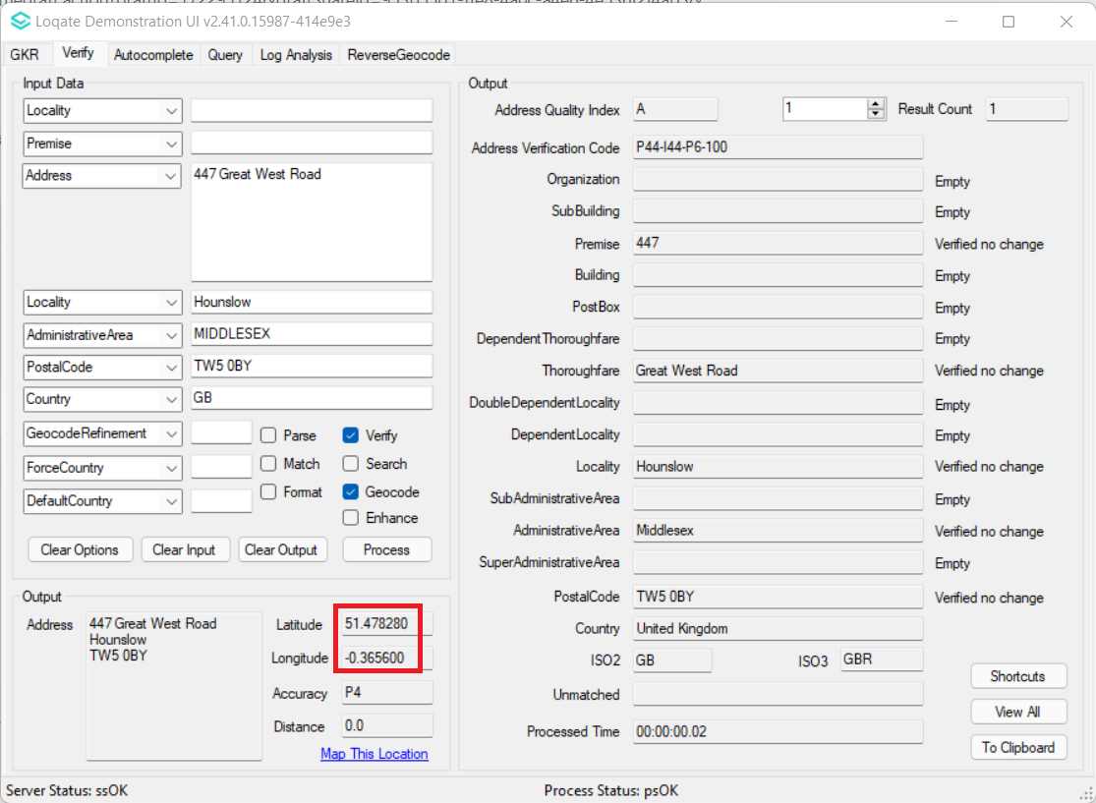 |  | 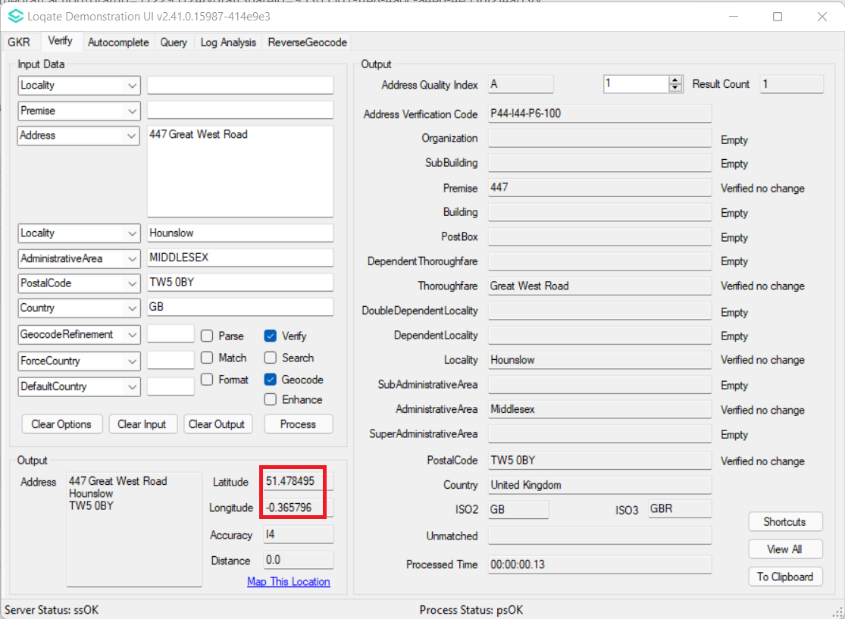

Case Number | Change Description | Category | Country | Example Address
- | Improve the parsing of the 10-digit Makani number by introducing the Makani Number field. | Data | UAE | Address1: Level #7, Garhoud Views, Office #12, Sheikh Rashid Road, Al Garhoud, Dubai, P.O.Box: 31514, Dubai  Country: United Arab Emirates
Before Image/Behaviour |  |  |  | After Image/Behaviour
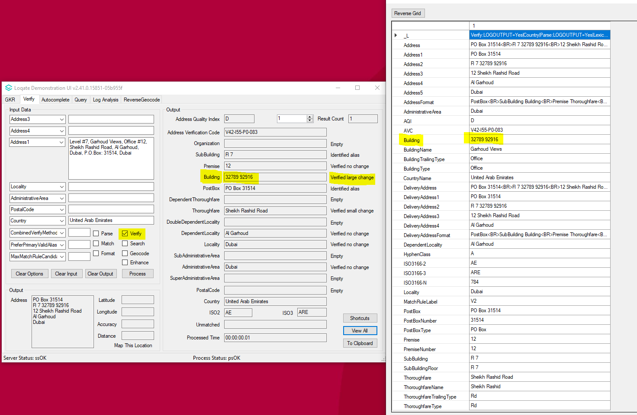 |  |  |  | 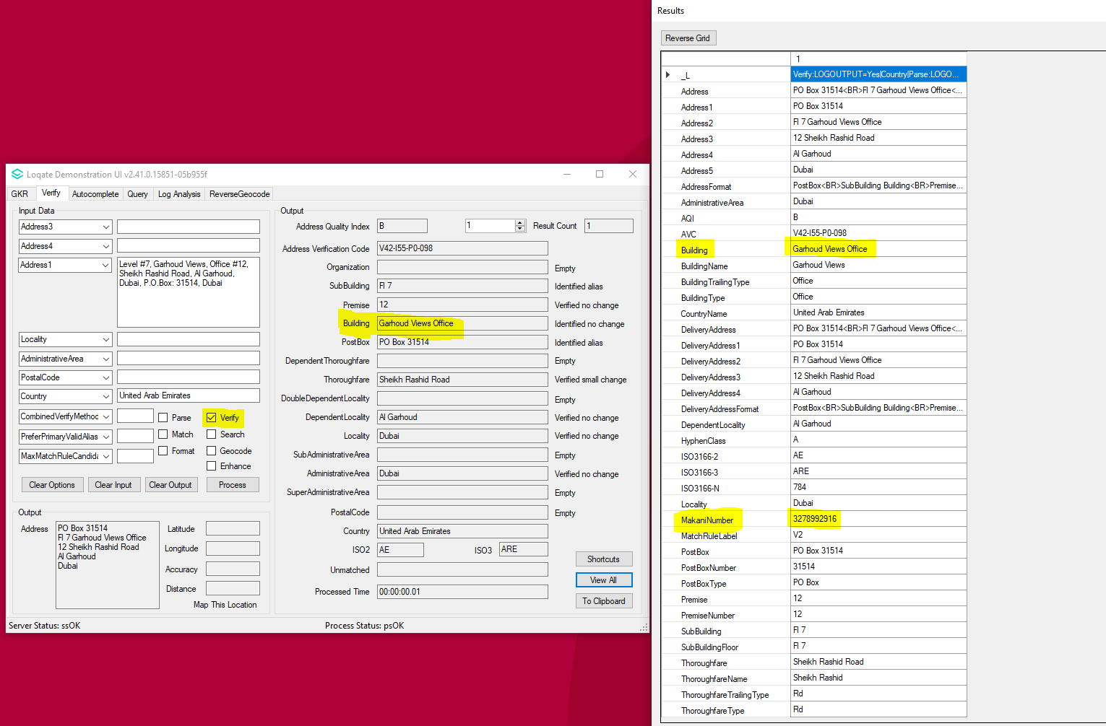

Case Number | Change Description | Category | Country | Example Address
CAS-38496-N7X6M4 | Improve the parsing and verification | Data | IRL | Case 1  Address1: Baggot Hall, 41 Baggot Street Lower, Dublin 2  Country : IRL  Case 2  Address1: 53 Broadford Cres  Locality: Dublin  AdministrativeArea: CO DUBLIN  PostalCode: 16  Country : IRL  Case 3  Address1: 79 Hampton St  Locality: Balbriggan  AdministrativeArea: CO DUBLIN  Country : IRL
Before Image/Behaviour - Case 1 |  |  |  | After Image/Behaviour – Case 1
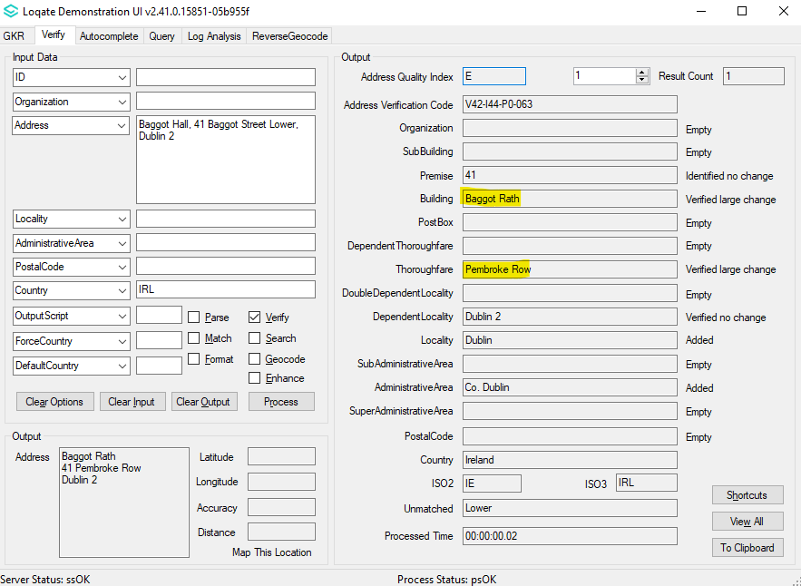 |  |  |  | 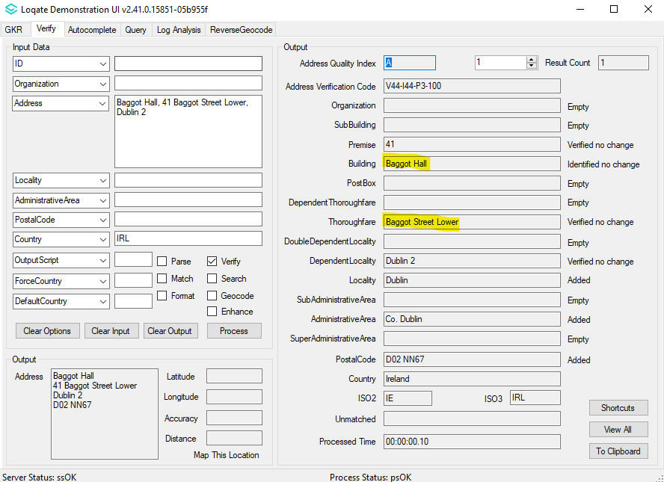
Case 2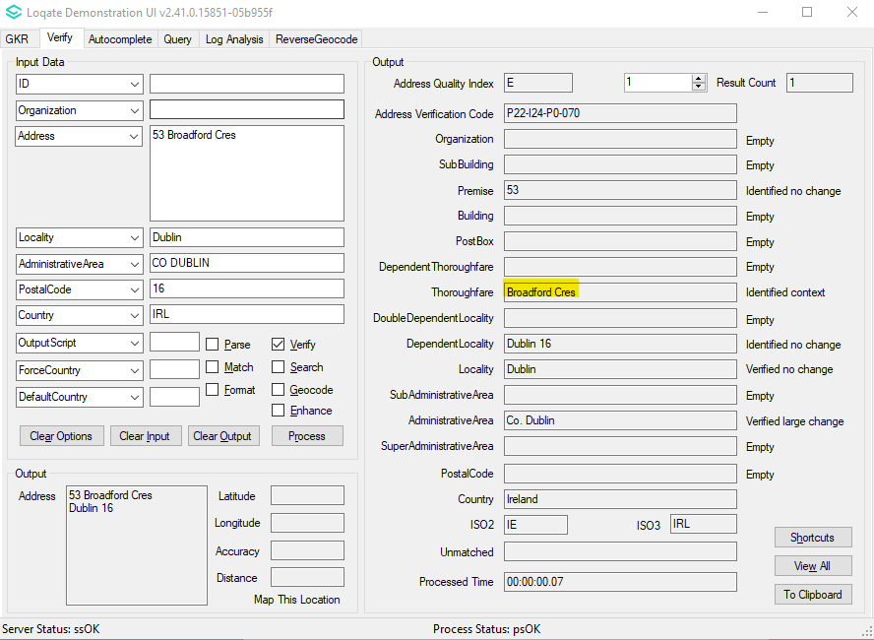 |  |  |  | Case 2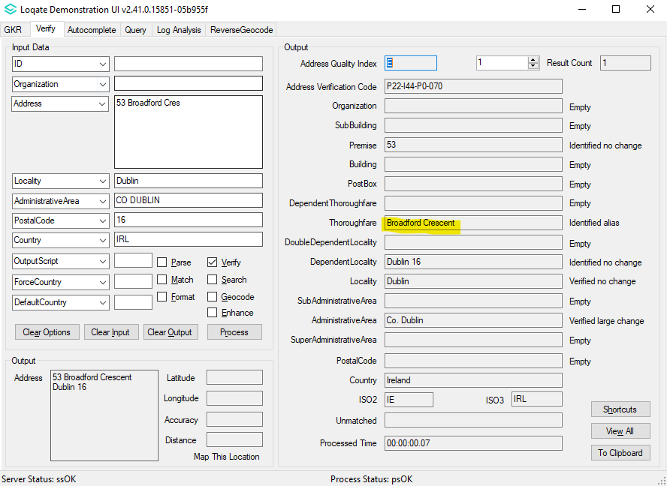
Case 3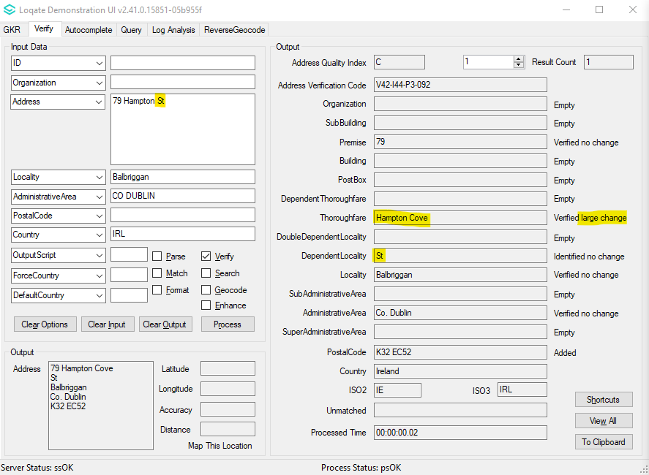 |  |  |  | Case 3 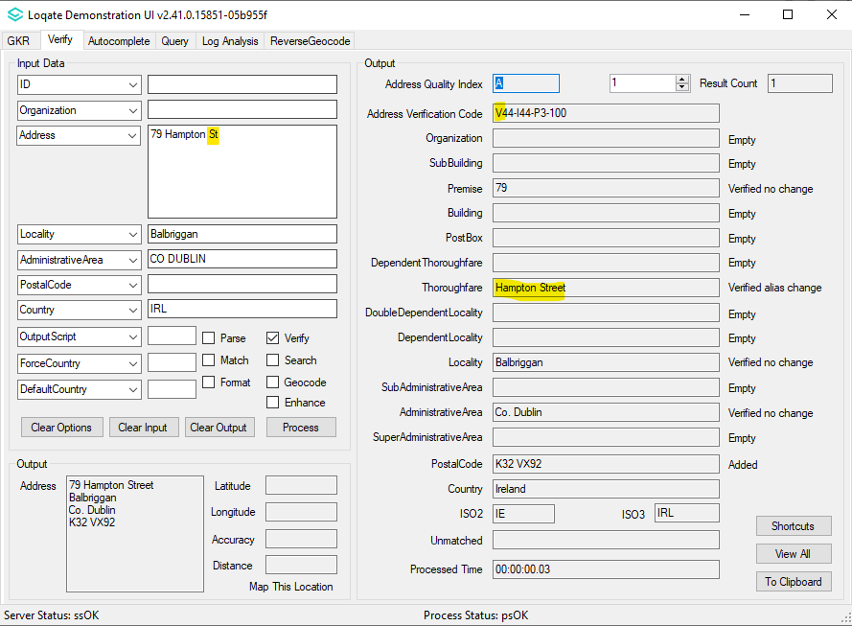

Case Number | Change Description | Category | Country | Example Address
CAS-38514-M9 | Woodland Heights can now be verified | Data | IRL | Address1: 29 Woodland Heights  Carrickbeg  Carrick-On-Suir Co. Tipperary  Country : IRL
Before Image/Behaviour |  | After Image/Behaviour
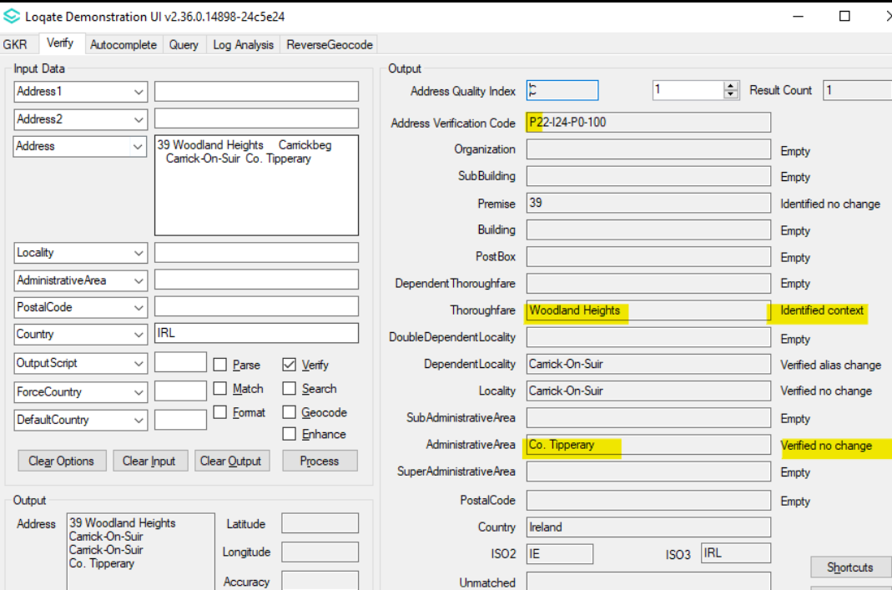 |  | 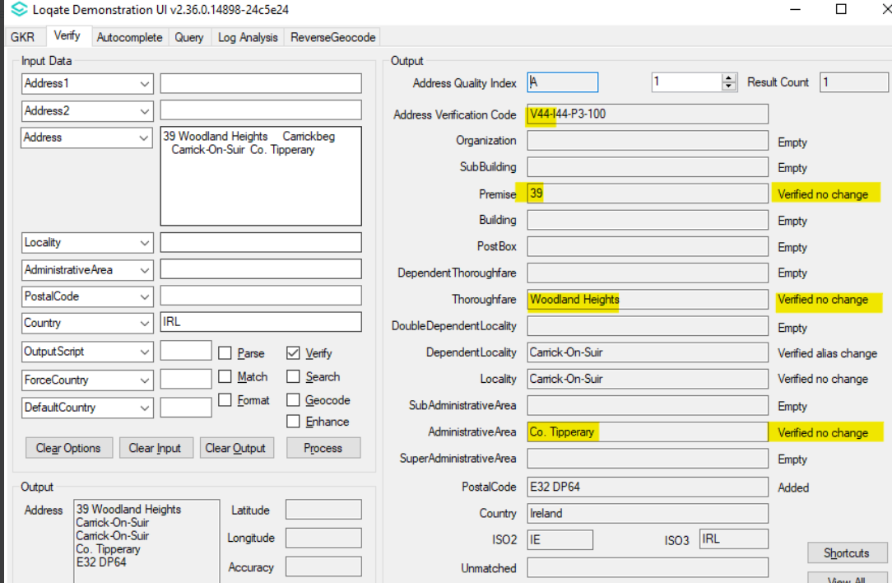

Case Number | Change Description | Category | Country | Example Address
CAS-02161-Z3C3R4 | Removal of Federated States of Micronesia (FM), Marshall Islands (MH) and Palau (PW) from United States Dataset | Data | USA | -
Before Image/Behaviour
The entries of FM,MH,PW in US seed dataset.

AdministrativeArea 138571 Federated States of Micronesia<S=LATN,L=EN>|@FM
AdministrativeArea 138582 Marshall Islands<S=LATN,L=EN>|@MH
AdministrativeArea 138568 Palau<S=LATN,L=EN>|@PW

After Image/Behaviour
The entries of FM,MH,PW in FM,MH,PW no longer in US seed dataset.

Case Number | Change Description | Category | Country | Example Address
CAS-51092-W1Q3N1 | Fix incorrect parsing & verification of Canada address | Data | CAN | Address: 259 ST. PAUL ST W  Locality: ST CATHARINES  AdministrativeArea: ON  PostalCode: L25 2E4  Country : Canada

Before Image/Behavior | After Image/Behavior
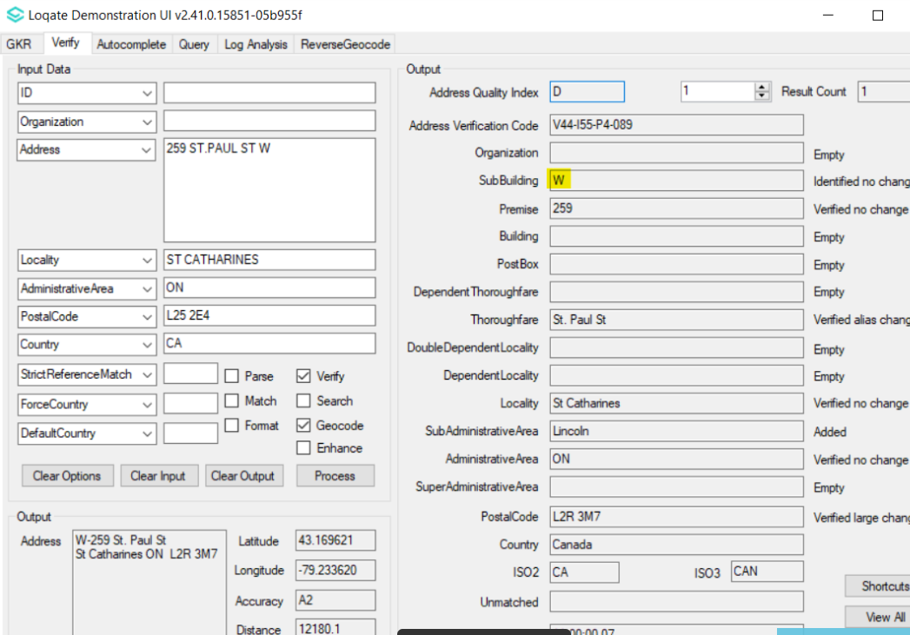 | 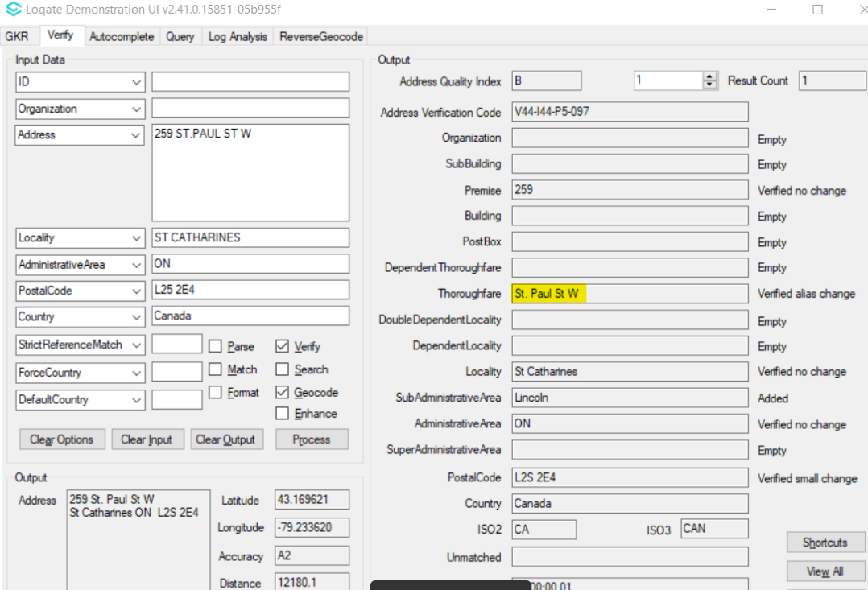

Case Number | Change Description | Category | Country | Example Address
CAS-41322-T6W6Z6 | Removal of incorrect postcode in Luxembourg seed dataset | Data | LUX | -

Before Image/Behaviour
Locality 2724 SubAdministrativeArea 2681 Dippach-Gare<S=LATN,L=FR> 4970|4971|4974|4975
After Image/Behaviour
Locality 2724 SubAdministrativeArea 2681 Dippach-Gare<S=LATN,L=FR> 4970|4971|4975

Case Number | Change Description | Category | Country | Example Address
CAS-52506-G5C0S8 | Postbox now follow strict match rule regardless of input casing. | API | All | Address: GPO Box 544d Melbourne Vic 3001  Country: AU
Before Image/Behavior |  | After Image/Behavior
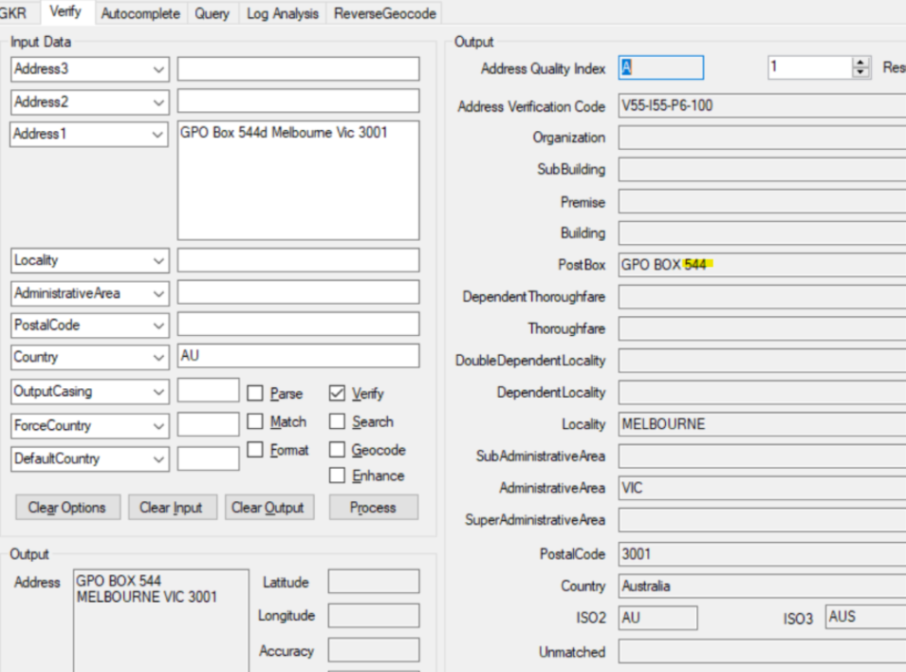  GPO Box in lowercase |  | 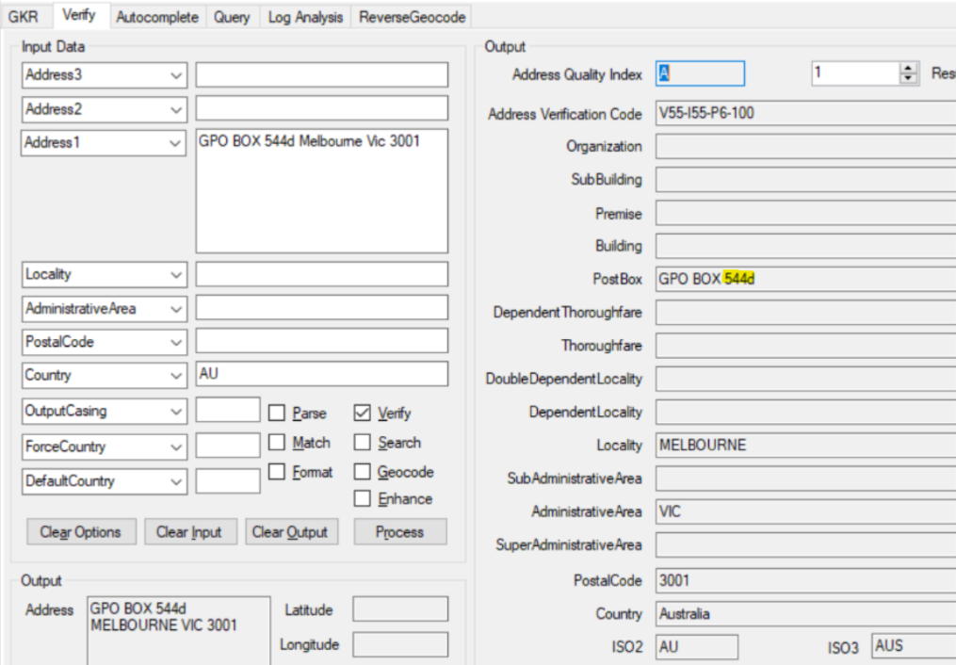  GPO Box in lowercase
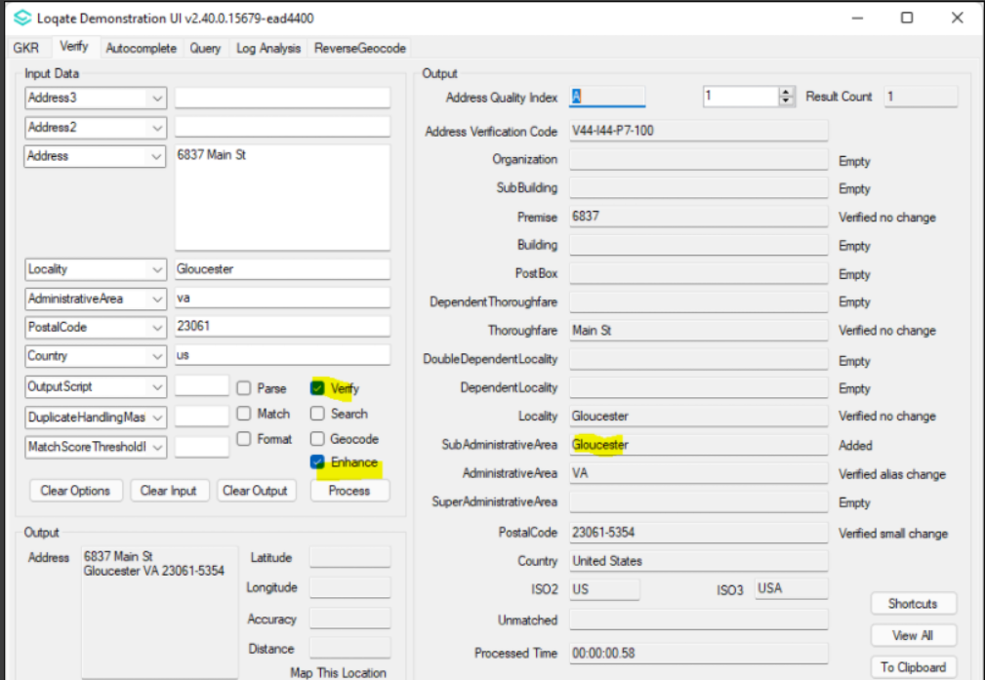  GPO BOX in uppercase |  | 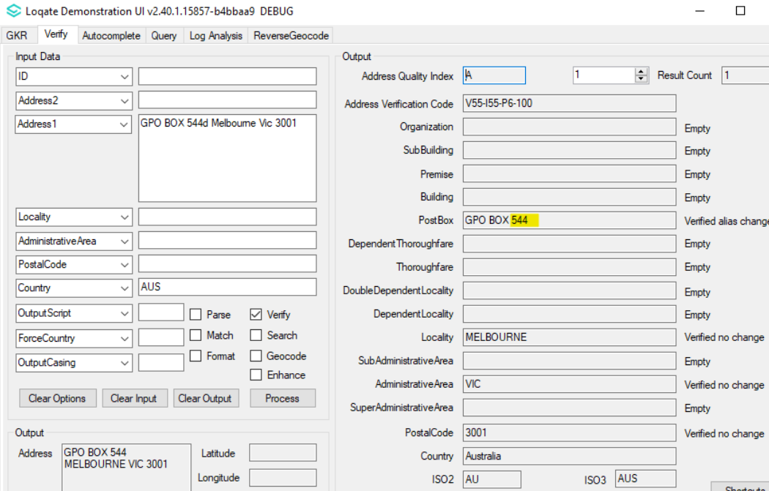  GPO BOX in uppercase

