Loqate, A GBG Solution
Release Notes – Verify API
2021Q4.1 Minor Release

Case Resolutions
Please visit https://support.loqate.com/release-information/2021q4-1-resolved-cases/ for a list of cases resolved in this release. If you would like more details on any of the solved cases listed, please contact LoqateSupport@gbgplc.com for further information.

Local API Notices
This is to inform our customers that in this 2021Q4.1 release we have included performance improvements over the recent current releases. Please upgrade your API as soon as reasonable to benefit from the latest performance improvements.

Local API Improvements

Verify Improvements

In the 2021Q4.1 release there is a fix for a format issue on Australian addresses containing a PO BOX

2021Q4.0 - Lowercase (Before Change) | 2021Q4.0 - Uppercase (Before Change)
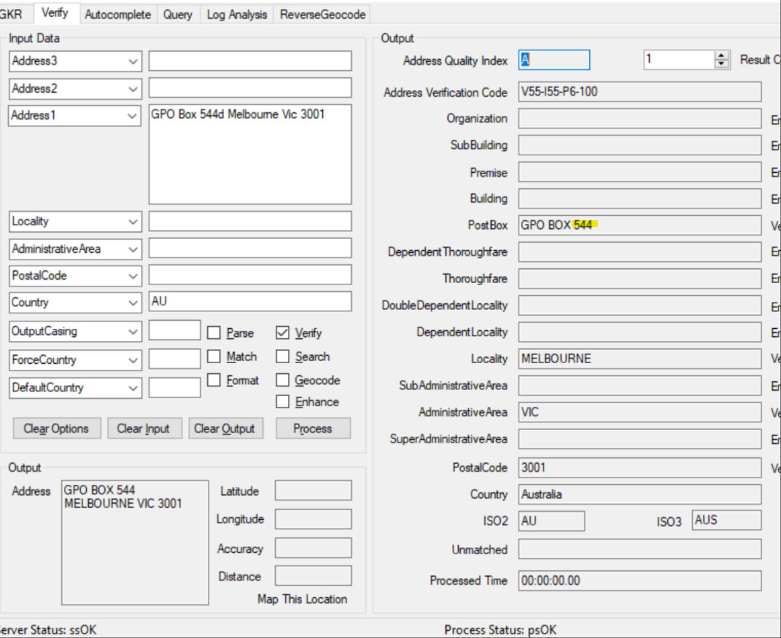  When PO Box is in lower case, result is GPO BOX 544. | 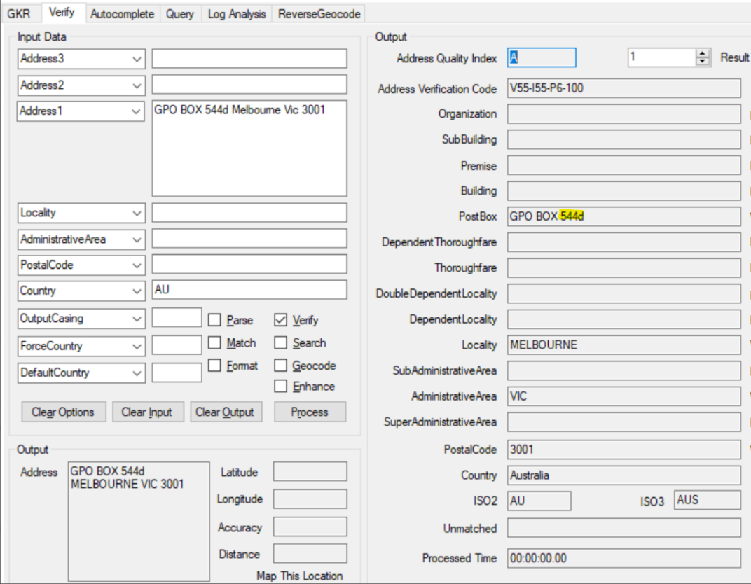  When PO BOX is in upper case, result is GPO BOX 544d.

2021Q4.0 - Lowercase (Before Change) | 2021Q4.0 - Uppercase (Before Change)
When PO Box is in lower case, result is GPO BOX 544.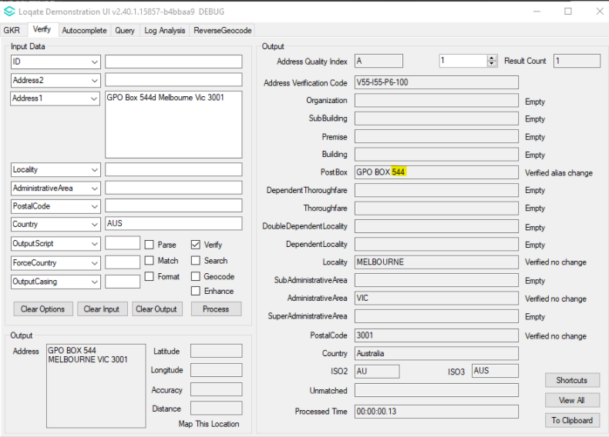 | When PO BOX is in upper case, result is GPO BOX 544.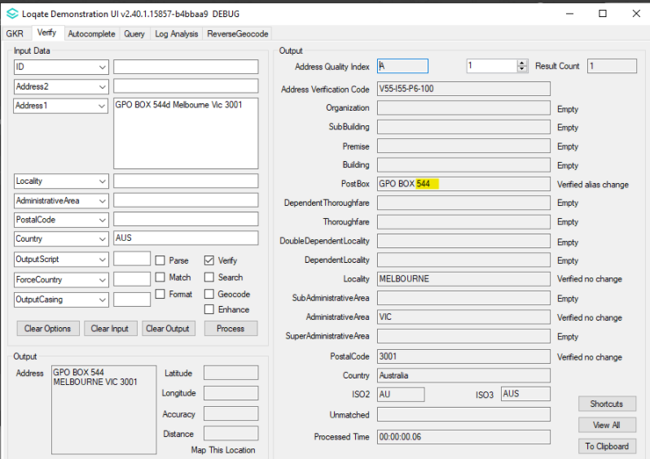

Installation Instructions

Please remember to update both the program files and the reference data and please install these to a new fresh folder location. The improvements are tied to the data in the Global Knowledge Repository and the Local API. When updating the data, it is recommended to use a new data folder each time in order to ensure the latest dataset is installed properly.

If you need any assistance with the upgrade of the Local API or the data update process, please contact GBG Loqate Support.

The setup wizard for the Local API can be obtained from our SFTP server. Please contact your account manager to retrieve the SFTP information. If you do not know who your account manager is, please contact the support team at LoqateSupport@gbgplc.com.

