Loqate, A GBG Solution

Release 2021Q4.0
Advance notice on release 2021 Q4.1 due to release on 1st December 2021
This is to inform our customers that the Q4.1 release will include some performance improvements over the current releases. We wanted to provide advance notice so you can plan your upgrades effectively.

Resolved Cases
Case Number | Change Description | Category | Country | Example Address
CAS-52104-R3M1X8 | Fix wrong/missing counties | Data | USA | Case1  Address1: 3585 Buck Mountian Rd  Locality: Roanoke  AdministrativeArea: VA  PostalCode: 24018  Country: United States of America  Case2  Address1: 6837 Main St  Locality: Gloucester  AdministrativeArea: VA  PostalCode: 23061  Country: United States of America

Before Image/Behaviour
Case1: Incorrect county returned
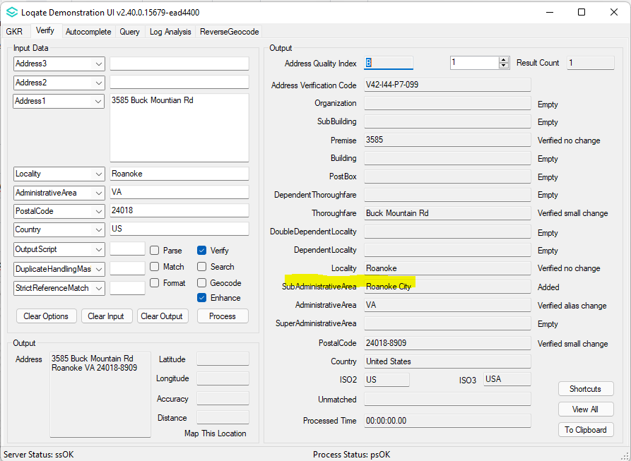
Case2: Missing county
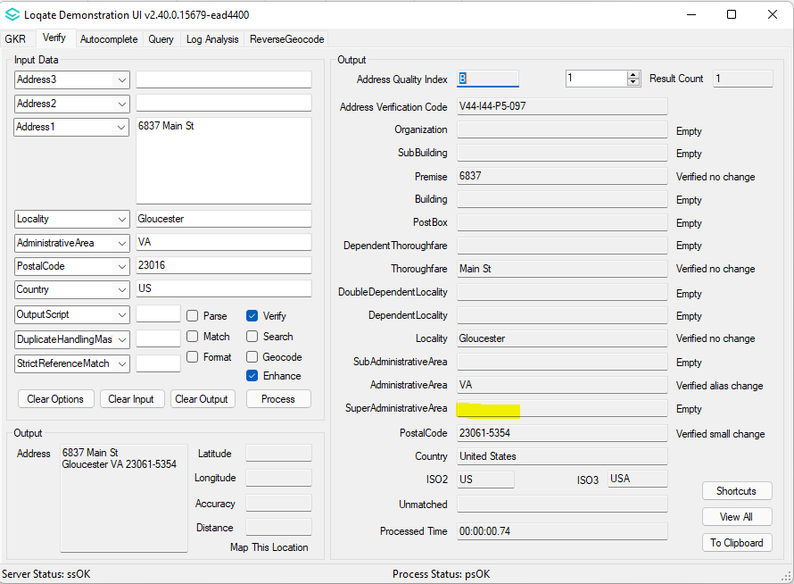

After Image/Behaviour Case1: Correct county returned
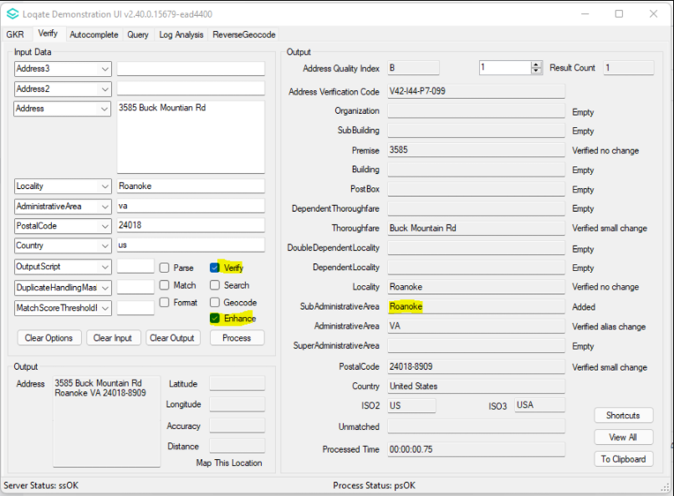
Case2: Correct county returned
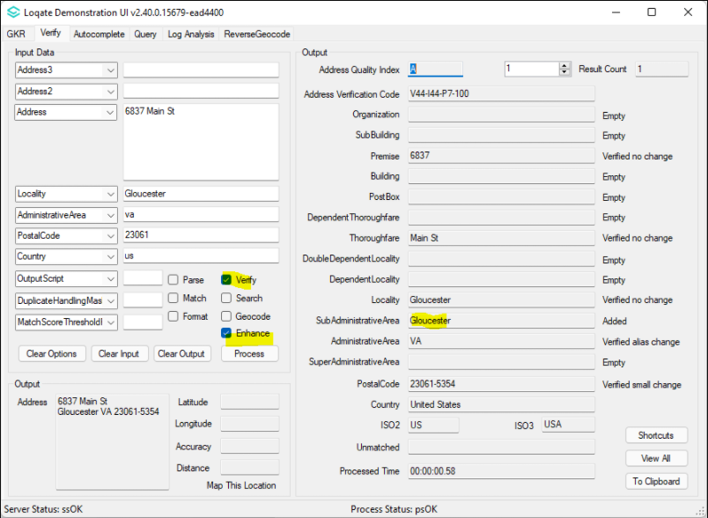

Case Number | Change Description | Category | Country | Example Address
CAS-50985-Y7Z6T7 | Changing Geographical Structure, following Australia Post standard. | Data | AUS | -

Before Image/Behaviour
Haymarket (and all other equivalent suburbs) located in DependentLocality
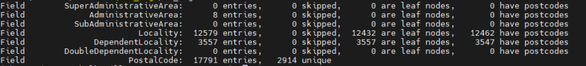
After Image/Behaviour
Haymarket (and all other equivalent suburbs) re-located to Locality
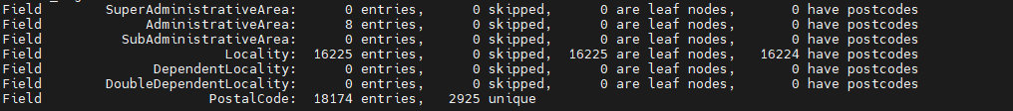

Case Number | Change Description | Category | Country | Example Address
CAS-53897-J9P1R4 | Incorrect Building no longer added | Data | AUS | 164 ThompsonAve, Cowes VIC 3922 AU
Before Image/Behaviour
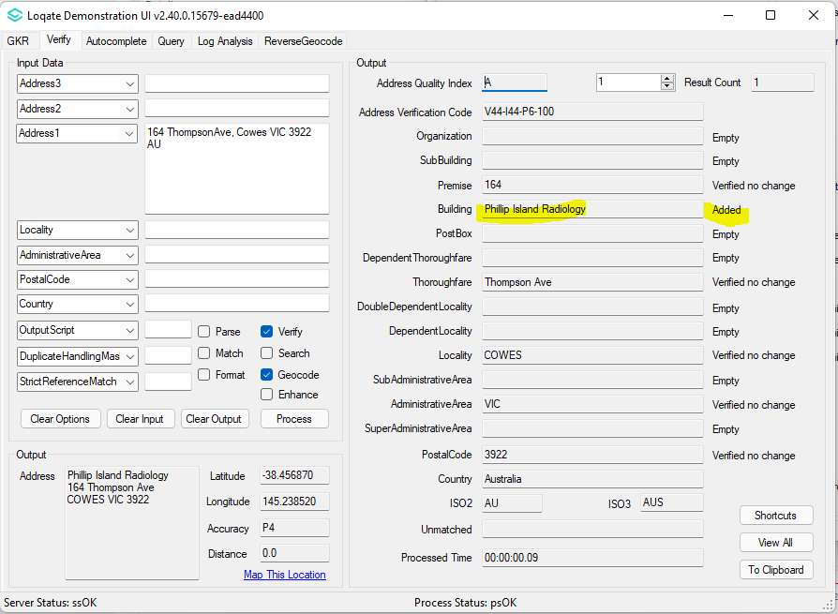

After Image/Behaviour
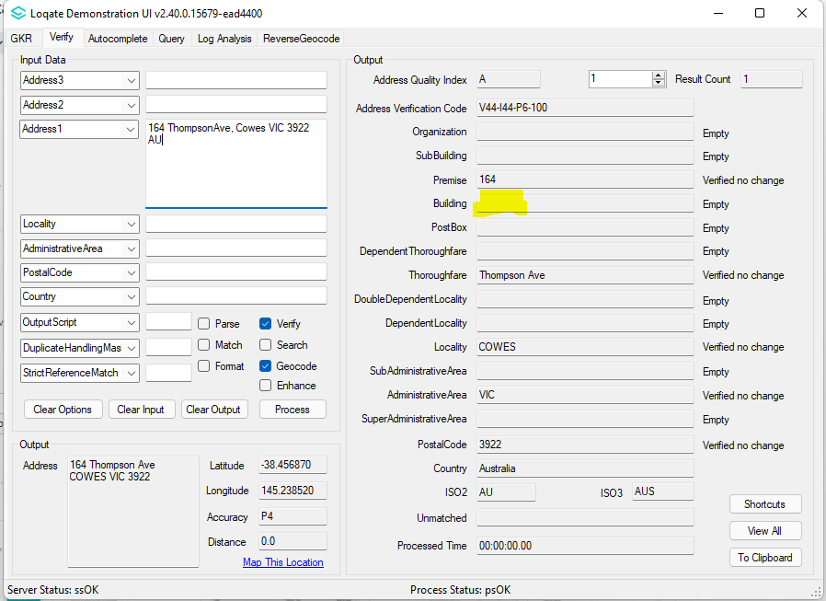

Case Number | Change Description | Category | Country | Example Address
CAS-11873-K8N0B8 | Validate to recognize non-hyphenated premise number as Hyphen B form | API | GBR | Address1: PEARCE MOTORS  Address2: 36 44 WEST ROAD  Locality: NEWCASTLE UPON TYNE  Administrative Area: TYNE AND WEAR  PostalCode: NE4 9PY  Country: GBR

Before Image/Behaviour
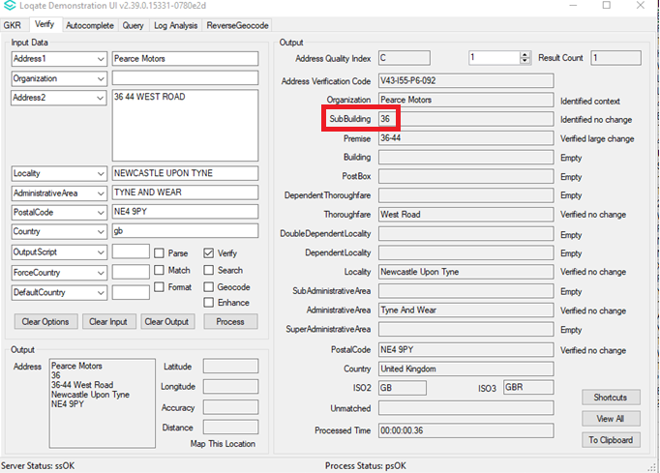

After Image/Behaviour
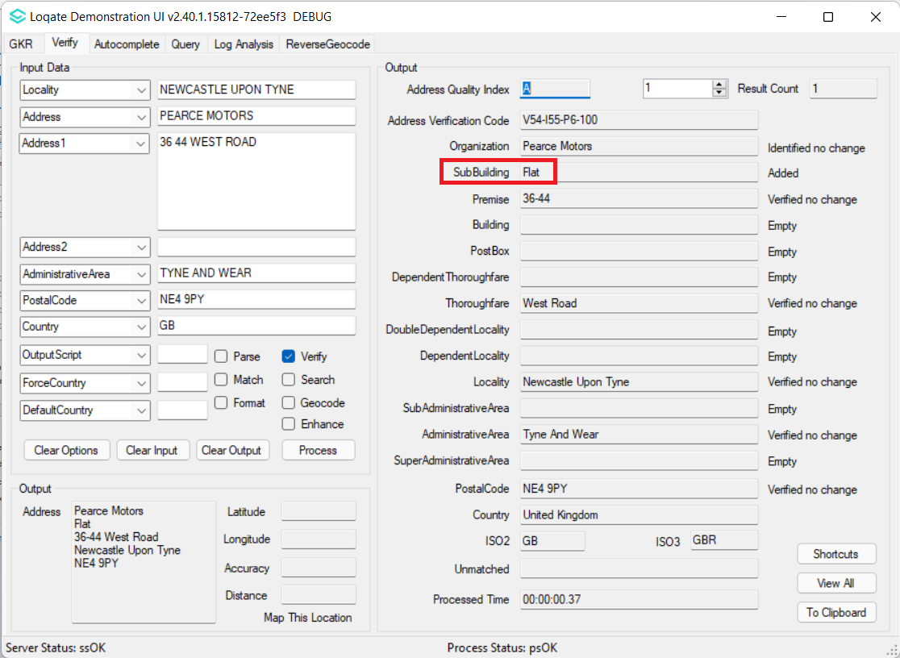

Case Number | Change Description | Category | Country | Example Address
CAS-52103-X1S0K8 | Delete empty address fields instead of assigning empty data | API | All | 19 Rue Des Tourterelles  67205 OBERHAUSBERGEN  FR
Before Image/Behaviour
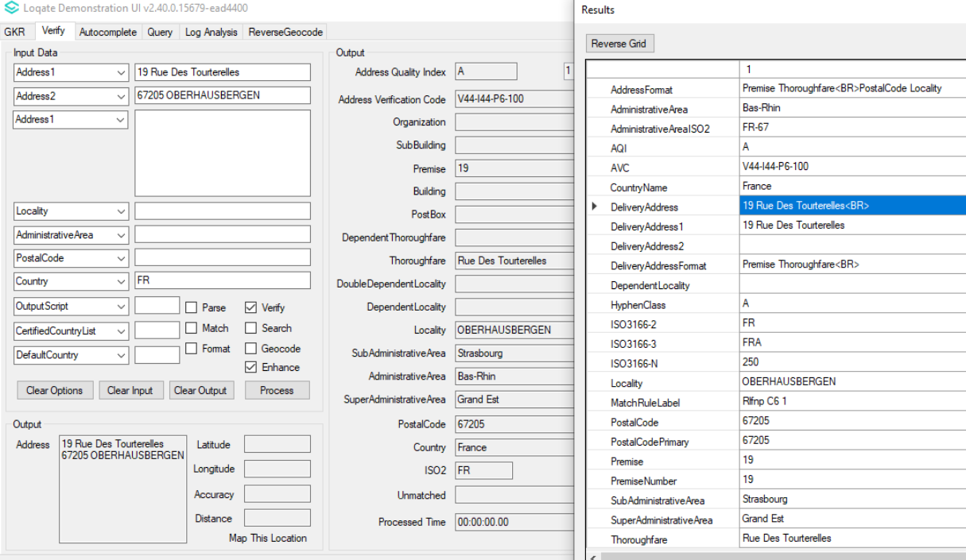

After Image/Behavior
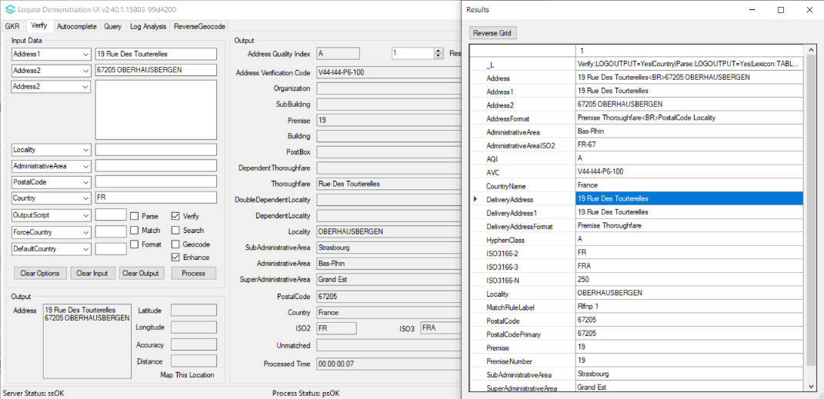

Case Number | Change Description | Category | Country | Example Address
CAS-03556-N1C3T4 | Ensure native characters are transliterated to Latin character when OutputScript=Latn  Users will need to update both 2021Q4.0 API and 2021Q4.0 Data in order to allow all reported cases in this ticket to produce expected results | API | KOR | 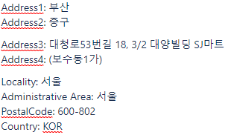

Before Image/Behavior
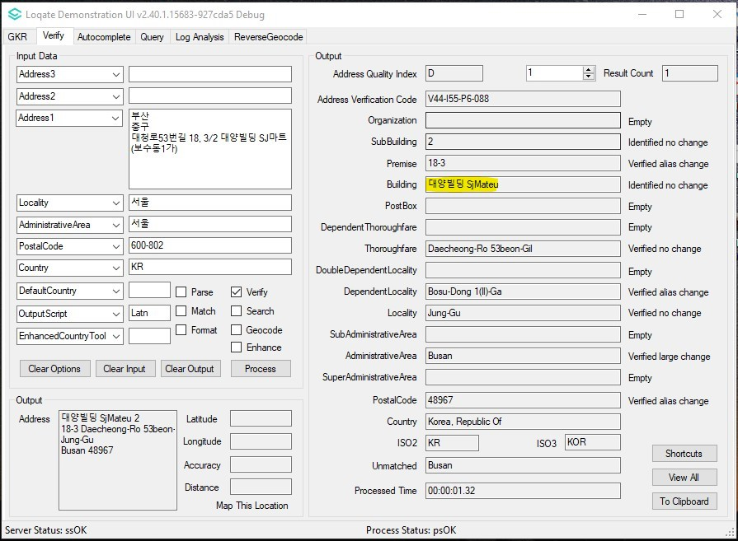
After Image/Behavior
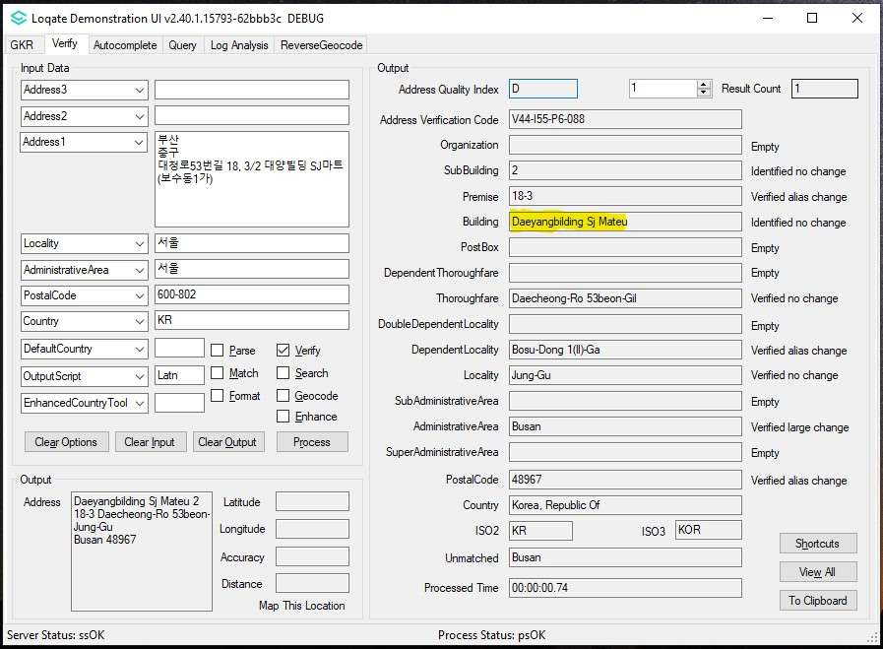

Case Number | Change Description | Category | Country | Example Address
CAS-11706-B1F3J0 | Ensure native characters are transliterated to Latin character when OutputScript=Latn | API | CHN | 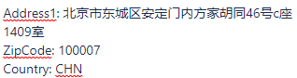
Before Image/Behavior
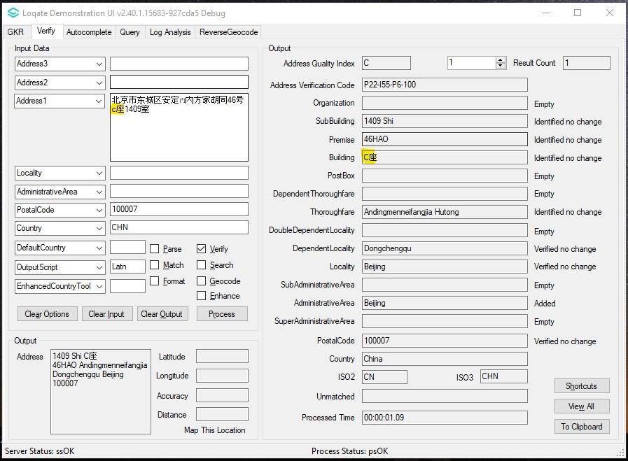

After Image/Behaviour
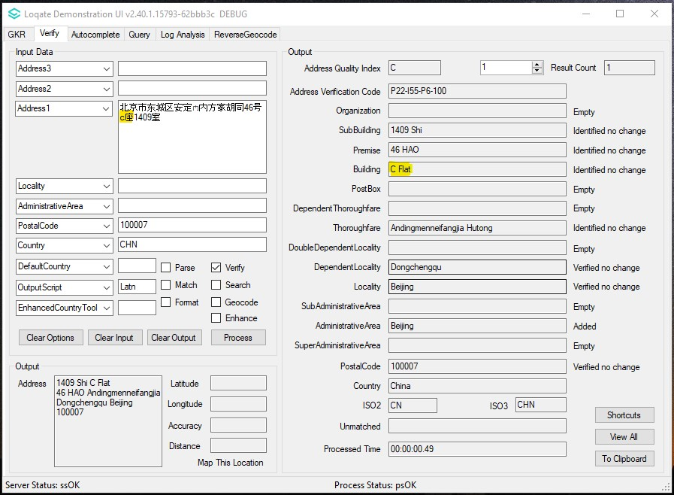

Case Number | Change Description | Category | Country | Example Address
CAS-46551-B4P8B5 | Turn official French Administrative Area alias as valid and add French name (alias) with correct language tags. | Data | CAN | -
Before Image/Behaviour
Example 1: No valid French alias for Nova Scotia.
Example 2: French alias with ENG language tag for Notre-Dame-des-Neiges.

After Image/Behaviour
Example 1: Have valid French alias for Nova Scotia.
Example 2: French alias with correct FRE language tag for Notre-Dame-des-Neiges.

Case Number | Change Description | Category | Country | Example Address
CAS-53810-M2P0S6  CAS-53815-N8Y6X3 | Merge CanadaPost address data with HERE Lat/Long data. Use this merged data as the only source in RD. | Data | CAN | Case1  Address1: 18 Dunsford Crescent  Locality: St Marys  AdminArea: ON  PostalCode: N4X1C6  Country: CA  Case2  Address1: 15 Water walk Dr Unit 511  Locality: Unionville  AdministrativeArea: ON  PostalCode: L6G 0G2  Country: CA

Before Image/Behaviour - Case1: GeoAccuracy verification level is higher than AVC.
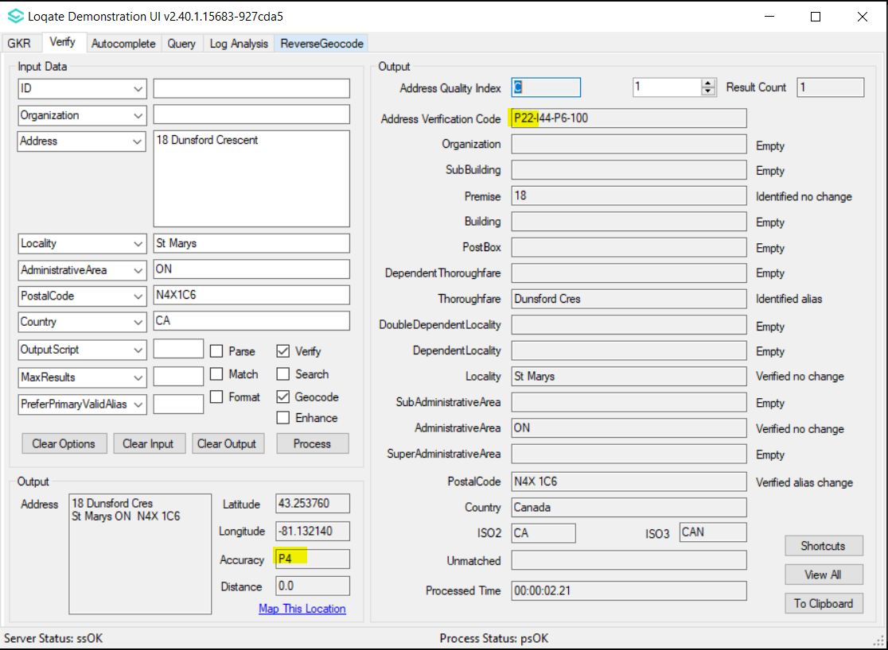
Case 2: AVC verification level is higher than GeoAccuracy.
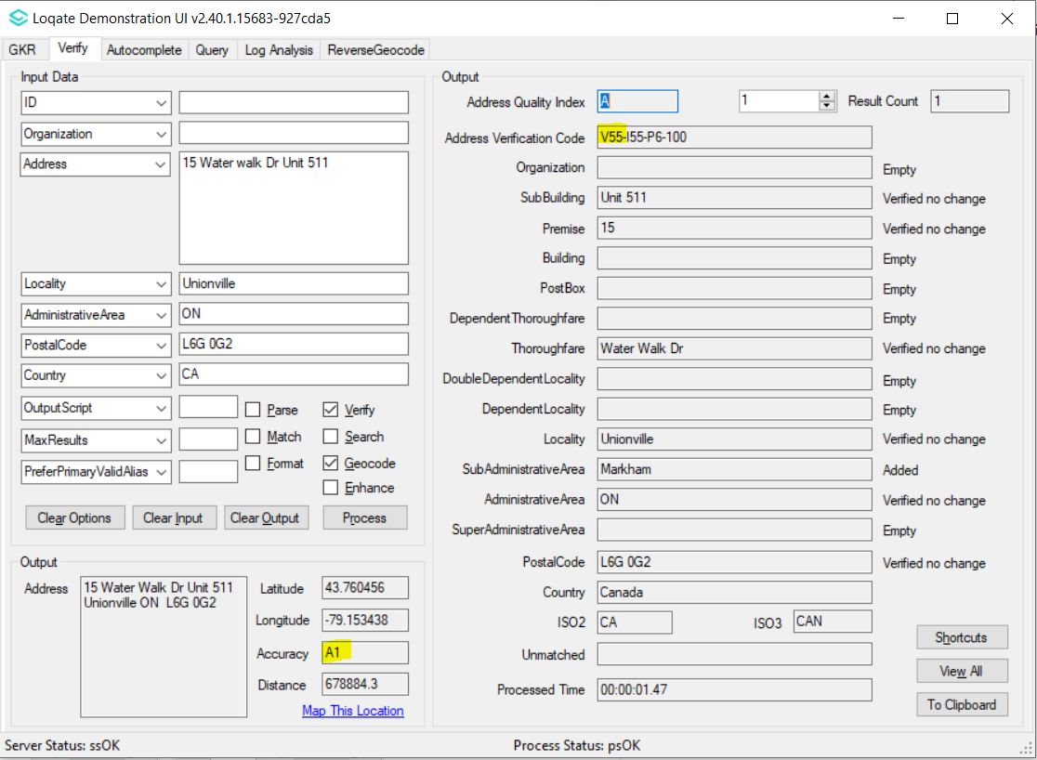
After Image/Behaviour - Case 1: GeoAccuracy verification level now match the AVC level.
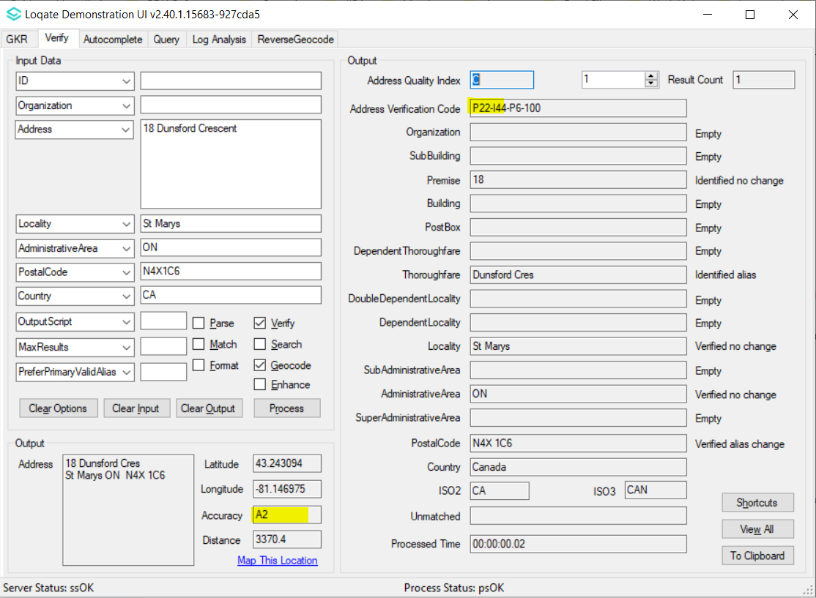
Case 2: The GeoAccuracy verification now up to level 4.
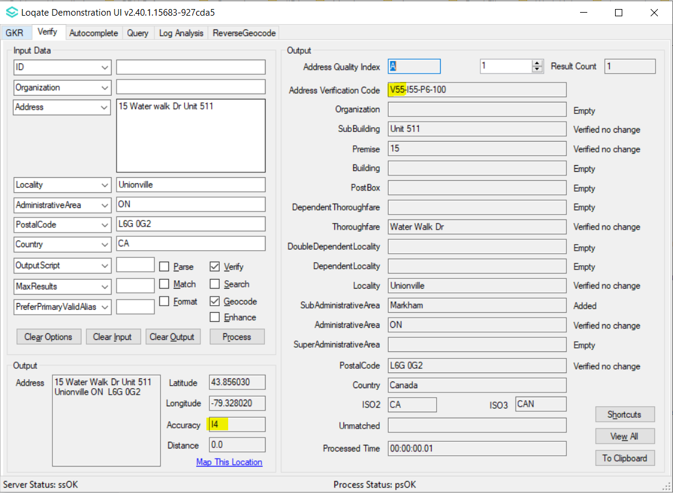

Case Number | Change Description | Category | Country | Example Address
CAS-02568-P5T7F1 | Merge CanadaPost address data with HERE Lat/Long data. Use this merged data as the only source in RD. | Data | CAN | An excel provided consists of a number of addresses. Below are one of them.  Address1: 84670 CLYDE LINE  Locality: MORRIS-TURNBERRY  AdministrativeArea: ON  Country: CA
Before Image/Behaviour
GeoAccuracy verification is lower than AVC.
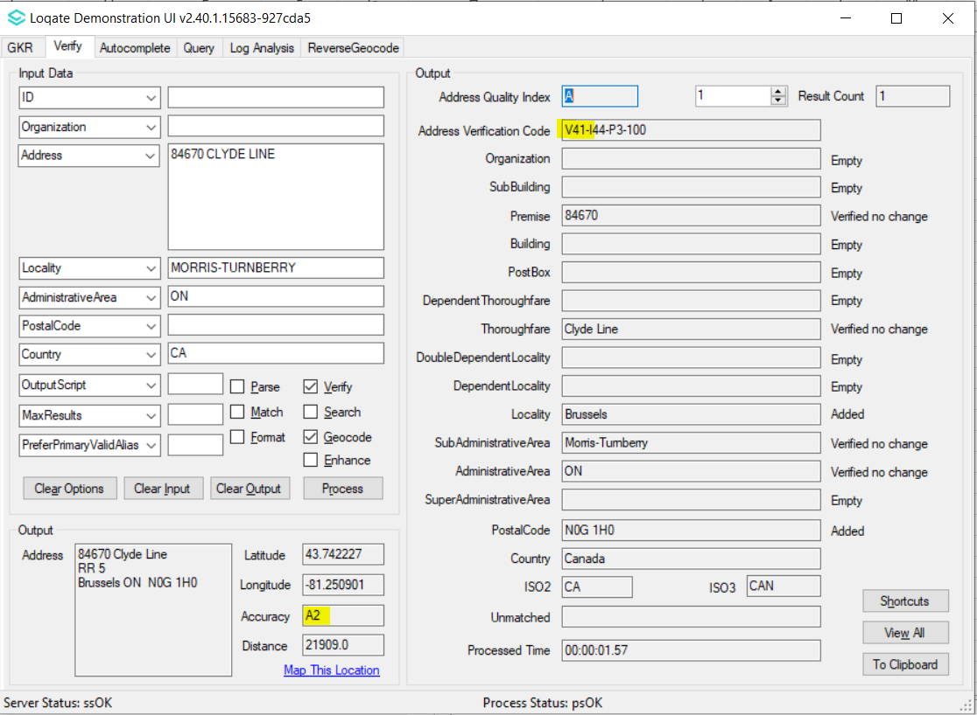

After Image/Behaviour
GeoAccuracy verification level now match the AVC level.
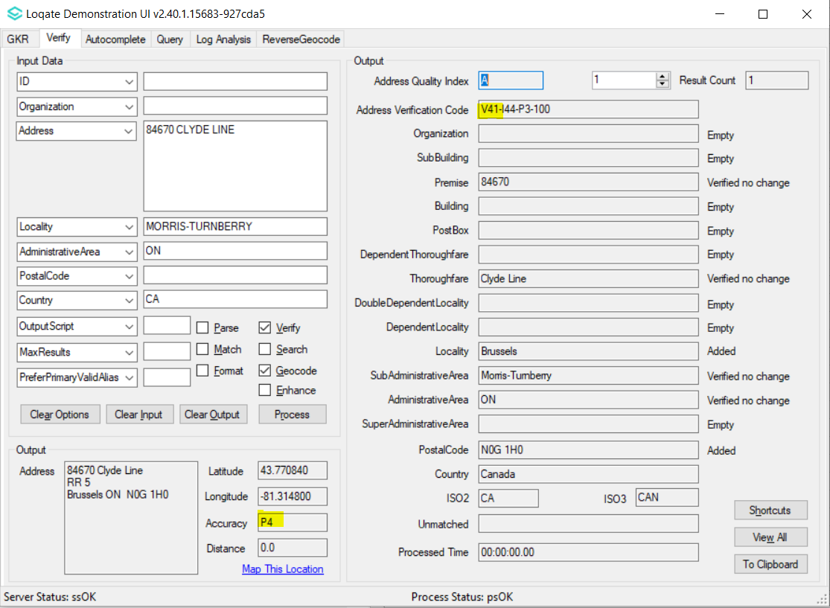

Case Number | Change Description | Category | Country | Example Address
CAS-37257-Z0S8K4 | Fix missing building | Data | Hong Kong | Address1: 1821 TIN YEE HOUSE  TIN PING ESTATE  Locality: New Territories  AdministrativeArea: Hong Kong  Country: HKG

Before Image/Behaviour
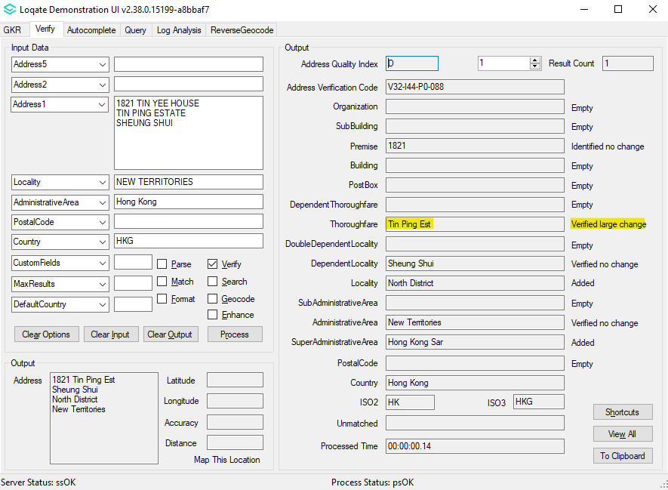

After Image/Behaviour
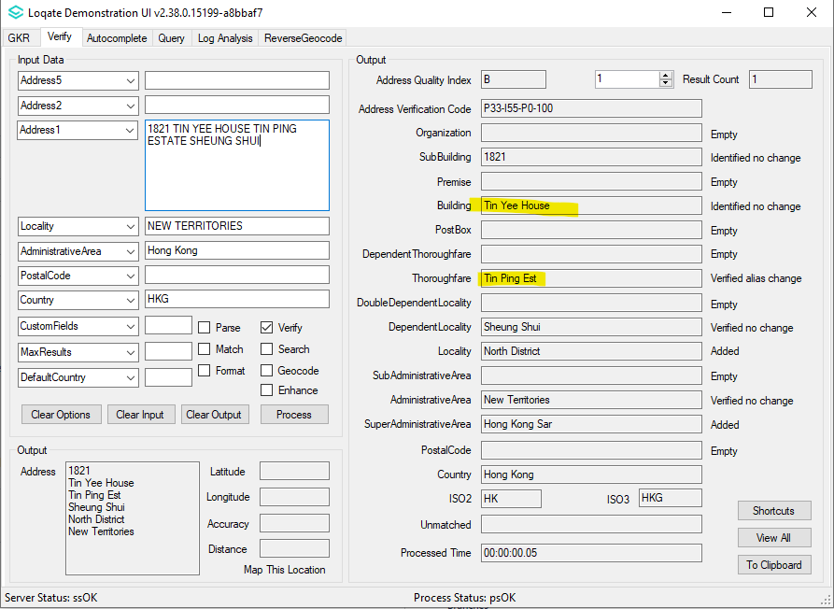

Case Number | Change Description | Category | Country | Example Address
CAS-37257-Z0S8K4 | Fix missing premise | Data | Hong Kong | Address1: FLAT 2 12/F BLOCK 2 NEW TOWN PLAZA PHASE 3  2-8 SHA TIN CENTRE STREET  Locality: Sha Tin, NT  Country: HKG
Before Image/Behaviour
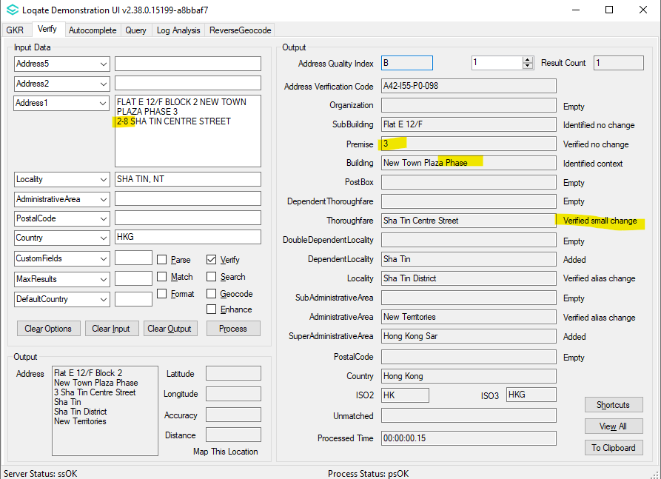

After Image/Behaviour
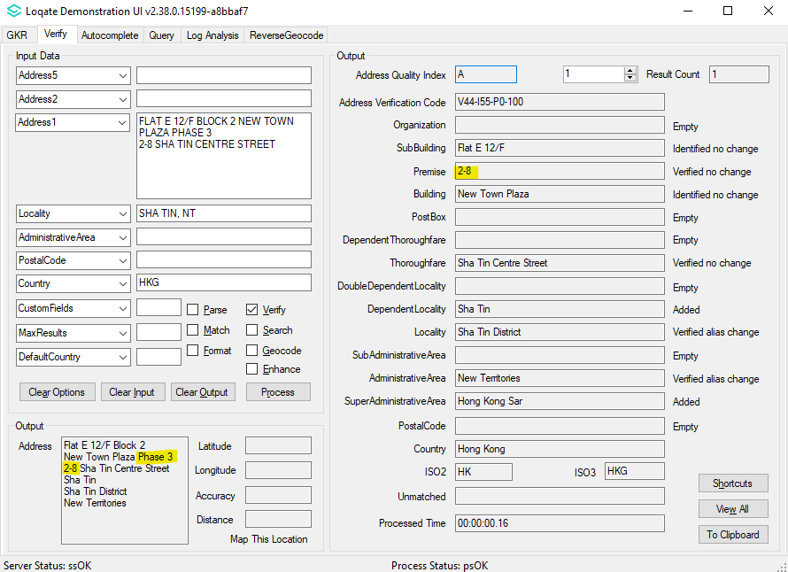

Case Number | Change Description | Category | Country | Example Address
CAS-37257-Z0S8K4 | Fix building parsing | Data | Hong Kong | Address1:  ROOM 2311, 23/F. BLK E  KORNHILL  QUARRY BAY  Locality: Hong Kong  AdministrativeArea: Hong Kong Country: HKG

Before Image/Behaviour
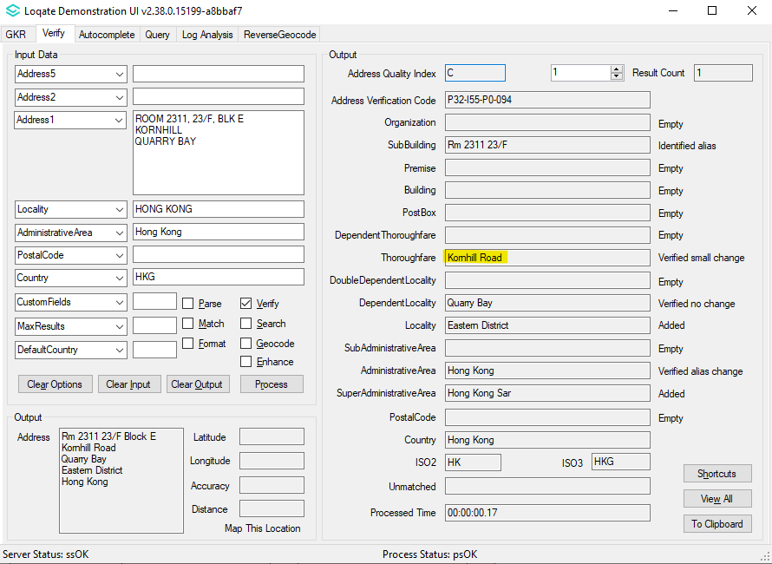

After Image/Behaviour
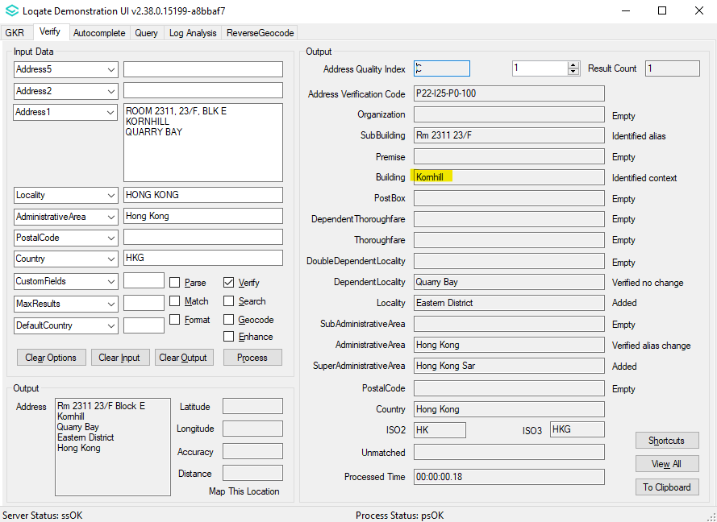

Case Number | Change Description | Category | Country | Example Address
CAS-11010-X3H1S5 | Realignment of Nazareth from SubAdministrativeArea to Locality in Geo structure | Data | Israel | No address
Before Image/Behaviour
SubAdministrativeArea 128043 AdministrativeArea 88298 Nazareth<S=LATN,L=EN>

After Image/Behaviour
Locality 101498 SubAdministrativeArea 96894 Nazareth<S=LATN,L=EN>

Case Number | Change Description | Category | Country | Example Address
CAS-30733-L3P0J8 | Fix Premise parsing | Data | Netherlands | Address1: PIETER CORNELISZ. HOOFTSTRAA 106 II  Locality: AMSTERDAM  Postal Code: 1071 CC  Country: NLD

Before Image/Behaviour
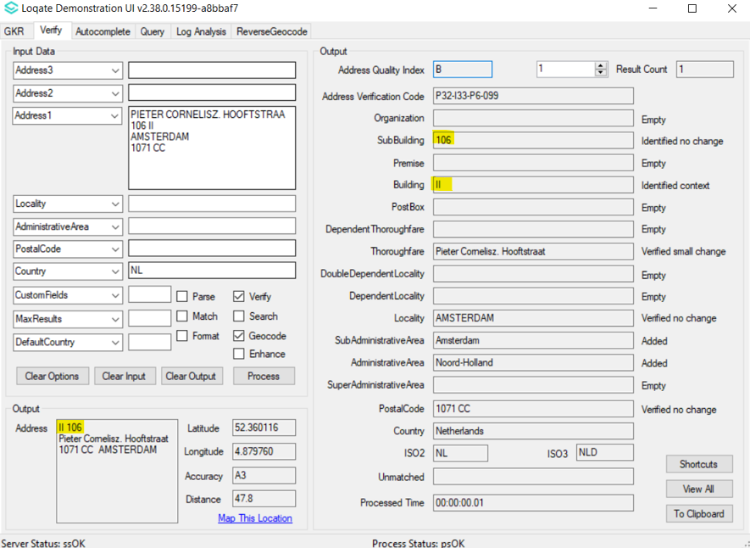

After Image/Behaviour
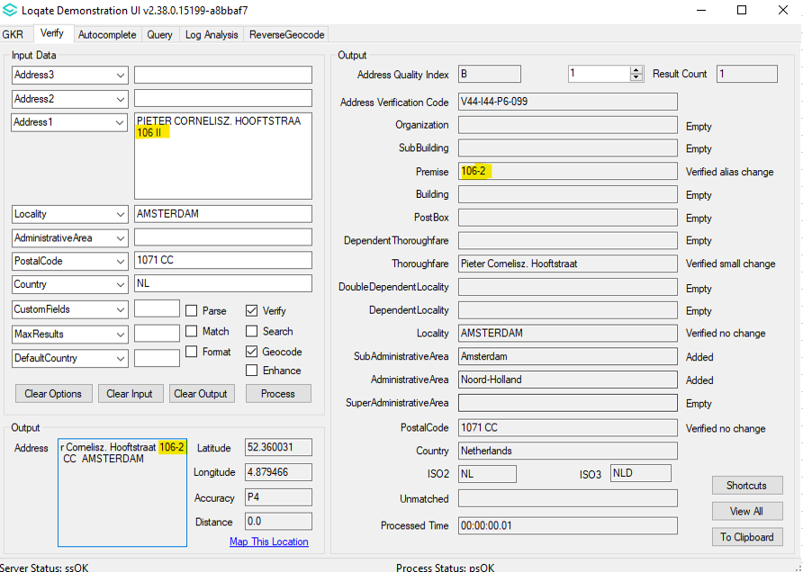

Case Number | Change Description | Category | Country | Example Address
CAS-30733-L3P0J8 | Improve Thoroughfare parsing | Data | Netherlands | Address1: 2E DE CARPENTIERSTRAAT 218  Locality: 'S-GRAVENHAGE  Postal Code: 2595 HM  Country: NLD
Before Image/Behaviour
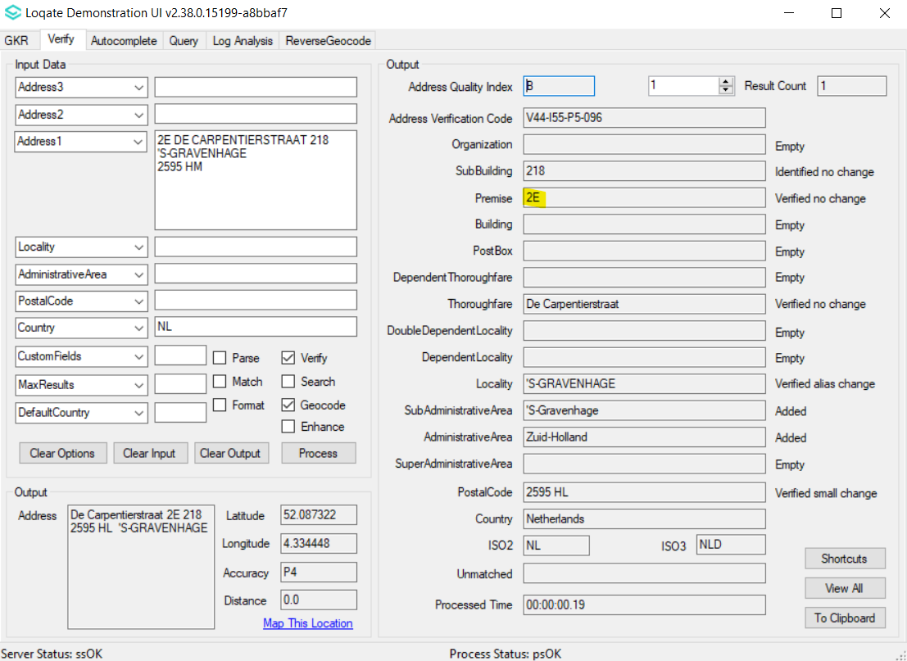

After Image/Behaviour
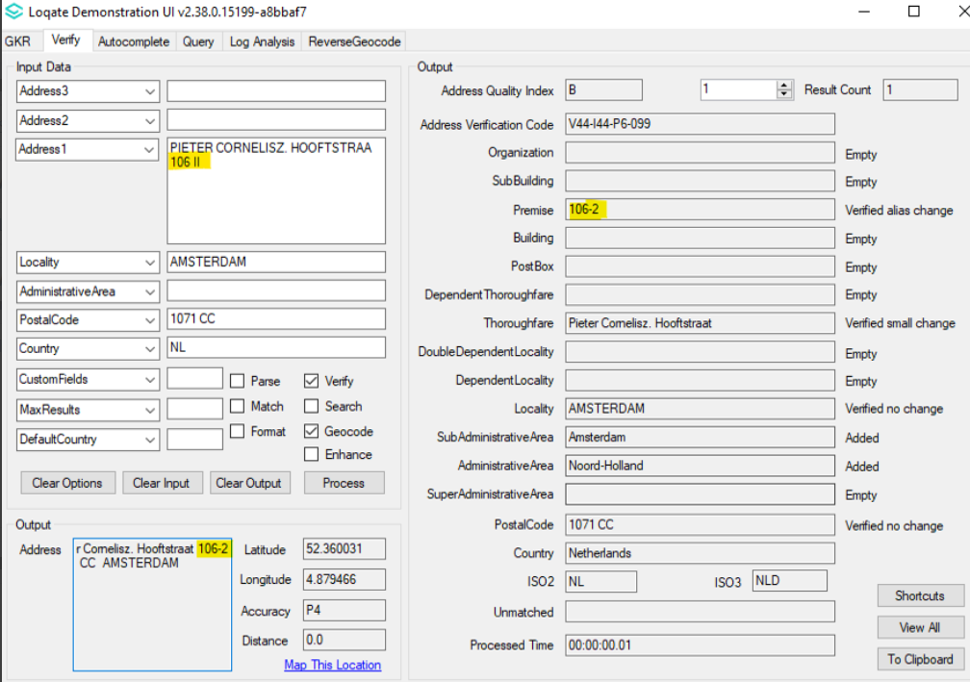

Case Number | Change Description | Category | Country | Example Address
CAS-49513-J1X3P2 | Adding lexicon rule to recognise locality input Teheran as Tehran. | Data | Iran | Address1: 320-324 Avenue Ferdowsi  Locality: Teheran  Country: IR

Before Image/Behaviour
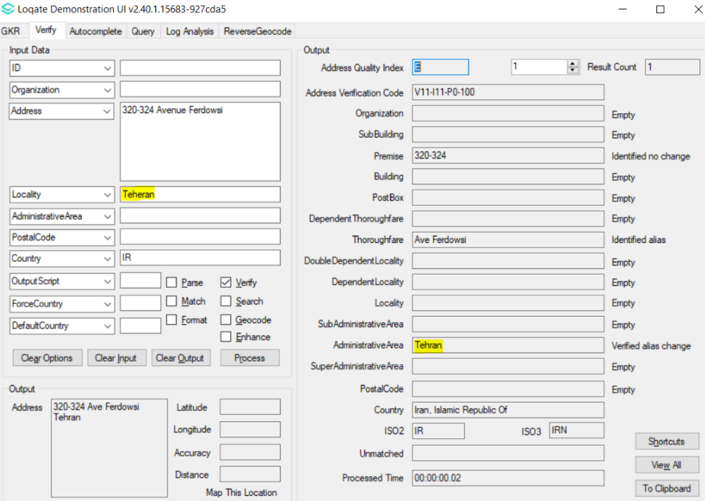

After Image/Behaviour
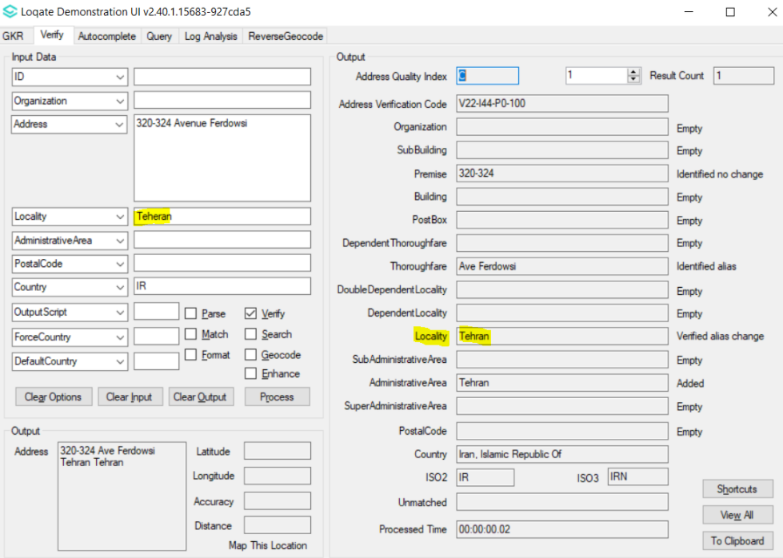

Case Number | Change Description | Category | Country | Example Address
CAS-32761-L9N2K1 | Fix the parsing issue of locality 'Ciudad Autonoma Buenos Aires' and DependentLocality 'San Nicolas' | Data | Argentina | Address1: 25 de Mayo  DependentLocality: San Nicolas  Locality: Buenos Aires  PostalCode: C1002ABG  Country: Argentina
Before Image/Behaviour
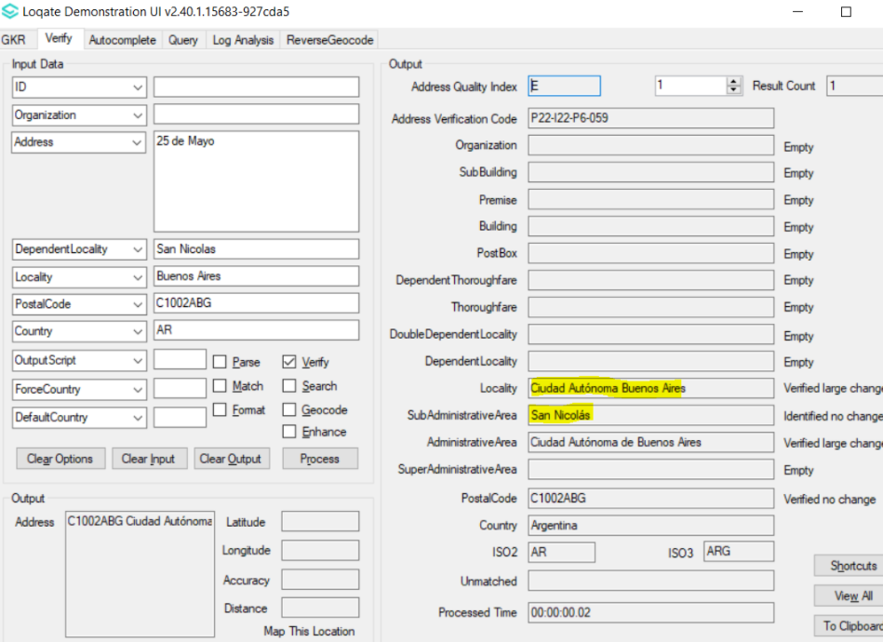

After Image/Behaviour
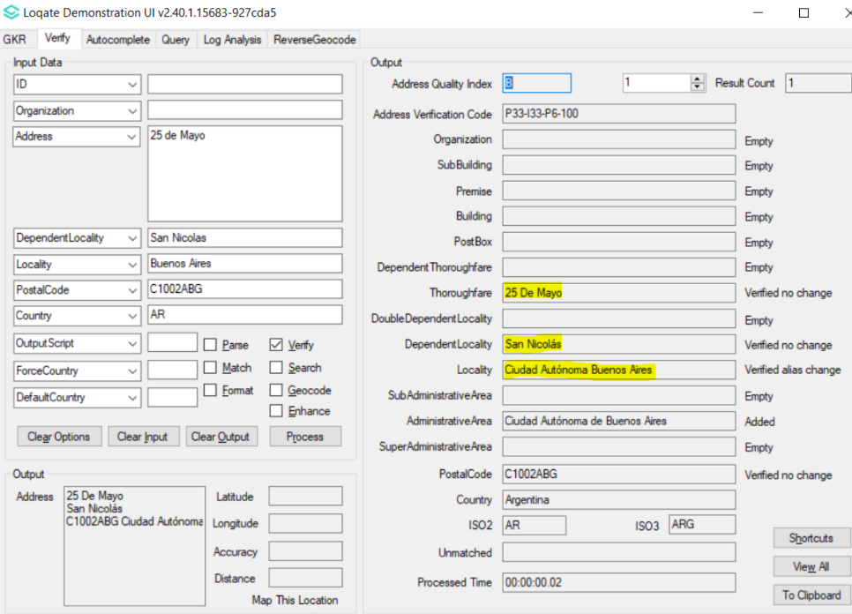

Case Number | Change Description | Category | Country | Example Address
CAS-12099-F0H2C8 | Fix double quotes issue in BuildingName value and remove irrelevant BuildingName value | Data | United States | Case 1  Address1: 5000 GULF BLVD  Address2: APT 503  Locality: ST PETE BEACH  AdministrativeArea: FL  PostalCode: 33706  Country: US  Case 2  Address1: 4000 Empire Dr Unit 120  Locality: Bakersfield  AdministrativeArea: CA  PostalCode: 93303  Country: US

Before Image/Behaviour -Case 1 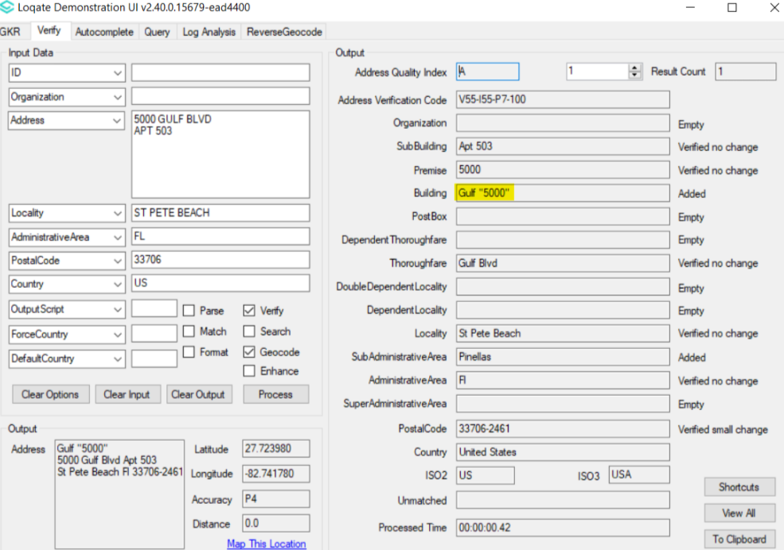
Case 2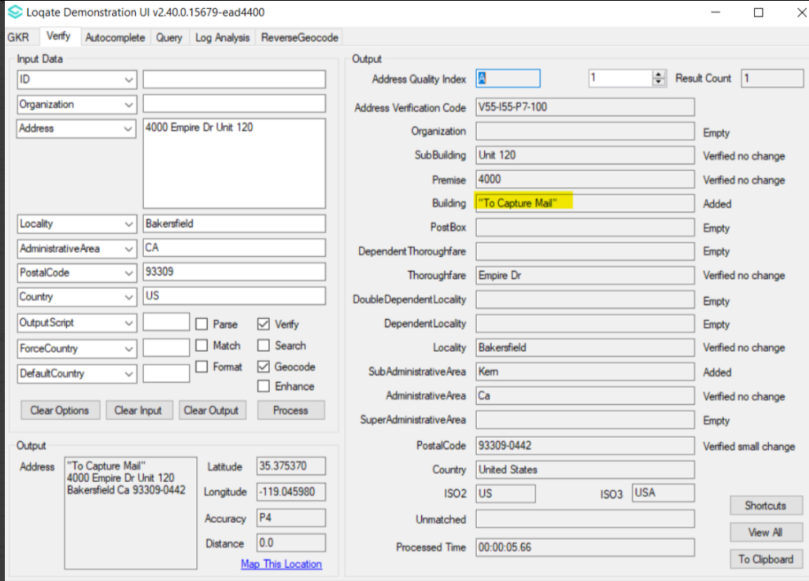

After Image/Behaviour - Case 1 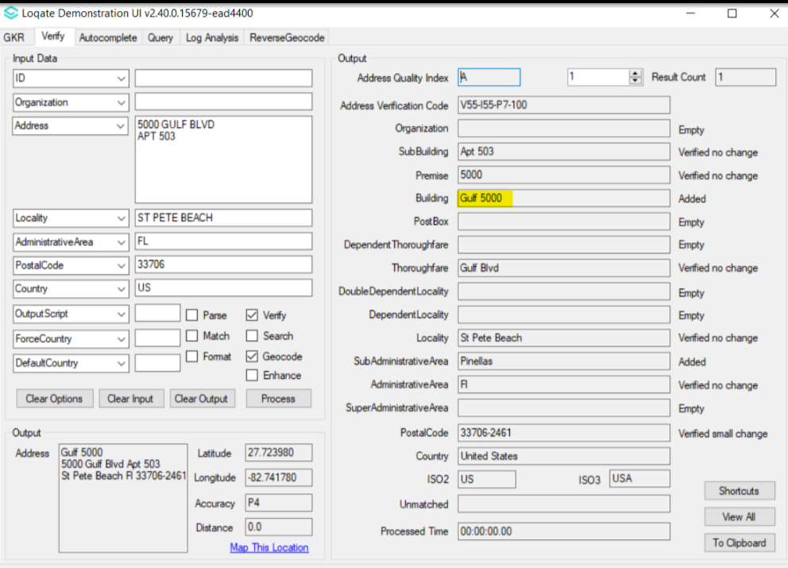
Case 2 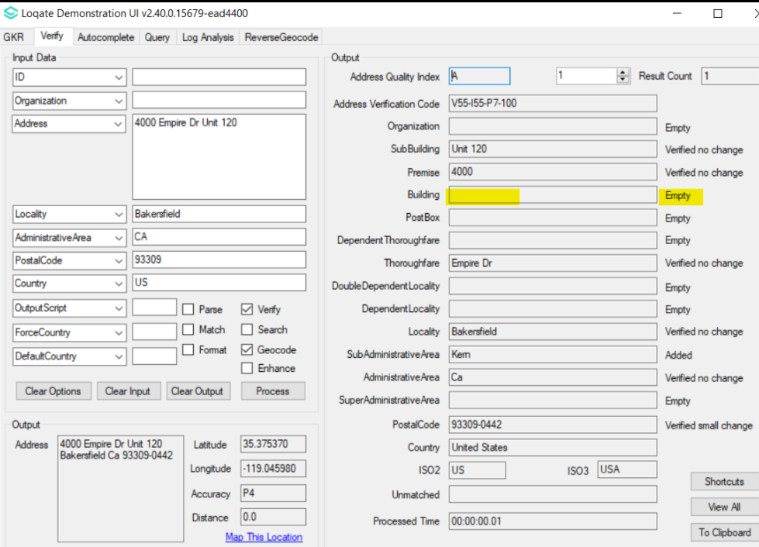

Case Number | Change Description | Category | Country | Example Address
CAS-03861-D9X0P7 | Reference data update via bpdh to fix numeric locality value issue | Data | Pakistan | Address1: 16c Sunset Lane  Address2: Phase 2  Locality: Karachi  Country: PK
Before Image/Behaviour
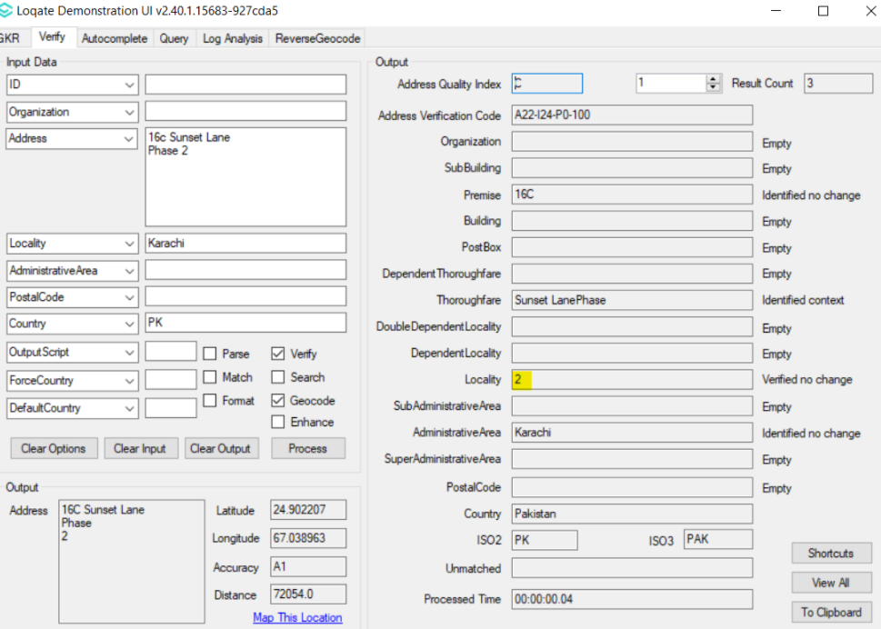

After Image/Behaviour
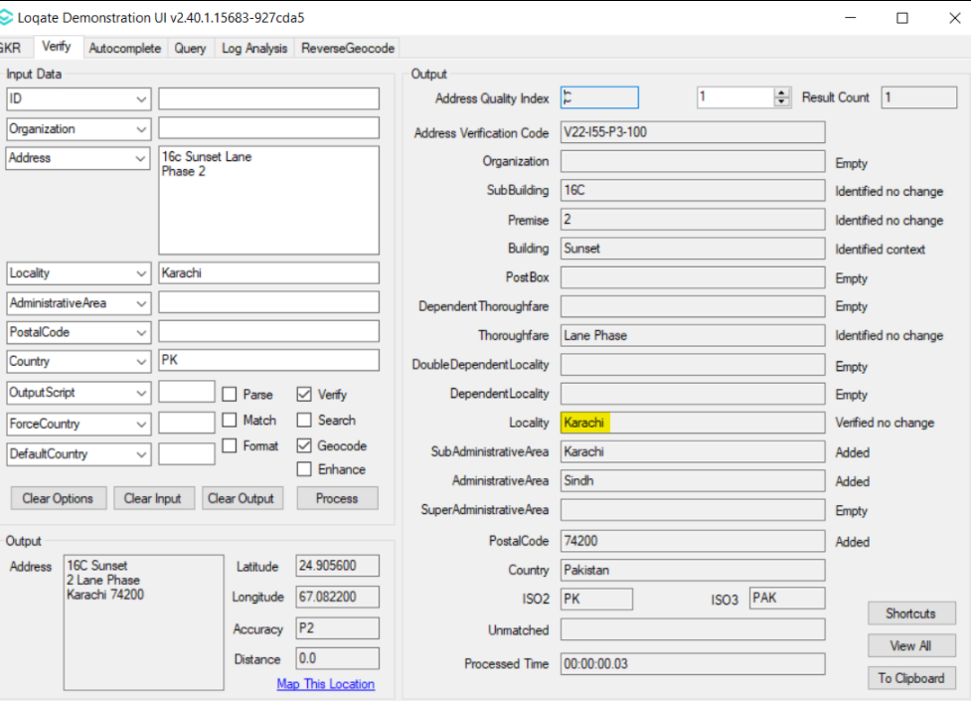

Case Number | Change Description | Category | Country | Example Address
CAS-01441-X7Y8L1 | Fix the issue with search output | Data | Germany | Case 1  Address 1: Talsperrstr. 12, 99897 Tambach-Dietharz, DE  Case 2  Address 1: Talsperrenstr. 12, 99897 Tambach

Before Image/Behaviour
Case 1 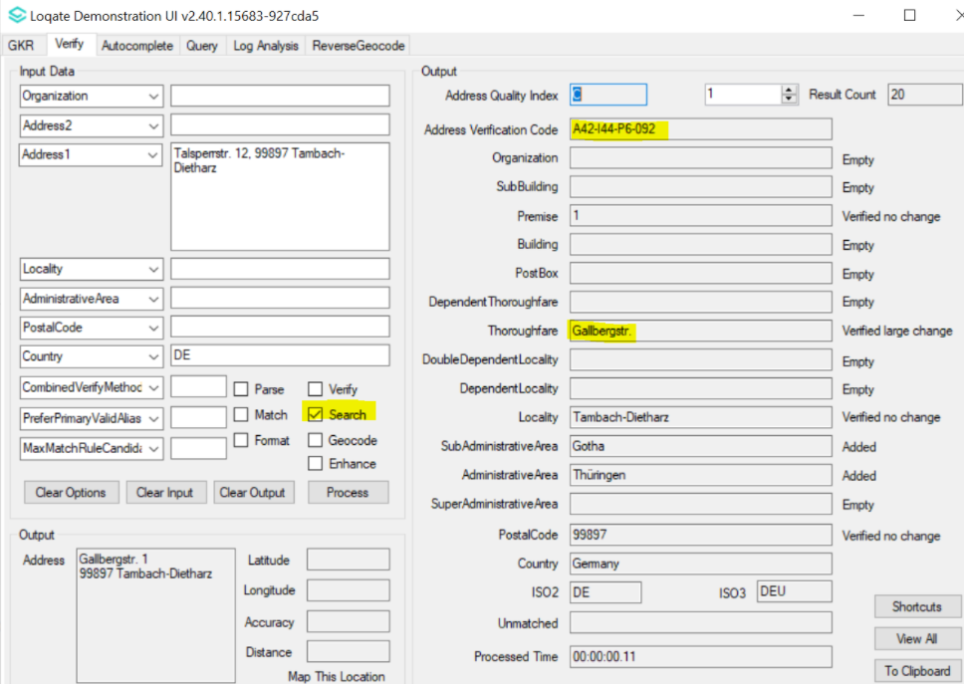
Case 2 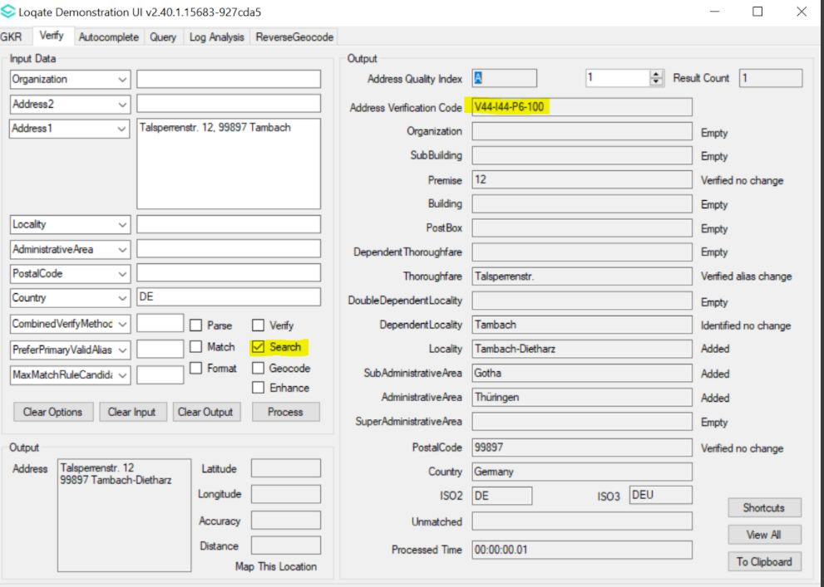

After Image/Behaviour
Case 1
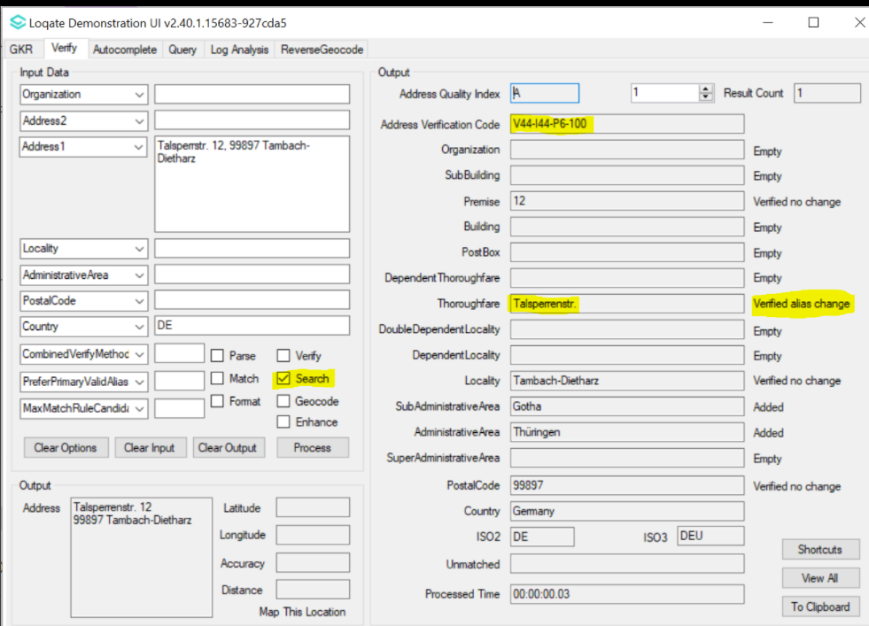
Case 2 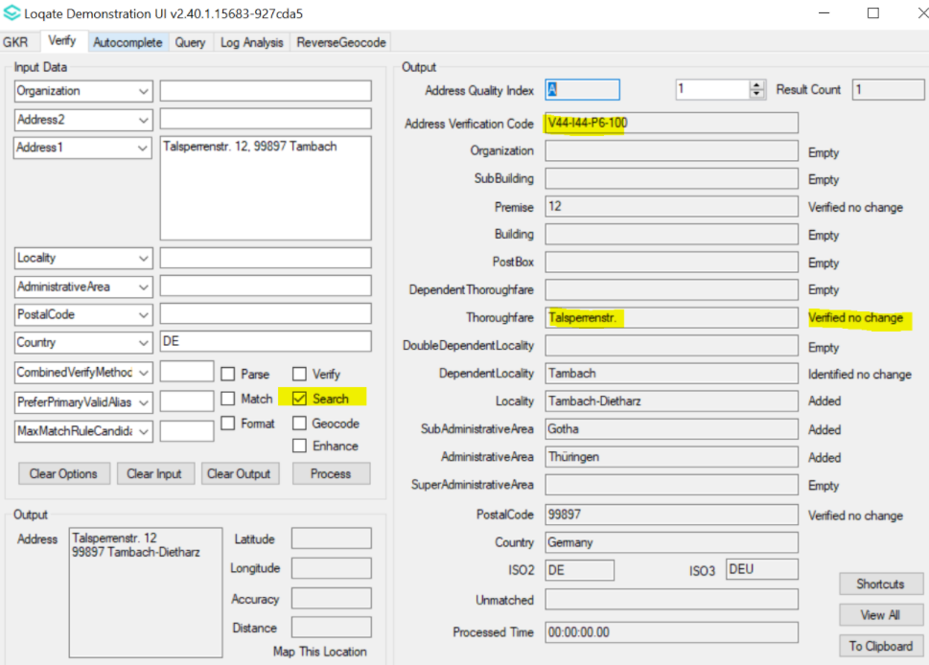

Case Number | Change Description | Category | Country | Example Address
CAS-30735-G7R5Y5 | Fix various issues with French addresses that contain LOTISSEMENT. | Data | France | Case 1  Address 1: 17 LOTISSEMENT PLANET I  Locality: MARIGNANE  PostalCode: 13700  Country: france  Case 2  Address 1: 1 LOTISSEMENT DE LA ROSE TREMIERE  Locality: PARENTIS EN BORN  PostalCode: 40160  Country: france
Before Image/Behaviour
Case 1
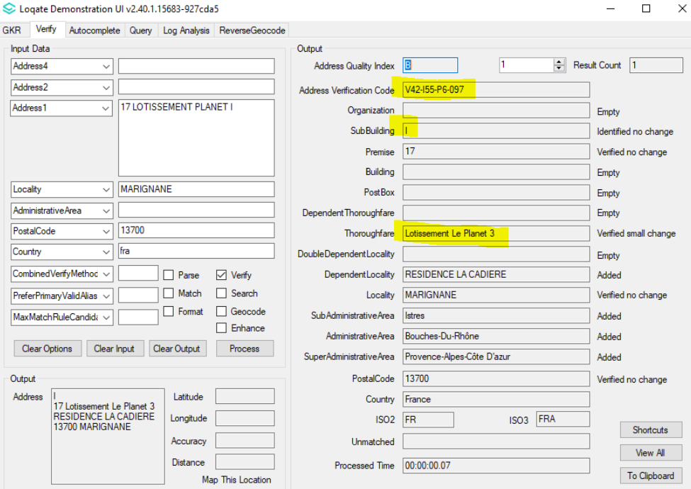
CASE 2
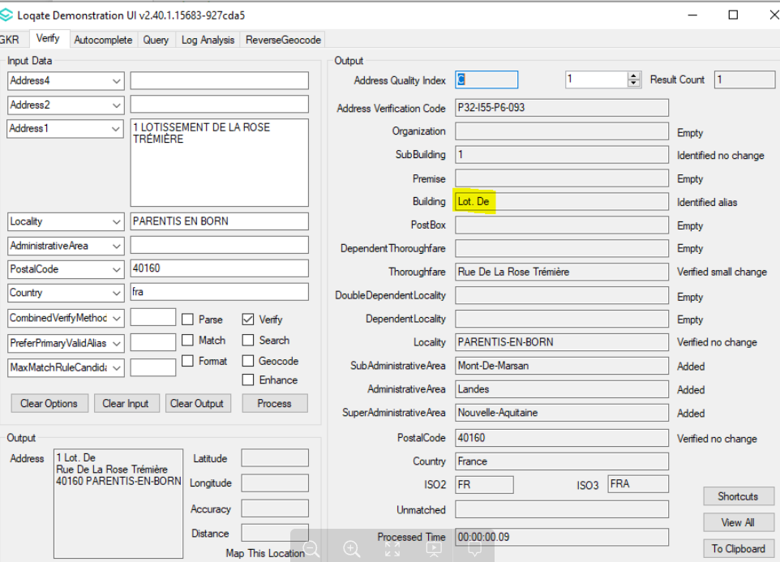

After Image/Behaviour - Case 1
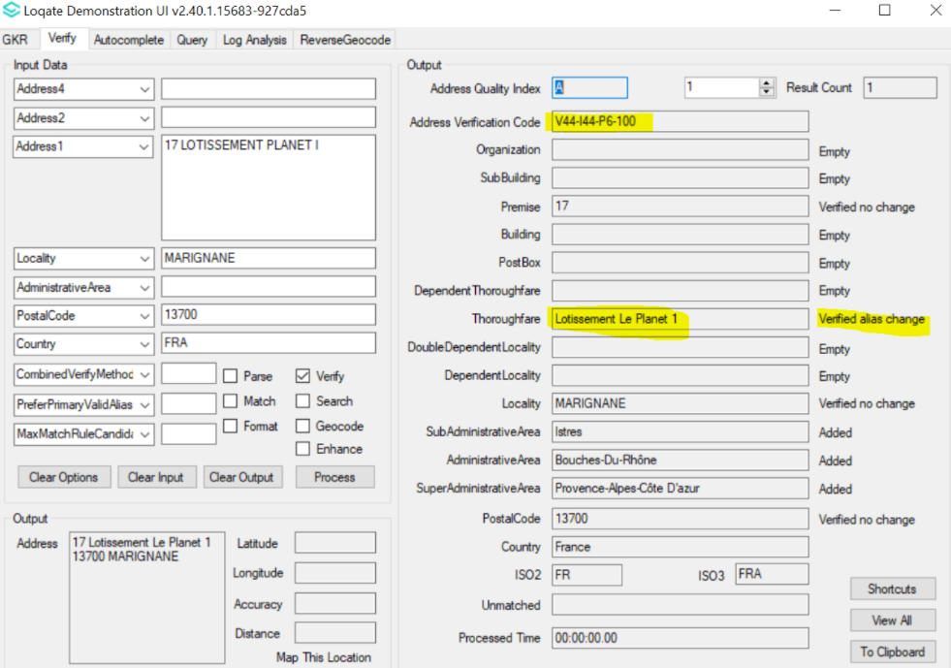
Case 2
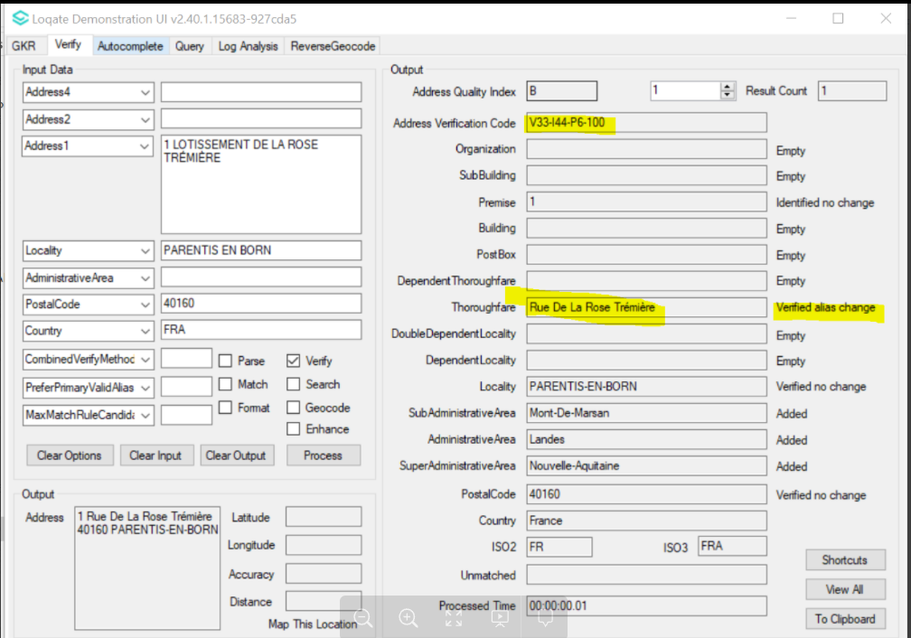

Case Number | Change Description | Category | Country | Example Address
CAS-51413-P9B1X0 | Reference Data update which now includes Postal Code 'D04 E4H9' | Data | Ireland | Address 1: 2 Strand Street  Locality: Dublin  Country: Ireland

Before Image/Behaviour
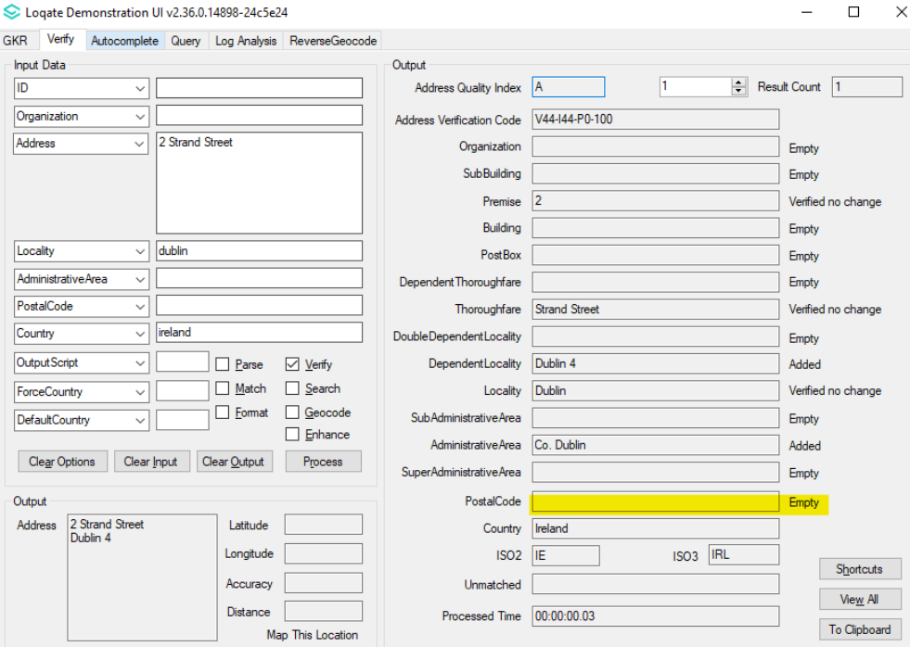

After Image/Behaviour
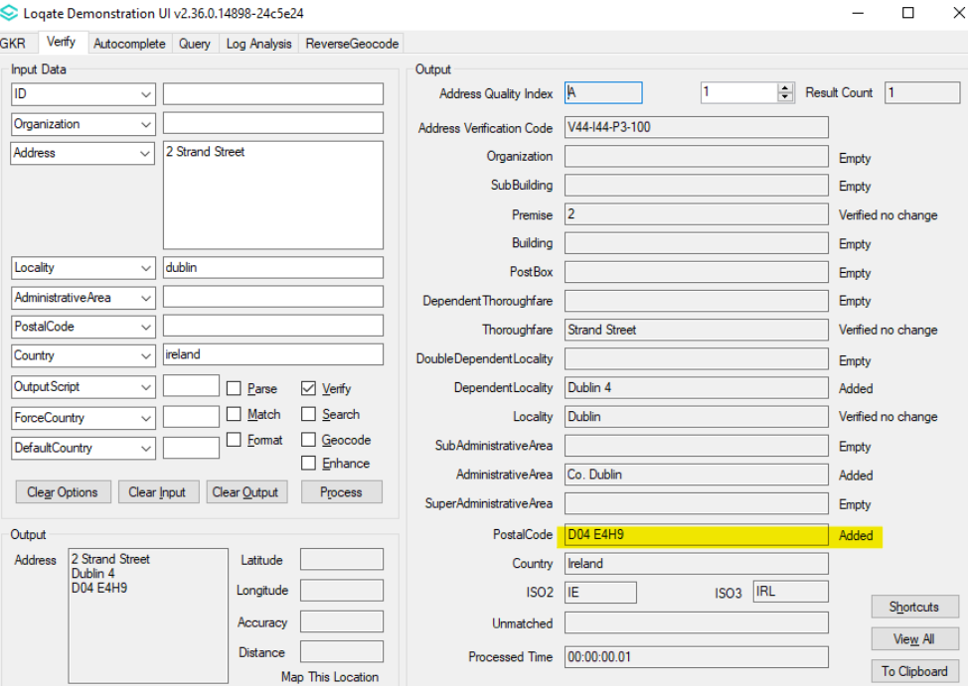

Case Number | Change Description | Category | Country | Example Address
CAS-12183-Y2J8X9 | Improved the parsing of 'Lieu Dit' where it no longer gets parsed into the Dependent Thoroughfare Field | Data | France | Address 1: LIEU DIT LES PLACES  Locality: CREMEAUX  PostalCode: 42260  Country: FRA
Before Image/Behaviour
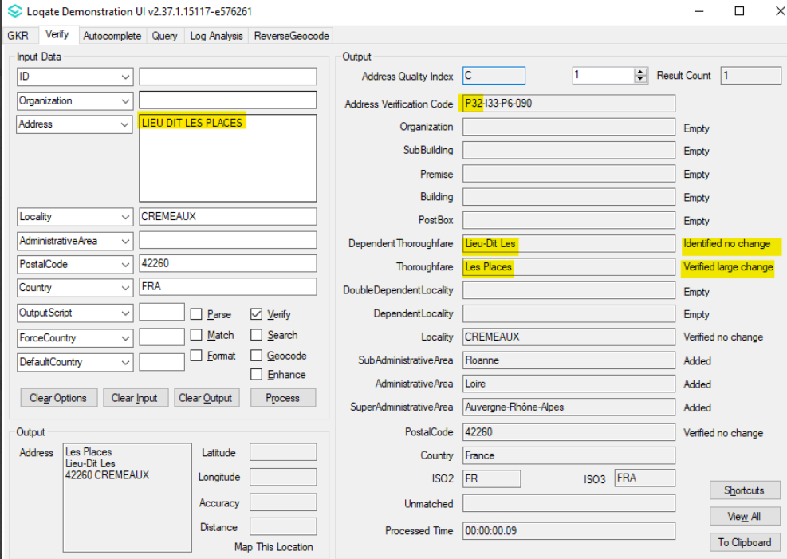

After Image/Behaviour
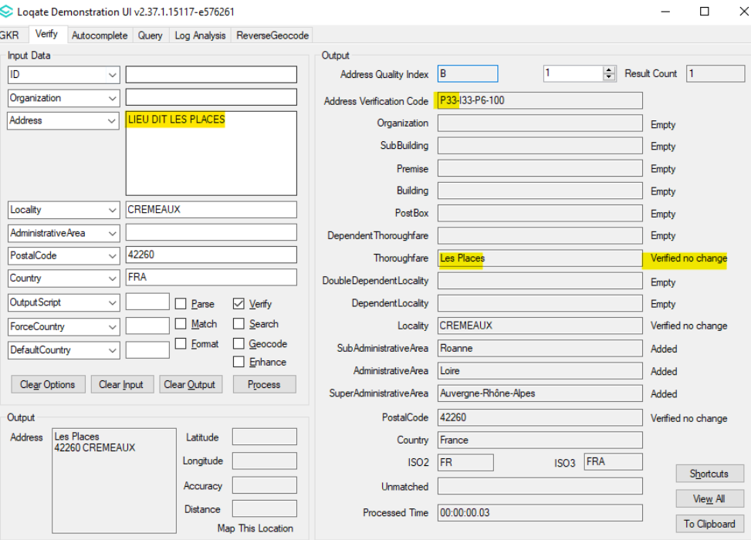

Case Number | Change Description | Category | Country | Example Address
CAS-46796-P1X8X9 | remove the invalid suffix "]" in the SubBuilding field | Data | USA | Address1 : 170 W 73RD ST  Address2: APT 8A1  City: New York  State: NY  Country: USA

Before Image/Behaviour
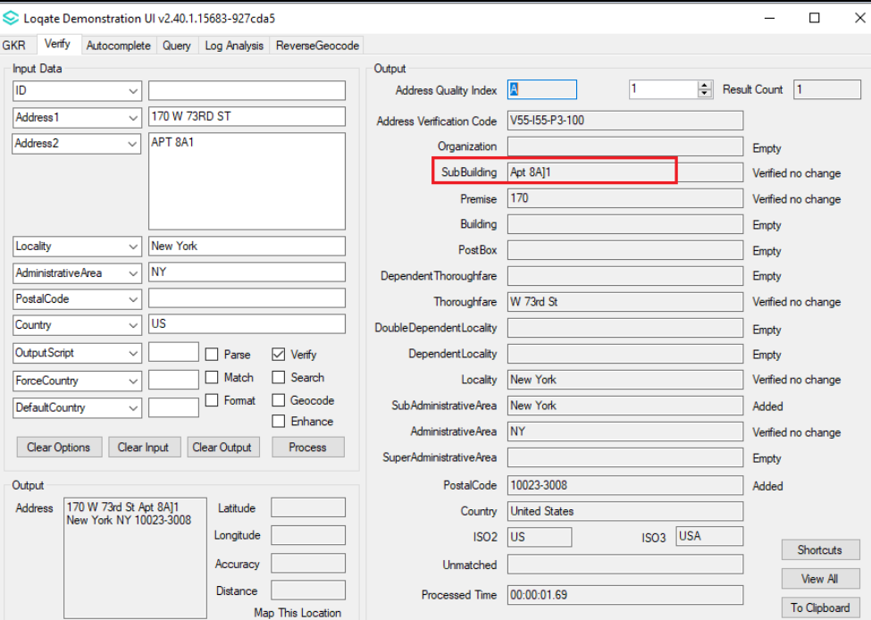

After Image/Behaviour
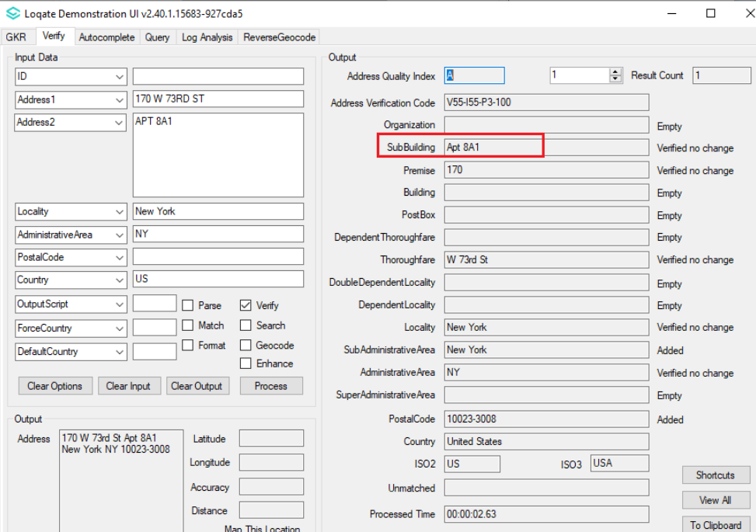

Case Number | Change Description | Category | Country | Example Address
CAS-09583-Q0Q0L1 | Correction on AdministrativeArea name | Data | TWN | Address1 : 408 RUIGUANG ROAD  City: TAIPEI  State: TAIPEI SPECIAL MUNICIPALITY  PostalCode : 114  Country: TWN
Before Image/Behaviour
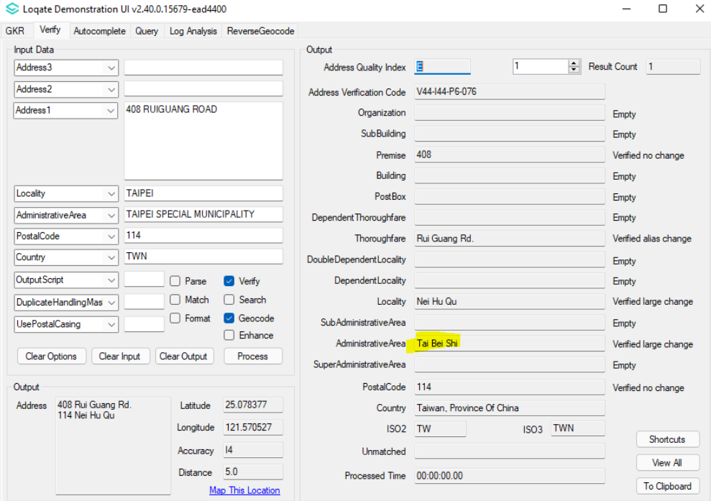

After Image/Behaviour
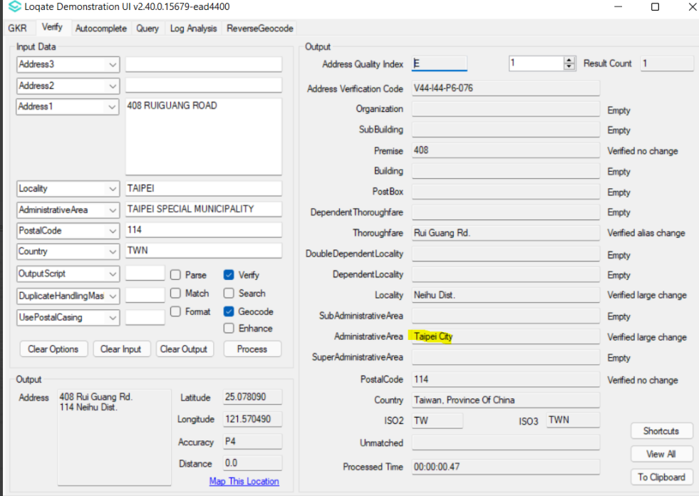

Case Number | Change Description | Category | Country | Example Address
CAS-51261-B5S4G9 | Correction on AdministrativeArea name | Data | TWN | Address1 : 11 Guang fu n rd songshan  Country: TWN

Before Image/Behaviour
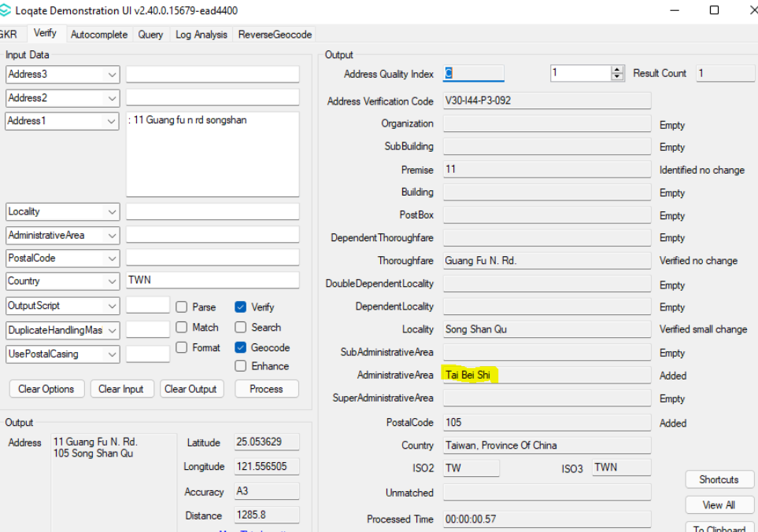

After Image/Behaviour
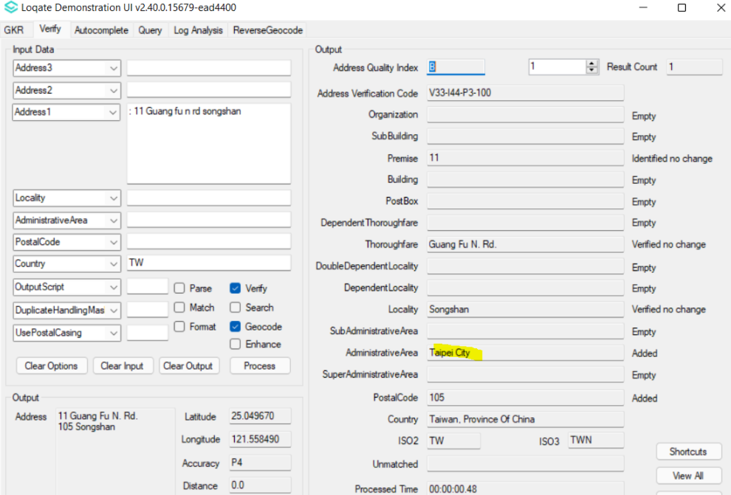

Case Number | Change Description | Category | Country | Example Address
CAS-10851-Q7X2J1 | Port Royal is now a Locality under Kingston Administrative Area | Data | JAM | Gloria's  15 Foreshore Road Port Royal Kingston  Jamaica
Before Image/Behaviour
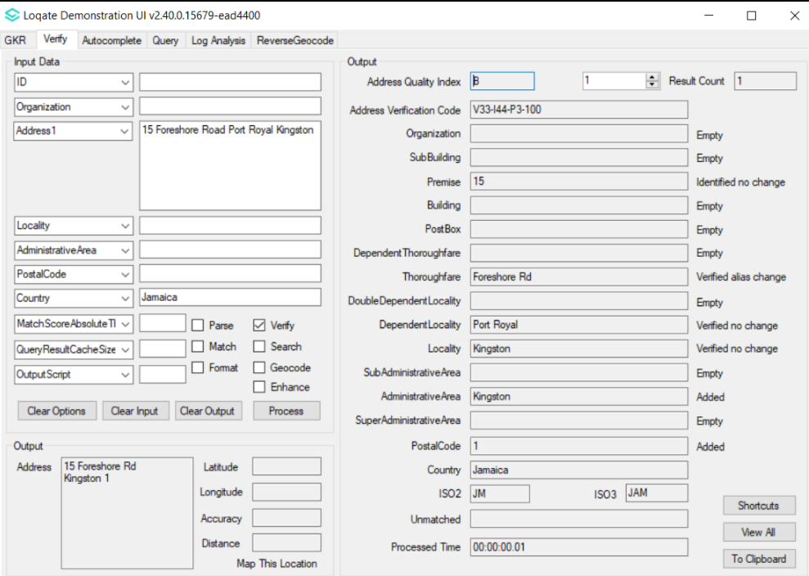

After Image/Behaviour
