Loqate, A GBG Solution
Release Notes – Reference Data & Knowledge Base
2021Q4.0 Major Release

Case Resolutions
Please visit https://support.loqate.com/release-information/2021q4-0-resolved-cases/ for a list of cases resolved in this release. If you would like more details on any of the solved cases listed, please contact LoqateSupport@gbgplc.com for further information.

Certification Expiration Dates
If you have purchased either the CASS (USA) or AMAS (Australia) certified products, please be aware that the datasets have expiration dates set by the respective postal authorities. Please ensure that you have the latest library and data installed to avoid loss of service through these products.

Please check Install Manager for the latest versions of AMAS and CASS.
 | Loqate Release Date | Certification Expiry Date*
AMAS Data | 2021-08-13 | 2021-12-31
CASS Data | 2021-09-14 | 2021-12-29
*Certification Expiry Date is different from Loqate license key expiry date. The earliest expiry date will apply.

For more information on expiry date checking for CASS and AMAS, please refer “Usage expiration” section in https://support.loqate.com/documentation/local-apis/cass-overview-2/ and https://support.loqate.com/address-matching-approval-system-amas/

Data Notices

USA Territories - Delayed

In the 2021Q3.1 minor release, it was announced that beginning in the 2021Q4.0 major release, the following countries: Micronesia, Federated States of (ISO2: FM), Marshall Islands (ISO2: MH), and Palau (ISO2: PW) will be removed from the USA data set. Please note this is now delayed and these countries will not be removed from the USA data set in the 2021Q4.0 release.

Important note: this has been delayed, Micronesia, Federated States of (ISO2: FM), Marshall Islands (ISO2: MH), and Palau (ISO2: PW) will remain in the USA data set in the 2021Q4.0 major release. We will provide updates when they become available.

Australia

From the 2021Q4.0 major release: the suburb field, defined by Australia Post will be moved back to Locality. The change will only occur in Verify output components; the address lines will be unaffected and will remain compliant with postal standards.
2021Q3.1 (Before Chang) | 2021Q4.0 (After Change)
Haymarket verified as DependentLocality | Haymarket verified as Locality
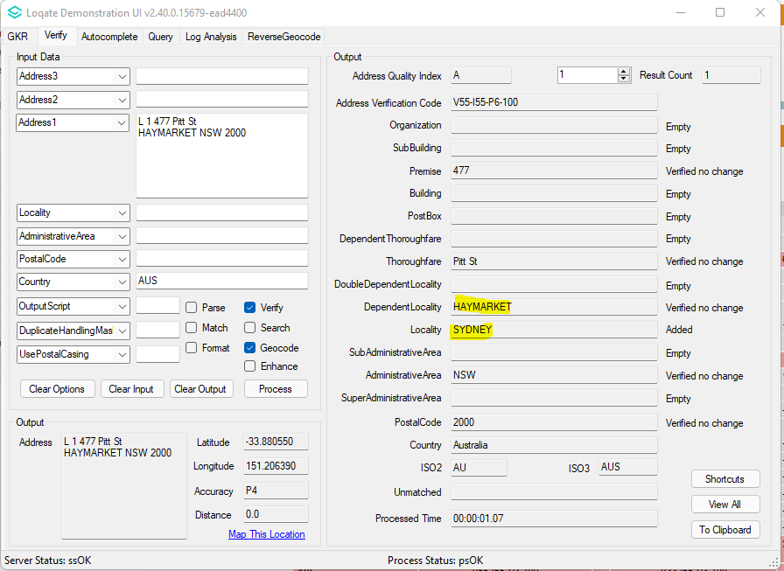 | 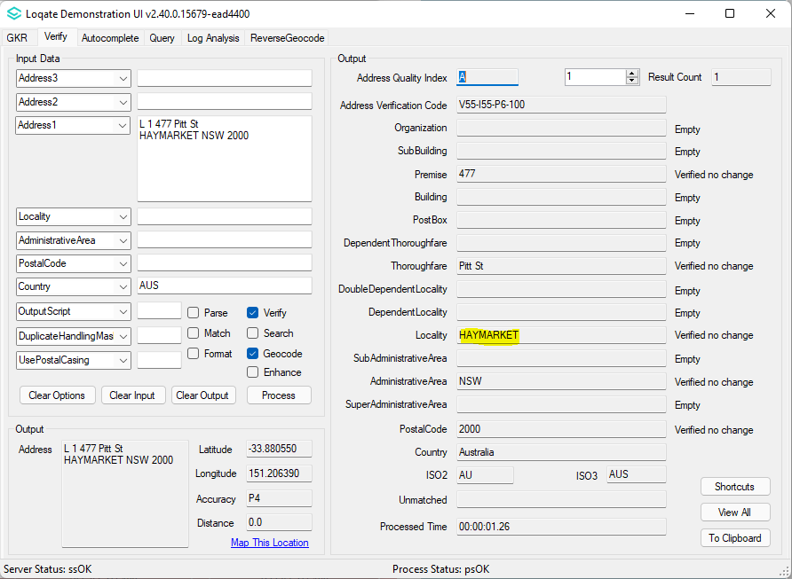

Canada

From the 2021Q4.0 major release, improvements are made within the geocode reference data to resolve the discrepancy users may have seen between verify results and geocoding results.

2021Q3.1 (Before Change) | 2021Q4.0 (After Change)
List of files:  rd_CA_ggg.lfs  rd_CA_ggg_r1.lfs  rd_CA_ggg_r2.lfs  rd_CA_ggg_rg.lfs  rd_CA_ggg_r.lfs | List of files:  rd_CA_ggg.lfs  rd_CA_ggg_rg.lfs

Canada Continued…

Sample address 1: 2021Q3.1 (Before Change)  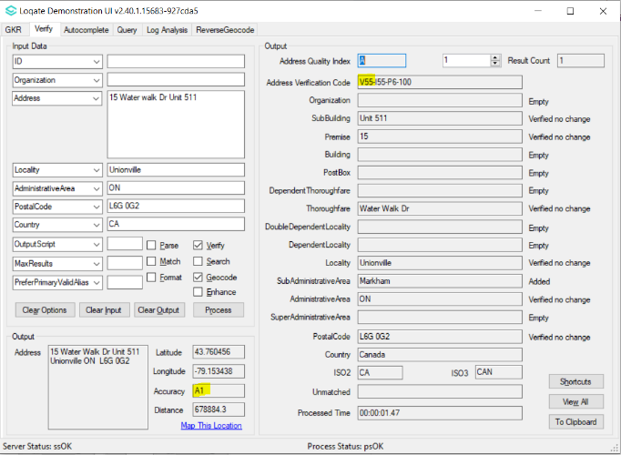  Poor GeoAccuracy – A1 returned  Sample address 2: 2021Q3.1 (Before Change)  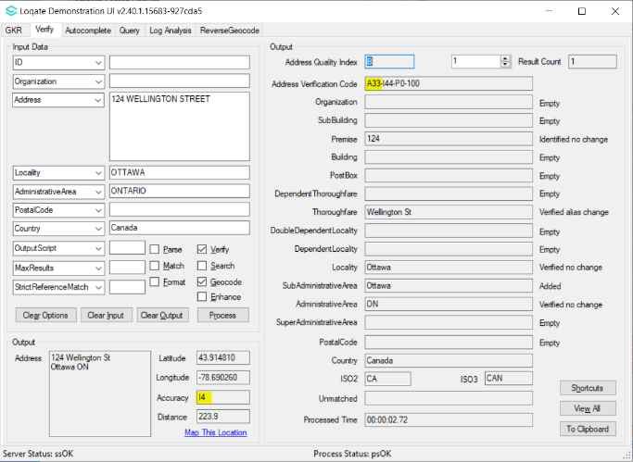  Geocoded Lat/Long is pointing to Thoroughfare in another Locality. | Sample address 1: 2021Q4.0 (After Change)  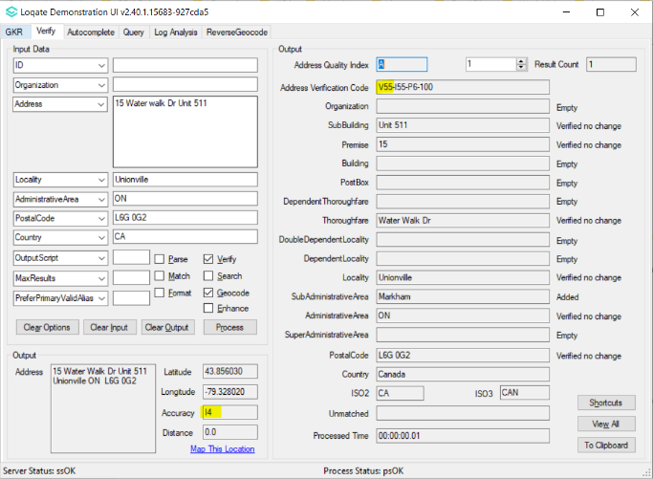  GeoAccuracy Improvement – I4 returned  Sample address 2: 2021Q4.0 (After Change)  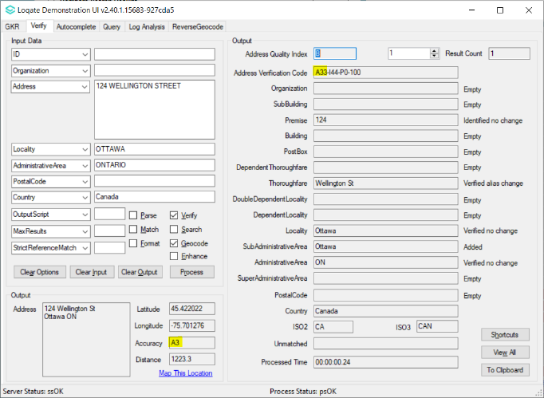  Geocoded Lat/Long is pointing to Thoroughfare in the correct Locality.

Data Improvements

Costa Rica (L4)

Country Information | Description
ISO2 | CR
ISO3 | CRI
Address Format | Organization  PostBox  Building SubBuilding  Thoroughfare Premise  DependentThoroughfare  DoubleDependentLocality  DependentLocality  AdministrativeArea Locality  PostalCode
PDH | YES
PDH completed date | 2021Q4.0
New Source | NO
Reference Data Pre-PDH | rd_CR_ai.lfs  rd_CR.lfs  rd_CR_rg.lfs
Reference Data Post-PDH | rd_CR_ggg.lfs  rd_CR_ggg_rg.lfs  rd_CR_vfy_ai.lfs  rd_CR_vfy.lfs

Improvements have been made to the verification results within the thoroughfare and premise fields.

2021Q3.1 (Before Change) | 2021Q4.0 (After Change)
Thoroughfare and Premise unable to parse and verify correctly  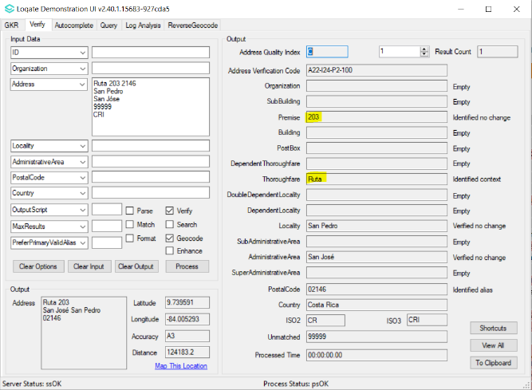 | Thoroughfare and Premise can be parsed now and able to verify.  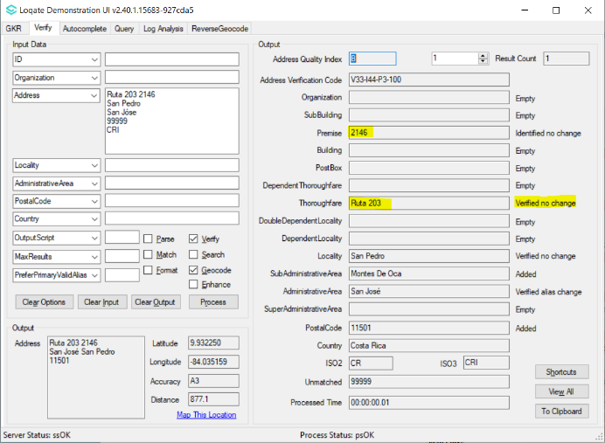

El Salvador (L3)

Country Information | Description
ISO2 | SV
ISO3 | SLV
Address Format | Organization  PostBox  Building SubBuilding  Thoroughfare Premise  DependentThoroughfare  DoubleDependentLocality  DependentLocality  Locality PostalCode  AdministrativeArea
PDH | YES
PDH completed date | 2021Q4.0
New Source | NO
Reference Data Pre-PDH
Reference Data Post-PDH

Improvements are made to the verification results within the SubAdministrativeArea and the AdministrativeArea fields.

2021Q3.1 (Before Change) | 2021Q4.0 (After Change)
No SubAdministrativeArea and no AdministrativeArea on output.  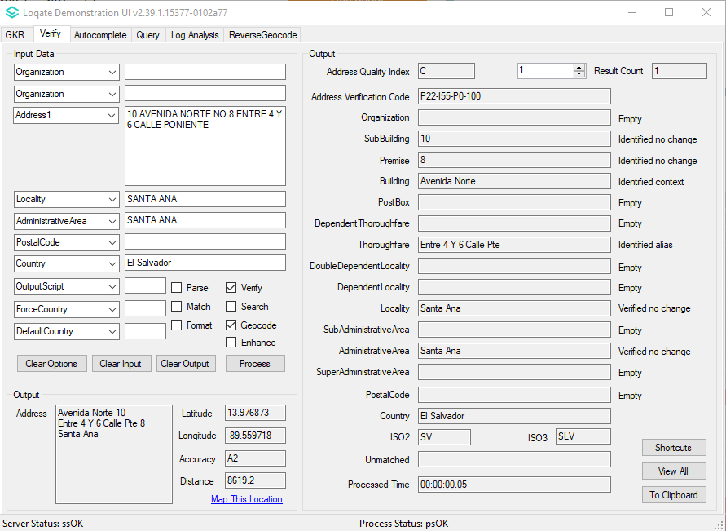 | More complete address with output following the correct address format.  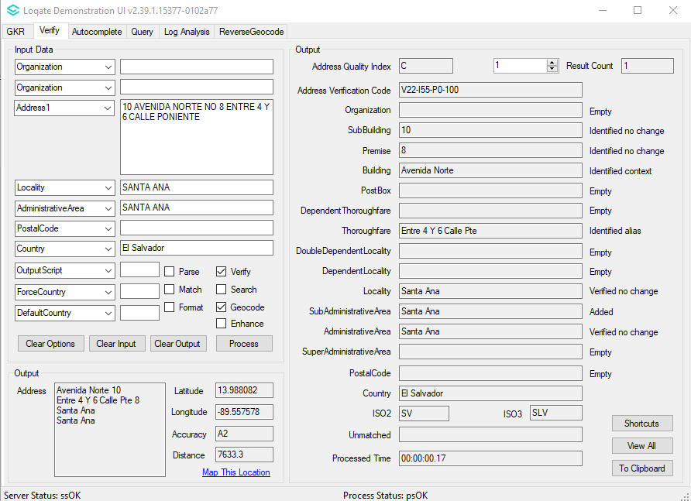

Iceland (L4)

Country Information | Description
ISO2 | IS
ISO3 | ISL
Address Format | Organization  Postbox  Thoroughfare Premise Building SubBuilding  DependentThoroughfare  DoubleDependentLocality  DependentLocality  PostalCode Locality
PDH | Yes
PDH Completed Date | 2021Q4.0
New Source | NO
Reference Data Pre-PDH | rd_IS.lfs  rd_IS_rg.lfs  rd_IS_ai.lfs
Reference Data Post-PDH | rd_IS_ggg.lfs  rd_IS_ggg_rg.lfs  rd_IS_vfy_ai.lfs  rd_IS_vfy.lfs

With the 2021Q4.0 major release, improvement can be seen with the verification results within the thoroughfare and premise fields.

2021Q3.1 (Before Change) | 2021Q4.0 (After Change)
Thoroughfare and Premise not verified | Thoroughfare and Premise now verified
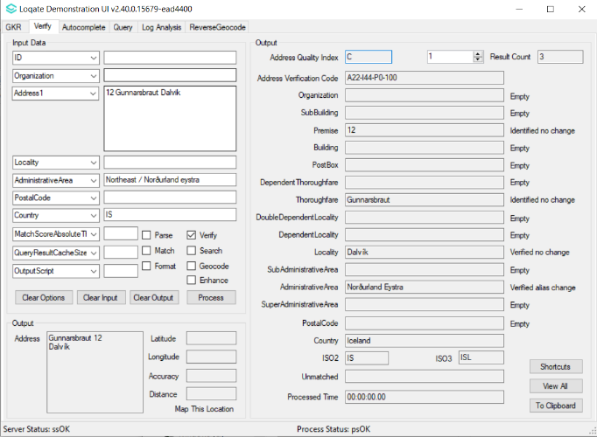 | 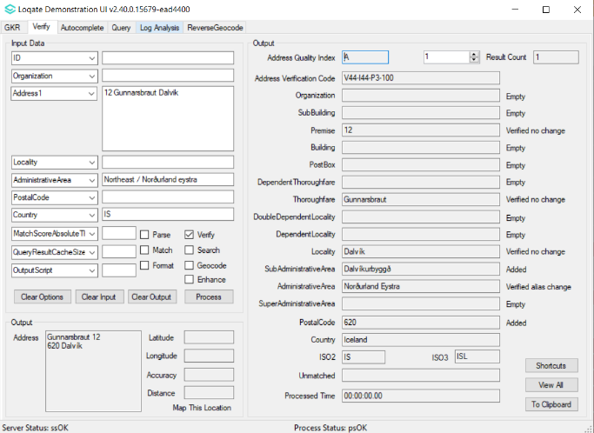

Jordan (L4)

Country Information | Description
ISO2 | JO
ISO3 | JOR
Address Format | Organization  PostBox  SubBuilding Building  Premise Thoroughfare  DependentThoroughfare  DoubleDependentLocality  DependentLocality  Locality PostalCode
PDH | YES
PDH completed date | 2021Q4.0
New Source | NO
Reference Data Pre-PDH | rd_JO_ai.lfs  rd_JO.lfs  rd_JO_rg.lfs
Reference Data Post-PDH | rd_JO_ggg.lfs  rd_JO_ggg_rg.lfs  rd_JO_vfy_ai.lfs  rd_JO_vfy.lfs

In the 2021Q4.0 major release, addresses are now verified with higher AVC results.

2021Q3.1 (Before Change) | 2021Q4.0 (After Change)
Address unable to parse and verify correctly  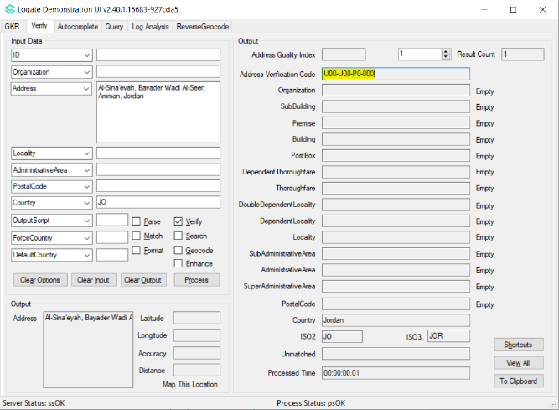 | Address can be parsed now and able to verify.  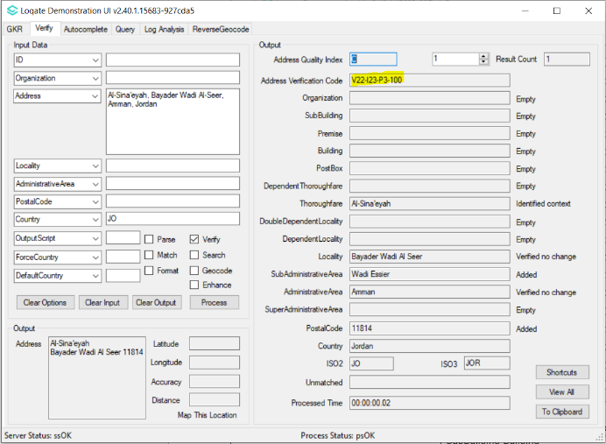

Kenya (L3)

Country Information | Description
ISO2 | KE
ISO3 | KEN
Address Format | Organization  Building SubBuilding  Premise Thoroughfare  DependentThoroughfare  DoubleDependentLocality  DependentLocality  Locality  PostalCode  AdministrativeArea
PDH | YES
PDH completed date | 2021Q4.0
New Source | NO
Reference Data Pre-PDH | rd_KE_vfy.lfs  rd_KE_vfy_ai.lfs  rd_KE_geo.lfs  rd_KE_geo_rg.lfs
Reference Data Post-PDH | rd_KE_vfy.lfs  rd_KE_vfy_ai.lfs  rd_KE_ggg.lfs  rd_KE_ggg_rg.lfs

Previously addresses were only verifiable up to the AdministrativeArea. In the 2021Q4.0 major release, improvements are made to the overall parsing results and higher AVC results are returned.

2021Q3.1 (Before Change) | 2021Q4.0 (After Change)
Only able to verify up till AdministrativeArea  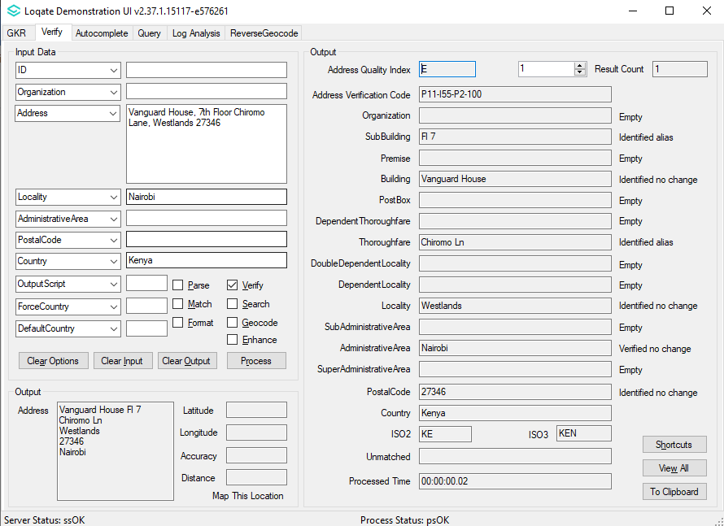 | Able to parse to correct fields which improve the verification levels  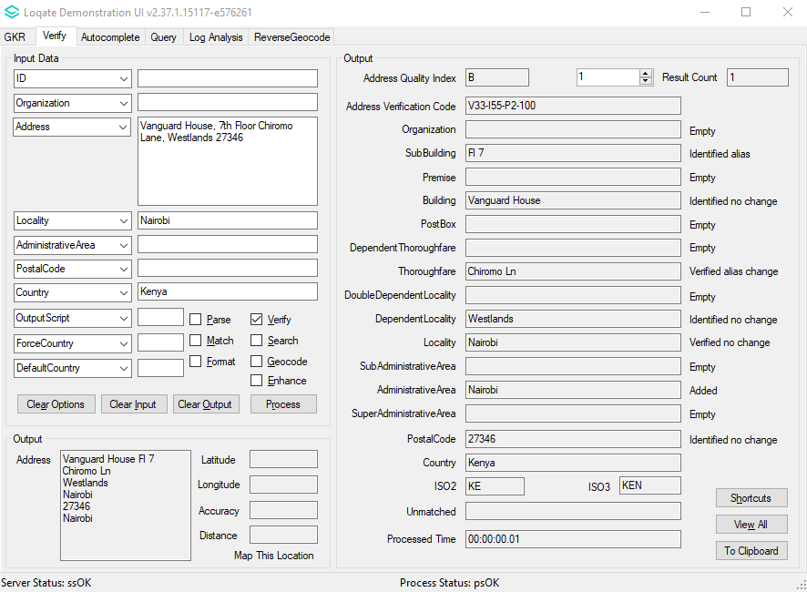

Lao People's Democratic Republic (L2)

Country Information | Description
ISO2 | LA
ISO3 | LAO
Address Format | Organization  PostBox  SubBuilding Building  Premise Thoroughfare  DependentThoroughfare  DoubleDependentLocality  DependentLocality  PostalCode, Locality, AdministrativeArea
PDH | YES
PDH completed date | 2021Q4.0
New Source | NO
Reference Data Pre-PDH | rd_LA_ai.lfs  rd_LA.lfs  rd_LA_rg.lfs
Reference Data Post-PDH | rd_LA_ggg.lfs  rd_LA_ggg_rg.lfs  rd_LA_vfy_ai.lfs  rd_LA_vfy.lfs

Previously addresses may have been unverifiable. In the 2021Q4.0 major release, addresses can be verifiable to the Locality level.

2021Q3.1 (Before Change) | 2021Q4.0 (After Change)
Address cannot be verified.  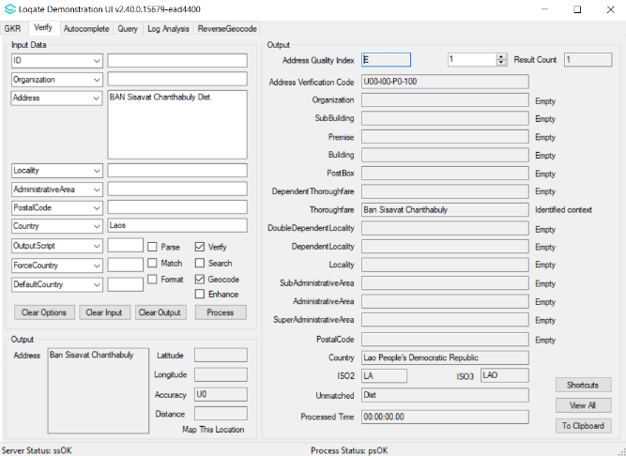 | Locality and SubAdministrativeArea can be verified and AdministrativeArea is added.  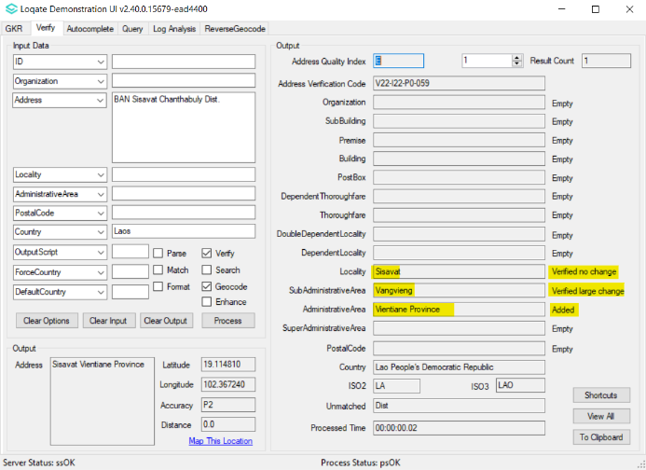

Malta (L3)

Country Information | Description
ISO2 | MT
ISO3 | MLT
Address Format | Organization  PostBox  SubBuilding Building  Premise Thoroughfare  DependentThoroughfare  DoubleDependentLocality  DependentLocality  Locality PostalCode  AdministrativeArea
PDH | YES
PDH completed date | 2021Q4.0
New Source | NO
Reference Data Pre-PDH | rd_MT_ai.lfs  rd_MT_geop.lfs  rd_MT_geop_rg.lfs  rd_MT.lfs  rd_MT_rg.lfs
Reference Data Post-PDH | rd_MT_ggg.lfs  rd_MT_ggg_rg.lfs  rd_MT_vfy_ai.lfs  rd_MT_vfy.lfs

With this release, improvements can be seen in the verification results within the thoroughfare field.

2021Q3.1 (Before Change) | 2021Q4.0 (After Change)
Thoroughfare not verified.  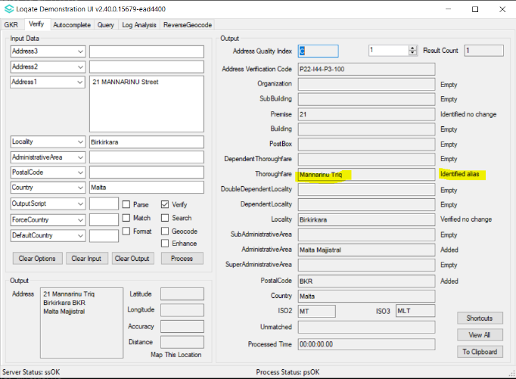 | Thoroughfare verified alias change.  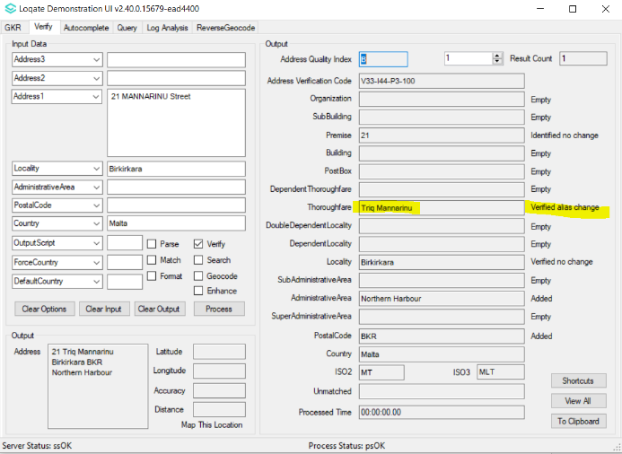

Marshall Islands (L4)

Country Information | Description
ISO2 | MH
ISO3 | MHL
Address Format | Organization  PostBox  SubBuilding Building  Premise Thoroughfare  DependentThoroughfare  DoubleDependentLocality  DependentLocality  Locality AdministrativeArea PostalCode
PDH | YES
PDH completed date | 2021Q4.0
New Source | NO
Reference Data Pre-PDH | rd_MH_vfy.lfs  rd_MH_vfy_ai.lfs  rd_MH_geo.lfs  rd_MH_geo_rg.lfs
Reference Data Post-PDH | rd_MH_vfy.lfs  rd_MH_vfy_ai.lfs  rd_MH_ggg.lfs  rd_MH_ggg_rg.lfs

In the 2021Q4.0 major release, improvements are made within the SubAdministrativeArea and AdministrativeArea fields.

2021Q3.1 (Before Change) | 2021Q4.0 (After Change)
“Marshall Islands” was returning as a SubAdministrativeArea  Titlecase “Mh” for AdministrativeArea  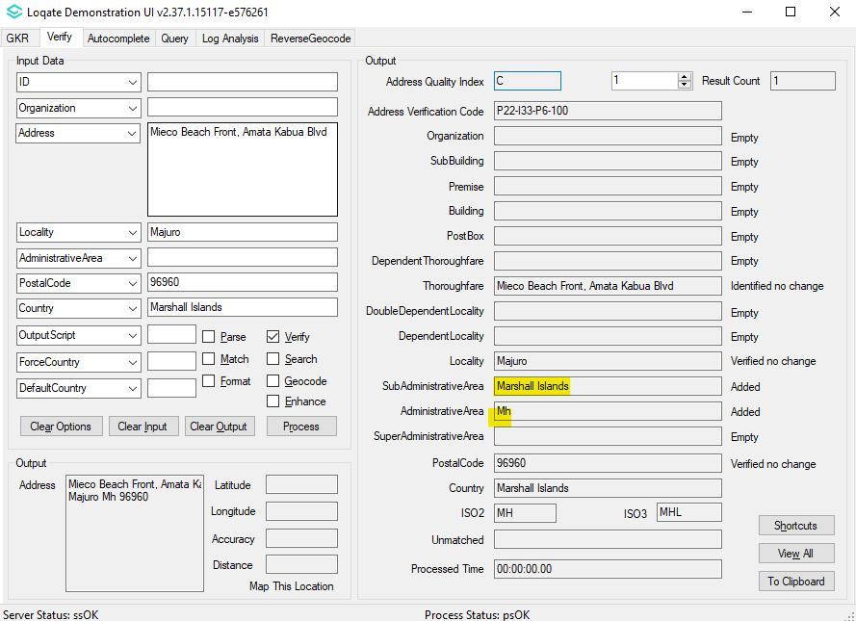 | Correct SubAdministrativeArea returned instead of “Marshall Island”  Uppercase of “MH” for AdministrativeArea  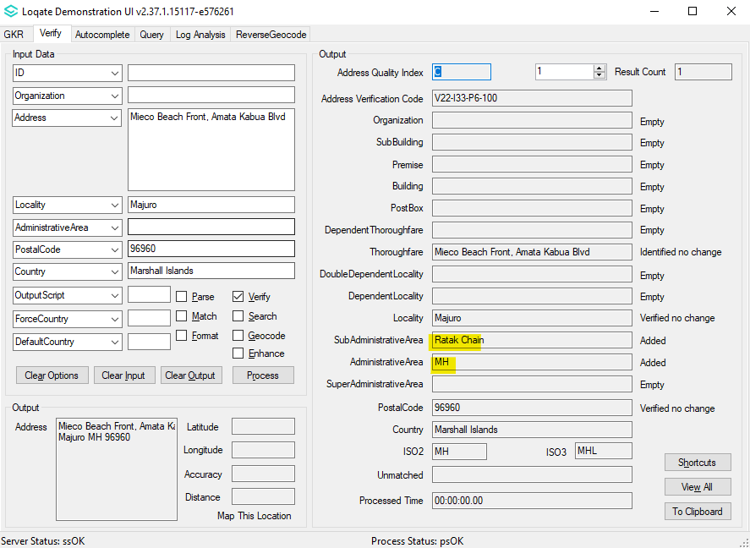

Micronesia (Federated States of) (L2)

Country Information | Description
ISO2 | FM
ISO3 | FSM
Address Format | Organization  PostBox  SubBuilding Building  Premise Thoroughfare  DependentThoroughfare  DoubleDependentLocality  Locality AdministrativeArea PostalCode
PDH | YES
PDH completed date | 2021Q4.0
New Source | NO
Reference Data Pre-PDH | rd_FM_vfy.lfs  rd_FM_vfy_ai.lfs  rd_FM_geo.lfs  rd_FM_geo_rg.lfs
Reference Data Post-PDH | rd_FM_vfy.lfs  rd_FM_vfy_ai.lfs  rd_FM_ggg.lfs  rd_FM_ggg_rg.lfs

Improvements are made to the overall verification results and to the address format.

2021Q3.1 (Before Change) | 2021Q4.0 (After Change)
Unable to verify some of the addresses.  Output is not in correct address format.  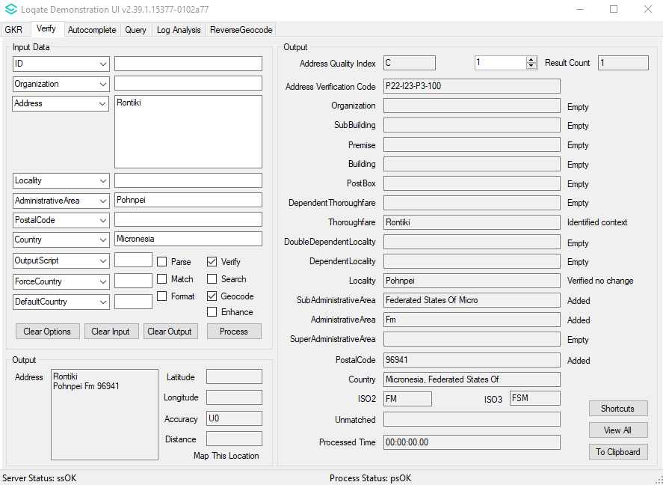 | Able to verify more addresses.  Output following the correct address format.  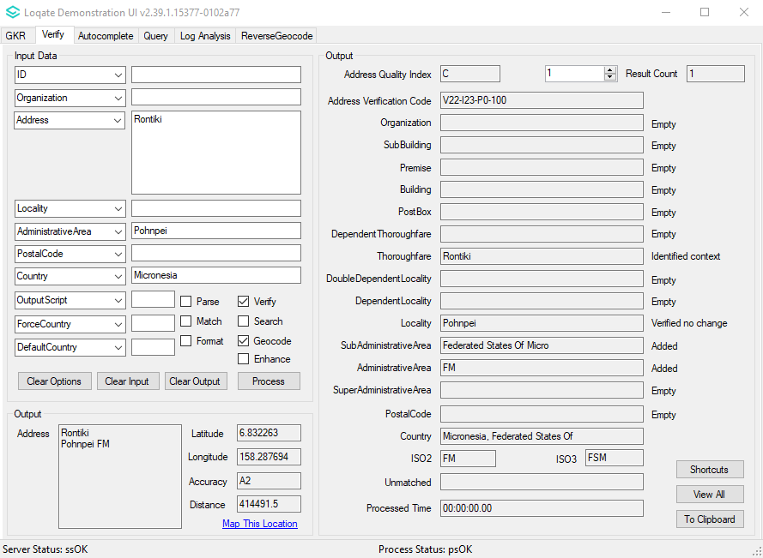

New Caledonia (L4)

Country Information | Description
ISO2 | NC
ISO3 | NCL
Address Format | Organization  PostBox  SubBuilding Building  Premise Thoroughfare  DependentThoroughfare  DoubleDependentLocality  DependentLocality  PostalCode Locality AdministrativeArea
PDH | YES
PDH completed date | 2021Q4.0
New Source | NO
Reference Data Pre-PDH | rd_NC_ai.lfs  rd_NC.lfs  rd_NC_rg.lfs
Reference Data Post-PDH | rd_NC_ggg.lfs  rd_NC_ggg_rg.lfs  rd_NC_vfy_ai.lfs  rd_NC_vfy.lfs

In this release, improvements are made to the verification results within the SubAdministrativeArea, AdministrativeArea, and PostalCode fields.

2021Q3.1 (Before Change) | 2021Q4.0 (After Change)
No SubAdministrativeArea and AdministrativeArea. Postal code is identified.  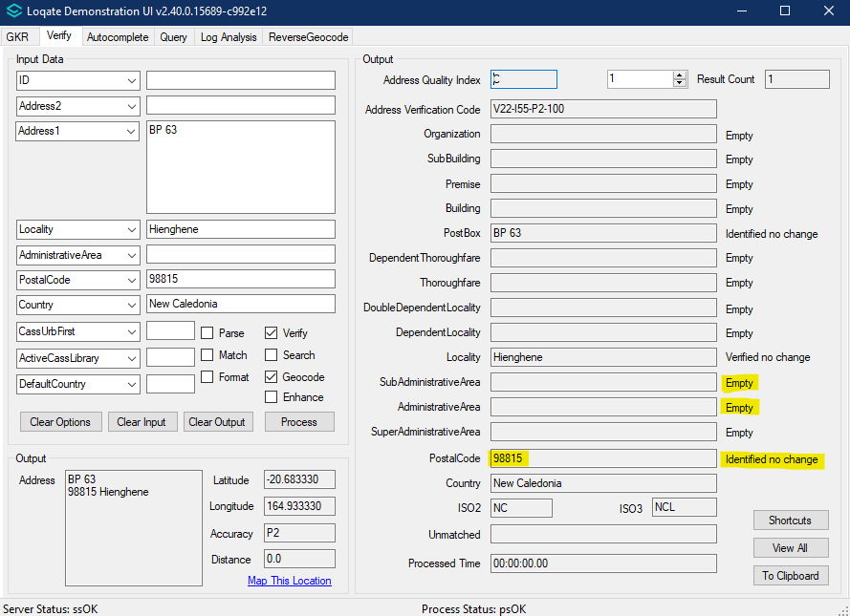 | Added SubAdministrativeArea and AdministrativeArea. Postal code is verified.  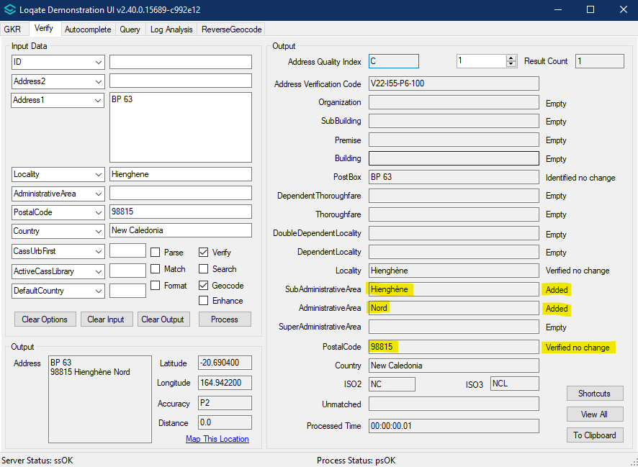

Macedonia, The Former Yugoslav Republic of (L4)

Country Information | Description
ISO2 | MK
ISO3 | MKD
Address Format | Organization  PostBox  Building SubBuilding  Thoroughfare Premise  DependentThoroughfare  DoubleDependentLocality  DependentLocality  PostalCode Locality
PDH | Yes
PDH Completed Date | 2021Q4.0
New Source | NO
Reference Data Pre-PDH | rd_MK.lfs  rd_MK_rg.lfs  rd_MK_ai.lfs  rd_MK_geop.lfs  rd_MK_geop_rg.lfs
Reference Data Post-PDH | rd_MK_ggg.lfs  rd_MK_ggg_rg.lfs  rd_MK_vfy_ai.lfs  rd_MK_vfy.lfs

This release makes improvements to the verification results within the premise and thoroughfare fields.

2021Q3.1 (Before Change) | 2021Q4.0 (After Change)
Premise and thoroughfare not able to be verified | Premise and thoroughfare can now be verified
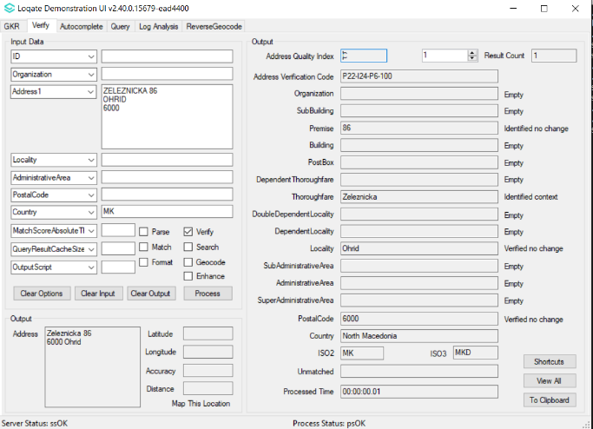 | 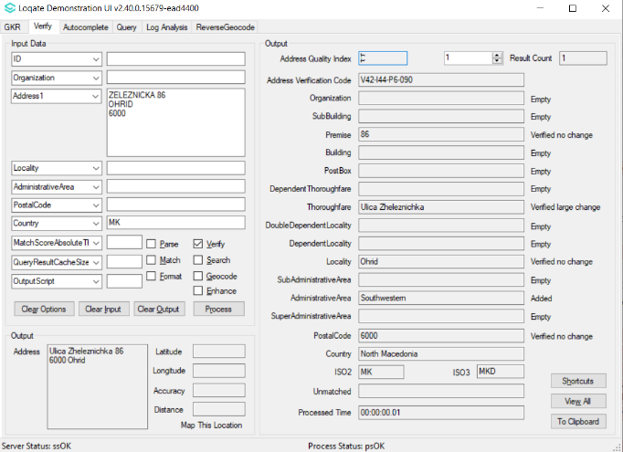

Pakistan (L2)

Country Information | Description
ISO2 | PK
ISO3 | PAK
Address Format | Organization  PostBox  SubBuilding Building  Premise Thoroughfare  DependentThoroughfare  DoubleDependentLocality  DependentLocality  Locality, PostalCode
PDH | YES
PDH completed date | 2021Q4.0
New Source | NO
Reference Data Pre-PDH | rd_PK_ai.lfs  rd_PK.lfs  rd_PK_rg.lfs
Reference Data Post-PDH | rd_PK_ggg.lfs  rd_PK_ggg_rg.lfs  rd_PK_vfy_ai.lfs  rd_PK_vfy.lfs

Previously addresses may have been unverifiable. This release makes improvements to the overall verification and addresses can be verifiable up to the Locality level.

2021Q3.1 (Before Change) | 2021Q4.0 (After Change)
Address cannot be verified  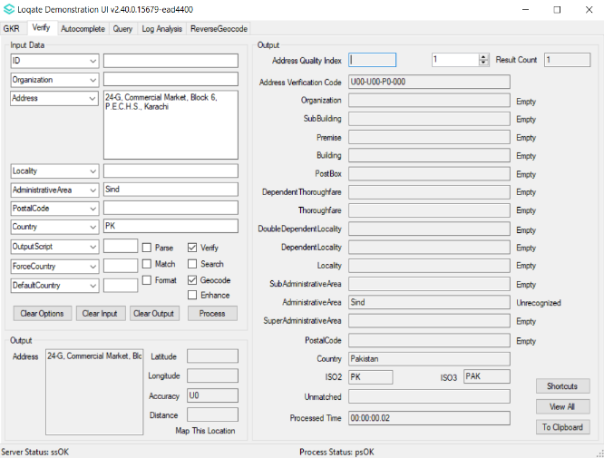 | AdministrativeArea and Locality are verified. Postal code and SubAdministrativeArea are added.  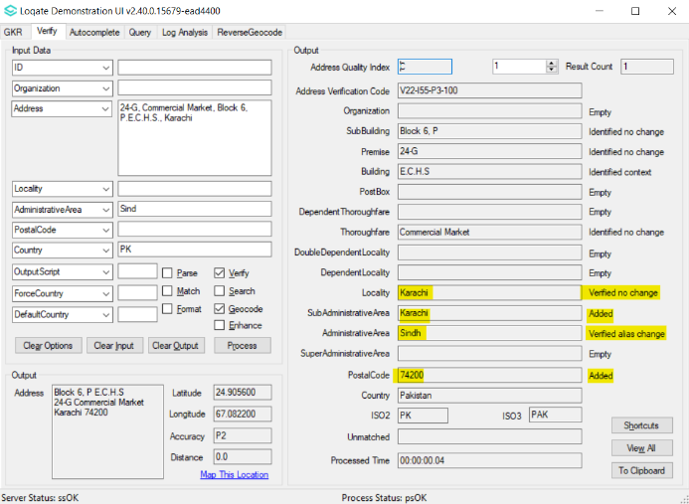

Palau (L2)

Country Information | Description
ISO2 | PW
ISO3 | PLW
Address Format | Organization  PostBox  SubBuilding Building  Premise Thoroughfare  DependentThoroughfare  DoubleDependentLocality  DependentLocality  Locality AdministrativeArea PostalCode
PDH | YES
PDH completed date | 2021Q4.0
New Source | NO
Reference Data Pre-PDH | rd_PW_vfy.lfs  rd_PW_vfy_ai.lfs  rd_PW_geo.lfs  rd_PW_geo_rg.lfs
Reference Data Post-PDH | rd_PW_ggg.lfs  rd_PW_ggg_rg.lfs  rd_PW_vfy_ai.lfs  rd_PW_vfy.lfs

In this release, improvements including address format and verification results can be seen within the AdministrativeArea.

2021Q3.1 (Before Change) | 2021Q4.0 (After Change)
AdministrativeArea is added but not in the correct format.  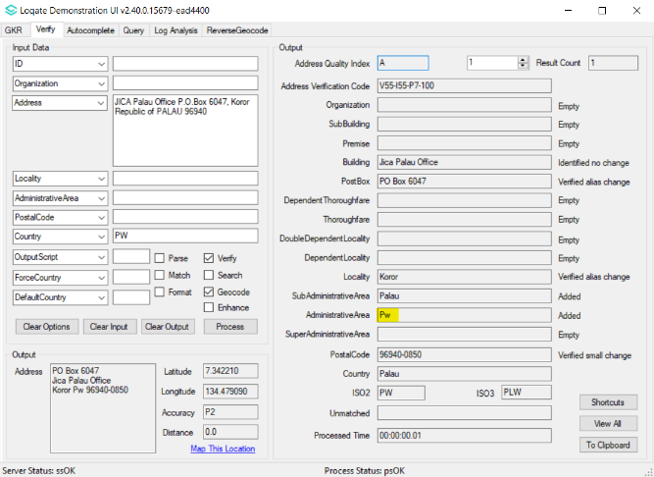 | AdministrativeArea is added and capitalised following the correct format. 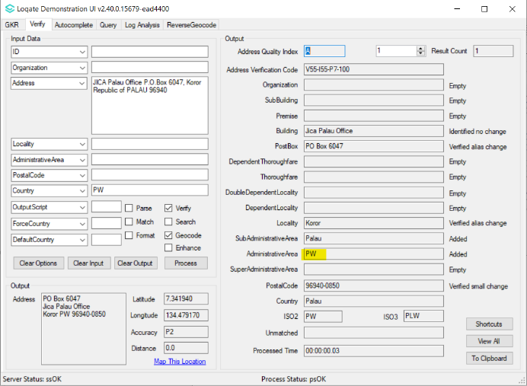

Réunion (L4)

Country Information | Description
ISO2 | RE
ISO3 | REU
Address Format | Organization  PostBox  SubBuilding Building  Premise Thoroughfare  DependentThoroughfare  DoubleDependentLocality  DependentLocality  PostalCode Locality
PDH | YES
PDH completed date | 2021Q4.0
New Source | NO
Reference Data Pre-PDH | rd_RE.lfs  rd_RE_ai.lfs  rd_RE_rg.lfs
Reference Data Post-PDH | rd_RE_vfy.lfs  rd_RE_vfy_ai.lfs  rd_RE_ggg.lfs  rd_RE_ggg_rg.lfs

This release makes improvements to the overall verification results and addresses can be verified up to the premise level.

2021Q3.1 (Before Change) | 2021Q4.0 (After Change)
Addresses are identified up to level 3 (Thoroughfare).  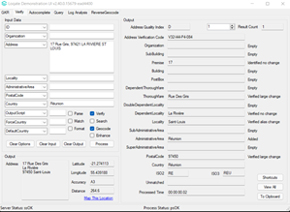 | Able to verify more addresses up to level 4 (premise).  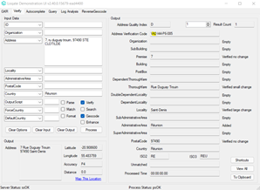

Romania (L4)

Country Information | Description
ISO2 | RO
ISO3 | ROU
Address Format | Organization  PostBox  Thoroughfare Premise Building SubBuilding  DependentThoroughfare  DoubleDependentLocality  DependentLocality  PostalCode Locality
PDH | YES
PDH completed date | 2021Q4.0
New Source | NO
Reference Data Pre-PDH | rd_RO_ai.lfs  rd_RO_geop.lfs  rd_RO_geop_rg.lfs  rd_RO.lfs  rd_RO_rg.lfs
Reference Data Post-PDH | rd_RO_ggg.lfs  rd_RO_ggg_rg.lfs  rd_RO_vfy_ai.lfs  rd_RO_vfy.lfs

This release makes improvements to the verification results within the thoroughfare field.

2021Q3.1 (Before Change) | 2021Q4.0 (After Change)
Thoroughfare without type verified large change.  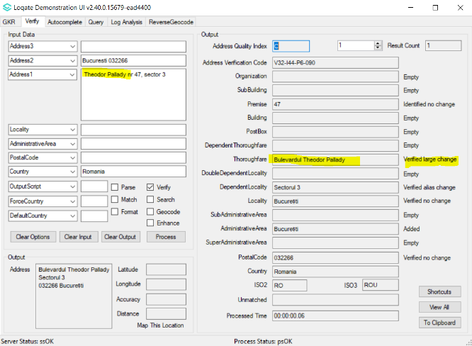 | Thoroughfare without type able to be verified alias change.  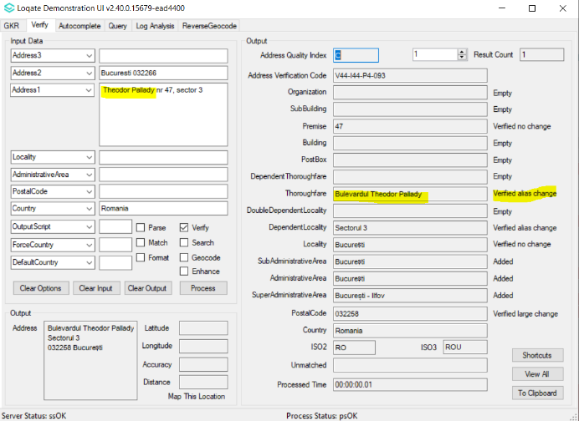

Sao Tome and Principe (L3)

Country Information | Description
ISO2 | ST
ISO3 | STP
Address Format | Organization  PostBox  Building SubBuilding  Thoroughfare Premise  DependentThoroughfare  DoubleDependentLocality  DependentLocality  Locality
PDH | Yes
PDH Completed Date | 2021Q4.0
New Source | NO
Reference Data Pre-PDH | rd_ST.lfs  rd_ST_rg.lfs  rd_ST_ai.lfs
Reference Data Post-PDH | rd_ST_ggg.lfs  rd_ST_ggg_rg.lfs  rd_ST_vfy_ai.lfs  rd_ST_vfy.lfs

The 2021Q4.0 major release makes improvements to the verification results within the thoroughfare field.

2021Q3.1 (Before Change) | 2021Q4.0 (After Change)
Thoroughfare not able to be verified | Thoroughfare able to be verified
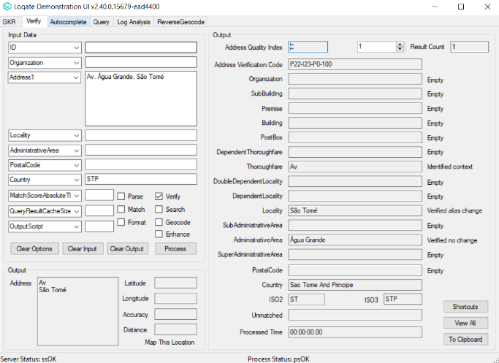 | 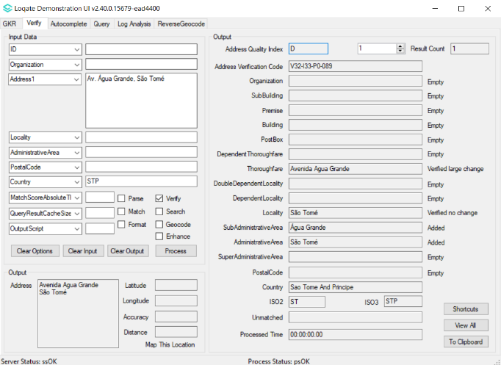

Sri Lanka (L3)

Country Information | Description
ISO2 | LK
ISO3 | LKA
Address Format | Organization  PostBox  SubBuilding Building  Premise Thoroughfare  DependentThoroughfare  DoubleDependentLocality  DependentLocality  Locality  PostalCode
PDH | YES
PDH completed date | 2021Q4.0
New Source | NO
Reference Data Pre-PDH | rd_LK_ai.lfs  rd_LK.lfs  rd_LK_rg.lfs
Reference Data Post-PDH | rd_LK_ggg.lfs  rd_LK_ggg_rg.lfs  rd_LK_vfy_ai.lfs  rd_LK_vfy.lfs

The 2021Q4.0 major release makes improvements to the verification results within the thoroughfare field.

2021Q3.1 (Before Change) | 2021Q4.0 (After Change)
Thoroughfare not verified.  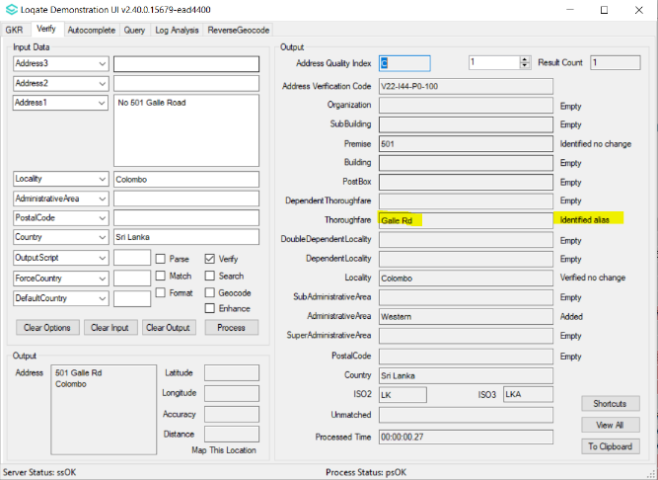 | Thoroughfare verified.  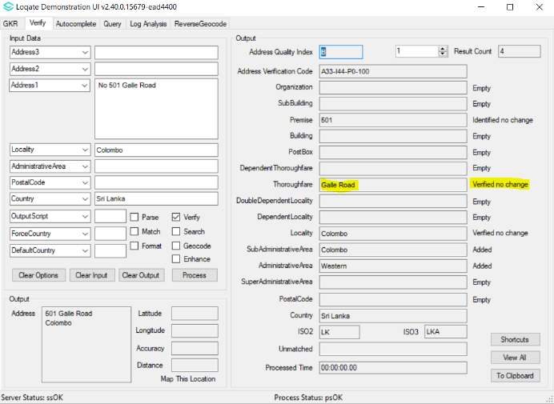

Taiwan (L4)

Country Information | Description
ISO2 | TW
ISO3 | TWN
Address Format | Organization  PostBox  SubBuilding Building  Premise DependentThoroughfare Thoroughfare  DoubleDependentLocality  DependentLocality  PostalCode Locality
PDH | YES
PDH completed date | 2021Q4.0
New Source | NO
Reference Data Pre-PDH | rd_TW_ai.lfs  rd_TW.lfs  rd_TW_rg.lfs  rd_TW_geop_rg.lfs  rd_TW_geop.lfs
Reference Data Post-PDH | rd_TW_ggg.lfs  rd_TW_ggg_rg.lfs  rd_TW_vfy_ai.lfs  rd_TW_vfy.lfs

This release makes improvements to the verification results within the AdministrativeArea, including general field name standardization.

2021Q3.1 (Before Change) | 2021Q4.0 (After Change)
Incorrect AdministrativeArea returned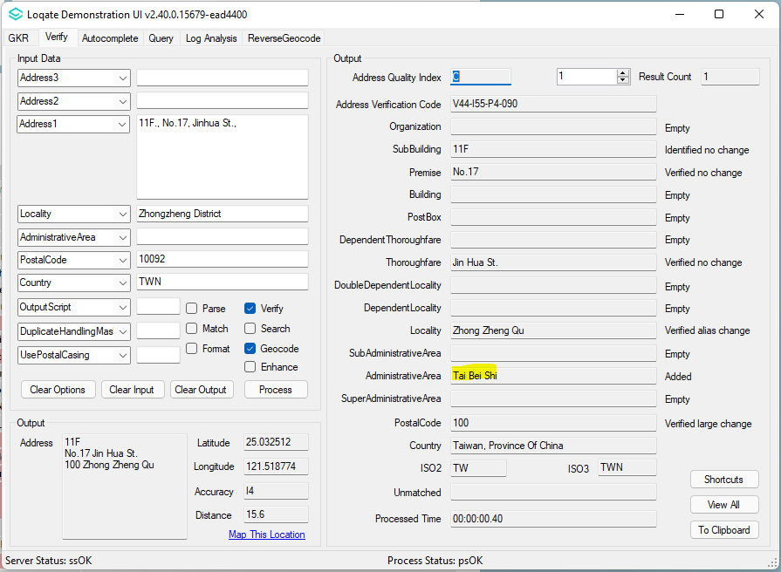 | Correct AdministrativeArea returned  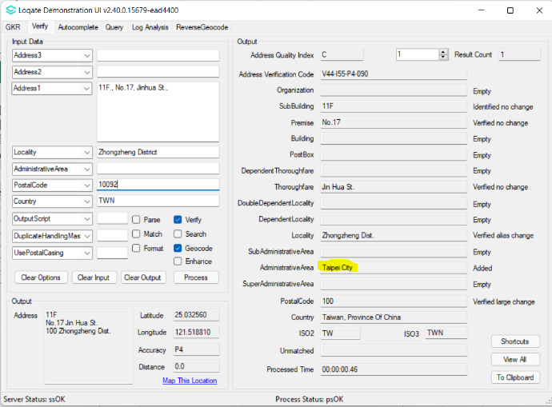

Knowledge Base & Reference Data Updates
The table below shows which countries have been updated, and how, in this release.
If there is a PDH in the reference data column, this shows a country was included in the country improvement project.

- Reference Data: 29 countries
- Lexicon: 4 countries
- Context Rules: 25 countries

COUNTRY NAME | ISO CODE | CONTEXT RULES | LEXICONS | REFERENCE DATA
AFGHANISTAN | AF
ÅLAND ISLANDS | AX
ALBANIA | AL
ALGERIA | DZ
AMERICAN SAMOA | AS
ANDORRA | AD
ANGOLA | AO
ANGUILLA | AI
ANTARCTICA | AQ
ANTIGUA AND BARBUDA | AG |  | X | X
ARGENTINA | AR |  | X
ARMENIA | AM
ARUBA | AW
AUSTRALIA | AU |  | X | X
AUSTRIA | AT
AZERBAIJAN | AZ
BAHAMAS | BS
BAHRAIN | BH
BANGLADESH | BD
BARBADOS | BB
BELARUS | BY
BELGIUM | BE
BELIZE | BZ
BENIN | BJ
BERMUDA | BM
BHUTAN | BT
BOLIVIA (PLURINATIONAL STATE OF) | BO
BONAIRE, SINT EUSTATIUS AND SABA | BQ
BOSNIA AND HERZEGOVINA | BA
BOTSWANA | BW
BOUVET ISLAND | BV
BRAZIL | BR
BRITISH INDIAN OCEAN TERRITORY | IO
BRUNEI DARUSSALAM | BN
BULGARIA | BG
BURKINA FASO | BF
BURUNDI | BI
CABO VERDE | CV
CAMBODIA | KH
CAMEROON | CM
CANADA | CA |  | X | X
CAYMAN ISLANDS | KY
CENTRAL AFRICAN REPUBLIC | CF
CHAD | TD
CHILE | CL
CHINA | CN
CHRISTMAS ISLAND | CX
COCOS (KEELING) ISLANDS | CC
COLOMBIA | CO
COMOROS | KM
CONGO | CG
CONGO, DEMOCRATIC REPUBLIC OF THE | CD
COOK ISLANDS | CK
COSTA RICA | CR |  | X | X
CÔTE D'IVOIRE | CI
CROATIA | HR
CUBA | CU
CURAÇAO | CW
CYPRUS | CY
CZECHIA | CZ
DENMARK | DK
DJIBOUTI | DJ
DOMINICA | DM
DOMINICAN REPUBLIC | DO
ECUADOR | EC
EGYPT | EG
EL SALVADOR | SV |  | X | X
EQUATORIAL GUINEA | GQ
ERITREA | ER
ESTONIA | EE
ETHIOPIA | ET
FALKLAND ISLANDS (MALVINAS) | FK
FAROE ISLANDS | FO
FIJI | FJ
FINLAND | FI
FRANCE | FR |  | X
FRENCH GUIANA | GF
FRENCH POLYNESIA | PF
FRENCH SOUTHERN TERRITORIES | TF
GABON | GA
GAMBIA | GM
GEORGIA | GE
GERMANY | DE |  | X
GHANA | GH
GIBRALTAR | GI
GREECE | GR
GREENLAND | GL
GRENADA | GD
GUADELOUPE | GP
GUAM | GU
GUATEMALA | GT
GUERNSEY | GG |  |  | X
GUINEA | GN
GUINEA-BISSAU | GW
GUYANA | GY
HAITI | HT
HEARD ISLAND AND MCDONALD ISLANDS | HM
HONDURAS | HN
HONG KONG | HK | X | X
HUNGARY | HU
ICELAND | IS |  | X | X
INDIA | IN
INDONESIA | ID
IRAN | IR |  | X
IRAQ | IQ
IRELAND | IE |  |  | X
ISLE OF MAN | IM |  |  | X
ISRAEL | IL |  |  | X
ITALY | IT
JAMAICA | JM |  | X | X
JAPAN | JP
JERSEY | JE |  |  | X
JORDAN | JO |  | X | X
KAZAKHSTAN | KZ
KENYA | KE |  | X | X
KIRIBATI | KI
KOREA (DEMOCRATIC PEOPLE'S REPUBLIC OF) | KP
KOREA, REPUBLIC OF | KR
KUWAIT | KW
KYRGYZSTAN | KG
LAO PEOPLE'S DEMOCRATIC REPUBLIC | LA | X | X | X
LATVIA | LV
LEBANON | LB
LESOTHO | LS
LIBERIA | LR
LIBYA | LY
LIECHTENSTEIN | LI
LITHUANIA | LT
LUXEMBOURG | LU
MACAO | MO
MADAGASCAR | MG
MALAWI | MW
MALAYSIA | MY
MALDIVES | MV
MALI | ML
MALTA | MT |  | X | X
MARSHALL ISLANDS | MH |  |  | X
MARTINIQUE | MQ
MAURITANIA | MR
MAURITIUS | MU
MAYOTTE | YT
MEXICO | MX
MICRONESIA (FEDERATED STATES OF) | FM |  |  | X
MOLDOVA, REPUBLIC OF | MD
MONACO | MC
MONGOLIA | MN
MONTENEGRO | ME
MONTSERRAT | MS
MOROCCO | MA
MOZAMBIQUE | MZ
MYANMAR | MM
NAMIBIA | NA
NAURU | NR
NEPAL | NP
NETHERLANDS | NL |  | X
NEW CALEDONIA | NC |  | X | X
NEW ZEALAND | NZ
NICARAGUA | NI
NIGER | NE
NIGERIA | NG
NIUE | NU
NORFOLK ISLAND | NF
NORTH MACEDONIA | MK |  | X | X
NORTHERN MARIANA ISLANDS | MP
NORWAY | NO
OMAN | OM
PAKISTAN | PK | X | X | X
PALAU | PW |  |  | X
PALESTINE, STATE OF | PS
PANAMA | PA
PAPUA NEW GUINEA | PG
PARAGUAY | PY
PERU | PE
PHILIPPINES | PH
PITCAIRN | PN
POLAND | PL
PORTUGAL | PT
PUERTO RICO | PR
QATAR | QA
RÉUNION | RE |  | X | X
ROMANIA | RO | X | X | X
RUSSIAN FEDERATION | RU
RWANDA | RW
SAINT BARTHÉLEMY | BL
SAINT HELENA, ASCENSION AND TRISTAN DA CUNHA | SH
SAINT KITTS AND NEVIS | KN
SAINT LUCIA | LC
SAINT MARTIN (FRENCH PART) | MF
SAINT PIERRE AND MIQUELON | PM
SAINT VINCENT AND THE GRENADINES | VC
SAMOA | WS
SAN MARINO | SM
SAO TOME AND PRINCIPE | ST |  | X | X
SAUDI ARABIA | SA
SENEGAL | SN
SERBIA | RS
SEYCHELLES | SC
SIERRA LEONE | SL
SINGAPORE | SG
SINT MAARTEN (DUTCH PART) | SX
SLOVAKIA | SK
SLOVENIA | SI
SOLOMON ISLANDS | SB
SOMALIA | SO
SOUTH AFRICA | ZA
SOUTH GEORGIA AND THE SOUTH SANDWICH ISLANDS | GS
SOUTH SUDAN | SS
SPAIN | ES
SRI LANKA | LK |  | X | X
SUDAN | SD
SURINAME | SR
SVALBARD AND JAN MAYEN | SJ
SWAZILAND | SZ
SWEDEN | SE
SWITZERLAND | CH
SYRIAN ARAB REPUBLIC | SY
TAIWAN | TW |  | X | X
TAJIKISTAN | TJ
TANZANIA, UNITED REPUBLIC OF | TZ
THAILAND | TH
TIMOR-LESTE | TL
TOGO | TG
TOKELAU | TK
TONGA | TO
TRINIDAD AND TOBAGO | TT
TUNISIA | TN
TURKEY | TR
TURKMENISTAN | TM
TURKS AND CAICOS ISLANDS | TC
TUVALU | TV
UGANDA | UG
UKRAINE | UA
UNITED ARAB EMIRATES | AE
UNITED KINGDOM | GB |  |  | X
UNITED STATES MINOR OUTLYING ISLANDS | UM
UNITED STATES OF AMERICA | US |  |  | X
URUGUAY | UY
UZBEKISTAN | UZ
VANUATU | VU
VATICAN CITY | VA
VENEZUELA (BOLIVARIAN REPUBLIC OF) | VE
VIET NAM | VN
VIRGIN ISLANDS (BRITISH) | VG
VIRGIN ISLANDS (U.S.) | VI
WALLIS AND FUTUNA | WF
WESTERN SAHARA | EH
YEMEN | YE
ZAMBIA | ZM
ZIMBABWE | ZW

