Loqate, A GBG Solution
Release Notes – Geographic Hierarchy (Seed) Data
2021Q3.1 Minor Release

Overview
The following document identifies all improvements and changes made to the Seed data files for the Loqate 2021Q3.1 Minor Release.

Case Resolutions
The below section includes a summary of resolved cases in this release.

External issue ID | Country | Description
CAS-10846-L4Q5R3 | GP | Updated the incorrect localities in the reference data for the following Localities: Bananier, Pigeon, Sainte Marie and Douville.
 |  | 2021Q3.0 (Before change)  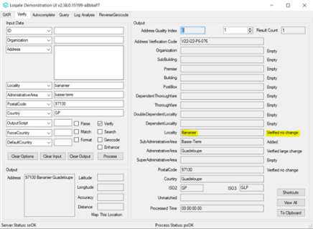 | 2021Q3.1 (After change)  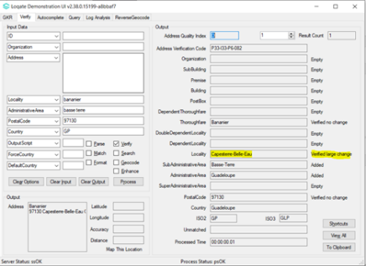
CAS-06589-V6V9P2 | FI | Addition of Swedish language tag.
2021Q3.0 (Before change)
AdministrativeArea 78 Ahvenanmaa<S=LATN,L=FI>|Åland
2021Q3.1 (After change)
AdministrativeArea 78 Ahvenanmaa<S=LATN,L=FI>|Åland<S=LATX,L=SV>

External issue ID | Country | Description
CAS-10705-V5X3X2 | BG | Realignment of Bulgaria Seed structure
2021Q3.0 (Before change):
Locality 10903 AdministrativeArea 10809 Godech<S=LATN,L=EN> 2240
Locality 7102 AdministrativeArea 7094 Dulovo<S=LATN,L=EN> 7650
DependentLocality 6852 Locality 6837 Raynino<S=LATN,L=EN> 7421
DependentLocality 6851 Locality 6837 Podayva<S=LATN,L=EN> 7431
2021Q3.1 (After change):
SubAdministrativeArea 10903 AdministrativeArea 10809 Godech<S=LATN><L=EN>
SubAdministrativeArea 7102 AdministrativeArea 7094 Dulovo<S=LATN><L=EN>
Locality 6852 SubAdministrativeArea 6837 Raynino<S=LATN><L=EN> 7421
Locality 6851 SubAdministrativeArea 6837 Podayva<S=LATN><L=EN> 7431
CAS-10681-C4F5K8 | EE | Updated the localities to better align with postal authorities. This change includes removing Localities that are no longer existing or Localities that have been merged with other Localities.
2021Q3.0 (Before change):
Locality 43111 AdministrativeArea 9264 Rägavere vald<S=LATX,L=ET>|+Raegavere vald|-Ragavere vald|$Rägavere

2021Q3.1 (After change)
Locality 11290 AdministrativeArea 9264 Vinni vald<S=LATN><L=ET>|$Vinni|$Laekvere|$Laekvere vald|$Rägavere|$Rägavere vald|$Wen Ni Xiang|???<S=HANS><L=ZH> 44315|46015|46207

External issue ID | Country | Description
CAS-49408-D0F1L6 | PR | Updated the AdministrativeArea field to include “@” indicator
2021Q3.0 (Before Change):
AdministrativeArea 6219 Puerto Rico<S=LATN><L=ES>|PR
2021Q3.1 (After change):
AdministrativeArea 6219 Puerto Rico<S=LATN><L=ES>|@PR
CAS-10704-J8S2S0 | CZ | Standardized AdministrativeArea names.
2021Q3.0 (Before Change)
DependentLocality 112950 Locality 57108 Velžyszio k.<S=LATX,L=LT>|-Velzyszio k.|$Velzio k.|$Velžys|$Velzys|$Velžio
2021Q3.1 (After change):
AdministrativeArea 121868 KrajVyso?ina<S=LATN><L=CS>|-Kraj Vysocina
CAS-02263-N1J3C8 | DE | Data improvement for the Sachsen AdministrativeArea
 |  | 2021Q3.0 (Before change):
2021Q3.1 (After change):
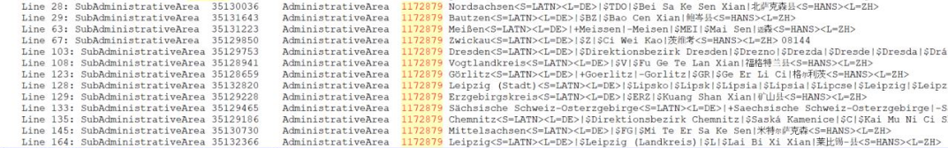
CAS-50744-P3G6X7 / CAS-50751-R1D2Y1 | 5 countries: (LT,RU,TH,TR,VN) | Casing improvement - Title casing for all name
2021Q3.0 (Before change):
DependentLocality 112950 Locality 57108 Velžyszio k.<S=LATX,L=LT>|-Velzyszio k.|$Velžys|$Velzys|$VELZIO K.|$Velžio
2021Q3.1 (After change):
DependentLocality 112950 Locality 57108 Velžyszio k.<S=LATX,L=LT>|-Velzyszio k.|$Velzio k.|$Velžys|$Velzys|$Velžio

File Changes
The table below indicates the count of changed rows between the previous major and current release. There are no or nominal changes for all other country files.

Dataset | Count | Description
AU | 30 | Data refresh; Addition of entries and postalcode
AZ | 787 | Data refresh; Geographical re-structuring: removed DependentLocality field; Addition of entries, aliases and postalcode
BG | 5,857 | Case resolution: CAS-10705-V5X3X2: Geographical re-structuring - Demoting SuperAdministrativeArea,AdministrativeArea to AdministrativeArea,SubAdministrativeArea
CA | 1,102 | Data refresh; Addition of entries and postalcode
CU | 827 | Data refresh; Addition of entries and aliases
CZ | 13,850 | Case resolution: CAS-10704-J8S2S0: AdministrativeArea name correction; PostalCode formatting changed from 58601 to 586 01
DE | 9,820 | Case resolution: CAS-02263-N1J3C8; Data refresh; Bulk recipient postalcode Addition; Addition of entries, aliases, and postalcode
DO | 606 | Data refresh; Addition of entries, aliases, and postalcode
EE | 6,619 | Case resolution: CAS-10681-C4F5K8: Localities (municipality) are now merged; Data refresh; Addition of aliases and postalcode
FI | 487 | Case resolution: CAS-06589-V6V9P2: Valid Swedish aliases are now tagged with Swedish language tag; Data refresh; Addition of entries and postalcode
GB | 682 | Data refresh; Addition of entries and postalcode
GG | 1 | Data refresh; Addition of postalcode
GP | 9 | Case resolution: CAS-10846-L4Q5R3: relocation of locality to dependentLocality
HK | 193 | Data refresh; ID changed due to geographical re-structuring: Demoting SubAdministrativeArea, Locality to Locality, DependentLocality.
IM | 2 | Data refresh; Addition of postalcode
JE | 1 | Data refresh; Addition of entries, postalcode
JM | 888 | Data refresh; Addition of aliases entries
LT | 12 | Casing improvement
MX | 10 | Updated ordering of "@": from Chiapas<S=LATN,L=ES>|$CHA|@CHIS to Chiapas<S=LATN,L=ES>|@CHIS|$CHA
PR | 1 | Case resolution: CAS-49408-D0F1L6 Addition of "@" to valid acronym
RU | 23,798 | Case resolution: CAS-49408-D0F1L6; Casing improvement
RW | 102 | Data refresh; Addition of aliases
TH | 6,142 | Casing improvement
Dataset | Count | Description
TL | 2,821 | Data refresh; Addition of entries
TN | 325 | Data refresh; Addition of entries
TR | 79 | Casing improvement
VN | 182,536 | Casing improvement

Geographic Structure Changes
The following table describe changes to the country structures document.

Dataset | Description
AZ | In the 2021Q3.1 release, the SubAdministrativeArea field is removed in order to better align with the postal authorities.
BG | Updated local field name values to the following:  Previously 2021Q3.1  SuperAdministrativeArea: Oblast AdministrativeArea: Oblast  AdministrativeArea: Obshtin SubAdministrativeArea: Obshti  Locality: Grad Locality: Grad/Naseleno myasto  DependentLocality: Urezhdan DependentLocality: Urezhdan
CW | Info: SubAdministrativeArea from "Y" to "N"
GP | Added DependentLocality field
HK | Updated local field name values to the following:  Loqate Field Previously 2021Q2.1  SuperAdministrativeArea Region Special Administrative Regio  AdministrativeArea District Region  SubAdministrativeArea SubAdministrativeAre: Sub-district Locality: District  DependentLocality Village Settlemen

