Loqate, A GBG Solution
Release Notes – Reference Data & Knowledge Base
2021Q3.1 Minor Release

Case Resolutions
Please visit https://support.loqate.com/release-information/2021q3-1-resolved-cases/ for a list of cases resolved in this release. If you would like more details on any of the solved cases listed, please contact LoqateSupport@gbgplc.com for further information.

Certification Expiration Dates
If you have purchased either the CASS (USA) or AMAS (Australia) certified products, please be aware that the datasets have expiration dates set by the respective postal authorities. Please ensure that you have the latest library and data installed to avoid loss of service through these products.

Please check Install Manager for the latest versions of AMAS and CASS.
 | Loqate Release Date | Certification Expiry Date*
AMAS Data | 2021-08-13 | 2021-12-31
CASS Data | 2021-08-13 | 2021-11-28
*Certification Expiry Date is different from Loqate license key expiry date. The earliest expiry date will apply.

For more information on expiry date checking for CASS and AMAS, please refer “Usage expiration” section in https://support.loqate.com/documentation/local-apis/cass-overview-2/ and https://support.loqate.com/address-matching-approval-system-amas/

Data Notices

Czech Republic

In the 2021Q3.1 minor release, the PostalCode formatting has been updated in order to better align with the postal authorities. Previously the PostalCode may not have included a space. In this release, the space is included.

2021Q3.0 (Before change) | 2021Q3.1 (After change)
Postal code with its space removed. | Postal code with its space restored.
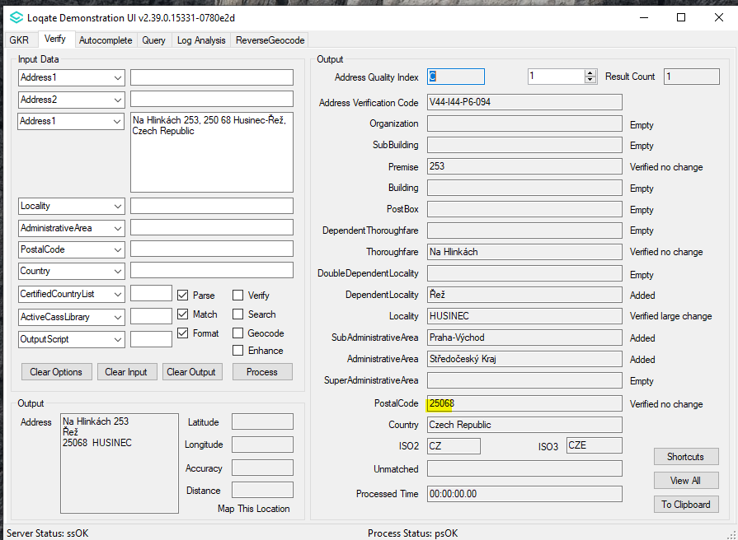 | 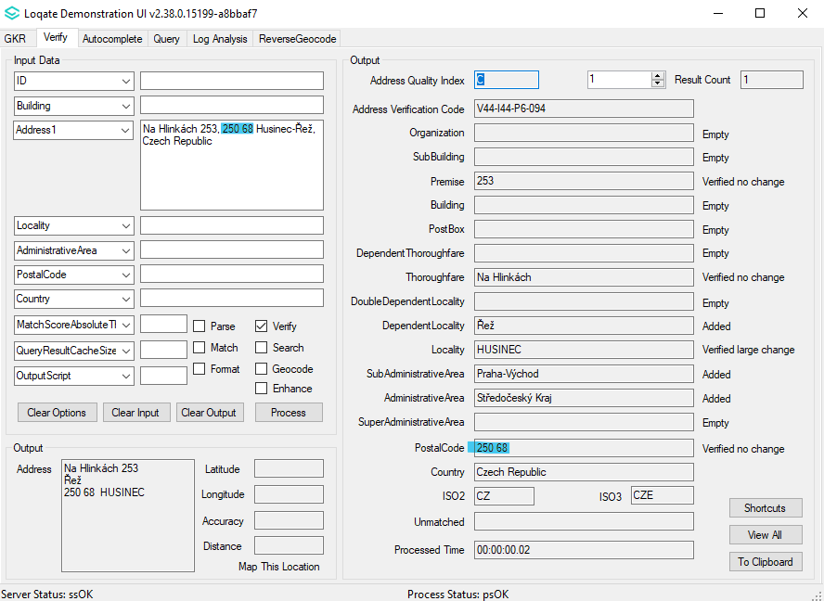

Germany

Previously users of the bulk recipients addresses may have experienced certain addresses where the organization name was unverifiable, this issue is now resolved with the 2021Q3.1 minor release. Organization Name, Locality, and PostalCode fields have improved verification results for the bulk recipient addresses.

2021Q3.0 (Before change) | 2021Q3.1 (After change)
Organization Name for bulk recipients address format was not verified.  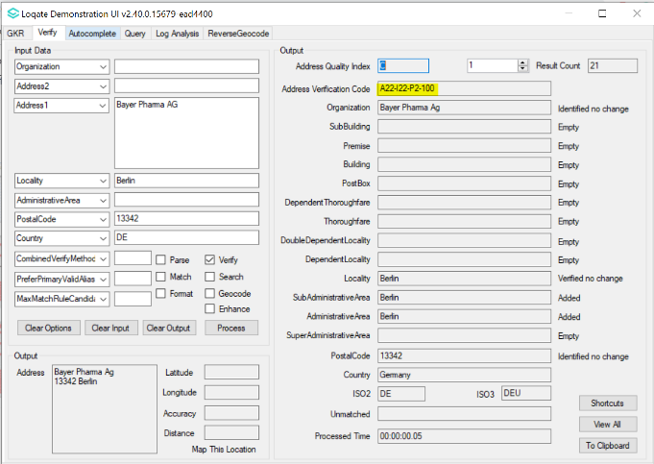 | Organization Name, Locality and Postal Code input are now verified up to L5.  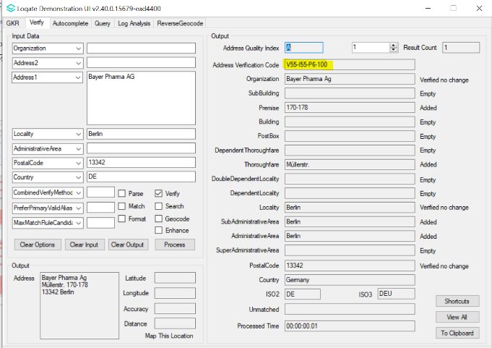

Hong Kong

Improvements have been made to the alignment of the below fields for HongKong:

The Locality field has been moved to the AdministrativeArea field.
The DependentLocality field has been moved to the Locality field.
The DoubleDependentLocality has been moved to the DependentLocality field.

USA Territories

According to the: https://www.cia.gov/the-world-factbook/field/independence: Micronesia, Federated States of (ISO2: FM), Marshall Islands (ISO2: MH), and Palau (ISO2: PW) are considered independent from the USA.

As these nations are considered independent countries, beginning in the 2021Q4.0 major release, the following countries will be removed from the USA data set:

FM - Federated States of Micronesia
MH - Marshall Islands
PW – Palau

USA CASS2 Engine

Please note: From the 2021Q2.0 major release, the USA CASS2 engine will be made available. Information on the USA CASS2 engine can be found on the support site here. Please contact your account manager for additional information in regards to accessing USA CASS2.

Data Improvements

Azerbaijan (L4)

Country Information | Description
ISO2 | AZ
ISO3 | AZE
Address Format | Organization  PostBox  SubBuilding Building  Premise Thoroughfare  DependentThoroughfare  DoubleDependentLocality  DependentLocality  PostalCode Locality  AdministrativeArea
PDH | YES
PDH completed date | 2021Q3.1
New Source | NO
Reference Data Pre-PDH | rd_AZ_ggg.lfs  rd_AZ_ggg_rg.lfs  rd_AZ_vfy_ai.lfs  rd_AZ_vfy.lfs
Reference Data Post-PDH | rd_AZ_geo.lfs  rd_AZ_geo_rg.lfs  rd_AZ_vfy_ai.lfs  rd_AZ_vfy.lfs

This release makes improvements to the verification results within the Thoroughfare fields.

2021Q3.0 (Before change) | 2021Q3.1 (After change)
Thoroughfare not verified.  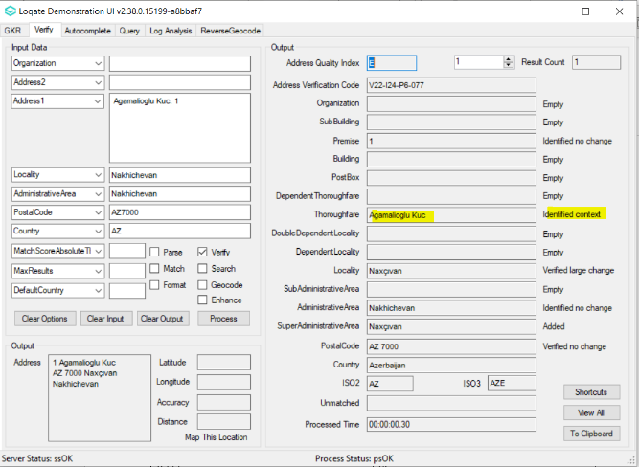 | Thoroughfare verified alias change.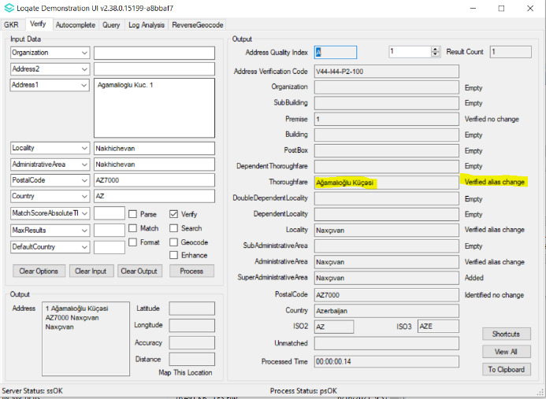

Bulgaria (L4)

Country Information | Description
ISO2 | BG
ISO3 | BGR
Address Format | Organization  PostBox  Thoroughfare Premise Building SubBuilding  DependentThoroughfare  DoubleDependentLocality  DependentLocality  PostalCode Locality
PDH | YES
PDH completed date | 2021Q3.1
New Source | NO
Reference Data Pre-PDH | rd_BG_ai.lfs  rd_BG_geop.lfs  rd_BG_geop_rg.lfs  rd_BG.lfs  rd_BG_rg.lfs
Reference Data Post-PDH | rd_BG_ggg.lfs  rd_BG_ggg_rg.lfs  rd_BG_vfy_ai.lfs  rd_BG_vfy.lfs

Improvements have been made to the verification results within the thoroughfare field.

2021Q3.0 (Before change) | 2021Q3.1 (After change)
Input thoroughfare without thoroughfare type verified large change.  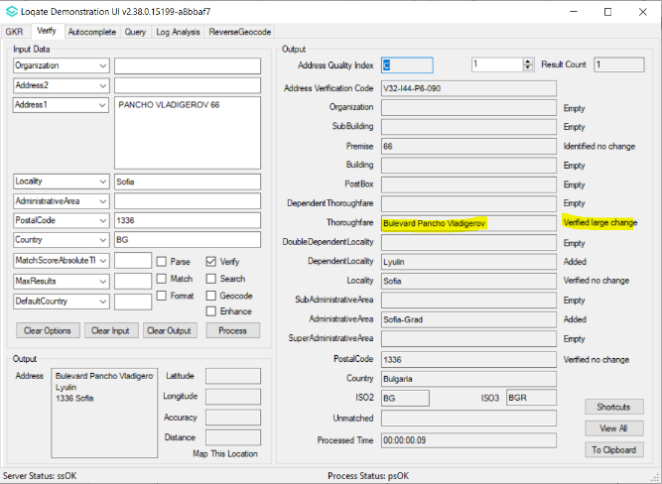 | Input thoroughfare without thoroughfare type verified alias change.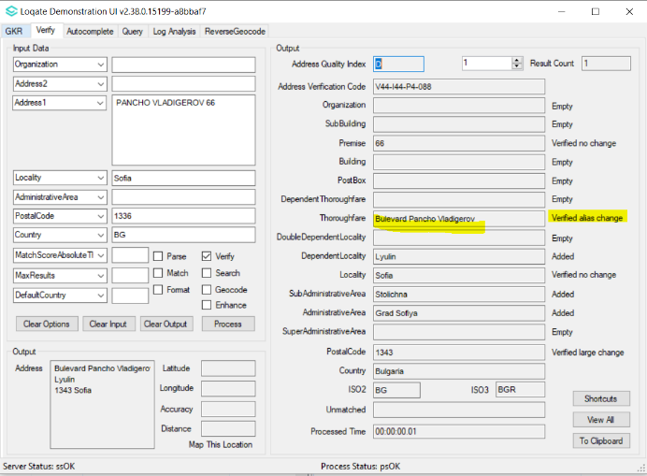

Cuba (L3)

Country Information | Description
ISO2 | CU
ISO3 | CUB
Address Format | Organization  PostBox  Thoroughfare Premise DependentThoroughfare Building SubBuilding  DoubleDependentLocality  DependentLocality  PostalCode Locality AdministrativeArea
PDH | YES
PDH completed date | 2021Q3.1
New Source | NO
Reference Data Pre-PDH | rd_CU.lfs  rd_CU_ai.lfs  rd_CU_rg.lfs
Reference Data Post-PDH | rd_CU_ggg.lfs  rd_CU_ggg_rg.lfs  rd_CU_vfy_ai.lfs  rd_CU_vfy.lfs

This release makes improvements to the verification results within the Thoroughfare and Locality fields.

2021Q3.0 (Before change) | 2021Q3.1 (After change)
Thoroughfare was not verified, and Locality was incorrectly verified.  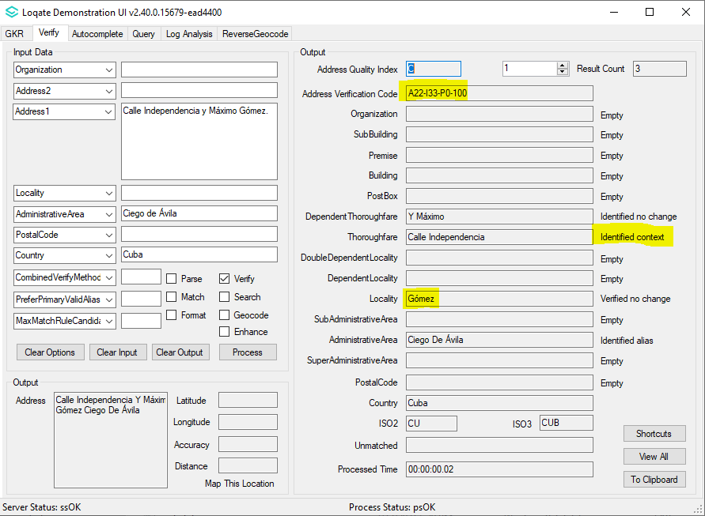 | Thoroughfare and Locality are now correctly verified.  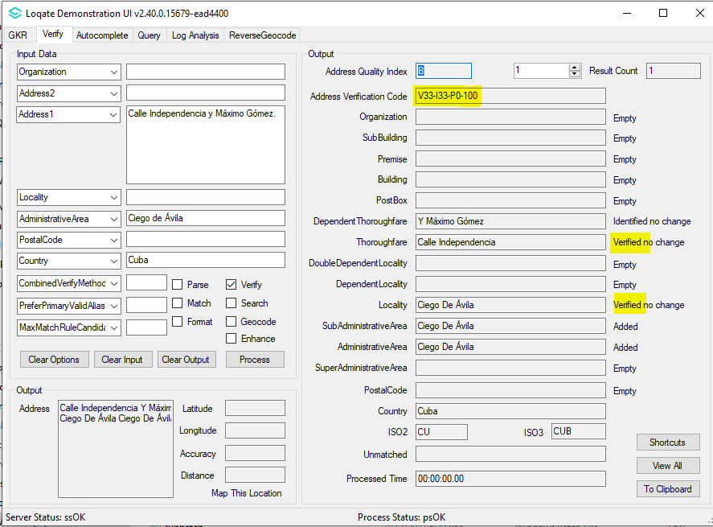

Dominican Republic (L3)

Country Information | Description
ISO2 | DO
ISO3 | DOM
Address Format | Organization  PostBox  Building SubBuilding  Thoroughfare Premise  DependentThoroughfare  DoubleDependentLocality  DependentLocality  PostalCode Locality
PDH | YES
PDH completed date | 2021Q3.1
New Source | NO
Reference data Pre-PDH | rd_DO.lfs  rd_DO_ai.lfs  rd_DO_rg.lfs
Reference data Post-PDH | rd_DO_vfy.lfs  rd_DO_vfy_ai.lfs  rd_DO_ggg.lfs  rd_DO_ggg_rg.lfs

This release makes improvements to the overall alignment and addresses are now verified with the expected hierarchy.

2021Q3.0 (Before change) | 2021Q3.1 (After change)
Many addresses may have be verified with unexpected hierarchy.  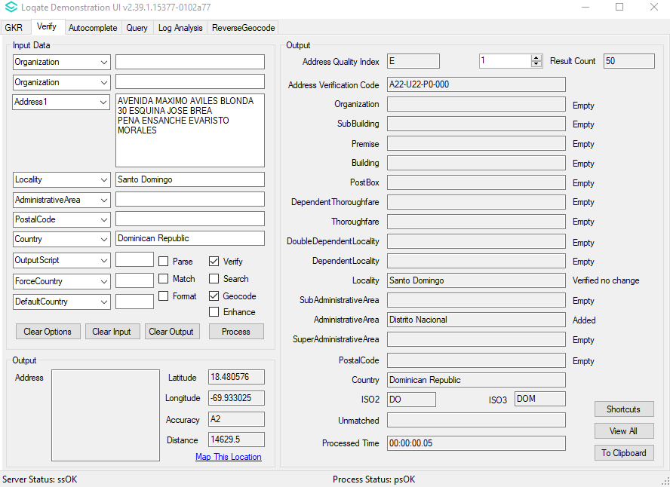 | Addresses are now in the correct hierarchy.  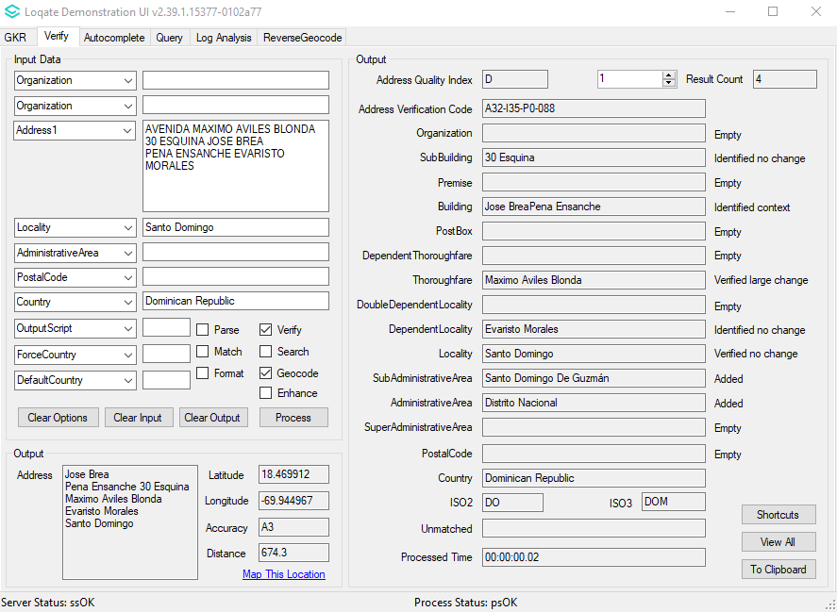

Estonia (L4)

Country Information | Description
ISO2 | EE
ISO3 | EST
Address Format | Organization  PostBox  Building SubBuilding  Thoroughfare Premise  DependentThoroughfare  DoubleDependentLocality  DependentLocality  PostalCode Locality
PDH | YES
PDH Completed Date | 2021Q3.1
New Source | NO
Reference Data Pre-PDH | rd_EE.lfs  rd_EE_rg.lfs  rd_EE_geop_rg.lfs  rd_EE_geop.lfs  rd_EE_ai.lfs
Reference Data Post-PDH | rd_EE_vfy.lfs  rd_EE_vfy_ai.lfs  rd_EE_ggg.lfs  rd_EE_ggg_rg.lfs

AdministrativeArea and Locality names have been updated to the newer names.

2021Q3.0 (Before change) | 2021Q3.1 (After change)
Administrative Area and Locality names are of older version. | Administrative Area and Locality names are now of the newer version.
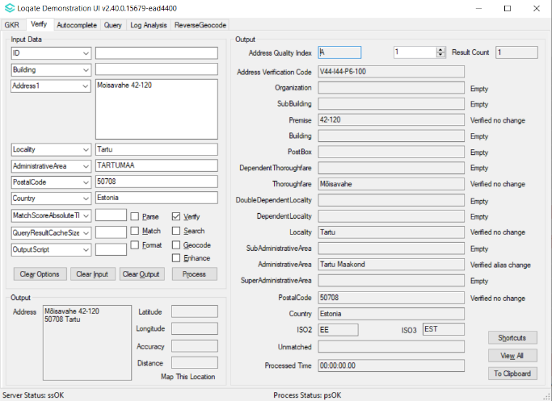 | 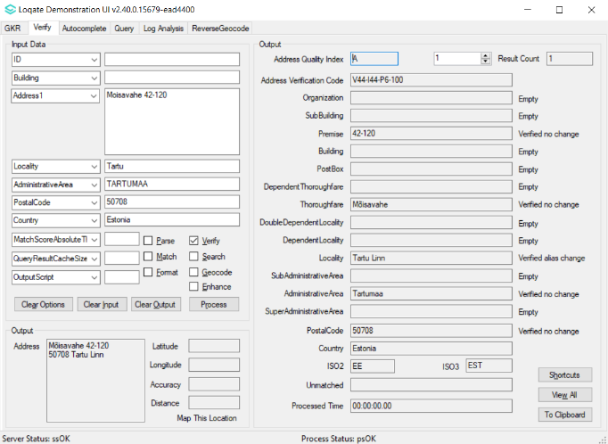

Guadeloupe (L4)

Country Information | Description
ISO2 | GP
ISO3 | GLP
Address Format | Organization  PostBox  SubBuilding Building  Premise Thoroughfare  DependentThoroughfare  DoubleDependentLocality  DependentLocality  PostalCode Locality AdministrativeArea
PDH | YES
PDH completed date | 2021Q3.1
New Source | NO
Reference Data Pre-PDH | rd_GP_vfy.lfs  rd_GP_vfy_ai.lfs  rd_GP_ggg.lfs  rd_GP_ggg_rg.lfs
Reference Data Post-PDH | rd_GP_vfy.lfs  rd_GP_vfy_ai.lfs  rd_GP_ggg.lfs  rd_GP_ggg_rg.lfs

The 2021Q3.1 minor release makes improvements to the paring results within the Thoroughfare field.

2021Q3.0 (Before change) | 2021Q3.1 (After change)
Thoroughfare parsed incorrectly  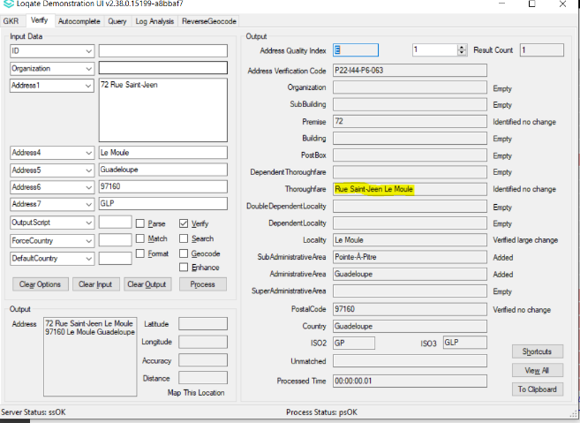 | Fixed the parsing thoroughfare issue  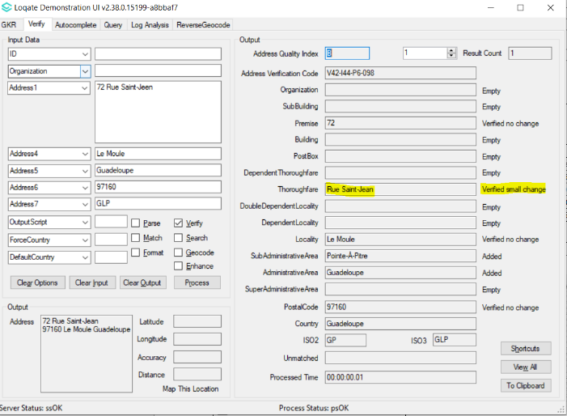

Hong Kong (L5)

Country Information | Description
ISO2 | HK
ISO3 | HKG
Address Format | Organization  PostBox  SubBuilding BuildingPhase  Building  Premise Thoroughfare  DependentThoroughfare  DependentLocality  Locality  AdministrativeArea
PDH | YES
PDH completed date | 2021Q3.1
New Source | YES
Reference Data Pre-PDH | rd_HK_geo.lfs  rd_HK_geo_rg.lfs  rd_HK_vfy_ai.lfs  rd_HK_vfy.lfs
Reference Data Post-PDH | rd_HK_ggg.lfs  rd_HK_ggg_rg.lfs  rd_HK_vfy_ai.lfs  rd_HK_vfy.lfs

In this release, improvements have been made to the alignment between the AdministrativeArea fields, Locality, DependentLocality, and DoubleDependentLocality.

The Locality field has been moved to the AdministrativeArea field.
The DependentLocality field has been moved to the Locality field.
The DoubleDependentLocality has been moved to the DependentLocality field.

2021Q3.0 (Before change) | 2021Q3.1 (After change)
Alignment: Locality, DependentLocality, DoubleDependentLocality.  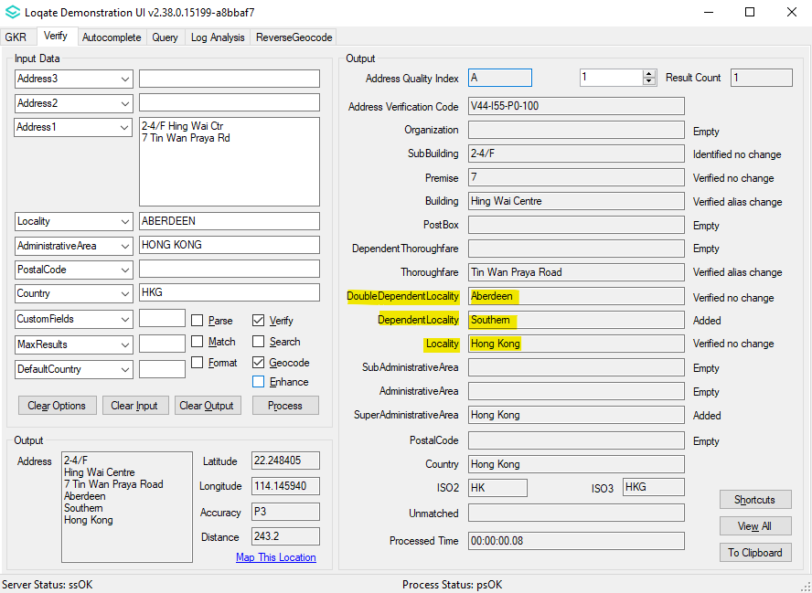 | Alignment change: previous Locality is now Administrative Area, previous DependentLocality is now Locality, previous DoubleDependentLocality is now DependentLocality.  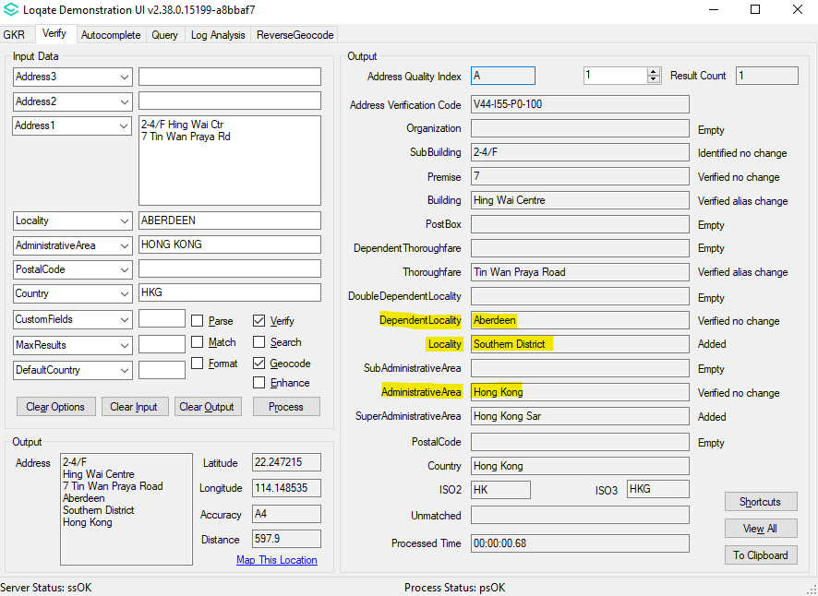
DoubleDependentLocality not verified.  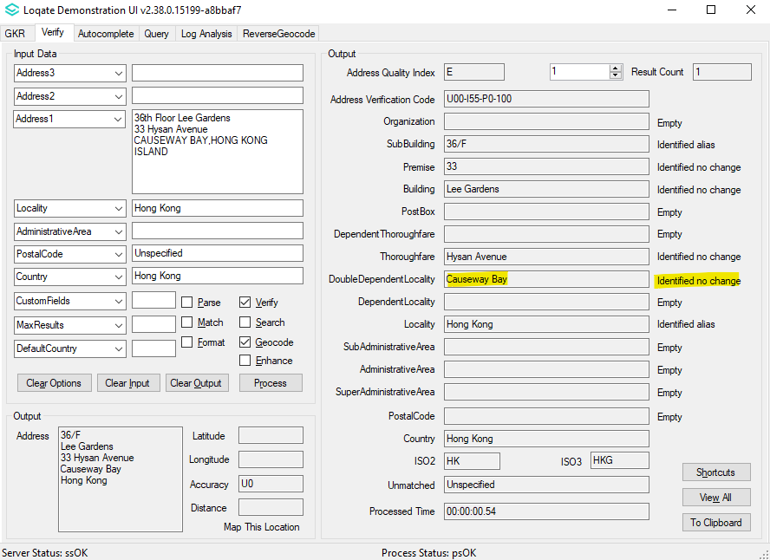 | DependentLocality (previously DoubleDependentLocality) can be verified correctly.  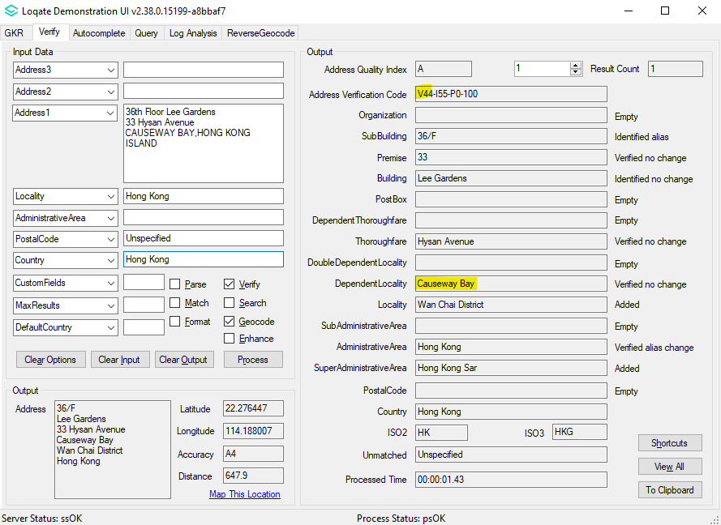

Jamaica (L3)

Country Information | Description
ISO2 | JM
ISO3 | JAM
Address Format | Default format:  Organization  PostBox  SubBuilding Building  Premise Thoroughfare  DependentThoroughfare  DependentLocality  Locality  AdministrativeArea  Conditional formatting (If PostalCode present):  Organization  PostBox  SubBuilding Building  Premise Thoroughfare  DependentThoroughfare  Locality PostalCode
PDH | YES
PDH completed date | 2021Q3.1
New Source | NO
Reference Data Pre-PDH | rd_JM_vfy.lfs  rd_JM_vfy_ai.lfs  rd_JM_ggg.lfs  rd_JM_ggg_rg.lfs
Reference Data Post-PDH | rd_JM_vfy.lfs  rd_JM_vfy_ai.lfs  rd_JM_ggg.lfs  rd_JM_ggg_rg.lfs

Rwanda (L3)

Country Information | Description
ISO2 | RW
ISO3 | RWA
Address Format | Organization  PostBox  SubBuilding Building  Premise Thoroughfare  DependentThoroughfare  DoubleDependentLocality  DependentLocality  Locality
PDH | YES
PDH completed date | 2021Q3.1
New Source | NO
Reference Data Pre-PDH | rd_RW.lfs  rd_RW_ai.lfs  rd_RW_rg.lfs
Reference Data Post-PDH | rd_RW_vfy.lfs  rd_RW_vfy_ai.lfs  rd_RW_ggg.lfs  rd_RW_ggg_rg.lfs

The 2021Q3.1 minor release makes improvements to the overall alignment of addresses and improvements are made to the overall verification results for addresses in Rwanda. .

2021Q3.0 (Before change) | 2021Q3.1 (After change)
Addresses may have been in the wrong hierarchy.  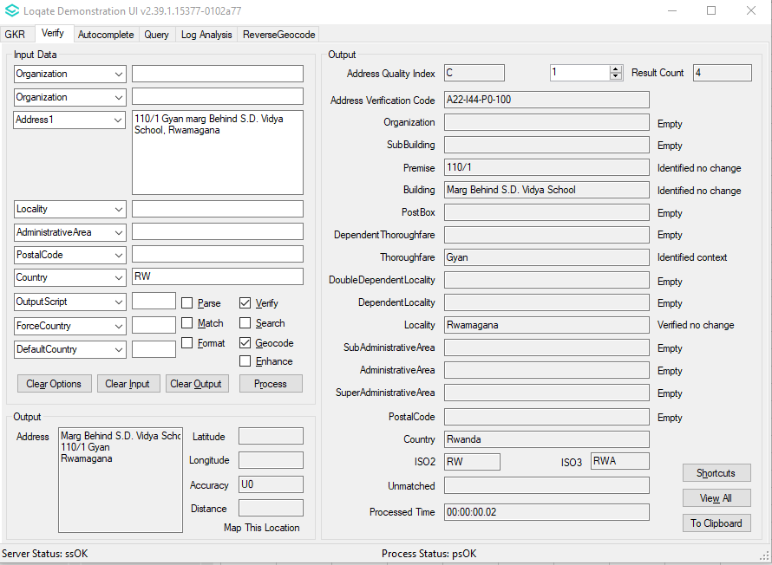 | Addresses are now verified in the correct hierarchy.  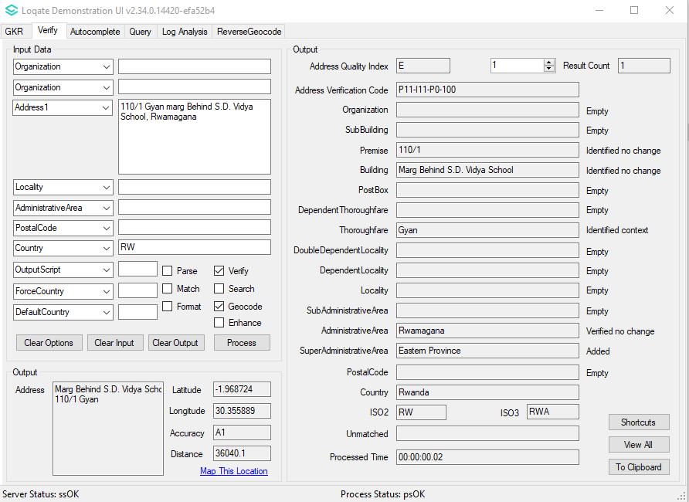

Solomon Islands (L2)

Country Information | Description
ISO2 | SB
ISO3 | SLB
Address Format | Organization  PostBox  SubBuilding Building  Premise Thoroughfare  DependentThoroughfare  DoubleDependentLocality  DependentLocality  Locality  AdministrativeArea
PDH | YES
PDH completed date | 2021Q3.1
New Source | NO
Reference Data Pre-PDH | rd_SB.lfs  rd_SB_ai.lfs  rd_SB_rg.lfs
Reference Data Post-PDH | rd_SB_vfy.lfs  rd_SB_vfy_ai.lfs  rd_SB_ggg.lfs  rd_SB_ggg_rg.lfs

In the 2021Q3.1 minor release, improvements have been made to the verification level within the Locality field.

2021Q3.0 (Before change) | 2021Q3.1 (After change)
Some addresses were returning U0 even Locality was in input.  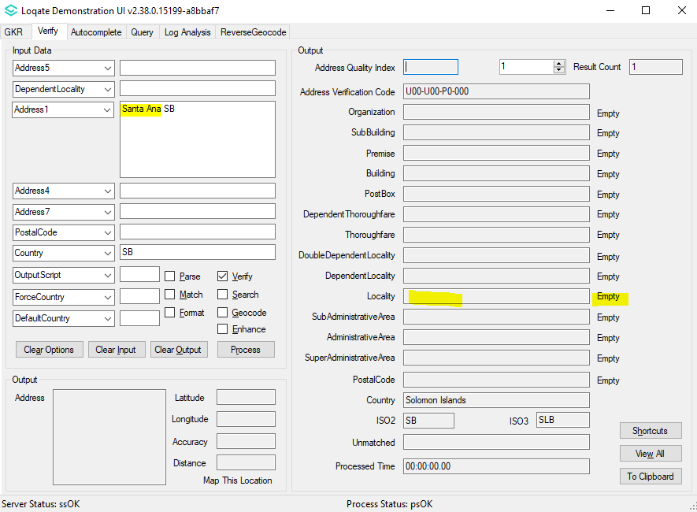 | Those addresses are now able to verify up to Locality level.  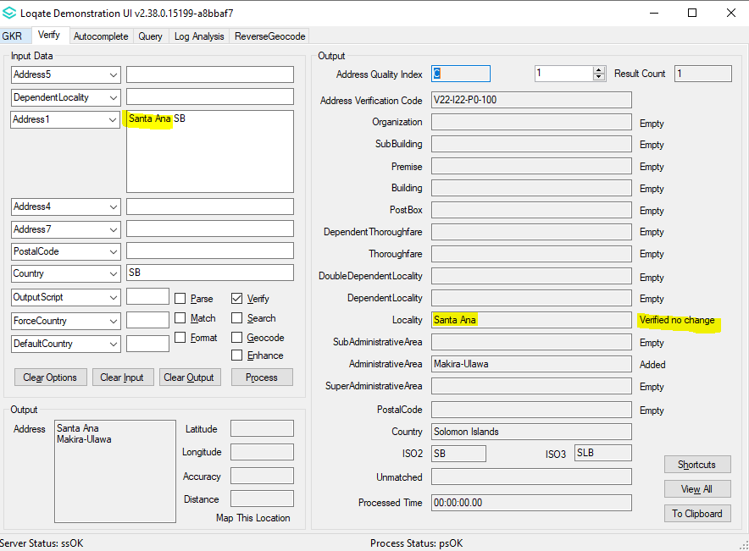

Timor-Leste (L2)

Country Information | Description
ISO2 | TL
ISO3 | TLS
Address Format | Organization  PostBox  SubBuilding Building  Premise Thoroughfare  DependentThoroughfare  DoubleDependentLocality  DependentLocality  Locality PostalCode
PDH | YES
PDH completed date | 2021Q3.1
New Source | NO
Reference Data Pre-PDH | rd_TL.lfs  rd_TL_ai.lfs  rd_TL_rg.lfs
Reference Data Post-PDH | rd_TL_vfy.lfs  rd_TL_vfy_ai.lfs  rd_TL_ggg.lfs  rd_TL_ggg_rg.lfs

In this release, improvements have been made to increase the verification results of addresses in Timor-Leste.

2021Q3.0 (Before change) | 2021Q3.1 (After change)
Unable to verify some addresses.  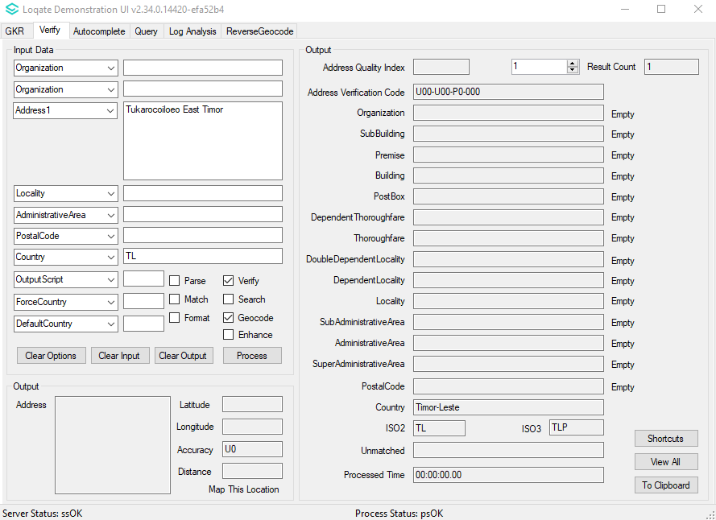 | Improved verification for some addresses.  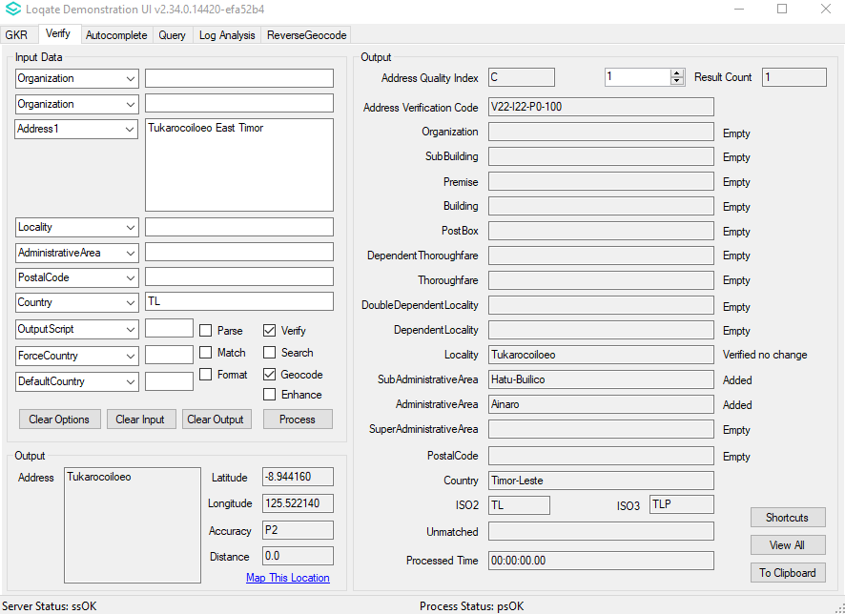

Tunisia (L4)

Country Information | Description
ISO2 | TN
ISO3 | TUN
Address Format | Organization  PostBox  Building SubBuilding  Thoroughfare Premise  DependentThoroughfare  DoubleDependentLocality  DependentLocality  PostalCode Locality
PDH | YES
PDH completed date | 2021Q3.1
New Source | NO
Reference Data Pre-PDH | rd_TN.lfs  rd_TN_ai.lfs  rd_TN_rg.lfs
Reference Data Post-PDH | rd_TN_vfy.lfs  rd_TN_vfy_ai.lfs  rd_TN_ggg.lfs  rd_TN_ggg_rg.lfs

In the 2021Q3.1 minor release, the parsing between the AdministrativeArea and SuperAdministrativeArea fields are resolved. Improvements have also been made to the verification results within the Premise field.

2021Q3.0 (Before change) | 2021Q3.1 (After change)
Premise was unverified and incorrect parsing of AdministrativeArea to SuperAdministrativeArea  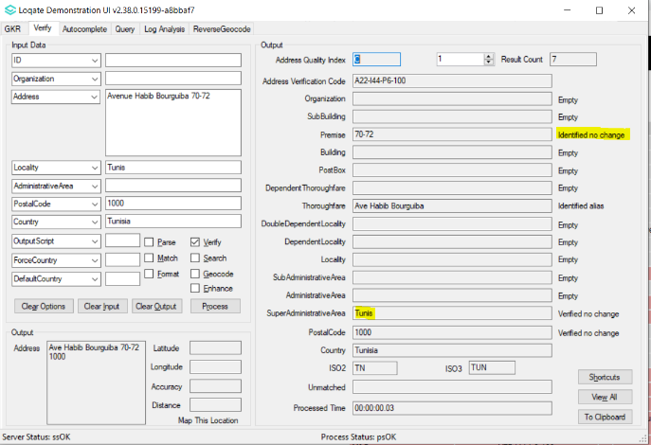 | Premise is now verified and AdministrativeArea parsed correctly.  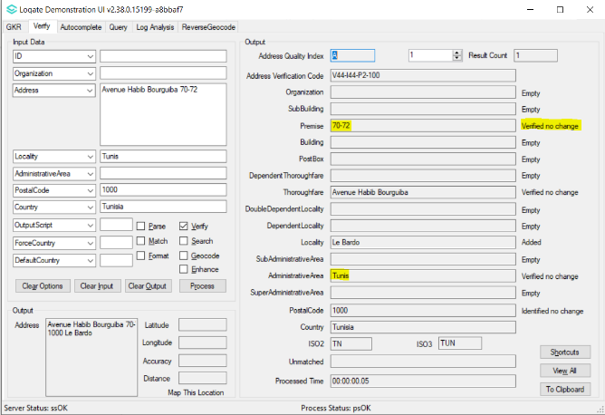

Knowledge Base & Reference Data Updates
The table below shows which countries have been updated, and how, in this release.
If there is a PDH in the reference data column, this shows a country was included in the country improvement project.

- Reference Data: 31 countries
- Context: 3 countries
- Lexicon: 18 countries

COUNTRY NAME | ISO CODE | CONTEXT RULES | LEXICONS | REFERENCE DATA
AFGHANISTAN | AF
ÅLAND ISLANDS | AX
ALBANIA | AL
ALGERIA | DZ
AMERICAN SAMOA | AS |  |  | X
ANDORRA | AD
ANGOLA | AO
ANGUILLA | AI
ANTARCTICA | AQ
ANTIGUA AND BARBUDA | AG
ARGENTINA | AR
ARMENIA | AM
ARUBA | AW
AUSTRALIA | AU |  | X | X
AUSTRIA | AT
AZERBAIJAN | AZ |  | X | X
BAHAMAS | BS
BAHRAIN | BH
BANGLADESH | BD
BARBADOS | BB
BELARUS | BY
BELGIUM | BE |  |  | X
BELIZE | BZ
BENIN | BJ
BERMUDA | BM
BHUTAN | BT
BOLIVIA (PLURINATIONAL STATE OF) | BO
BONAIRE, SINT EUSTATIUS AND SABA | BQ
BOSNIA AND HERZEGOVINA | BA
BOTSWANA | BW
BOUVET ISLAND | BV
BRAZIL | BR
BRITISH INDIAN OCEAN TERRITORY | IO
BRUNEI DARUSSALAM | BN
BULGARIA | BG |  | X | X
BURKINA FASO | BF
BURUNDI | BI
CABO VERDE | CV
CAMBODIA | KH
CAMEROON | CM
CANADA | CA |  | X | X
CAYMAN ISLANDS | KY
CENTRAL AFRICAN REPUBLIC | CF
CHAD | TD
CHILE | CL
CHINA | CN
CHRISTMAS ISLAND | CX
COCOS (KEELING) ISLANDS | CC
COLOMBIA | CO
COMOROS | KM
CONGO | CG
CONGO, DEMOCRATIC REPUBLIC OF THE | CD
COOK ISLANDS | CK
COSTA RICA | CR
CÔTE D'IVOIRE | CI
CROATIA | HR
CUBA | CU |  | X | X
CURAÇAO | CW
CYPRUS | CY
CZECHIA | CZ |  |  | X
DENMARK | DK
DJIBOUTI | DJ
DOMINICA | DM
DOMINICAN REPUBLIC | DO |  | X | X
ECUADOR | EC
EGYPT | EG
EL SALVADOR | SV
EQUATORIAL GUINEA | GQ
ERITREA | ER
ESTONIA | EE |  | X | X
ETHIOPIA | ET
FALKLAND ISLANDS (MALVINAS) | FK
FAROE ISLANDS | FO
FIJI | FJ
FINLAND | FI |  |  | X
FRANCE | FR
FRENCH GUIANA | GF
FRENCH POLYNESIA | PF
FRENCH SOUTHERN TERRITORIES | TF
GABON | GA
GAMBIA | GM
GEORGIA | GE
GERMANY | DE |  | X | X
GHANA | GH
GIBRALTAR | GI
GREECE | GR
GREENLAND | GL
GRENADA | GD
GUADELOUPE | GP |  | X | X
GUAM | GU |  |  | X
GUATEMALA | GT
GUERNSEY | GG |  |  | X
GUINEA | GN
GUINEA-BISSAU | GW
GUYANA | GY
HAITI | HT
HEARD ISLAND AND MCDONALD ISLANDS | HM
HONDURAS | HN
HONG KONG | HK | X | X | X
HUNGARY | HU
ICELAND | IS
INDIA | IN | X
INDONESIA | ID
IRAN | IR
IRAQ | IQ
IRELAND | IE
ISLE OF MAN | IM |  |  | X
ISRAEL | IL
ITALY | IT
JAMAICA | JM |  | X | X
JAPAN | JP
JERSEY | JE |  |  | X
JORDAN | JO
KAZAKHSTAN | KZ
KENYA | KE
KIRIBATI | KI
KOREA (DEMOCRATIC PEOPLE'S REPUBLIC OF) | KP
KOREA, REPUBLIC OF | KR | X | X
KUWAIT | KW
KYRGYZSTAN | KG
LAO PEOPLE'S DEMOCRATIC REPUBLIC | LA
LATVIA | LV
LEBANON | LB
LESOTHO | LS
LIBERIA | LR
LIBYA | LY
LIECHTENSTEIN | LI
LITHUANIA | LT
LUXEMBOURG | LU
MACAO | MO
MADAGASCAR | MG
MALAWI | MW
MALAYSIA | MY
MALDIVES | MV
MALI | ML
MALTA | MT
MARSHALL ISLANDS | MH |  |  | X
MARTINIQUE | MQ
MAURITANIA | MR
MAURITIUS | MU
MAYOTTE | YT
MEXICO | MX |  | X | X
MICRONESIA (FEDERATED STATES OF) | FM |  |  | X
MOLDOVA, REPUBLIC OF | MD
MONACO | MC
MONGOLIA | MN
MONTENEGRO | ME
MONTSERRAT | MS
MOROCCO | MA
MOZAMBIQUE | MZ
MYANMAR | MM
NAMIBIA | NA
NAURU | NR
NEPAL | NP
NETHERLANDS | NL |  | X
NEW CALEDONIA | NC
NEW ZEALAND | NZ
NICARAGUA | NI
NIGER | NE
NIGERIA | NG
NIUE | NU
NORFOLK ISLAND | NF
NORTH MACEDONIA | MK
NORTHERN MARIANA ISLANDS | MP |  |  | X
NORWAY | NO
OMAN | OM
PAKISTAN | PK
PALAU | PW |  |  | X
PALESTINE, STATE OF | PS
PANAMA | PA
PAPUA NEW GUINEA | PG
PARAGUAY | PY
PERU | PE
PHILIPPINES | PH
PITCAIRN | PN
POLAND | PL
PORTUGAL | PT
PUERTO RICO | PR |  |  | X
QATAR | QA
RÉUNION | RE
ROMANIA | RO |  | X
RUSSIAN FEDERATION | RU
RWANDA | RW |  | X | X
SAINT BARTHÉLEMY | BL
SAINT HELENA, ASCENSION AND TRISTAN DA CUNHA | SH
SAINT KITTS AND NEVIS | KN
SAINT LUCIA | LC
SAINT MARTIN (FRENCH PART) | MF
SAINT PIERRE AND MIQUELON | PM
SAINT VINCENT AND THE GRENADINES | VC
SAMOA | WS
SAN MARINO | SM
SAO TOME AND PRINCIPE | ST
SAUDI ARABIA | SA
SENEGAL | SN
SERBIA | RS
SEYCHELLES | SC
SIERRA LEONE | SL
SINGAPORE | SG
SINT MAARTEN (DUTCH PART) | SX
SLOVAKIA | SK
SLOVENIA | SI
SOLOMON ISLANDS | SB |  | X | X
SOMALIA | SO
SOUTH AFRICA | ZA
SOUTH GEORGIA AND THE SOUTH SANDWICH ISLANDS | GS
SOUTH SUDAN | SS
SPAIN | ES
SRI LANKA | LK
SUDAN | SD
SURINAME | SR
SVALBARD AND JAN MAYEN | SJ
SWAZILAND | SZ
SWEDEN | SE
SWITZERLAND | CH
SYRIAN ARAB REPUBLIC | SY
TAIWAN | TW
TAJIKISTAN | TJ
TANZANIA, UNITED REPUBLIC OF | TZ
THAILAND | TH
TIMOR-LESTE | TL |  |  | X
TOGO | TG
TOKELAU | TK
TONGA | TO
TRINIDAD AND TOBAGO | TT
TUNISIA | TN |  | X | X
TURKEY | TR
TURKMENISTAN | TM
TURKS AND CAICOS ISLANDS | TC
TUVALU | TV
UGANDA | UG
UKRAINE | UA
UNITED ARAB EMIRATES | AE
UNITED KINGDOM | GB |  |  | X
UNITED STATES MINOR OUTLYING ISLANDS | UM
UNITED STATES OF AMERICA | US |  |  | X
URUGUAY | UY
UZBEKISTAN | UZ
VANUATU | VU
VATICAN CITY | VA
VENEZUELA (BOLIVARIAN REPUBLIC OF) | VE
VIET NAM | VN
VIRGIN ISLANDS (BRITISH) | VG
VIRGIN ISLANDS (U.S.) | VI
WALLIS AND FUTUNA | WF
WESTERN SAHARA | EH
YEMEN | YE
ZAMBIA | ZM
ZIMBABWE | ZW

