Loqate, A GBG Solution
Release Notes – Verify API
2021Q3.1_Minor Release

Case Resolutions
Please visit https://support.loqate.com/release-information/2021q3-1-resolved-cases/ for a list of cases resolved in this release. If you would like more details on any of the solved cases listed, please contact LoqateSupport@gbgplc.com for further information.

Local API Improvements

Server Option: DefaultCountry

Users may have experienced a delay when using the server option: DefaultCountry, this issue is now resolved in the 2021Q3.1 minor release.

Verify

Previously users may have seen certain addresses where the Thoroughfare was unexpectedly verified as the PostBox field, this issue is resolved with the 2021Q3.1 minor release.

2021Q3.0 (Before change) | 2021Q3.1 (After change)
Thoroughfare was incorrectly verified as PostBox that produced false positive V5 results  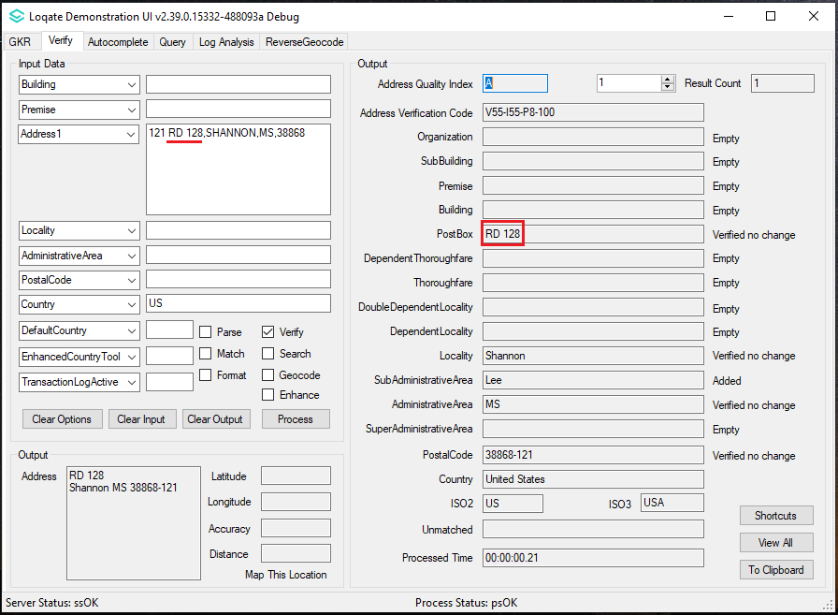 | Organization Name, Locality and Postal Code input are now verified up to L5.  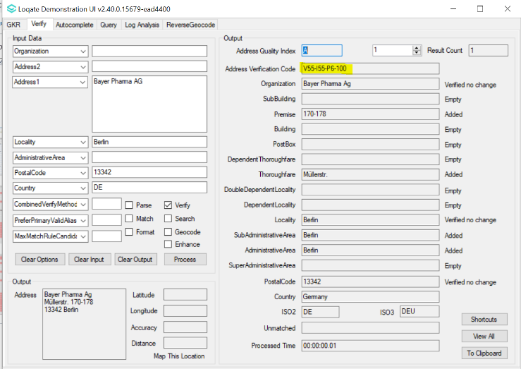

Geocode

Geocode may have returned unexpected Latitude and Longitude results for certain addresses in the minority territories for the United Kingdom, this issue is now resolved in the 2021Q3.1 minor release.

2021Q3.0 (Before change) | 2021Q3.1 (After change)
Geocode points to a location in Scotland.  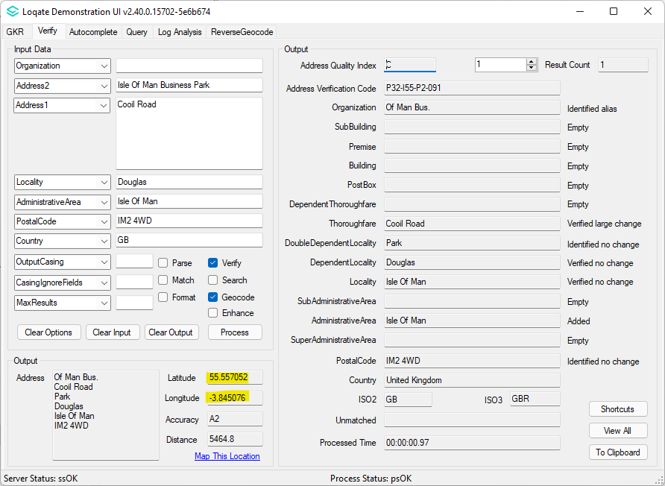 | Geocode points to Cooil Road in Isle of Man.  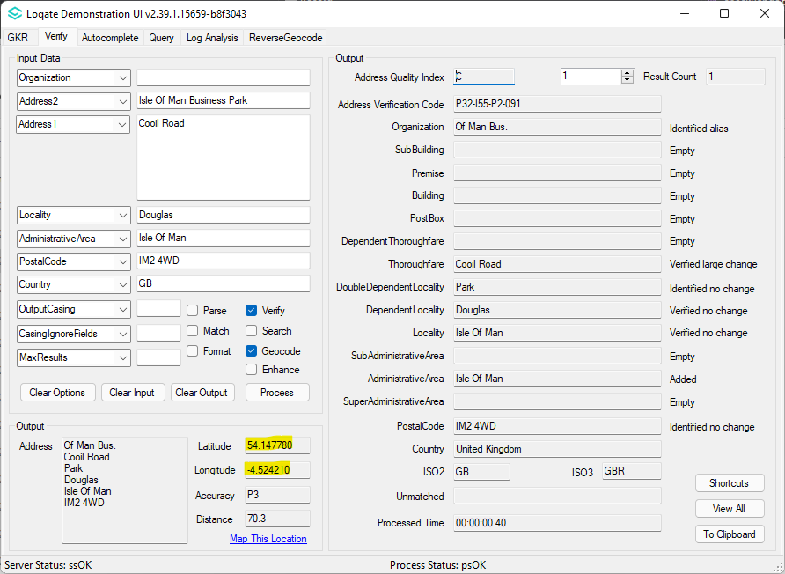

Installation Instructions

Please remember to update both the program files and the reference data. The improvements are tied to the data in the Global Knowledge Repository and the Local API. When updating the data, it is recommended to use a new data folder each time in order to ensure the latest dataset is installed properly.

If you need any assistance with the upgrade of the Local API or the data update process, please contact GBG Loqate Support.

The setup wizard for the Local API can be obtained from our SFTP server. Please contact your account manager to retrieve the SFTP information. If you do not know who your account manager is, please contact the support team at LoqateSupport@gbgplc.com.

