Loqate, A GBG Solution
Release Notes – Reference Data & Knowledge Base
2021Q3.0 Major Release

Case Resolutions
Please visit https://support.loqate.com/release-information/2021q3-0-resolved-cases/ for a list of cases resolved in this release. If you would like more details on any of the solved cases listed, please contact LoqateSupport@gbgplc.com for further information.

Certification Expiration Dates
If you have purchased either the CASS (USA) or AMAS (Australia) certified products, please be aware that the datasets have expiration dates set by the respective postal authorities. Please ensure that you have the latest library and data installed to avoid loss of service through these products.

Please check Install Manager for the latest versions of AMAS and CASS.
 | Loqate Release Date | Certification Expiry Date*
AMAS Data | 2021-06-01 | 2021-09-30
CASS Data | 2021-07-15 | 2021-10-28
*Certification Expiry Date is different from Loqate license key expiry date. The earliest expiry date will apply.

For more information on expiry date checking for CASS and AMAS, please refer “Usage expiration” section in https://support.loqate.com/documentation/local-apis/cass-overview-2/ and https://support.loqate.com/address-matching-approval-system-amas/

Data Notices
CAMEO – Enhancement Data Sets

From the 2021Q3.0 major release, CAMEO Enhancement Data Set for the U.S. is now available to customers as an add-on. The CAMEO data set is used to provide consumer segmentation system linking ZIP+4 information to demographic lifestyle and socio-economic insight. The CAMEO data set can be used for the following applications: To enhance and segment consumer databases. Additional information can be found here. Please contact your account manager for additional information in regards to accessing CAMEO.

USA CASS2 Engine

Please note: From the 2021Q2.0 major release, the USA CASS2 engine will be made available. Information on the USA CASS2 engine can be found on the support site here. Please contact your account manager for additional information in regards to accessing USA CASS2.

Italy

From the 2021Q3.0 major release, there are geographical re-structuring changes for Italy. The SubAdministrativeArea (local name: commune) is now the Locality. The locality (local name: hamlet) is now the DependentLocality.

2021Q2.1 | 2021Q3.0
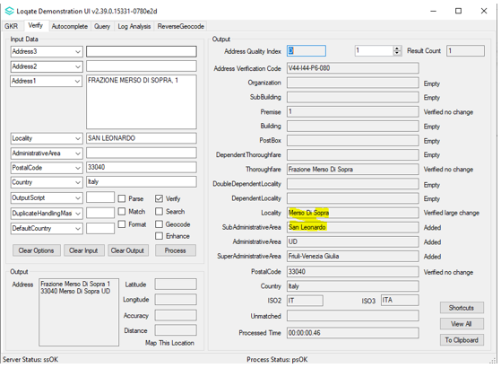 | 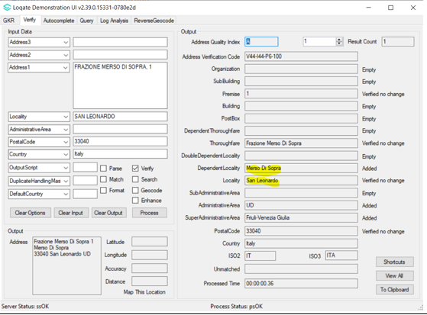
San Leonard verified in SubAministrativeArea, Merso Di Sopra verified in Locality. | After re-alignment, San Leonard verified in Locality, Merso Di Sopra verified in DependentLocality.

Canada

From the 2021Q3.0 major release, there is a new geographical field addition within the SubAdministrativeArea level in the reference data. Improvements have been made to the verification results within the thoroughfare field.

2021Q2.1 | 2021Q3.0
Incorrectly parsed Locality to Thoroughfare and SubAdministrativeArea to Locality.  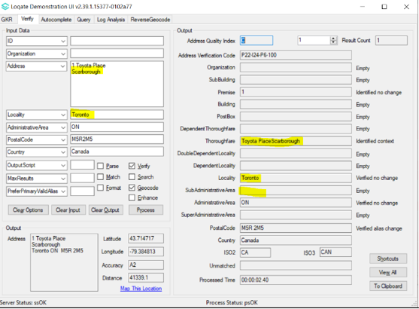 | Correctly parsed and verified Locality and SubAdministrativeArea.  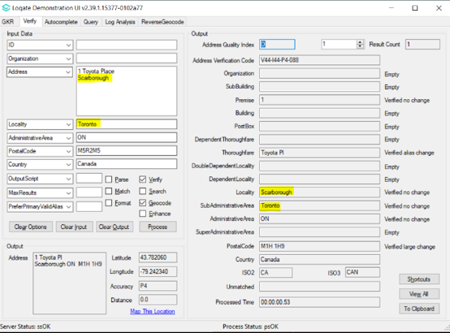
Montreal parsed to Locality and verified large changed to Verdun.  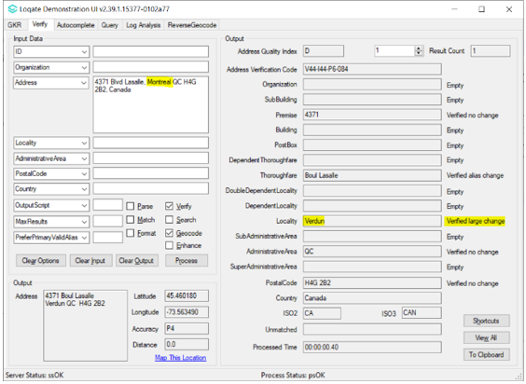 | Montreal parsed to SubAdministrativeArea and verified. Verdun is added into Locality. Overall match score improved.  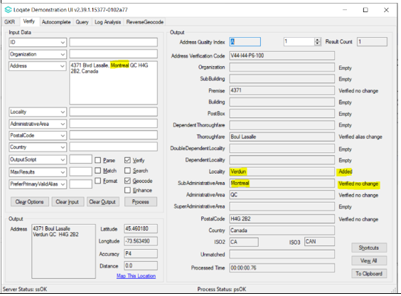

Canada Continued…

2021Q2.1 | 2021Q3.0
Two different input addresses having the same Thoroughfare gets verified to two different Thoroughfare records in RD.  Input 1  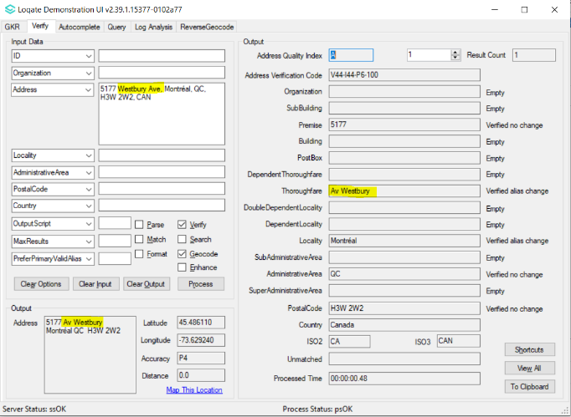  Input 2  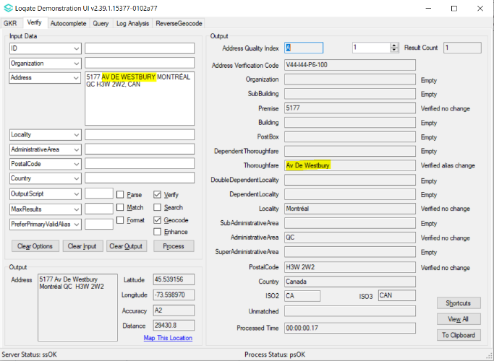 | The two different input addresses now verified to the same Thoroughfare record in RD.  Input 1  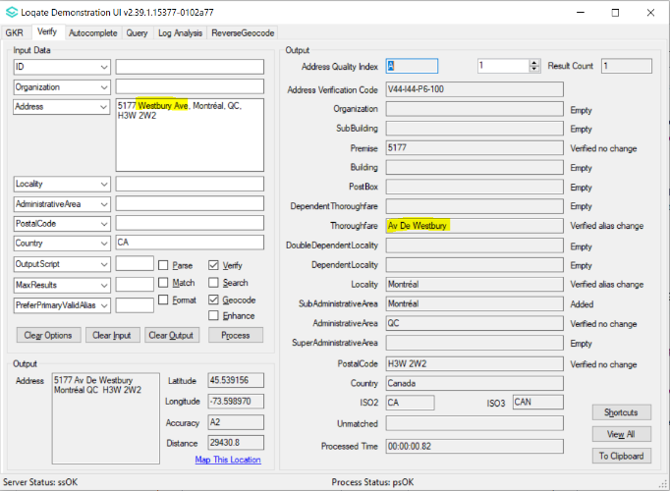  Input 2  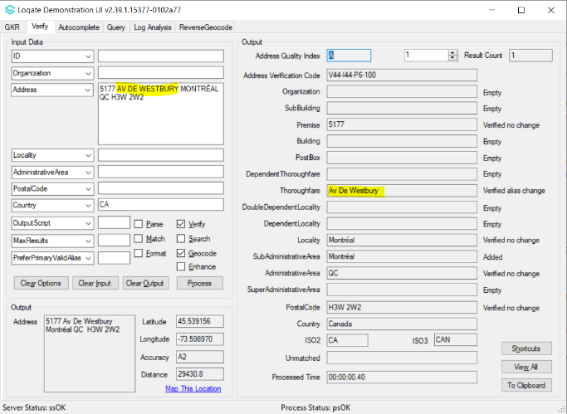

Norway

From the 2021Q3.0 major release, the address format has changed in order to better align with the postal authority. If the SubBuilding information is available, the SubBuilding will appear before the Thoroughfare and Premise.

2021Q2.1 |  | 2021Q3.0
Address format: | Organization  PostBox  Building  Thoroughfare Premise SubBuilding  DependentThoroughfare  PostalCode Locality | Address format: | Organization  PostBox  Building SubBuilding  Thoroughfare Premise  DependentThoroughfare  PostalCode Locality
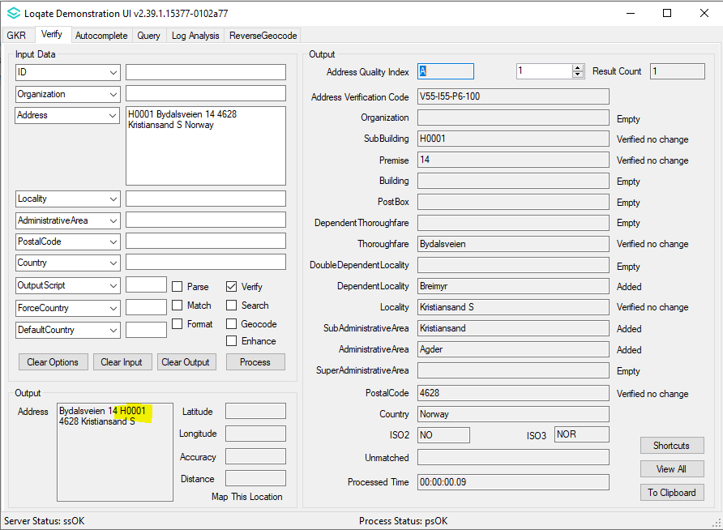 |  | 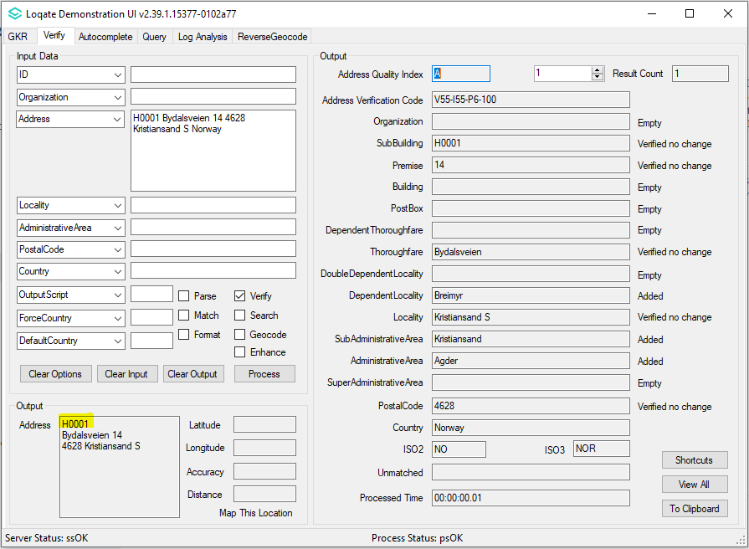

China

For China addresses, if the output is in Latin script, the DeliveryAddress field should include the DependentLocality element which is consistent with the DeliveryAddress field when the output is in Native script.

2021Q2.1 |  | 2021Q3.0
DeliveryAddress format in Latin: | PostBox  SubBuilding Building  PremiseDependentThoroughfareThoroughfare  DoubleDependentLocality | DeliveryAddress format in Latin: | PostBox  SubBuilding Building  PremiseDependentThoroughfareThoroughfare  DoubleDependentLocality  DependentLocality
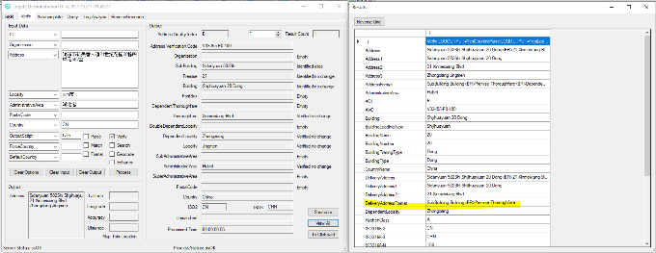 |  | 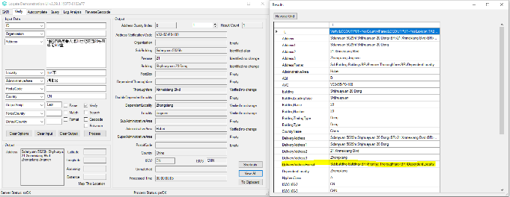

Data Improvements

Afghanistan (L2)

Country Information | Description
ISO2 | AF
ISO3 | AFG
Address Format | Organization  PostBox  Building SubBuilding  Thoroughfare Premise  DependentThoroughfare  DoubleDependentLocality  DependentLocality  Locality
PDH | YES
PDH completed date | 2021Q3.0
New Source | NO
Reference Data Pre-PDH | rd_AF_ai.lfs  rd_AF.lfs  rd_AF_rg.lfs
Reference Data Post-PDH | rd_AF_ggg.lfs  rd_AF_ggg_rg.lfs  rd_AF_vfy_ai.lfs  rd_AF_vfy.lfs

In this release improvements have been made to the verification results within the Thoroughfare field.

2021Q2.1 | 2021Q3.0
Thoroughfare was not verified.  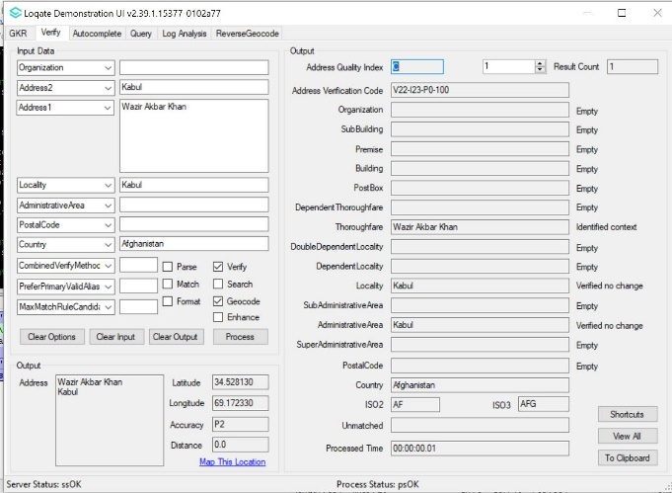 | Thoroughfare is now verified.  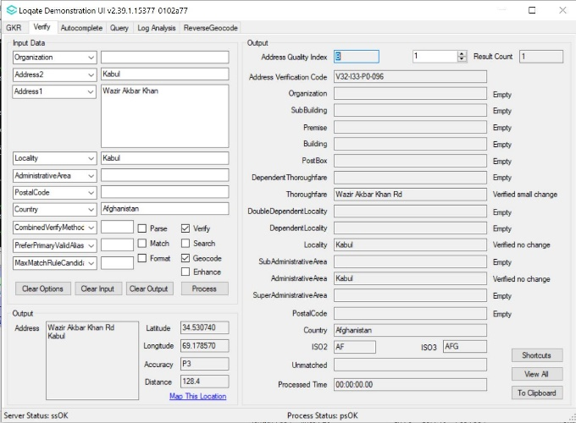

Benin (L3)

Country Information | Description
ISO2 | BJ
ISO3 | BEN
Address Format | Organization  PostBox  SubBuilding Building  Premise Thoroughfare  DependentThoroughfare  DoubleDependentLocality  DependentLocality  Locality
PDH | YES
PDH completed date | 2021Q3.0
New Source | NO
Reference Data Pre-PDH | rd_BJ.lfs  rd_BJ_ai.lfs  rd_BJ_rg.lfs
Reference Data Post-PDH | rd_BJ_vfy.lfs  rd_BJ_vfy_ai.lfs  rd_BJ_ggg.lfs  rd_BJ_ggg_rg.lfs

With the 2021Q3.0 major release, improvements are made in the SubAdministrativeArea and AdministrativeArea fields.

2021Q2.1 | 2021Q3.0
No SubAdministrativeArea and AdministrativeArea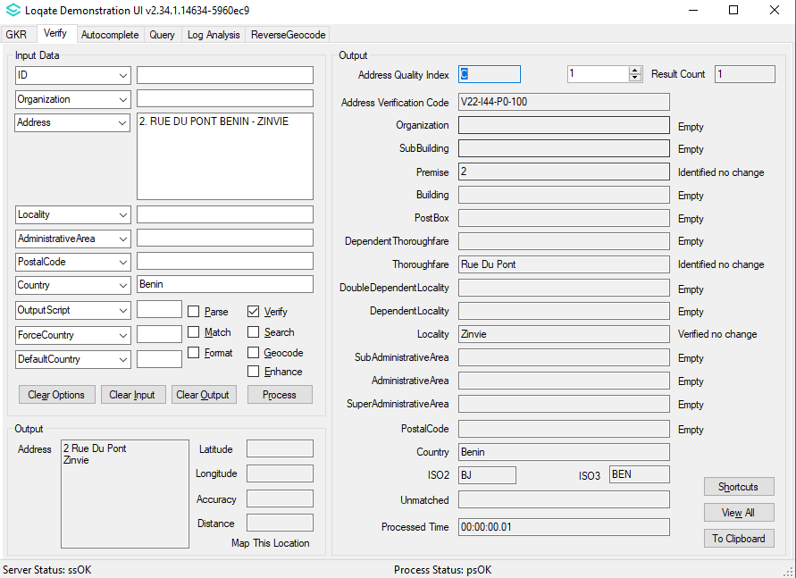 | Added SubAdministrativeArea and AdministrativeArea.  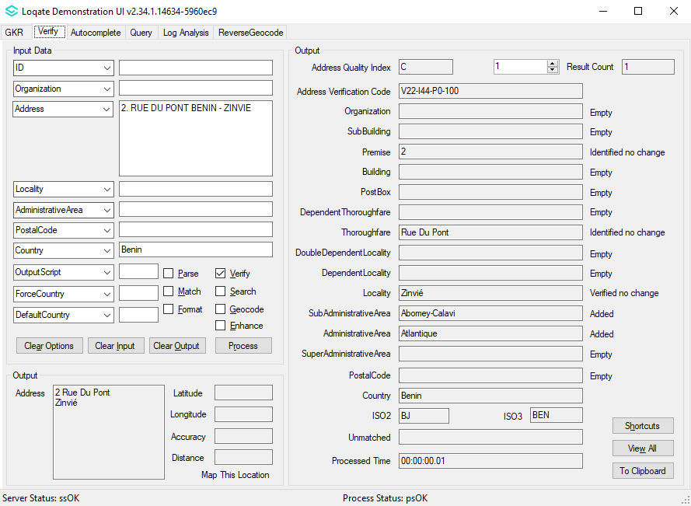

Cambodia (L2)

Country Information | Description
ISO2 | KH
ISO3 | KHM
Address Format | Organization  PostBox  SubBuilding Building  Premise Thoroughfare  DependentThoroughfare  DoubleDependentLocality  DependentLocality  Locality  AdministrativeArea PostalCode
PDH | YES
PDH completed date | 2021Q3.0
New Source | NO
Reference Data Pre-PDH | rd_KH.lfs  rd_KH_ai.lfs  rd_KH_rg.lfs
Reference Data Post-PDH | rd_KH_vfy.lfs  rd_KH_vfy_ai.lfs  rd_KH_ggg.lfs  rd_KH_ggg_rg.lfs

Prior to the 2021Q3.0 major release, there were limitations with parsing that may have caused low verification results for addresses in Cambodia. With the 2021Q3.0 major release, improvements are made to the parse results and provides higher verification results to addresses in Cambodia.

2021Q2.1 | 2021Q3.0
Previously limitation in parsing and causing low verification.  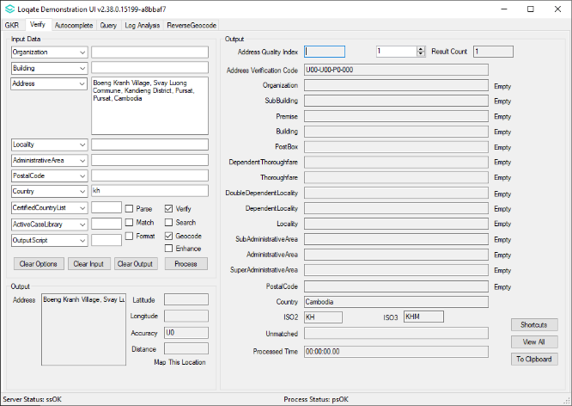 | Improved parsing and better verify accuracy.  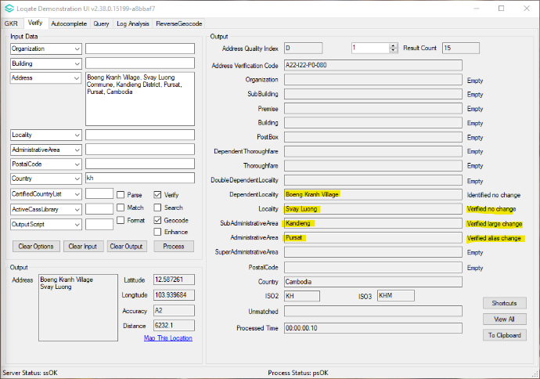

Denmark (L5)

Country Information | Description
ISO2 | DK
ISO3 | DNK
Address Format | Organization  PostBox  Building  Thoroughfare Premise SubBuilding  DependentThoroughfare  DoubleDependentLocality  DependentLocality  PostalCode Locality
PDH | YES
PDH completed date | 2021Q3.0
New Source | YES
Reference Data Pre-PDH | rd_DK_ggg.lfs  rd_DK_ggg_rg.lfs  rd_DK_vfy_ai.lfs  rd_DK_vfy.lfs
Reference Data Post-PDH | rd_DK_ggg.lfs  rd_DK_ggg_rg.lfs  rd_DK_vfy_ai.lfs  rd_DK_vfy.lfs

In this release, improvements have been made to the verification results within the SubBuilding, Premise, and Thoroughfare fields.

2021Q2.1 | 2021Q3.0
Thoroughfare, Premise and SubBuilding is not verified.  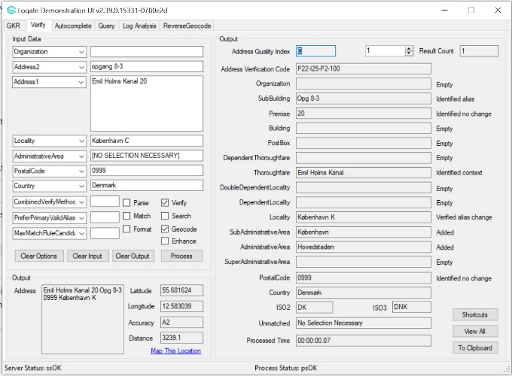 | Thoroughfare, Premise and SubBuilding are now verified.  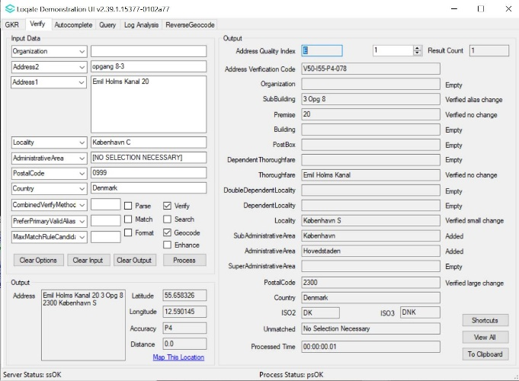

Fiji (L4)

Country Information | Description
ISO2 | FJ
ISO3 | FJI
Address Format | Organization  PostBox  SubBuilding Building  Premise Thoroughfare  DependentThoroughfare  DoubleDependentLocality  DependentLocality  Locality
PDH | YES
PDH completed date | 2021Q3.0
New Source | NO
Reference Data Pre-PDH | rd_FJ.lfs  rd_FJ_ai.lfs  rd_FJ_rg.lfs
Reference Data Post-PDH | rd_FJ_vfy.lfs  rd_FJ_vfy_ai.lfs  rd_FJ_ggg.lfs  rd_FJ_ggg_rg.lfs

With the 2021Q3.0 major release, improvements have been made to the verification results within the SuperAdministrativeArea and AdministrativeArea fields.

2021Q2.1 | 2021Q3.0
No SuperAdministrativeArea; Incorrect AdministrativeArea returned.  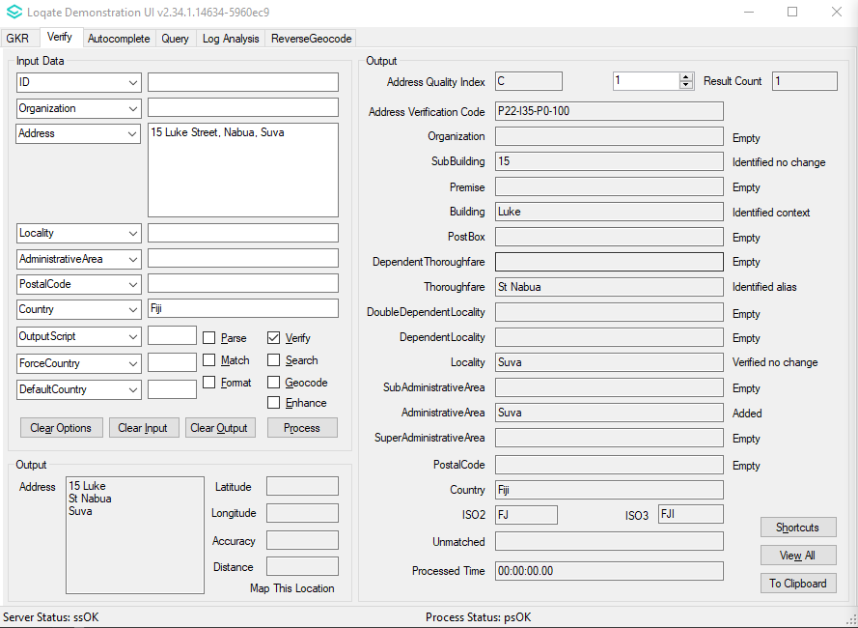 | Added SuperAdministrativeArea; correct AdministrativeArea returned.  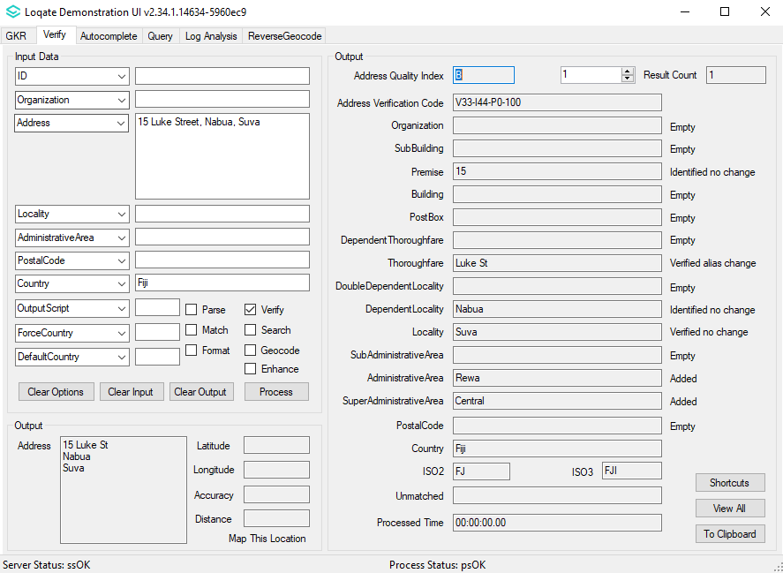

French Southern Territories (L2)

Country Information | Description
ISO2 | TF
ISO3 | ATF
Address Format | Organization  PostBox  Building SubBuilding  Thoroughfare Premise  DependentThoroughfare  DoubleDependentLocality  DependentLocality  PostalCode Locality
PDH | YES
PDH completed date | 2021Q3.0
New Source | NO
Reference Data Pre-PDH | rd_TF.lfs  rd_TF_ai.lfs  rd_TF_rg.lfs
Reference Data Post-PDH | rd_TF_vfy.lfs  rd_TF_vfy_ai.lfs  rd_TF_ggg.lfs  rd_TF_ggg_rg.lfs

In this release, improvements have been made to the verification results of addresses in the French Southern Territories.

2021Q2.1 | 2021Q3.0
Address unable to verify.  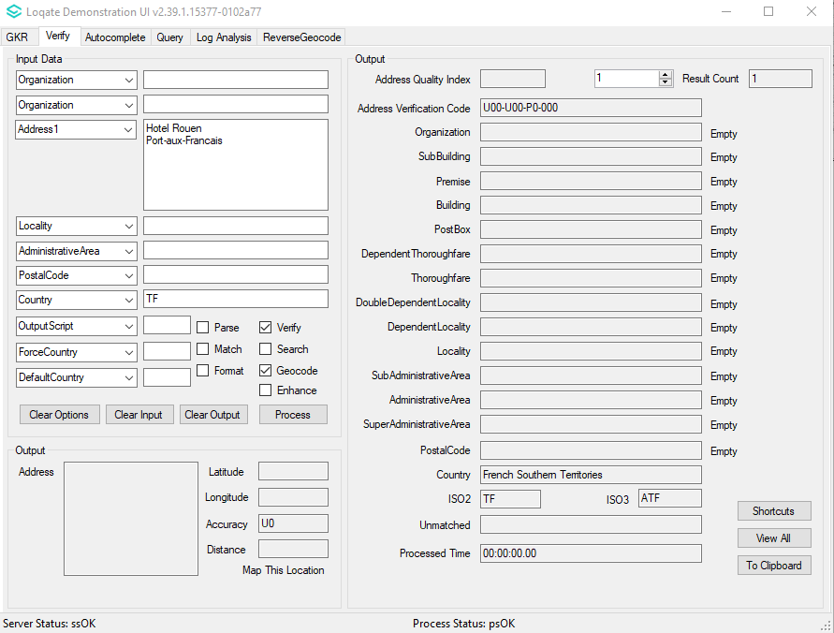 | Address now able to be verified with correct hierarchy.  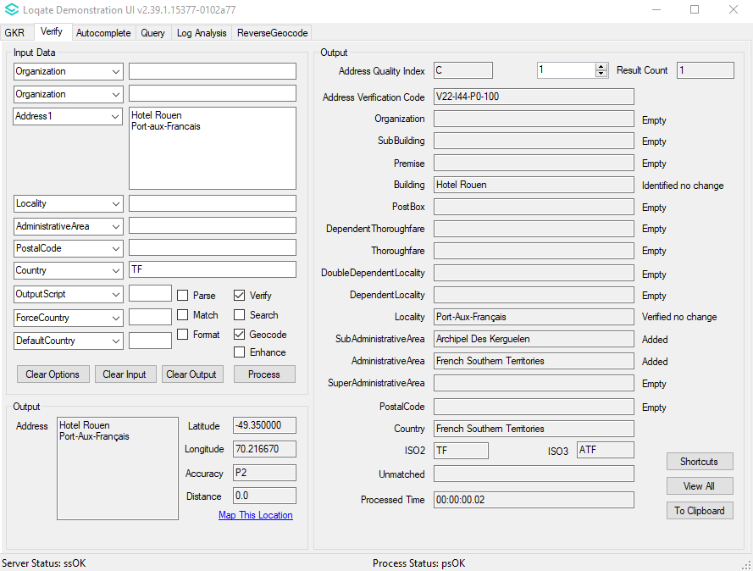

Greenland (L3)

Country Information | Description
ISO2 | GL
ISO3 | GRL
Address Format | Organization  PostBox  Building SubBuilding  Thoroughfare Premise  DependentThoroughfare  DoubleDependentLocality  DependentLocality  PostalCode Locality
PDH | YES
PDH completed date | 2021Q3.0
New Source | YES
Reference Data Pre-PDH | rd_GL_ai.lfs  rd_GL.lfs  rd_GL_rg.lfs
Reference Data Post-PDH | rd_GL_ggg.lfs  rd_GL_ggg_rg.lfs  rd_GL_vfy_ai.lfs  rd_GL_vfy.lfs

Improvements are made within the Premise field in the 2021Q3.0 major release.

2021Q2.1 | 2021Q3.0
Premise not available in reference data.  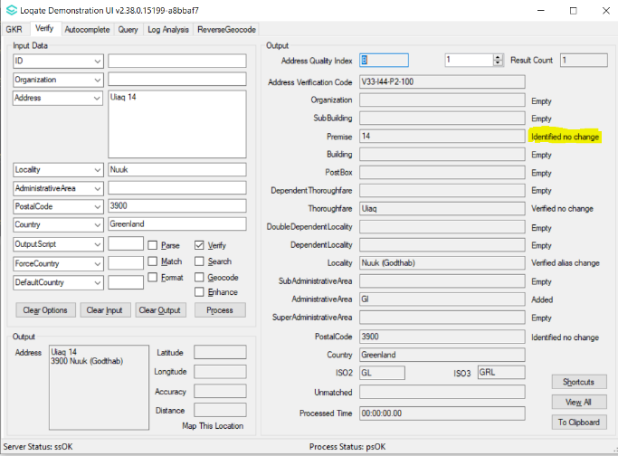 | Premise is now verified.  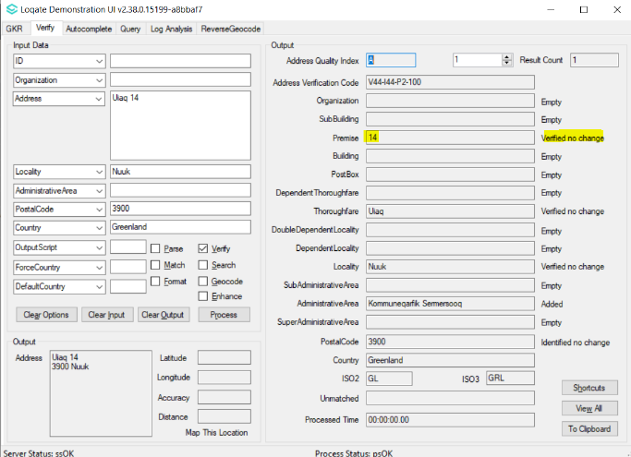

Gabon (L3)

Country Information | Description
ISO2 | GA
ISO3 | GAB
Address Format | Organization  PostBox  SubBuilding Building  Premise Thoroughfare  DependentThoroughfare  DoubleDependentLocality  DependentLocality  Locality
PDH | YES
PDH completed date | 2021Q3.0
New Source | YES
Reference Data Pre-PDH | rd_GA_ai.lfs  rd_GA.lfs  rd_GA_rg.lfs
Reference Data Post-PDH | rd_GA_ggg.lfs  rd_GA_ggg_rg.lfs  rd_GA_vfy_ai.lfs  rd_GA_vfy.lfs

In this release, improvements have been made to the AdministrativeArea and SubAdministrativeArea fields. With these updates, the AVC results and fieldStatus have also improved.

2021Q2.1 | 2021Q3.0
Some records returned ambiguous due to AdministrativeArea and SubAdministrativeArea unable to verify with field status: added.  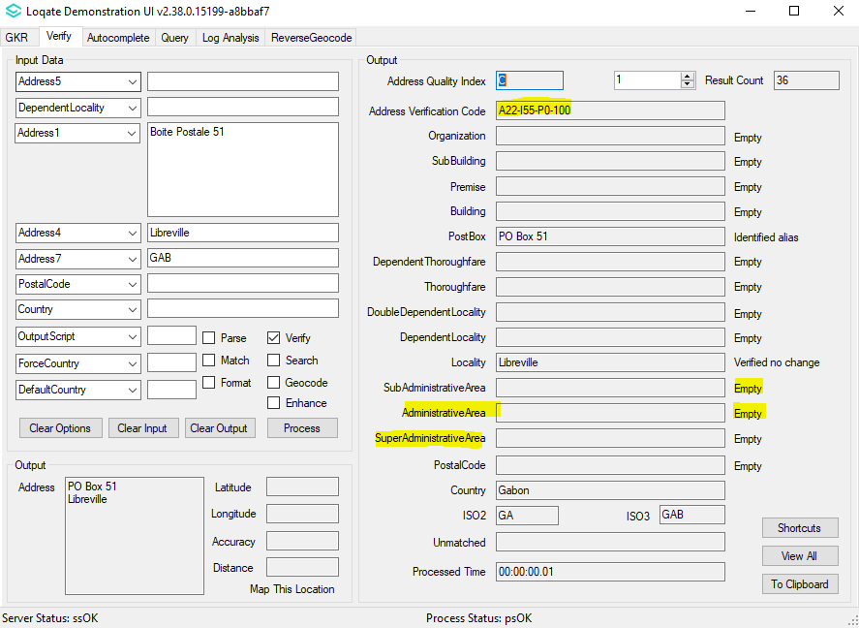 | Records AdministrativeArea and SubAdministrativeArea are now able to be verify with field status: added.  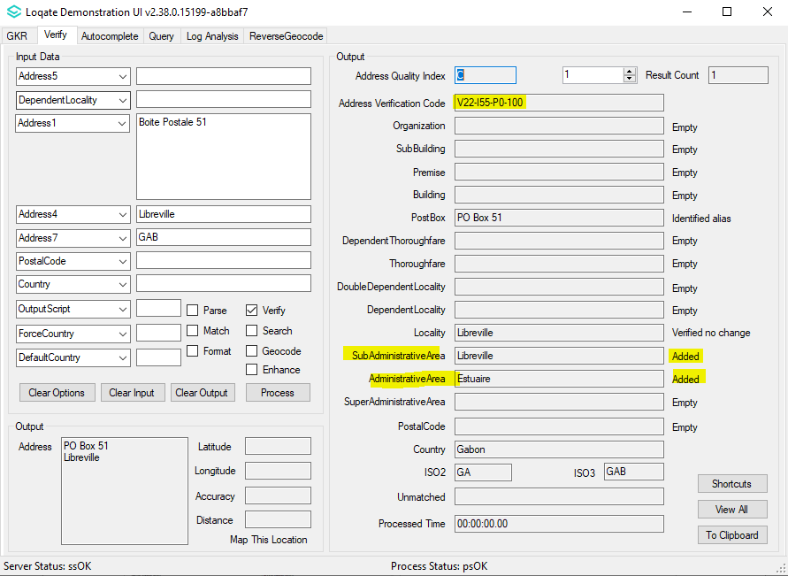

Indonesia (L4)

Country Information | Description
ISO2 | ID
ISO3 | IDN
Address Format | Organization  PostBox  Building SubBuilding  Thoroughfare Premise  DependentThoroughfare  DoubleDependentLocality  DependentLocality  Locality PostalCode
PDH | YES
PDH completed date | 2021Q3.0
New Source | YES
Reference Data Pre-PDH | rd_ID_geo.lfs  rd_ID_geop.lfs  rd_ID_geop_rg.lfs  rd_ID_geo_rg.lfs  rd_ID_vfy_ai.lfs  rd_ID_vfy.lfs
Reference Data Post-PDH | rd_ID_ggg.lfs  rd_ID_ggg_rg.lfs  rd_ID_ggg_r.lfs  rd_ID_vfy_ai.lfs  rd_ID_vfy.lfs

From the 2021Q3.0 major release, the PDH process has vastly improved the parsing results with addresses in Indonesia.
The Locality: Jakarta will now include the corresponding directional in the verification results.

2021Q2.1 | 2021Q3.0
Input locality Jakarta verified as Jakarta.  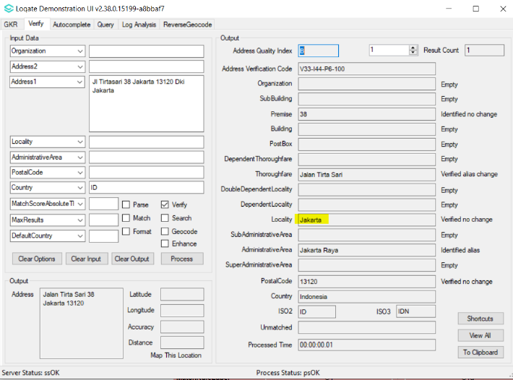 | Input locality Jakarta verified as Jakarta directional (Jakarta Timur, Jakarta Barat etc).  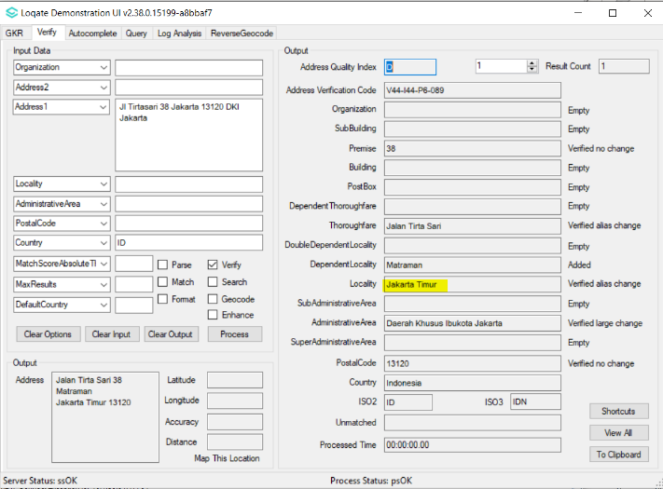

Indonesia Continued…

Address unable to be parsed.  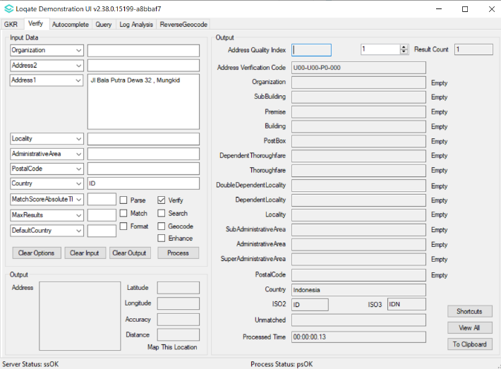 | Address able to be parsed and verified. Major parsing improvement.  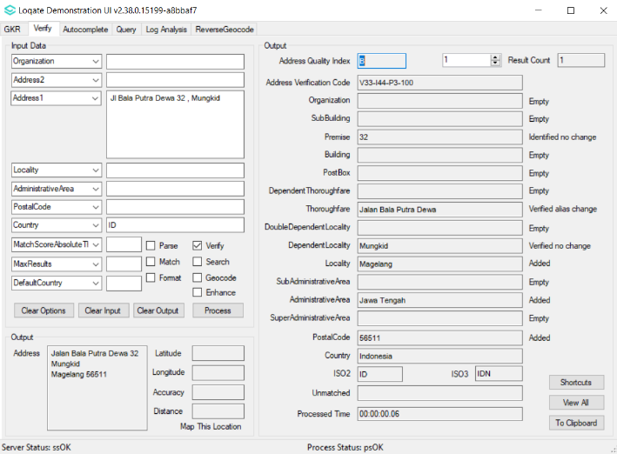

Iran (L2)

Country Information | Description
ISO2 | IR
ISO3 | IRN
Address Format | Organization  PostBox  SubBuilding Building  Premise Thoroughfare  DependentThoroughfare  DoubleDependentLocality  DependentLocality  PostalCode Locality AdministrativeArea
PDH | YES
PDH completed date | 2021Q3.0
New Source | NO
Reference Data Pre-PDH | rd_IR.lfs  rd_IR_ai.lfs  rd_IR_rg.lfs
Reference Data Post-PDH | rd_IR_vfy.lfs  rd_IR_vfy_ai.lfs  rd_IR_ggg.lfs  rd_IR_ggg_rg.lfs

In this release, improvements have been made to the verification results within the AdministrativeArea field.

Iran Continued…

2021Q2.1 | 2021Q3.0
No AdministrativeArea.  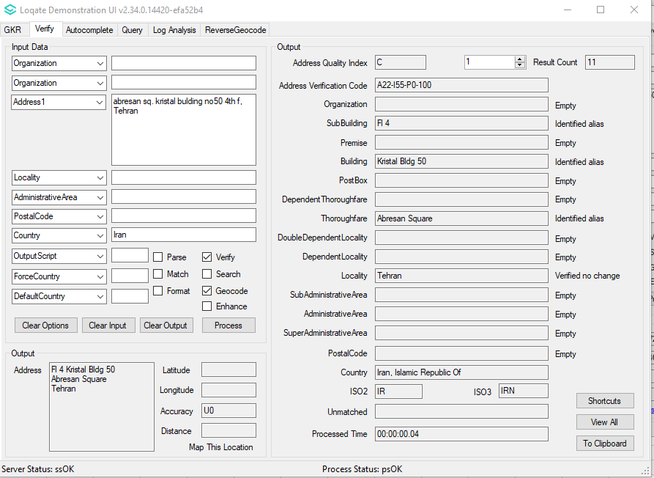 | Corrected hierarchy with added AdministrativeArea.  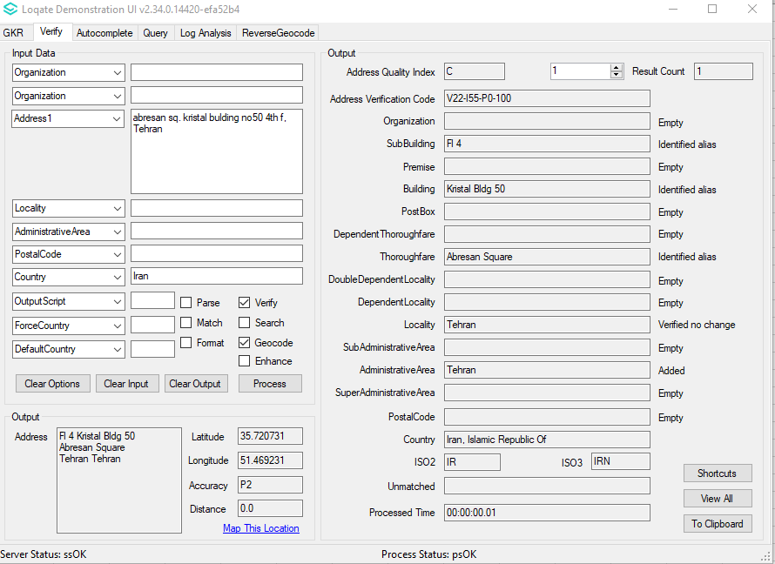

Kiribati (L3)

Country Information | Description
ISO2 | KI
ISO3 | KIR
Address Format | Organization  PostBox  SubBuilding Building  Premise Thoroughfare  DependentThoroughfare  DoubleDependentLocality  DependentLocality  Locality  AdministrativeArea
PDH | YES
PDH completed date | 2021Q3.0
New Source | NO
Reference Data Pre-PDH | rd_KI.lfs  rd_KI_ai.lfs  rd_KI_rg.lfs
Reference Data Post-PDH | rd_KI_vfy.lfs  rd_KI_vfy_ai.lfs  rd_KI_ggg.lfs  rd_KI_ggg_rg.lfs

In the 2021Q3.0 major release, improvements have been made to the verification results within the thoroughfare field.

2021Q2.1 | 2021Q3.0
Betio incorrectly parsed.  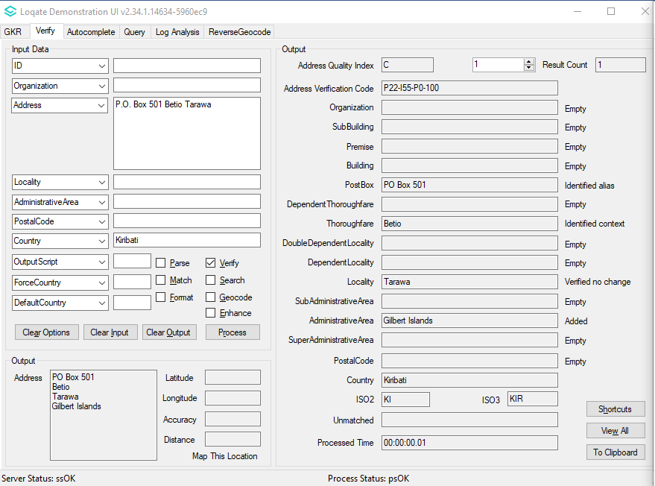 | Betio correctly parsed and verified. Better hierarchy.  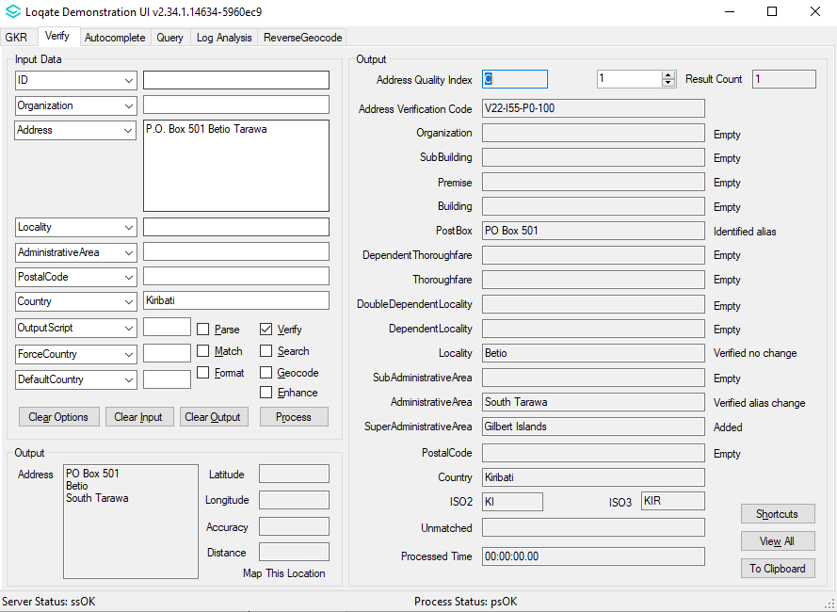

Mali (L3)

Country Information | Description
ISO2 | ML
ISO3 | MLI
Address Format | Organization  PostBox  Building SubBuilding  Thoroughfare Premise  DependentThoroughfare  DoubleDependentLocality  DependentLocality  Locality
PDH | YES
PDH completed date | 2021Q3.0
New Source | NO
Reference Data Pre-PDH | rd_ML_ai.lfs  rd_ML.lfs  rd_ML_rg.lfs
Reference Data Post-PDH | rd_ML_ggg.lfs  rd_ML_ggg_rg.lfs  rd_ML_vfy_ai.lfs  rd_ML_vfy.lfs

In this release, improvements have been made to the parse results and addresses are able to verify up to the Thoroughfare level.

2021Q2.1 | 2021Q3.0
Address unable to parse correctly resulting in U0  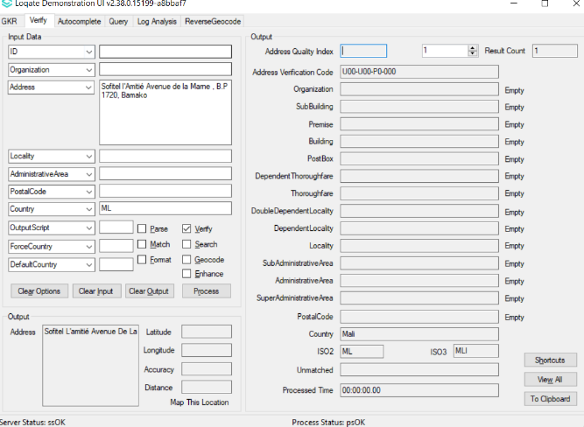 | Parsing improved and address able to verify up to thoroughfare level  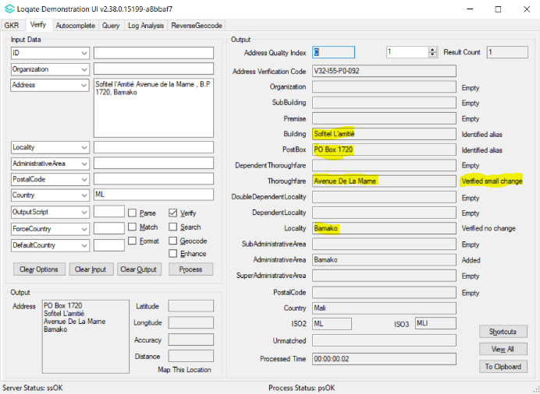

Myanmar (L3)

Country Information | Description
ISO2 | MM
ISO3 | MMR
Address Format | Organization  PostBox  Building SubBuilding  Premise Thoroughfare  DependentThoroughfare  DoubleDependentLocality  DependentLocality  Locality PostalCode
PDH | YES
PDH completed date | 2021Q3.0
New Source | NO
Reference Data Pre-PDH | rd_MM_ai.lfs  rd_MM.lfs  rd_MM_rg.lfs
Reference Data Post-PDH | rd_MM_ggg.lfs  rd_MM_ggg_rg.lfs  rd_MM_vfy_ai.lfs  rd_MM_vfy.lfs

With this release, improvements have been made to the parse results and addresses are able to verify up to the Thoroughfare and Premise level.

2021Q2.1 | 2021Q3.0
Address unable to parse correctly resulting in U0  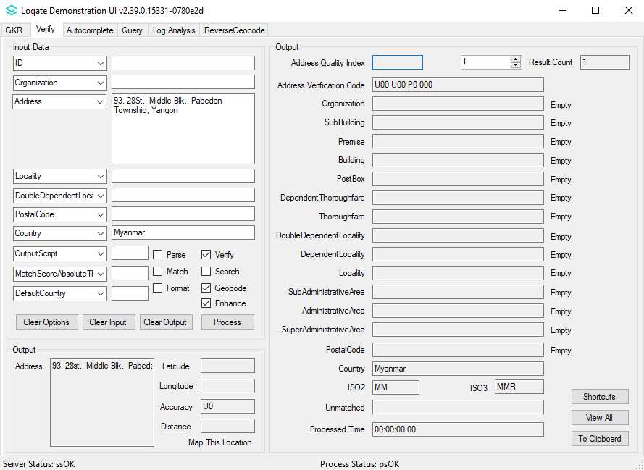 | Parsing improved and address able to verify up to thoroughfare and premise level  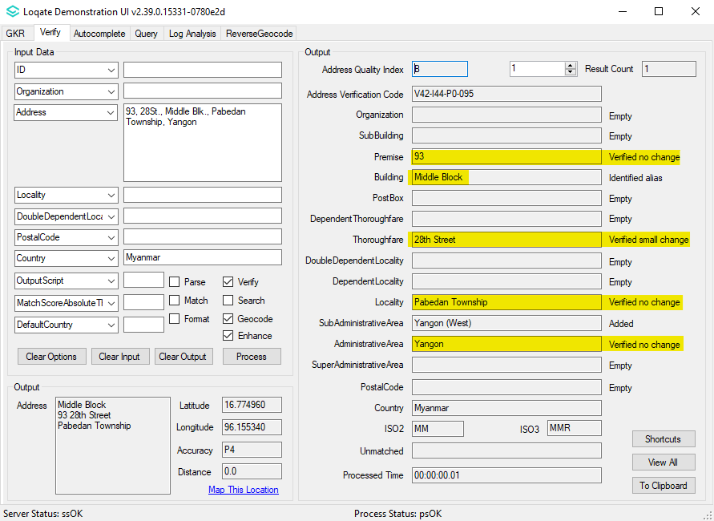

Niue (L3)

Country Information | Description
ISO2 | NU
ISO3 | NIU
Address Format | Organization  PostBox  SubBuilding Building  Premise Thoroughfare  DependentThoroughfare  DoubleDependentLocality  DependentLocality  Locality
PDH | YES
PDH completed date | 2021Q3.0
New Source | NO
Reference Data Pre-PDH | rd_NU.lfs  rd_NU_ai.lfs  rd_NU_rg.lfs
Reference Data Post-PDH | rd_NU_vfy.lfs  rd_NU_vfy_ai.lfs  rd_NU_ggg.lfs  rd_NU_ggg_rg.lfs

With this release, improvements have been made to the verification of the AdministrativeArea field.

2021Q2.1 | 2021Q3.0
Niue is an AdministrativeArea  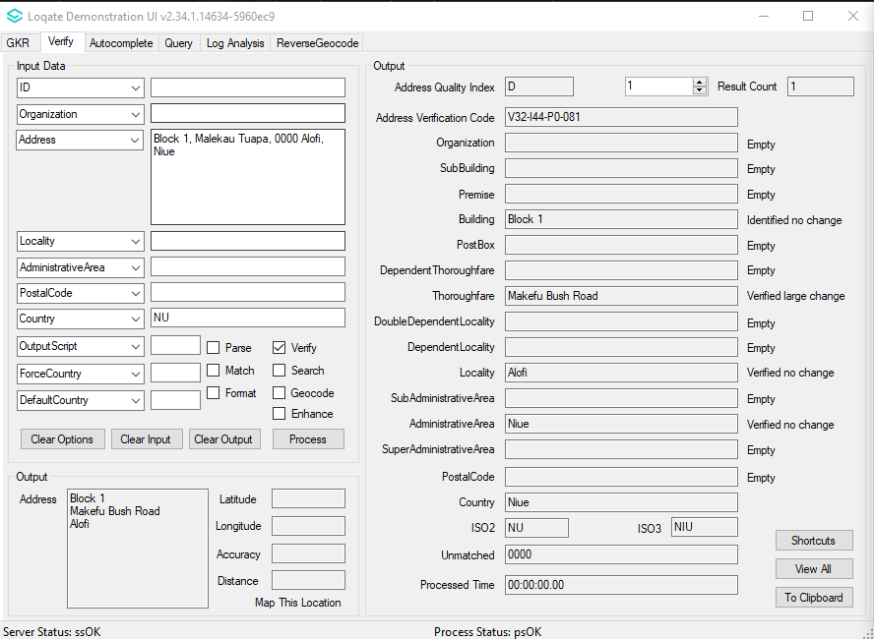 | Niue no longer an AdministrativeArea  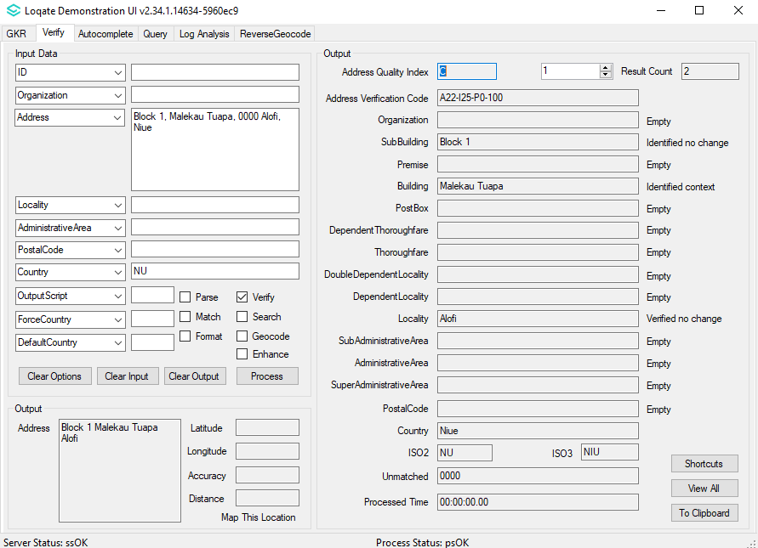

Saint Lucia (L3)

Country Information | Description
ISO2 | LC
ISO3 | LCA
Address Format | Organization  PostBox  SubBuilding Building  Premise Thoroughfare  DependentThoroughfare  DoubleDependentLocality  DependentLocality  Locality PostalCode
PDH | YES
PDH completed date | 2021Q3.0
New Source | NO
Reference Data Pre-PDH | rd_LC_vfy.lfs  rd_LC_vfy_ai.lfs  rd_LC_ggg.lfs  rd_LC_ggg_rg.lfs
Reference Data Post-PDH | rd_LC_vfy.lfs  rd_LC_vfy_ai.lfs  rd_LC_ggg.lfs  rd_LC_ggg_rg.lfs

In this release, improvements have been made to the alignment between Locality and DependentLocality fields. Improvements are made to the verification results within the PostalCode field.

2021Q2.1 | 2021Q3.0
Contains incorrect hierarchy.  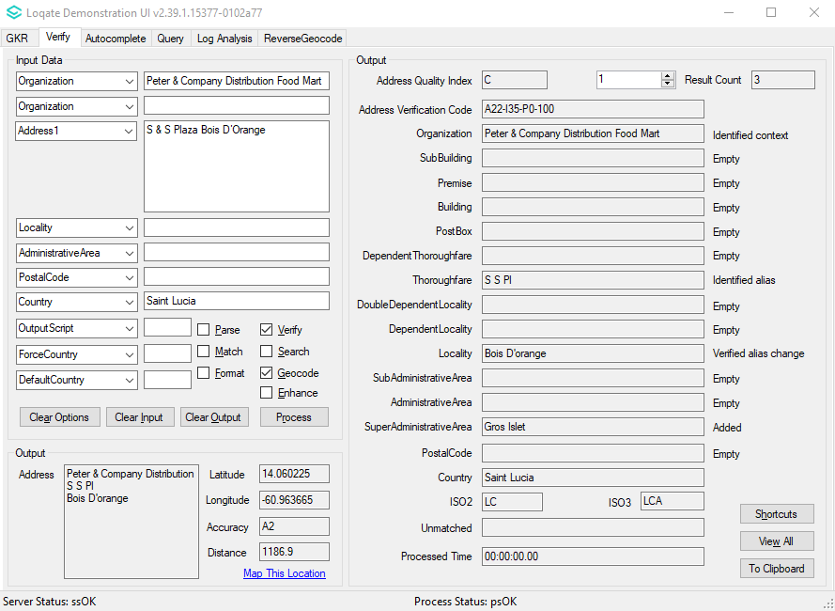 | Corrected the hierarchy with Locality and DependentLocality. PostalCode is added now.  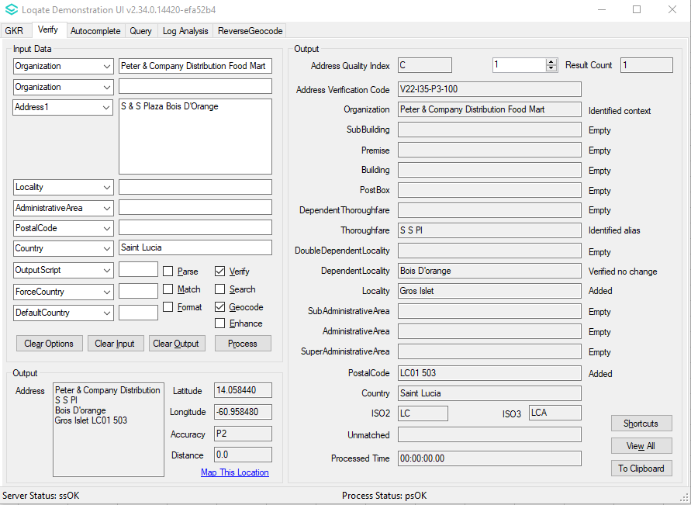

Samoa (L3)

Country Information | Description
ISO2 | WS
ISO3 | WSM
Address Format | Organization  PostBox  SubBuilding Building  Premise Thoroughfare  DependentThoroughfare  DoubleDependentLocality  DependentLocality  Locality
PDH | YES
PDH completed date | 2021Q3.0
New Source | NO
Reference Data Pre-PDH | rd_WS.lfs  rd_WS_ai.lfs  rd_WS_rg.lfs
Reference Data Post-PDH | rd_WS_vfy.lfs  rd_WS_vfy_ai.lfs  rd_WS_ggg.lfs  rd_WS_ggg_rg.lfs

This release provides improvements to the verification results within the AdministrativeArea and SubAdministrativeArea fields.

2021Q2.1 | 2021Q3.0
Incorrect AdministrativeArea returned.  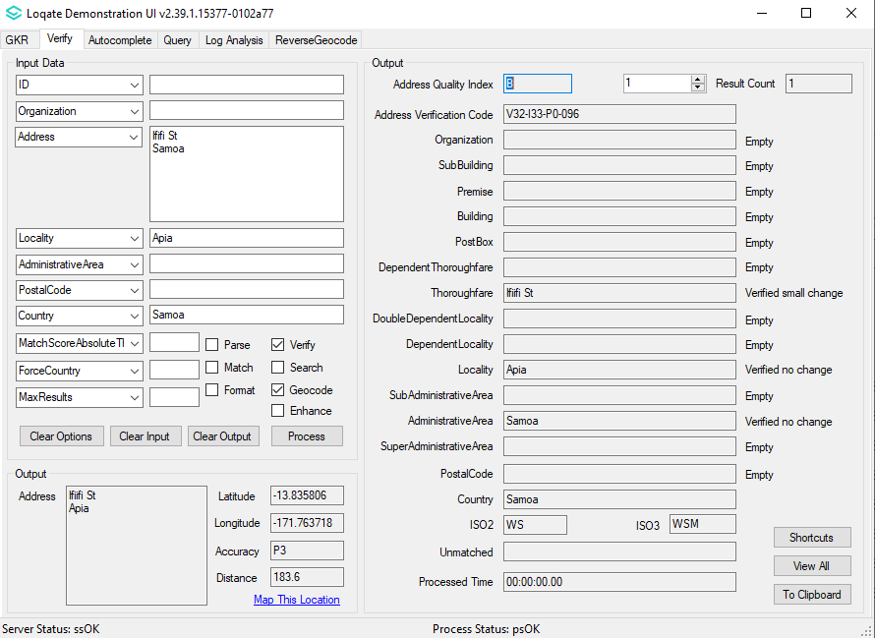 | Correct AdministrativeArea returned, and SubAdministrativeArea added.  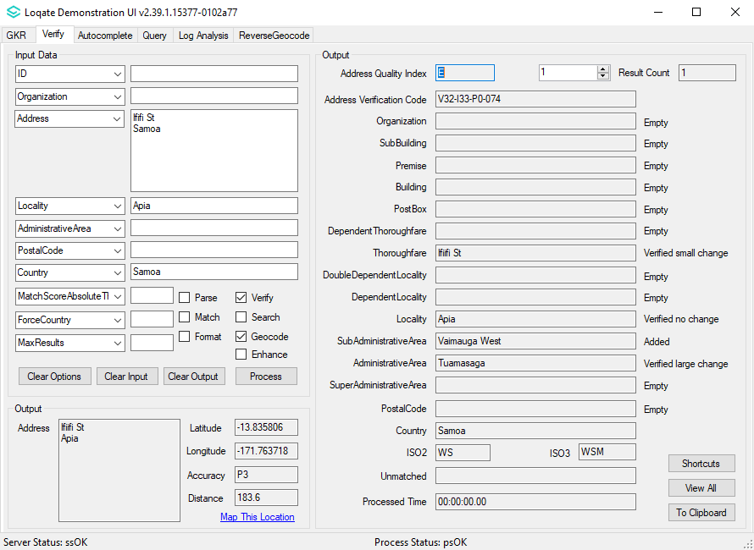

Svalbard and Jan Mayen (L4)

Country Information | Description
ISO2 | SJ
ISO3 | SJM
Address Format | Organization  PostBox  Building SubBuilding  Thoroughfare Premise  DependentThoroughfare  DoubleDependentLocality  DependentLocality  PostalCode Locality
PDH | YES
PDH completed date | 2021Q3.0
New Source | NO
Reference Data Pre-PDH | rd_SJ_ai.lfs  rd_SJ.lfs  rd_SJ_rg.lfs
Reference Data Post-PDH | rd_SJ_ggg.lfs  rd_SJ_ggg_rg.lfs  rd_SJ_vfy_ai.lfs  rd_SJ_vfy.lfs

This release provides improvements to the parse results, and verification results within the Locality field.

2021Q2.1 | 2021Q3.0
Address unable to parse correctly resulting in U0  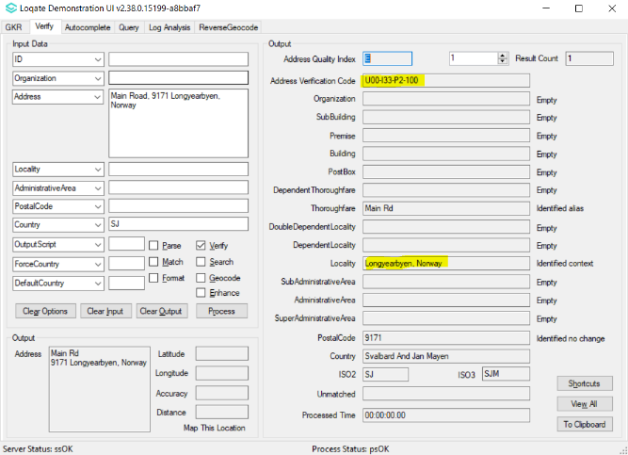 | Parsing improved and locality able to be verified.  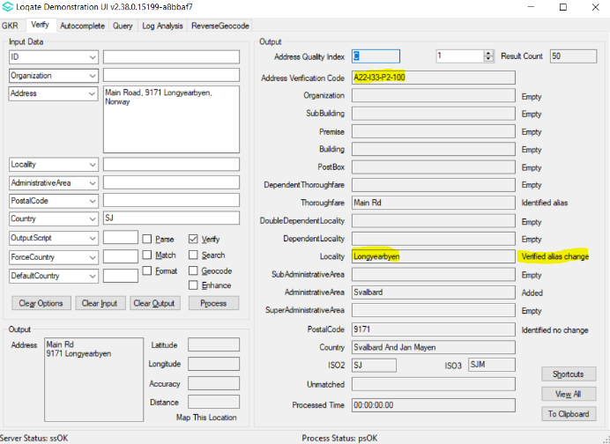

Tokelau (L3)

Country Information | Description
ISO2 | TK
ISO3 | TKL
Address Format | Organization  PostBox  SubBuilding Building  Premise Thoroughfare  DependentThoroughfare  DoubleDependentLocality  DependentLocality  Locality
PDH | YES
PDH completed date | 2021Q3.0
New Source | NO
Reference Data Pre-PDH | rd_TK.lfs  rd_TK_ai.lfs  rd_TK_rg.lfs
Referenec Data Post-PDH | rd_TK_vfy.lfs  rd_TK_vfy_ai.lfs  rd_TK_ggg.lfs  rd_TK_ggg_rg.lfs

This release provides improvements to the verification results of addresses in Tokelau.

2021Q2.1 | 2021Q3.0
Address unable to verify.  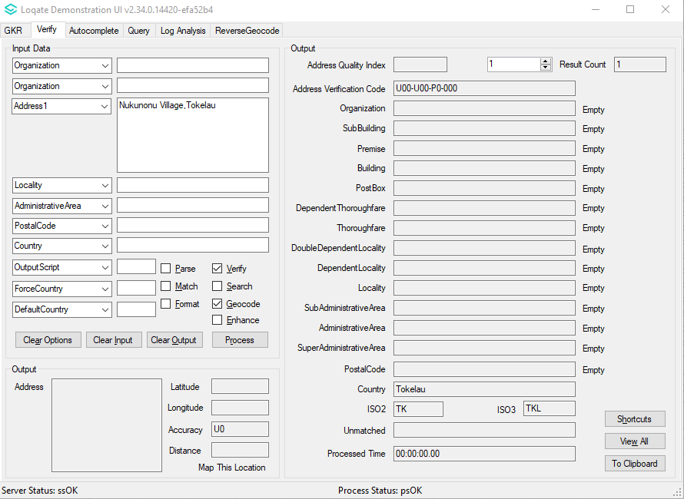 | Address now able to be verified.  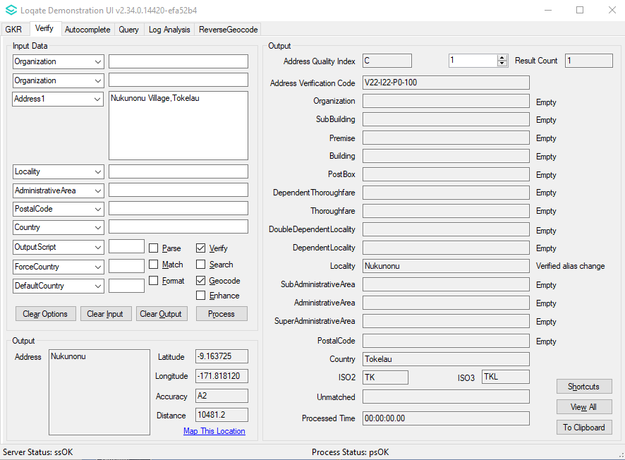

Tuvalu (L3)

Country Information | Description
ISO2 | TV
ISO3 | TUV
Address Format | Organization  PostBox  Building SubBuilding  Thoroughfare Premise  DependentThoroughfare  DoubleDependentLocality  DependentLocality  Locality
PDH | YES
PDH completed date | 2021Q3.0
New Source | NO
Reference Data Pre-PDH | rd_TV.lfs  rd_TV_ai.lfs  rd_TV_rg.lfs
Reference Data Post-PDH | rd_TV_vfy.lfs  rd_TV_vfy_ai.lfs  rd_TV_ggg.lfs  rd_TV_ggg_rg.lfs

In this release, improvements are made to the verification results of addresses in Tuvalu.

2021Q2.1 | 2021Q3.0
Address unable to verify.  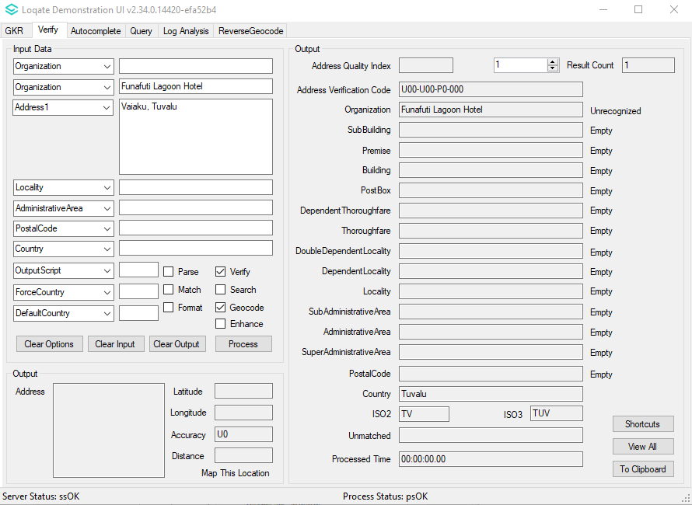 | Address now able to be verified.  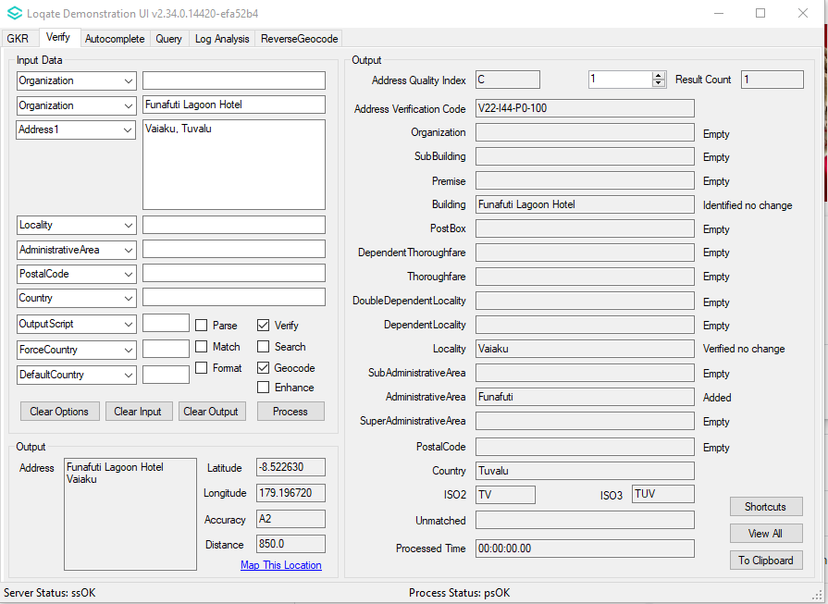

Western Sahara (L3)

Country Information | Description
ISO2 | EH
ISO3 | ESH
Address Format | Organization  PostBox  SubBuilding Building  Premise Thoroughfare  DependentThoroughfare  DoubleDependentLocality  DependentLocality  PostalCode Locality
PDH | YES
PDH completed date | 2021Q3.0
New Source | NO
Reference Data Pre-PDH | rd_EH_vfy.lfs  rd_EH_vfy_ai.lfs  rd_EH_ggg.lfs  rd_EH_ggg_rg.lfs
Reference Data Post-PDH | rd_EH_vfy.lfs  rd_EH_vfy_ai.lfs  rd_EH_ggg.lfs  rd_EH_ggg_rg.lfs

This release provides additional SubAdministrativeArea and AdministrativeArea.

2021Q2.1 | 2021Q3.0
No SubAdministrativeArea and AdministrativeArea.  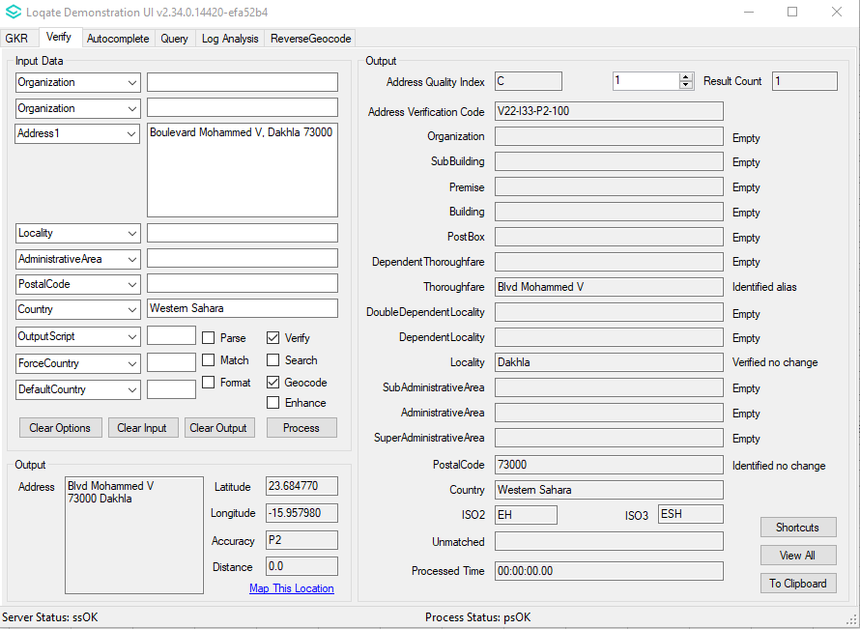 | Added SubAdministrativeArea and AdministrativeArea.  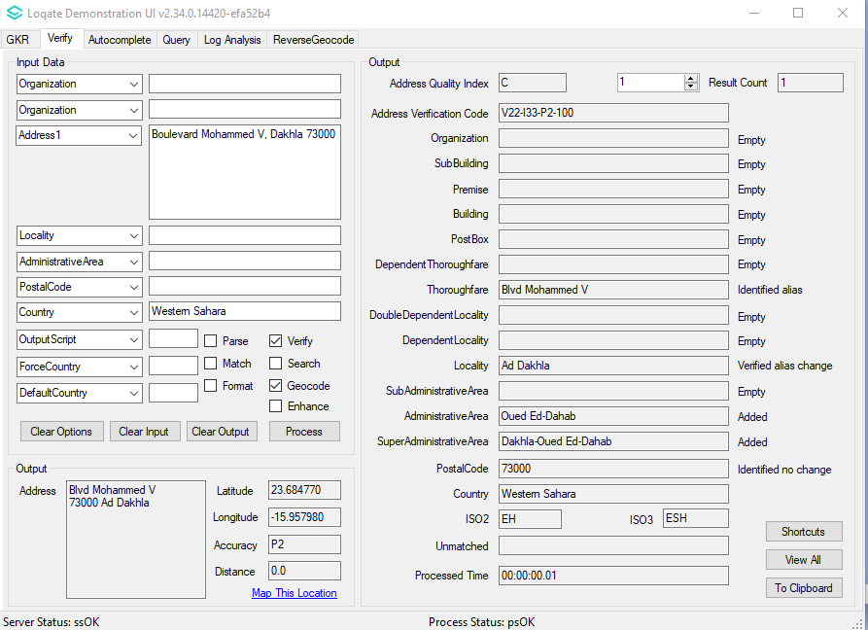

United States Minor Outlying Islands (L2)

Country Information | Description
ISO2 | UM
ISO3 | UMI
Address Format | Organization  PostBox  SubBuilding Building  Premise Thoroughfare  DependentThoroughfare  DoubleDependentLocality  DependentLocality  Locality AdministrativeArea PostalCode
PDH | YES
PDH completed date | 2021Q3.0
New Source | NO
Reference Data Pre-PDH | rd_UM.lfs  rd_UM_ai.lfs  rd_UM_rg.lfs
Reference Data Post-PDH | rd_UM_vfy.lfs  rd_UM_vfy_ai.lfs  rd_UM_ggg.lfs  rd_UM_ggg_rg.lfs

In this release, improvements are made with the verification results in the SubAdministrativeArea and PostalCode fields.

2021Q2.1 | 2021Q3.0
No PostalCode found and old name was used. Incorrect SubAdministrativeArea added.  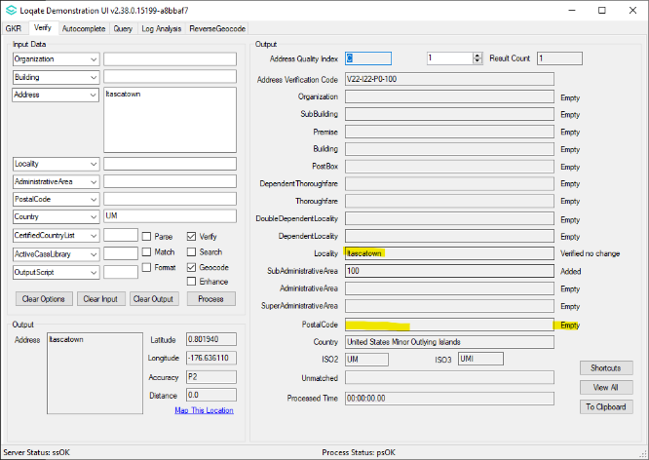 | PostalCode added now with new name.  Incorrect SubAdministrativeArea no longer added.  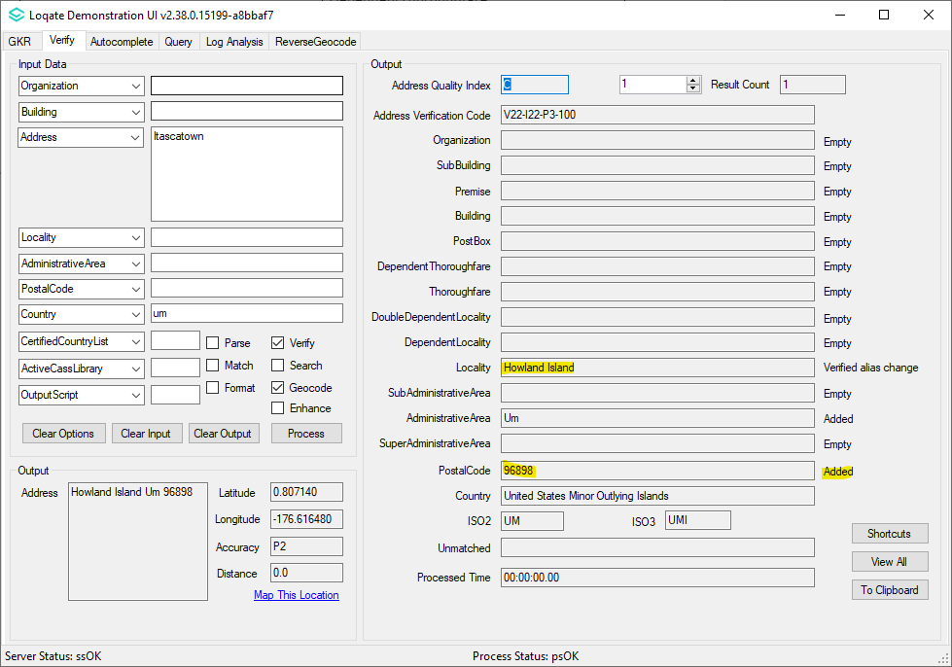

Tonga (L3)

Country Information | Description
ISO2 | TO
ISO3 | TON
Address Format | Organization  PostBox  SubBuilding Building  Premise Thoroughfare  DependentThoroughfare  DoubleDependentLocality  DependentLocality  Locality AdministrativeArea
PDH | YES
PDH completed date | 2021Q3.0
New Source | NO
Reference Data Pre-PDH | rd_TO.lfs  rd_TO_ai.lfs  rd_TO_rg.lfs
Reference Data Post-PDH | rd_TO_vfy.lfs  rd_TO_vfy_ai.lfs  rd_TO_ggg.lfs  rd_TO_ggg_rg.lfs

In this release, the alignment within the Thoroughfare and DependentLocality fields have improved.

2021Q2.1 | 2021Q3.0
Maufanga incorrectly parsed to thoroughfare.  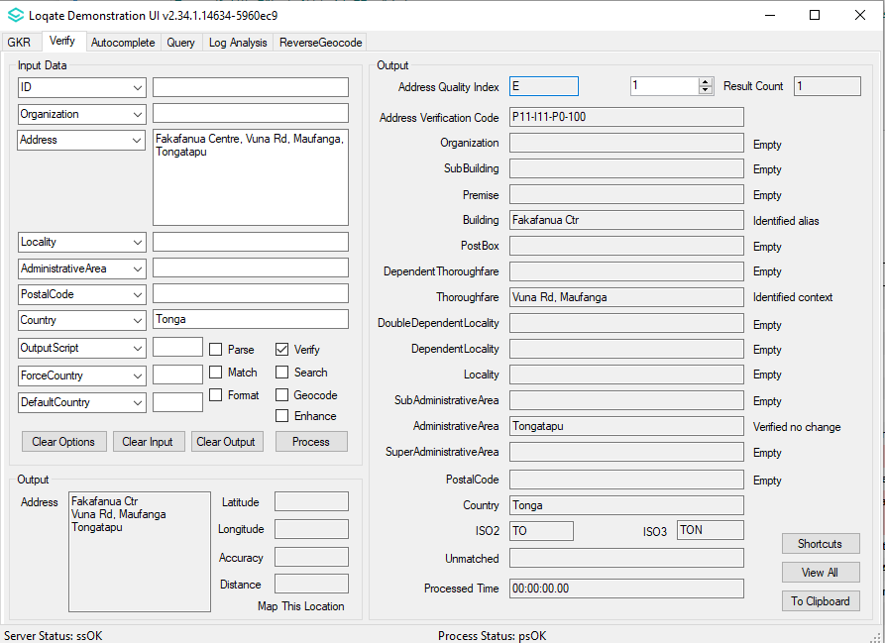 | Maufanga correctly parsed to DependentLocality field.  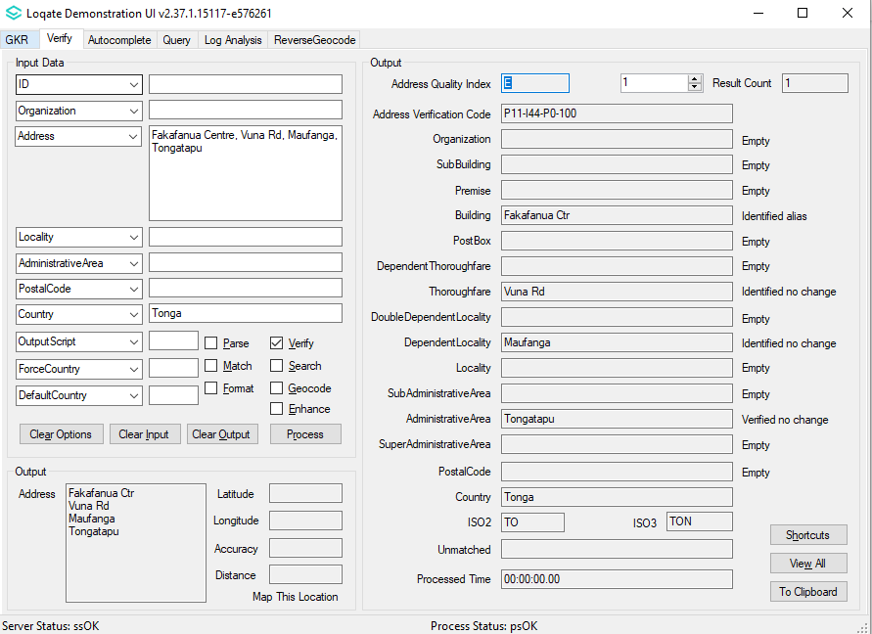

Knowledge Base & Reference Data Updates
The table below shows which countries have been updated, and how, in this release.
If there is a PDH in the reference data column, this shows a country was included in the country improvement project.

- Reference Data: 118 countries
- Lexicon: 6 countries
- Context Rules: 35 countries

COUNTRY NAME | ISO CODE | CONTEXT RULES | LEXICONS | REFERENCE DATA
ANDORRA | AD
UNITED ARAB EMIRATES | AE
AFGHANISTAN | AF |  | X | X
ANTIGUA AND BARBUDA | AG
ANGUILLA | AI
ALBANIA | AL |  |  | X
ARMENIA | AM
ANGOLA | AO
ANTARCTICA | AQ
ARGENTINA | AR
AMERICAN SAMOA | AS |  |  | X
AUSTRIA | AT
AUSTRALIA | AU |  | X | X
ARUBA | AW
ÅLAND ISLANDS | AX
AZERBAIJAN | AZ
BOSNIA AND HERZEGOVINA | BA
BARBADOS | BB
BANGLADESH | BD
BELGIUM | BE
BURKINA FASO | BF
BULGARIA | BG
BAHRAIN | BH
BURUNDI | BI
BENIN | BJ |  | X | X
SAINT BARTHÉLEMY | BL
BERMUDA | BM
BRUNEI DARUSSALAM | BN
BOLIVIA (PLURINATIONAL STATE OF) | BO
BONAIRE, SINT EUSTATIUS AND SABA | BQ
BRAZIL | BR
BAHAMAS | BS
BHUTAN | BT
BOUVET ISLAND | BV
BOTSWANA | BW |  |  | X
BELARUS | BY
BELIZE | BZ
CANADA | CA |  | X | X
COCOS (KEELING) ISLANDS | CC
CONGO, DEMOCRATIC REPUBLIC OF THE | CD |  |  | X
CENTRAL AFRICAN REPUBLIC | CF |  |  | X
CONGO | CG |  |  | X
SWITZERLAND | CH
CÔTE D'IVOIRE | CI |  |  | X
COOK ISLANDS | CK
CHILE | CL
CAMEROON | CM |  |  | X
CHINA | CN
COLOMBIA | CO
COSTA RICA | CR |  |  | X
CUBA | CU |  |  | X
CABO VERDE | CV |  |  | X
CURAÇAO | CW
CHRISTMAS ISLAND | CX
CYPRUS | CY
CZECHIA | CZ
GERMANY | DE | X | X
DJIBOUTI | DJ |  |  | X
DENMARK | DK |  | X | X
DOMINICA | DM
DOMINICAN REPUBLIC | DO
ALGERIA | DZ |  |  | X
ECUADOR | EC
ESTONIA | EE
EGYPT | EG
WESTERN SAHARA | EH |  | X | X
ERITREA | ER |  |  | X
SPAIN | ES |  | X
ETHIOPIA | ET |  |  | X
FINLAND | FI
FIJI | FJ |  | X | X
FALKLAND ISLANDS (MALVINAS) | FK |  |  | X
MICRONESIA (FEDERATED STATES OF) | FM |  |  | X
FAROE ISLANDS | FO |  |  | X
FRANCE | FR | X | X
GABON | GA |  | X | X
UNITED KINGDOM | GB |  | X | X
GRENADA | GD
GEORGIA | GE |  |  | X
FRENCH GUIANA | GF |  |  | X
GUERNSEY | GG |  |  | X
GHANA | GH |  |  | X
GIBRALTAR | GI
GREENLAND | GL |  | X | X
GAMBIA | GM
GUINEA | GN |  |  | X
GUADELOUPE | GP |  |  | X
EQUATORIAL GUINEA | GQ |  |  | X
GREECE | GR
SOUTH GEORGIA AND THE SOUTH SANDWICH ISLANDS | GS
GUATEMALA | GT |  |  | X
GUAM | GU |  |  | X
GUINEA-BISSAU | GW |  |  | X
GUYANA | GY
HONG KONG | HK | X | X
HEARD ISLAND AND MCDONALD ISLANDS | HM
HONDURAS | HN
CROATIA | HR |  |  | X
HAITI | HT
HUNGARY | HU
INDONESIA | ID |  | X | X
IRELAND | IE
ISRAEL | IL
ISLE OF MAN | IM |  |  | X
INDIA | IN |  | X | X
BRITISH INDIAN OCEAN TERRITORY | IO
IRAQ | IQ
IRAN | IR |  | X | X
ICELAND | IS |  |  | X
ITALY | IT |  | X | X
JERSEY | JE |  |  | X
JAMAICA | JM
JORDAN | JO |  |  | X
JAPAN | JP
KENYA | KE |  |  | X
KYRGYZSTAN | KG |  |  | X
CAMBODIA | KH | X | X | X
KIRIBATI | KI |  | X | X
COMOROS | KM
SAINT KITTS AND NEVIS | KN
KOREA (DEMOCRATIC PEOPLE'S REPUBLIC OF) | KP
KOREA, REPUBLIC OF | KR
KUWAIT | KW |  |  | X
CAYMAN ISLANDS | KY
KAZAKHSTAN | KZ
LAO PEOPLE'S DEMOCRATIC REPUBLIC | LA |  |  | X
LEBANON | LB |  |  | X
SAINT LUCIA | LC |  | X | X
LIECHTENSTEIN | LI |  |  | X
SRI LANKA | LK |  |  | X
LIBERIA | LR |  |  | X
LESOTHO | LS |  |  | X
LITHUANIA | LT
LUXEMBOURG | LU
LATVIA | LV
LIBYA | LY |  |  | X
MOROCCO | MA |  |  | X
MONACO | MC
MOLDOVA, REPUBLIC OF | MD
MONTENEGRO | ME |  |  | X
SAINT MARTIN (FRENCH PART) | MF |  |  | X
MADAGASCAR | MG |  |  | X
MARSHALL ISLANDS | MH
NORTH MACEDONIA | MK
MALI | ML |  | X | X
MYANMAR | MM |  | X | X
MONGOLIA | MN
MACAO | MO
NORTHERN MARIANA ISLANDS | MP
MARTINIQUE | MQ |  |  | X
MAURITANIA | MR |  |  | X
MONTSERRAT | MS
MALTA | MT
MAURITIUS | MU |  |  | X
MALDIVES | MV |  |  | X
MALAWI | MW |  |  | X
MEXICO | MX
MALAYSIA | MY |  | X
MOZAMBIQUE | MZ |  |  | X
NAMIBIA | NA |  |  | X
NEW CALEDONIA | NC |  |  | X
NIGER | NE |  |  | X
NORFOLK ISLAND | NF |  |  | X
NIGERIA | NG |  |  | X
NICARAGUA | NI
NETHERLANDS | NL |  | X
NORWAY | NO
NEPAL | NP |  |  | X
NAURU | NR
NIUE | NU |  | X | X
NEW ZEALAND | NZ
OMAN | OM |  |  | X
PANAMA | PA
PERU | PE
FRENCH POLYNESIA | PF |  |  | X
PAPUA NEW GUINEA | PG
PHILIPPINES | PH | X | X | X
PAKISTAN | PK |  |  | X
POLAND | PL
SAINT PIERRE AND MIQUELON | PM
PITCAIRN | PN
PUERTO RICO | PR |  |  | X
PALESTINE, STATE OF | PS
PORTUGAL | PT
PALAU | PW
PARAGUAY | PY
QATAR | QA |  |  | X
RÉUNION | RE |  |  | X
ROMANIA | RO
SERBIA | RS
RUSSIAN FEDERATION | RU
RWANDA | RW |  |  | X
SAUDI ARABIA | SA
SOLOMON ISLANDS | SB |  |  | X
SEYCHELLES | SC |  |  | X
SUDAN | SD
SWEDEN | SE
SINGAPORE | SG
SAINT HELENA, ASCENSION AND TRISTAN DA CUNHA | SH |  |  | X
SLOVENIA | SI
SVALBARD AND JAN MAYEN | SJ |  | X | X
SLOVAKIA | SK |  |  | X
SIERRA LEONE | SL |  |  | X
SAN MARINO | SM
SENEGAL | SN |  |  | X
SOMALIA | SO
SURINAME | SR
SOUTH SUDAN | SS
SAO TOME AND PRINCIPE | ST |  |  | X
EL SALVADOR | SV |  |  | X
SINT MAARTEN (DUTCH PART) | SX
SYRIAN ARAB REPUBLIC | SY
SWAZILAND | SZ |  |  | X
TURKS AND CAICOS ISLANDS | TC |  |  | X
CHAD | TD
FRENCH SOUTHERN TERRITORIES | TF |  | X | X
TOGO | TG |  |  | X
THAILAND | TH |  |  | X
TAJIKISTAN | TJ
TOKELAU | TK |  | X | X
TIMOR-LESTE | TL |  | X
TURKMENISTAN | TM |  |  | X
TUNISIA | TN |  |  | X
TONGA | TO |  | X | X
TURKEY | TR
TRINIDAD AND TOBAGO | TT
TUVALU | TV |  | X | X
TAIWAN | TW
TANZANIA, UNITED REPUBLIC OF | TZ |  |  | X
UKRAINE | UA
UGANDA | UG
UNITED STATES MINOR OUTLYING ISLANDS | UM |  | X | X
UNITED STATES OF AMERICA | US | X | X | X
URUGUAY | UY
UZBEKISTAN | UZ |  |  | X
VATICAN CITY | VA |  |  | X
SAINT VINCENT AND THE GRENADINES | VC
VENEZUELA (BOLIVARIAN REPUBLIC OF) | VE
VIRGIN ISLANDS (BRITISH) | VG |  |  | X
VIRGIN ISLANDS (U.S.) | VI |  |  | X
VIET NAM | VN
VANUATU | VU
WALLIS AND FUTUNA | WF
SAMOA | WS |  |  | X
YEMEN | YE |  |  | X
MAYOTTE | YT |  |  | X
SOUTH AFRICA | ZA
ZAMBIA | ZM |  |  | X
ZIMBABWE | ZW |  |  | X

