Loqate, A GBG Solution
Release Notes – Verify API
2021Q3.0_Major Release

Case Resolutions
Please visit https://support.loqate.com/release-information/2021q3-0-resolved-cases/ for a list of cases resolved in this release. If you would like more details on any of the solved cases listed, please contact LoqateSupport@gbgplc.com for further information.

Local API Improvements

Search
With the 2021Q3.0 major release, Loqate has enhanced the search accuracy by identifying the best match based on similar pattern of the input's premise number.

2021Q2.1 | 2021Q3.0
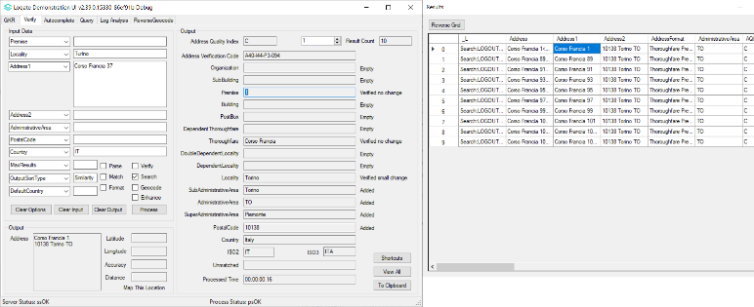 | 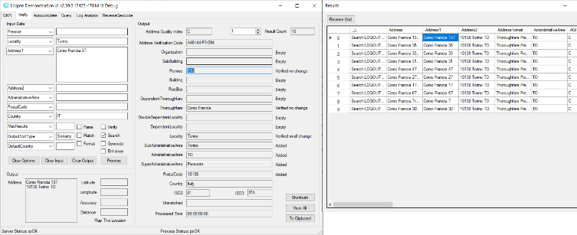
2021Q2.1: The list of premise numbers is not relevant to the input | 2021Q3.0: The best match of premise number is identified after sorting the list according to the input's premise number

Verify and Enhance

Updating Locality with Enhance on will not affect the MatchScore results.

2021Q2.1 | 2021Q3.0
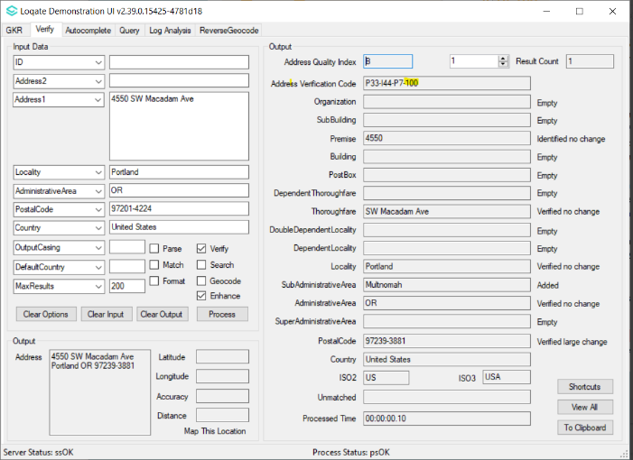 | 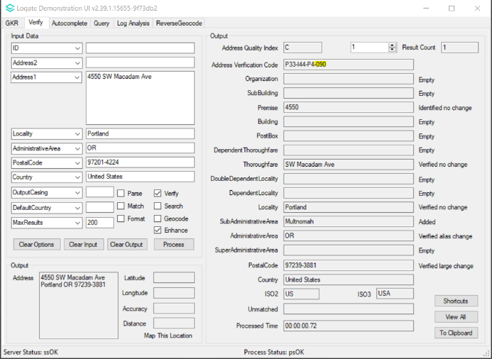
2021Q2.1: The matchscore is 100 despite Postal code is Verified Large change. | 2021Q3.0: The matchscore now correctly reflects the fields' status.

Verify

Enable Parsing to reflect accuracy when using the server option DefaultCountry value.

2021Q2.1 | 2021Q3.0
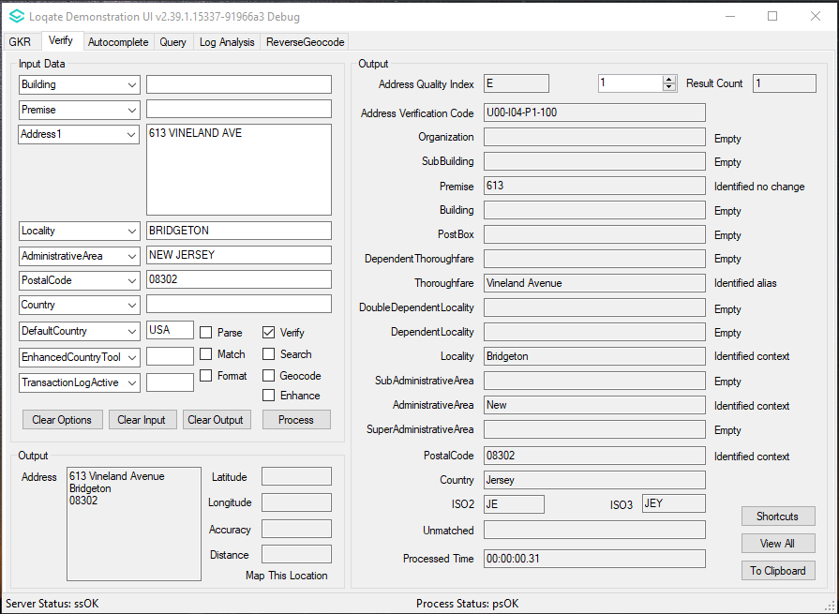 | 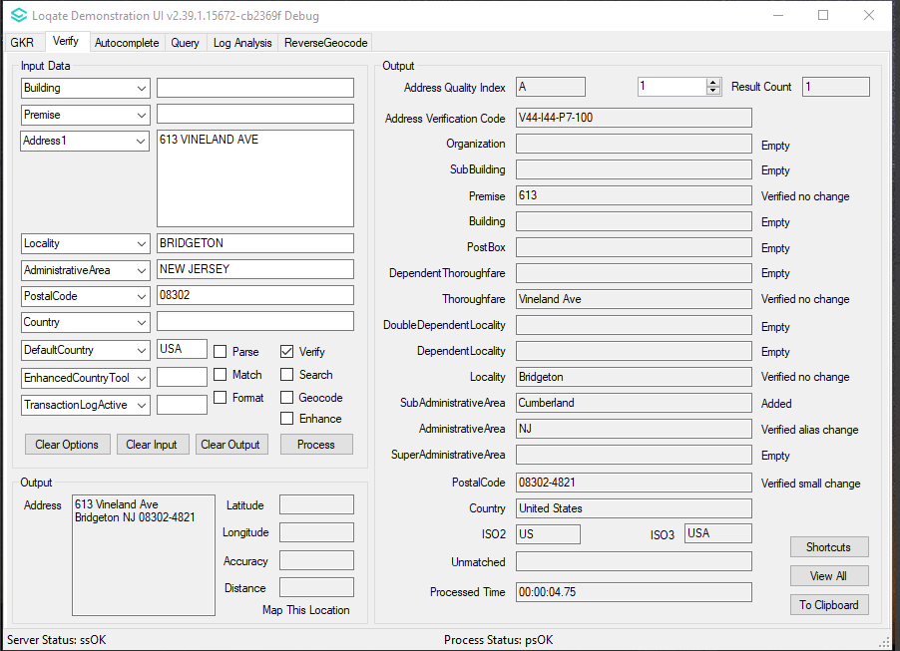
2021Q2.1: The address is detected to a wrong country - Jersey, and unable to be recognized by the engine. | 2021Q3.0: The address is detected as "USA", and able to be verified to V44 results.

Installation Instructions

Please remember to update both the program files and the reference data. The improvements are tied to the data in the Global Knowledge Repository and the Local API. When updating the data, it is recommended to use a new data folder each time in order to ensure the latest dataset is installed properly.

If you need any assistance with the upgrade of the Local API or the data update process, please contact GBG Loqate Support.

The setup wizard for the Local API can be obtained from our SFTP server. Please contact your account manager to retrieve the SFTP information. If you do not know who your account manager is, please contact the support team at LoqateSupport@gbgplc.com.

