Loqate, A GBG Solution
Release Notes – Reference Data & Knowledge Base
2021Q2.0 Major Release

Case Resolutions
Please visit https://support.loqate.com/release-information/2021q2-0-resolved-cases/ for a list of cases resolved in this release. If you would like more details on any of the solved cases listed, please contact LoqateSupport@gbgplc.com for further information.

Certification Expiration Dates
If you have purchased either the CASS (USA) or AMAS (Australia) certified products, please be aware that the datasets have expiration dates set by the respective postal authorities. Please ensure that you have the latest library and data installed to avoid loss of service through these products.

Please check Install Manager for the latest versions of AMAS and CASS.
 | Loqate Release Date | Certification Expiry Date*
AMAS Data | 2021-02-26 | 2021-06-30
CASS Data | 2021-04-15 | 2021-07-29
*Certification Expiry Date is different from Loqate license key expiry date. The earliest expiry date will apply.

For more information on expiry date checking for CASS and AMAS, please refer “Usage expiration” section in https://support.loqate.com/documentation/local-apis/cass-overview-2/ and https://support.loqate.com/address-matching-approval-system-amas/

Data Notices

Australia

Please note: From the 2021Q2.0 Major Release, the “Suburb” field, defined by Australia Post, will be moved from Locality to DependentLocality and the wider metropolitan region (or city) will become the Locality. The change will only occur in Verify output components; the address lines will be unaffected and will remain compliant with postal standards.

United States (Verify & CASS) & Puerto Rico (Verify)

Please note: The following update will be delayed: the address line containing the “URB” (Urbanization, if present) will be moving above the address line containing the premise and street. This is a corrective change to ensure compliance with USPS standards. We will notify you when this change is available.

For example (2020Q4.1 on left; from 2021Q2.0 on right)
280 Calle 13 NW  Urb Puerto Nuevo  San Juan PR 00920-2206 | Urb Puerto Nuevo  280 Calle 13 NW  San Juan PR 00920-2206

USA CASS2 Engine

Please note: From the 2021Q2.0 major release, the USA CASS2 engine will be made available. Information on the USA CASS2 engine can be found on the support site here. Please contact your account manager for additional information in regards to accessing USA CASS2.

Data Improvements

Australia

Country Information | Description
ISO2 | AU
ISO3 | AUS
Address Format (Default) | Organization  PostBox  Building  SubBuilding Premise Thoroughfare  DependentThoroughfare  DoubleDependentLocality  Locality AdministrativeArea PostalCode
Conditional Address Format (When DependentLocality is present) | Organization  PostBox  Building  SubBuilding Premise Thoroughfare  DependentThoroughfare  DoubleDependentLocality  Dependent AdministrativeArea PostalCode
PDH | YES
PDH completed date | 2021Q2.0
New Source | NO
Reference Data Pre-PDH | rd_AU_ggg.lfs  rd_AU_ggg_rg.lfs  rd_AU_ggg_r.lfs  rd_AU_vfy_ai.lfs  rd_AU_vfy.lfs
Reference Data Post-PDH | rd_AU_ggg.lfs  rd_AU_ggg_rg.lfs  rd_AU_ggg_r.lfs  rd_AU_vfy_ai.lfs  rd_AU_vfy.lfs

In the 2021Q2.0 major release, the “Suburb” field will be moved from Locality to DependentLocality and the wider metropolitan region will become the Locality. This change will occur in Verify output components; the address lines will be unaffected and will remain compliant with postal standards.

When a DependentLocality is present, the address format will use the conditional address format (provided in the above table) for Australia.

Additional updates include improvements in the verification results within the Building, Thoroughfare, and DependentLocality fields.

India

With this release, two AdministrativeArea have been updated to better align with the postal authority. The two AdministrativeArea (Dadra and Nagar Haveli; Daman and Diu) are merged into a single Administrative called Dadra & Nagar Haveli & Daman & Diu.

Country Improvement Program (PDH)
The following section will display the changes made during the country improvement program.
For more details on our Country Improvement Program, please visit the support site here. The country verification level is displayed in parenthesis next to the country name.

Barbados

Country Information | Description
ISO2 | BB
ISO3 | BRB
Address Format | Organization  PostBox  SubBuilding Building  Premise Thoroughfare  DependentThoroughfare  DoubleDependentLocality  DependentLocality  Locality PostalCode
PDH | YES
PDH completed date | 2021Q2.0
New Source | NO
Reference Data Pre-PDH | rd_BB_vfy.lfs  rd_BB_vfy_ai.lfs  rd_BB_ggg.lfs  rd_BB_ggg_rg.lfs
Reference Data Post-PDH | rd_BB_vfy.lfs  rd_BB_vfy_ai.lfs  rd_BB_ggg.lfs  rd_BB_ggg_rg.lfs

This release includes improvements with the verification results in the DependentLocality field.

Bhutan

Country Information | Description
ISO2 | BT
ISO3 | BTN
Address Format | Organization  PostBox  SubBuilding Building  Premise Thoroughfare  DependentThoroughfare  DoubleDependentLocality  DependentLocality  Locality PostalCode
PDH | YES
PDH completed date | 2021Q2.0

Bhutan Continued…

New Source | NO
Reference Data Pre-PDH | rd_BT.lfs  rd_BT_ai.lfs  rd_BT_rg.lfs
Reference Data Post-PDH | rd_BT_vfy.lfs  rd_BT_vfy_ai.lfs  rd_BT_ggg.lfs  rd_BT_ggg_rg.lfs

In this release, the alignment between SuperAdministrativeArea and AdministrativeArea fields are now resolved.

This release also includes improvements to the verification results within the PostalCode field.

Burkina Faso

Country Information | Description
ISO2 | BF
ISO3 | BFA
Address Format | Organization  PostBox  SubBuilding Building  Premise Thoroughfare  DependentThoroughfare  DoubleDependentLocality  DependentLocality  Locality
PDH | YES
PDH completed date | 2021Q2.0
New Source | NO
Reference Data Pre-PDH | rd_BF.lfs  rd_BF_ai.lfs  rd_BF_rg.lfs
Reference Data Post-PDH | rd_BF_vfy.lfs  rd_BF_vfy_ai.lfs  rd_BF_ggg.lfs  rd_BF_ggg_rg.lfs

This release provides improved verification results in the SuperAdministrativeArea and the AdministrativeArea fields.

Burundi

Country Information | Description
ISO2 | BI
ISO3 | BDI
Address Format | Organization  PostBox  SubBuilding Building  Premise Thoroughfare  DependentThoroughfare  DoubleDependentLocality  DependentLocality  Locality
PDH | YES
PDH completed date | 2021Q2.0
New Source | NO
Reference Data Pre-PDH | rd_BI.lfs  rd_BI_ai.lfs  rd_BI_rg.lfs  rd_BI_geop.lfs  rd_BI_geop_rg.lfs
Reference Data Post-PDH | rd_BI_vfy.lfs  rd_BI_vfy_ai.lfs  rd_BI_ggg.lfs  rd_BI_ggg_rg.lfs

In this release, verification results are improved within the following fields: AdministrativeArea, SubAdministrativeArea, and DependentLocality.

Gambia

Country Information | Description
ISO2 | GM
ISO3 | GMB
Address Format | Organization  PostBox  SubBuilding Building  Premise Thoroughfare  DependentThoroughfare  DoubleDependentLocality  DependentLocality  Locality
PDH | YES
PDH completed date | 2021Q2.0
New Source | NO
Reference Data Pre-PDH | rd_GM.lfs  rd_GM_ai.lfs  Rd_GM_rg.lfs
Reference Data Post-PDH | rd_GM_vfy.lfs  rd_GM_vfy_ai.lfs  rd_GM_ggg.lfs  Rd_GM_ggg_rg.lfs

Gambia Continued…

With this release, the AdministrativeArea and SubAdministrativeArea are updated to better align with the postal authority. Banjul Centra will be included as a SubAdministrativeArea and Western has been removed as an AdministrativeArea.

Holy See (Vatican City State)

Country Information | Description
ISO2 | VA
ISO3 | VAT
Address Format | Organization  PostBox  Building SubBuilding  Thoroughfare Premise  DependentThoroughfare  DoubleDependentLocality  DependentLocality  PostalCode Locality AdministrativeArea
PDH | YES
PDH completed date | 2021Q2.0
New Source | NO
Reference Data Pre-PDH | rd_VA_vfy.lfs  rd_VA_vfy_ai.lfs  rd_VA_ggg.lfs  rd_VA_ggg_rg.lfs
Reference Data Post-PDH | rd_VA_vfy.lfs  rd_VA_vfy_ai.lfs  rd_VA_ggg.lfs  rd_VA_ggg_rg.lfs

With this release, the alignment between AdministrativeArea and Locality are now resolved and improvements in the verification results are made.

Kazakhstan

Country Information | Description
ISO2 | KZ
ISO3 | KAZ
Address Format: (Cyrillic script) | AdministrativeArea  SubAdministrativeArea  PostalCode ,Locality  DependentLocality  DoubleDependentLocality  DependentThoroughfare  Thoroughfare Premise Building SubBuilding  PostBox  Organization

Kazakhstan Continued…

Address Format: (Latin script) | Organization  PostBox  Thoroughfare Premise Building SubBuilding  DependentThoroughfare  DoubleDependentLocality  DependentLocality  PostalCode ,Locality  SubAdministrativeArea  AdministrativeArea
PDH | YES
PDH completed date | 2021Q2.0
New Source | NO
Reference Data Pre-PDH | rd_KZ_ai.lfs  rd_KZ_geop.lfs  rd_KZ_geop_rg.lfs  rd_KZ.lfs  rd_KZ_rg.lfs
Reference Data Post-PDH | rd_KZ_vfy.lfs  rd_KZ_vfy_ai.lfs  rd_KZ_ggg.lfs  rd_KZ_ggg_rg.lfs

With this release, improvements are made to the verification results in the AdministrativeArea and SubAdministrativeArea fields.

Nauru

Country Information | Description
ISO2 | NR
ISO3 | NRU
Address Format | Organization  PostBox  SubBuilding Building  Premise Thoroughfare  DependentThoroughfare  DoubleDependentLocality  DependentLocality  Locality  PostalCode
PDH | YES
PDH completed date | 2021Q2.0
New Source | NO
Reference Data Pre-PDH | rd_NR.lfs  rd_NR_ai.lfs  rd_NR_rg.lfs
Reference Data Post-PDH | rd_NR_vfy.lfs  rd_NR_vfy_ai.lfs  rd_NR_ggg.lfs  rd_NR_ggg_rg.lfs

Nauru Continued…

This release includes improvements to the verification results within the AdministrativeArea field.

Palestine, State of

Country Information | Description
ISO2 | PS
ISO3 | PSE
Address Format | Organization  PostBox  Building SubBuilding  Thoroughfare Premise  DependentThoroughfare  DoubleDependentLocality  DependentLocality  Locality AdministrativeArea PostalCode
PDH | YES
PDH completed date | 2021Q2.0
New Source | NO
Reference Data Pre-PDH | rd_PS.lfs  rd_PS_ai.lfs  rd_PS_rg.lfs
Reference Data Post-PDH | rd_PS_vfy.lfs  rd_PS_vfy_ai.lfs  rd_PS_ggg.lfs  rd_PS_ggg_rg.lfs

With this release, improvements are made to the verification results in the Locality field.

Saint Pierre and Miquelon

Country Information | Description
ISO2 | PM
ISO3 | SPM
Address Format | Organization  PostBox  SubBuilding Building  Premise Thoroughfare  DependentThoroughfare  DoubleDependentLocality  DependentLocality  PostalCode Locality AdministrativeArea
PDH | YES
PDH completed date | 2021Q2.0
New Source | NO
Reference Data Pre-PDH | rd_PM.lfs  rd_PM_ai.lfs  rd_PM_rg.lfs

Saint Pierre and Miquelon Conitnued…

Reference Data Post-PDH | rd_PM_vfy.lfs  rd_PM_vfy_ai.lfs  rd_PM_ggg.lfs  rd_PM_ggg_rg.lfs

Verification results are improved within the SubAdministrativeArea and AdministrativeArea fields.

Sudan

Country Information | Description
ISO2 | SD
ISO3 | SDN
Address Format | Organization  PostBox  SubBuilding Building  Premise Thoroughfare  DependentThoroughfare  DoubleDependentLocality  DependentLocality  PostalCode  Locality
PDH | YES
PDH completed date | 2021Q2.0
New Source | NO
Reference Data Pre-PDH | rd_SD.lfs  rd_SD_ai.lfs  rd_SD_rg.lfs
Reference Data Post-PDH | rd_SD_vfy.lfs  rd_SD_vfy_ai.lfs  rd_SD_ggg.lfs  rd_SD_ggg_rg.lfs

In this release, improvements are made to the verification results for the SubAdministrativeArea field.

Syrian Arab Republic

Country Information | Description
ISO2 | SY
ISO3 | SYR
Address Format | Organization  PostBox  SubBuilding Building  Premise Thoroughfare  DependentThoroughfare  DoubleDependentLocality  DependentLocality  Locality
PDH | YES
PDH completed date | 2021Q2.0

Syrian Arab Republic Continued…

New Source | NO
Reference Data Pre-PDH | rd_SY.lfs  rd_SY_ai.lfs  rd_SY_rg.lfs
Reference Data Post-PDH | rd_SY_vfy.lfs  rd_SY_vfy_ai.lfs  rd_SY_ggg.lfs  rd_SY_ggg_rg.lfs

This release includes improvements to the verification results for the AdministrativeArea field.

Yemen

Country Information | Description
ISO2 | YE
ISO3 | YEM
Address Format | Organization  PostBox  SubBuilding Building  Premise Thoroughfare  DependentThoroughfare  DoubleDependentLocality  DependentLocality  Locality
PDH | YES
PDH completed date | 2021Q2.0
New Source | NO
Reference Data Pre-PDH | rd_YE.lfs  rd_YE_ai.lfs  rd_YE_rg.lfs
Reference Data Post-PDH | rd_YE_vfy.lfs  rd_YE_vfy_ai.lfs  rd_YE_ggg.lfs  rd_YE_ggg_rg.lfs

With this release, improvements are made to the verification results for the AdministrativeArea and the SubAdministrativeArea fields.

Vietnam

Country Information | Description
ISO2 | VN
ISO3 | VNM
Address Format | Organization  PostBox  SubBuilding Building  Premise Thoroughfare  DependentThoroughfare  DoubleDependentLocality DependentLocality  Locality, SubAdministrativeArea  AdministrativeArea PostalCode
PDH | YES
PDH completed date | 2021Q2.0
New Source | NO
Reference Data Pre-PDH | rd_VN_ai.lfs  rd_VN_geop.lfs  rd_VN_geop_rg.lfs  rd_VN.lfs  rd_VN_rg.lfs
Reference Data Post-PDH | rd_VN_vfy.lfs  rd_VN_vfy_ai.lfs  rd_VN_ggg.lfs  rd_VN_ggg_rg.lfs

In this release, improvements are made to the verification results for the Building and Thoroughfare fields.

From the 2021Q2.0 major release, “Ward” will be included as a Locality and District will be included as a SubAdministrativeArea.

Vietnam Continued…
2021Q1.1 | 2021Q2.0
Building and Thoroughfare were not parsed correctly.  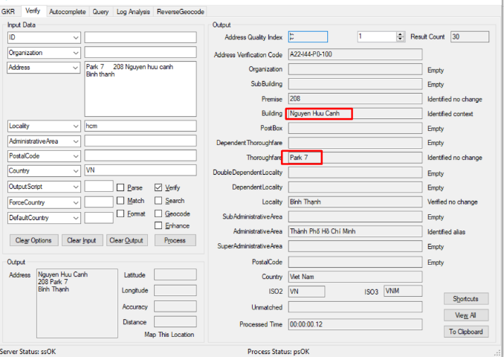 | Building and Thoroughfare are parsed correctly after the fix.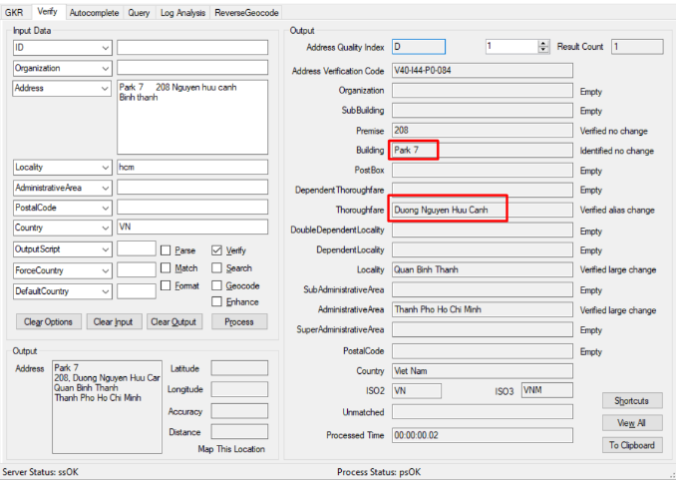
Previously most of the localities (ward) and SubAdministrativeArea (district) were demoted one level  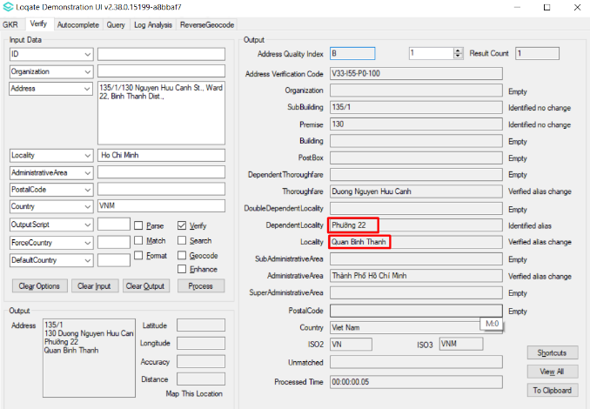 | Fixed the alignment where the ‘Ward’ now verified as locality and ‘District’ verified as SubAdministrativeArea  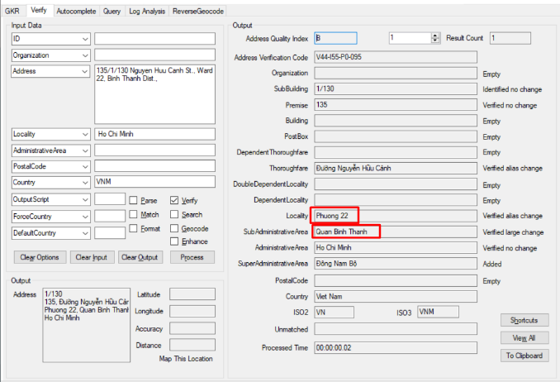
Incorrect address format in previous release.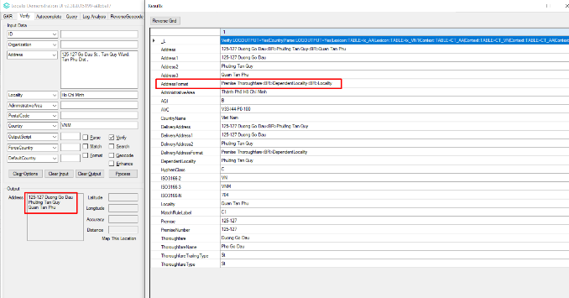 | The address format has been fixed in accordance to Vietnam addressing format.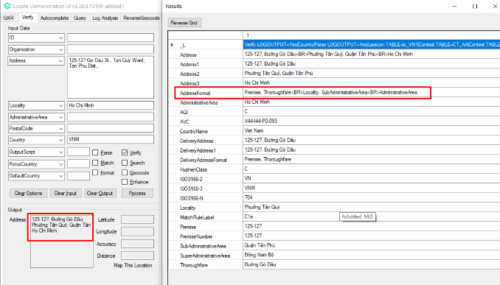

Knowledge Base & Reference Data Updates
The table below shows which countries have been updated, and how, in this release.
If there is a PDH in the reference data column, this shows a country was included in the country improvement project.

- Reference Data: 40 countries
- Lexicon: 22 countries
- Context Rules: 4 countries

COUNTRY NAME | ISO CODE | CONTEXT RULES | LEXICONS | REFERENCE DATA
ANDORRA | AD
UNITED ARAB EMIRATES | AE
AFGHANISTAN | AF
ANTIGUA AND BARBUDA | AG
ANGUILLA | AI
ALBANIA | AL
ARMENIA | AM
ANGOLA | AO
ANTARCTICA | AQ
ARGENTINA | AR
AMERICAN SAMOA | AS |  |  | X
AUSTRIA | AT |  |  | X
AUSTRALIA | AU |  | X | X
ARUBA | AW
ÅLAND ISLANDS | AX
AZERBAIJAN | AZ
BOSNIA AND HERZEGOVINA | BA |  |  | X
BARBADOS | BB |  | X | X
BANGLADESH | BD
BELGIUM | BE
BURKINA FASO | BF |  | X | X
BULGARIA | BG
BAHRAIN | BH
BURUNDI | BI |  | X | X
BENIN | BJ
SAINT BARTHÉLEMY | BL
BERMUDA | BM
BRUNEI DARUSSALAM | BN
BOLIVIA (PLURINATIONAL STATE OF) | BO
BONAIRE, SINT EUSTATIUS AND SABA | BQ
BRAZIL | BR | X
BAHAMAS | BS
BHUTAN | BT |  | X | X
BOUVET ISLAND | BV
BOTSWANA | BW
BELARUS | BY
BELIZE | BZ
CANADA | CA | X | X | X
COCOS (KEELING) ISLANDS | CC
CONGO, DEMOCRATIC REPUBLIC OF THE | CD
CENTRAL AFRICAN REPUBLIC | CF
CONGO | CG
SWITZERLAND | CH
CÔTE D'IVOIRE | CI
COOK ISLANDS | CK
CHILE | CL
CAMEROON | CM
CHINA | CN
COLOMBIA | CO | X
COSTA RICA | CR
CUBA | CU
CABO VERDE | CV
CURAÇAO | CW
CHRISTMAS ISLAND | CX
CYPRUS | CY |  |  | X
CZECHIA | CZ
GERMANY | DE |  | X | X
DJIBOUTI | DJ
DENMARK | DK
DOMINICA | DM
DOMINICAN REPUBLIC | DO
ALGERIA | DZ
ECUADOR | EC
ESTONIA | EE
EGYPT | EG
WESTERN SAHARA | EH
ERITREA | ER
SPAIN | ES |  |  | X
ETHIOPIA | ET
FINLAND | FI
FIJI | FJ
FALKLAND ISLANDS (MALVINAS) | FK
MICRONESIA (FEDERATED STATES OF) | FM |  |  | X
FAROE ISLANDS | FO
FRANCE | FR
GABON | GA
UNITED KINGDOM | GB |  |  | X
GRENADA | GD
GEORGIA | GE
FRENCH GUIANA | GF
GUERNSEY | GG |  |  | X
GHANA | GH
GIBRALTAR | GI
GREENLAND | GL
GAMBIA | GM |  | X | X
GUINEA | GN
GUADELOUPE | GP
EQUATORIAL GUINEA | GQ
GREECE | GR
SOUTH GEORGIA AND THE SOUTH SANDWICH ISLANDS | GS
GUATEMALA | GT
GUAM | GU |  |  | X
GUINEA-BISSAU | GW
GUYANA | GY
HONG KONG | HK
HEARD ISLAND AND MCDONALD ISLANDS | HM
HONDURAS | HN
CROATIA | HR
HAITI | HT
HUNGARY | HU
INDONESIA | ID
IRELAND | IE
ISRAEL | IL
ISLE OF MAN | IM |  |  | X
INDIA | IN |  |  | X
BRITISH INDIAN OCEAN TERRITORY | IO
IRAQ | IQ
IRAN | IR
ICELAND | IS
ITALY | IT
JERSEY | JE |  |  | X
JAMAICA | JM
JORDAN | JO
JAPAN | JP
KENYA | KE
KYRGYZSTAN | KG
CAMBODIA | KH
KIRIBATI | KI
COMOROS | KM
SAINT KITTS AND NEVIS | KN
KOREA (DEMOCRATIC PEOPLE'S REPUBLIC OF) | KP
KOREA, REPUBLIC OF | KR |  |  | X
KUWAIT | KW
CAYMAN ISLANDS | KY
KAZAKHSTAN | KZ |  | X | X
LAO PEOPLE'S DEMOCRATIC REPUBLIC | LA
LEBANON | LB
SAINT LUCIA | LC
LIECHTENSTEIN | LI
SRI LANKA | LK
LIBERIA | LR
LESOTHO | LS
LITHUANIA | LT
LUXEMBOURG | LU
LATVIA | LV
LIBYA | LY
MOROCCO | MA
MONACO | MC
MOLDOVA, REPUBLIC OF | MD
MONTENEGRO | ME
SAINT MARTIN (FRENCH PART) | MF
MADAGASCAR | MG
MARSHALL ISLANDS | MH |  |  | X
NORTH MACEDONIA | MK
MALI | ML
MYANMAR | MM
MONGOLIA | MN
MACAO | MO
NORTHERN MARIANA ISLANDS | MP |  |  | X
MARTINIQUE | MQ
MAURITANIA | MR
MONTSERRAT | MS
MALTA | MT
MAURITIUS | MU
MALDIVES | MV
MALAWI | MW
MEXICO | MX
MALAYSIA | MY
MOZAMBIQUE | MZ
NAMIBIA | NA
NEW CALEDONIA | NC
NIGER | NE
NORFOLK ISLAND | NF
NIGERIA | NG
NICARAGUA | NI
NETHERLANDS | NL
NORWAY | NO
NEPAL | NP
NAURU | NR |  | X | X
NIUE | NU
NEW ZEALAND | NZ
OMAN | OM |  |  | X
PANAMA | PA
PERU | PE
FRENCH POLYNESIA | PF
PAPUA NEW GUINEA | PG
PHILIPPINES | PH
PAKISTAN | PK
POLAND | PL
SAINT PIERRE AND MIQUELON | PM |  | X | X
PITCAIRN | PN |  | X | X
PUERTO RICO | PR |  |  | X
PALESTINE, STATE OF | PS |  | X | X
PORTUGAL | PT
PALAU | PW |  |  | X
PARAGUAY | PY
QATAR | QA
RÉUNION | RE
ROMANIA | RO |  |  | X
SERBIA | RS
RUSSIAN FEDERATION | RU |  | X
RWANDA | RW
SAUDI ARABIA | SA
SOLOMON ISLANDS | SB
SEYCHELLES | SC
SUDAN | SD |  | X | X
SWEDEN | SE
SINGAPORE | SG
SAINT HELENA, ASCENSION AND TRISTAN DA CUNHA | SH
SLOVENIA | SI
SVALBARD AND JAN MAYEN | SJ
SLOVAKIA | SK
SIERRA LEONE | SL
SAN MARINO | SM
SENEGAL | SN
SOMALIA | SO
SURINAME | SR
SOUTH SUDAN | SS
SAO TOME AND PRINCIPE | ST
EL SALVADOR | SV
SINT MAARTEN (DUTCH PART) | SX
SYRIAN ARAB REPUBLIC | SY |  | X | X
SWAZILAND | SZ
TURKS AND CAICOS ISLANDS | TC
CHAD | TD
FRENCH SOUTHERN TERRITORIES | TF
TOGO | TG
THAILAND | TH
TAJIKISTAN | TJ
TOKELAU | TK
TIMOR-LESTE | TL
TURKMENISTAN | TM
TUNISIA | TN
TONGA | TO
TURKEY | TR
TRINIDAD AND TOBAGO | TT |  | X | X
TUVALU | TV
TAIWAN | TW |  | X
TANZANIA, UNITED REPUBLIC OF | TZ
UKRAINE | UA
UGANDA | UG
UNITED STATES MINOR OUTLYING ISLANDS | UM
UNITED STATES OF AMERICA | US |  | X | X
URUGUAY | UY
UZBEKISTAN | UZ
VATICAN CITY | VA |  | X | X
SAINT VINCENT AND THE GRENADINES | VC
VENEZUELA (BOLIVARIAN REPUBLIC OF) | VE
VIRGIN ISLANDS (BRITISH) | VG
VIRGIN ISLANDS (U.S.) | VI |  |  | X
VIET NAM | VN | X | X | X
VANUATU | VU
WALLIS AND FUTUNA | WF
SAMOA | WS
YEMEN | YE |  | X | X
MAYOTTE | YT
SOUTH AFRICA | ZA
ZAMBIA | ZM
ZIMBABWE | ZW

