Loqate, A GBG Solution
Release Notes – Reference Data & Knowledge Base
2021Q2.1 Minor Release

Case Resolutions
Please visit https://support.loqate.com/release-information/2021q2-1-resolved-cases/ for a list of cases resolved in this release. If you would like more details on any of the solved cases listed, please contact LoqateSupport@gbgplc.com for further information.

Certification Expiration Dates
If you have purchased either the CASS (USA) or AMAS (Australia) certified products, please be aware that the datasets have expiration dates set by the respective postal authorities. Please ensure that you have the latest library and data installed to avoid loss of service through these products.

Please check Install Manager for the latest versions of AMAS and CASS.
 | Loqate Release Date | Certification Expiry Date*
AMAS Data | 2021-02-26 | 2021-06-30
CASS Data | 2021-05-17 | 2021-08-28
*Certification Expiry Date is different from Loqate license key expiry date. The earliest expiry date will apply.

For more information on expiry date checking for CASS and AMAS, please refer “Usage expiration” section in https://support.loqate.com/documentation/local-apis/cass-overview-2/ and https://support.loqate.com/address-matching-approval-system-amas/

Data Notices

Australia

Please note: From the 2021Q2.0 Major Release, the “Suburb” field, defined by Australia Post, has been moved from Locality to DependentLocality and the wider metropolitan region (or city) is now the Locality. The change will only occur in Verify output components; the address lines will be unaffected and will remain compliant with postal standards.

USA CASS2 Engine

Please note: From the 2021Q2.0 major release, the USA CASS2 engine will be made available. Information on the USA CASS2 engine can be found on the support site here. Please contact your account manager for additional information in regards to accessing USA CASS2.

Data Improvements

Timor-Leste

The ISO3 for Timor-Leste will now display as TLS.

2021Q2.0 | 2021Q2.1
ISO3 was TLP  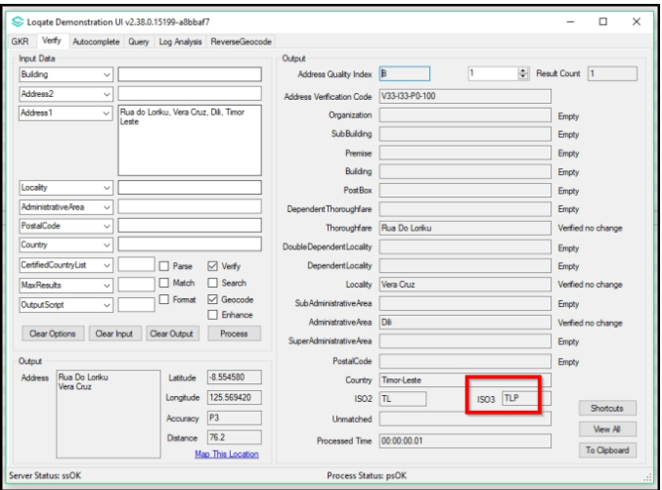 | ISO3 is now TLS  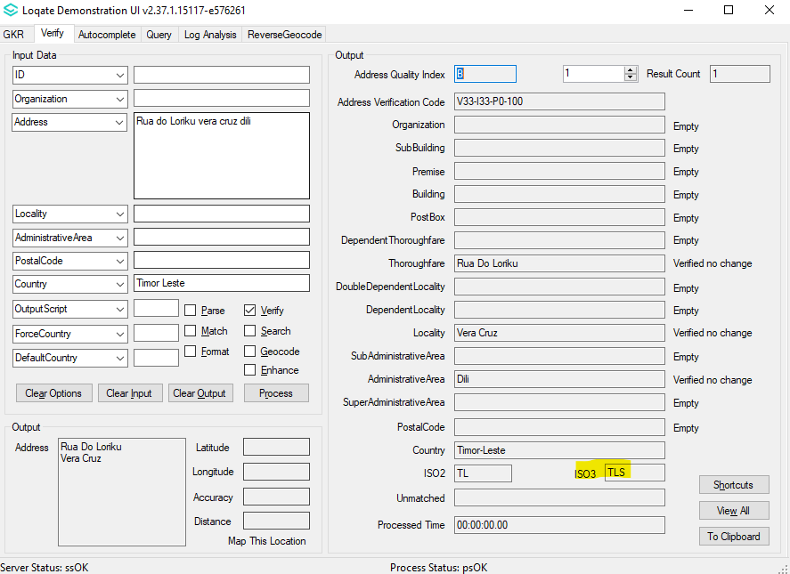

Malaysia

The 2021Q2.1 minor release makes improvements to the parsing results of the DependentLocality field.

2021Q2.0 | 2021Q2.1
Incorrect parsing of DependentLocality.  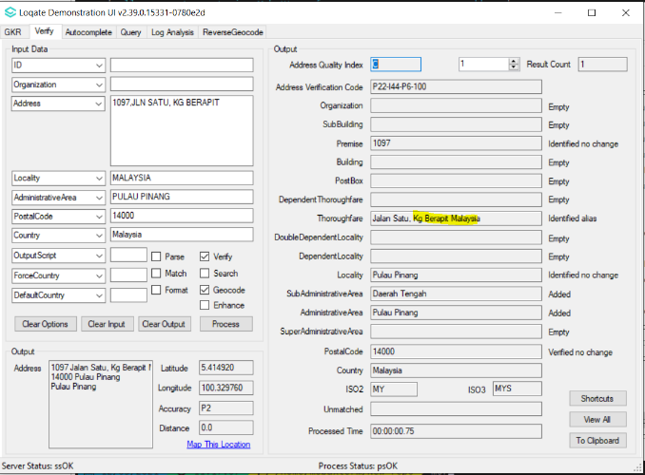 | Correct parsing of DependentLocality. General improvement in parsing & verification.  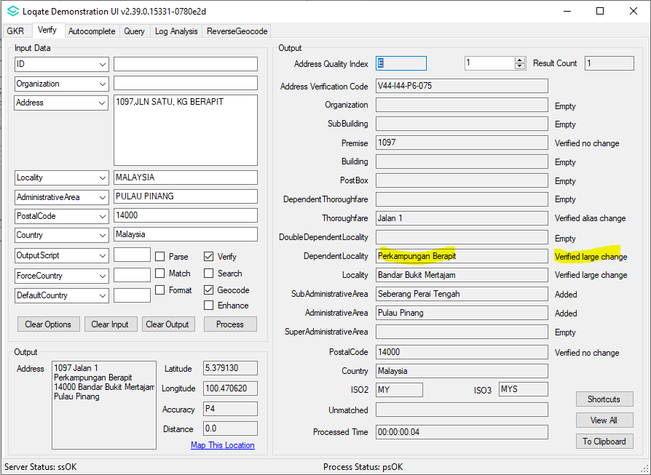

Country Improvement Program (PDH)
The following section will display the changes made during the country improvement program.
For more details on our Country Improvement Program, please visit the support site here. The country verification level is displayed in parenthesis next to the country name.

Bosnia and Herzegovina (L4)

Country Information | Description
ISO2 | BA
ISO3 | BIH
Address Format | Organization  PostBox  Building SubBuilding  Thoroughfare Premise  DependentThoroughfare  DoubleDependentLocality  DependentLocality  PostalCode Locality
PDH | YES
PDH completed date | 2021Q2.1
New Source | NO
Reference Data Pre-PDH | rd_BA.lfs  rd_BA_ai.lfs  rd_BA_rg.lfs  rd_BA_geop.lfs  rd_BA_geop_rg.lfs
Reference Data Post-PDH | rd_BA_vfy.lfs  rd_BA_vfy_ai.lfs  rd_BA_ggg.lfs  rd_BA_ggg_rg.lfs

The 2021Q2.1 minor release provides improvement to the transliterated results when transliterating from Latin to Cyrillic.

2021Q2.0 | 2021Q2.1
Users may have experienced certain cases where Latin input changes to Cyrillic output.  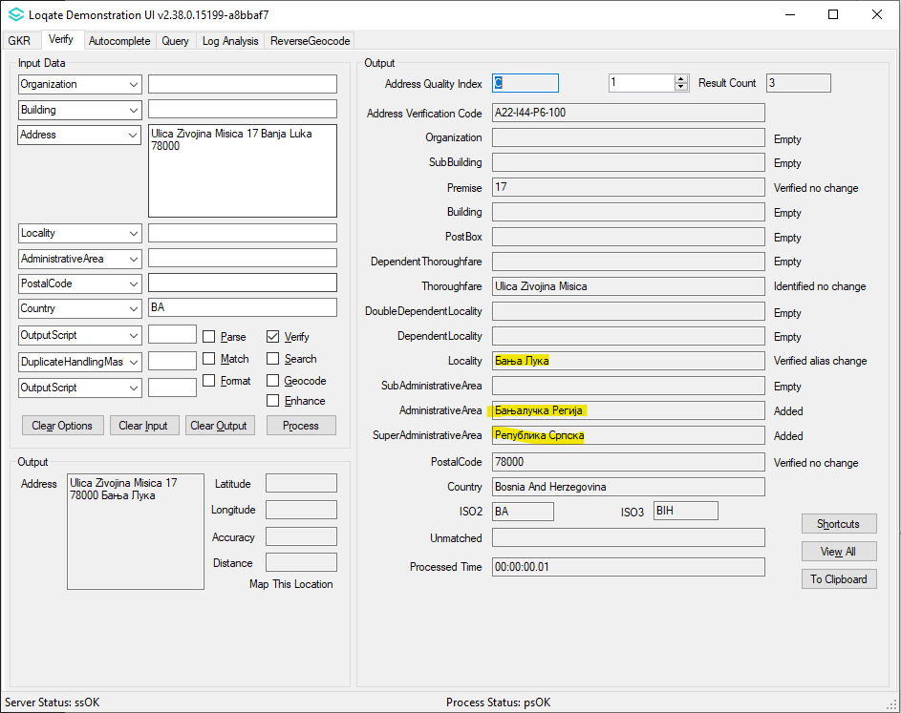 | Latin Input correctly verifying as Latin output.  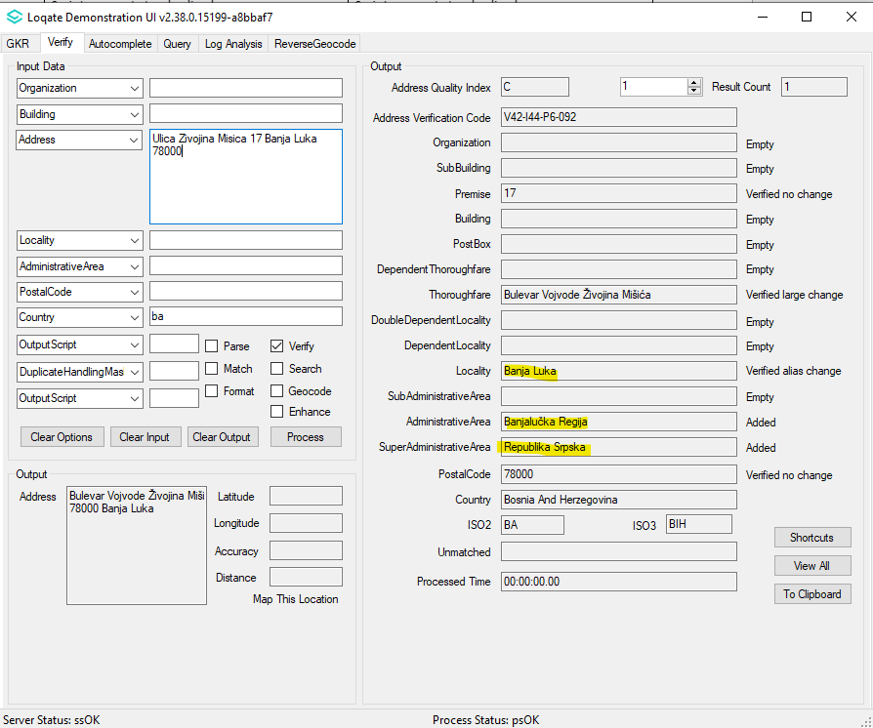

Belize (L3)

Country Information | Description
ISO2 | BZ
ISO3 | BLZ
Address Format | Organization  PostBox  SubBuilding Building  Premise Thoroughfare  DependentThoroughfare  DoubleDependentLocality  DependentLocality  Locality
PDH | YES
PDH completed date | 2021Q2.1
New Source | NO
Reference Data Pre-PDH | rd_BZ.lfs  rd_BZ_ai.lfs  rd_BZ_rg.lfs
Reference Data Post-PDH | rd_BZ_vfy.lfs  rd_BZ_vfy_ai.lfs  rd_BZ_ggg.lfs  rd_BZ_ggg_rg.lfs

This release makes improvements to the verification results of the AdministrativeArea field.

2021Q2.0 | 2021Q2.1
Unexpected AdministrativeArea  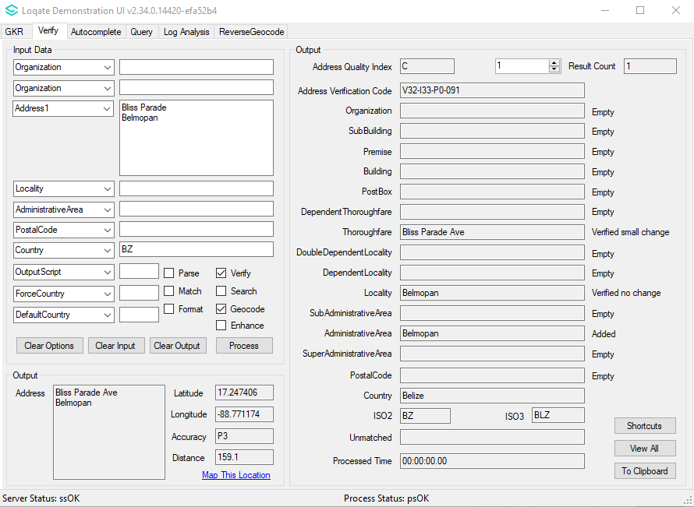 | Corrected AdministrativeArea.  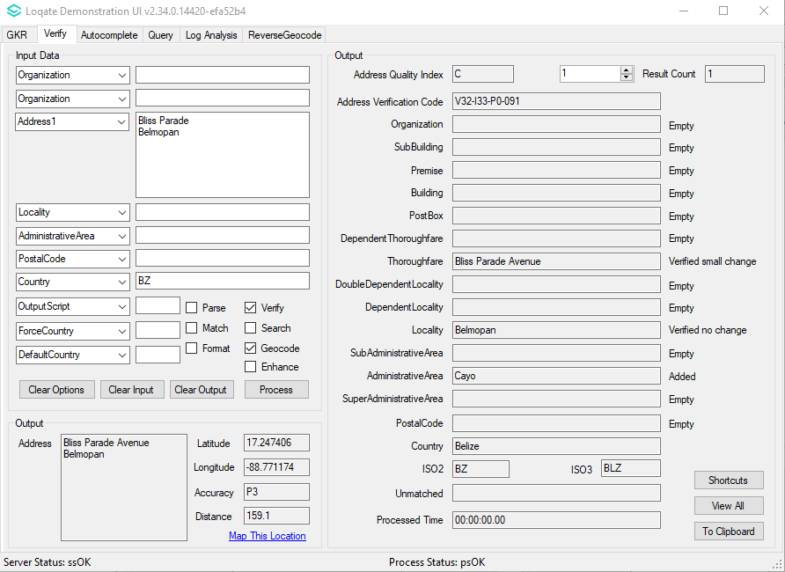

Equatorial Guinea (L3)

Country Information | Description
ISO2 | GQ
ISO3 | GNQ
Address Format | Organization  PostBox  SubBuilding Building  Premise Thoroughfare  DependentThoroughfare  DoubleDependentLocality  DependentLocality  Locality
PDH | YES
PDH completed date | 2021Q2.1
New Source | NO
Reference data Pre-PDH | rd_GQ_ai.lfs  rd_GQ.lfs  rd_GQ_rg.lfs
Reference data Post-PDH | rd_GQ_ggg.lfs  rd_GQ_ggg_rg.lfs  rd_GQ_vfy_ai.lfs  rd_GQ_vfy.lfs

This release makes improvements to the alignment between the SubAdministrativeArea, AdministrativeArea, and SuperAdministrativeArea fields.

2021Q2.0 | 2021Q2.1
SubAdministrativeArea, AdministrativeArea and SuperAdministrativeArea are not verified and missing.  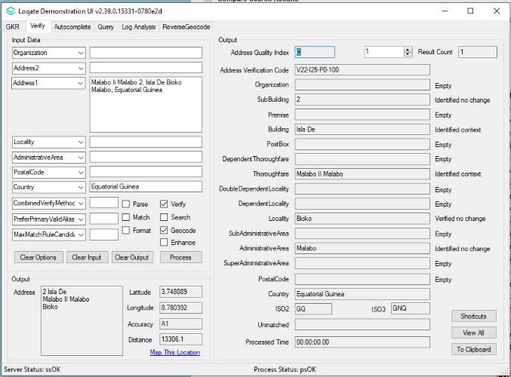 | SubAdministrativeArea, AdministrativeArea and SuperAdministrativeArea are now added and corrected.  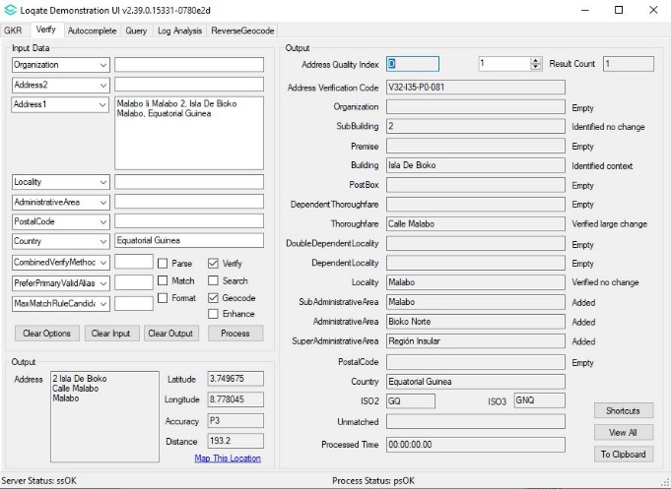

Guinea-Bissau (L3)

Country Information | Description
ISO2 | GW
ISO3 | GNB
Address Format | Organization  PostBox  Building SubBuilding  Thoroughfare Premise  DependentThoroughfare  DoubleDependentLocality  DependentLocality  PostalCode Locality
PDH | YES
PDH completed date | 2021Q2.1
New Source | NO
Reference Data Pre-PDH | rd_GW_ai.lfs  rd_GW.lfs  rd_GW_rg.lfs
Reference Data Post-PDH | rd_GW_ggg.lfs  rd_GW_ggg_rg.lfs  rd_GW_vfy_ai.lfs  rd_GW_vfy.lfs

This release makes improvements to the verification results within the AdministrativeArea field.

2021Q2.0 | 2021Q2.1
AdministrativeArea is missing.  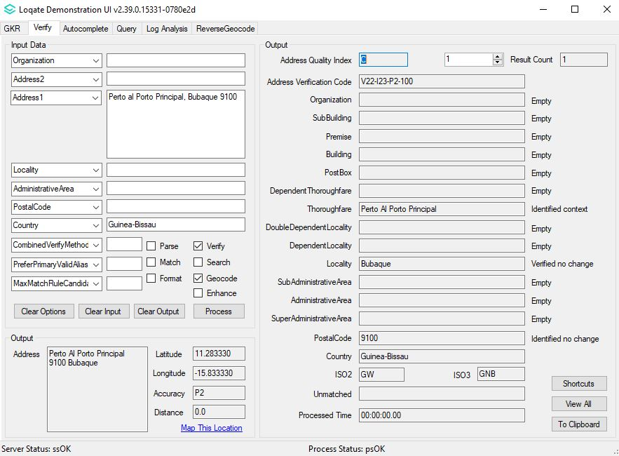 | AdministrativeArea is now added.  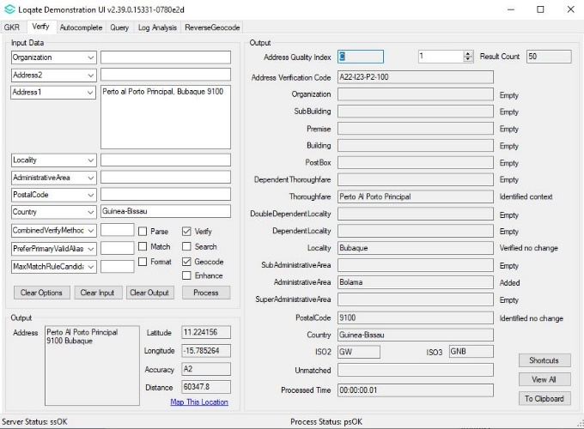

Guyana (L3)

Country Information | Description
ISO2 | GY
ISO3 | GUY
Address Format | Organization  PostBox  SubBuilding Building  Premise Thoroughfare  DependentThoroughfare  DoubleDependentLocality  DependentLocality  Locality
PDH | YES
PDH completed date | 2021Q2.1
New Source | NO
Reference Data Pre-PDH | rd_GY_ggg.lfs  rd_GY_ggg_rg.lfs  rd_GY_vfy_ai.lfs  rd_GY_vfy.lfs
Reference Data Post-PDH | rd_GY_ggg.lfs  rd_GY_ggg_rg.lfs  rd_GY_vfy_ai.lfs  rd_GY_vfy.lfs

This release makes improvements to the alignment between the SubAdministrativeArea and the AdministrativeArea fields.

2021Q2.0 | 2021Q2.1
SubAdministrativeArea is missing.  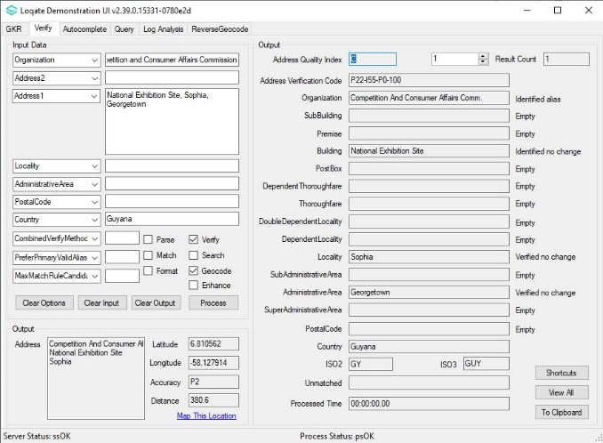 | SubAdministrativeArea and AdministrativeArea is now added and corrected.  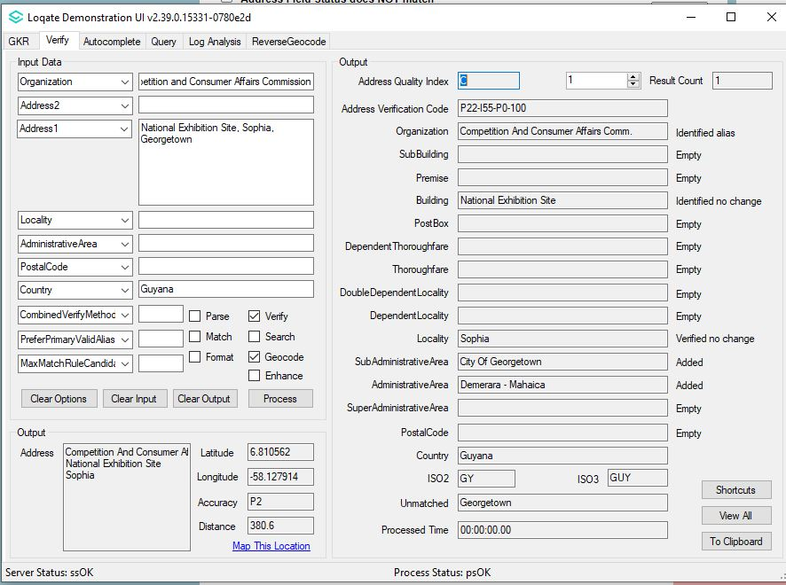

Comoros (L3)

Country Information | Description
ISO2 | KM
ISO3 | COM
Address Format | Organization  PostBox  SubBuilding Building  Premise Thoroughfare  DependentThoroughfare  DoubleDependentLocality  DependentLocality  Locality
PDH | YES
PDH completed date | 2021Q2.1
New Source | NO
Reference Data Pre-PDH | rd_KM.lfs  rd_KM_ai.lfs  rd_KM_rg.lfs
Reference Data Post-PDH | rd_KM_vfy.lfs  rd_KM_vfy_ai.lfs  rd_KM_ggg.lfs  rd_KM_ggg_rg.lfs

The 2021Q2.1 minor release makes improvements to the verification results within the AdministrativeArea field.

2021Q2.0 | 2021Q2.1
No AdministrativeArea information.  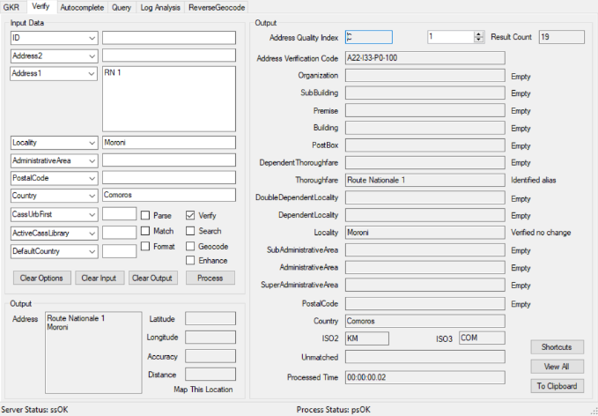 | AdministrativeArea is added.  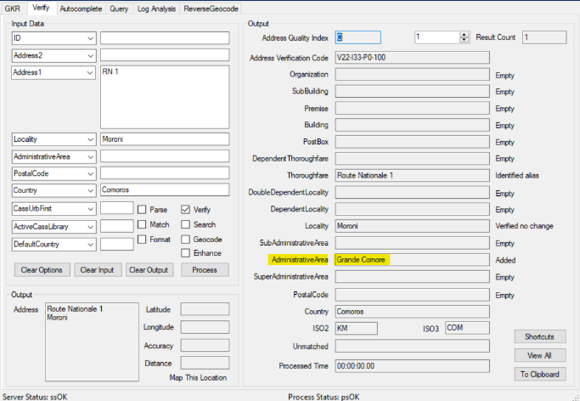

Northern Mariana Islands (L2)

Country Information | Description
ISO2 | MP
ISO3 | MNP
Address Format | Organization  PostBox  SubBuilding Building  Premise Thoroughfare  DependentThoroughfare  DoubleDependentLocality  DependentLocality  Locality AdministrativeArea PostalCode
PDH | YES
PDH completed date | 2021Q2.1
New Source | NO
Reference data Pre-PDH | rd_MP_vfy.lfs  rd_MP_vfy_ai.lfs  rd_MP_geo.lfs  rd_MP_geo_rg.lfs
Reference data Post-PDH | rd_MP_vfy.lfs  rd_MP_vfy_ai.lfs  rd_MP_ggg.lfs  rd_MP_ggg_rg.lfs

The 2021Q2.1 minor release makes improvements to the verification results within the AdministrativeArea, SubAdministrativeArea, Locality, and DependentLocality fields.

2021Q2.0 | 2021Q2.1
Users may have seen cases where an address is unable to verify.  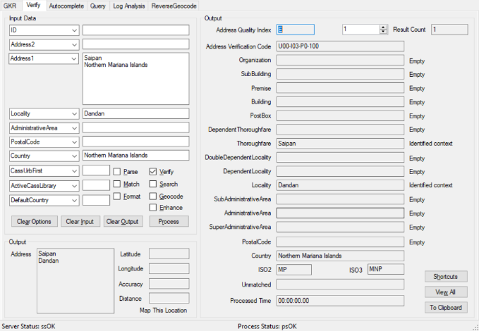 | Address is verified up to level 2; AdministrativeArea, SubAdministrativeArea, Locality, DependentLocality are now added/verified.  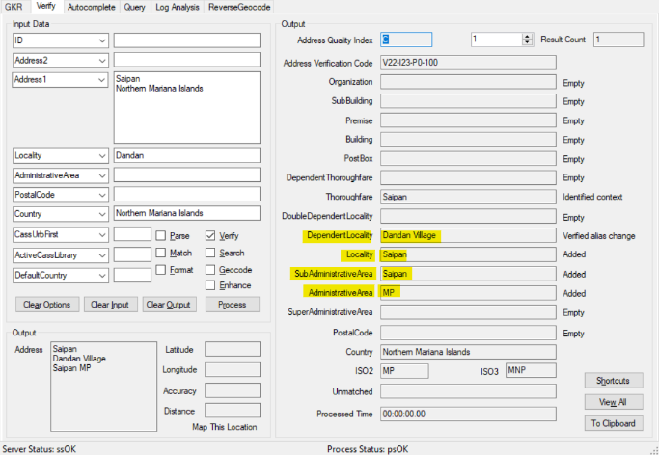

Oman (L4)

Country Information | Description
ISO2 | OM
ISO3 | OMN
Address Format | Organization  PostBox  SubBuilding Building  Premise Thoroughfare  DependentThoroughfare  DoubleDependentLocality  DependentLocality  PostalCode  Locality  AdministrativeArea
PDH | YES
PDH completed date | 2021Q2.1
New Source | NO
Reference data Pre-PDH | rd_OM.lfs  rd_OM_ai.lfs  rd_OM_rg.lfs
Reference data Post-PDH | rd_OM_vfy.lfs  rd_OM_vfy_ai.lfs  rd_OM_ggg.lfs  rd_OM_ggg_rg.lfs

Users may have experienced unverifiable addresses. This is now resolved in the 2021Q2.1 minor release. Addresses are now verifiable up to the Locality level (level 2).

2021Q2.0 | 2021Q2.1
Users may have experienced unverifiable addresses.  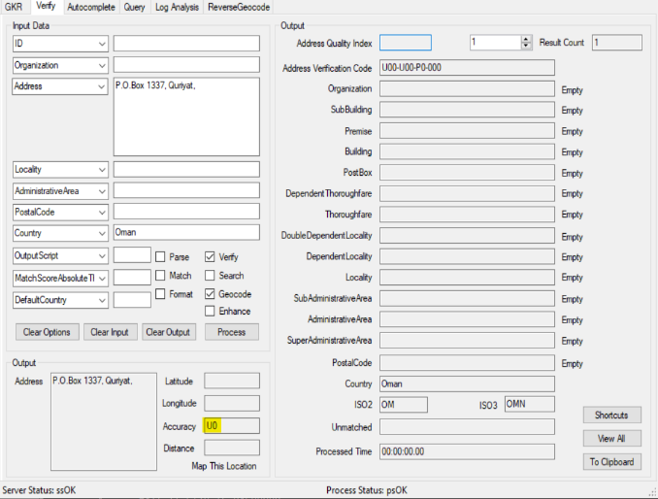 | Address can now be verified up to level 2; AdministrativeArea & Locality are now added/verified.  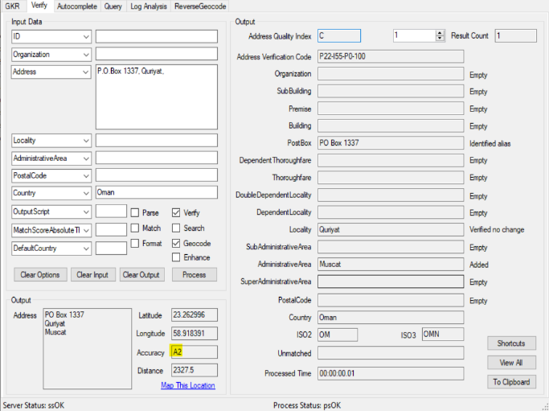

South Sudan (L3)

Country Information | Description
ISO2 | SS
ISO3 | SSD
Address Format | Organization  PostBox  SubBuilding Building  Premise Thoroughfare  DependentThoroughfare  DoubleDependentLocality  DependentLocality  PostalCode  Locality
PDH | YES
PDH completed date | 2021Q2.1
New Source | NO
Reference Data Pre-pdh | rd_SS.lfs  rd_SS_ai.lfs  rd_SS_rg.lfs
Reference Data Post-pdh | rd_SS_vfy.lfs  rd_SS_vfy_ai.lfs  rd_SS_ggg.lfs  rd_SS_ggg_rg.lfs

Eswatini (L3)

Country Information | Description
ISO2 | SZ
ISO3 | SWZ
Address Format | Organization  PostBox  SubBuilding Building  Premise Thoroughfare  DependentThoroughfare  DoubleDependentLocality  DependentLocality  Locality  PostalCode
PDH | YES
PDH completed date | 2021Q2.1
New Source | NO
Reference Data Pre-PDH | rd_SZ.lfs  rd_SZ_ai.lfs  rd_SZ_rg.lfs
Reference Data Post-PDH | rd_SZ_vfy.lfs  rd_SZ_vfy_ai.lfs  rd_SZ_ggg.lfs  rd_SZ_ggg_rg.lfs

Eswatini Continued…

Previously addresses may have included up to the Locality level. In the 2021Q2.1 minor release, may now include the following additional information: SubAdministrativeArea, AdministrativeArea, and PostalCode information.

2021Q2.0 | 2021Q2.1
Addresses may have only included Locality information.  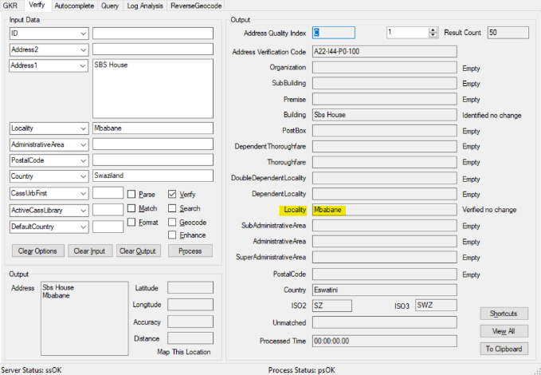 | SubAdministrativeArea, AdministrativeArea and PostalCode are added.  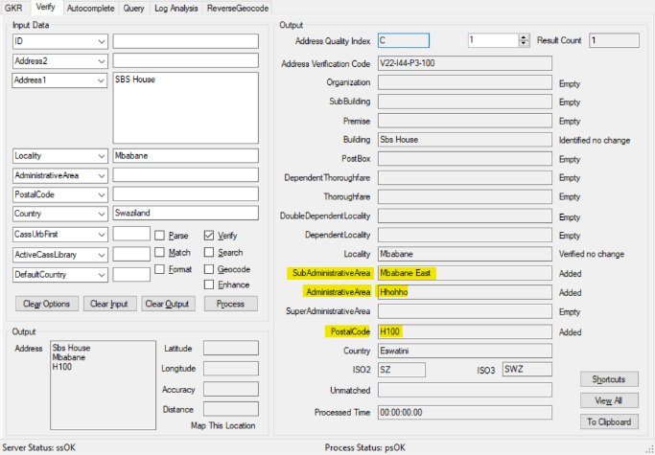

Chad (L3)

Country Information | Description
ISO2 | TD
ISO3 | TCD
Address Format | Organization  PostBox  SubBuilding Building  Premise Thoroughfare  DependentThoroughfare  DoubleDependentLocality  DependentLocality  Locality
PDH | YES
PDH completed date | 2021Q2.1
New Source | NO
Reference Data Pre-PDH | rd_TD.lfs  rd_TD_ai.lfs  rd_TD_rg.lfs
Reference Data Post-PDH | rd_TD_vfy.lfs  rd_TD_vfy_ai.lfs  rd_TD_ggg.lfs  rd_TD_ggg_rg.lfs

Chad Continued…

Previously users may have seen addresses verified without AdministrativeArea; the 2021Q2.1 minor release now includes the AdministrativeArea information.

2021Q2.0 | 2021Q2.1
AdministrativeArea info is missing.  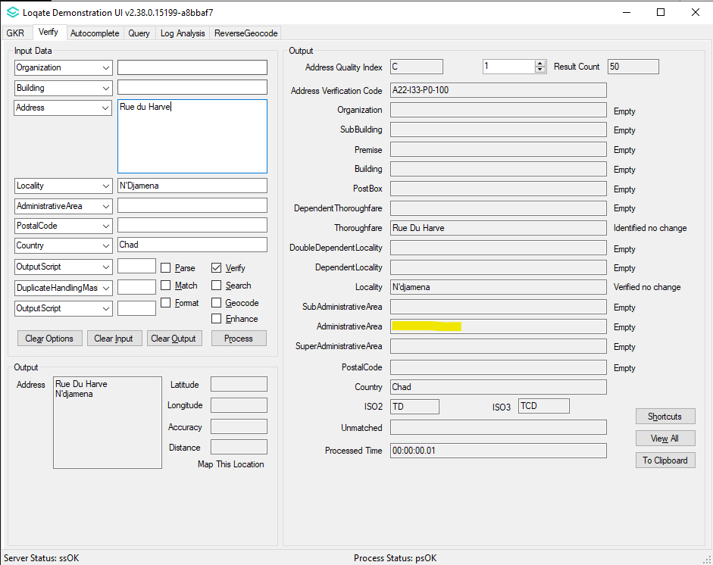 | AdministrativeArea info is added.  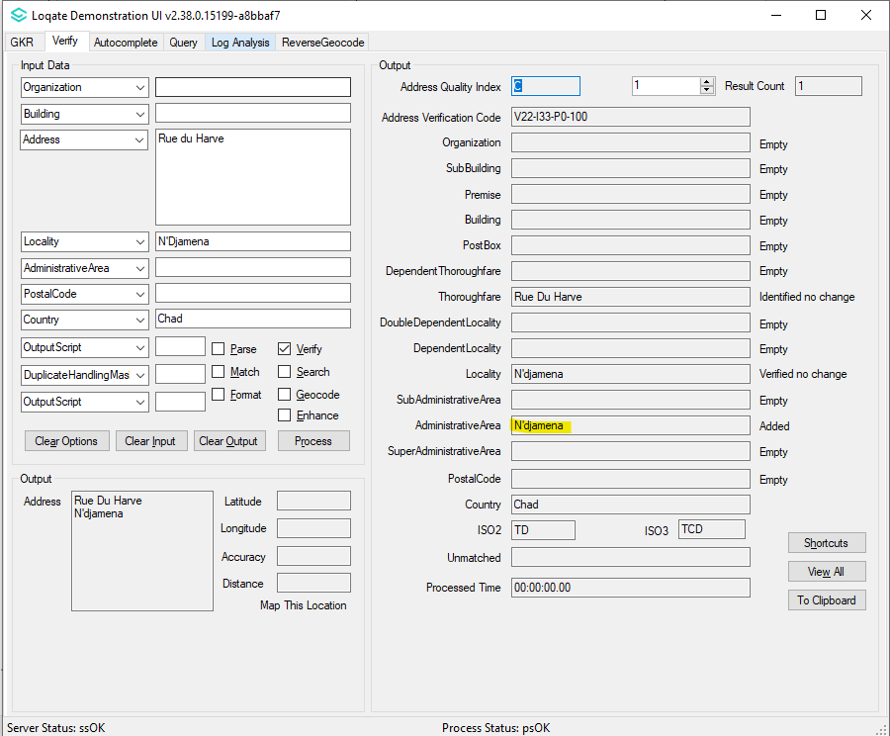

Tajikistan (L3)

Country Information | Description
ISO2 | TJ
ISO3 | TJK
Address Format | Organization  PostBox  Building SubBuilding  Thoroughfare Premise  DependentThoroughfare  DoubleDependentLocality  DependentLocality  PostalCode Locality
PDH | YES
PDH completed date | 2021Q2.1
New Source | NO
Reference Data Pre-PDH | rd_TJ.lfs  rd_TJ_ai.lfs  rd_TJ_rg.lfs
Reference Data Post-PDH | rd_TJ_vfy.lfs  rd_TJ_vfy_ai.lfs  rd_TJ_ggg.lfs  rd_TJ_ggg_rg.lfs

This release makes improvements to the verification results in the SubAdministrativeArea and the AdministrativeArea fields.

Tajikistan Continued…

2021Q2.0 | 2021Q2.1
SubAdministrativeArea and AdministrativeArea info was not found.  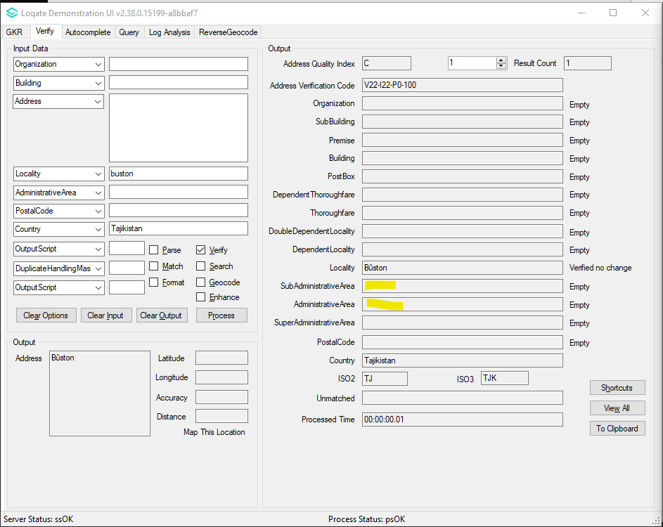 | SubAdministrativeArea and AdministrativeArea info is added.  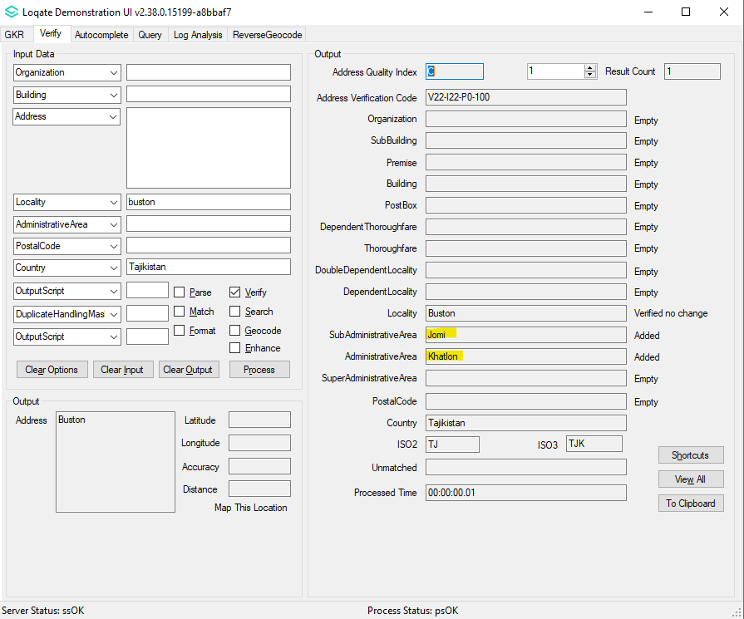

Wallis and Futuna (L3)

Country Information | Description
ISO2 | WF
ISO3 | WLF
Address Format | Organization  PostBox  Building SubBuilding  Thoroughfare Premise  DependentThoroughfare  DoubleDependentLocality  DependentLocality  PostalCode Locality
PDH | YES
PDH completed date | 2021Q2.1
New Source | NO
Reference Data Pre-PDH | rd_WF.lfs  rd_WF_ai.lfs  rd_WF_rg.lfs
Reference Data Post-PDH | rd_WF_vfy.lfs  rd_WF_vfy_ai.lfs  rd_WF_ggg.lfs  rd_WF_ggg_rg.lfs

This release makes improvements to the verification results within the SubAdministrativeArea and AdministrativeArea fields.

Wallis and Futuna Continued…

2021Q2.0 | 2021Q2.1
SubAdministrativeArea and AdministrativeArea info was not found.  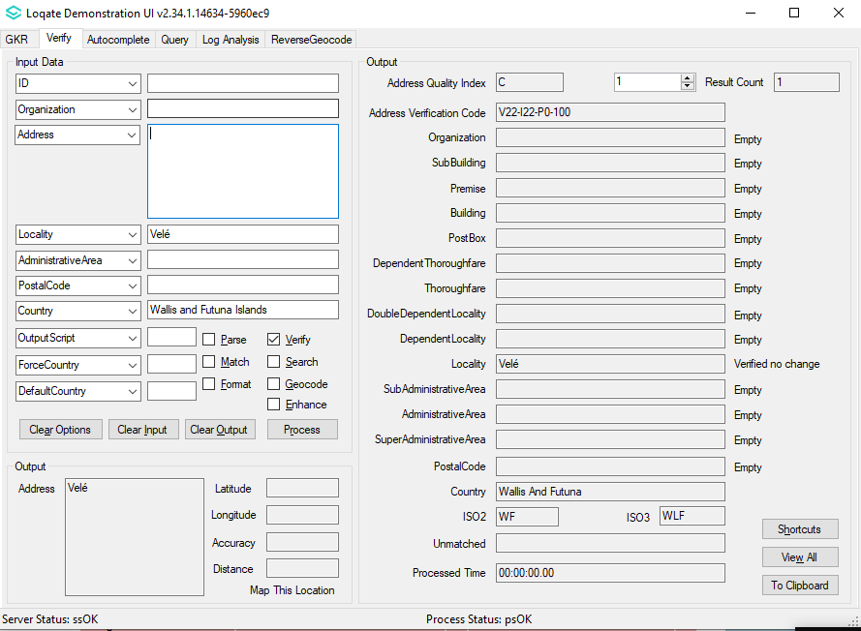 | SubAdministrativeArea and AdministrativeArea info is added.  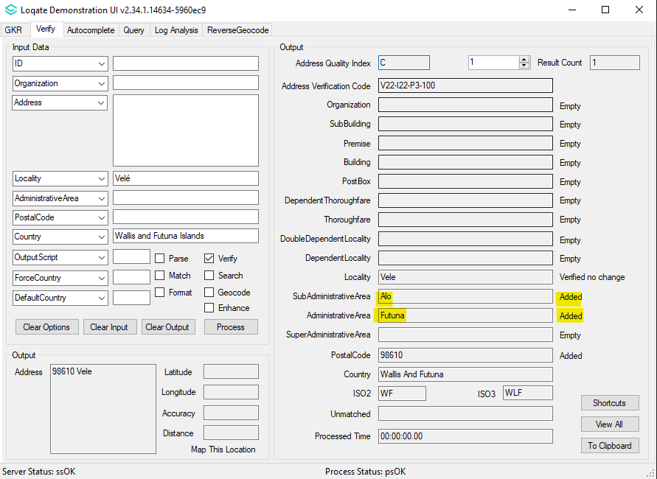

Knowledge Base & Reference Data Updates
The table below shows which countries have been updated, and how, in this release.
If there is a PDH in the reference data column, this shows a country was included in the country improvement project.

- Reference Data: 31 countries
- Lexicon: 19 countries
- Context Rules: 3 countries

COUNTRY NAME | ISO CODE | CONTEXT RULES | LEXICONS | REFERENCE DATA
AFGHANISTAN | AF
ÅLAND ISLANDS | AX
ALBANIA | AL
ALGERIA | DZ
AMERICAN SAMOA | AS |  |  | X
ANDORRA | AD
ANGOLA | AO
ANGUILLA | AI
ANTARCTICA | AQ
ANTIGUA AND BARBUDA | AG
ARGENTINA | AR
ARMENIA | AM
ARUBA | AW
AUSTRALIA | AU |  | X | X
AUSTRIA | AT
AZERBAIJAN | AZ
BAHAMAS | BS
BAHRAIN | BH
BANGLADESH | BD
BARBADOS | BB
BELARUS | BY
BELGIUM | BE
BELIZE | BZ |  | X | X
BENIN | BJ
BERMUDA | BM
BHUTAN | BT
BOLIVIA (PLURINATIONAL STATE OF) | BO
BONAIRE, SINT EUSTATIUS AND SABA | BQ
BOSNIA AND HERZEGOVINA | BA |  | X | X
BOTSWANA | BW
BOUVET ISLAND | BV
BRAZIL | BR
BRITISH INDIAN OCEAN TERRITORY | IO
BRUNEI DARUSSALAM | BN
BULGARIA | BG
BURKINA FASO | BF
BURUNDI | BI
CABO VERDE | CV
CAMBODIA | KH
CAMEROON | CM
CANADA | CA
CAYMAN ISLANDS | KY
CENTRAL AFRICAN REPUBLIC | CF
CHAD | TD |  | X | X
CHILE | CL
CHINA | CN | X | X
CHRISTMAS ISLAND | CX
COCOS (KEELING) ISLANDS | CC
COLOMBIA | CO
COMOROS | KM |  | X | X
CONGO | CG
CONGO, DEMOCRATIC REPUBLIC OF THE | CD
COOK ISLANDS | CK |  | X
COSTA RICA | CR
CÔTE D'IVOIRE | CI
CROATIA | HR
CUBA | CU
CURAÇAO | CW
CYPRUS | CY
CZECHIA | CZ
DENMARK | DK
DJIBOUTI | DJ
DOMINICA | DM
DOMINICAN REPUBLIC | DO
ECUADOR | EC
EGYPT | EG
EL SALVADOR | SV
EQUATORIAL GUINEA | GQ |  | X | X
ERITREA | ER
ESTONIA | EE
ETHIOPIA | ET
FALKLAND ISLANDS (MALVINAS) | FK
FAROE ISLANDS | FO
FIJI | FJ
FINLAND | FI
FRANCE | FR
FRENCH GUIANA | GF
FRENCH POLYNESIA | PF
FRENCH SOUTHERN TERRITORIES | TF
GABON | GA
GAMBIA | GM
GEORGIA | GE
GERMANY | DE
GHANA | GH
GIBRALTAR | GI
GREECE | GR
GREENLAND | GL
GRENADA | GD
GUADELOUPE | GP
GUAM | GU |  |  | X
GUATEMALA | GT
GUERNSEY | GG |  |  | X
GUINEA | GN
GUINEA-BISSAU | GW |  | X | X
GUYANA | GY |  | X | X
HAITI | HT
HEARD ISLAND AND MCDONALD ISLANDS | HM
HONDURAS | HN
HONG KONG | HK
HUNGARY | HU
ICELAND | IS
INDIA | IN
INDONESIA | ID
IRAN | IR
IRAQ | IQ
IRELAND | IE
ISLE OF MAN | IM |  |  | X
ISRAEL | IL
ITALY | IT |  | X
JAMAICA | JM
JAPAN | JP
JERSEY | JE |  |  | X
JORDAN | JO
KAZAKHSTAN | KZ
KENYA | KE
KIRIBATI | KI
KOREA (DEMOCRATIC PEOPLE'S REPUBLIC OF) | KP
KOREA, REPUBLIC OF | KR
KUWAIT | KW
KYRGYZSTAN | KG
LAO PEOPLE'S DEMOCRATIC REPUBLIC | LA
LATVIA | LV
LEBANON | LB
LESOTHO | LS
LIBERIA | LR
LIBYA | LY
LIECHTENSTEIN | LI
LITHUANIA | LT
LUXEMBOURG | LU
MACAO | MO
MADAGASCAR | MG
MALAWI | MW
MALAYSIA | MY | X | X | X
MALDIVES | MV
MALI | ML
MALTA | MT
MARSHALL ISLANDS | MH |  |  | X
MARTINIQUE | MQ
MAURITANIA | MR
MAURITIUS | MU
MAYOTTE | YT
MEXICO | MX
MICRONESIA (FEDERATED STATES OF) | FM |  |  | X
MOLDOVA, REPUBLIC OF | MD
MONACO | MC
MONGOLIA | MN
MONTENEGRO | ME
MONTSERRAT | MS
MOROCCO | MA
MOZAMBIQUE | MZ
MYANMAR | MM
NAMIBIA | NA
NAURU | NR
NEPAL | NP
NETHERLANDS | NL
NEW CALEDONIA | NC
NEW ZEALAND | NZ
NICARAGUA | NI
NIGER | NE
NIGERIA | NG
NIUE | NU
NORFOLK ISLAND | NF
NORTH MACEDONIA | MK
NORTHERN MARIANA ISLANDS | MP |  |  | X
NORWAY | NO
OMAN | OM |  | X | X
PAKISTAN | PK
PALAU | PW |  |  | X
PALESTINE, STATE OF | PS
PANAMA | PA
PAPUA NEW GUINEA | PG
PARAGUAY | PY
PERU | PE
PHILIPPINES | PH
PITCAIRN | PN
POLAND | PL |  |  | X
PORTUGAL | PT
PUERTO RICO | PR |  |  | X
QATAR | QA
RÉUNION | RE
ROMANIA | RO
RUSSIAN FEDERATION | RU |  |  | X
RWANDA | RW
SAINT BARTHÉLEMY | BL
SAINT HELENA, ASCENSION AND TRISTAN DA CUNHA | SH
SAINT KITTS AND NEVIS | KN
SAINT LUCIA | LC
SAINT MARTIN (FRENCH PART) | MF
SAINT PIERRE AND MIQUELON | PM
SAINT VINCENT AND THE GRENADINES | VC
SAMOA | WS
SAN MARINO | SM
SAO TOME AND PRINCIPE | ST
SAUDI ARABIA | SA
SENEGAL | SN
SERBIA | RS
SEYCHELLES | SC
SIERRA LEONE | SL
SINGAPORE | SG |  |  | X
SINT MAARTEN (DUTCH PART) | SX
SLOVAKIA | SK
SLOVENIA | SI
SOLOMON ISLANDS | SB
SOMALIA | SO
SOUTH AFRICA | ZA
SOUTH GEORGIA AND THE SOUTH SANDWICH ISLANDS | GS
SOUTH SUDAN | SS |  | X | X
SPAIN | ES
SRI LANKA | LK
SUDAN | SD
SURINAME | SR
SVALBARD AND JAN MAYEN | SJ
SWAZILAND | SZ |  | X | X
SWEDEN | SE |  | X
SWITZERLAND | CH |  |  | X
SYRIAN ARAB REPUBLIC | SY
TAIWAN | TW
TAJIKISTAN | TJ | X | X | X
TANZANIA, UNITED REPUBLIC OF | TZ
THAILAND | TH
TIMOR-LESTE | TL
TOGO | TG
TOKELAU | TK
TONGA | TO
TRINIDAD AND TOBAGO | TT
TUNISIA | TN
TURKEY | TR
TURKMENISTAN | TM
TURKS AND CAICOS ISLANDS | TC
TUVALU | TV
UGANDA | UG
UKRAINE | UA
UNITED ARAB EMIRATES | AE
UNITED KINGDOM | GB |  |  | X
UNITED STATES MINOR OUTLYING ISLANDS | UM
UNITED STATES OF AMERICA | US |  | X | X
URUGUAY | UY
UZBEKISTAN | UZ
VANUATU | VU
VATICAN CITY | VA
VENEZUELA (BOLIVARIAN REPUBLIC OF) | VE
VIET NAM | VN
VIRGIN ISLANDS (BRITISH) | VG
VIRGIN ISLANDS (U.S.) | VI |  |  | X
WALLIS AND FUTUNA | WF |  | X | X
WESTERN SAHARA | EH
YEMEN | YE
ZAMBIA | ZM
ZIMBABWE | ZW

