Loqate, A GBG Solution
Release Notes – Verify API
2021Q2.1 Minor Release

Case Resolutions
Please visit https://support.loqate.com/release-information/2021q2-1-resolved-cases/ for a list of cases resolved in this release. If you would like more details on any of the solved cases listed, please contact LoqateSupport@gbgplc.com for further information.

Supported Platforms

Legacy Platforms

The installers and libraries have moved to a new location for the following platforms: HPUX, Solaris, and Sparc. Please contact the support team: LoqateSupport@gbgplc.com for additional information on obtaining the installers and libraries for these platforms.

Local API Improvements

Coordinate Address Improvements

In the 2021Q2.1 minor release, improvements have been made to the parse results within the premise and thoroughfare fields for coordinate addresses. This change has an impact in the following countries: Brazil, Sweden, United States of America, Slovakia, Portugal, and France.

The following example is in reference to USA addresses. In the following example, using the input thoroughfare: “W 3500 S”, previously the engine would parse the premise as “3500S 2965W" as the numbers could potentially be a premise number. The 2021Q2.1 minor release added an enhancement feature that allows the Verify tool to parse the coordinate address. The parse results will now return the thoroughfare as “W 3500 S”. Please see Fig. 1 for screenshot.

Coordinate Address Improvements Continued…

Fig. 1
2021Q2.0 (Before Changes) | 2021Q2.1 (After Changes)
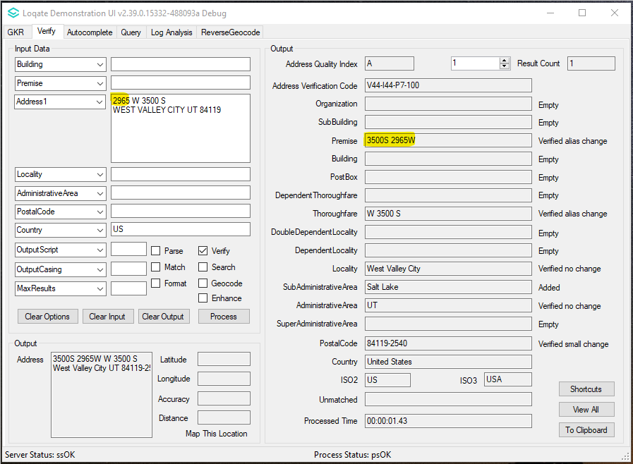  2021Q2.0: VerifyTool may return unexpected output in premise field. Example: premise "3500S 2965W" | 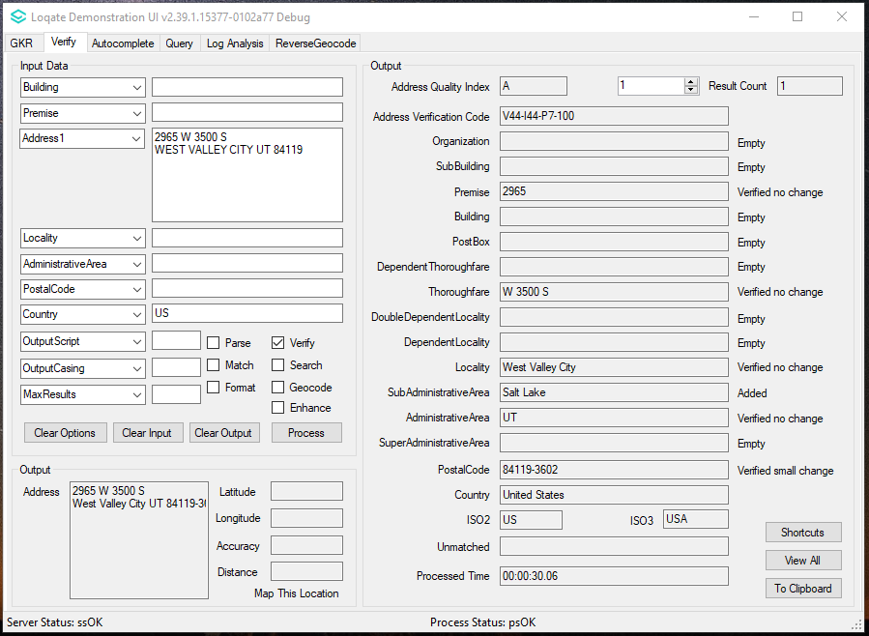  2021Q2.1: VerifyTool returns correct Premise output.  Example: Premise "2965"

Search

With the 2021Q2.1 minor release when using Search, users may have seen unexpected results within the ID and Premise fields; this is now resolved in this release. Please see Fig. 3 below for example screenshots.

Fig. 3

2021Q2.0 (Before Changes) | 2021Q2.1 (After Changes)
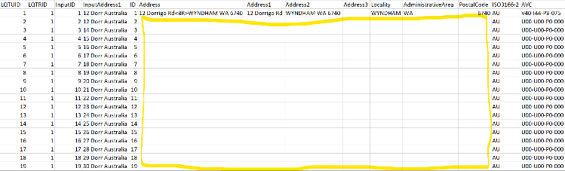  2021Q2.0: When running batch with the following parameters added to loqate.ini:  QueryResultCacheSize=5000  ContextResultCacheSize=5000  ContextCountryCacheSize=10  Only the 1st search has result. | 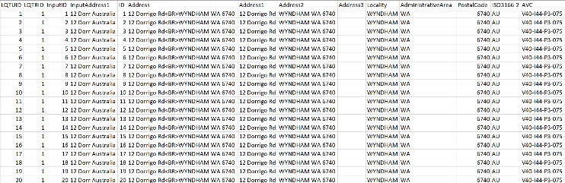  2021Q2.1: When running batch with the following parameters added to loqate.ini:  QueryResultCacheSize=5000  ContextResultCacheSize=5000  ContextCountryCacheSize=10  All search has the same result.
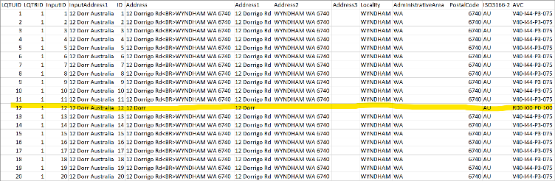  2021Q2.0: When running batch, users may experience inconsistent results with same input. | 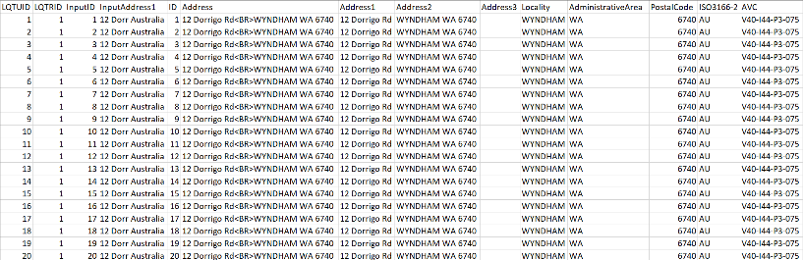  2021Q2.1: Results are now consistent.

Reverse Geocode
When using reverse geocode, some users may have experienced certain results were returning 0.0 latitude and longitude or certain results where the latitude and longitude did not match the input; this is now resolved with this release and reverse geocode will now return the expected latitude and longitude. Please see Fig. 2 below for examples of use cases.

Reverse Geocode Continued…
Fig. 2
2021Q2.0  CASE 1:  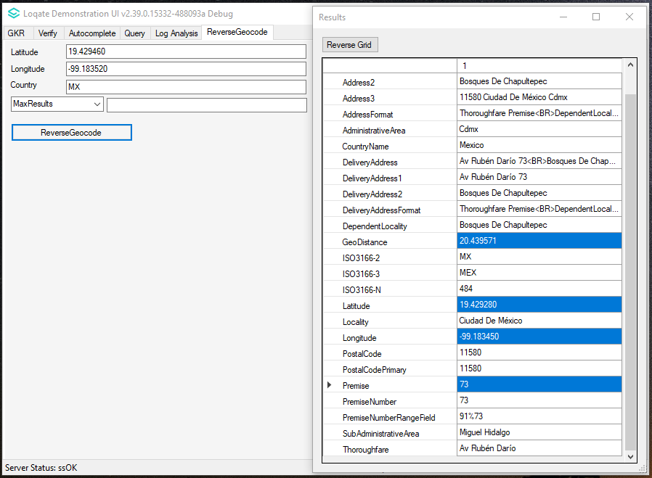  2021Q2.0: Reverse Geocode returns GeoDistance "20.439571" and the output latitude and longitude may not match with the input's  CASE 2:  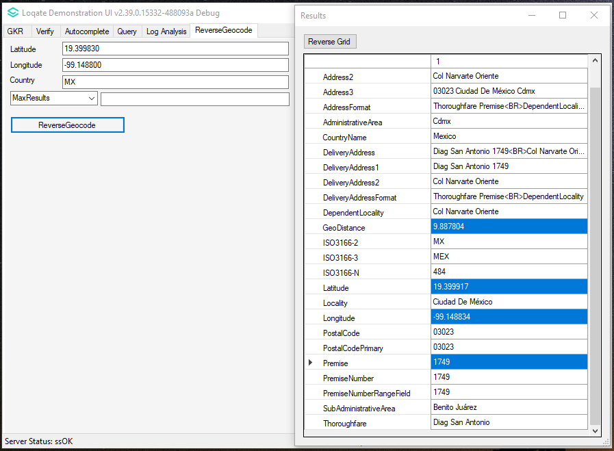  2021Q2.0: Reverse Geocode returns GeoDistance "9.887804" and both output latitude  and longitude does not match with the input's | 2021Q2.1  CASE 1:  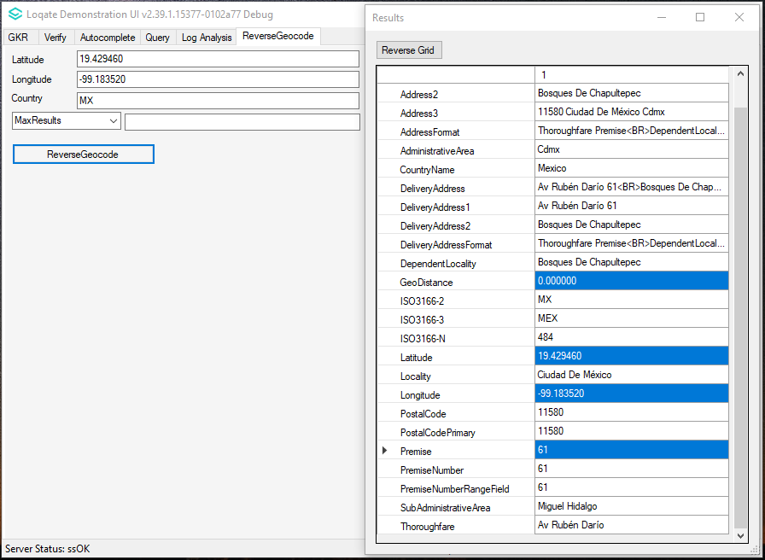  2021Q2.1: Reverse Geocode returns GeoDistance "0.000000" and the output latitude and longitude will match with the input's  CASE 2:  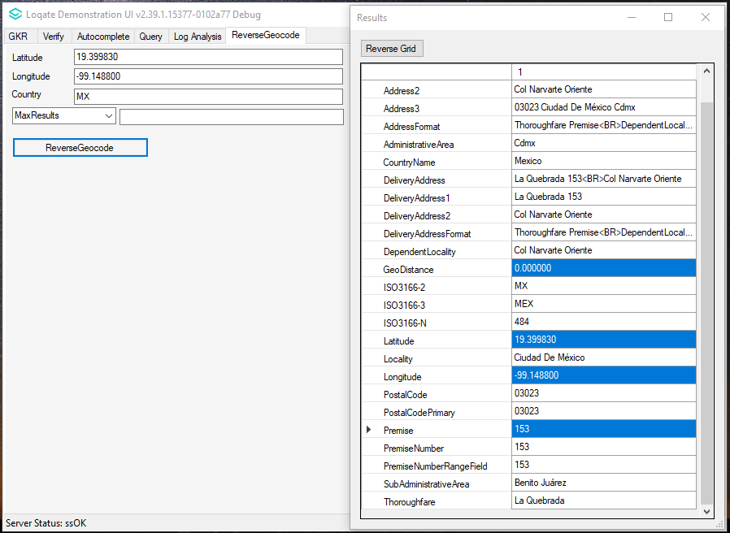  2021Q2.1: Reverse Geocode returns GeoDistance "0.000000" with both output latitude and longitude matching with the input's
India Example:  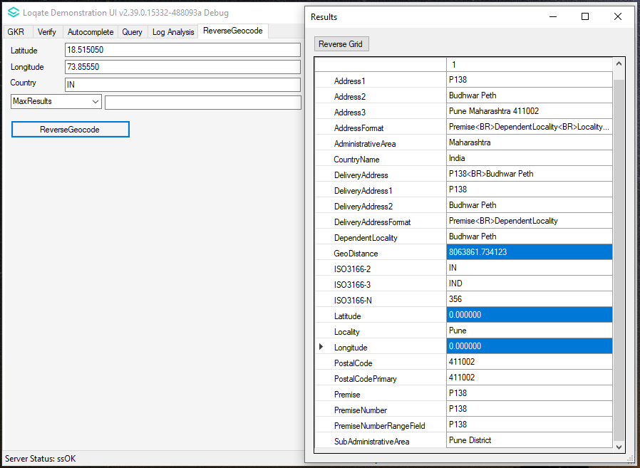  2021Q2.0: Reverse Geocode returns GeoDistance "8063861.734123", both output Latitude and Longitude are "0.000000" | India Example:  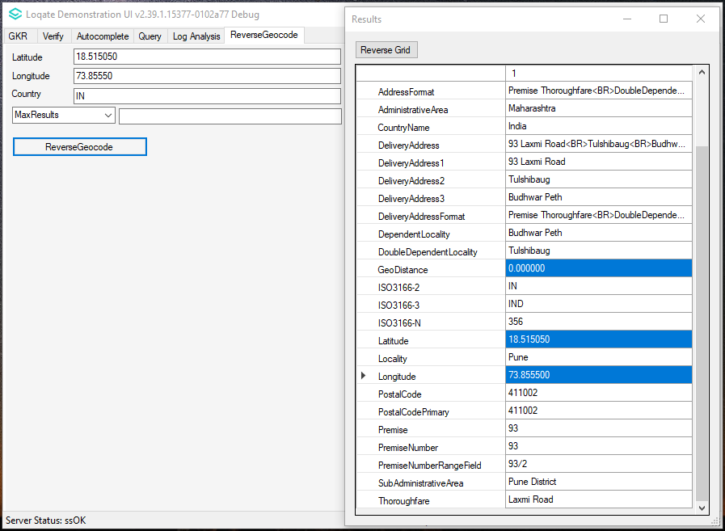  2021Q2.1: Reverse Geocode returns GeoDistance "0.000000" with both output latitude and longitude match with the input's
Canada Example:  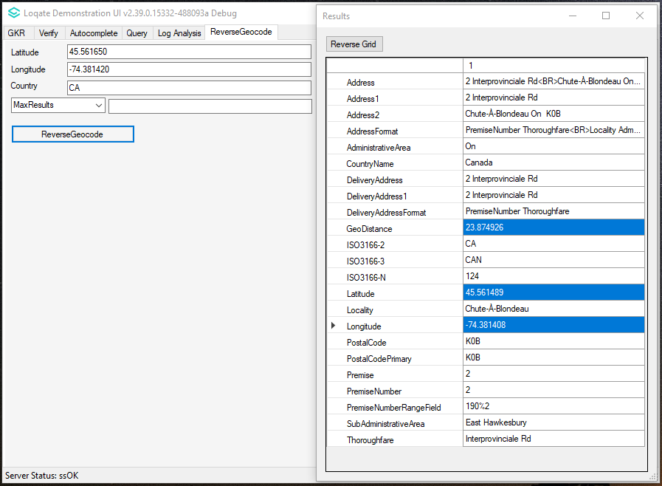  2021Q2.0: Reverse Geocode returns GeoDistance "23.874926" and both output latitude  and longitude does not match with the input's | Canada Example:  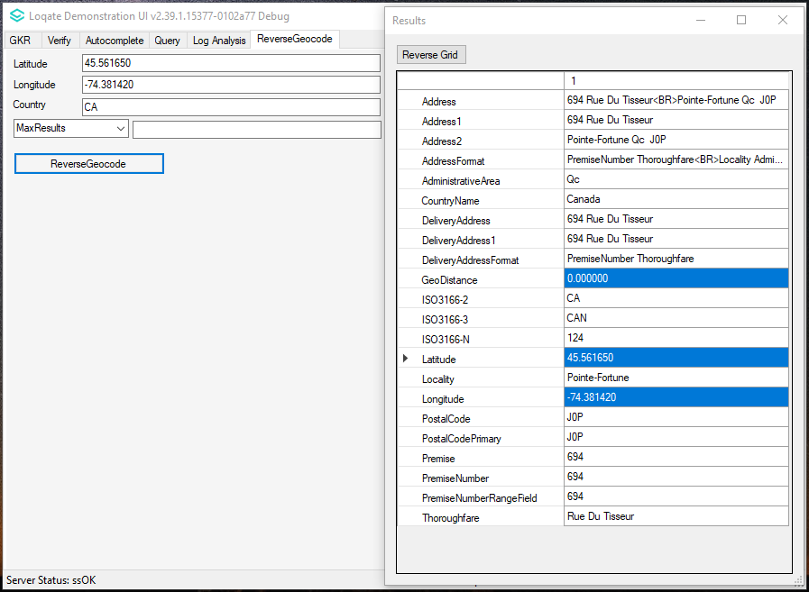  2021Q2.0: Reverse Geocode returns GeoDistance "0.000000" with both output latitude  and longitude match with the input's

Improved verification results for United Kingdom (GB)

Some users may have experienced unexpected AVC results for United Kingdom addresses, the issue was caused by the implementation of new FieldLevelMap. This is now resolved in the 2021Q2.1 minor release.

2021Q2.0 (Before Changes) | 2021Q2.1 (After Changes)
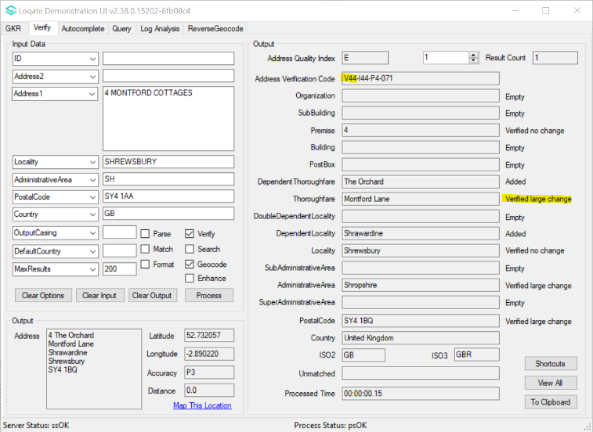  2021Q2.0: The AVC is incorrect, it should be 2 when thoroughfare is "Verified Large Change". | 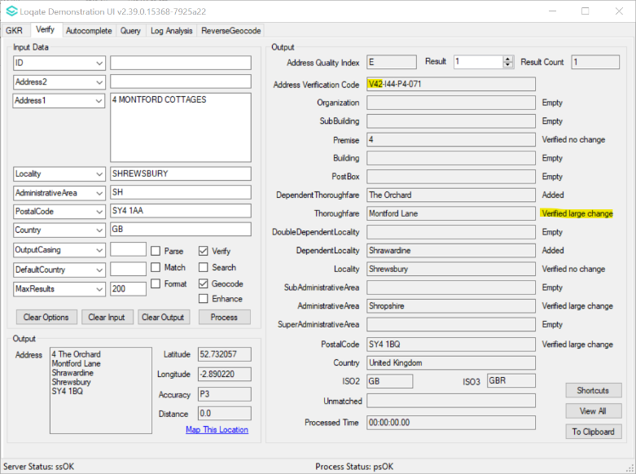  2021Q2.1: The AVC is now corrected.

Installation Instructions

Please remember to update both the program files and the reference data. The improvements are tied to the data in the Global Knowledge Repository and the Local API. If you need any assistance with the upgrade of the Local API or the data update process, please contact GBG Loqate Support.

The setup wizard for the Local API can be obtained from our SFTP server. Please contact your account manager to retrieve the SFTP information. If you do not know who your account manager is, please contact the support team at LoqateSupport@gbgplc.com.

