Loqate, A GBG Solution
Release Notes – Reference Data & Knowledge Base
2021Q1.0 Major Release

Case Resolutions
Please visit http://support.loqate.com/2021Q1-0-resolved-cases/ for a list of cases resolved in this release. If you would like more details on any of the solved cases listed, please contact support@loqate.com for further information.

Certification Expiration Dates
If you have purchased either the CASS (USA) or AMAS (Australia) certified products, please be aware that the datasets have expiration dates set by the respective postal authorities. Please ensure that you have the latest library and data installed to avoid loss of service through these products.

Please check Install Manager for the latest versions of AMAS and CASS.
 | Loqate Release Date | Certification Expiry Date*
AMAS Data | 2020-12-02 | 2021-03-31
CASS Data | 2021-01-15 | 2021-04-30
*Certification Expiry Date is different from Loqate license key expiry date. The earliest expiry date will apply.

For more information on expiry date checking for CASS and AMAS, please refer “Usage expiration” section in https://support.loqate.com/documentation/local-apis/cass-overview-2/ and https://support.loqate.com/address-matching-approval-system-amas/

Data Notices

Australia

Please note: From the 2021Q2.0 major release, the “Suburb” field, defined by Australia Post, will be moved from Locality to DependentLocality and the wider metropolitan region (or city) will become the Locality. The change will only occur in Verify output components; the address lines will be unaffected and will remain compliant with postal standards.

United States (Verify & CASS) & Puerto Rico (Verify)

Please note: From the 2021Q2.0 major release, the address line containing the “URB” (Urbanization, if present) will be moving above the address line containing the premise and street. This is a corrective change to ensure compliance with USPS standards.

For example (2020Q4.1 on left; from 2021Q2.0 on right)
280 Calle 13 NW  Urb Puerto Nuevo  San Juan PR 00920-2206 | Urb Puerto Nuevo  280 Calle 13 NW  San Juan PR 00920-2206

Data Improvements

Argentina

With this release, the AdministrativeArea has been updated to better align with the postal authority. Only one AdministrativeArea will be affected by this change: Ciudad Autónoma de Buenos Aires will be included as an AdministrativeArea.

2020Q4.1 | 2021Q1.0
Empty AdministrativeArea returned for Ciudad Autonoma Buenos Aires (Locality).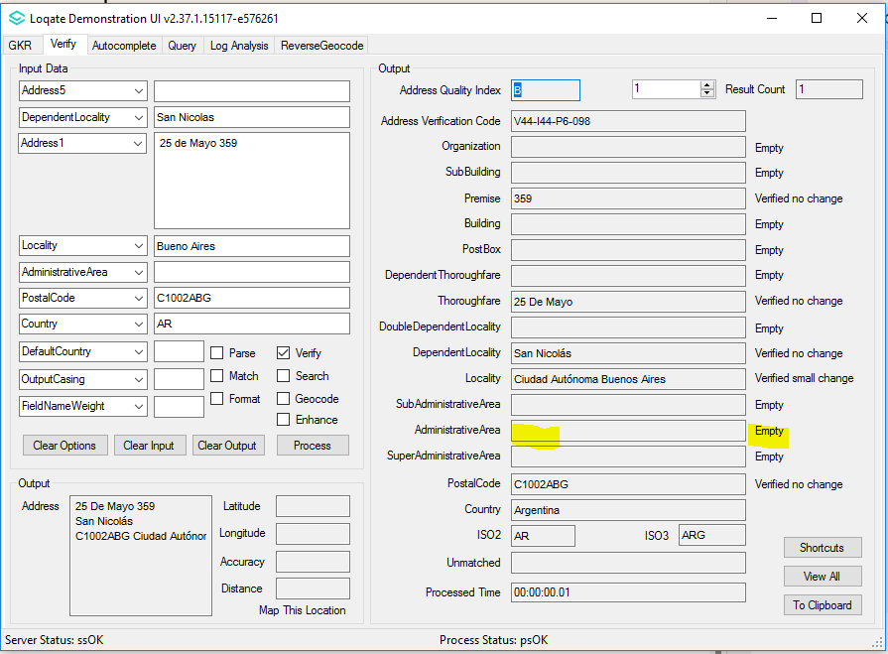 | There’s an AdministrativeArea returned now for Ciudad Autonoma Buenos Aires (Locality).  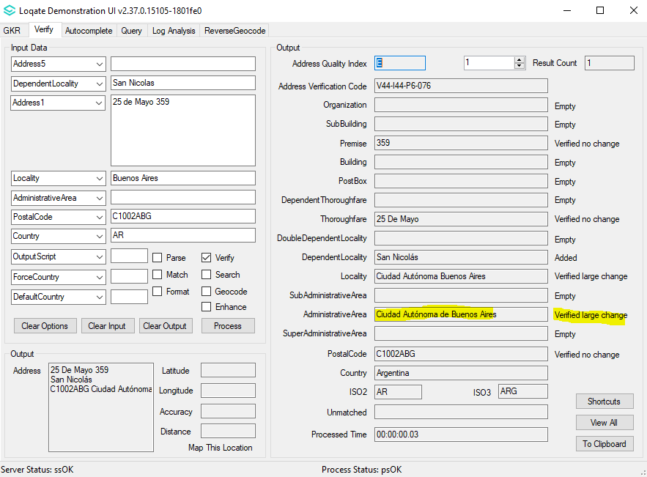

Colombia

In this release, the input “#” is now a valid input for the Thoroughfare field. The “#” symbol is an indicator for Number (No) in the Thoroughfare field. Please see screenshot below for an example.

2020Q4.1 | 2021Q1.0
The input # (indicator for Number) previously did not appear in the output.  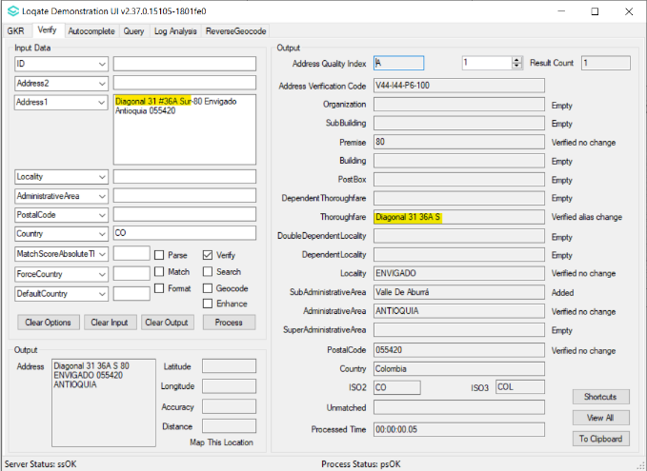 | The input # (indicator for Number) is preserved in output field.  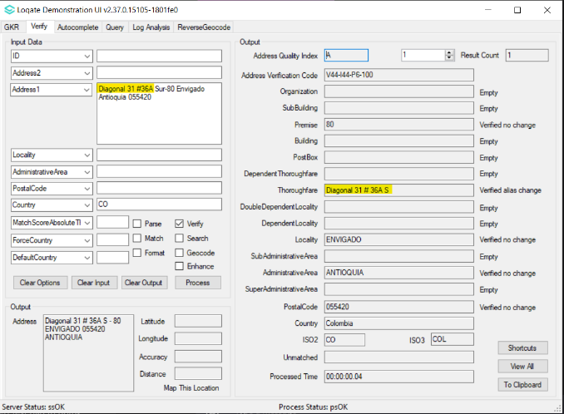

Colombia Continued…

Please note, users may see the below AVC changes in an isolated number of cases. These changes are expected, and the reason noted in the ‘Comment’ section.

AVC | Comment
V4 to V3 | Users may find that some premise aren’t available in the reference data, this is expected. The change is corrective.
V4 to A2 | False positives were removed. The change is corrective.

Country Improvement Program (PDH)
The following section will display the changes made during the country improvement program.
For more details on our Country Improvement Program, please visit the support site here.

Croatia

Country Information | Description
ISO2 | HR
ISO3 | HRV
Address Format | Organization  PostBox  Building SubBuilding  Thoroughfare Premise  DependentThoroughfare  DoubleDependentLocality  DependentLocality  PostalCode Locality
PDH | YES
PDH completed date | 2021Q1.0
New Source | NO
Reference Data Pre-PDH | rd_HR.lfs  rd_HR_rg.lfs  rd_HR_ai.lfs  rd_HR_geop.lfs  rd_ HR_geop_rg.lfs
Reference Data Post-PDH | rd_HR_vfy.lfs  rd_HR_vfy_ai.lfs  rd_HR_ggg.lfs  rd_HR_ggg_rg.lfs

Croatia Continued

The 2021Q1.0 major release improved verification results in the premise and locality fields.

2020Q4.1 | 2021Q1.0
Address unable to verify the locality and Premise.  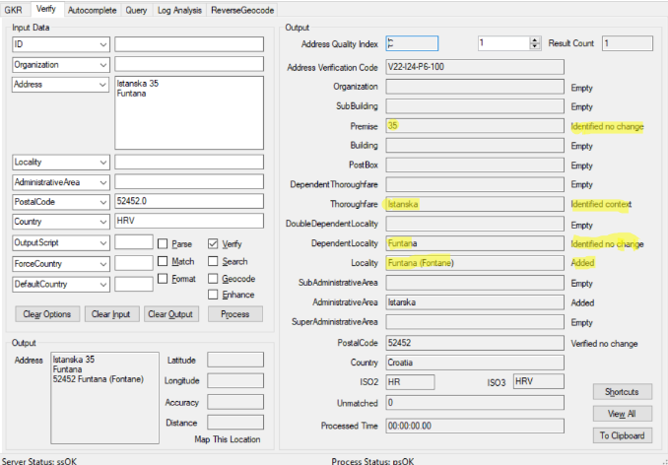 | Premise and Locality able to verify now.  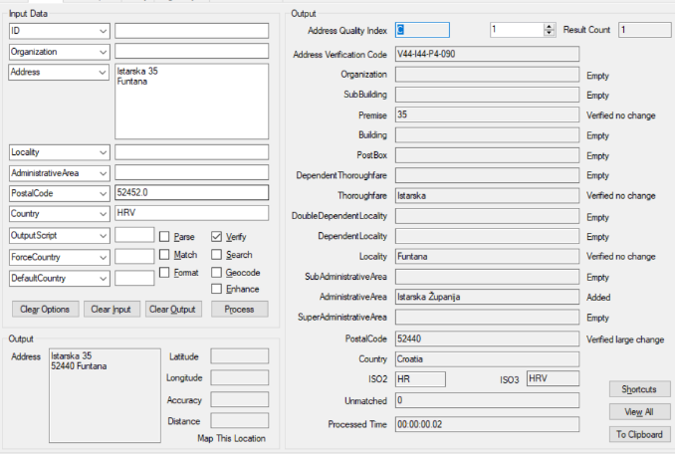

Moldova

Country Information | Description
ISO2 | MD
ISO3 | MDA
Address Format | Organization  PostBox  Building SubBuilding  Thoroughfare Premise  DependentThoroughfare  DoubleDependentLocality  DependentLocality  PostalCode Locality
PDH | YES
PDH completed date | 2021Q1.0
New Source | NO
Reference Data Pre-PDH | rd_MD.lfs  rd_MD_rg.lfs  rd_MD_ai.lfs
Reference Data Post-PDH | rd_MD_vfy.lfs  rd_MD_vfy_ai.lfs  rd_MD_ggg.lfs  rd_MD_ggg_rg.lfs

Previously non-standard formats were unverifiable. In this release, some non-standard formats are now accepted.

2020Q4.1 | 2021Q1.0
Address (non-standard format) unable to verify previously.  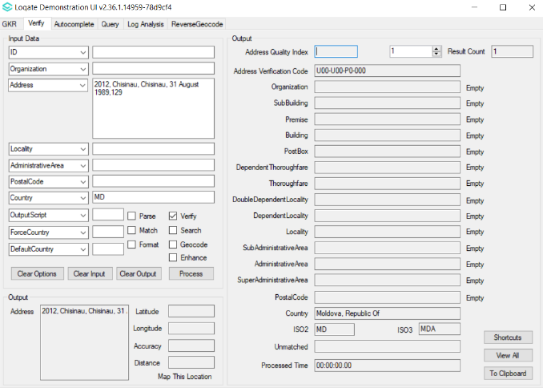 | Address (non-standard format) able to verify now.  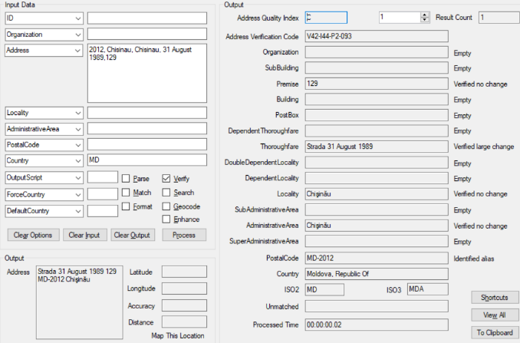

Mozambique

Country Information | Description
ISO2 | MZ
ISO3 | MOZ
Address Format | Organization  PostBox  Building SubBuilding  Thoroughfare  PostalCode Locality
PDH | YES
PDH completed date | 2021Q1.0
New Source | NO
Reference Data Pre-PDH | rd_MZ_ai.lfs  rd_MZ.lfs  rd_MZ_rg.lfs
Reference Data Post-PDH | rd_MZ_ggg.lfs  rd_MZ_ggg_rg.lfs  rd_MZ_vfy_ai.lfs  rd_MZ_vfy.lfs

This release provides improved verification results in the Thoroughfare fields.

2020Q4.1 | 2021Q1.0
Thoroughfare is incorrectly parsed and verified  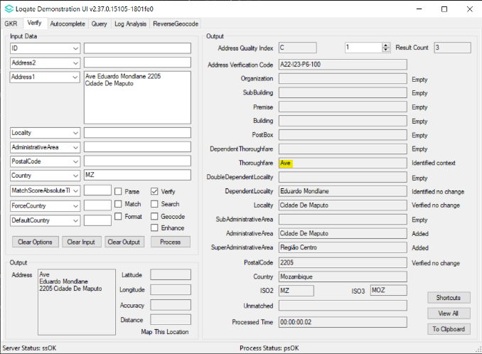 | Thoroughfare is parsed and verified correctly  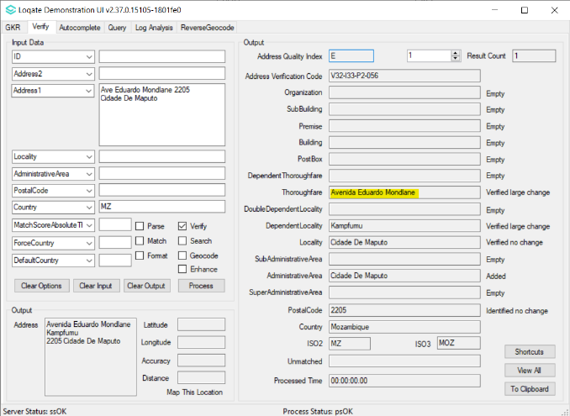

United Kingdom

Country Information | Description
ISO2 | GB
ISO3 | GBR
Address Format  Default Format: | Organization  Department  PostBox  SubBuilding Building  Premise Thoroughfare  DoubleDependentLocality  DependentLocality  Locality  PostalCode
Address Format  Conditional Address Format:  (I) If a DependentThoroughfare is present then the format will be: | Organization  Department  PostBox  SubBuilding Building  Premise DependentThoroughfare  Thoroughfare  DoubleDependentLocality  DependentLocality  Locality  PostalCode
Address Format  Conditional Address Format:  (ii) If the Thoroughfare is absent, whereas Premise & Thoroughfare are present then the format will be: | Organization  Department  Premise Building  DoubleDependentLocality  DependentLocality  Locality  PostalCode
PDH | YES
PDH completed date | 2021Q1.0
New Source | NO
Reference data Pre-PDH | rd_GB_geo.lfs  rd_GB_geop.lfs  rd_GB_geop_rg.lfs  rd_GB_geop_r.lfs  rd_GB_geo_rg.lfs  rd_GB_vfy_ai.lfs  rd_GB_vfy.lfs
Reference data Post-PDH | rd_GB_ggg.lfs  rd_GB_ggg_rg.lfs  rd_GB_ggg_r.lfs  rd_GB_vfy_ai.lfs  rd_GB_vfy.lfs
Enhanced Files Pre-PDH | rd_GB_enh_DPS.lfs  rd_GB_enh_DPS_r.lfs
Enhanced Files Post-PDH | rd_GB_enh_DPS.lfs  rd_GB_enh_DPS_r1.lfs  rd_GB_enh_DPS_r.lfs

United Kingdom Continued…

2020Q4.1 | 2021Q1.0
Administrative Area identified.  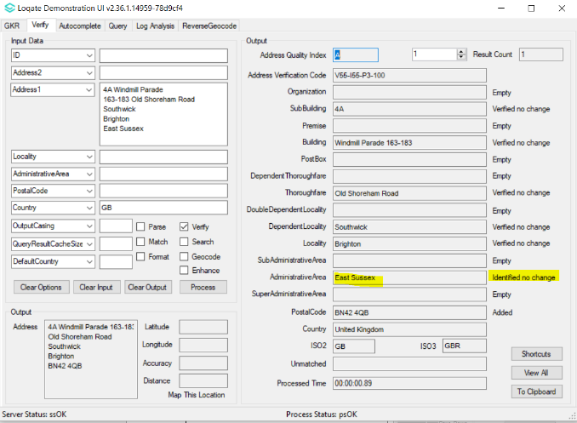 | Administrative Area verified.  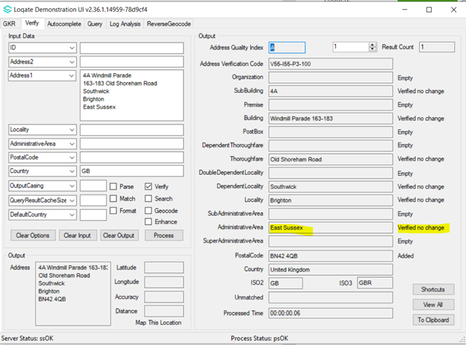
Building alias information added when not provided in input.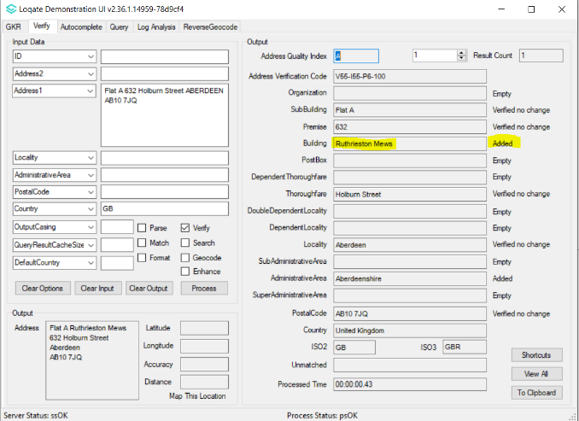 | Building alias information no longer added when not provided in input.  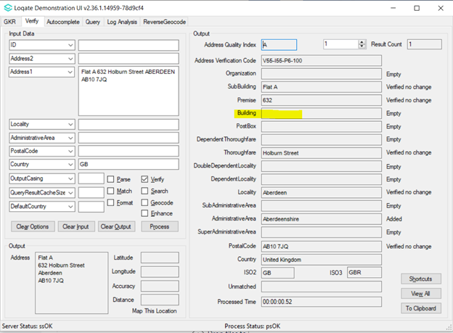

SubBuilding not verified when input has no premise and thoroughfare.  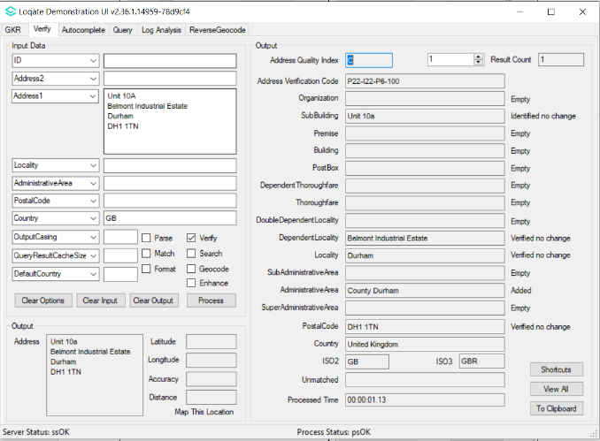 | With the correct postal code, SubBuilding able to be verified without thoroughfare and premise.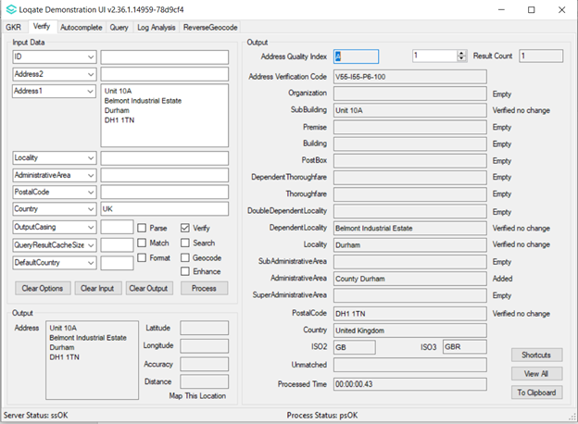

United Kingdom Continued…

Inaccurate geocoding codes P4 returned for assigned geo-coordinates.  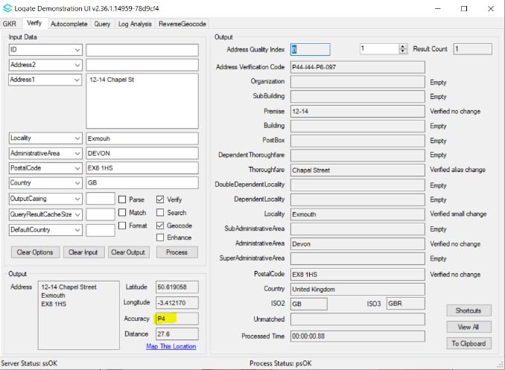 | More accurate geocoding codes I4 returned for assigned geo-coordinates.  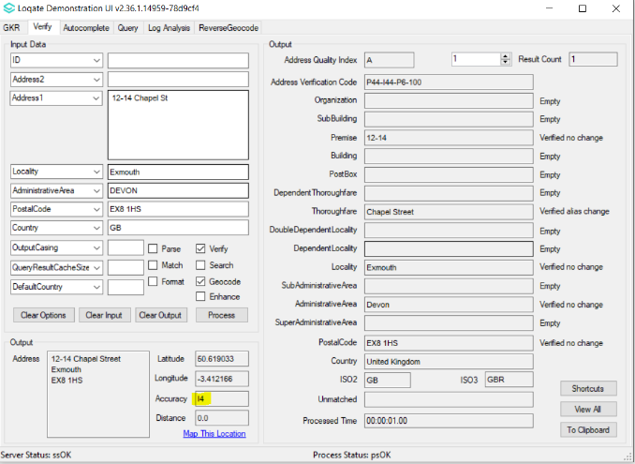

The source has been updated for AdministrativeArea in GBR in order to better align the data from the postal authority. Due to this change, two AdministrativeArea will change: County Derry corrects to County Londonderry and some records identified as Leicestershire will update to Rutland.
In addition to updates to the AdministrativeArea, the Enhance feature (available with Verify) will now provide three new, additional fields that offer alternative AdministrativeArea names.
These fields are: AdministrativeCounty, FormerPostalCounty, and TraditionalCounty. Please see screenshot below for an example of these fields. Additional information can be found on the support site: https://support.loqate.com/gb-enhancement-data-fields/.

2021Q1.0
Improvement in verify enhanced result:
There’re three additional counties information returned for the address.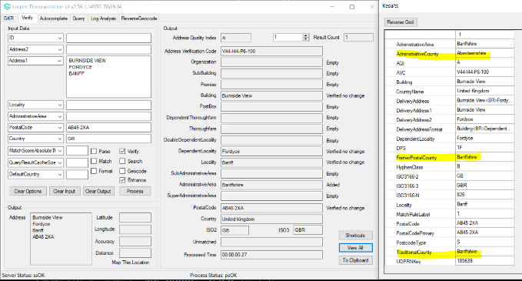

Panama

Country Information | Description
ISO2 | PA
ISO3 | PAN
Address Format | Organization  PostBox  Building SubBuilding  Thoroughfare Premise  DependentThoroughfare  DependentLocality  PostalCode Locality  AdministrativeArea
PDH | YES
PDH completed date | 2021Q1.0
New Source | NO
Reference Data Pre-PDH | rd_PA_ai.lfs  rd_PA_geop.lfs  rd_PA_geop_rg.lfs  rd_PA.lfs  rd_PA_rg.lfs
Reference Data Post-PDH | rd_PA_ggg.lfs  rd_PA_ggg_rg.lfs  rd_PA_vfy_ai.lfs  rd_PA_vfy.lfs

In this release, the alignment between Thoroughfare and Locality fields are now resolved.
Previously the PostalCodeSecondary may have been incorrectly identified, this issue is now resolved with the 2021Q1.0 major release.
2020Q4.1 | 2021Q1.0
Parsing error with the Locality field  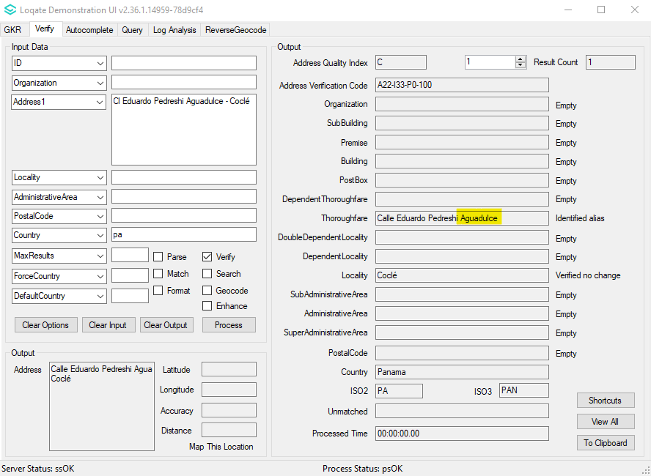 | Locality parsed correctly and matching level improved.  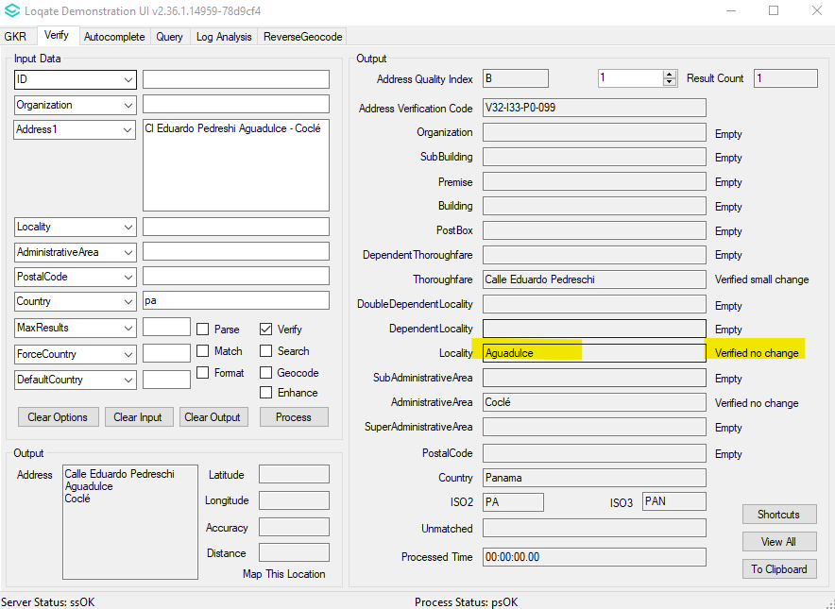

Knowledge Base & Reference Data Updates
The table below shows which countries have been updated, and how, in this release.
If there is a PDH in the reference data column, this shows a country was included in the country improvement project.

- Reference Data: 148 countries
- Lexicon: 10 countries
- Context Rules: 2 countries

COUNTRY NAME | ISO CODE | CONTEXT RULES | LEXICONS | REFERENCE DATA
AFGHANISTAN | AF
ÅLAND ISLANDS | AX
ALBANIA | AL |  |  | X
ALGERIA | DZ |  |  | X
AMERICAN SAMOA | AS |  |  | X
ANDORRA | AD
ANGOLA | AO
ANGUILLA | AI
ANTARCTICA | AQ
ANTIGUA AND BARBUDA | AG
ARGENTINA | AR |  |  | X
ARMENIA | AM
ARUBA | AW |  |  | X
AUSTRALIA | AU |  | X | X
AUSTRIA | AT
AZERBAIJAN | AZ |  |  | X
BAHAMAS | BS
BAHRAIN | BH
BANGLADESH | BD
BARBADOS | BB |  |  | X
BELARUS | BY
BELGIUM | BE
BELIZE | BZ |  |  | X
BENIN | BJ |  |  | X
BERMUDA | BM |  |  | X
BHUTAN | BT |  |  | X
BOLIVIA (PLURINATIONAL STATE OF) | BO
BONAIRE, SINT EUSTATIUS AND SABA | BQ
BOSNIA AND HERZEGOVINA | BA |  |  | X
BOTSWANA | BW
BOUVET ISLAND | BV
BRAZIL | BR
BRITISH INDIAN OCEAN TERRITORY | IO |  |  | X
BRUNEI DARUSSALAM | BN |  |  | X
BULGARIA | BG |  | X
BURKINA FASO | BF |  |  | X
BURUNDI | BI
CABO VERDE | CV |  |  | X
CAMBODIA | KH
CAMEROON | CM |  |  | X
CANADA | CA | X |  | X
CAYMAN ISLANDS | KY
CENTRAL AFRICAN REPUBLIC | CF |  |  | X
CHAD | TD |  |  | X
CHILE | CL
CHINA | CN |  |  | X
CHRISTMAS ISLAND | CX |  |  | X
COCOS (KEELING) ISLANDS | CC |  |  | X
COLOMBIA | CO |  |  | X
COMOROS | KM |  |  | X
CONGO | CG |  |  | X
CONGO, DEMOCRATIC REPUBLIC OF THE | CD |  |  | X
COOK ISLANDS | CK |  |  | X
COSTA RICA | CR |  |  | X
CÔTE D'IVOIRE | CI |  |  | X
CROATIA | HR |  | X | X
CUBA | CU |  |  | X
CURAÇAO | CW
CYPRUS | CY |  |  | X
CZECHIA | CZ
DENMARK | DK
DJIBOUTI | DJ |  |  | X
DOMINICA | DM
DOMINICAN REPUBLIC | DO
ECUADOR | EC
EGYPT | EG |  | X | X
EL SALVADOR | SV
EQUATORIAL GUINEA | GQ |  |  | X
ERITREA | ER |  |  | X
ESTONIA | EE |  |  | X
ETHIOPIA | ET |  |  | X
FALKLAND ISLANDS (MALVINAS) | FK |  |  | X
FAROE ISLANDS | FO |  |  | X
FIJI | FJ |  |  | X
FINLAND | FI
FRANCE | FR |  | X
FRENCH GUIANA | GF |  |  | X
FRENCH POLYNESIA | PF
FRENCH SOUTHERN TERRITORIES | TF |  |  | X
GABON | GA |  |  | X
GAMBIA | GM |  |  | X
GEORGIA | GE |  |  | X
GERMANY | DE
GHANA | GH |  |  | X
GIBRALTAR | GI |  |  | X
GREECE | GR
GREENLAND | GL |  |  | X
GRENADA | GD
GUADELOUPE | GP
GUAM | GU |  |  | X
GUATEMALA | GT |  |  | X
GUERNSEY | GG |  |  | X
GUINEA | GN |  |  | X
GUINEA-BISSAU | GW |  |  | X
GUYANA | GY |  |  | X
HAITI | HT
HEARD ISLAND AND MCDONALD ISLANDS | HM
HONDURAS | HN |  |  | X
HONG KONG | HK
HUNGARY | HU
ICELAND | IS
INDIA | IN
INDONESIA | ID
IRAN | IR |  |  | X
IRAQ | IQ |  |  | X
IRELAND | IE
ISLE OF MAN | IM |  |  | X
ISRAEL | IL
ITALY | IT |  |  | X
JAMAICA | JM
JAPAN | JP
JERSEY | JE |  |  | X
JORDAN | JO |  |  | X
KAZAKHSTAN | KZ
KENYA | KE |  |  | X
KIRIBATI | KI |  |  | X
KOREA (DEMOCRATIC PEOPLE'S REPUBLIC OF) | KP |  |  | X
KOREA, REPUBLIC OF | KR
KUWAIT | KW |  |  | X
KYRGYZSTAN | KG
LAO PEOPLE'S DEMOCRATIC REPUBLIC | LA |  |  | X
LATVIA | LV
LEBANON | LB |  |  | X
LESOTHO | LS |  |  | X
LIBERIA | LR |  |  | X
LIBYA | LY |  |  | X
LIECHTENSTEIN | LI
LITHUANIA | LT
LUXEMBOURG | LU
MACAO | MO
MADAGASCAR | MG |  |  | X
MALAWI | MW
MALAYSIA | MY
MALDIVES | MV |  |  | X
MALI | ML |  |  | X
MALTA | MT |  |  | X
MARSHALL ISLANDS | MH |  |  | X
MARTINIQUE | MQ |  |  | X
MAURITANIA | MR |  |  | X
MAURITIUS | MU
MAYOTTE | YT |  |  | X
MEXICO | MX |  | X
MICRONESIA (FEDERATED STATES OF) | FM |  |  | X
MOLDOVA, REPUBLIC OF | MD | X | X | X
MONACO | MC |  |  | X
MONGOLIA | MN
MONTENEGRO | ME |  |  | X
MONTSERRAT | MS |  |  | X
MOROCCO | MA
MOZAMBIQUE | MZ |  |  | X
MYANMAR | MM |  |  | X
NAMIBIA | NA |  |  | X
NAURU | NR |  |  | X
NEPAL | NP |  |  | X
NETHERLANDS | NL
NEW CALEDONIA | NC |  |  | X
NEW ZEALAND | NZ |  |  | X
NICARAGUA | NI
NIGER | NE |  |  | X
NIGERIA | NG
NIUE | NU |  |  | X
NORFOLK ISLAND | NF |  |  | X
NORTH MACEDONIA | MK |  |  | X
NORTHERN MARIANA ISLANDS | MP |  |  | X
NORWAY | NO
OMAN | OM |  |  | X
PAKISTAN | PK |  |  | X
PALAU | PW |  |  | X
PALESTINE, STATE OF | PS |  |  | X
PANAMA | PA |  | X | X
PAPUA NEW GUINEA | PG
PARAGUAY | PY
PERU | PE
PHILIPPINES | PH
PITCAIRN | PN |  |  | X
POLAND | PL
PORTUGAL | PT
PUERTO RICO | PR |  |  | X
QATAR | QA
RÉUNION | RE |  |  | X
ROMANIA | RO |  |  | X
RUSSIAN FEDERATION | RU
RWANDA | RW |  |  | X
SAINT BARTHÉLEMY | BL |  |  | X
SAINT HELENA, ASCENSION AND TRISTAN DA CUNHA | SH |  |  | X
SAINT KITTS AND NEVIS | KN
SAINT LUCIA | LC |  |  | X
SAINT MARTIN (FRENCH PART) | MF
SAINT PIERRE AND MIQUELON | PM |  |  | X
SAINT VINCENT AND THE GRENADINES | VC
SAMOA | WS |  |  | X
SAN MARINO | SM
SAO TOME AND PRINCIPE | ST |  |  | X
SAUDI ARABIA | SA
SENEGAL | SN
SERBIA | RS
SEYCHELLES | SC |  |  | X
SIERRA LEONE | SL |  |  | X
SINGAPORE | SG
SINT MAARTEN (DUTCH PART) | SX
SLOVAKIA | SK
SLOVENIA | SI
SOLOMON ISLANDS | SB |  |  | X
SOMALIA | SO |  |  | X
SOUTH AFRICA | ZA
SOUTH GEORGIA AND THE SOUTH SANDWICH ISLANDS | GS
SOUTH SUDAN | SS |  |  | X
SPAIN | ES
SRI LANKA | LK |  |  | X
SUDAN | SD |  |  | X
SURINAME | SR |  |  | X
SVALBARD AND JAN MAYEN | SJ |  |  | X
SWAZILAND | SZ |  |  | X
SWEDEN | SE
SWITZERLAND | CH
SYRIAN ARAB REPUBLIC | SY |  |  | X
TAIWAN | TW
TAJIKISTAN | TJ |  |  | X
TANZANIA, UNITED REPUBLIC OF | TZ |  |  | X
THAILAND | TH
TIMOR-LESTE | TL |  |  | X
TOGO | TG |  |  | X
TOKELAU | TK |  |  | X
TONGA | TO |  |  | X
TRINIDAD AND TOBAGO | TT
TUNISIA | TN |  |  | X
TURKEY | TR
TURKMENISTAN | TM |  |  | X
TURKS AND CAICOS ISLANDS | TC |  |  | X
TUVALU | TV |  |  | X
UGANDA | UG
UKRAINE | UA
UNITED ARAB EMIRATES | AE
UNITED KINGDOM | GB |  | X | X
UNITED STATES MINOR OUTLYING ISLANDS | UM |  |  | X
UNITED STATES OF AMERICA | US |  | X | X
URUGUAY | UY
UZBEKISTAN | UZ |  |  | X
VANUATU | VU |  |  | X
VATICAN CITY | VA
VENEZUELA (BOLIVARIAN REPUBLIC OF) | VE |  |  | X
VIET NAM | VN
VIRGIN ISLANDS (BRITISH) | VG |  |  | X
VIRGIN ISLANDS (U.S.) | VI |  |  | X
WALLIS AND FUTUNA | WF |  |  | X
WESTERN SAHARA | EH |  |  | X
YEMEN | YE |  |  | X
ZAMBIA | ZM |  |  | X
ZIMBABWE | ZW |  |  | X

