Loqate, A GBG Solution Release Notes
2020Q4.1 Minor Release
Table of Contents
Case Resolutions 3
Supported Platforms 3
Local API Improvements 3
Certification Expiration Dates 4
Country Improvement Program (PDH) 5
Dominica 5
Grenada 6
Saint Kitts and Nevis 7
Papua New Guinea 8
Knowledge Base & Reference Data Updates 9
Installation Instructions 15
Standard GBG Loqate Installation (Multi-Threaded) 15
Standard GBG Loqate Installation (Single-Threaded) 16
SFTP Server Contents 16

Case Resolutions
Please visit http://support.loqate.com/2020Q4-1-resolved-cases/ for a list of cases resolved in this release.

If you would like more details on any of the solved cases listed, please contact support@loqate.com for further information.

Supported Platforms
The platform AIX6.1 has reached the end of life and will no longer be supported from the 2021Q1.0 major release onwards. For additional information on the retirement of platforms for this release, please visit the support site here. To view a full list of the supported platforms please see the release information page here and select the ‘Supported Platforms’ link for the release in question. Please contact your account manager for further questions or additional information.

Local API Improvements
- The line separator for the following countries: Haiti, Lithuania, and Luxembourg, are updated in the 2020Q4.1 minor release.
- Users may experience a delay when using the Java Loqate API, version 2.35.1.14811-30fef9a; this issue is resolved in 2020Q4.1.
- The certification fields PMBType and PostBox will now display in upper case, regardless of OutputCasing.

Certification Expiration Dates
If you have purchased either the CASS (USA) or AMAS (Australia) certified products, please be aware that the datasets have expiration dates set by the respective postal authorities. Please ensure that you have the latest library and data installed to avoid loss of service through these products.

Please check Install Manager for the latest versions of AMAS and CASS.
 | Loqate Release Date | Certification Expiry Date*
AMAS Data | 2020-09-04 | 2020-12-31
CASS Data | 2020-11-17 | 2021-03-01
*Certification Expiry Date is different from Loqate license key expiry date. The earliest expiry date will apply.

For more information on expiry date checking for CASS and AMAS, please refer “Usage expiration” section in https://support.loqate.com/documentation/local-apis/cass-overview-2/ and https://support.loqate.com/address-matching-approval-system-amas/

Country Improvement Program (PDH)
The following section will display the changes made during the country improvement program.
For more details on our Country Improvement Program, please visit the support site here.

Dominica

Country Information | Description
ISO2 | DM
ISO3 | DMA
Address Format | Organization  PostBox  SubBuilding Building  Premise Thoroughfare  DependentThoroughfare  DoubleDependentLocality  DependentLocality  Locality
PDH | YES
PDH completed date | 2020Q4.1
New Source | NO

 | Pre-PDH | Post-PDH
Reference Data | rd_DM_ggg.lfs  rd_DM_ggg_rg.lfs  rd_DM_vfy_ai.lfs  rd_DM_vfy.lfs | rd_DM_ggg.lfs  rd_DM_ggg_rg.lfs  rd_DM_vfy_ai.lfs  rd_DM_vfy.lfs

2020Q4.0 | 2020Q4.1
Address unable to verify previously.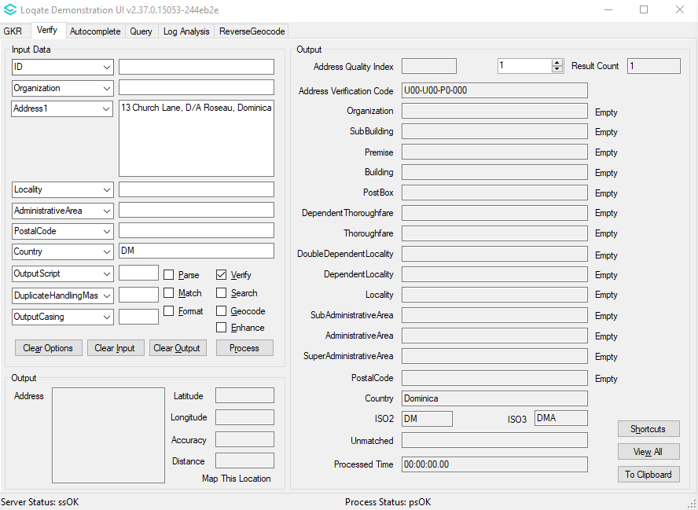 | Able to verify now.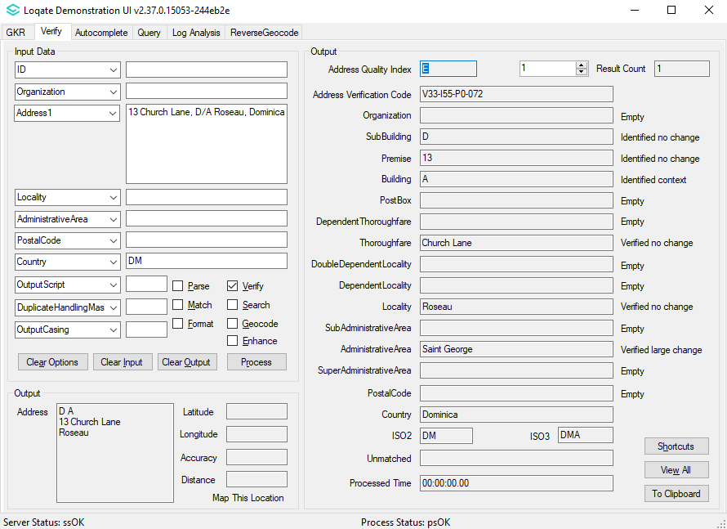

Grenada

Country Information | Description
ISO2 | GD
ISO3 | GRD
Address Format | Organization  PostBox  SubBuilding Building  Premise Thoroughfare  DependentThoroughfare  DoubleDependentLocality  DependentLocality  Locality
PDH | YES
PDH completed date | 2020Q4.1
New Source | NO

 | Pre-PDH | Post-PDH
Reference Data | rd_GD_ggg.lfs  rd_GD_ggg_rg.lfs  rd_GD_vfy_ai.lfs  rd_GD_vfy.lfs | rd_GD_ggg.lfs  rd_GD_ggg_rg.lfs  rd_GD_vfy_ai.lfs  rd_GD_vfy.lfs

2020Q4.0 | 2020Q4.1
Address unable to verify previously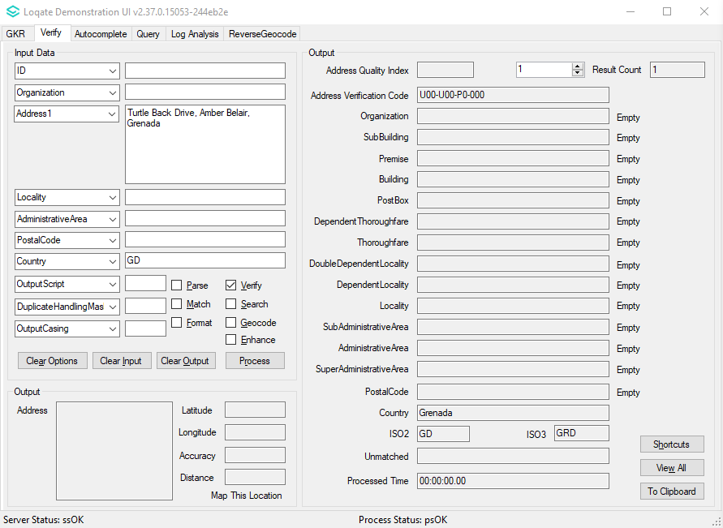 | Able to verify now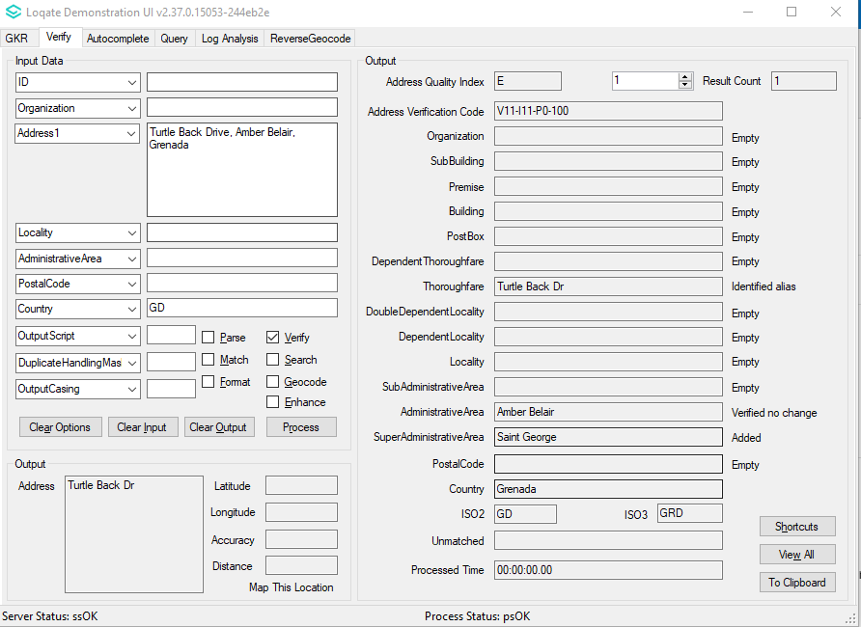

Saint Kitts and Nevis

Country Information | Description
ISO2 | KN
ISO3 | KNA
Address Format | Organization  PostBox  SubBuilding Building  Premise Thoroughfare  DependentThoroughfare  DoubleDependentLocality  DependentLocality  Locality
PDH | YES
PDH completed date | 2020Q4.1
New Source | NO

 | Pre-PDH | Post-PDH
Reference Data | rd_KN_ggg.lfs  rd_KN_ggg_rg.lfs  rd_KN_vfy_ai.lfs  rd_KN_vfy.lfs | rd_KN_ggg.lfs  rd_KN_ggg_rg.lfs  rd_KN_vfy_ai.lfs  rd_KN_vfy.lfs

2020Q4.0 | 2020Q4.1
AdminArea and SuperAdminArea not added previously.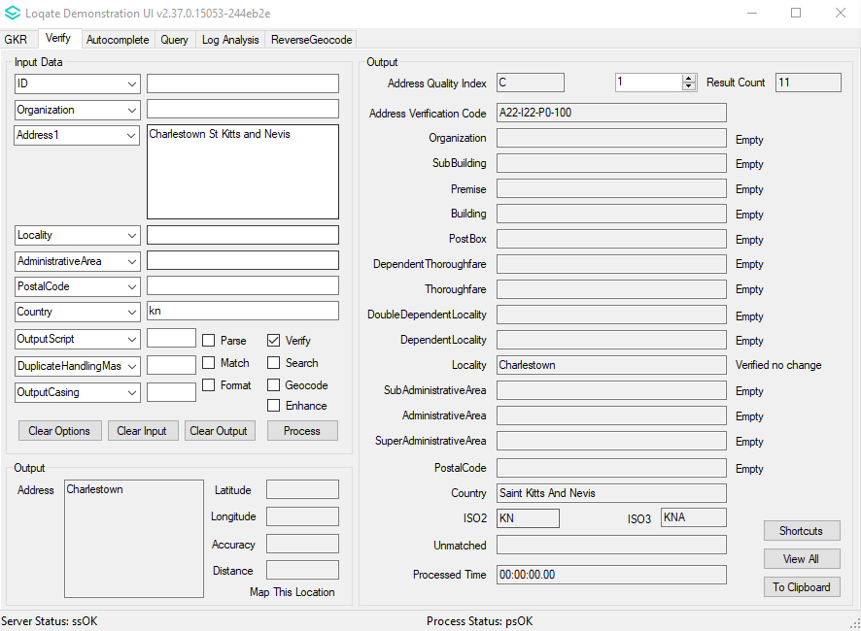 | AdminArea and SuperAdminArea added now.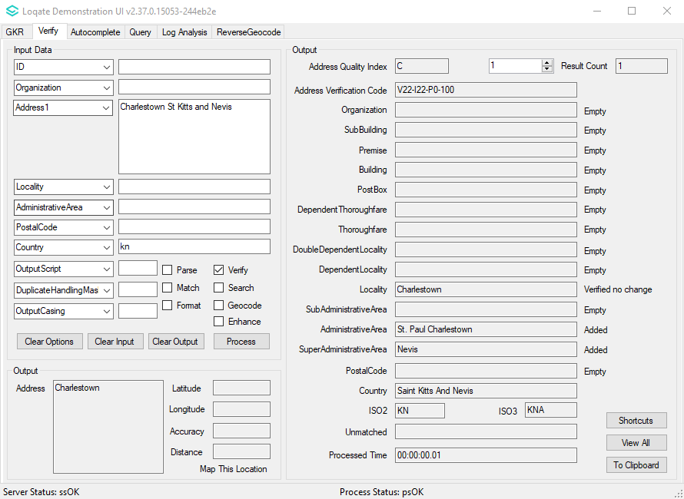

Papua New Guinea

Country Information | Description
ISO2 | PG
ISO3 | PNG
Address Format | Organization  PostBox  SubBuilding Building  Premise Thoroughfare  DependentThoroughfare  DoubleDependentLocality  DependentLocality  Locality PostalCode  AdministrativeArea
PDH | YES
PDH completed date | 2020Q4.1
New Source | NO

 | Pre-PDH | Post-PDH
Reference Data | rd_PG.lfs  rd_PG_ai.lfs  rd_PG_rg.lfs | rd_PG_vfy.lfs  rd_PG_vfy_ai.lfs  rd_PG_ggg.lfs  rd_PG_ggg_rg.lfs

2020Q4.0 | 2020Q4.1
Certain addresses do not have Administrative Area return.  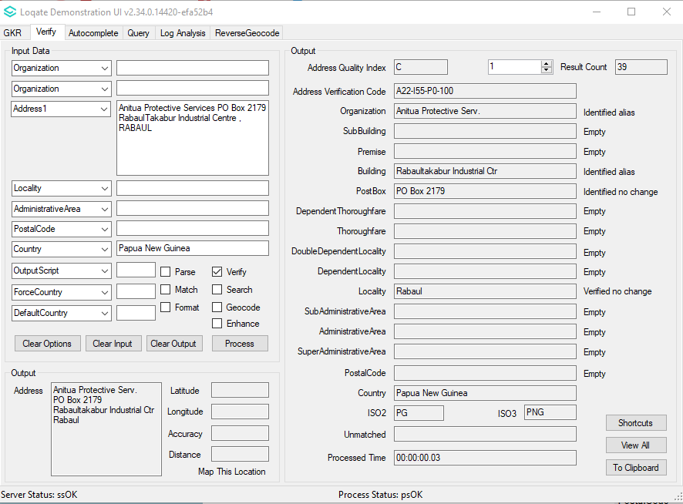 | New update will return Administrative Area for certain addresses.  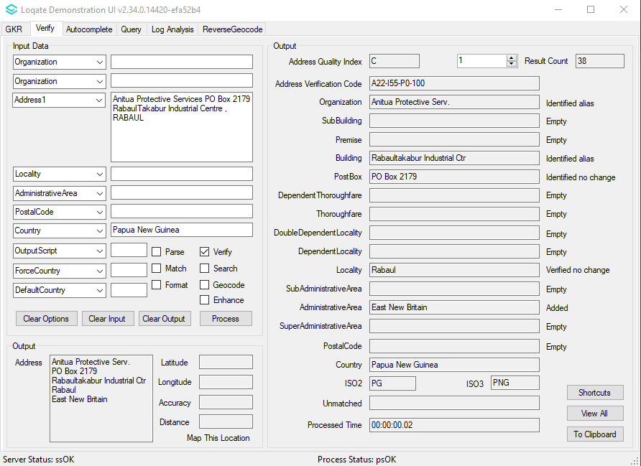

Knowledge Base & Reference Data Updates
The table below shows which countries have been updated, and how, in this release.
If there is a PDH in the reference data column, this shows a country was included in the country improvement project.

- Reference Data: 22 countries (new PDH: Dominica, Grenada, Saint Kitts and Nevis, Papua New Guinea)
- Lexicon: 13 countries
- Context Rules: 0 countries

COUNTRY NAME | ISO CODE | CONTEXT RULES | LEXICONS | REFERENCE DATA
AFGHANISTAN | AF
ÅLAND ISLANDS | AX
ALBANIA | AL
ALGERIA | DZ
AMERICAN SAMOA | AS |  |  | X
ANDORRA | AD
ANGOLA | AO
ANGUILLA | AI
ANTARCTICA | AQ
ANTIGUA AND BARBUDA | AG
ARGENTINA | AR
ARMENIA | AM
ARUBA | AW
AUSTRALIA | AU |  | X | X
AUSTRIA | AT |  | X | X
AZERBAIJAN | AZ
BAHAMAS | BS
BAHRAIN | BH
BANGLADESH | BD
BARBADOS | BB
BELARUS | BY
BELGIUM | BE
BELIZE | BZ
BENIN | BJ
BERMUDA | BM
BHUTAN | BT
BOLIVIA (PLURINATIONAL STATE OF) | BO
BONAIRE, SINT EUSTATIUS AND SABA | BQ
BOSNIA AND HERZEGOVINA | BA
BOTSWANA | BW
BOUVET ISLAND | BV
BRAZIL | BR
BRITISH INDIAN OCEAN TERRITORY | IO
BRUNEI DARUSSALAM | BN
BULGARIA | BG
BURKINA FASO | BF
BURUNDI | BI
CABO VERDE | CV
CAMBODIA | KH
CAMEROON | CM
CANADA | CA |  |  | X
CAYMAN ISLANDS | KY
CENTRAL AFRICAN REPUBLIC | CF
CHAD | TD
CHILE | CL
CHINA | CN
CHRISTMAS ISLAND | CX
COCOS (KEELING) ISLANDS | CC
COLOMBIA | CO
COMOROS | KM
CONGO | CG
CONGO, DEMOCRATIC REPUBLIC OF THE | CD
COOK ISLANDS | CK
COSTA RICA | CR
CÔTE D'IVOIRE | CI
CROATIA | HR
CUBA | CU
CURAÇAO | CW
CYPRUS | CY
CZECHIA | CZ
DENMARK | DK
DJIBOUTI | DJ
DOMINICA | DM |  | X | X
DOMINICAN REPUBLIC | DO
ECUADOR | EC
EGYPT | EG
EL SALVADOR | SV
EQUATORIAL GUINEA | GQ
ERITREA | ER
ESTONIA | EE
ETHIOPIA | ET
FALKLAND ISLANDS (MALVINAS) | FK
FAROE ISLANDS | FO
FIJI | FJ
FINLAND | FI
FRANCE | FR
FRENCH GUIANA | GF
FRENCH POLYNESIA | PF
FRENCH SOUTHERN TERRITORIES | TF
GABON | GA
GAMBIA | GM
GEORGIA | GE
GERMANY | DE |  | X | X
GHANA | GH
GIBRALTAR | GI
GREECE | GR
GREENLAND | GL
GRENADA | GD |  | X | X
GUADELOUPE | GP
GUAM | GU |  |  | X
GUATEMALA | GT
GUERNSEY | GG |  | X | X
GUINEA | GN
GUINEA-BISSAU | GW
GUYANA | GY
HAITI | HT
HEARD ISLAND AND MCDONALD ISLANDS | HM
HONDURAS | HN
HONG KONG | HK
HUNGARY | HU |  | X
ICELAND | IS
INDIA | IN
INDONESIA | ID
IRAN | IR
IRAQ | IQ
IRELAND | IE
ISLE OF MAN | IM |  |  | X
ISRAEL | IL
ITALY | IT
JAMAICA | JM
JAPAN | JP
JERSEY | JE |  |  | X
JORDAN | JO
KAZAKHSTAN | KZ
KENYA | KE
KIRIBATI | KI
KOREA (DEMOCRATIC PEOPLE'S REPUBLIC OF) | KP
KOREA, REPUBLIC OF | KR |  | X
KUWAIT | KW
KYRGYZSTAN | KG
LAO PEOPLE'S DEMOCRATIC REPUBLIC | LA
LATVIA | LV
LEBANON | LB
LESOTHO | LS
LIBERIA | LR
LIBYA | LY
LIECHTENSTEIN | LI
LITHUANIA | LT
LUXEMBOURG | LU
MACAO | MO
MADAGASCAR | MG
MALAWI | MW
MALAYSIA | MY
MALDIVES | MV
MALI | ML
MALTA | MT
MARSHALL ISLANDS | MH |  |  | X
MARTINIQUE | MQ
MAURITANIA | MR
MAURITIUS | MU
MAYOTTE | YT
MEXICO | MX |  | X
MICRONESIA (FEDERATED STATES OF) | FM |  |  | X
MOLDOVA, REPUBLIC OF | MD
MONACO | MC
MONGOLIA | MN
MONTENEGRO | ME
MONTSERRAT | MS
MOROCCO | MA
MOZAMBIQUE | MZ
MYANMAR | MM
NAMIBIA | NA
NAURU | NR
NEPAL | NP
NETHERLANDS | NL |  | X | X
NEW CALEDONIA | NC
NEW ZEALAND | NZ
NICARAGUA | NI
NIGER | NE
NIGERIA | NG
NIUE | NU
NORFOLK ISLAND | NF
NORTH MACEDONIA | MK
NORTHERN MARIANA ISLANDS | MP |  |  | X
NORWAY | NO
OMAN | OM
PAKISTAN | PK
PALAU | PW |  |  | X
PALESTINE, STATE OF | PS
PANAMA | PA
PAPUA NEW GUINEA | PG |  | X | X
PARAGUAY | PY
PERU | PE
PHILIPPINES | PH
PITCAIRN | PN
POLAND | PL
PORTUGAL | PT
PUERTO RICO | PR |  |  | X
QATAR | QA
RÉUNION | RE
ROMANIA | RO
RUSSIAN FEDERATION | RU
RWANDA | RW
SAINT BARTHÉLEMY | BL
SAINT HELENA, ASCENSION AND TRISTAN DA CUNHA | SH
SAINT KITTS AND NEVIS | KN |  | X | X
SAINT LUCIA | LC
SAINT MARTIN (FRENCH PART) | MF
SAINT PIERRE AND MIQUELON | PM
SAINT VINCENT AND THE GRENADINES | VC
SAMOA | WS
SAN MARINO | SM
SAO TOME AND PRINCIPE | ST
SAUDI ARABIA | SA
SENEGAL | SN
SERBIA | RS
SEYCHELLES | SC
SIERRA LEONE | SL
SINGAPORE | SG
SINT MAARTEN (DUTCH PART) | SX
SLOVAKIA | SK
SLOVENIA | SI
SOLOMON ISLANDS | SB
SOMALIA | SO
SOUTH AFRICA | ZA
SOUTH GEORGIA AND THE SOUTH SANDWICH ISLANDS | GS
SOUTH SUDAN | SS
SPAIN | ES
SRI LANKA | LK
SUDAN | SD
SURINAME | SR
SVALBARD AND JAN MAYEN | SJ
SWAZILAND | SZ
SWEDEN | SE
SWITZERLAND | CH
SYRIAN ARAB REPUBLIC | SY
TAIWAN | TW
TAJIKISTAN | TJ
TANZANIA, UNITED REPUBLIC OF | TZ
THAILAND | TH
TIMOR-LESTE | TL
TOGO | TG
TOKELAU | TK
TONGA | TO
TRINIDAD AND TOBAGO | TT
TUNISIA | TN
TURKEY | TR
TURKMENISTAN | TM
TURKS AND CAICOS ISLANDS | TC
TUVALU | TV
UGANDA | UG
UKRAINE | UA
UNITED ARAB EMIRATES | AE
UNITED KINGDOM | GB |  |  | X
UNITED STATES MINOR OUTLYING ISLANDS | UM
UNITED STATES OF AMERICA | US |  | X | X
URUGUAY | UY
UZBEKISTAN | UZ
VANUATU | VU
VATICAN CITY | VA
VENEZUELA (BOLIVARIAN REPUBLIC OF) | VE
VIET NAM | VN
VIRGIN ISLANDS (BRITISH) | VG
VIRGIN ISLANDS (U.S.) | VI |  |  | X
WALLIS AND FUTUNA | WF
WESTERN SAHARA | EH
YEMEN | YE
ZAMBIA | ZM
ZIMBABWE | ZW

Installation Instructions
The 2020Q4.1 release makes improvements to the performance of the verification process and the quality of the results.

Please remember to update both the program files and the reference data. The improvements are tied to the data in the Global Knowledge Repository and the Local API. If you need any assistance with the upgrade of the Local API or the data update process, please contact GBG Loqate Support.

The setup wizard for the Local API can be obtained from our SFTP server. Please contact your account manager to retrieve the SFTP information. If you do not know who your account manager is, please contact the support team at support@loqate.com.

GBG Loqate data packs can be downloaded and installed using the Install Manager. This is a component you will need to select during the installation of the Local API as shown below.

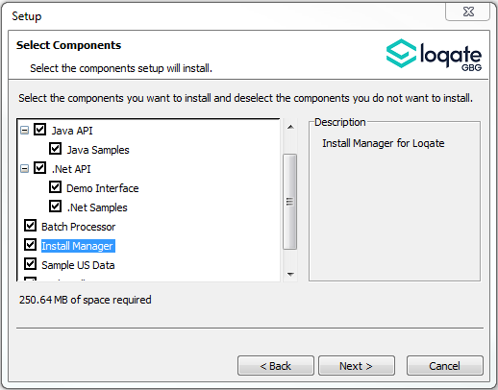

Standard GBG Loqate Installation (Multi-Threaded)
- Download the contents of the 2020Q4.1/app-installer-mt.
- Check the MD5 checksums to ensure that the download has been successful.
- Run the relevant Loqate Local API installer. Please note you may need to add execute privileges to the relevant installer when using Linux. Make sure the option “Install Manager” is selected for installation.
- Execute the Install Manager script (InstallManager.bat on Windows and InstallManager.sh on other Linux/Unix platforms) and install the data. For further details, please review the 2020Q4.1 Installation Instructions document.
- Run the relevant Global Knowledge Repository installer. Please note you may need to add execute privileges when using Linux.

Standard GBG Loqate Installation (Single-Threaded)
- Download the contents of the 2020Q4.1/app-installer-st directory.
- Check the MD5 checksums to ensure that the download has been successful.
- Run the relevant Loqate Local API installer. Please note you may need to add execute privileges to the relevant installer when using Linux. Make sure the option “Install Manager” is selected for installation.
- Execute the InstallManager script (InstallManager.bat on Windows and InstallManager.sh on other Linux/Unix platforms) and install the data. For further details, please review the 2020Q4.1 Installation Instructions document.
- Run the relevant Global Knowledge Repository installer. Please note you may need to add execute privileges when using Linux.

SFTP Server Contents
Please see https://support.loqate.com/2020q4-1-directory-filename-updates-release-sftp/ for more information about the file contents for this release.

