Loqate, A GBG Solution Release Notes
2020Q4.0 Major Release
Table of Contents
Case Resolutions 3
Supported Platforms 3
Loqate API Installer 3
Interactive Test Client 3
OSGI 3
Local API Improvements 4
Hyphenated Premise Number 4
Additional API Improvements 4
Certification Expiration Dates 5
Country Improvement Program (PDH) 6
Belarus 6
Bonaire, Sint Eustatius and Saba 7
Curaçao 8
Hungary 9
Kyrgyzstan 10
Macao 11
Mongolia 12
Senegal 13
Knowledge Base & Reference Data Updates 15
Installation Instructions 24
Standard GBG Loqate Installation (Multi-Threaded) 24
Standard GBG Loqate Installation (Single-Threaded) 25
SFTP Server Contents 25

Case Resolutions
Please visit http://support.loqate.com/2020Q4-0-resolved-cases/ for a list of cases resolved in this release.

If you would like more details on any of the solved cases listed, please contact support@loqate.com for further information.

Supported Platforms
The platform AIX6.1 has reached the end of life and will no longer be supported from the 2021Q1.0 major release onwards. For additional information on the retirement of platforms for this release, please visit the support site here. To view a full list of the supported platforms please see the release information page here and select the ‘Supported Platforms’ link for the release in question. Please contact your account manager for further questions or additional information.

Loqate API Installer

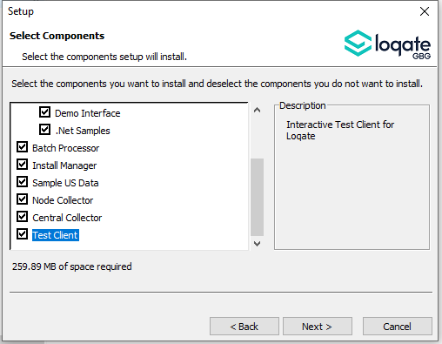
Interactive Test Client
The interactive test client is an interactive address testing facility for command line entry; this was available with the 2020Q3.1 minor release onwards. The Windows VS2019 version of the interactive test client is now available with the 2020Q4.0 major release. The guide for using this test client is available on the support site here.

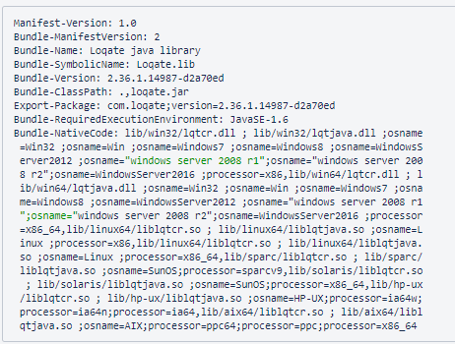
OSGI
The OSGI Bundle-Version and the Export-Package will be changing in the 2020Q4.0 major release. Please see fig. 1 below for a sample of these changes. The Bundle-Version is now the API Version. Please see the screenshot for a sample manifest file from the jar.
Fig. 1
Bundle-Version | 2.37.0.15105-1801fe0
Export-Package | com.loqate;version= 2.37.0.15105-1801fe0

Local API Improvements

Hyphenated Premise Number

In the 2020Q4.0 release, certain U.S. addresses with premise numbers that contain a hyphen have improved verification results. This change is only available to Queens, NY. For example an input premise: ‘25-14’ may now be verified as ‘2514’.

2020Q3.1 | 2002Q4.0
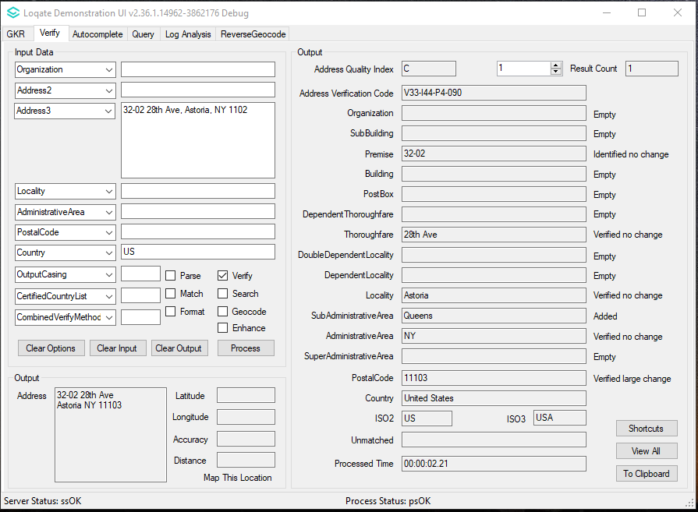  The address with hyphenated premise is able to verify to level 3 only | 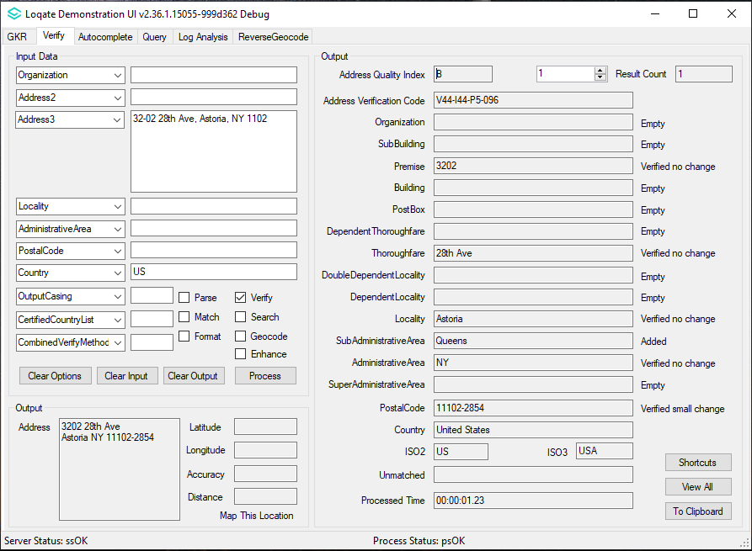  The address with hyphenated premise is able to verify to level 4

Additional API Improvements

The following API updates are included in the 2020Q4.0 major release:
- Improved processing time for Hong Kong addresses
- Improvements to verification with thoroughfare names in Poland
- The server option OutputCasing will now ignore case changes for the following: PrimaryAddressLine, SecodaryAddressLine, and certain CASS fields, which will remain uppercase
- Updated matchscore consistency between Linux and Windows platforms

Certification Expiration Dates
If you have purchased either the CASS (USA) or AMAS (Australia) certified products, please be aware that the datasets have expiration dates set by the respective postal authorities. Please ensure that you have the latest library and data installed to avoid loss of service through these products.

Please check Install Manager for the latest versions of AMAS and CASS.
 | Loqate Release Date | Certification Expiry Date*
AMAS Data | 2020-09-04 | 2020-12-31
CASS Data | 2020-10-10 | 2020-12-30
*Certification Expiry Date is different from Loqate license key expiry date. The earliest expiry date will apply.

For more information on expiry date checking for CASS and AMAS, please refer “Usage expiration” section in https://support.loqate.com/documentation/local-apis/cass-overview-2/ and https://support.loqate.com/address-matching-approval-system-amas/

Country Improvement Program (PDH)
The following section will display the changes made during the country improvement program.
For more details on our Country Improvement Program, please visit the support site here.

Belarus

Country Information | Description
ISO2 | BY
ISO3 | BLR
Address Format | Organization  PostBox  Thoroughfare Premise DependentThoroughfare Building SubBuilding  DoubleDependentLocality  PostalCode Locality  DependentLocality
PDH | YES
PDH completed date | 2020Q4.0
New Source | NO

 | Pre-PDH | Post-PDH
Reference Data | rd_BY_rg.lfs  rd_BY.lfs  rd_BY_ai.lfs | rd_BY_vfy.lfs  rd_BY_vfy_ai.lfs  rd_BY_ggg.lfs  rd_BY_ggg_rg.lfs

There are improvements made to the Postal Code field information for Belarus in this release.

2020Q3.1 | 2020Q4.0
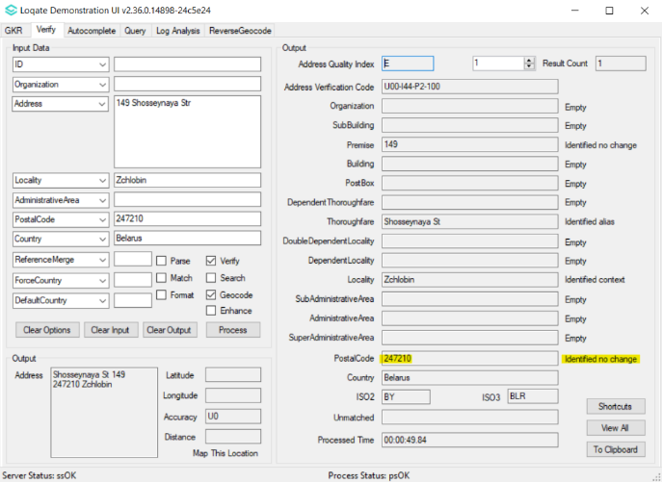  PostalCode is unverified | 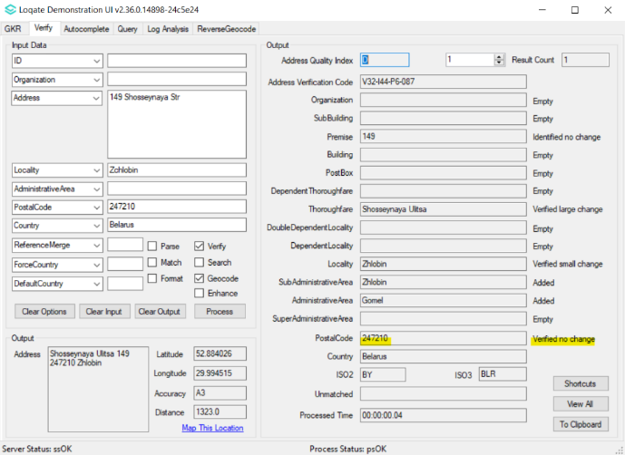  PostalCode is now verified.

Bonaire, Sint Eustatius and Saba

Country Information | Description
ISO2 | BQ
ISO3 | BES
Address Format | Organization  PostBox  Building SubBuilding  Thoroughfare Premise  DependentThoroughfare  DoubleDependentLocality  DependentLocality  Locality
PDH | YES
PDH completed date | 2020Q4.0
New Source | NO

 | Pre-PDH | Post-PDH
Reference Data | rd_BQ.lfs  rd_BQ_rg.lfs  rd_BQ_ai.lfs | rd_BQ_ggg.lfs  rd_BQ_ggg_rg.lfs  rd_BQ_vfy.lfs  rd_BQ_vfy_ai.lfs

The 2020Q4.0 major release makes improvements with the re-alignment from Administrative Area to Locality and Super Administrative Area to Administrative Area.

2020Q3.1 | 2020Q4.0
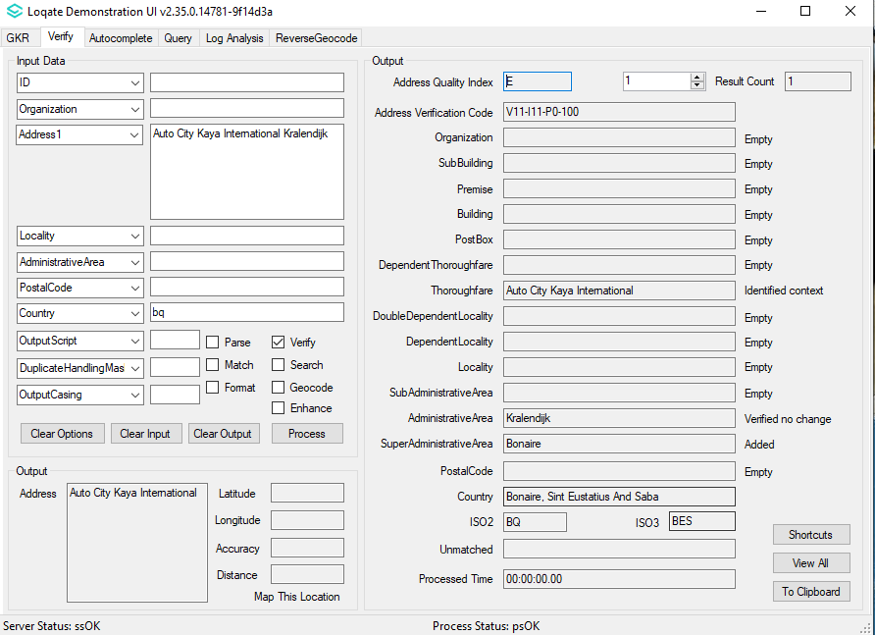  Locality information was unavailable. Only Super Administrative Area and Administrative Area were available. | 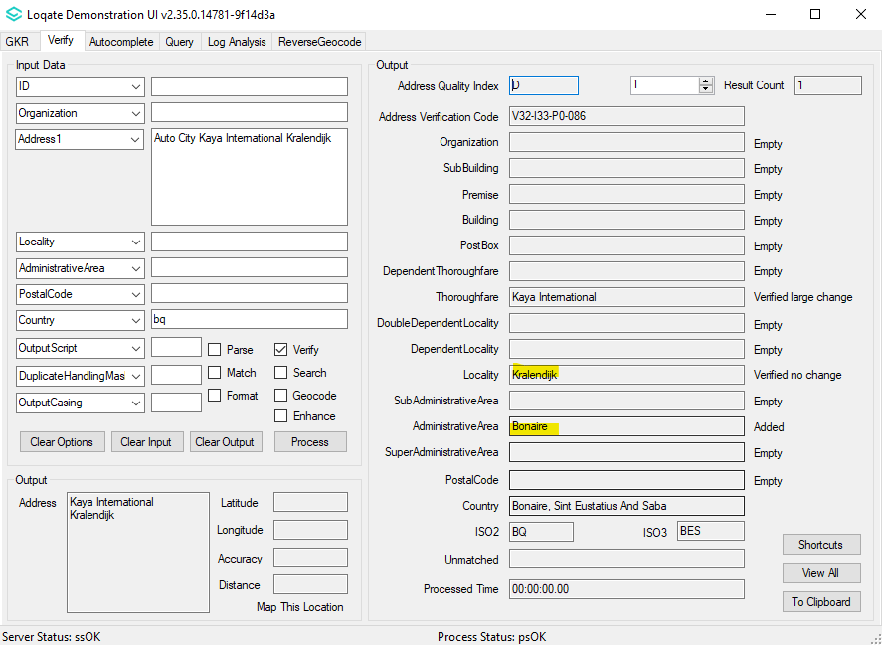  Re-alignment from Administrative Area to Locality, Super Administrative Area to Administrative Area, improving AVC results.

Curaçao

Country Information | Description
ISO2 | CW
ISO3 | CUW
Address Format | Organization  PostBox  Building SubBuilding  Thoroughfare Premise  DependentThoroughfare  DoubleDependentLocality  DependentLocality  Locality
PDH | YES
PDH completed date | 2020Q4.0
New Source | NO

 | Pre-PDH | Post-PDH
Reference Data | rd_CW_ggg.lfs  rd_CW_ggg_rg.lfs  rd_CW_vfy.lfs  rd_CW_vfy_ai.lfs | rd_CW_ggg.lfs  rd_CW_ggg_rg.lfs  rd_CW_vfy.lfs  rd_CW_vfy_ai.lfs

The 2020Q4.0 major release provides more verifiable localities in Curaçao.

2020Q3.1 | 2020Q4.0
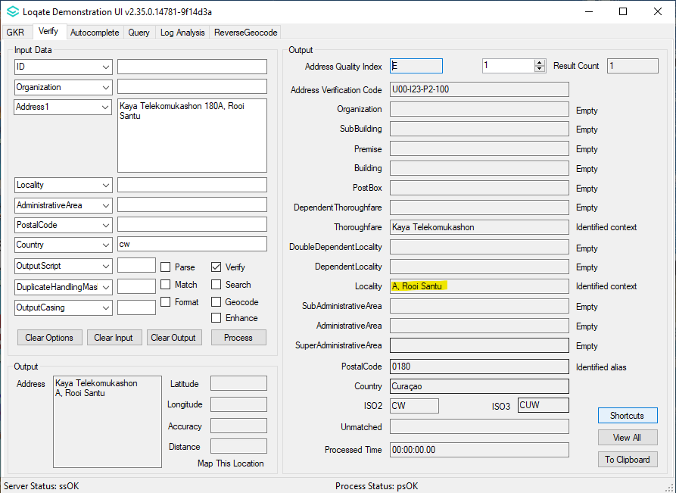  Unable to verify some Localities | 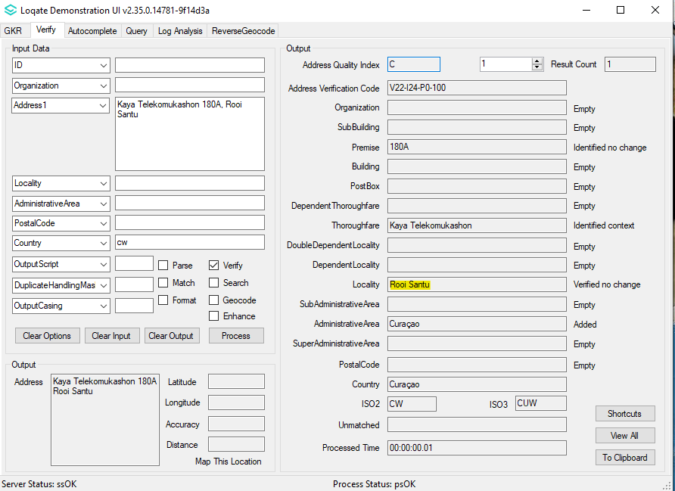  Able to verify more Localities level

Hungary

Country Information | Description
ISO2 | HU
ISO3 | HUN
Address Format | Organization  Locality  Thoroughfare Premise  Building SubBuilding  DependentThoroughfare  PostBox  PostalCode
PDH | YES
PDH completed date | 2020Q4.0
New Source | NO

 | Pre-PDH | Post-PDH
Reference Data | rd_HU_geop.lfs  rd_HU_geop_rg.lfs  rd_HU.lfs  rd_HU_ai.lfs  rd_HU_rg.lfs | rd_HU_ggg.lfs  rd_HU_ggg_rg.lfs  rd_HU_vfy.lfs  rd_HU_vfy_ai.lfs

There are improvements made with the thoroughfare and premise fields in Hungary in this release.

2020Q3.1 | 2020Q4.0
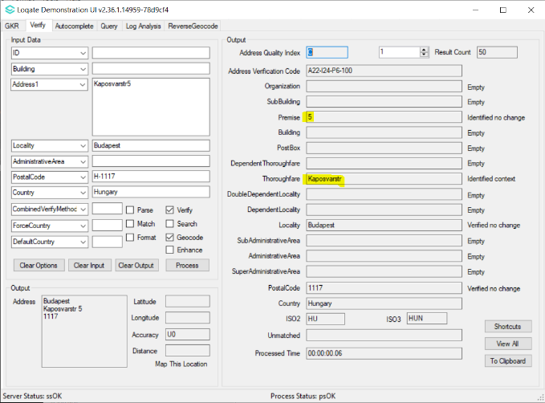  Unable to verify certain Thoroughfares and Premises | 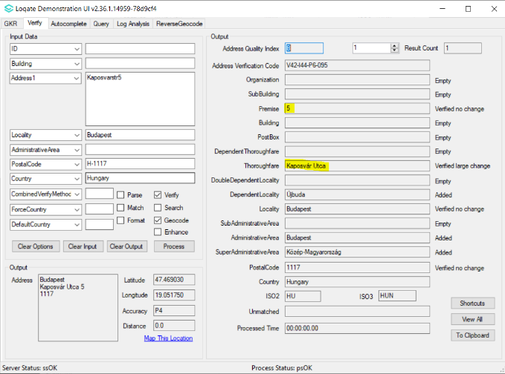  Able to verify more Thoroughfares and Premise level

Kyrgyzstan

Country Information | Description
ISO2 | KG
ISO3 | KGZ
Address Format | Organization  PostalCode Locality  PostBox  Building SubBuilding  Thoroughfare Premise  DependentThoroughfare DoubleDependentLocality  DependentLocality
PDH | YES
PDH completed date | 2020Q4.0
New Source | NO

 | Pre-PDH | Post-PDH
Reference Data | rd_KG.lfs  rd_KG_rg.lfs  rd_KG_ai.lfs | rd_KG_vfy.lfs  rd_KG_vfy_ai.lfs  rd_KG_ggg.lfs  rd_KG_ggg_rg.lfs

This release includes improvements in the verification results with the Locality and Thoroughfare levels in Kyrgyzstan.

2020Q3.1 | 2020Q4.0
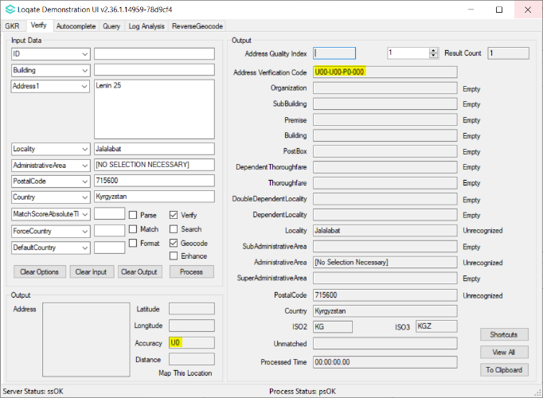  Unable to verify certain addresses due to the input locality | 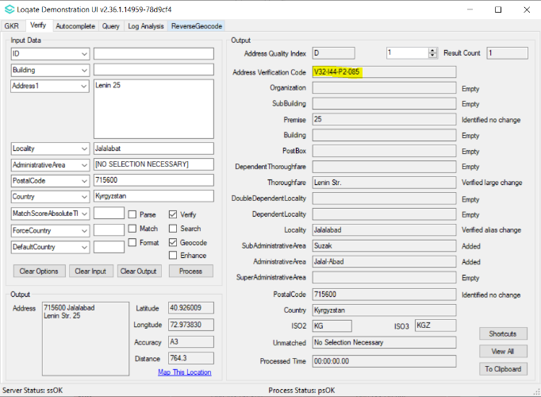  Able to verify more addresses up to thoroughfare level

Macao

Country Information | Description
ISO2 | MO
ISO3 | MAC
Address Format | Organization  PostBox  Building SubBuilding  Thoroughfare Premise  DependentThoroughfare DoubleDependentLocality  DependentLocality  Locality
PDH | YES
PDH completed date | 2020Q4.0
New Source | YES

 | Pre-PDH | Post-PDH
Reference Data | rd_MO_ai.lfs  rd_MO_geop.lfs  rd_MO_geop_rg.lfs  rd_MO.lfs  rd_MO_rg.lfs | rd_MO_vfy.lfs  rd_MO_vfy_ai.lfs  rd_MO_ggg.lfs  rd_MO_ggg_rg.lfs

The data refresh for Macao improved verification results and more addresses can be verified up to the premise level.

2020Q3.1 | 2020Q4.0
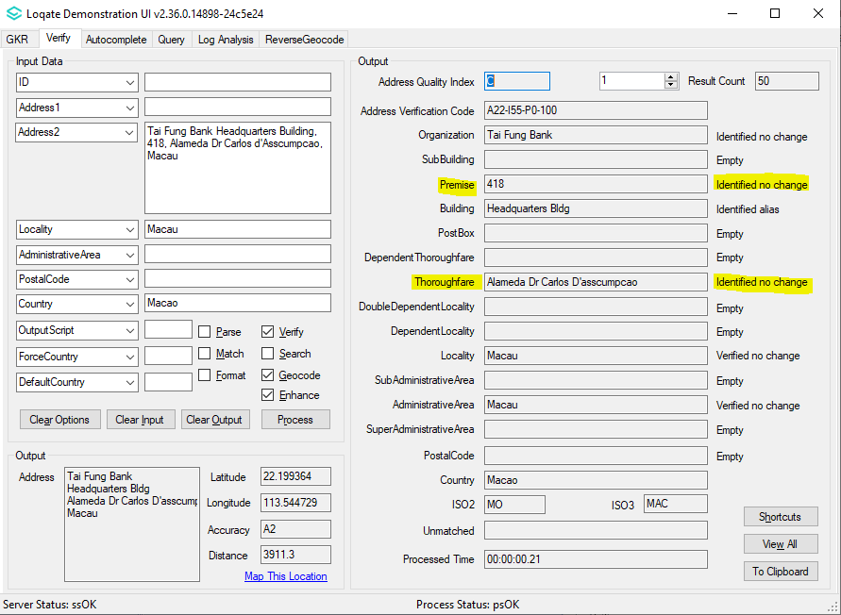  Many premise and thoroughfares were unable to verify. | 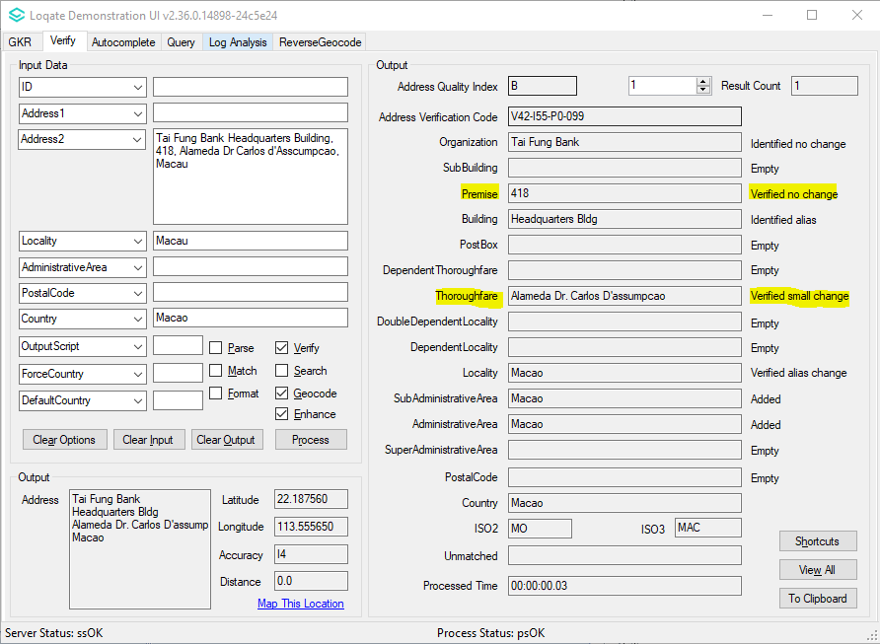  Due to data refresh, more premises and thoroughfares are now verifiable.

Mongolia

Country Information | Description
ISO2 | MN
ISO3 | MNG
Address Format | Organization  PostBox  SubBuilding Building  Premise Thoroughfare  DependentThoroughfare  DoubleDependentLocality  DependentLocality  Locality PostalCode
PDH | YES
PDH completed date | 2020Q4.0
New Source | NO

 | Pre-PDH | Post-PDH
Reference Data | rd_MN.lfs  rd_MN_ai.lfs  rd_MN_rg.lfs | rd_MN_vfy.lfs  rd_MN_vfy_ai.lfs  rd_MN_ggg.lfs  rd_MN_ggg_rg.lfs

The 2020Q4.0 major release includes realignment of Super Administrative Area to Administrative Area.

2020Q3.1 | 2020Q4.0
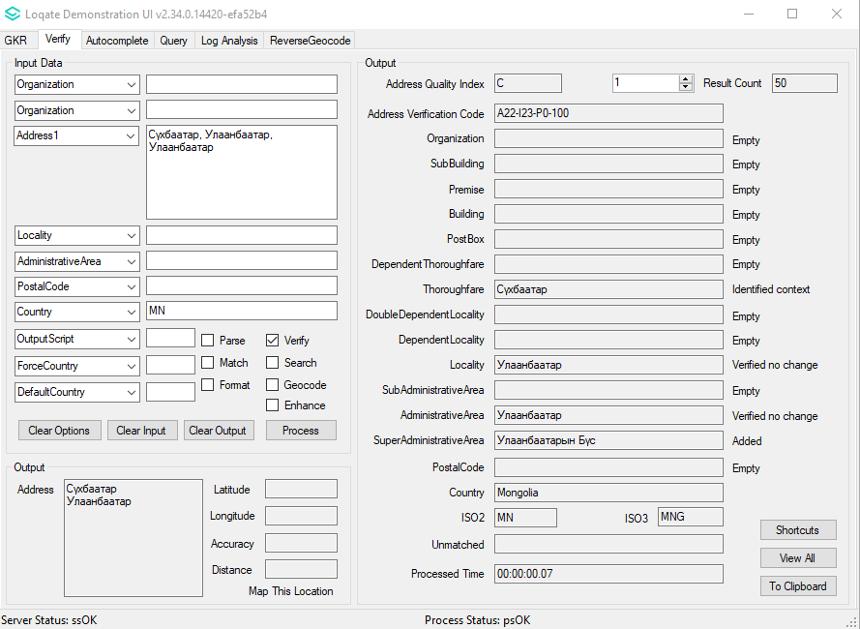  Mongolia has Super Administrative Area. | 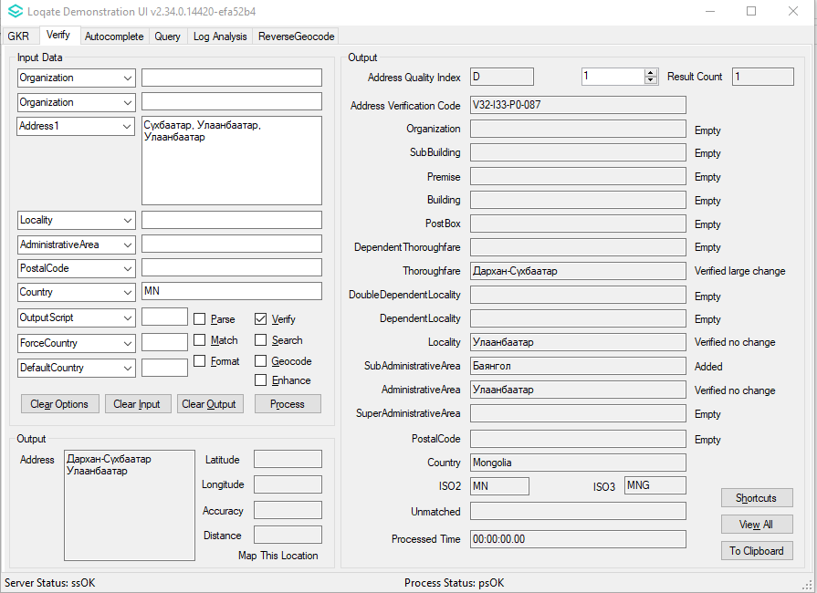  Realigned Super Administrative Area to Administrative Area.

Senegal

Country Information | Description
ISO2 | SN
ISO3 | SEN
Address Format | Organization  PostBox  SubBuilding Building  Premise Thoroughfare  DependentThoroughfare  DoubleDependentLocality  DependentLocality  PostalCode Locality AdministrativeArea
PDH | YES
PDH completed date | 2020Q4.0
New Source | NO

 | Pre-PDH | Post-PDH
Reference Data | rd_SN_rg.lfs  rd_SN.lfs  rd_SN_ai.lfs | rd_SN_vfy.lfs  rd_SN_vfy_ai.lfs  rd_SN_ggg.lfs  rd_SN_ggg_rg.lfs

The 2020Q4.0 major release includes realignment in the following fields for Senegal: SuperAdministrativeArea to AdministrativeArea, AdministrativeArea to SubAdministrativeArea,
SubAdministrativeArea to Locality, and Locality to DependentLocality.

2020Q3.1 | 2020Q4.0
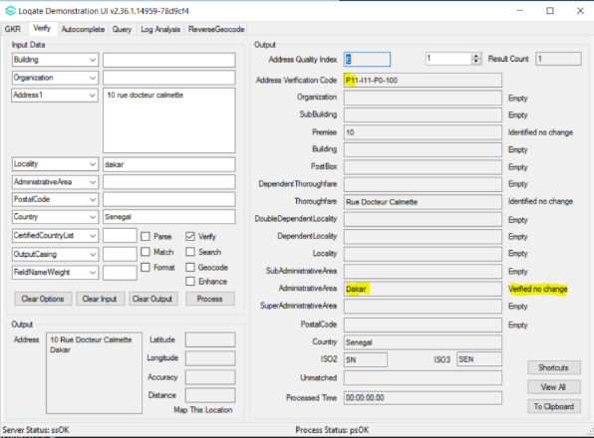  Dakar parsed and verified as Administrative Area, AVC=P1 returned. | 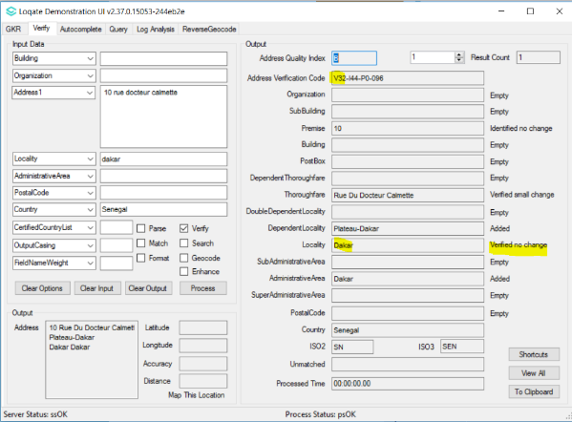  Dakar parsed and verified as Locality, which yield better AVC (V3).

Knowledge Base & Reference Data Updates
The table below shows which countries have been updated, and how, in this release.
If there is a PDH in the reference data column, this shows a country was included in the country improvement project.

- Reference Data: 153 countries
- Lexicon: 16 countries
- Context Rules: 2 countries

COUNTRY NAME | ISO CODE | CONTEXT RULES | LEXICONS | REFERENCE DATA
AFGHANISTAN | AF |  |  | X
ÅLAND ISLANDS | AX
ALBANIA | AL |  |  | X
ALGERIA | DZ |  |  | X
AMERICAN SAMOA | AS |  |  | X
ANDORRA | AD
ANGOLA | AO
ANGUILLA | AI
ANTARCTICA | AQ
ANTIGUA AND BARBUDA | AG |  | X | X
ARGENTINA | AR |  |  | X
ARMENIA | AM
ARUBA | AW
AUSTRALIA | AU |  | X | X
AUSTRIA | AT
AZERBAIJAN | AZ |  |  | X
BAHAMAS | BS
BAHRAIN | BH
BANGLADESH | BD
BARBADOS | BB
BELARUS | BY |  | X | X
BELGIUM | BE
BELIZE | BZ |  |  | X
BENIN | BJ |  |  | X
BERMUDA | BM |  |  | X
BHUTAN | BT |  |  | X
BOLIVIA (PLURINATIONAL STATE OF) | BO
BONAIRE, SINT EUSTATIUS AND SABA | BQ |  | X | X
BOSNIA AND HERZEGOVINA | BA |  |  | X
BOTSWANA | BW
BOUVET ISLAND | BV
BRAZIL | BR
BRITISH INDIAN OCEAN TERRITORY | IO |  |  | X
BRUNEI DARUSSALAM | BN |  |  | X
BULGARIA | BG
BURKINA FASO | BF |  |  | X
BURUNDI | BI
CABO VERDE | CV |  |  | X
CAMBODIA | KH
CAMEROON | CM |  |  | X
CANADA | CA |  |  | X
CAYMAN ISLANDS | KY
CENTRAL AFRICAN REPUBLIC | CF |  |  | X
CHAD | TD |  |  | X
CHILE | CL
CHINA | CN |  |  | X
CHRISTMAS ISLAND | CX |  |  | X
COCOS (KEELING) ISLANDS | CC |  |  | X
COLOMBIA | CO
COMOROS | KM |  |  | X
CONGO | CG |  |  | X
CONGO, DEMOCRATIC REPUBLIC OF THE | CD |  |  | X
COOK ISLANDS | CK |  |  | X
COSTA RICA | CR |  |  | X
CÔTE D'IVOIRE | CI |  |  | X
CROATIA | HR |  |  | X
CUBA | CU |  |  | X
CURAÇAO | CW |  | X | X
CYPRUS | CY
CZECHIA | CZ
DENMARK | DK
DJIBOUTI | DJ |  |  | X
DOMINICA | DM |  |  | X
DOMINICAN REPUBLIC | DO
ECUADOR | EC
EGYPT | EG
EL SALVADOR | SV
EQUATORIAL GUINEA | GQ |  |  | X
ERITREA | ER |  |  | X
ESTONIA | EE |  |  | X
ETHIOPIA | ET |  |  | X
FALKLAND ISLANDS (MALVINAS) | FK |  |  | X
FAROE ISLANDS | FO |  |  | X
FIJI | FJ |  |  | X
FINLAND | FI
FRANCE | FR
FRENCH GUIANA | GF |  |  | X
FRENCH POLYNESIA | PF
FRENCH SOUTHERN TERRITORIES | TF |  |  | X
GABON | GA |  |  | X
GAMBIA | GM |  |  | X
GEORGIA | GE
GERMANY | DE |  | X | X
GHANA | GH |  |  | X
GIBRALTAR | GI |  |  | X
GREECE | GR
GREENLAND | GL |  |  | X
GRENADA | GD
GUADELOUPE | GP
GUAM | GU |  |  | X
GUATEMALA | GT |  |  | X
GUERNSEY | GG |  |  | X
GUINEA | GN |  |  | X
GUINEA-BISSAU | GW |  |  | X
GUYANA | GY |  |  | X
HAITI | HT
HEARD ISLAND AND MCDONALD ISLANDS | HM
HONDURAS | HN
HONG KONG | HK
HUNGARY | HU | X | X | X
ICELAND | IS
INDIA | IN
INDONESIA | ID
IRAN | IR |  |  | X
IRAQ | IQ |  |  | X
IRELAND | IE
ISLE OF MAN | IM |  |  | X
ISRAEL | IL
ITALY | IT
JAMAICA | JM
JAPAN | JP
JERSEY | JE |  |  | X
JORDAN | JO |  |  | X
KAZAKHSTAN | KZ
KENYA | KE |  |  | X
KIRIBATI | KI |  |  | X
KOREA (DEMOCRATIC PEOPLE'S REPUBLIC OF) | KP |  |  | X
KOREA, REPUBLIC OF | KR
KUWAIT | KW |  |  | X
KYRGYZSTAN | KG |  | X | X
LAO PEOPLE'S DEMOCRATIC REPUBLIC | LA |  |  | X
LATVIA | LV
LEBANON | LB |  |  | X
LESOTHO | LS |  |  | X
LIBERIA | LR |  |  | X
LIBYA | LY |  |  | X
LIECHTENSTEIN | LI
LITHUANIA | LT
LUXEMBOURG | LU
MACAO | MO |  | X | X
MADAGASCAR | MG |  |  | X
MALAWI | MW
MALAYSIA | MY
MALDIVES | MV |  |  | X
MALI | ML |  |  | X
MALTA | MT |  |  | X
MARSHALL ISLANDS | MH |  |  | X
MARTINIQUE | MQ
MAURITANIA | MR |  |  | X
MAURITIUS | MU |  |  | X
MAYOTTE | YT |  |  | X
MEXICO | MX
MICRONESIA (FEDERATED STATES OF) | FM |  |  | X
MOLDOVA, REPUBLIC OF | MD
MONACO | MC |  |  | X
MONGOLIA | MN |  | X | X
MONTENEGRO | ME |  |  | X
MONTSERRAT | MS |  |  | X
MOROCCO | MA
MOZAMBIQUE | MZ
MYANMAR | MM |  |  | X
NAMIBIA | NA |  |  | X
NAURU | NR |  |  | X
NEPAL | NP |  |  | X
NETHERLANDS | NL |  |  | X
NEW CALEDONIA | NC |  |  | X
NEW ZEALAND | NZ |  | X
NICARAGUA | NI
NIGER | NE |  |  | X
NIGERIA | NG
NIUE | NU |  |  | X
NORFOLK ISLAND | NF |  |  | X
NORTH MACEDONIA | MK |  |  | X
NORTHERN MARIANA ISLANDS | MP |  |  | X
NORWAY | NO
OMAN | OM |  |  | X
PAKISTAN | PK |  |  | X
PALAU | PW |  |  | X
PALESTINE, STATE OF | PS |  |  | X
PANAMA | PA
PAPUA NEW GUINEA | PG |  |  | X
PARAGUAY | PY
PERU | PE
PHILIPPINES | PH
PITCAIRN | PN |  |  | X
POLAND | PL |  |  | X
PORTUGAL | PT
PUERTO RICO | PR |  |  | X
QATAR | QA
RÉUNION | RE |  |  | X
ROMANIA | RO |  | X | X
RUSSIAN FEDERATION | RU
RWANDA | RW |  |  | X
SAINT BARTHÉLEMY | BL
SAINT HELENA, ASCENSION AND TRISTAN DA CUNHA | SH |  |  | X
SAINT KITTS AND NEVIS | KN |  |  | X
SAINT LUCIA | LC
SAINT MARTIN (FRENCH PART) | MF |  |  | X
SAINT PIERRE AND MIQUELON | PM |  |  | X
SAINT VINCENT AND THE GRENADINES | VC |  |  | X
SAMOA | WS |  |  | X
SAN MARINO | SM
SAO TOME AND PRINCIPE | ST |  |  | X
SAUDI ARABIA | SA
SENEGAL | SN |  | X | X
SERBIA | RS | X | X | X
SEYCHELLES | SC |  |  | X
SIERRA LEONE | SL |  |  | X
SINGAPORE | SG
SINT MAARTEN (DUTCH PART) | SX
SLOVAKIA | SK
SLOVENIA | SI
SOLOMON ISLANDS | SB |  |  | X
SOMALIA | SO |  |  | X
SOUTH AFRICA | ZA
SOUTH GEORGIA AND THE SOUTH SANDWICH ISLANDS | GS |  |  | X
SOUTH SUDAN | SS |  |  | X
SPAIN | ES
SRI LANKA | LK |  | X | X
SUDAN | SD |  |  | X
SURINAME | SR |  |  | X
SVALBARD AND JAN MAYEN | SJ |  |  | X
SWAZILAND | SZ |  |  | X
SWEDEN | SE
SWITZERLAND | CH
SYRIAN ARAB REPUBLIC | SY |  |  | X
TAIWAN | TW
TAJIKISTAN | TJ |  |  | X
TANZANIA, UNITED REPUBLIC OF | TZ |  |  | X
THAILAND | TH
TIMOR-LESTE | TL |  |  | X
TOGO | TG |  |  | X
TOKELAU | TK |  |  | X
TONGA | TO |  |  | X
TRINIDAD AND TOBAGO | TT
TUNISIA | TN |  |  | X
TURKEY | TR
TURKMENISTAN | TM |  |  | X
TURKS AND CAICOS ISLANDS | TC |  |  | X
TUVALU | TV |  |  | X
UGANDA | UG
UKRAINE | UA
UNITED ARAB EMIRATES | AE
UNITED KINGDOM | GB |  |  | X
UNITED STATES MINOR OUTLYING ISLANDS | UM |  |  | X
UNITED STATES OF AMERICA | US |  | X | X
URUGUAY | UY
UZBEKISTAN | UZ |  |  | X
VANUATU | VU |  |  | X
VATICAN CITY | VA
VENEZUELA (BOLIVARIAN REPUBLIC OF) | VE
VIET NAM | VN
VIRGIN ISLANDS (BRITISH) | VG |  |  | X
VIRGIN ISLANDS (U.S.) | VI |  |  | X
WALLIS AND FUTUNA | WF |  |  | X
WESTERN SAHARA | EH |  |  | X
YEMEN | YE |  |  | X
ZAMBIA | ZM |  |  | X
ZIMBABWE | ZW |  |  | X

Installation Instructions
The 2020Q4.0 release makes improvements to the performance of the verification process and the quality of the results.

Please remember to update both the program files and the reference data. The improvements are tied to the data in the Global Knowledge Repository and the Local API. If you need any assistance with the upgrade of the Local API or the data update process, please contact GBG Loqate Support.

The setup wizard for the Local API can be obtained from our SFTP server. Please contact your account manager to retrieve the SFTP information. If you do not know who your account manager is, please contact the support team at support@loqate.com.

GBG Loqate data packs can be downloaded and installed using the Install Manager. This is a component you will need to select during the installation of the Local API as shown below.

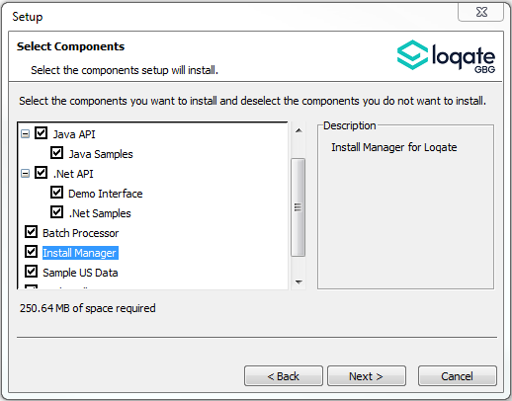

Standard GBG Loqate Installation (Multi-Threaded)
- Download the contents of the 2020Q4.0/app-installer-mt.
- Check the MD5 checksums to ensure that the download has been successful.
- Run the relevant Loqate Local API installer. Please note you may need to add execute privileges to the relevant installer when using Linux. Make sure the option “Install Manager” is selected for installation.
- Execute the Install Manager script (InstallManager.bat on Windows and InstallManager.sh on other Linux/Unix platforms) and install the data. For further details, please review the 2020Q4.0 Installation Instructions document.
- Run the relevant Global Knowledge Repository installer. Please note you may need to add execute privileges when using Linux.

Standard GBG Loqate Installation (Single-Threaded)
- Download the contents of the 2020Q4.0/app-installer-st directory.
- Check the MD5 checksums to ensure that the download has been successful.
- Run the relevant Loqate Local API installer. Please note you may need to add execute privileges to the relevant installer when using Linux. Make sure the option “Install Manager” is selected for installation.
- Execute the InstallManager script (InstallManager.bat on Windows and InstallManager.sh on other Linux/Unix platforms) and install the data. For further details, please review the 2020Q4.0 Installation Instructions document.
- Run the relevant Global Knowledge Repository installer. Please note you may need to add execute privileges when using Linux.

SFTP Server Contents
Please see https://support.loqate.com/2020q4-0-directory-filename-updates-release-sftp/ for more information about the file contents for this release.

