Loqate, A GBG Solution Release Notes
2020Q3.1 Minor Release
Table of Contents
Case Resolutions 3
Install Manager 3
Md5sum 3
Loqate API Installer 3
Interactive Test Client 3
Local API Improvements 4
Server Options 4
Certification Expiration Dates 4
Country Improvement Program (PDH) 5
BAHAMAS 5
BANGLADESH 6
Knowledge Base & Reference Data Updates 7
Installation Instructions 8
Standard GBG Loqate Installation (Multi-Threaded) 8
Standard GBG Loqate Installation (Single-Threaded) 9
SFTP Server Contents 9

Case Resolutions
Please visit http://support.loqate.com/2020q3-1-resolved-cases/ for a list of cases resolved in this release.

If you would like more details on any of the solved cases listed, please contact support@loqate.com for further information.

Install Manager

Md5sum

A new version of Install Manager will be available in this release, version 14.0.0. In this version, md5sum hash files for certification products (CASS, AMAS, and SERP) are written to separate .txt files following the download and installation. Certification datapacks (*.lfz) will continue to be written to datapacks_* file under the download folder. Md5sum hash values for certifications datasets will be written to the data folder and md5sum hash values for certifications library will be written to the Loqate installation folder.

Fig. 1

Folder | Files | Notes
Loqate Installation Folder | certification_lib_local_md5<timestamp>.txt_ | hash values locally generated for the certification library is available in this file.
 | certification_lib_server_md5<timestamp>.txt_ | hash values from the server for the certification library selected for download is available in this file.
Data  Folder | certification_data_local_md5<timestamp>.txt_ | hash values generated locally for the certification data files installed is available in this file
 | certification_data_server_md5<timestamp>.txt_ | hash values from server for the certification data files selected for download is available in this file

Loqate API Installer
In this release, the default installation path has been updated to C:\Loqate. It is recommended to install Loqate outside of C:\program files; otherwise, you may receive permission issues.

Interactive Test Client
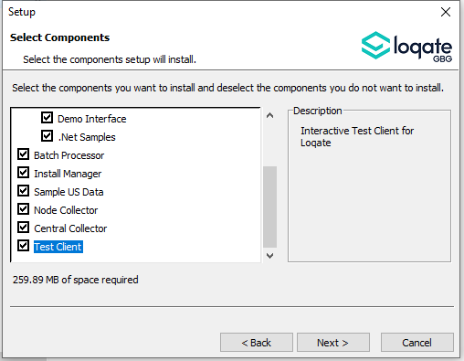
In this release, there is a new test client available. This is an interactive address testing facility for command line entry. Please note, it is not available with VS2019; we will provide updates when it becomes available with VS2019. The guide for using this test client is available on the support site here.

Local API Improvements

Server Options

The server option OutputCasing will now ignore case changes for the following: thoroughfare pre- and post-directional, and certain CASS fields, which will remain uppercase.

Certification Expiration Dates
If you have purchased either the CASS (USA) or AMAS (Australia) certified products, please be aware that the datasets have expiration dates set by the respective postal authorities. Please ensure that you have the latest library and data installed to avoid loss of service through these products.

Please check Install Manager for the latest versions of AMAS and CASS.

 | Loqate Release Date | Certification Expiry Date*
AMAS Data | 2020-05-28 | 2020-09-30
CASS Data | 2020-08-27 | 2020-11-28
*Certification Expiry Date is different from Loqate license key expiry date. The earliest expiry date will apply.

For more information on expiry date checking for CASS and AMAS, please refer “Usage expiration” section in https://support.loqate.com/documentation/local-apis/cass-overview-2/ and https://support.loqate.com/address-matching-approval-system-amas/

Country Improvement Program (PDH)
The following section will display the changes made during the country improvement program.
For more details on our Country Improvement Program, please visit the support site here.

BAHAMAS

Country Information | Description
ISO2 | BS
ISO3 | BHS
Address Format | Organization  PostBox  SubBuilding Building  Premise Thoroughfare  DependentThoroughfare  DoubleDependentLocality  DependentLocality  Locality AdministrativeArea
PDH | YES
PDH completed date | 2020Q3.1
New Source | NO

 | Pre-PDH | Post-PDH
Reference Data | rd_BS_ai.lfs  rd_BS.lfs  rd_BS_rg.lfs | rd_BS_ggg.lfs  rd_BS_ggg_rg.lfs  rd_BS_vfy_ai.lfs  rd_BS_vfy.lfs

In the 2020Q3.1 release, the AdministrativeArea field has been standardized and normalized for the Bahamas.

2020Q3.0 | 2020Q3.1
Incorrect AdministrativeArea returned.  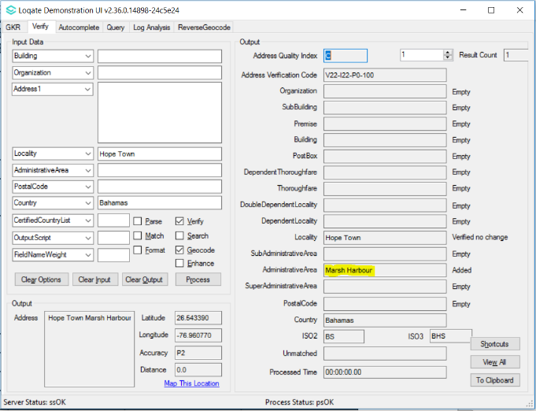 | AdministrativeArea correctly returned.  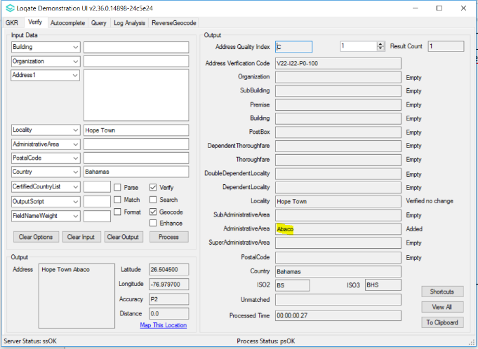

BANGLADESH

Country Information | Description
ISO2 | BD
ISO3 | BGD
Address Format | Organization  PostBox  Building SubBuilding  Thoroughfare Premise  DependentThoroughfare  DoubleDependentLocality  DependentLocality  Locality - PostalCode
PDH | YES
PDH completed date | 2020Q3.1
New Source | NO

 | Pre-PDH | Post-PDH
Reference Data | rd_BD.lfs  rd_BD_ai.lfs  rd_BD_rg.lfs | rd_BD.lfs  rd_BD_ai.lfs  rd_BD_rg.lfs  rd_BD_enh_S.lfs

With the 2020Q3.1 minor release, there are alignment improvements in the SuperAdministrativeArea and AdministrativeArea fields for Bangladesh.

2020Q3.0 | 2020Q3.1
Bangladesh has SuperAdministrativeArea.  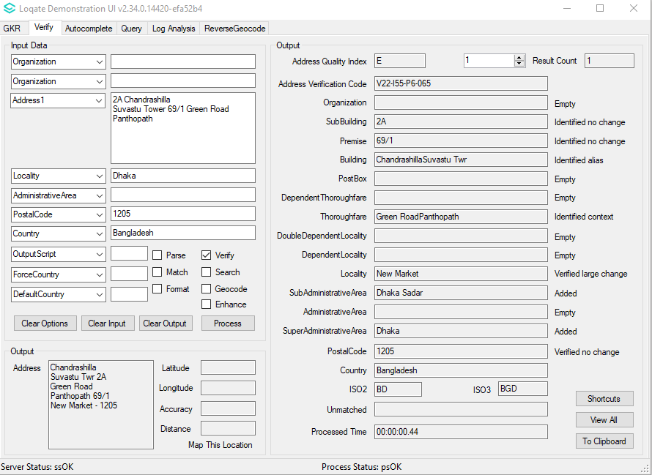 | Realigned SuperAdministrative Area to AdministrativeArea.  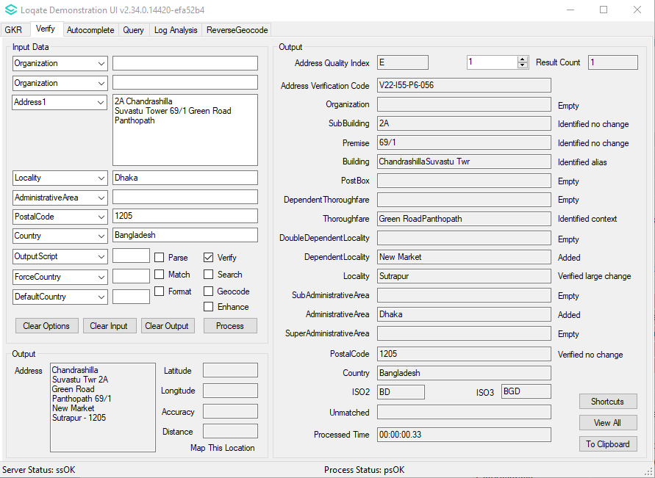

Knowledge Base & Reference Data Updates
The table below shows which countries have been updated, and how, in this release.
There were two PDH countries updated in this release: BAHAMAS AND BANGLADESH.

- Reference Data = 11 Countries
- Lexicons = 8 Countries
- Context Rules = 1 Country
- PDH = 2 countries

COUNTRY NAME | ISO CODE | CONTEXT RULES | LEXICONS | REFERENCE DATA
BAHAMAS | BS |  | X | X
BANGLADESH | BD |  | X | X
CANADA | CA |  |  | X
CZECHIA | CZ |  | X | X
EGYPT | EG |  | X | X
GERMANY | DE |  | X
GUERNSEY | GG |  |  | X
ISLE OF MAN | IM |  |  | X
JERSEY | JE |  |  | X
KOREA, REPUBLIC OF | KR | X | X | X
NORWAY | NO |  | X
SPAIN | ES |  | X | X
UNITED KINGDOM | GB |  |  | X

Installation Instructions
The 2020Q3.1 release makes improvements to the performance of the verification process and the quality of the results.

Please remember to update both the program files and the reference data. The improvements are tied to the data in the Global Knowledge Repository and the Local API. If you need any assistance with the upgrade of the Local API or the data update process, please contact GBG Loqate Support.

The setup wizard for the Local API can be obtained from our SFTP server. Please contact your account manager to retrieve the SFTP information. If you do not know who your account manager is, please contact the support team at support@loqate.com.

GBG Loqate data packs can be downloaded and installed using the Install Manager. This is a component you will need to select during the installation of the Local API as shown below.

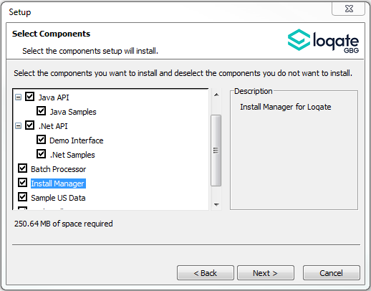

Standard GBG Loqate Installation (Multi-Threaded)
- Download the contents of the 2020Q3.1/app-installer-mt.
- Check the MD5 checksums to ensure that the download has been successful.
- Run the relevant Loqate Local API installer. Please note you may need to add execute privileges to the relevant installer when using Linux. Make sure the option “Install Manager” is selected for installation.
- Execute the Install Manager script (InstallManager.bat on Windows and InstallManager.sh on other Linux/Unix platforms) and install the data. For further details, please review the 2020Q3.1 Installation Instructions document.
- Run the relevant Global Knowledge Repository installer. Please note you may need to add execute privileges when using Linux.

Standard GBG Loqate Installation (Single-Threaded)
- Download the contents of the 2020Q3.1/app-installer-st.
- Check the MD5 checksums to ensure that the download has been successful.
- Run the relevant Loqate Local API installer. Please note you may need to add execute privileges to the relevant installer when using Linux. Make sure the option “Install Manager” is selected for installation.
- Execute the InstallManager script (InstallManager.bat on Windows and InstallManager.sh on other Linux/Unix platforms) and install the data. For further details, please review the 2020Q3.1 Installation Instructions document.
- Run the relevant Global Knowledge Repository installer. Please note you may need to add execute privileges when using Linux.

SFTP Server Contents

Please see https://support.loqate.com/release-information/2020q3-1-major-release/2020q3-1-directory-filename-updates-release-sftp/ for more information about the file contents for this release delivery.

