Loqate, A GBG Solution Release Notes
2020Q3.0 Major Release
Table of Contents
Case Resolutions 3
Install Manager Improvements 3
Md5sum 3
Local API Improvements 3
Server Option: IgnoreUnmatched 3
Alignment Improvements 3
Certification Expiration Dates 4
Country Improvement Program (PDH) 5
ANGUILLA 5
ARGENTINA 6
ARMENIA 7
NORWAY 8
Knowledge Base & Reference Data Updates 9
Installation Instructions 15
Standard GBG Loqate Installation (Multi-Threaded) 15
Standard GBG Loqate Installation (Single-Threaded) 16
SFTP Server Contents 16

Case Resolutions
Please visit http://support.loqate.com/2020q3-0-resolved-cases/ for a list of cases resolved in this release.

If you would like more details on any of the solved cases listed, please contact support@loqate.com for further information.

Install Manager Improvements

Md5sum
Install Manager version 13.0.0 makes improvements to the way the md5sum are processed. Md5sums to files (data files, certification data files, and certification library files – server version) will now be processed after the datapacks are downloaded. In previous install manager versions, both the server and local data files were created at the same time, only the timestamp will be slightly earlier compared to the local md5sum version.

Local API Improvements

Server Option: IgnoreUnmatched
When using the server option IgnoreUnmatched, in the Loqate Demonstration UI (lqtDemo.exe), users may have seen empty results. This is now resolved and IgnoreUnmatched will function as expected. Additional information on how to use this server option can be found on the support site here.

Alignment Improvements
Users may experience unexpected behavior with PO Box results when the correct postal codes were included. This is resolved and PO Box will now return the expected addresses.

Certification Expiration Dates
If you have purchased either the CASS (USA) or AMAS (Australia) certified products, please be aware that the datasets have expiration dates set by the respective postal authorities. Please ensure that you have the latest library and data installed to avoid loss of service through these products.

Please check Install Manager for the latest versions of AMAS and CASS.

 | Loqate Release Date | Certification Expiry Date*
AMAS Data | 2020-05-28 | 2020-09-30
CASS Data | 2020-06-15 | 2020-09-29
*Certification Expiry Date is different from Loqate license key expiry date. The earliest expiry date will apply.

For more information on expiry date checking for CASS and AMAS, please refer “Usage expiration” section in https://support.loqate.com/documentation/local-apis/cass-overview-2/ and https://support.loqate.com/address-matching-approval-system-amas/

Country Improvement Program (PDH)
The following section will display the changes made during the country improvement program.
For more details on our Country Improvement Program, please visit the support site here.

ANGUILLA

Country Information | Description
ISO2 | AI
ISO3 | AIA
Address Format | Organization  PostBox  SubBuilding Building  Premise Thoroughfare  DependentThoroughfare  DoubleDependentLocality  DependentLocality  Locality PostalCode
PDH | Yes
PDH Last Update Date | 2020-07
New Source | NO

The PDH process corrected alignment issues within the AdministrativeArea and Locality fields.

Users may have seen incorrect PostalCodes in the previous release; this issue is resolved in the 2020Q3.0 major release.

ARGENTINA

Country Information | Description
ISO2 | AR
ISO3 | ARG
Address Format | Organization  PostBox  Thoroughfare Premise  Building SubBuildingFloor SubBuildingType SubBuildingNumber SubBuildingExtra DoubleDependentLocality DependentLocality  PostalCodePrimary PostalCodeSecondary Locality
PDH | Yes (Refresh)
PDH Last Update Date | 2020-07
New Source | NO

 | Pre-CountryRefresh | Post-CountryRefresh
Reference Data | rd_AR_ggg.lfs  rd_AR_ggg_rg.lfs  rd_AR_ggg_r.lfs  rd_AR_vfy_ai.lfs  rd_AR_vfy.lfs | rd_AR_ggg.lfs  rd_AR_ggg_rg.lfs  rd_AR_ggg_r.lfs  rd_AR_vfy_ai.lfs  rd_AR_vfy.lfs

In the 2020QQ3.0 major release, Ciudad Autónoma de Buenos Aires AdministrativeArea now contains only the Locality - Ciudad Autónoma Buenos Aires. This release also makes corrections to the alignment in which the previous Dependent Localities under Comuna SubAdministrativeArea are now under it.

2020Q2.1 | 2020Q3.0
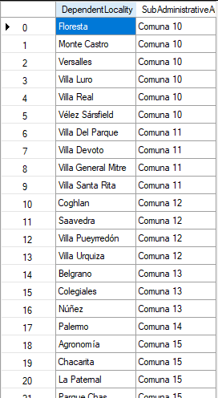  Ciudad Autónoma de Buenos Aires AdministrativeArea consists of Dependent Localities that were listed in a set of Comuna SubAdministrativeArea. | 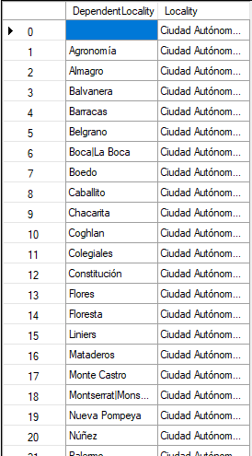  Ciudad Autónoma de Buenos Aires AdministrativeArea now contains only Locality - Ciudad Autónoma Buenos Aires, and the previous Dependent Localities under Comuna SubAdministrativeArea are now under it.

ARMENIA

Country Information | Description
ISO2 | AM
ISO3 | ARM
Address Format | Organization  PostBox  SubBuilding Building  Premise Thoroughfare  DependentThoroughfare  DoubleDependentLocality  DependentLocality  PostalCode Locality
PDH | Yes
PDH completed date | 2020-07
New Source | NO

 | Pre-PDH | Post-PDH
Reference Data | rd_AM_ai.lfs  rd_AM.lfs  rd_AM_rg.lfs | rd_AM_ggg.lfs  rd_AM_ggg_rg.lfs  rd_AM_vfy_ai.lfs  rd_AM_vfy.lfs

The PDH process made improvements to the English transliteration alias within the thoroughfare field.

2020Q2.1 | 2020Q3.0
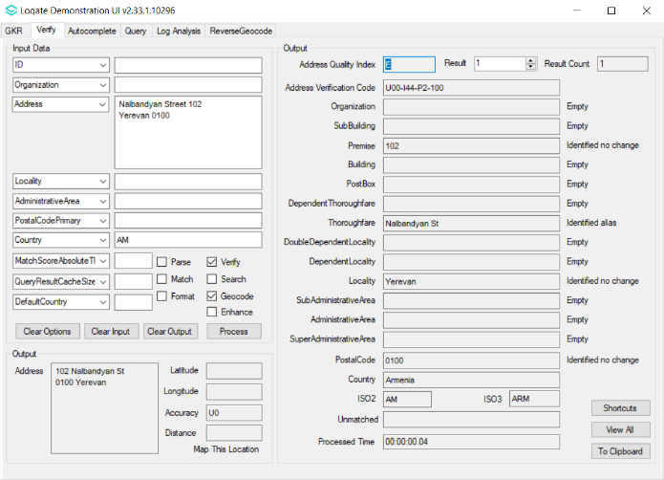  Input thoroughfare with English thoroughfare type (Street) identified. | 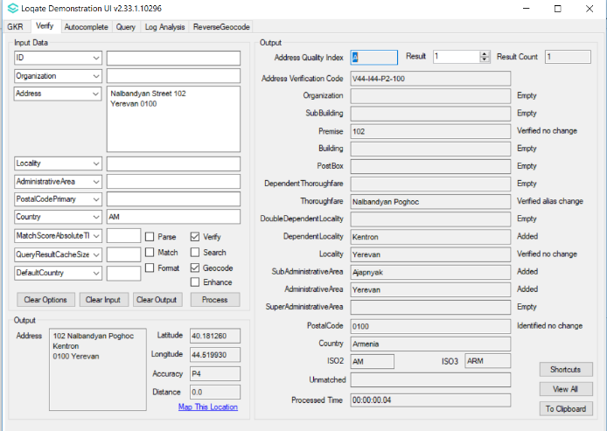  Input thoroughfare with English thoroughfare type verified alias change as the thoroughfare with transliterated thoroughfare type (Poghoc).

NORWAY

In 2020Q3.0 release, PDH made changes to the AdministrativeArea and SubAdministrativeArea fields.

Due to changes made by Norwegian authorities that were effective from January 2020, the following changes are now available in the Norway PDH data.

Examples of AdministrativeArea that merged include:
- Aust-Agder and Vest-Agder has combined together and become Agder
- Vestfold and Telemark has combine and become Vestfold Og Telemark
- Nord-Trondelag and Sor-Trondelag has combined and become Trondelag

Examples of SubAdministrativeArea that merged include:
- Jondal and Odda has becoming part of Ullensvang in Administrative Area of Vestland
- Svelvik in Administrative Area of Vestfold Og Telemark has merged with Drammen in Viken
- Forde, Gaular, Jolster and Nautsdal have combined together and formed a new Sub Administrative Area named Sunnfjord located in Vestland

Knowledge Base & Reference Data Updates
The table below shows which countries have been updated, and how, in this release.
If there is a PDH in the reference data column, this shows a country was included in the country improvement project.

- Reference Data = 154 Countries
- Lexicons = 27 Countries
- Context Rules = 2 Countries
- PDH = 2 Countries

COUNTRY NAME | ISO CODE | CONTEXT RULES | LEXICONS | REFERENCE DATA
AFGHANISTAN | AF |  |  | X
ÅLAND ISLANDS | AX
ALBANIA | AL |  |  | X
ALGERIA | DZ |  |  | X
AMERICAN SAMOA | AS |  |  | X
ANDORRA | AD
ANGOLA | AO
ANGUILLA | AI |  | X | PDH
ANTARCTICA | AQ
ANTIGUA AND BARBUDA | AG |  | X | X
ARGENTINA | AR |  | X | X
ARMENIA | AM |  | X | PDH
ARUBA | AW
AUSTRALIA | AU
AUSTRIA | AT
AZERBAIJAN | AZ |  |  | X
BAHAMAS | BS |  |  | X
BAHRAIN | BH
BANGLADESH | BD |  |  | X
BARBADOS | BB
BELARUS | BY
BELGIUM | BE
BELIZE | BZ |  |  | X
BENIN | BJ |  |  | X
BERMUDA | BM |  |  | X
BHUTAN | BT |  |  | X
BOLIVIA (PLURINATIONAL STATE OF) | BO | X | X
BONAIRE, SINT EUSTATIUS AND SABA | BQ
BOSNIA AND HERZEGOVINA | BA |  |  | X
BOTSWANA | BW
BOUVET ISLAND | BV
BRAZIL | BR
BRITISH INDIAN OCEAN TERRITORY | IO |  |  | X
BRUNEI DARUSSALAM | BN |  |  | X
BULGARIA | BG
BURKINA FASO | BF |  |  | X
BURUNDI | BI
CABO VERDE | CV |  |  | X
CAMBODIA | KH |  |  | X
CAMEROON | CM |  |  | X
CANADA | CA |  |  | X
CAYMAN ISLANDS | KY
CENTRAL AFRICAN REPUBLIC | CF |  |  | X
CHAD | TD |  |  | X
CHILE | CL
CHINA | CN |  |  | X
CHRISTMAS ISLAND | CX |  |  | X
COCOS (KEELING) ISLANDS | CC |  |  | X
COLOMBIA | CO
COMOROS | KM |  |  | X
CONGO | CG |  |  | X
CONGO, DEMOCRATIC REPUBLIC OF THE | CD |  |  | X
COOK ISLANDS | CK |  |  | X
COSTA RICA | CR |  |  | X
CÔTE D'IVOIRE | CI |  |  | X
CROATIA | HR |  |  | X
CUBA | CU |  |  | X
CURAÇAO | CW |  |  | X
CYPRUS | CY |  |  | X
CZECHIA | CZ
DENMARK | DK
DJIBOUTI | DJ |  |  | X
DOMINICA | DM |  | X | X
DOMINICAN REPUBLIC | DO |  |  | X
ECUADOR | EC
EGYPT | EG
EL SALVADOR | SV
EQUATORIAL GUINEA | GQ |  | X
ERITREA | ER |  | X | X
ESTONIA | EE |  |  | X
ETHIOPIA | ET |  |  | X
FALKLAND ISLANDS (MALVINAS) | FK |  |  | X
FAROE ISLANDS | FO |  |  | X
FIJI | FJ |  |  | X
FINLAND | FI
FRANCE | FR |  | X
FRENCH GUIANA | GF |  |  | X
FRENCH POLYNESIA | PF
FRENCH SOUTHERN TERRITORIES | TF |  | X | X
GABON | GA |  |  | X
GAMBIA | GM |  | X | X
GEORGIA | GE
GERMANY | DE |  | X | X
GHANA | GH |  |  | X
GIBRALTAR | GI |  |  | X
GREECE | GR
GREENLAND | GL |  |  | X
GRENADA | GD |  | X
GUADELOUPE | GP
GUAM | GU |  |  | X
GUATEMALA | GT |  |  | X
GUERNSEY | GG |  |  | X
GUINEA | GN |  |  | X
GUINEA-BISSAU | GW |  |  | X
GUYANA | GY
HAITI | HT
HEARD ISLAND AND MCDONALD ISLANDS | HM
HONDURAS | HN
HONG KONG | HK
HUNGARY | HU
ICELAND | IS
INDIA | IN
INDONESIA | ID
IRAN | IR |  |  | X
IRAQ | IQ |  |  | X
IRELAND | IE
ISLE OF MAN | IM |  |  | X
ISRAEL | IL |  | X
ITALY | IT
JAMAICA | JM
JAPAN | JP
JERSEY | JE |  |  | X
JORDAN | JO |  |  | X
KAZAKHSTAN | KZ
KENYA | KE |  |  | X
KIRIBATI | KI |  | X | X
KOREA (DEMOCRATIC PEOPLE'S REPUBLIC OF) | KP |  |  | X
KOREA, REPUBLIC OF | KR
KUWAIT | KW |  |  | X
KYRGYZSTAN | KG |  |  | X
LAO PEOPLE'S DEMOCRATIC REPUBLIC | LA |  |  | X
LATVIA | LV
LEBANON | LB |  |  | X
LESOTHO | LS |  |  | X
LIBERIA | LR |  |  | X
LIBYA | LY |  |  | X
LIECHTENSTEIN | LI
LITHUANIA | LT
LUXEMBOURG | LU
MACAO | MO
MADAGASCAR | MG |  |  | X
MALAWI | MW |  | X
MALAYSIA | MY
MALDIVES | MV |  |  | X
MALI | ML |  |  | X
MALTA | MT |  |  | X
MARSHALL ISLANDS | MH |  |  | X
MARTINIQUE | MQ |  |  | X
MAURITANIA | MR |  |  | X
MAURITIUS | MU |  |  | X
MAYOTTE | YT |  |  | X
MEXICO | MX
MICRONESIA (FEDERATED STATES OF) | FM |  |  | X
MOLDOVA, REPUBLIC OF | MD |  |  | X
MONACO | MC |  |  | X
MONGOLIA | MN |  |  | X
MONTENEGRO | ME |  |  | X
MONTSERRAT | MS |  | X | X
MOROCCO | MA |  |  | X
MOZAMBIQUE | MZ
MYANMAR | MM |  |  | X
NAMIBIA | NA |  |  | X
NAURU | NR |  | X | X
NEPAL | NP |  |  | X
NETHERLANDS | NL
NEW CALEDONIA | NC |  |  | X
NEW ZEALAND | NZ
NICARAGUA | NI
NIGER | NE |  |  | X
NIGERIA | NG
NIUE | NU |  | X | X
NORFOLK ISLAND | NF |  |  | X
NORTH MACEDONIA | MK |  |  | X
NORTHERN MARIANA ISLANDS | MP |  |  | X
NORWAY | NO |  | X | X
OMAN | OM |  |  | X
PAKISTAN | PK |  |  | X
PALAU | PW |  |  | X
PALESTINE, STATE OF | PS |  | X
PANAMA | PA
PAPUA NEW GUINEA | PG |  |  | X
PARAGUAY | PY
PERU | PE | X | X | X
PHILIPPINES | PH
PITCAIRN | PN |  |  | X
POLAND | PL
PORTUGAL | PT
PUERTO RICO | PR |  |  | X
QATAR | QA
RÉUNION | RE |  |  | X
ROMANIA | RO |  |  | X
RUSSIAN FEDERATION | RU |  |  | X
RWANDA | RW |  |  | X
SAINT BARTHÉLEMY | BL
SAINT HELENA, ASCENSION AND TRISTAN DA CUNHA | SH |  |  | X
SAINT KITTS AND NEVIS | KN |  |  | X
SAINT LUCIA | LC
SAINT MARTIN (FRENCH PART) | MF |  |  | X
SAINT PIERRE AND MIQUELON | PM |  |  | X
SAINT VINCENT AND THE GRENADINES | VC |  |  | X
SAMOA | WS |  |  | X
SAN MARINO | SM
SAO TOME AND PRINCIPE | ST |  |  | X
SAUDI ARABIA | SA
SENEGAL | SN |  |  | X
SERBIA | RS
SEYCHELLES | SC |  |  | X
SIERRA LEONE | SL |  |  | X
SINGAPORE | SG
SINT MAARTEN (DUTCH PART) | SX
SLOVAKIA | SK
SLOVENIA | SI
SOLOMON ISLANDS | SB |  |  | X
SOMALIA | SO |  |  | X
SOUTH AFRICA | ZA
SOUTH GEORGIA AND THE SOUTH SANDWICH ISLANDS | GS |  |  | X
SOUTH SUDAN | SS |  |  | X
SPAIN | ES |  | X
SRI LANKA | LK |  |  | X
SUDAN | SD |  |  | X
SURINAME | SR |  |  | X
SVALBARD AND JAN MAYEN | SJ |  | X
SWAZILAND | SZ |  |  | X
SWEDEN | SE
SWITZERLAND | CH
SYRIAN ARAB REPUBLIC | SY |  |  | X
TAIWAN | TW
TAJIKISTAN | TJ |  |  | X
TANZANIA, UNITED REPUBLIC OF | TZ |  |  | X
THAILAND | TH
TIMOR-LESTE | TL |  |  | X
TOGO | TG |  |  | X
TOKELAU | TK |  | X | X
TONGA | TO |  |  | X
TRINIDAD AND TOBAGO | TT |  |  | X
TUNISIA | TN |  |  | X
TURKEY | TR
TURKMENISTAN | TM |  |  | X
TURKS AND CAICOS ISLANDS | TC |  |  | X
TUVALU | TV |  | X | X
UGANDA | UG
UKRAINE | UA
UNITED ARAB EMIRATES | AE
UNITED KINGDOM | GB |  |  | X
UNITED STATES MINOR OUTLYING ISLANDS | UM |  |  | X
UNITED STATES OF AMERICA | US |  | X | X
URUGUAY | UY
UZBEKISTAN | UZ |  |  | X
VANUATU | VU |  |  | X
VATICAN CITY | VA
VENEZUELA (BOLIVARIAN REPUBLIC OF) | VE
VIET NAM | VN
VIRGIN ISLANDS (BRITISH) | VG |  |  | X
VIRGIN ISLANDS (U.S.) | VI |  |  | X
WALLIS AND FUTUNA | WF |  |  | X
WESTERN SAHARA | EH
YEMEN | YE |  |  | X
ZAMBIA | ZM |  |  | X
ZIMBABWE | ZW |  |  | X

Installation Instructions
The 2020Q3.0 release makes improvements to the performance of the verification process and the quality of the results.

Please remember to update both the program files and the reference data. The improvements are tied to the data in the Global Knowledge Repository and the Local API. If you need any assistance with the upgrade of the Local API or the data update process, please contact GBG Loqate Support.

The setup wizard for the Local API can be obtained from our SFTP server. Please contact your account manager to retrieve the SFTP information. If you do not know who your account manager is, please contact the support team at support@loqate.com.

GBG Loqate data packs can be downloaded and installed using the Install Manager. This is a component you will need to select during the installation of the Local API as shown below.

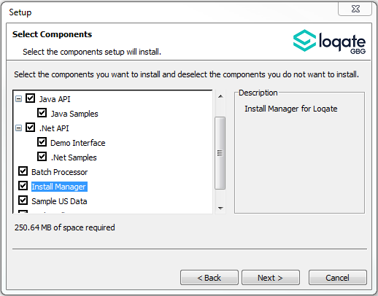

Standard GBG Loqate Installation (Multi-Threaded)
- Download the contents of the 2020Q3.0/app-installer-mt.
- Check the MD5 checksums to ensure that the download has been successful.
- Run the relevant Loqate Local API installer. Please note you may need to add execute privileges to the relevant installer when using Linux. Make sure the option “Install Manager” is selected for installation.
- Execute the Install Manager script (InstallManager.bat on Windows and InstallManager.sh on other Linux/Unix platforms) and install the data. For further details, please review the 2020Q3.0 Installation Instructions document.
- Run the relevant Global Knowledge Repository installer. Please note you may need to add execute privileges when using Linux.

Standard GBG Loqate Installation (Single-Threaded)
- Download the contents of the 2020Q3.0/app-installer-st.
- Check the MD5 checksums to ensure that the download has been successful.
- Run the relevant Loqate Local API installer. Please note you may need to add execute privileges to the relevant installer when using Linux. Make sure the option “Install Manager” is selected for installation.
- Execute the InstallManager script (InstallManager.bat on Windows and InstallManager.sh on other Linux/Unix platforms) and install the data. For further details, please review the 2020Q3.0 Installation Instructions document.
- Run the relevant Global Knowledge Repository installer. Please note you may need to add execute privileges when using Linux.

SFTP Server Contents

Please see https://support.loqate.com/release-information/2020q3-0-major-release/2020q3-0-directory-filename-updates-release-sftp/ for more information about the file contents for this release delivery.

