Loqate, A GBG Solution Release Notes
2020Q2.0 Major Release
Table of Contents
Case Resolutions 3
Install Manager Improvements 3
Install Manager Update 3
OS Logging 3
Download URL 3
Directory and File Renaming 4
Local API Improvements 4
Typo Handling Improvement 4
Certification Expiration Dates 5
Country Improvement Program (PDH) 6
Current Countries Completed PDH 6
Ukraine 8
Russia 10
Slovenia 12
Knowledge Base & Reference Data Updates 14
Installation Instructions 20
Standard GBG Loqate Installation (Multi-Threaded) 20
Standard GBG Loqate Installation (Single-Threaded) 21
SFTP Server Contents 21

Case Resolutions
Please visit http://support.loqate.com/2020q2-0-resolved-cases/ for a list of cases resolved in this release.

If you would like more details on any of the solved cases listed, please contact support@loqate.com for further information.

Install Manager Improvements

Install Manager Update

A new version of Install Manager will be available in this release, version 12.0.0. In this version, md5 hash files are now available for certification products (CASS, AMAS, and SERP). These are written to txt files following the download and installation. Certification datapacks (*.lfz) will be written to datapacks_* file under the download folder.

Starting with the 2020Q2.0 release, the data folder will include two new files for the md5sum hash values for certifications:

- certification_server_md5<timestamp>.txt
- certification_local_md5<timestamp>.txt
IMPORTANT NOTE: Loqate recommends to backup current data and install the new data to a new folder using the license key to download the data through Install Manager. This will help ensure users are using the latest files from the 2020Q2.0 release.

OS Logging
With this release, Loqate will be making a change to the information being logged when a request is made to the Install Manager web service for new datapacks. In addition to the license key and datapack list, Loqate will now collect the OS and version of the requesting client. This data is being collected so that Loqate can continue to provide support for the latest and most relevant platforms.

Download URL
The download URL button will not be included with Install Manager version 12.0.0. Users can still request this feature through the support team if required. Please email support at support@loqate.com and provide the OS version when requesting the Download URLs.

Directory and File Renaming

The directory and file names are being updated in order to provide clarity on the installers and binaries that are required for installation. With this release, the new structure can be found in /2020Q2.0-NewStructure. From 2020Q3.0 onwards, this structure will be used in place of the existing one.

For more information about this change, along with a side-by-side map of old and new file names, please visit: https://support.loqate.com/sftp-api-filename-updates/.

Due to this change, the SFTP Contents section, below, has been removed for this release.

Local API Improvements

Typo Handling Improvement

The matching engine has made some improvements around typo handling. Customers may see improvements with typo handling in New Zealand and France. See Fig. 1 below for examples.

Fig. 1

2020Q1.1 | 2020Q2.0
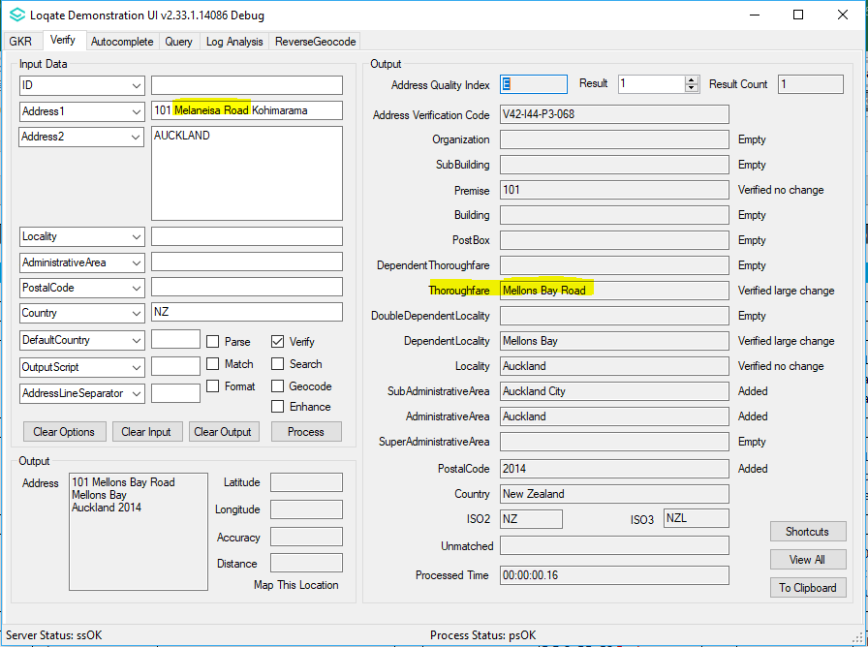  2020Q1.1: Sample case for New Zealand. Thoroughfare  "Melaneisa Road" was changed to "Mellaons Bar Road" | 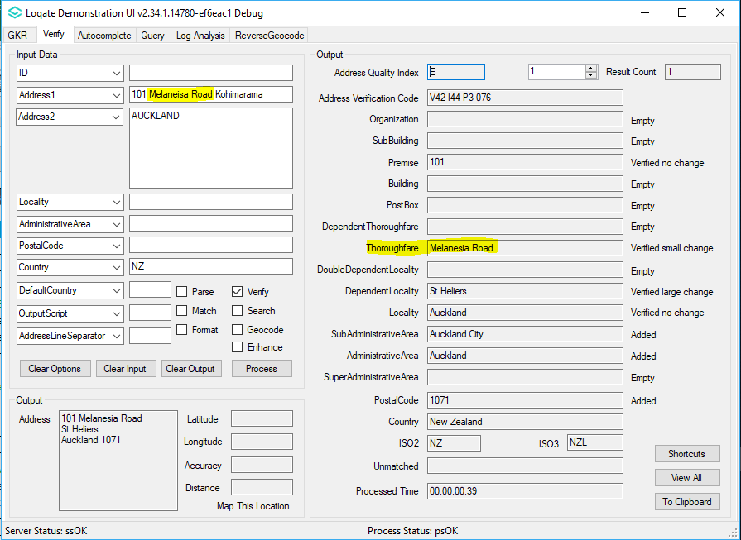  2020Q2.0: Sample case for New Zealand. Thoroughfare  "Melaneisa Road" has been fixed as "Melanesia Road"
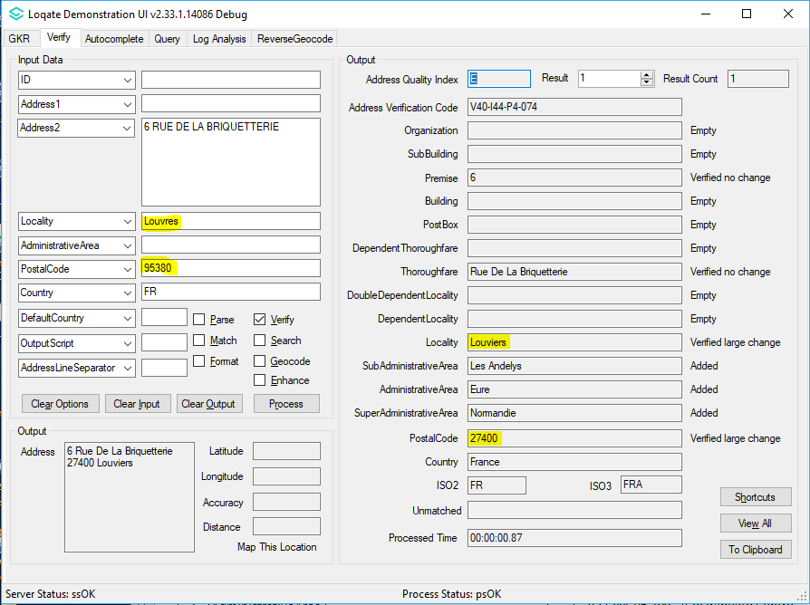  2020Q1.1: Sample case for France. Locality "Louvres" and PostalCode "95380" were changed to "Louviers" and "27400" | 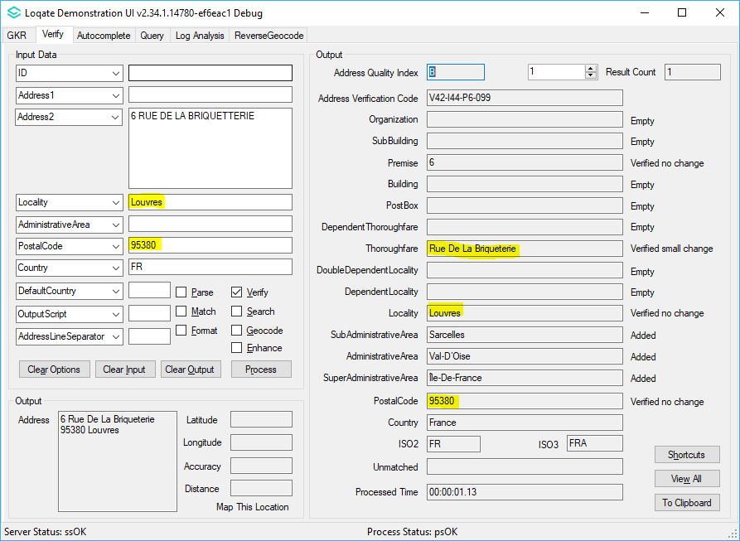  2020Q2.0: Sample case for France. "RUE DE LA BRIQUETTERIE" has been fixed as "Rue De La Briqueterie", as such, Locality and PostalCode are verified

Certification Expiration Dates
If you have purchased either the CASS (USA) or AMAS (Australia) certified products, please be aware that the datasets have expiration dates set by the respective postal authorities. Please ensure that you have the latest library and data installed to avoid loss of service through these products.

Please check Install Manager for the latest versions of AMAS and CASS.
 | Loqate Release Date | Certification Expiry Date*
AMAS Data | 2020-02-06 | 2020-06-30
CASS Data | 2020-04-15 | 2020-07-29
*Certification Expiry Date is different from Loqate license key expiry date. The earliest expiry date will apply.

For more information on expiry date checking for CASS and AMAS, please refer “Usage expiration” section in https://support.loqate.com/documentation/local-apis/cass-overview-2/ and https://support.loqate.com/address-matching-approval-system-amas/

Country Improvement Program (PDH)
The following section will display the changes made during the country improvement program. For this quarter, we have released improved datasets for the countries: Russia, Ukraine, and Slovenia.

For more details on our Country Improvement Program, please visit the support site here.

Current Countries Completed PDH

COUNTRY | DATE PDH COMPLETED | VERIFICATION LEVEL
RUSSIA | 2020-04 | L4
UKRAINE | 2020-04 | L4+
SLOVENIA | 2020-04 | L4+
IRELAND | 2020-02 | L4
SLOVAKIA | 2020-02 | L4
ANGOLA | 2020-02 | L3
ISRAEL | 2019-11 | L4
BELGIUM | 2019-10 | L4+
GREECE | 2019-10 | L4
INDIA | 2019-10 | L4
TURKEY | 2019-10 | L4
ARGENTINA | 2019-07 | L4
COLOMBIA | 2019-07 | L4
ITALY | 2019-07 | L4
THAILAND | 2019-07 | L4
PERU | 2019-07 | L4
SAN MARINO | 2019-07 | L4
HAITI | 2019-07 | L3-
NICARAGUA | 2019-07 | L3-
QATAR | 2019-07 | L4
UNITED ARAB EMIRATES | 2019-07 | L4
KOREA, REPUBLIC OF | 2019-04 | L4
PORTUGAL | 2019-04 | L4
SPAIN | 2019-04 | L4
MALAYSIA | 2019-04 | L4
PHILIPPINES | 2019-04 | L4
URUGUAY | 2019-04 | L4
ISLE OF MAN | 2019-04 | L5
GUERNSEY | 2019-04 | L5
JERSEY | 2019-04 | L5
LITHUANIA | 2019-04 | L4
SINGAPORE | 2018-10 | L4
SOUTH AFRICA | 2018-10 | L4
AUSTRIA | 2018-10 | L4
COUNTRY | Date PDH Completed | Verification Level
BRAZIL | 2018-07 | L4
MEXICO | 2018-07 | L4
CZECH REPUBLIC | 2018-04 | L4
UNITED STATES | 2018-01 | L5
JAPAN | 2018-01 | L4
DENMARK | 2018-01 | L5
NORWAY | 2018-01 | L4
GERMANY | 2017-11 | L4
NETHERLANDS | 2017-10 | L4
NEW ZEALAND | 2017-10 | L5
FRENCH POLYNESIA | 2017-10 | L3
FRANCE | 2017-07 | L4
SWEDEN | 2017-07 | L4
CANADA | 2017-04 | L5
AUSTRALIA | 2017-04 | L5
SWITZERLAND | 2017-01 | L4
FINLAND | 2017-01 | L4
EGYPT | 2017-01 | L4
ANDORRA | 2017-01 | L4
ECUADOR | 2017-01 | L4

Ukraine

Country Information | Description
ISO2 | UA
ISO3 | UKR
Address Format | Organization  PostBox  Building  Thoroughfare Premise  SubBuilding  DependentThoroughfare  DoubleDependentLocality  DependentLocality Locality  AdministrativeArea  PostalCode
PDH | YES
PDH completed date | 2020-04
New Source | NO

 | Pre-PDH | Post-PDH
Reference Data | rd_UA.lfs  rd_UA_ai.lfs  rd_UA_geop.lfs  rd_UA_geop_r.lfs  rd_UA_geop_rg.lfs  rd_UA_r.lfs  rd_UA_rg.lfs | rd_UA_ggg.lfs  rd_UA_ggg_rg.lfs  rd_UA_ggg_r.lfs  rd_UA_vfy_ai.lfs  rd_UA_vfy.lfs

2020Q1.1 | 2020Q2.0
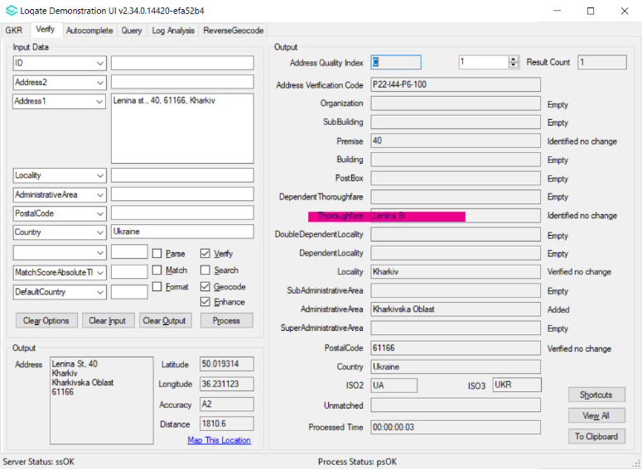  Thoroughfare is only identified no change | 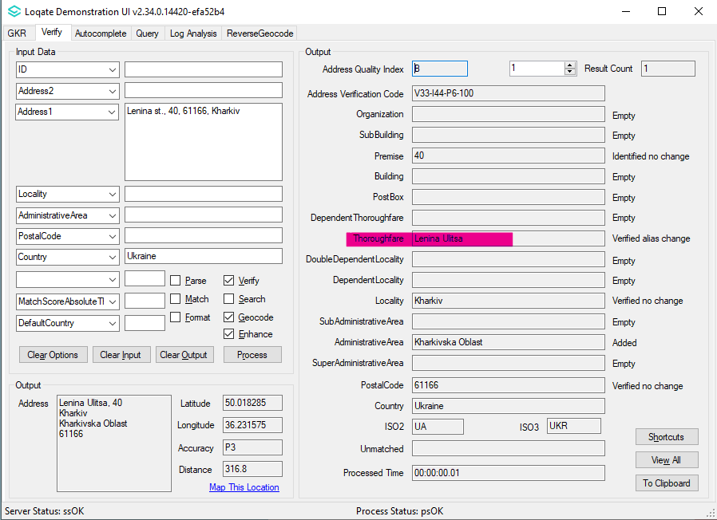  Thoroughfare has become verified alias change
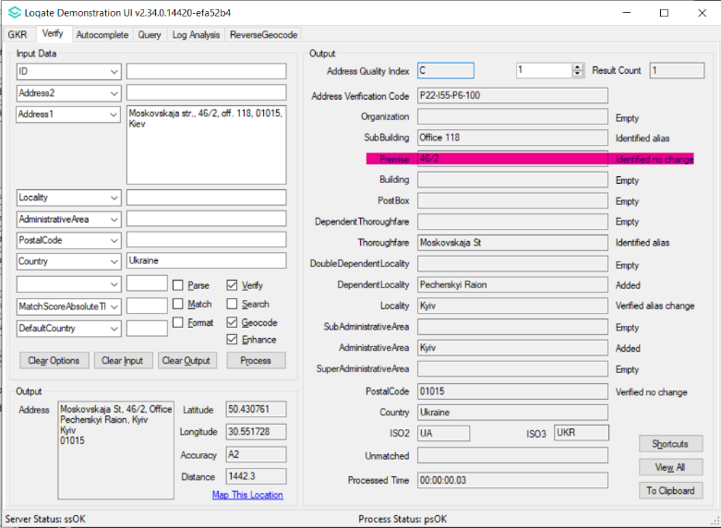  Premise Number doesn't exist in Reference Data | 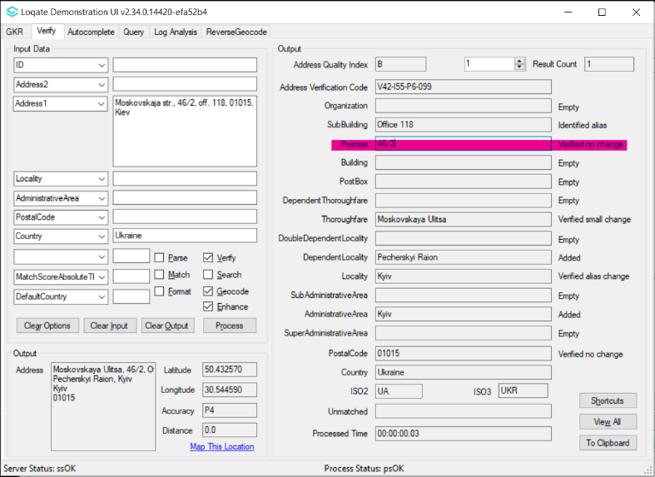  Premise Number exist in Reference Data which make the address become verified until Level 4

Russia

Country Information | Description
ISO2 | RU
ISO3 | RUS
Address Format | Organization  PostBox  Building  Thoroughfare Premise SubBuilding  DependentThoroughfare  DoubleDependentLocality  DependentLocality  Locality  AdministrativeArea  PostalCode
PDH | YES
PDH completed date | 2020Q2.0
New Source

 | Pre-PDH | Post-PDH
Reference Data | rd_RU_geo.lfs  rd_RU_geop.lfs  rd_RU_geop_r1.lfs  rd_RU_geop_rg.lfs  rd_RU_geop_r.lfs  rd_RU_geo_rg.lfs  rd_RU_geo_r.lfs  rd_RU_vfy_ai.lfs  rd_RU_vfy.lfs | rd_RU_ggg.lfs  rd_RU_ggg_r1.lfs  rd_RU_ggg_r2.lfs  rd_RU_ggg_rg.lfs  rd_RU_ggg_r.lfs  rd_RU_vfy_ai.lfs  rd_RU_vfy.lfs

Russia: When comparing to 2020Q1.1, there is an overall uplift of ~15% to 19%

2020Q1.1 | 2020Q2.0
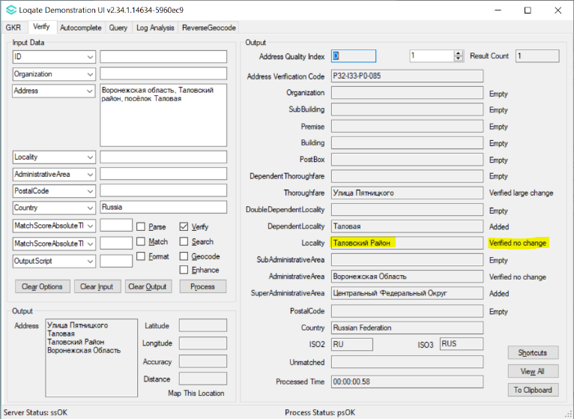  2020Q1.1 - District is at Locality level. | 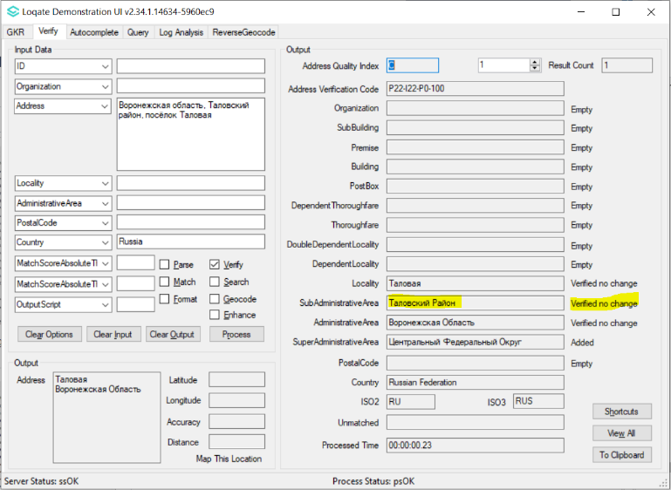  2020Q2.0 - District is re-aligned to SubAdministrativeArea level.
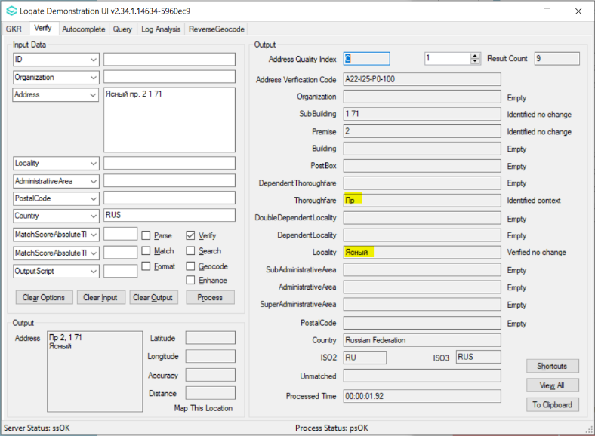  2020Q1.1 - Thoroughfare incorrectly parsed to Locality. | 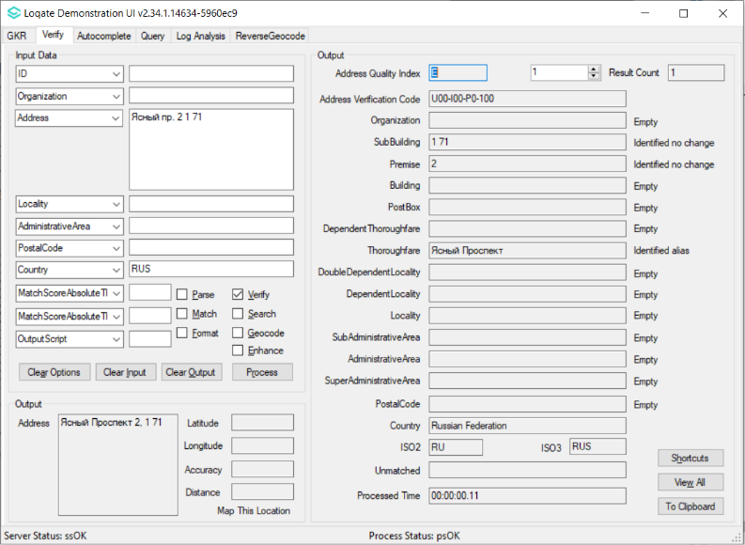  2020Q2.0 - Thoroughfare correctly parsed.
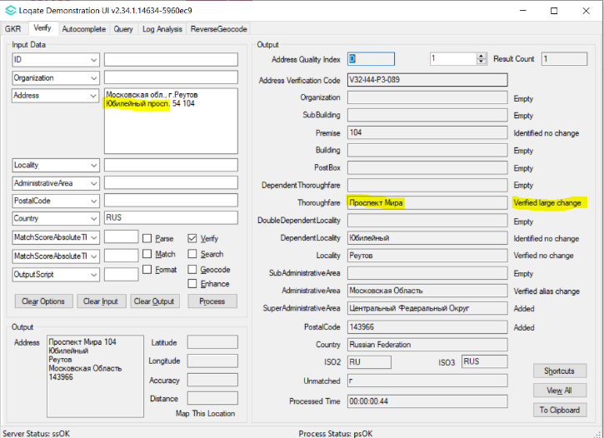  2020Q1.1 - Incorrectly verified to other thoroughfare | 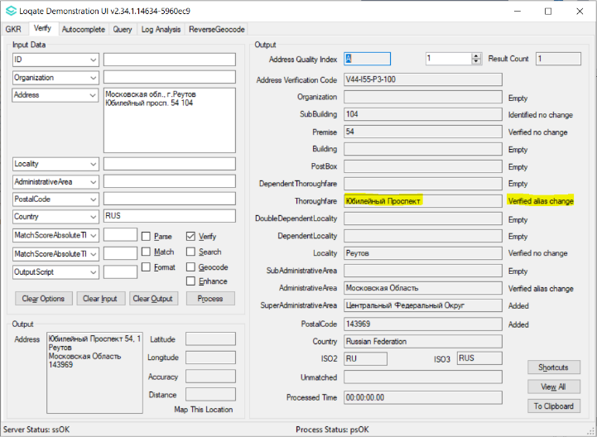  2020Q2.0 - Thoroughfare correctly verified. (More thoroughfare aliases covered)

With the 2020Q2.0 release, Russia performance has increased by ~14%. Overall, around 80% of the addresses data has changed due to the re-alignment of Locality and DependentLocality (to SubAdministrativeArea).

Below are additional changes to Russia processing, based on Loqate test data:
The status match and status parse refer to whether the address has been Verified, Corrected, Parsed or Not Matched. The rescode value references if a search was successful.

Russia (Native) changes:
- The match to thoroughfare level increased by ~12%
- The match to locality level decreased by ~3%. These changes are due to re-alignment.
- The status match increased by ~14%.
- The status parse increased by ~3%

Additional improvements to Russia data:
- Improvements have been made to the primary name selection in the data field.
- Improvements on Saint Petersburg data where incomplete city district level is now corrected and complete at DependentLocality level.
- Alignment corrections have been made at SubAdministrativeArea level (Districts).

Slovenia

Country Information | Description
ISO2 | SI
ISO3 | SVN
Address Format | Building SubBuilding Organization  PostBox  Thoroughfare Premise  DependentThoroughfare  DoubleDependentLocality  DependentLocality  PostalCode Locality
PDH | YES
PDH completed date | 2020-04
New Source | NO

 | Pre-PDH | Post-PDH
Reference Data | rd_SI.lfs  rd_SI_ai.lfs  rd_SI_rg.lfs  rd_SI_geop.lfs  rd_SI_geop_rg.lfs | rd_SI_ggg.lfs  rd_SI_ggg_rg.lfs  rd_SI_vfy_ai.lfs  rd_SI_vfy.lfs

2020Q1.1 | 2020Q2.0
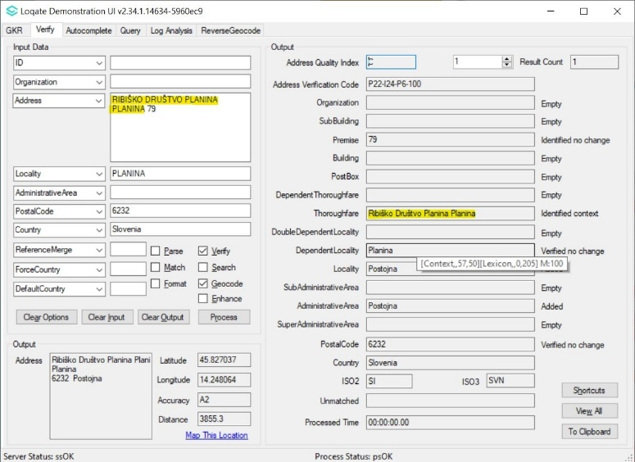  2020Q1.1 - 'RIBISKO DRUSTVO PLANINA' which is an Organization is wrongly combined and parsed into Thoroughfare field. | 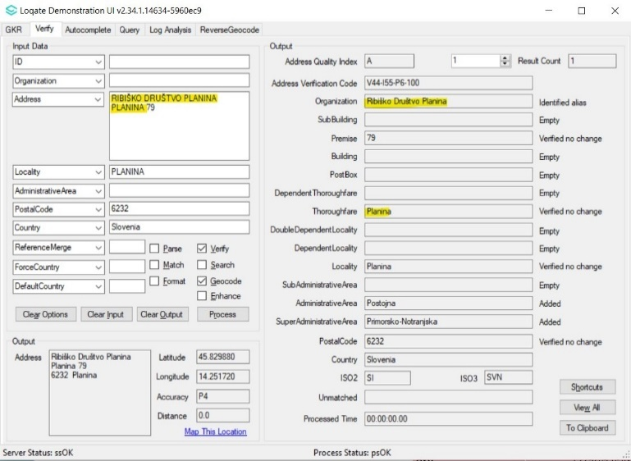  2020Q2.0 - 'RIBISKO DRUSTVO PLANINA' is correctly parsed into Organization field and Thoroughfare is verified.
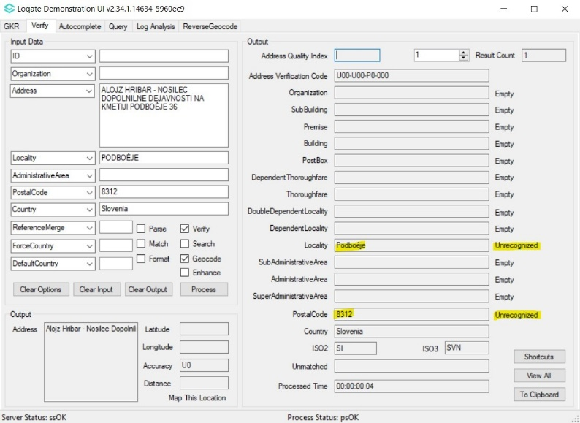  2020Q1.1 - Locality and PostalCode are unrecognized | 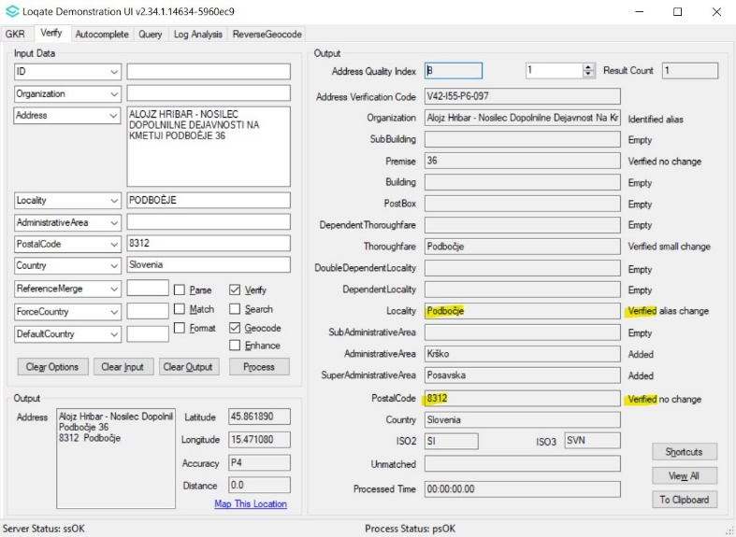  2020Q2.0 - Locality and PostalCode are verified

Knowledge Base & Reference Data Updates
The table below shows which countries have been updated, and how, in this release.
If there is a PDH in the reference data column, this shows a country was included in the country improvement project.

- Reference Data = 180
- Lexicons = 15
- Context Rules = 2
- New PDH Countries = 3 (Russia, Slovenia, Ukraine)

COUNTRY NAME | ISO CODE | CONTEXT RULES | LEXICONS | REFERENCE DATA
ANDORRA | AD
UNITED ARAB EMIRATES | AE
AFGHANISTAN | AF |  |  | X
ANTIGUA AND BARBUDA | AG |  |  | X
ANGUILLA | AI |  |  | X
ALBANIA | AL |  |  | X
ARMENIA | AM |  |  | X
ANGOLA | AO
ANTARCTICA | AQ
ARGENTINA | AR |  | X
AMERICAN SAMOA | AS |  |  | X
AUSTRIA | AT |  | X | X
AUSTRALIA | AU |  | X | X
ARUBA | AW |  |  | X
ÅLAND ISLANDS | AX |  |  | X
AZERBAIJAN | AZ |  |  | X
BOSNIA AND HERZEGOVINA | BA |  |  | X
BARBADOS | BB |  |  | X
BANGLADESH | BD |  |  | X
BELGIUM | BE
BURKINA FASO | BF |  |  | X
BULGARIA | BG
BAHRAIN | BH
BURUNDI | BI
BENIN | BJ |  |  | X
SAINT BARTHÉLEMY | BL |  |  | X
BERMUDA | BM |  |  | X
BRUNEI DARUSSALAM | BN |  |  | X
BOLIVIA (PLURINATIONAL STATE OF) | BO |  |  | X
BONAIRE, SINT EUSTATIUS AND SABA | BQ |  |  | X
BRAZIL | BR
BAHAMAS | BS |  |  | X
BHUTAN | BT |  |  | X
BOUVET ISLAND | BV
BOTSWANA | BW
BELARUS | BY
BELIZE | BZ |  |  | X
CANADA | CA |  | X | X
COCOS (KEELING) ISLANDS | CC |  |  | X
CONGO, DEMOCRATIC REPUBLIC OF THE | CD |  |  | X
CENTRAL AFRICAN REPUBLIC | CF |  |  | X
CONGO | CG |  |  | X
SWITZERLAND | CH
CÔTE D'IVOIRE | CI |  |  | X
COOK ISLANDS | CK |  |  | X
CHILE | CL
CAMEROON | CM |  |  | X
CHINA | CN |  |  | X
COLOMBIA | CO
COSTA RICA | CR |  |  | X
CUBA | CU |  |  | X
CABO VERDE | CV |  |  | X
CURAÇAO | CW |  |  | X
CHRISTMAS ISLAND | CX |  |  | X
CYPRUS | CY |  |  | X
CZECHIA | CZ
GERMANY | DE |  | X | X
DJIBOUTI | DJ |  |  | X
DENMARK | DK |  |  | X
DOMINICA | DM |  |  | X
DOMINICAN REPUBLIC | DO |  |  | X
ALGERIA | DZ |  |  | X
ECUADOR | EC
ESTONIA | EE |  |  | X
EGYPT | EG
WESTERN SAHARA | EH |  |  | X
ERITREA | ER |  |  | X
SPAIN | ES
ETHIOPIA | ET |  |  | X
FINLAND | FI
FIJI | FJ |  |  | X
FALKLAND ISLANDS (MALVINAS) | FK |  |  | X
MICRONESIA (FEDERATED STATES OF) | FM |  |  | X
FAROE ISLANDS | FO |  |  | X
FRANCE | FR |  | X | X
GABON | GA |  |  | X
UNITED KINGDOM | GB |  |  | X
GRENADA | GD |  |  | X
GEORGIA | GE
FRENCH GUIANA | GF |  |  | X
GUERNSEY | GG
GHANA | GH |  |  | X
GIBRALTAR | GI |  |  | X
GREENLAND | GL |  |  | X
GAMBIA | GM |  |  | X
GUINEA | GN |  |  | X
GUADELOUPE | GP
EQUATORIAL GUINEA | GQ |  |  | X
GREECE | GR
SOUTH GEORGIA AND THE SOUTH SANDWICH ISLANDS | GS |  |  | X
GUATEMALA | GT |  |  | X
GUAM | GU |  |  | X
GUINEA-BISSAU | GW |  |  | X
GUYANA | GY |  |  | X
HONG KONG | HK |  |  | X
HEARD ISLAND AND MCDONALD ISLANDS | HM
HONDURAS | HN
CROATIA | HR |  |  | X
HAITI | HT
HUNGARY | HU
INDONESIA | ID
IRELAND | IE | X | X | X
ISRAEL | IL |  | X | X
ISLE OF MAN | IM |  |  | X
INDIA | IN |  |  | X
BRITISH INDIAN OCEAN TERRITORY | IO |  |  | X
IRAQ | IQ |  |  | X
IRAN | IR |  |  | X
ICELAND | IS
ITALY | IT |  |  | X
JERSEY | JE |  | X | X
JAMAICA | JM
JORDAN | JO |  |  | X
JAPAN | JP
KENYA | KE |  |  | X
KYRGYZSTAN | KG |  |  | X
CAMBODIA | KH |  |  | X
KIRIBATI | KI |  |  | X
COMOROS | KM |  |  | X
SAINT KITTS AND NEVIS | KN |  |  | X
KOREA (DEMOCRATIC PEOPLE'S REPUBLIC OF) | KP |  |  | X
KOREA, REPUBLIC OF | KR
KUWAIT | KW |  |  | X
CAYMAN ISLANDS | KY |  |  | X
KAZAKHSTAN | KZ
LAO PEOPLE'S DEMOCRATIC REPUBLIC | LA |  |  | X
LEBANON | LB |  |  | X
SAINT LUCIA | LC |  |  | X
LIECHTENSTEIN | LI
SRI LANKA | LK |  |  | X
LIBERIA | LR |  |  | X
LESOTHO | LS |  |  | X
LITHUANIA | LT |  | X | X
LUXEMBOURG | LU
LATVIA | LV
LIBYA | LY |  |  | X
MOROCCO | MA |  |  | X
MONACO | MC |  |  | X
MOLDOVA, REPUBLIC OF | MD |  |  | X
MONTENEGRO | ME |  |  | X
SAINT MARTIN (FRENCH PART) | MF |  |  | X
MADAGASCAR | MG |  |  | X
MARSHALL ISLANDS | MH |  |  | X
NORTH MACEDONIA | MK |  |  | X
MALI | ML |  |  | X
MYANMAR | MM |  |  | X
MONGOLIA | MN |  |  | X
MACAO | MO
NORTHERN MARIANA ISLANDS | MP |  |  | X
MARTINIQUE | MQ |  |  | X
MAURITANIA | MR |  |  | X
MONTSERRAT | MS |  |  | X
MALTA | MT |  |  | X
MAURITIUS | MU |  |  | X
MALDIVES | MV |  |  | X
MALAWI | MW |  |  | X
MEXICO | MX
MALAYSIA | MY
MOZAMBIQUE | MZ
NAMIBIA | NA |  |  | X
NEW CALEDONIA | NC |  |  | X
NIGER | NE |  |  | X
NORFOLK ISLAND | NF |  |  | X
NIGERIA | NG
NICARAGUA | NI
NETHERLANDS | NL
NORWAY | NO
NEPAL | NP |  |  | X
NAURU | NR |  |  | X
NIUE | NU |  |  | X
NEW ZEALAND | NZ |  |  | X
OMAN | OM |  |  | X
PANAMA | PA
PERU | PE
FRENCH POLYNESIA | PF |  |  | X
PAPUA NEW GUINEA | PG |  |  | X
PHILIPPINES | PH |  | X | X
PAKISTAN | PK |  |  | X
POLAND | PL
SAINT PIERRE AND MIQUELON | PM |  |  | X
PITCAIRN | PN |  |  | X
PUERTO RICO | PR
PALESTINE, STATE OF | PS |  |  | X
PORTUGAL | PT |  | X
PALAU | PW |  |  | X
PARAGUAY | PY |  |  | X
QATAR | QA
RÉUNION | RE |  |  | X
ROMANIA | RO |  |  | X
SERBIA | RS
RUSSIAN FEDERATION | RU | X | X | PDH
RWANDA | RW |  |  | X
SAUDI ARABIA | SA
SOLOMON ISLANDS | SB |  |  | X
SEYCHELLES | SC |  |  | X
SUDAN | SD |  |  | X
SWEDEN | SE
SINGAPORE | SG
SAINT HELENA, ASCENSION AND TRISTAN DA CUNHA | SH |  |  | X
SLOVENIA | SI |  | X | PDH
SVALBARD AND JAN MAYEN | SJ |  |  | X
SLOVAKIA | SK
SIERRA LEONE | SL |  |  | X
SAN MARINO | SM
SENEGAL | SN |  |  | X
SOMALIA | SO |  |  | X
SURINAME | SR |  |  | X
SOUTH SUDAN | SS |  |  | X
SAO TOME AND PRINCIPE | ST |  |  | X
EL SALVADOR | SV |  |  | X
SINT MAARTEN (DUTCH PART) | SX
SYRIAN ARAB REPUBLIC | SY |  |  | X
SWAZILAND | SZ |  |  | X
TURKS AND CAICOS ISLANDS | TC |  |  | X
CHAD | TD |  |  | X
FRENCH SOUTHERN TERRITORIES | TF |  |  | X
TOGO | TG |  |  | X
THAILAND | TH
TAJIKISTAN | TJ |  |  | X
TOKELAU | TK |  |  | X
TIMOR-LESTE | TL |  |  | X
TURKMENISTAN | TM |  |  | X
TUNISIA | TN |  |  | X
TONGA | TO |  |  | X
TURKEY | TR
TRINIDAD AND TOBAGO | TT |  |  | X
TUVALU | TV |  |  | X
TAIWAN | TW
TANZANIA, UNITED REPUBLIC OF | TZ |  |  | X
UKRAINE | UA |  | X | PDH
UGANDA | UG
UNITED STATES MINOR OUTLYING ISLANDS | UM |  |  | X
UNITED STATES OF AMERICA | US |  |  | X
URUGUAY | UY
UZBEKISTAN | UZ |  |  | X
VATICAN CITY | VA |  |  | X
SAINT VINCENT AND THE GRENADINES | VC |  |  | X
VENEZUELA (BOLIVARIAN REPUBLIC OF) | VE |  |  | X
VIRGIN ISLANDS (BRITISH) | VG |  |  | X
VIRGIN ISLANDS (U.S.) | VI |  |  | X
VIET NAM | VN
VANUATU | VU |  |  | X
WALLIS AND FUTUNA | WF |  |  | X
SAMOA | WS |  |  | X
YEMEN | YE |  |  | X
MAYOTTE | YT |  |  | X
SOUTH AFRICA | ZA
ZAMBIA | ZM |  |  | X
ZIMBABWE | ZW |  |  | X

Installation Instructions
The 2020Q2.0 release makes improvements to the performance of the verification process and the quality of the results.

Please remember to update both the program files and the reference data. The improvements are tied to the data in the Global Knowledge Repository and the Local API. If you need any assistance with the upgrade of the Local API or the data update process, please contact GBG Loqate Support.

The setup wizard for the Local API can be obtained from our SFTP server. Please contact your account manager to retrieve the SFTP information. If you do not know who your account manager is, please contact the support team at support@loqate.com.

GBG Loqate data packs can be downloaded and installed using the Install Manager. This is a component you will need to select during the installation of the Local API as shown below.

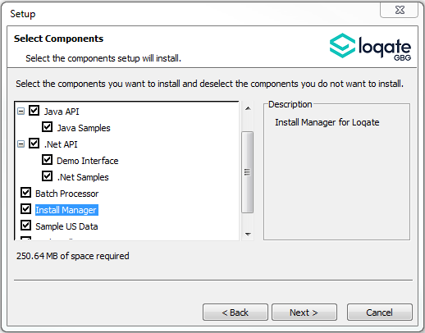

Standard GBG Loqate Installation (Multi-Threaded)
- Download the contents of the 2020Q2.0/AppInstaller directory (or new 2020Q2.0-NewStructure/app-installer-mt).
- Check the MD5 checksums to ensure that the download has been successful.
- Run the relevant Loqate Local API installer. Please note you may need to add execute privileges to the relevant installer when using Linux. Make sure the option “Install Manager” is selected for installation.
- Execute the Install Manager script (InstallManager.bat on Windows and InstallManager.sh on other Linux/Unix platforms) and install the data. For further details, please review the 2020Q2.0 Installation Instructions document.
- Run the relevant Global Knowledge Repository installer. Please note you may need to add execute privileges when using Linux.

Standard GBG Loqate Installation (Single-Threaded)
- Download the contents of the 2020Q2.0/STAppInstaller directory (or new 2020Q2.0-NewStructure/app-installer-st).
- Check the MD5 checksums to ensure that the download has been successful.
- Run the relevant Loqate Local API installer. Please note you may need to add execute privileges to the relevant installer when using Linux. Make sure the option “Install Manager” is selected for installation.
- Execute the InstallManager script (InstallManager.bat on Windows and InstallManager.sh on other Linux/Unix platforms) and install the data. For further details, please review the 2020Q2.0 Installation Instructions document.
- Run the relevant Global Knowledge Repository installer. Please note you may need to add execute privileges when using Linux.

SFTP Server Contents
This section has been intentionally removed for this release.

Please see https://support.loqate.com/sftp-api-filename-updates/ for more information about the file contents for this release delivery.

