Loqate, A GBG Solution Release Notes
2020Q1.1 Minor Release
Table of Contents
Case Resolutions 3
New GCC7 Linux Build Available with Q1.1 3
Local API Improvements 3
Certification Expiration Dates 4
Country Improvement Program (PDH) 5
Current Countries Completed PDH 5
Ireland 6
Slovakia 7
Angola 8
Knowledge Base & Reference Data Updates 10
Installation Instructions 11
Standard GBG Loqate Installation (Multi-threaded) 11
Single-threaded GBG Loqate Installation 12
SFTP Server Contents 12
Need Help? 13

Case Resolutions
Please visit http://support.loqate.com/2020q1-1-resolved-cases/ for a list of cases resolved in this release.

If you would like more details on any of the solved cases listed, please contact support@loqate.com for further information.

New GCC7 Linux Build Available
For the 2020Q1.1 release, Loqate have created a new port for Linux Ubuntu compiled using gcc7.
The minimum requirements for this are Linux Ubuntu 18.04 and gcc7.4.0.

Customers that have environments that can support gcc7 are encouraged to take this port, as it can provide significant performance improvements.

This build will now be included in all future releases.

Directory structure/server contents:

- AppInstaller\loqate_installer_x86_64-gcc7
- Rawfiles\linux64-gcc7
  - liblqtcr.so
  - lqtbatch
  - liblqtjava.so
  - loqate.jar

Local API Improvements
There are no significant changes or enhancements with this release.

Certification Expiration Dates
If you have purchased either the CASS (USA) or AMAS (Australia) certified products, please be aware that the datasets have expiration dates set by the respective postal authorities. Please ensure that you have the latest library and data installed to avoid loss of service through these products.

Please check Install Manager for the latest versions of AMAS and CASS.
 | Loqate Release Date | Certification Expiry Date*
AMAS Data | 2019-11-21 | 2020-03-31
CASS Data | 2020-02-10 | 2020-05-30
*Certification Expiry Date is different from Loqate license key expiry date. The earliest expiry date will apply.

For more information on expiry date checking for CASS and AMAS, please refer “Usage expiration” section in https://support.loqate.com/documentation/local-apis/cass-overview-2/ and https://support.loqate.com/address-matching-approval-system-amas/

Country Improvement Program (PDH)
The following section will display the changes made during the country improvement program. For this quarter we’ve released improved datasets for the countries: Ireland, Slovakia, Angola.

For more details on our Country Improvement Program, please visit the support site here.

Current Countries Completed PDH

COUNTRY | Date PDH Completed | Verification Level |  |  | COUNTRY | Date PDH Completed | Verification Level
IRELAND | 2020-02 | L4 |  |  | JERSEY | 2019-04 | L5
SLOVAKIA | 2020-02 | L4 |  |  | LITHUANIA | 2019-04 | L4
ANGOLA | 2020-02 | L3 |  |  | SINGAPORE | 2018-10 | L4
ISRAEL | 2019-11 | L4 |  |  | SOUTH AFRICA | 2018-10 | L4
BELGIUM | 2019-10 | L4+ |  |  | AUSTRIA | 2018-10 | L4
GREECE | 2019-10 | L4 |  |  | BRAZIL | 2018-07 | L4
INDIA | 2019-10 | L4 |  |  | MEXICO | 2018-07 | L4
TURKEY | 2019-10 | L4 |  |  | CZECH REPUBLIC | 2018-04 | L4
ARGENTINA | 2019-07 | L4 |  |  | UNITED STATES | 2018-01 | L5
COLOMBIA | 2019-07 | L4 |  |  | JAPAN | 2018-01 | L4
ITALY | 2019-07 | L4 |  |  | DENMARK | 2018-01 | L5
THAILAND | 2019-07 | L4 |  |  | NORWAY | 2018-01 | L4
PERU | 2019-07 | L4 |  |  | GERMANY | 2017-11 | L4
SAN MARINO | 2019-07 | L4 |  |  | NETHERLANDS | 2017-10 | L4
HAITI | 2019-07 | L3- |  |  | NEW ZEALAND | 2017-10 | L5
NICARAGUA | 2019-07 | L3- |  |  | FRENCH POLYNESIA | 2017-10 | L3
QATAR | 2019-07 | L4 |  |  | FRANCE | 2017-07 | L4
UNITED ARAB EMIRATES | 2019-07 | L4 |  |  | SWEDEN | 2017-07 | L4
KOREA, REPUBLIC OF | 2019-04 | L4 |  |  | CANADA | 2017-04 | L5
PORTUGAL | 2019-04 | L4 |  |  | AUSTRALIA | 2017-04 | L5
SPAIN | 2019-04 | L4 |  |  | SWITZERLAND | 2017-01 | L4
MALAYSIA | 2019-04 | L4 |  |  | FINLAND | 2017-01 | L4
PHILIPPINES | 2019-04 | L4 |  |  | EGYPT | 2017-01 | L4
URUGUAY | 2019-04 | L4 |  |  | ANDORRA | 2017-01 | L4
ISLE OF MAN | 2019-04 | L5 |  |  | ECUADOR | 2017-01 | L4
GUERNSEY | 2019-04 | L5

Ireland

Country Information | Description
ISO2 | IE
ISO3 | IRL
Address Format | Organization  PostBox  SubBuilding Building  Premise Thoroughfare  DependentThoroughfare  DependentLocality  Locality  AdministrativeArea  PostalCode
Address Format for Dublin 1- 24 | Organization  PostBox  SubBuilding Building  Premise Thoroughfare  DependentThoroughfare  DependentLocality  PostalCode
PDH | Yes
PDH completed date | 2020Q1.1
New Source | No

Files Used | Pre-PDH | Post-PDH
Reference Data | rd_IE_rg.lfs  rd_IE.lfs  rd_IE_geop_rg.lfs  rd_IE_geop.lfs  rd_IE_ai.lfs | rd_IE_ggg.lfs  rd_IE_ggg_rg.lfs  rd_IE_vfy_ai.lfs  rd_IE_vfy.lfs

Important notes regarding our Q1.1 Ireland dataset:

Our standard IRL Verify dataset now includes some postal code data (also referred to as Eircodes). Providing this data within our standard dataset does not require any additional user agreements of flow-down terms.

Customers are reminded that Loqate continue to provide a premium Eircode product, which provides higher quality data and additional features, which will include:

- Full Eircode coverage - our standard dataset does not provide 100% postcode coverage
- Gaelic and English languages - standard IRL only has English
- Higher quality point-level or rooftop geocoding – standard IRL geocode still has point-level

Please contact your channel manager to learn more about our Eircode product (additional supplier terms will be required with all end users).

2020Q1.0 | 2020Q1.1
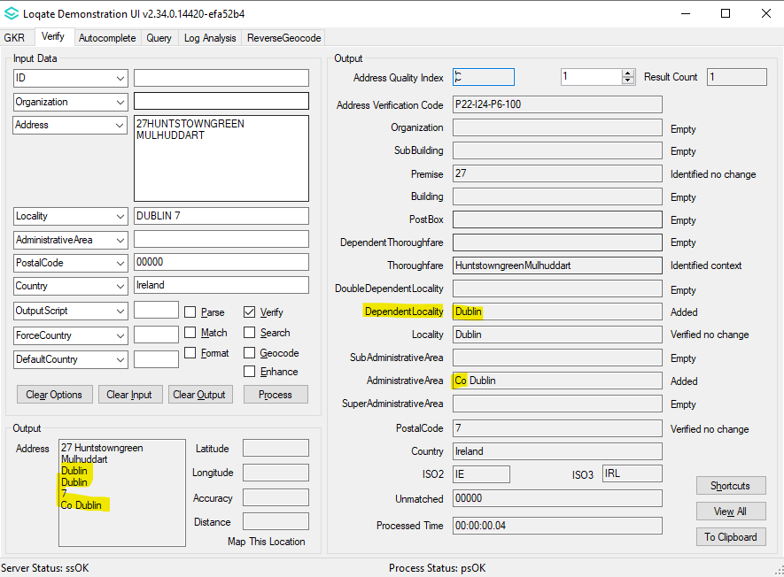  2020Q1.0:  1. Dublin 1 to 24 is not a recognized DependentLocality.  2. AdministrativeArea format does not have "." between Co and name  3. PostalCode is in the old format.  4. Address format retains all information. | 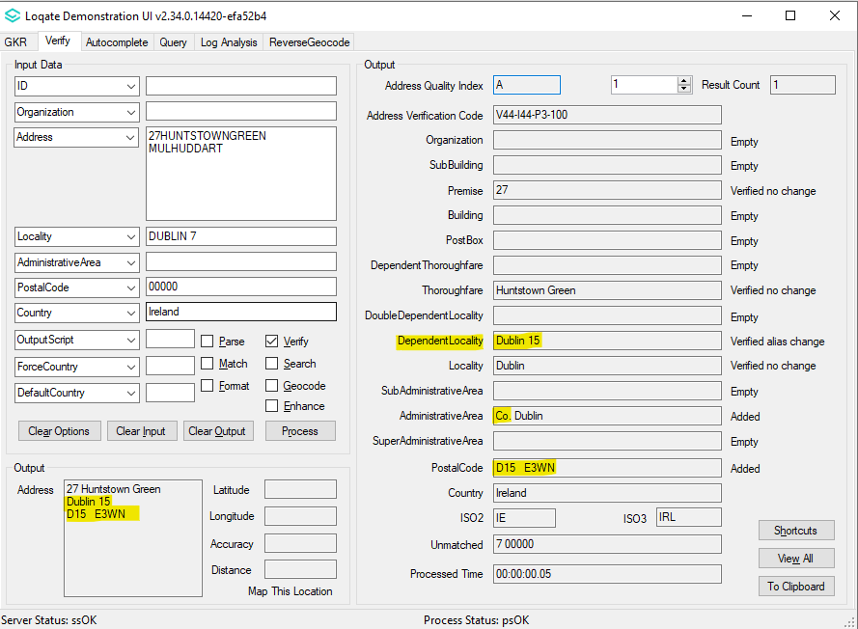  2020Q1.1:  1. Dublin 1 to 24 is now parsed as a DependentLocality  2. AdministrativeArea now contains "." in between Co and name  3. Format of PostalCode is now changed to 7 Alpha-numeric characters  4. Address Format changed if DependentLocality for Dublin 1 to 24 exists. Locality and AdministrativeArea wont be showing.

Slovakia

Country Information | Description
ISO2 | SK
ISO3 | SVK
Address Format | Organization  PostBox  SubBuilding  Thoroughfare Premise  DependentThoroughfare  DoubleDependentLocality  DependentLocality  PostalCode Locality
PDH | Yes
PDH completed date | 2020Q1.1
New Source | No

Files Used | Pre-PDH | Post-PDH
Reference Data | rd_SK_ggg.lfs  rd_SK_ggg_rg.lfs  rd_SK_vfy_ai.lfs  rd_SK_vfy.lfs | rd_SK_ggg.lfs  rd_SK_ggg_rg.lfs  rd_SK_vfy_ai.lfs  rd_SK_vfy.lfs

2020Q1.0 | 2020Q1.1
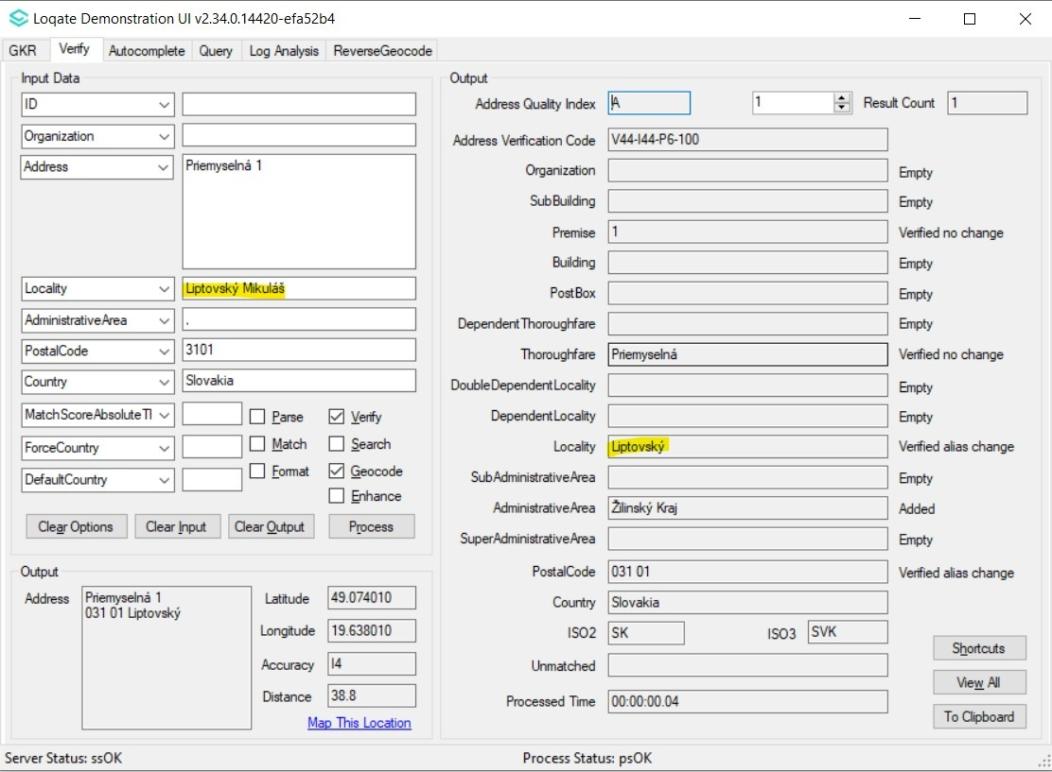  2020Q1.0: Incorrect Locality name is parsed | 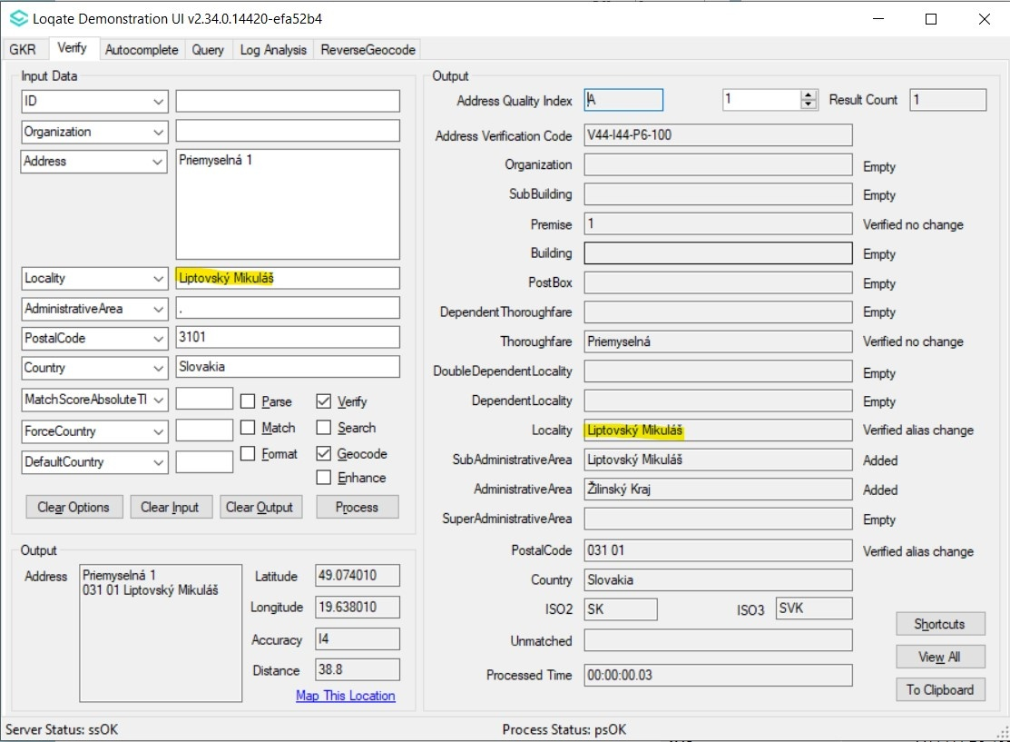  2020Q1.1: Locality name is parsed correctly
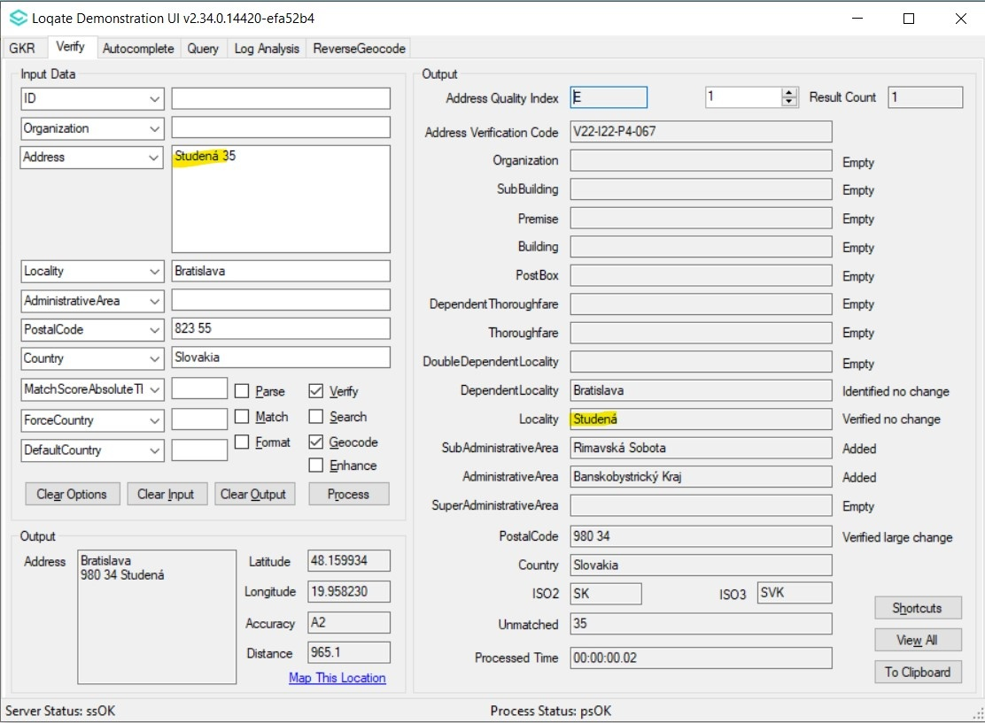  2020Q1.0: 'Studena' which is a Thoroughfare is incorrectly parsed as Locality. | 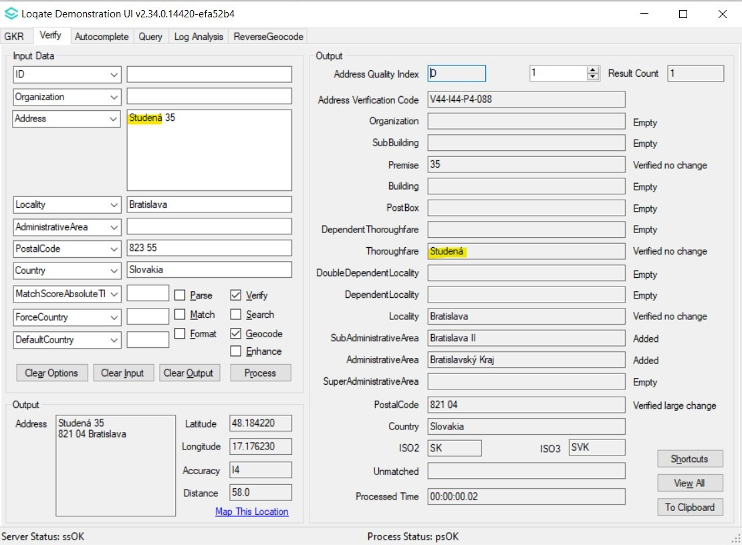  2020Q1.1: 'Studena' is correctly parsed as Thoroughfare.

Angola

Country Information | Description
ISO2 | AO
ISO3 | AGO
Address Format (Latin) | Organization  PostBox  Building SubBuilding  Thoroughfare Premise  DependentThoroughfare  DoubleDependentLocality  DependentLocality  Locality
PDH | Yes
PDH completed date | 2020Q1.1
New Source | No

Files Used | Pre-PDH | Post-PDH
Reference Data | rd_AO.lfs  rd_AO_rg.lfs  rd_AO_ai.lfs | rd_AO_ggg.lfs  rd_AO_ggg_rg.lfs  rd_AO_vfy_ai.lfs  rd_AO_vfy.lfs

2020Q1.0 | 2020Q1.1
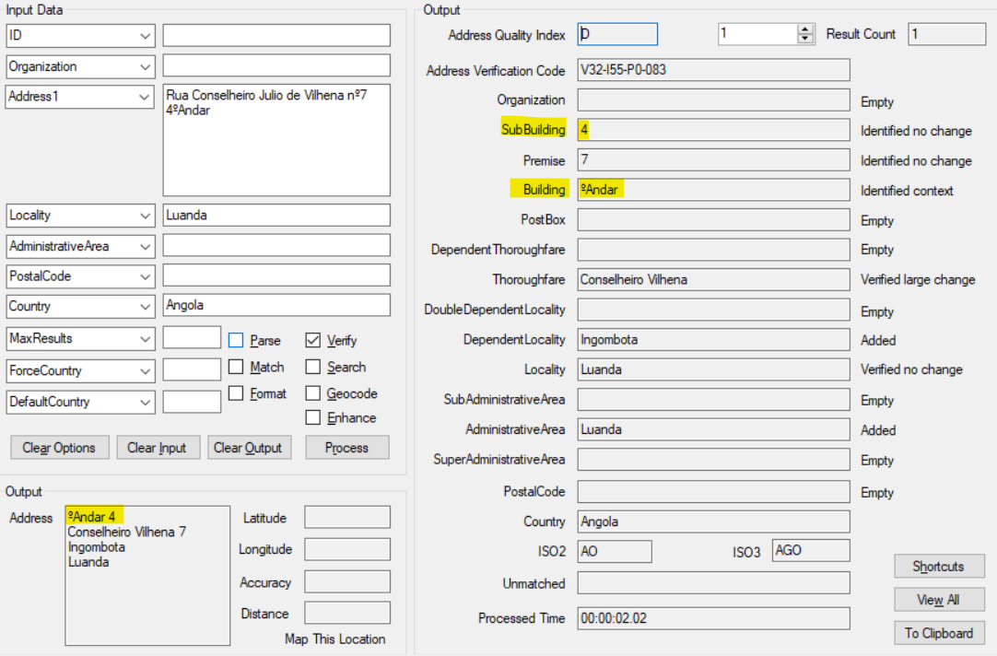  2020Q1.0: 'Andar' which means 'floor' was incorrectly parsed into Building | 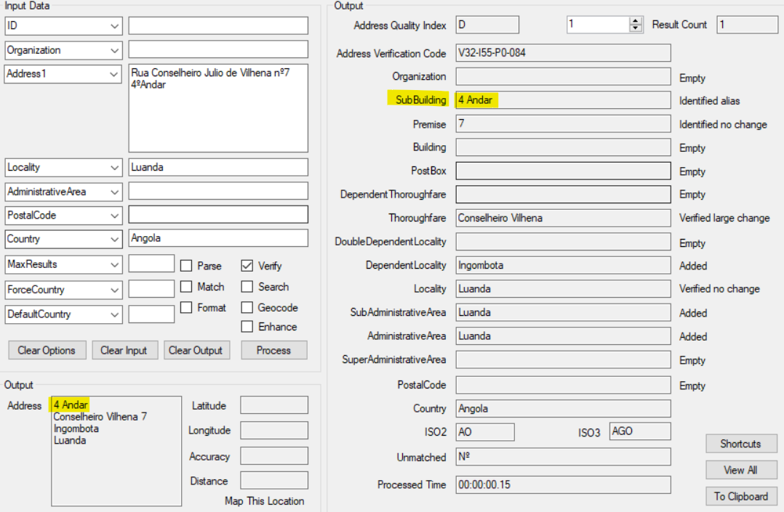  2020Q1.1: 'Andar' correctly parsed into SubBuilding field.
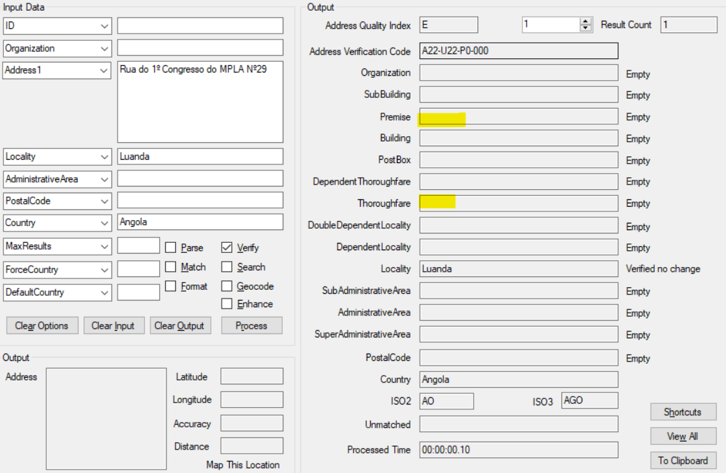  2020Q1.0: Thoroughfare and Premise not parsed at all. | 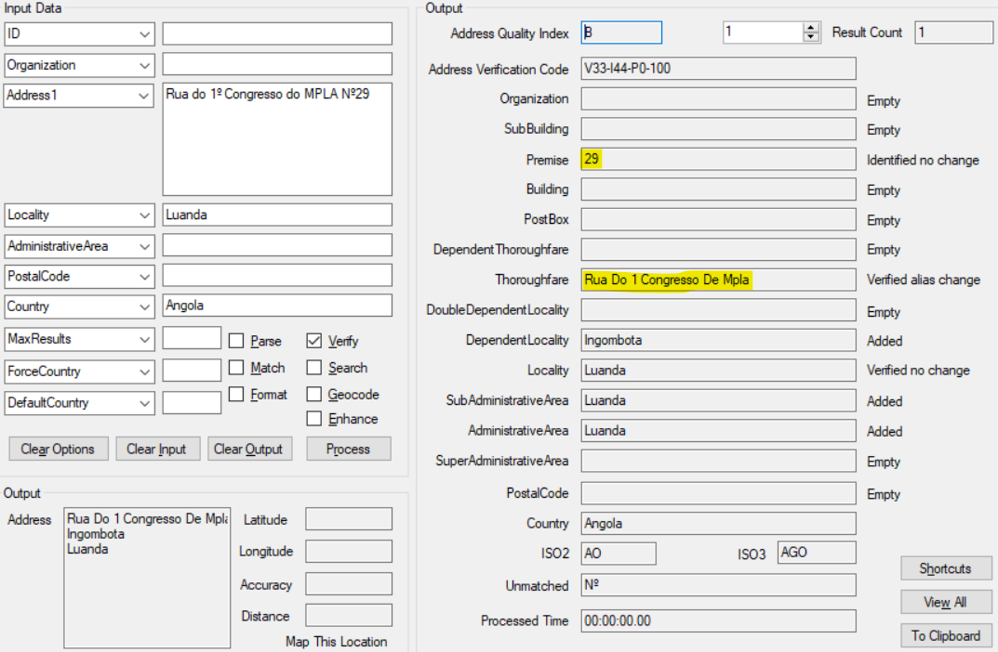  2020Q1.1: Thoroughfare and Premise parsed correctly.

Knowledge Base & Reference Data Updates
The table below shows which countries have been updated, and how, in this release.
If there is a PDH in the reference data column, this shows a country was included in the country improvement project.

- Reference Data = 17
- Lexicons = 5
- Context Rules = 2

DATASET NAME | ISO2 | CONTEXT RULES | LEXICONS | REFERENCE DATA
ANGOLA | AO | X | X | PDH
AMERICAN SAMOA | AS |  |  | X
CANADA | CA |  |  | X
MICRONESIA, FEDERATED STATES OF | FM |  |  | X
UNITED KINGDOM | GB |  |  | X
GUERNSEY | GG |  |  | X
GUAM | GU |  |  | X
IRELAND | IE | X | X | PDH
ISLE OF MAN | IM |  |  | X
JERSEY | JE |  |  | X
LUXEMBOURG | LU |  | X
MARSHALL ISLANDS | MH |  |  | X
NORTHERN MARIANA ISLANDS | MP |  |  | X
PUERTO RICO | PR |  |  | X
PALAU | PW |  |  | X
SLOVAKIA | SK |  | X | PDH
UNITED STATES | US |  | X | X
VIRGIN ISLANDS, U.S. | VI |  |  | X

Installation Instructions
The 2020Q1.1 release makes improvements to the performance of the verification process and the quality of the results.

Please remember to update both the program files and the reference data. The improvements are tied to the data in the Global Knowledge Repository and the Local API. If you need any assistance with the upgrade of the Local API or the data update process, please contact GBG Loqate Support.

The setup wizard for the Local API can be obtained from our SFTP server. Please contact your account manager to retrieve the SFTP information. If you do not know who your account manager is, please contact the support team at support@loqate.com.

GBG Loqate data packs can be downloaded and installed using the Install Manager. This is a component you will need to select during the installation of the Local API as shown below.

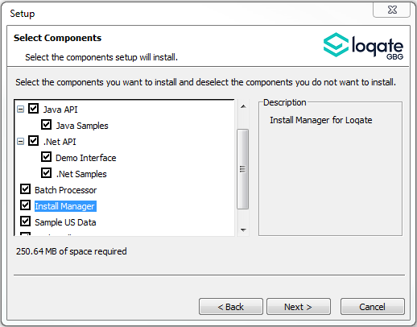

Standard GBG Loqate Installation (Multi-threaded)
- Download the contents of the 202020Q1.1/AppInstaller directory.
- Check the MD5 checksums to ensure that the download has been successful.
- Run the relevant Loqate Local API installer. Please note you may need to add execute privileges to the relevant installer when using Linux. Make sure the option “Install Manager” is selected for installation.
- Execute the Install Manager script (InstallManager.bat on Windows and InstallManager.sh on other Linux/Unix platforms) and install the data. For further details, please review the 2020Q1.1 Installation Instructions document.
- Run the relevant Global Knowledge Repository installer. Please note you may need to add execute privileges when using Linux.

Single-threaded GBG Loqate Installation
- Download the contents of the 2020Q1.1/STAppInstaller directory.
- Check the MD5 checksums to ensure that the download has been successful.
- Run the relevant Loqate Local API installer. Please note you may need to add execute privileges to the relevant installer when using Linux. Make sure the option “Install Manager” is selected for installation.
- Execute the InstallManager script (InstallManager.bat on Windows and InstallManager.sh on other Linux/Unix platforms) and install the data. For further details, please review the 2020Q1.1 Installation Instructions document.
- Run the relevant Global Knowledge Repository installer. Please note you may need to add execute privileges when using Linux.

SFTP Server Contents
On the GBG Loqate SFTP server, you will find the following items:
- AppInstaller: The folder which contains the Loqate Local API installer
- loqate_installer_aix: The AIX Loqate Local API installer
- loqate_installer_hpux: The HP-UX Loqate Local API installer
- loqate_installer_solaris_x86: The Solaris x86 Loqate Local API installer
- loqate_installer_sparc: The Solaris SPARC Loqate Local API installer
- loqate_installer_x86: The Linux 32-bit Loqate Local API installer
- loqate_installer_x86-cpp5: The Linux 32-bit C++ v5 Local API Loqate library installer
- loqate_installer_x86_64: The Linux 64-bit Loqate Local API installer
- loqate_installer_x86_64-gcc7 (NEW): Linux 64-bit Local API Installer ported using gcc7
- setup.exe: The Windows 32-bit Loqate Local API installer
- setup_x64.exe: The Windows 64-bit Loqate Local API installer
- AppInstaller-md5.txt : Contains the checksums of the files in the folder
- STAppInstaller: The folder which contains the Loqate Local API installer for single-threaded libraries
- loqate_installer_aix: The AIX Loqate Local API installer
- loqate_installer_hpux: The HP-UX Loqate Local API installer
- loqate_installer_solaris_x86: The Solaris x86 Loqate Local API installer
- loqate_installer_sparc: The Solaris SPARC Loqate Local API installer
- loqate_installer_x86: The Linux 32-bit Loqate Local API installer
- loqate_installer_x86-cpp5: The Linux 32-bit C++ v5 Local API Loqate library installer
- loqate_installer_x86_64: The Linux 64-bit Loqate Local API installer
- AppInstaller-md5.txt : Contains the checksums of the files in the folder
- STAppInstaller-md5.txt : Contains the checksums of the files in the folder
- OSGi: The folder which contains the OSGi bundle for the Loqate Local API
- loqate-osgi-1.0.0.0.jar: The OSGi bundle for Loqate Local API installer
- osgi-md5.txt: Contains the checksums of the files in the folder
- Rawfiles: The folder which contains the Loqate Local API files in the following subfolders
- aix: The AIX Loqate Local API library files
- hp-ux: The HP-UX Loqate Local API library files
- solaris_x86: The Solaris x86 Loqate Local API library files
- sparc: The Solaris SPARC Loqate Local API library files
- linux32: The Linux 32-bit Loqate Local API library files
- linux32-cpp5: The Linux 32-bit C++ v5 Loqate Local API library files
- linux64: The Linux 64-bit Loqate Local API library files
- linux64-gcc7 (NEW): The Linux 64-bit Loqate Local API library files (using gcc7)
- win64: The Windows 32-bit Loqate Local API library files
- win32: The Windows 64-bit Loqate Local API library files

Need Help?
Many answers to your questions may be found in our support pages. For additional information, please visit the support site. Below are a list of useful links.

- Support Home Page: http://support.loqate.com
- Getting Started: https://support.loqate.com/getting-started/
- Local APIs: http://support.loqate.com/support/local-apis/
- Field Descriptions: http://support.loqate.com/support/fielddescrip/
- Server and Process Options: http://support.loqate.com/support/options/
- System Requirements: http://support.loqate.com/system-requirements/
If you have any general questions, issues, or enhancement request you’d like to share with us, please contact our support team at: support@loqate.com.

