Loqate, A GBG Solution Release Notes
2020Q1.0 Major Release
Table of Contents
Case Resolutions 3
Install Manager Improvements 3
Product Code Updates 3
Minimum API Requirement 3
Install Manager 3
Local API Improvements 5
Local API Version Format 5
Revised Casing Behavior 5
Duplicate Handling 6
Context Handling Improvement 6
Certification Expiration Dates 6
Country Improvement Program (PDH) 7
Current Countries Completed PDH 7
Chile 9
Liechtenstein 11
Luxembourg 12
Poland 14
Knowledge Base & Reference Data Updates 16
Installation Instructions 21
Standard GBG Loqate Installation (Multi-threaded) 21
Single-threaded GBG Loqate Installation 22
SFTP Server Contents 22
Need Help? 23

Case Resolutions
Please visit http://support.loqate.com/2020q1-0-resolved-cases/ for a list of cases resolved in this release.

If you would like more details on any of the solved cases listed, please contact support@loqate.com for further information.

Install Manager Improvements

Product Code Updates
The USA and USA Territories product codes have been updated. Please use the license key to download the data through Install Manager. It is recommended to update the data, otherwise these countries may experience issues.

See table 1 below for the product code to countries mapping.

table 1.

Product (Product Code) | Countries post 2020Q1 | Countries prior 2020Q1
USA Datasets (DS*USA) | US | AS,GU,PR,US,VI
North America Other Datasets (DS*NAO) | Legacy | FM,MH,MP,PM,PW,UM
USA Territories Datasets (DS*USAT) | AS,FM,GU,MH,MP,PM,PR,PW,UM,VI | -

IMPORTANT NOTE: This change is applicable for license keys that contain only USA products. All existing keys have already been updated, there is no further action required from customers.

This change does not affect any users whose license key includes Worldwide products.

Minimum API Requirement
Due to new changes made in the API, the following data will need to have the minimum API set to 2020Q1.0 release: Argentina, Australia, Brazil, Canada, Chile, Finland, Italy, Liechtenstein, Luxembourg, Mexico, Netherlands, Poland, Switzerland, and United States. It is recommended to update to the latest 2020Q1.0 API in order to view the latest updates for the knowledge files and the listed countries.

Install Manager
There is a new version of Install Manager available with this release, version 11.0.0. In Install Manager version 11.0.0, the md5sum hash values of datapacks and data files are written to text files at the end of download and installation. The new files containing md5sum hash values are located in both the download and data installation folders.

See Fig. 1 below for the file naming convention.

Fig. 1:

Folder | Files | Notes
Download folder | datapacks_server_<timestamp>.txt | hash values from server for the datapacks selected for download is available in this file
 | datapacks_local_<timestamp>.txt | hash values locally generated for the datapacks downloaded is available in this file
 | datapacks_error_log_<timestamp>.txt | list of datapacks that failed installation as available will be listed in this file
Data Installation folder | data_server_<timestamp>.txt | hash values from server for the data files selected for download is available in this file
 | data_local_<timestamp>.txt | hash values generated locally for data files installed is available in this file

IMPORTANT NOTE: The md5sums will only be available for products selected for download; not for all products listed in the license key.

Md5sums are not available for Certification products in this release.

This feature is not available for an offline installation scenario.

Local API Improvements

Local API Version Format
Starting with the 2020Q1.0 release, due to the upgrade in our current code management system, the format of Local API version will be changing to include a hyphen plus the version number at the end.

Please see example in Fig. 2 below for the new version format.

Fig. 2:

Release | Version
2019Q4.0 | 2.33.0.10255
2020Q1.0 | 2.34.0.14420-efa52b4

Revised Casing Behavior

IMPORTANT NOTE: In order to view the casing improvements, please update to the latest 2020Q1.0 API.

When using both the 2020Q1.0 API and Data, customers will see improvements to the way the Loqate engine handles casing on data in several countries. The casing improvements will allow users to override output casing.

The revised casing behavior is an improvement for all countries. However, for Argentina, Australia, Brazil, Canada, Italy, and Mexico, there maybe some more noticeable improvements where customers may see casing changes. These types of changes can include updated title cases.

For example, in Argentina, Ciudad Autónoma De Buenos Aires will display as Ciudad Autónoma de Buenos Aires.

Duplicate Handling

The 2020Q1.0 release makes improvement to the duplicate handling option. The duplicate handling option will remove non-address elements or unverifiable address elements.

For example, if a postalcode is in the address line 1 input field and the postalcode input field; with the duplicate handling option, the Loqate engine will be able to identify the duplication.

Context Handling Improvement

In this release, the context handling makes improvements to the way in which PostBox and SubBuilding input fields are processed. The RefLex tool will now process PostBox and SubBuilding fields; the performance issue is also resolved in this release. Further improvements to context handling will be included for the next major release.

Certification Expiration Dates
If you have purchased either the CASS (USA) or AMAS (Australia) certified products, please be aware that the datasets have expiration dates set by the respective postal authorities. Please ensure that you have the latest library and data installed to avoid loss of service through these products.

Please check Install Manager for the latest versions of AMAS and CASS.
 | Loqate Release Date | Certification Expiry Date*
AMAS Data | 2019-11-21 | 2020-03-31
CASS Data | 2019-12-15 | 2020-03-29
*Certification Expiry Date is different from Loqate license key expiry date. The earliest expiry date will apply.

For more information on expiry date checking for CASS and AMAS, please refer “Usage expiration” section in https://support.loqate.com/documentation/local-apis/cass-overview-2/ and https://support.loqate.com/address-matching-approval-system-amas/

Country Improvement Program (PDH)
The following section will display the changes made during the country improvement program. For this quarter, we have released improved datasets for the countries: Chile, Liechtenstein, Luxembourg, Poland.

For more details on our Country Improvement Program, please visit the support site here.

Current Countries Completed PDH

COUNTRY | Date PDH Completed | Verification Level
CHILE | 2020-01 | L4+
LIECHTENSTEIN | 2020-01 | L4+
LUXEMBOURG | 2020-01 | L4
POLAND | 2020-01 | L4+
ISRAEL | 2019-11 | L4
BELGIUM | 2019-10 | L4+
GREECE | 2019-10 | L4
INDIA | 2019-10 | L4
TURKEY | 2019-10 | L4
ARGENTINA | 2019-07 | L4
COLOMBIA | 2019-07 | L4
ITALY | 2019-07 | L4
THAILAND | 2019-07 | L4
PERU | 2019-07 | L4
SAN MARINO | 2019-07 | L4
HAITI | 2019-07 | L3-
NICARAGUA | 2019-07 | L3-
QATAR | 2019-07 | L4
UNITED ARAB EMIRATES | 2019-07 | L4
KOREA, REPUBLIC OF | 2019-04 | L4
PORTUGAL | 2019-04 | L4
SPAIN | 2019-04 | L4
MALAYSIA | 2019-04 | L4
PHILIPPINES | 2019-04 | L4
URUGUAY | 2019-04 | L4
ISLE OF MAN | 2019-04 | L5
GUERNSEY | 2019-04 | L5
JERSEY | 2019-04 | L5
LITHUANIA | 2019-04 | L4
SINGAPORE | 2018-10 | L4
SOUTH AFRICA | 2018-10 | L4
AUSTRIA | 2018-10 | L4
BRAZIL | 2018-07 | L4
MEXICO | 2018-07 | L4
CZECH REPUBLIC | 2018-04 | L4
UNITED STATES | 2018-01 | L5
JAPAN | 2018-01 | L4
DENMARK | 2018-01 | L5
NORWAY | 2018-01 | L4
GERMANY | 2017-11 | L4
NETHERLANDS | 2017-10 | L4
NEW ZEALAND | 2017-10 | L5
FRENCH POLYNESIA | 2017-10 | L3
FRANCE | 2017-07 | L4
SWEDEN | 2017-07 | L4
CANADA | 2017-04 | L5
AUSTRALIA | 2017-04 | L5
SWITZERLAND | 2017-01 | L4
FINLAND | 2017-01 | L4
EGYPT | 2017-01 | L4
ANDORRA | 2017-01 | L4
ECUADOR | 2017-01 | L4

Chile

Country Information | Description
ISO2 | CL
ISO3 | CHL
Address Format (Latin) | Organization  PostBox  Building SubBuilding  Thoroughfare Premise  DependentThoroughfare  DoubleDependentLocality  Locality DependentLocality
PDH | Yes
PDH completed date | 2020Q1.0
New Source | No

 | Pre-PDH | Post-PDH
Reference Data | rd_CL.lfs  rd_CL_rg.lfs  rd_CL_ai.lfs | rd_CL_ggg.lfs  rd_CL_ggg_rg.lfs  rd_CL_ggg_r.lfs  rd_CL_vfy.lfs  rd_CL_vfy_ai.lfs

The PDH process corrected alignment issues in both the AdministrativeArea and SubAdministrativeArea fields.

The AdministrativeArea will now output the standard form versus the abbreviated form. For example, Ar will now verify as Araucania.

See screenshots below for examples.

2019Q4.0 | 2020Q1.0
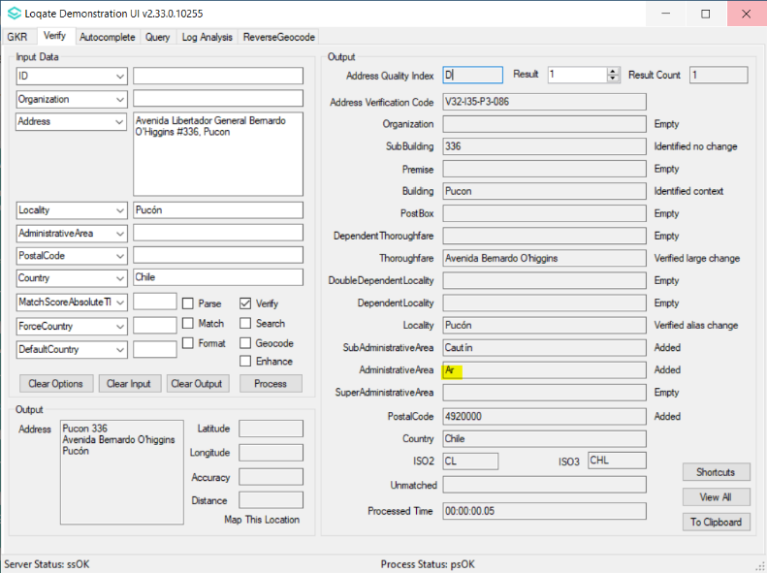  2019Q4.0 - AdministrativeArea is output in abbreviated form | 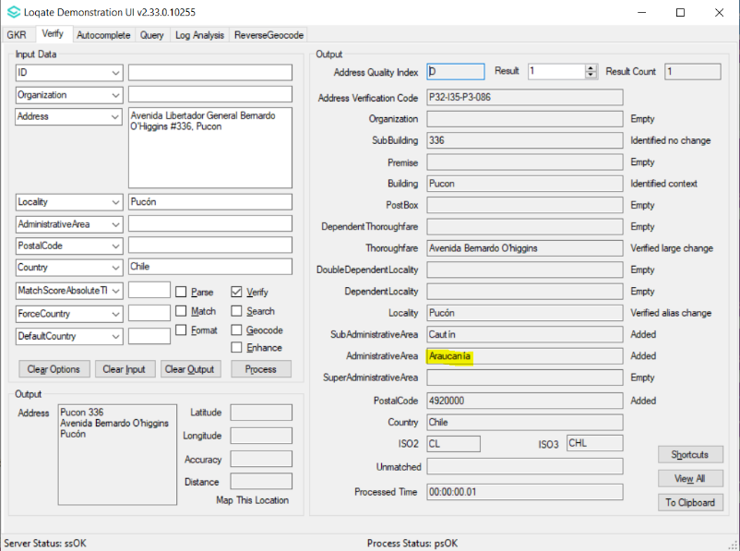  2020Q1.0 - AdministrativeArea is standardized to full form
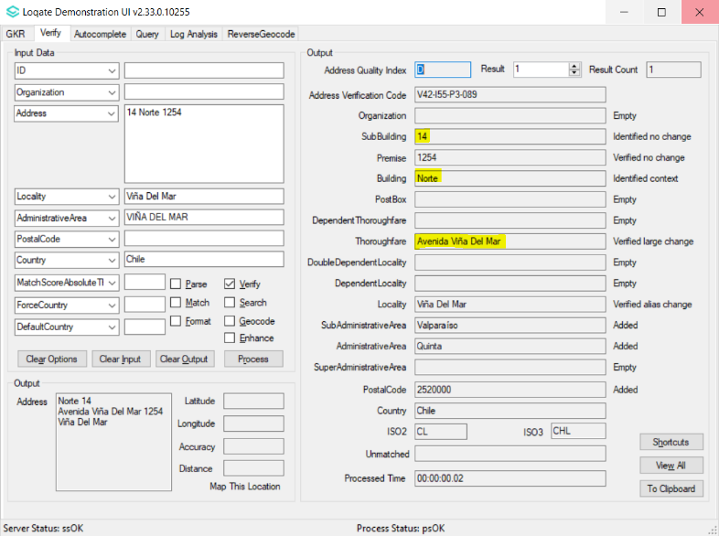  2019Q4.0 - The Thoroughfare is incorrectly verified | 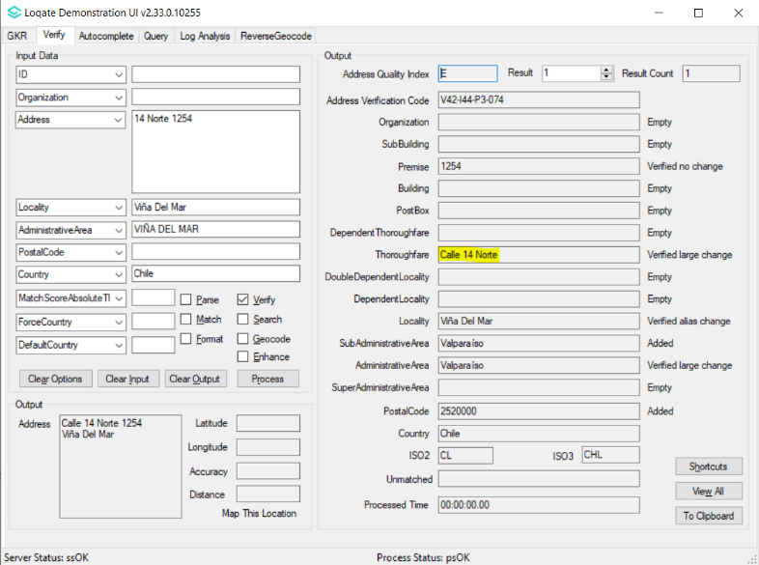  2020Q1.0 - The Thoroughfare is verified correctly
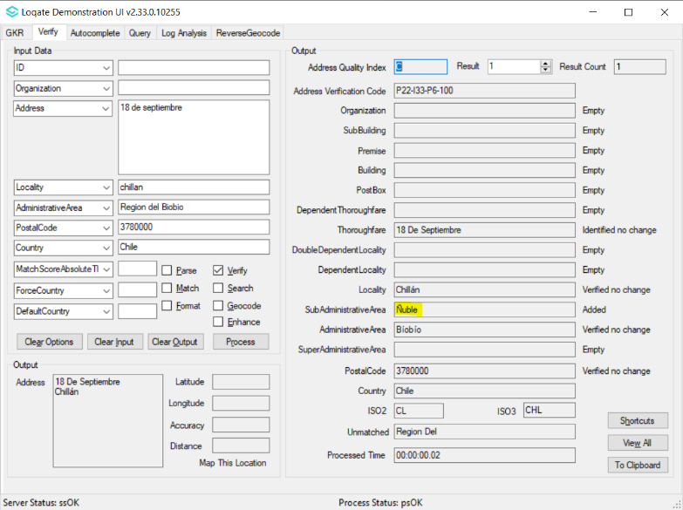  2019Q4.0 - Ñuble returned in SubAdministrativeArea field. | 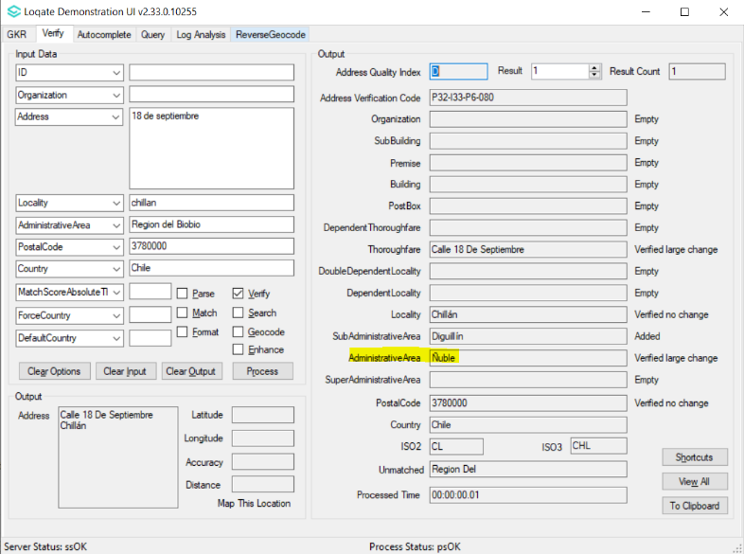  2020Q1.0 - After realignment, Ñuble corrected to AdministrativeArea field.

Liechtenstein

Country Information | Description
ISO2 | LI
ISO3 | LIE
Address Format (Latin) | Organization  PostBox  SubBuilding  Thoroughfare Premise  DependentThoroughfare  DoubleDependentLocality  DependentLocality  PostalCode Locality
PDH | Yes
PDH completed date | 2020Q1.0
New Source | No

 | Pre-PDH | Post-PDH
Reference Data | rd_LI.lfs  rd_LI_ai.lfs  rd_LI_rg.lfs  rd_LI_geop.lfs  rd_LI_geop_rg.lfs | rd_LI_vfy.lfs  rd_LI_vfy_ai.lfs  rd_LI_ggg.lfs  rd_LI_ggg_rg.lfs

The SuperAdministrativeArea and AdministrativeArea alignment issues are resolved with the 2020Q1.0 PDH process for Liechtenstein.

See screenshots below for examples

2019Q4.0 | 2020Q1.0
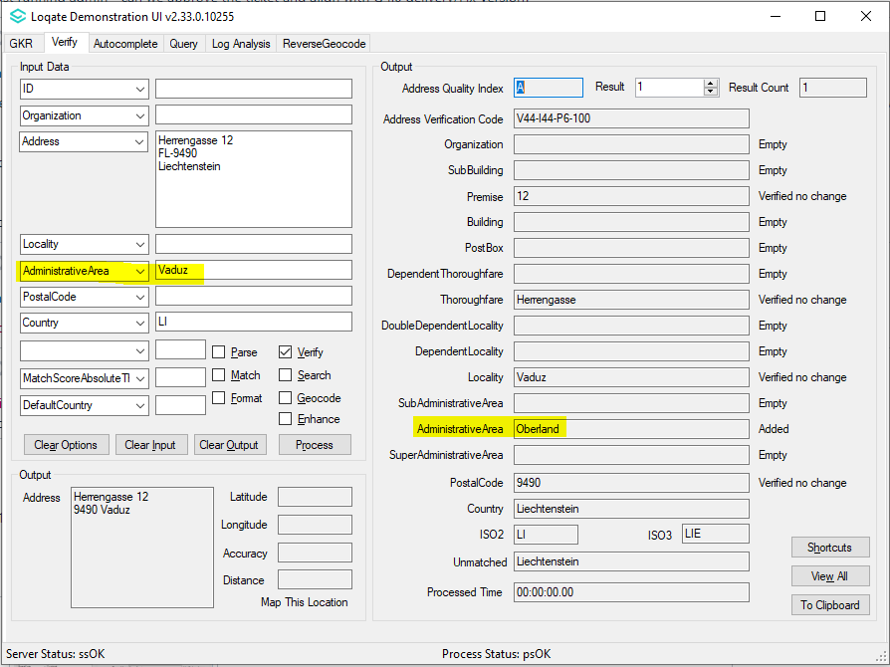  2019Q4.0 - Oberland returned in AdministrativeArea. | 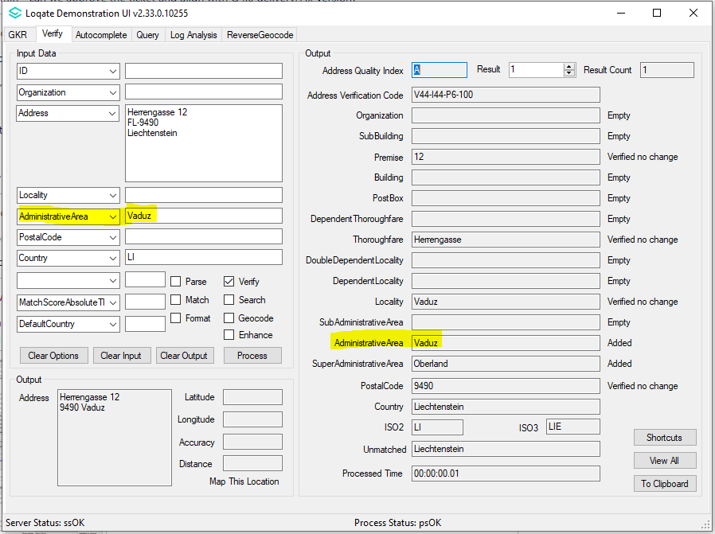  2020Q1.0 - After re-alignment, Oberland corrected to SuperAdministrativeArea field.

Luxembourg

Country Information | Description
ISO2 | LU
ISO3 | LUX
Address Format (Latin) | Organization  PostBox  SubBuilding Building  Premise Thoroughfare  DependentThoroughfare  DoubleDependentLocality  DependentLocality
PDH | Yes
PDH completed date | 2020Q1.0
New Source | No

 | Pre-PDH | Post-PDH
Reference Data | rd_LU_rg.lfs  rd_LU.lfs  rd_LU_geop_rg.lfs  rd_LU_geop.lfs  rd_LU_ai.lfs | rd_LU_vfy.lfs  rd_LU_vfy_ai.lfs  rd_LU_ggg.lfs  rd_LU_ggg_rg.lfs

PDH resolves realignment within the DependentLocality and Locality fields in Luxembourg.

The PostalCode field will now return the Postcode preceded by "L-" where applicable.

See screenshots below for examples

2019Q4.0 | 2020Q1.0
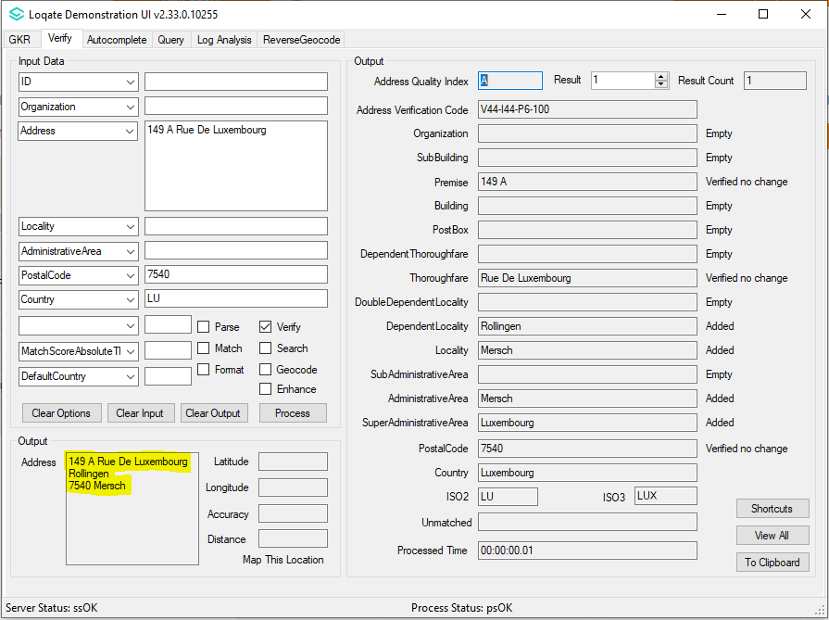  2019Q4.0 - The Rollingen returned in DependentLocality field. | 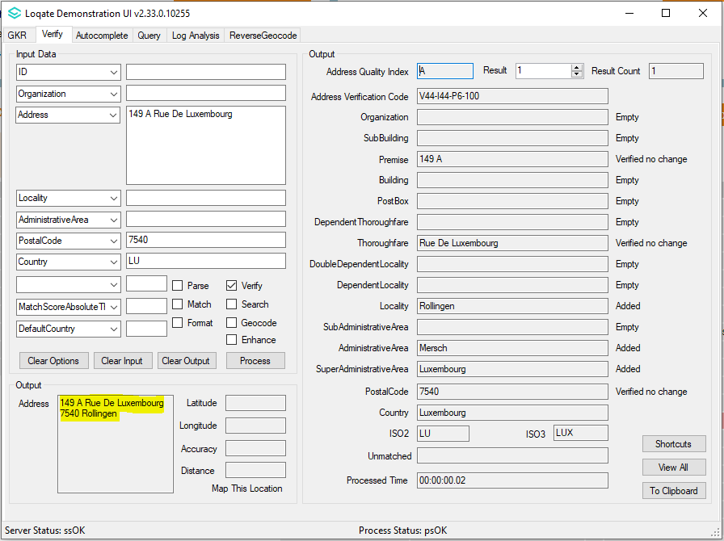  2020Q1.0 - After re-alignment, Rollingen corrected to Locality field.
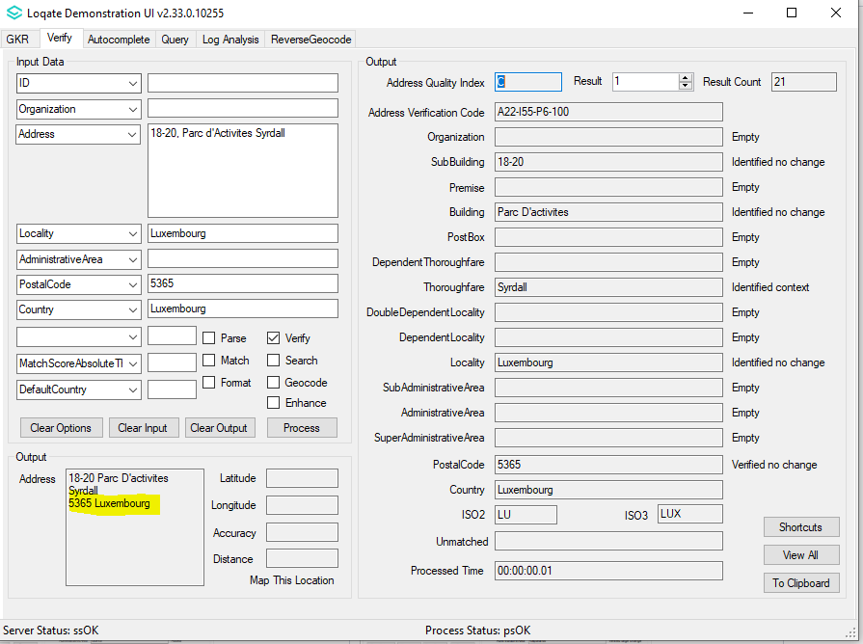  2019Q4.0 - Address format does not have postcode prefix "L-" | 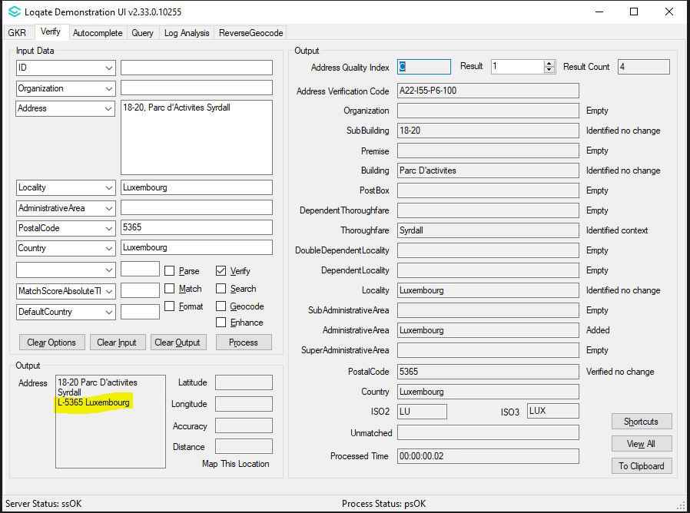  2020Q1.0 - Postcode preceded by "L-" returned in the address format

Poland

Country Information | Description
ISO2 | PL
ISO3 | POL
Address Format (Latin) | Organization  PostBox  SubBuilding Building  Thoroughfare Premise  DependentThoroughfare  DoubleDependentLocality  DependentLocality  PostalCode Locality
PDH | Yes
PDH completed date | 2020Q1.0
New Source | No

 | Pre-PDH | Post-PDH
Reference Data | rd_PL.lfs  rd_PL_rg.lfs  rd_PL_geop_rg.lfs  rd_PL_geop.lfs  rd_PL_ai.lfs | rd_PL_ggg.lfs  rd_PL_ggg_rg.lfs  rd_PL_ggg_r.lfs  rd_PL_vfy_ai.lfs  rd_PL_vfy.lfs

Through PDH, when applicable, Rural Localities will now include the suffix "M.".

See screenshots below for examples

2019Q4.0 | 2020Q1.0
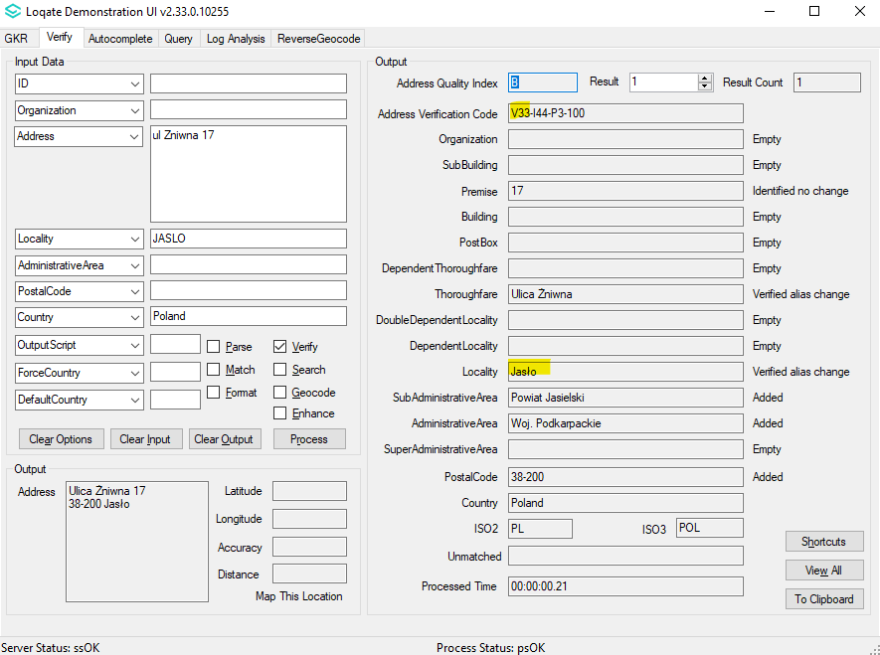  2019Q4.0 - Urban Gminas does not have the suffix "M." to distinguish between Rural Gminas | 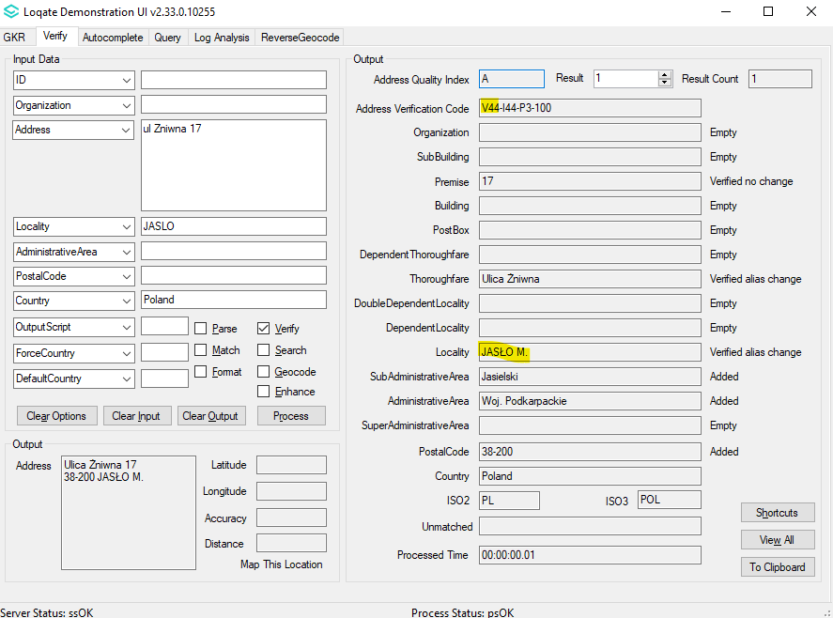  2020Q1.0 - Urban Gminas now has the suffix "M.", Premise number can now be verified as there is no ambiguity
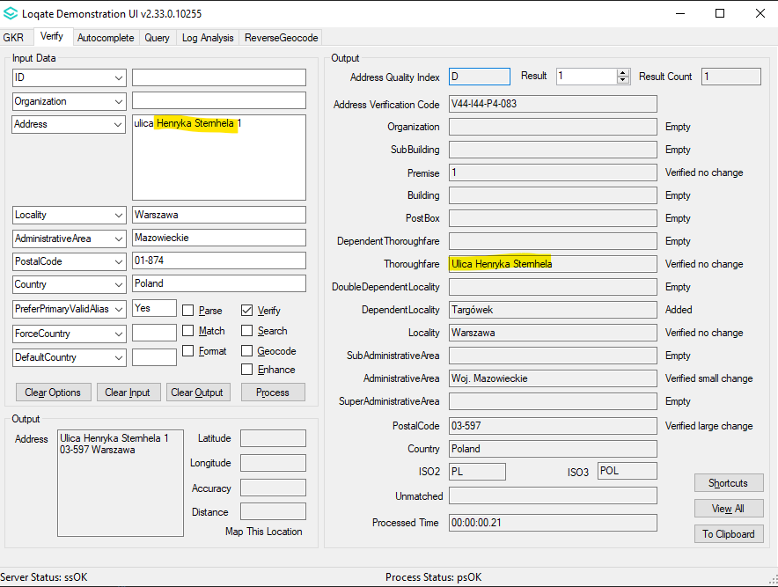  2019Q4.0 - Obsolete thoroughfare name verified. | 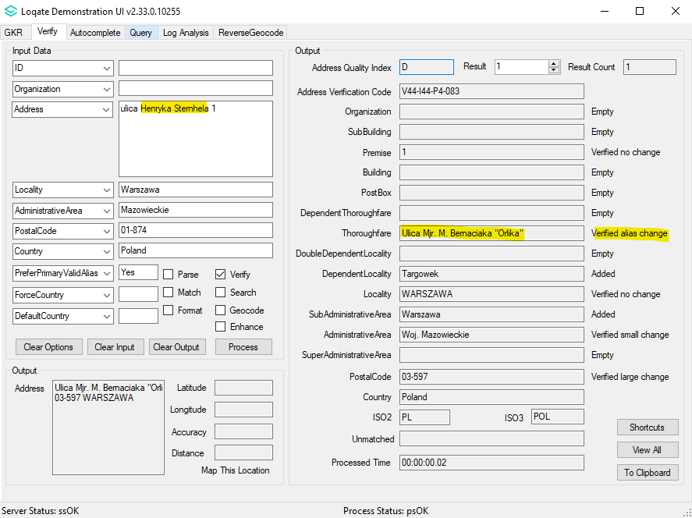  2020Q1.0 - Obsolete thoroughfare name corrected to New thoroughfare name

Knowledge Base & Reference Data Updates
The table below shows which countries have been updated, and how, in this release.
If there is a PDH in the reference data column, this shows a country was included in the country improvement project.

- Reference Data = 176
- Lexicons = 9
- Context Rules = None
- New PDH Countries = 4 (Chile, Liechtenstein, Luxembourg, Poland)

COUNTRY NAME | ISO CODE | CONTEXT RULES | LEXICONS | REFERENCE DATA
ANTIGUA AND BARBUDA | AG |  |  | X
ANGUILLA | AI |  |  | X
ALBANIA | AL |  |  | X
ARMENIA | AM |  |  | X
ANGOLA | AO |  |  | X
AMERICAN SAMOA | AS |  |  | X
AUSTRALIA | AU |  | X | X
ARUBA | AW |  |  | X
AZERBAIJAN | AZ |  |  | X
BOSNIA AND HERZEGOVINA | BA |  |  | X
BARBADOS | BB |  |  | X
BANGLADESH | BD |  |  | X
BURKINA FASO | BF |  |  | X
BENIN | BJ |  |  | X
Saint Barthélemy | BL |  |  | X
BERMUDA | BM |  |  | X
BRUNEI DARUSSALAM | BN |  |  | X
BOLIVIA, PLURINATIONAL STATE OF | BO |  |  | X
BONAIRE, SINT EUSTATIUS AND SABA | BQ |  |  | X
BAHAMAS | BS |  |  | X
BHUTAN | BT |  |  | X
BELIZE | BZ |  |  | X
CANADA | CA |  |  | X
COCOS (KEELING) ISLANDS | CC |  |  | X
CONGO, THE DEMOCRATIC REPUBLIC OF THE | CD |  |  | X
CENTRAL AFRICAN REPUBLIC | CF |  |  | X
CONGO | CG |  |  | X
SWITZERLAND | CH |  |  | X
Côte d’Ivoire | CI |  |  | X
COOK ISLANDS | CK |  |  | X
CHILE | CL |  | X | PDH
CAMEROON | CM |  |  | X
COSTA RICA | CR |  |  | X
CUBA | CU |  |  | X
CAPE VERDE | CV |  | X | X
CHRISTMAS ISLAND | CX |  |  | X
CYPRUS | CY |  |  | X
DJIBOUTI | DJ |  |  | X
DOMINICA | DM |  |  | X
DOMINICAN REPUBLIC | DO |  |  | X
ALGERIA | DZ |  |  | X
ESTONIA | EE |  |  | X
WESTERN SAHARA | EH |  |  | X
ERITREA | ER |  |  | X
ETHIOPIA | ET |  |  | X
FINLAND | FI |  | X | X
FIJI | FJ |  |  | X
FALKLAND ISLANDS (MALVINAS) | FK |  |  | X
MICRONESIA, FEDERATED STATES OF | FM |  |  | X
FAROE ISLANDS | FO |  |  | X
FRANCE | FR |  |  | X
GABON | GA |  |  | X
UNITED KINGDOM | GB |  |  | X
GRENADA | GD |  |  | X
FRENCH GUIANA | GF |  |  | X
GUERNSEY | GG |  |  | X
GHANA | GH |  |  | X
GIBRALTAR | GI |  |  | X
GREENLAND | GL |  |  | X
GAMBIA | GM |  |  | X
GUINEA | GN |  |  | X
GUADELOUPE | GP |  |  | X
EQUATORIAL GUINEA | GQ |  |  | X
SOUTH GEORGIA AND THE SOUTH SANDWICH ISLANDS | GS |  |  | X
GUATEMALA | GT |  |  | X
GUAM | GU |  |  | X
GUINEA-BISSAU | GW |  |  | X
GUYANA | GY |  |  | X
HONDURAS | HN |  |  | X
HUNGARY | HU |  |  | X
ISLE OF MAN | IM |  |  | X
INDIA | IN |  |  | X
BRITISH INDIAN OCEAN TERRITORY | IO |  |  | X
IRAQ | IQ |  |  | X
IRAN, ISLAMIC REPUBLIC OF | IR |  |  | X
JERSEY | JE |  |  | X
KENYA | KE |  |  | X
KYRGYZSTAN | KG |  |  | X
CAMBODIA | KH |  |  | X
KIRIBATI | KI |  |  | X
COMOROS | KM |  |  | X
SAINT KITTS AND NEVIS | KN |  |  | X
KOREA, DEMOCRATIC PEOPLE’S REPUBLIC OF | KP |  |  | X
KUWAIT | KW |  |  | X
CAYMAN ISLANDS | KY |  |  | X
LAO PEOPLE’S DEMOCRATIC REPUBLIC | LA |  |  | X
LEBANON | LB |  |  | X
SAINT LUCIA | LC |  |  | X
LIECHTENSTEIN | LI |  | X | PDH
SRI LANKA | LK |  |  | X
LIBERIA | LR |  |  | X
LESOTHO | LS |  |  | X
LUXEMBOURG | LU |  | X | PDH
LIBYA | LY |  |  | X
MOROCCO | MA |  |  | X
MONACO | MC |  |  | X
MOLDOVA, REPUBLIC OF | MD |  |  | X
MONTENEGRO | ME |  |  | X
SAINT MARTIN (FRENCH PART) | MF |  |  | X
MADAGASCAR | MG |  |  | X
MARSHALL ISLANDS | MH |  |  | X
MACEDONIA (NORTH MACEDONIA) | MK |  |  | X
MALI | ML |  |  | X
MYANMAR | MM |  |  | X
MONGOLIA | MN |  |  | X
NORTHERN MARIANA ISLANDS | MP |  |  | X
MARTINIQUE | MQ |  |  | X
MAURITANIA | MR |  |  | X
MONTSERRAT | MS |  |  | X
MALTA | MT |  |  | X
MAURITIUS | MU |  |  | X
MALDIVES | MV |  |  | X
MALAWI | MW |  |  | X
MALAYSIA | MY |  | X
NAMIBIA | NA |  |  | X
NEW CALEDONIA | NC |  |  | X
NIGER | NE |  |  | X
NORFOLK ISLAND | NF |  |  | X
NEPAL | NP |  |  | X
NAURU | NR |  |  | X
NIUE | NU |  |  | X
OMAN | OM |  |  | X
PAPUA NEW GUINEA | PG |  |  | X
PAKISTAN | PK |  |  | X
POLAND | PL |  | X | PDH
SAINT PIERRE AND MIQUELON | PM |  |  | X
PITCAIRN | PN |  |  | X
PUERTO RICO | PR |  |  | X
PALESTINE, STATE OF | PS |  |  | X
PORTUGAL | PT |  |  | X
PALAU | PW |  |  | X
PARAGUAY | PY |  |  | X
Réunion | RE |  |  | X
ROMANIA | RO |  |  | X
RWANDA | RW |  |  | X
SOLOMON ISLANDS | SB |  |  | X
SEYCHELLES | SC |  |  | X
SUDAN | SD |  |  | X
SAINT HELENA, ASCENSION AND TRISTAN DA CUNHA | SH |  |  | X
SLOVENIA | SI |  |  | X
SVALBARD AND JAN MAYEN | SJ |  |  | X
SIERRA LEONE | SL |  |  | X
SENEGAL | SN |  |  | X
SOMALIA | SO |  |  | X
SURINAME | SR |  |  | X
SOUTH SUDAN, REPUBLIC OF | SS |  |  | X
SAO TOME AND PRINCIPE | ST |  |  | X
EL SALVADOR | SV |  |  | X
SYRIAN ARAB REPUBLIC | SY |  |  | X
ESWATINI | SZ |  |  | X
TURKS AND CAICOS ISLANDS | TC |  |  | X
CHAD | TD |  |  | X
FRENCH SOUTHERN TERRITORIES | TF |  |  | X
TOGO | TG |  |  | X
TAJIKISTAN | TJ |  |  | X
TOKELAU | TK |  |  | X
TIMOR-LESTE | TL |  |  | X
TURKMENISTAN | TM |  |  | X
TONGA | TO |  |  | X
TRINIDAD AND TOBAGO | TT |  |  | X
TUVALU | TV |  |  | X
TANZANIA, UNITED REPUBLIC OF | TZ |  |  | X
UKRAINE | UA |  |  | X
UNITED STATES MINOR OUTLYING ISLANDS | UM |  |  | X
UNITED STATES | US |  | X | X
UZBEKISTAN | UZ |  |  | X
HOLY SEE (VATICAN CITY STATE) | VA |  |  | X
SAINT VINCENT AND THE GRENADINES | VC |  |  | X
VIRGIN ISLANDS, BRITISH | VG |  |  | X
VIRGIN ISLANDS, U.S. | VI |  |  | X
VANUATU | VU |  |  | X
WALLIS AND FUTUNA | WF |  |  | X
SAMOA | WS |  |  | X
YEMEN | YE |  |  | X
MAYOTTE | YT |  |  | X
ZAMBIA | ZM |  |  | X
ZIMBABWE | ZW |  |  | X

Installation Instructions
The 2020Q1.0 release makes improvements to the performance of the verification process and the quality of the results.

Please remember to update both the program files and the reference data. The improvements are tied to the data in the Global Knowledge Repository and the Local API. If you need any assistance with the upgrade of the Local API or the data update process, please contact GBG Loqate Support.

The setup wizard for the Local API can be obtained from our SFTP server. Please contact your account manager to retrieve the SFTP information. If you do not know who your account manager is, please contact the support team at support@loqate.com.

GBG Loqate data packs can be downloaded and installed using the Install Manager. This is a component you will need to select during the installation of the Local API as shown below.

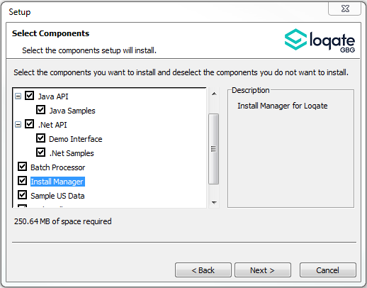

Standard GBG Loqate Installation (Multi-threaded)
- Download the contents of the 2020Q1.0/AppInstaller directory.
- Check the MD5 checksums to ensure that the download has been successful.
- Run the relevant Loqate Local API installer. Please note you may need to add execute privileges to the relevant installer when using Linux. Make sure the option “Install Manager” is selected for installation.
- Execute the Install Manager script (InstallManager.bat on Windows and InstallManager.sh on other Linux/Unix platforms) and install the data. For further details, please review the 2020Q1.0 Installation Instructions document.
- Run the relevant Global Knowledge Repository installer. Please note you may need to add execute privileges when using Linux.

Single-threaded GBG Loqate Installation
- Download the contents of the 2020Q1.0/STAppInstaller directory.
- Check the MD5 checksums to ensure that the download has been successful.
- Run the relevant Loqate Local API installer. Please note you may need to add execute privileges to the relevant installer when using Linux. Make sure the option “Install Manager” is selected for installation.
- Execute the InstallManager script (InstallManager.bat on Windows and InstallManager.sh on other Linux/Unix platforms) and install the data. For further details, please review the 2020Q1.0 Installation Instructions document.
- Run the relevant Global Knowledge Repository installer. Please note you may need to add execute privileges when using Linux.

SFTP Server Contents
On the GBG Loqate SFTP server, you will find the following items:
- AppInstaller: The folder which contains the Loqate Local API installer
- loqate_installer_aix: The AIX Loqate Local API installer
- loqate_installer_hpux: The HP-UX Loqate Local API installer
- loqate_installer_solaris_x86: The Solaris x86 Loqate Local API installer
- loqate_installer_sparc: The Solaris SPARC Loqate Local API installer
- loqate_installer_x86: The Linux 32-bit Loqate Local API installer
- loqate_installer_x86-cpp5: The Linux 32-bit C++ v5 Local API Loqate library installer
- loqate_installer_x86_64: The Linux 64-bit Loqate Local API installer
- setup.exe: The Windows 32-bit Loqate Local API installer
- setup_x64.exe: The Windows 64-bit Loqate Local API installer
- AppInstaller-md5.txt : Contains the checksums of the files in the folder
- STAppInstaller: The folder which contains the Loqate Local API installer for single-threaded libraries
- loqate_installer_aix: The AIX Loqate Local API installer
- loqate_installer_hpux: The HP-UX Loqate Local API installer
- loqate_installer_solaris_x86: The Solaris x86 Loqate Local API installer
- loqate_installer_sparc: The Solaris SPARC Loqate Local API installer
- loqate_installer_x86: The Linux 32-bit Loqate Local API installer
- loqate_installer_x86-cpp5: The Linux 32-bit C++ v5 Local API Loqate library installer
- loqate_installer_x86_64: The Linux 64-bit Loqate Local API installer
- AppInstaller-md5.txt : Contains the checksums of the files in the folder
- STAppInstaller-md5.txt : Contains the checksums of the files in the folder
- OSGi: The folder which contains the OSGi bundle for the Loqate Local API
- loqate-osgi-1.0.0.0.jar: The OSGi bundle for Loqate Local API installer
- osgi-md5.txt: Contains the checksums of the files in the folder
- Rawfiles: The folder which contains the Loqate Local API files in the following subfolders
- aix: The AIX Loqate Local API library files
- hp-ux: The HP-UX Loqate Local API library files
- solaris_x86: The Solaris x86 Loqate Local API library files
- sparc: The Solaris SPARC Loqate Local API library files
- linux32: The Linux 32-bit Loqate Local API library files
- linux32-cpp5: The Linux 32-bit C++ v5 Loqate Local API library files
- linux64: The Linux 64-bit Loqate Local API library files
- win64: The Windows 32-bit Loqate Local API library files
- win32: The Windows 64-bit Loqate Local API library files

Need Help?
Many answers to your questions may be found in our support pages. For additional information, please visit the support site. Below are a list of useful links.

- Support Home Page: http://support.loqate.com
- Getting Started: https://support.loqate.com/getting-started/
- Local APIs: http://support.loqate.com/support/local-apis/
- Field Descriptions: http://support.loqate.com/support/fielddescrip/
- Server and Process Options: http://support.loqate.com/support/options/
- System Requirements: http://support.loqate.com/system-requirements/
If you have any general questions, issues, or enhancement request you’d like to share with us, please contact our support team at: support@loqate.com.

